The neurosurgical and anesthesiologists routine
Routine perioperative monitoring included continuous electrocardiography, pulse oximetry, and non-invasive blood pressure measurement. General anesthesia was induced with ciprofol, rocuronium, and sufentanil. Intraoperative monitoring included airway pressure, end-tidal carbon dioxide concentration (EtCO₂), train-of-four (TOF) monitoring, post-tetanic count (PTC) and urine output. Neuromuscular blockade was titrated with rocuronium to achieve the targeted depth for each group: TOF of 0 with PTC ≤3 for the sham and the PNS-d groups, and a TOF of 1-2 for the PNS-p group. A lung-protective ventilation strategy was adopted, with tidal volumes of 6 to 8 ml kg⁻¹, positive end-expiratory pressure of 0 to 5 cm H₂O, and respiratory rate of 12-20 breaths per minute. Prophylactic antibiotics, typically a second- or third-generation cephalosporin, metronidazole, or clindamycin, were intravenously 30 min before the surgical incision.

Additional Table 1. Definition of Postoperative Pulmonary Complications
Subtype of PPCs | EPCO Definition
Pneumonia | CXR with at least one of the following: infiltrate, consolidation, cavitation; plus at least one of the following: fever>38  °C with no other cause, white cell count <4 or >12 × 10⁹ L⁻¹, >70 year of age with altered mental status with no other cause; plus at least two of the following: new purulent/ changed sputum, increased secretions/ suctioning, new/ worse cough/ dyspnoea/ tachypnoea, rales/ bronchial breath sounds, worsening gas exchange
Respiratory failure | Postoperative PaO₂ <8 kPa (60 mmHg) on room air, a PaO₂: FiO₂ ratio <40 kPa (300 mmHg), or arterial oxyhaemoglobin saturation measured with pulse oximetry <90% and requiring oxygen therapy
Pleural effusion | CXR with blunting of costophrenic angle, loss of sharp silhouette of the ipsilateral hemidiaphragm in upright position, displacement of adjacent anatomical structures, or (in supine position) hazy opacity in one hemithorax with preserved vascular shadows
Atelectasis | Lung opacification with mediastinal shift, hilum or hemidiaphragm shift towards the affected area, with compensatory hyperinflation in adjacent non-atelectatic lung
Pneumothorax | Air in the pleural space with no vascular bed surrounding the visceral pleura
Bronchospasm | Newly detected expiratory wheeze treated with bronchodilators
Aspiration pneumonitis | Acute lung injury after inhalation of regurgitated gastric contents
European Perioperative Clinical Outcome definitions for postoperative pulmonary complications. EPCO, European Perioperative Clinical Outcome; CXR, chest radiograph; PaO₂, partial pressure of oxygen in arterial blood; FiO₂, fraction of inspired oxygen; PPCs, Postoperative Pulmonary Complications.

Additional Table 2. Incidence and Comparison of PPC Subtypes Across Study Groups
PPCs (n, %) | Overall | Sham Group  (n=40) | PNS-d Group  (n=40) | PNS-p Group  (n=40) | P-Value
Composite respiratory complications, n (%) | 37 (30.8) | 16 (40) | 11 (27.5) | 10 (25) | 0.298
Pneumonia | 30 (25) | 12 (30) | 10 (25) | 8 (20) | 0.587
Pleural effusion | 7 (5.8) | 4 (10.0) | 1 (2.5) | 2 (5.0) | 0.500
Respiratory failure | 2 (1.7) | 1 (2.5) | 1 (2.5) | 0 (0.0) | 1.000
Atelectasis | 2 (1.7) | 1 (2.5) | 0 (0.0) | 1 (2.5) | 1.000
≥2 subtype of PPCs | 3 (2.5) | 1 (2.5) | 1 (2.5) | 1 (2.5) | 1.000
PPCs, postoperative pulmonary complications; PNS, phrenic nerve stimulation.

Additional Table 3. Group Differences in Pulmonary Hypoplastic Changes
Pulmonary hypoplastic changes, n (%) | Sham Group  (n=33) | PNS-d Group  (n=28) | PNS-p Group  (n=32) | P-Value
Overall | 29 (87.9) | 27 (96.4) | 30 (93.8) | 0.557
Left lung | 28 (84.8) | 25 (89.3) | 28 (87.5) | 0.928
Right lung | 28 (84.8) | 27 (96.4) | 29 (90.6) | 0.373
PNS, phrenic nerve stimulation.

Additional Fig 1. Diaphragmatic Ultrasound Measurement
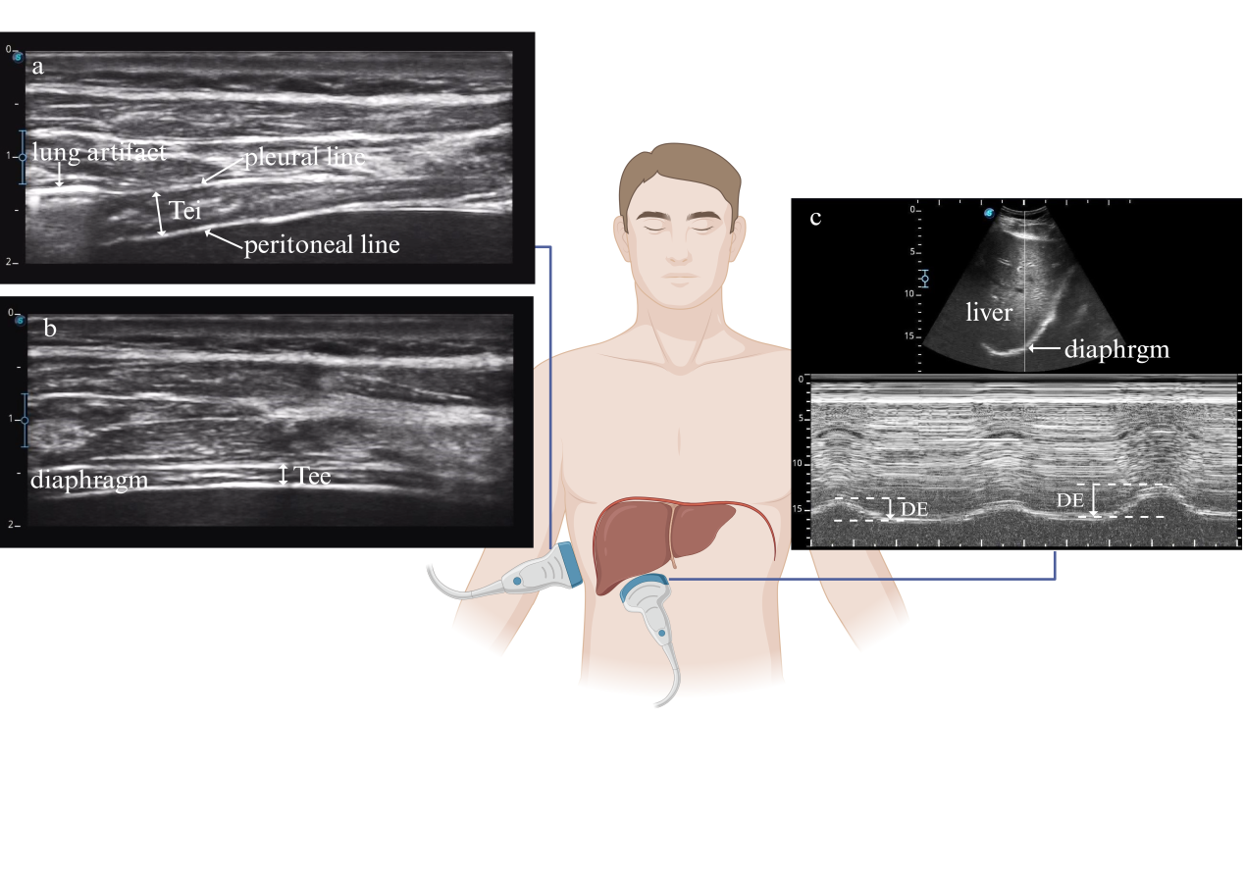
Diaphragmatic Ultrasound: Diaphragmatic Thickening Fraction (TFdi) Measurement and Phrenic Nerve Modulation Intensity Determination. (a) Diaphragmatic thickness during deep inspiration measured by B-mode ultrasound. (b) Diaphragmatic thickness during deep expiration measured by B-mode ultrasound. The TFdi was measured using a high-frequency linear probe. The probe was placed perpendicular to the long axis of the ribs or parallel to the intercostal space at the 7th/8th or 8th/9th intercostal space along the mid-axillary or anterior axillary line. Under B-mode imaging, the diaphragm was identified, and the distance between the pleural and peritoneal layers was measured.(c) Diaphragmatic Excursion (DE) during quiet breath measured by M-mode ultrasound. DE was measured using a 2-5 MHz convex array transducer. The probe was positioned subcostally between the midclavicular and anterior axillary lines on the right hemithorax, with gentle cephalad angulation to obtain optimal visualization of the right hemidiaphragmatic dome. Following identification of the diaphragm in B-mode, the imaging modality was switched to M-mode. The sampling line was aligned perpendicular to the diaphragmatic plane to measure the maximal vertical displacement between the peak inspiratory and end-expiratory positions during the respiratory cycle. Phrenic nerve modulation intensity was gradually increased until DE improved, and this intensity was defined as the intraoperative modulation intensity. The TFdi was calculated using the following formula:
$$TFdi=\frac{ Tei−Tee}{Tee}∗100$$
Tei, Thickness at end-inspiration; Tee, Thickness at end-expiration.

Sensitivity Analysis
Demographic and Baseline Data
Characteristic |  | Sham Group  (n=39) | PNS-d Group  (n=38) | PNS-p Group  (n=37) | P-Value
Sex, male, n (%) |  | 17 (43.6) | 23 (60.5) | 17 (45.9) | 0.277
Age, y |  | 52 (36, 61) | 55 (45, 61) | 53 (37, 64) | 0.667
BMI, kg m⁻² |  | 24.3 ± 3.7 | 24.3 ± 2.8 | 26 ± 2.8 | 0.027
Smoker, n (%) |  | 7 (17.9) | 12 (31.6) | 8 (21.6) | 0.349
Alcohol drinker, n (%) |  | 12 (30.8) | 8 (21.1) | 11 (29.7) | 0.578
Medical history, n (%)
Surgical history |  | 22 (56.4) | 16 (42.1) | 19 (51.4) | 0.446
Radiotherapy and/or chemotherapy |  | 4 (10.3) | 5 (13.2) | 9 (24.3) | 0.210
Hypertension |  | 8 (20.5) | 7 (18.4) | 8 (21.6) | 0.940
Diabetes mellitus |  | 5 (12.8) | 4 (10.5) | 3 (8.1) | 0.927
Coronary artery disease |  | 1 (2.6) | 1 (2.6) | 1 (2.7) | 1.000
Stroke |  | 1 (2.6) | 0 (0) | 1 (2.7) | 0.770
Pre-operation
ASA physical status, n (%)
I |  | 0 (0) | 0 (0) | 0 (0) | 1.000
II |  | 39 (0) | 38 (0) | 37 (0) | 1.000
Tumor type, n (%)
Intra-axial brain tumors |  | 26 (66.7) | 26 (68.4) | 21 (56.8) | 0.526
Intra-operation
Operative position, n (%)
 | Supine position | 26 (66.7) | 30 (78.9) | 30 (81.1) | 0.285
 | Left-lateral position | 10 (25.6) | 4 (10.5) | 4 (10.8) | 0.115
 | Right-lateral position | 3 (7.7) | 4 (10.5) | 3 (8.1) | 0.921
Duration of anesthesia; h |  | 5.3 (4.6,6.4) | 5.6 (4.4,6.8) | 5.3 (4.5,6.4) | 0.811
Hemodynamics
MAP max, mmHg |  | 99 (95,108) | 97 (92,107) | 99 (94,103) | 0.630
MAP min, mmHg |  | 70 ± 6 | 69 ± 5 | 70 ± 7 | 0.795
Fluid
Blood loss, ml |  | 300 (300,500) | 400 (200,500) | 400 (200,500) | 0.930
Urine, ml |  | 1500  (1000,2000) | 1500  (1000,1800) | 1300  (1000,2050) | 0.776
Total fluid balance, ml |  | 2350  (1850,2950) | 2050  (1600,2838) | 2250  (1850,2800) | 0.425
Data are expressed as mean ± standard deviation, or median (inter-quartile range), and absolute numbers (percentage) as appropriate. ASA, American Society of Anesthesiologists; PNS, phrenic nerve stimulation; MAP, mean arterial pressure, MAP= diastolic blood pressure+1/3 pulse pressure difference.

In the sensitivity analysis, BMI differed significantly among the three patient groups (P=0.027), but post-hoc testing with Bonferroni correction showed no statistically significant intergroup differences.Baseline characteristics were well-balanced across the three patient groups.

Sensitivity Analysis
Incidence of subtype of PPCs in each group and compare
PPCs (n, %) | Overall | Sham Group  (n=39) | PNS-d Group  (n=38) | PNS-p Group  (n=37) | P-Value
Composite respiratory complications, n (%) | 37 (32.5) | 16 (41) | 11 (28.9) | 10 (27) | 0.365
Pneumonia | 30 (26.3) | 12 (30.8) | 10 (26.3) | 8 (21.6) | 0.664
Pleural effusion | 7 (6.1) | 4 (10.3) | 1 (2.6) | 2 (5.4) | 0.447
Respiratory failure | 2 (1.8) | 1 (2.6) | 1 (2.6) | 0 (0.0) | 1.000
Atelectasis | 2 (1.8) | 1 (2.6) | 0 (0.0) | 1 (2.7) | 0.770
≥2 subtype of PPCs | 3 (2.6) | 1 (2.6) | 1 (2.6) | 1 (2.7) | 1.000
PPCs, postoperative pulmonary complications; PNS, phrenic nerve stimulation.

Sensitivity analysis after exclusion of six lost-to-follow-up cases (n=116) revealed no significant intergroup differences in postoperative pulmonary complication rates (P>0.05 for all comparisons). This per-protocol analysis demonstrated consistency with the primary intention-to-treat results, supporting the robustness of our findings.

