Supplementary Information

NMR spectra of the obtained compounds
¹H-NMR spectrum of C₁
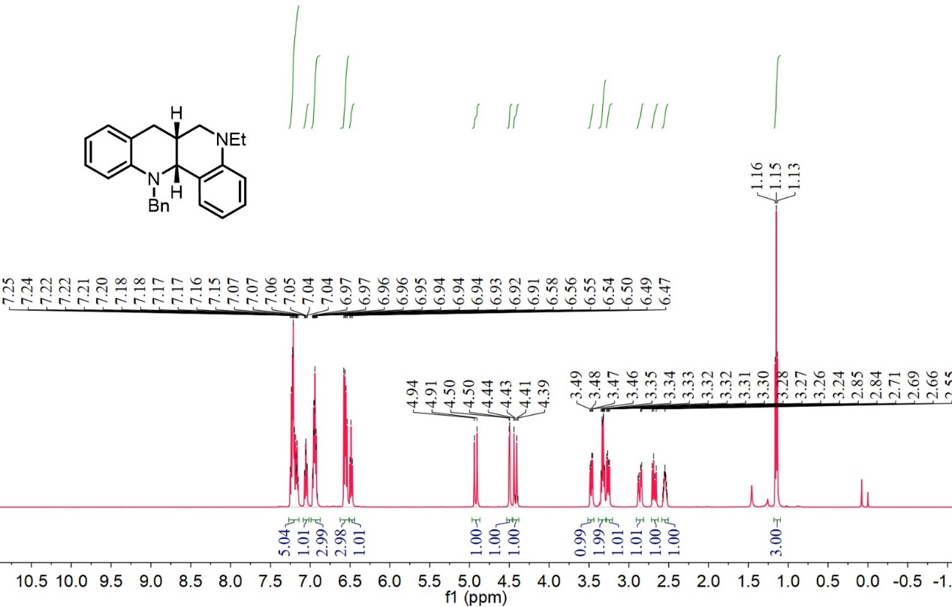

¹³C-NMR spectrum of C₁
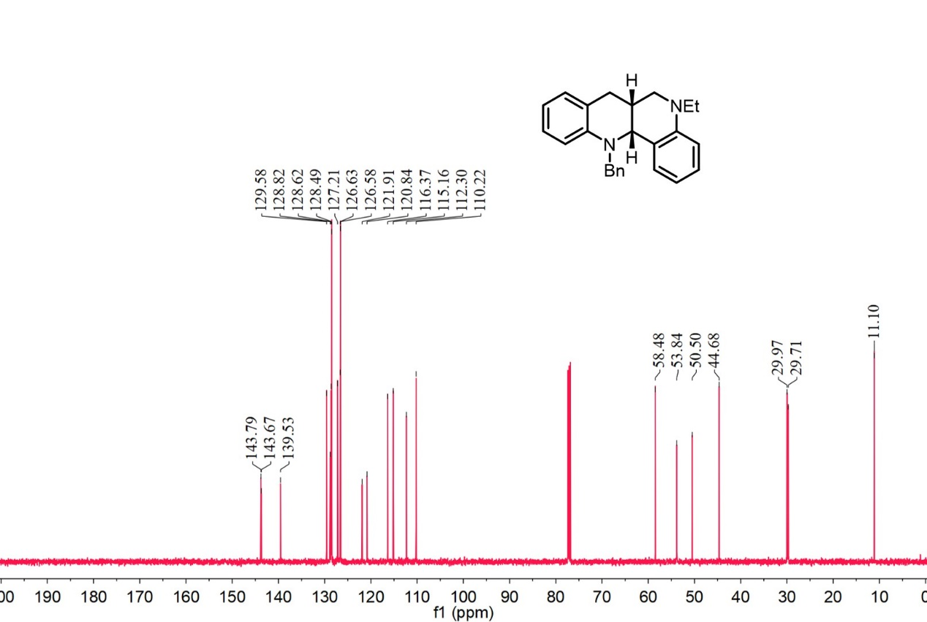
¹H-NMR spectrum of C₂
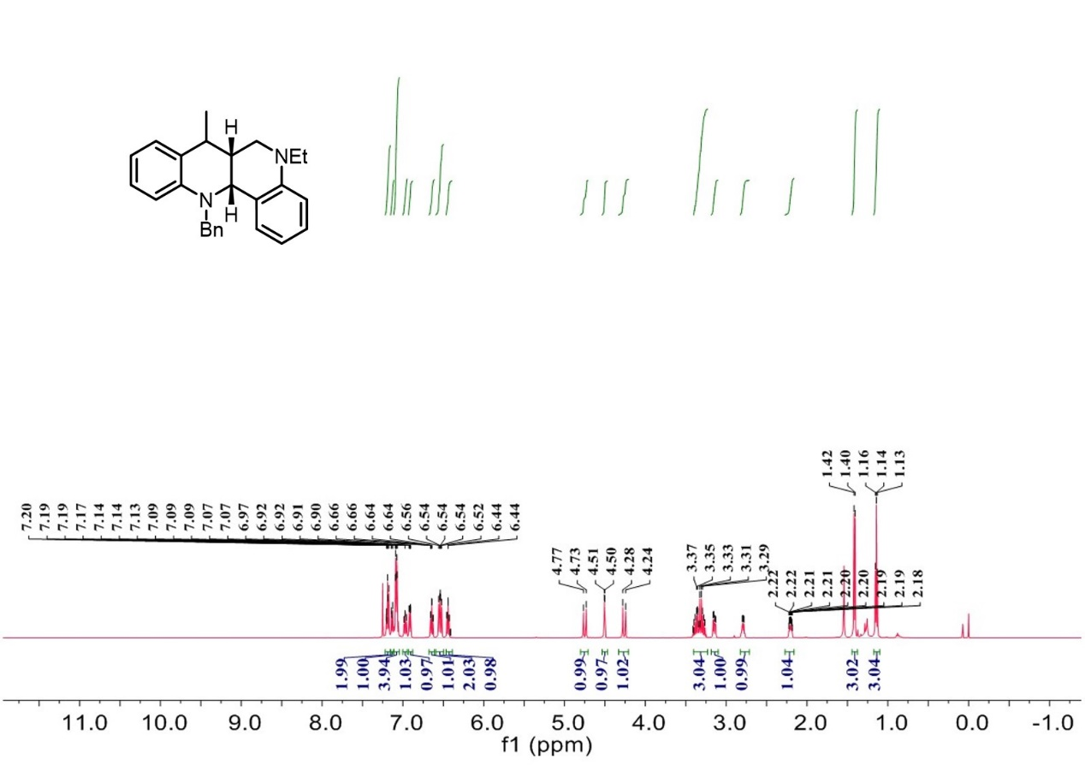

¹³C-NMR spectrum of C₂
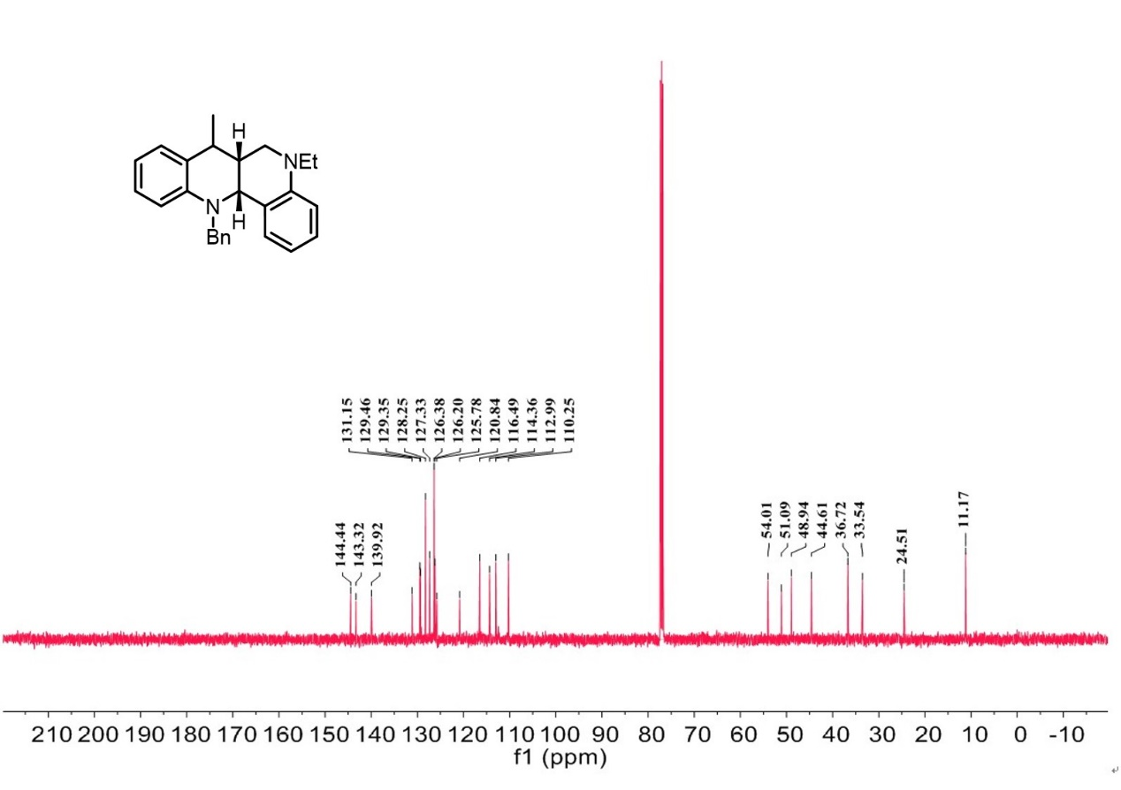

¹H-NMR spectrum of C₃
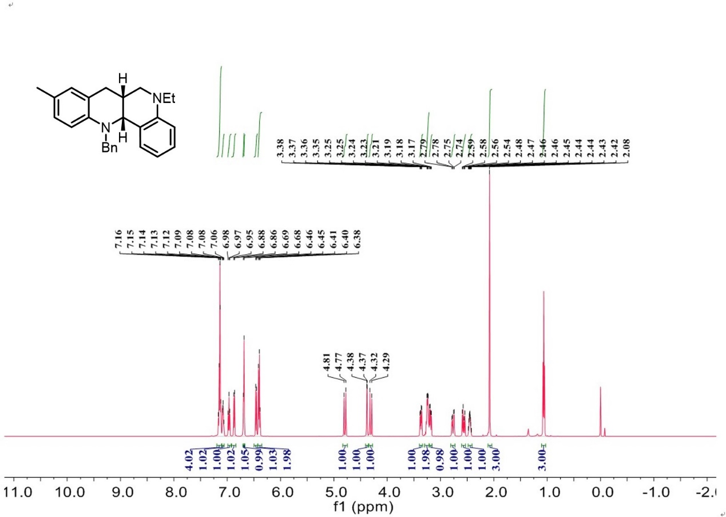

¹³C-NMR spectrum of C₃
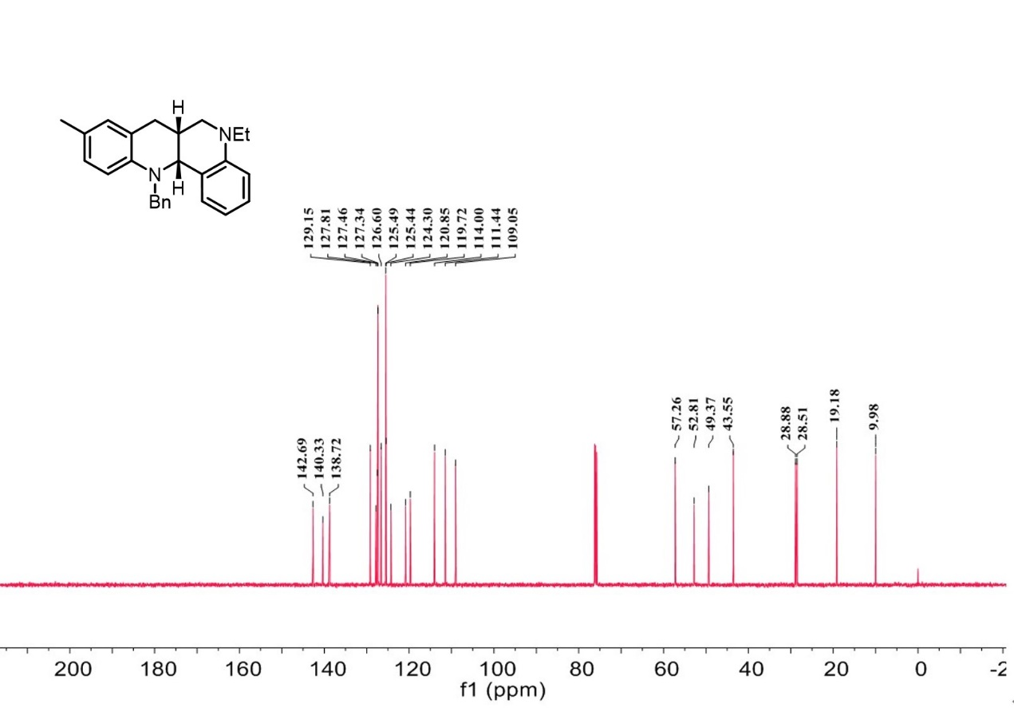

¹H-NMR spectrum of C₄
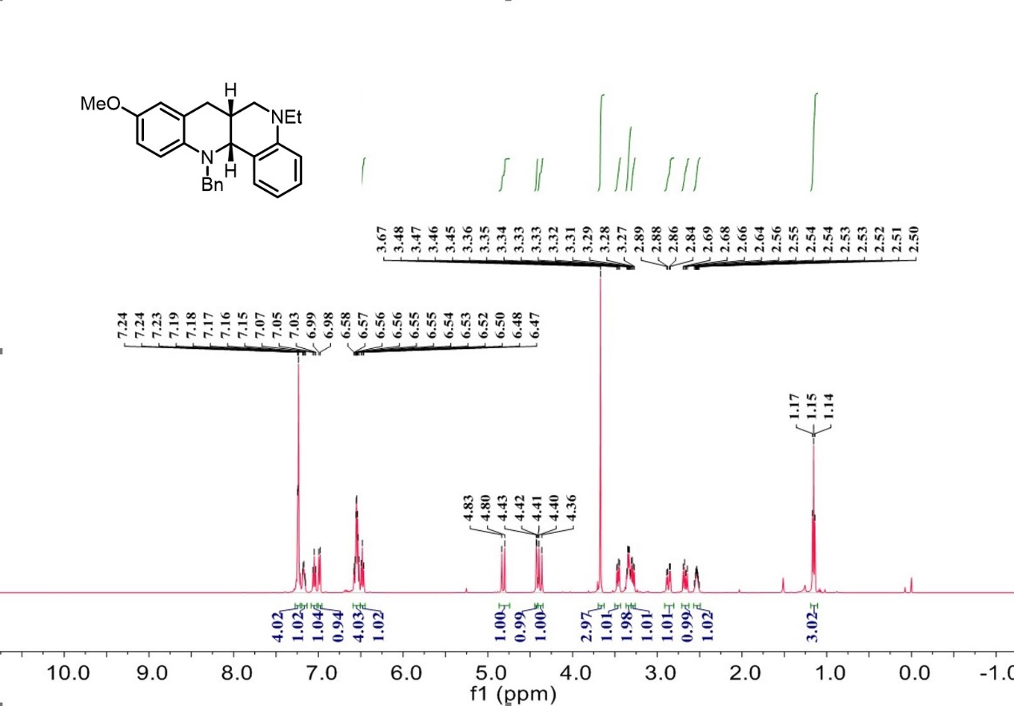

¹³C-NMR spectrum of C₄
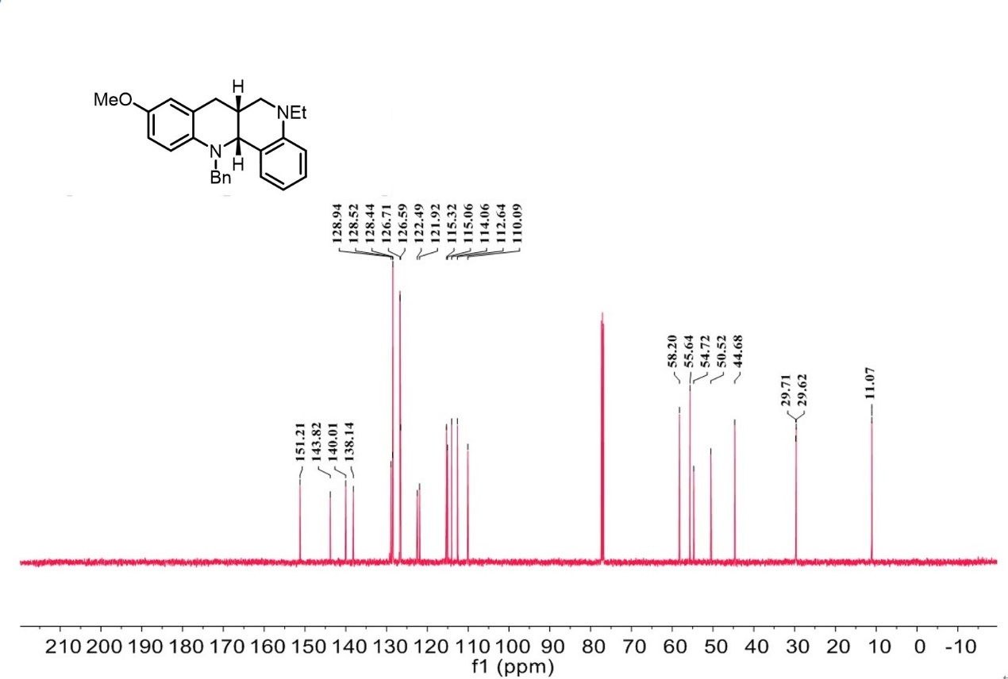

¹H-NMR spectrum of C₅
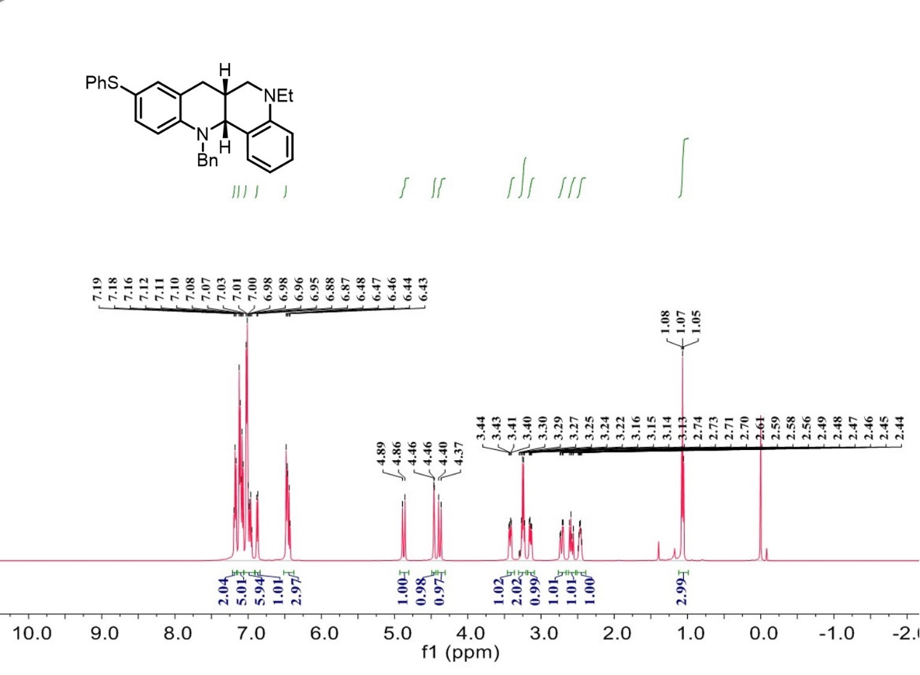

¹³C-NMR spectrum of C₅
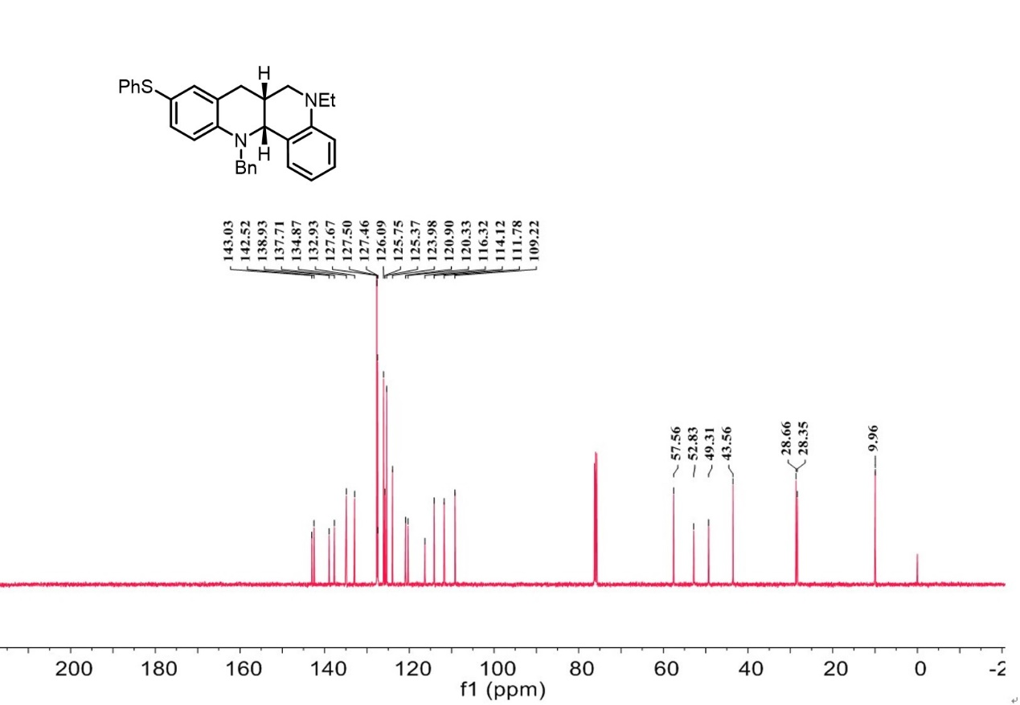

¹H-NMR spectrum of C₆
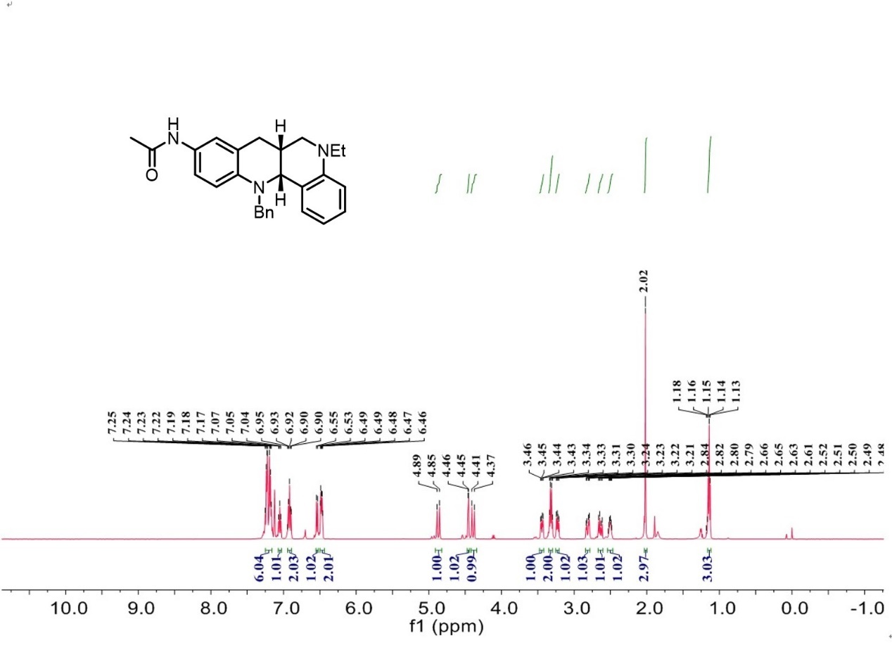

¹³C-NMR spectrum of C₆
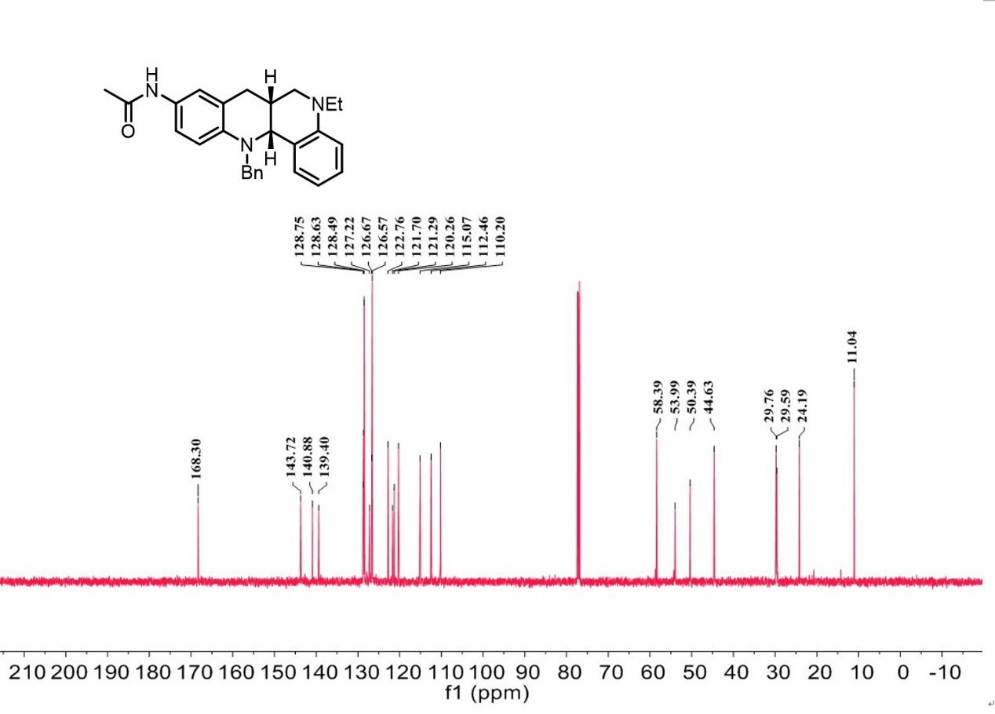

¹H-NMR spectrum of C₇
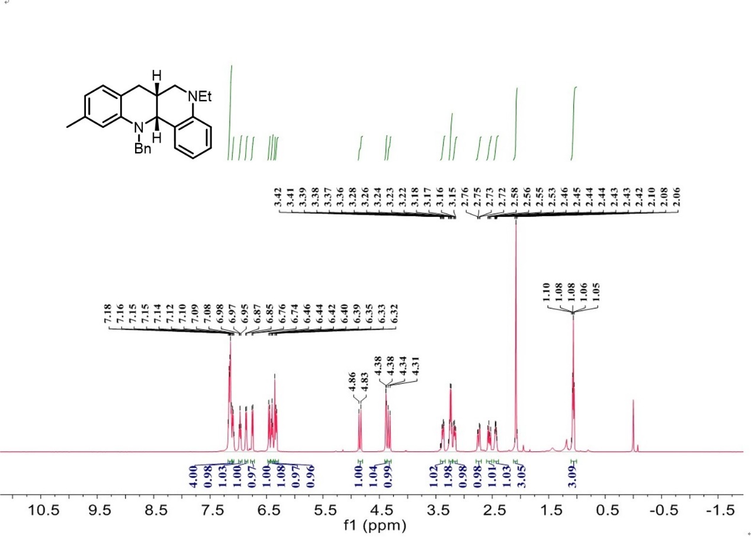

¹³C-NMR spectrum of C₇
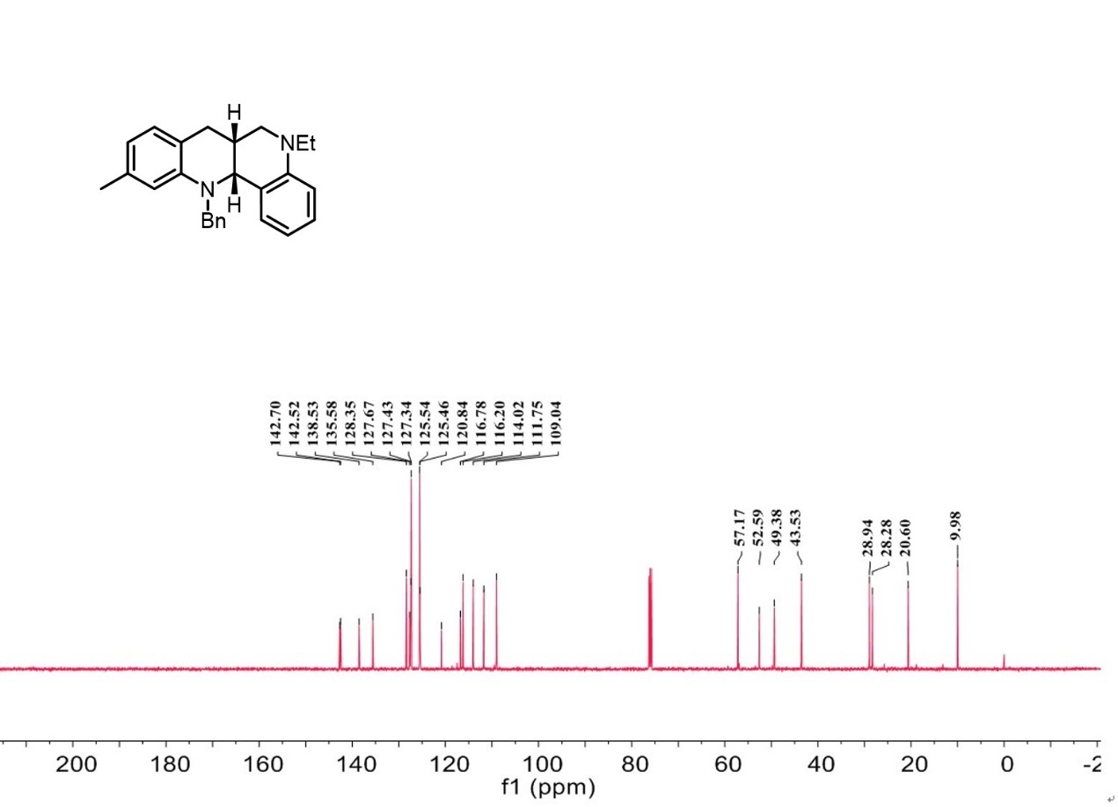

¹H-NMR spectrum of C₈
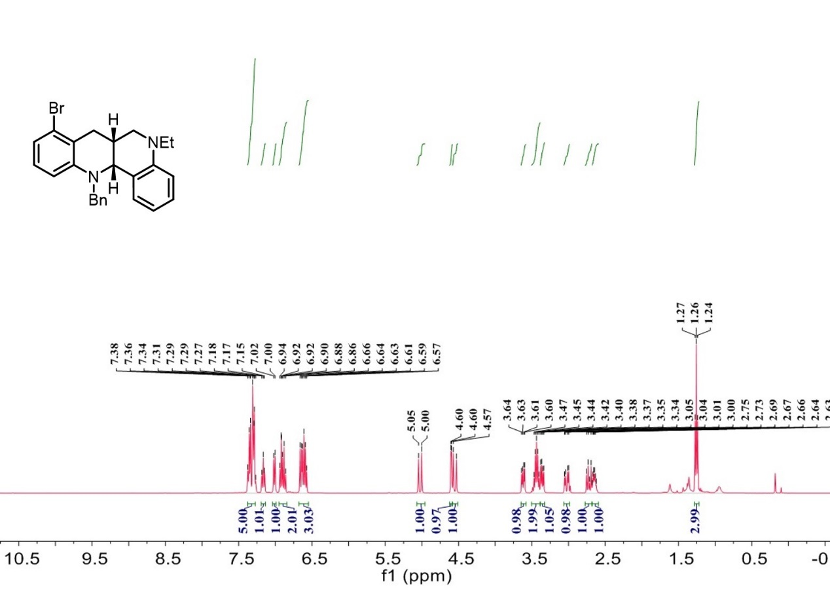

¹³C-NMR spectrum of C₈
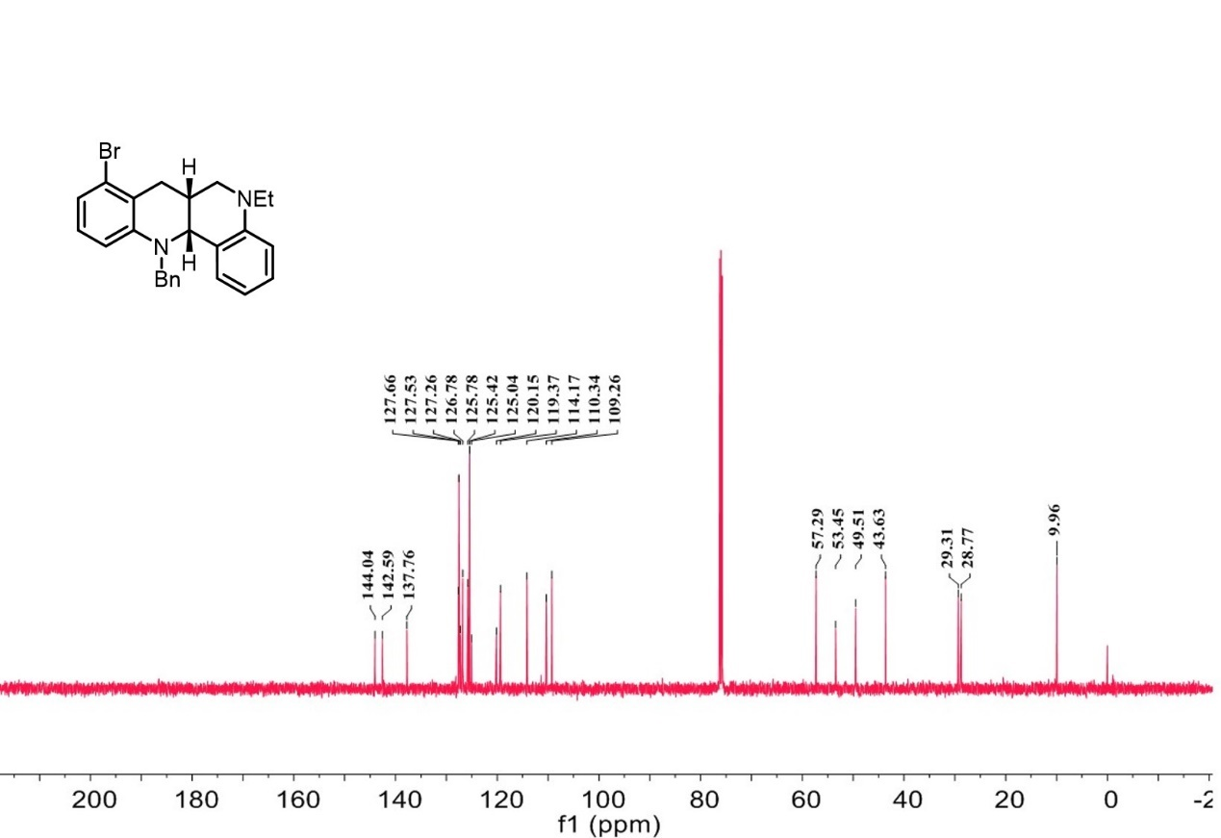

¹H-NMR spectrum of C₉
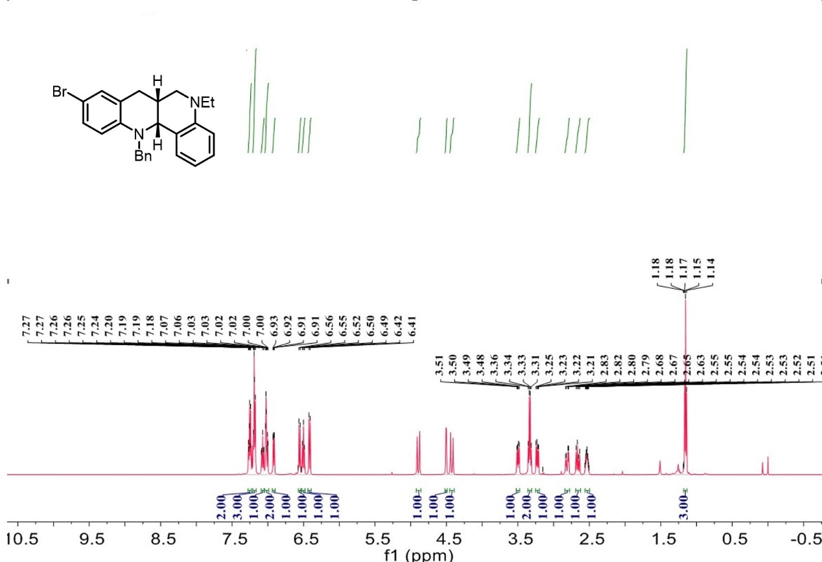

¹³C-NMR spectrum of C₉
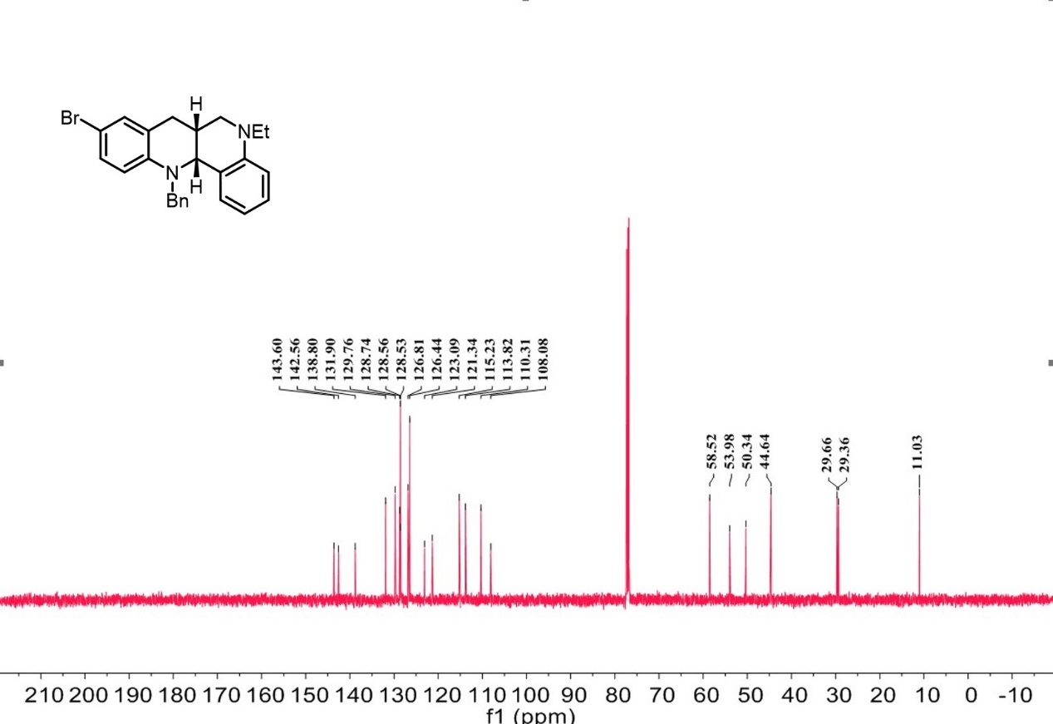

¹H-NMR spectrum of C₁₀

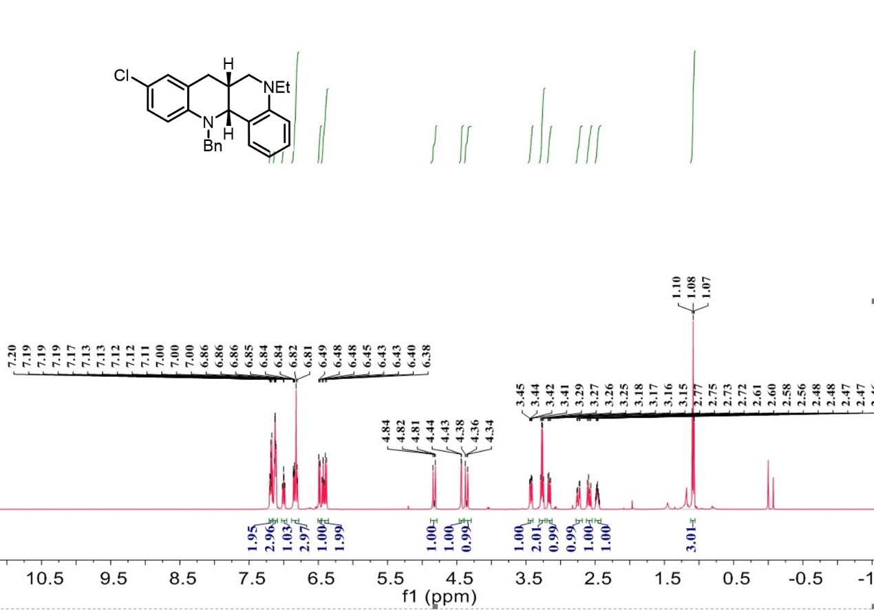

¹³C-NMR spectrum of C₁₀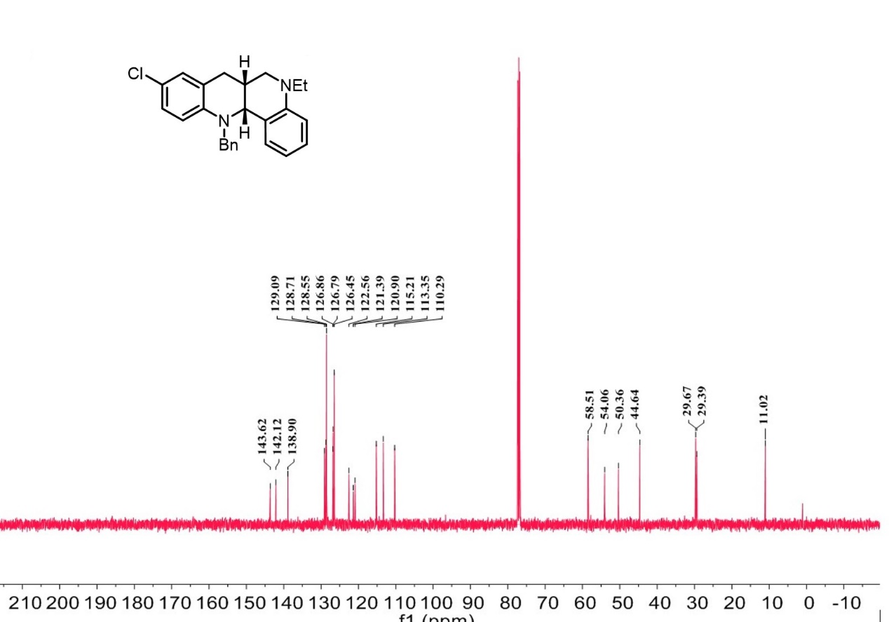

¹H-NMR spectrum of C₁₁
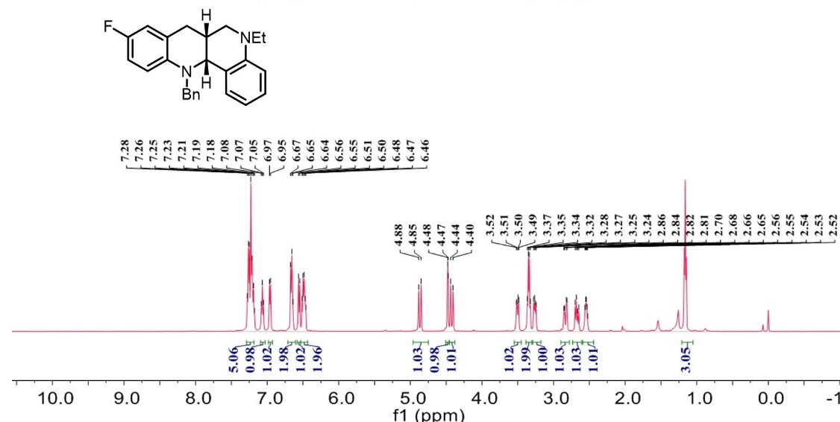
¹³C-NMR spectrum of C₁₁
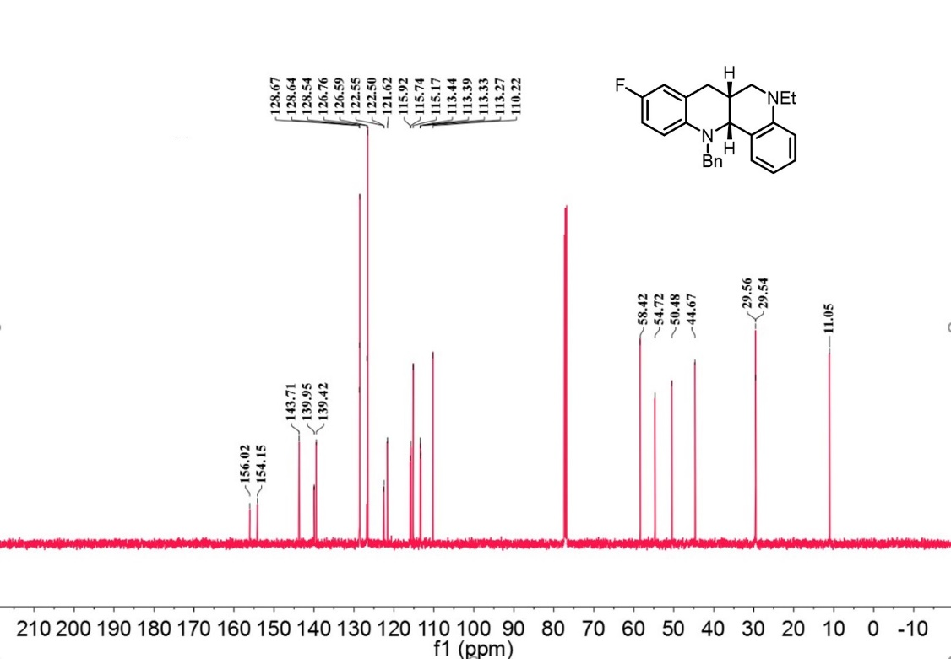
¹⁹F-NMR spectrum of C₁₁
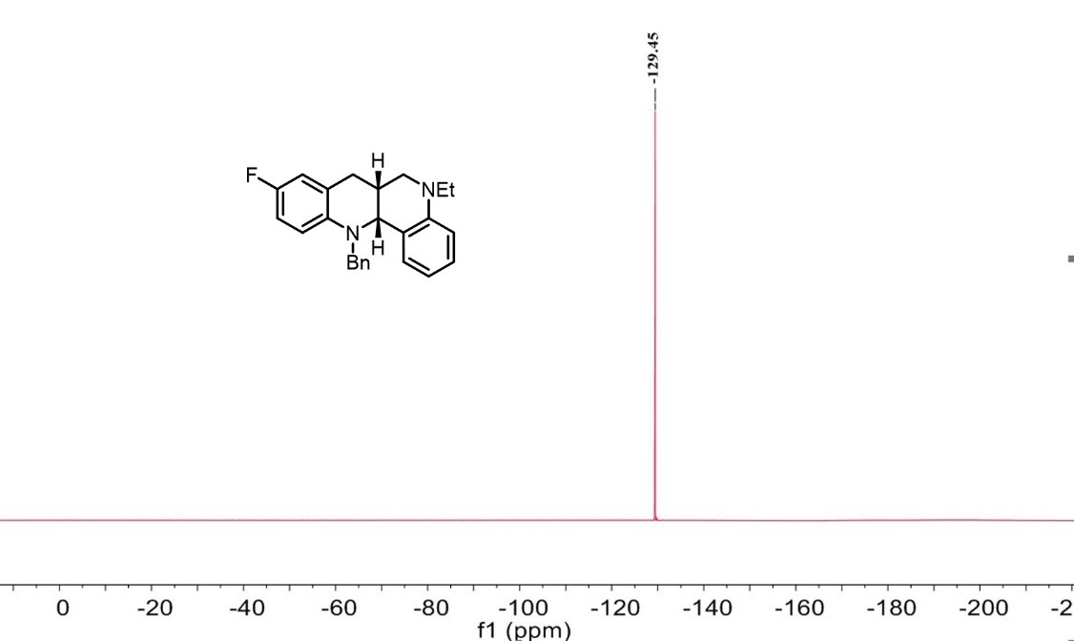

¹H-NMR spectrum of C₁₂
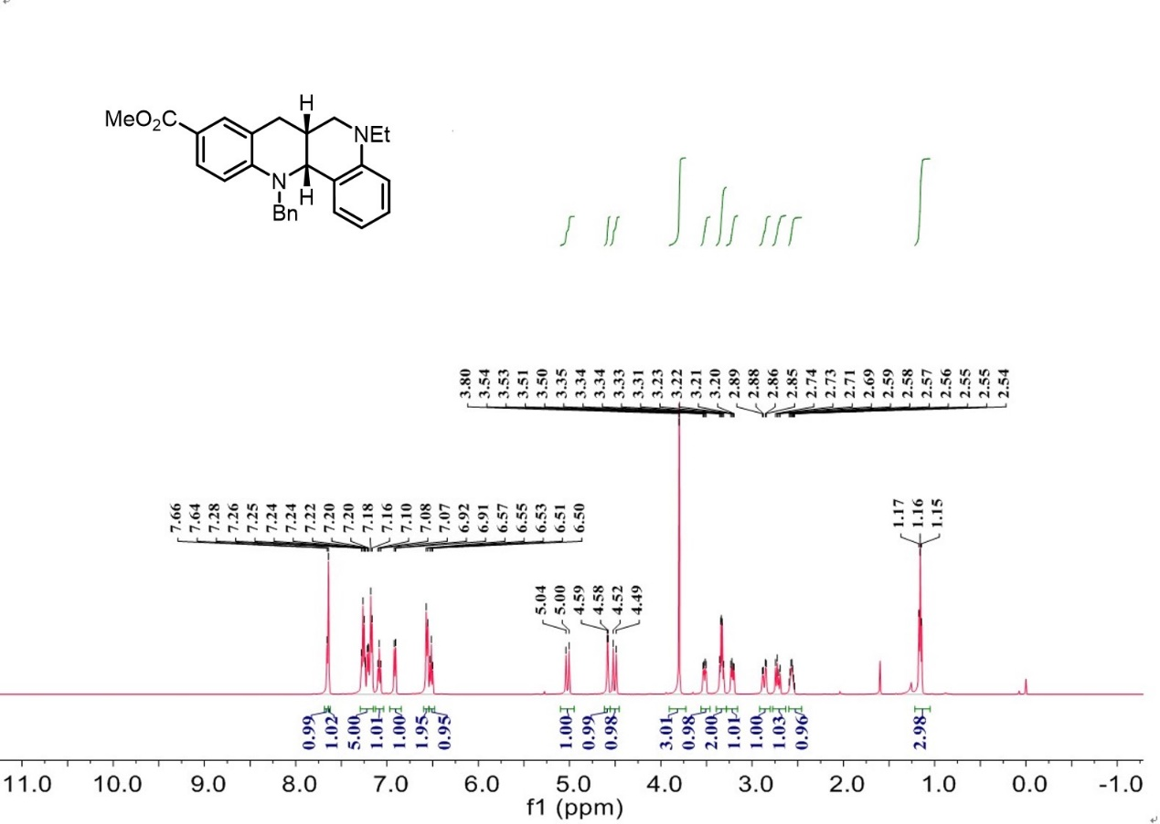

¹³C-NMR spectrum of C₁₂
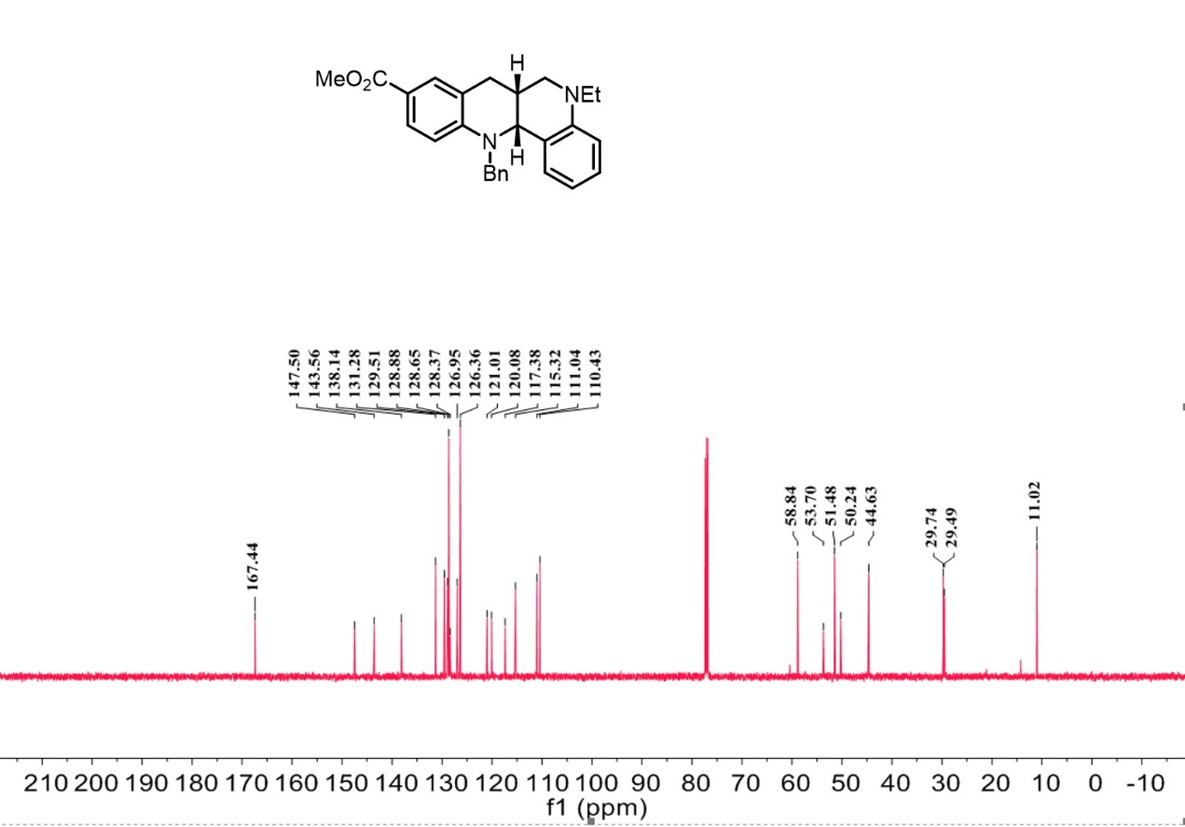

¹H-NMR spectrum of C₁₃
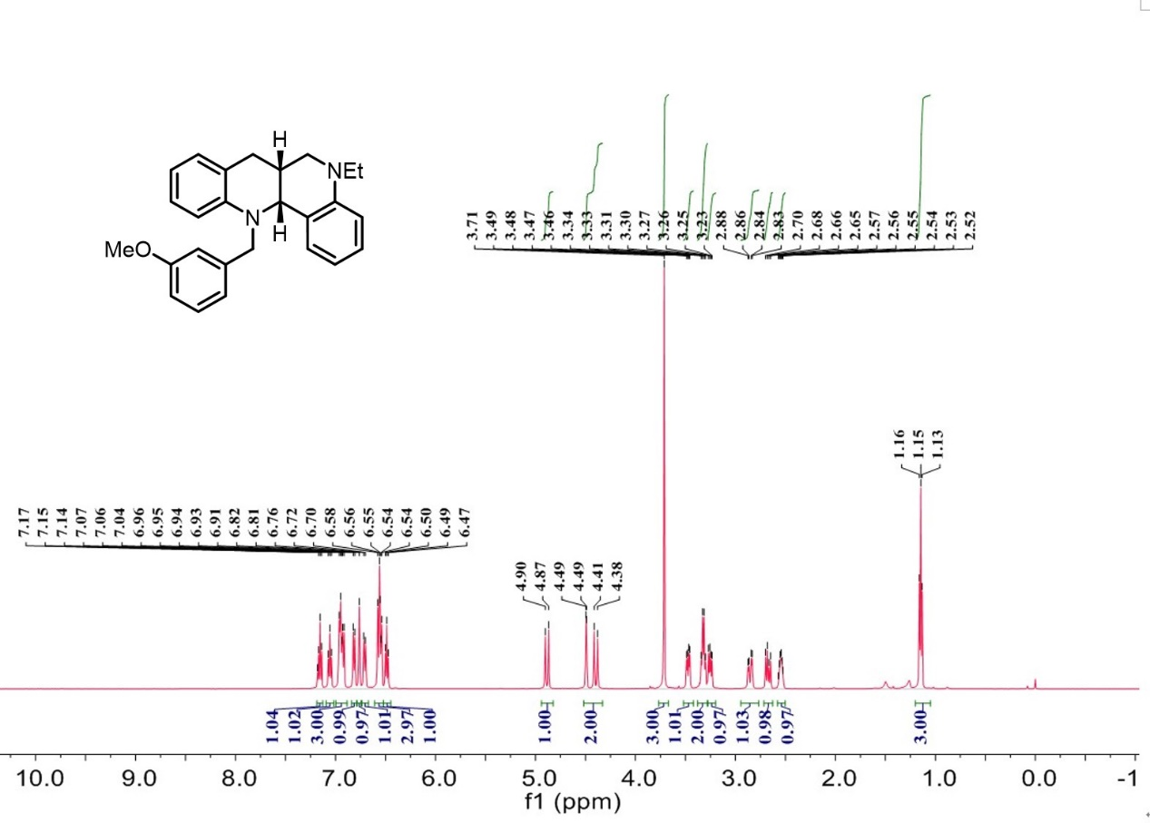

¹³C-NMR spectrum of C₁₃
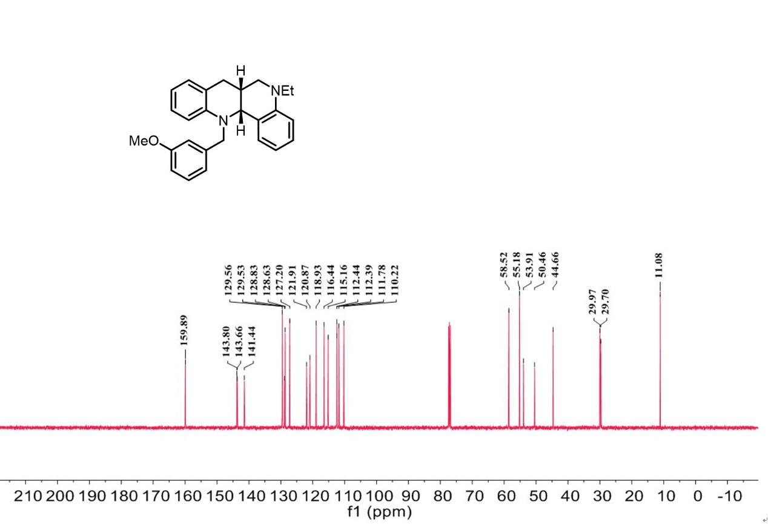

¹H-NMR spectrum of C₁₄
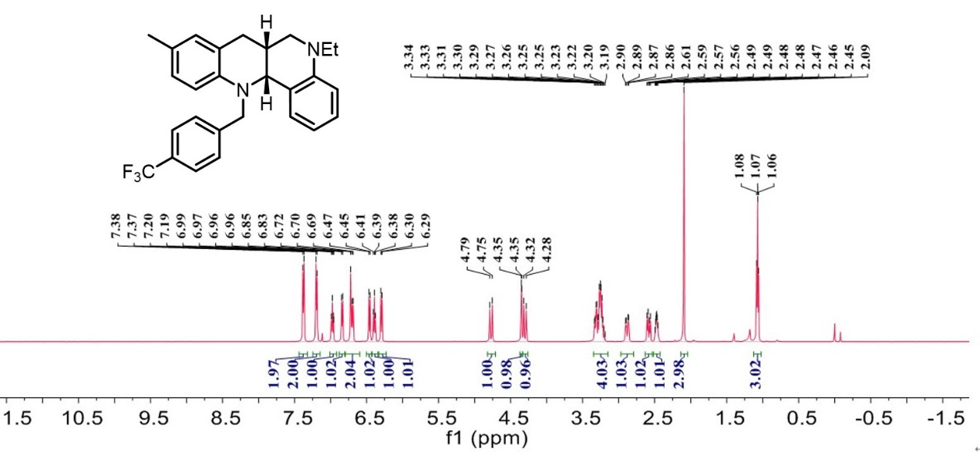
¹³C-NMR spectrum of C₁₄
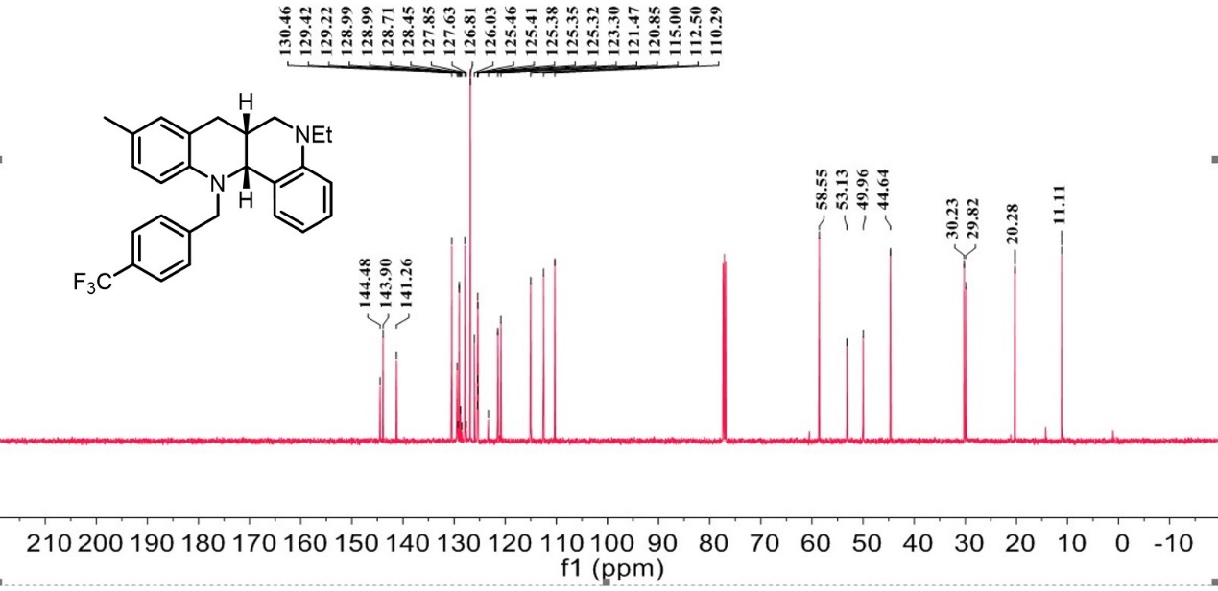
¹⁹F-NMR spectrum of C₁₄
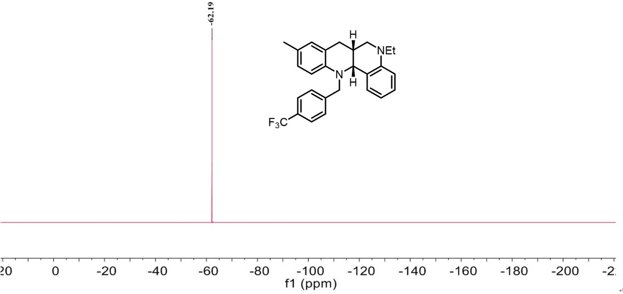

¹H-NMR spectrum of C₁₅
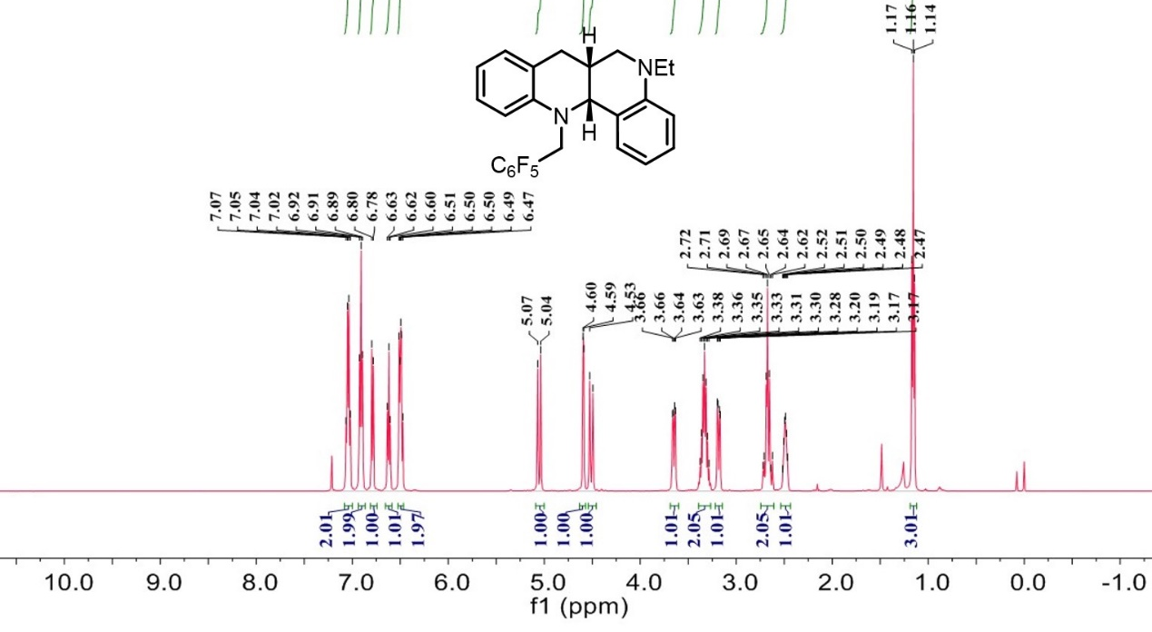
¹³C-NMR spectrum of C₁₅
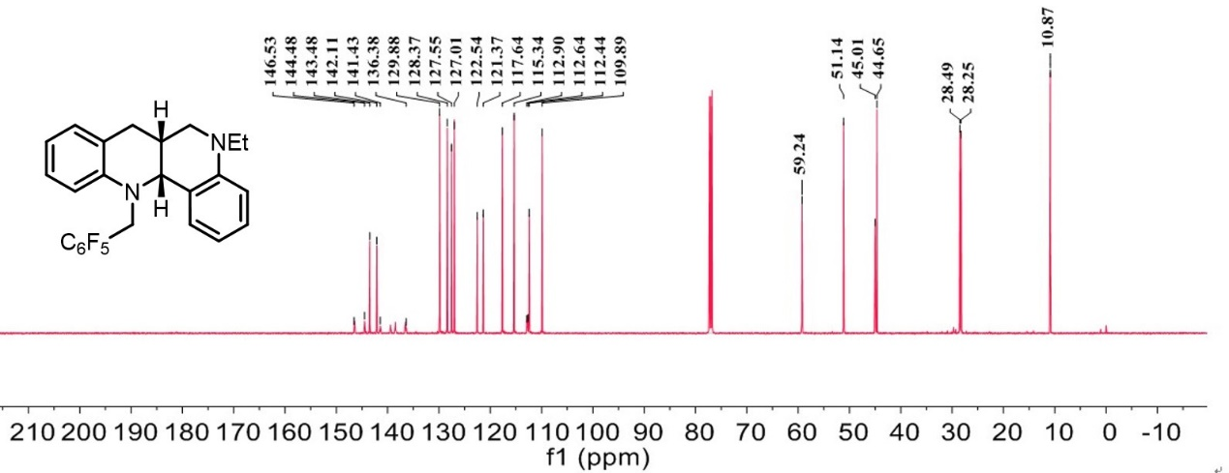
¹⁹F-NMR spectrum of C₁₅
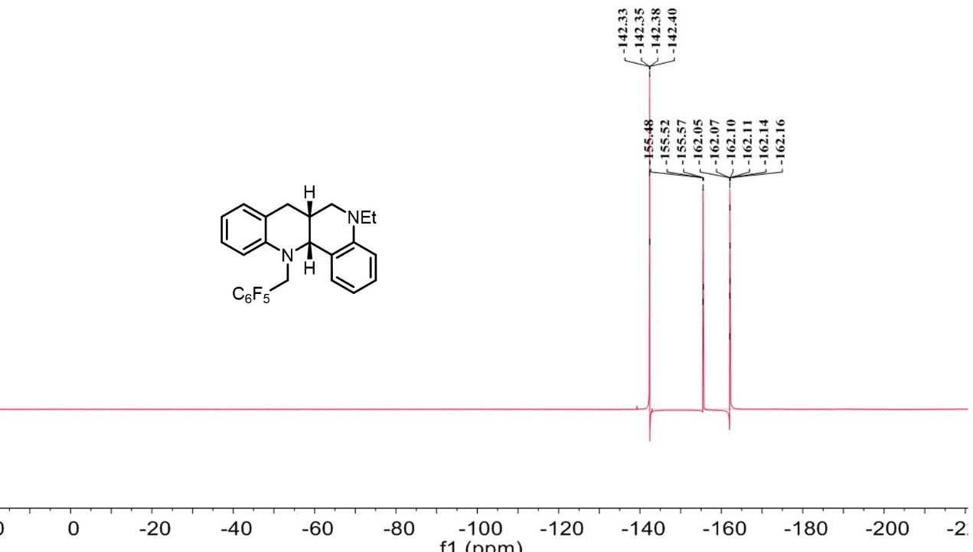
¹H-NMR spectrum of C₁₆
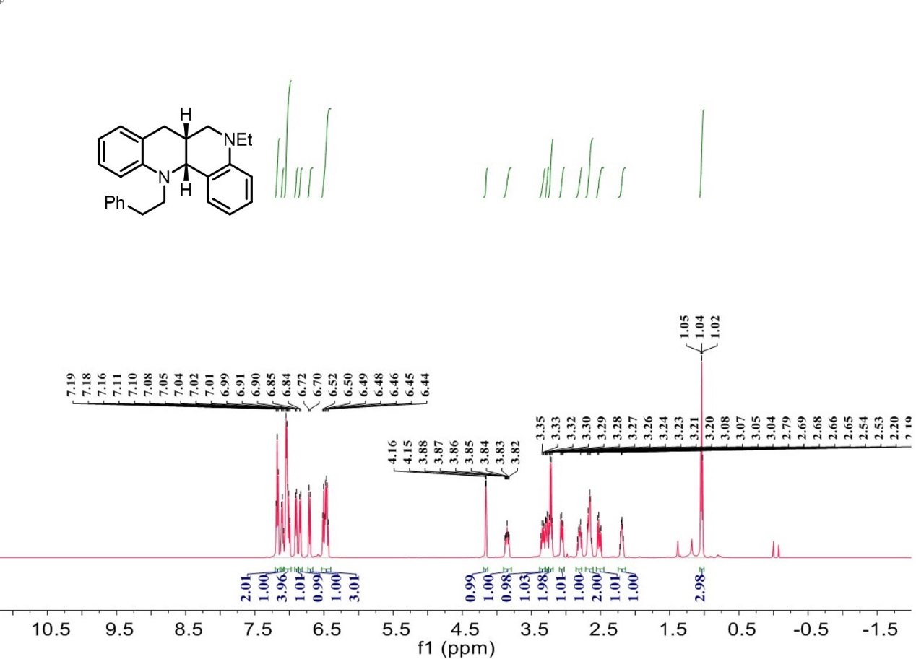

¹³C-NMR spectrum of C₁₆
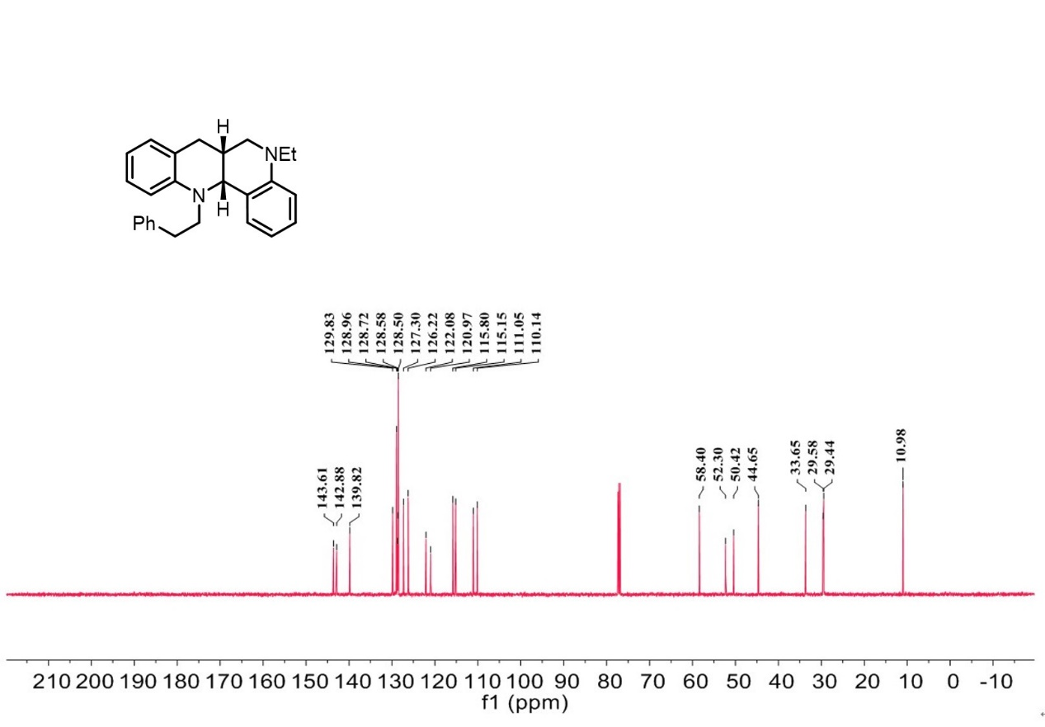

¹H-NMR spectrum of C₁₇
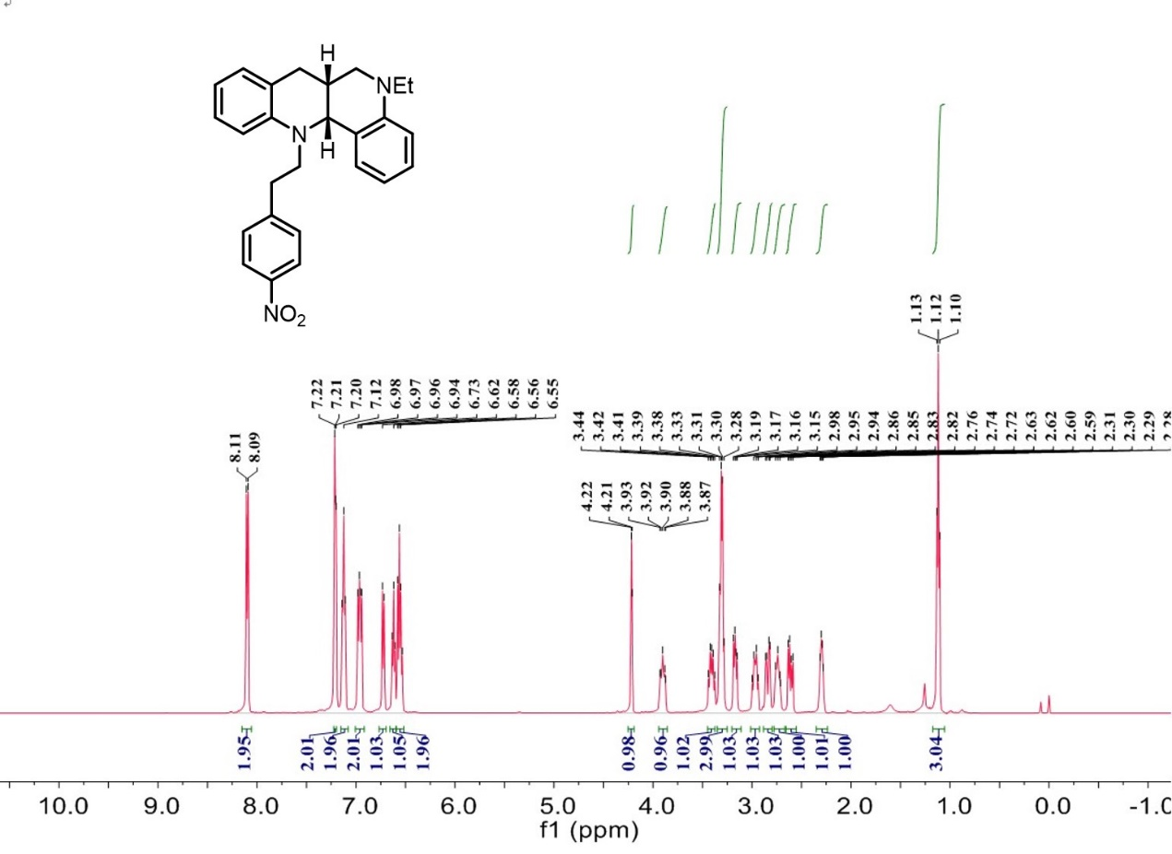
¹³C-NMR spectrum of C₁₇
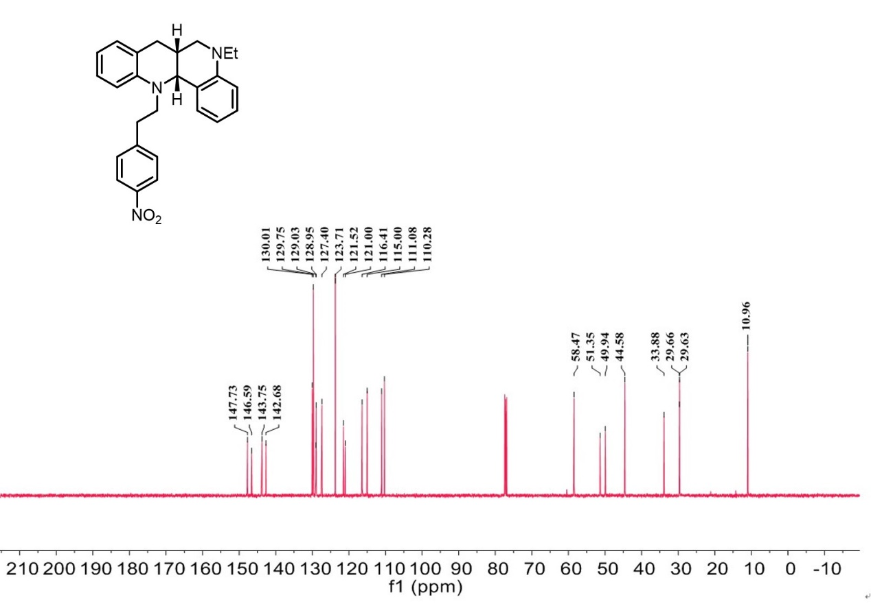

¹H-NMR spectrum of C₁₈
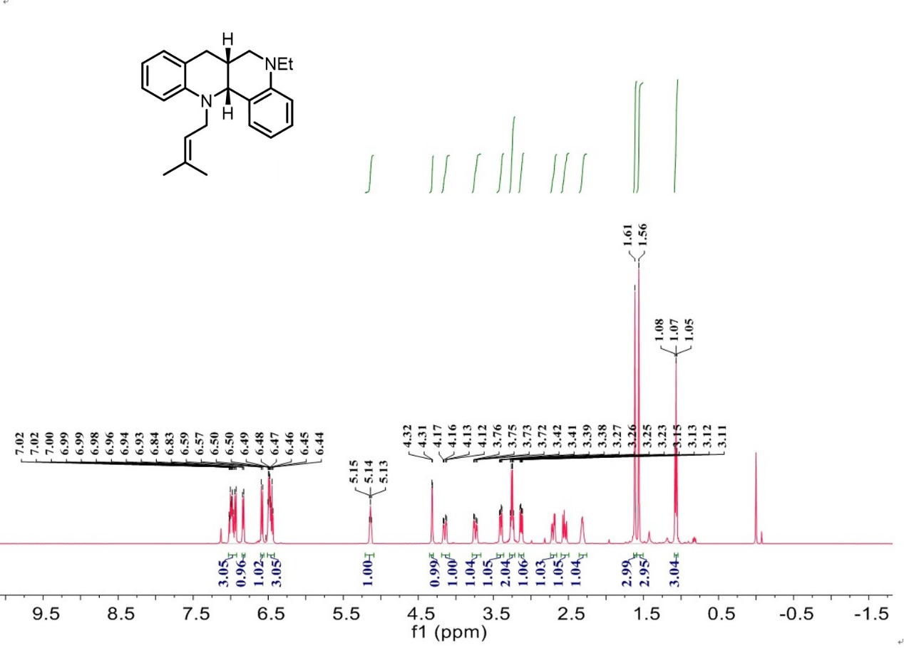

¹³C-NMR spectrum of C₁₈
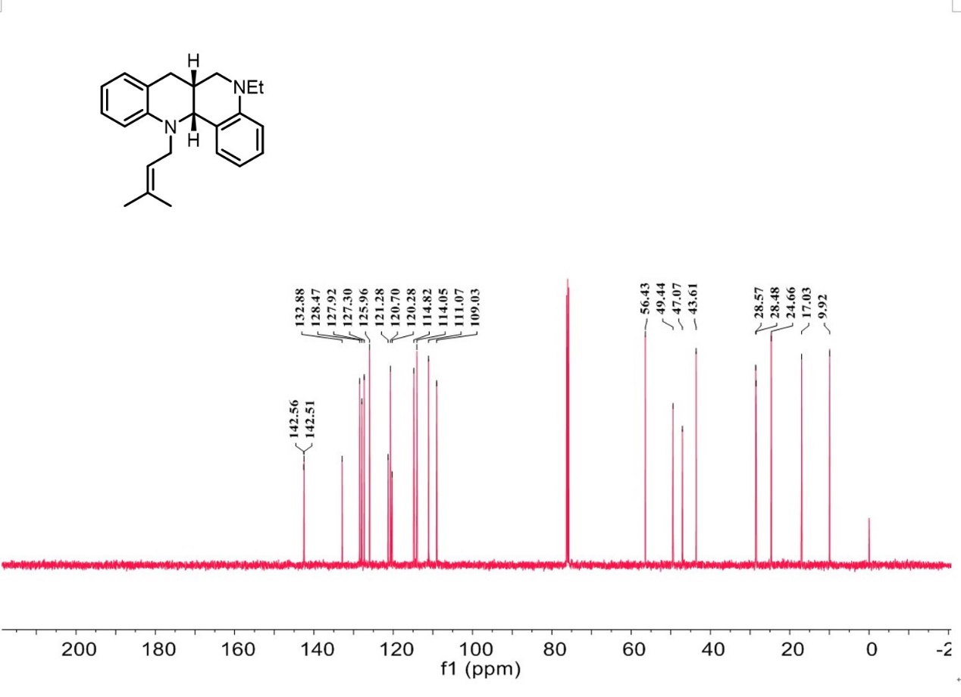
¹H-NMR spectrum of C₁₉

¹³C-NMR spectrum of C₁₉
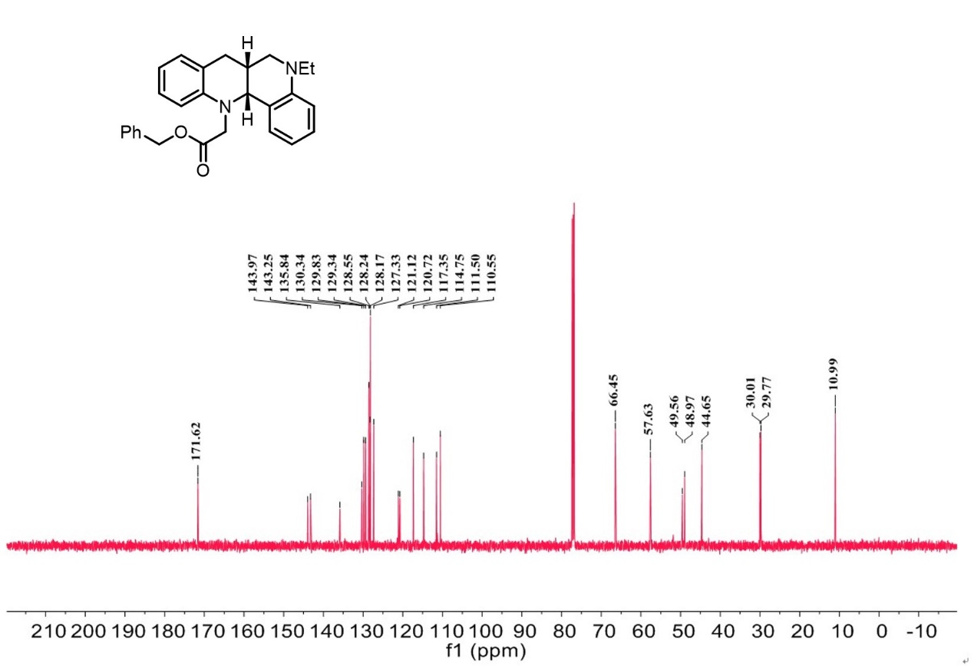

¹H-NMR spectrum of C₂₀
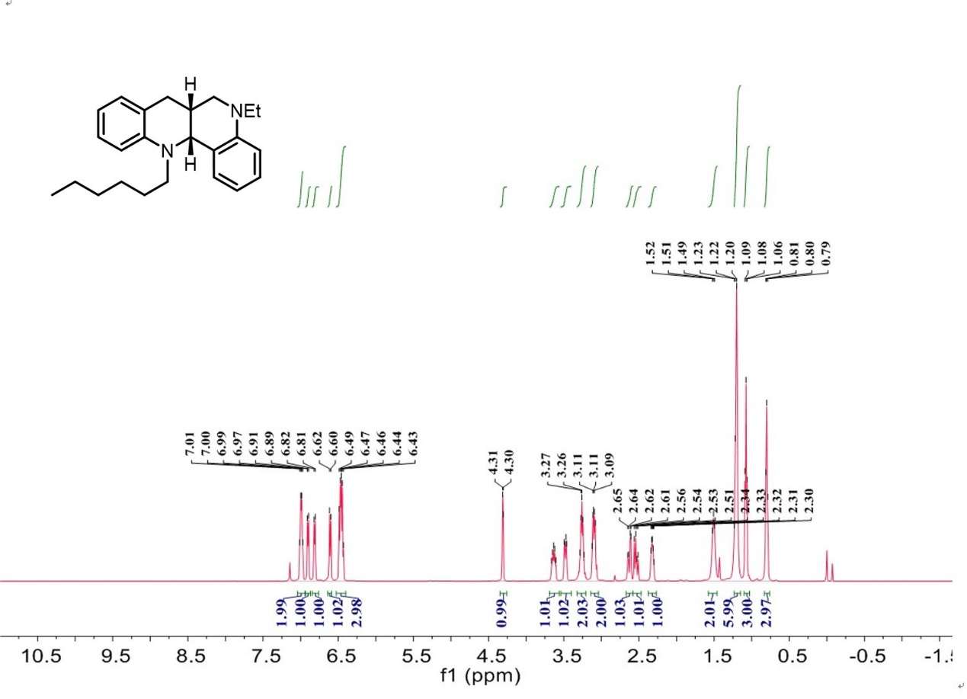

¹³C-NMR spectrum of C₂₀
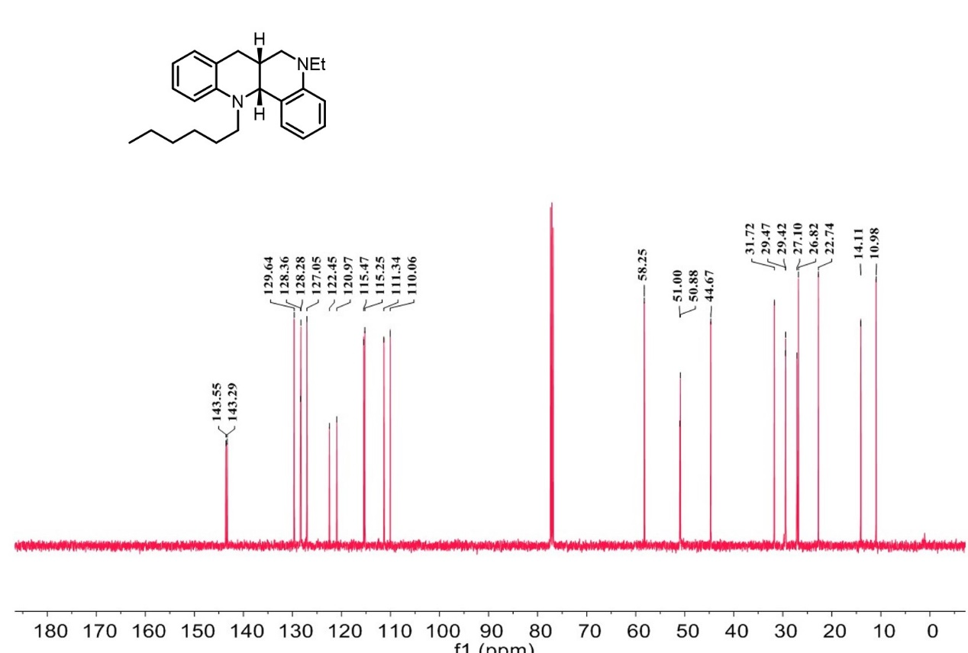

¹H-NMR spectrum of C₂₁
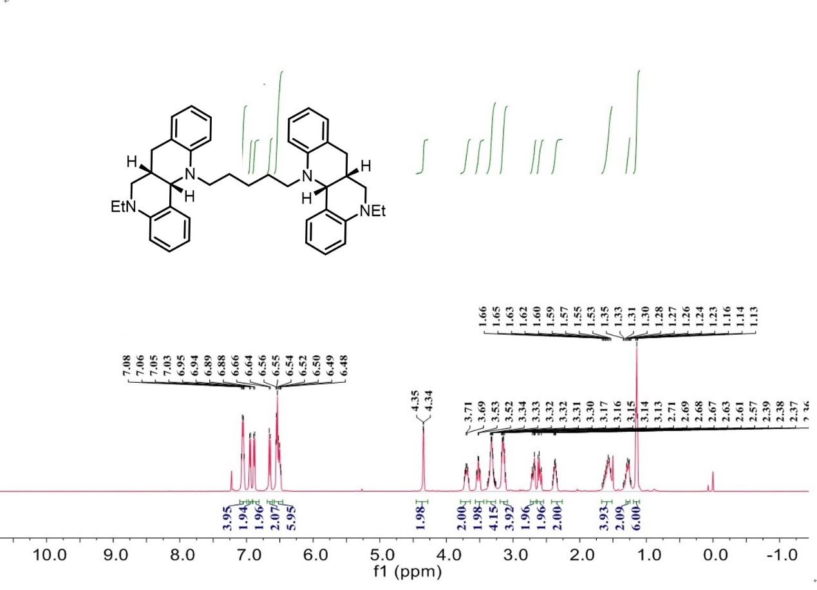

¹³C-NMR spectrum of C₂₁
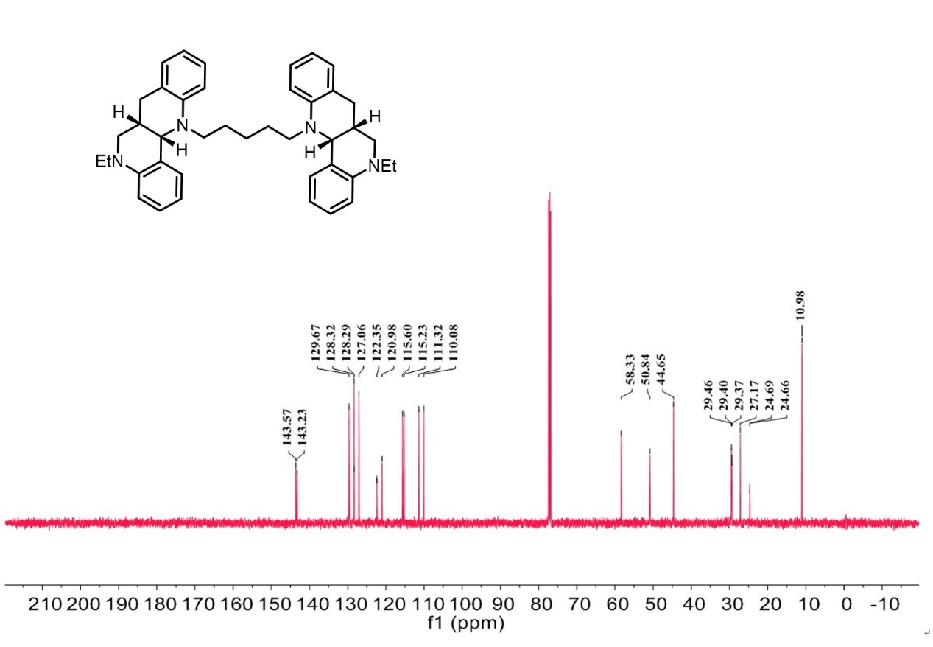

¹H-NMR spectrum of C₂₂
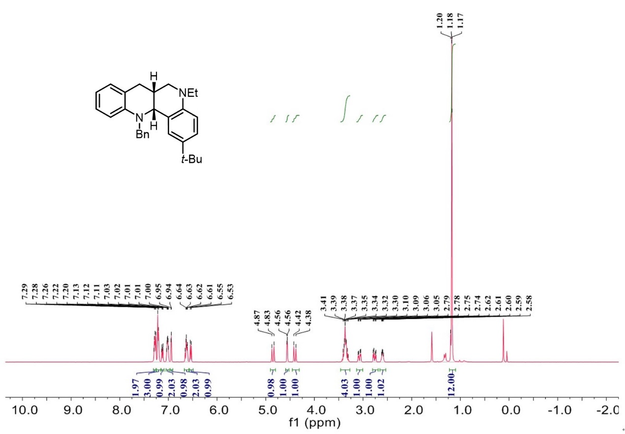

¹³C-NMR spectrum of C₂₂
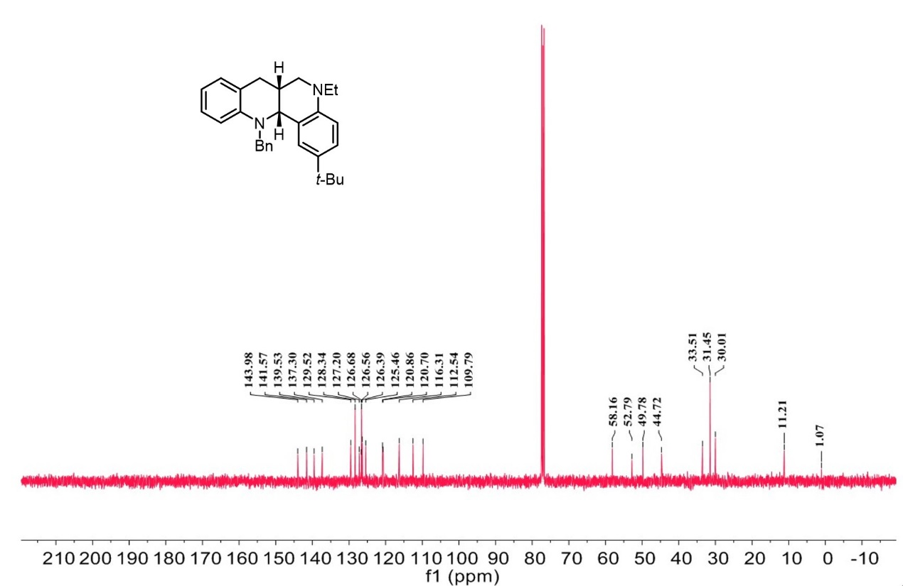

¹H-NMR spectrum of C₂₃

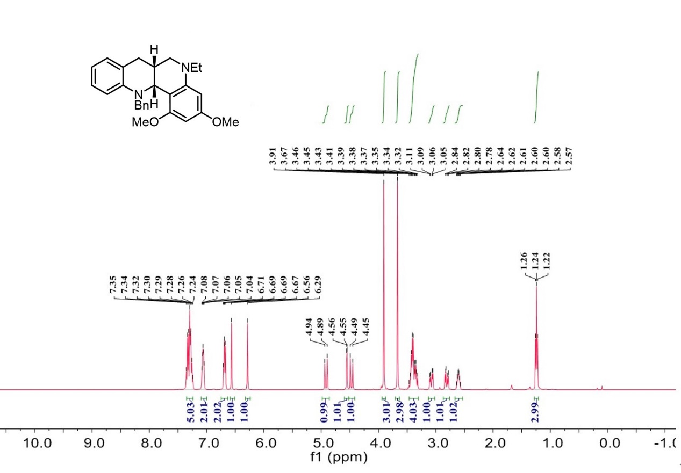

¹³C-NMR spectrum of C₂₃
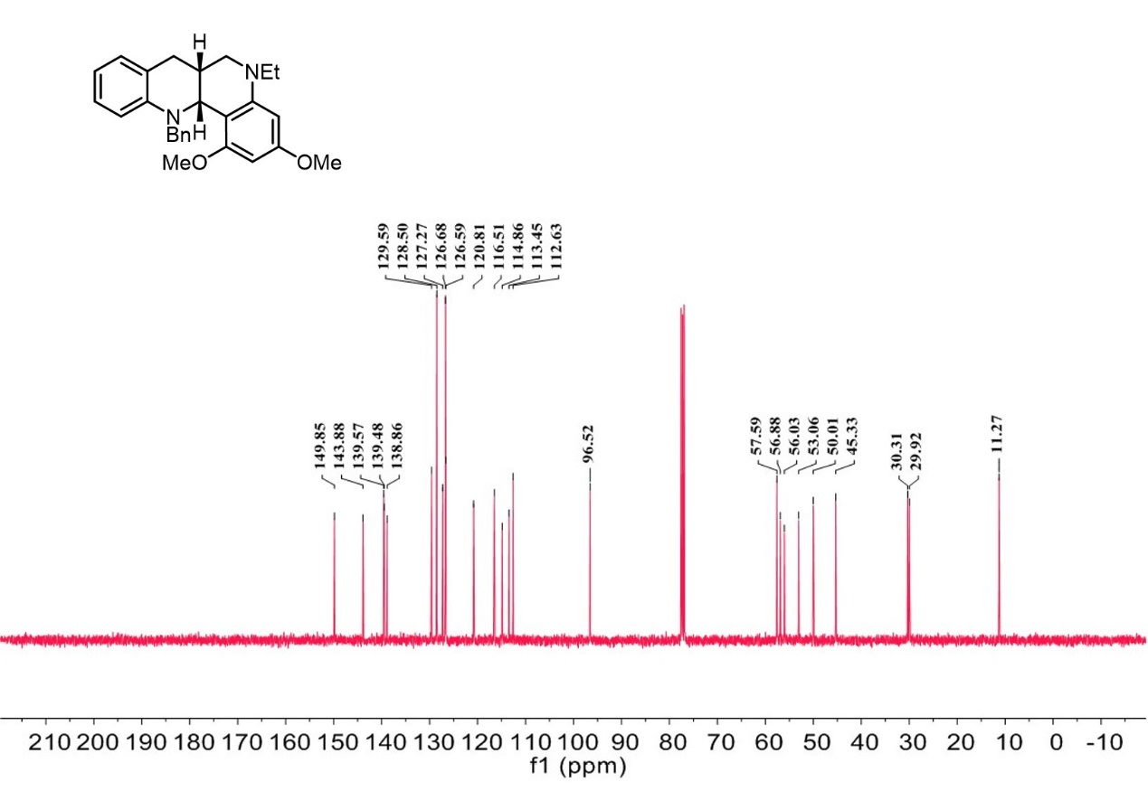

¹H-NMR spectrum of C₂₄
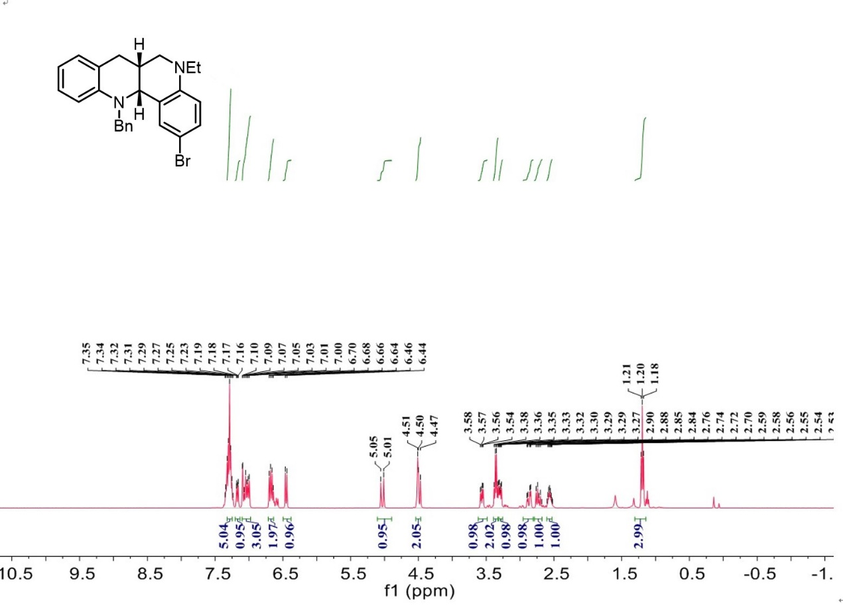

¹³C-NMR spectrum of C₂₄
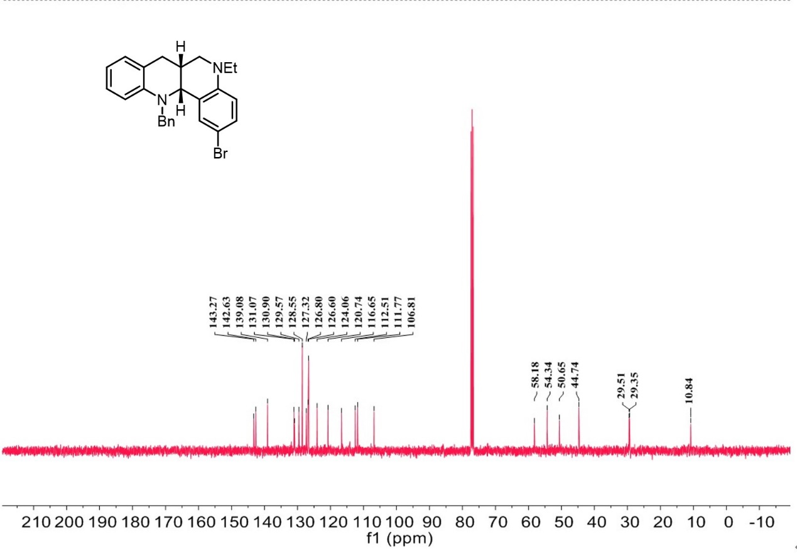

¹H-NMR spectrum of C₂₅
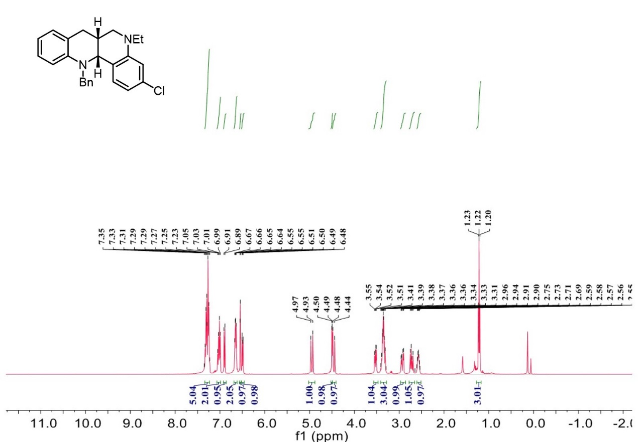

¹³C-NMR spectrum of C₂₅
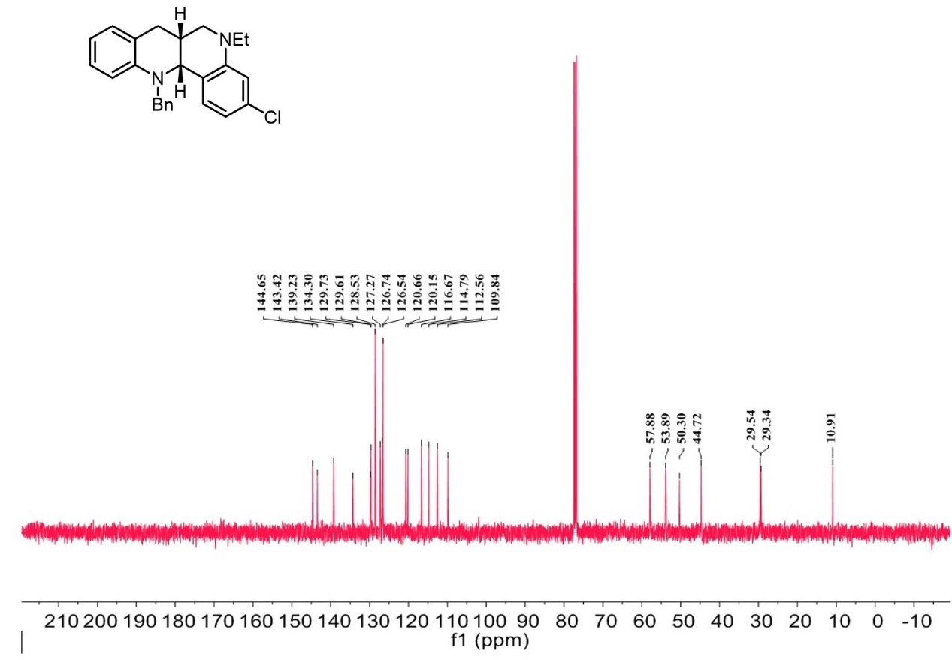

¹H-NMR spectrum of C₂₆

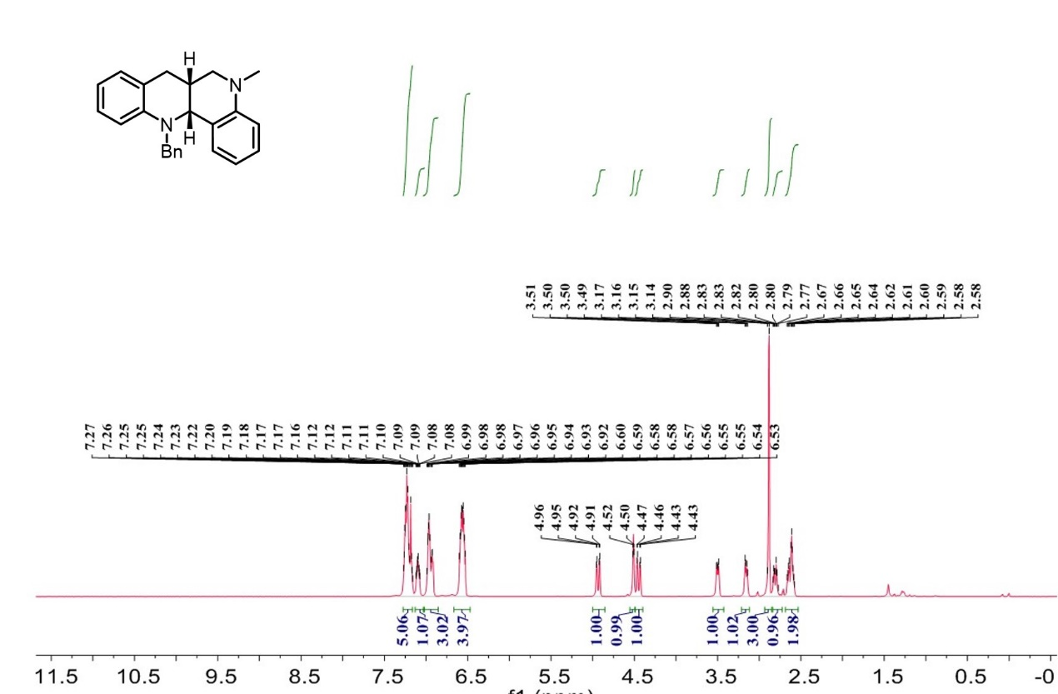

¹³C-NMR spectrum of C₂₆

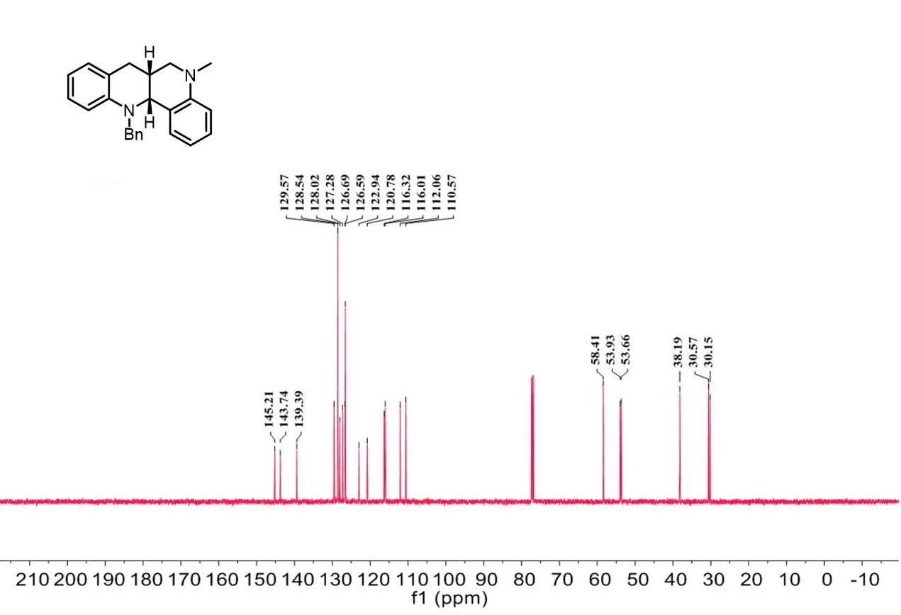

¹H-NMR spectrum of C₂₇

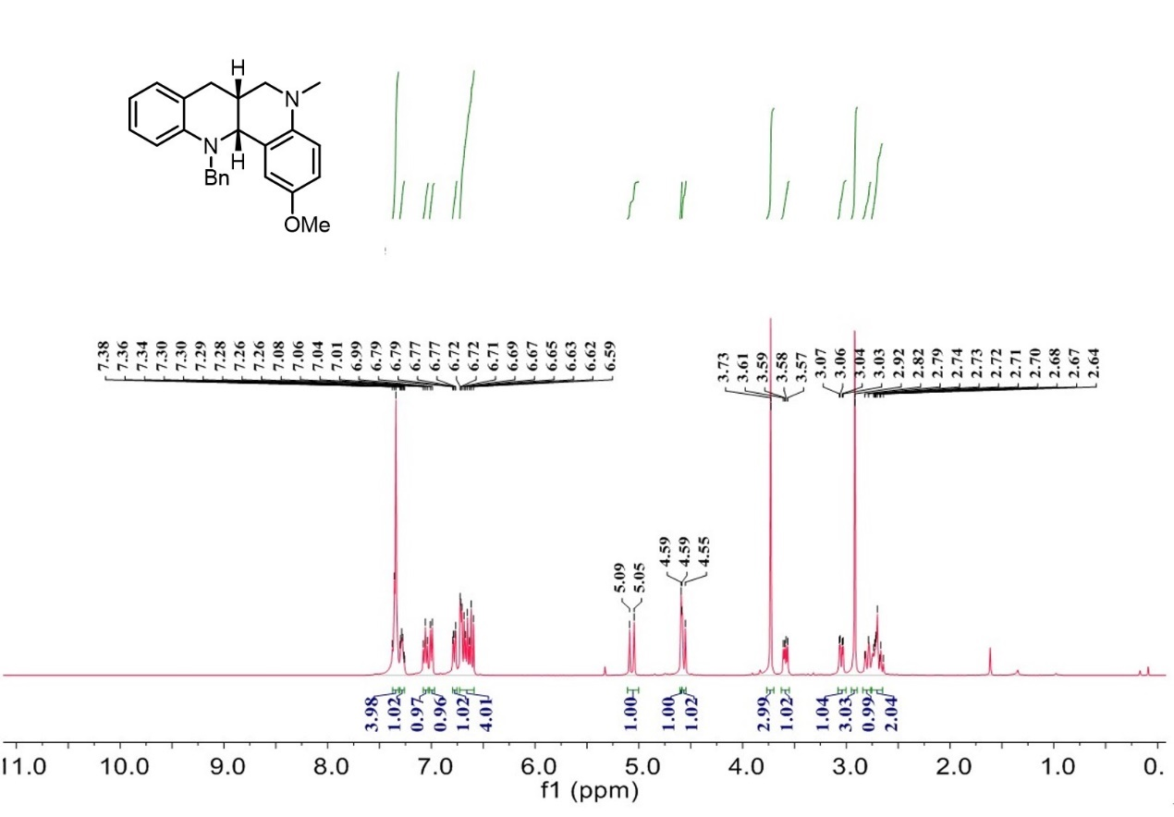

¹³C-NMR spectrum of C₂₇

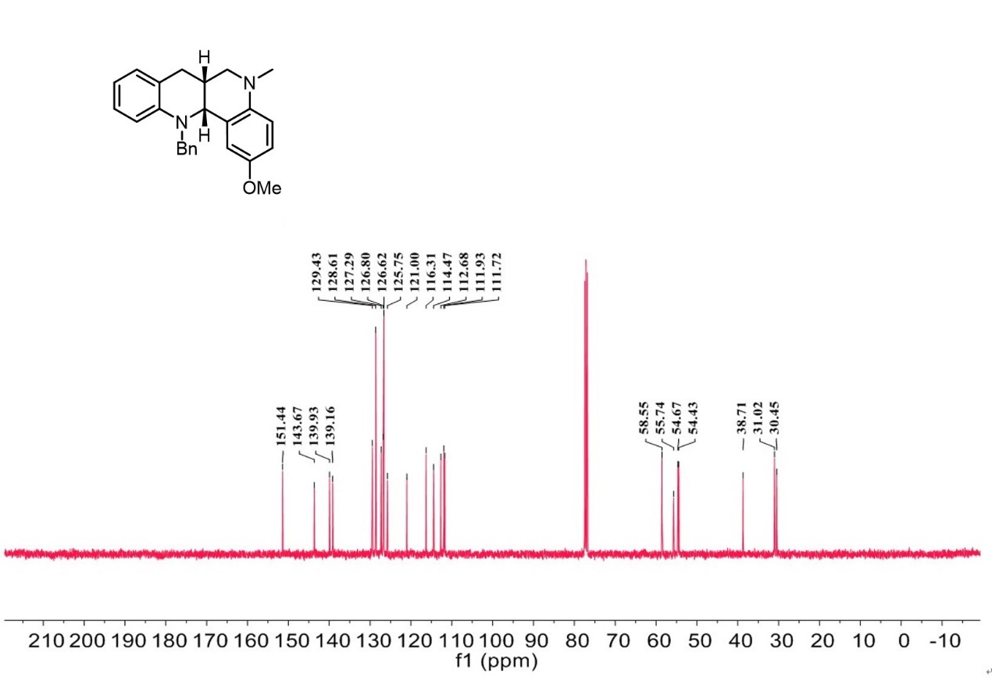

¹H-NMR spectrum of C₂₈

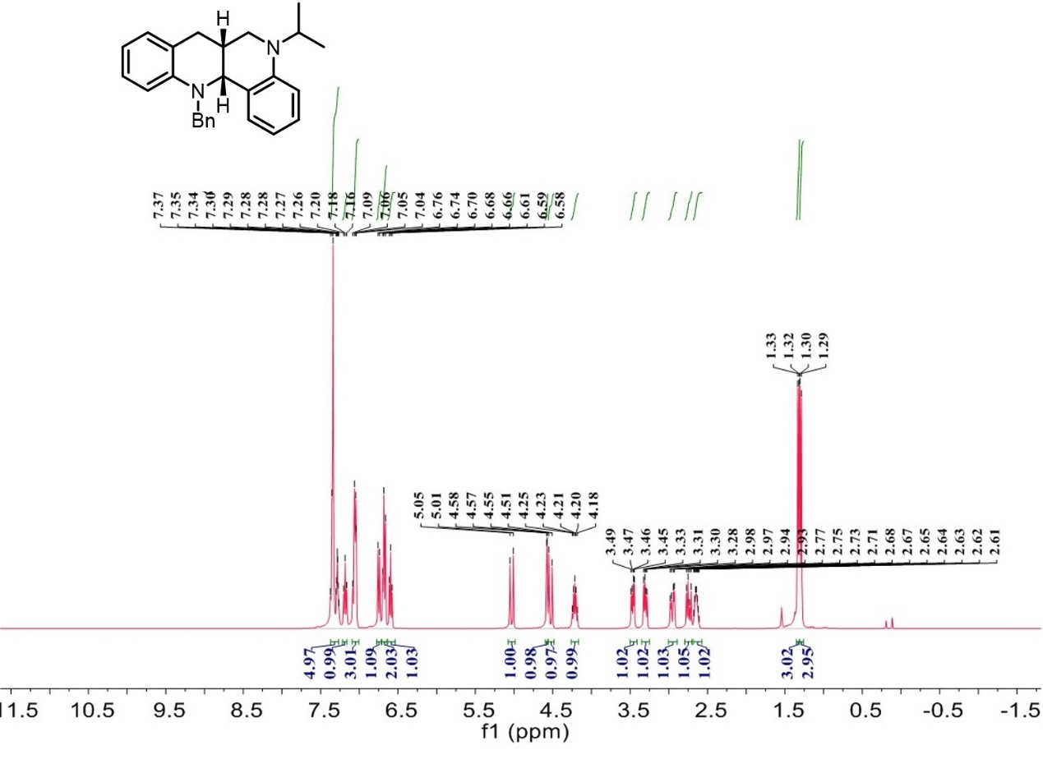

¹³C-NMR spectrum of C₂₈

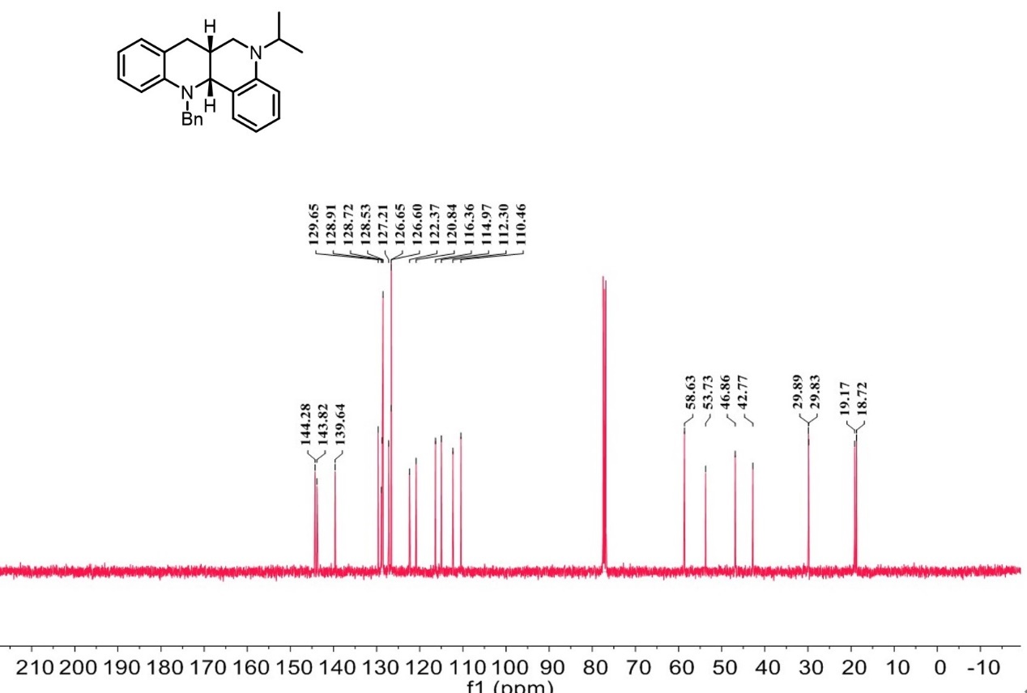

¹H-NMR spectrum of C₂₉

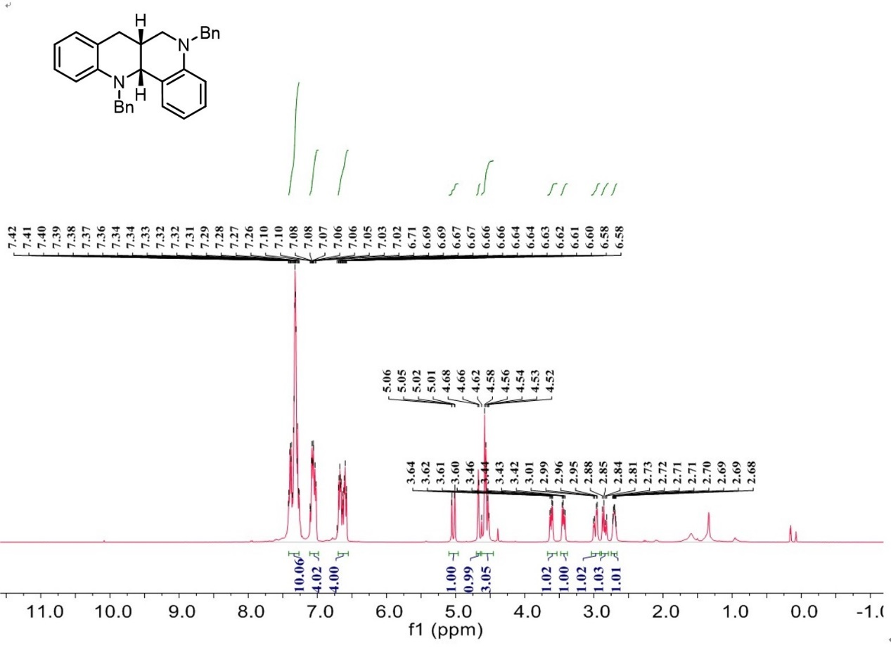

¹³C-NMR spectrum of C₂₉

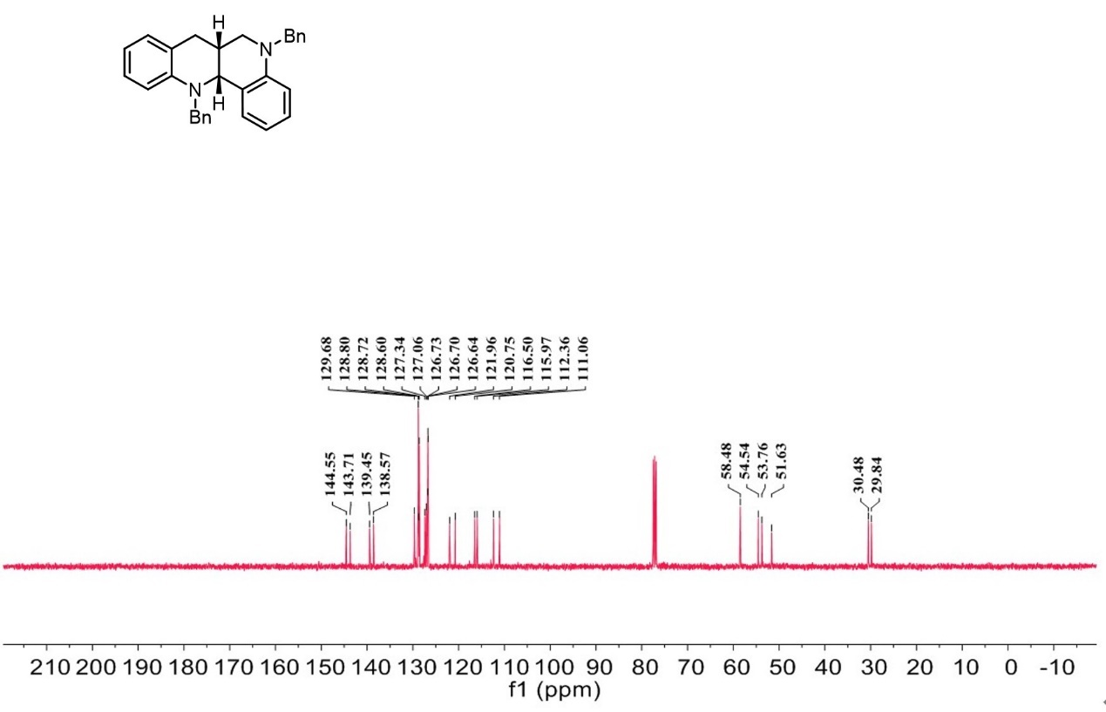

¹H-NMR spectrum of C₃₀

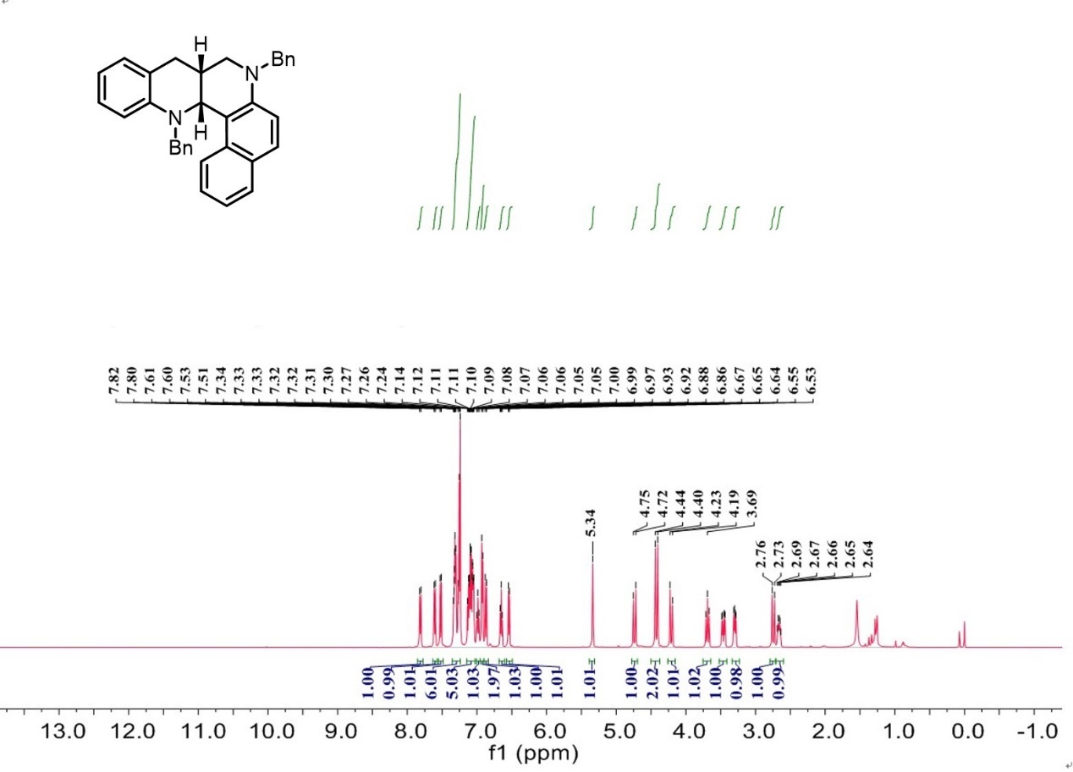

¹³C-NMR spectrum of C₃₀

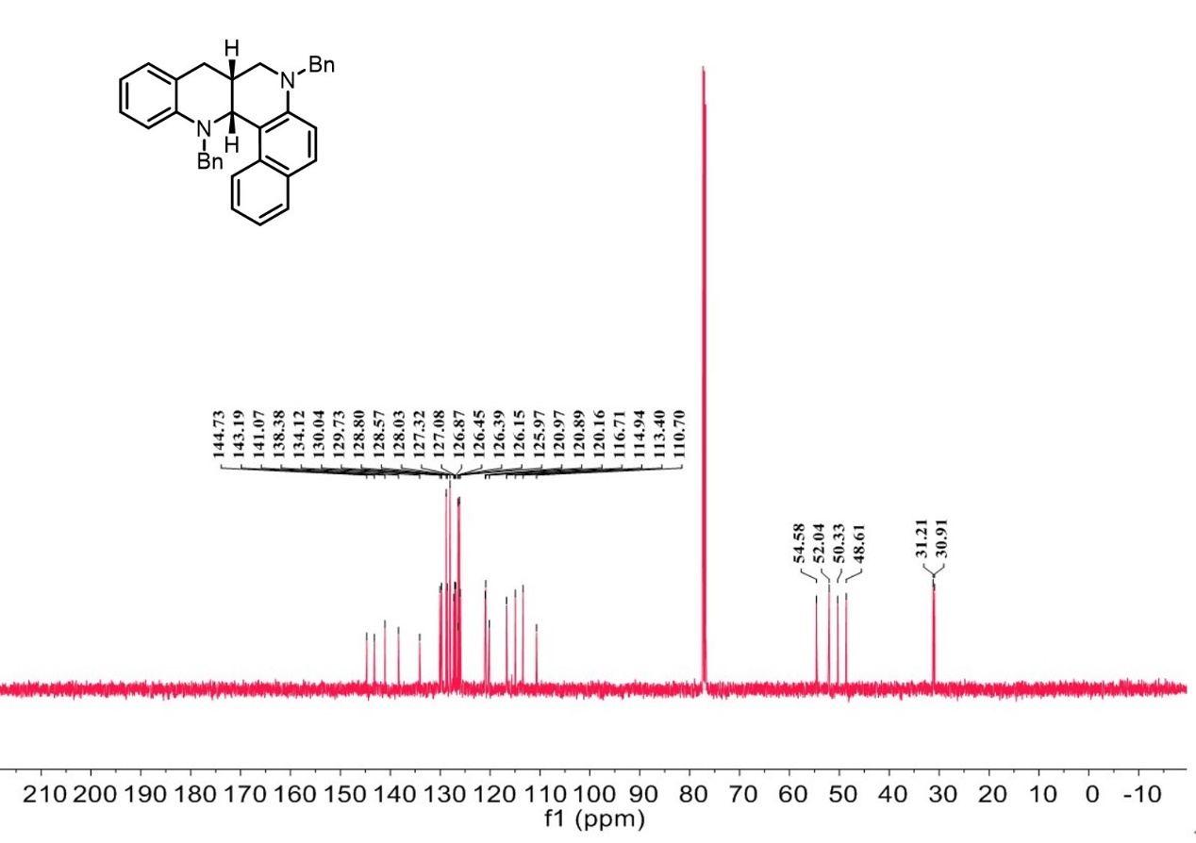
¹H-NMR spectrum of C₃₁

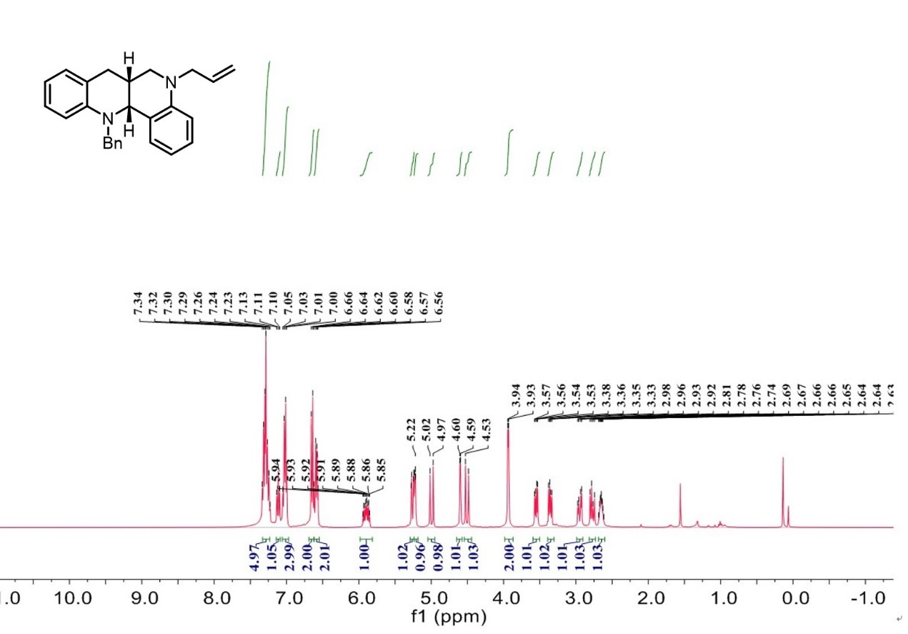

¹³C-NMR spectrum of C₃₁

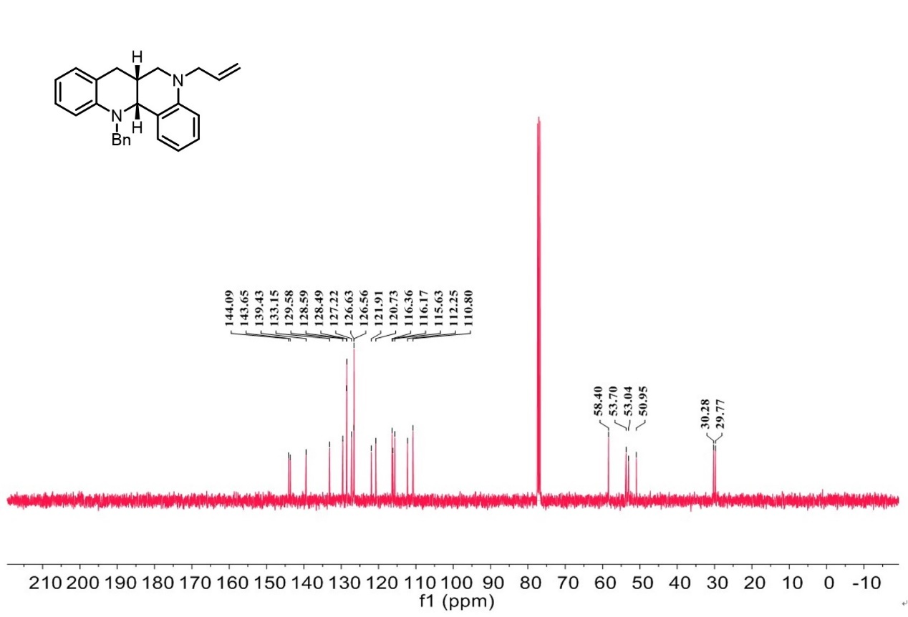

¹H-NMR spectrum of C₃₂

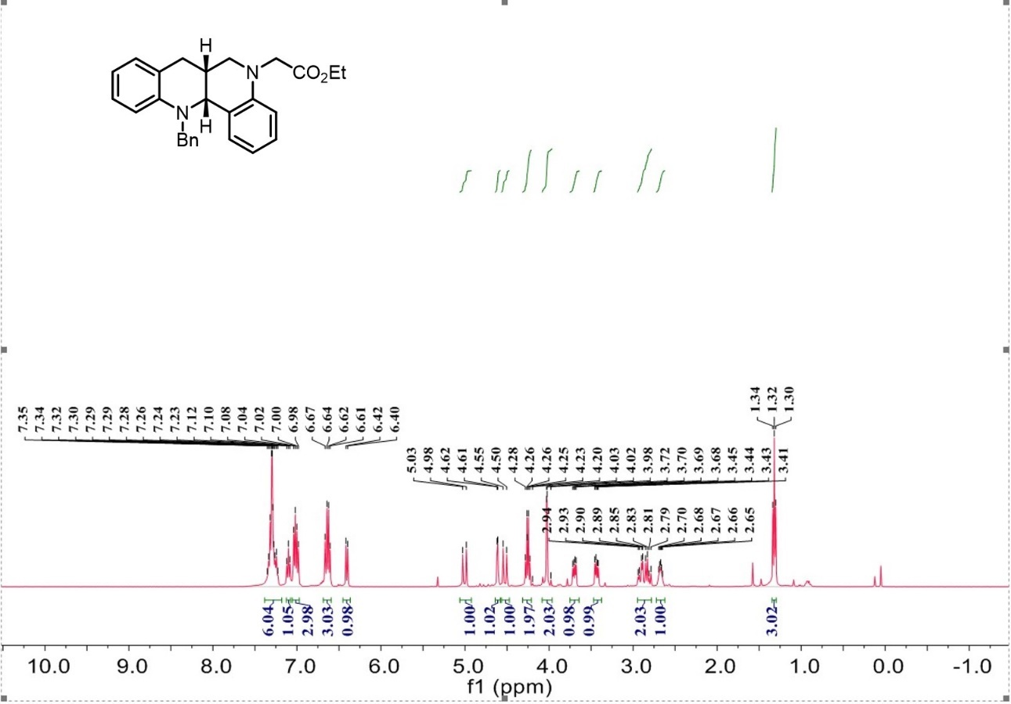

¹³C-NMR spectrum of C₃₂

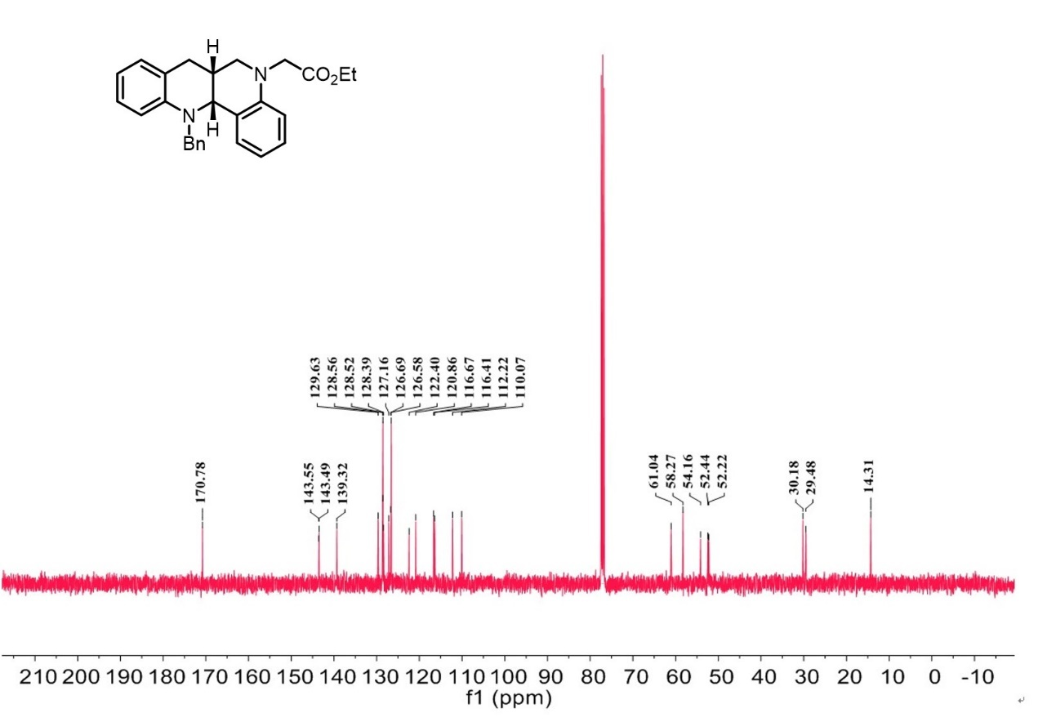

¹H-NMR spectrum of C₃₃

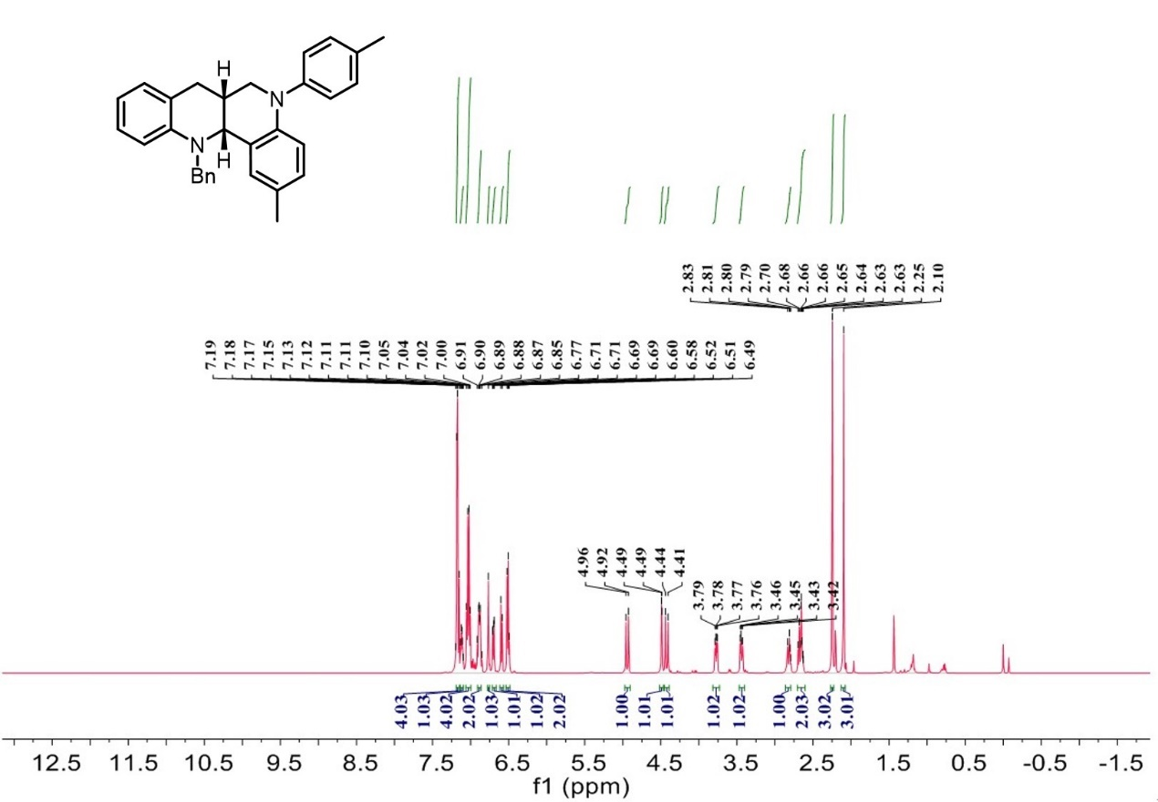

¹³C-NMR spectrum of C₃₃

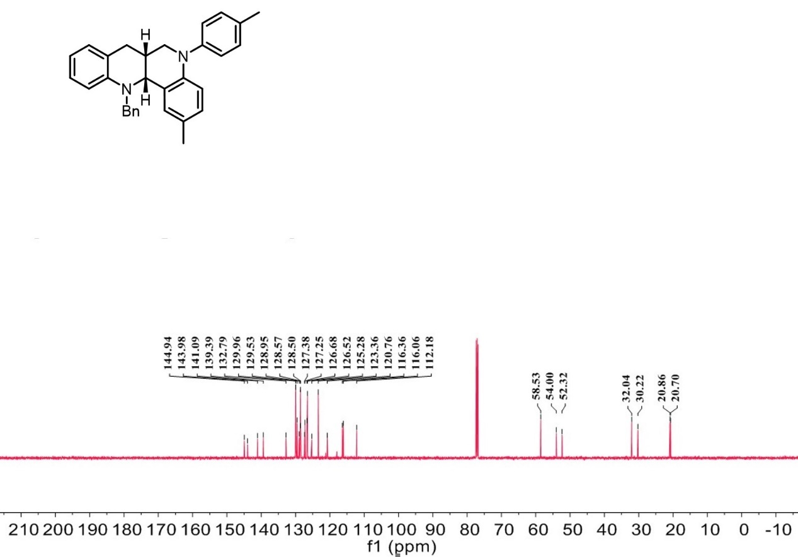

¹H-NMR spectrum of C₃₄

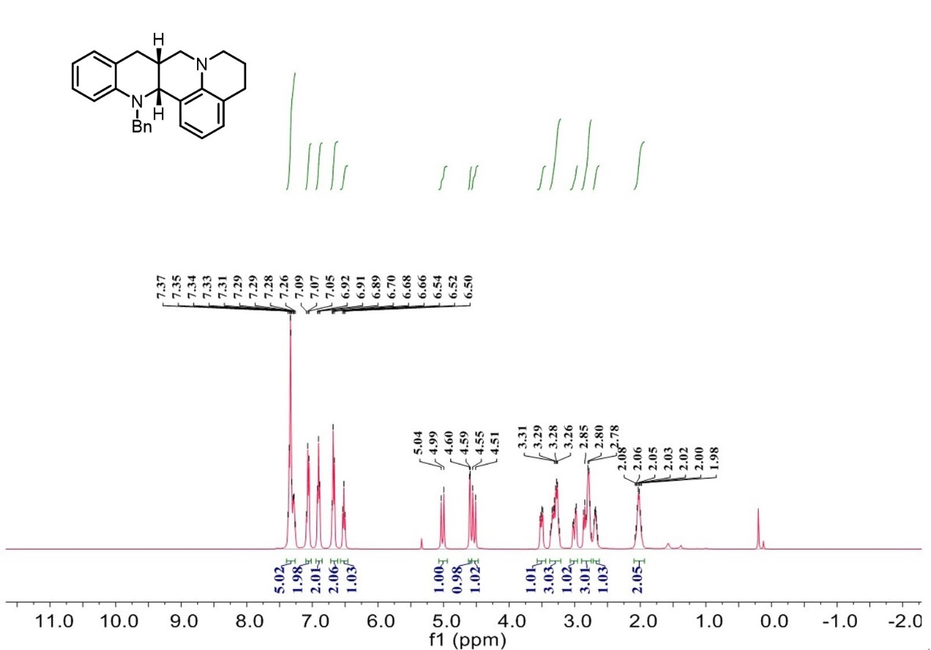

¹³C-NMR spectrum of C₃₄

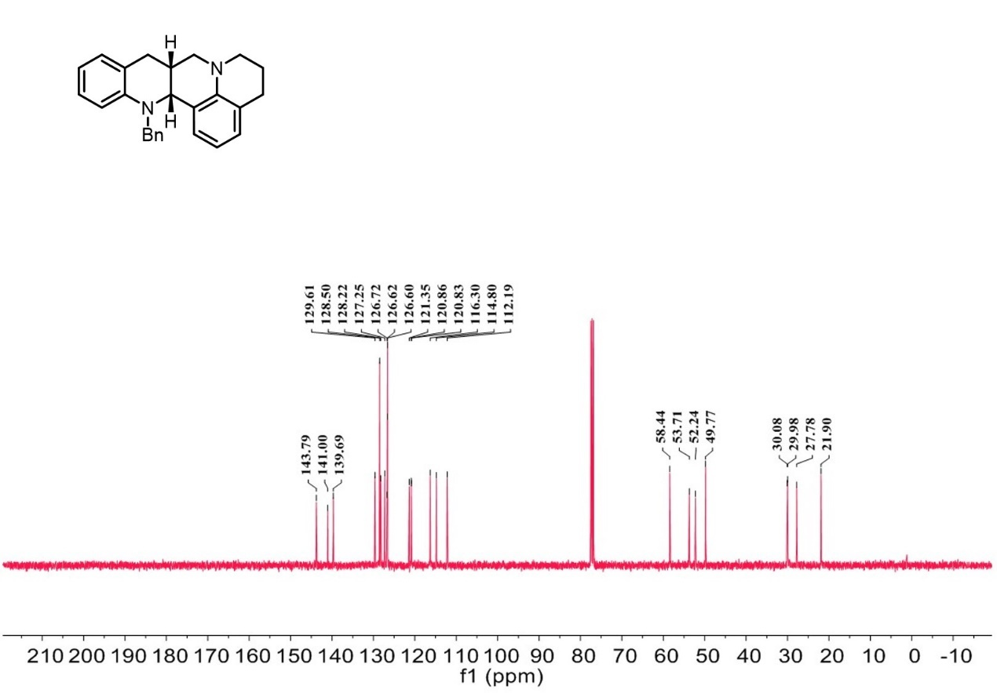

¹H-NMR spectrum of C₃₅

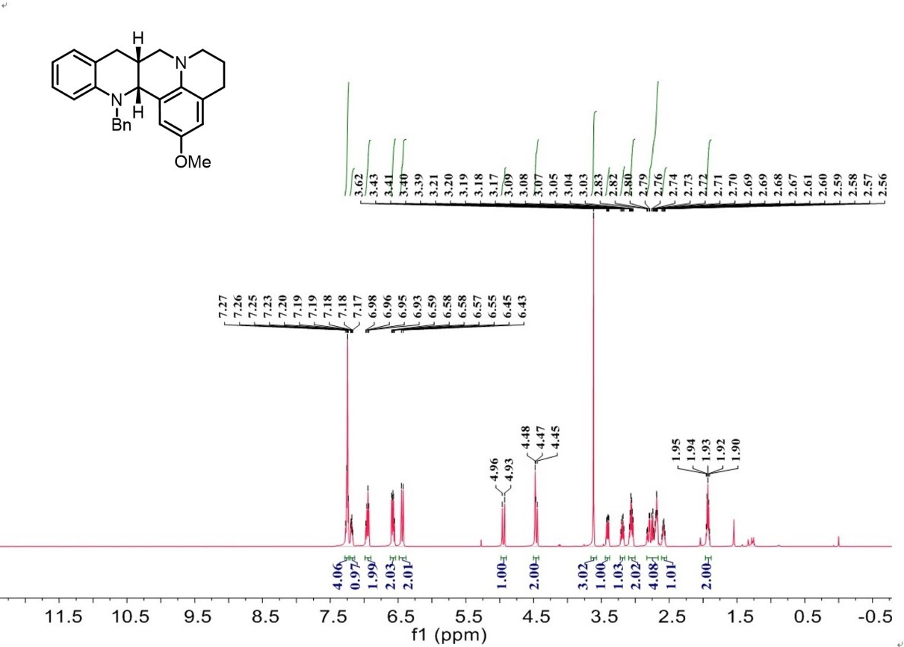

¹³C-NMR spectrum of C₃₅

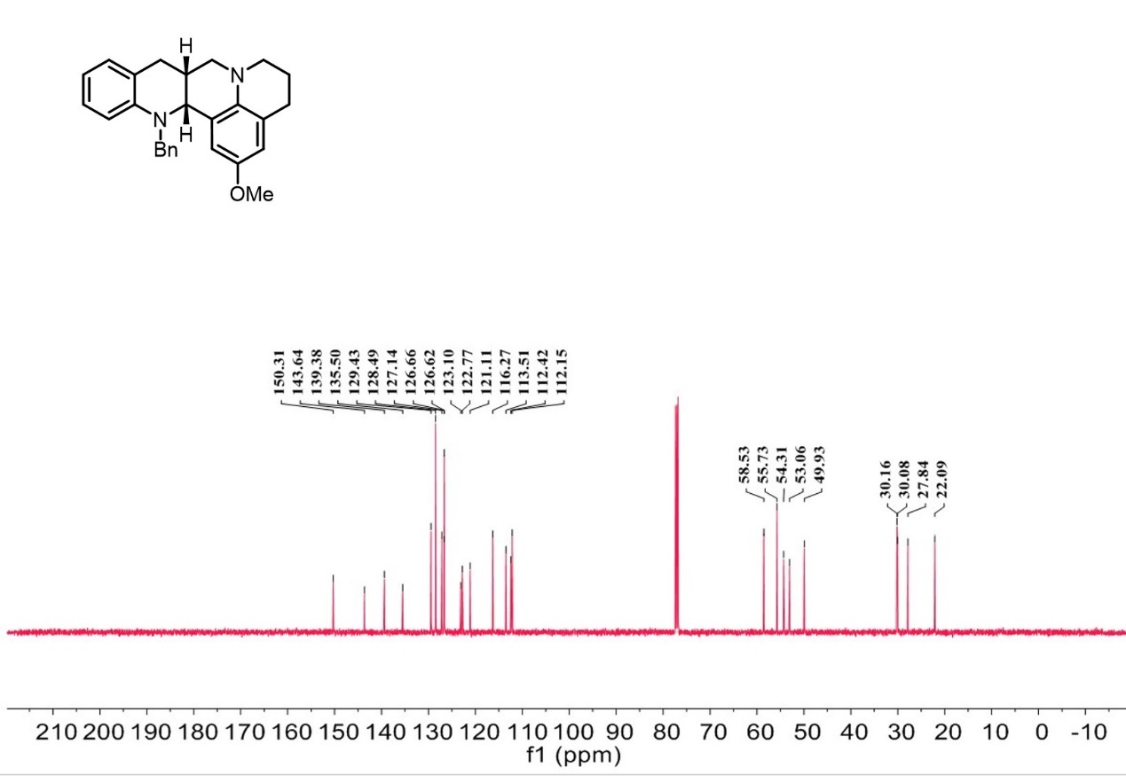
¹H-NMR spectrum of C₃₆

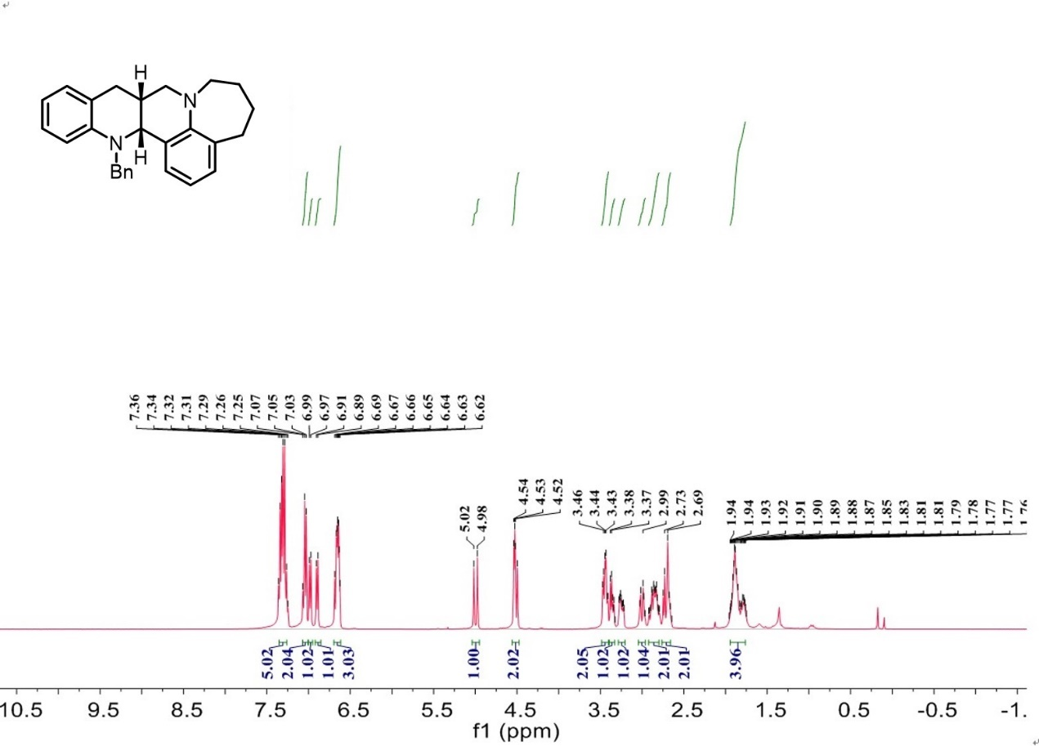

¹³C-NMR spectrum of C₃₆

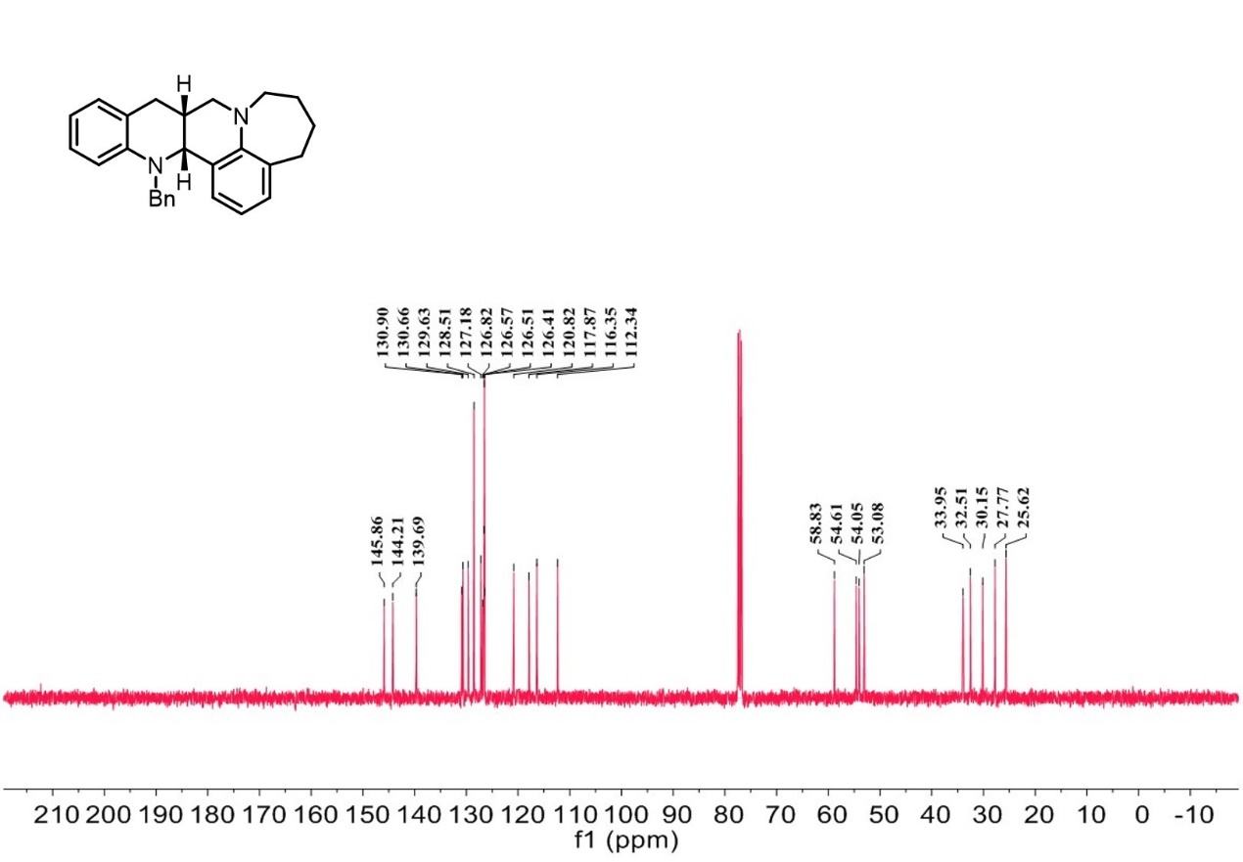
¹H-NMR spectrum of C₃₇

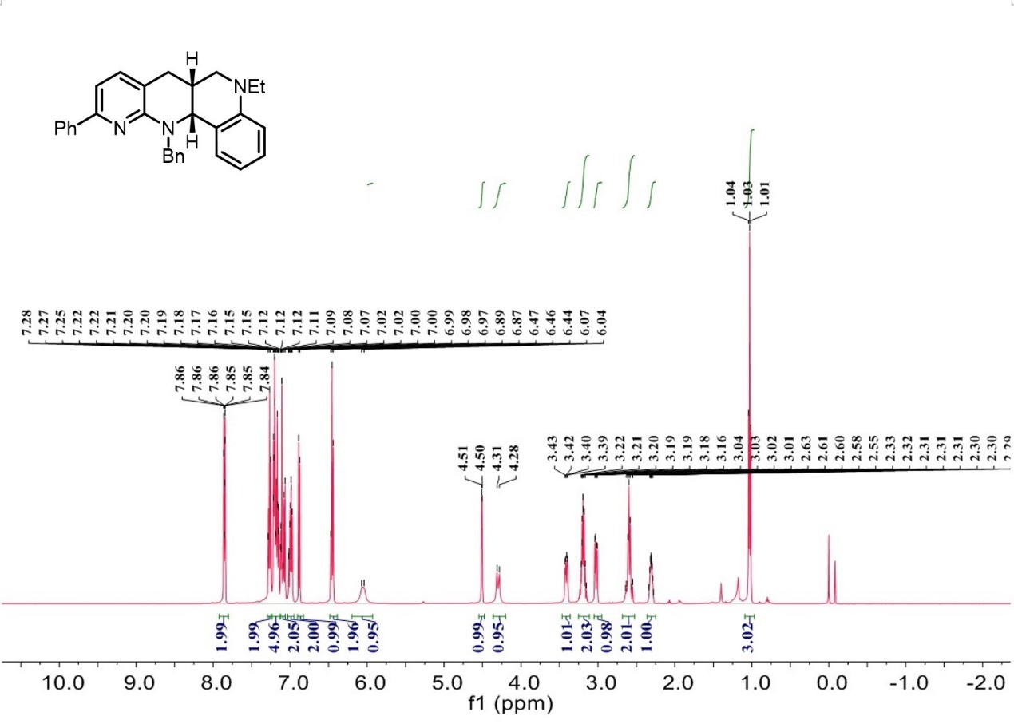

¹³C-NMR spectrum of C₃₇

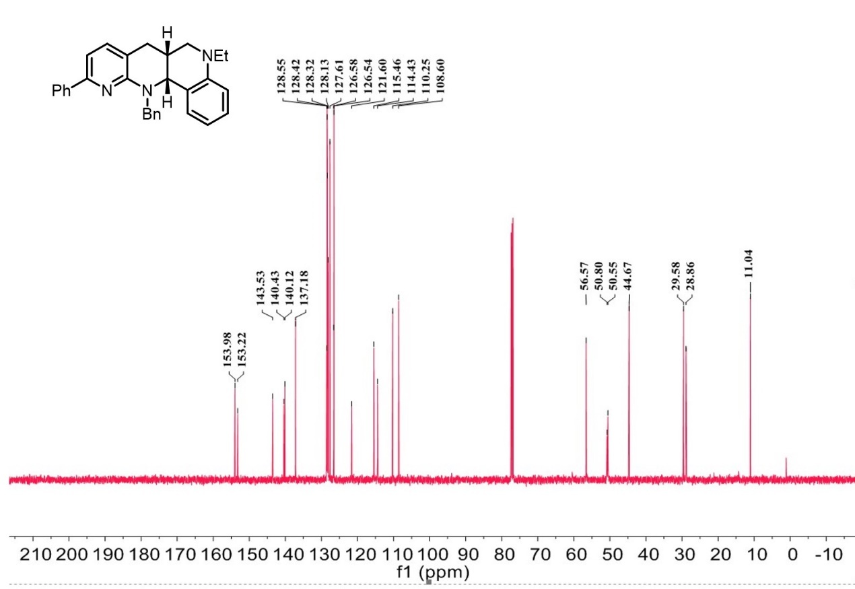
¹H-NMR spectrum of C₃₈

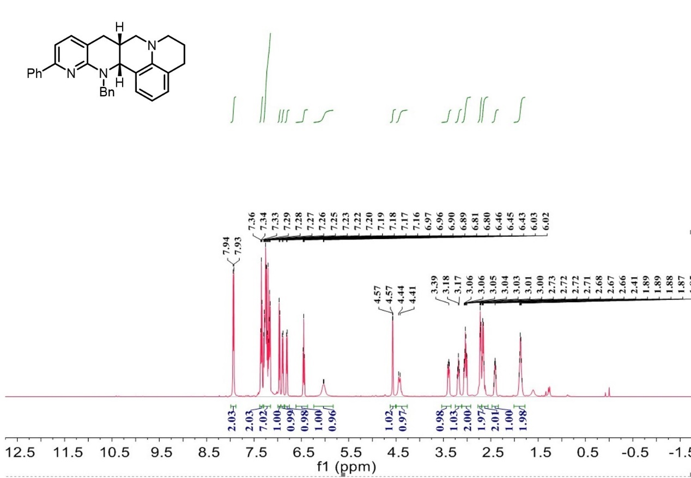

¹³C-NMR spectrum of C₃₈

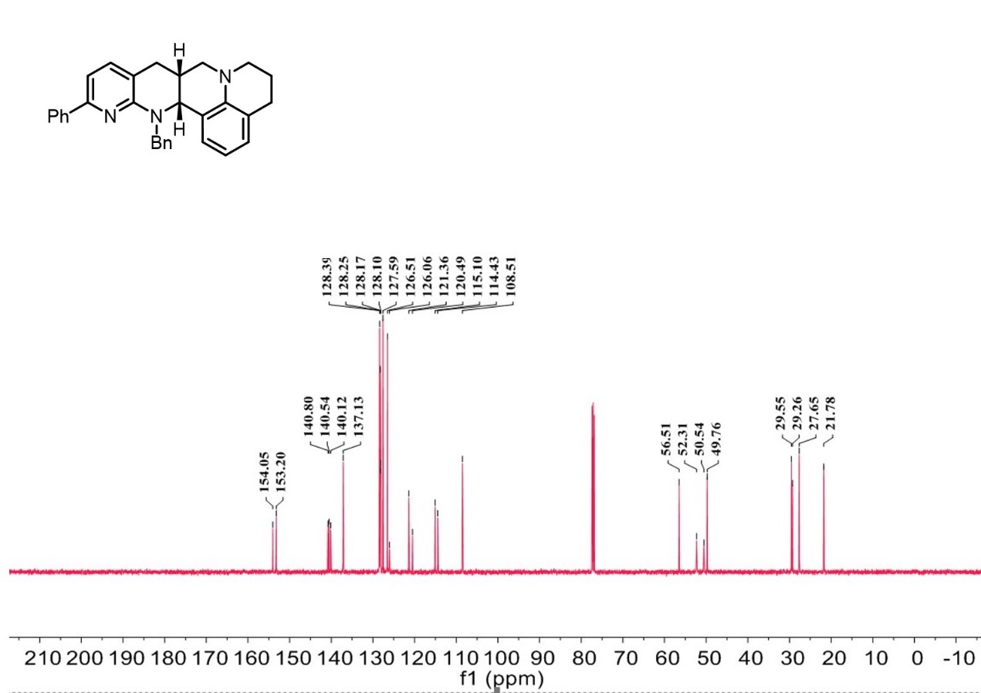

¹H-NMR spectrum of C₃₉

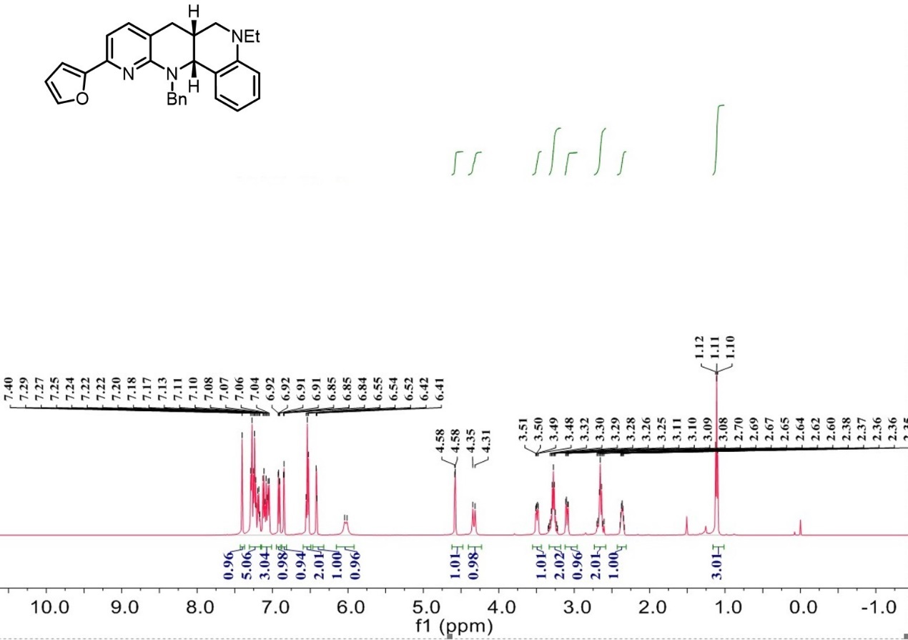

¹³C-NMR spectrum of C₃₉

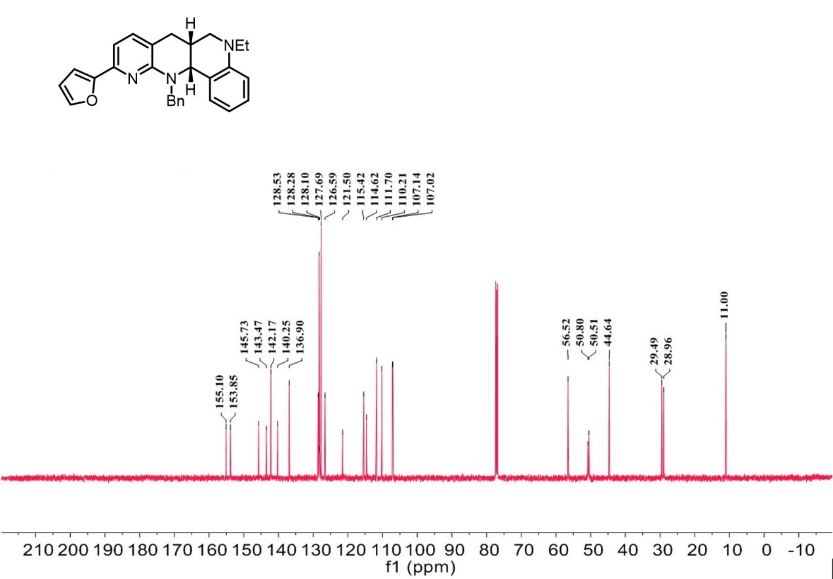

¹H-NMR spectrum of C₄₀

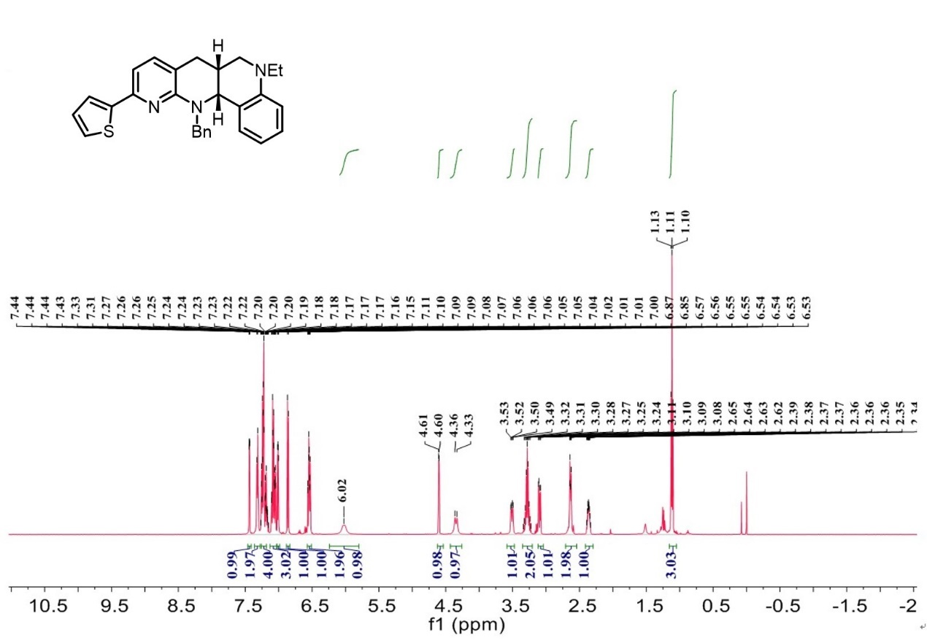

¹³C-NMR spectrum of C₄₀

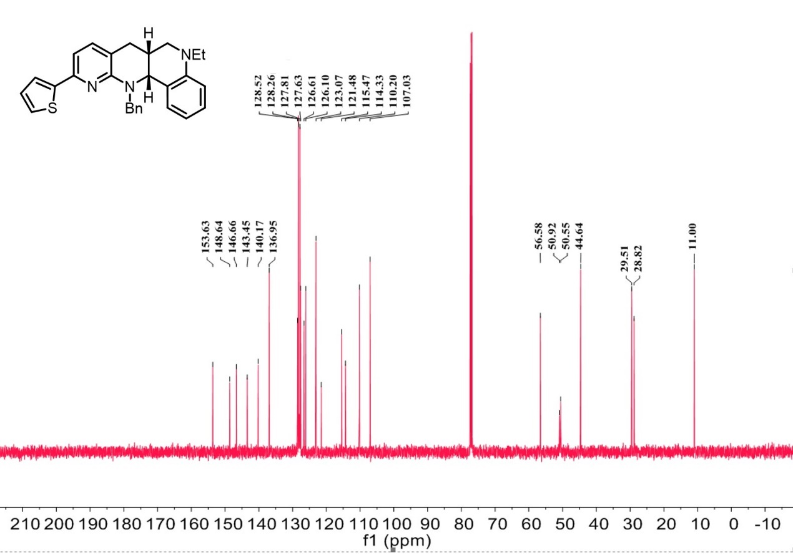

¹H-NMR spectrum of C₄₁

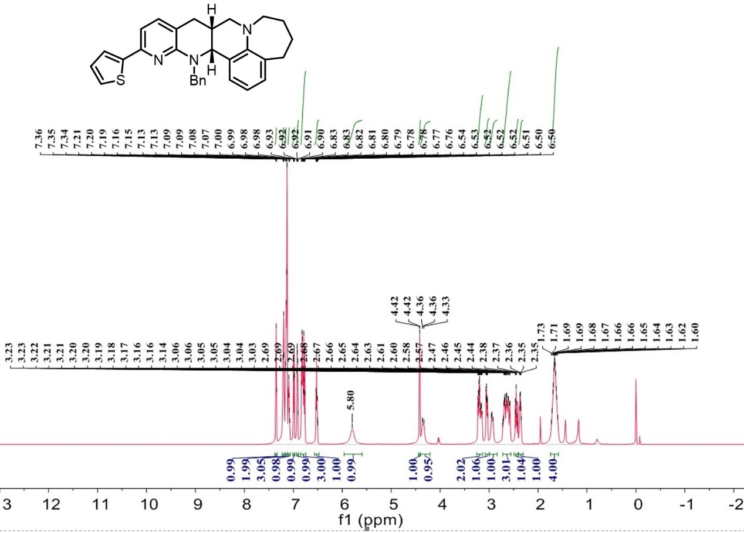

¹³C-NMR spectrum of C₄₁

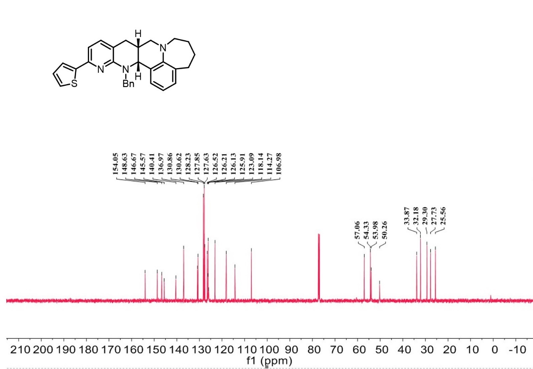
¹H-NMR spectrum of C₄₂

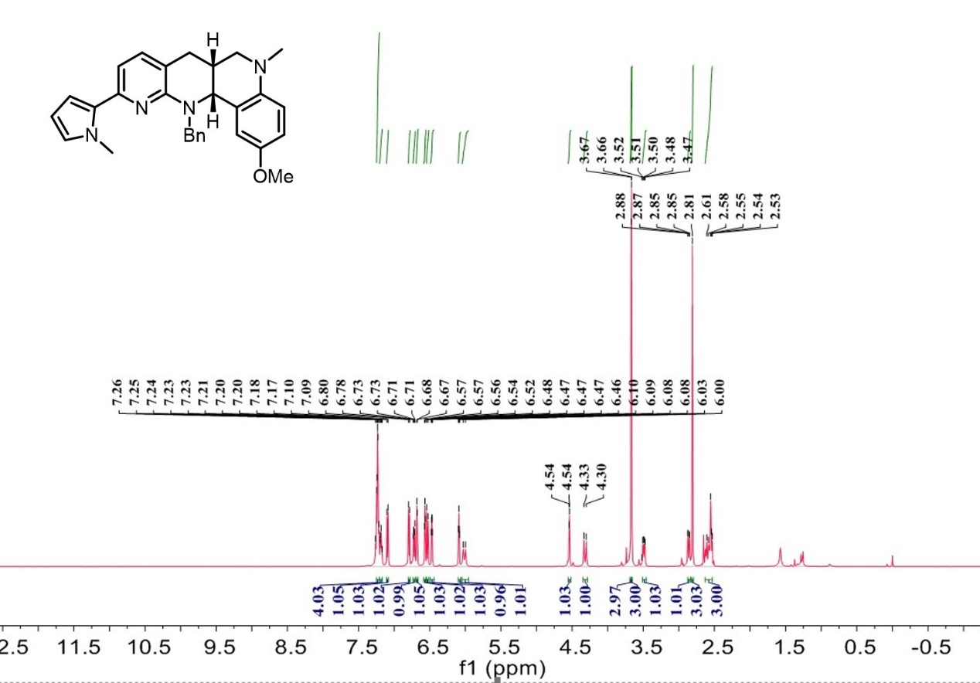

¹³C-NMR spectrum of C₄₂

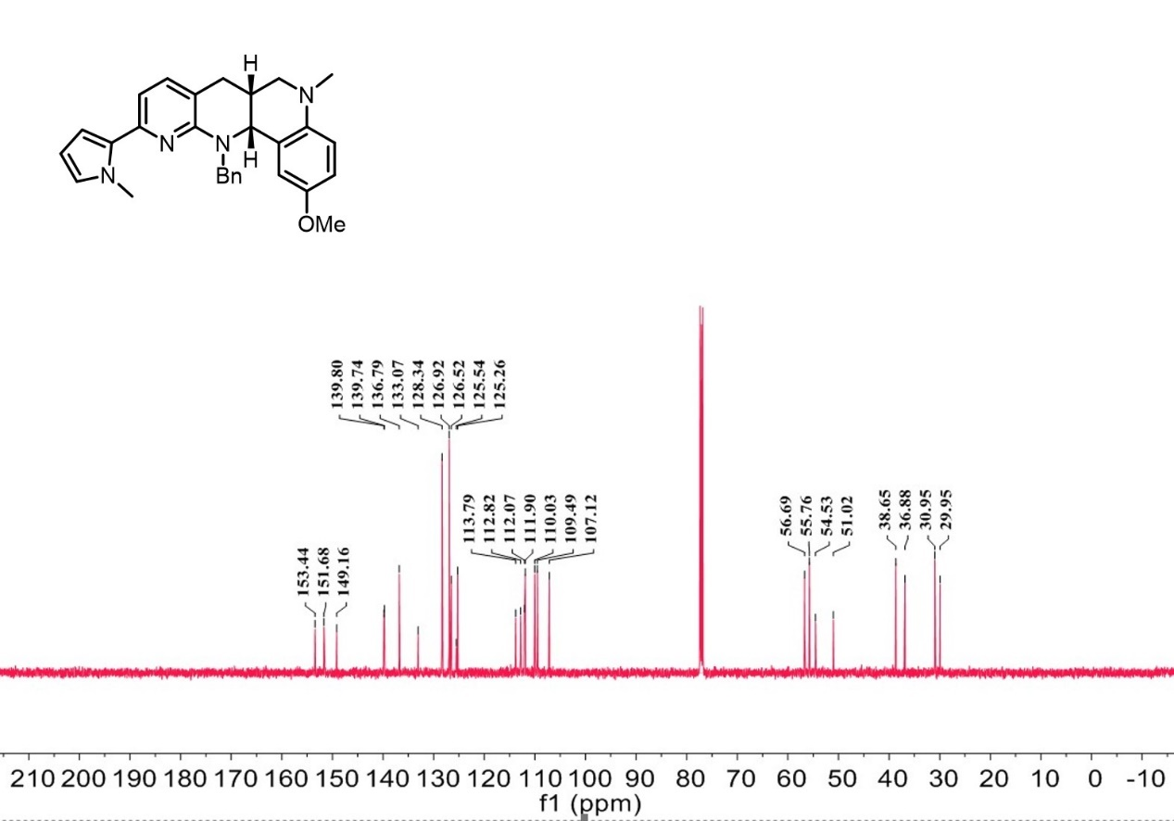

¹H-NMR spectrum of C₄₃

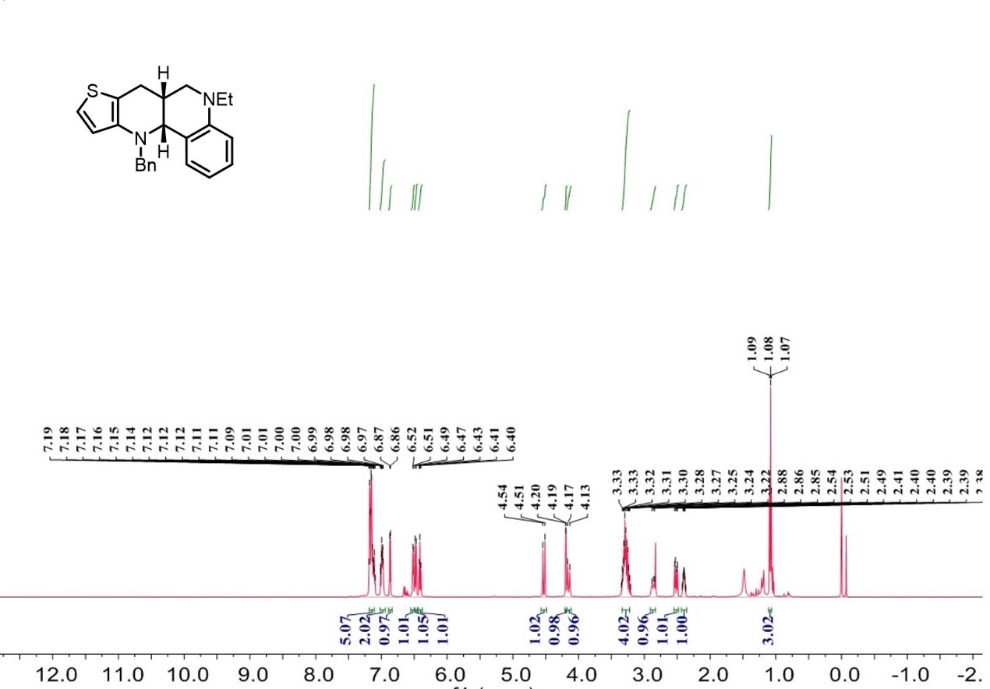

¹³C-NMR spectrum of C₄₃

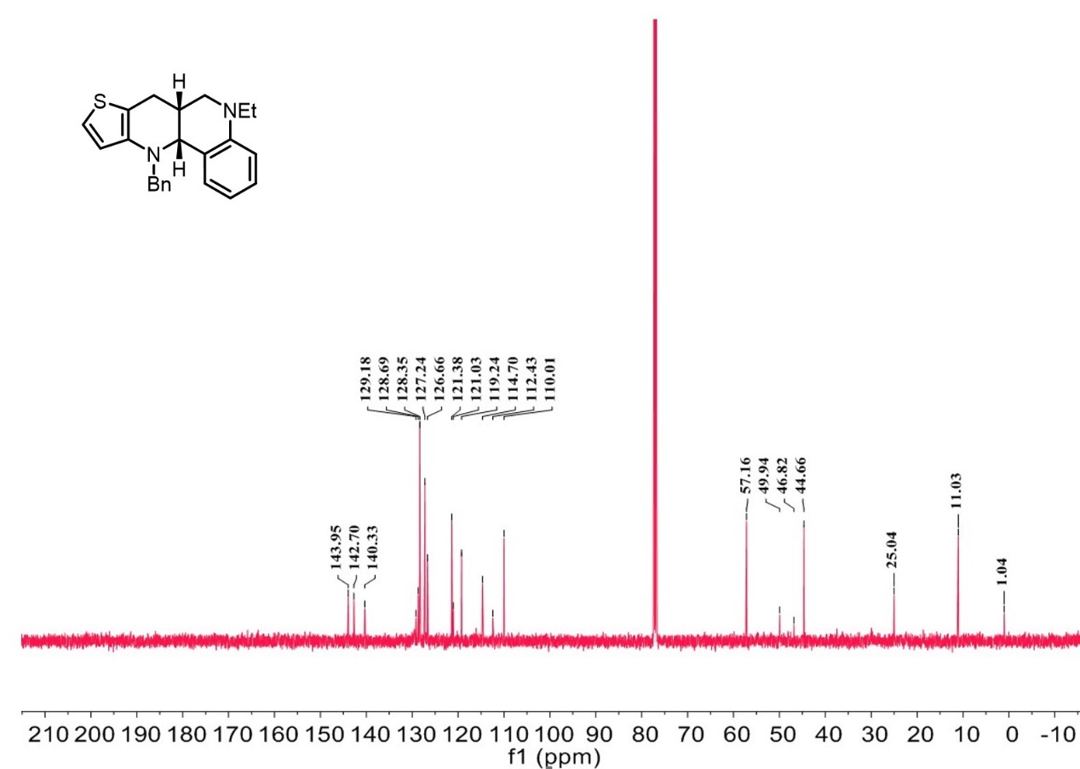

¹H-NMR spectrum of C₄₄

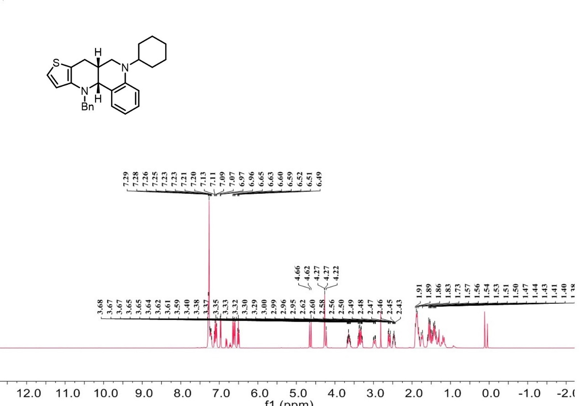

¹³C-NMR spectrum of C₄₄

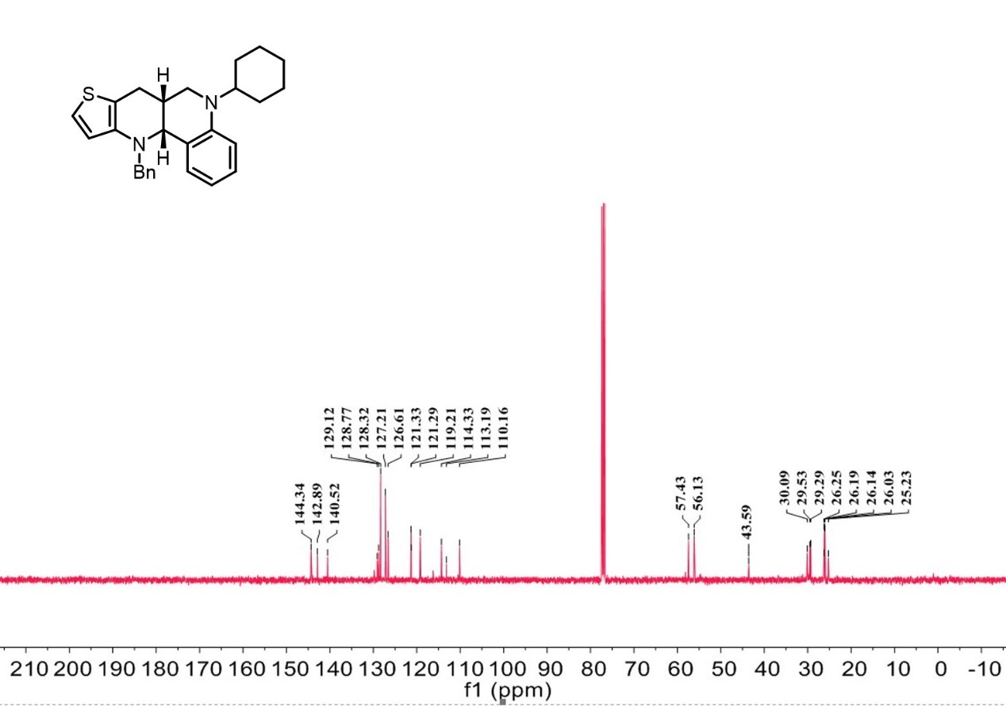

¹H-NMR spectrum of C₄₅

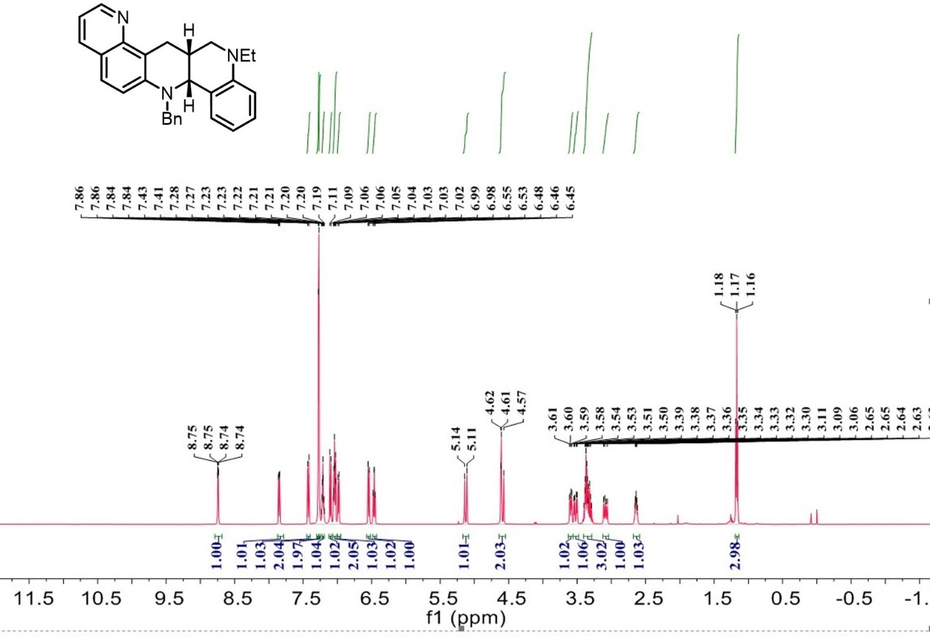

¹³C-NMR spectrum of C₄₅

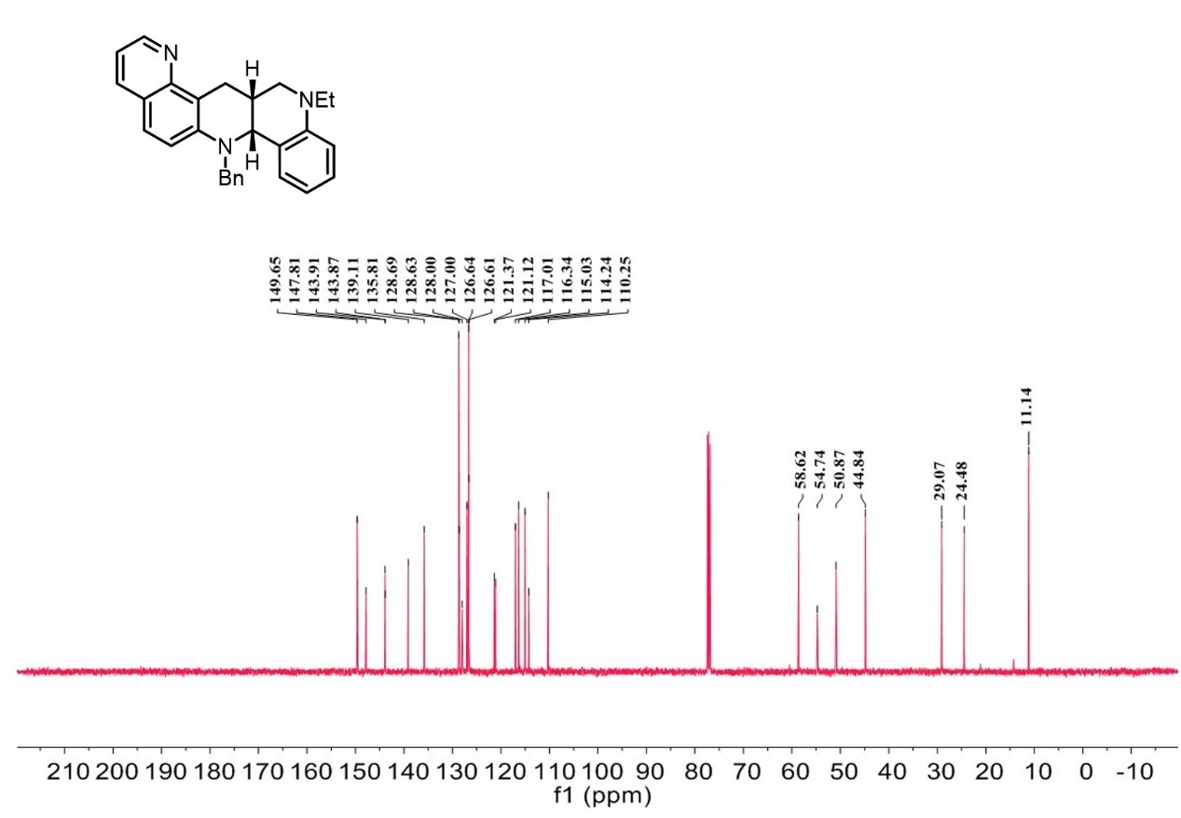

¹H-NMR spectrum of C₄₆

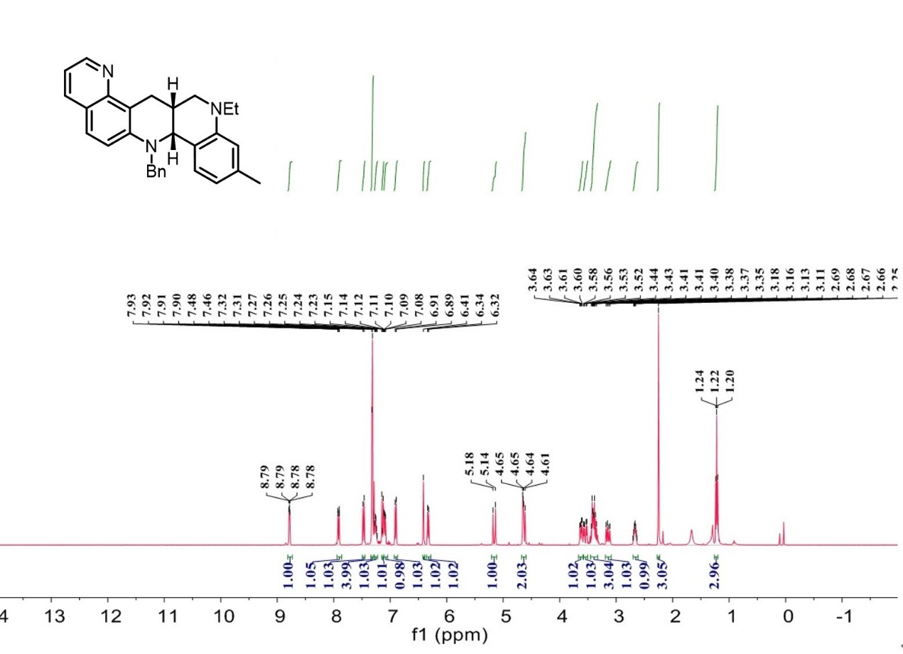

¹³C-NMR spectrum of C₄₆

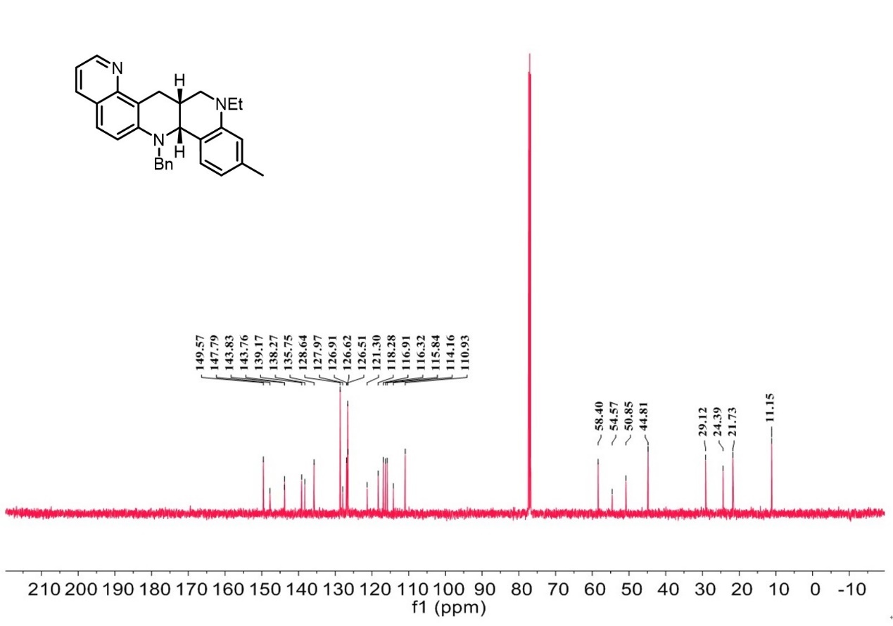
¹H-NMR spectrum of C₄₇

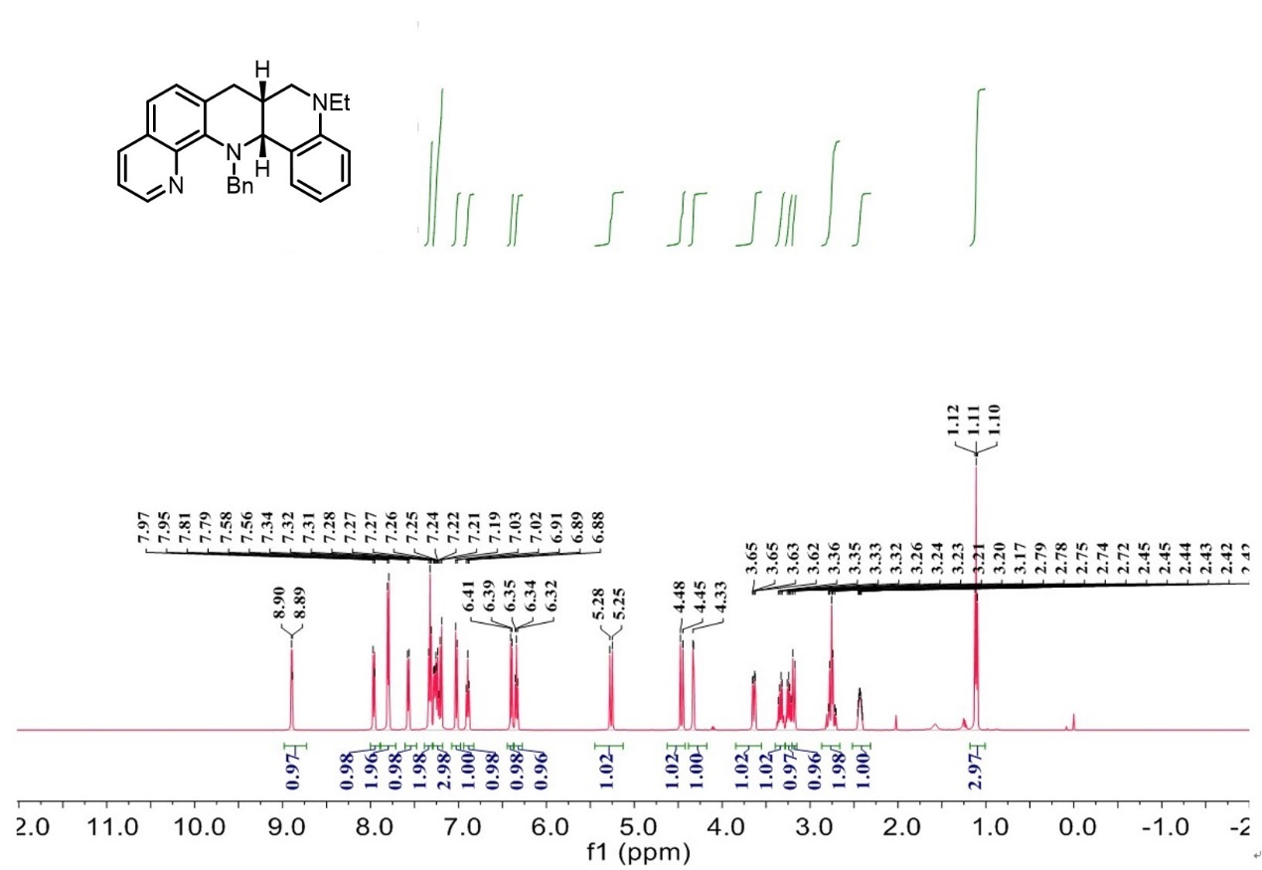

¹³C-NMR spectrum of C₄₇

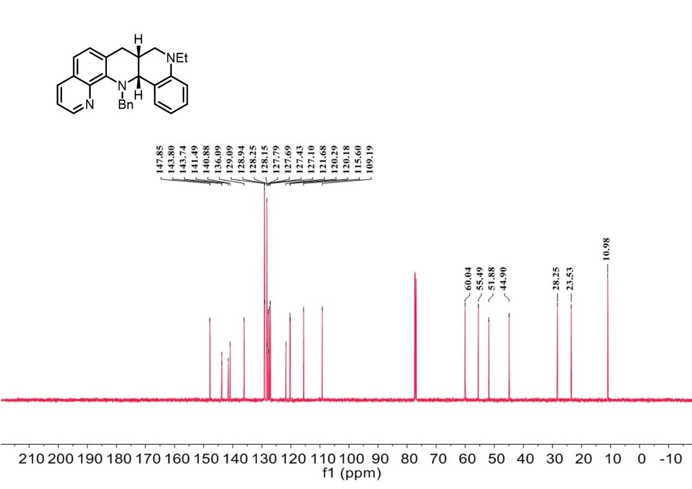

¹H-NMR spectrum of C₄₈

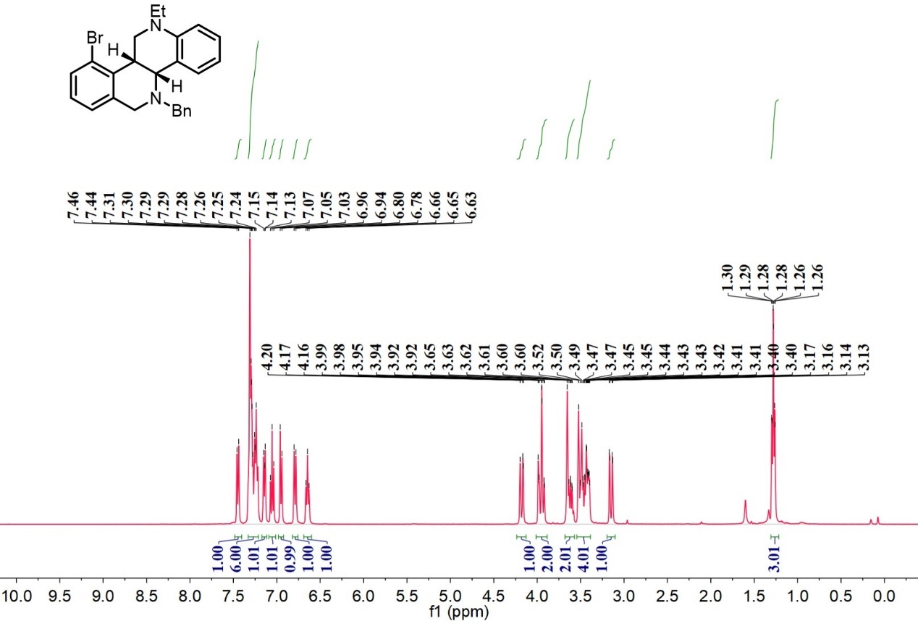

¹³C-NMR spectrum of C₄₈

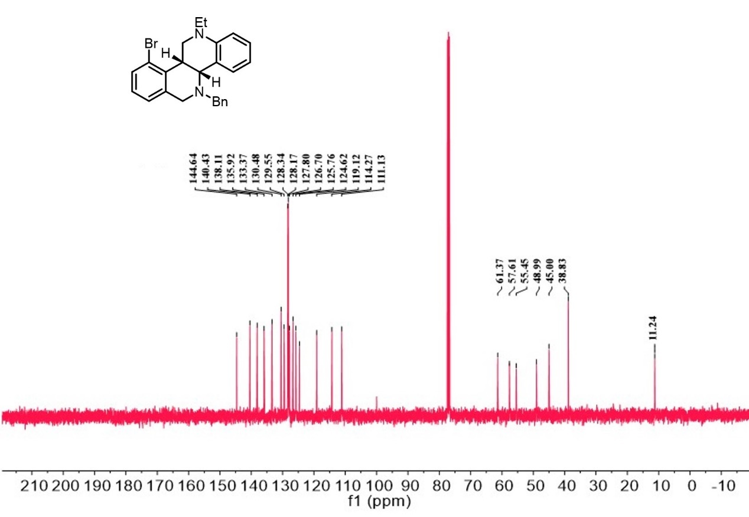

¹H-NMR spectrum of C₄₉

¹³C-NMR spectrum of C₄₉

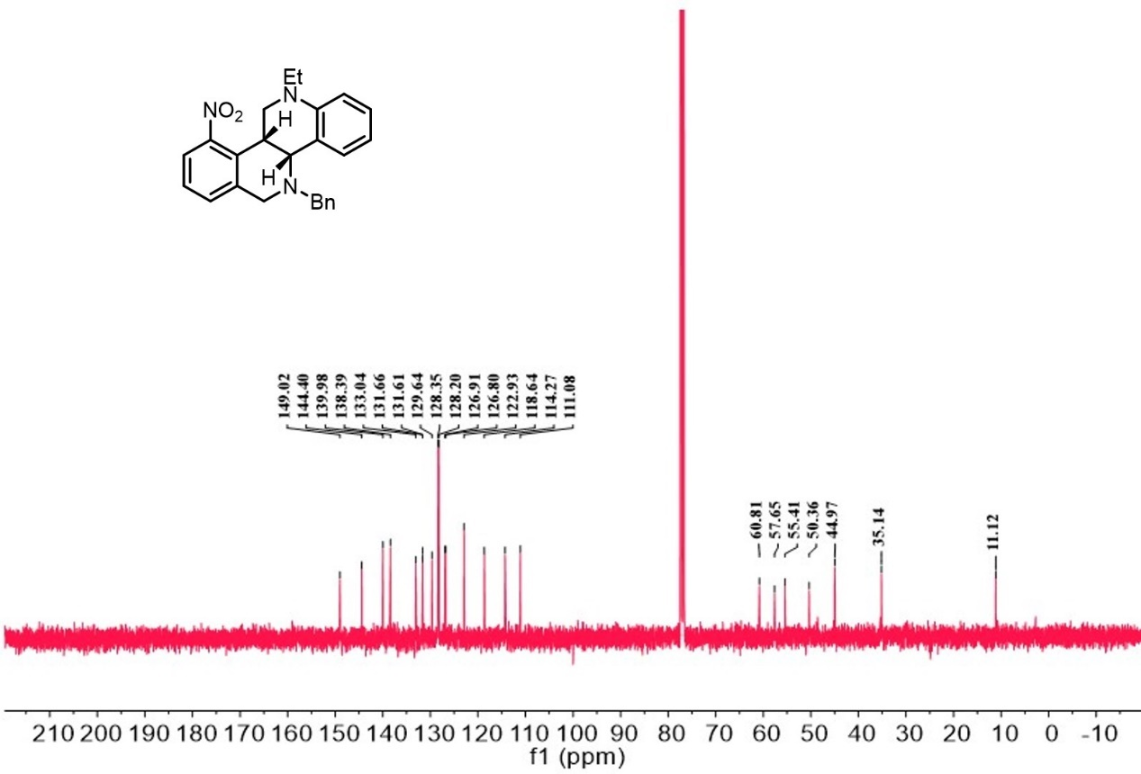
¹H-NMR spectrum of C₅₀

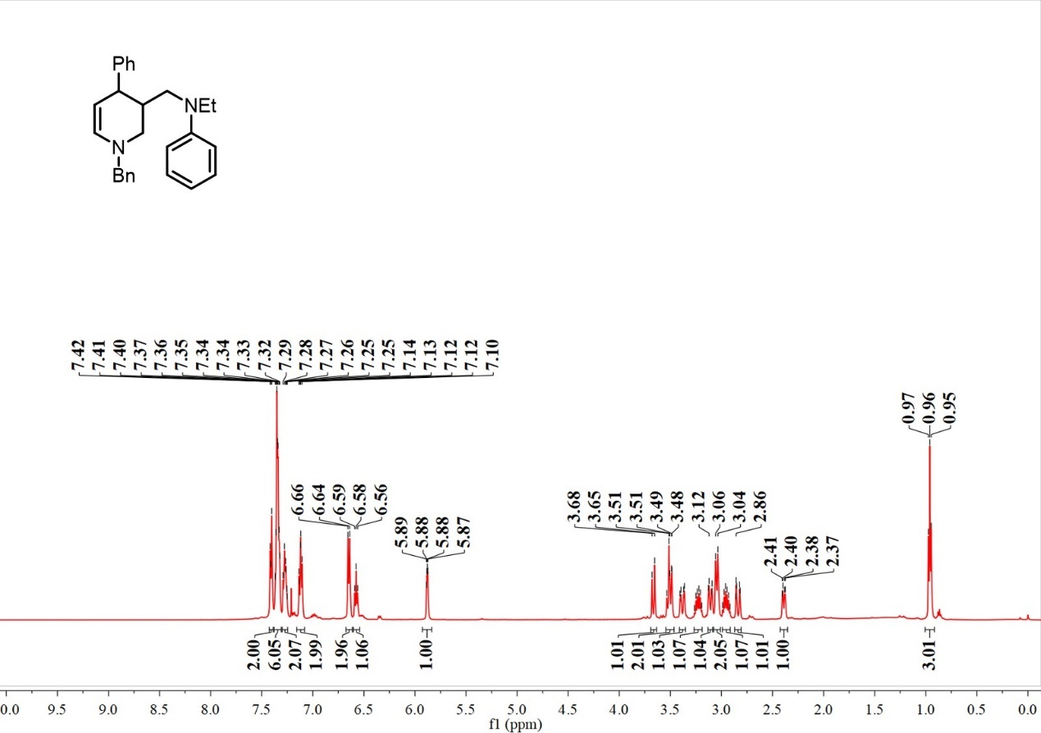

¹³C-NMR spectrum of C₅₀

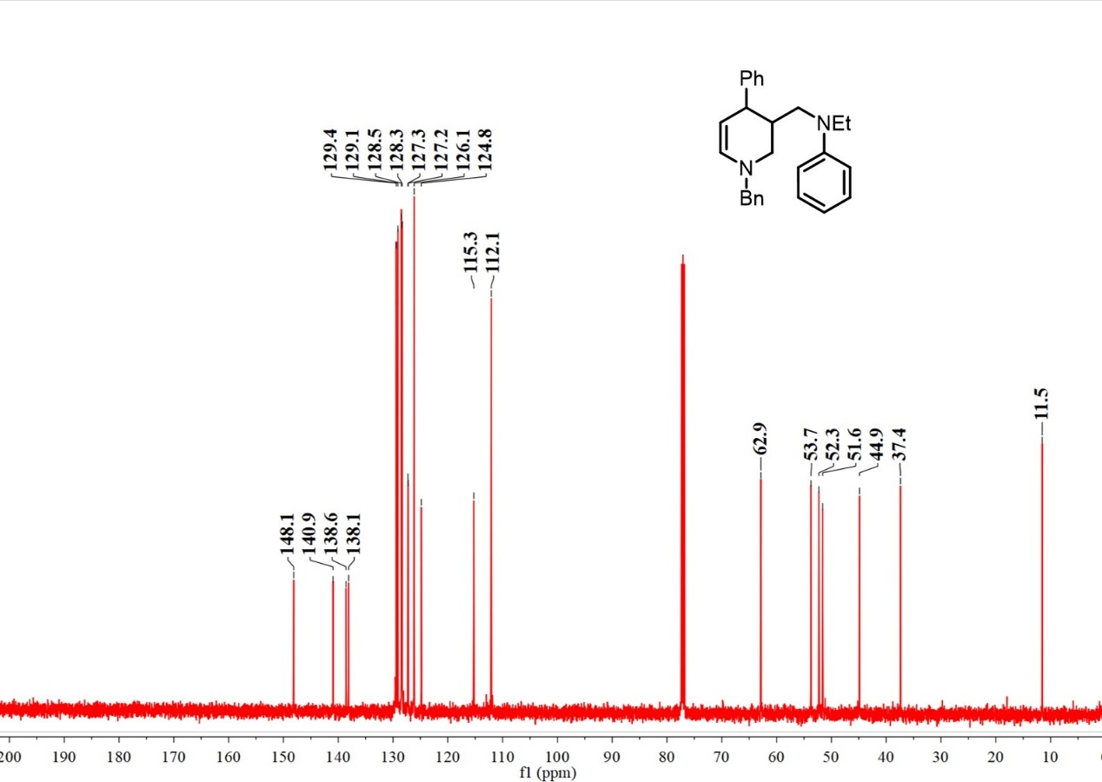

¹H-NMR spectrum of C₅₁

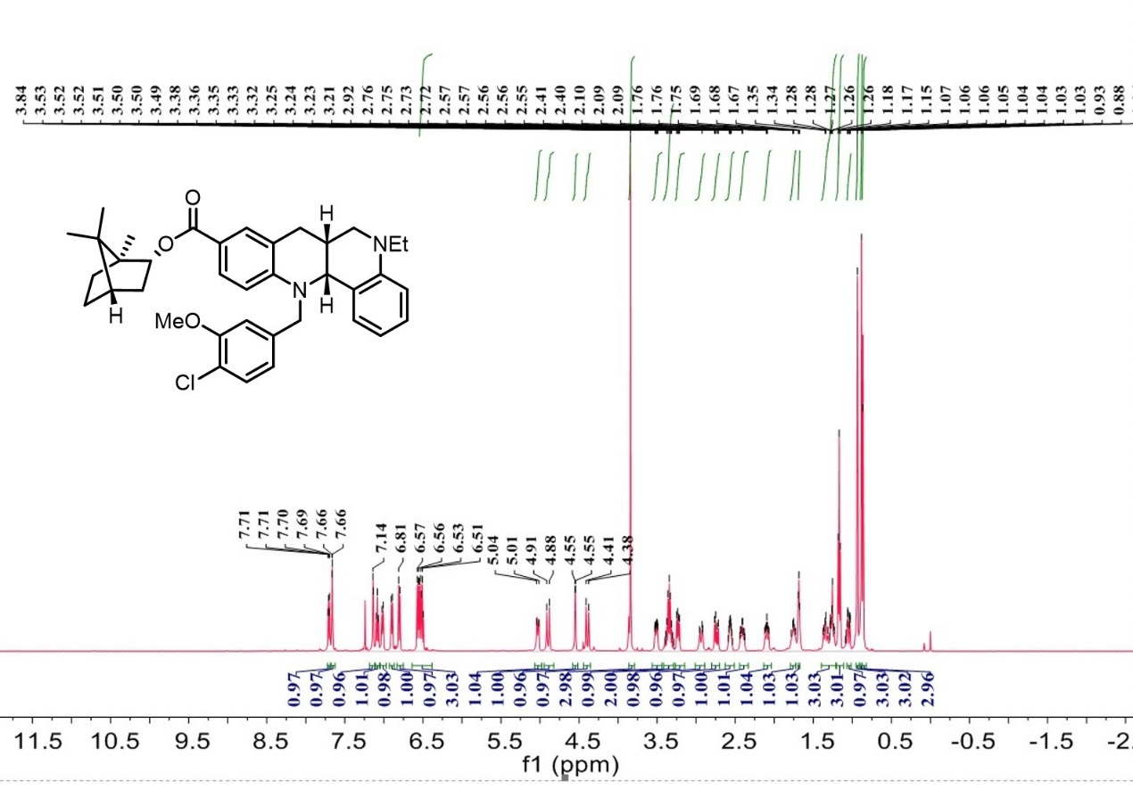

¹³C-NMR spectrum of C₅₁

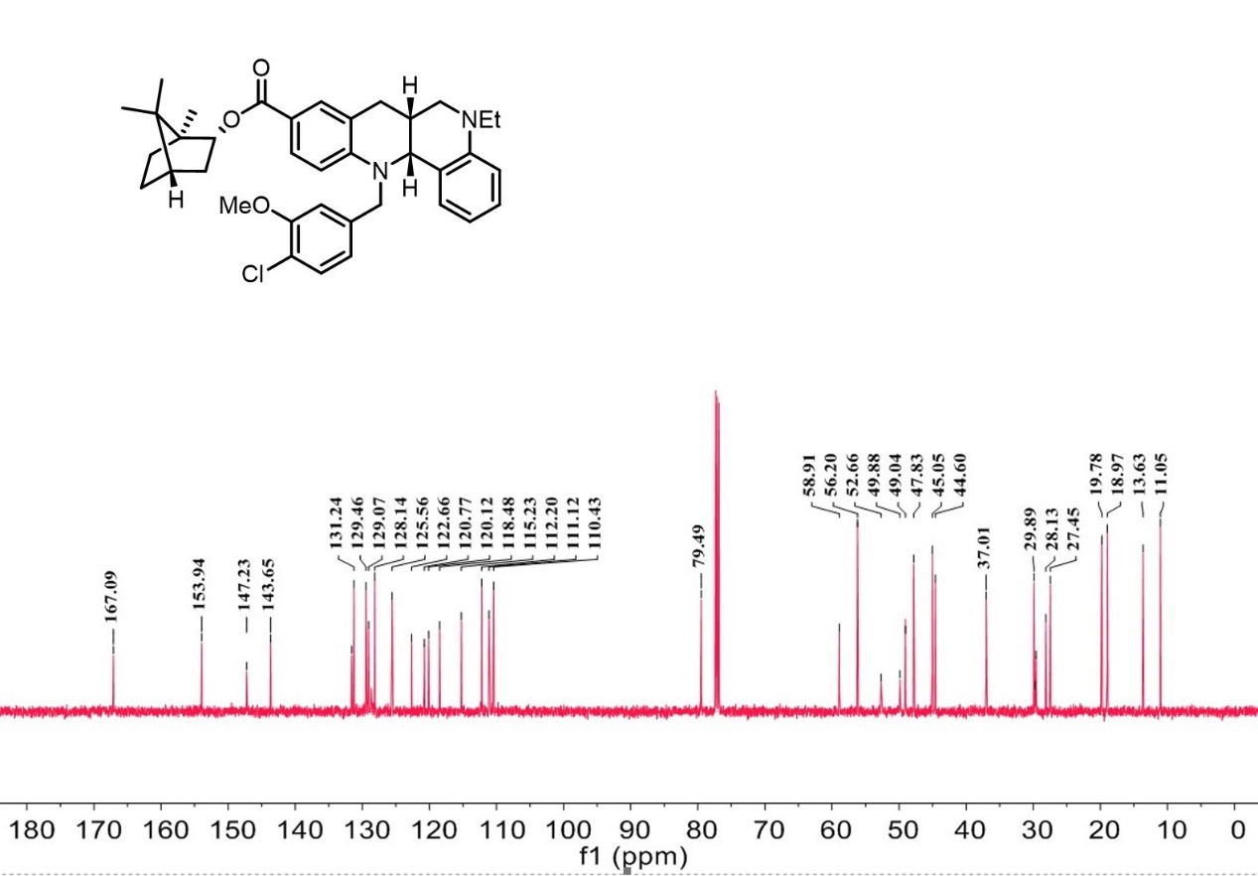

¹H-NMR spectrum of C₅₂

¹³C-NMR spectrum of C₅₂

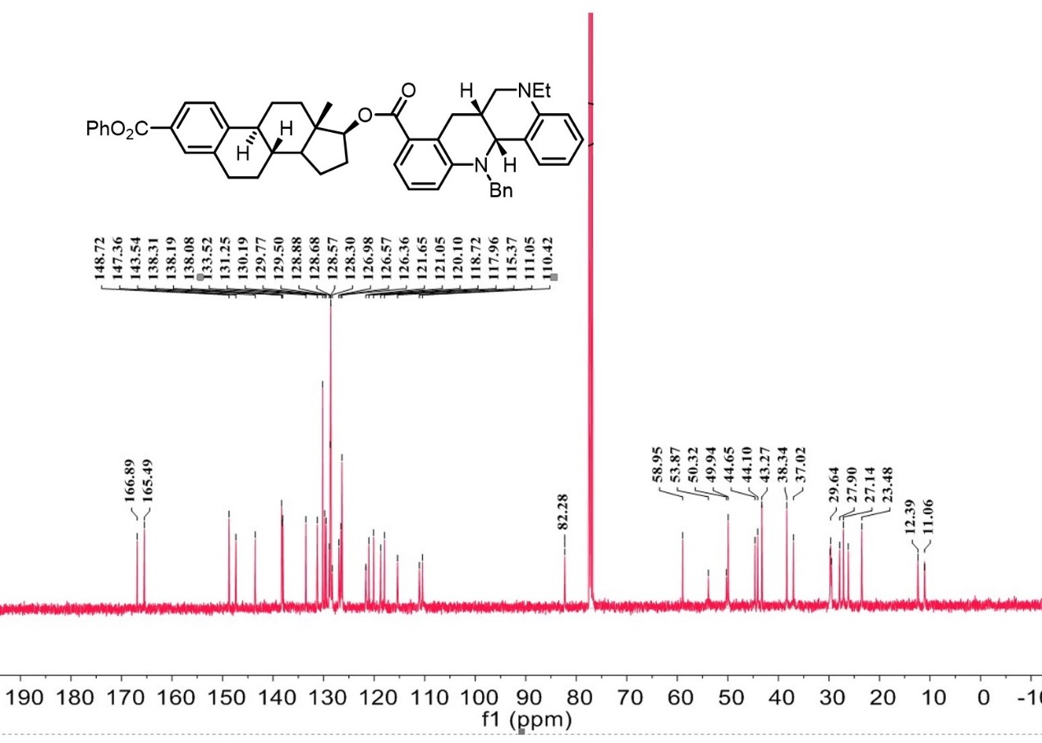

¹H-NMR spectrum of C₅₃
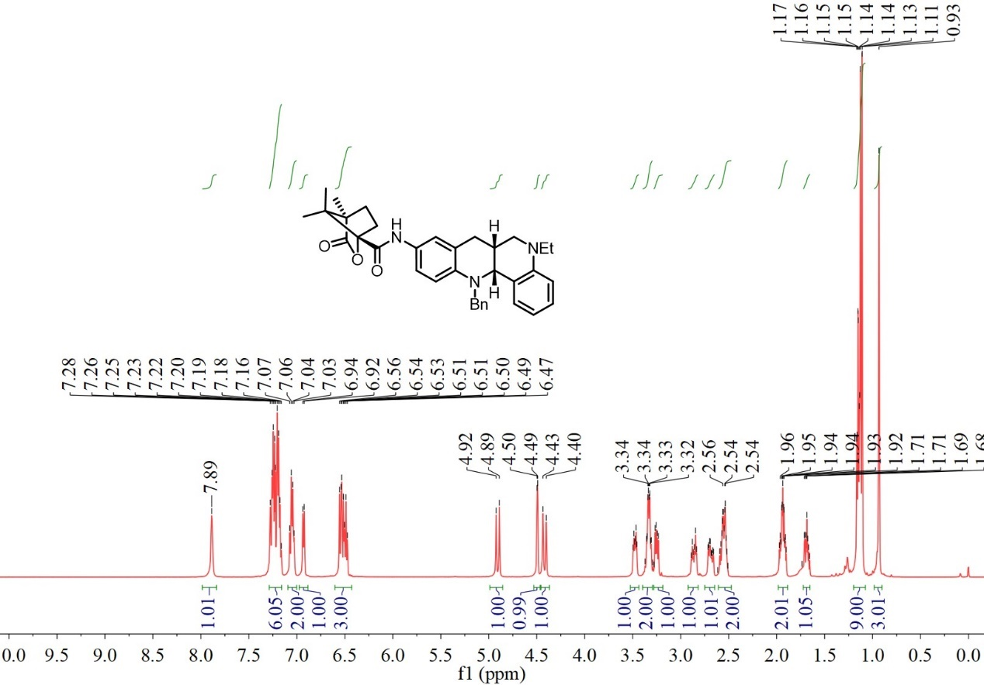

¹³C-NMR spectrum of C₅₃

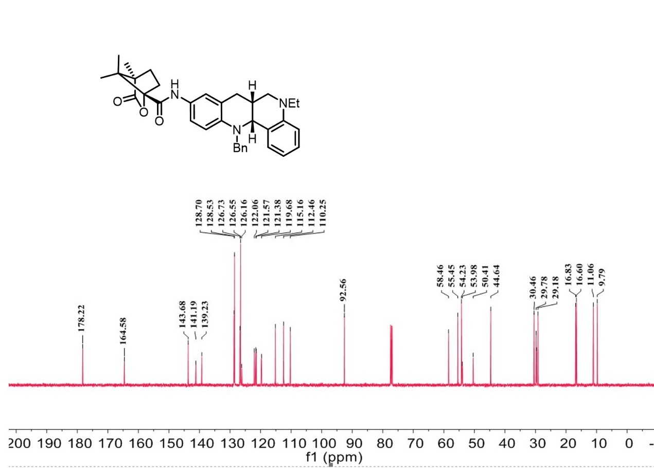
¹H-NMR spectrum of C₅₄

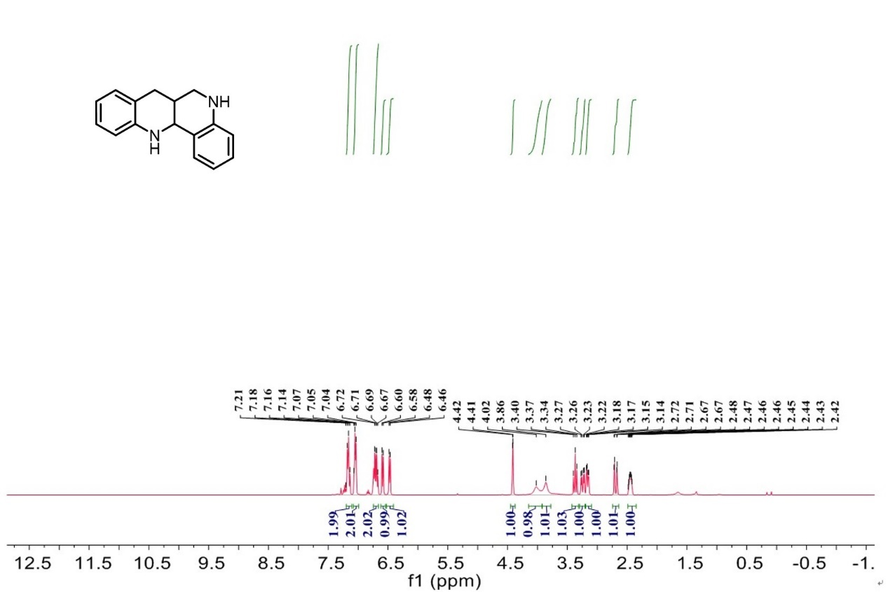

¹³C-NMR spectrum of C₅₄

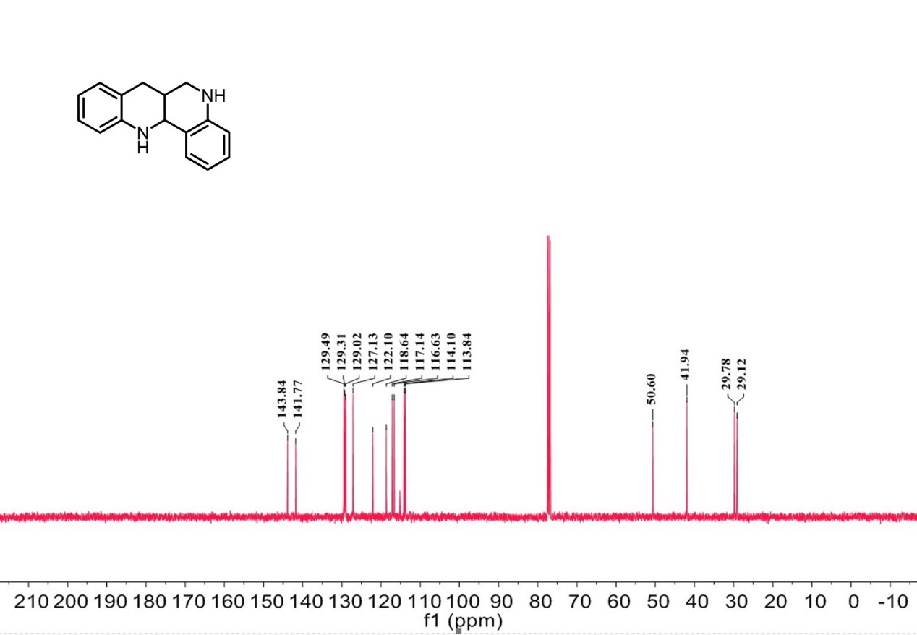

¹H-NMR spectrum of D₁

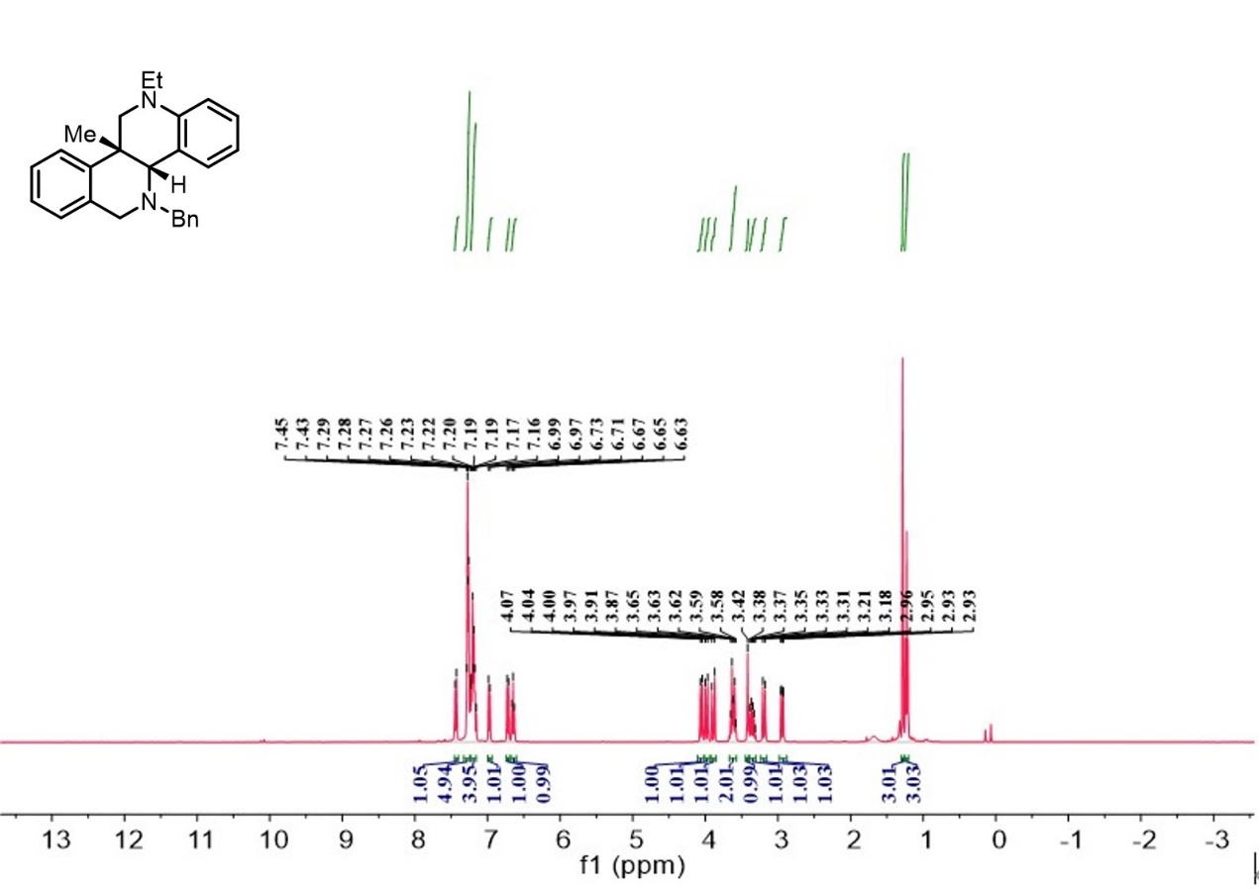

¹³C-NMR spectrum of D₁

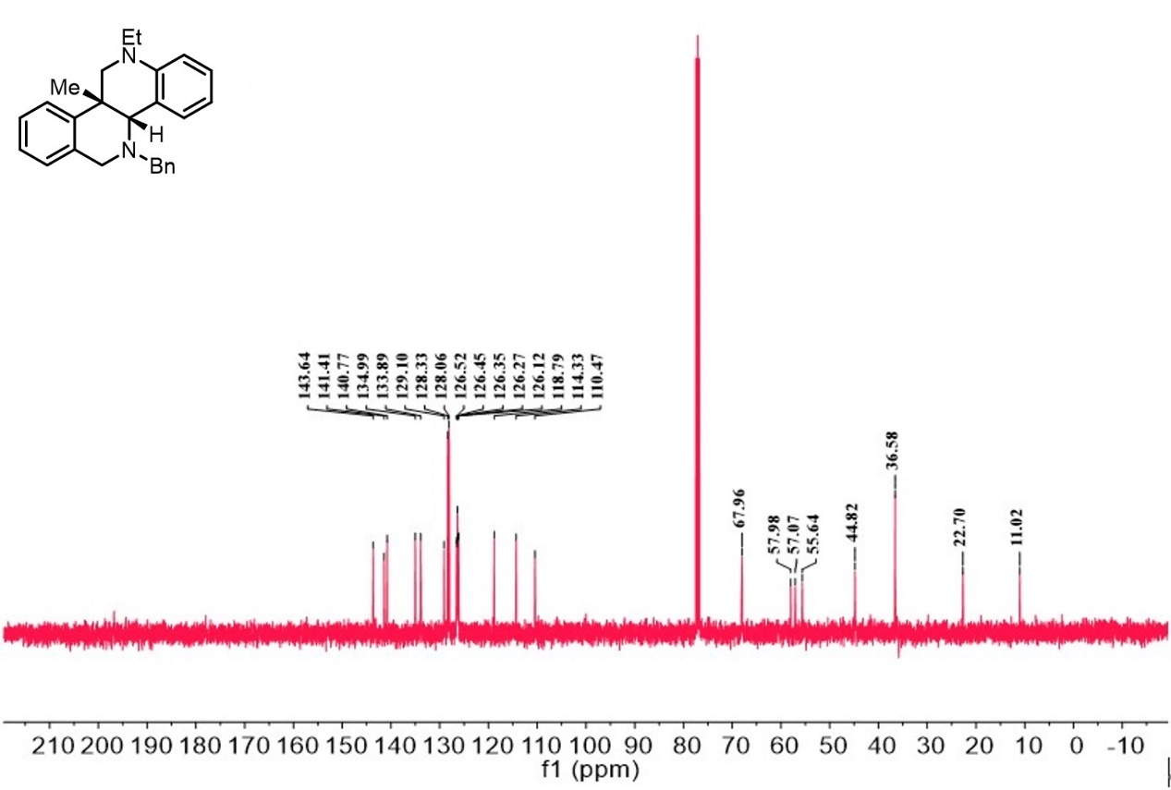

¹H-NMR spectrum of D₂

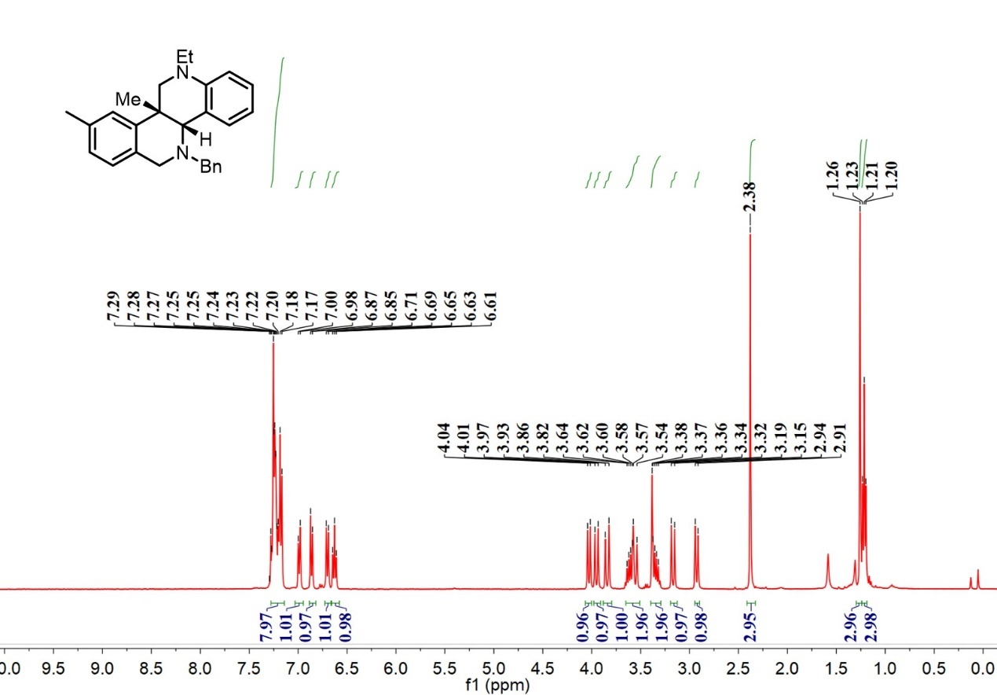

¹³C-NMR spectrum of D₂

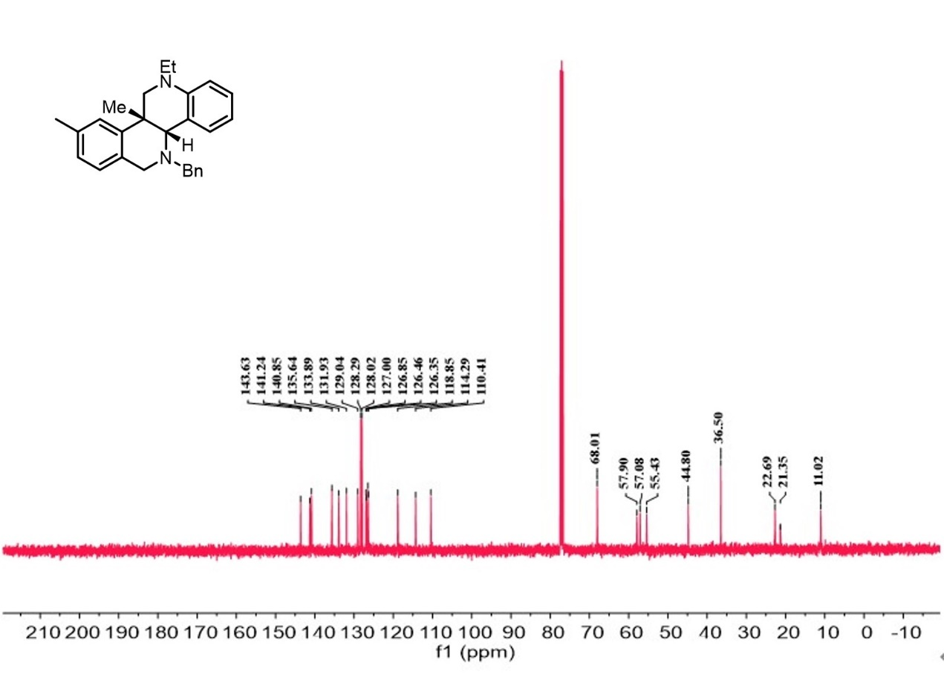
¹H-NMR spectrum of D₃
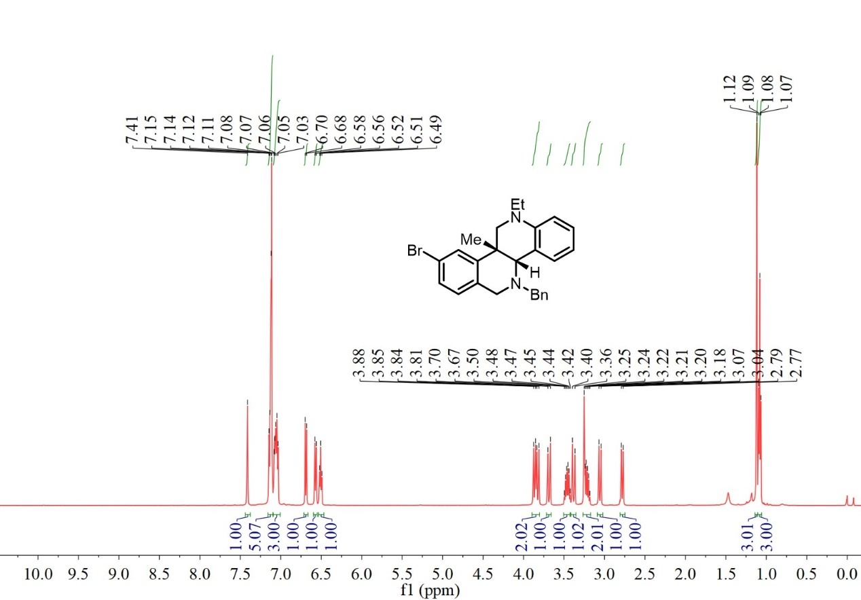

¹³C-NMR spectrum of D₃

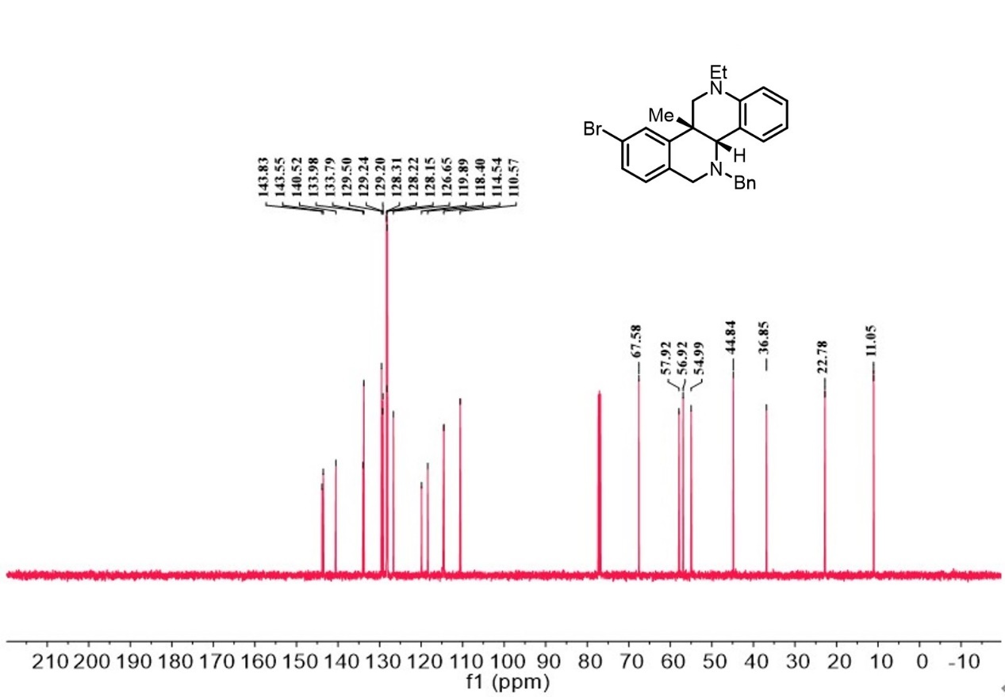

¹H-NMR spectrum of D₄

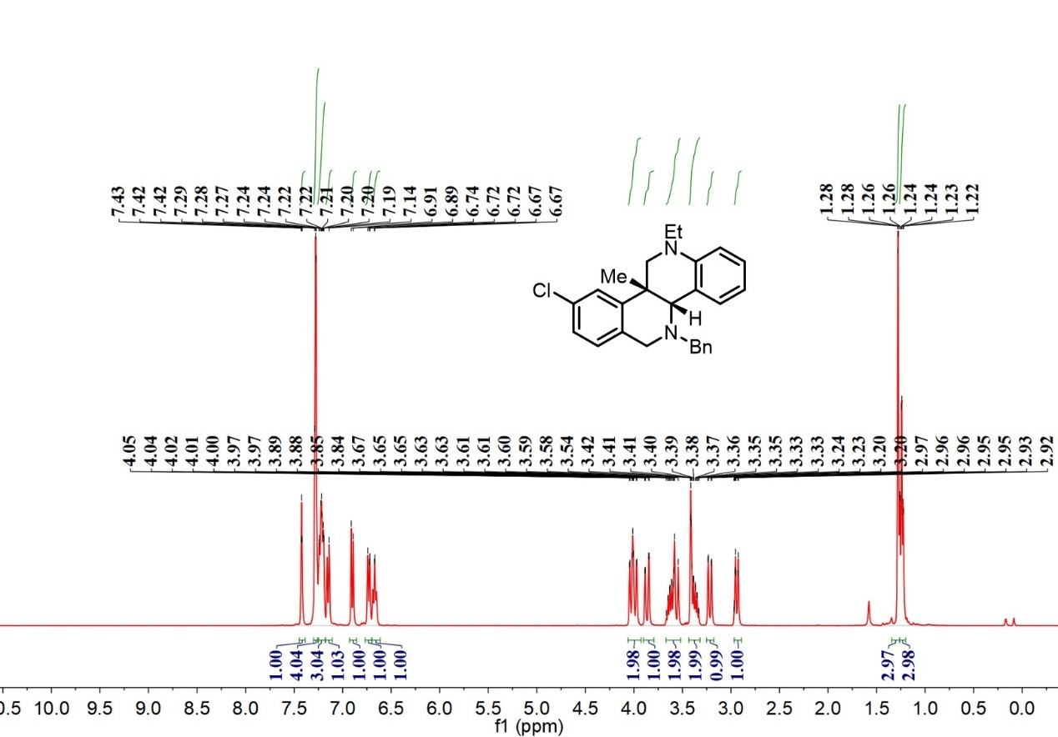

¹³C-NMR spectrum of D₄

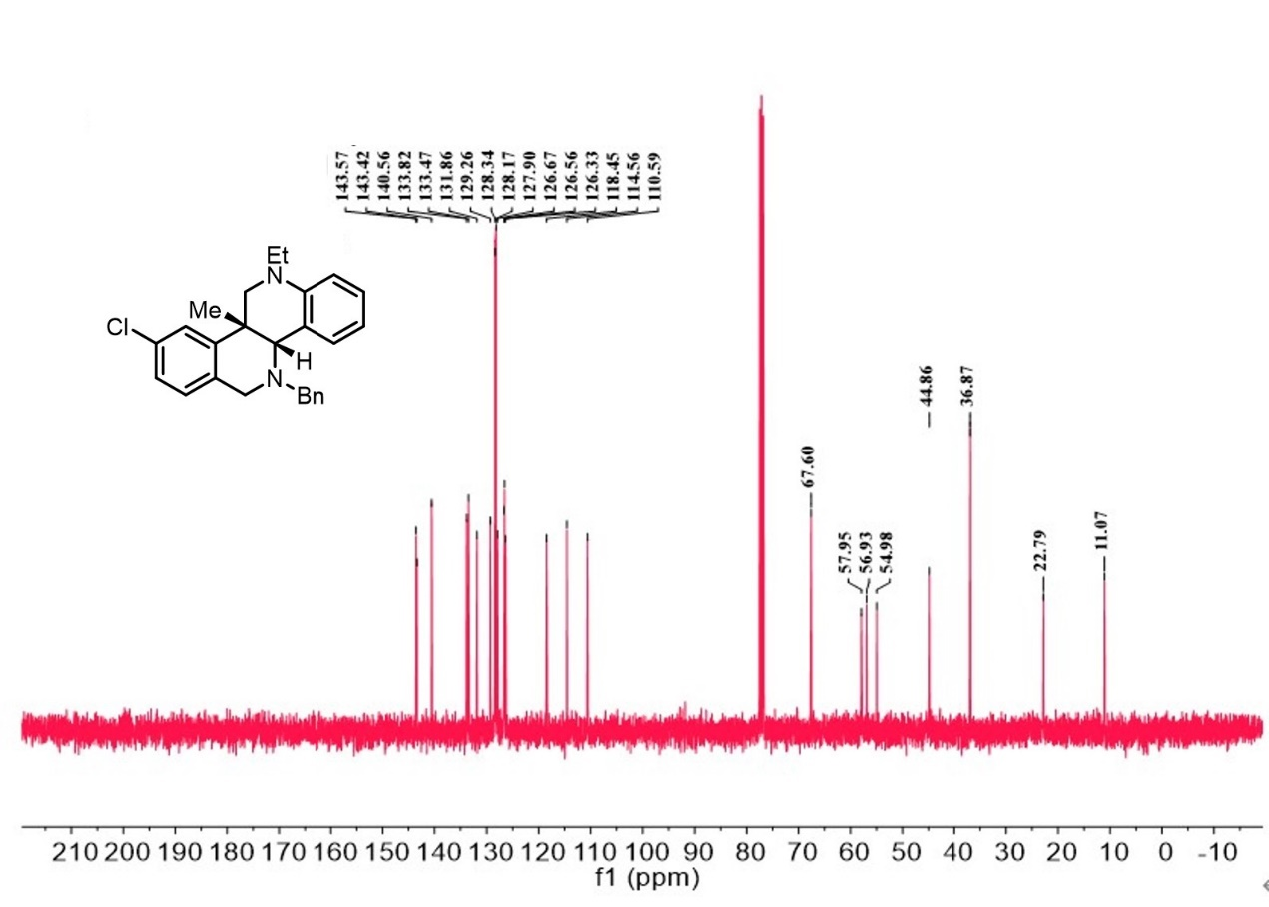
¹H-NMR spectrum of D₅
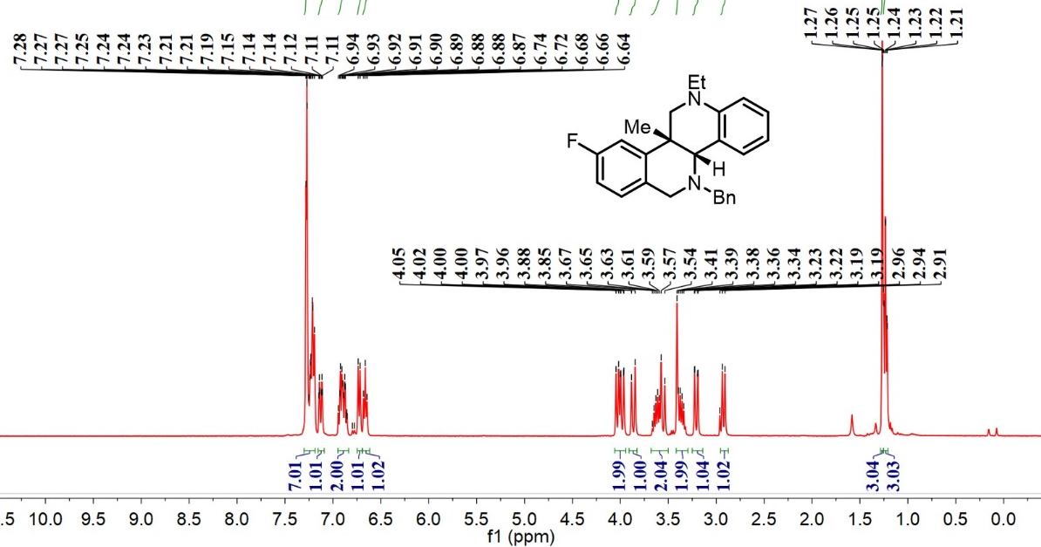
¹³C-NMR spectrum of D₅
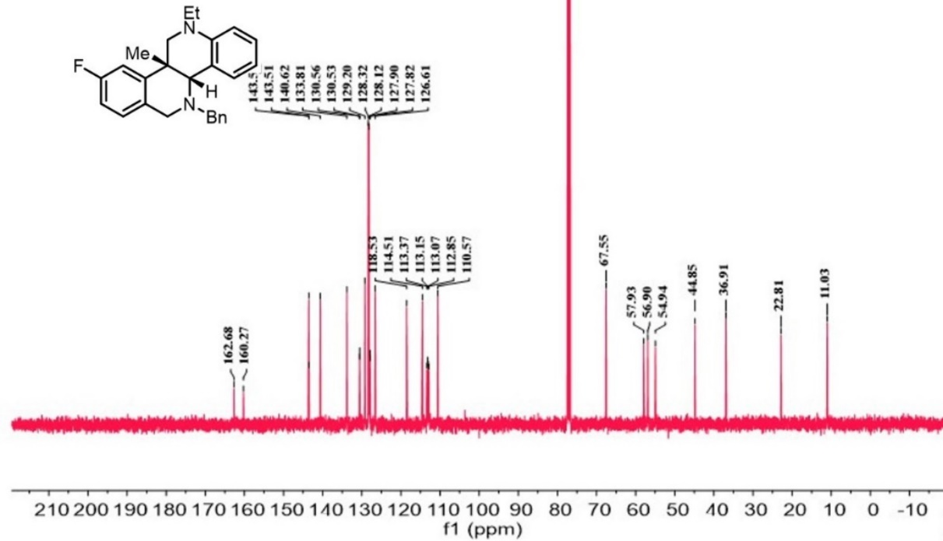
¹⁹F-NMR spectrum of D₅

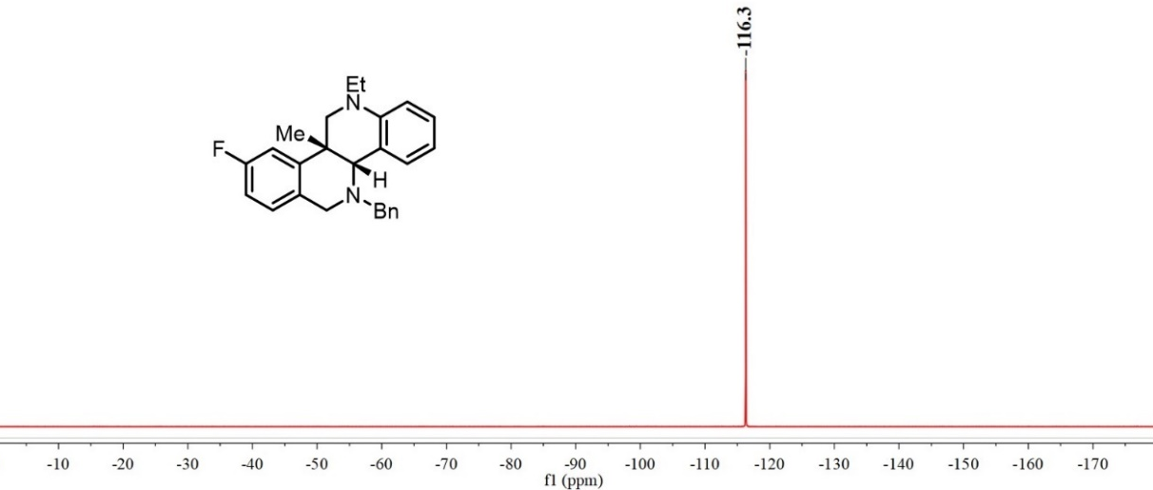
¹H-NMR spectrum of D₆

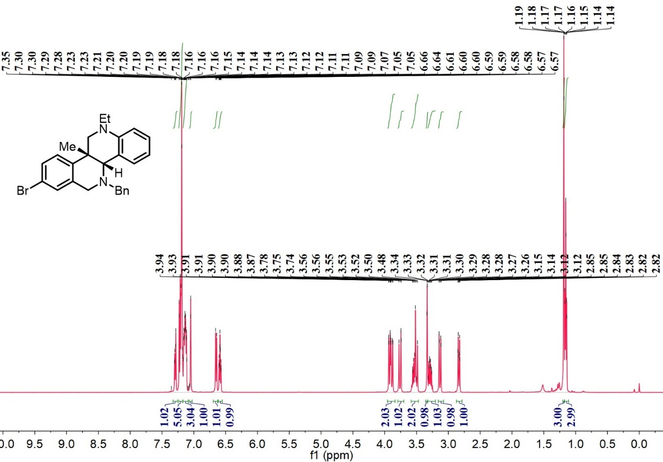

¹³C-NMR spectrum of D₆

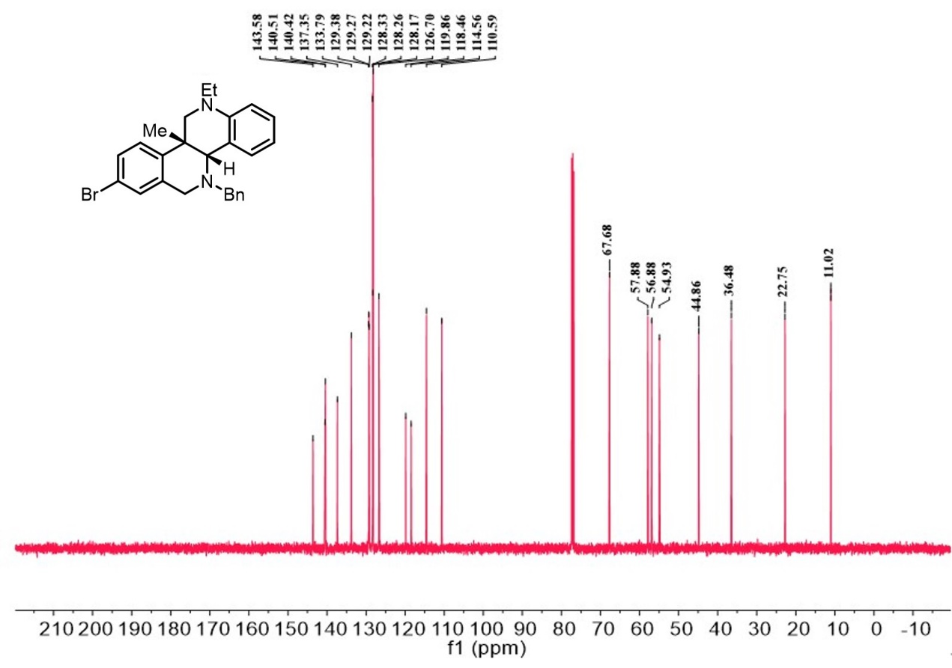
¹H-NMR spectrum of D₇

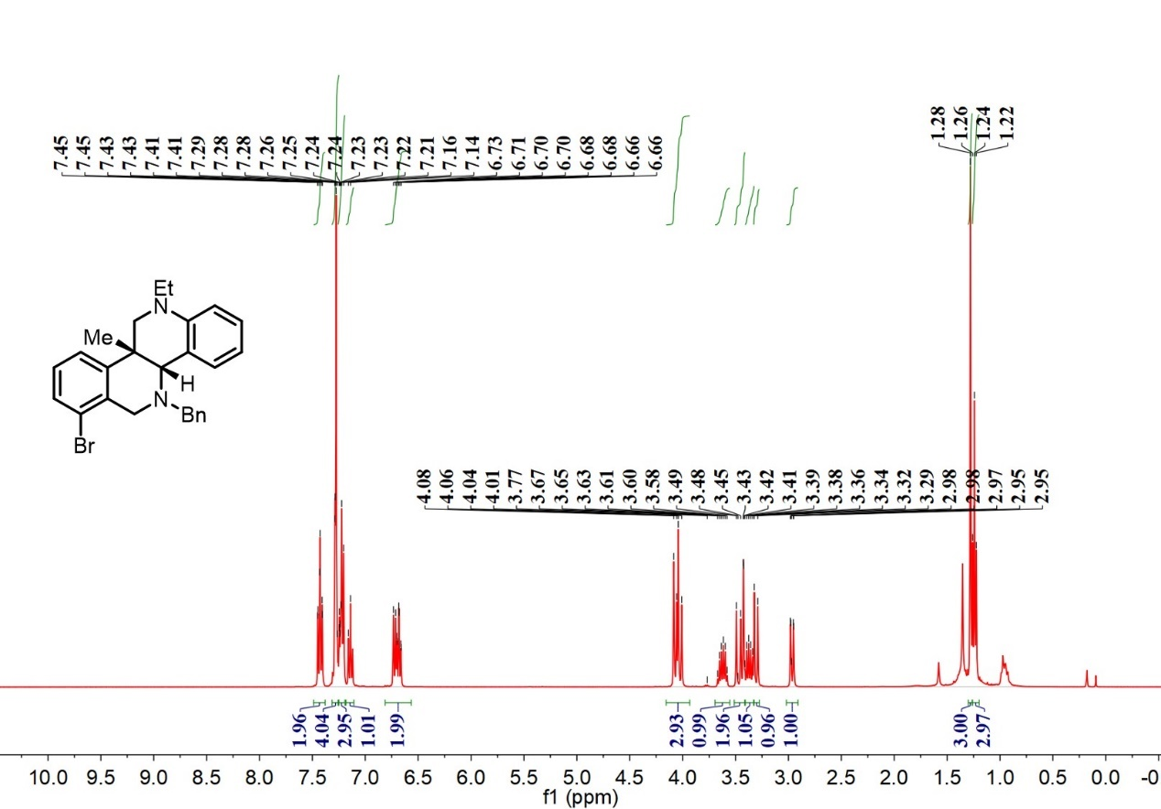

¹³C-NMR spectrum of D₇

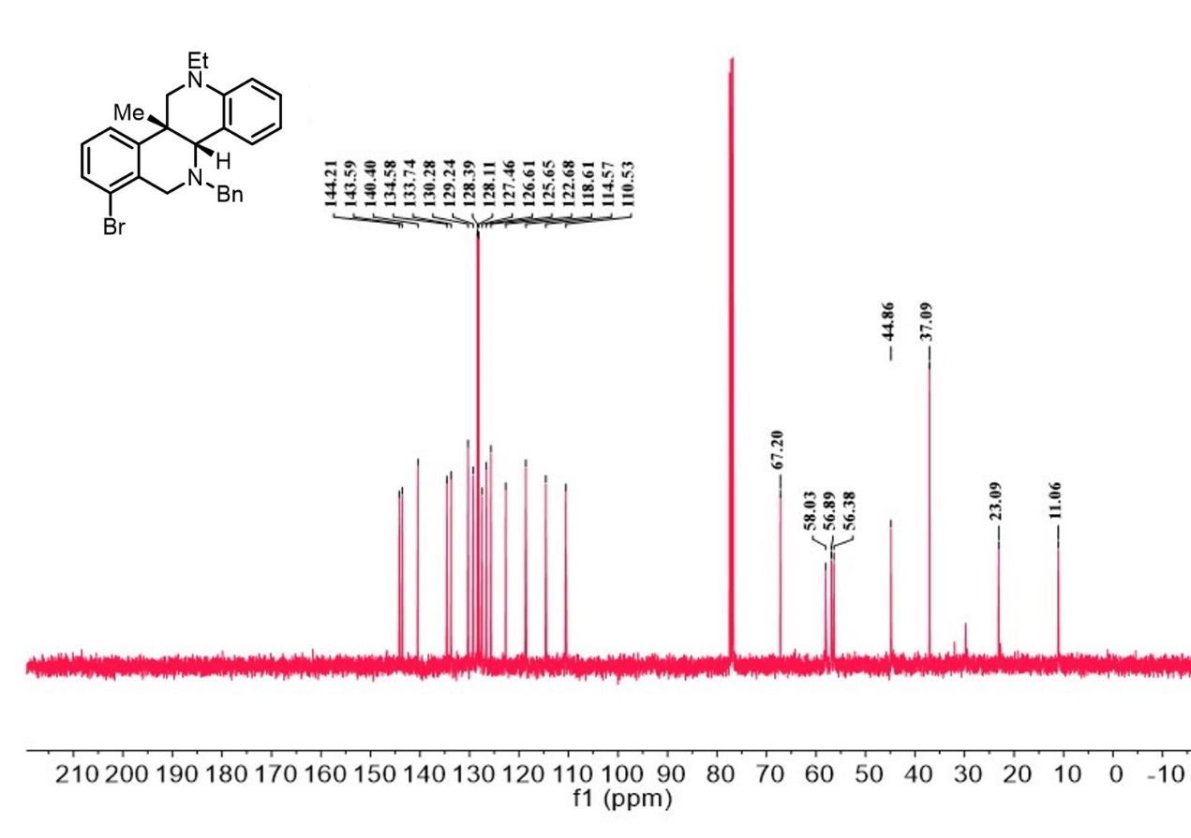
¹H-NMR spectrum of D₈

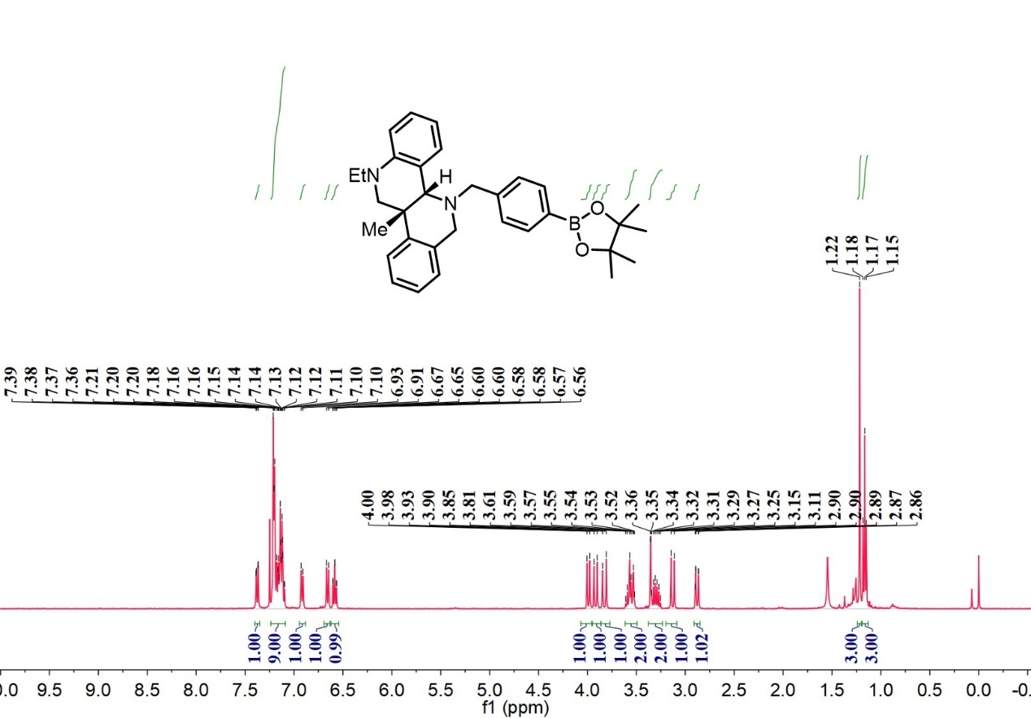

¹³C-NMR spectrum of D₈

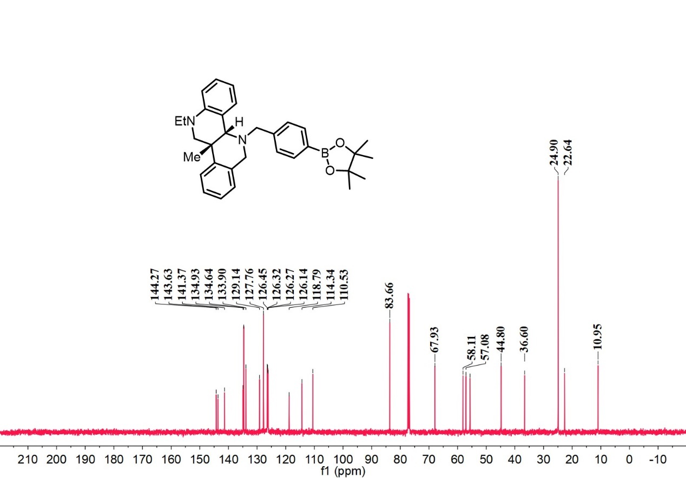
¹H-NMR spectrum of D₉

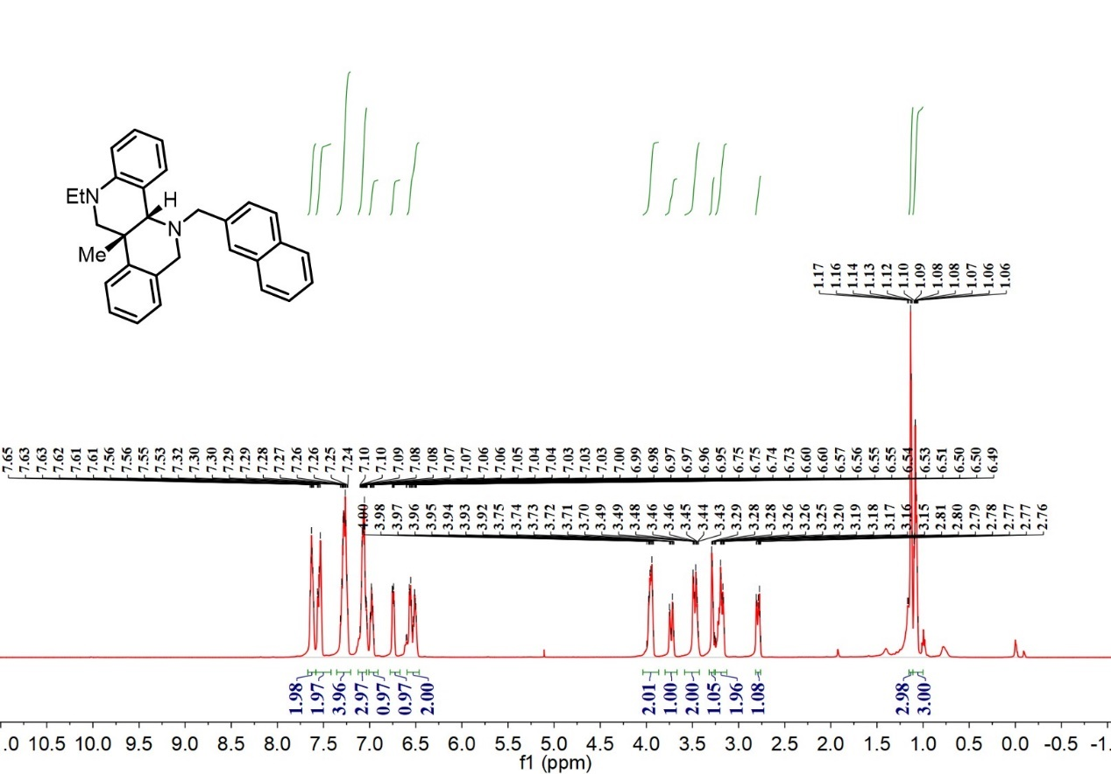

¹³C-NMR spectrum of D₉

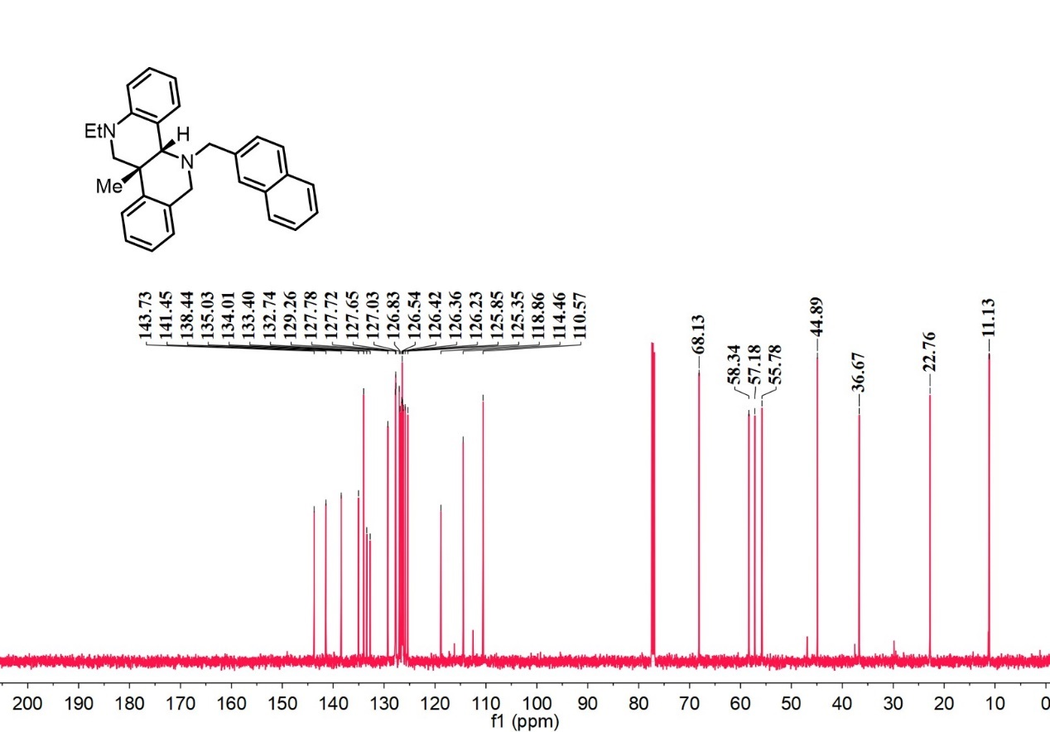
¹H-NMR spectrum of D₁₀
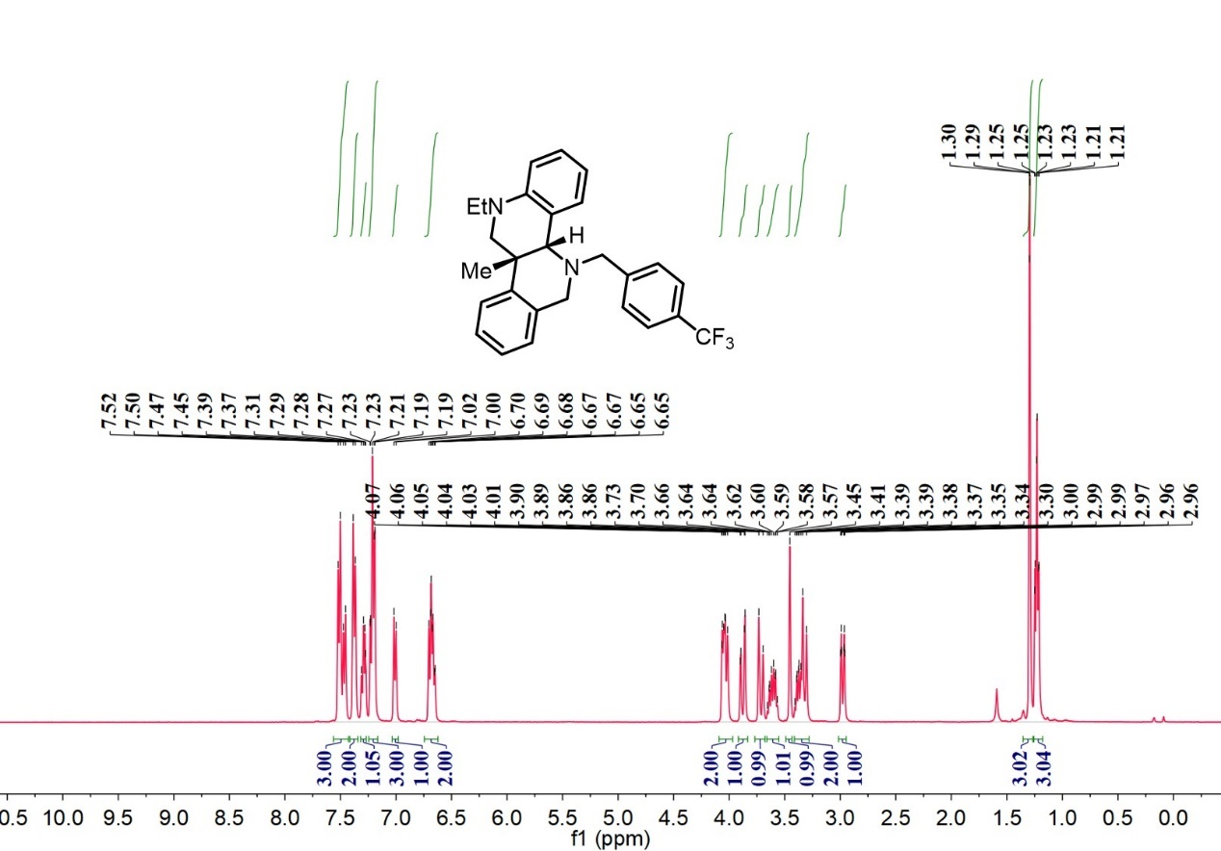

¹³C-NMR spectrum of D₁₀

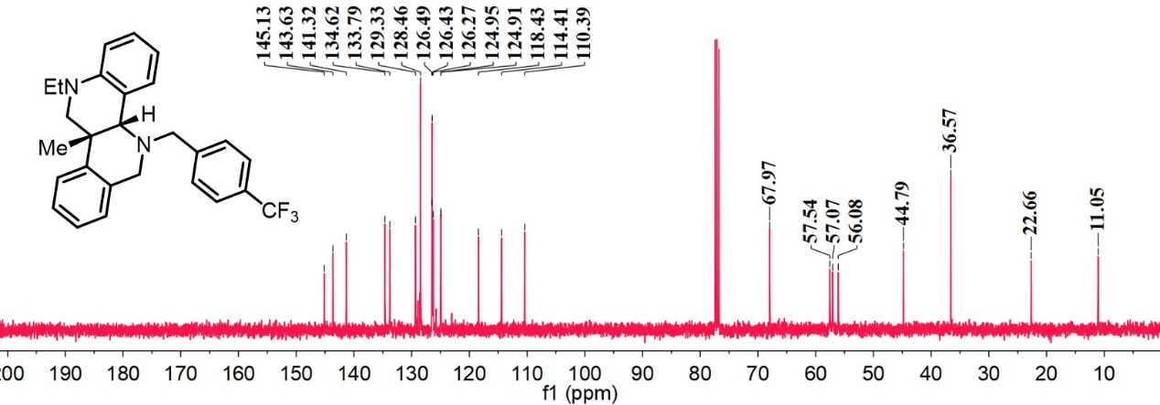

¹⁹F-NMR spectrum of D₁₀

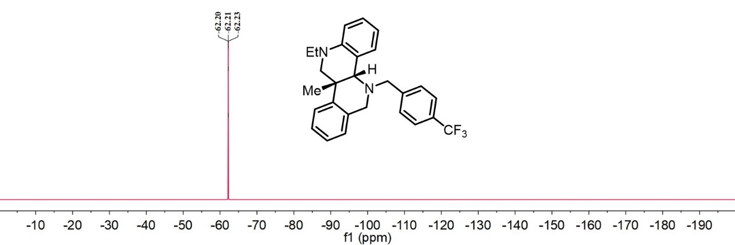
¹H-NMR spectrum of D₁₁

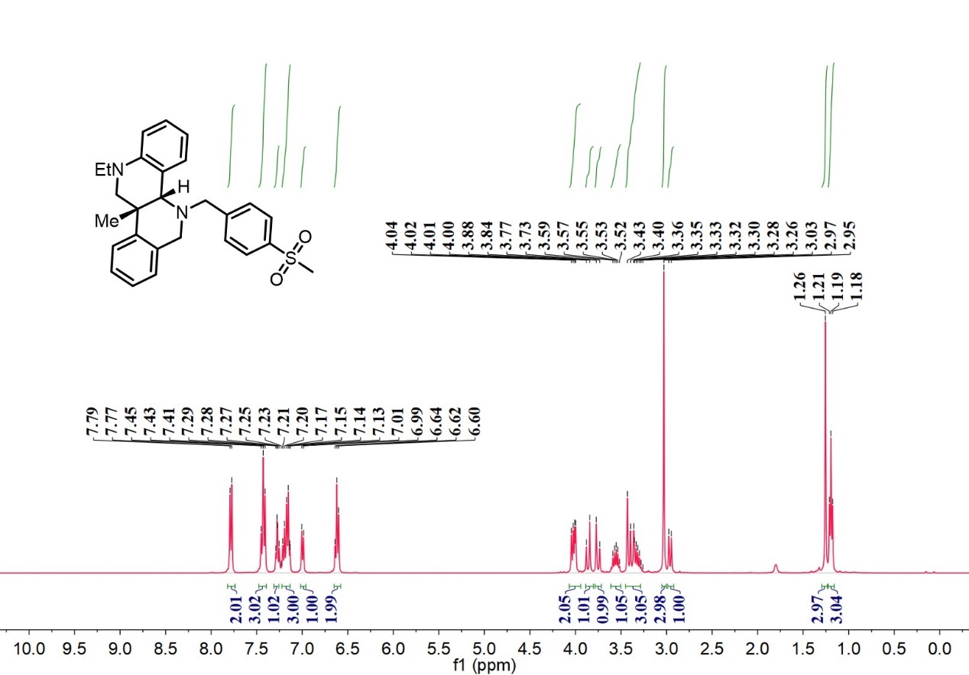

¹³C-NMR spectrum of D₁₁

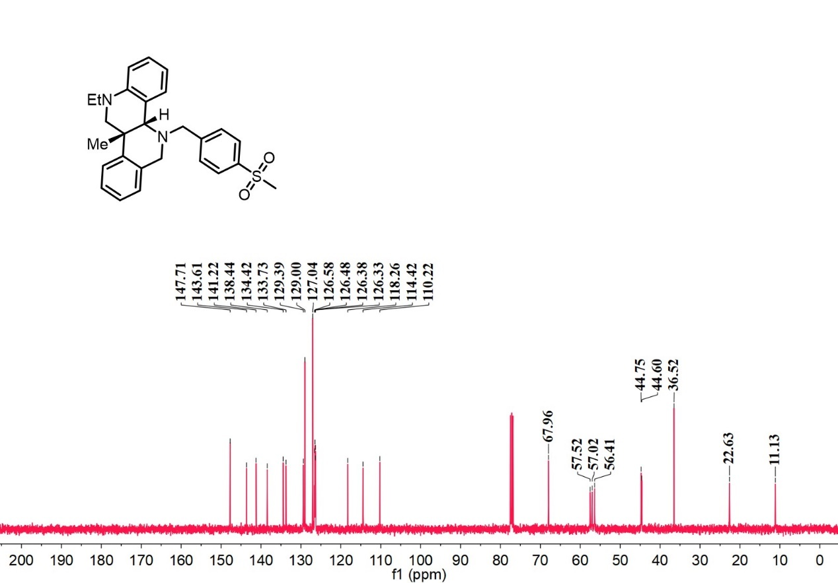
¹H-NMR spectrum of D₁₂

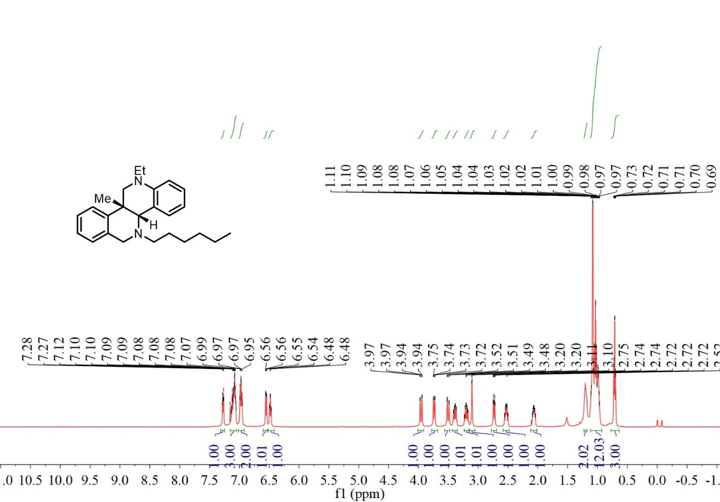

¹³C-NMR spectrum of D₁₂

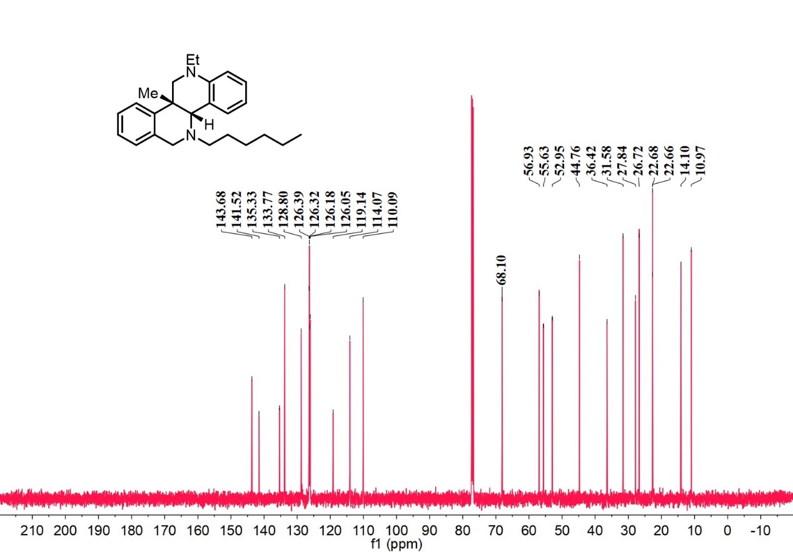
¹H-NMR spectrum of D₁₃

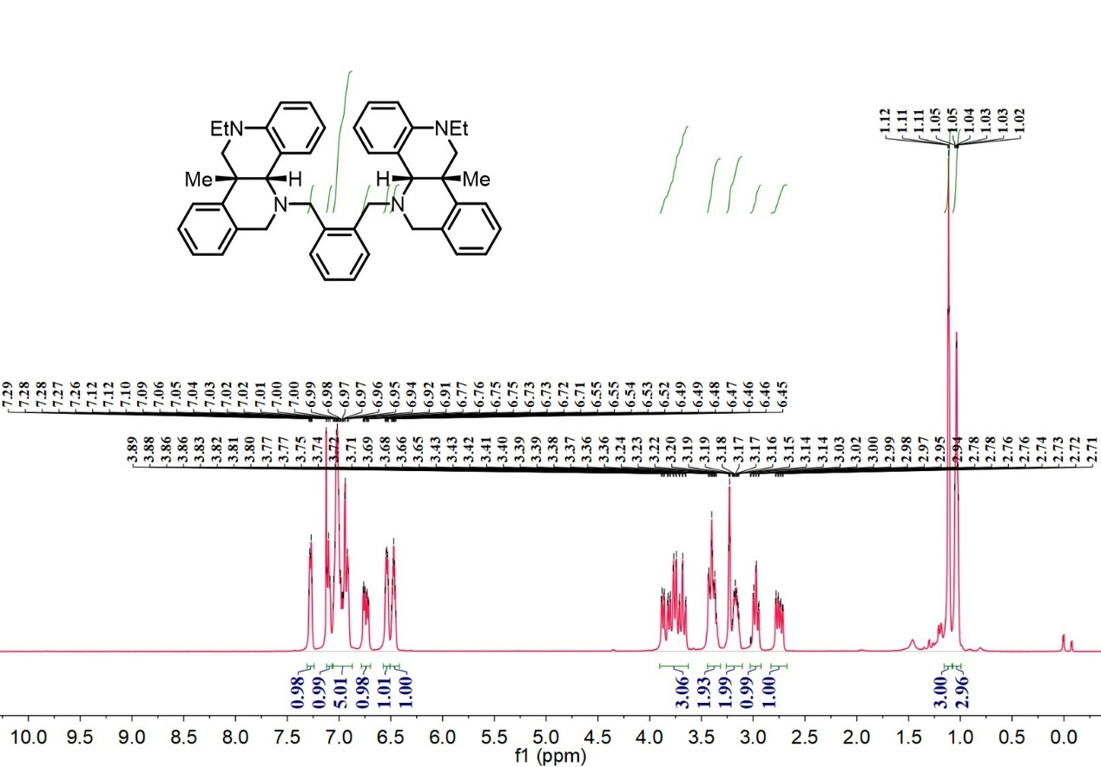

¹³C-NMR spectrum of D₁₃

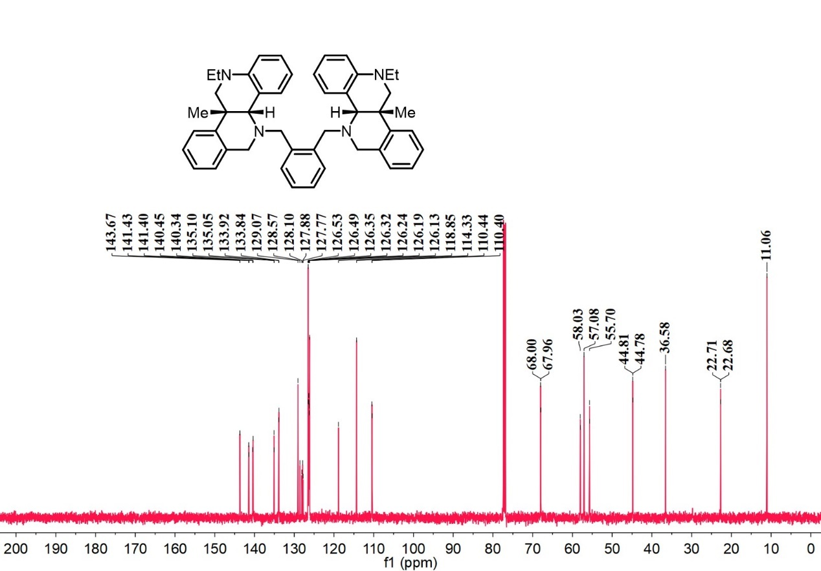
¹H-NMR spectrum of D₁₄

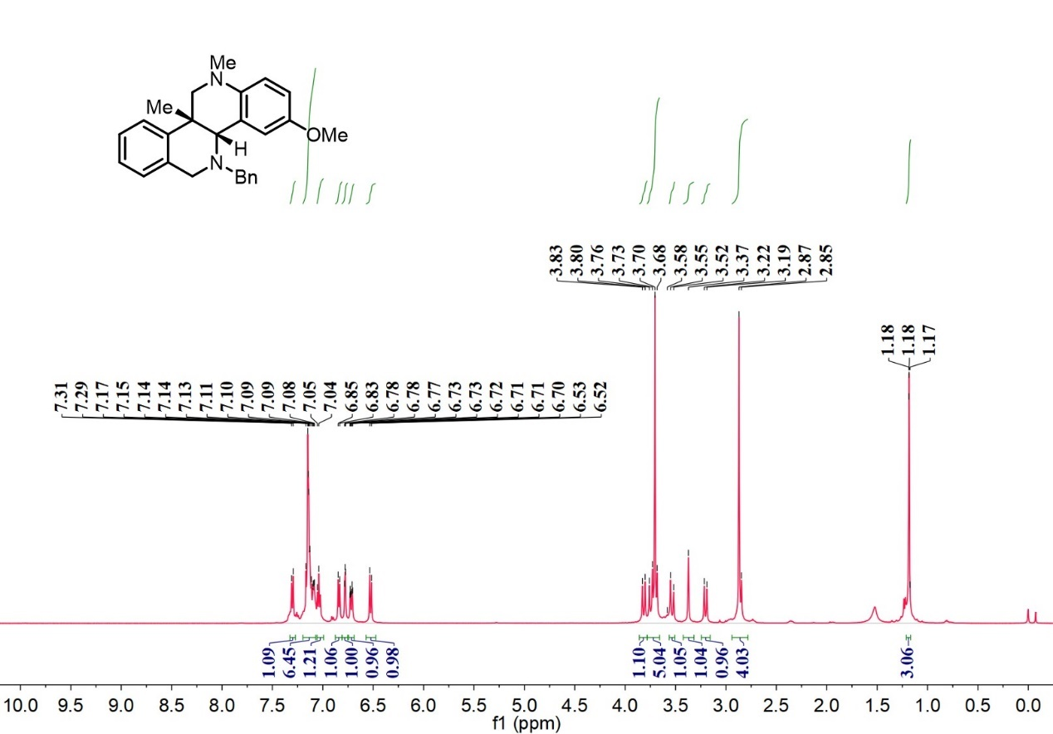

¹³C-NMR spectrum of D₁₄

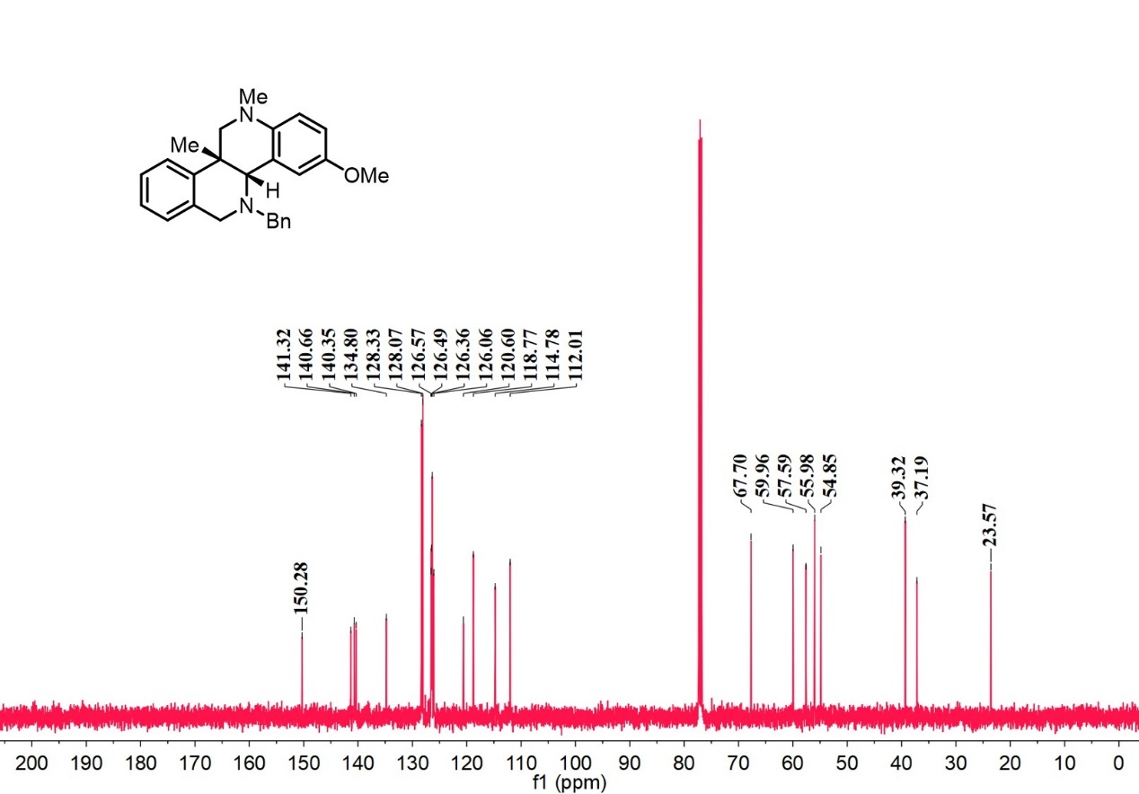
¹H-NMR spectrum of D₁₅

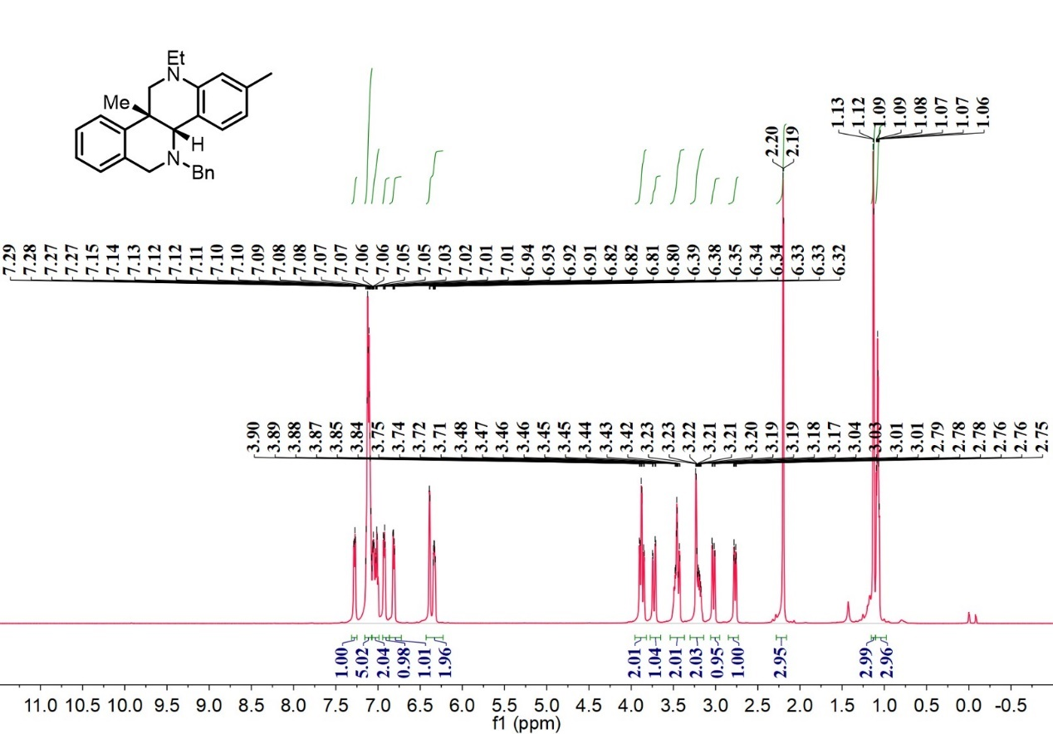

¹³C-NMR spectrum of D₁₅

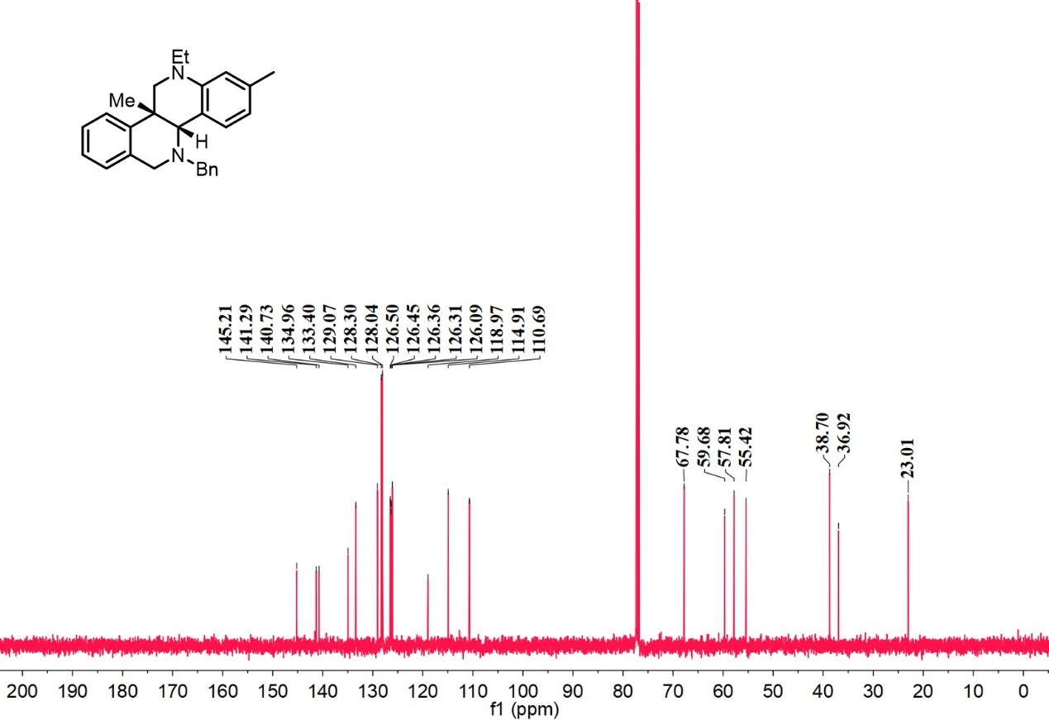
¹H-NMR spectrum of D₁₆

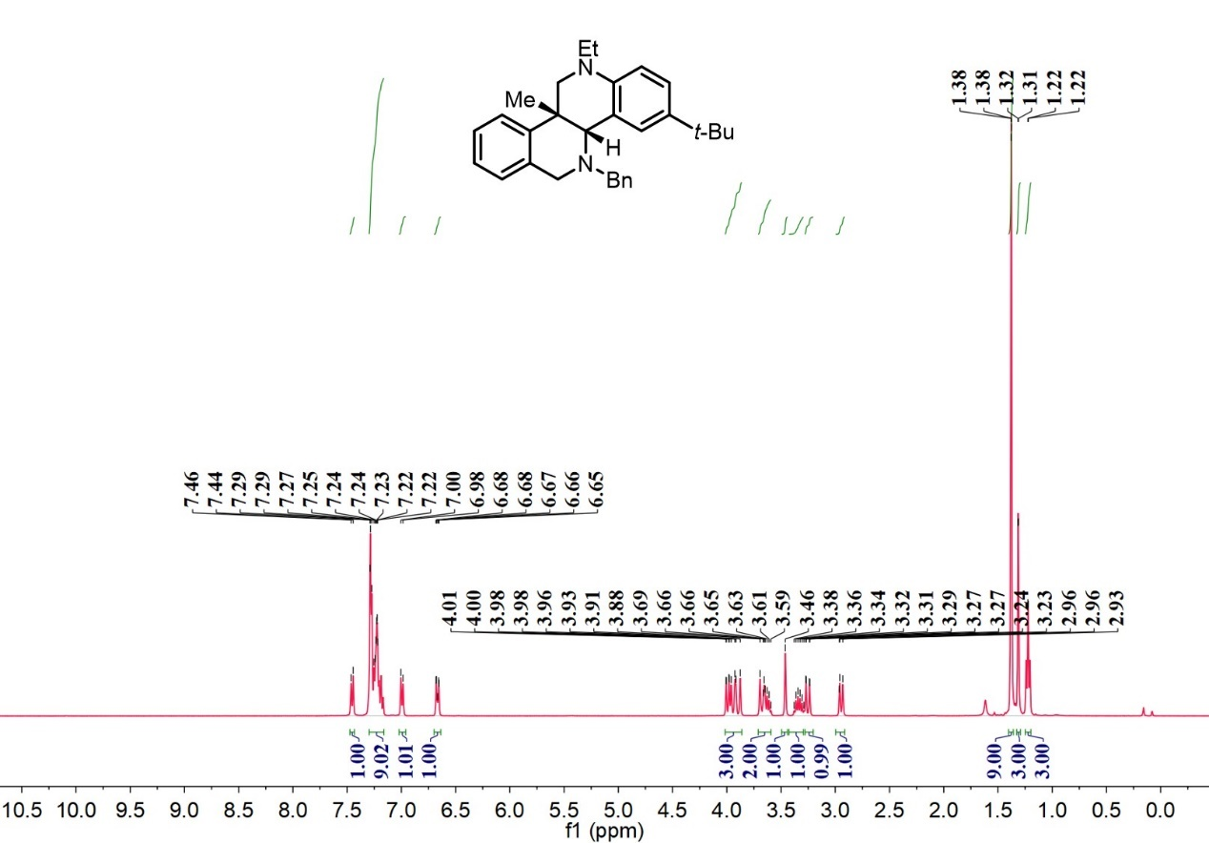

¹³C-NMR spectrum of D₁₆

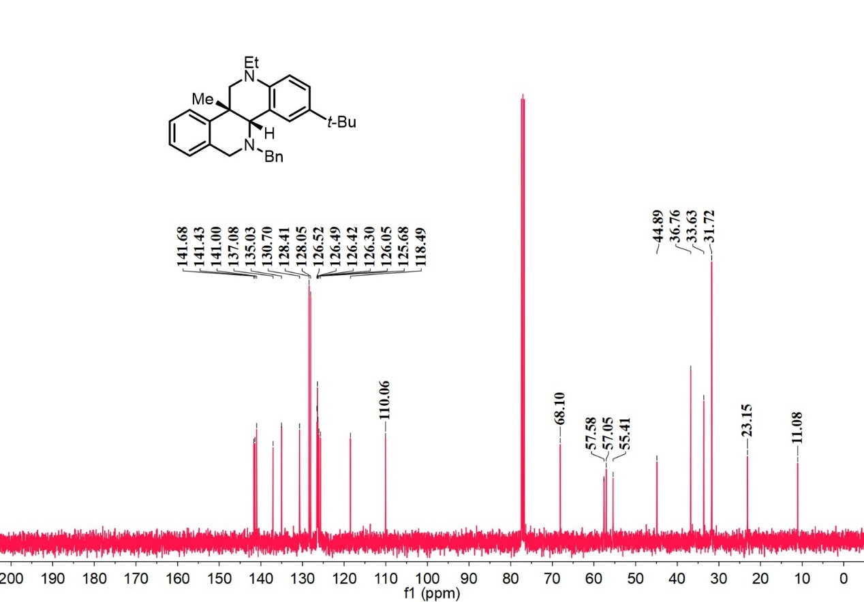
¹H-NMR spectrum of D₁₇

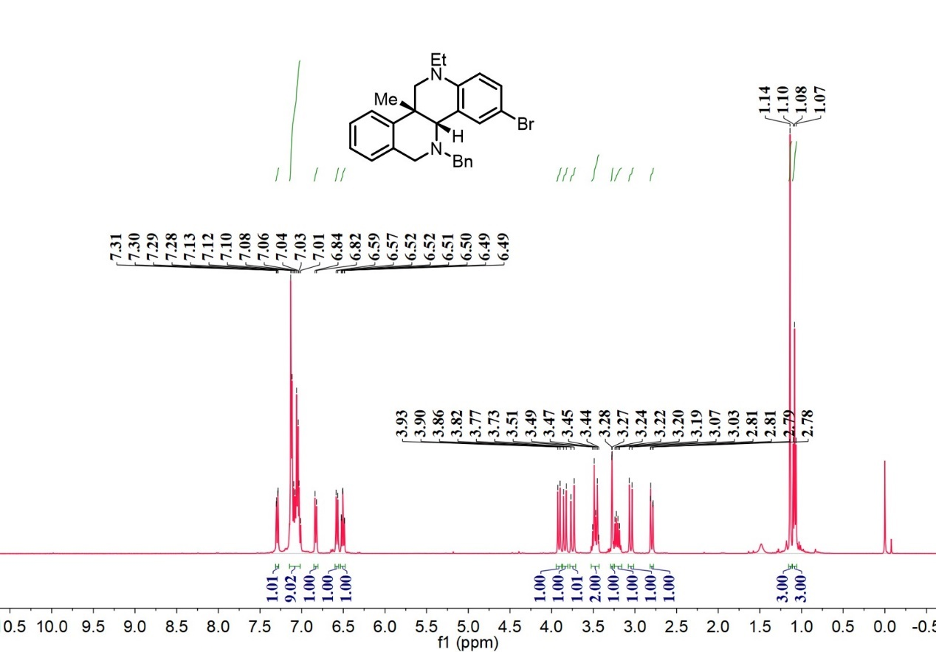

¹³C-NMR spectrum of D₁₇

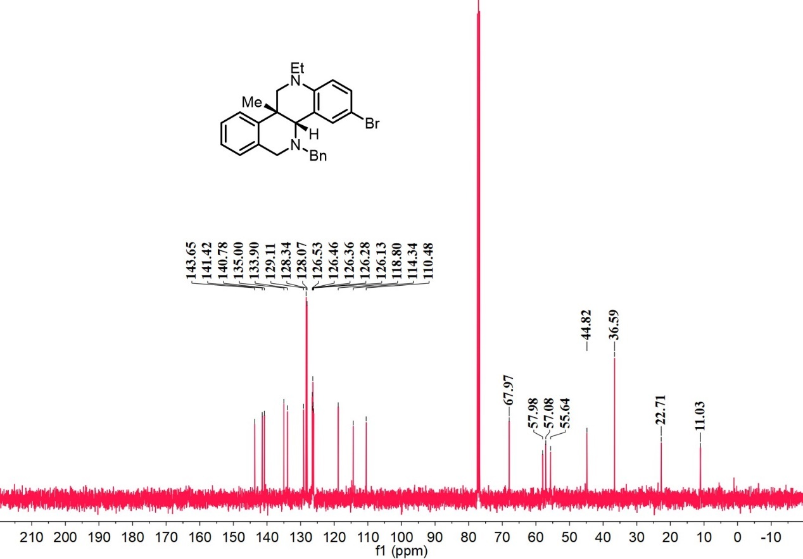
¹H-NMR spectrum of D₁₈

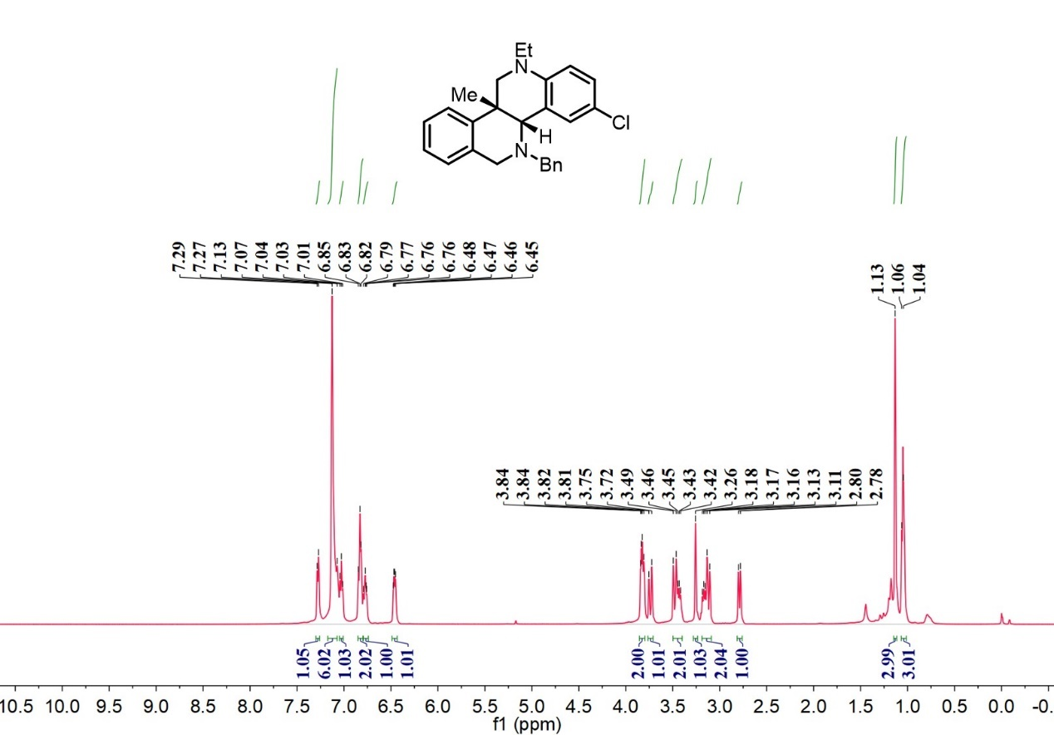

¹³C-NMR spectrum of D₁₈

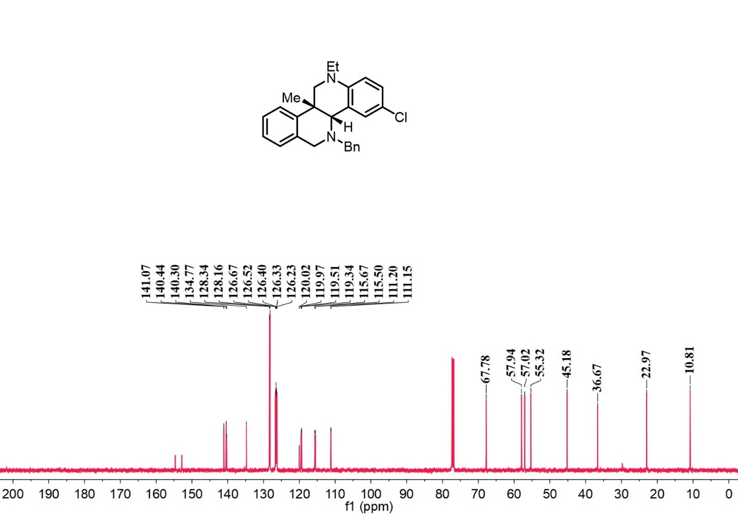
¹H-NMR spectrum of D₁₉
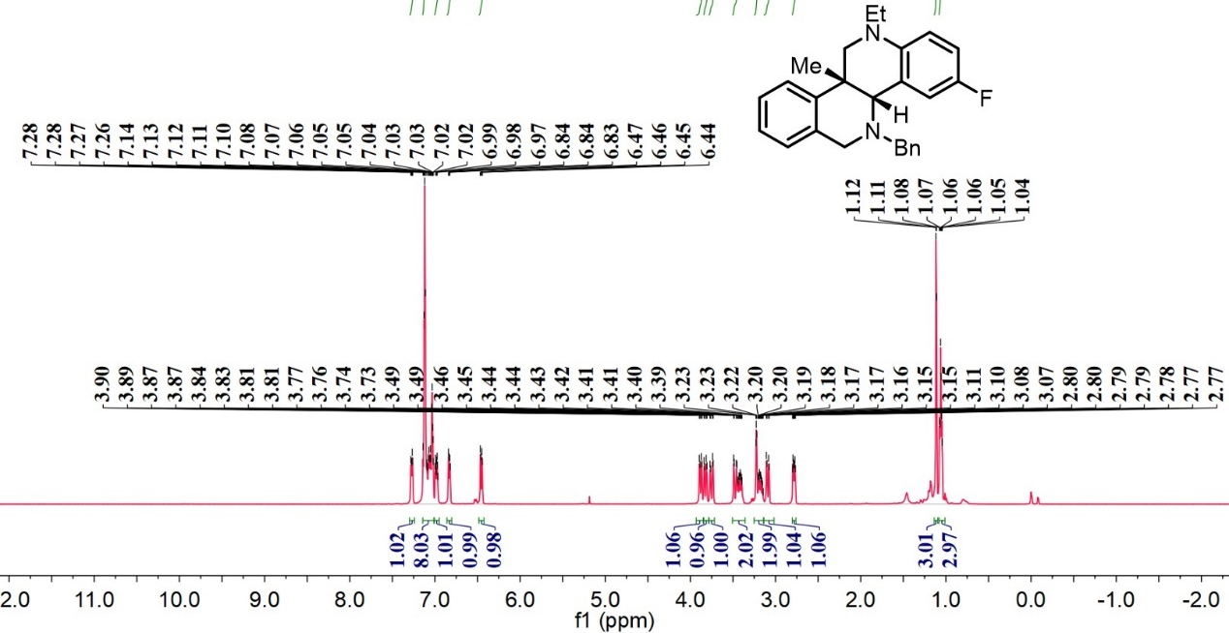

¹³C-NMR spectrum of D₁₉
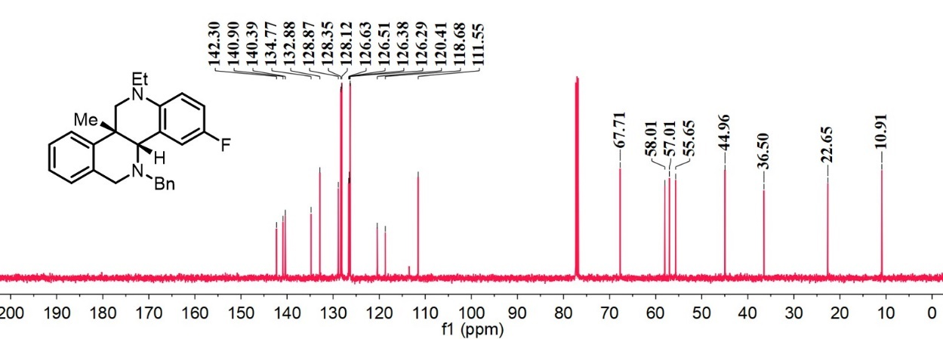

¹⁹F-NMR spectrum of D₁₉
¹H-NMR spectrum of D₂₀

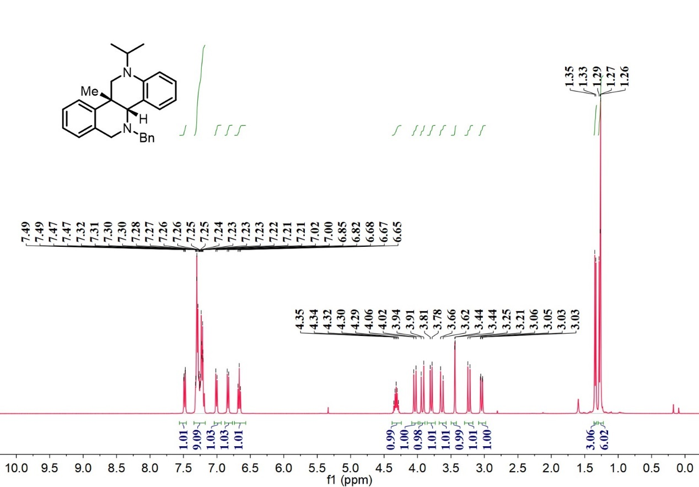

¹³C-NMR spectrum of D₂₀

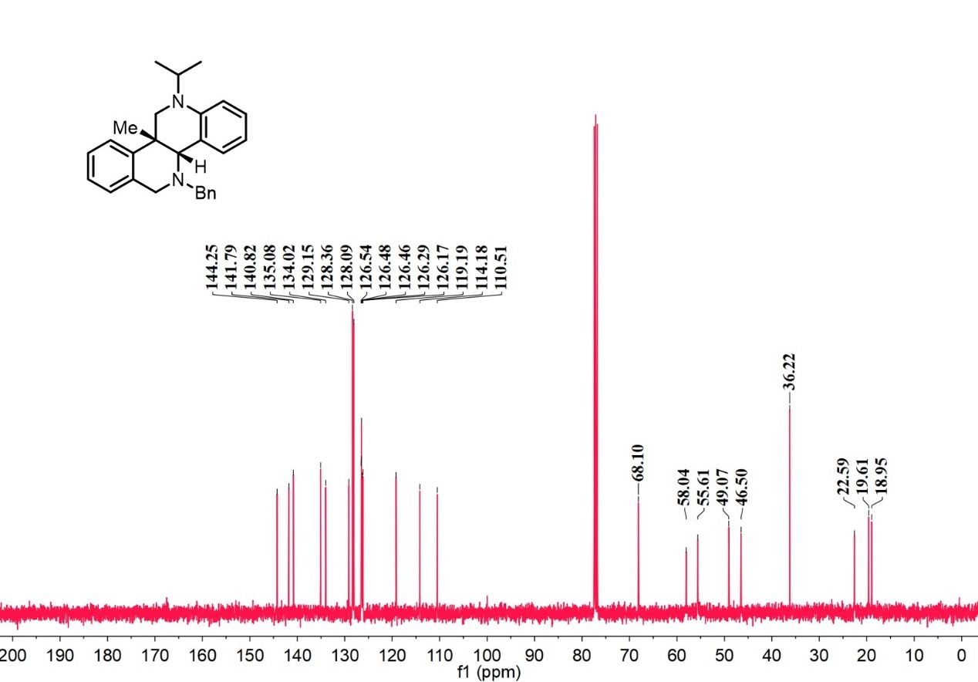
¹H-NMR spectrum of D₂₁

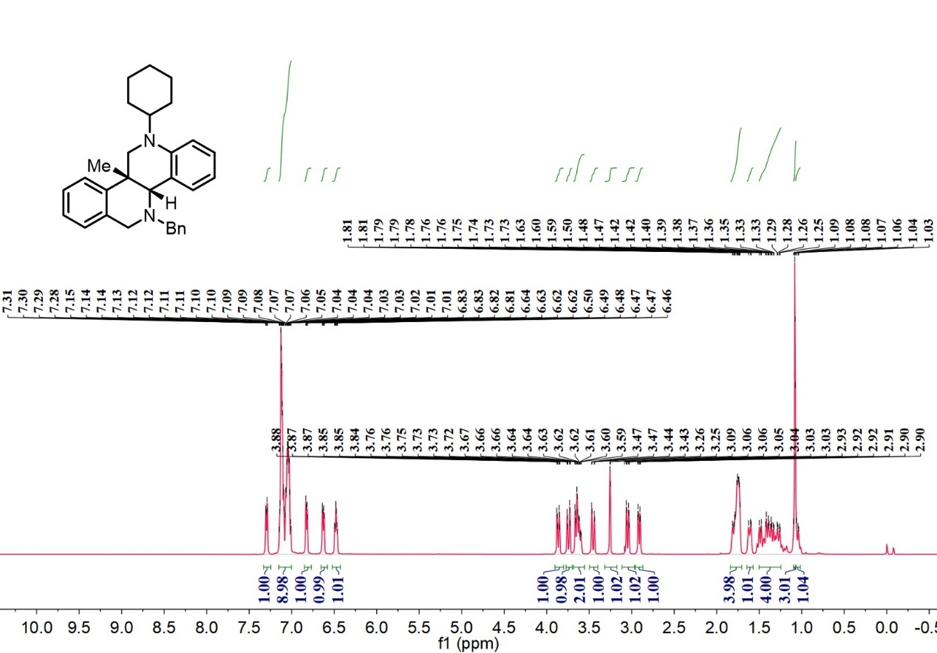

¹³C-NMR spectrum of D₂₁

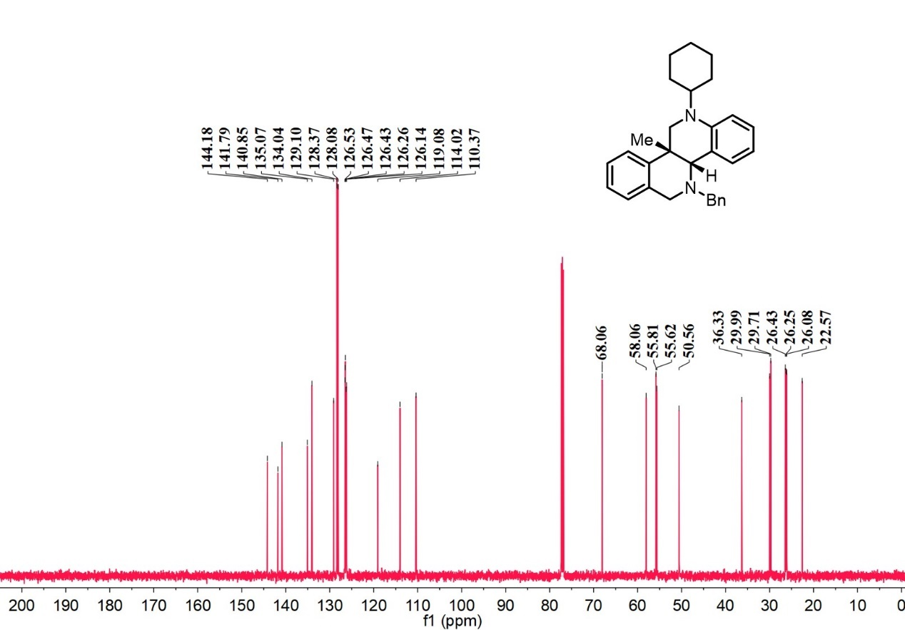
¹H-NMR spectrum of D₂₂

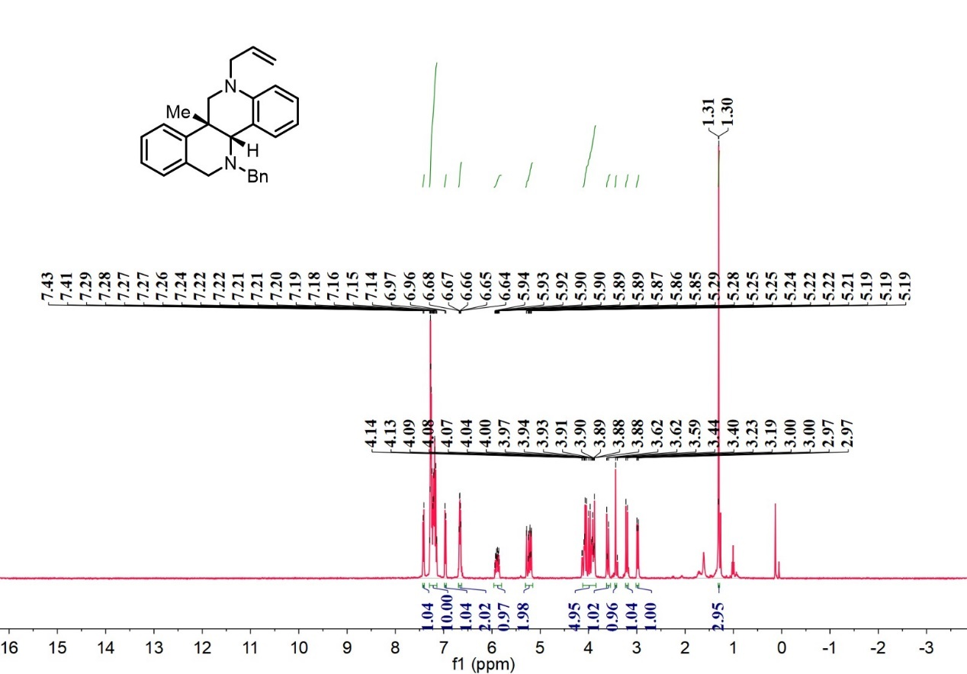

¹³C-NMR spectrum of D₂₂

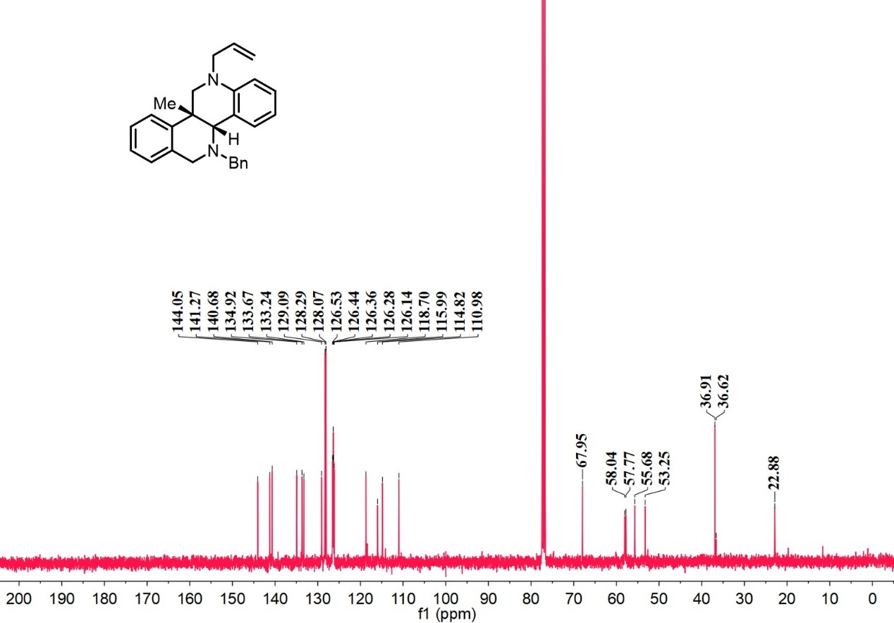
¹H-NMR spectrum of D₂₃

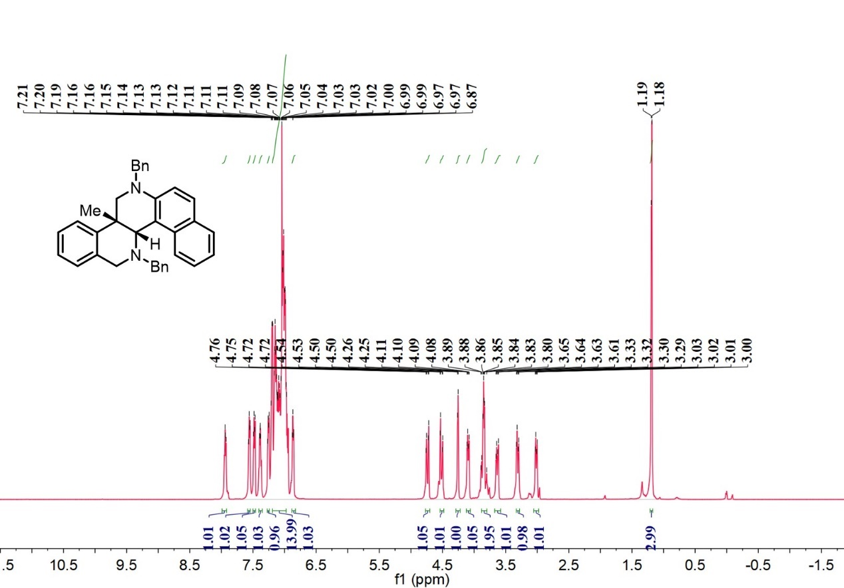

¹³C-NMR spectrum of D₂₃

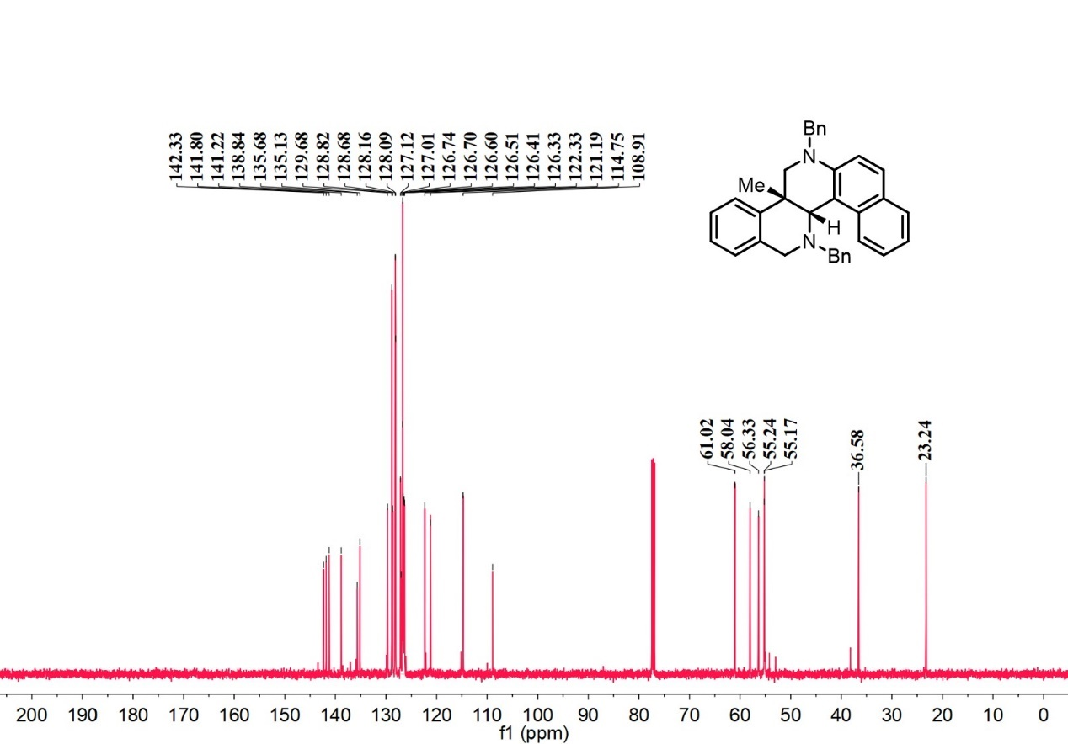
¹H-NMR spectrum of D₂₄

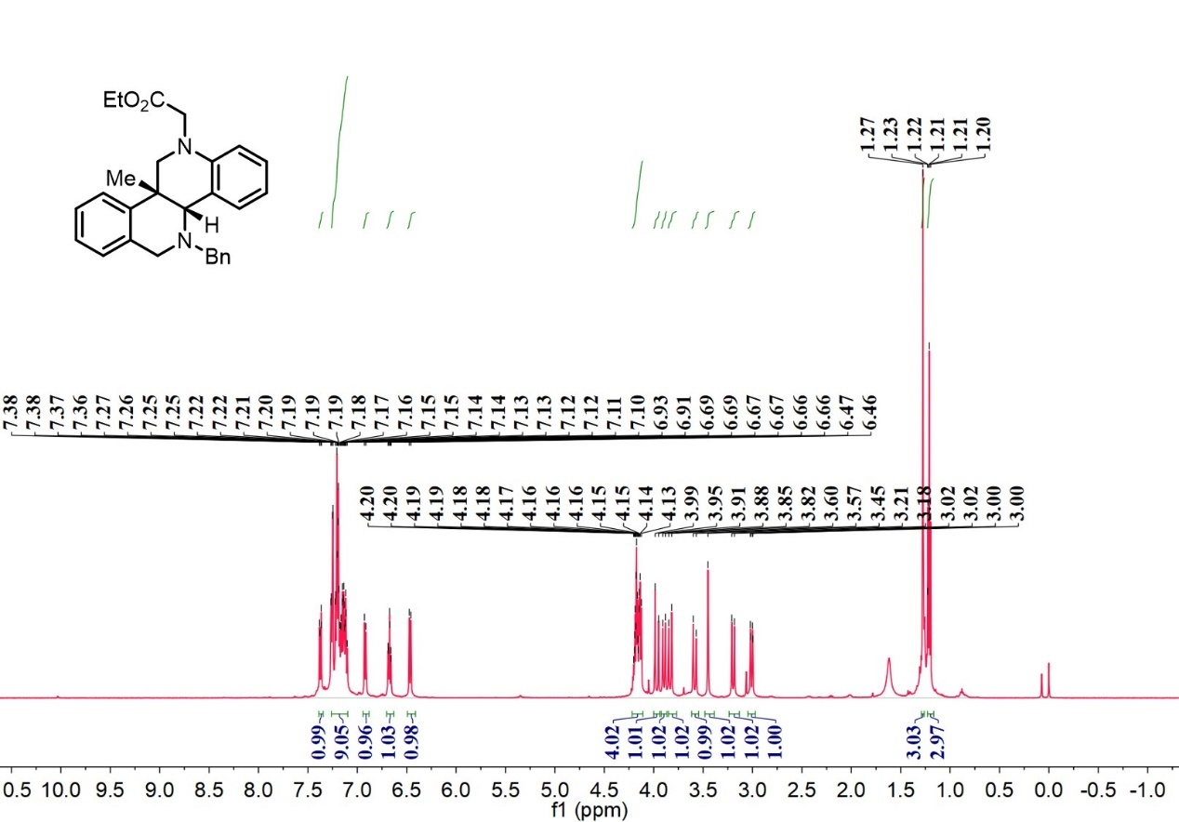

¹³C-NMR spectrum of D₂₄

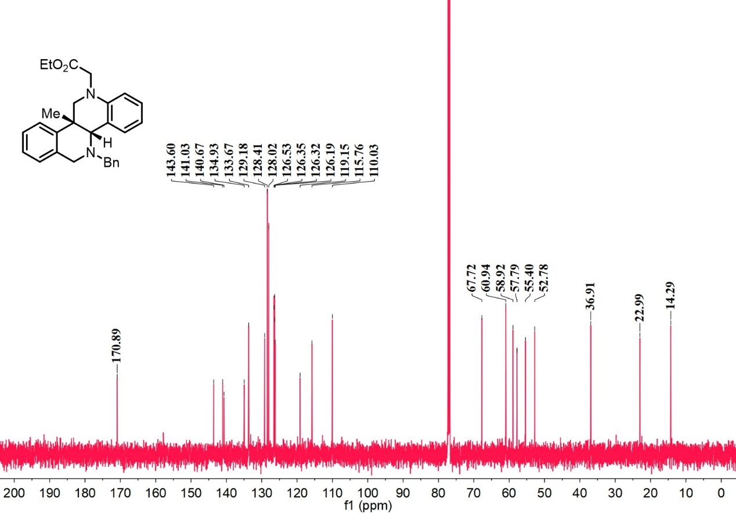
¹H-NMR spectrum of D₂₅

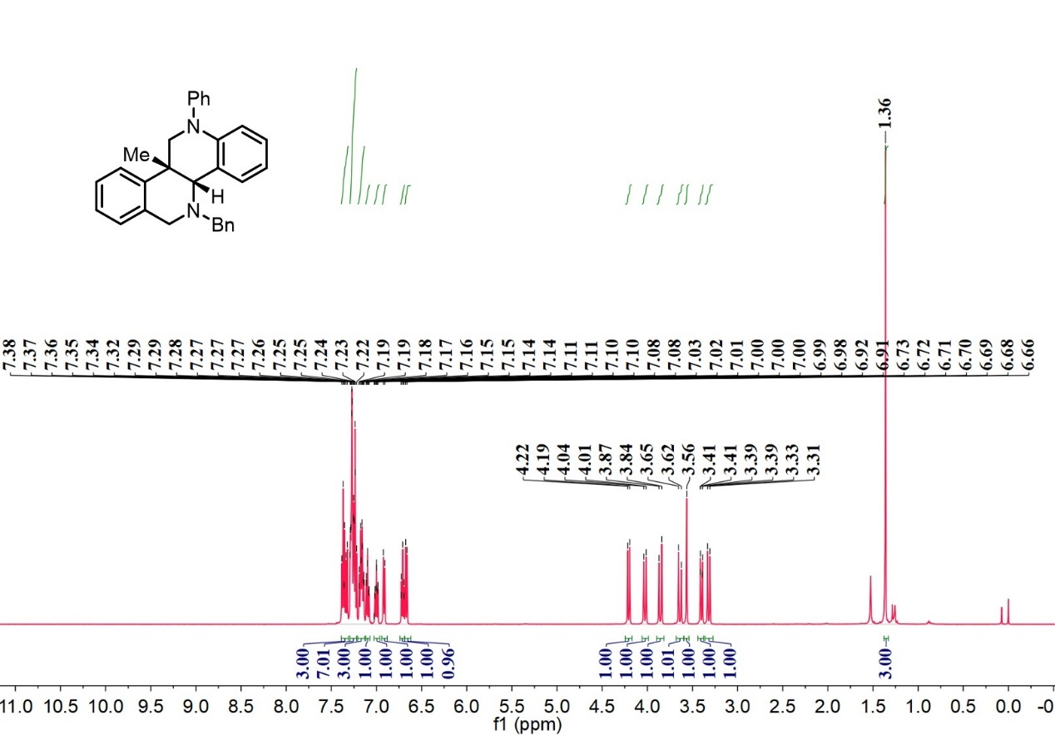

¹³C-NMR spectrum of D₂₅

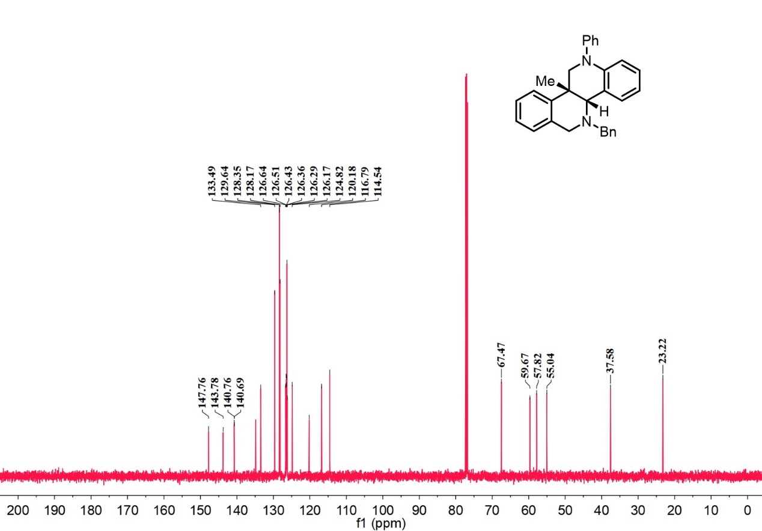
¹H-NMR spectrum of D₂₆

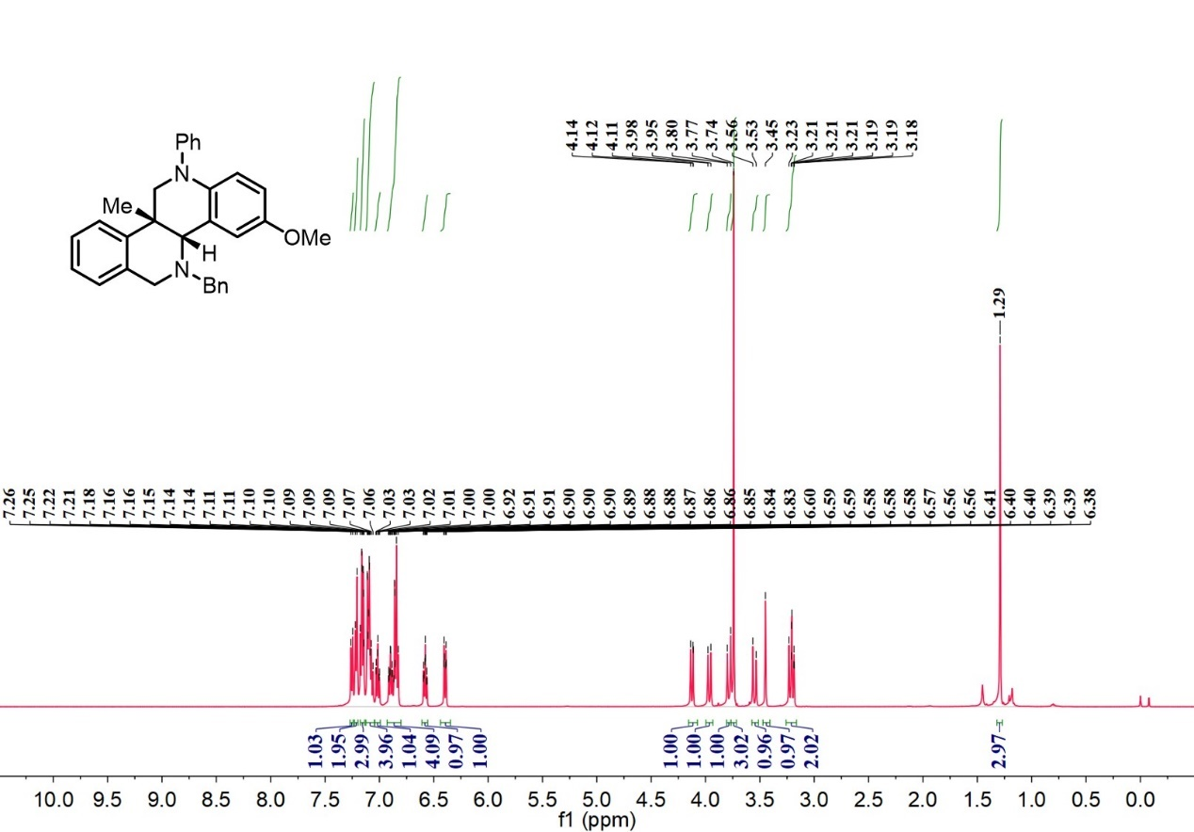

¹³C-NMR spectrum of D₂₆

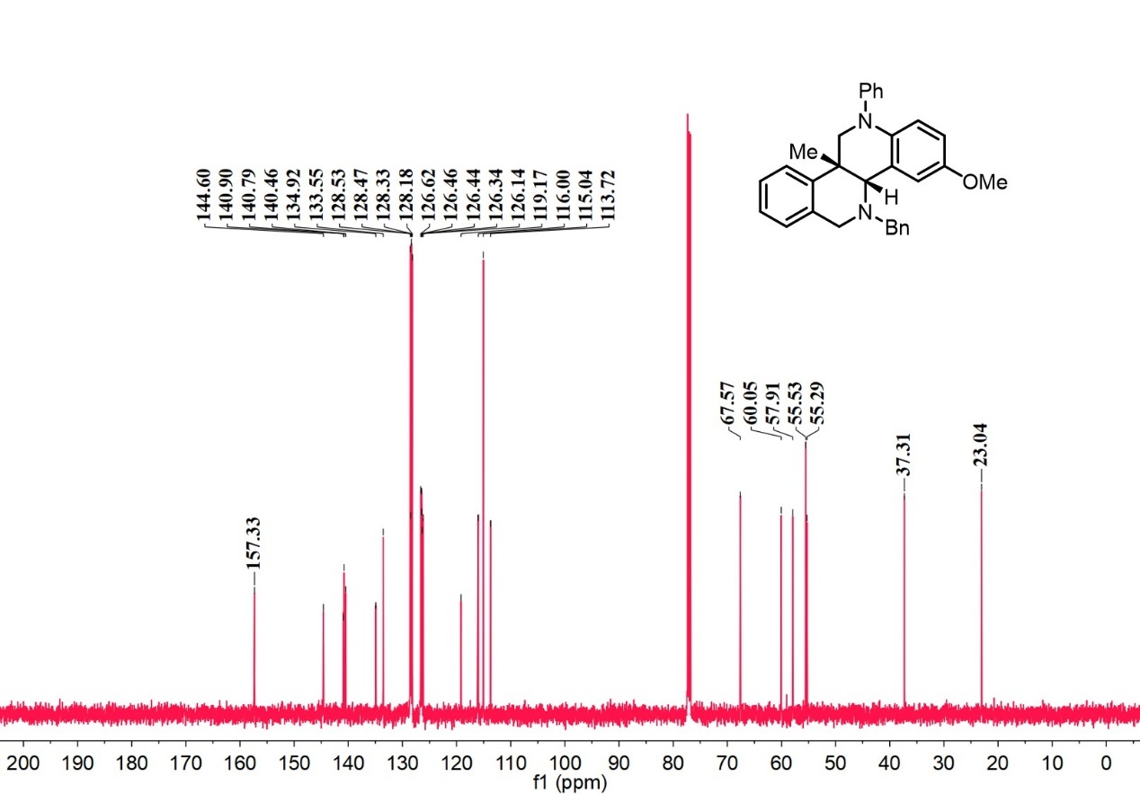
¹H-NMR spectrum of D₂₇

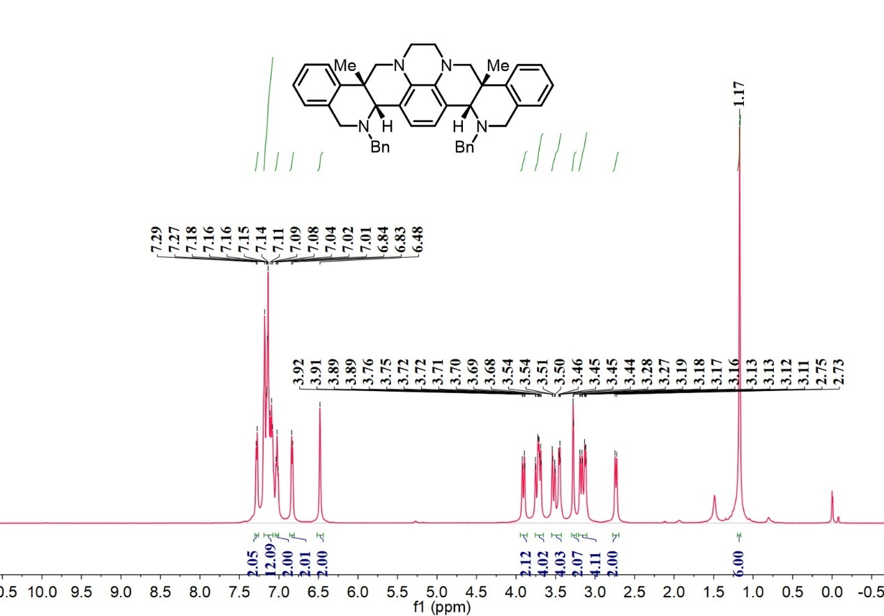

¹³C-NMR spectrum of D₂₇

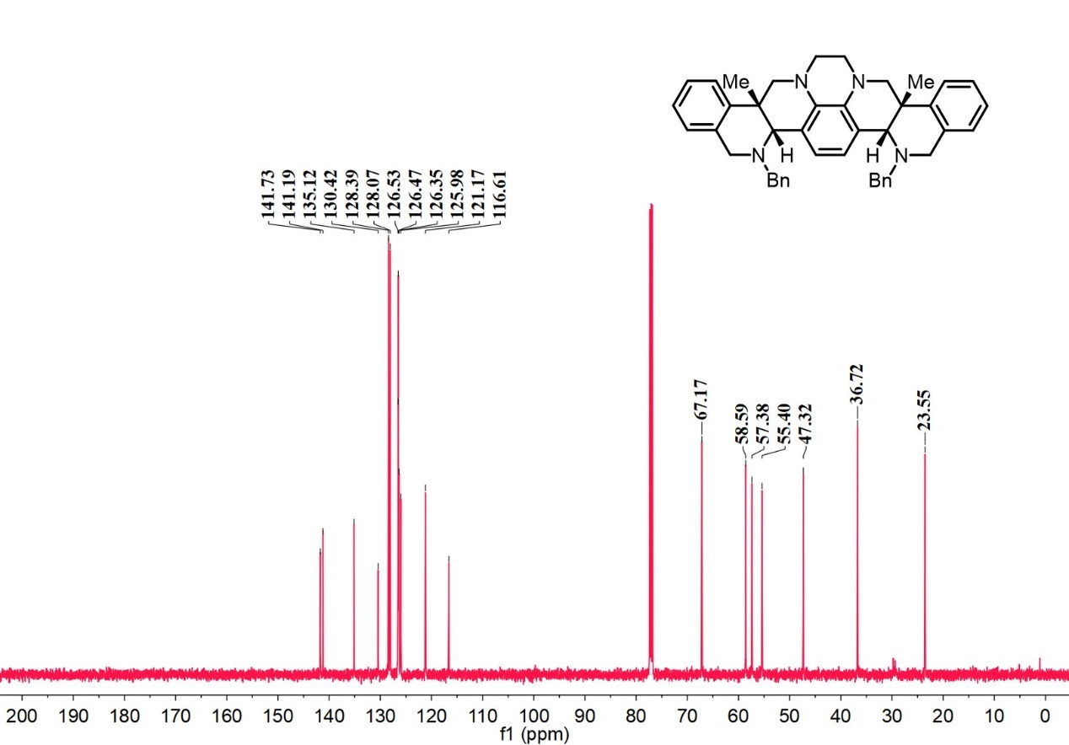
¹H-NMR spectrum of D₂₈

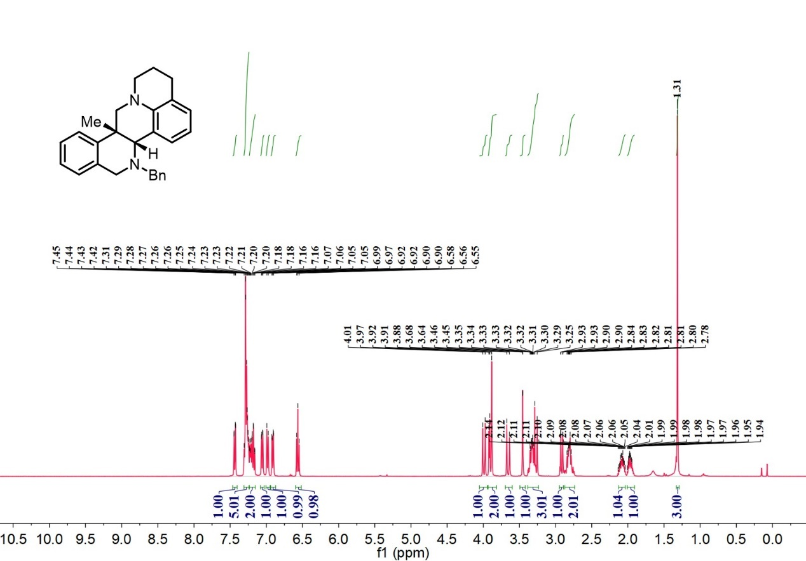

¹³C-NMR spectrum of D₂₈

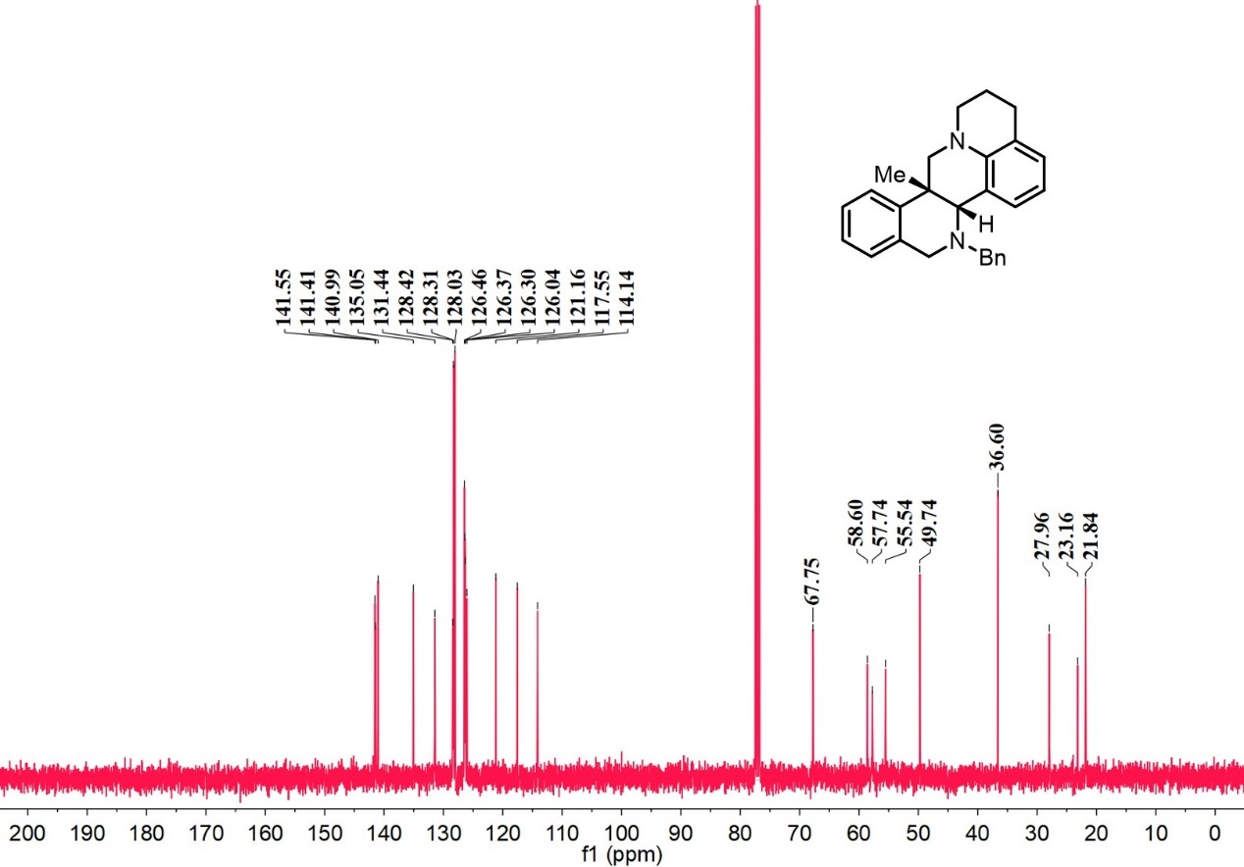
¹H-NMR spectrum of D₂₉

¹³C-NMR spectrum of D₂₉

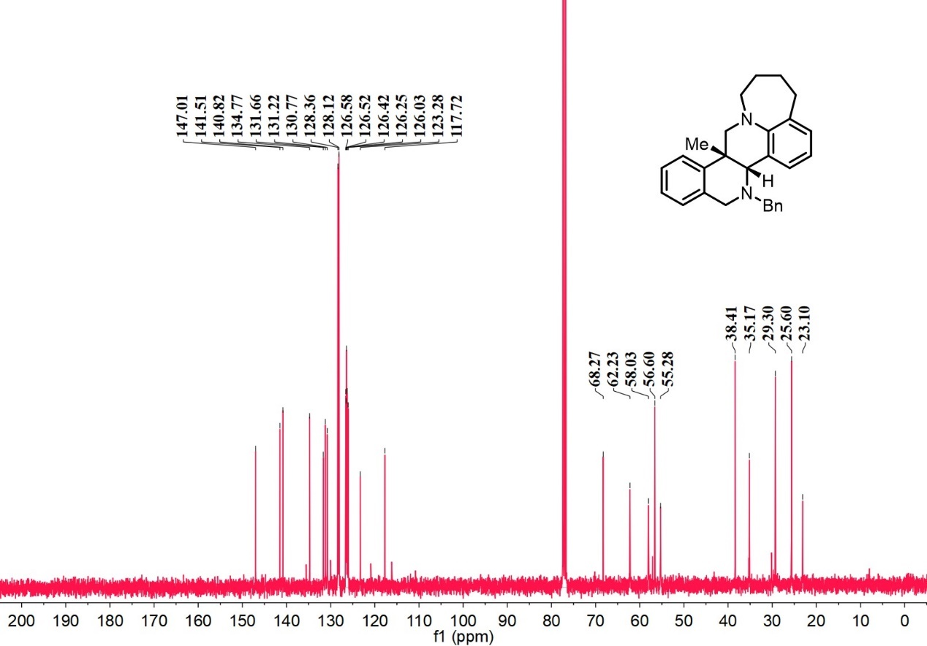
¹H-NMR spectrum of D₃₀

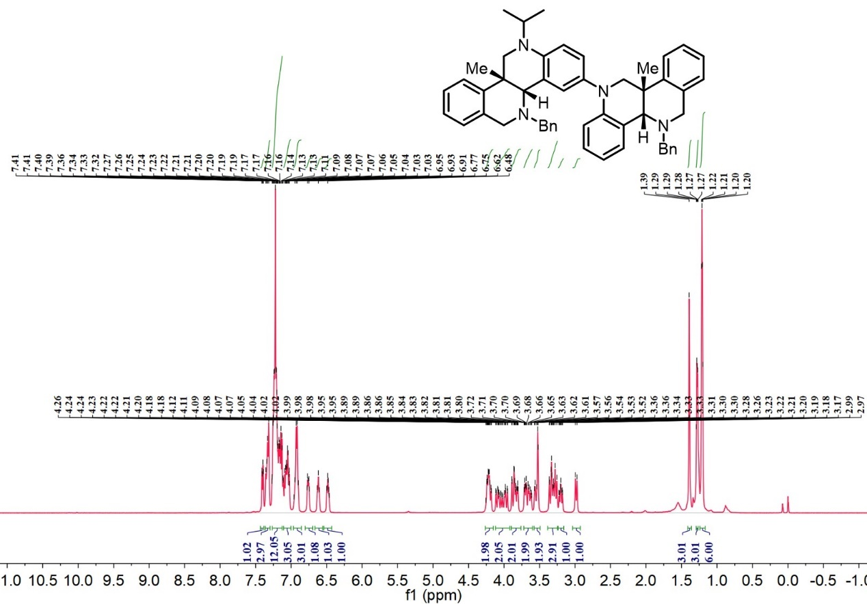

¹³C-NMR spectrum of D₃₀

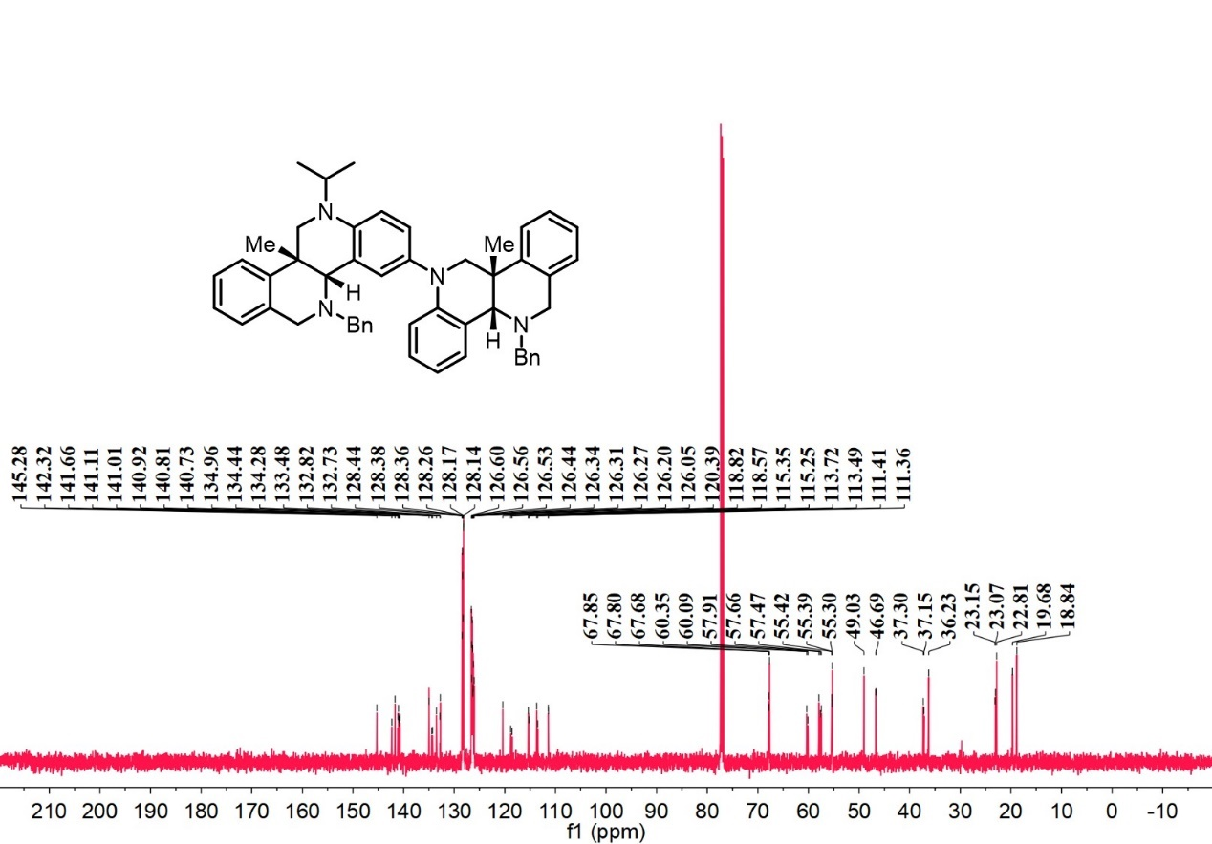
¹H-NMR spectrum of D₃₁

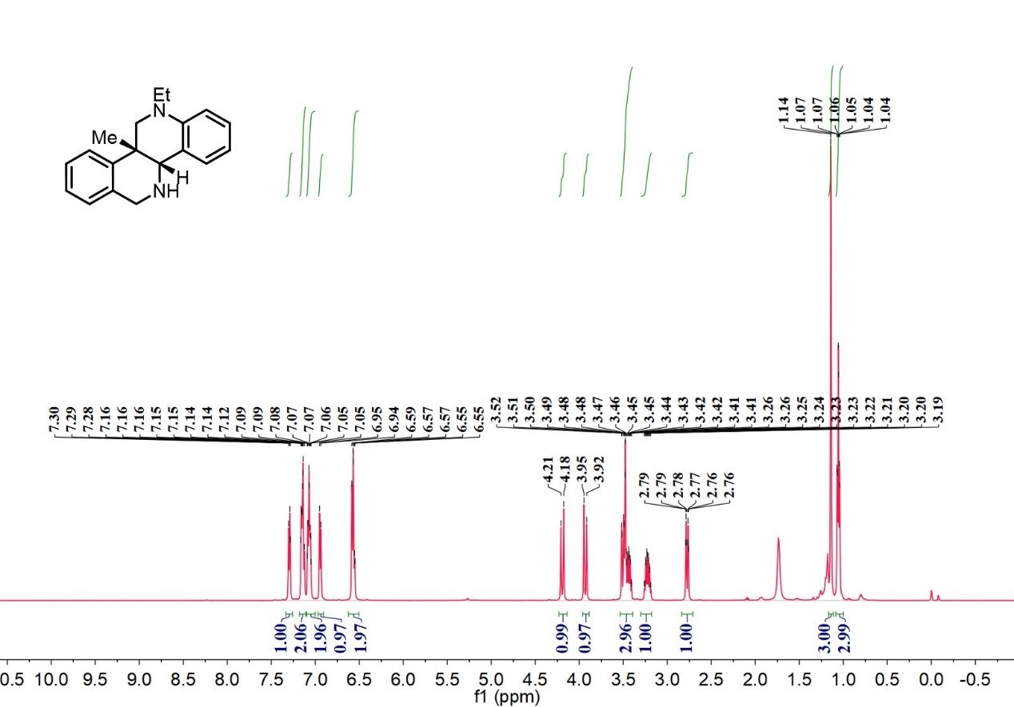

¹³C-NMR spectrum of D₃₁

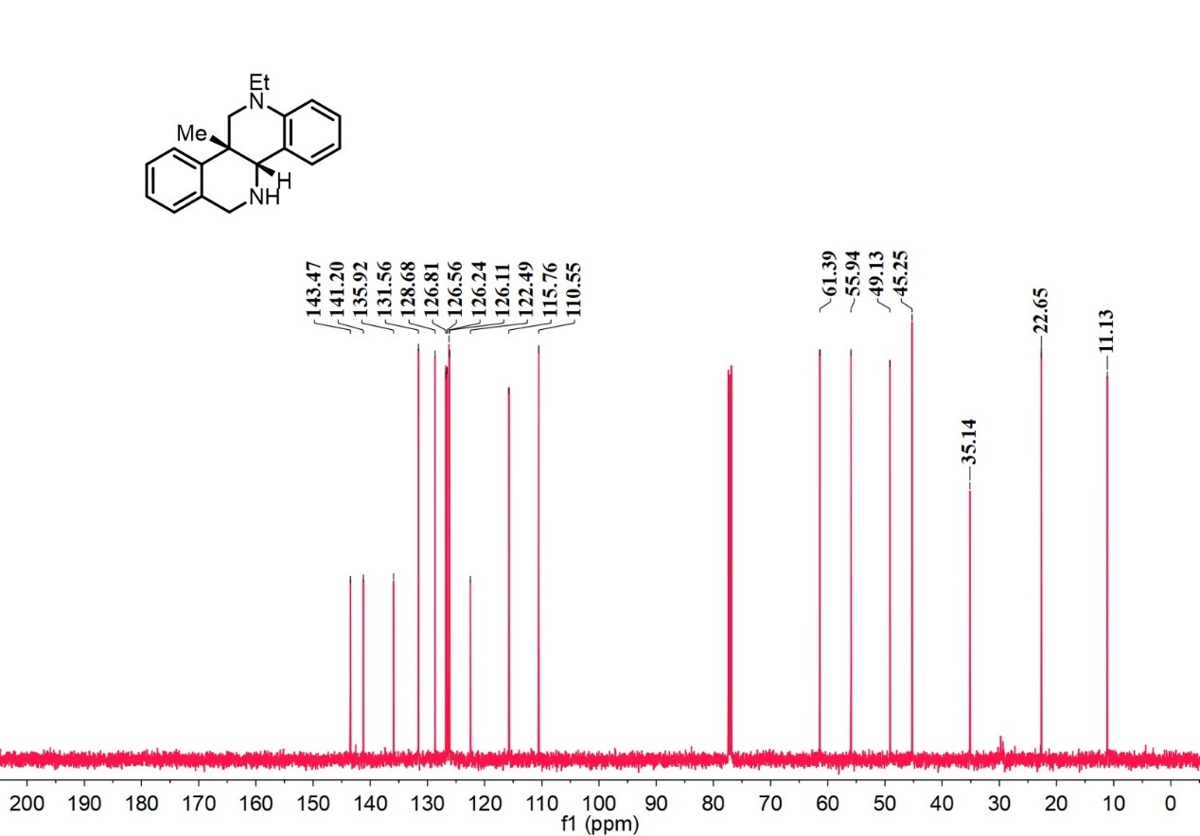

¹H-NMR spectrum of int-1

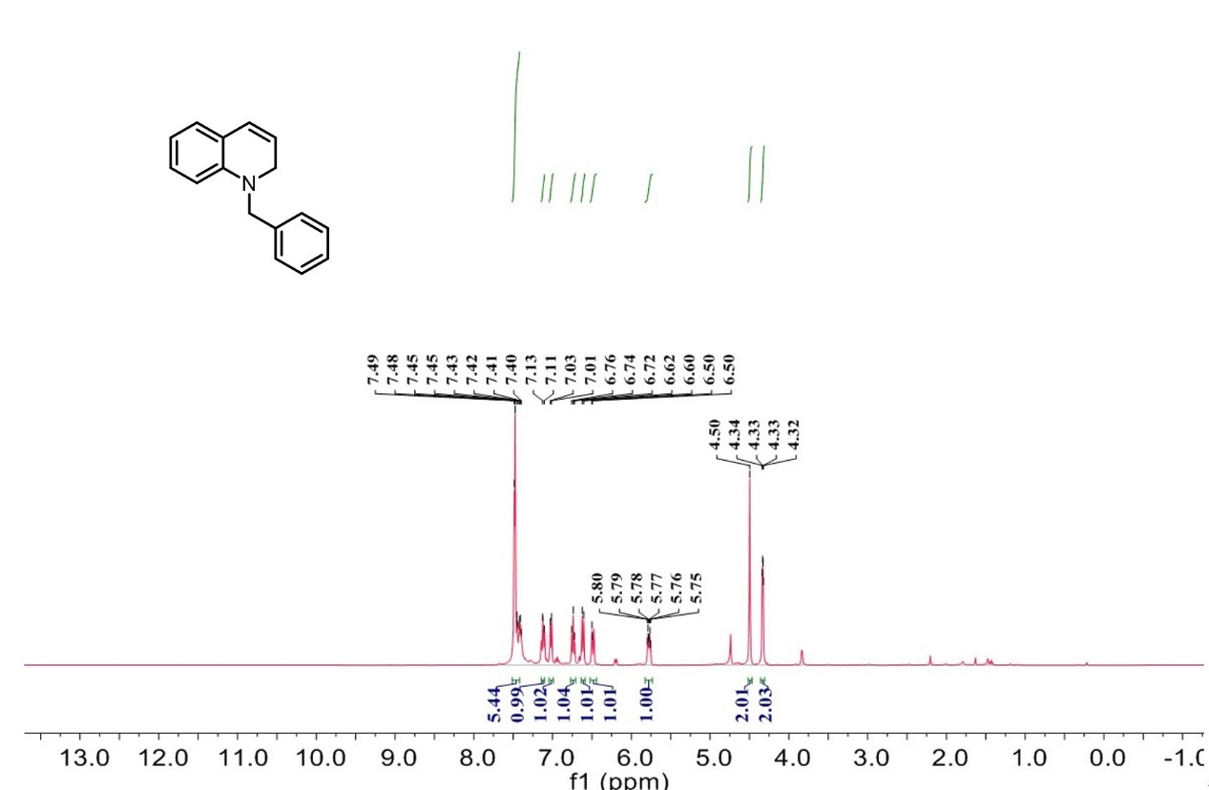

¹³C-NMR spectrum of int-1

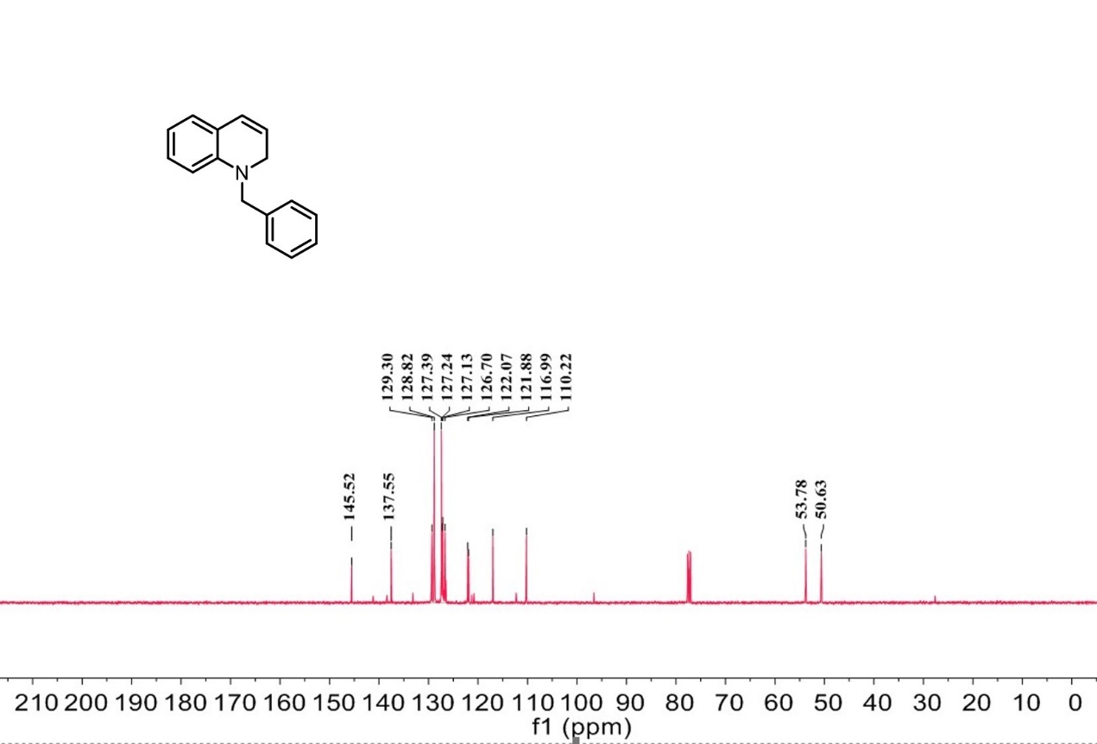

¹H-NMR spectrum of int-6

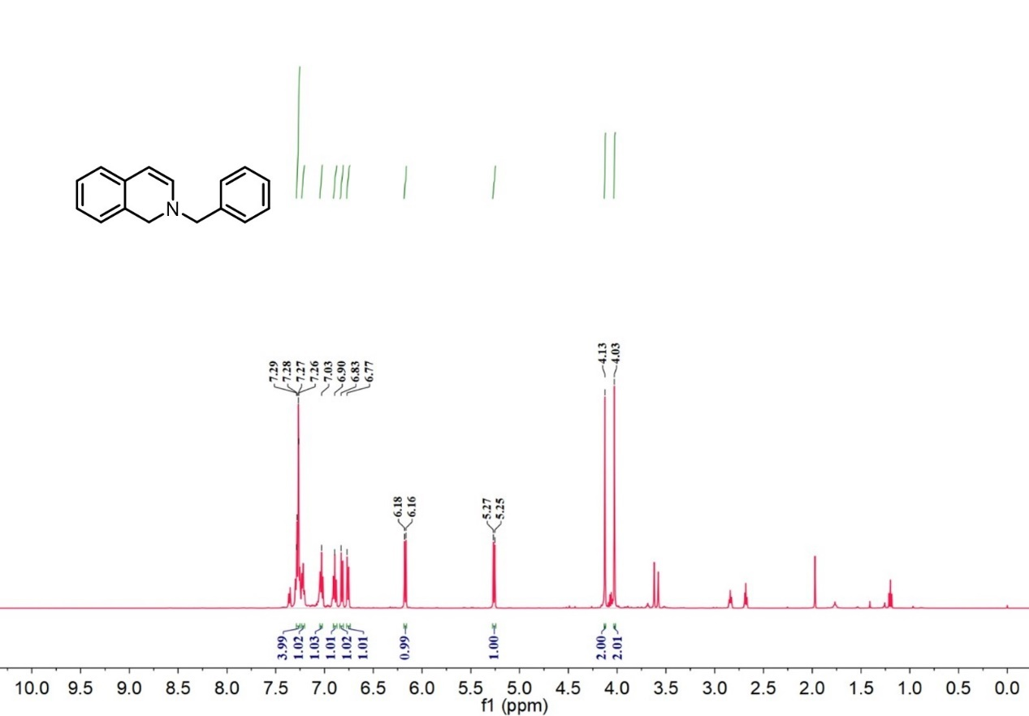

¹³C-NMR spectrum of int-6

