Supplementary materials to:
Increasing clinical utility of prenatal exome sequencing: the potential power of Artificial Intelligence phenotype-driven analysis
Maayke A. de Koning¹, Mariëtte J.V. Hoffer¹, Alexander J.M. Dingemans², Ilse Feenstra², Malou Heijligers³, Dineke Westra², Helger G. Yntema², Galuh D.N. Astuti², Mariet W. Elting⁴, Mariëlle E. van Gijn⁴, Quinten Waisfisz⁴, Nicole Corsten-Janssen⁵, Birgit Sikkema-Raddatz⁵, Andrea C. Postmus⁵, Klaske D. Lichtenbelt⁶, Ellen van Binsbergen⁶, Hanneke W.M. van Deutekom⁶, Mar Rodriguez Girondo⁷, Rocio Acuna-Hidalgo⁸, Gijs W.E. Santen¹, Manon Suerink¹

- Department of Clinical Genetics, Leiden University Medical Center, Leiden, the Netherlands
- Department of Human Genetics, Radboud university nijmegen medical center, Nijmegen, The Netherlands
- Department of Clinical Genetics, Maastricht University Medical Centre, Maastricht, The Netherlands
- Department of Human Genetics, Amsterdam University Medical Center, Amsterdam, The Netherlands
- Department of Genetics, University Medical Center Groningen, University of Groningen, Groningen, The Netherlands
- Department of Genetics, Utrecht University Medical Center, Utrecht, the Netherlands.
- Department of Biomedical Data Sciences, Leiden University Medical Center, Leiden, the Netherlands
- Nostos Genomics GmbH, Berlin, Germany.
Table of contents
Methods genetic diagnostics 2
Methods genetic diagnostics University Medical Centre Groningen (UMCG) 2
Methods genetic diagnostics Radboud university medical centre (Radboudumc) and Maastricht University Medical Centre (MUMC) 2
Methods genetic diagnostics University Medical Centre Utrecht (UMCU) 3
Methods genetic diagnostics AmsterdamUMC 3
Methods genetic diagnostics Leiden University Medical Centre (LUMC) 3
Table S1: Details on phenotype and AI-driven analyses of all cases 5
Table S2: Number of variants identified per analysis method 20
Figure S1: Flowchart of patient inclusion 21
Figure S2: Mosaic KRAS variant in case 105 22
Figure S3: Secondary analysis of the effect of newer releases of the AI software on the total number of prioritized variants, divided by different parameters 23
References 25

Methods genetic diagnostics

Methods genetic diagnostics University Medical Centre Groningen (UMCG)
Fetal DNA was derived from chorionic villi or amniotic fluid and parental DNA was derived from blood according to standard diagnostic procedures. Fetal and parental DNA were prepared for WES using SureSelect Human All Exon V7 (Agilent) target enrichment on the Magnis NGS Prep System (Agilent) followed by sequencing on a NextSeq500 sequencer (Illumina) aiming for 20x coverage for 95% of the target genes.
Raw WES data was processed by our in-house developed pipeline, as previously described¹. The resulting VCF files were uploaded in Alissa NGS-Bench Lab software (Agilent) and analyzed using a virtual gene panel of monogenic diseases based on approximately 5042 genes from the Clinical Genomics Database² and Online Mendelian Inheritance in Man (OMIM)³. Genes associated with late-onset diseases were removed. Variants in the gene panel were filtered using an in-house developed filter tree based on multiple parameters, including quality, an in-house generated database, allele frequencies from GnomAD, Human Gene Mutation Database (HGMD), ClinVar, GAVIN (Gene-Aware Variant Interpretation)⁴, functional effect predictions, conservation scores and inheritance modes.
Variants remaining after these filtering steps were evaluated by the operating technician and a genetic laboratory specialist using the Alamut Batch software (Interactive Biosoftware). Classifications of variants was largely based on American College of Medical Genetics and Genomics (ACMG)⁵ guidelines. Only variants classified as “pathogenic”(P, class 5) and “likely pathogenic”(LP, class 4) were communicated to parents. “Variants of uncertain significance” (VUS, class 3) were only communicated if it seemed to fit the fetal phenotype after consulting the clinical geneticist.

Methods genetic diagnostics Radboud university medical centre (Radboudumc) and Maastricht University Medical Centre (MUMC)
Exome sequencing was performed as described before⁶, with some slight modifications. DNA samples were sheared using a Covaris R230 ultrasonicator (Covaris), followed by exome capture using the Twist Human Exome + RefSeq Panel or the Twist Exome 2.0 plus Comprehensive Exome Spike-in Kit (Twist Bioscience). For all samples, 2 × 150-basepair (bp) paired-end sequencing on a Illumina NovaSeq 6000 (Illumina) short-read sequencing platform was performed. Downstream processing, read alignment, SNV calling, and CNV calling was performed as previously described^{7, 8} via an custom-made inhouse developed sequence analysis pipeline. A minimum read depth of 20× was achieved for over 95% of the targeted regions, with an average coverage of 80×. Whenever possible, libraries from both the fetus and parents were sequenced concurrently to facilitate optimal data interpretation. In instances where DNA from one or both parents was unavailable, sequencing was performed solely on the fetal sample.
Analysis and interpretation of single nucleotide variants (SNVs) and (CNVs) present in the gene panel(s) of interest were analyzed was executed as described by Faas et al⁹; variants in genes outside these panels were bioinformatically filtered out.

Methods genetic diagnostics University Medical Centre Utrecht (UMCU)
Whole Exome Sequencing (WES) was performed on DNA isolated from either amnion fluid cells or chorion biopsy cells. Enrichment was performed with the Agilent SureSelect Human All Exon V7 kit, sequence data was obtained on an Illumina 150bp paired-end sequencing on a NovaSeq6000 platform. Sequence data is produced of all protein coding exons of the genes within a panel including 20 base pairs flanking the exon intron boundaries. Coverage of a gene or gene panel is calculated by an inhouse developed software on the bases of a minimal coverage of 15x unique sequence reads for the protein coding exons. As part of a gene panel analysis, different modes of inheritance ar analyzed; in a trio analyses parents are included in the analyses and segregation of a variant can be determined.
Used software and databases ; BWA alignment¹⁰, GATK HaplotypeCaller¹¹, Exomedepth, Alissa Interpret, HGMD professional. Alamut Visual, GnomAD, ClinVar, VKGL-database, IGV, UCSC genome browser, Decipher, Database of Genomic Variants. Samples checked for DNA contamination (like maternal cell contamination) by a bioinformatic analyses.

Methods genetic diagnostics AmsterdamUMC
Trio WES was performed using KAPA HyperPlus ERAT+ kit for library preparation, KAPA HyperExome (Roche) for target enrichment and 150 bp paired-end sequencing on an Illumina Sequencer (NextSeq 2000, Novaseq6000 or NovaseqXplus). An in-house WES pipeline has been developed and improved over the years (RoDa v5) to perform variant calling conforming the GATK Best Practice DNAseq workflow. The pipeline starts with the preprocessing of sequence data (FASTQ files) which includes 1) mapping the sequenced reads against the human reference genome (GRCh37/hg19) using the Burrows-Wheeler Aligner (BWA v0.7.10)¹⁰, 2) duplicate marking using samblaster (v0.1.22) and 3) samtools (v1.10) to generate BAM files. The preprocessing is finalized by performing the Local Realignment Around Indels and Base Quality Score Recalibration (BQSR) using the GenomeAnalysisToolKit (GATK v3.3-0)¹¹ producing analysis ready BAM files. The analysis ready BAM files are necessary to perform the variant calling analysis and process the data further with GATK to generate VCF files with the called variants. The 30x coverage of the exome was >90% for all samples. Variants were filtered and annotated using Alissa Interpret software (Agilent) and prioritized based in their presence in specific preselected gene sets, mode of inheritance (de novo autosomal dominant, autosomal recessive, X-linked recessive), the associated disorder with the respective gene in relation to the observed phenotype of the fetus, and the molecular classification of the variants.

Methods genetic diagnostics Leiden University Medical Centre (LUMC)
DNA was fragmented into 200 to 500 bp fragments by means of Adaptive Focused Acoustics (Covaris Inc, Woburn, USA) shearing according to the manufacturer's protocol. Exomes were captured using the Clinical Research Exome v2 capture library kit (Agilent, Santa Clara, USA) accompanied by Illumina paired end Sequencing on an Illumina platform (Illumina, San Diego, USA), generating 2 × 150 bp paired end reads with at least 80x median coverage. The exome sequencing protocol was validated for clinical use according to ISO 15189.
An in-house sequence analysis pipeline (Modular GATK-Based Variant Calling Pipeline, MAGPIE) based on read alignment using Burrows-Wheeler Alignment (BWA-MEM) and variant calling using the Genome Analysis Toolkit (GATK) Haplotype Caller¹¹ and UnifiedGenotyper¹² was used to align reads and call variants on the generated BAM files. Different software packages are used for further analysis of variants. Variants were subsequently annotated using the Variant Effect Predictor¹³. Included annotation fields were, amongst others, variant consequence, sift scores, polyphen scores, CADD scores, and allele frequencies in the 1000 Genomes populations. An in-house developed tool additionally annotated variants using dbSNP132, gnomAD allele frequencies, and the Genome of the Netherlands frequencies (GoNL). After annotation, variants with an allele frequency of > 5% in the Genome of the Netherlands or in the 1000 Genomes project were excluded from further interpretation. More recent, the DRAGEN Germline Pipeline is used for alignment and variant calling. MOON software (Diploid, Leuven, Belgium) of Franklin (Genoox) was used for interpretation of variants, employing an HPO-term driven analysis and optionally gene panel analysis. Variants were then classified according to ACMG guidelines¹⁴.

Table S1: Details on phenotype and AI-driven analyses of all cases
Case nr | AI Version | Date of analysis | Nr of HPO-terms | HPO-terms | Total nr prioritized variants | Non- corresponding inheritance | Low quality | Not matching the phenotype / No IF | IF | LB / B matching the phenotype | VUS matching the phenotype | LP / P matching the Phenotype
1 | 3 | 03-01-2023 | 2 | Biliary atresia HP:0005912, Aplasia/Hypoplasia of the gallbladder HP:0011466 | 7 | 2 | 4 | 1 | 0 | 0 | 0 | 0
2 | 9 | 07-02-2023 | 1 | Agenesis of corpus callosum HP:0001274 | 26 | 8 | 16 | 1 | 0 | 0 | 0 | 1
3 | 9 | 14-02-2023 | 2 | Aplasia/Hypoplasia of the corpus callosum HP:0007370, Blake's pouch cyst HP:0033140 | 18 | 4 | 9 | 5 | 0 | 0 | 0 | 0
4 | 10 | 28-02-2023 | 2 | Cleft lip HP:0410030, Cleft palate HP:0000175 | 16 | 5 | 9 | 2 | 0 | 0 | 0 | 0
5 | 10 | 28-02-2023 | 2 | Tetralogy of Fallot HP:0001636, Short fetal femur length HP:0011428 | 7 | 2 | 1 | 4 | 0 | 0 | 0 | 0
6 | 24 | 10-07-2023 | 3 | Cleft lip HP:0410030, Unilateral cleft lip HP:0100333, Cleft palate HP:0000175 | 17 | 5 | 7 | 5 | 0 | 0 | 0 | 0
7 | 12 | 20-03-2023 | 6 | Urethral obstruction HP:0000796, Single umbilical artery HP:0001195, Hyperechogenic kidneys HP:0004719, Urethral valve HP:0010481, Fetal megacystis HP:0010956, Bilateral fetal pyelectasis HP:0011129 | 8 | 2 | 4 | 2 | 0 | 0 | 0 | 0
8 | 12 | 22-03-2023 | 4 | Edema HP:0000969, Intellectual disability HP:0001249, Hydrops fetalis HP:0001789, Increased nuchal translucency HP:0010880 | 16 | 3 | 5 | 7 | 0 | 1 | 0 | 0
9 | 12 | 28-03-2023 | 8 | Abnormal rectum morphology HP:0002034, Abnormal intestine morphology HP:0002242, Abnormal sacrum morphology HP:0005107, Anterior sacral meningocele HP:0007293, Presacral teratoma HP:0009793, Sacrococcygeal teratoma HP:0030736, Presacral ganglioneuroma HP:0031455, Pelvic mass HP:0031501 | 21 | 5 | 9 | 7 | 0 | 0 | 0 | 0
10 | 12 | 28-03-2023 | 6 | Abnormal sternum morphology HP:0000766, Abnormality of skeletal maturation HP:0000927, Sternal punctate calcifications HP:0006637, Abnormal musculoskeletal physiology HP:0011843, Abnormal sternal ossification HP:0011863, Dysharmonic accelerated bone age HP:0200001 | 15 | 3 | 9 | 2 | 0 | 0 | 0 | 1
11 | 13 | 24-04-2023 | 3 | Orofacial cleft HP:0000202, Cleft upper lip HP:0000204, Cleft lip HP:0410030 | 13 | 2 | 5 | 4 | 0 | 1 | 1 | 0
12 | 14 | 10-05-2024 | 3 | Microcephaly HP:0000252, Growth abnormality HP:0001507, Intrauterine growth retardation HP:0001511 | 16 | 2 | 9 | 5 | 0 | 0 | 0 | 0
13 | 14 | 10-05-2023 | 3 | Hydrocephalus HP:0000238, Macrocephaly HP:0000256, Abnormal cerebral ventricle morphology HP:0002118 | 11 | 4 | 1 | 5 | 0 | 1 | 0 | 0
14 | 14 | 15-05-2023 | 3 | Orofacial cleft HP:0000202, Cleft upper lip HP:0000204, Cleft lip HP:0410030 | 14 | 4 | 5 | 5 | 0 | 0 | 0 | 0
15 | 24 | 06-07-2023 | 3 | Hypoglycemia HP:0001943, Meconium ileus HP:0004401, Intestinal obstruction HP:0005214 | 12 | 6 | 1 | 5 | 0 | 0 | 0 | 0
16 | 24 | 06-07-2023 | 6 | Intellectual disability HP:0001249, Intrauterine growth retardation HP:0001511, Cardiomegaly HP:0001640, Aplasia/Hypoplasia of the corpus callosum HP:0007370, Echogenic intracardiac focus HP:0010942, Interhemispheric cyst HP:0032327 | 9 | 1 | 4 | 3 | 0 | 1 | 0 | 0
17 | 24 | 10-07-2023 | 4 | Abnormal sternum morphology HP:0000766, Intrauterine growth retardation HP:0001511, Short long bone HP:0003026, Childhood onset short-limb short stature | 14 | 4 | 5 | 4 | 0 | 0 | 0 | 1
18 | 24 | 12-07-2023 | 3 | Thickened nuchal skin fold HP:0000474, Intrauterine growth retardation HP:0001511, Fetal cystic hygroma HP:0010878 | 21 | 8 | 7 | 5 | 0 | 1 | 0 | 0
19 | 26 | 03-08-2023 | 5 | Abnormal corpus callosum morphology HP:0001273, Hydrops fetalis HP:0001789, Pleural effusion HP:0002202, Intracranial cystic lesion HP:0010576, Mild fetal ventriculomegaly HP:0010952 | 26 | 6 | 11 | 6 | 0 | 0 | 1 | 2
20 | 26 | 03-08-2023 | 1 | Tetralogy of fallot HP:0001636 | 14 | 3 | 4 | 6 | 0 | 1 | 0 | 0
21 | 26 | 03-08-2023 | 2 | Hypoplastic right heart HP:0010954, Hypoplastic heart HP:0001961 | 30 | 8 | 10 | 12 | 0 | 0 | 0 | 0
22 | 26 | 03-08-2023 | 3 | Foetal choroid plexus cysts HP:0011426, Echogenic intracardiac focus HP:0010942, Fetal ultrasound soft marker HP:0011425 | 15 | 4 | 3 | 7 | 0 | 1 | 0 | 0
23 | 28 | 24-08-2023 | 2 | Intrauterine growth retardation HP:0001511, Aplasia/hypoplasia of the cerebrum HP:0007364 | 12 | 2 | 4 | 3 | 0 | 2 | 0 | 1
24 | 28 | 24-08-2023 | 2 | Increased nuchal translucency HP:0010880, Intellectual disability HP:0001249 | 20 | 4 | 8 | 6 | 0 | 2 | 0 | 0
25 | 28 | 24-08-2023 | 2 | Aortic valve stenosis HP:0001650, Hypoplastic left heart HP:0004383 | 13 | 2 | 3 | 7 | 0 | 1 | 0 | 0
26 | 28 | 24-08-2023 | 4 | Ventriculomegaly HP:0002119, Intrauterine growth retardation HP:0001511, Congenital heart defect HP:0001627, Hypoplastic corpus callosum HP:0002079 | 7 | 1 | 2 | 1 | 0 | 1 | 0 | 2
27 | 28 | 24-08-2023 | 2 | Congenital heart defects HP:0001627, Single umbilical artery HP:0001195 | 10 | 5 | 0 | 3 | 0 | 2 | 0 | 0
28 | 31 | 21-09-2023 | 3 | Abnormal corpus callosum morphology HP:0001273, Neurodevelopmental abnormality HP:0012759, Congenital cystic adenomatoid malformation of the lung HP:0010959 | 14 | 2 | 2 | 9 | 0 | 1 | 0 | 0
29 | 31 | 21-09-2023 | 1 | Increased nuchal translucency HP:0010880 | 15 | 4 | 5 | 5 | 0 | 1 | 0 | 0
30 | 31 | 21-09-2023 | 4 | Wide metaphyses HP:0003016, Hypoplastic ribs HP:0000773, Short tubular bones HP:0003026, Abnormal heart morphology HP:0001627 | 11 | 4 | 4 | 1 | 0 | 0 | 0 | 2
31 | 31 | 21-09-2023 | 2 | Increased nuchal translucency HP:0010880, Ventricular septal defect HP:0001629 | 16 | 2 | 12 | 2 | 0 | 0 | 0 | 0
32 | 31 | 21-09-2023 | 3 | Increased nuchal translucency HP:0010880, Dilatation of the bladder HP:0010955, Renal cyst HP:0000107 | 22 | 2 | 8 | 11 | 0 | 0 | 0 | 1
33 | 31 | 26-09-2023 | 1 | Unilateral renal agenesis HP:0000122 | 9 | 1 | 0 | 8 | 0 | 0 | 0 | 0
34 | 31 | 26-09-2023 | 1 | Ventricular septal defect HP:0001629 | 21 | 1 | 6 | 13 | 0 | 0 | 0 | 1
35 | 31 | 26-09-2023 | 2 | Hemangioma HP:0001028, Teratoma HP:0009792 | 36 | 6 | 16 | 14 | 0 | 0 | 0 | 0
36 | 31 | 26-09-2023 | 3 | Craniosynostosis HP:0001363, Choroid plexus cyst HP:0002190, Encephalocele HP:0002084 | 9 | 1 | 1 | 7 | 0 | 0 | 0 | 0
37 | 32 | 02-10-2023 | 3 | Ventriculomegaly HP:0002119, Pericardial effusion HP:0001698, Abnormal cerebral morphology HP:0002060 | 10 | 7 | 0 | 2 | 0 | 1 | 0 | 0
38 | 32 | 02-10-2023 | 1 | Mild fetal ventriculomegaly HP:0010952, Ventriculomegaly HP:0002119, Abnormality of brain morphology HP:0012443 | 11 | 4 | 2 | 3 | 0 | 1 | 0 | 1
39 | 32 | 02-10-2023 | 2 | Thickened nuchal skin fold HP:0000474, Abnormality of the lymphatic system HP:0100763 | 7 | 2 | 0 | 5 | 0 | 0 | 0 | 0
40 | 32 | 02-10-2023 | 1 | Intrauterine growth retardation HP:0001511 | 7 | 4 | 1 | 2 | 0 | 0 | 0 | 0
41 | 32 | 02-10-2023 | 4 | Hydronephrosis HP:0000126, Aplasia/hypoplasia of the corpus callosum HP:0007370, Atrial septal defect HP:0001631, Tetralogy of fallot HP:0001636 | 9 | 0 | 0 | 9 | 0 | 0 | 0 | 0
42 | 34 | 16-10-2023 | 2 | Intrauterine growth retardation HP:0001511, Short fetal femur length HP:0011428 | 13 | 4 | 0 | 9 | 0 | 0 | 0 | 0
43 | 34 | 16-10-2023 | 6 | Thickened nuchal skin fold HP:0000474, Single umbilical artery HP:0001195, Aplasia/hypoplasia involving forearm bones HP:0006503, Abnormal heart morphology HP:0001627, Abnormality of the lymphatic system HP:0100763, Aplasia/hypoplasia involving bones of the extremities HP:0045060 | 10 | 1 | 4 | 4 | 0 | 1 | 0 | 0
44 | 34 | 16-10-2023 | 3 | Tetralogy of fallot HP:0001636, Right aortic arch HP:0012020, Abnormal heart morphology HP:0001627 | 11 | 2 | 1 | 7 | 0 | 1 | 0 | 0
45 | 34 | 16-10-2023 | 4 | Dextrocardia HP:0001651, Abnormal atrioventricular connection HP:0011546, Abnormal pulmonary artery morphology HP:0030966, Double outlet right ventricle HP:0001719 | 11 | 1 | 2 | 8 | 0 | 0 | 0 | 0
46 | 34 | 16-10-2023 | 4 | Talipes equinovarus HP:0001762, Tricuspid regurgitation HP:0005180, Intracranial cystic lesion HP:0010576, Abnormality of the fetal cardiovascular system HP:0010948 | 14 | 0 | 1 | 12 | 0 | 0 | 0 | 1
47 | 34 | 16-10-2023 | 3 | Hypoplastic right heart HP:0010954, Double inlet left ventricle HP:0011555, Abnormal heart morphology HP:0001627 | 10 | 0 | 1 | 7 | 0 | 2 | 0 | 0
48 | 34 | 16-10-2023 | 2 | Cystic hygroma HP:0000476, Abnormality of the lymphatic system HP:0100763 | 12 | 4 | 2 | 6 | 0 | 0 | 0 | 0
49 | 37 | 02-11-2023 | 2 | Transposition of the great arteries HP:0001669, Coarctation of aorta HP:0001680 | 12 | 3 | 0 | 9 | 0 | 0 | 0 | 0
50 | 37 | 02-11-2023 | 1 | Talipes equinovarus HP:0001762 | 10 | 3 | 0 | 7 | 0 | 0 | 0 | 0
51 | 37 | 02-11-2023 | 2 | Renal cyst HP:0000107, Pericardial effusion HP:0001698 | 6 | 2 | 1 | 2 | 0 | 1 | 0 | 0
52 | 38 | 09-11-2023 | 1 | Cleft lip HP:0410030 | 10 | 3 | 2 | 4 | 0 | 1 | 0 | 0
53 | 38 | 09-11-2023 | 2 | Cleft palate HP:0000175, Cleft upper lip HP:0000204 | 14 | 2 | 0 | 12 | 0 | 0 | 0 | 0
54 | 38 | 09-11-2023 | 2 | Ventricular septal defect HP:0001629, Subarterial ventricular septal defect HP:0011681 | 11 | 3 | 0 | 8 | 0 | 0 | 0 | 0
55 | 38 | 09-11-2023 | 3 | Microcephaly HP:0000252, Intrauterine growth retardation HP:0001511, Persistent left superior vena cava HP:0005301 | 9 | 2 | 0 | 6 | 0 | 1 | 0 | 0
56 | 38 | 09-11-2023 | 1 | Talipes HP:0001883 | 8 | 1 | 1 | 6 | 0 | 0 | 0 | 0
57 | 51 | 26-02-2024 | 2 | Distal arthrogryposis HP:0005684, Abnormality of limbs HP:0040064 | 9 | 0 | 1 | 8 | 0 | 0 | 0 | 0
58 | 51 | 26-02-2024 | 1 | Aplasia/Hypoplasia of the lungs HP:0006703 | 16 | 4 | 2 | 7 | 1 | 1 | 1 | 0
59 | 51 | 26-02-2024 | 2 | Microcephaly HP:0000252, Single umbilical artery HP:0001195 | 9 | 1 | 3 | 4 | 0 | 0 | 1 | 0
60 | 38 | 09-11-2023 | 1 | Abnormal ventricular septum morphology HP:0010438 | 15 | 2 | 2 | 9 | 0 | 1 | 0 | 1
61 | 51 | 26-02-2024 | 3 | Cerebellar hypoplasia HP:0001321, Ventriculomegaly HP:0002119, Mild fetal ventriculomegaly HP:0010952 | 11 | 3 | 1 | 7 | 0 | 0 | 0 | 0
62 | 51 | 26-02-2024 | 6 | Cystic hygroma HP:0000476, Congenital diaphragmatic hernia HP:0000776, Abnormality of prenatal development or birth HP:0001197, Abnormal cerebellum morphology HP:0001317, Abnormal heart morphology HP:0001627, Ventriculomegaly HP:0002119 | 10 | 5 | 0 | 5 | 0 | 0 | 0 | 0
63 | 51 | 26-02-2024 | 3 | Single umbilical artery HP:0001195, Abnormal esophagus morphology HP:0002031, Right aortic arch HP:0012020 | 9 | 3 | 0 | 6 | 0 | 0 | 0 | 0
64 | 51 | 26-02-2024 | 2 | Cleft palate HP:0000175, Cleft lip HP:0410030 | 6 | 0 | 2 | 3 | 0 | 0 | 0 | 1
65 | 51 | 26-02-2024 | 2 | Cleft palate HP:0000175, Cleft lip HP:0410030 | 12 | 2 | 0 | 10 | 0 | 0 | 0 | 0
66 | 51 | 26-02-2024 | 1 | Dilatation of the bladder HP:0010955 | 10 | 1 | 1 | 8 | 0 | 0 | 0 | 0
67 | 51 | 26-02-2024 | 1 | Fetal pleural effusion HP:0025676 | 5 | 1 | 1 | 3 | 0 | 0 | 0 | 0
68 | 51 | 26-02-2024 | 7 | Pelvic kidney HP:0000125, Microcephaly HP:0000252, Single umbilical artery HP:0001195, Ventricular septal defect HP:0001629, Abnormal myocardium morphology HP:0001637, Coarctation of aorta HP:0001680, Mesocardia HP:0011599 | 13 | 2 | 3 | 7 | 0 | 0 | 0 | 1
69 | 51 | 26-02-2024 | 1 | Fetal megacystis HP:0010956 | 10 | 2 | 0 | 8 | 0 | 0 | 0 | 0
70 | 51 | 26-02-2024 | 1 | Renal agenesis HP:0000104 | 12 | 2 | 1 | 6 | 0 | 2 | 1 | 0
71 | 74 | 10-09-2024 | 1 | Fetal pleural effusion HP:0025676 | 8 | 3 | 0 | 4 | 1 | 0 | 0 | 0
72 | 74 | 10-09-2024 | 1 | Unilateral renal agenesis HP:0000122 | 11 | 0 | 0 | 11 | 0 | 0 | 0 | 0
73 | 74 | 10-09-2024 | 3 | Facial edema HP:0000282, Thickened nuchal skin fold HP:0000474, Increased nuchal translucency HP:0010880 | 13 | 2 | 0 | 10 | 1 | 0 | 0 | 0
74 | 74 | 10-09-2024 | 2 | Ventricular septal defect HP:0001629, Abnormal aortic morphology HP:0001679 | 8 | 1 | 0 | 7 | 0 | 0 | 0 | 0
75 | 74 | 10-09-2024 | 1 | Talipes equinovarus HP:0001762 | 12 | 2 | 1 | 6 | 1 | 2 | 0 | 0
76 | 74 | 10-09-2024 | 1 | Gastroschisis HP:0001543 | 10 | 0 | 1 | 7 | 0 | 2 | 0 | 0
77 | 74 | 10-09-2024 | 1 | Craniosynostosis HP:0001363 | 7 | 1 | 1 | 5 | 0 | 0 | 0 | 0
78 | 74 | 10-09-2024 | 1 | Facial edema HP:0000282, Thickened nuchal skin fold HP:0000474, Increased nuchal translucency HP:0010880 | 7 | 0 | 0 | 7 | 0 | 0 | 0 | 0
79 | 74 | 10-09-2024 | 1 | Microcephaly HP:0000252 | 7 | 2 | 1 | 3 | 0 | 1 | 0 | 0
80 | 74 | 10-09-2024 | 1 | Echogenic fetal bowel HP:0010943 | 7 | 0 | 2 | 5 | 0 | 0 | 0 | 0
81 | 74 | 10-09-2024 | 4 | Abnormality of the genital system HP:0000078, Talipes equinovarus HP:0001762, Hydrops fetalis HP:0001789, Uterus didelphys HP:0003762 | 13 | 3 | 1 | 6 | 0 | 1 | 1 | 1
82 | 74 | 10-09-2024 | 4 | Talipes HP:0001883, Talipes equinovarus HP:0001762, Short femur HP:0003097, Short fetal femur length HP:0011428 | 8 | 0 | 0 | 8 | 0 | 0 | 0 | 0
83 | 74 | 10-09-2024 | 1 | Coarctation of aorta HP:0001680 | 7 | 0 | 0 | 7 | 0 | 0 | 0 | 0
84 | 74 | 10-09-2024 | 1 | Right aortic arch HP:0012020 | 7 | 1 | 3 | 3 | 0 | 0 | 0 | 0
85 | 74 | 10-09-2024 | 1 | Ventriculomegaly HP:0002119 | 8 | 2 | 0 | 5 | 0 | 1 | 0 | 0
86 | 74 | 10-09-2024 | 1 | Partial agenesis of the corpus callosum HP:0001338 | 12 | 2 | 2 | 8 | 0 | 0 | 0 | 0
87 | 74 | 10-09-2024 | 3 | Hydrops fetalis HP:0001789, Fetal ascites HP:0001791, Increased nuchal translucency HP:0010880 | 10 | 1 | 2 | 6 | 0 | 0 | 0 | 1
88 | 77 | 28-10-2024 | 9 | Ventricular septal defect HP:0001629, Interrupted aortic arch HP:0011611, Mitral regurgitation HP:0001653, Tricuspid regurgitation HP:0005180, Hypoplasia of the thymus HP:0000778, Retrognathia HP:0000278, Long philtrum HP:0000343, Low-set ears HP:0000369, Increased nuchal translucency HP:0010880 | 10 | 4 | 0 | 5 | 0 | 0 | 0 | 1
89 | 77 | 28-10-2024 | 1 | Intrauterine growth retardation HP:0001511 | 12 | 4 | 1 | 4 | 0 | 3 | 0 | 0
90 | 77 | 28-10-2024 | 2 | Brachycephaly HP:0000248, Agenesis of corpus callosum HP:0001274 | 5 | 0 | 1 | 3 | 0 | 0 | 0 | 1
91 | 77 | 28-10-2024 | 3 | Short fetal femur length HP:0011428, Intrauterine growth retardation HP:0001511, Ambiguous genitalia HP:0000062 | 12 | 3 | 1 | 6 | 0 | 1 | 1 | 0
92 | 77 | 28-10-2024 | 2 | Arthrogryposis-like hand anomaly HP:0005612, Upper extremity akinesia HP:0033412 | 11 | 2 | 2 | 7 | 0 | 0 | 0 | 0
93 | 77 | 28-10-2024 | 3 | Talipes equinovarus HP:0001762, Increased nuchal translucency HP:0010880, Abnormal lower limb bone morphology HP:0040069 | 11 | 0 | 2 | 9 | 0 | 0 | 0 | 0
94 | 77 | 28-10-2024 | 2 | Polycystic kidney dysplasia HP:0000113, Hyperechogenic kidneys HP:0004719 | 16 | 1 | 5 | 7 | 0 | 1 | 1 | 1
95 | 77 | 28-10-2024 | 1 | Absence of the pulmonary valve HP:0005134 | 5 | 3 | 1 | 1 | 0 | 0 | 0 | 0
96 | 77 | 28-10-2024 | 3 | Duplicated collecting system HP:0000081, Hemangioma HP:0001028, Increased nuchal translucency HP:0010880 | 17 | 5 | 0 | 12 | 0 | 0 | 0 | 0
97 | 77 | 28-10-2024 | 1 | Right aortic arch with mirror image branching HP:0002627 | 0 | 0 | 0 | 0 | 0 | 0 | 0 | 0
98 | 77 | 28-10-2024 | 2 | Agenesis of corpus callosum HP:0001274, Intrauterine growth retardation HP:0001511 | 7 | 2 | 0 | 5 | 0 | 0 | 0 | 0
99 | 77 | 28-10-2024 | 6 | Horseshoe kidney HP:0000085, Single umbilical artery HP:0001195, Bilateral talipes equinovarus HP:0001776, Foot polydactyly HP:0001829, Hemivertebrae HP:0002937, Thoracic scoliosis HP:0002943 | 10 | 1 | 2 | 7 | 0 | 0 | 0 | 0
100 | 77 | 28-10-2024 | 10 | Multicystic kidney dysplasia HP:0000003, Retrognathia HP:0000278, Single umbilical artery HP:0001195, Talipes equinovarus HP:0001762, Rocker bottom foot HP:0001838, Short forearm HP:0005773, Increased nuchal translucency HP:0010880, Echogenic fetal bowel HP:0010943, Fetal pericardial effusion HP:0025671, Sonographic non-visualized fetal bladder HP:0034217 | 6 | 1 | 0 | 4 | 0 | 1 | 0 | 0
101 | 77 | 28-10-2024 | 1 | Hydrops fetalis HP:0001789 | 8 | 1 | 1 | 6 | 0 | 0 | 0 | 0
102 | 77 | 28-10-2024 | 2 | Bilateral postaxial polydactyly HP:0006136, Increased nuchal translucency HP:0010880 | 9 | 1 | 1 | 5 | 0 | 1 | 0 | 1
103 | 77 | 28-10-2024 | 1 | Septo-optic dysplasia HP:0100842 | 11 | 2 | 2 | 7 | 0 | 0 | 0 | 0
104 | 77 | 28-10-2024 | 1 | Moderate intrauterine growth retardation HP:0011408 | 9 | 1 | 0 | 8 | 0 | 0 | 0 | 0
105 | 77 | 28-10-2024 | 3 | Subvalvular aortic stenosis HP:0001682, Hydrops fetalis HP:0001789, Premature atrial contractions HP:0006699 | 6 | 2 | 0 | 4 | 0 | 0 | 0 | 0
106 | 77 | 28-10-2024 | 3 | Single umbilical artery HP:0001195, Polyhydramnios HP:0001561, Increased nuchal translucency HP:0010880 | 6 | 0 | 0 | 6 | 0 | 0 | 0 | 0
107 | 77 | 28-10-2024 | 3 | Hypoplastic left heart HP:0004383, Atrioventricular canal defect HP:0006695, Congenital mitral stenosis HP:0011570 | 10 | 3 | 1 | 6 | 0 | 0 | 0 | 0
108 | 77 | 28-10-2024 | 1 | Micrognathia HP:0000347 | 9 | 4 | 1 | 4 | 0 | 0 | 0 | 0
109 | 77 | 28-10-2024 | 4 | Ventricular septal defect HP:0001629, Transposition of the great arteries HP:0001669, Double outlet right ventricle HP:0001719, Hypoplastic left heart HP:0004383 | 7 | 1 | 3 | 3 | 0 | 0 | 0 | 0
110 | 77 | 28-10-2024 | 1 | Coarctation of aorta HP:0001680 | 6 | 0 | 1 | 5 | 0 | 0 | 0 | 0
111 | 77 | 28-10-2024 | 2 | Split hand HP:0001171, Unilateral oligodactyly HP:0006230 | 11 | 1 | 2 | 8 | 0 | 0 | 0 | 0
112 | 77 | 28-10-2024 | 4 | Agenesis of corpus callosum HP:0001274, Intrauterine growth retardation HP:0001511, Oligohydramnios HP:0001562, Echogenic fetal bowel HP:0010943 | 8 | 0 | 1 | 7 | 0 | 0 | 0 | 0
113 | 77 | 28-10-2024 | 1 | Unilateral cleft lip HP:0100333 | 6 | 0 | 2 | 4 | 0 | 0 | 0 | 0
114 | 77 | 28-10-2024 | 1 | Coarctation of aorta HP:0001680 | 10 | 0 | 1 | 9 | 0 | 0 | 0 | 0
115 | 77 | 28-10-2024 | 3 | Short long bone HP:0003026, Short fetal femur length HP:0011428, Intrauterine growth retardation HP:0001511 | 5 | 1 | 1 | 3 | 0 | 0 | 0 | 0
116 | 77 | 28-10-2024 | 1 | Tetralogy of Fallot HP:0001636 | 13 | 2 | 2 | 9 | 0 | 0 | 0 | 0
117 | 77 | 28-10-2024 | 1 | Bilateral talipes equinovarus HP:0001776 | 14 | 3 | 1 | 10 | 0 | 0 | 0 | 0
118 | 77 | 28-10-2024 | 1 | Increased nuchal translucency HP:0010880 | 7 | 0 | 2 | 5 | 0 | 0 | 0 | 0
119 | 77 | 28-10-2024 | 1 | Ventricular septal defect HP:0001629 | 11 | 1 | 1 | 8 | 0 | 1 | 0 | 0
120 | 77 | 28-10-2024 | 3 | Single umbilical artery HP:0001195, Hypertrophic cardiomyopathy HP:0001639, Increased nuchal translucency HP:0010880 | 12 | 0 | 1 | 9 | 0 | 2 | 0 | 0
121 | 77 | 20-11-2024 | 1 | Increased nuchal translucency HP:0010880 | 11 | 5 | 0 | 6 | 0 | 0 | 0 | 0
122 | 77 | 20-11-2024 | 2 | Bilateral cleft lip HP:0100336, Bilateral cleft palate HP:0100337 | 9 | 1 | 2 | 6 | 0 | 0 | 0 | 0
123 | 77 | 20-11-2024 | 7 | Scoliosis HP:0002650, Atrioventricular canal defect HP:0006695, Lumbar hemivertebrae HP:0008439, Partial anomalous pulmonary venous return HP:0010773, Increased nuchal translucency HP:0010880, Right atrial isomerism HP:0011536, Subpulmonary stenosis HP:0034348 | 6 | 0 | 1 | 4 | 0 | 0 | 0 | 1
124 | 80 | 09-12-2024 | 3 | Microcephaly HP:0000252, Tetralogy of Fallot HP:0001636, Persistent left superior vena cava HP:0005301 | 4 | 0 | 1 | 2 | 0 | 0 | 0 | 1
125 | 80 | 09-12-2024 | 1 | Increased nuchal translucency HP:0010880 | 8 | 2 | 0 | 5 | 0 | 0 | 0 | 1
126 | 80 | 09-12-2024 | 3 | Fetal cystic hygroma HP:0010878, Increased nuchal translucency HP:0010880, Fetal pleural effusion HP:0025676 | 7 | 2 | 3 | 1 | 0 | 1 | 0 | 0
127 | 80 | 09-12-2024 | 2 | Unilateral renal agenesis HP:0000122, Renal hypoplasia/aplasia HP:0008678 | 5 | 0 | 3 | 2 | 0 | 0 | 0 | 0
128 | 82 | 12-12-2024 | 4 | Microcephaly HP:0000252, Dolichocephaly HP:0000268, Abnormality of neuronal migration HP:0002269, Abnormal brain morphology HP:0012443 | 2 | 0 | 0 | 2 | 0 | 0 | 0 | 0
129 | 82 | 12-12-2024 | 1 | Caudal appendage HP:0002825 | 7 | 2 | 0 | 5 | 0 | 0 | 0 | 0
130 | 82 | 12-12-2024 | 1 | Microcephaly HP:0000252 | 7 | 1 | 0 | 6 | 0 | 0 | 0 | 0
131 | 82 | 12-12-2024 | 0 | NA | 6 | 1 | 0 | 5 | 0 | 0 | 0 | 0
132 | 82 | 12-12-2024 | 3 | Ambiguous genitalia, male HP:0000033, Hypospadias HP:0000047, Intrauterine growth retardation HP:0001511 | 5 | 0 | 0 | 5 | 0 | 0 | 0 | 0
133 | 82 | 12-12-2024 | 2 | Talipes equinovarus HP:0001762, Talipes HP:0001883 | 7 | 2 | 0 | 5 | 0 | 0 | 0 | 0
134 | 82 | 12-12-2024 | 2 | Renal agenesis HP:0000104, Abnormal renal morphology HP:0012210 | 3 | 0 | 0 | 1 | 0 | 2 | 0 | 0
135 | 82 | 12-12-2024 | 1 | Intrauterine growth retardation HP:0001511 | 4 | 1 | 0 | 2 | 0 | 1 | 0 | 0
136 | 82 | 12-12-2024 | 2 | Fetal pleural effusion HP:0025676, Hydrops fetalis HP:0001789 | 8 | 1 | 0 | 5 | 0 | 2 | 0 | 0
137 | 77 | 20-11-2024 | 1 | Increased nuchal translucency HP:0010880 | 12 | 1 | 1 | 10 | 0 | 0 | 0 | 0
138 | 77 | 20-11-2024 | 2 | Coarctation of aorta HP:0001680, Persistent left superior vena cava HP:0005301 | 18 | 3 | 2 | 13 | 0 | 0 | 0 | 0
139 | 77 | 20-11-2024 | 1 | Severe intrauterine growth retardation HP:0008846 | 16 | 2 | 3 | 11 | 0 | 0 | 0 | 0
140 | 77 | 20-11-2024 | 1 | Increased nuchal translucency HP:0010880 | 13 | 1 | 3 | 7 | 0 | 2 | 0 | 0
141 | 77 | 20-11-2024 | 2 | Fetal pyelectasis HP:0010945, Fetal megacystis HP:0010956 | 11 | 4 | 1 | 6 | 0 | 0 | 0 | 0
142 | 77 | 20-11-2024 | 1 | Increased nuchal translucency HP:0010880 | 7 | 1 | 2 | 2 | 0 | 1 | 1 | 0
143 | 77 | 20-11-2024 | 2 | Hydronephrosis HP:0000126, Large for gestational age HP:0001520 | 17 | 1 | 3 | 9 | 1 | 3 | 0 | 0
144 | 77 | 20-11-2024 | 1 | Abnormal septum pellucidum morphology HP:0007375 | 8 | 2 | 2 | 3 | 0 | 1 | 0 | 0
145 | 77 | 20-11-2024 | 1 | Right aortic arch HP:0012020 | 11 | 1 | 0 | 8 | 2 | 0 | 0 | 0
146 | 77 | 20-11-2024 | 1 | Increased nuchal translucency HP:0010880 | 10 | 1 | 4 | 4 | 0 | 0 | 1 | 0
147 | 77 | 20-11-2024 | 6 | Dandy-Walker malformation HP:0001305, Cerebellar hypoplasia HP:0001321, Ventriculomegaly HP:0002119, Abnormal cerebellar vermis morphology HP:0002334, Cerebellar malformation HP:0002438, Interhemispheric cyst HP:0032327 | 8 | 0 | 2 | 4 | 0 | 2 | 0 | 0
148 | 77 | 20-11-2024 | 2 | Tetralogy of Fallot HP:0001636, Double outlet right ventricle HP:0001719 | 11 | 0 | 1 | 8 | 0 | 1 | 0 | 1
149 | 77 | 20-11-2024 | 1 | Right aortic arch HP:0012020 | 7 | 0 | 2 | 5 | 0 | 0 | 0 | 0
150 | 77 | 20-11-2024 | 4 | Tetralogy of Fallot HP:0001636, Severe intrauterine growth retardation HP:0008846, Single umbilical artery HP:0001195, Oligohydramnios HP:0001562 | 12 | 3 | 2 | 6 | 0 | 1 | 0 | 0
151 | 77 | 20-11-2024 | 1 | Intrauterine growth retardation HP:0001511 | 7 | 2 | 0 | 5 | 0 | 0 | 0 | 0
152 | 77 | 20-11-2024 | 3 | Ventricular septal defect HP:0001629, Pulmonic stenosis HP:0001642, Transposition of the great arteries HP:0001669 | 7 | 1 | 1 | 3 | 0 | 2 | 0 | 0
153 | 77 | 20-11-2024 | 2 | Polyhydramnios HP:0001561, Short fetal femur length HP:0011428 | 8 | 2 | 1 | 4 | 1 | 0 | 0 | 0
154 | 84 | 02-01-2025 | 3 | Cerebellar vermis hypoplasia, HP:0001320 Cerebellar hypoplasia HP:0001321, Increased nuchal translucency HP:0010880 | 11 | 0 | 3 | 6 | 0 | 1 | 0 | 1
155 | 84 | 02-01-2025 | 2 | Abnormal septum pellucidum morphology HP:0007375, Fetal choroid plexus cysts HP:0011426 | 11 | 3 | 1 | 7 | 0 | 0 | 0 | 0
156 | 77 | 25-11-2024 | 2 | Partial anomalous pulmonary venous return HP:0010773, Scimitar anomaly HP:0011626 | 10 | 0 | 1 | 9 | 0 | 0 | 0 | 0
157 | 77 | 25-11-2024 | 2 | Congenital diaphragmatic hernia HP:0000776, Dextrocardia HP:0001651 | 9 | 2 | 0 | 7 | 0 | 0 | 0 | 0
158 | 77 | 25-11-2024 | 2 | Fetal choroid plexus cysts HP:0011426, Widened subarachnoid space HP:0012704 | 9 | 0 | 1 | 8 | 0 | 0 | 0 | 0
159 | 77 | 25-11-2024 | 1 | Micrognathia HP:0000347 | 7 | 2 | 0 | 4 | 0 | 1 | 0 | 0
160 | 77 | 25-11-2024 | 1 | Agenesis of corpus callosum HP:0001274 | 9 | 1 | 1 | 5 | 0 | 2 | 0 | 0
161 | 77 | 25-11-2024 | 5 | Hemivertebrae HP:0002937, Persistent left superior vena cava HP:0005301, Mesocardia HP:0011599, Hypoplastic aortic arch HP:0012304, Prenatal double bubble sign HP:0025656 | 13 | 2 | 3 | 8 | 0 | 0 | 0 | 0
162 | 86 | 03-02-2025 | 4 | Multicystic kidney dysplasia HP:0000003, Cerebellar vermis hypoplasia HP:0001320, Echogenic fetal bowel HP:0010943, Moderate intrauterine growth retardation HP:0011408 | 12 | 0 | 5 | 5 | 0 | 1 | 1 | 0
163 | 86 | 03-02-2025 | 2 | Increased nuchal translucency HP:0010880, Fetal skin edema HP:0025672 | 15 | 4 | 2 | 9 | 0 | 0 | 0 | 0
164 | 86 | 03-02-2025 | 2 | Agenesis of corpus callosum HP:0001274, Absent cavum septum pellucidum HP:4000138 | 11 | 1 | 2 | 8 | 0 | 0 | 0 | 0
165 | 86 | 03-02-2025 | 1 | Perimembranous ventricular septal defect HP:0011682 | 10 | 0 | 5 | 4 | 0 | 1 | 0 | 0
166 | 86 | 03-02-2025 | 1 | Talipes equinovarus HP:0001762 | 12 | 0 | 4 | 6 | 0 | 2 | 0 | 0
167 | 86 | 03-02-2025 | 3 | Bell-shaped thorax HP:0001591, Encephalocele HP:0002084, Short fetal femur length HP:0011428 | 14 | 2 | 5 | 5 | 0 | 0 | 0 | 2
168 | 86 | 03-02-2025 | 1 | Short fetal femur length HP:0011428 | 20 | 4 | 11 | 5 | 0 | 0 | 0 | 0
169 | 86 | 03-02-2025 | 1 | Unilateral cleft lip HP:0100333 | 14 | 1 | 7 | 6 | 0 | 0 | 0 | 0
170 | 86 | 03-02-2025 | 1 | Fetal megacystis HP:0010956 | 11 | 0 | 2 | 8 | 1 | 0 | 0 | 0
171 | 86 | 03-02-2025 | 2 | Tetralogy of Fallot HP:0001636, Double outlet right ventricle HP:0001719 | 7 | 2 | 0 | 5 | 0 | 0 | 0 | 0
172 | 86 | 03-02-2025 | 1 | Omphalocele HP:0001539 | 4 | 0 | 0 | 4 | 0 | 0 | 0 | 0
173 | 86 | 03-02-2025 | 2 | Single umbilical artery HP:0001195, Fetal ascites HP:0001791 | 13 | 0 | 6 | 6 | 0 | 0 | 1 | 0
174 | 86 | 03-02-2025 | 1 | Microcephaly HP:0000252 | 6 | 0 | 1 | 4 | 0 | 1 | 0 | 0
175 | 86 | 03-02-2025 | 1 | Fetal neck mass HP:0034240 | 7 | 1 | 1 | 5 | 0 | 0 | 0 | 0
176 | 86 | 03-02-2025 | 1 | Microcephaly HP:0000252 | 8 | 1 | 1 | 6 | 0 | 0 | 0 | 0
177 | 86 | 03-02-2025 | 2 | Cardiomegaly HP:0001640, Atrial septal defect HP:0001631, Abnormal heart morphology HP:0001627 | 5 | 0 | 3 | 1 | 0 | 1 | 0 | 0
178 | 86 | 03-02-2025 | 8 | Orofacial cleft HP:0000202, Single umbilical artery HP:0001195, Hydrops fetalis HP:0001789, Hernia of the abdominal wall HP:0004299, Limb undergrowth HP:0009826, Fetal cystic hygroma HP:0010878, Fetal ultrasound soft marker HP:0011425, Ductus venosus agenesis HP:0034196 | 11 | 1 | 2 | 6 | 0 | 1 | 0 | 1
179 | 86 | 03-02-2025 | 1 | Microcephaly HP:0000252 | 7 | 0 | 3 | 3 | 0 | 1 | 0 | 0
180 | 86 | 03-02-2025 | 1 | Multicystic kidney dysplasia HP:0000003 | 13 | 2 | 2 | 8 | 0 | 0 | 0 | 1
181 | 86 | 03-02-2025 | 7 | Single umbilical artery HP:0001195, Intrauterine growth retardation HP:0001511, Omphalocele HP:0001539, Abnormal limb bone morphology HP:0002813, Increased nuchal translucency HP:0010880, Abnormality of umbilical vein blood flow HP:0010949, Abnormal fetal gastrointestinal system morphology HP:0034207 | 9 | 0 | 3 | 5 | 1 | 0 | 0 | 0
182 | 86 | 03-02-2025 | 5 | Omphalocele HP:0001539, Hydrops fetalis HP:0001789, Increased nuchal translucency HP:0010880, Distended jugular lymphatic sacs HP:0025701, Sonographic non-visualized fetal bladder HP:0034217 | 8 | 3 | 2 | 3 | 0 | 0 | 0 | 0
183 | 86 | 06-02-2025 | 9 | Orofacial cleft HP:0000202, Hemivertebrae HP:0002937, Vertebral fusion HP:0002948, Block vertebrae HP:0003305, Vertebral segmentation defect HP:0003422, Lumbar hemivertebrae HP:0008439, Bilateral cleft lip HP:0100336, Bilateral cleft palate HP:0100337, Cleft lip HP:0410030 | 12 | 4 | 0 | 7 | 0 | 1 | 0 | 0
184 | 86 | 06-02-2025 | 1 | Talipes HP:0001883 | 7 | 0 | 1 | 6 | 0 | 0 | 0 | 0
185 | 86 | 06-02-2025 | 2 | Ventricular septal defect HP:0001629, Abnormal tricuspid valve morphology HP:0001702 | 3 | 0 | 1 | 2 | 0 | 0 | 0 | 0
186 | 86 | 06-02-2025 | 2 | Orofacial cleft HP:0000202, Cleft lip HP:0410030 | 6 | 3 | 0 | 3 | 0 | 0 | 0 | 0
187 | 86 | 06-02-2025 | 2 | Single umbilical artery HP:0001195, Tetralogy of Fallot HP:0001636 | 8 | 0 | 0 | 7 | 0 | 1 | 0 | 0
188 | 87 | 26-02-2025 | 1 | Congenital diaphragmatic hernia HP:0000776 | 9 | 1 | 2 | 6 | 0 | 0 | 0 | 0
189 | 88 | 03-03-2025 | 2 | Micrognathia HP:0000347, Moderate intrauterine growth retardation HP:0011408 | 10 | 0 | 0 | 7 | 0 | 2 | 0 | 1
190 | 88 | 03-03-2025 | 1 | Hyperechogenic kidneys HP:0004719 | 10 | 2 | 0 | 6 | 0 | 2 | 0 | 0
191 | 88 | 03-03-2025 | 1 | Moderate intrauterine growth retardation HP:0011408 | 4 | 1 | 0 | 2 | 0 | 1 | 0 | 0
192 | 88 | 03-03-2025 | 1 | Intrauterine growth retardation HP:0001511 | 7 | 2 | 0 | 5 | 0 | 0 | 0 | 0
193 | 88 | 03-03-2025 | 1 | Increased nuchal translucency HP:0010880 | 8 | 3 | 0 | 2 | 0 | 3 | 0 | 0
194 | 89 | 12-03-2025 | 5 | Brachycephaly HP:0000248, Low-set ears HP:0000369, Single umbilical artery HP:0001195, Intrauterine growth retardation HP:0001511, Hypoplastic fetal nasal bone HP:0025707 | 8 | 1 | 1 | 6 | 0 | 0 | 0 | 0
195 | 89 | 12-03-2025 | 6 | Hypoplastic fetal nasal bone HP:0025707, Microcephaly HP:0000252, Long philtrum HP:0000343, Single umbilical artery HP:0001195, Intrauterine growth retardation HP:0001511, Midface retrusion HP:0011800 | 4 | 1 | 0 | 2 | 0 | 0 | 0 | 1
196 | 89 | 12-03-2025 | 1 | Abdominal situs inversus HP:0003363 | 5 | 1 | 0 | 4 | 0 | 0 | 0 | 0
197 | 89 | 12-03-2025 | 5 | Hypospadias HP:0000047, Hydroureter HP:0000072, Hydronephrosis HP:0000126, Single umbilical artery HP:0001195, Tetralogy of Fallot HP:0001636 | 12 | 4 | 1 | 7 | 0 | 0 | 0 | 0
198 | 89 | 12-03-2025 | 7 | Short ribs HP:0000773, Short long bone HP:0003026, Mesomelic/rhizomelic limb shortening HP:0005026, Bowing of the long bones HP:0006487, Overlapping fingers HP:0010557, Short fetal femur length HP:0011428, Hypoplastic fetal nasal bone HP:0025707 | 8 | 1 | 0 | 4 | 0 | 2 | 0 | 1
199 | 89 | 12-03-2025 | 3 | Omphalocele HP:0001539, Talipes equinovarus HP:0001762, Absent hand HP:0004050 | 2 | 1 | 0 | 1 | 0 | 0 | 0 | 0
200 | 89 | 12-03-2025 | 4 | Fetal cystic hygroma HP:0010878, Increased nuchal translucency HP:0010880, Fetal pleural effusion HP:0025676, Increased nuchal translucency HP:0010880, Distended jugular lymphatic sacs HP:0025701, Fetal megacystis HP:0010956 | 7 | 2 | 0 | 5 | 0 | 0 | 0 | 0
201 | 89 | 12-03-2025 | 7 | Brachycephaly HP:0000248, Anteverted nares HP:0000463, Lissencephaly HP:0001339, Polyhydramnios HP:0001561, Increased fetal movement HP:0010519, Muscular ventricular septal defect HP:0011623, Bilateral renal dysplasia HP:0012582 | 7 | 1 | 0 | 6 | 0 | 0 | 0 | 0
202 | 89 | 12-03-2025 | 2 | Increased nuchal translucency HP:0010880, Mild fetal ventriculomegaly HP:0010952 | 3 | 2 | 0 | 1 | 0 | 0 | 0 | 0
203 | 89 | 12-03-2025 | 1 | Congenital diaphragmatic hernia HP:0000776 | 5 | 3 | 0 | 2 | 0 | 0 | 0 | 0
204 | 89 | 12-03-2025 | 1 | Bilateral talipes equinovarus HP:0001776 | 2 | 0 | 1 | 1 | 0 | 0 | 0 | 0
205 | 89 | 12-03-2025 | 3 | Bilateral talipes equinovarus HP:0001776, Tibial bowing HP:0002982, Micromelia HP:0002983 | 12 | 7 | 0 | 4 | 0 | 0 | 0 | 1
206 | 89 | 12-03-2025 | 1 | Abnormal large intestine morphology HP:0002250 | 9 | 1 | 0 | 6 | 0 | 2 | 0 | 0
207 | 89 | 12-03-2025 | 1 | Bilateral talipes equinovarus HP:0001776 | 6 | 3 | 1 | 2 | 0 | 0 | 0 | 0
208 | 89 | 12-03-2025 | 1 | Congenital malformation of the great arteries HP:0011603 | 8 | 1 | 0 | 6 | 0 | 1 | 0 | 0
209 | 89 | 12-03-2025 | 4 | Ureteral duplication HP:0000073, Severe intrauterine growth retardation HP:0008846, Echogenic fetal bowel HP:0010943, Interhemispheric cyst HP:0032327 | 5 | 1 | 0 | 4 | 0 | 0 | 0 | 0
210 | 89 | 12-03-2025 | 1 | Transposition of the great arteries HP:0001669 | 3 | 2 | 0 | 1 | 0 | 0 | 0 | 0
211 | 89 | 12-03-2025 | 2 | Ventricular septal defect HP:0001629, Double outlet right ventricle HP:0001719 | 4 | 0 | 0 | 4 | 0 | 0 | 0 | 0
212 | 89 | 12-03-2025 | 1 | 3-4 finger osseus syndactyly HP:0006097 | 4 | 0 | 0 | 4 | 0 | 0 | 0 | 0
213 | 89 | 12-03-2025 | 2 | Ventricular septal defect HP:0001629, Transposition of the great arteries HP:0001669 | 4 | 0 | 0 | 3 | 1 | 0 | 0 | 0
214 | 89 | 12-03-2025 | 3 | Abnormality of umbilical vein blood flow HP:0010949, Congenital diaphragmatic hernia HP:0000776, Interhemispheric cyst HP:0032327 | 3 | 0 | 0 | 3 | 0 | 0 | 0 | 0
215 | 89 | 12-03-2025 | 1 | Microcephaly HP:0000252 | 3 | 1 | 0 | 2 | 0 | 0 | 0 | 0
216 | 89 | 12-03-2025 | 3 | Ventricular septal defect HP:0001629, Transposition of the great arteries HP:0001669, Double outlet right ventricle HP:0001719 | 9 | 2 | 3 | 4 | 0 | 0 | 0 | 0
217 | 89 | 12-03-2025 | 1 | Bilateral talipes equinovarus HP:0001776 | 2 | 0 | 0 | 2 | 0 | 0 | 0 | 0
218 | 89 | 12-03-2025 | 1 | Abnormal septum pellucidum morphology HP:0007375 | 3 | 1 | 0 | 2 | 0 | 0 | 0 | 0
219 | 89 | 12-03-2025 | 1 | Bilateral talipes equinovarus HP:0001776 | 3 | 0 | 0 | 3 | 0 | 0 | 0 | 0
220 | 89 | 12-03-2025 | 2 | Talipes equinovarus HP:0001762, Echogenic fetal bowel HP:0010943 | 6 | 0 | 0 | 6 | 0 | 0 | 0 | 0
221 | 89 | 12-03-2025 | 1 | Abnormal skull morphology HP:0000929 | 3 | 0 | 0 | 2 | 0 | 1 | 0 | 0
222 | 89 | 12-03-2025 | 1 | Split hand HP:0001171 | 6 | 1 | 0 | 5 | 0 | 0 | 0 | 0
223 | 89 | 12-03-2025 | 2 | Bilateral talipes equinovarus HP:0001776, Mild fetal ventriculomegaly HP:0010952 | 9 | 2 | 1 | 5 | 0 | 0 | 0 | 1
224 | 89 | 12-03-2025 | 2 | Hypospadias HP:0000047, Single umbilical artery HP:0001195 | 5 | 2 | 0 | 3 | 0 | 0 | 0 | 0
225 | 89 | 12-03-2025 | 1 | Bilateral talipes equinovarus HP:0001776 | 3 | 1 | 1 | 0 | 0 | 1 | 0 | 0
226 | 89 | 12-03-2025 | 2 | Echogenic intracardiac focus HP:0010942, Moderate intrauterine growth retardation HP:0011408 | 5 | 2 | 1 | 2 | 0 | 0 | 0 | 0
227 | 89 | 12-03-2025 | 2 | Short fetal femur length HP:0011428, Short long bone HP:0003026 | 6 | 1 | 0 | 5 | 0 | 0 | 0 | 0
228 | 89 | 12-03-2025 | 1 | Bilateral talipes equinovarus HP:0001776 | 7 | 3 | 0 | 4 | 0 | 0 | 0 | 0
229 | 89 | 12-03-2025 | 2 | Intrauterine growth retardation HP:0001511, Bilateral talipes equinovarus HP:0001776 | 6 | 4 | 0 | 2 | 0 | 0 | 0 | 0
230 | 89 | 12-03-2025 | 5 | Abdominal situs inversus HP:0003363, Persistent left superior vena cava HP:0005301, Echogenic fetal bowel HP:0010943, Right aortic arch HP:0012020, Fetal abdominal cyst HP:4000139 | 2 | 0 | 0 | 2 | 0 | 0 | 0 | 0
231 | 90 | 19-03-2025 | 1 | Orofacial cleft HP:0000202 | 3 | 1 | 0 | 1 | 0 | 1 | 0 | 0
232 | 90 | 19-03-2025 | 1 | Congenital diaphragmatic hernia HP:0000776 | 4 | 3 | 1 | 0 | 0 | 0 | 0 | 0
233 | 92 | 08-05-2025 | 3 | Fetal ascites HP:0001791, Echogenic fetal bowel HP:0010943, Hypoplastic fetal nasal bone HP:0025707 | 12 | 2 | 2 | 8 | 0 | 0 | 0 | 0
Abbreviations: AI: Artificial Intelligence, (L)B: (likely) Benign, HPO: Human Phenotype Ontology, IF: Incidental Finding, nr: number, (L)P: (likely) Pathogenic, VUS: Variant of Uncertain Significance

Table S2: Number of variants identified per analysis method
Result category | Clinical diagnostic work-up | DDG2P gene panel | p-valueª | Foetal anomalies gene panel | p-valueª | AI HPO-driven | p-valueª
Diagnosis (N) | 38 | 36 | 0.500 | 37 | 1.000 | 37 | 1.000
Overlapping |  | 36 |  | 37 |  | 37
Additional |  | 0 |  | 0 |  | 0
Not identified |  | 2 |  | 1 |  | 1
VUS (N) | 13 | 10 | 0.375 | 10 | 0.375 | 12 | 1.000
Overlapping |  | 9 |  | 9 |  | 11
Additional |  | 1 |  | 1 |  | 1
Not identified |  | 4 |  | 4 |  | 2
IF (N) | 8 | 6 | 0.500 | 10 | 0.500 | 11 | 0.508
Overlapping |  | 6 |  | 8 |  | 5
Additional |  | 0 |  | 2 |  | 6
Not identified |  | 2 |  | 0 |  | 3
ª: p-values compared to clinical diagnostic work-up
Abbreviations: DDG2P: Developmental Disorders panel in the Gene2Phenotype database, IF: incidental finding, VUS: variants of uncertain significance

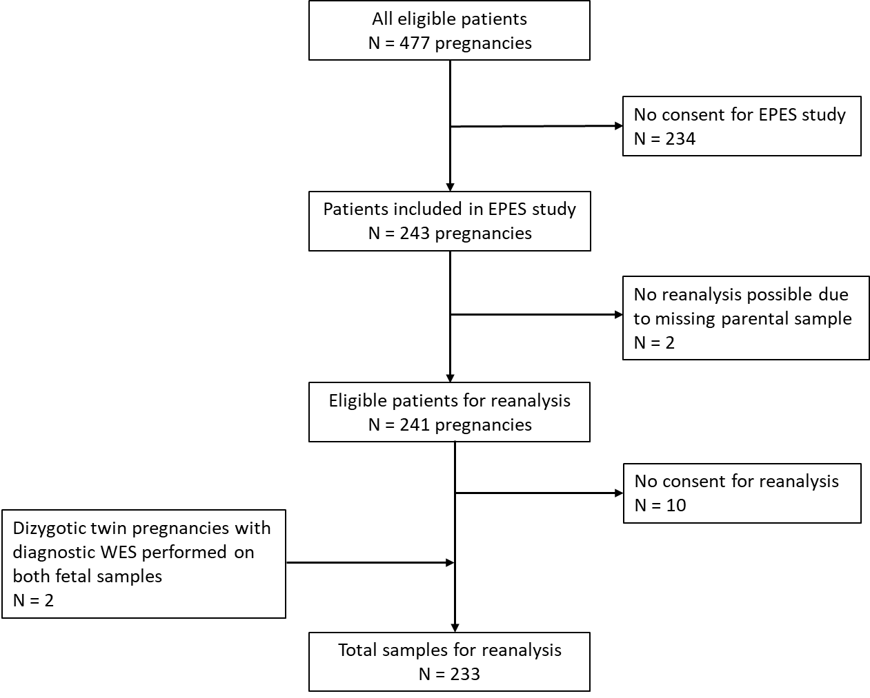
Figure S1: Flowchart of patient inclusion

Figure S2: Mosaic KRAS variant in case 105
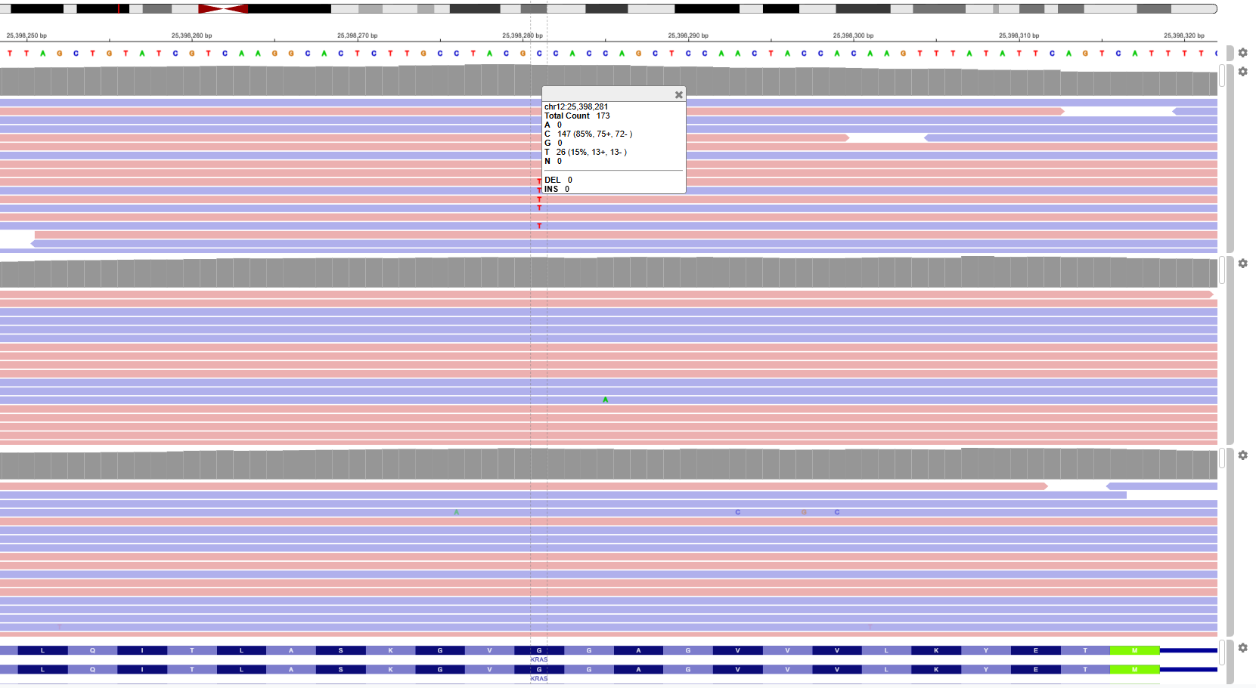
Screenshot of the web-based Integrative Genomics Viewer (IGV) with the low-grade mosaic KRAS (*190070) variant in samples of proband, mother and father (from top to bottom). Mosaic grade was 15%, with 26 of 173 reads harbouring the alternative allele.

Figure S3: Secondary analysis of the effect of newer releases of the AI software on the total number of prioritized variants, divided by different parameters

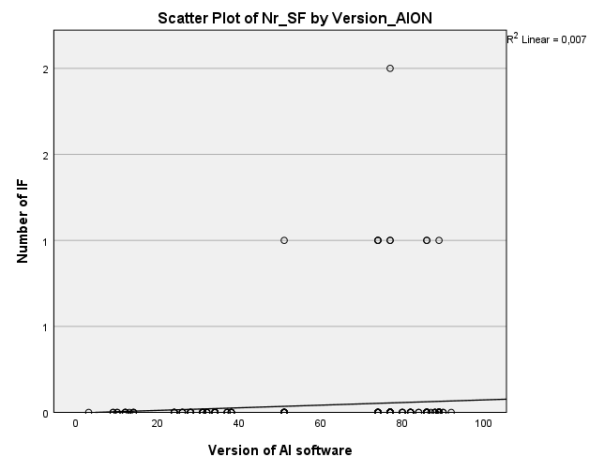
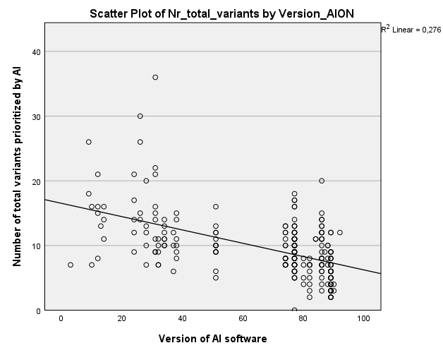
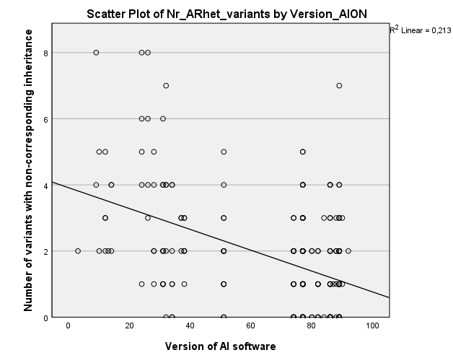
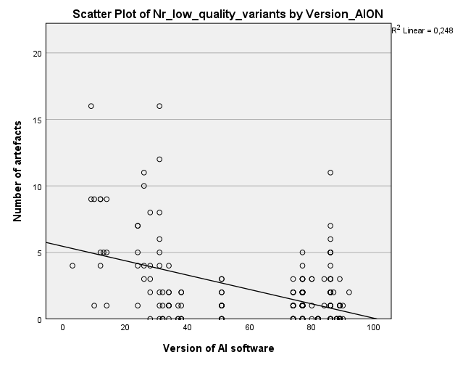
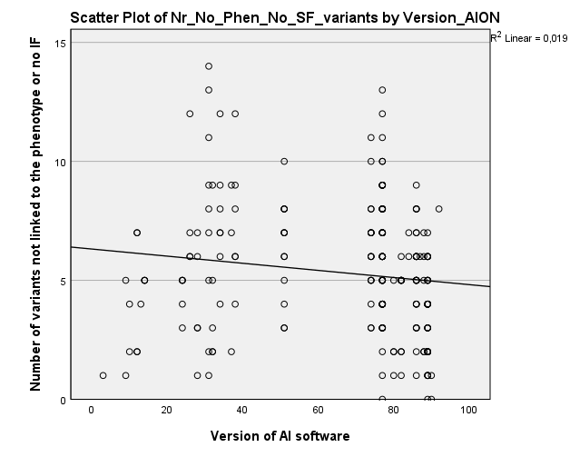
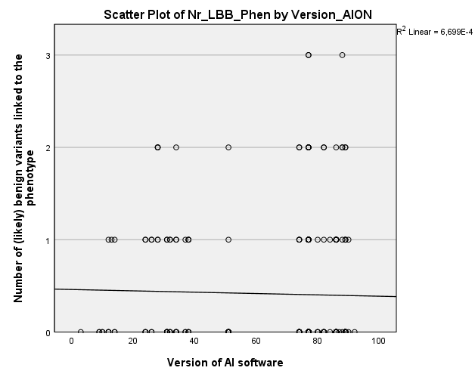
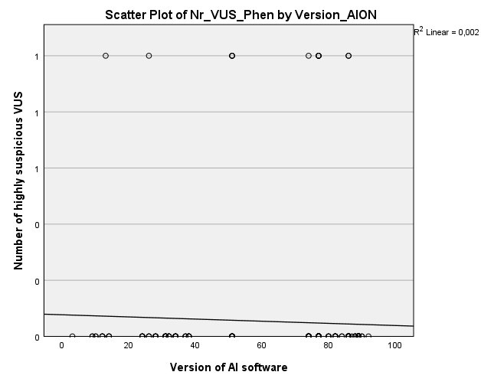
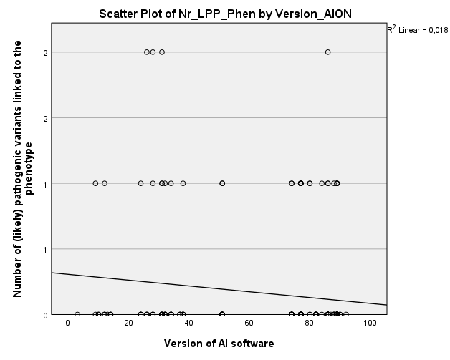
Fig. S3B
Fig. S3C
Fig. S3D
Fig. S3E
Fig. S3F
Fig. S3G
Fig. S3H
Fig. S3A
Fig. S3A: scatterplot with regression line of the total number of prioritized variants against the released version of the AI software, Pearson correlation -0.525, CI -0.612 - -0.424, p-value <0.001
Fig. S3B: scatterplot with regression line of the number of variants with non-corresponding inheritance against the released version of the AI software, Pearson correlation -0.462, CI -0.557 - -0.354, p-value <0.001
Fig. S3C: scatterplot with regression line of the number of artefacts against the released version of the AI software, Pearson correlation -0.498, CI -0.589 - -0.395, p-value <0.001
Fig. S3D: scatterplot with regression line of the number of variants not matching the phenotype or not classifying as an Incidental Finding (IF) against the released version of the AI software, Pearson correlation -0.137, CI -0.260 - -0.008, p-value = 0.037
Fig. S3E: scatterplot with regression line of number of variants classified as (likely) benign and matching the phenotype against the released version of the AI software, Pearson correlation -0.026, CI -0.154 – 0.103, p-value = 0.694
Fig. S3F: scatterplot with regression line of the number of highly suspicious Variants of Uncertain Significance (VUS) against the released version of the AI software, Pearson correlation -0.043, CI -0.170 – 0.086, p-value = 0.516
Fig. S3G: scatterplot with regression line of number of variants classified as (likely) pathogenic and matching the phenotype against the released version of the AI software, Pearson correlation -0.133, CI -0.258 – 0.005, p-value = 0.042
Fig, S3H: Fig. S1E: scatterplot with regression line of number of variants classified as incidental findings against the released version of the AI software, Pearson correlation 0.081, CI -0.048 – 0.208, p-value = 0.217

References
1. Corsten-Janssen N, Bouman K, Diphoorn JCD, et al. A prospective study on rapid exome sequencing as a diagnostic test for multiple congenital anomalies on fetal ultrasound. Prenat Diagn. Sep 2020;40(10):1300–1309. doi:10.1002/pd.5781
2. Solomon BD, Nguyen AD, Bear KA, Wolfsberg TG. Clinical genomic database. Proc Natl Acad Sci U S A. Jun 11 2013;110(24):9851–5. doi:10.1073/pnas.1302575110
3. Online Mendelian Inheritance in Man, OMIM®. McKusick-Nathans Institute of Genetic Medicine, Johns Hopkins University (Baltimore, MD). https://omim.org/
4. van der Velde KJ, de Boer EN, van Diemen CC, et al. GAVIN: Gene-Aware Variant INterpretation for medical sequencing. Genome Biol. Jan 16 2017;18(1):6. doi:10.1186/s13059-016-1141-7
5. Richards S, Aziz N, Bale S, et al. Standards and guidelines for the interpretation of sequence variants: a joint consensus recommendation of the American College of Medical Genetics and Genomics and the Association for Molecular Pathology. Genetics in medicine : official journal of the American College of Medical Genetics. 2015;17(5):405–424. doi:10.1038/gim.2015.30
6. Deden C, Neveling K, Zafeiropopoulou D, et al. Rapid whole exome sequencing in pregnancies to identify the underlying genetic cause in fetuses with congenital anomalies detected by ultrasound imaging. Prenat Diagn. Jul 2020;40(8):972–983. doi:10.1002/pd.5717
7. Lelieveld SH, Reijnders MR, Pfundt R, et al. Meta-analysis of 2,104 trios provides support for 10 new genes for intellectual disability. Nat Neurosci. Sep 2016;19(9):1194–6. doi:10.1038/nn.4352
8. Oud MS, de Leeuw N, Smeets D, et al. Innovative all-in-one exome sequencing strategy for diagnostic genetic testing in male infertility: Validation and 10-month experience. Andrology. Jul 2025;13(5):1078–1092. doi:10.1111/andr.13742
9. Faas BHW, Westra D, de Munnik SA, et al. All-in-one whole exome sequencing strategy with simultaneous copy number variant, single nucleotide variant and absence-of-heterozygosity analysis in fetuses with structural ultrasound anomalies: A 1-year experience. Prenat Diagn. Apr 2023;43(4):527–543. doi:10.1002/pd.6314
10. Li H, Durbin R. Fast and accurate short read alignment with Burrows-Wheeler transform. Bioinformatics. Jul 15 2009;25(14):1754–60. doi:10.1093/bioinformatics/btp324
11. Poplin R, Ruano-Rubio V, DePristo MA, et al. Scaling accurate genetic variant discovery to tens of thousands of samples. bioRxiv. 2018:201178. doi:10.1101/201178
12. McKenna A, Hanna M, Banks E, et al. The Genome Analysis Toolkit: a MapReduce framework for analyzing next-generation DNA sequencing data. Genome Res. Sep 2010;20(9):1297–303. doi:10.1101/gr.107524.110
13. McLaren W, Gil L, Hunt SE, et al. The Ensembl Variant Effect Predictor. Genome Biol. Jun 6 2016;17(1):122. doi:10.1186/s13059-016-0974-4
14. Richards S, Aziz N, Bale S, et al. Standards and guidelines for the interpretation of sequence variants: a joint consensus recommendation of the American College of Medical Genetics and Genomics and the Association for Molecular Pathology. Genet Med. May 2015;17(5):405–24. doi:10.1038/gim.2015.30

