Supplemental Information: Clinical and Demographic Determinants of Adherence to Digital Monitoring in Cirrhosis: A Prospective Cohort Analysis.
Authors: Buckholz, Thuluvath, Tanner, McSteen, Blocker, Cohen, Verna, Brown

Demographic Var | OR | 95% conf. interval |  | p-value
Age (continuous) | 0.99 | 0.95 | 1.03 | 0.56
Sex: Female (vs Male) | 0.89 | 0.38 | 2.12 | 0.80
Education: post-secondary (vs up to high school) | 2.01 | 0.72 | 5.60 | 0.18
Race: other (vs non-Hispanic white) | 0.63 | 0.27 | 1.49 | 0.29
Prior use of fitness tracker | 1.79 | 0.75 | 4.30 | 0.19
Supplementary Table 1. Association of demographic factors with daily adherence using univariable mixed-effects logistic regression.

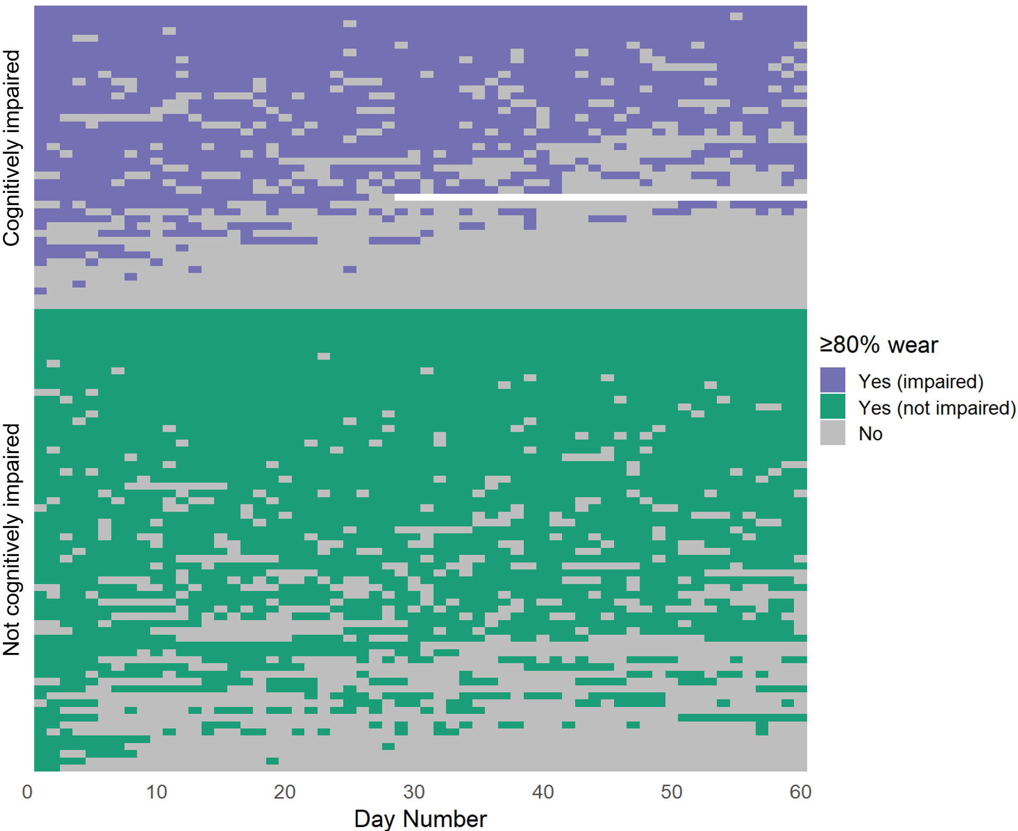
Supplementary Figure 1. Heatmap showing daily adherence patterns for cognitively impaired participants (purple / gray) and unimpaired participants (green / gray). An adherent day (purple or green) is one with ≥ 80% wear time. Days with <80% wear time are in gray and white indicates days that were not part of the study either because the participant had withdrawn or because data had not yet been collected. Within the impaired / unimpaired categories, participants were sorted by descending number of adherent days.

Group | OR | 95% confidence int. |  | p-value
No prior OHE, cognitively normal (n=47) | 1.00 | - | - | -
Prior OHE, cognitively normal (n=16) | 0.51 | 0.13 | 1.90 | 0.321
No prior OHE, cognitively abnormal (n=14) | 0.41 | 0.10 | 1.63 | 0.205
Prior OHE, cognitively abnormal (n=28) | 0.17 | 0.06 | 0.47 | 0.001
Table Table 2. Association of overt hepatic encephalopathy (OHE) and cognition with daily adherence using mixed-effects logistic regression. Participants were grouped into one of four categories based on whether there was prior OHE (Yes/No) and whether cognition was normal or abnormal (PHES ≤ -4). OR: odds ratio; PHES: PHES: Psychometric hepatic encephalopathy score.

