Supplementary material

Supplementary Table 1 Mean elevation of the villages surrounding Uzungwa Scarp Nature Forest Reserve (USNFR).
Village | Mean elevation (m.a.s.l.)
Ikule | 276
Chita | 332
Kidete | 342
Udagaji | 656
Itongoa | 668
Uluti | 1035
Itonya | 1435
Uhafiwa | 1494
Ukami | 1523
Ihimbo | 1584
Ilutila | 1677
Kipanga | 1710
Isanga | 1720
Idegenda | 1817
Mbawi | 1855
Masisiswe | 1920

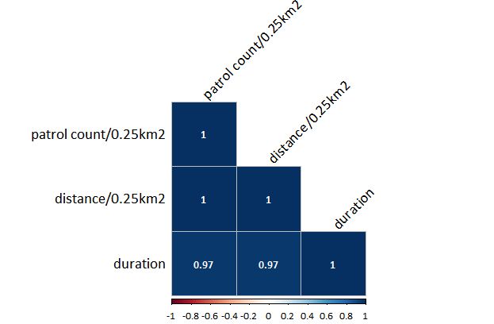

Supplementary Fig. 1 Correlation matrix of patrol effort metrics.

Supplementary Table 2 Patrol effort metrics and their values per year.
Year | Patrol count / 0.25km² | Distance (m) / 0.25km² | Duration (hours)
2018 | 659 | 316453.87 | 458.13
2019 | 768 | 374896.56 | 446.72
2020 | 642 | 291246.01 | 305.02
2021 | 1379 | 783415.09 | 708.67
2022 | 1494 | 857500.40 | 723.27
2023 | 1572 | 891849.09 | 832.41
Total | 6514 | 3515361.02 | 3474.22

Supplementary Table 3 Topographic and anthropogenic covariates and their minimum, maximum, median and mean values.
 | Elevation (m) | Distance to main trail (m) | Distance to border (m) | Slope (degrees)
min | 290.0 | 1.9 | 0.5 | 0.11
median | 1610.0 | 950.8 | 1347.5 | 12.13
mean | 1385.6 | 1381.1 | 1598.2 | 13.70
max | 2131.0 | 6837.4 | 5373.8 | 50.29

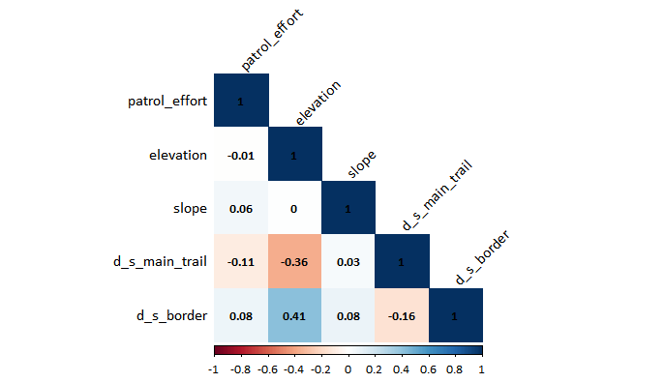

Supplementary Fig. 2 Correlation matrix for covariates tested.

Supplementary Table 4 Annual numbers of records for each type of illegal activity.
Illegal activity | 2018 | 2019 | 2020 | 2021 | 2022 | 2023 | Total
Wildlife poaching
Poacher | 28 | 14 | 2 | 6 | 0 | 2 | 52
Poacher escape | 11 | 2 | 0 | 0 | 0 | 0 | 13
Poachers' camp | 10 | 12 | 8 | 23 | 10 | 17 | 80
Poachers' trail | 3 | 4 | 3 | 1 | 0 | 0 | 11
Snare | 220 | 227 | 121 | 473 | 331 | 584 | 1956
Habitat destruction
Beehive | 2 | 7 | 3 | 21 | 0 | 0 | 33
Burnt area | 1 | 0 | 0 | 1 | 0 | 0 | 2
Firewood | 6 | 0 | 0 | 0 | 0 | 0 | 6
Litter | 2 | 1 | 0 | 0 | 0 | 0 | 3
Mining site | 0 | 0 | 1 | 1 | 0 | 0 | 2
New charcoal kiln | 14 | 5 | 2 | 0 | 1 | 1 | 23
New farm | 10 | 0 | 0 | 3 | 0 | 1 | 14
New sawing site | 54 | 13 | 6 | 11 | 3 | 14 | 101
New tree cut | 74 | 11 | 5 | 12 | 14 | 17 | 133
Old charcoal kiln | 1 | 0 | 2 | 1 | 0 | 0 | 4
Old farm site | 2 | 0 | 0 | 0 | 0 | 0 | 2
Old sawing site | 2 | 2 | 3 | 8 | 0 | 0 | 15
Old tree cut | 23 | 2 | 5 | 1 | 1 | 0 | 32
Trench | 5 | 0 | 0 | 0 | 0 | 0 | 5
Total illegal signs | 468 | 300 | 161 | 562 | 360 | 636 | 2487

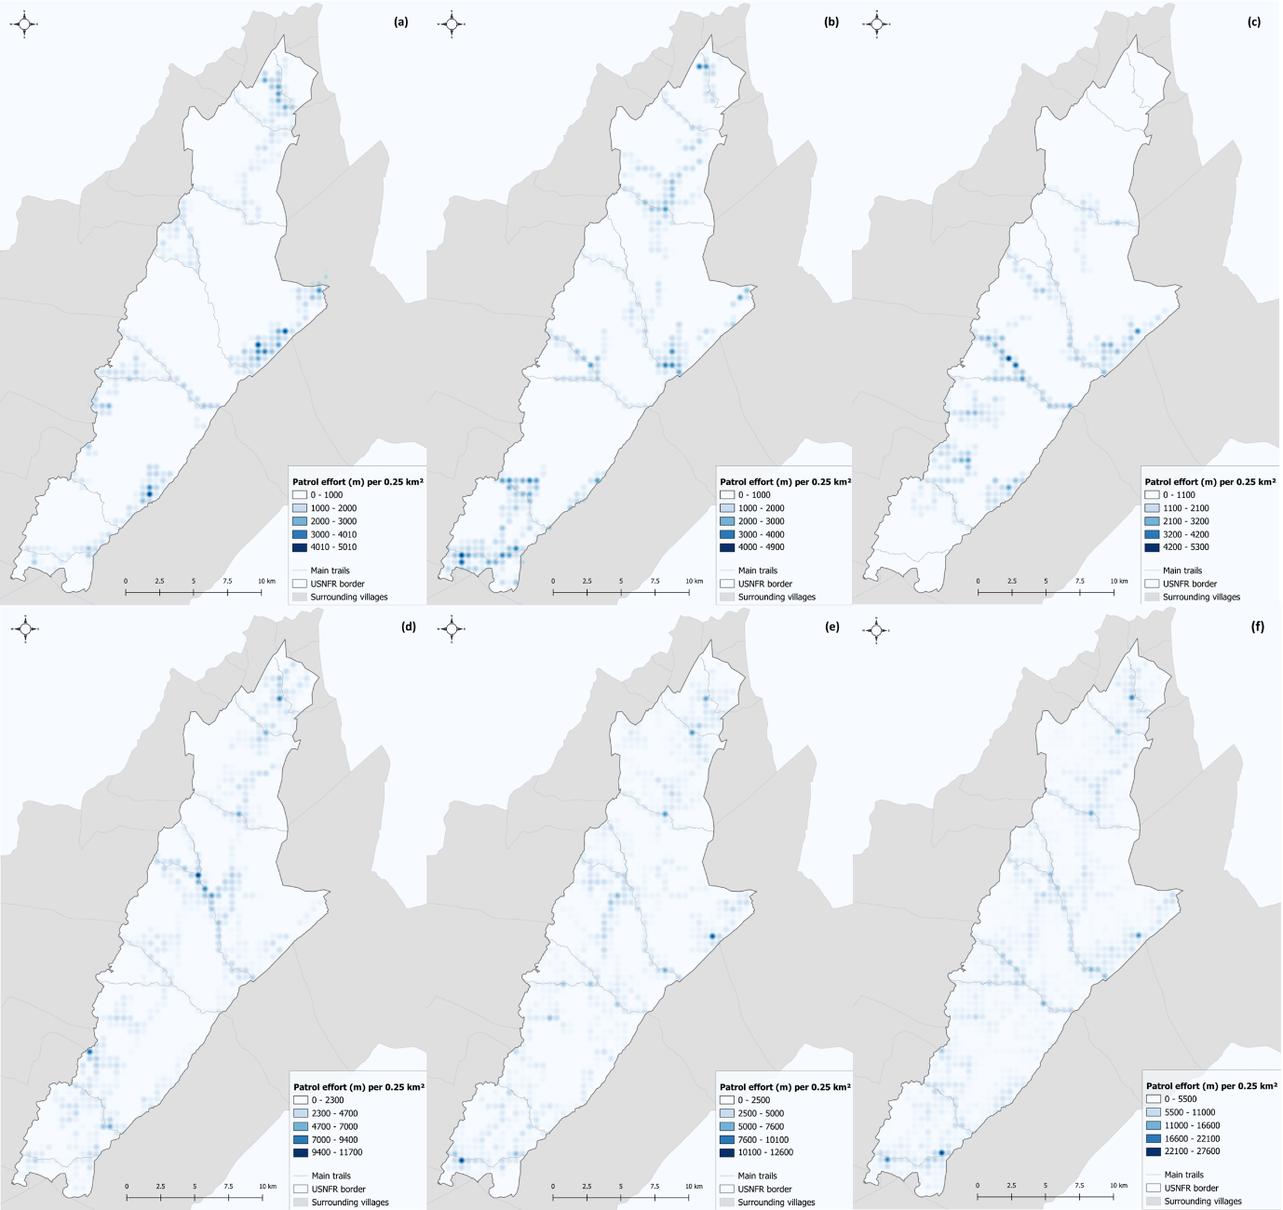

Supplementary Fig. 4 Heatmaps of patrol effort in (a) 2018, (b) 2019, (c) 2020, (d) 2021, (e) 2022 and (f) 2023.

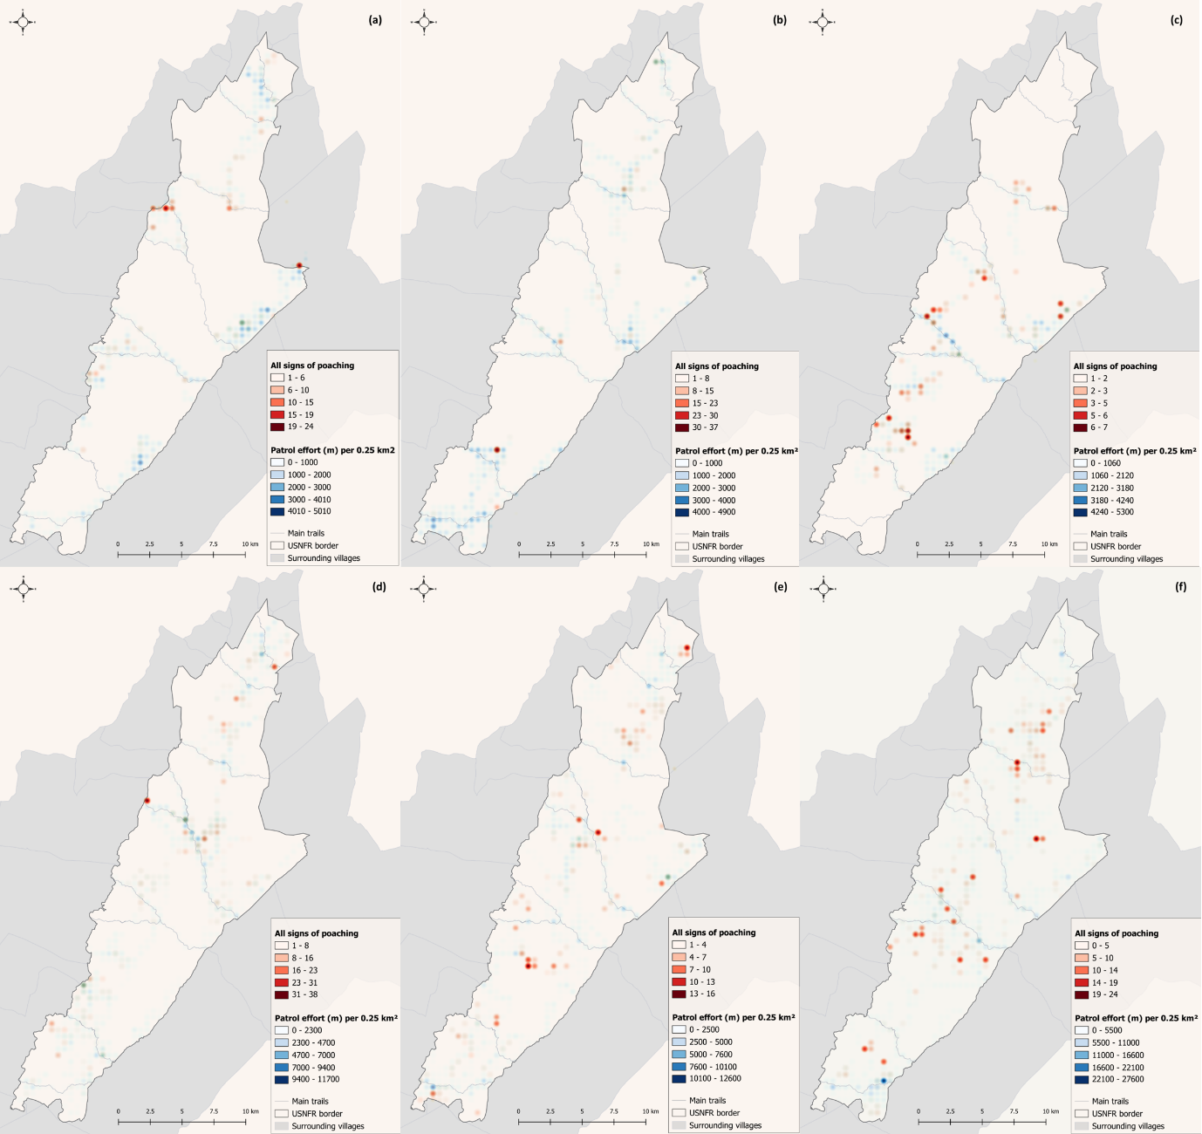

Supplementary Fig. 5 Heatmaps of all signs of poaching detected in (a) 2018, (b) 2019, (c) 2020, (d) 2021, (e) 2022 and (f) 2023.

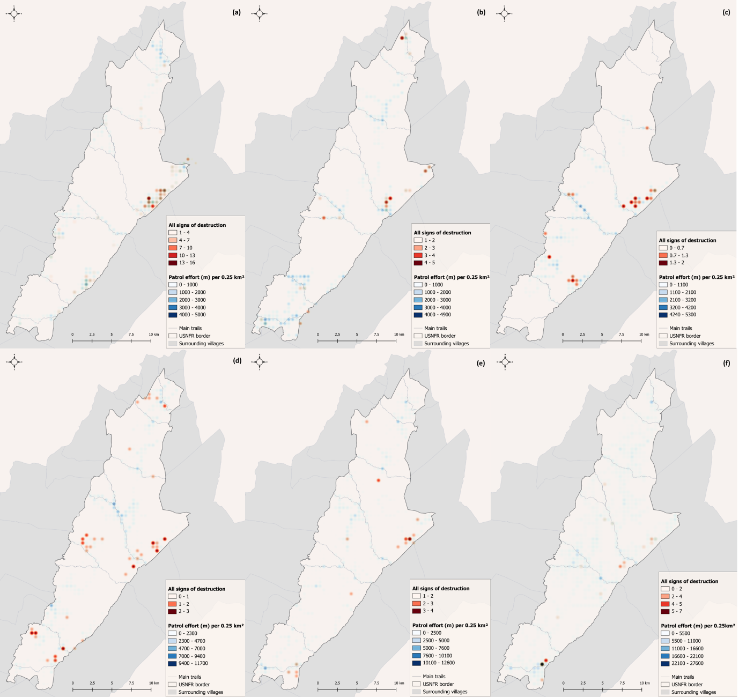
Supplementary Fig. 6 Heatmaps of all signs of habitat destruction detected in (a) 2018, (b) 2019, (c) 2020, (d) 2021, (e) 2022 and (f) 2023.

