Definition of Composite Inflammation-Nutrition Indicators
Thirteen composite hematological indicators were collected in this study to assess the dynamic changes in inflammation and nutritional status. The indicators and their definitions are as follows:
NLR: Neutrophil-to-Lymphocyte Ratio
PLR: Platelet-to-Lymphocyte Ratio
LMR: Lymphocyte-to-Monocyte Ratio
WHR: White Blood Cell-to-Hemoglobin Ratio
SII: Systemic Immune-Inflammation Index
AFR: Albumin-to-Fibrinogen Ratio
FPR: Fibrinogen-to-Albumin Ratio
PNI: Prognostic Nutritional Index
AISI: Aggregate Index of Systemic Inflammation
SIRI: Systemic Inflammation Response Index
NPAR: Neutrophil Percentage-to-Albumin Ratio
NPR: Platelet-to-Neutrophil Ratio
PAR: Platelet-to-Albumin Ratio
The calculation formulas for each indicator are shown in Figure S1. These indicators were calculated at two time points, before and after neoadjuvant therapy, to capture their dynamic variations for prognostic evaluation.
Table S1. the calculation formulas for each indicator.

Table S2. Univariate and multivariate Cox regression analyses of ΔPAR and ΔWHR for postoperative overall survival (OS) and disease-free survival (DFS).
Characteristics | OS |  |  |  |  |  | DFS
Characteristics | Total(N) | HR(95% CI) Univariable | P value | HR(95% CI)  Multivariable | P value |  | HR(95% CI)  Univariable | P value | HR(95% CI)  Multivariable | P value
ΔPAR | 259
Low | 107 | REF. |  | REF. |  |  | REF. |  | REF.
High | 152 | 3.64 (2.14 - 6.19) | < 0.001 | 3.14 (1.83 - 5.40) | < 0.001 |  | 2.44 (1.57 - 3.79) | < 0.001 | 2.21 (1.41 - 3.47) | < 0.001
ΔWHR | 259
Low | 120 | REF. |  | REF. |  |  | REF. |  | REF.
High | 139 | 2.58 (1.61 - 4.13) | < 0.001 | 2.19 (1.34 - 3.58) | 0.002 |  | 2.20 (1.45 - 3.35) | < 0.001 | 1.93 (1.25 - 2.99) | 0.003
Sex | 259
Female | 58 | REF. |  |  |  |  | REF.
Male | 201 | 0.87 (0.53 - 1.43) | 0.585 |  |  |  | 0.88 (0.56 - 1.38) | 0.580
Age | 259
≤65 | 135 | REF. |  |  |  |  | REF.
>65 | 124 | 1.21 (0.79 - 1.84) | 0.386 |  |  |  | 1.09 (0.74 - 1.61) | 0.662
BMI | 259
≤24 | 176 | REF. |  |  |  |  | REF.
>24 | 83 | 0.74 (0.46 - 1.19) | 0.218 |  |  |  | 0.98 (0.65 - 1.49) | 0.926
Pre CA199 | 259
≤37 | 227 | REF. |  | REF. |  |  | REF. |  | REF.
>37 | 32 | 2.46 (1.46 - 4.14) | < 0.001 | 2.38 (1.36 - 4.17) | 0.003 |  | 2.47 (1.53 - 4.00) | < 0.001 | 2.22 (1.32 - 3.71) | 0.003
Pre CEA | 259
≤5 | 183 | REF. |  |  |  |  | REF.
>5 | 76 | 1.26 (0.81 - 1.98) | 0.308 |  |  |  | 1.29 (0.85 - 1.96) | 0.225
TRG | 259
TRG 0-1 | 79 | REF. |  | REF. |  |  | REF. |  | REF.
TRG 2-3 | 180 | 3.44 (1.83 - 6.49) | < 0.001 | 0.70 (0.32 - 1.54) | 0.370 |  | 2.76 (1.62 - 4.71) | < 0.001 | 0.67 (0.34 - 1.29) | 0.229
ypT category | 259
pCR-yp T2 | 86 | REF. |  | REF. |  |  | REF. |  | REF.
yp T3-4 | 173 | 5.04 (2.52 - 10.06) | < 0.001 | 3.64 (1.53 - 8.66) | 0.003 |  | 4.26 (2.38 - 7.63) | < 0.001 | 3.10 (1.49 - 6.45) | 0.002
ypN category | 259
yp N0 | 118 | REF. |  | REF. |  |  | REF. |  | REF.
yp N+ | 141 | 3.51 (2.13 - 5.79) | < 0.001 | 2.18 (1.25 - 3.81) | 0.006 |  | 3.39 (2.16 - 5.34) | < 0.001 | 2.24 (1.35 - 3.69) | 0.002
Location | 259
Upper | 131 | REF. |  |  |  |  | REF.
Middle | 64 | 1.04 (0.61 - 1.77) | 0.887 |  |  |  | 1.28 (0.80 - 2.06) | 0.311
Lower | 59 | 1.12 (0.66 - 1.89) | 0.670 |  |  |  | 1.21 (0.74 - 1.98) | 0.459
Overlapping | 5 | 2.04 (0.63 - 6.58) | 0.235 |  |  |  | 2.53 (0.91 - 7.04) | 0.075
Tumor Size | 259
≤5 | 178 | REF. |  | REF. |  |  | REF. |  | REF.
>5 | 81 | 2.04 (1.33 - 3.12) | 0.001 | 1.42 (0.91 - 2.22) | 0.123 |  | 2.09 (1.41 - 3.10) | < 0.001 | 1.51 (0.99 - 2.28) | 0.054
Surgery | 259
Total | 211 | REF. |  |  |  |  | REF.
Partial | 48 | 0.78 (0.44 - 1.38) | 0.393 |  |  |  | 0.82 (0.49 - 1.38) | 0.450
AC | 259
No | 16 | REF. |  |  |  |  | REF.
Yes | 243 | 0.67 (0.31 - 1.46) | 0.318 |  |  |  | 0.70 (0.34 - 1.45) | 0.341
Histology type | 259
Differed | 113 | REF. |  | REF. |  |  | REF. |  | REF.
Undiffered | 123 | 1.57 (0.98 - 2.53) | 0.063 | 1.18 (0.73 - 1.91) | 0.508 |  | 1.59 (1.03 - 2.47) | 0.038 | 1.26 (0.80 - 1.96) | 0.316
Unknown | 23 | 2.42 (1.27 - 4.60) | 0.007 | 1.26 (0.65 - 2.43) | 0.490 |  | 2.71 (1.51 - 4.88) | < 0.001 | 1.64 (0.90 - 3.00) | 0.110
PNI | 259
No | 130 | REF. |  | REF. |  |  | REF. |  | REF.
Yes | 129 | 2.38 (1.52 - 3.72) | < 0.001 | 0.84 (0.50 - 1.42) | 0.508 |  | 2.32 (1.54 - 3.49) | < 0.001 | 0.89 (0.55 - 1.44) | 0.624
LVI | 259
No | 157 | REF. |  | REF. |  |  | REF. |  | REF.
Yes | 102 | 2.80 (1.82 - 4.31) | < 0.001 | 1.31 (0.81 - 2.14) | 0.276 |  | 2.55 (1.72 - 3.78) | < 0.001 | 1.18 (0.75 - 1.85) | 0.480
Abbreviations: PAR Platelet-to-Albumin Ratio; WHR White Blood Cell-to-Hemoglobin Ratio; BMI Body Mass Index; PreCA199 Preoperative Carbohydrate Antigen 19-9; PreCEA Preoperative Carcinoembryonic Antigen; TRG Tumor Regression Grade; pCR Pathological Complete Response; AC Adjuvant Chemotherapy; PNI Perineural Invasion; LVI Lymphovascular Invasion.
Table S3. Comparison of the performance of ΔPAR-, ΔWHR-, and iNUT-score–based models for OS.
Variables | ΔPAR | ΔWHR | iNUT-score | P  vs. PAR | P  vs. WHR
Training cohort
C-index | 0.63(0.589 - 0.68) | 0.62(0.56 - 0.67) | 0.68(0.63 - 0.73) | 0.025 | <0.01
AIC | 873.9 | 884.7 | 863.9 | <0.01 | <0.01
BIC | 876.4 | 887.1 | 866.3 | <0.01 | <0.01
NRI of iNUT-score (%) | 5.3%(-5.5% - 17.2%) | 7.3%(-3.8% - 15.5%)
IDI of iNUT-score (%) | 2.6%(0.2% - 5.2%) | 2.7%(0.2% - 5.3%)
Validation cohort
C-index | 0.60(0.55 - 0.66) | 0.61(0.55 - 0.66) | 0.64(0.59 - 0.70) | 0.037 | 0.04
AIC | 799.7 | 797.5 | 787.1 | <0.01 | <0.01
BIC | 802.2 | 799.9 | 789.5 | <0.01 | <0.01
NRI of iNUT-score (%) | 22.4%(-15.0% - 40.3%) | 22.4%(-9.0% - 59.6%)
IDI of iNUT-score (%) | 2.4%(-0.2% - 6.0%) | 0.1%(-2.9% - 3.3%)

Table S4. Comparison of the performance of ΔPAR-, ΔWHR-, and iNUT-score–based models for DFS.
Variables | ΔPAR | ΔWHR | iNUT-score | P  vs. PAR | P  vs. WHR
Training cohort
C-index | 0.61(0.57 - 0.65) | 0.60(0.55 - 0.65) | 0.65(0.60 - 0.70) | 0.044 | <0.01
AIC | 1041.1 | 1044 | 1031 | <0.01 | <0.01
BIC | 1043.8 | 1046.6 | 1033.6 | <0.01 | <0.01
NRI of iNUT-score (%) | 23.6%(-10.2% - 30.4%) | 23.6%(-9.3% - 31.3%)
IDI of iNUT-score (%) | 4.5%(-0.2% - 9.1%) | 3.2%(0.7% - 6.6%)
Validation cohort
C-index | 0.62(0.57 - 0.67) | 0.59(0.54 - 0.64) | 0.64(0.59 - 0.70) | 0.168 | <0.01
AIC | 836.8 | 845.7 | 831.5 | <0.01 | <0.01
BIC | 839.3 | 848.2 | 834 | <0.01 | <0.01
NRI of iNUT-score (%) | 24.5%(-11.0% - 68.5%) | 24.5%(0% - 71.3%)
IDI of iNUT-score (%) | 3.8%(-1.6% - 10.9%) | 3.0%(-0.5% - 6.3%)

Table S5. Univariate and multivariate Cox regression analyses of iNUT-score for postoperative overall survival (OS) and disease-free survival (DFS) in the training cohort.
Characteristics | OS |  |  |  |  |  | DFS
Characteristics | Total(N) | HR(95% CI)  Univariable | P value | HR(95% CI)  Multivariable | P value |  | HR(95% CI)  Univariable | P value | HR(95% CI)  Multivariable | P value
iNUT-score | 259
Low | 61 | REF. |  | REF. |  |  | REF. |  | REF.
Middle | 105 | 2.84 (1.24 - 6.52) | 0.014 | 2.57 (1.09 - 6.05) | 0.030 |  | 2.61 (1.30 - 5.24) | 0.007 | 2.34 (1.14 - 4.81) | 0.021
High | 93 | 7.10 (3.20 - 15.75) | < 0.001 | 6.71 (2.92 - 15.43) | < 0.001 |  | 4.81 (2.44 - 9.48) | < 0.001 | 4.55 (2.24 - 9.23) | < 0.001
Sex | 259
Female | 58 | REF. |  |  |  |  | REF.
Male | 201 | 0.87 (0.53 - 1.43) | 0.585 |  |  |  | 0.88 (0.56 - 1.38) | 0.580
Age | 259
≤65 | 135 | REF. |  |  |  |  | REF.
>65 | 124 | 1.21 (0.79 - 1.84) | 0.386 |  |  |  | 1.09 (0.74 - 1.61) | 0.662
BMI | 259
≤24 | 176 | REF. |  |  |  |  | REF.
>24 | 83 | 0.74 (0.46 - 1.19) | 0.218 |  |  |  | 0.98 (0.65 - 1.49) | 0.926
Pre CA199 | 259
≤37 | 227 | REF. |  | REF. |  |  | REF. |  | REF.
>37 | 32 | 2.46 (1.46 - 4.14) | < 0.001 | 2.38 (1.36 - 4.18) | 0.002 |  | 2.47 (1.53 - 4.00) | < 0.001 | 2.20 (1.31 - 3.69) | 0.003
Pre CEA | 259
≤5 | 183 | REF. |  |  |  |  | REF.
>5 | 76 | 1.26 (0.81 - 1.98) | 0.308 |  |  |  | 1.29 (0.85 - 1.96) | 0.225
TRG | 259
TRG 0-1 | 79 | REF. |  | REF. |  |  | REF. |  | REF.
TRG 2-3 | 180 | 3.44 (1.83 - 6.49) | < 0.001 | 0.69 (0.31 - 1.54) | 0.368 |  | 2.76 (1.62 - 4.71) | < 0.001 | 0.66 (0.34 - 1.28) | 0.216
ypT category | 259
pCR-yp T2 | 86 | REF. |  | REF. |  |  | REF. |  | REF.
yp T3-4 | 173 | 5.04 (2.52 - 10.06) | < 0.001 | 3.63 (1.52 - 8.62) | 0.004 |  | 4.26 (2.38 - 7.63) | < 0.001 | 3.14 (1.51 - 6.53) | 0.002
ypN category | 259
yp N0 | 118 | REF. |  | REF. |  |  | REF. |  | REF.
yp N+ | 141 | 3.51 (2.13 - 5.79) | < 0.001 | 2.20 (1.25 - 3.84) | 0.006 |  | 3.39 (2.16 - 5.34) | < 0.001 | 2.25 (1.36 - 3.72) | 0.002
Location | 259
Upper | 131 | REF. |  |  |  |  | REF.
Middle | 64 | 1.04 (0.61 - 1.77) | 0.887 |  |  |  | 1.28 (0.80 - 2.06) | 0.311
Lower | 59 | 1.12 (0.66 - 1.89) | 0.670 |  |  |  | 1.21 (0.74 - 1.98) | 0.459
Overlapping | 5 | 2.04 (0.63 - 6.58) | 0.235 |  |  |  | 2.53 (0.91 - 7.04) | 0.075
Tumor Size | 259
≤5 | 178 | REF. |  | REF. |  |  | REF. |  | REF.
>5 | 81 | 2.04 (1.33 - 3.12) | 0.001 | 1.42 (0.90 - 2.22) | 0.131 |  | 2.09 (1.41 - 3.10) | < 0.001 | 1.48 (0.97 - 2.26) | 0.068
Surgery | 259
Total | 211 | REF. |  |  |  |  | REF.
Partial | 48 | 0.78 (0.44 - 1.38) | 0.393 |  |  |  | 0.82 (0.49 - 1.38) | 0.450
AC | 259
No | 16 | REF. |  |  |  |  | REF.
Yes | 243 | 0.67 (0.31 - 1.46) | 0.318 |  |  |  | 0.70 (0.34 - 1.45) | 0.341
Histology type | 259
Differed | 113 | REF. |  | REF. |  |  | REF. |  | REF.
Undiffered | 123 | 1.57 (0.98 - 2.53) | 0.063 | 1.17 (0.72 - 1.90) | 0.530 |  | 1.59 (1.03 - 2.47) | 0.038 | 1.25 (0.80 - 1.96) | 0.318
Unknown | 23 | 2.42 (1.27 - 4.60) | 0.007 | 1.24 (0.65 - 2.40) | 0.514 |  | 2.71 (1.51 - 4.88) | < 0.001 | 1.62 (0.89 - 2.97) | 0.118
PNI | 259
No | 130 | REF. |  | REF. |  |  | REF. |  | REF.
Yes | 129 | 2.38 (1.52 - 3.72) | < 0.001 | 0.83 (0.49 - 1.40) | 0.477 |  | 2.32 (1.54 - 3.49) | < 0.001 | 0.88 (0.54 - 1.43) | 0.609
LVI | 259
No | 157 | REF. |  | REF. |  |  | REF. |  | REF.
Yes | 102 | 2.80 (1.82 - 4.31) | < 0.001 | 1.33 (0.81 - 2.17) | 0.257 |  | 2.55 (1.72 - 3.78) | < 0.001 | 1.17 (0.74 - 1.84) | 0.495
Abbreviations: BMI Body Mass Index; PreCA199 Preoperative Carbohydrate Antigen 19-9; PreCEA Preoperative Carcinoembryonic Antigen; TRG Tumor Regression Grade; pCR Pathological Complete Response; AC Adjuvant Chemotherapy; PNI Perineural Invasion; LVI Lymphovascular Invasion.

Table S6. Univariate and multivariate Cox regression analyses of iNUT-score for postoperative overall survival (OS) and disease-free survival (DFS) in the validation cohort.
Characteristics | OS |  |  |  |  |  | DFS
Characteristics | Total(N) | HR(95% CI)  Univariable | P value | HR(95% CI)  Multivariable | P value |  | HR(95% CI)  Univariable | P value | HR(95% CI)  Multivariable | P value
iNUT-score | 170
Low | 55 | REF. |  | REF. |  |  | REF. |  | REF.
Middle | 65 | 2.04 (1.10 - 3.76) | 0.023 | 1.77 (0.94 - 3.32) | 0.075 |  | 2.05 (1.15 - 3.66) | 0.015 | 1.89 (1.04 - 3.39) | 0.036
High | 50 | 4.66 (2.55 - 8.50) | < 0.001 | 3.22 (1.72 - 6.03) | < 0.001 |  | 4.14 (2.33 - 7.35) | < 0.001 | 3.14 (1.73 - 5.70) | < 0.001
Sex | 170
Female | 47 | REF. |  |  |  |  | REF.
Male | 123 | 1.10 (0.68 - 1.77) | 0.697 |  |  |  | 1.22 (0.76 - 1.98) | 0.410
Age | 170
≤65 | 99 | REF. |  |  |  |  | REF.
>65 | 71 | 0.93 (0.60 - 1.44) | 0.754 |  |  |  | 0.94 (0.62 - 1.43) | 0.764
BMI | 170
≤24 | 135 | REF. |  |  |  |  | REF.
>24 | 35 | 0.91 (0.54 - 1.52) | 0.708 |  |  |  | 1.01 (0.61 - 1.66) | 0.972
PreCA199 | 170
≤37 | 139 | REF. |  | REF. |  |  | REF. |  | REF.
>37 | 31 | 2.54 (1.59 - 4.05) | < 0.001 | 1.86 (1.12 - 3.08) | 0.016 |  | 2.57 (1.62 - 4.10) | < 0.001 | 1.97 (1.19 - 3.25) | 0.008
PreCEA | 170
≤5 | 124 | REF. |  |  |  |  | REF.
>5 | 46 | 1.19 (0.75 - 1.89) | 0.454 |  |  |  | 1.16 (0.74 - 1.83) | 0.508
TRG | 170
TRG 0-1 | 39 | REF. |  | REF. |  |  | REF. |  | REF.
TRG 2-3 | 131 | 2.17 (1.18 - 4.00) | 0.013 | 1.61 (0.72 - 3.60) | 0.245 |  | 2.26 (1.26 - 4.08) | 0.006 | 1.58 (0.73 - 3.39) | 0.246
ypT category | 170
ypT 0-2 | 43 | REF. |  | REF. |  |  | REF. |  | REF.
ypT 3-4 | 127 | 2.15 (1.19 - 3.88) | 0.011 | 0.72 (0.32 - 1.60) | 0.419 |  | 2.47 (1.37 - 4.44) | 0.003 | 0.92 (0.42 - 2.03) | 0.837
ypN category | 170
yp N0 | 66 | REF. |  | REF. |  |  | REF. |  | REF.
yp N+ | 104 | 4.38 (2.51 - 7.67) | < 0.001 | 2.66 (1.43 - 4.94) | 0.002 |  | 3.73 (2.24 - 6.20) | < 0.001 | 2.16 (1.22 - 3.84) | 0.008
Location | 170
Upper | 80 | REF. |  |  |  |  | REF.
Middle | 47 | 1.41 (0.87 - 2.27) | 0.166 |  |  |  | 1.31 (0.81 - 2.12) | 0.278
Lower | 34 | 0.80 (0.44 - 1.48) | 0.479 |  |  |  | 0.92 (0.53 - 1.62) | 0.780
Overlapping | 9 | 0.91 (0.33 - 2.56) | 0.864 |  |  |  | 1.04 (0.41 - 2.63) | 0.937
Tumor Size | 170
≤5 | 129 | REF. |  | REF. |  |  | REF.
>5 | 41 | 1.64 (1.03 - 2.61) | 0.038 | 0.90 (0.53 - 1.54) | 0.706 |  | 1.42 (0.89 - 2.27) | 0.138
Surgery | 170
Total | 141 | REF. |  |  |  |  | REF.
Partial | 29 | 0.88 (0.49 - 1.60) | 0.681 |  |  |  | 1.14 (0.67 - 1.93) | 0.633
AC | 170
No | 19 | REF. |  |  |  |  | REF.
Yes | 151 | 1.03 (0.53 - 1.99) | 0.930 |  |  |  | 0.95 (0.50 - 1.79) | 0.869
Histology type | 170
Differed | 76 | REF. |  | REF. |  |  | REF. |  | REF.
Undiffered | 85 | 1.96 (1.26 - 3.07) | 0.003 | 1.44 (0.90 - 2.30) | 0.129 |  | 1.68 (1.10 - 2.58) | 0.016 | 1.34 (0.86 - 2.10) | 0.197
Unknown | 9 | 0.97 (0.30 - 3.16) | 0.954 | 1.94 (0.46 - 8.17) | 0.367 |  | 0.76 (0.24 - 2.48) | 0.651 | 1.62 (0.40 - 6.62) | 0.501
PNI | 170
No | 93 | REF. |  | REF. |  |  | REF. |  | REF.
Yes | 77 | 3.24 (2.08 - 5.05) | < 0.001 | 2.25 (1.32 - 3.84) | 0.003 |  | 3.19 (2.08 - 4.91) | < 0.001 | 2.17 (1.34 - 3.53) | 0.002
LVI | 170
No | 100 | REF. |  | REF. |  |  | REF. |  | REF.
Yes | 70 | 2.38 (1.56 - 3.65) | < 0.001 | 1.18 (0.73 - 1.90) | 0.503 |  | 2.18 (1.44 - 3.30) | < 0.001 | 1.12 (0.70 - 1.77) | 0.642
Abbreviations: BMI Body Mass Index; PreCA199 Preoperative Carbohydrate Antigen 19-9; PreCEA Preoperative Carcinoembryonic Antigen; TRG Tumor Regression Grade; pCR Pathological Complete Response; AC Adjuvant Chemotherapy; Diff. Differentiation; PNI Perineural Invasion; LVI Lymphovascular Invasion.
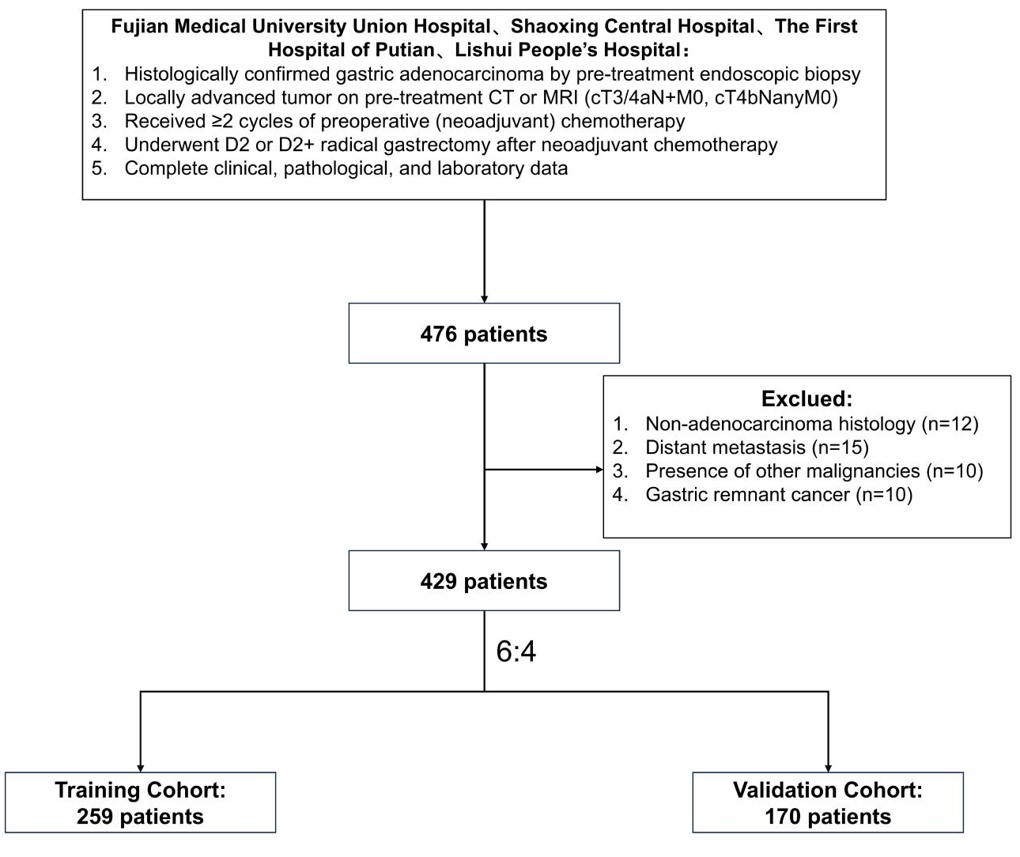

Figure S1. Study flowchart.
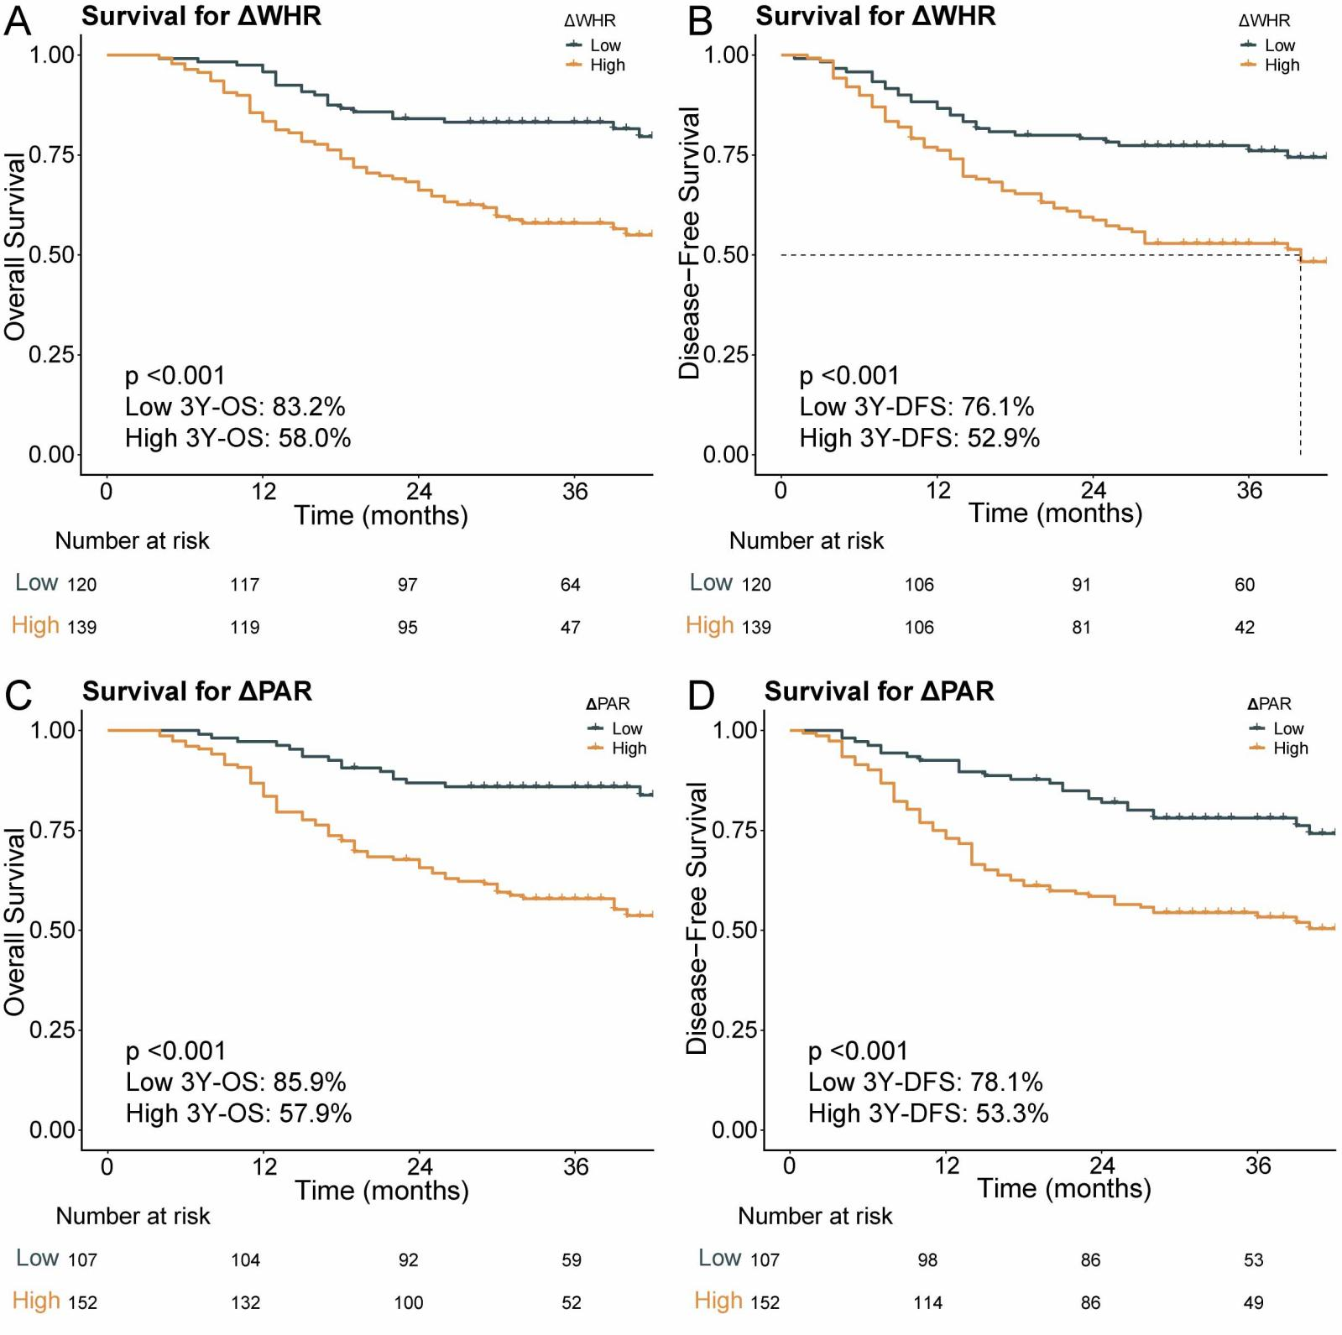
Figure S2. Kaplan-Meier survival curves stratified by ΔPAR and ΔWHR in the training cohort. (A) Overall survival (OS) stratified by ΔPAR. (B) Disease-free survival (DFS) stratified by ΔPAR. (C) OS stratified by ΔWHR. (D) DFS stratified by ΔWHR.
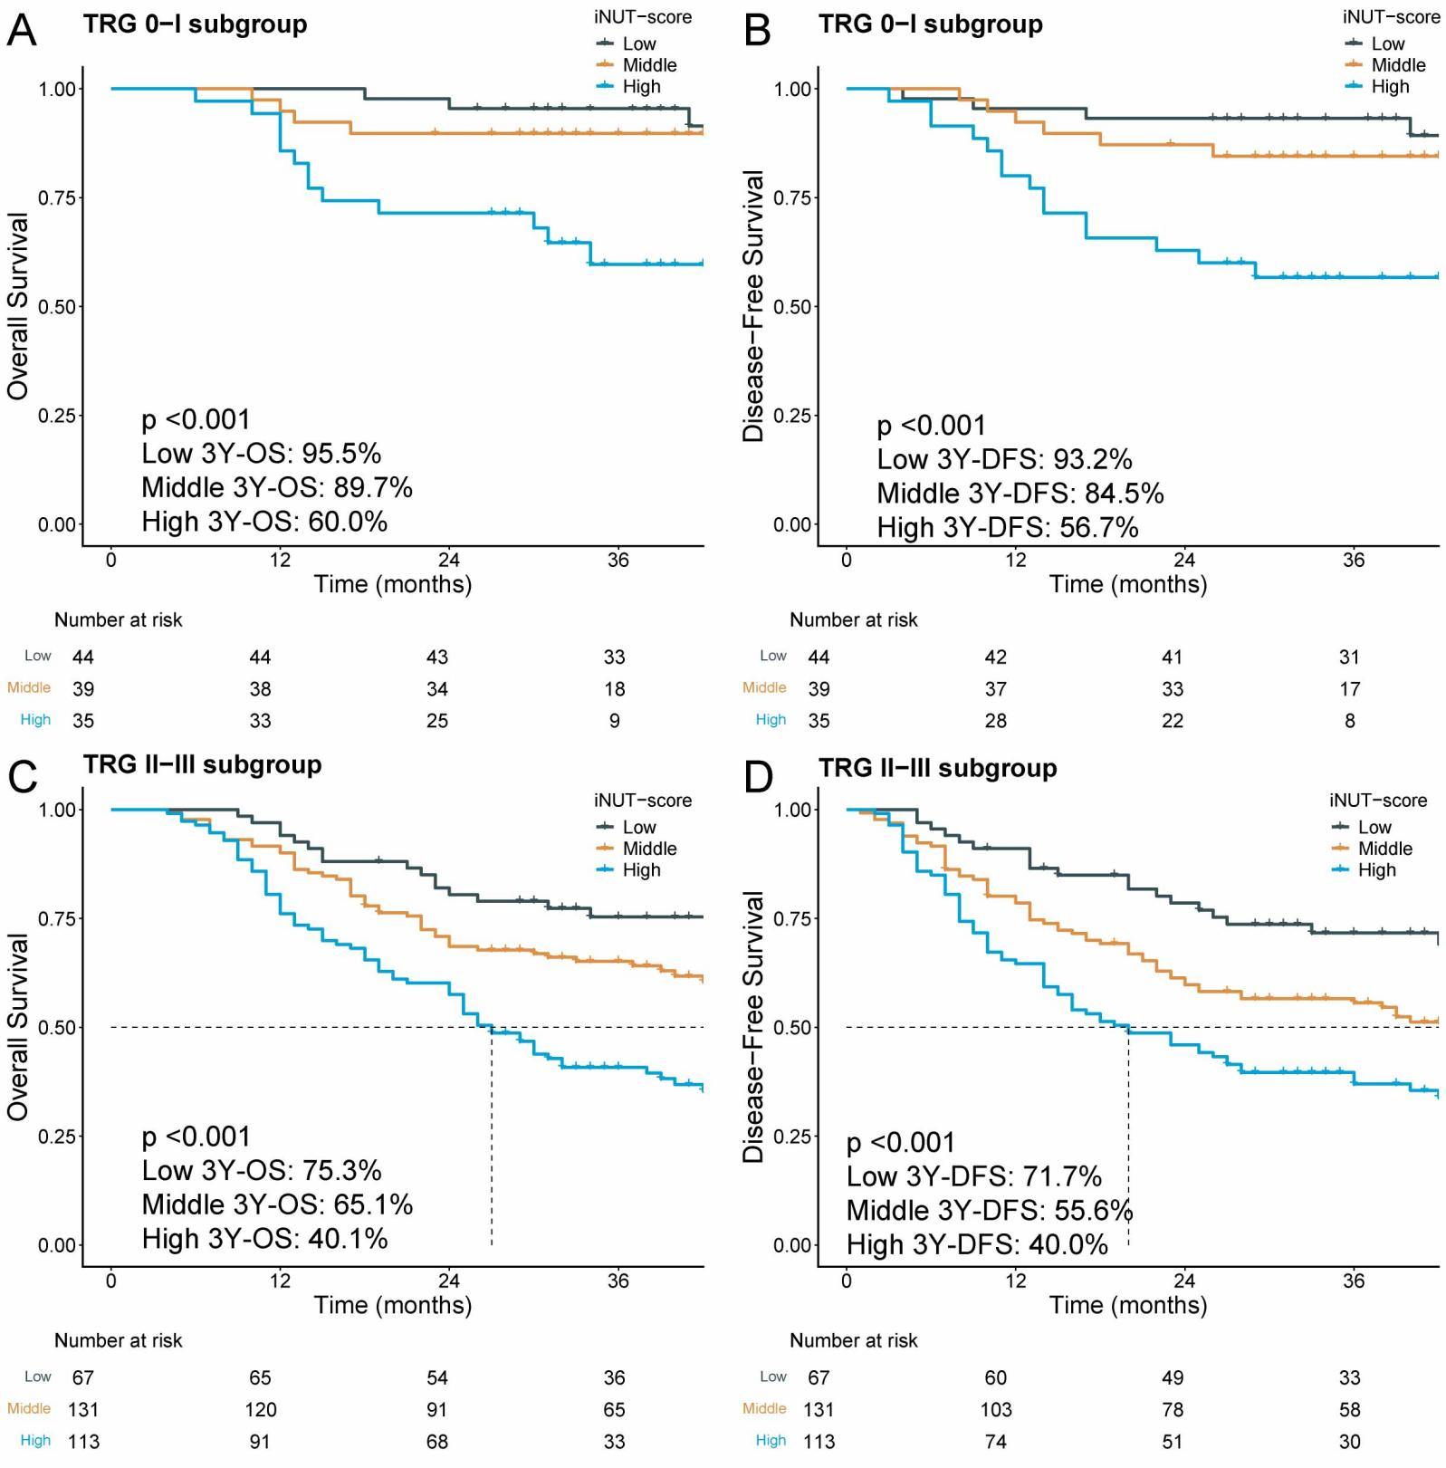
Figure S3. Kaplan-Meier survival curves of TRG subgroups in the overall population. (A) Overall survival (OS) in the TRG 0-1 group. (B) Disease-free survival (DFS) in the TRG 0-1 group. (C) OS in the TRG 2-3 group. (D) DFS in the TRG 2-3 group.

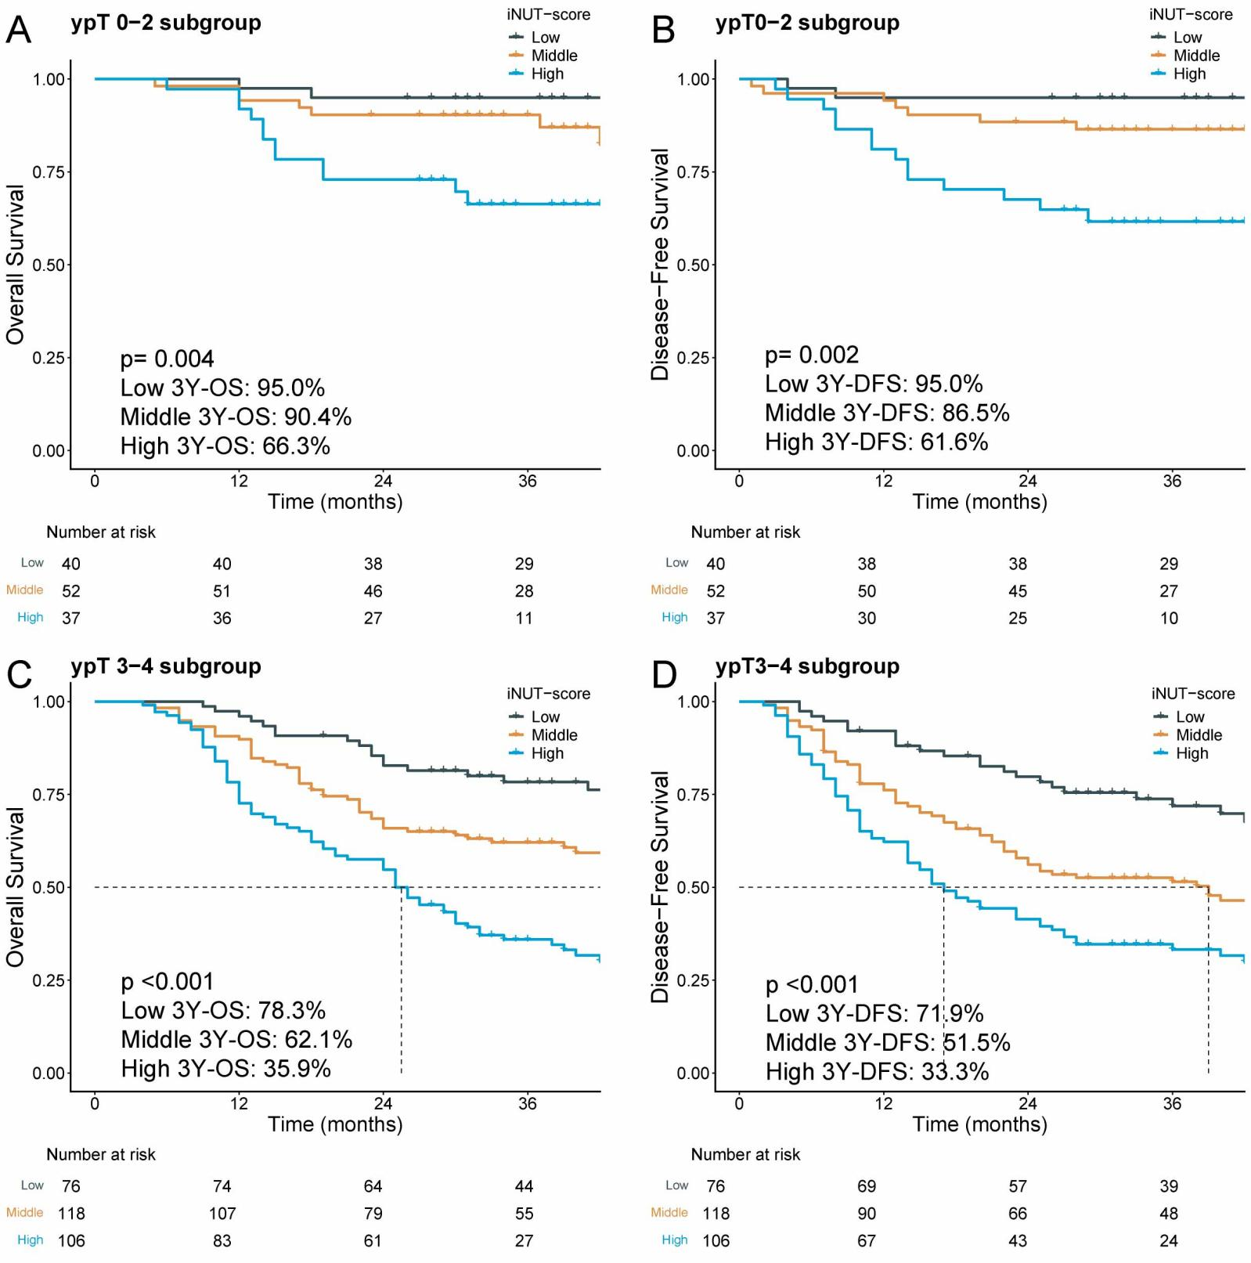
Figure S4. Kaplan-Meier survival curves of ypT subgroups in the overall population. (A) Overall survival (OS) in the ypT 0-2 group. (B) Disease-free survival (DFS) in the ypT 0-2 group. (C) OS in the ypT 3-4 group. (D) DFS in the ypT 3-4 group.

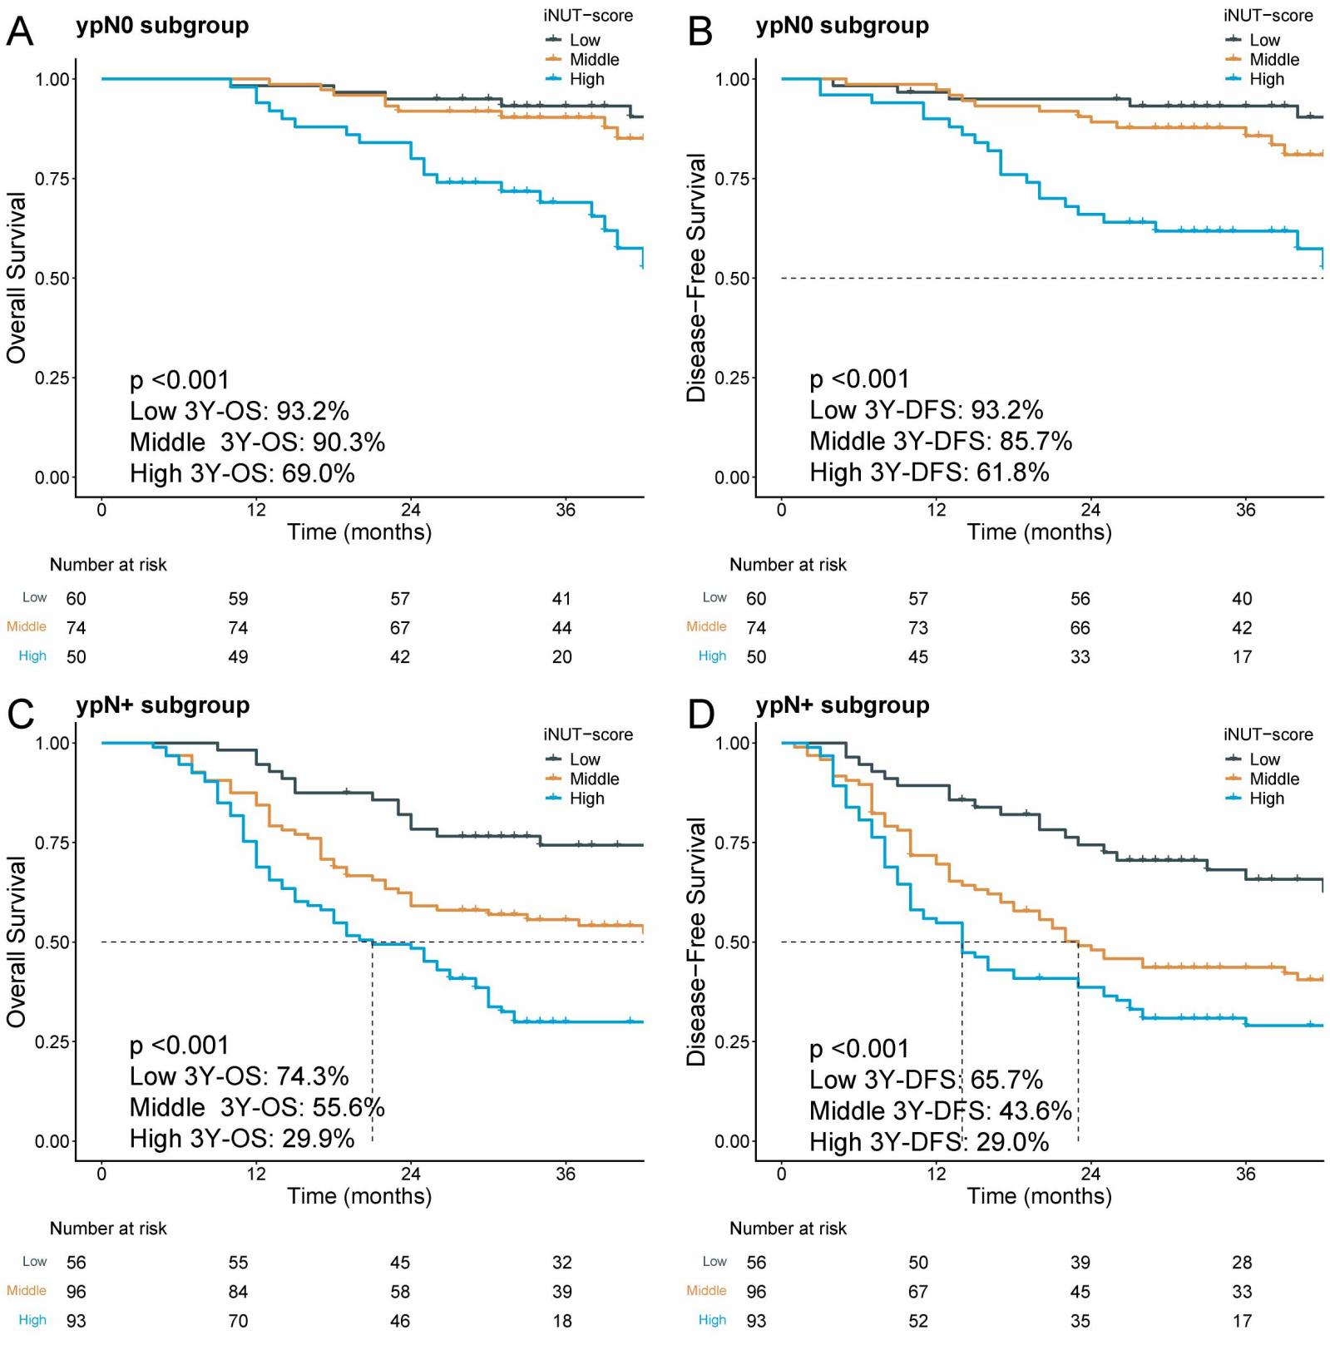
Figure S5. Kaplan-Meier survival curves of ypN subgroups in the overall population. (A) Overall survival (OS) in the ypN0 group. (B) Disease-free survival (DFS) in the ypN0 group. (C) OS in the ypN+ group. (D) DFS in the ypN+ group.
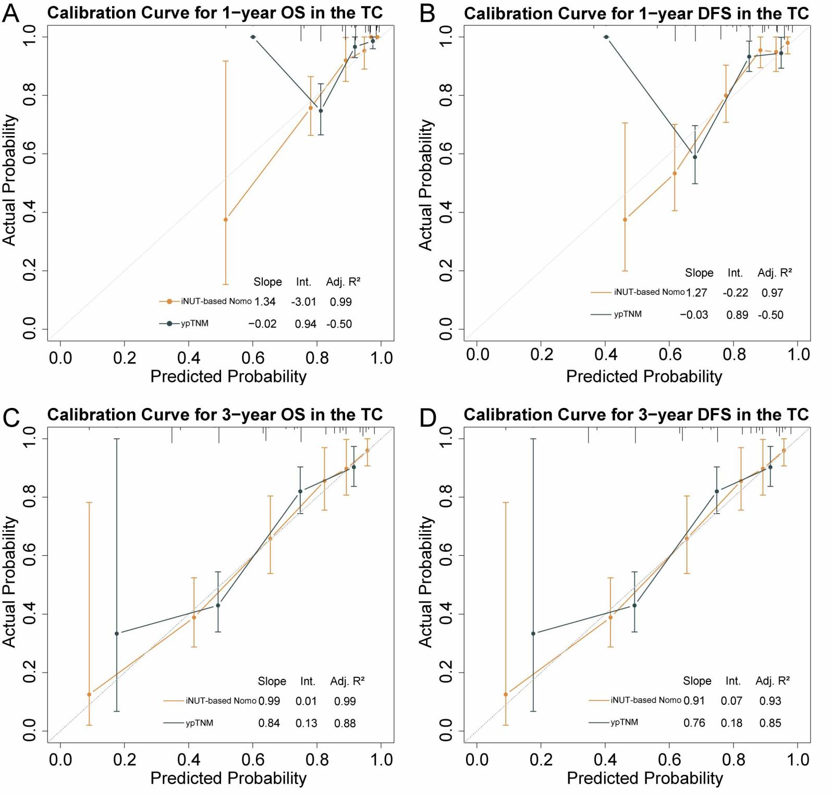
Figure S6. Calibration curves comparing the iNUT-based nomogram and the ypTNM staging system in the training cohort. (A) Calibration curve for 1-year overall survival (OS). (B) Calibration curve for 1-year disease-free survival (DFS). (C) Calibration curve for 3-year OS. (D) Calibration curve for 3-year DFS.
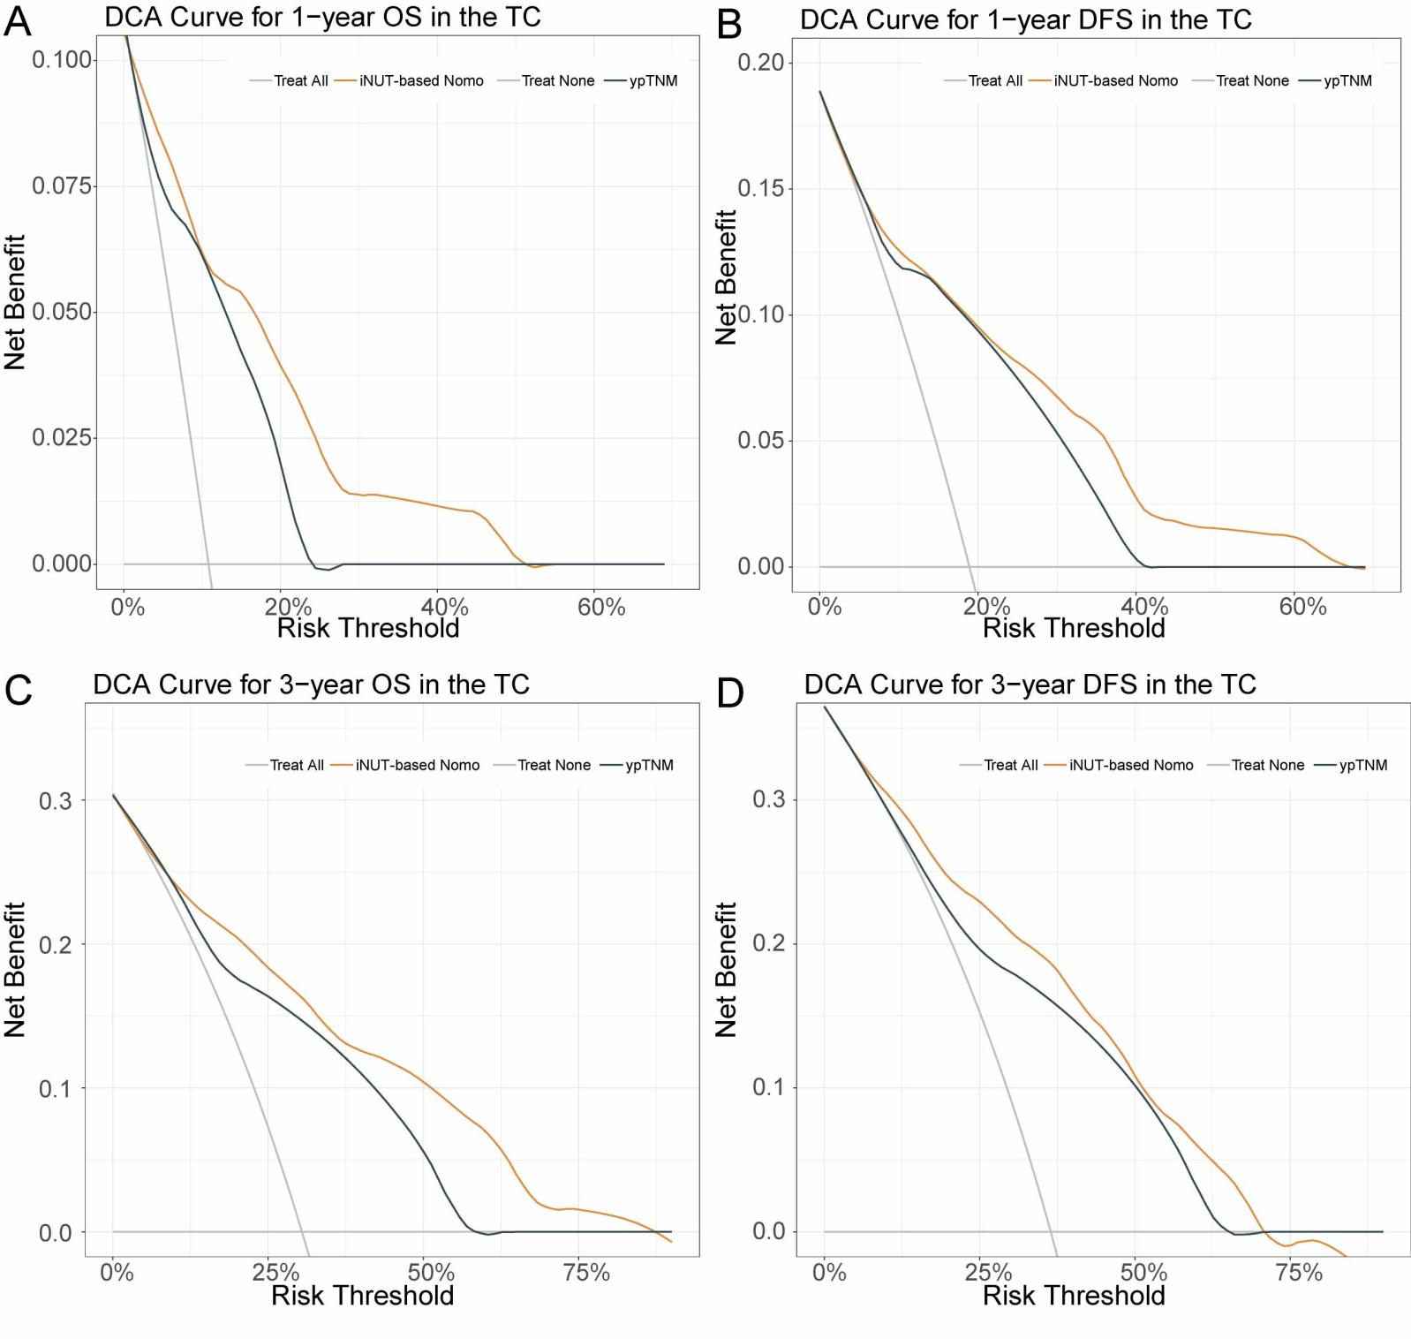
Figure S7. Decision curve analysis (DCA) comparing the iNUT-based nomogram and the ypTNM staging system in the training cohort. (A) DCA for 1-year overall survival (OS). (B) DCA for 1-year disease-free survival (DFS). (C) DCA for 3-year OS. (D) DCA for 3-year DFS.
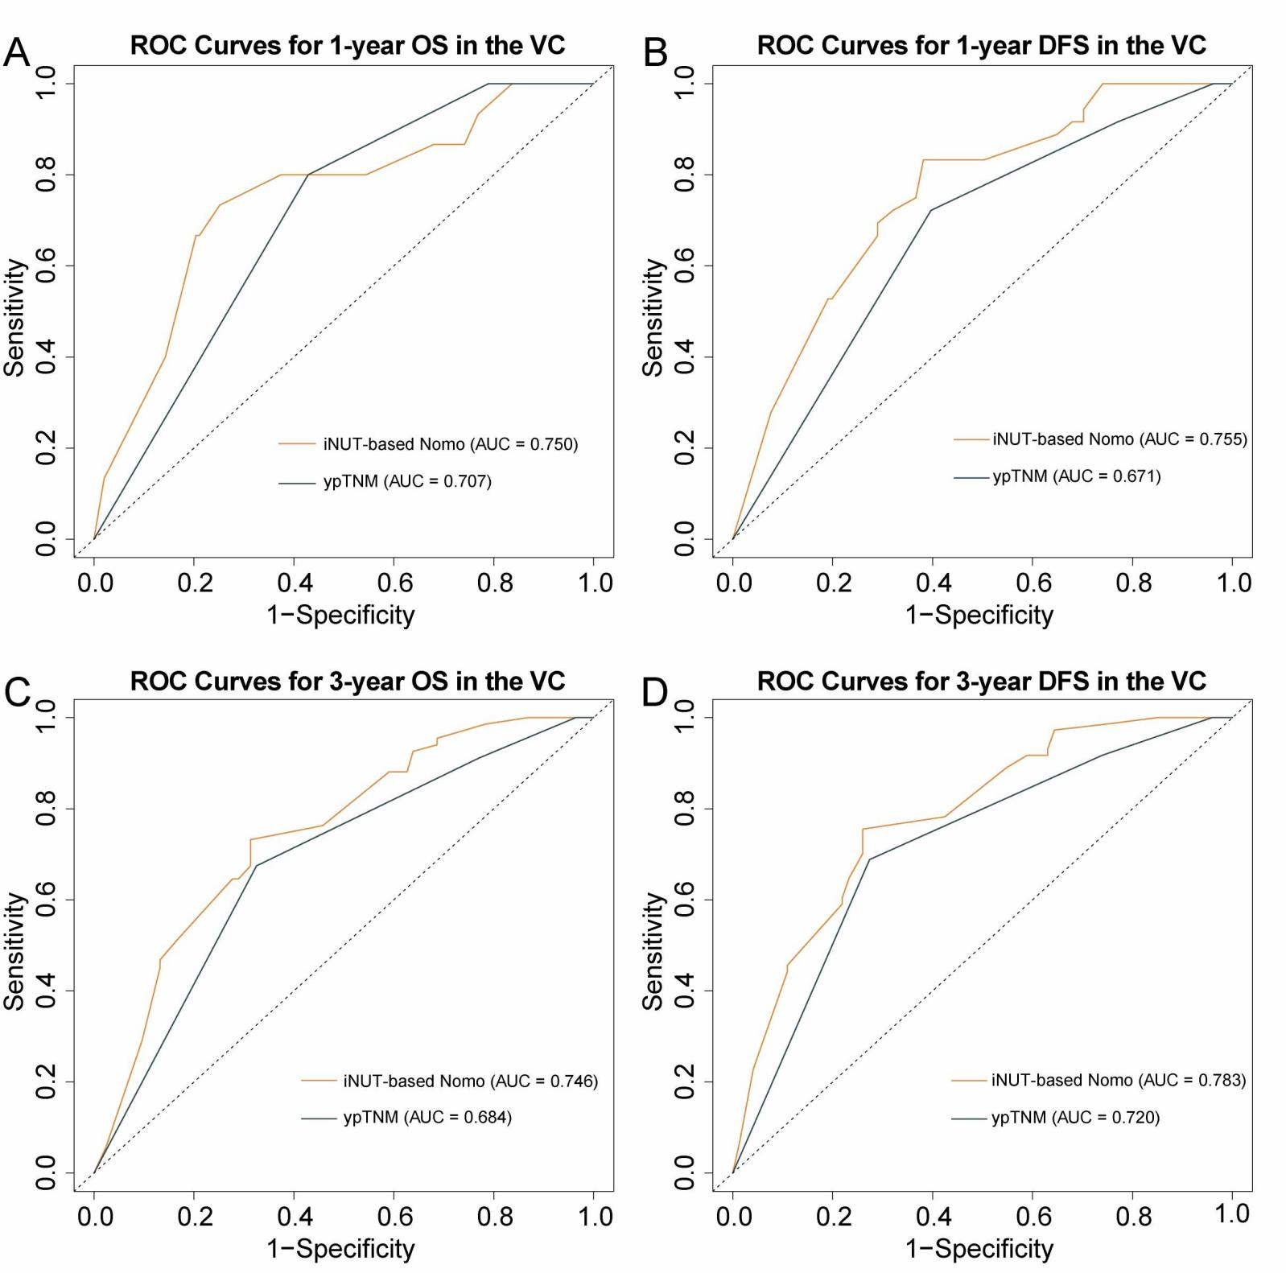
Figure S8. Comparison of receiver operating characteristic (ROC) curves between the iNUT-based nomogram and the ypTNM staging system in the validation cohort. (A) ROC curve for 1-year overall survival (OS). (B) ROC curve for 1-year disease-free survival (DFS). (C) ROC curve for 3-year OS. (D) ROC curve for 3-year DFS.
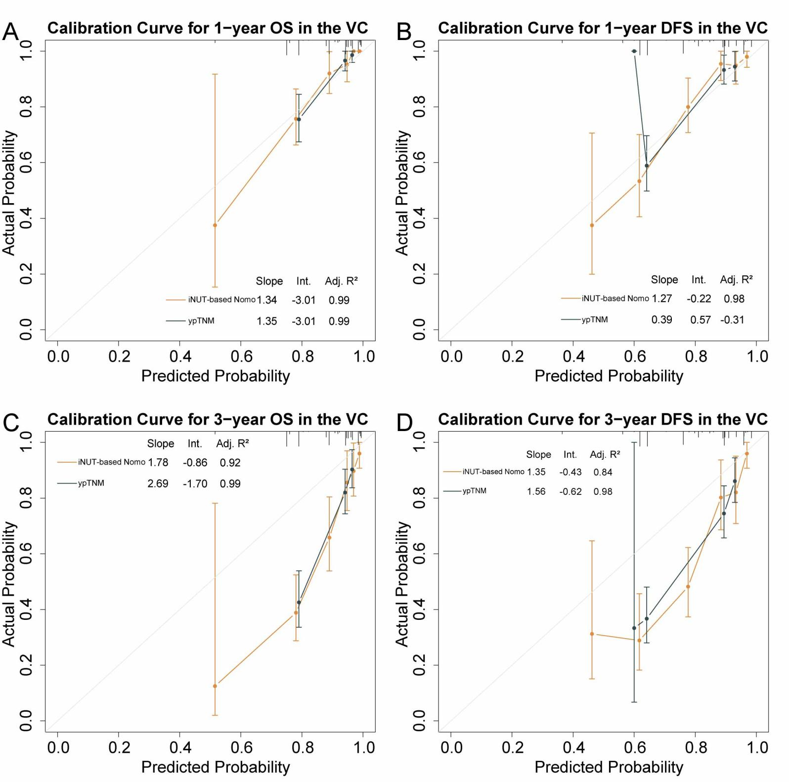
Figure S9. Calibration curves comparing the iNUT-based nomogram and the ypTNM staging system in the validation cohort. (A) Calibration curve for 1-year overall survival (OS). (B) Calibration curve for 1-year disease-free survival (DFS). (C) Calibration curve for 3-year OS. (D) Calibration curve for 3-year DFS.
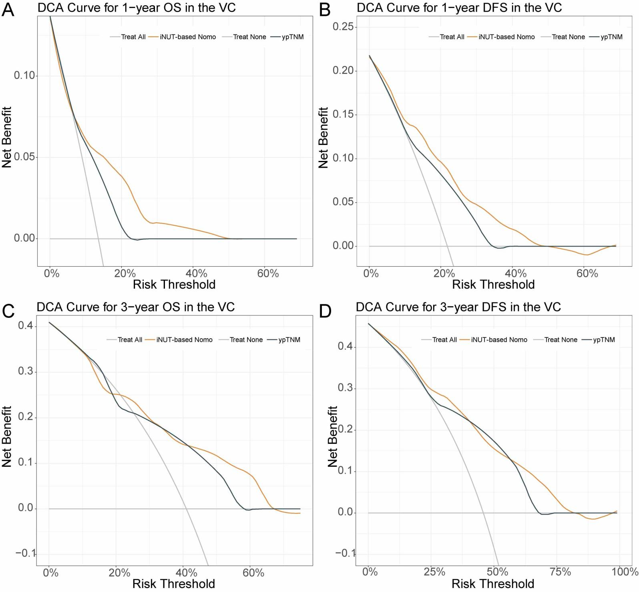
Figure S10. Decision curve analysis (DCA) comparing the iNUT-based nomogram and the ypTNM staging system in the validation cohort. (A) DCA for 1-year overall survival (OS). (B) DCA for 1-year disease-free survival (DFS). (C) DCA for 3-year OS. (D) DCA for 3-year DFS.

