Full-length uncropped Western blot images. The regions used in the main figures are indicated by boxes.

Uncropped western blots-not for publication; AKR1C3 for Fig 3G.tif

Uncropped western blots-not for publication; β-actin for Fig 3G.tif

Uncropped western blots-not for publication; PTGS2 for Fig 4C.tif

Uncropped western blots-not for publication; 4-HNE for Fig 4C.tif

Uncropped western blots-not for publication; SLC7A11 for Fig 4C.tif


Uncropped western blots-not for publication; FTH1 for Fig 4C.tif

Uncropped western blots-not for publication; AKR1C3 for Fig 4C.tif

Uncropped western blots-not for publication; β-actin for Fig 4C.tif
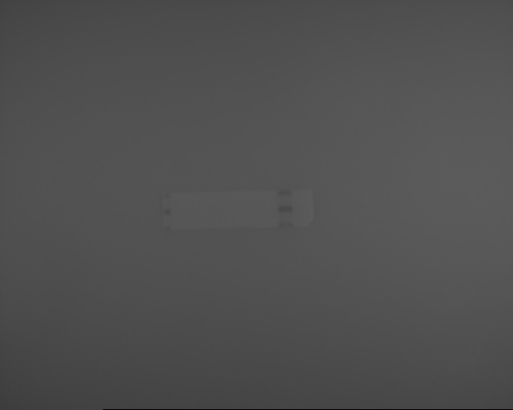
Uncropped western blots-not for publication; AKR1C3 for Fig 6C.tif
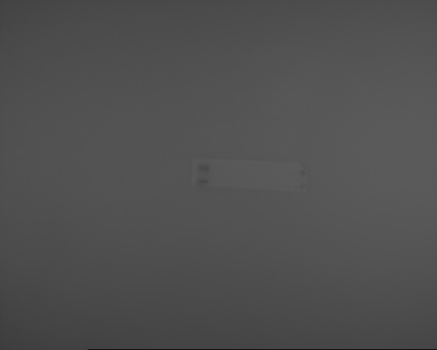
Uncropped western blots-not for publication; β-actin for Fig 6C.tif
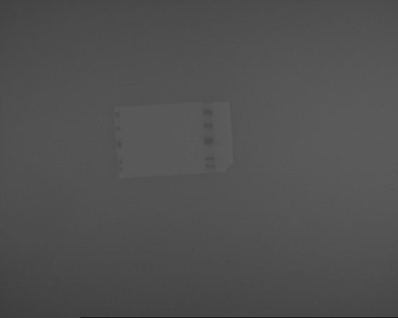
Uncropped western blots-not for publication;GPX4 for Fig 6H.tif

Uncropped western blots-not for publication;SLC7A11 for Fig 6H.tif

Uncropped western blots-not for publication; 4-HNE for Fig 6H.tif
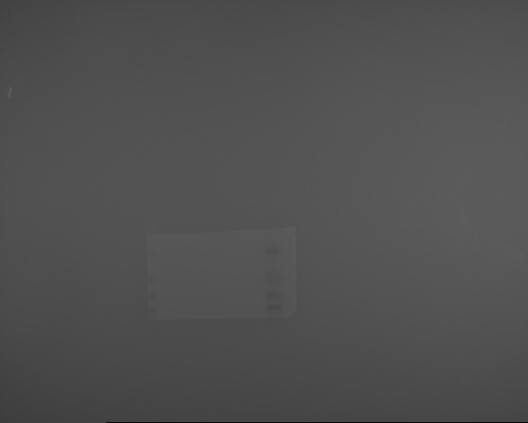
Uncropped western blots-not for publication; β-actin for Fig 6H.tif
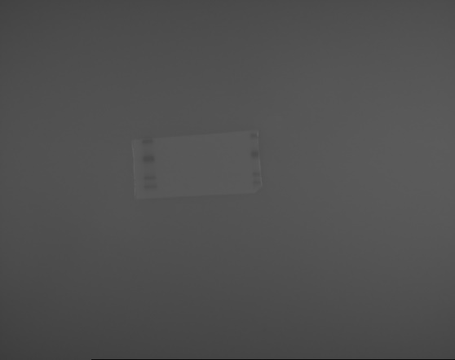
Uncropped western blots-not for publication; 4-HNE for Fig 8G.tif
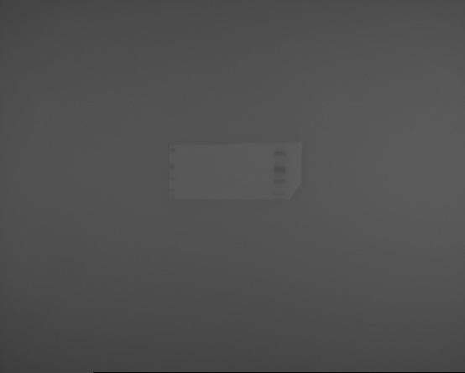
Uncropped western blots-not for publication; SLC7A11 for Fig 8G.tif
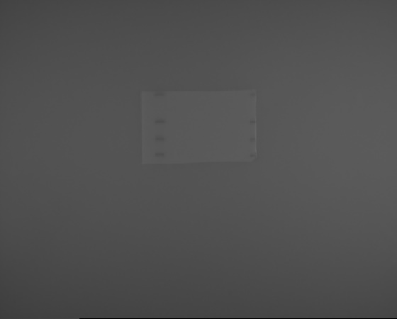
Uncropped western blots-not for publication; AKR1C3 for Fig 8G.tif
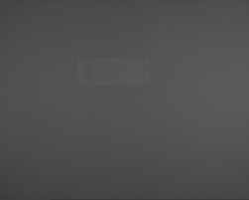
Uncropped western blots-not for publication; β-actin for Fig 8G.tif

Uncropped western blots-not for publication; COL1A1 for Fig 9H.tif

Uncropped western blots-not for publication; RUNX2 for Fig 9H.tif

Uncropped western blots-not for publication; OCN for Fig 9H.tif

Uncropped western blots-not for publication; β-actin for Fig 9H.tif

