Supplementary Information
S.1 LUTs adjustment in NIS-Elements software for image acquisition
In order to get the same quality of the photos taken by the fluorescent microscope, we set LUTs in the range of 500-2000. Figure S.1 shows the different between default value which is 0 – 16383 and changed value which is 550 – 3203.
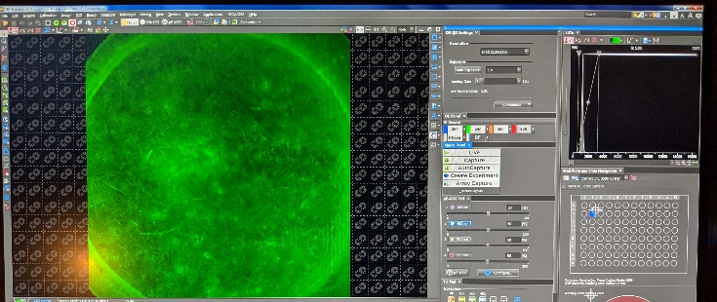
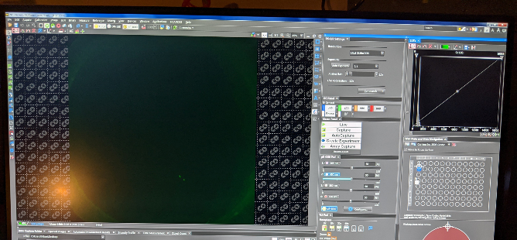

(before) (after)
Figure S.1 The difference output images before and after changing the LUTs value

