Genomics of perivascular space burden unravels early mechanisms of cerebral small vessel disease

SUPPLEMENTARY DATA
Table of contents

SUPPLEMENTARY METHODS 3
1) Description of study populations 3
2) MRI protocol and phenotyping 7
3) Dilated perivascular space visual rating scales 11
3.1. Zhu scale 11
3.2. Edinburgh scale 11
3.3. UNIVRSE (Uniform Neuro-Imaging of Virchow-Robin Spaces Enlargement consortium) scale 11
3.4. NOMAS scale 11
3.5. Sydney MAS and OATS scale 11
4) Covariates 12
5) Genotyping, quality control and imputation 12
6) Meta-analyses and related quality control 12
7) Number of independent phenotypes calculation for multiple testing correction 12
8) GWAS summary statistics used for exploring clinical correlates of dPVS 13
9) Mendelian randomization 14
10) Pathway analyses 14
11) Transcriptome-wide association studies 14
12) Processing and quality control of next generation sequencing data 15
12.1 UK Biobank 15
12.2 BRIDGET 15
13) Acknowledgements 16
SUPPLEMENTARY RESULTS 19
1) Haplotype analysis of the chr20q13.12 locus 19
SUPPLEMENTARY TABLES 21
1) Suppl. Table 1: Study design and sample characteristics of the individual studies 21
2) Suppl. Table 2. dPVS burden cut-off description in each cohort 21
3) Suppl. Table 3. GWAS genotyping platforms, imputation panels and quality control of genotypes 21
4) Suppl. Table 4. Description of the number of SNPs available for each study (GWAS meta-analysis) 21
5) Suppl. Table 5. Association of the discovery meta-analysis genetics variants (p-value<5x10-6) with BG and HIP dPVS in UKB and the combined meta-analysis 21
6) Suppl. Table 6. Conditional and joint multiple-SNP analysis of dPVS GWAS summary statistics (GCTA-cojo) 21
7) Suppl. Table 7. Loci reaching GW significance in the multiancestry meta-analysis using MR-MEGA 21
8) Suppl. Table 8. Gene-based test (European GWAS meta-analysis) 21
9) Suppl. Table 9. Genetics variants associated with high dilated perivascular spaces burden (5x10-8<p-value<5x10-6) in the combined meta-analysis 21
10) Suppl. Table 10. Shared genetic contribution between extensive dPVS burden and other traits - LD-score regression 21
11) Suppl. Table 11. Shared genetic correlation between dPVS burden in CHARGE cohorts and UKB………….. 21
12) Suppl. Table 12. Multi-trait analysis of genome-wide association summary statistics of dPVS burden, white matter hyperintensity volume and lacunar brain infarcts 21
13) Suppl. Table 13. Whole exome sequencing association analyses with dPVS - single variant association results 21
14) Suppl. Table 14. Whole exome sequencing association analyses with dPVS – gene-based burden test results 21
15) Suppl. Table 15. Shared genetic contribution between extensive dPVS burden and other traits….. 21
16) Suppl. Table 16. Association of dilated perivascular spaces genome-wide significant genetic variants with other published traits (GWAS catalog) 21
17) Suppl. Table 17. Mendelian randomization analysis between putative risk factors and extensive dPVS burden and between extensive dPVS burden and neurological traits, using GSMR and radial MR 21
18) Suppl. Table 18. Pathway analysis using MAGMA software 21
19) Suppl. Table 19. Pathway analysis using VEGAS software 21
20) Suppl. Table 20. Enrichment in genes mutated in OMIM syndromes associated with white matter hyperintensities, leukodystrophy or leukoencephalopathy stroke and dementia 21
21) Suppl. Table 21. Transcriptome-wide significant genes with extensive dPVS burden 21
22) Suppl. Table 22. RNA-seq datasets used in the Single cell Type Enrichment Analysis for Phenotypes (STEAP) pipeline 21
23) Suppl. Table 23. Cell-type enrichment analysis 21
SUPPLEMENTARY FIGURES 22
1) Supplementary Figure 1 : QQ and Manhattan plots 22
2) Supplementary Figure 2 : regional association plots 31
2.1. Dilated perivascular spaces in white matter 31
2.2. Dilated perivascular spaces in basal ganglia 39
2.3. Dilated perivascular spaces in hippocampus 40
3) Supplementary Figure 3 : Association of WM dPVS SNPs with WM dPVS burden in the i-Share cohort (N=1,748) 42
4) Supplementary Figure 4 : meta-regression with age of the three genome-wide significant WM dPVS loci that also showed significant associations with WM dPVS in young adults 43
5) Supplementary Figure 5. Brain expression pattern across the lifespan of genes near genome-wide significant dPVS loci that are also identified in the TWAS or that are the nearest genes of variants showing an association with dPVS already in young adults 44
5.1. Genes in white matter dPVS loci 44
5.2. Genes in basal ganglia dPVS loci 46
5.3. Genes in hippocampus dPVS loci 47
6) Supplementary Figure 6. Enrichment of dPVS genes in targets of drugs validated in other indication (Genome for REPositioning drugs) 48
7) Supplementary Figure 7. Enrichment of dPVS genes in targets of drugs validated in other indication (Trans-Phar) 49
References 50

SUPPLEMENTARY METHODS

Description of study populations

Austrian Stroke Prevention Study (ASPS)
The ASPS study is a prospective study on the effects of vascular risk factors on brain structure and function in the normal elderly population of the city of Graz, Austria.^{1,2} A total of 2007 participants were randomly selected from the official community register stratified by gender and 5-year age groups. Individuals with a history of neuropsychiatric disease, including previous stroke, transient ischemic attacks, and dementia, or an abnormal neurologic examination determined on the basis of a structured clinical interview and a physical and neurologic examination were excluded from the study. During 2 study periods between September 1991 and March 1994, and between January 1999 and December 2003, an extended diagnostic work-up including MRI and neuropsychological testing was performed in 1076 participants aged 45 to 85 years randomly selected from the entire cohort (509 from the first period and 567 from the second). In 1992, blood was drawn from all study participants for DNA extraction. They were all European Caucasians. Genotyping was performed in 996 participants using the Human Genotyping Facility, Genetic Laboratory Department of Internal Medicine, Erasmus MC, Rotterdam, The Netherlands. Brain MRI with dPVS assessment and GWAS data were available for 471 participants.

Austrian Stroke Prevention Family Study (ASPS-Fam)
ASPS-Fam represents an extension of the Austrian Stroke Prevention Study (ASPS), which was established in 1991.^{1,2} Between 2006 and 2013, study participants of the ASPS and their first-grade relatives were invited to enter ASPS-Fam.^{1,2} Inclusion criteria were no history of previous stroke or dementia and a normal neurologic examination. A total of 419 individuals from 176 families were included into the study. The number of members per family ranged from 2 to 6. The entire cohort underwent a thorough diagnostic workup including clinical history, laboratory evaluation, cognitive testing, and an extended vascular risk factor assessment. They were all European Caucasians. Those 306 participants who passed genotyping quality control and had dPVS assessment on brain MRI were available for these analyses.

Epidemiology of Dementia in Singapore Study (EDIS)
The EDIS study is a subsample of the Singapore Epidemiology of Eye Disease Study, a population-based study including participants from three cohorts with different ethnicities: Chinese (Singapore Chinese Eye Study (SCES)),³ Malay (Singapore Malay Eye Study–2 (SIMES)),⁴ and Indians (Singapore Indian Eye Study–2). Participants aged 60 years or older underwent cognitive screening with the Abbreviated Mental Test and self-reported forgetfulness. A total of 957 participants with an Abbreviated Mental Test score ≤6 (≤6 years of formal education) or ≤8 (>6 years of formal education) or reporting forgetfulness were included in the second phase of the EDIS Study where they were offered to underwent a 3T brain MRI. A total of 127 Chinese and 212 Malay participants had been scanned as well as genotyped and were available for these analyses.

Framingham Heart Study (FHS)
The FHS study is a 3-generation community-based and prospective cohort that was initiated in 1948 to investigate risk factors for cardiovascular disease including stroke. It comprises 3 generations of participants: the original cohort followed-up since 1948 (original)⁵ their offspring, followed-up since 1971 (offspring),⁶ and children from the largest offspring families enrolled in 2002 (Gen 3).⁷ The original cohort enrolled 5 209 men and women who comprised two-thirds of the adult population then residing in Framingham, Massachusetts. Survivors continue to receive biennial examinations. The offspring cohort comprises 5 124 persons (including 3 514 biological offspring) who have been examined approximately once every 4 years. Participants in the Original and Offspring cohorts have been invited to undergo brain MRI since 1999. Brain MRI in Gen 3 only began in 2007 and is not included in these analyses. The population of Framingham was virtually entirely white in 1948, when the original cohort was recruited. FHS participants are under continuous surveillance for neurological outcomes including transient ischemic attack, stroke, and dementia^{8,9} Participants had DNA extracted and provided consent for genotyping in the 1990s. Genotyping was performed at Affymetrix (Santa Clara, Calif) through an NHLBI-funded SNP-Health Association Resource (SHARe) project. A total of 191 participants with dPVS assessment on brain MRI were included in this analysis.

i-Share Study (lifespan exploration)
This study was used for the lifespan exploration of dPVS loci. The Internet-based Students HeAlth Research Enterprise (i-Share) study, a prospective population-based cohort of students in higher education institutions in France, is the largest ongoing epidemiological study conducted on students’ health. The aims of the i-Share study are to assess the students’ health and well-being, to study risk behaviors in this specific population, the frequency and consequences of various diseases, as well as, the pathophysiological mechanisms diseases affecting older persons which have a long preclinical phase and for which intermediate biomarkers could already be measured at a very young age. Students who were at least 18 years old, enrolled at a university or other higher education institution, and who are able to understand written French were eligible to participate on a voluntary basis via the i-Share website (http://www.i-share.fr/). Currently, over 20 000 participants have been included, of whom 1 999 participants from the Bordeaux University site, who provided written informed consent, were enrolled in an ancillary study involving brain MRI (acquired on a Siemens 3T Prisma scanner) and genetic testing, including genome-wide genotyping on the Affymetrix Precision Medicine Axiom array (imputed on the HRC reference panel). Of these, 1 748 participants had both high-quality brain MRI with dPVS assessment and genome-wide genotype data available, and were included in this analysis.

Investigating Silent Strokes in Hypertensives: a Magnetic Resonance Imaging Study (ISSYS)
The aim of the ISSYS study was to determine the prevalence of silent cerebrovascular lesions in a large cohort of hypertensive participants and to study their associated factors.¹⁰ The ISSYS study is an observational prospective study of 1 037 participants with essential hypertension aged 50-70 years old without history of stroke or dementia, selected from 14 primary care centers in the north area of Barcelona city. Out of these, 976 (94.1%) completed baseline procedures, including a brain MRI. Participants were followed-up for at least three years. The study protocol has been approved by the Ethics Committee of Vall d’Hebron Hospital and IDIAP Jordi Gol (University Research Institute in Primary Care). A total of 241 participants with GWAS data and dPVS assessment were included in this analysis.

Lothian Birth Cohort 1936 (LBC1936)
The LBC1936 cohort consists of relatively healthy individuals assessed on cognitive and medical measures at age 70 years (n=1 091), and again with brain imaging traits at 73 years of age (n=866). They were born in 1936, most took part in the Scottish Mental Survey of 1947, and all lived independently in the Lothian region of Scotland. A full description of participant recruitment and testing can be found elsewhere.^{11,12} The study was approved by the Lothian (REC 07/MRE00/58) and Scottish Multicentre (MREC/01/0/56) Research Ethics Committees and all subjects gave written informed consent. A total of 582 participants with GWAS data and dPVS measurement were included in this analysis.

The Northern Manhattan Study (NOMAS)
The Northern Manhattan Study is a population-based study of 3,298 stroke-free participants enrolled from the Northern Manhattan neighborhood between 1993 and 2001 using random digit dialing.¹³ Between 2003 and 2008 all remaining stroke-free participants aged 50 years or older were invited to undergo a brain MRI.¹⁴ The study was approved by the local institutional review board (Columbia University and University of Miami). A total of 1,290 participants underwent brain MRI. Of these, 717 participants of Hispanic ancestry, 168 of African American ancestry and 138 of European ancestry with genome-wide genotype data available and dPVS assessment were included in this analysis.

Rotterdam Study (RS)
The Rotterdam Study is a population-based cohort study among inhabitants of a district of Rotterdam (Ommoord), The Netherlands, and aims to examine the determinants of disease and health in the elderly with a focus on neurogeriatric, cardiovascular, bone, and eye disease.¹⁵ In 1990-1993, 7,983 persons aged 55 years and older participated and were re-examined every 3 to 4 years (Rotterdam Study I). In 2000-2001 the cohort was expanded by 3,011 persons aged 55 and over who had not yet been part of the Rotterdam Study (Rotterdam Study II). In 2006-2008 a second expansion (Rotterdam Study III) of 3,932 persons aged 45 and over was realized. All participants had DNA extracted at their first visit. Genotyping was attempted in participants with high-quality extracted DNA in 2007-2008. In total, 6,291 samples from the Rotterdam Study I, 2,157 samples from Rotterdam Study II and 3,048 samples from Rotterdam Study III were available with good quality genotyping data. Genotyping was done at the Human Genotyping Facility, Genetic Laboratory Department of Internal Medicine, Erasmus MC, Rotterdam, the Netherlands. From 2005 onwards, brain MRI scanning was implemented in the core protocol of all Rotterdam Study cohorts.¹⁶ As a result, 933, 643 and 2,425 participants from respectively Rotterdam Study I, II and III had been scanned and genotyped and were available for these analyses.

Study of Health in Pomerania (SHIP)
We analyzed data from the Study of Health in Pomerania (SHIP).¹⁷ The target population was comprised of adult German residents in northeastern Germany living in three cities and 29 communities, with a total population of 212,157 participants. A two-stage stratified cluster sample of adults aged 20-79 years (baseline) was randomly drawn from local registries. The net sample (without migrated or deceased persons) comprised 6,267 eligible participants, of which 4,308 participated at baseline SHIP-0 between 1997 and 2001. Follow-up examination (SHIP-1) was conducted 5 years after baseline and included 3,300 participants. From 2008 to 2012 the third phase of data collection (SHIP-2, N=2,333) was carried out. Concurrent with SHIP-2 a new sample called SHIP-Trend-0 (N=4,420) in the same area was drawn in 2008 and similar examinations were undertaken. SHIP and SHIP-TREND were approved by the local ethics committee. After complete description of the study to the subjects, written informed consent was obtained.
Participants from SHIP-2 and SHIP-Trend-0 were asked to participate in a whole-body magnetic resonance imaging (MRI) assessment¹⁸ After exclusion of subjects who refused participation or fulfilled exclusion criteria for MRI (e.g. cardiac pacemaker), 1,163 participants from SHIP-2 and 2,154 participants from SHIP-Trend-0 underwent whole-body MRI (total number N=3,317). After exclusion of MRI with technical artifacts, major structural abnormalities and stroke, full data sets with GWAS data and brain MRI were available in 1,036 participants in SHIP-2 and 1,960 participants in SHIP-Trend-0 and included in this project.

Sydney Memory and Ageing Study (MAS) & Older Australian Twins Study (OATS)
Sydney Memory and Ageing Study (MAS)
The Sydney Memory and Ageing Study began in 2005 and is a longitudinal community-based study investigating mild cognitive impairment and the rate of cognitive change over time. Participants aged 70-90 years were randomly recruited from the compulsory electoral roll in Sydney, Australia. Exclusion criteria included limited English or a medical/psychological condition that would prevent them from completing assessments, dementia diagnosis, an age and education-adjusted MMSE score <24, psychotic symptoms, or a diagnosis of schizophrenia/bipolar disorder and/or a progressive malignancy. All participants provided informed written consent and the ethics committees of the University of New South Wales and the South Eastern Sydney and Illawarra Area Health Service approved the study. At baseline, 1 037 participants were included with a mean age of 78.84 years and 44.8% were men. Further details are provided in Sachdev et al., (2010).¹⁹ For the current study, there were 186 participants free of stroke with whole genome sequencing and dPVS assessment available for analysis.
Older Australian Twins Study (OATS)
Participants aged 65 years and over were recruited from the Australian Twin Registry and also through a recruitment drive. Inclusion criteria included an ability to consent, a co-twin who also consented to participate, completion of some education in English and residence in one of the three eastern states (Victoria, New South Wales, Queensland). Exclusion criteria included inadequate English to complete the assessment, current diagnosis of malignancy or other life-threatening medical illness and/or a current acute psychosis diagnosis. Written informed consent was obtained from all participants and the ethics committees of the Australian Twin Registry, University of New South Wales, University of Melbourne, Queensland Institute of Medical Research and the South Eastern Sydney and Illawarra Area Health Service. At baseline, there were 623 participants with a mean age of 70.77 years and 65.2% of the sample were women. For further details see Sachdev et al. (2009)²⁰ and Sachdev et al. (2010).¹⁹ For the current study, there were 131 participants with whole genome sequencing and dPVS assessment available for analysis.

Three-City Dijon Study (3C-Dijon)
The 3C is a cohort study conducted in three French cities (Bordeaux, Dijon, and Montpellier), comprising 9,294 participants, designed to estimate the risk of dementia and cognitive impairment attributable to vascular factors.²¹ Eligibility criteria included living in the city and being registered on the electoral rolls in 1999, 65 years or older, and not institutionalized. The study protocol was approved by the Ethical Committee of the University Hospital of Kremlin-Bicêtre and each participant signed an informed consent. Data reported in this article were obtained in Dijon (3C-Dijon study), where 4,931 individuals were recruited (1999 –2001). The overall design of the 3C-Dijon study is detailed elsewhere.^{21,22} Participants aged less than 80 years and enrolled between June 1999 and September 2000 (n=2,763) were invited to undergo a brain MRI. Although 2,285 subjects agreed to participate (82.7%), because of financial limitations, 1,924 MRI scans were performed, of which 1,683 had also genotype data. A total of 1,500 stroke free participants with GWAS data and dPVS assessment were included in this analysis.
These images were then further analyzed with the optimized Voxel-Based Morphometry (VBM) protocol, using Statistical Parametric Mapping 99 (SPM99) that we modified in order to consider the structural characteristics of the aged brain, as described in detail elsewhere. Of the remaining 1,707 individuals with brain MRI data, 1,578 had QC’ed genetic data and after exclusion of participants with prevalent stroke, prevalent dementia or brain tumor 1,491 individuals were available for the genetic analysis.

UK Biobank (UKB)
UK Biobank is a prospective study that recruited 502,620 community-dwelling participants from across the United Kingdom between 2006 and 2010, aged 40 to 69 years (http://www.ukbiobank.ac.uk). The study collects extensive data from questionnaires, interviews, health records, physical measures, biological samples, and imaging. A subset of the participants also underwent brain MRI. Patients with a baseline diagnosis of stroke, multiple sclerosis, Parkinson disease, any other neurodegenerative problem (International Classification of Diseases, Ninth Revision/Tenth Revision, or self-report or health-record linkage) or no genetic data were excluded. UK Biobank received ethical approval from the research ethics committee (reference 11/NW/0382). All participants provided informed consent to participate. Procedures for brain imaging acquisition and initial quality check have been described previously and are available on the UK Biobank website (Brain Imaging Documentation V1.3; http://www.ukbiobank.ac.uk). In brief, all brain MRI data were acquired on a single standard Siemens Skyra 3T scanner (Siemens Medical Solutions, Germany) using the standard Siemens 32-channel radiofrequency receiver head coil. A total of 28,655 stroke-free participants with GWAS data and dPVS assessment were included in this analysis.

MRI protocol and phenotyping

Study name | MRI-scanner (Brand, Tesla) | MRI sequences used for dPVS quantification | dPVS quantification method / scale used (slices used) | Large dPVS (≥3 mm) are included in the scoring of dPVS burden in addition to small dPVS | Intracranial volume (ICV) quantification method/software
ASPS | Gyroscan S15 and ACS, Philips Medical Systems, Eindhoven, The Netherlands; 1.5Tesla | 0.9x0.9x5mm³ T2 | UNIVRSE scale (Basal ganglia and centrum semiovale: predefined slice; hippocampus and mesencephalon: whole structure) | Yes | ICV was not available in ASPS. Brain parenchymal fraction was used as a covariate and was calculated using axial T2 scans with Sienax (https://fsl.fmrib.ox.ac.uk/fsl/fslwiki/SIENA).  Brain parenchymal fraction was defined as the ratio of the brain parenchymal tissue volume to the total volume within the surface contour of the whole brain
ASPS-Fam | 3T whole body scanner (TimTrio; Siemens Healthcare, Erlangen, Germany) | 0.9x0.9x3mm³ T2 | UNIVRSE scale (Basal ganglia and centrum semiovale: predefined slice; hippocampus and mesencephalon: whole structure) | Yes | Freesurfer 5.3
EDIS-SCES | SIEMENS 3Tesla | 3D 1mm³ T1, 2D 1x1x3mm³ T2 | UNIVRSE scale (Basal ganglia and centrum semiovale: predefined slice; hippocampus and mesencephalon: whole structure) | Yes | Rotterdam study pipeline
EDIS-SIMES | SIEMENS 3Tesla | 3D 1mm³ T1, 2D 1x1x3mm³ T2 | UNIVRSE scale (Basal ganglia and centrum semiovale: predefined slice; hippocampus and mesencephalon: whole structure) | Yes | Rotterdam study pipeline
FHS | 1.5 tesla MR Siemens Magnetom | T2 weighted axial sequences | - UNIVRSE scale for BG and HIP  - EDINBURGH scale for CSO | No | In-house algorithm based on FLAIR sequences
i-Share (lifespan exploration) | 3T Siemens Prisma | 3D T1 | Zhu scale | Yes | Freesurfer v6.0
ISSYS | General Electrics, 1.5 Tesla | Axial T2 | Edinburgh scale (most severe slice, most severe hemisphere) | No | ICA
LBC1936 | GE Signa Horizon 1.5 Tesla HDxt clinical scanner (General Electric, Milwaukee, WI, USA) | 2D 1x1x2mm³ T2-weighted | Edinburgh scale | Yes | ICV includes the contents within the inner skull table and has its inferior limit in the axial slice just superior to the tip of the odontoid peg at the foramen magnum and superior to the inferior limits of the cerebellar tonsils. The ICV, given in mm³, was obtained semi-automatically using the T2*W sequence. The first approximation of the ICV was obtained automatically using the Object Extraction Tool in Analyze 9.0 (Mayo Clinic, Analyze 9.0. AnalyzeDirect, Inc. Mayo Clinic). Then, the cervical spinal cord inferior to the inferior boundary was removed manually, along with the pituitary gland (in cases where this latter structure was included).
NOMAS | 1.5 Tesla (Philips Medical Systems, Best, the Netherlands) | 3D T1, FLAIR | NOMAS scale (dPVS were rated in regions of interest in basal ganglia and white matter, dPVS in temporal lobes were used as proxy for dPVS in hippocampus, whole structure was rated for dPVS in mesencephalon)  - grade 0 = no dPVS  - grade 1 = 1-3 dPVS  - grade 2 = ≥4 dPVS | No | Non-brain elements were manually removed from the image by operator guided tracing of the dura mater within the cranial vault including the middle cranial fossa, but excluding the posterior fossa and cerebellum. The resulting measure of the cranial vault was defined as the total cranial volume to correct for differences in head size among subjects.²³
RS1 | 1.5 T GE Signa Excite | T2-weighted, T1-weighted and fluid-attenuated inversion recovery sequence | UNIVRSE scale | Yes | Supratentorial intracranial volume was estimated by summing total grey and white matter volume and cerebrospinal fluid.²⁴
RS2 | 1.5 T GE Signa Excite | T2-weighted, T1-weighted and fluid-attenuated inversion recovery sequence | UNIVRSE scale | Yes | Supratentorial intracranial volume was estimated by summing total grey and white matter volume and cerebrospinal fluid.²⁴
RS3 | 1.5 T GE Signa Excite | T2-weighted sequence | Automated quantification using a 3D convolutional network regression method²⁵ | No | Supratentorial intracranial volume was estimated by summing total grey and white matter volume and cerebrospinal fluid.²⁴
SHIP / SHIP-TREND | 1.5 T Siemens MRI scanner (Magnetom Avanto, Siemens Medical Systems, Erlangen, Germany) | T1 1mm³, T2 FLAIR (0.9 x 0.9 x 3.0 mm3) | UNIVRSE scale | No | SPM8 with VBM8 toolbox
Sydney MAS | Philips, 3T Achieva Quasar Dual scanner | 3D T1 and FLAIR | Two predefined axial slices in the basal ganglia and centrum semiovale, i.e., 2 mm and 37 mm superior to the anterior commissure.  Quantitative scale (dPVS numbers) | Yes²⁶ | Freesurfer v6.0
OATS | Two 1.5T Siemens scanners: Magnetom Avanto and Sonata | 3D T1 and FLAIR | Same as Sydney MAS | Yes, same as in MAS²⁶ | Freesurfer v5.3
3C-Dijon | 1.5-Tesla Magnetom scanner (Siemens, Erlangen, Germany) | 3D-T1, T2 and proton density | Zhu scale | No | Voxel-Based Morphometry (VBM) protocol, using Statistical Parametric Mapping 99 (SPM99)
UKB | 3T Siemens Skyra (Siemens Healthineers, Erlangen, Germany) | T1 | Automated quantification using a 3D convolutional network regression method²⁵ | No | FreeSurfer v6.0

Dilated perivascular space visual rating scales

Zhu scale
dPVS were rated on 3D-T1 in both hemispheres. In the WM, dPVS were rated using a 4-grade score: grade 1 for <10 dPVS in the total WM; grade 2 for >10 dPVS in the total WM and <10 in the slice containing the greatest number of dPVS; grade 3 for 10-20 dPVS in the slice containing the greatest number of dPVS; and grade 4 for >20 dPVS in the slice containing the greatest number of dPVS. In BG, the slice containing the greatest number of dPVS was used for the rating, dPVS were also rated using a 4-grade score: grade 1 for <5 dPVS; grade 2 for 5-10 dPVS; grade 3 for >10 dPVS but still numerable; and grade 4 for innumerable dPVS resulting in a cribriform change in BG. In hippocampus, dPVS count was reported. Lesions fulfilling the same criteria except for a diameter ≥3 mm were carefully examined in the 3 planes (shape, signal intensity) to differentiate them from LI and WMH. Only lesions with a typical vascular shape (including cystic lesions with an extension of vascular shape) and that followed the orientation of perforating vessels were considered dPVS.²⁷

Edinburgh scale
dPVS were rated on axial T2 on the most severe slice and in the most severe hemisphere. In WM, BG and HIP, dPVS were rated using a 4-grade score: grade 0 for no dPVS; grade 1 for 1-10 dPVS; grade 2 for 11-20 dPVS; grade 3 for 21-40 dPVS; grade 4 for >40 dPVS. Large dPVS were included in the dPVS score.^{28,29}
In ISSYS HIP-dPVS were rated in both hemispheres, leading to a 8-grade score and large dPVS were rated separately.³⁰

UNIVRSE (Uniform Neuro-Imaging of Virchow-Robin Spaces Enlargement consortium) scale
dPVS were rated on axial T2 in both hemispheres on a continuous scale from 0 to 20 dPVS, with the highest category being >20 dPVS. dPVS were rated on predefined slices in WM and BG. In WM, the predefined slice was 1 cm above the lateral ventricles; in BG, this was the slice showing the anterior commissure or, when not visible, the first slice superior to it. dPVS count in the whole hippocampus was reported. Large dPVS were differentiated from LI by the shape of the lesion, the absence of hyperintense rim on FLAIR; and from WMH by signal intensity on T2.³¹
Based on the UNIVRSE scale, a deep-learning method was developed to automatically count dPVS,²⁴ which was used in RS3 using T2-weighted sequences and in the UKB using T1 sequences.

Concerning the Zhu, Edinburgh and UNIVRSE scales, a secondary sequence (T1 or T2) was used when dPVS were not typical on the primary sequence, and FLAIR was used to differentiate dPVS from WMH. Large dPVS and LI were rated with each scale.

NOMAS scale
dPVS were rated on 3D-T1 according to a 3-grade score: grade 0 for no dPVS; grade 1 for 1-3 dPVS; and grade 2 for >3 dPVS in 12 sections (4 sections in BG leading to a 8-grade score, 8 sections in WM leading to a 16-grade score). dPVS rating in the left and right temporal lobes was used as a proxy for dPVS in hippocampus (4-grade score). Large dPVS were differentiated from LI using FLAIR characteristics (hyperintense rim), anatomic location, and features of the lesions.¹⁴

Sydney MAS and OATS scale
dPVS were rated on 3D-T1 using a predefined slice in the basal ganglia and centrum semiovale, i.e., 2 mm and 37 mm superior to the anterior commissure on a continuous scale from 0 to 20. If the predefined slice was at the level where the lateral ventricules were still visible, the slice immediately superior to the lateral ventricules was selected.²⁶

Covariates

Hypertension was defined as SBP ≥140 mm Hg, DBP ≥90 mm Hg or use of an antihypertensive drug. Diabetes mellitus was defined as a fasting blood glucose ≥126mg/dl (7 mmol/L), or use of insulin or oral hypoglycemic agents for all the cohorts except FHS and SHIP and SHIP-TREND; in FHS diabetes mellitus is defined as a blood glucose ≥200 mg/dL or a fasting blood glucose ≥126 mg/dL or current treatment for diabetes; in SHIP and SHIP-TREND diabetes is defined as use of antidiabetics or HbA1C>6.5. History of cardiovascular disease at MRI included cardiovascular disease as coronary heart disease, peripheral artery disease, or congestive heart failure in 3C-Dijon and EDIS-SIMES; it included myocardial infarction or atrial fibrillation in ASPS; myocardial infarction, atrial fibrillation, angina pectoris or left ventricular hypertrophy in ASPS-Fam; in SHIP and SHIP-TREND it corresponded to self-reported heart attack only.

Genotyping, quality control and imputation

See Suppl. Table 3 in Excel file.

Meta-analyses and related quality control

Quantile-Quantile (QQ) plots of the P-values (observed versus expected) in the population based GWAS (discovery stage) for the four phenotypes are presented along with the genomic inflation factor (λ) (Suppl. Figure 2 Table 3), suggesting no systematic inflation of association statistics.

Number of independent phenotypes calculation for multiple testing correction

The number of independent traits was estimated using correlations between traits in the 3C study²¹ applying the Matrix Spectral Decomposition (matSpDlite)³² method (http://neurogenetics.qimrberghofer.edu.au/matSpDlite/) for vascular risk factors (7 independent phenotypes), other MRI-markers of cSVD (2 independent phenotypes), hippocampal and subcortical volumes (5 independent phenotypes). We considered 3 independent phenotypes for stroke (any stroke, ischemic stroke, ICH stroke), one independent phenotype for AD, one for Parkinson disease, and 2 for sleep patterns.

GWAS summary statistics used for exploring clinical correlates of dPVS
Traits |  | Publication |  |  | PMID |  |  | GWAS summary statistics access
Risks factors
DBP | Evangelou E et al., Nature Genetics 2018 ³³ |  |  | 30429575 |  |  | By application
SBP | Evangelou E et al., Nature Genetics 2018 ³³ |  |  | 30429575 |  |  | By application
PP | Evangelou E et al., Nature Genetics 2018 ³³ |  |  | 30429575 |  |  | By application
BMI | Yengo L et al., Hum Mol Genet, 2018³⁴ |  |  | 30124842 |  |  | https://portals.broadinstitute.org
HDL | Willer CJ et al., Nature Genetics 2013 ³⁵ |  |  | 24097068 |  |  | http://lipidgenetics.org/
LDL | Willer CJ et al., Nature Genetics 2013 ³⁵ |  |  | 24097068 |  |  | http://lipidgenetics.org/
TG | Willer CJ et al., Nature Genetics 2013 ³⁵ |  |  | 24097068 |  |  | http://lipidgenetics.org/
T2D | Xue A et al., Nature Communications 2018 ³⁶ |  |  | 30054458 |  |  | http://cnsgenomics.com/data.html
Sleep | Dashti HS et al., Nature Communications 2019³⁷ |  |  | 30846698 |  |  | http://sleepdisordergenetics.org/
Other MRI-markers of brain aging
WMHV | Sargurupremraj et al., Nature Communications 2020³⁸ |  |  | 33293549 |  |  | By application
BI and LI | Chauhan et al., Neurology 2019³⁹ |  |  | 30651383 |  |  | By application
HCV | Hibar et al., Nature Communication 2017⁴⁰ |  |  | 28098162 |  |  | By application
Subcortical volumes | Satizabal et al., Nature Genetics 2019⁴¹ |  |  | 31636452 |  |  | By application
Clinical traits
AS | Malik R et al., Nature Genetics 2018 ⁴² |  |  | 29531354 |  |  | http://www.megastroke.org/index.html
IS | Malik R et al., Nature Genetics 2018 ⁴² |  |  | 29531354 |  |  | http://www.megastroke.org/index.html
CE | Malik R et al., Nature Genetics 2018 ⁴² |  |  | 29531354 |  |  | http://www.megastroke.org/index.html
LAS | Malik R et al., Nature Genetics 2018 ⁴² |  |  | 29531354 |  |  | http://www.megastroke.org/index.html
SVS | Malik R et al., Nature Genetics 2018 ⁴² |  |  | 29531354 |  |  | http://www.megastroke.org/index.html
Deep ICH | Woo D et al., American Journal of Human genetics 2014 ⁴³ |  |  | 24656865 |  |  | http://cerebrovascularportal.org
Lobar ICH | Woo D et al., American Journal of Human genetics 2014 ⁴³ |  |  | 24656865 |  |  | http://cerebrovascularportal.org
AD | Schwartzentruber et al., Nature Genetics 2021 ⁴⁴ |  |  | 33589840 |  |  | https://www.ebi.ac.uk
Parkinson | Nalls et al., Lancet Neurology 2019 ⁴⁵ |  |  | 31701892 |  |  | By application
Abbreviations: DBP = Diastolic Blood Pressure; SBP = Systolic Blood Pressure; PP = Pulse Pressure; BMI = Body Mass Index; HDL = High-Density Lipoprotein; LDL = Low-Density Lipoprotein; TG = triglycerides; T2D = Type II Diabetes; Sleep = Sleep patterns including sleep duration, short and long sleep; WMHV = white matter hyperintensity volume; BI = covert MRI-defined brain infarcts; LI = covert MRI-defined lacunes; HCV = hippocampal volume; AS = All Stroke; IS = Ischemic Stroke; CE = cardioembolic stroke; LAS = Large Artery Stroke; SVS = Small Vessel Stroke; ICH = Intracerebral Hemorrhage; AD = Alzheimer's Disease.

Mendelian randomization

We used a Mendelian randomization approach to explore the causal relation of putative risk factors with extensive dPVS burden, and of extensive dPVS burden with neurological traits. The summary statistics were clumped using the 1000G imputed 3C-Dijon study data (r² threshold: 0.05, window size: 1 Mb and p-value threshold < 5x10⁻⁸), and only SNPs with a MAF > 0.001 were used.
First we used the Generalised Summary-data-based Mendelian Randomisation method implemented in the GCTA software (GCTA-GSMR)⁴⁶ This method was based on a generalized least squares approach using genome-wide significant SNPs associated with the exposure (p<5x10⁻⁸) as an instrument, accounting for remaining LD between variants not removed by clumping. The heterogeneity in independent instrument (HEIDI)-outlier method was used to remove SNPs from genetic instruments that showed pleiotropic effects on both the exposure and the outcome.
Second, for significant GSMR associations we conducted a secondary MR analysis using RadialMR,⁴⁷ to estimate the putative causal effect ($β_{IVW}$) of an exposure on the outcome using the inverse-variance weighting (IVW) method.⁴⁷ Only independent SNPs (r²<0.01 based on 1000 Genomes European sample, window size = 1 Mb) reaching genome-wide significance (p<$5{×10}^{-8}$) were included as recommended (Supplementary Appendix).⁴⁸ Cochran’s Q statistic was used to test for the presence of heterogeneity (p<0.05) due to horizontal pleiotropy that occurs when instruments affect the outcome independently of the exposure.⁴⁷ Outlier SNPs were identified by regressing the predicted causal estimate against the inverse variance weights. After excluding these SNPs, we ran another set of analyses composed of another IVW test and a MR-Egger regression.⁴⁹ Only these results are shown. In Egger regression, the heterogeneity was assessed using the Rücker’s Q’ statistic.⁴⁷ We calculated the Q_{R} statistic which is the ratio of Q’ (Egger) on Q (IVW). A Q_{R} close to 1 indicates that both IVW and MR-Egger models fit the data equally well and so made us select the IVW model. Finally, we formally ruled out horizontal pleiotropy by not interpreting the results for the models with a significant (p<0.05) MR-Egger intercept. Results from the IVW fixed effect estimates from RadialMR are also presented.⁴⁷

Pathway analyses

First we used MAGMA gene set analyses, 10,678 gene sets (curated gene sets: 4,761, GO terms: 5,917) from MsigDB v6.2 were used, and a p-value <3.8x10⁻⁵ correction for 1,320 independent gene sets was considered significant.
As a sensitivity analysis, we used the VEGAS2Pathway approach. VEGAS2Pathway accounted for gene density in LD blocks or correlated association p-values of neighboring genes, SNP density, and pathway size using a resampling strategy. The empirical significance threshold for VEGAS2Pathway was 1x10-5 accounting for 6,213 correlated pathways.

Transcriptome-wide association studies

For transcriptome-wide association studies we used precomputed functional weights from 22 publicly available gene expression reference panels from blood (Netherlands Twin Registry (NTR); Young Finns Study (YFS)),^{50,51} arterial (Genotype-Tissue Expression version 7 (GTEx v7)),⁵² brain (GTEx v7, CommonMind Consortium (CMC))^{52,53} and peripheral nerve tissues (GTEx v7).⁵² We estimated the TWAS Z-score (association statistic between imputed gene expression and dPVS burden), derived from the SNP-expression weights, SNP-dPVS effect estimates and the SNP correlation matrix. Transcriptome-wide significant genes (eGenes) and the corresponding QTLs (eQTLs) were determined using Bonferroni correction, based in each reference panel on the average number of features (4,235 genes) tested across all the reference panels⁵⁰ and correcting for the 3 independent dPVS locations (p-value <3.93x10⁻⁶).

Processing and quality control of next generation sequencing data

12.1 UK Biobank
We downloaded the joint genotype data of recently released 200,643 whole exome sequencing (WES) samples in multi-sample PLINK file format from the UK Biobank (UKB) portal. This dataset was processed using the Functionally Equivalence pipeline that retains the original quality scores (also called as the OQFE protocol) described earlier.⁵⁴ This dataset includes variants in both the target exonic regions and 100 bp flanking regions upstream and downstream around the exonic capture target. This dataset was mapped to human genome build GRCh38.
Quality control
No samples were removed due to our in-house quality control protocols with filters: missingness >20%, >6 standard deviations for number of singletons and F statistics of heterozygosity <0.20 or >0.20. We considered only biallelic variants (SNPs and Indels) and filtered out variants with missingness >20%, and Hardy Weinberg equilibrium (HWE) p-value <1×10⁻⁶. Out of total 200,643 samples with WES data, 16,995 participants of European ancestry with information on dPVS status in white matter (WM, N extensive dPVS=4,531), basal ganglia (BG, N extensive dPVS=4,424) and hippocampus (HIP, N extensive dPVS=4,497) were considered in this study. We used the recommended REGENIE protocols to perform association analysis of UKB data. For this we first extracted the directly genotyped array data of 16,995 participants with WES and dPVS information. In this genotype data we removed variants with minor allele frequency (MAF) <1%, minor allele count <100, genotype missingness <90% and HWE p-value <1×10⁻¹⁵. No sample was removed due to missingness more than 10%.
Whole exome association analyses
Using this high quality directly genotyped data we performed the Step 1 of REGENIE, which fits a whole genome logistic ridge regression model to generate 23 leave one chromosome out (LOCO) predictions of each dPVS phenotype. In Step 2, we performed whole exome association studies of single variants by testing association of each genetic variant with individual dPVS phenotype conditioned on the LOCO predictions generated in Step 1 avoiding proximal contamination. In REGENIE analyses we used Firth logistic regression to account for imbalanced case-control ratio. Similarly we performed rare variant gene-based burden tests using the 23 LOCO predictions generated in Step 1. For the rare variant gene-based burden test, we first annotated all the variants in WES data to different functional consequences using variant effect predictor (v90). Using these annotations we created the REGENIE compatible variant annotation and mask definition files. We created a mask called ‘protein modifying’, which includes VEP defined variant consequences: 3_prime_UTR_variant, 5_prime_UTR_variant, coding_sequence_variant, frameshift_variant, incomplete_terminal_codon_variant, inframe_insertion, mature_miRNA_variant, missense_variant, non_coding_transcript_exon_variant, protein_altering_variant, splice_acceptor_variant, splice_donor_variant, splice_region_variant, start_lost, stop_gained, stop_lost, stop_retained_variant. We performed gene-based burden test in REGENIE of variants with MAF<1%, using the ‘comphet’ scheme, which applies the maximum threshold of 2 to the the sum of variants in the mask.

12.2 BRIDGET
For the whole exome association study in the BRain Imaging, cognition, Dementia and next generation Genomics (BRIDGET) consortium, we used the exome content of whole genome sequencing data generated at >30X at McGill Genome Center on 2,802 participants from 7 population-based cohort studies (Supplementary Table 1).
Harmonization of Read Alignments
Whole genome sequencing data was analyzed for variants using the GenPipes⁵⁵ DnaSeq pipeline which implements an adaptation of the GATK Best Practices.⁵⁶⁻⁵⁹ Reads were aligned to the human reference genome (build GRCh38) using the BWA-mem aligner.⁶⁰ Mapped reads were further refined using GATK and Picard program suites⁵⁸ (http://broadinstitute.github.io/picard) to improve mapping near insertions and deletions (indels; GATK IndelRealigner), to remove duplicate reads (Picard MarkDuplicates) and to improve quality scores (GATK BaseRecalibrator). Single Nucleotide Variants were called using GATK HaplotypeCaller in gvcf mode to allow efficient downstream merging of multiple samples into one variant file. All the samples within a cohort were combined using GATK CombineGVCFs, and finally genotyped using GenotypeGVCFs.
Quality control
We then applied a quality control procedure to the WGS data. Possible DNA contamination of sequence data was assessed using verifyBamID,⁶¹ on the set of known variants provided in dbSNP build142. A sample was considered contaminated and removed from the analysis when the FreeMix value > 3%. We addtionally validated the reported sex of each sample using the inferred sex found with the function indexcov⁶² from goleft. All samples with discordant reported vs. infered sex status were removed from the analysis. After applying quality control filters, 2,792 individuals with WGS data were available, of whom 2,015 also had the dPVS phenotype.
Phenotype pooling strategy and single variant analyses
Given the small sample size with WGS in each cohort, we ran a pooled association analysis by combining the data from all cohorts. All associations were tested using REGENIE⁶³ and adjusted for age at MRI, sex, the first four principal components of population stratification [PCs], ICV, and the site (if several scanners were used in a cohort, each one was considered as a separate site). The PCs were generated using Plink 1.9 from a randomly selected subset of high-quality genetic markers (missingness<0.05, and MAF>0.05). The same set of variants was used in the first step of Regenie. In step 2 of REGENIE, we used all variants with minor allele count (MAC)>5 and tested them in association with dPVS using a logistic mixed model with the approximate Firth logistic regression test as implemented in this software.
Whole exome association analyses
We implemented the same analysis pipeline as in the protocol described above for UK Biobank.

Acknowledgements

This project is supported by a grant overseen by the French National Research Agency (ANR) as part of the “Investment for the Future Programme” ANR-18-RHUS-0002. It is also supported by an EU Joint Programme -Neurodegenerative Disease Research (JPND) project through the following funding organisations under the aegis of JPND -www.jpnd.eu: Australia, National Health and Medical Research Council, Austria, Federal Ministry of Science, Research and Economy; Canada, Canadian Institutes of Health Research; France, French National Research Agency; Germany, Federal Ministry of Education and Research; Netherlands, The Netherlands Organisation for Health Research and Development; United Kingdom, Medical Research Council. This project has received funding from the European Union’s Horizon 2020 research and innovation programme under grant agreement No 643417, No 640643, and No 667375 and 754517. The project also received funding from the French National Research Agency (ANR) through the VASCOGENE and SHIVA projects, and from the Initiative of Excellence of the University of Bordeaux (C-SMART project). Computations were performed on the Bordeaux Bioinformatics Center (CBiB) computer resources, University of Bordeaux. Funding support for additional computer resources has been provided to S.D. by the Fondation Claude Pompidou. The Three City Study: The Three City (3C) Study is conducted under a partnership agreement among the Institut National de la Santé et de la Recherche Médicale (INSERM), the University of Bordeaux, and Sanofi-Aventis. The Fondation pour la Recherche Médicale funded the preparation and initiation of the study. The 3C Study is also supported by the Caisse Nationale Maladie des Travailleurs Salariés, Direction Générale de la Santé, Mutuelle Générale de l’Education Nationale (MGEN), Institut de la Longévité, Conseils Régionaux of Aquitaine and Bourgogne, Fondation de France, and Ministry of Research–INSERM Programme “Cohortes et collections de données biologiques.” Christophe Tzourio and Stéphanie Debette have received investigator-initiated research funding from the French National Research Agency (ANR) and from the Fondation Leducq. We thank Dr. Anne Boland (CNG) for her technical help in preparing the DNA samples for analyses. This work was supported by the National Foundation for Alzheimer’s disease and related disorders, the Institut Pasteur de Lille, the labex DISTALZ and the Centre National de Génotypage.
The Internet based Students HeAlth Research Enterprise (i-Share) study is conducted by the Universities of Bordeaux and Versailles Saint-Quentin-en-Yvelines (France). The i-Share study has received funding by the French National Agency (Agence Nationale de la Recherche, ANR), via the Investment for the Future programme (grand number ANR-10-COHO-05 and ANR-18-RHUS-0002. ) and from the University of Bordeaux Initiative of Exellence (IdEX). This project has also received funding from the European Research Council (ERC) under the European Union's Horizon 2020 research and innovation programme under grant agreement No 640643.
The Rotterdam Study is funded by Erasmus Medical Center and Erasmus University, Rotterdam, Netherlands Organization for the Health Research and Development (ZonMw), the Research Institute for Diseases in the Elderly (RIDE), the Ministry of Education, Culture and Science, the Ministry for Health, Welfare and Sports, the European Commission (DG XII), and the Municipality of Rotterdam. The authors are grateful to the study participants, the staff from the Rotterdam Study and the participating general practitioners and pharmacists. The generation and management of GWAS genotype data for the Rotterdam Study (RS I, RS II, RS III) were executed by the Human Genotyping Facility of the Genetic Laboratory of the Department of Internal Medicine, Erasmus MC, Rotterdam, The Netherlands. The GWAS datasets are supported by the Netherlands Organisation of Scientific Research NWO Investments (nr. 175.010.2005.011, 911-03-012), the Genetic Laboratory of the Department of Internal Medicine, Erasmus MC, the Research Institute for Diseases in the Elderly (014-93-015; RIDE2), the Netherlands Genomics Initiative (NGI)/Netherlands Organisation for Scientific Research (NWO) Netherlands Consortium for Healthy Aging (NCHA), project nr. 050-060-810. We thank Pascal Arp, Mila Jhamai, Marijn Verkerk, Lizbeth Herrera and Marjolein Peters, and Carolina Medina-Gomez, for their help in creating the GWAS database, and Karol Estrada, Yurii Aulchenko, and Carolina Medina-Gomez, for the creation and analysis of imputed data. HHHA is supported by ZonMW grant number 916.19.151.
This research has been conducted using the UK Biobank Resource under Application Number 23509.
This work was supported by the National Heart, Lung and Blood Institute’s Framingham Heart Study (Contract No. N01-HC-25195, No. HHSN268201500001I and No. 75N92019D00031). This study was also supported by grants from the National Institute of Aging (R01s AG031287, AG054076, AG049607, AG059421, AG059725, U01s AG049505, AG052409), the National Institute of Neurological Disorders and Stroke (R01 NS017950). Funding for SHARe Affymetrix genotyping was provided by NHLBI Contract N02-HL64278. The computational work reported in this paper was performed on the Shared Computing Cluster which is administered by Boston University’s Research Computing Services. We also thank all the FHS study participants.
SHIP is part of the Community Medicine Research net of the University of Greifswald, Germany, which is funded by the Federal Ministry of Education and Research (grants no. 01ZZ9603, 01ZZ0103, and 01ZZ0403), the Ministry of Cultural Affairs as well as the Social Ministry of the Federal State of Mecklenburg-West Pomerania, and the network ‘Greifswald Approach to Individualized Medicine (GANI_MED)’ funded by the Federal Ministry of Education and Research (grant 03IS2061A). Genome-wide data have been supported by the Federal Ministry of Education and Research (grant no. 03ZIK012) and a joint grant from Siemens Healthcare, Erlangen, Germany and the Federal State of Mecklenburg- West Pomerania. Whole-body MR imaging was supported by a joint grant from Siemens Healthcare, Erlangen, Germany and the Federal State of Mecklenburg West Pomerania. The University of Greifswald is a member of the Caché Campus program of the InterSystems GmbH.
We gratefully acknowledge and thank the NOMAS participants. Funding was awarded through grants from the National Institute of Neurological Disorders and Stroke (R01 NS 29993) and the Evelyn F. McKnight Brain Institute.
The authors thank the staff and the participants for their valuable contributions. We thank Birgit Reinhart for her long-term administrative commitment, Elfi Hofer for the technical assistance at creating the DNA bank, Ing. Johann Semmler and Anita Harb for DNA sequencing and DNA analyses by TaqMan assays and Irmgard Poelzl for supervising the quality management processes after ISO9001 at the biobanking and DNA analyses.
The Medical University of Graz and the Steiermärkische Krankenanstaltengesellschaft support the databank of the ASPS/ASPS-Fam. The research reported in this article was funded by the Austrian Science Fund (FWF) grant numbers PI904, P20545-P05 and P13180 and supported by the Austrian National Bank Anniversary Fund, P15435 and the Austrian Ministry of Science under the aegis of the EU Joint Programme-Neurodegenerative Disease Research (JPND)-www.jpnd.eu.
We thank the LBC1936 cohort members and research staff involved in data collection, processing and preparation. The LBC1936 is supported by Age UK (Disconnected Mind programme grant). The work was undertaken by The University of Edinburgh Centre for Cognitive Ageing and Cognitive Epidemiology, part of the cross council Lifelong Health and Wellbeing Initiative (MR/K026992/1). The brain imaging was performed in the Brain Research Imaging Centre (www.bric.ed.ac.uk) a centre in the SINAPSE Collaboration (www.sinapse.ac.uk) supported by the Scottish Funding Council and Chief Scientist Office. Funding from the UK Biotechnology and Biological Sciences Research Council (BBSRC) and the UK Medical Research Council (MRC) is gratefully acknowledged. Genotyping was supported by a grant from the BBSRC (Ref. BB/F019394/1).
This research was funded by the Instituto de Salud Carlos III (grant numbers PI10/0705, PI14/01535, PI17/02222), co-financed by the European Regional Development Fund.
The Epidemiology of Dementia in Singapore study is supported by the National Medical Research Council (NMRC), Singapore (NMRC/CG/NUHS/2010 [Grant no: R-184-006-184-511]) and (NMRC/CSA/038/2013)
The Sydney Memory and Ageing Study has been funded by three National Health & Medical Research Council (NHMRC) Program Grants (ID No. ID350833, ID568969, and APP1093083). Collection of WGS data was supported by the NHMRC National Institute for Dementia Research Grants APP1115575 and APP1115462. We thank the participants and their informants for their time and generosity in contributing to this research. We also acknowledge the MAS research team: https://cheba.unsw.edu.au/research-projects/sydney-memory-and-ageing-study.
The OATS study has been funded by a National Health & Medical Research Council (NHMRC) and Australian Research Council (ARC) Strategic Award Grant of the Ageing Well, Ageing Productively Program (ID No. 401162); NHMRC Project (seed) Grants (ID No. 1024224 and 1025243); NHMRC Project Grants (ID No. 1045325 and 1085606); and NHMRC Program Grants (ID No. 568969 and 1093083). Collection of WGS data was supported by the NHMRC National Institute for Dementia Research Grants APP1115575 and APP1115462. This research was facilitated through access to Twins Research Australia, a national resource supported by a Centre of Research Excellence Grant (ID No. 1079102) from the National Health and Medical Research Council. We thank the participants for their time and generosity in contributing to this research. We acknowledge the contribution of the OATS research team (https://cheba.unsw.edu.au/project/older-australian-twins-study) to this study.
The Study of Health in Pomerania (SHIP) is part of the Community Medicine Research net (CMR) (http://www.medizin.uni-greifswald.de/icm) of the University Medicine Greifswald, which is funded by the Federal Ministry of Education and Research (grants no. 01ZZ9603, 01ZZ0103, and 01ZZ0403), the Ministry of Cultural Affairs as well as the Social Ministry of the Federal State of Mecklenburg-West Pomerania, and the network ‘Greifswald Approach to Individualized Medicine (GANI_MED)’ funded by the Federal Ministry of Education and Research (grant 03IS2061A). Genome-wide data have been supported by the Federal Ministry of Education and Research (grant no. 03ZIK012) and a joint grant from Siemens Healthineers, Erlangen, Germany and the Federal State of Mecklenburg- West Pomerania. The University of Greifswald is a member of the Caché Campus program of the InterSystems GmbH. This study was further supported by the EU-JPND Funding for BRIDGET (FKZ:01ED1615). HJG has received travel grants and speakers honoraria from Fresenius Medical Care, Servier, Neuraxpharm and Janssen Cilag as well as research funding from Fresenius Medical Care.
Work done at the Canadian Center for Computational Genomics was supported by Genome Canada. Data analyses were enabled by compute and storage resources provided by Compute Canada and Calcul Québec. GB is supported by the Fonds de Recherche Santé Québec and the Canada Research Chair program.

SUPPLEMENTARY RESULTS

Haplotype analysis of the chr20q13.12 locus

Haplotype analyses were conducted in the 3C-Dijon population-based cohort study (N=1,500) using the THESIAS software.⁶⁴
In this sample, the allele frequencies of the 6 lead variants classified as independent by GCTA-COJO were as follows:
- 20:45255618 rs2425881 A/G 0.15
- 20:45258292 rs2425884 T/C 0.56
- 20:45269867 rs6011998 C/T 0.04
- 20:45276381 rs112407396 A/T 0.02
- 20:45302135 rs56104388 T/C 0.009
- 20:45314435 rs72485816 T/C 0.03

Linkage disequilibrium and haplotype analyses of the four low frequency / rare variants revealed that they are in strong negative linkage disequilibrium (LD, D’= -1, r² ~0), each rare allele being carried by only one haplotype as illustrated in Suppl. Table A below. Among all 5 inferred haplotype, one haplotype CTTT tended to be more frequent in participants with extensive WM dPVS (“WM dPVS =1”) than in those without extensive WM dPVS (“WM dPVS =0”) (0.035 vs 0.020). Compared to the most frequent haplotype, the CTTT haplotype was associated with an increased risk of 1.71 [1.02–2.85], p=0.04. Of note, the CTTT haplotype is the only haplotype carrying the rs112407396-T allele.

Suppl. Table A: Association with WM dPVS of haplotypes comprising the four low frequency / rare lead variants at chr20q13.12, in the 3C-Dijon cohort (N=1,500)

Polymorphisms |  |  |  | Haplotype Frequencies
rs6011998 | rs112407396 | rs56104388 | rs72485816 | WM dPVS = 0  N = 1154 | WM dPVS = 1  N = 346 | Haplotypic Odds Ratio [95%CI]
C | A | T | T | 0.898 | 0.891 | reference
C | A | T | C | 0.030 | 0.026 | OR = 0.851 [0.499 - 1.451] p=0.55
C | A | C | T | 0.009 | 0.009 | OR = 0.996 [0.434 - 2.285] p=0.99
C | T | T | T | 0.020 | 0.035 | OR = 1.709 [1.023 - 2.854] p=0.04
T | A | T | T | 0.041 | 0.037 | OR = 0.893 [0.572 - 1.394] p=0.62

Compared to the 4 low frequency / rare variants that were in strong LD, the two common rs2425881 and rs2425884 are in modest LD (r²=0.05, D’=0.48, p<10⁻⁴), generating four haplotypes. The haplotype composed of the two common rs2425881-A and rs2425884-C allele was more frequent in the “WM dPVS=1” group than in the in “WM dPVS=0” group (0.548 vs 0.505), as illustrated in Suppl. Table B below. All three other haplotypes were homogeneously less frequent in the “WM dPVS=0” group and associated with a decreased risk of 0.84 [0.70 - 1.00], p=0.05. By symmetry, the AC haplotype was associated with WM dPVS with an OR of 1.19 [0.997 – 1.427].

Suppl. Table B: Association with WM dPVS of haplotypes comprising the two common lead variants at chr20q13.12, in the 3C-Dijon cohort (N=1,500)

Polymorphisms |  | Haplotype Frequencies
rs2425881 | rs2425884 | dPVS_WM = 0  N = 1154 | dPVS_WM = 1  N = 346 | Haplotypic Odds Ratio [95%CI]
A | T | 0.335 | 0.317 | OR = 0.877 [0.711 - 1.08] p=0.218
A | C | 0.505 | 0.548 | Reference
G | T | 0.114 | 0.092 | OR = 0.744 [0.542 - 1.023] p=0.069
G | C | 0.045 | 0.042 | OR = 0.860 [0.508 - 1.456] p=0.575

Further haplotype analysis of the 6 SNPs suggests that 3 SNPs are enough to characterize the pattern of association with the WM dPVS status, these 3 SNPs being those derived from the two distinct analyses described above, rs112407396, rs2425881 and rs2425884.
As shown in the Suppl. Table C below, the rs112407396-T allele is carried by the common at-risk haplotype defined by the rs2425881-A and rs2425884-C allele. Compared to the ACA haplotype, the ACT haplotype was associated with an increased risk of 1.70 [0.94 – 3.05]. Compared to the ACA haplotype, all three other non AC- haplotypes were less frequent in the “WM dPVS=1” group and were homogeneously associated with decreased risk of 0.80 [0.67 - 0.95] (p=0.014).
In conclusion, these data are compatible with an increased risk associated with the AC- haplotypic background (OR = 1.25 [1.05 – 1.49]), which is amplified by ~1.7 in the presence of the rs112407396-T allele.

Suppl. Table C: Association with WM dPVS of haplotypes comprising the three lead variants at chr20q13.12 that are sufficient to characterize the haplotype structure at this locus, in the 3C-Dijon cohort (N=1,500)

Polymorphisms |  |  | Haplotype Frequencies
rs2425881 | rs2425884 | rs112407396 | dPVS_WM = 0  N = 1154 | dPVS_WM = 1  N = 346 | Haplotypic Odds Ratio [95%CI]
A | T | A | 0.332 | 0.312 | OR = 0.895 [0.723 - 1.108] p=0.31
A | C | A | 0.489 | 0.519 | reference
A | C | T | 0.017 | 0.030 | OR = 1.698 [0.945 - 3.052] p=0.08
G | T | A | 0.114 | 0.092 | OR = 0.766 [0.557 - 1.053] p=0.10
G | C | A | 0.044 | 0.040 | OR = 0.853 [0.497 - 1.464] p=0.56

Of note, the pattern of LD and haplotype patterns discussed above that were observed in the 3C-Dijon study were very similar to those can be inferred from the European population panel available at https://ldlink.nci.nih.gov/?tab=home

SUPPLEMENTARY TABLES

See Suppl. Tables in attached electronic Excel file.

Suppl. Table 1: Study design and sample characteristics of the individual studies

Suppl. Table 2. dPVS burden cut-off description in each cohort

Suppl. Table 3. GWAS genotyping platforms, imputation panels and quality control of genotypes

Suppl. Table 4. Description of the number of SNPs available for each study (GWAS meta-analysis)

Suppl. Table 5. Association of the discovery meta-analysis genetics variants (p-value<5x10-6) with BG and HIP dPVS in UKB and the combined meta-analysis

Suppl. Table 6. Conditional and joint multiple-SNP analysis of dPVS GWAS summary statistics (GCTA-cojo)

Suppl. Table 7. Loci reaching GW significance in the multiancestry meta-analysis using MR-MEGA

Suppl. Table 8. Gene-based test (European GWAS meta-analysis)

Suppl. Table 9. Genetics variants associated with high dilated perivascular spaces burden (5x10-8<p-value<5x10-6) in the combined meta-analysis

Suppl. Table 10. Shared genetic contribution between extensive dPVS burden and other traits - LD-score regression

Suppl. Table 11. Shared genetic correlation between dPVS burden in CHARGE cohorts and UKB

Suppl. Table 12. Multi-trait analysis of genome-wide association summary statistics of dPVS burden, white matter hyperintensity volume and lacunar brain infarcts

Suppl. Table 13. Whole exome sequencing association analyses with dPVS - single variant association results

Suppl. Table 14. Whole exome sequencing association analyses with dPVS – gene-based burden test results

Suppl. Table 15. Shared genetic contribution between extensive dPVS burden and other traits

Suppl. Table 16. Association of dilated perivascular spaces genome-wide significant genetic variants with other published traits (GWAS catalog)

Suppl. Table 17. Mendelian randomization analysis between putative risk factors and extensive dPVS burden and between extensive dPVS burden and neurological traits, using GSMR and radial MR

Suppl. Table 18. Pathway analysis using MAGMA software

Suppl. Table 19. Pathway analysis using VEGAS software

Suppl. Table 20. Enrichment in genes mutated in OMIM syndromes associated with white matter hyperintensities, leukodystrophy or leukoencephalopathy stroke and dementia

Suppl. Table 21. Transcriptome-wide significant genes with extensive dPVS burden

Suppl. Table 22. RNA-seq datasets used in the Single cell Type Enrichment Analysis for Phenotypes (STEAP) pipeline

Suppl. Table 23. Cell-type enrichment analysis

SUPPLEMENTARY FIGURES

Supplementary Figure 1 : QQ and Manhattan plots

Extensive dPVS burden in the white matter (combined meta-analysis)
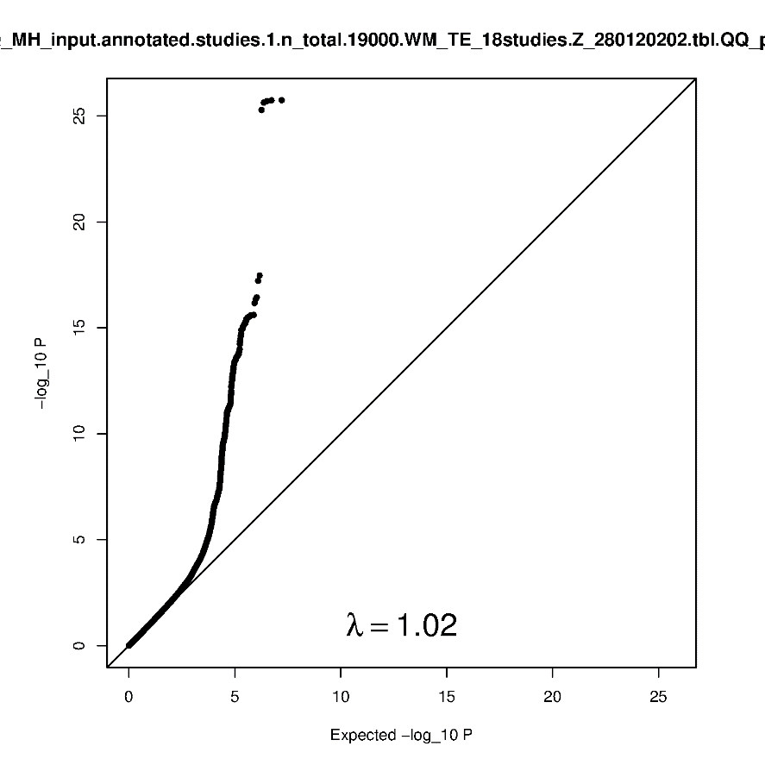
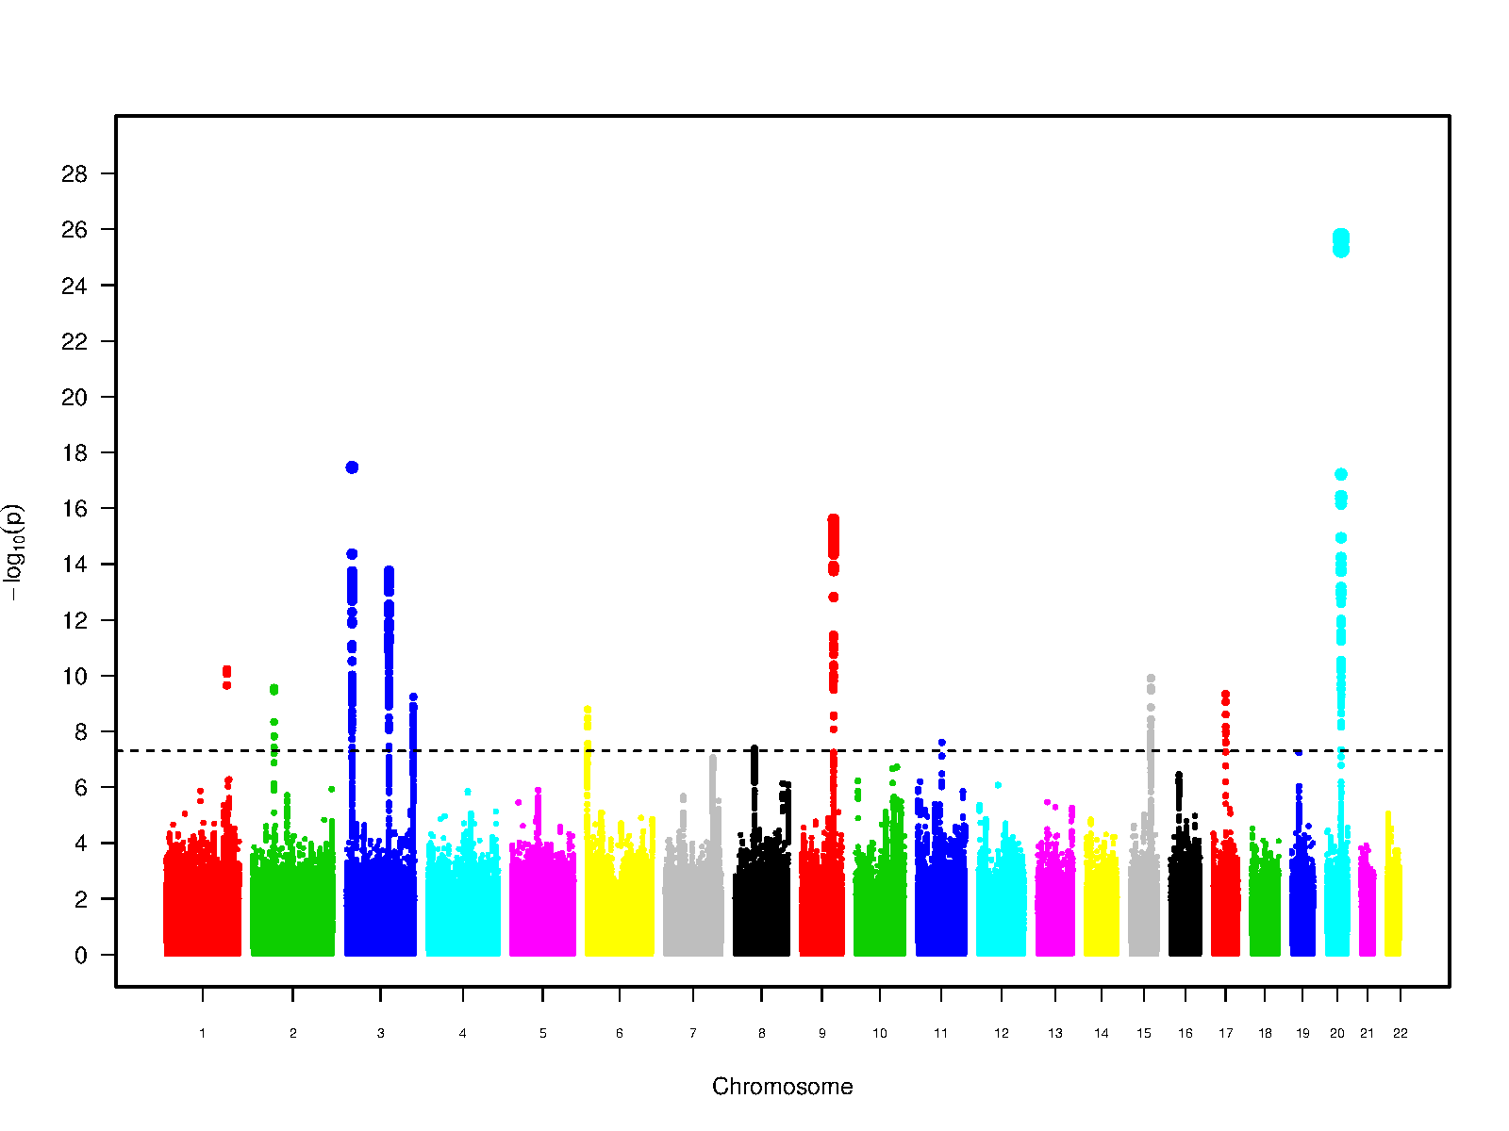

Extensive dPVS burden in basal ganglia (combined meta-analysis)

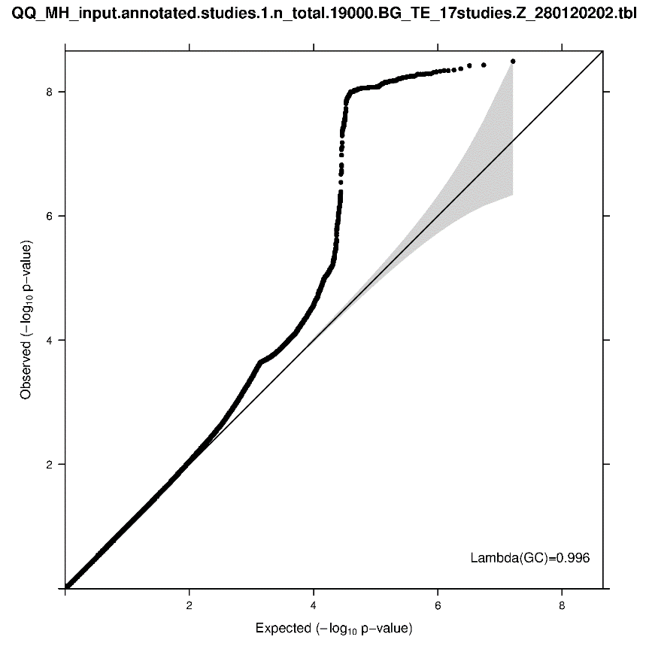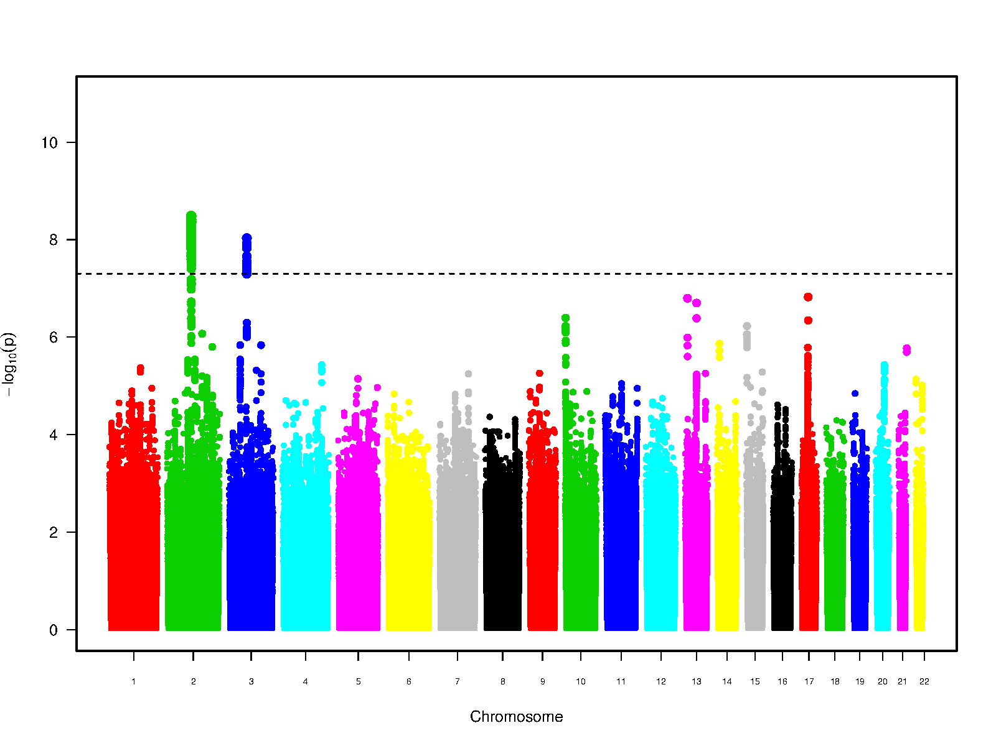

Extensive dPVS burden in hippocampus (combined meta-analysis)

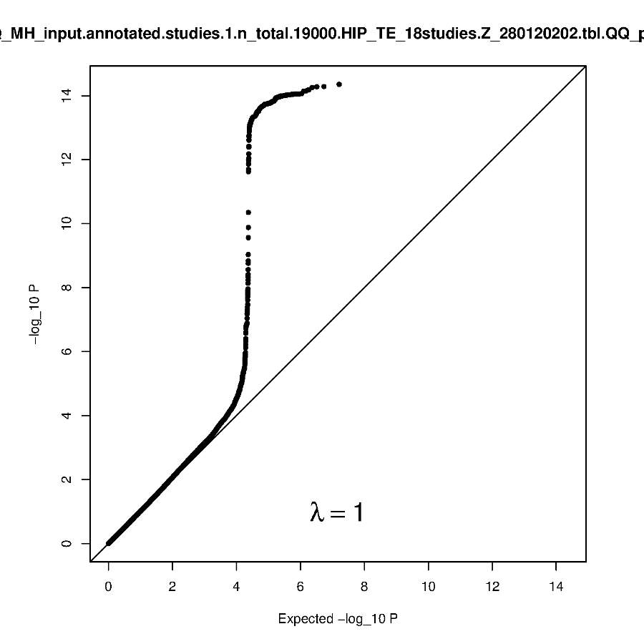

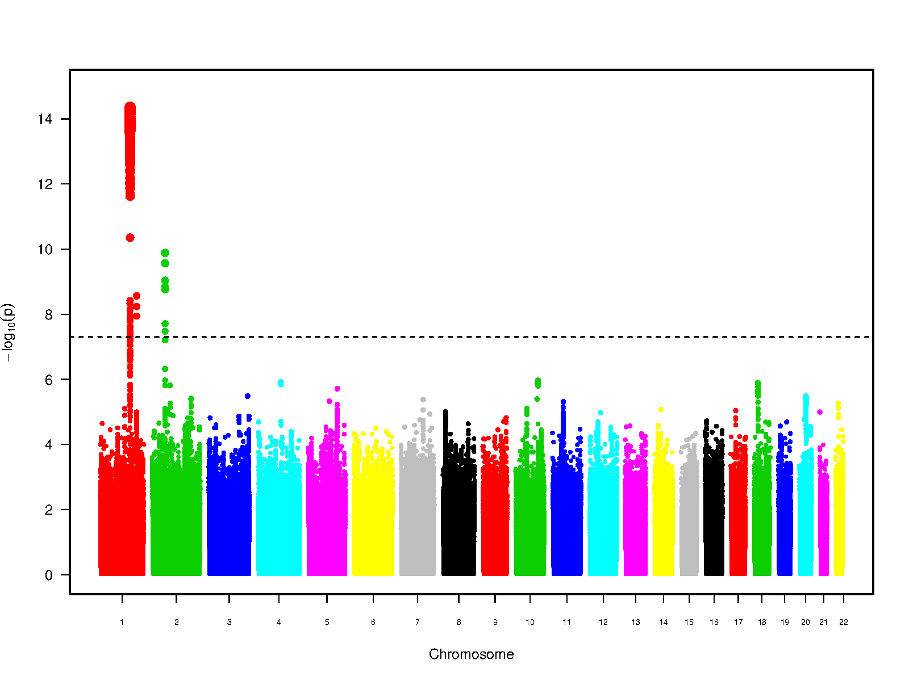
Extensive dPVS burden in the white matter (stage 1 meta-analysis)

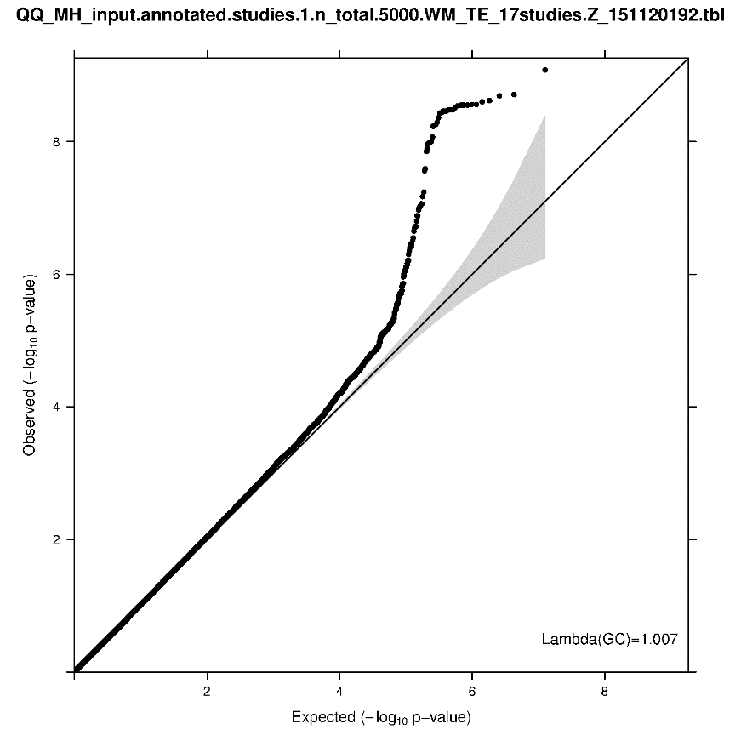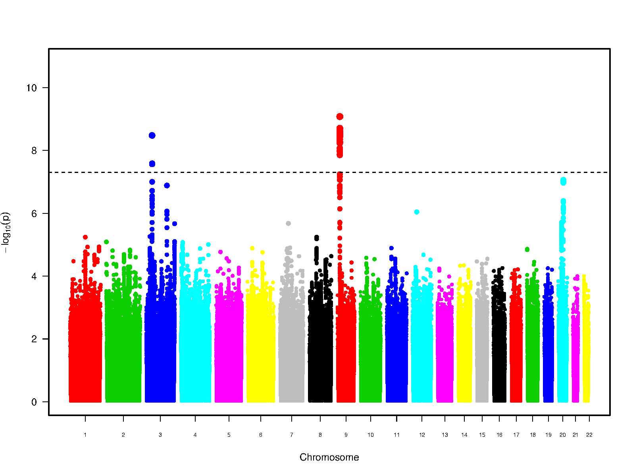

Extensive dPVS burden in basal ganglia (stage 1 meta-analysis)

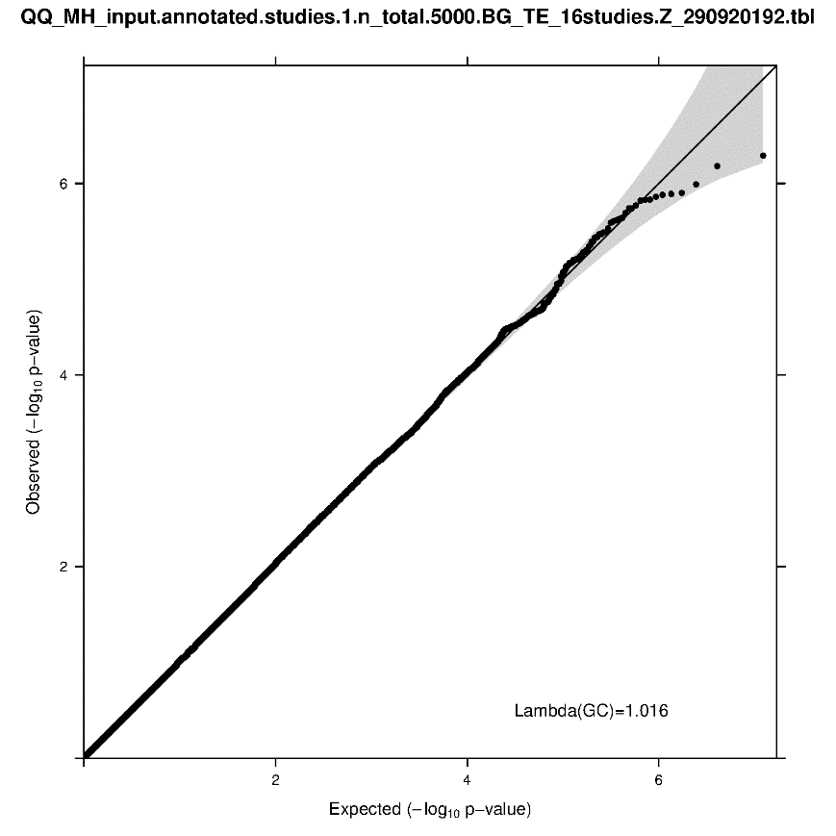
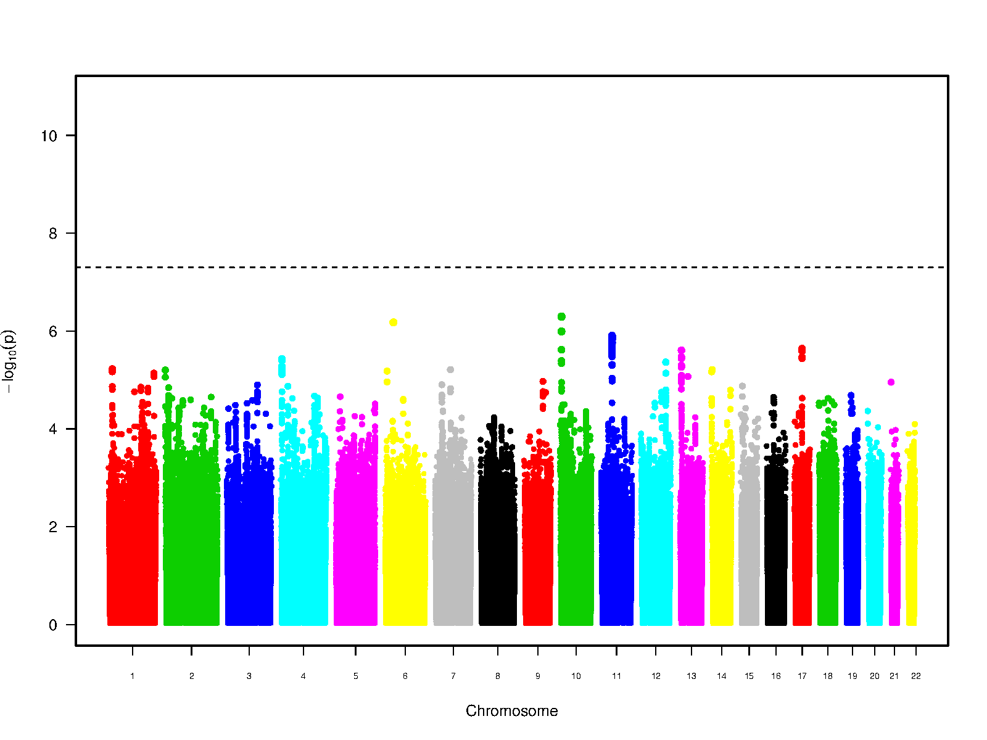

Extensive dPVS burden in hippocampus (stage 1 meta-analysis)

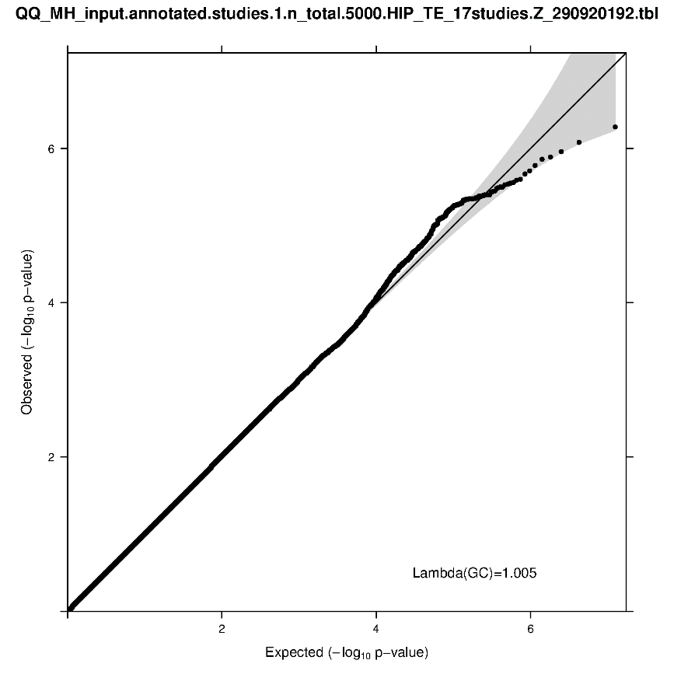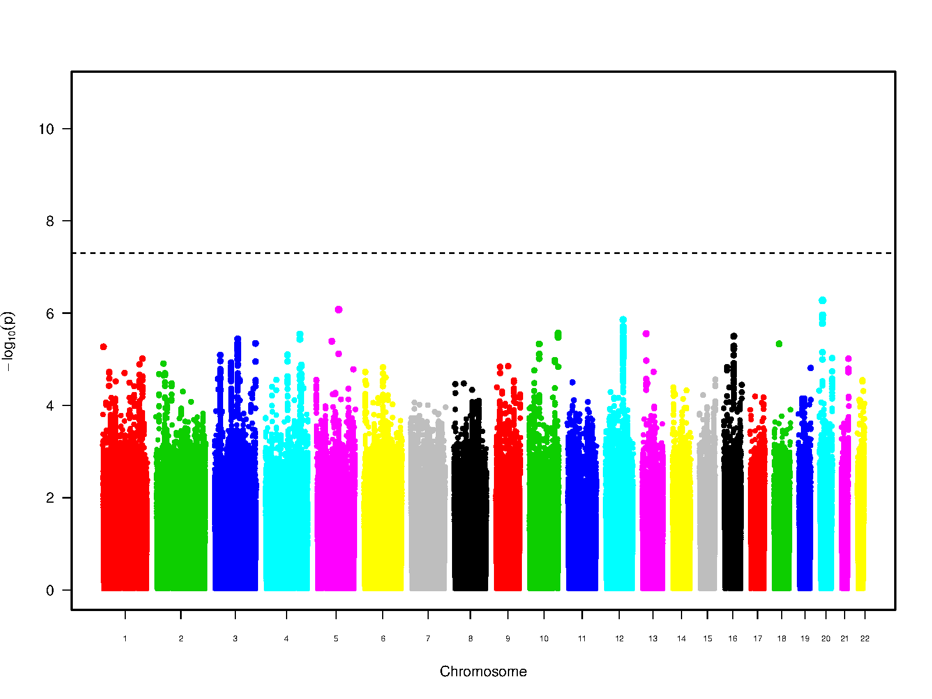

Extensive dPVS burden in the white matter (European meta-analysis)

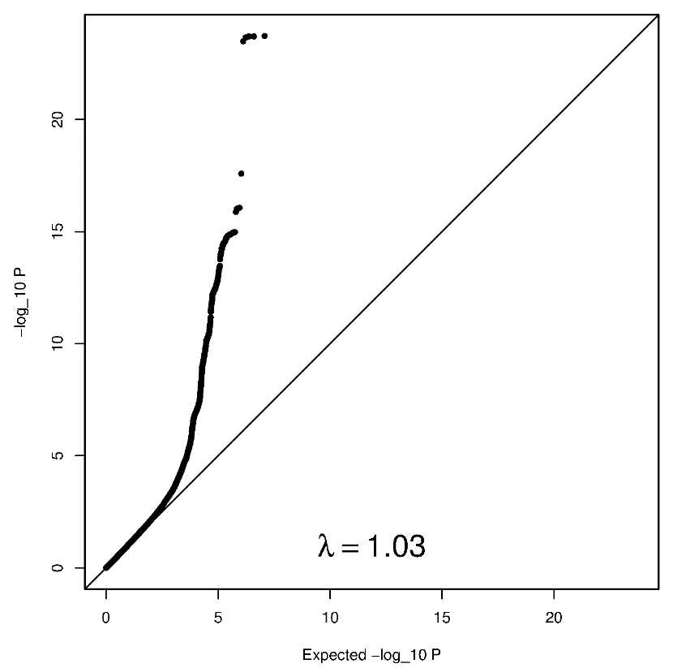

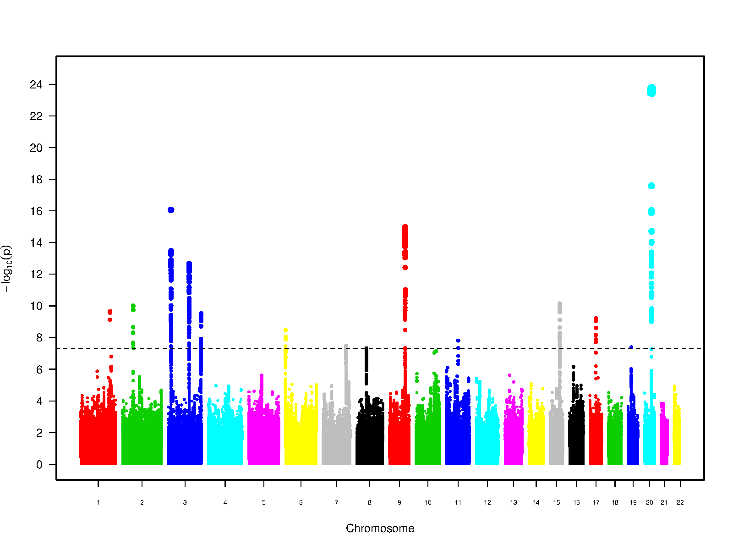

Extensive dPVS burden in basal ganglia (European meta-analysis)

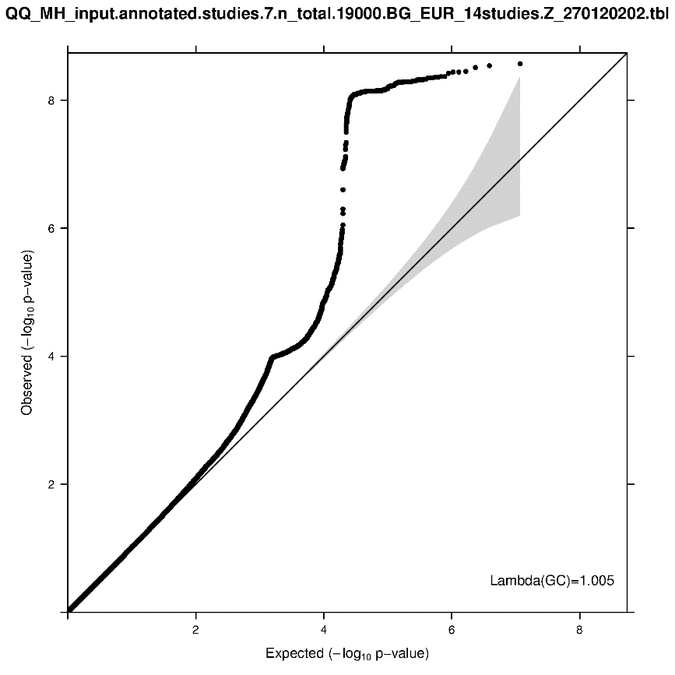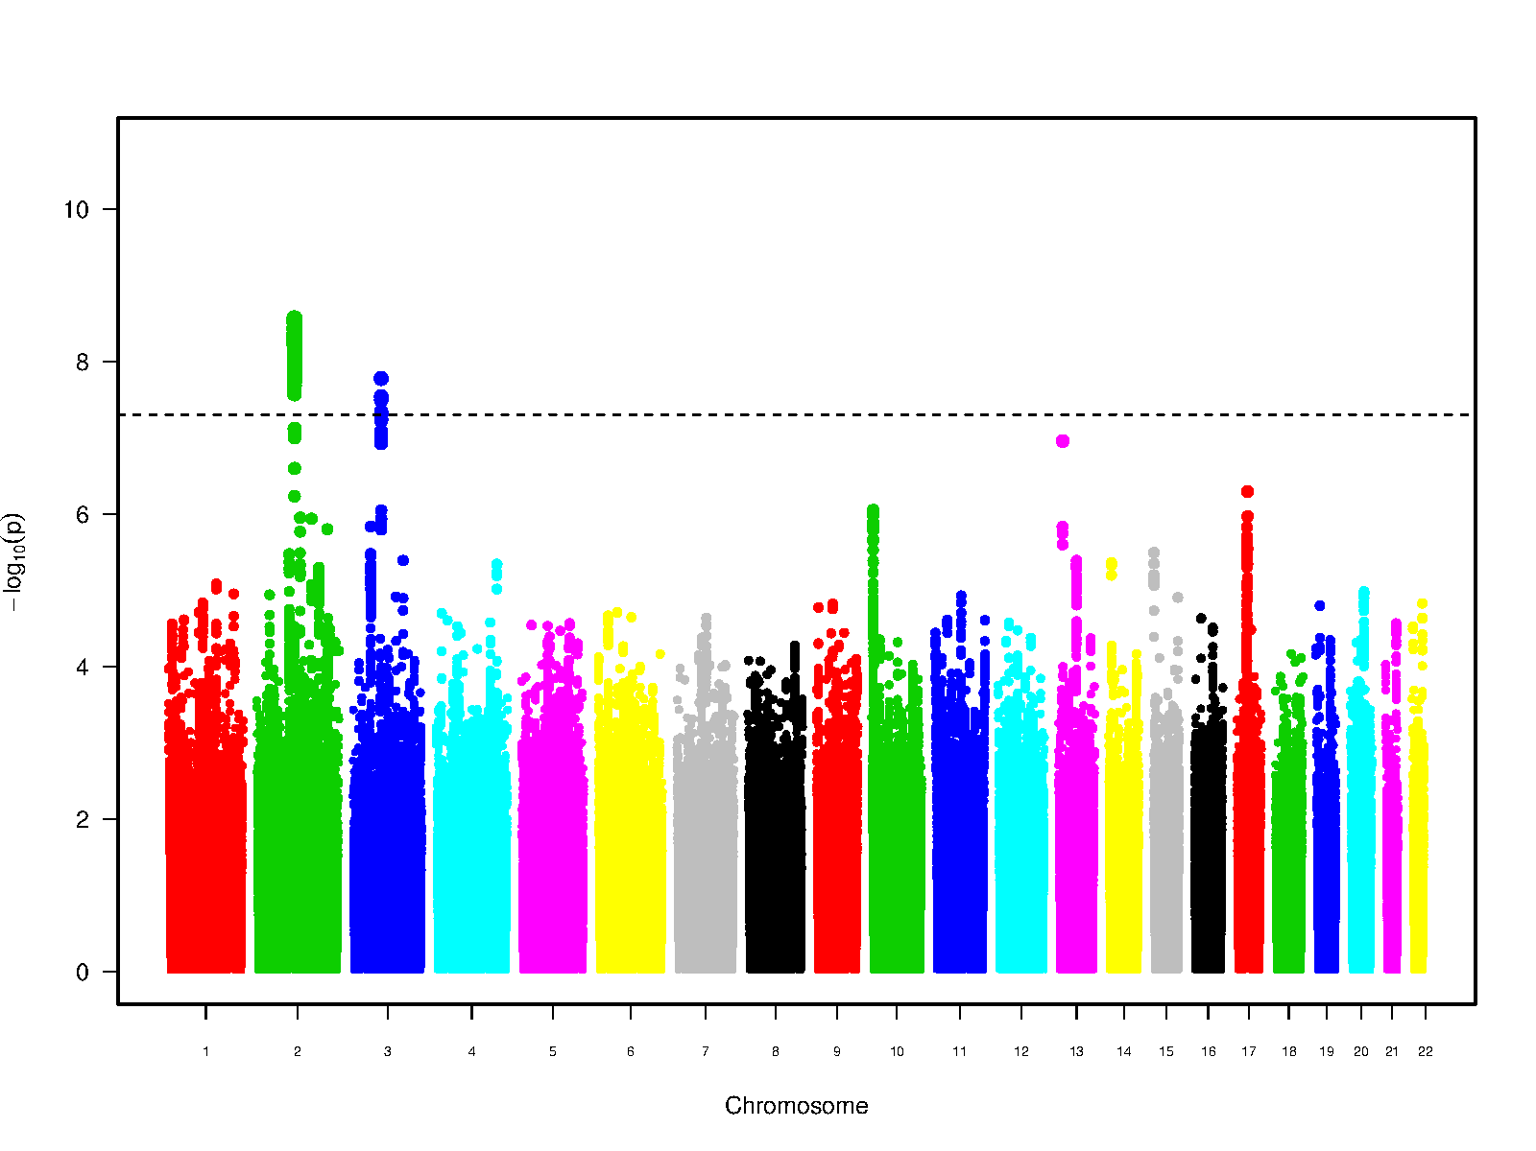

Extensive dPVS burden in hippocampus (European meta-analysis)

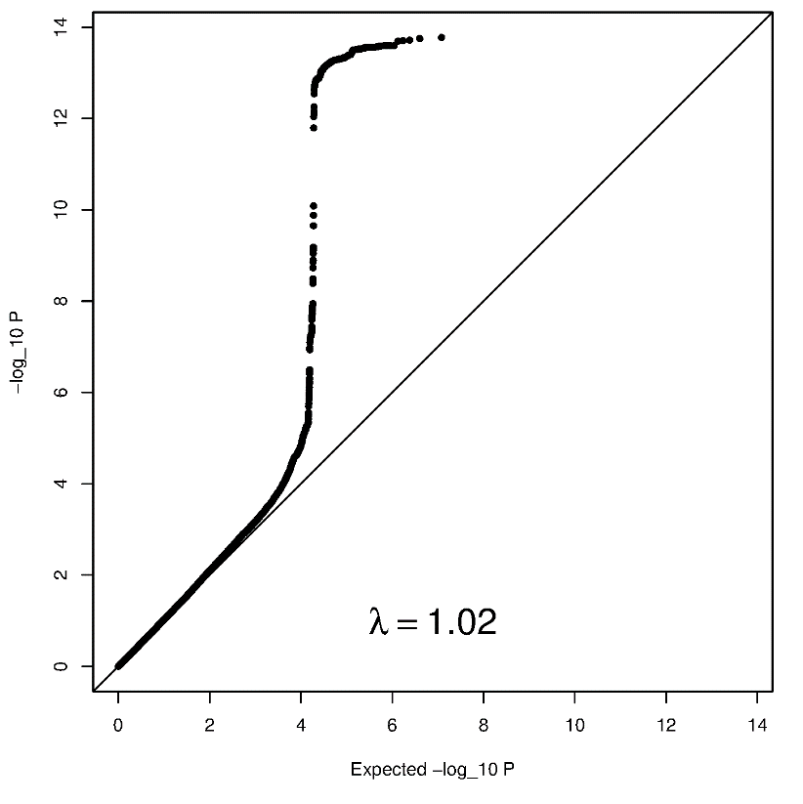

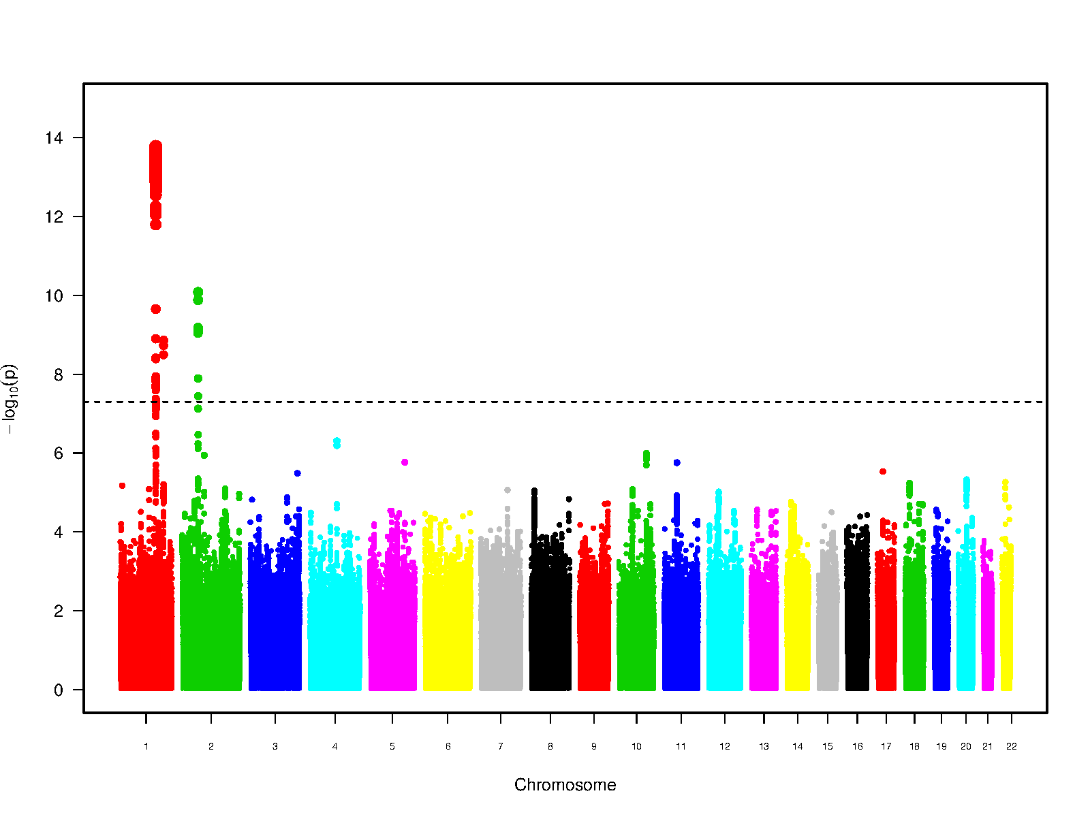

Supplementary Figure 2 : regional association plots

Each circle indicates a single-nucleotide polymorphism (SNPs) with a color scale corresponding to the r2 value for that SNP and the top SNP from 1000 Genomes. Purple diamonds indicate the SNPs with the strongest association. Estimated recombination from 1000 Genomes are indicated blue lines. The bottom panels show the relative position of genes within each locus.

2.1. Dilated perivascular spaces in white matter

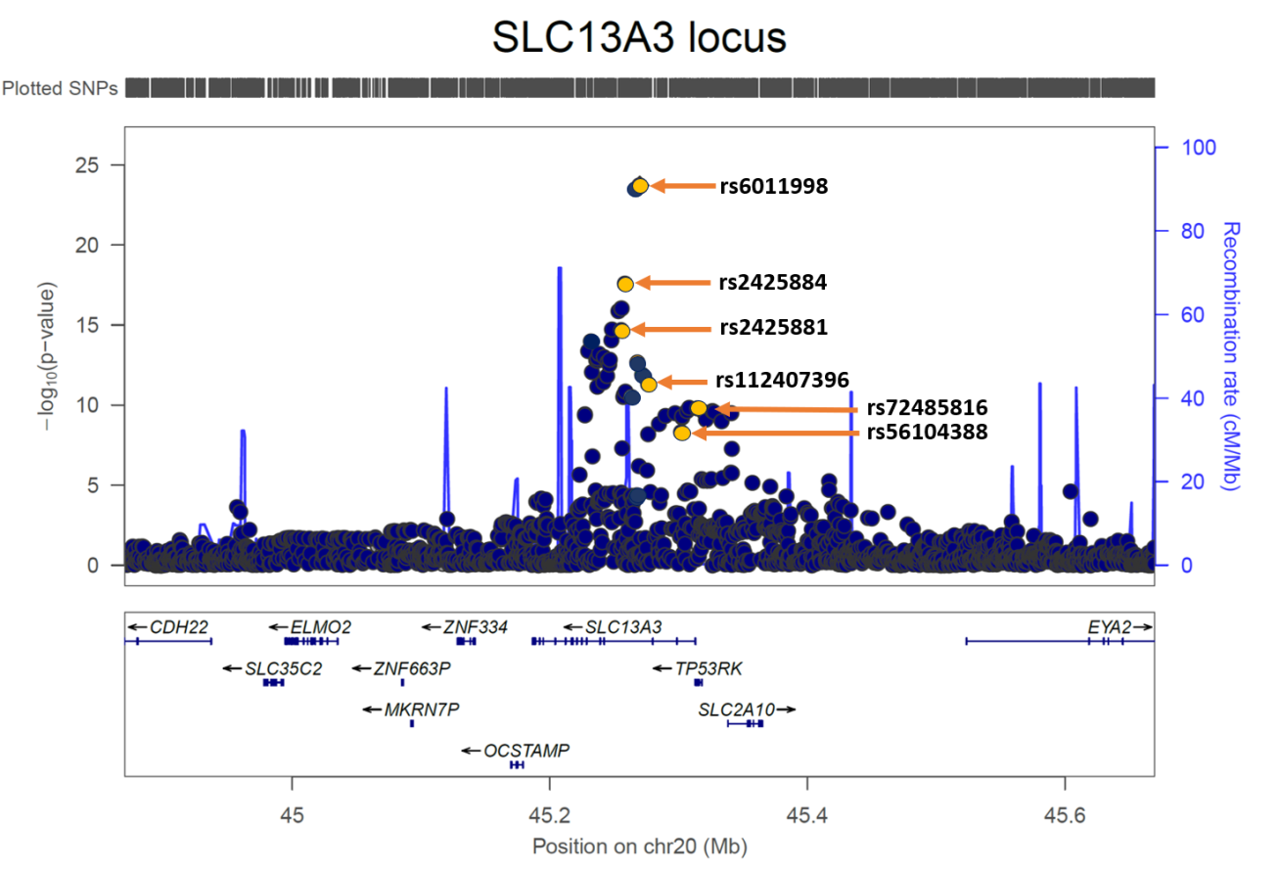
20q13.12
Regional plot of the chr20q13.13 locus with 6 independent signals identified by GCTA-COJO (orange).

3p25.1
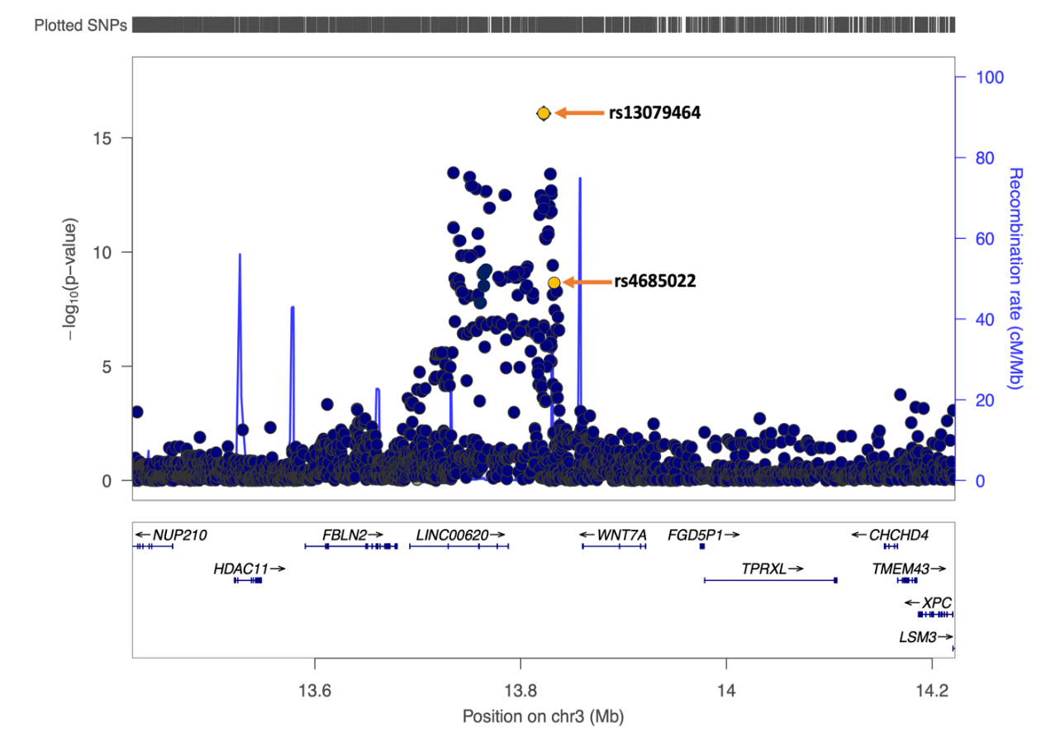
Regional plot of the chr20q13.13 locus with 6 independent signals identified by GCTA-COJO (orange)

9q31.3
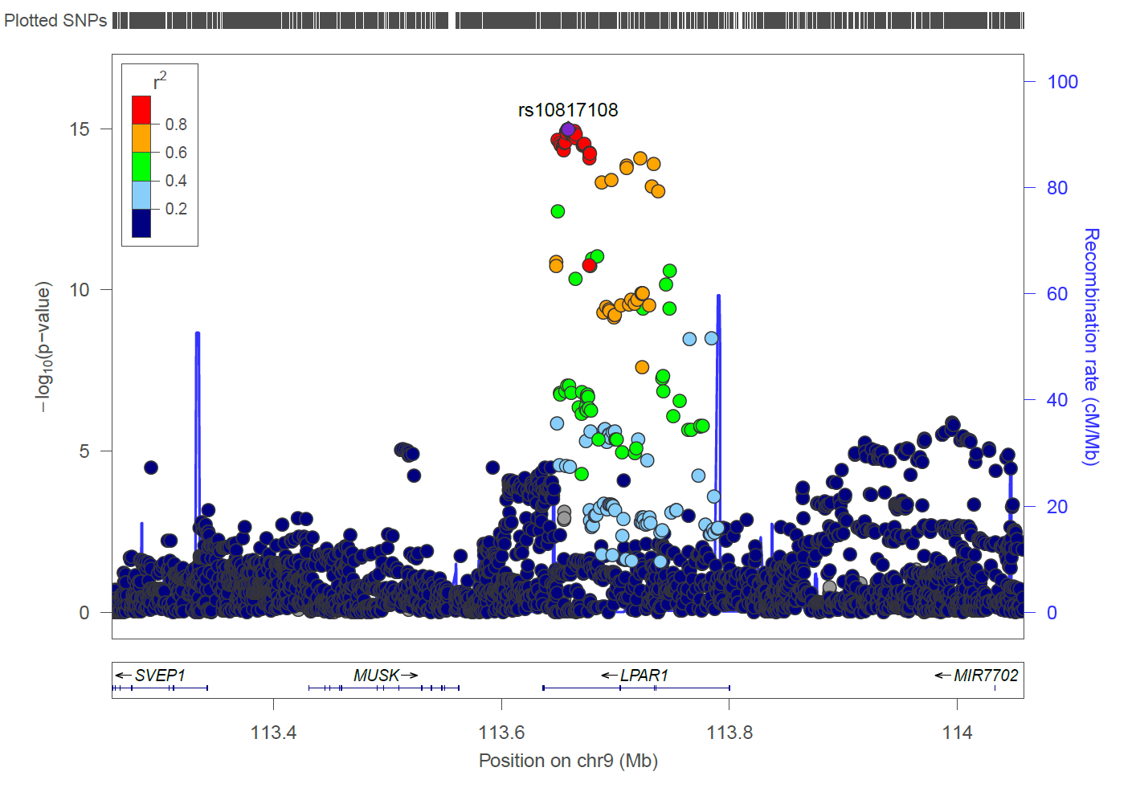

3q21.2
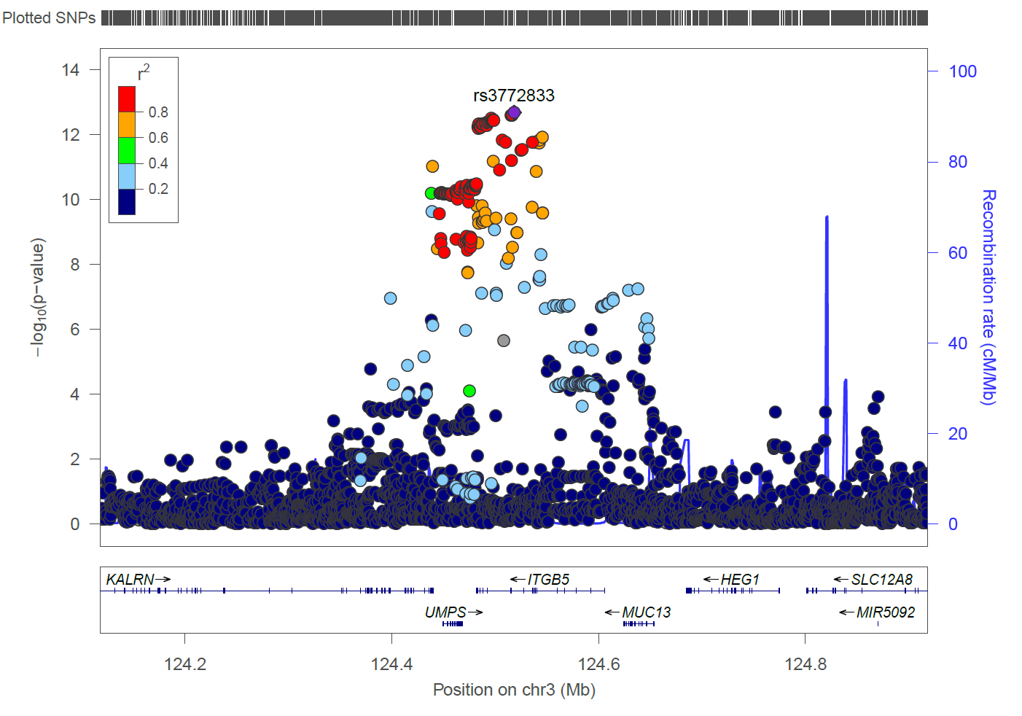
1q41
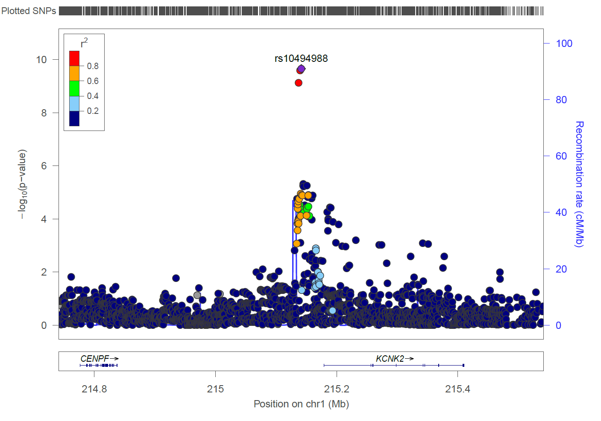

15q25.3
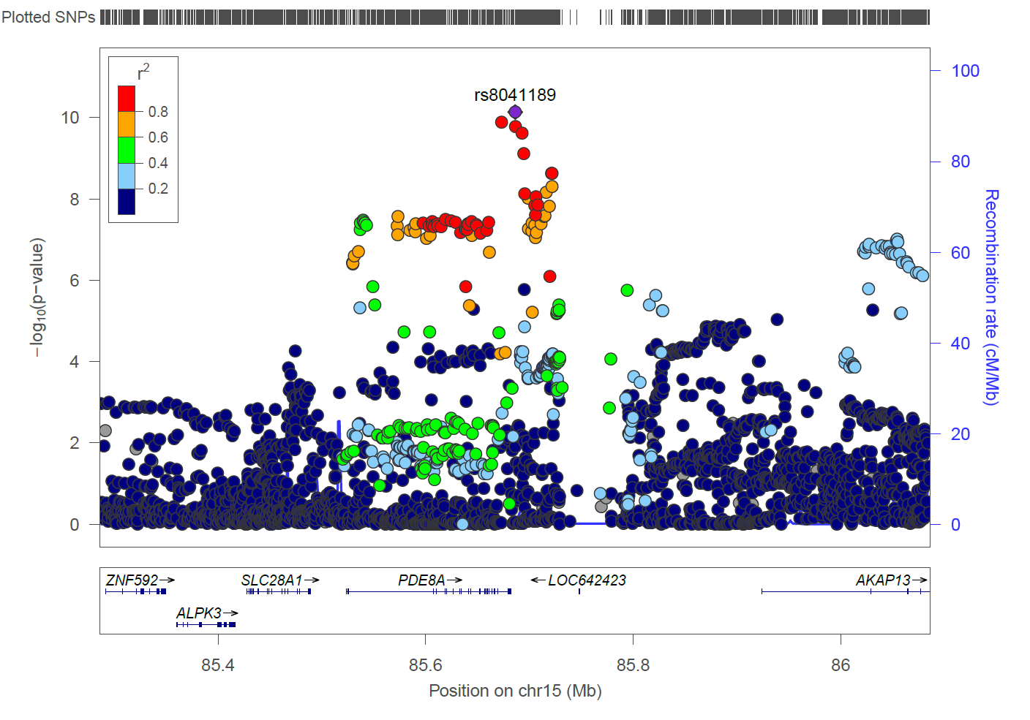

2p16.1
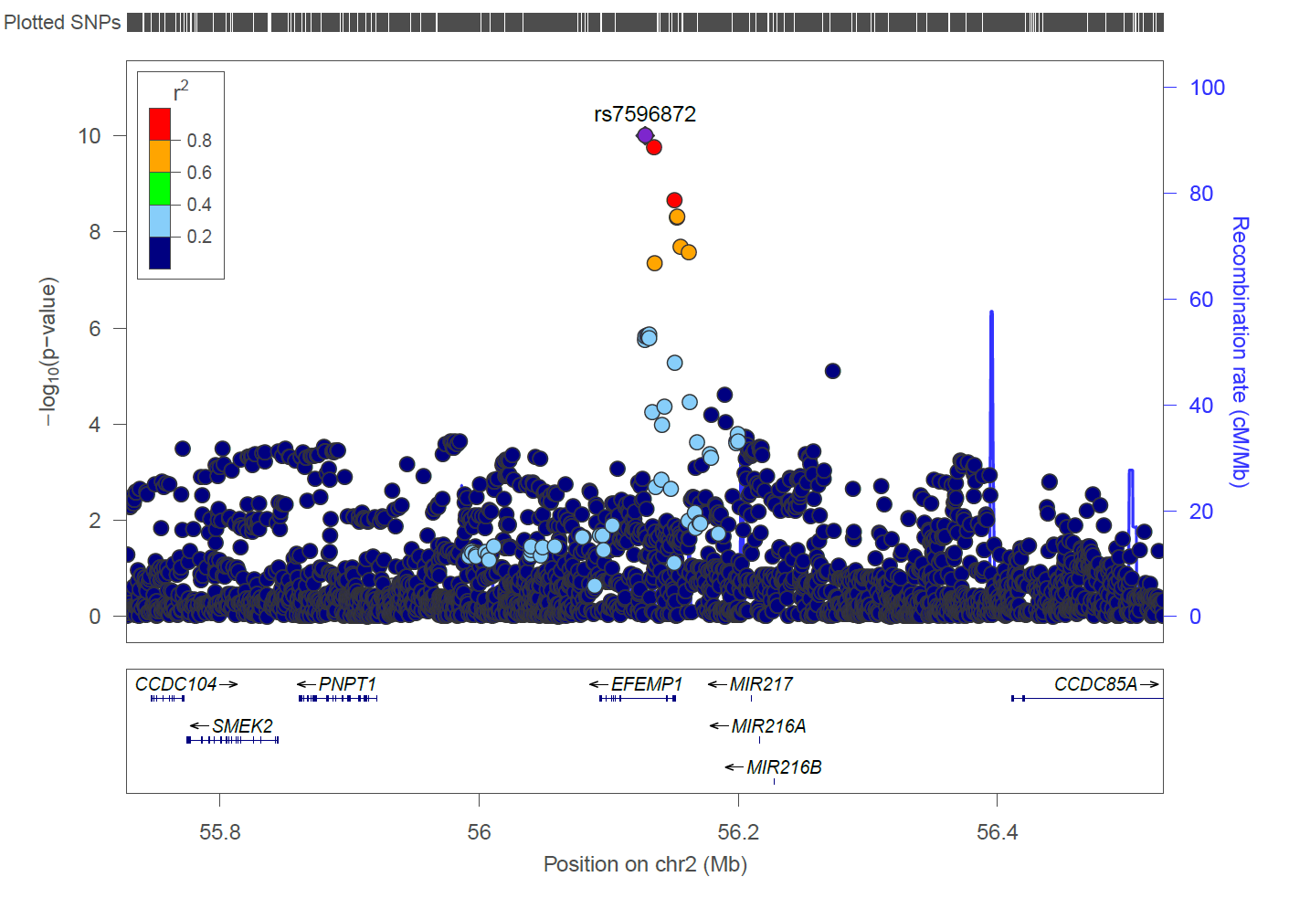

17q21.31
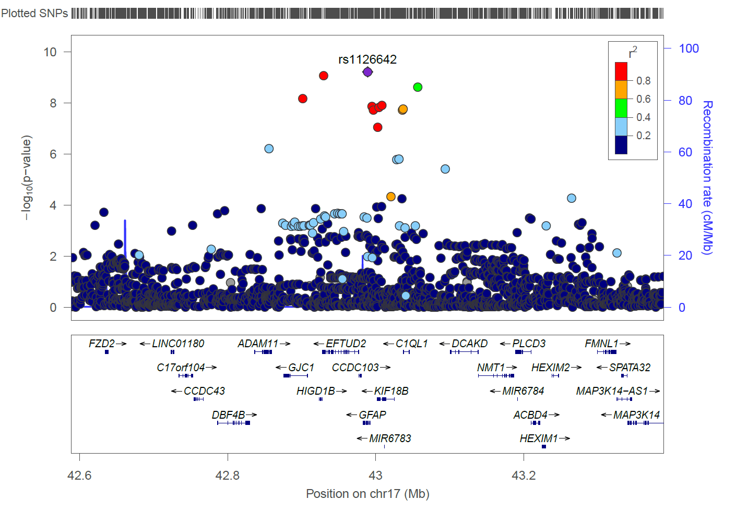

3q29
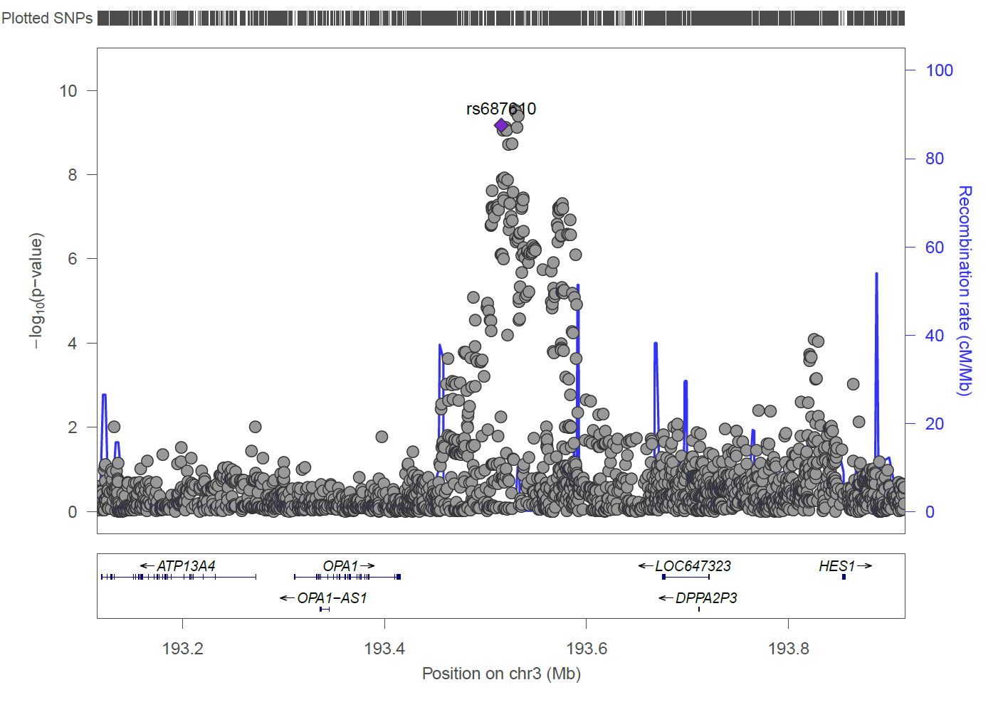

6p25.2
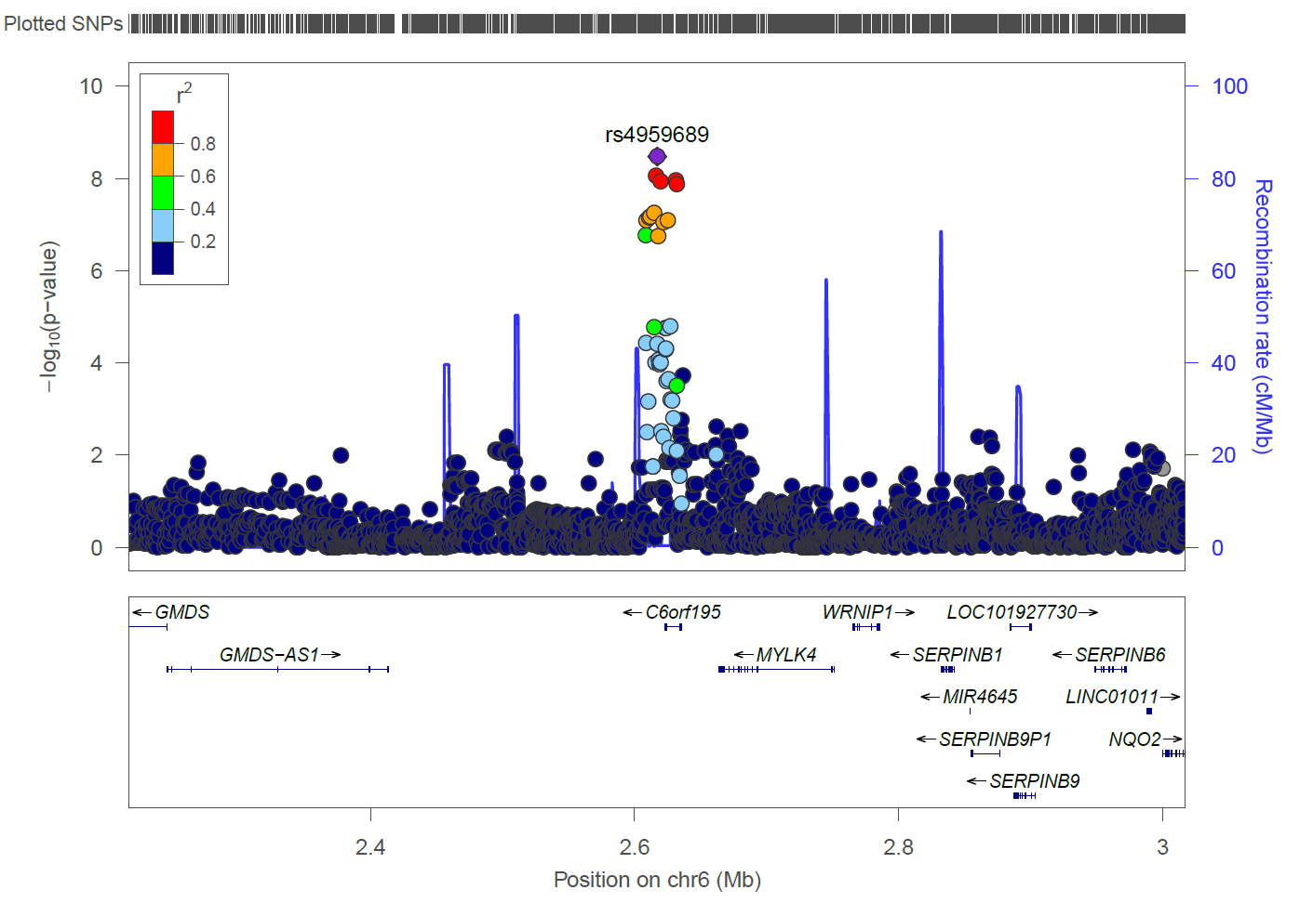
11q13.3
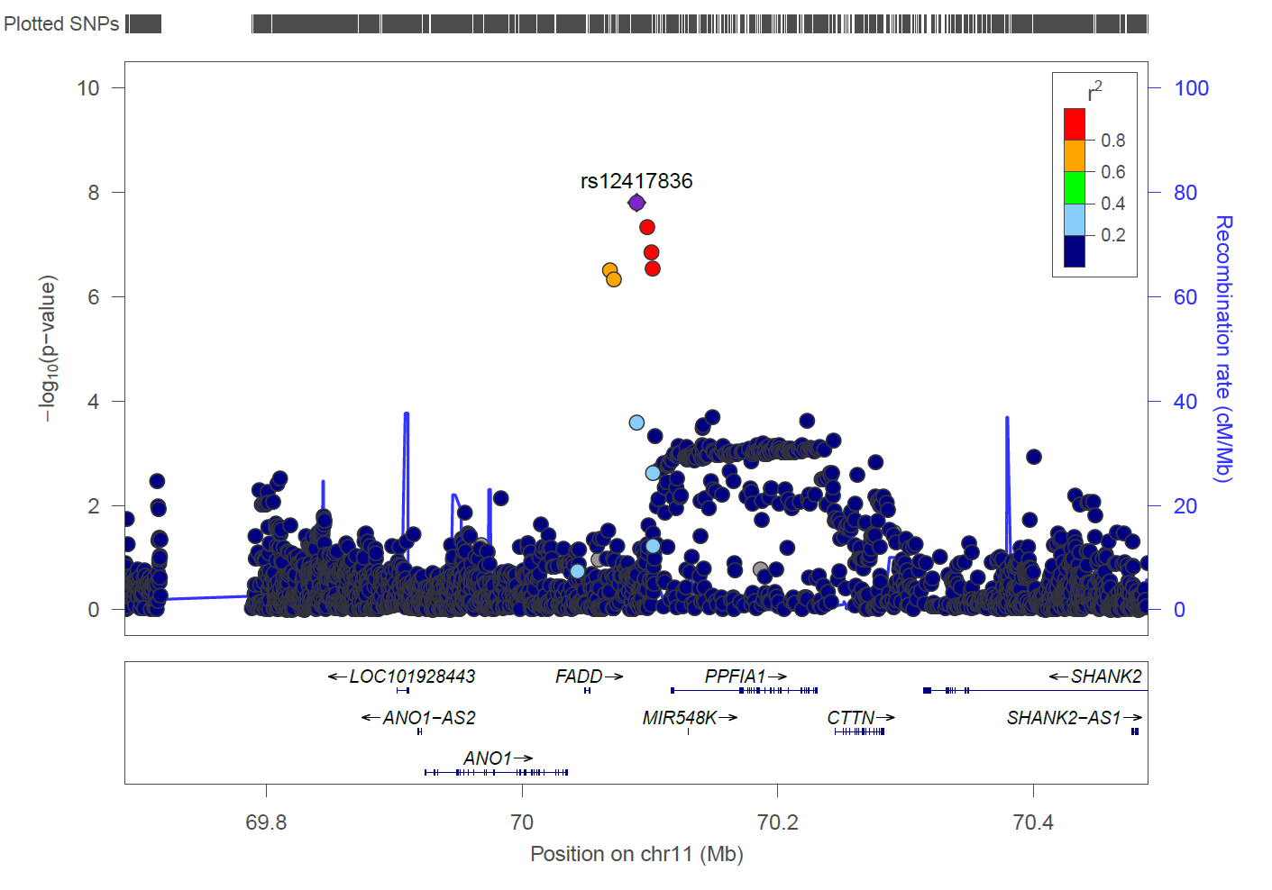
8p11.21
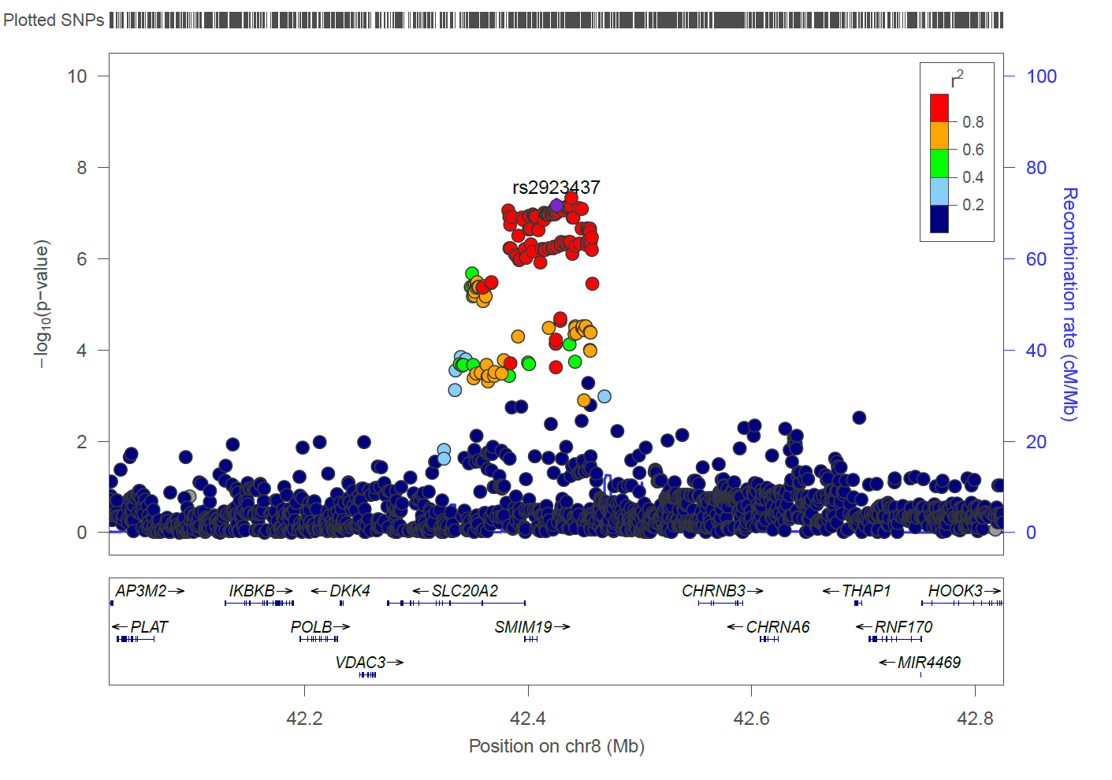

6p25.3
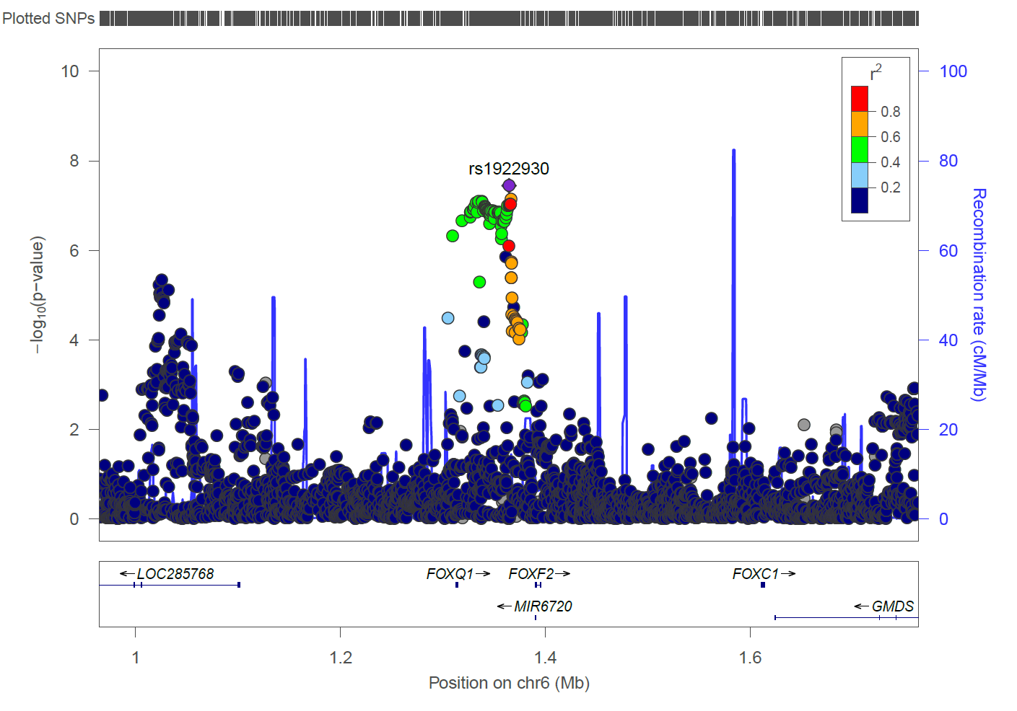

19p13.11 (European locus)
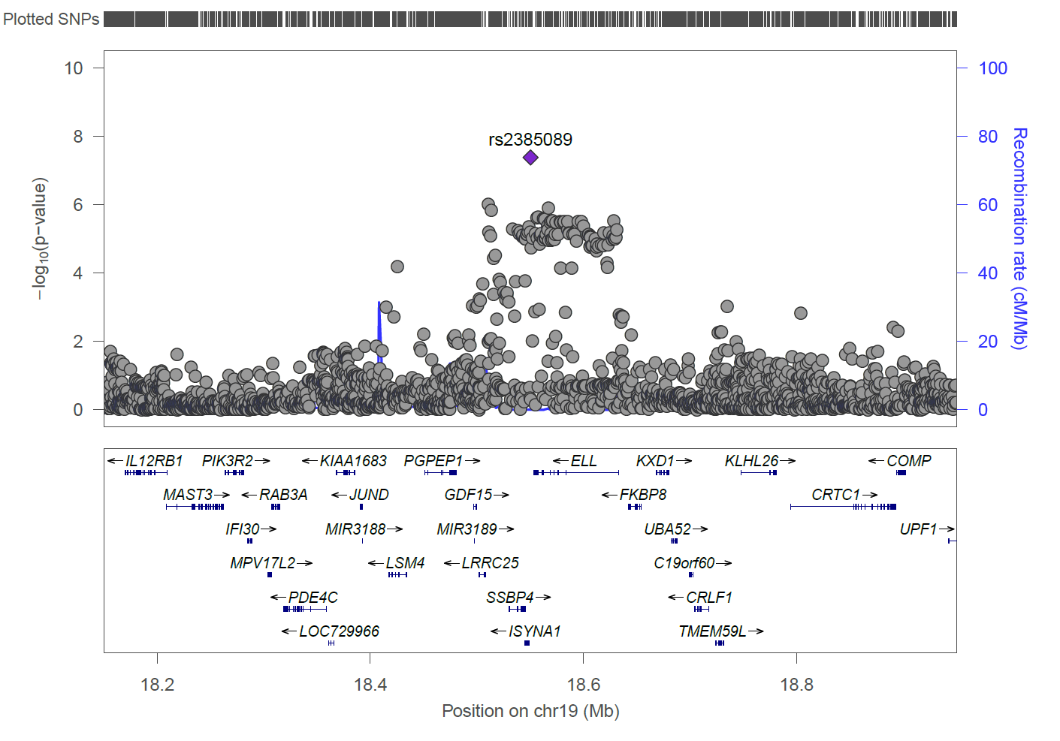
7q33 (European locus)
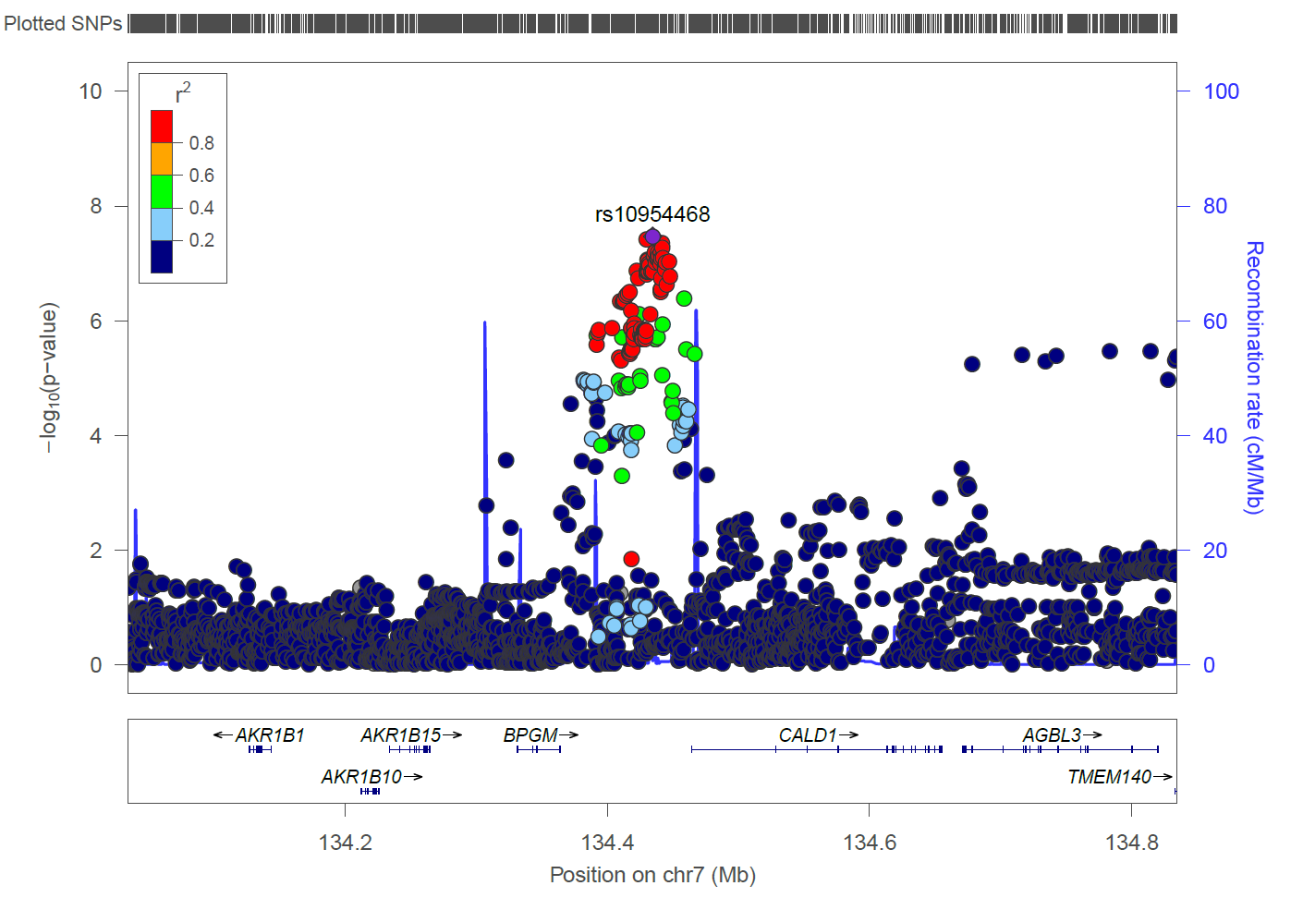

Dilated perivascular spaces in basal ganglia

2q33.2
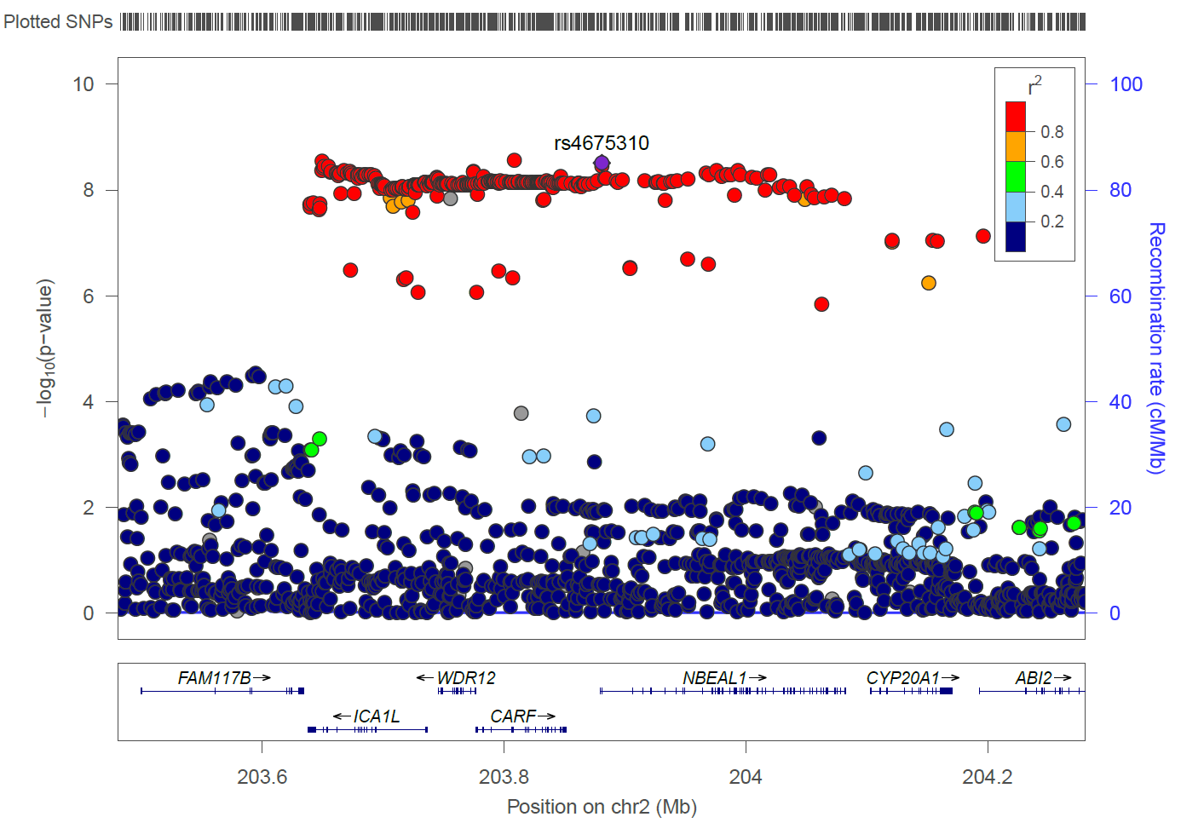
3q26.31
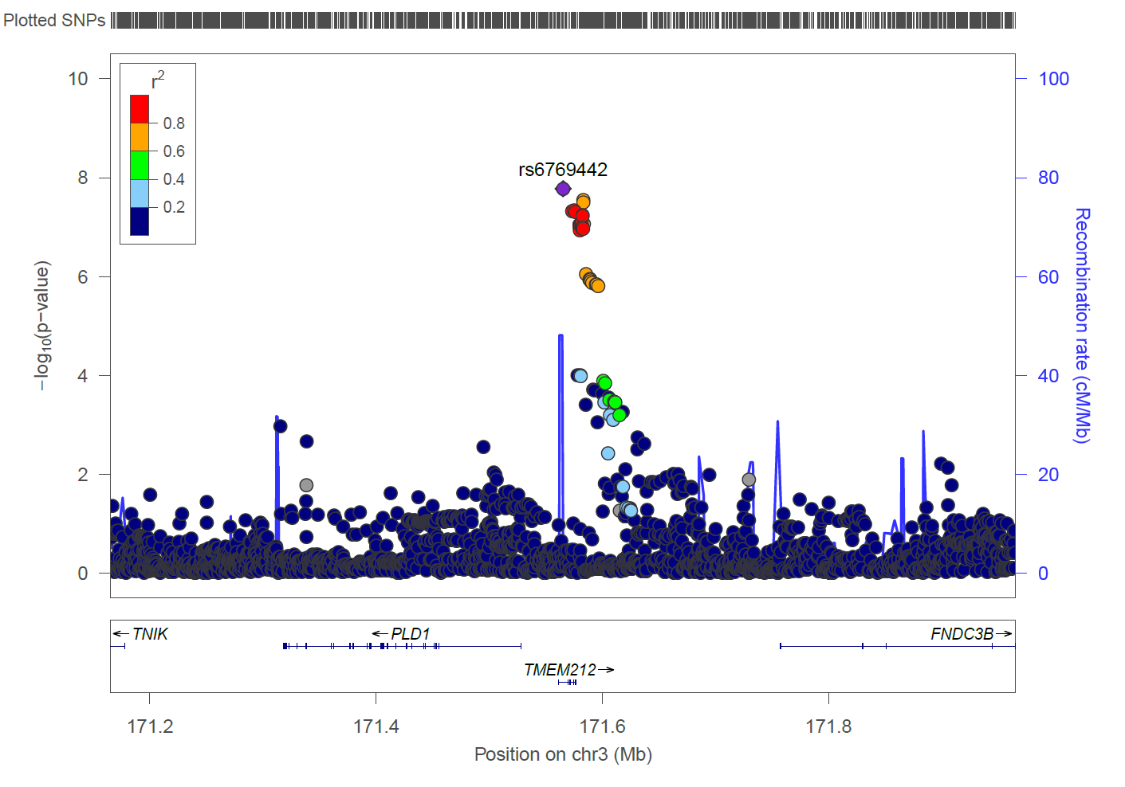

Dilated perivascular spaces in hippocampus

1q25.3
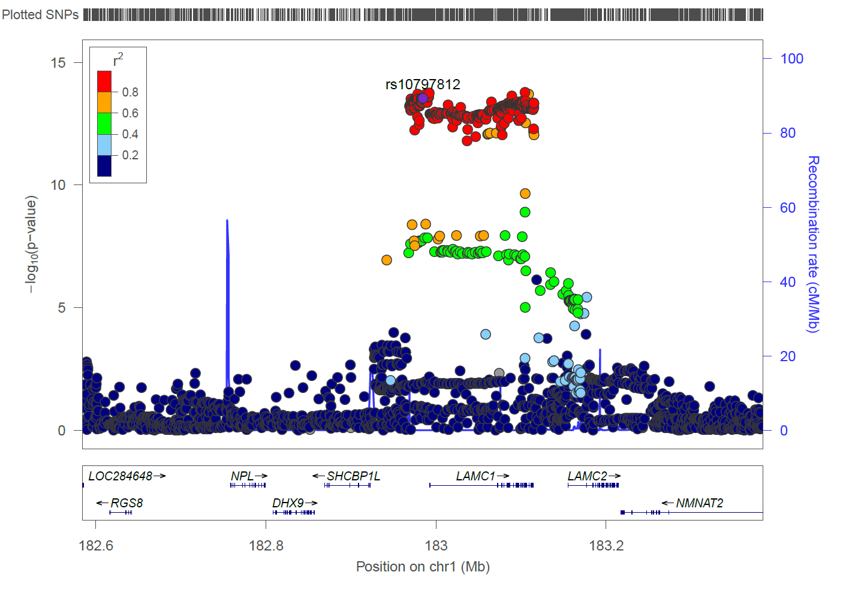
2p16.1
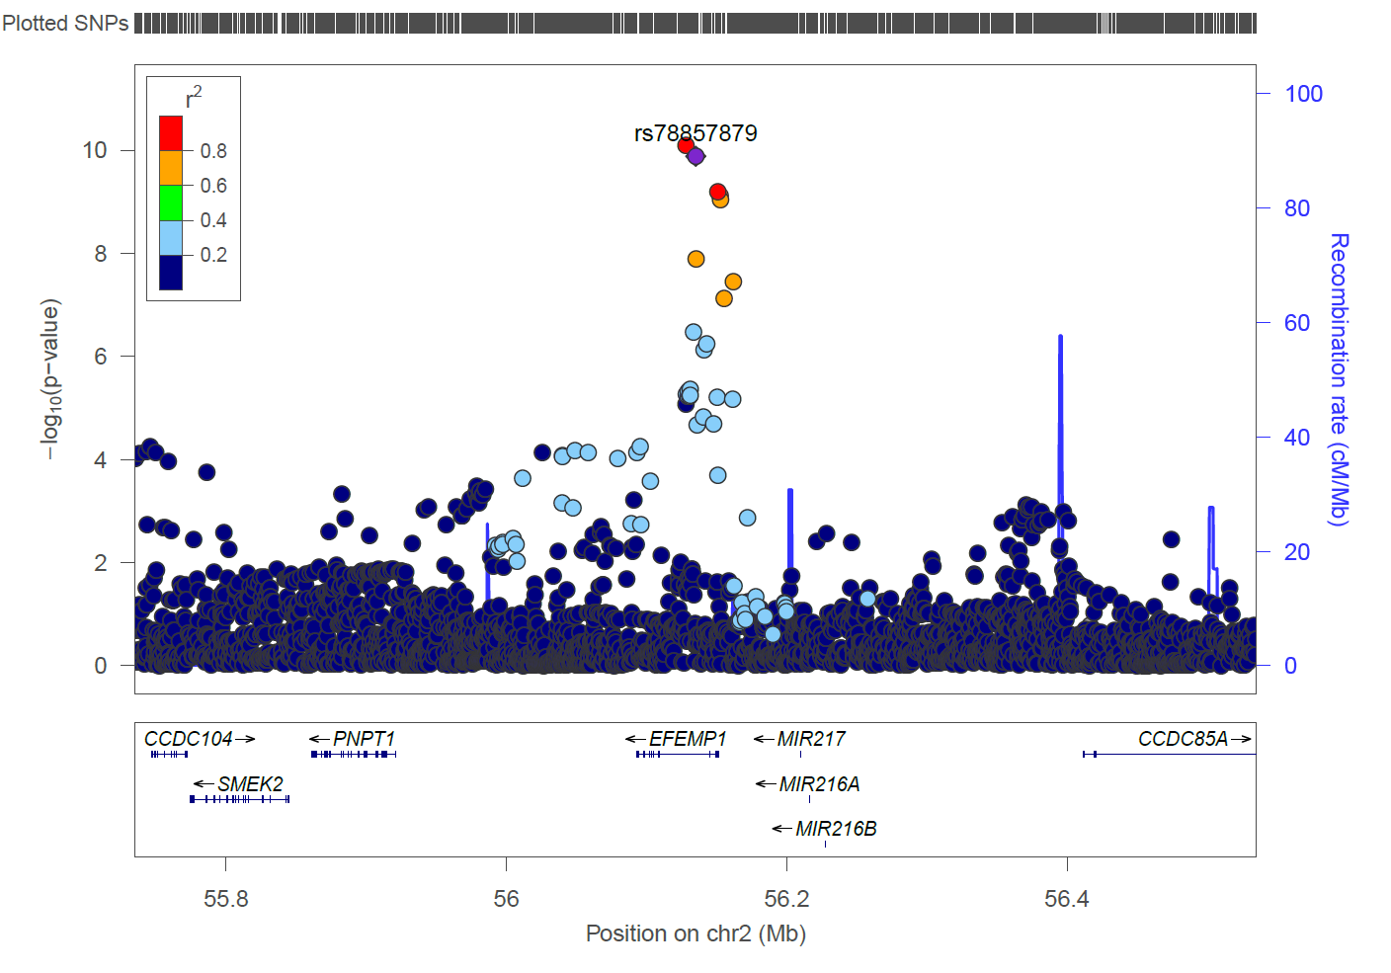

1q41
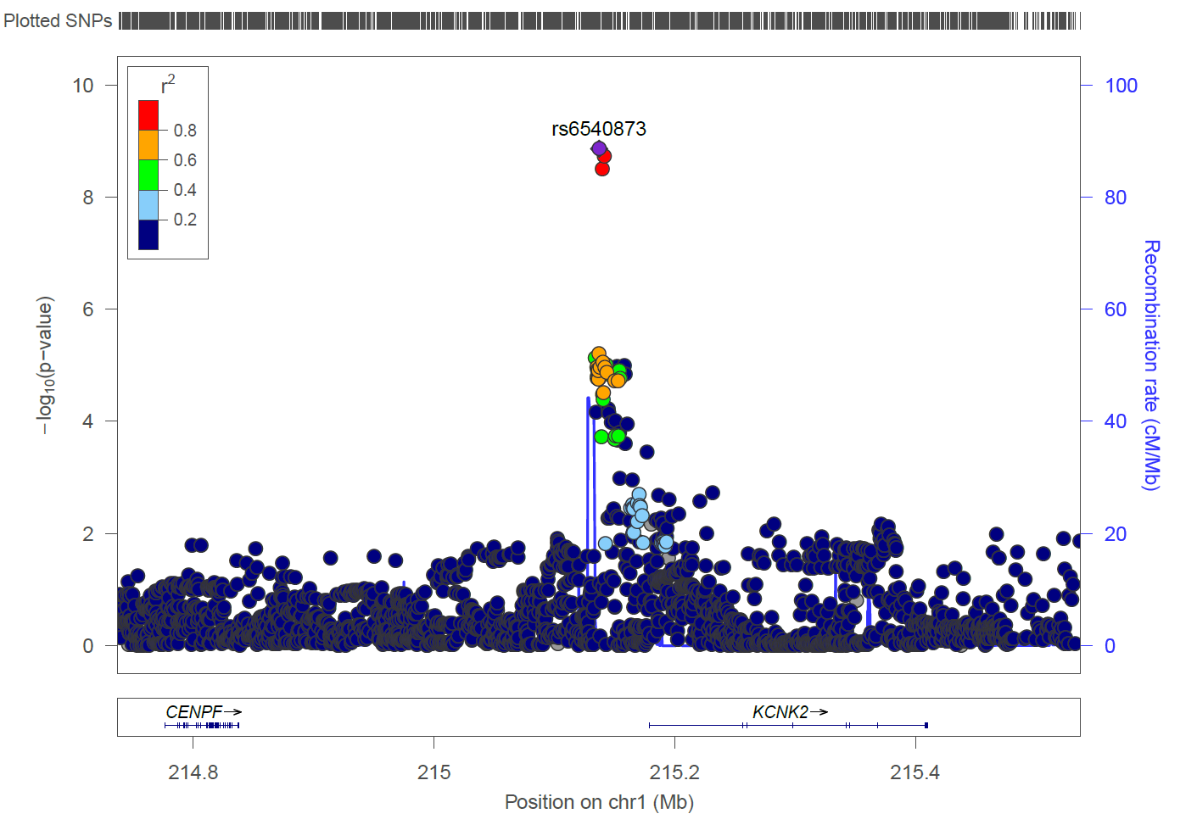

Supplementary Figure 3 : Association of WM dPVS SNPs with WM dPVS burden in the i-Share cohort (N=1,748)
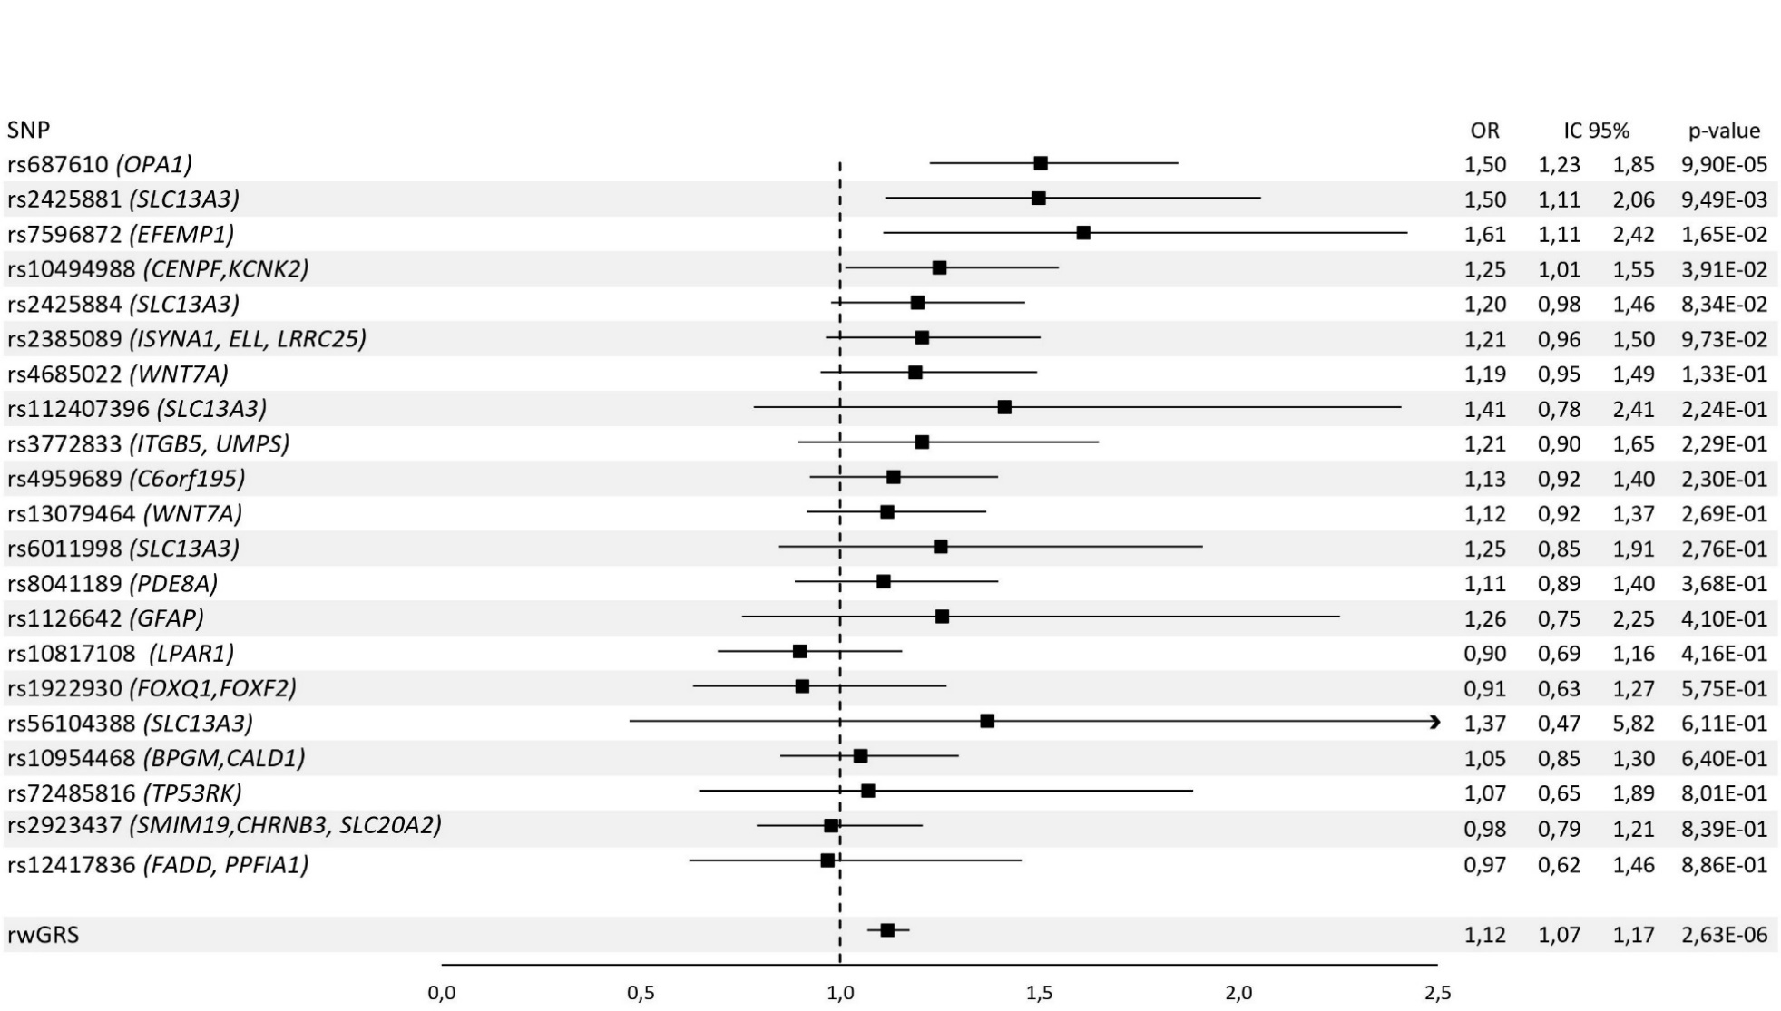

rwGRS indicates rescaled weighted genetic risk score. Odds Ratio and 95% confidence interval are shown. The model is a logistic regression adjusted for age, sex, intracranial volume (cm³) and the first four principal components of population stratification.

Supplementary Figure 4 : meta-regression with age of the three genome-wide significant WM dPVS loci that also showed significant associations with WM dPVS in young adults
Meta-regression with age at the chr20q13.12 locus (near SLC13A3)
Meta-regression with age at the chr3q29 locus (near OPA1)
Meta-regression with age at the chr2p16.1 locus (at EFEMP1)
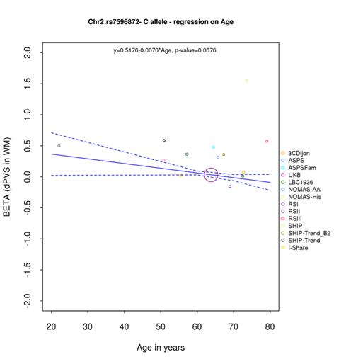
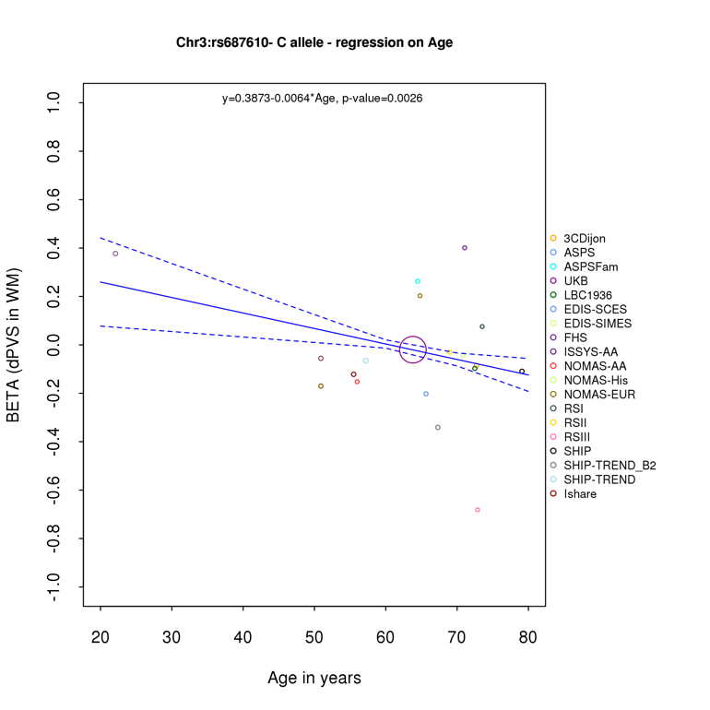
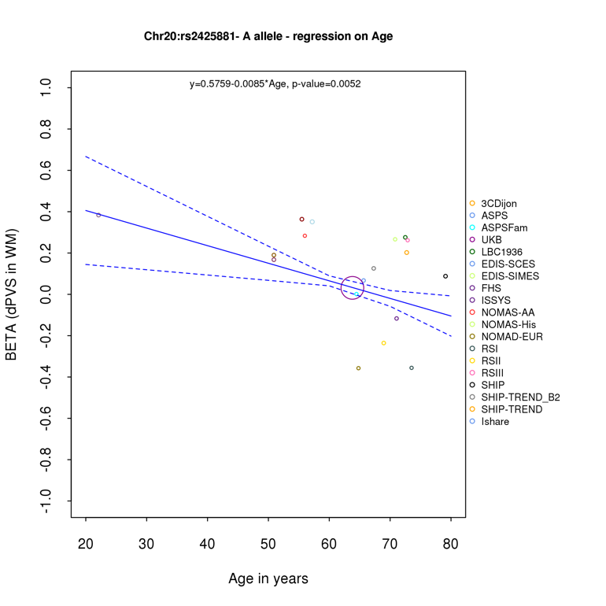

We tested for a significant modifying effect of age on associations with WM dPVS for the three genome-wide significant WM dPVS loci that also showed significant associations with WM dPVS in young adults (Methods). For this purpose we collected the effect estimates (along with their standard errors) for the lead SNPs at these three loci in each individual cohort (all cohorts included in the stage 2 meta-analysis and the follow-up cohort in young adults [i-Share])

Supplementary Figure 5. Brain expression pattern across the lifespan of genes near genome-wide significant dPVS loci that are also identified in the TWAS or that are the nearest genes of variants showing an association with dPVS already in young adults

5.1. Genes in white matter dPVS loci
*
*
*
*
SMIM19
SMIM19

5.2. Genes in basal ganglia dPVS loci

5.3. Genes in hippocampus dPVS loci
*
*

The figure displays brain expression pattern across the lifespan of the 11 significant dPVS TWAS-COLOC genes from genome-wide significant dPVS GWAS loci and the genes closest to the 3 loci associated with dPVS burden across the adult lifespan. The spatio-temporal gene expression level is plotted as log2-transformed exon array signal intensity (y-axis) against the post conception days (x-axis) as provided by the Human Brain Transcriptom project database. Periods of human development and adulthood are indicated by vertical dashed lines: 4-8 post conception weeks [PCW] (period 1), 8-10 PCW (period 2), 10-13 PCW (period 3), 13-16 PCW (period 4), 16-19 PCW (period 5), 19-24 PCW (period 6), 24-38 PCW (period 7), birth- 6 postnatal months (period 8), 6-12 postnatal months (period 9), 1- 6 years (period 10), 6-12 years (period 11), 12-20 years (period 12), 20-40 years (period 13), 40-60 years (period 14), and 60 years+ (period 15). The boundary between pre- and postnatal periods is indicated by the solid vertical line. Each colored point represents the expression level of each gene across 16 anatomical brain regions and ages. Brain structure includes 11 neocortical areas (NCX, blue), and 5 subcortical regions: hippocampus (HIP, cyan), amygdala (AMY, orange), striatum (STR, black), mediodorsal nucleus of thalamus (MD, dark green), and cerebellar cortex (CBC, red).
Neocortical areas include orbital prefrontal cortex (OFC), dorsolateral prefrontal cortex (DFC), ventrolateral prefrontal cortex (VFC), medial prefrontal cortex (MFC), primary motor cortex (M1C), primary somatosensory cortex (S1C), posterior inferior parietal cortex (IPC), primary auditory cortex (A1C), posterior superior temporal cortex (STC), inferior temporal cortex (ITC), and primary visual cortex (V1C). *Genes associated with dPVS burden in the GWAS meta-analysis and in the young adult cohort (i-Share study)

Supplementary Figure 6. Enrichment of dPVS genes in targets of drugs validated in other indication (Genome for REPositioning drugs) ⁶⁵
WM dPVS
HIP dPVS
BG dPVS
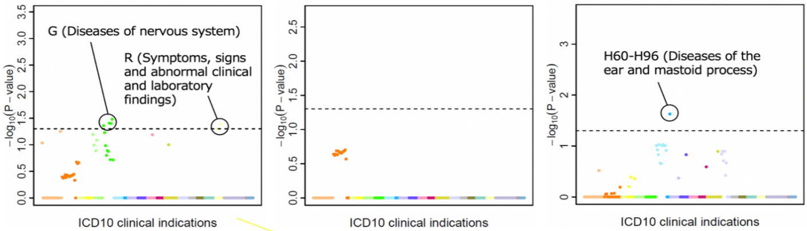
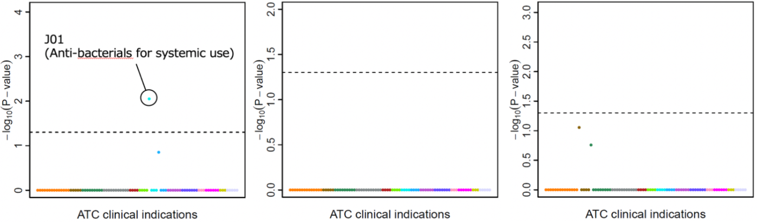

ATC indicates Anatomical Therapeutic Chemical classification; ICD10, the 10th revision of the International Statistical Classification of Diseases and Related Health Problems
We found a significant enrichment of BG dPVS genes in targets for antiinfectives for systemic use (ATC J01, OR=252.4, P=8.85x10⁻³), driven by CRHR1 (chr17q21.31), a target for telavancin; in targets of drugs for diseases of the nervous system (G50-G59, G70-G73, and G80-G83, OR=51.0, 49.7, and 60.4, P=3.90x10⁻², 4.00x10⁻², and 3.32x10⁻²) and for symptoms and signs involving cognition, perception, emotional state and behaviour (R40-R46, OR=48.4, P=4.10x10⁻²), driven by MAPT (chr17q21.31), a target for davunetide. Of note, CRHR1 antagonists were shown to attenuate blood brain barrier permeability, cortical vascular hyperpermeability and tight junction disruption. Davenutide reduces levels of phosphorylated tau in a transgenic mouse model of AD,⁶⁶ and showed a signal of potential efficacy in patients with mild cognitive impairment.⁶⁷ We also found a significant enrichment of HIP dPVS genes in targets of drugs for diseases of the ear (H90-H95, OR=57.6, P=2.34x10⁻²), driven by SERPIND1 (chr22q11.21) a target for sulodexide, used for the prophylaxis and treatment of vascular diseases with increased risk of thrombosis.

Supplementary Figure 7. Enrichment of dPVS genes in targets of drugs validated in other indication (Trans-Phar)⁶⁸
WM dPVS
BG dPVS
HIP dPVS

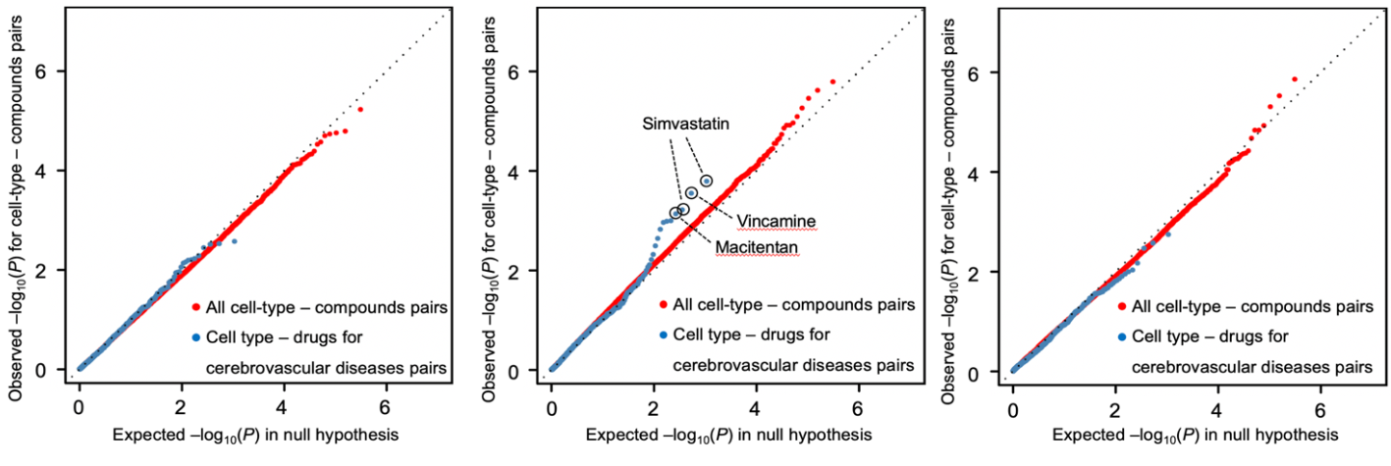
Leveraging TWAS on all GTEx v7 tissues and a database of compound-regulated gene expression (C-map), we observed significant enrichment of HIP dPVS in drugs for vascular disease, including simvastatin (P=1.64x10⁻⁴), vincamine (vasodilator increasing cerebral blood flow, P=2.87x10⁻⁴), and macitentan (used for pulmonary arterial hypertension, P=7.46x10⁻⁴).

References

1. Schmidt, R. et al. Assessment of cerebrovascular risk profiles in healthy persons: definition of research goals and the Austrian Stroke Prevention Study (ASPS). Neuroepidemiology 13, 308-13 (1994).
2. Schmidt, R., Fazekas, F., Kapeller, P., Schmidt, H. & Hartung, H.P. MRI white matter hyperintensities: three-year follow-up of the Austrian Stroke Prevention Study. Neurology 53, 132-139 (1999).
3. Hilal, S. et al. Prevalence of cognitive impairment in Chinese: epidemiology of dementia in Singapore study. J Neurol Neurosurg Psychiatry 84, 686-92 (2013).
4. Rosman, M. et al. Singapore Malay Eye Study: rationale and methodology of 6-year follow-up study (SiMES-2). Clin Exp Ophthalmol 40, 557-68 (2012).
5. Dawber, T.R. & Kannel, W.B. The Framingham study. An epidemiological approach to coronary heart disease. Circulation 34, 553-5 (1966).
6. Feinleib, M., Kannel, W.B., Garrison, R.J., McNamara, P.M. & Castelli, W.P. The Framingham Offspring Study. Design and preliminary data. Prev Med 4, 518-25 (1975).
7. Splansky, G.L. et al. The Third Generation Cohort of the National Heart, Lung, and Blood Institute's Framingham Heart Study: design, recruitment, and initial examination. Am J Epidemiol 165, 1328-35 (2007).
8. Carandang, R. et al. Trends in incidence, lifetime risk, severity, and 30-day mortality of stroke over the past 50 years. JAMA 296, 2939-46 (2006).
9. Seshadri, S. et al. The lifetime risk of stroke: estimates from the Framingham Study. Stroke 37, 345-50 (2006).
10. Riba-Llena, I. et al. Investigating silent strokes in hypertensives: a magnetic resonance imaging study (ISSYS): rationale and protocol design. BMC Neurol 13, 130 (2013).
11. Wardlaw, J.M. et al. Brain aging, cognition in youth and old age and vascular disease in the Lothian Birth Cohort 1936: rationale, design and methodology of the imaging protocol. Int J Stroke 6, 547-59 (2011).
12. Deary, I.J. et al. The Lothian Birth Cohort 1936: a study to examine influences on cognitive ageing from age 11 to age 70 and beyond. BMC Geriatr 7, 28 (2007).
13. Sacco, R.L. et al. Homocysteine and the risk of ischemic stroke in a triethnic cohort: the NOrthern MAnhattan Study. Stroke 35, 2263-9 (2004).
14. Gutierrez, J. et al. Pulsatile and steady components of blood pressure and subclinical cerebrovascular disease: the Northern Manhattan Study. Journal of Hypertension 33, 2115 (2015).
15. Ikram, M.A. et al. Objectives, design and main findings until 2020 from the Rotterdam Study. Eur J Epidemiol 35, 483-517 (2020).
16. Ikram, M.A. et al. The Rotterdam Scan Study: design update 2016 and main findings. Eur J Epidemiol 30, 1299-315 (2015).
17. Volzke, H. et al. Cohort profile: the study of health in Pomerania. Int J Epidemiol 40, 294-307 (2011).
18. Hegenscheid, K. et al. Whole-body magnetic resonance imaging of healthy volunteers: pilot study results from the population-based SHIP study. Rofo 181, 748-59 (2009).
19. Sachdev, P.S. et al. The Sydney Memory and Ageing Study (MAS): methodology and baseline medical and neuropsychiatric characteristics of an elderly epidemiological non-demented cohort of Australians aged 70-90 years. Int Psychogeriatr 22, 1248-64 (2010).
20. Sachdev, P.S. et al. A comprehensive neuropsychiatric study of elderly twins: the Older Australian Twins Study. Twin Res Hum Genet 12, 573-82 (2009).
21. Vascular factors and risk of dementia: design of the Three-City Study and baseline characteristics of the study population. Neuroepidemiology 22, 316-25 (2003).
22. Godin, O. et al. White matter lesions as a predictor of depression in the elderly: the 3C-Dijon study. Biol Psychiatry 63, 663-9 (2008).
23. Wright, C.B. et al. Total homocysteine is associated with white matter hyperintensity volume: the Northern Manhattan Study. Stroke 36, 1207-11 (2005).
24. Vrooman, H.A. et al. Multi-spectral brain tissue segmentation using automatically trained k-Nearest-Neighbor classification. Neuroimage 37, 71-81 (2007).
25. Dubost, F. et al. Enlarged perivascular spaces in brain MRI: Automated quantification in four regions. Neuroimage 185, 534-544 (2019).
26. Paradise, M.B. et al. Development and validation of a rating scale for perivascular spaces on 3T MRI. J Neurol Sci 409, 116621 (2020).
27. Zhu, Y.-C. et al. Severity of dilated Virchow-Robin spaces is associated with age, blood pressure, and MRI markers of small vessel disease: a population-based study. Stroke 41, 2483-2490 (2010).
28. MacLullich, A. et al. Enlarged perivascular spaces are associated with cognitive function in healthy elderly men. Journal of Neurology, Neurosurgery, and Psychiatry 75, 1519 (2004).
29. Potter, G.M., Chappell, F.M., Morris, Z. & Wardlaw, J.M. Cerebral Perivascular Spaces Visible on Magnetic Resonance Imaging: Development of a Qualitative Rating Scale and its Observer Reliability. Cerebrovascular Diseases 39, 224-231 (2015).
30. Riba-Llena, I. et al. Assessment of enlarged perivascular spaces and their relation to target organ damage and mild cognitive impairment in patients with hypertension. European Journal of Neurology 23, 1044-1050 (2016).
31. Adams, H.H.H. et al. Rating Method for Dilated Virchow–Robin Spaces on Magnetic Resonance Imaging. Stroke 44, 1732-1735 (2013).
32. Li, J. & Ji, L. Adjusting multiple testing in multilocus analyses using the eigenvalues of a correlation matrix. Heredity (Edinb) 95, 221-7 (2005).
33. Evangelou, E. et al. Genetic analysis of over 1 million people identifies 535 new loci associated with blood pressure traits. Nat Genet 50, 1412-1425 (2018).
34. Yengo, L. et al. Meta-analysis of genome-wide association studies for height and body mass index in approximately 700000 individuals of European ancestry. Hum Mol Genet 27, 3641-3649 (2018).
35. Willer, C.J. et al. Discovery and refinement of loci associated with lipid levels. Nat Genet 45, 1274-1283 (2013).
36. Xue, A. et al. Genome-wide association analyses identify 143 risk variants and putative regulatory mechanisms for type 2 diabetes. Nat Commun 9, 2941 (2018).
37. Dashti, H.S. et al. Genome-wide association study identifies genetic loci for self-reported habitual sleep duration supported by accelerometer-derived estimates. Nat Commun 10, 1100 (2019).
38. Sargurupremraj, M. et al. Cerebral small vessel disease genomics and its implications across the lifespan. Nat Commun 11, 6285 (2020).
39. Chauhan, G. et al. Genetic and lifestyle risk factors for MRI-defined brain infarcts in a population-based setting. Neurology (2019).
40. Hibar, D.P. et al. Novel genetic loci associated with hippocampal volume. Nat Commun 8, 13624 (2017).
41. Satizabal, C.L. et al. Genetic architecture of subcortical brain structures in 38,851 individuals. Nat Genet 51, 1624-1636 (2019).
42. Malik, R. et al. Multiancestry genome-wide association study of 520,000 subjects identifies 32 loci associated with stroke and stroke subtypes. Nat Genet 50, 524-537 (2018).
43. Woo, D. et al. Meta-analysis of genome-wide association studies identifies 1q22 as a susceptibility locus for intracerebral hemorrhage. Am J Hum Genet 94, 511-21 (2014).
44. Schwartzentruber, J. et al. Genome-wide meta-analysis, fine-mapping and integrative prioritization implicate new Alzheimer's disease risk genes. Nat Genet 53, 392-402 (2021).
45. Nalls, M.A. et al. Identification of novel risk loci, causal insights, and heritable risk for Parkinson's disease: a meta-analysis of genome-wide association studies. Lancet Neurol 18, 1091-1102 (2019).
46. Zhu, Z. et al. Causal associations between risk factors and common diseases inferred from GWAS summary data. Nat Commun 9, 224 (2018).
47. Bowden, J. et al. Improving the visualization, interpretation and analysis of two-sample summary data Mendelian randomization via the Radial plot and Radial regression. Int J Epidemiol 47, 1264-1278 (2018).
48. Swerdlow, D.I. et al. Selecting instruments for Mendelian randomization in the wake of genome-wide association studies. Int J Epidemiol 45, 1600-1616 (2016).
49. Bowden, J., Davey Smith, G. & Burgess, S. Mendelian randomization with invalid instruments: effect estimation and bias detection through Egger regression. Int J Epidemiol 44, 512-25 (2015).
50. Gusev, A. et al. Integrative approaches for large-scale transcriptome-wide association studies. Nat Genet 48, 245-52 (2016).
51. Wright, F.A. et al. Heritability and genomics of gene expression in peripheral blood. Nat Genet 46, 430-7 (2014).
52. The Genotype-Tissue Expression (GTEx) project. Nat Genet 45, 580-5 (2013).
53. Fromer, M. et al. Gene expression elucidates functional impact of polygenic risk for schizophrenia. Nat Neurosci 19, 1442-1453 (2016).
54. Szustakowski, J.D. et al. Advancing human genetics research and drug discovery through exome sequencing of the UK Biobank. Nature Genetics 53, 942-948 (2021).
55. Bourgey, M. et al. GenPipes: an open-source framework for distributed and scalable genomic analyses. GigaScience 8, giz037 (2019).
56. Auwera, G.A. et al. From FastQ Data to High‐Confidence Variant Calls: The Genome Analysis Toolkit Best Practices Pipeline. Current Protocols in Bioinformatics 43(2013).
57. DePristo, M.A. et al. A framework for variation discovery and genotyping using next-generation DNA sequencing data. Nature Genetics 43, 491-498 (2011).
58. McKenna, A. et al. The Genome Analysis Toolkit: A MapReduce framework for analyzing next-generation DNA sequencing data. Genome Research 20, 1297-1303 (2010).
59. Poplin, R. et al. Scaling accurate genetic variant discovery to tens of thousands of samples. (Genomics, 2017).
60. Li, H. & Durbin, R. Fast and accurate long-read alignment with Burrows–Wheeler transform. Bioinformatics 26, 589-595 (2010).
61. Jun, G. et al. Detecting and Estimating Contamination of Human DNA Samples in Sequencing and Array-Based Genotype Data. The American Journal of Human Genetics 91, 839-848 (2012).
62. Pedersen, B.S., Collins, R.L., Talkowski, M.E. & Quinlan, A.R. Indexcov: fast coverage quality control for whole-genome sequencing. GigaScience 6(2017).
63. Mbatchou, J. et al. Computationally efficient whole-genome regression for quantitative and binary traits. Nature Genetics 53, 1097-1103 (2021).
64. Tregouet, D.A. & Garelle, V. A new JAVA interface implementation of THESIAS: testing haplotype effects in association studies. Bioinformatics 23, 1038-9 (2007).
65. Sakaue, S. & Okada, Y. GREP: genome for REPositioning drugs. Bioinformatics 35, 3821-3823 (2019).
66. Matsuoka, Y. et al. Intranasal NAP administration reduces accumulation of amyloid peptide and tau hyperphosphorylation in a transgenic mouse model of Alzheimer's disease at early pathological stage. J Mol Neurosci 31, 165-70 (2007).
67. Morimoto, B.H. et al. A double-blind, placebo-controlled, ascending-dose, randomized study to evaluate the safety, tolerability and effects on cognition of AL-108 after 12 weeks of intranasal administration in subjects with mild cognitive impairment. Dement Geriatr Cogn Disord 35, 325-36 (2013).
68. Konuma, T., Ogawa, K. & Okada, Y. Integration of genetically regulated gene expression and pharmacological library provides therapeutic drug candidates. Hum Mol Genet 30, 294-304 (2021).

