Supporting Information

Biophysical and structural studies reveal marginal stability of Acyl ACP Reductase: a crucial hydrocarbon biosynthetic enzyme

Ashima Sharma, Tabinda Shakeel, Mayank Gupta, Girish H. Rajacharya, Syed Shams Yazdani*

List of supporting information:
Figure S1. A. Chromatogram showing AAR elution profile during GFC monitored at 280 nm. B. 12% SDS-PAGE showing GFC eluted AAR fractions.
Figure S2. DLS of Pooled GFC fractions showing polydisperse state of solution.
Figure S3. LC-MS profile of lipid extract bound to AAR
Figure S4. MD simulation based studies on AAR.
Table S1: LC-MS analysis based list of lipid candidates binding to AAR protein.

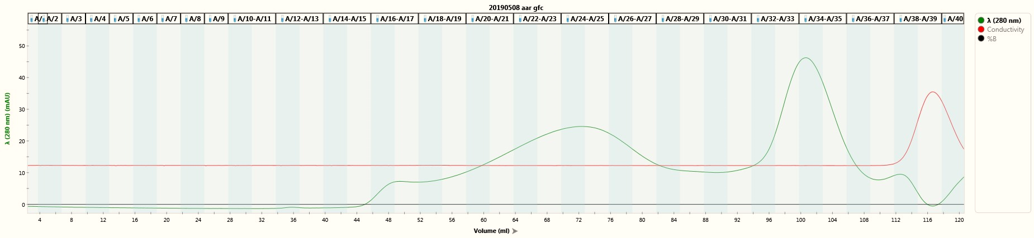
A.
1 2 3 4 5 6 7 8 9 10 11 12 13 14 15 16 17 18 19 20 21 22 23 24 25 26 27 28 29 30 31 32 33 34 35 36 37 38 39 40
Absorbance 280nm (mAU)
Volume (mL)
Conductivity
Flow rate (1mL/min)
Fractions
l------- a ------l l------- b ------l l------- c ------l l------- d -------l

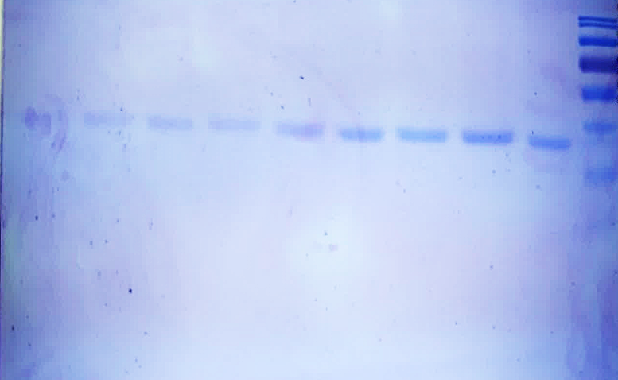
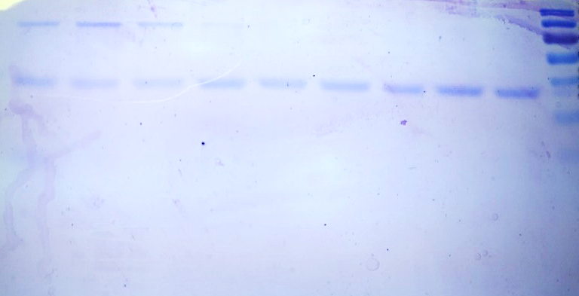
B.
43kD
34kD
l------- a ---------l l---------- b ---------l l--------- c ----------l l------------ d -----------l
M 16 17 18 19 20 21 22 23 24 M 25 26 27 28 29 30 31 32 33

Figure S1. A. Chromatogram showing AAR elution profile during GFC monitored at 280 nm. a, b, c, and d represent pooled fraction 19-21, 22-24, 25-27, and 28-30 respectively. B. 12% SDS-PAGE showing GFC eluted AAR fractions. Lane 16-33 represents the AAR fractions corresponding to the chromatogram, Lane M, medium molecular weight protein marker.

Figure S2. DLS of Pooled GFC fractions showing polydisperse state of solution.

Relative Abundance

Retention Time (min)

Relative Abundance

m/z

Figure S3: LC-MS profile of lipid extract bound to AAR. A, Fractionation profile of lipid extract. B, Full ESI-MS scan in positive ion mode (300-1000) m/z R_{t}: 0.2- 8.95 min.

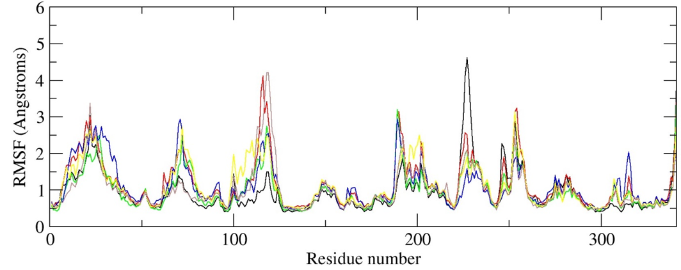
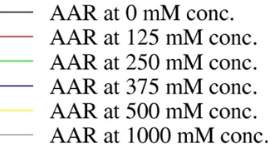
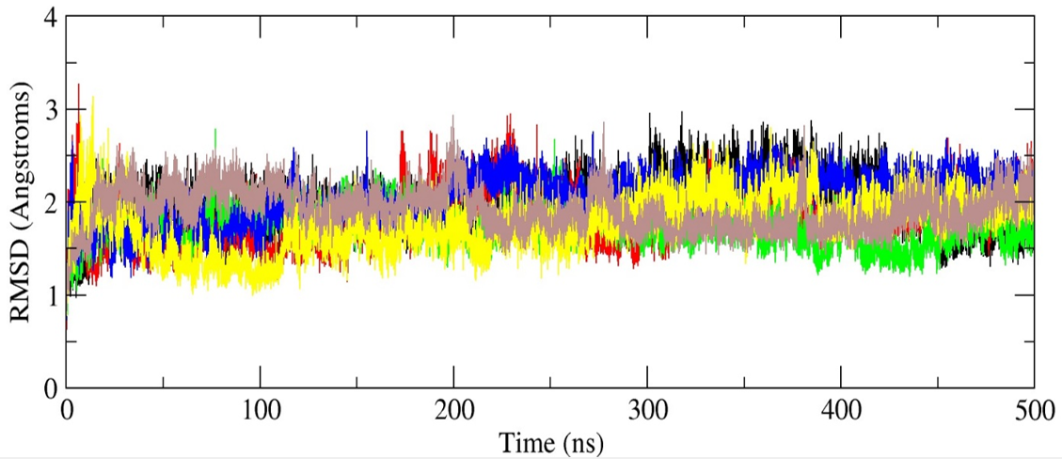
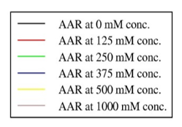

A.

B.

Figure S4. MD simulation-based studies on AAR. A, Average root mean square deviation (RMSD) in Å with reference to the initial structure used in the simulation. B, Average root mean square fluctuation (RMSF) in Å for each amino acid of AAR protein.

Table S1: LC-MS analysis based list of lipid candidates binding to AAR protein. The table outlines lipid compound ID, the retention time (RT), m/z value, mass error given in parts per million [ppm]).

Compound ID | Formula | Observed m/z | Calculated m/z | R_{t} | Error (ppm)
Fatty acids
FA(30:5)+H | C30 H51 O2 | 443.3875 | 443.3884 | 7.18 | -2.02
FA(37:6)+H | C37 H63 O2 | 539.4847 | 539.4823 | 7.42 | 4.6
FA(31:6)+H | C 31 H51 O2 | 455.3876 | 455.3884 | 7.72 | -1.62
FA(26:5)+H | C26 H43 O2 | 387.3239 | 387.3258 | 8.59 | -4.68
Hydroxy fatty acids
OAHFA(26:0)+H | C26 H51 O4 | 427.3768 | 427.3782 | 1.24 | -3.28
OAHFA(55:5)+H | C55 H99 O4 | 823.7549 | 823.7538 | 5.69 | 1.31
OAHFA(37:1)+H | C37 H71 O4 | 579.5342 | 579.5347 | 5.78 | -0.82
OAHFA(54:5)+H | C54 H97 O4 | 809.7402 | 809.7381 | 5.83 | 2.59
OAHFA(59:8)+H | C59 H101 O4 | 873.771 | 873.7694 | 5.83 | 1.76
OAHFA(55:6)+H | C55 H97 O4 | 821.738 | 821.7381 | 5.84 | -0.11
OAHFA(57:7)+H | C57 H99 O4 | 847.7555 | 847.7538 | 6.07 | 2.01
OAHFA(39:2)+H | C39 H73 O4 | 605.5482 | 605.5503 | 6.1 | -3.51
OAHFA(56:7)+H | C56 H97 O4 | 833.7402 | 833.7381 | 6.23 | 2.48
OAHFA(56:5)+H | C56 H101 O4 | 837.771 | 837.7694 | 6.23 | 1.81
OAHFA(51:5)+H | C51 H91 O4 | 767.693 | 767.6912 | 6.33 | 2.41
OAHFA(36:1)+H | C36 H69 O4 | 565.5172 | 565.519 | 6.44 | -3.22
OAHFA(53:6)+H | C53 H93 O4 | 793.7084 | 793.7068 | 6.46 | 1.99
OAHFA(53:4)+H | C53 H97 O4 | 797.7386 | 797.7381 | 6.46 | 0.63
OAHFA(54:7)+H | C54 H93 O4 | 805.7078 | 805.7068 | 6.46 | 1.23
OAHFA(61:4)+H | C61 H113 O4 | 909.8673 | 909.8633 | 6.64 | 4.3
OAHFA(53:7)+H | C53 H91 O4 | 791.6933 | 791.6912 | 6.75 | 2.71
OAHFA(50:5)+H | C50 H89 O4 | 753.6772 | 753.6755 | 6.81 | 2.26
OAHFA(35:1)+H | C35 H67 O4 | 551.5018 | 551.5034 | 6.86 | -2.92
OAHFA(44:1)+H | C44 H85 O4 | 677.6421 | 677.6442 | 6.9 | -3.19
OAHFA(47:4)+H | C47 H85 O4 | 713.6457 | 713.6442 | 6.93 | 1.99
OAHFA(50:12)+H | C50 H75 O4 | 739.5638 | 739.566 | 7 | -2.99
OAHFA(51:4)+H | C51 H93 O4 | 769.7083 | 769.7068 | 7.04 | 1.95
OAHFA(60:4)+H | C60 H111 O4 | 895.8494 | 895.8477 | 7.47 | 1.95
OAHFA(56:6)+H | C56 H99 O4 | 835.7513 | 835.7538 | 7.56 | -2.97
OAHFA(61:7)+H | C61 H107 O4 | 903.8175 | 903.8164 | 7.6 | 1.29
OAHFA(52:4)+H | C52 H95 O4 | 783.7242 | 783.7225 | 7.64 | 2.16
OAHFA(59:7)+H | C59 H103 O4 | 875.7866 | 875.7851 | 7.65 | 1.78
OAHFA(60:10)+H | C60 H99 O4 | 883.7512 | 883.7538 | 7.65 | -2.91
OAHFA(31:2)+H | C31 H57 O4 | 493.423 | 493.4251 | 7.68 | -4.27
OAHFA(56:10)+H | C56 H91 O4 | 827.6941 | 827.6912 | 7.68 | 3.54
OAHFA(51:2)+H | C51 H97 O4 | 773.7419 | 773.7381 | 7.74 | 4.92
OAHFA(38:2)+H | C38 H71 O4 | 591.533 | 591.5347 | 7.83 | -2.92
OAHFA(35:4)+H | C35 H61 O4 | 545.4548 | 545.4564 | 7.88 | -2.96
OAHFA(34:4)+H | C34 H59 O4 | 531.4392 | 531.4408 | 7.89 | -3.03
OAHFA(28:1)+H | C28 H53 O4 | 453.3946 | 453.3938 | 7.96 | 1.68
OAHFA(60:8)+H | C60 H103 O4 | 887.7811 | 887.7851 | 8.02 | -4.49
OAHFA(29:1)+H | C29 H55 O4 | 467.408 | 467.4095 | 8.04 | -3.27
OAHFA(57:8)+H | C57 H97 O4 | 845.742 | 845.7381 | 8.14 | 4.57
OAHFA(37:2)+H | C37 H69 O4 | 577.5172 | 577.519 | 8.18 | -3.17
OAHFA(50:4)+H | C50 H91 O4 | 755.6936 | 755.6912 | 8.24 | 3.17
OAHFA(30:2)+H | C30 H55 O4 | 479.4074 | 479.4095 | 8.35 | -4.43
OAHFA(30:1)+H | C30 H57 O4 | 481.4236 | 481.4251 | 8.35 | -3.20
OAHFA(39:4)+H | C39 H69 O4 | 601.5174 | 601.519 | 8.35 | -2.79
OAHFA(39:7)+H | C39 H63 O4 | 595.4713 | 595.4721 | 8.4 | -1.34
OAHFA(55:8)+H | C55 H93 O4 | 817.7078 | 817.7068 | 8.44 | 1.16
OAHFA(32:2)+H | C32 H59 O4 | 507.4392 | 507.4408 | 8.47 | -3.20
OAHFA(34:6)+H | C34 H55 O4 | 527.4107 | 527.4095 | 8.48 | 2.38
OAHFA(49:4)+H | C49 H89 O4 | 741.6779 | 741.6755 | 8.48 | 3.19
OAHFA(47:6)+H | C47 H81 O4 | 709.6146 | 709.6129 | 8.52 | 2.36
OAHFA(49:11)+H | C49 H75 O4 | 727.5656 | 727.566 | 8.52 | -0.49
OAHFA(41:5)+H | C41 H71 O4 | 627.534 | 627.5347 | 8.55 | -1.09
OAHFA(60:6)+H | C60 H107 O4 | 891.8179 | 891.8164 | 8.55 | 1.73
OAHFA(60:7)+H | C60 H105 O4 | 889.8024 | 889.8007 | 8.61 | 1.92
OAHFA(32:1)+H | C32 H61 O4 | 509.4548 | 509.4564 | 8.64 | -3.23
OAHFA(33:3)+H | C33 H59 O4 | 519.4392 | 519.4408 | 8.64 | -3.05
OAHFA(33:2)+H | C33 H61 O4 | 521.4548 | 521.4564 | 8.64 | -3.05
OAHFA(33:1)+H | C33 H63 O4 | 523.4704 | 523.4721 | 8.64 | -3.22
OAHFA(34:2)+H | C34 H63 O4 | 535.4704 | 535.4721 | 8.64 | -3.08
OAHFA(34:1)+H | C34 H65 O4 | 537.486 | 537.4877 | 8.64 | -3.14
OAHFA(35:3)+H | C35 H63 O4 | 547.4705 | 547.4721 | 8.64 | -2.91
OAHFA(35:2)+H | C35 H65 O4 | 549.4861 | 549.4877 | 8.64 | -3.05
OAHFA(36:2)+H | C36 H67 O4 | 563.5017 | 563.5034 | 8.64 | -3.08
OAHFA(37:4)+H | C37 H65 O4 | 573.4861 | 573.4877 | 8.64 | -2.80
OAHFA(38:4)+H | C38 H67 O4 | 587.5025 | 587.5034 | 8.64 | -1.45
OAHFA(39:6)+H | C39 H65 O4 | 597.4861 | 597.4877 | 8.64 | -2.69
OAHFA(45:5)+H | C45 H79 O4 | 683.5997 | 683.5973 | 8.64 | 3.48
OAHFA(31:1)+H | C31 H59 O4 | 495.4392 | 495.4408 | 8.67 | -3.13
OAHFA(36:3)+H | C36 H65 O4 | 561.486 | 561.4877 | 8.67 | -3.01
OAHFA(38:3)+H | C38 H69 O4 | 589.5173 | 589.519 | 8.67 | -2.94
OAHFA(39:5)+H | C39 H67 O4 | 599.5018 | 599.5034 | 8.67 | -2.66
OAHFA(42:2)+H | C42 H79 O4 | 647.5956 | 647.5973 | 8.67 | -2.59
OAHFA(58:10)+H | C58 H95 O4 | 855.7251 | 855.7225 | 8.71 | 3.04
OAHFA(39:3)+H | C39 H71 O4 | 603.5329 | 603.5347 | 8.72 | -3.02
OAHFA(41:3)+H | C41 H75 O4 | 631.5643 | 631.566 | 8.72 | -2.59
OAHFA(34:3)+H | C34 H61 O4 | 533.4548 | 533.4564 | 8.73 | -3.03
OAHFA(48:2)+H | C48 H91 O4 | 731.6886 | 731.6912 | 8.73 | -3.52
OAHFA(51:7)+H | C51 H87 O4 | 763.662 | 763.6599 | 8.74 | 2.78
OAHFA(46:2)+H | C46 H87 O4 | 703.6578 | 703.6599 | 8.76 | -2.97
OAHFA(43:2)+H | C43 H81 O4 | 661.6111 | 661.6129 | 8.8 | -2.76
OAHFA(47:3)+H | C47 H87 O4 | 715.6576 | 715.6599 | 8.8 | -3.18
OAHFA(61:5)+H | C61 H111 O4 | 907.8455 | 907.8477 | 8.81 | -2.36
OAHFA(42:3)+H | C42 H77 O4 | 645.581 | 645.5816 | 8.82 | -0.94
OAHFA(43:1)+H | C43 H83 O4 | 663.6266 | 663.6286 | 8.82 | -3
OAHFA(44:2)+H | C44 H83 O4 | 675.6265 | 675.6286 | 8.82 | -3.05
OAHFA(45:2)+H | C45 H85 O4 | 689.6423 | 689.6442 | 8.82 | -2.77
OAHFA(58:4)+H | C58 H107 O4 | 867.8174 | 867.8164 | 8.83 | 1.16
OAHFA(52:1)+H | C52 H101 O4 | 789.7683 | 789.7694 | 8.85 | -1.39
OAHFA(60:5)+H | C60 H109 O4 | 893.8336 | 893.832 | 8.85 | 1.80
OAHFA(56:4)+H | C56 H103 O4 | 839.786 | 839.7851 | 8.86 | 1.05
OAHFA(58:8)+H | C58 H99 O4 | 859.7561 | 859.7538 | 8.86 | 2.68
OAHFA(59:6)+H | C59 H105 O4 | 877.8017 | 877.8007 | 8.86 | 1.11
OAHFA(61:8)+H | C61 H105 O4 | 901.8015 | 901.8007 | 8.86 | 0.86
OAHFA(45:4)+H | C45 H81 O4 | 685.6149 | 685.6129 | 8.88 | 2.8
OAHFA(43:4)+H | C43 H77 O4 | 657.5811 | 657.5816 | 8.89 | -0.82
OAHFA(58:5)+H | C58 H105 O4 | 865.802 | 865.8007 | 8.89 | 1.41
OAHFA(42:1)+H | C42 H81 O4 | 649.611 | 649.6129 | 8.91 | -2.92
OAHFA(47:5)+H | C47 H83 O4 | 711.6308 | 711.6286 | 8.91 | 3.15
OAHFA(57:5)+H | C57 H103 O4 | 851.7863 | 851.7851 | 8.91 | 1.44
OAHFA(41:4)+H | C41 H73 O4 | 629.5483 | 629.5503 | 8.94 | -3.31
OAHFA(49:6)+H | C49 H85 O4 | 737.6462 | 737.6442 | 8.98 | 2.71
OAHFA(41:1)+H | C41 H79 O4 | 635.5953 | 635.5973 | 8.99 | -3.06
OAHFA(37:3)+H | C37 H67 O4 | 575.5018 | 575.5034 | 9 | -2.82
OAHFA(40:1)+H | C40 H77 O4 | 621.5797 | 621.5816 | 9 | -3.06
Prenol lipid
Co(Q8)+H | C49 H75 O4 | 727.5656 | 727.566 | 8.52 | -0.49

