SUPPLEMENTARY INFORMATION

Table S1. Initial nutrient concentrations employed during nutrient-dependent cultures.
Treatment Label | Nitrogen ª | Phosphorus | Acetic acid
Treatment Label | gN L⁻¹ (gN L⁻¹) | gPO₄ L⁻¹ | gC L⁻¹
TAP ^{b} | 0.382 (0.098) | 0.096 | 0.42
[Low P : Low N] | 0.335 (0.042) | 0.0096 | 0.42
[Low N] | 0.335 (0.042) | 0.0960 | 0.42
[Med N] | 0.356 (0.070) | 0.0960 | 0.42
[Low P] | 0.382 (0.098) | 0.0096 | 0.42
[Med P] | 0.382 (0.098) | 0.0480 | 0.42
[Low A] | 0.382 (0.098) | 0.0960 | 0.21
[High A] | 0.382 (0.098) | 0.0960 | 0.75
[High A +] | 0.382 (0.098) | 0.0960 | 1.26
[High A : Low N-] | 0.315 (0.032) | 0.0960 | 1.26
[High A : Low P] | 0.382 (0.098) | 0.0096 | 1.26
[High N++] | 0.742 (0.450) | 0.0960 | 0.42
[High P++] | 0.382 (0.098) | 0.3860 | 0.42
[High A++] | 0.382 (0.098) | 0.0960 | 2.52
ª First column refers to total nitrogen concentration; second column refers only to the nitrogen concentration from NH₄Cl.
^{b} Initial nutrient concentrations in standard TAP medium.

Table S2. p-values obtained by one-way ANOVA (tukey test). Asterisks (*) denote significant differences (p <0.05*, 0.01**, 0.001***) with respect to [TAP]. The analysis was carried out in Origin Pro 2017 (b9.4.1.354).

 | p values
Treatment pair | X | S (%) | S (gC/L) | L (%) | L (gC/L)
[TAP] | - | - | - | - | -
[TAP] [Low P : Low N] | 0.0483* | 4.24E-06*** | 0.00E+00*** | 0.1524 | 1.0000
[TAP] [Low N] | 0.7886 | 4.73E-06*** | 0.00E+00*** | 0.0007 | 0.0179*
[TAP] [Med N] | 1.0000 | 0.0398* | 8.47E-06*** | 0.0429* | 0.0883
[TAP] [Low P] | 0.3837 | 0.0063** | 1.70E-05*** | 0.9720 | 0.9970
[TAP] [Med P] | 0.9850 | 0.9764 | 0.6502 | 1.0000 | 0.9992
[TAP] [Low A] | 0.2189 | 1.0000 | 0.0684 | 1.0000 | 0.7367
[TAP] [High A] | 0.0438* | 1.0000 | 0.2327 | 0.2928 | 0.0005
[TAP] [High A+] | 0.0099** | 0.1675 | 2.97E-08*** | 0.0628 | 8.99E-06
[TAP] [High A : Low N-] | 0.0269* | 0.00E+00*** | 0.00E+00*** | 0.0021** | 0.9989
[TAP] [High A : Low P] | 0.3421 | 0.5626 | 1.37E-05*** | 0.5414 | 0.0052**
[TAP] [HIGH N] | 0.0001*** | 0.4311 | 0.3261 | 1.0000 | 0.0009
[TAP] [HIGH P] | 0.9842 | 1.0000 | 0.8638 | 1.0000 | 1.0000
[TAP] [HIGH A] | 0.9838 | 1.0000 | 1.0000 | 1.0000 | 0.9996

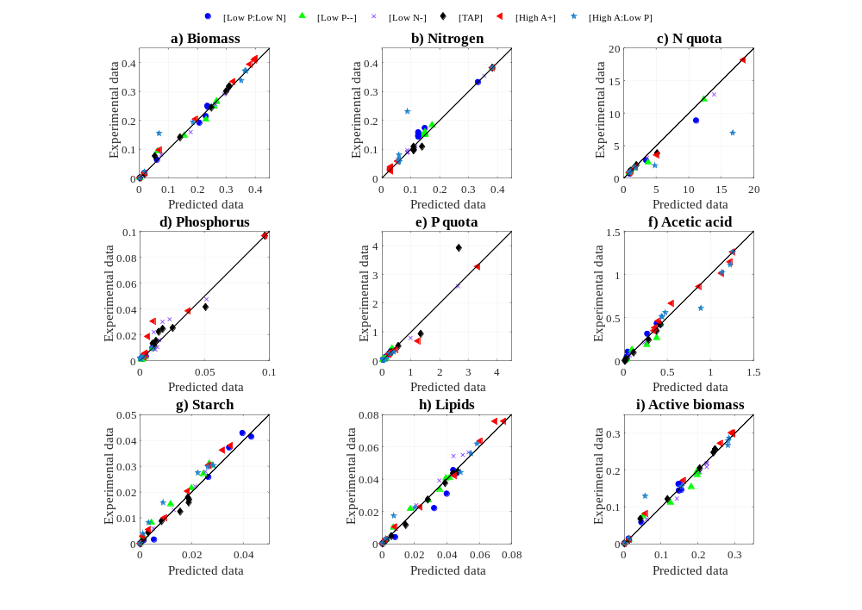
Fig. S1 Parity plots comparing predicted and experimental data for both fitting and validating datasets for: a) biomass, b) nitrogen, c) nitrogen quota, d) phosphorus, e) phosphorus quota, f) acetic acid, g) starch, h) lipids, and i) active biomass. Data are the mean of two independent experimental replicates.

Supplementary Information: Normalised sensitivity analysis.
To assess the effect of the model kinetic parameters on the state variables, a normalised sensitivity analysis was performed by calculating:
$$Sensitivity=\frac{∂Z_{i}}{∂P_{i}}∙\frac{P_{i,o}}{Z_{i,o}}=\frac{∂Z_{i}/Z_{i,o}}{∂P_{i}/P_{i,o}}$$
Here, ${∂Z_{i}}/{∂P_{i}}$ denotes the response change in a model state variable with respect to a corresponding change in a model parameter, and $Z_{i,o}$ is the response of the model state variable when the parameter is set to $P_{i,o}$. The sensitivity reflects the outcome of a change in the parameter value: for sensitivities > 0, a change in the parameter increases the response of the model variable; for sensitivities < 0, a change in the parameter decreases the response of the model variable. Meanwhile, the greater the sensitivity, the greater the effect of the parameter. For computations: i) parameters were increased by 1 % with respect to their estimated value, whilst keeping all other parameters constant (local sensitivity), and ii) the sensitivity was computed over a 200 h cultivation period.
Model outputs for each evaluated parameter were generated using initial conditions equivalent to those used in [TAP] (No=0.382 gN/L, Po=0.096 gPO₄/L, and Ao=0.42 gC/L), with the exception of the minimum P quota, $q_{P,0}$, where various phosphorous-limited initial conditions were used as the effect of this parameter only becamos significant as initial P concentrations decrease (Figure S2). The results of the sensitivity analysis are presented in Figure S3.

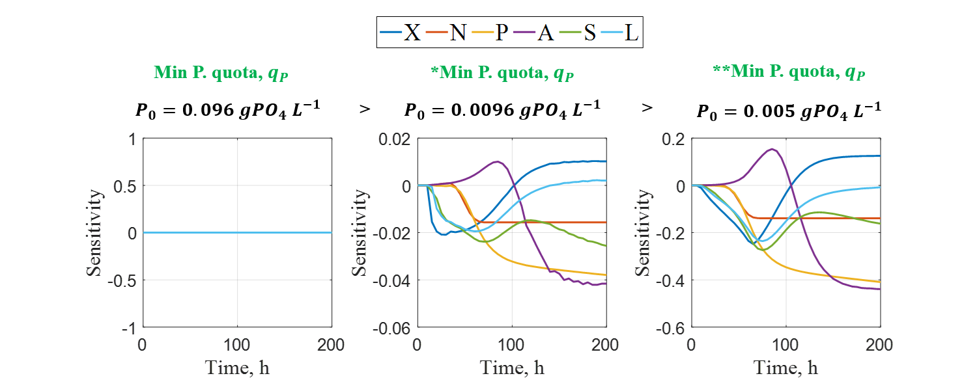
Fig. S2 Normalised sensitivity of the model state variables with respect to a 1 % increase in $q_{P,0}$, over a 200 h cultivation period subject to different initial phosphorous concentrations. Parameter colour denotes: green – associated to biomass growth.

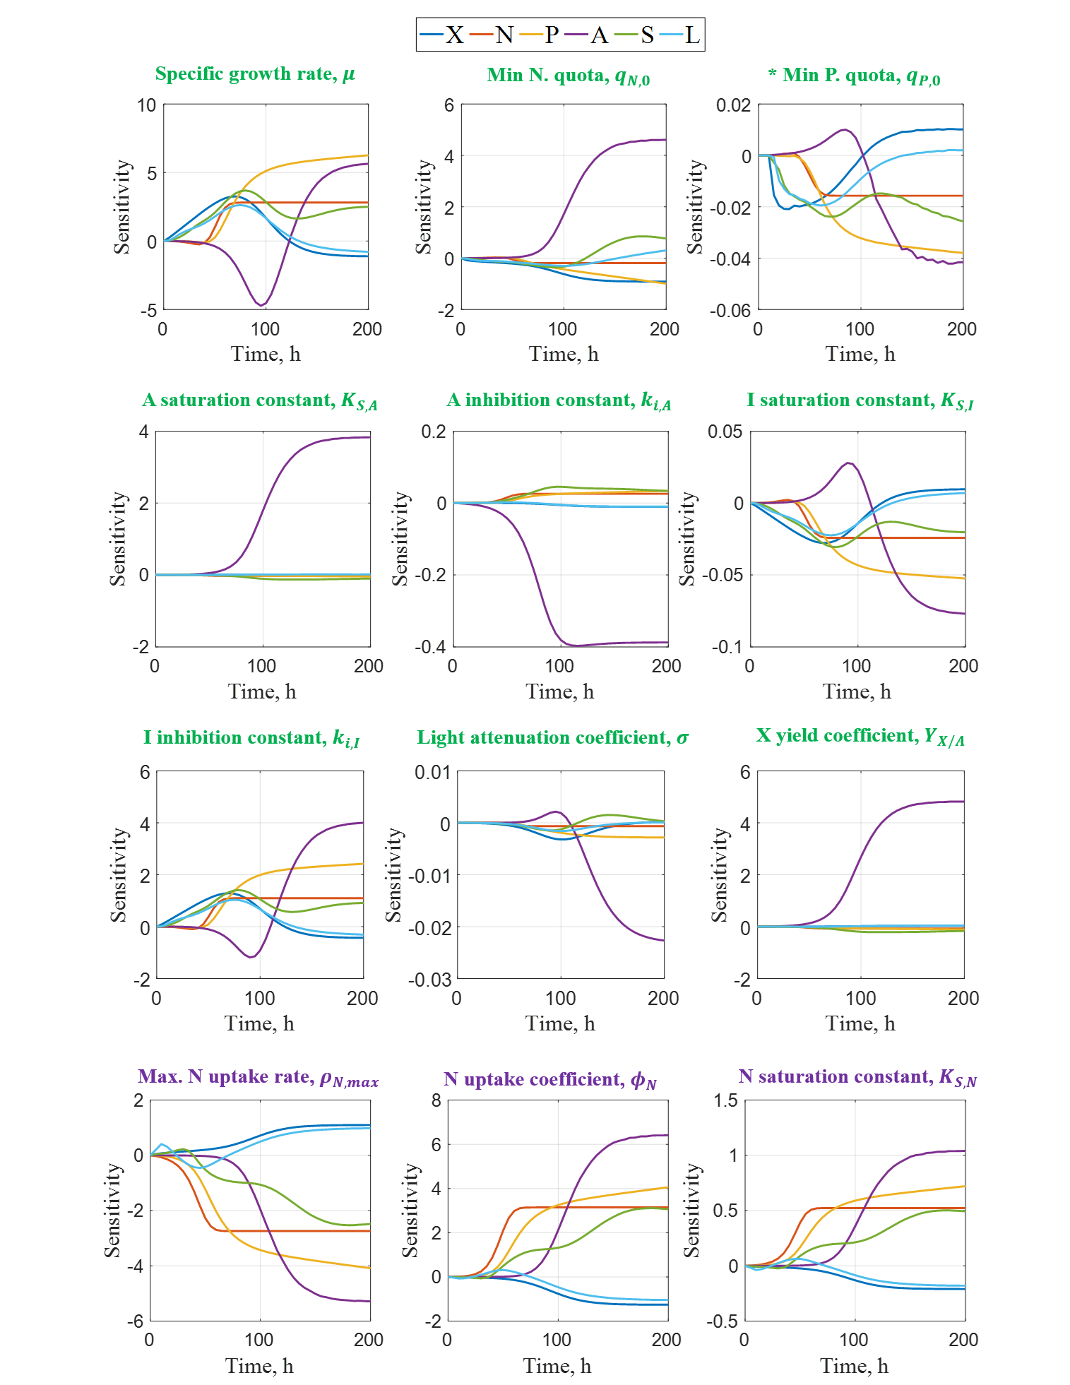
Fig. S3 Normalised sensitivity of the model state variables with respect to a 1 % increase in each model parameter, over a 200 h cultivation period. Parameter colours denote: green – associated to biomass growth, purple – associated to N uptake, orange – associated to P uptake, and black – associated to starch and lipid formation. * The sensitivities for $q_{P,0}$ were obtained by setting P₀=0.0096 gPO4 L⁻¹.
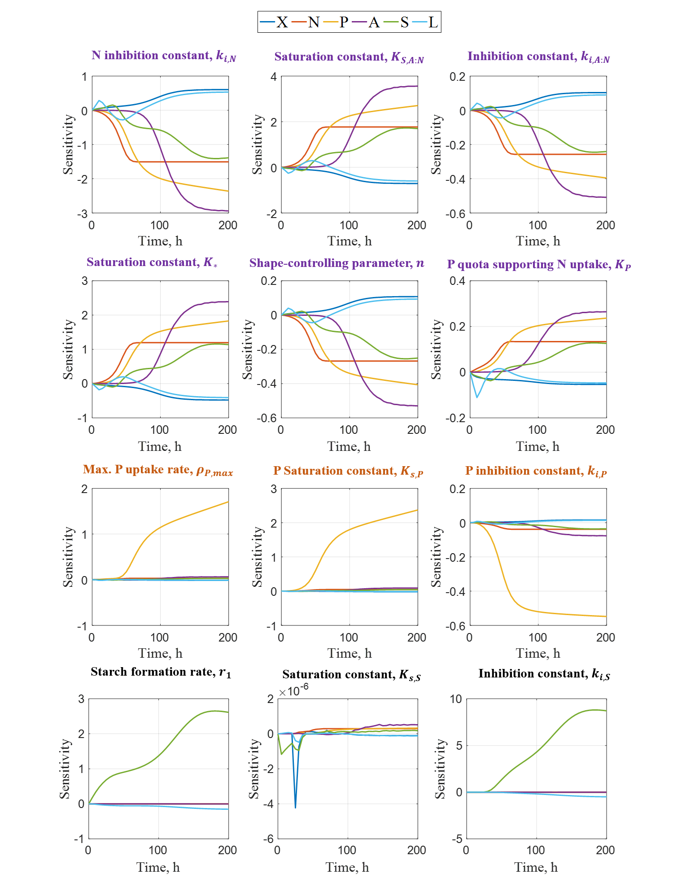
Fig. S3 (cont.) Normalised sensitivity of the model state variables with respect to a 1 % increase in each model parameter, over a 200 h cultivation period. Parameter colours denote: green – associated to biomass growth, purple – associated to N uptake, orange – associated to P uptake, and black – associated to starch and lipid formation.
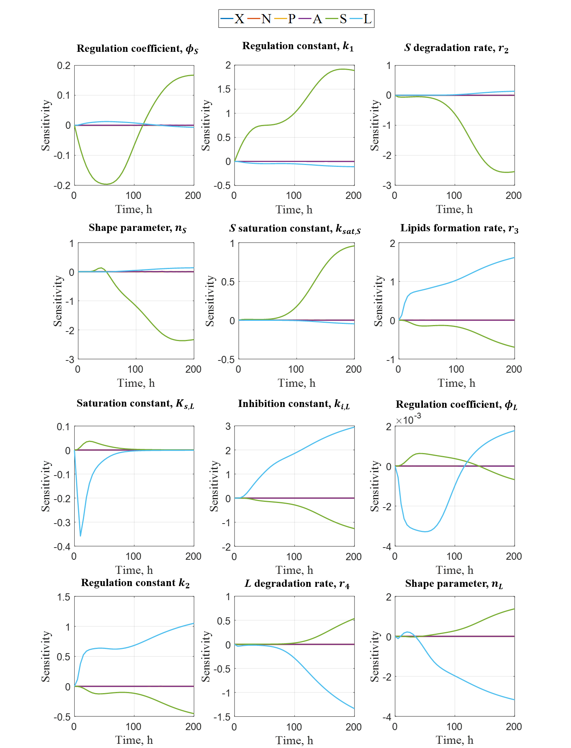
Fig. S3 (cont.) Normalised sensitivity of the model state variables with respect to a 1 % increase in each model parameter, over a 200 h cultivation period. Parameter colours denote: green – associated to biomass growth, purple – associated to N uptake, orange – associated to P uptake, and black – associated to starch and lipid formation.
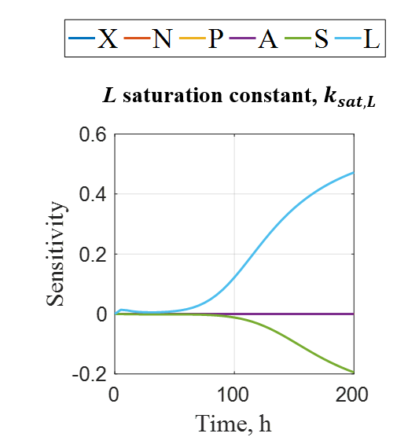
Fig. S3 (cont.) Normalised sensitivity of the model state variables with respect to a 1 % increase in each model parameter, over a 200 h cultivation period. Parameter colours denote: green – associated to biomass growth, purple – associated to N uptake, orange – associated to P uptake, and black – associated to starch and lipid formation.

As per the sensitivity analysis, the specific growth rate, μ, is one of the most significant parameters of the model as a small change in this parameter affects state variables to a great extent (up to -5 : +5). The significance of this parameter is expected as it portrays the growth of microalgal biomass subject to the effects of the nitrogen quota, phosphorous, and acetic acid. Although the remaining parameters associated to microalgal growth (in green) have an effect on the other state variables, their effect is predominantly greater on nitrogen consumption, which regulates the nitrogen quota and, in consequence, microalgal growth.
The sensitivity analysis shown above allows to observe that the effects of the model parameters associated to biomass growth and N uptake are as significant to phosphorous as they are for nitrogen. However, whilst nitrogen-associated parameters (in purple) have an effect on all model variables, the three phosphorus-associated parameters (i.e. $ρ_{P,max}$, $K_{S,P}$ and $k_{i,P}$) (in orange) only affect phosphorous since their computed sensitivities are considerably low for the remaining variables.With respect to the parameters associated to starch and lipid formation (in black), the computed sensitivity indicates that the effect of these parameters is only significant to starch, S, or lipid, L, accumulation, respectively. The effect of these parameters on the remaining variables is negligible (sensitivity=0) given that the equations governing X, N, P, and A are completely independent of storage molecule accumulation.
As per the sensitivity analysis shown above, 4 model parameters were deemed not sensitive: $σ$, $k_{S,I}$, $K_{s,S}$, and $ϕ_{L}$. The values of these parameters were thus set to: $σ=1$ (nominal value), $k_{S,I}=1.4$ (Mairet et al., 2011), and $K_{s,S}=0$ (negligible effect), and $ϕ_{L}=0$ (negligible effect).

