Intrathecal mesenchymal stem cell therapy in progressive multiple sclerosis: cross-compartment immune profiling in the SMART-MS randomized trial
Dimitrios Kleftogiannis*, (PhD)⁷, Sonia Gavasso* (PhD) ¹, Live Egeland Eidem (MSc)¹², Jonas Bull Haugsøen (MD)¹, Trygve Holmøy (MD, PhD)^{2,8}, Linn Steffensen (MD, PhD)^{3,13}, Kristin Wesnes (MD, PhD)⁴, Markus Rojewski (PhD)⁵, Harald Barsnes (PhD)^{9,10}, Niyaz Al-Sharabi (PhD)⁶, Samih Mohamed-Ahmed (PhD)⁶, Marie Ytterdal (MSc)¹, Casper Eugen Sandvik (MSc)¹, Øivind Torkildsen (MD, PhD)^{1,7}, Hubert Schrezenmeier (MD, PhD)⁵, Kamal Mustafa (PhD)⁶, Frode Steingrimsen Berven (PhD)⁹, Lars Bø (MD, PhD)^{1,7}, Torbjørn Kråkenes** (PhD), ¹ Christopher Elnan Kvistad** (MD, PhD)¹

¹ Department of Neurology, Haukeland University Hospital, Bergen, Norway
² Department of Neurology, Akershus University Hospital, Lørenskog, Norway
³ Department of Neurology, University Hospital of North Norway (UNN), Tromsø, Norway
⁴ Department of Neurology, St. Olavs Hospital, Trondheim, Norway
⁵ Institut für Klinische Transfusionsmedizin und Immungenetik, Ulm, German Red Cross Blood Transfusion Service Baden-Württemberg-Hessen and University Hospital Ulm, Ulm, Germany
⁶ Department of Clinical Dentistry, University of Bergen, Bergen, Norway
⁷ Department of Clinical Medicine, University of Bergen, Bergen, Norway
⁸ Institute of Clinical Medicine, University of Oslo, Oslo, Norway
⁹ Proteomics Unit, Department of Biomedicine, University of Bergen, Bergen, Norway
¹⁰ Computational Biology Unit, Department of Informatics, University of Bergen, Bergen, Norway
¹² Research Department, Stavanger University Hospital, Stavanger, Norway
¹³ Institute of Clinical Medicine, UiT The Arctic University of Norway, Tromsø, Norway

*Contributed equally as first authors
** Contributed equally as last authors

Corresponding Author: Dimitrios Kleftogiannis, email: dimitrios.kleftogiannis@uib.no

SUPPLEMENTARY MATERIAL

SUPPLEMENTARY TABLE 1
Antibody panel used for CyTOF-based immune profiling, indicating markers for lineage identification, differentiation, activation, and trafficking programs used in clustering and functional score analyses.

Marker | Primary use | Used for Annotation | Biological role / rationale
CD45 | Inclusion / gating | No | Pan-leukocyte marker used to define total immune cells.
CD66b | Exclusion / gating | No | Neutrophil marker used to exclude granulocytes (CD45⁺CD66b^{low}).
CD235ab | Lineage | No | Erythroid lineage marker
CD3 | Lineage | YES | Pan–T cell marker.
CD4 | Lineage | YES | CD4⁺ T cell identification.
CD8a | Lineage | YES | CD8⁺ T cell identification.
CD19 | Lineage | YES | Pan–B cell marker.
CD20 | Lineage | YES | B cell marker used to distinguish mature B cell subsets.
CD14 | Lineage | YES | Classical monocyte marker.
CD16 | Lineage | YES | Non-classical monocytes and NK-cell subset identification.
CD56 | Lineage | YES | NK-cell identification and maturation states.
CD11c | Lineage | YES | Myeloid dendritic cells and monocytes.
CD33 | Lineage | YES | Myeloid lineage marker.
CD123 | Lineage | YES | Plasmacytoid dendritic cell identification.
CD135 (FLT3) | Lineage | No | Dendritic cell progenitors and myeloid differentiation.
CD133 | Lineage | No | Progenitor/stem-like cell marker.
CD34 | Lineage | YES | Hematopoietic progenitor marker.
CD117 (c-KIT) | Lineage | No | Myeloid and progenitor cell identification.
CD105 | Lineage | No | Endothelial/stromal-associated marker, MSC-related contexts.
CD90 | Lineage | No | Stem-like and stromal-associated marker.
CD45RA | Differentiation | YES | Naïve T cell marker.
CD45RO | Differentiation | YES | Memory T cell marker.
CD27 | Differentiation | YES | Memory and activation marker on T and B cells.
CD10 | Differentiation | No | Naïve and transitional B cell marker.
CD38 | Activation | YES | Activation and differentiation marker across lymphoid and myeloid cells.
HLA-DR | Activation | YES | Antigen presentation and immune activation marker.
CD25 (IL-2Rα) | Functional | YES | T cell activation and regulatory T cell–associated marker.
CD127 (IL-7Rα) | Functional | YES | Inversely associated with regulatory T cell phenotype.
CD73 | Functional | No | Immunoregulatory and metabolic marker (adenosine pathway).
CD278 (ICOS) | Functional | No | T cell activation and co-stimulation marker.
CD44 | Functional | No | Activation, memory, and tissue trafficking marker.
CD161 | Functional | No | Th17-associated and innate-like lymphocyte marker.
CD196 (CCR6) | Functional & migratory | No | Th17-associated chemokine receptor.
CD194 (CCR4) | Functional & migratory | No | T cell homing and inflammatory trafficking marker.
CD195 (CCR5) | Functional & migratory | No | Inflammatory and CNS-homing–associated receptor.
CD184 (CXCR4) | Functional & migratory | No | Bone marrow and CNS homing, cell migration.
CD185 (CXCR5) | Functional & migratory | No | B cell follicular homing and Tfh-related marker.
CD49d (VLA-4) | Functional & migratory | No | CNS and endothelial adhesion; MS-relevant trafficking marker.
CD49f | Functional & migratory | No | Integrin involved in tissue adhesion and migration.
CD162 (PSGL-1) | Functional & migratory | No | Leukocyte rolling and vascular adhesion.
CD146 | Functional & migratory | No | Endothelial interaction and CNS migration marker.

SUPPLEMENTARY TABLE 2
Selected CSF proteins from differential abundance analysis following intrathecal MSC treatment. Columns report protein identity, functional annotation, MSC-associated effect size, statistical significance (p value and FDR), and classification as potential technical contamination (blood- or epithelial-derived).

Protein Name | Short description | estimate | p.value | FDR | is contamination
POSTN | Secreted extracellular matrix protein involved in tissue remodelling, fibrosis, and cell–matrix interactions; implicated in repair processes and structural reorganization. | 1.44 | 0.00 | 0.05 | FALSE
SPARC | Matricellular protein regulating extracellular matrix organization, collagen assembly, and cell–matrix signalling; involved in tissue remodelling and wound responses. | 0.41 | 0.00 | 0.09 | FALSE
COL3A1 | Fibrillar collagen type III, a major component of extracellular matrix in connective tissues; associated with tissue integrity and remodelling. | 0.71 | 0.00 | 0.08 | FALSE
COL5A1 | Minor fibrillar collagen regulating collagen fibril assembly and extracellular matrix structure. | 0.98 | 0.00 | 0.08 | FALSE
CFL1 | Actin-binding protein that regulates cytoskeletal dynamics, actin filament turnover, and cell motility. | 0.53 | 0.00 | 0.08 | FALSE
HDHD2 | Haloacid dehalogenase–like hydrolase involved in nucleotide and phosphometabolite metabolism; associated with cellular metabolic processes. | 0.34 | 0.00 | 0.08 | FALSE
COL1A1 | Major fibrillar collagen type I; structural component of extracellular matrix and connective tissues. | 0.74 | 0.00 | 0.05 | FALSE
COL11A1 | Minor fibrillar collagen involved in regulation of collagen fibril diameter and matrix organization. | 0.92 | 0.00 | 0.09 | FALSE
COMP | Cartilage oligomeric matrix protein; extracellular matrix protein involved in matrix assembly and structural stability. | 0.83 | 0.00 | 0.04 | FALSE
COL1A2 | Alpha chain of collagen type I; contributes to extracellular matrix tensile strength and tissue architecture. | 0.62 | 0.00 | 0.05 | FALSE
PARK7 | Multifunctional protein involved in oxidative stress response, cellular protection, and metabolic regulation; expressed broadly in neural and immune cells. | 0.33 | 0.00 | 0.08 | FALSE
EPHB2 | Ephrin receptor tyrosine kinase involved in axon guidance, synaptic plasticity, and cell–cell signalling within the nervous system. | 0.41 | 0.00 | 0.09 | FALSE
HBA1 | Hemoglobin subunit alpha; typically reflects blood-derived contamination when detected in CSF proteomics. | 1.98 | 0.24 | 0.42 | TRUE
VIM | Intermediate filament protein involved in cytoskeletal organization; expressed in mesenchymal and activated cells. | 1.71 | 0.11 | 0.28 | TRUE
TUBB2A | Beta-tubulin isoform; core component of microtubules and intracellular transport machinery. | 1.27 | 0.04 | 0.19 | TRUE
HSPB1 | Small heat shock protein involved in stress responses, cytoskeletal stabilization, and protein folding. | 1.30 | 0.03 | 0.17 | TRUE
KRT1 | Keratin type I intermediate filament protein; commonly associated with epithelial and skin contamination in CSF samples. | 2.22 | 0.16 | 0.34 | TRUE
KPRP | Keratinocyte proline-rich protein; expressed in epidermal differentiation and skin barrier formation. | 2.46 | 0.19 | 0.38 | TRUE
PLEC | Cytolinker protein connecting intermediate filaments to other cytoskeletal elements; abundant in epithelial tissues. | 1.92 | 0.09 | 0.26 | TRUE
HBB | Hemoglobin subunit beta; marker of blood contamination in CSF proteomic analyses. | 2.89 | 0.21 | 0.39 | TRUE
DSG1 | Desmosomal cadherin involved in epithelial cell–cell adhesion; skin-associated protein. | 1.29 | 0.36 | 0.52 | TRUE
DSP | Structural component of desmosomes linking cadherins to intermediate filaments; enriched in epithelial tissues. | 1.42 | 0.28 | 0.45 | TRUE
AHNAK | Large scaffolding protein involved in membrane–cytoskeleton organization and cellular stress responses. | 1.01 | 0.08 | 0.25 | TRUE
TUBA1A | Alpha-tubulin isoform; essential component of microtubules and intracellular transport. | 1.25 | 0.03 | 0.17 | TRUE
JUP | Junctional protein involved in desmosomal and adherens junction integrity; expressed in epithelial and cardiac tissues. | 1.28 | 0.29 | 0.46 | TRUE
EEF2 | Translation elongation factor involved in protein synthesis and cellular metabolic activity. | 1.13 | 0.03 | 0.18 | TRUE
CA3 | Carbonic anhydrase III; highly expressed in muscle and erythrocytes, commonly reflecting blood contamination in CSF. | 1.14 | 0.13 | 0.30 | TRUE
DCD | Antimicrobial peptide expressed in sweat glands and skin; indicates epithelial contamination when detected in CSF. | 2.08 | 0.18 | 0.36 | TRUE
KRT9 | Keratin expressed in palmoplantar epidermis; strong indicator of skin contamination. | 2.41 | 0.13 | 0.30 | TRUE

Supplementary Figure 1: Cell counts per immune phenotype at baseline. Bar plot showing the number of immune cells assigned to each of the 25 phenotyped cell populations based on CyTOF analysis of baseline peripheral blood samples.

Supplementary Figure 2: Cell counts per immune phenotype at 6m and 12m. Bar plots showing the number of immune cells assigned to each of the 25 phenotyped cell populations based on CyTOF analysis of peripheral blood sampled at 6 months (6m) and 12 months (12m) post MSC administration.

Supplementary Figure 3: Immune landscape at 6m and 12m post MSC administration. UMAP projection of all CD45⁺CD66b^{low/neg} cells at 6 months (6m) and 12 months (12m) post MSC administration coloured by the 25 immune phenotypes identified by unsupervised clustering

Supplementary Figure 4: MSC-associated effects on peripheral immune cell composition. Volcano plot showing MSC-associated effects on peripheral immune cell composition. Effect estimates from mixed-effects models comparing MSC versus control periods are plotted against −log10 p-values. Each point represents one immune phenotype, with positive values indicating relative enrichment during MSC exposure.

Supplementary Figure 5: Baseline distribution of blood-based functional program scores. Baseline distributions of composite functional program scores across all 25 immune phenotypes. Jittered gray points represent patient-level values, while solid colored points indicate the cohort median ± standard error of the mean.

Supplementary Figure 6: Lineage-level separation of functional programs at baseline. Principal component analysis (PCA) of baseline functional program profiles across immune phenotypes. Each point represents a distinct immune cell population and is colored according to its major lineage.

Supplementary Figure 7: Baseline functional landscape and longitudinal stability of CNS-homing programs.
(A) Heatmap summarizing median baseline functional program scores across the 25 immune phenotypes included in the study.
(B) Scatter plots showing the relationship between baseline CNS-homing scores and post-treatment values measured after MSC exposure (6 or 12 months, depending on treatment sequence). Each point represents an individual patient, illustrating preservation of relative CNS-homing signatures over time.

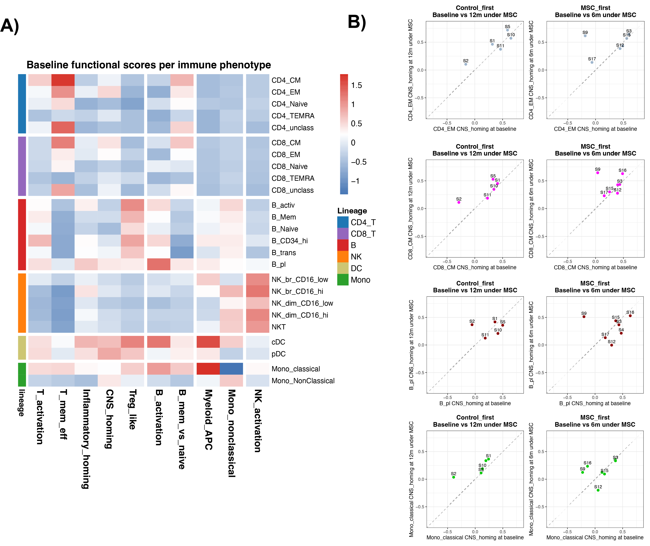

Supplementary Figure 8: Global structure of the CSF proteomic landscape across time and treatment.
Dimensionality reduction of normalized CSF proteomic profiles using (A) multidimensional scaling, (B) uniform manifold approximation and projection (UMAP), and (C) principal component analysis (PCA). Each point represents an individual CSF sample collected at baseline or after treatment. Points are colored by condition (baseline, control, MSC), and lines connect longitudinal samples from the same individual, illustrating within-patient trajectories over time.

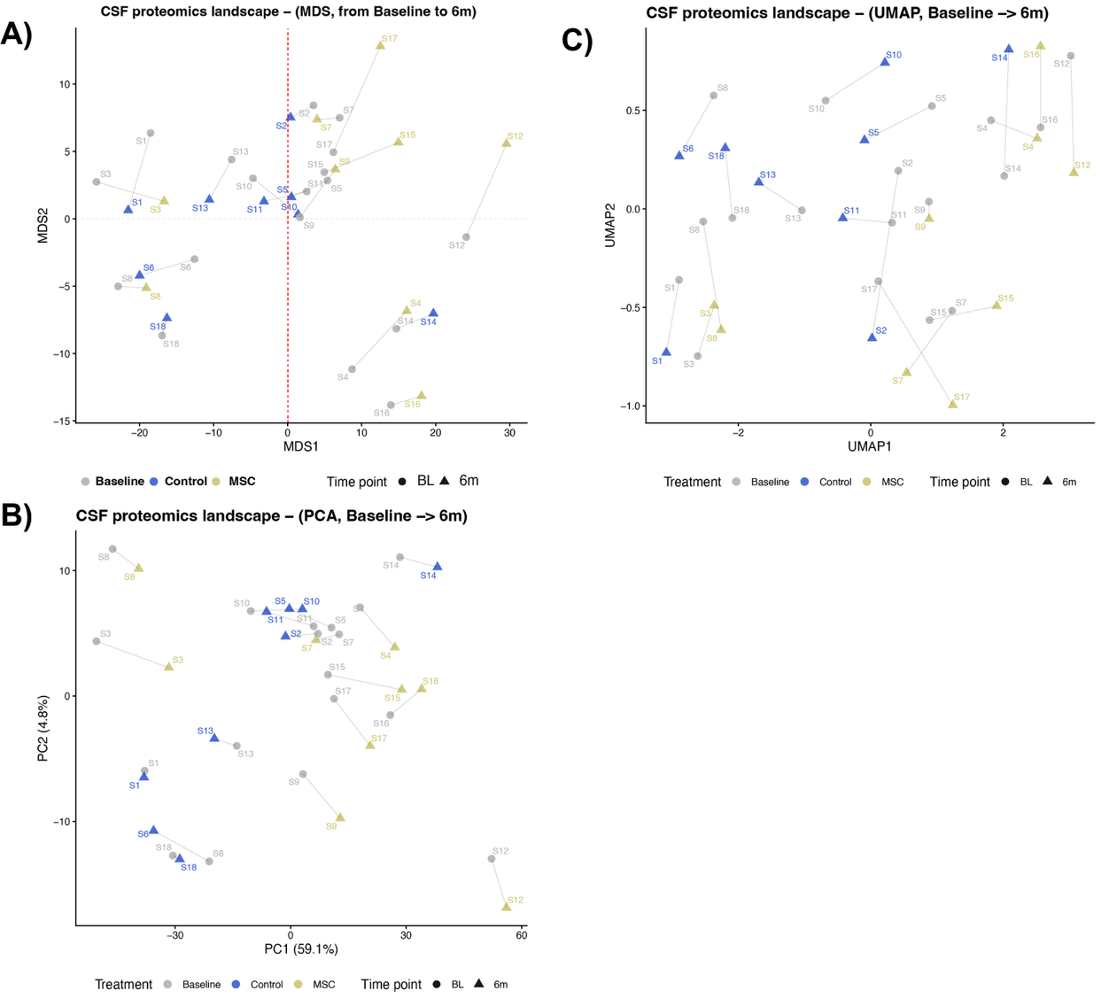

Supplementary Figure 9: GSEA of MSC-associated CSF programs. Dot plot summarizing GO gene set enrichment analysis of MSC-associated CSF proteomic changes using the full protein dataset. Pathways are ranked by normalized enrichment score (NES), with dot size indicating the leading-edge gene ratio and color representing FDR-adjusted significance.

Supplementary Figure 10: GSEA enrichment plots for selected GO biological processes. Proteins are ranked by MSC-associated effect size derived from longitudinal CSF proteomic analysis (6 months minus baseline). Enrichment curves indicate the cumulative distribution of pathway members along the ranked protein list, with positive normalized enrichment scores (NES) reflecting relative enrichment during MSC exposure. Vertical tick marks denote the positions of individual pathway proteins in the ranked list, and shaded regions highlight the leading-edge subset driving pathway enrichment.

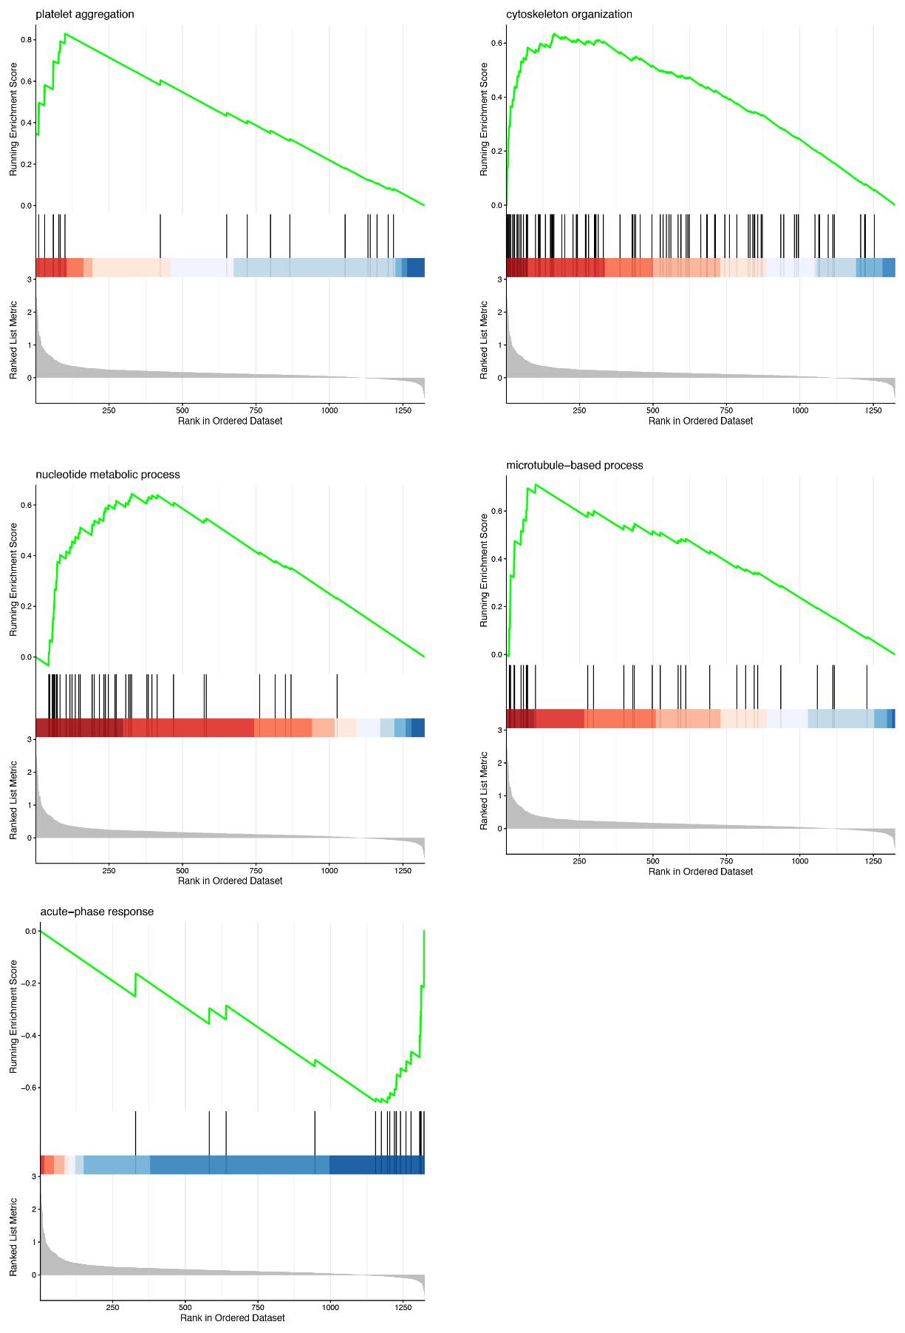

Supplementary Figure 11: Blood–CSF coupling between circulating immune functional programs and CSF proteomic programs. Scatter plots show the relationship between longitudinal changes in blood-derived functional program scores (CyTOF) and corresponding CSF functional program scores across selected immune cell populations. Each point represents an individual patient, and solid lines indicate linear regression fits stratified by treatment period (MSC vs. control). Shaded areas denote 95% confidence intervals. Analyses focus on mechanistically compatible program pairs to assess whether MSC-associated CSF remodelling aligns with specific peripheral immune functional states.

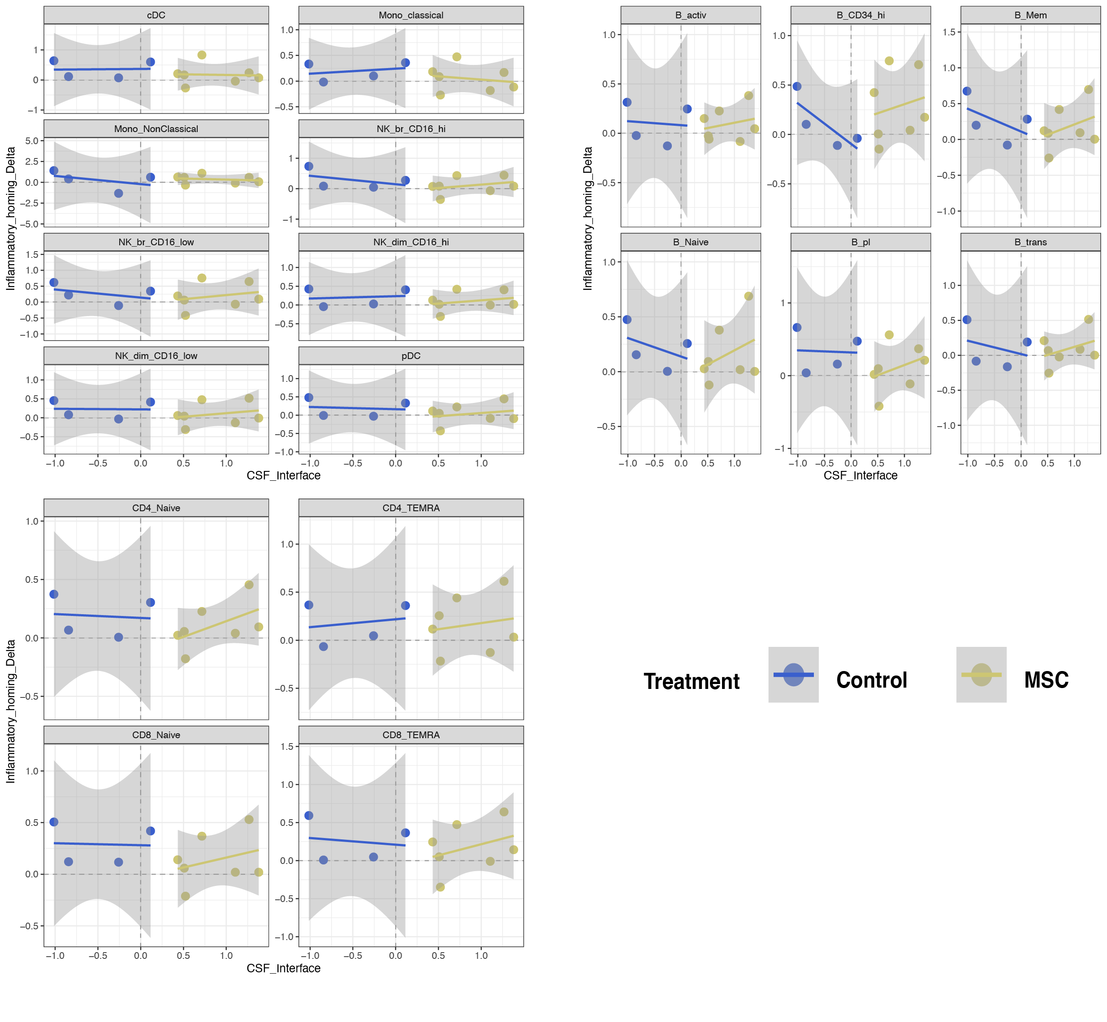

Supplementary Figure 12: Longitudinal peripheral immune composition during MSC and control periods. Line plots show relative cell frequencies (percentage of total CD45⁺ cells; untransformed values) for selected immune phenotypes at baseline, 6 months, and 12 months. Individual patient trajectories are shown, with points connected across time to illustrate within-patient stability and variability during MSC and control treatment periods.

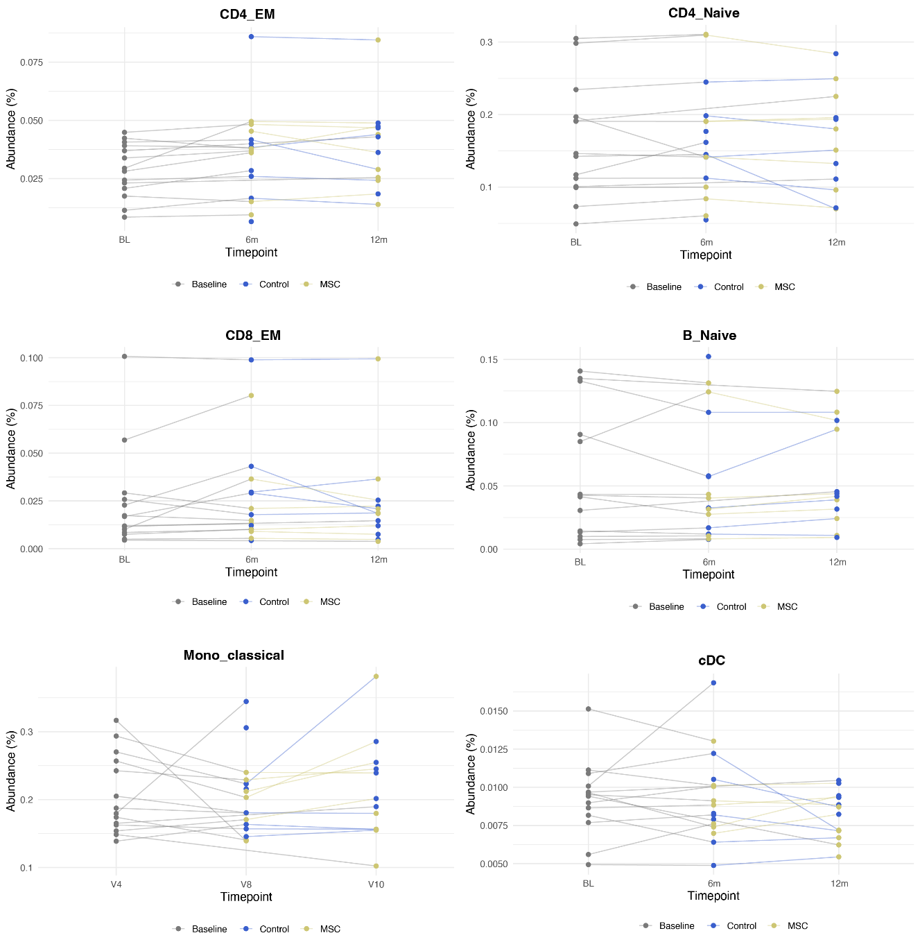

Supplementary Figure 13: Representative diagnostic plots for linear mixed-effects models used in the immune composition analysis. For selected immune phenotypes, scatter plots display residuals versus fitted values (top), assessing homoscedasticity and model fit, while quantile–quantile (QQ) plots of residuals (bottom) evaluate departures from normality.

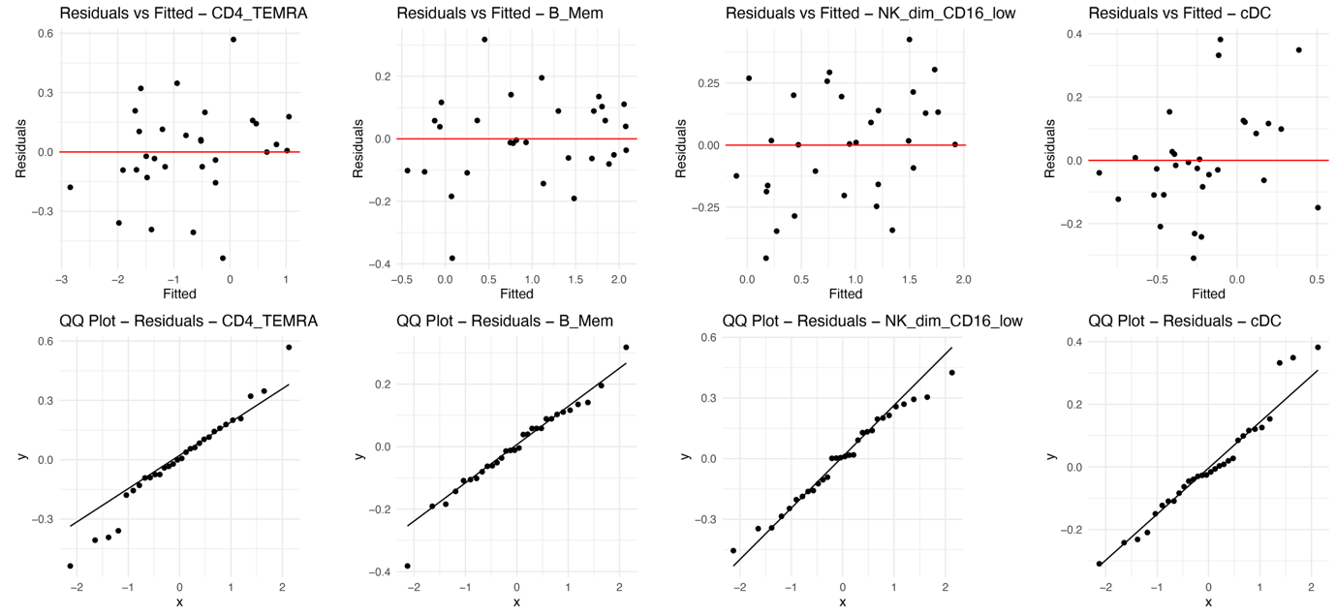

Supplementary Figure 14: Sensitivity analysis of MSC effects on immune composition. Forest plot showing MSC treatment effect estimates from an alternative linear mixed-effects modelling strategy applied to CLR-transformed frequencies of all 25 immune phenotypes. Points represent estimated fixed-effect coefficients for MSC exposure, and horizontal bars denote 95% confidence intervals. This alternative formulation serves as a sensitivity analysis to assess the robustness of the primary compositional findings shown in the main results.

Supplementary Figure 15: Targeted visualization of differentially enriched CSF proteins stratified by clinical reactivity. Boxplots showing longitudinal protein changes (Δ = 6 months − baseline) for differentially enriched CSF proteins identified in the differential abundance analysis. Samples are stratified by clinical subgroup, including control, MSC without adverse events or MRI findings, MSC with adverse events only, and MSC with both adverse events and MRI findings. Individual patient values are displayed as overlaid points to illustrate inter-individual variability.

Supplementary Figure 16: Targeted visualization of selected contamination related CSF proteins stratified by clinical reactivity. Boxplots showing longitudinal protein changes (Δ = 6 months − baseline) for selected CSF proteins commonly associated with contamination and other procedural causes. Samples are stratified by clinical subgroup, including control, MSC without adverse events or MRI findings, MSC with adverse events only, and MSC with both adverse events and MRI findings. Individual patient values are displayed as overlaid points to illustrate inter-individual variability.

Supplementary Figure 17: Targeted visualization of selected inflammation related CSF proteins stratified by clinical reactivity. Boxplots showing longitudinal protein changes (Δ = 6 months − baseline) for selected CSF proteins commonly associated with inflammatory processes. Samples are stratified by clinical subgroup, including control, MSC without adverse events or MRI findings, MSC with adverse events only, and MSC with both adverse events and MRI findings. Individual patient values are displayed as overlaid points to illustrate inter-individual variability.

Supplementary Figure 18: Relationships between CSF functional program scores and CSF reactivity score across clinical subgroups. Scatter plots illustrating pairwise relationships between longitudinal CSF functional program scores derived from proteomic changes (Δ = 6 months − baseline).
(A) Association between the CSF innate/vascular inflammatory program and the CSF ECM/interface remodelling program.
(B) Association between the CSF innate/vascular inflammatory program and the CSF metabolic/cytoskeletal adaptation program.
(C) Associations between the CSF reactivity score and each CSF functional program (metabolic/cytoskeletal, ECM/interface remodelling, and innate/vascular inflammatory). Each point represents an individual patient, coloured by clinical subgroup (Control, MSC without adverse events or MRI findings, MSC with adverse events only, MSC with adverse events and MRI findings). Dashed lines indicate zero-centred score values.
