Supplementary materials
Supplementary Tables
STab. 1. A zero-shot approach was more favorable than a contrastive learning approach.
STab. 2. Prediction performance at EC Level 1–4 across New392 and Ram255 validation datasets, corresponding to Fig. 1f-g.
STab. 3. Summary of datasets of microbial protein sequences, corresponding to Fig. 2a-b.
STab. 4. Enzyme activity prediction performance across representation models.
STab. 5. EC number prediction of PETase candidates from Mariana Trench microbiomes.

Supplementary Figures
SFig. 1. Detailed architecture of the RAMER framework and training dataset construction.
SFig. 2. The comparison and selection of protein language models (PLMs) for protein sequence embedding employed in RAMER.
SFig. 3. Visual clustering of enzymatic and non-enzymatic proteins in Swiss-Prot with different protein representation models.
SFig. 4. Clustering performance evaluation of RAMER, ESM, ProtT5, and the embedding modules of CLEAN.
SFig. 5. Embeddings of catalytic reactions with RAMER and MolT5 and clustering performance evaluation.
SFig. 6. Prediction performance stratified by training set enzyme abundance and sequence homology.
SFig. 7. A enzyme versus non-enzyme binary classifier.
SFig. 8. Distribution of protein and enzyme sizes across datasets.
SFig. 9. EC class distribution of bacterial unclassified ‘dark matter’ proteins from NMPFamsDB.
SFig. 10. Over- and under-represented EC enzyme classes associated with distinct environmental microbiomes.
SFig. 11. Sequence and structural similarities of the known and predicted PETases, corresponding to Fig. 3a right panel.
SFig. 12. Mining of candidate PUases, corresponding to Fig. 3h.
SFig. 13. Structural and sequence analysis of previously misannotated adenylate kinase (ADK) homologs.
SFig. 14. RAMER-derived prediction of catalytic activity and growth temperature of adenylate kinase (ADK) enzymes.
SFig. 15. Adenylate kinase (ADK) subtype classifier and distribution across environmental microbiomes.
SFig. 16. Alignment of mined fluorinases and known fluorinases.
SFig. 17. RAMER-based clustering, phylogeny and structural analysis of experimentally validated PETase candidates, corresponding to Fig. 4e-f.
SFig. 18. Alignment of mined PETases in Marina Trench sediment microbiome and IsPETase.
SFig. 19. ESM- and GearNet-based clustering of PETases mined in Marina Trench sediment microbiome.

Supplementary Files
SFile 1. Ram-255 validation set.
SFile 2. The 118 enzymes released after 2023 without level-4 EC numbers.
SFile 3. Abundances and ratios of billion-scale enzymes across level-1 to level-4 EC classes.
SFile 4. Abundances, ratios, and Z-score of enzymes from gcMeta and Mariana Trench sediments across 25 environments.
SFile 5. Enzymes predicted as EC 3.1.1.101.
SFile 6. Reported nature PETases and adenylate kinases.
SFile 7. Mined PURases.
SFile 8. Candidate PETases.
STab. 1. A zero-shot approach was more favorable than a contrastive learning approach. We examined three models with a contrastive learning architecture identical to those used by Yu et al. in the development of CLEAN¹, including Triplet Margin Loss and SupConH contrastive loss. Their performance was compared with that of CLEAN (trained on the CLEAN100 dataset, see Materials and Methods), as well as the zero-shot RAMER top-1 and max-sep modes. The contrastive learning models were trained on the CLEAN70 dataset in which any pair of sequences shared no more than 70% sequence identity, following the protocol of ref.¹. The RAMER-based zero-shot prediction is also based on CLEAN70. The New-392 dataset was used for testing. Bold values indicate the best performance for each metric.
Model and method | Precision | Recall | F1
CLEAN | 0.5955 | 0.4791 | 0.4967
RAMER Triplet Margin Loss function | 0.5931 | 0.493 | 0.5046
RAMER with supconH Loss function (3720 epochs) | 0.5562 | 0.503 | 0.5057
RAMER with supconH Loss function (840 epochs) | 0.6075 | 0.5249 | 0.533
RAMER zero-shot top1 mode | 0.6037 | 0.5288 | 0.5401
RAMER zero-shot max-sep mode | 0.5815 | 0.5865 | 0.5502
STab. 2. Prediction performance at EC Level 1–4 across New392 and Ram255 validation datasets, corresponding to Fig. 1f-g. Bold values mark the best performance for each metric.
metric | Model | New392 |  |  |  |  | Ram255
metric | Model | EC level 1 | EC level 2 | EC level 3 | EC level 4 |  | EC level 1 | EC level 2 | EC level 3 | EC level 4
Precision | RAMER (max-sep) | 0.912 | 0.885 | 0.828 | 0.622 |  | 0.902 | 0.868 | 0.866 | 0.811
Precision | RAMER (top-1) | 0.972 | 0.954 | 0.945 | 0.607 |  | 0.974 | 0.948 | 0.946 | 0.800
Precision | CLEAN | 0.961 | 0.940 | 0.928 | 0.596 |  | 0.943 | 0.920 | 0.933 | 0.745
Precision | GraphEC | 0.517 | 0.504 | 0.658 | 0.459 |  | 0.478 | 0.524 | 0.623 | 0.675
Precision | DeepECTransformer | 0.927 | 0.941 | 0.910 | 0.427 |  | 0.942 | 0.910 | 0.846 | 0.652
Precision | ProteInfer | 0.953 | 0.934 | 0.915 | 0.409 |  | 0.937 | 0.932 | 0.868 | 0.541
Precision | ProTrek | 0.953 | 0.931 | 0.889 | 0.422 |  | 0.905 | 0.884 | 0.867 | 0.484
Recall | RAMER (max-sep) | 0.977 | 0.952 | 0.875 | 0.662 |  | 0.985 | 0.969 | 0.958 | 0.871
Recall | RAMER (top-1) | 0.975 | 0.950 | 0.870 | 0.563 |  | 0.973 | 0.962 | 0.950 | 0.781
Recall | CLEAN | 0.937 | 0.897 | 0.865 | 0.479 |  | 0.961 | 0.923 | 0.915 | 0.720
Recall | GraphEC | 0.998 | 0.972 | 0.885 | 0.549 |  | 0.973 | 0.950 | 0.935 | 0.810
Recall | DeepECTransformer | 0.884 | 0.859 | 0.762 | 0.326 |  | 0.744 | 0.735 | 0.719 | 0.609
Recall | ProteInfer | 0.866 | 0.811 | 0.785 | 0.284 |  | 0.764 | 0.712 | 0.677 | 0.473
Recall | ProTrek | 0.942 | 0.897 | 0.847 | 0.352 |  | 0.895 | 0.854 | 0.800 | 0.419
F1 | RAMER (max-sep) | 0.939 | 0.903 | 0.830 | 0.621 |  | 0.939 | 0.909 | 0.901 | 0.829
F1 | RAMER (top-1) | 0.973 | 0.945 | 0.863 | 0.570 |  | 0.973 | 0.953 | 0.943 | 0.785
F1 | CLEAN | 0.944 | 0.907 | 0.874 | 0.497 |  | 0.951 | 0.918 | 0.917 | 0.727
F1 | GraphEC | 0.655 | 0.622 | 0.703 | 0.462 |  | 0.622 | 0.630 | 0.696 | 0.708
F1 | DeepECTransformer | 0.903 | 0.891 | 0.798 | 0.335 |  | 0.826 | 0.803 | 0.762 | 0.623
F1 | ProteInfer | 0.905 | 0.860 | 0.816 | 0.309 |  | 0.840 | 0.799 | 0.742 | 0.494
F1 | ProTrek | 0.946 | 0.903 | 0.852 | 0.364 |  | 0.899 | 0.862 | 0.820 | 0.433

STab. 3. Summary of datasets of microbial protein sequences, corresponding to Fig. 2a-b. Environmental classifications follow gcMeta annotations. Mariana Trench denotes the sediment microbiome dataset from ref.². T From NMPFamsDB, only proteins of bacterial origin were used. Proteins with >1024 amino acids (aa) were excluded from all datasets. Proteins with <200 aa from GOPC were also disregarded.
Database/  Dataset | Environment/  habitat | Protein count | Fasta Size | Enzyme count | Protein median length (aa) | Access time
Global Catalogue of Metagenomics (gcMeta)³ | Wetlands Sediment | 359,817 | 139M | 153,186 | 226 | Nov 2025
Global Catalogue of Metagenomics (gcMeta)³ | Bean Rhizosphere | 733,476 | 297M | 329,685 | 242 | Nov 2025
Global Catalogue of Metagenomics (gcMeta)³ | Arabidopsis Rhizosphere | 1,042,431 | 417M | 438,706 | 235 | Nov 2025
Global Catalogue of Metagenomics (gcMeta)³ | Wheat Rhizosphere | 1,497,978 | 604M | 628,692 | 238 | Nov 2025
Global Catalogue of Metagenomics (gcMeta)³ | Rice Rhizosphere | 3,230,089 | 1.3G | 1,329,194 | 236 | Nov 2025
Global Catalogue of Metagenomics (gcMeta)³ | Agricultural Soil | 5,414,894 | 2.3G | 2,326,168 | 259 | Nov 2025
Global Catalogue of Metagenomics (gcMeta)³ | Freshwater Riverine | 5,330,457 | 2.3G | 2,521,149 | 268 | Nov 2025
Global Catalogue of Metagenomics (gcMeta)³ | Groundwater | 4,344,377 | 1.8G | 1,718,988 | 240 | Nov 2025
Global Catalogue of Metagenomics (gcMeta)³ | Permafrost | 13,248,708 | 5.5G | 5,759,862 | 258 | Nov 2025
Global Catalogue of Metagenomics (gcMeta)³ | Freshwater Sediment | 16,413,067 | 6.8G | 7,495,347 | 265 | Nov 2025
Global Catalogue of Metagenomics (gcMeta)³ | Hot Spring | 11,347,358 | 4.9G | 4,991,330 | 266 | Nov 2025
Global Catalogue of Metagenomics (gcMeta)³ | Acid Mine Drainage | 8,467,159 | 3.7G | 3,785,950 | 266 | Nov 2025
Global Catalogue of Metagenomics (gcMeta)³ | Hot Habitat | 13,250,188 | 4.9G | 5,771,237 | 264 | Nov 2025
Global Catalogue of Metagenomics (gcMeta)³ | Saline-alkaline Habitat | 13,227,987 | 5.6G | 5,724,246 | 260 | Nov 2025
Global Catalogue of Metagenomics (gcMeta)³ | Acid Habitat | 10,691,762 | 4.6G | 4,732,915 | 263 | Nov 2025
Global Catalogue of Metagenomics (gcMeta)³ | Drinking Water | 15,607,987 | 6.4G | 6,672,191 | 249 | Nov 2025
Global Catalogue of Metagenomics (gcMeta)³ | Hydrothermal Vent | 14,023,650 | 5.9G | 6,106,814 | 262 | Nov 2025
Global Catalogue of Metagenomics (gcMeta)³ | Marine Sediment | 18,923,116 | 7.8G | 8,244,415 | 257 | Nov 2025
Global Catalogue of Metagenomics (gcMeta)³ | Pressure Habitat | 16,543,998 | 7.0G | 7,239,905 | 258 | Nov 2025
Global Catalogue of Metagenomics (gcMeta)³ | Saline Lake | 15,189,806 | 6.5G | 6,586,852 | 262 | Nov 2025
Global Catalogue of Metagenomics (gcMeta)³ | Cold Habitat | 21,285,628 | 9.0G | 9,380,799 | 261 | Nov 2025
Global Catalogue of Metagenomics (gcMeta)³ | Freshwater Lake Water | 35,625,184 | 16G | 17,178,737 | 280 | Nov 2025
Global Catalogue of Metagenomics (gcMeta)³ | Wastewater | 41,018,101 | 18G | 18,284,658 | 272 | Nov 2025
Global Catalogue of Metagenomics (gcMeta)³ | Marine Seawater | 123,692,153 | 54G | 62,119,269 | 279 | Nov 2025
MGnify⁴ | - | 2,455,939,992 | 492.18G | 754,996,958 | 162 | Apr 2024
NMPFamsDB⁵ | - | 14,301,619 | 2.28G | 316,000 | 94 | Feb 2025
Global Ocean Microbiome Protein Catalog (GOPC)⁶ | Marine | 2,458,203,511 | 309.81G | 84,828,594 | 80 | Apr 2025
Mariana Trench² | Marine | 20,833,416 | 8.11G | 8,267,638 | 225 | Jul 2025

STab. 4. Enzyme activity prediction performance across representation models. Benchmarked on the test set used by CataPro in ref.⁷ with 10-fold cross-validation. Protein sequences were embedded with RAMER, ProtT5, ESM-1b, and ESM2-650M. Substrate molecules were embedded with MolT5. The concatenated protein-substrate embeddings were subsequently fed into the XGBoost model for training. In each fold of the 10-fold cross-validation, the model was trained on the training subset and evaluated on the corresponding held-out validation subset. K_{cat}, turnover number; K_{M}, Michaelis constant; PCC, Pearson correlation coefficient; SCC, Spearman rank correlation coefficient; RMSE, root mean square error.
Model | K_{cat} |  |  |  | K_{M}
Model | PCC | SCC | RMSE |  | PCC | SCC | RMSE
RAMER | 0.4972 | 0.4888 | 1.3271 |  | 0.6532 | 0.6507 | 0.976
ProtT5 | 0.4887 | 0.4779 | 1.3375 |  | 0.6434 | 0.6391 | 0.9885
ESM2-650m | 0.4748 | 0.4599 | 1.3504 |  | 0.6404 | 0.6353 | 0.9921
ESM-1b | 0.4806 | 0.4749 | 1.3443 |  | 0.6446 | 0.6416 | 0.9869

STab. 5. EC number prediction of PETase candidates from Mariana Trench microbiomes. Candidate PETases (EC 3.1.1.101) were mined from Mariana Trench sediment microbiome using RAMER (see workflow in Fig. 4d). At least two other models (CLEAN, DeepECTransformer, Proteinfer, and GraphEC) did not assign EC 3.1.1.101 to these enzymes. GraphEC, which outputs five EC numbers per enzyme in descending confidence, assigned EC 3.1.1.101 to 7 out of the 21 candidates, but only as the lowest-ranked prediction. Protein sizes, presence of Ser-His-Asp (S-H-D) catalytic triad, and the characteristic GxSxG motif are provided.
ID | Length (amino acid) | Predicted EC number |  |  |  |  | Catalytic triad | GxSxG motif
ID | Length (amino acid) | RAMER max-sep mode | CLEAN | DeepEC  Transformer | Proteinfer | GraphEC | Catalytic triad | GxSxG motif
FD22 | 305 | 3.1.1.101 | 2.1.1.86; 1.1.2.7 | None | 3.-.-.- | 3.1.1.74; 3.1.1.72; 3.1.1.3; 3.1.1.73; 4.2.99.18 | S-H-D | G-S-G
FD28 | 322 | 3.1.1.101 | 3.1.1.1; 3.1.1.56 | 3.1.1.1; 3.1.1.3 | 3.1.1.- | 3.1.1.72; 3.1.1.73; 3.1.26.5; 3.1.1.3; 4.2.99.18 | S-H-D | G-S-G
FD35 | 303 | 3.1.1.101 | 1.1.2.7 | None | 3.1.1.- | 3.1.1.74; 2.7.1.50; 3.1.1.117; 2.5.1.3; 3.1.1.72 | S-H-D | G-S-G
FD36 | 333 | 3.1.1.101 | 1.11.1.10 | None | None | 3.1.1.74; 3.1.1.72; 3.1.1.3; 3.1.1.73; 3.1.1.101 | S-H-D | G-S-G
FD37 | 365 | 3.1.1.101 | 3.1.1.101 | None | 3.1.1.- | 3.1.1.3; 3.1.1.74; 3.1.1.72; 3.1.1.73; 3.1.1.101 | S-H-D | GWSMG
FD39 | 349 | 3.1.1.101 | 3.4.24.38 | None | None | 3.1.1.74; 3.1.1.72; 3.1.1.3; 3.1.1.73; 2.5.1.3 | S-H-D | G-S-G
FD40 | 275 | 3.1.1.101 | 3.1.1.1 | None | 3.1.1.- | 3.1.1.3; 3.1.1.73; 3.1.1.72; 3.1.1.1; 3.1.1.74 | S-H-D | G-S-G
FD46 | 300 | 3.1.1.101 | 3.4.24.38; 3.5.1.79 | None | 3.-.-.- | 3.1.1.74; 3.1.1.3; 3.1.1.72; 3.1.1.73; 4.2.99.18 | S-H-D | G-S-G
FD48 | 202 | 3.1.1.101 | 2.3.1.43 | None | None | 3.1.1.3; 3.1.1.74; 3.1.1.72; 3.1.1.73; 3.1.1.101 | S-H-D | G-S-G
FD49 | 209 | 3.1.1.101 | 3.1.1.101 | None | 3.1.1.- | 3.1.1.3; 3.1.1.74; 3.1.1.72; 3.1.1.73; 3.1.1.101 | None | G-SMG
FD53 | 317 | 3.1.1.101 | 3.1.1.101 | 3.1.1.3 | 3.1.-.- | 3.1.1.3; 3.1.1.74; 3.1.1.72; 3.1.1.73; 3.1.1.101 | S-H-D | G-S-G
FD54 | 235 | 3.1.1.101 | 3.1.1.1 | 3.1.1.1 | 3.4.-.- | 3.1.1.3; 3.1.1.72; 3.1.1.73; 3.1.1.74; 3.1.26.5 | None | G-S-G
FD58 | 300 | 3.1.1.101 | 3.5.1.79; 3.4.24.38 | None | None | 3.1.1.74; 3.1.1.72; 3.1.1.3; 3.1.1.73; 4.2.99.18 | S-H-D | G-S-G
FD62 | 322 | 3.1.1.101 | 3.4.24.38 | 3.1.1.3 | 3.1.1.- | 3.1.1.74; 3.1.1.3; 3.1.1.72; 3.1.1.73; 4.2.99.18 | S-H-D | G-S-G
FD63 | 322 | 3.1.1.101 | 3.4.24.38 | 3.1.1.3 | 3.1.-.- | 3.1.1.74; 3.1.1.3; 3.1.1.72; 3.1.1.73; 4.2.99.18 | S-H-D | G-S-G
FD65 | 309 | 3.1.1.101 | 3.1.1.101 | None | 3.1.-.- | 3.1.1.3; 3.1.1.74; 3.1.1.72; 3.1.1.73; 3.1.1.101 | S-H-D | G-S-G
FD71 | 277 | 3.1.1.101 | 3.1.1.1 | None | 3.1.1.- | 3.1.1.3; 3.1.1.73; 3.1.1.72; 3.1.1.74; 3.1.1.1 | S-H-D | G-S-G
FD79 | 334 | 3.1.1.101 | 1.1.2.7 | None | None | 3.1.1.74; 3.1.1.3; 3.1.1.72; 3.1.1.73; 4.2.99.18 | S-H-D | G-S-G
FD82 | 305 | 3.1.1.101 | 3.5.1.79 | None | 3.1.-.- | 3.1.1.74; 3.1.1.3; 3.1.1.72; 4.2.99.18; 3.1.1.73 | S-H-D | G-S-G
FD96 | 142 | 3.1.1.101 | 2.1.1.86 | None | None | 3.1.1.3; 3.1.1.74; 3.1.1.73; 3.1.1.72; 3.1.1.101 | S-H-D | G-SMG
FD98 | 184 | 3.1.1.101 | 3.1.1.6 | None | None | 3.1.1.3; 3.1.26.5; 4.2.99.18; 2.7.1.50; 2.7.7.6 | S-H-D | G-S-G

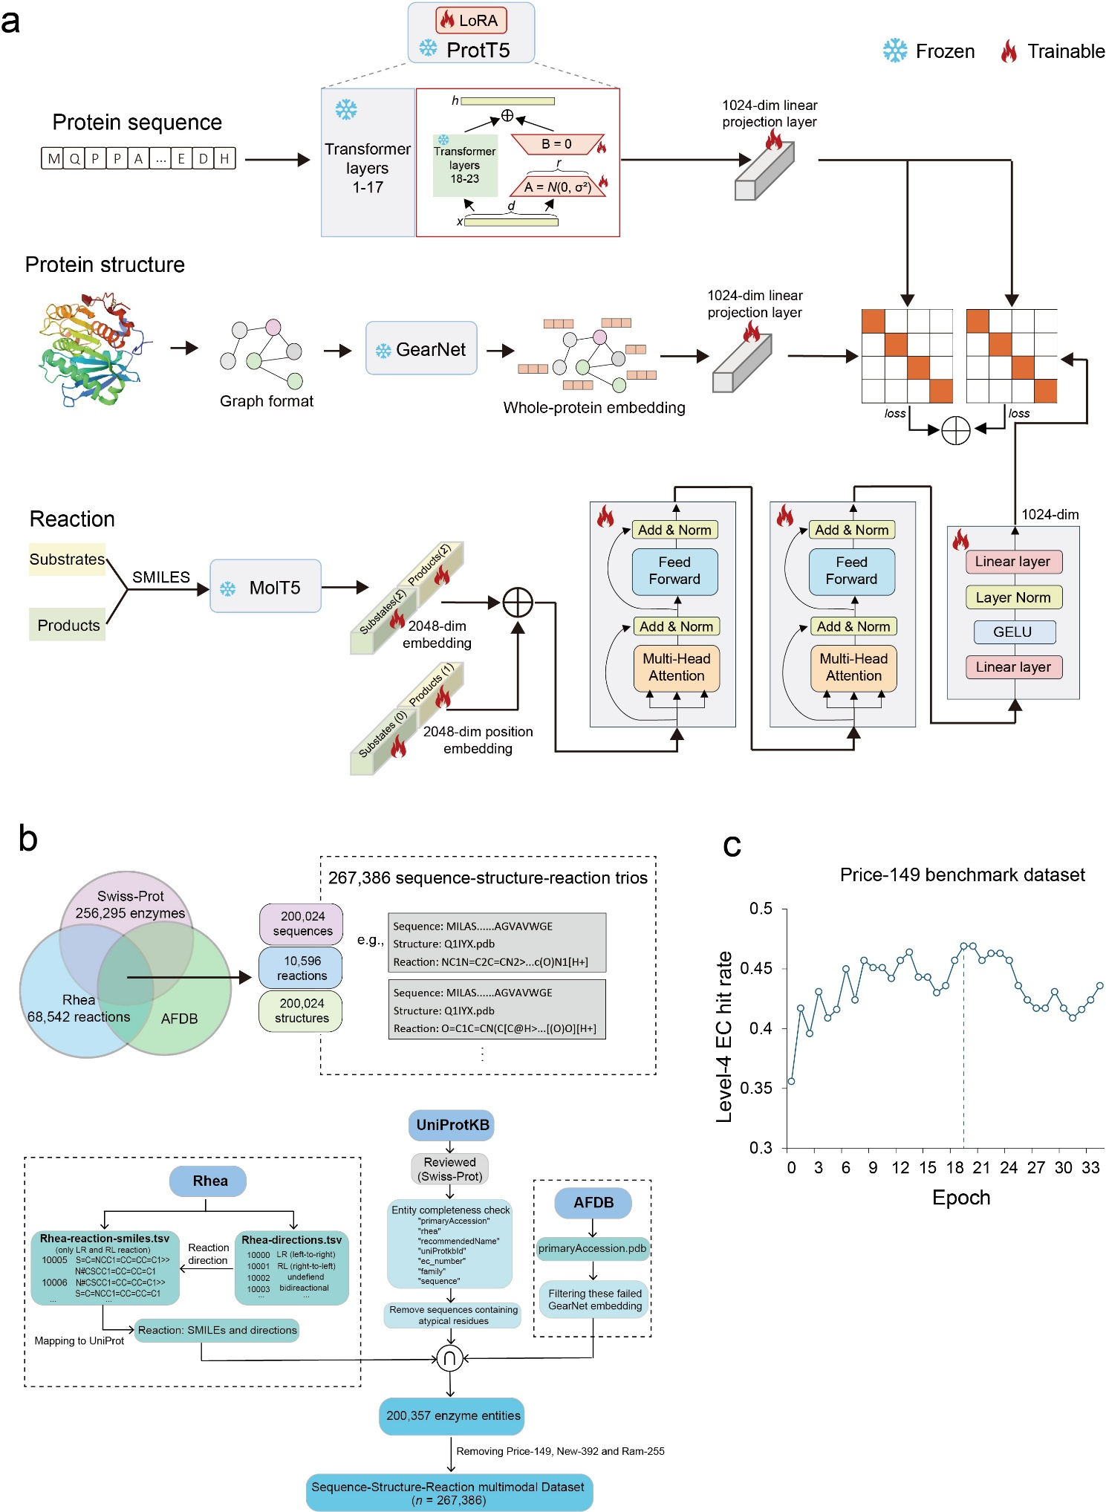
SFig. 1. Detailed architecture of the RAMER framework and training dataset construction. (a) Detailed schematic of the RAMER multimodal architecture. Circle-cross symbols denote element-wise summation; dim, dimension. Protein sequence features are extracted from a frozen ProtT5 model with trainable LoRA fine-tuning. The symbol + denotes summation. (b) Construction of the multi-modal training dataset. Top: Venn diagram illustrating the integration of data from Swiss-Prot, Rhea, and the AlphaFold Protein Structure Database (AFDB), yielding a total of 267,386 unique sequence–structure–reaction trios. Bottom: Workflow of data curation, filtering, and matching across RheaDB, UniProtKB (Swiss-Prot), and AFDB to compile the final high-quality tripartite dataset. The symbol ∩ represents the intersection operation. (c) Model epoch selection based on Level 4 Enzyme Commission (EC) number prediction hit rate, evaluated on the held-out Price-149 validation dataset. A small number of reactions are annotated as "undefined" or "bidirectional" in terms of reaction direction in Rhea, and they were treated as left to right (LR) reactions.

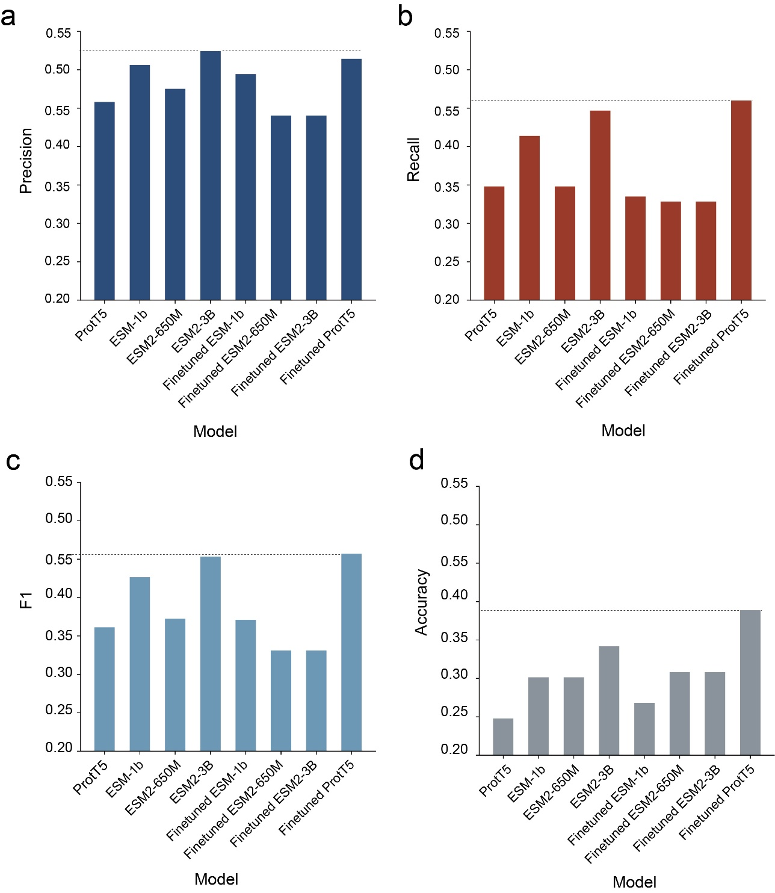
SFig. 2. The comparison and selection of protein language models (PLMs) for protein sequence embedding employed in RAMER. Model evaluation was performed on the Price-149 benchmark dataset at level‑4 Enzyme Commission (EC) classes. EC prediction performance was assessed on a reduced background set, the CLEAN‑70 set, which consists of approximately 70,000 enzymes sharing less than 70% pairwise identity¹. All models were built upon an identical tri-modal pretrained framework, differing only in the choice of PLMs and whether they received additional fine-tuning on enzyme sequences.

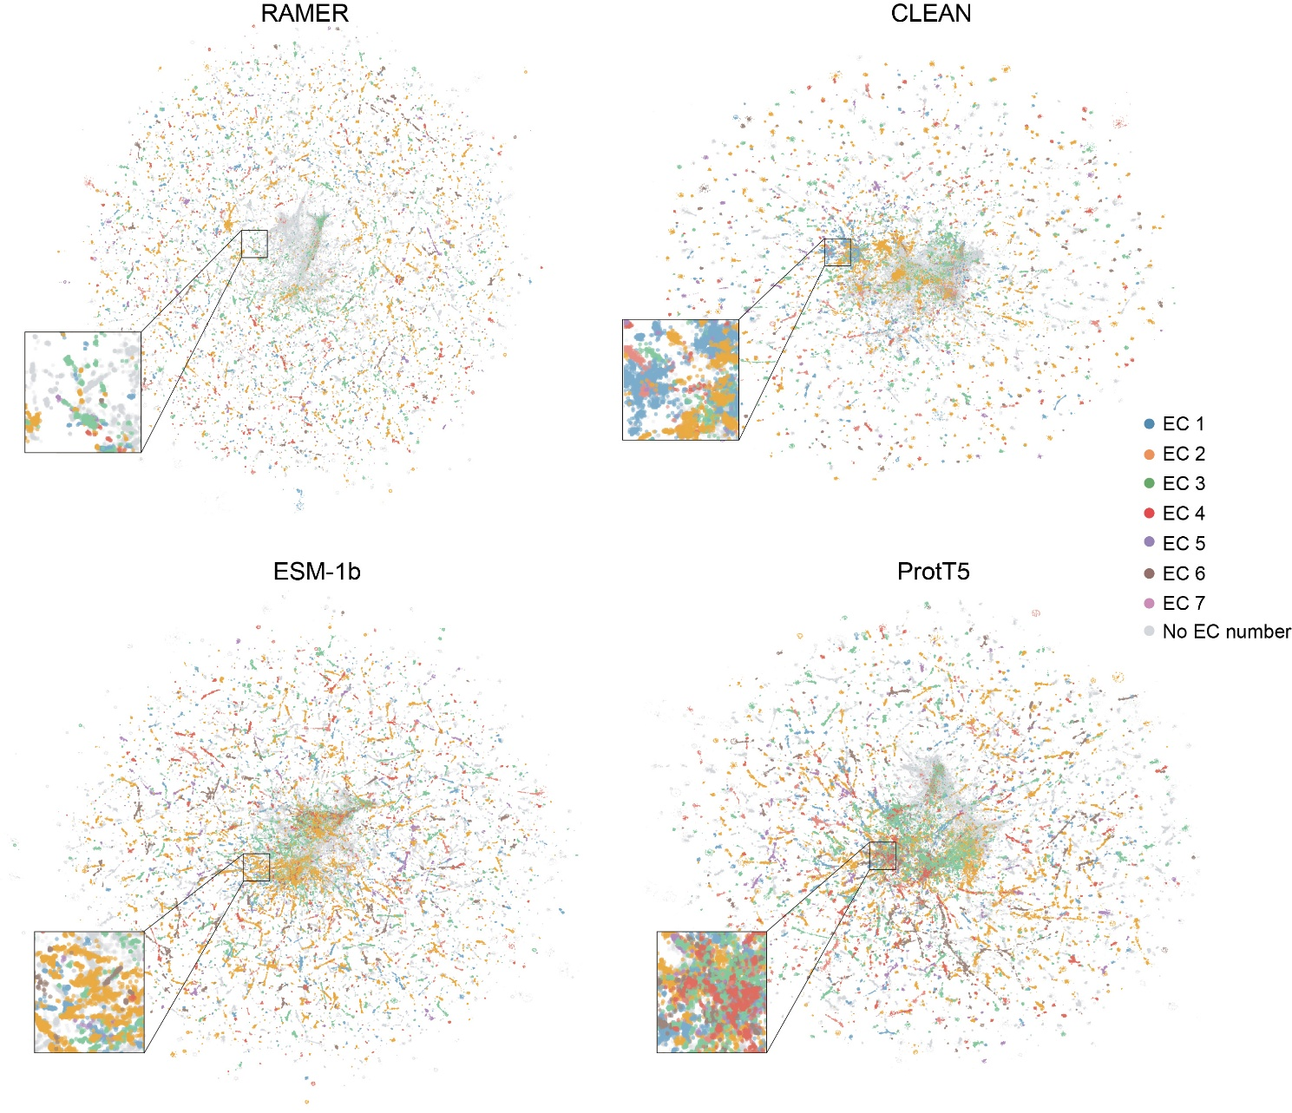
SFig. 3. Visual clustering of enzymatic and non-enzymatic proteins in Swiss-Prot with different protein representation models. Uniform manifold approximation and projection (UMAP) visualizations of Swiss-Prot protein embeddings generated by RAMER, CLEAN, ESM-1b, and ProtT5. Proteins are color-coded by their top-level Enzyme Commission (EC) class (EC 1–7, distinct colored points); proteins with no assigned EC number (non-enzymes) are colored grey. Insets provide magnified views of the central region of each embedding space. Compared with CLEAN, ESM-1b and ProtT5), RAMER exhibits a uniquely superior separation performance: non-enzymatic proteins are highly enriched and tightly clustered at the geometric center of the RAMER UMAP manifold, forming a distinct, concentrated core region clearly demarcated from surrounding enzyme populations. In contrast, all baseline models show substantial intermixing of enzymes and non-enzymes throughout the entire embedding space, with no clear central aggregation or effective discriminative boundary between the two groups.

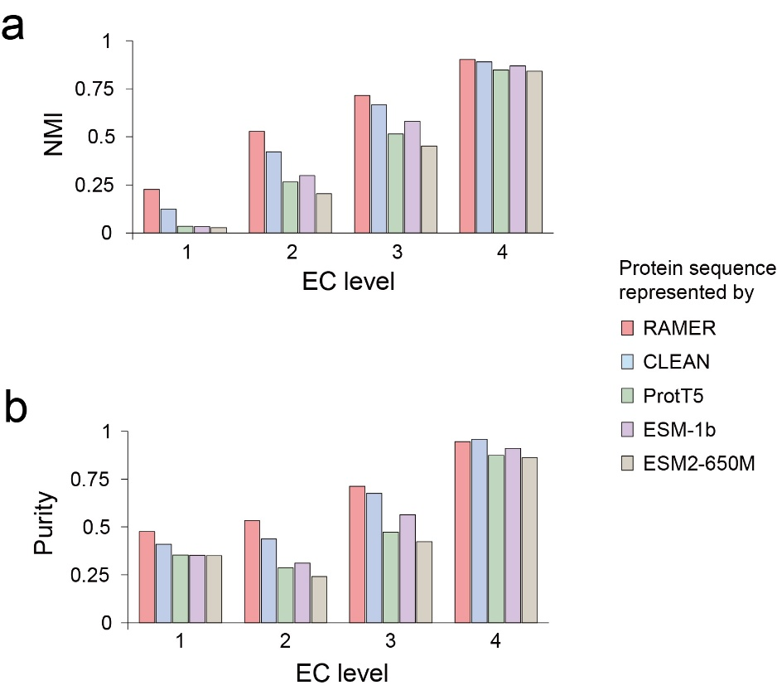
SFig. 4. Clustering performance evaluation of RAMER, ESM, ProtT5, and the embedding modules of CLEAN. Normalized Mutual Information (NMI) (a) and clustering Purity (b) were computed for enzyme annotations from Swiss-Prot, consistent with the setup in Fig. 1c–d.

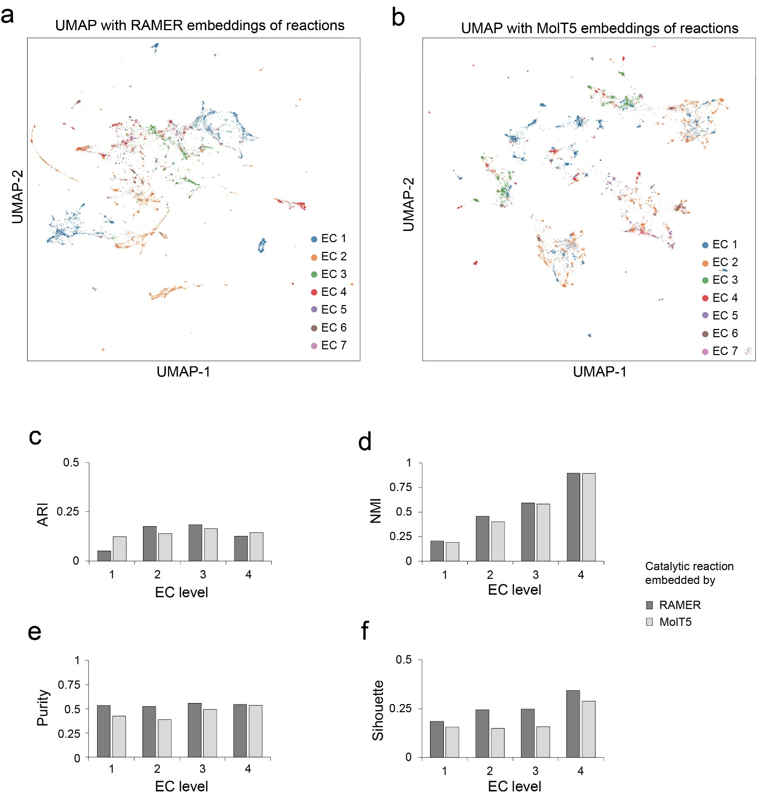
SFig. 5. Embeddings of catalytic reactions with RAMER and MolT5 and clustering performance evaluation. Catalytic reactions are sourced from the Rhea database, as illustrated in SFig. 1b. (a–b) Two-dimensional UMAP projections of catalytic reaction embeddings, colored by top-level Enzyme Commission (EC) functional class, derived from RAMER (a) and MolT5 (b). For the MolT5 baseline, embeddings of reaction substrates and products were concatenated for UMAP projection and clustering metric calculation. (c–f) Clustering performance comparison between RAMER- and MolT5-derived embeddings of reactions across the four EC hierarchical levels. ARI, adjusted rand index; NMI, normalized mutual information. RAMER achieves marginally superior clustering separation compared with MolT5.
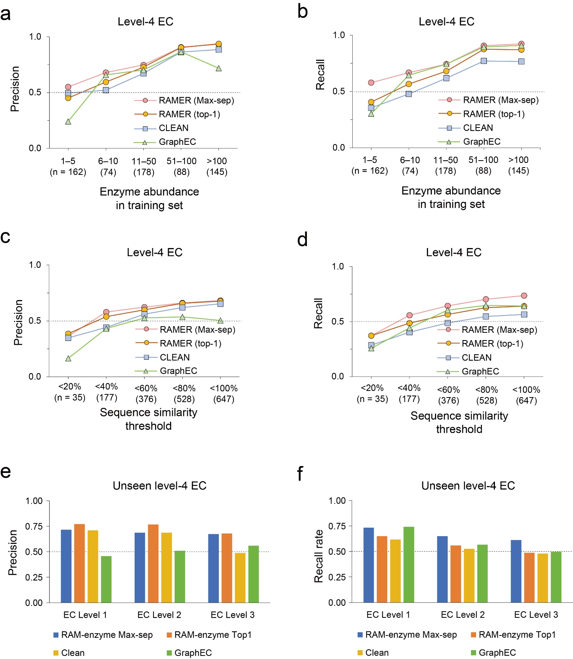
SFig. 6. Prediction performance stratified by training set enzyme abundance and sequence homology. (a–b) Precision and recall for level-4 Enzyme Commission (EC) class prediction, grouped by enzyme abundance bins in the training dataset, corresponding to Fig.1h. (c–d) Precision and recall for leel-4 EC prediction, stratified by sequence similarity threshold relative to training data, corresponding to Fig. 1i. (e–f) Precision and recall on unseen level-4 EC classes in background set, evaluated across EC hierarchical Levels 1–3, corresponding to Fig. 1j.

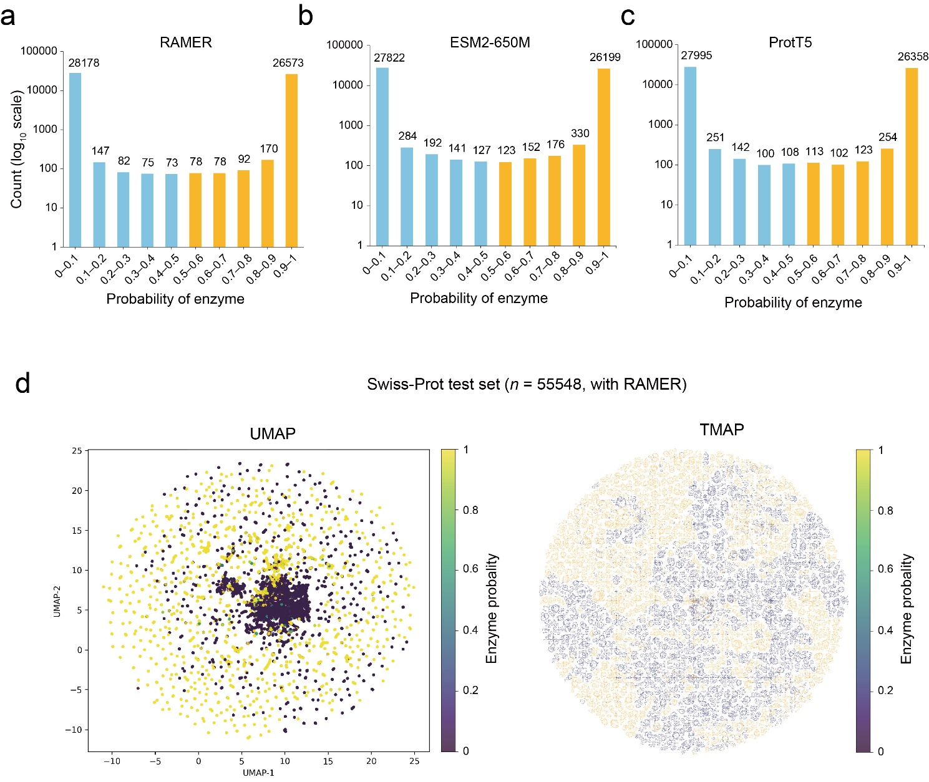
SFig. 7. A enzyme versus non-enzyme binary classifier. An XGBoost classifier was built to distinguish enzymatic and non-enzymatic proteins using annotations from the Swiss-Prot database. The dataset was randomly split, with 90% used for model training and the remaining 10% (n = 55548) reserved as the held-out test set. (a–c) Histograms illustrating sample count distributions across binned predicted enzyme probabilities (range: 0–1), for classifiers trained on embeddings from RAMER (a), ESM2-650M (b), and ProtT5 (c). All three representation methods yield a distinct bimodal probability distribution. Notably, RAMER embeddings result in far fewer proteins falling into the ambiguous intermediate probability range (0.1–0.9), compared to both ESM2-650M and ProtT5 baselines. (d) Two-dimensional dimensionality reduction projections of RAMER embeddings on the held-out Swiss-Prot test set. Points are colored by RAMER-derived predicted enzyme probability, visualized via UMAP (left) and Tree-based Map (TMAP, right). In the UMAP space, high-probability enzymes form a distinct, centrally enriched cluster; the TMAP visualization further demonstrates clear global separation between enzymatic and non-enzymatic protein manifolds.

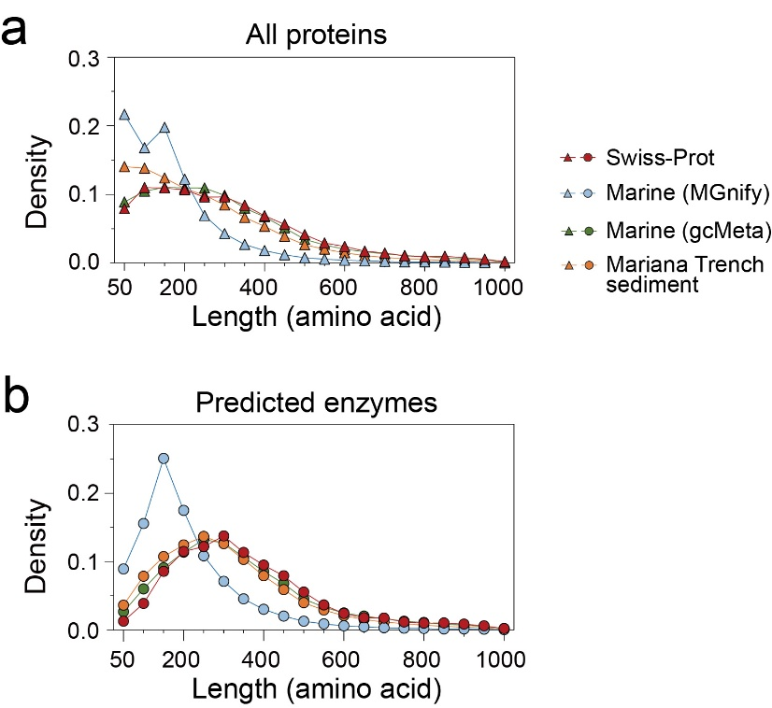
SFig. 8. Distribution of protein and enzyme sizes across datasets. (a) Protein length density distributions for proteins, compared across four sources: Swiss-Prot protein dataset, marine microbial proteins from MGnify database, marine proteins from gcMeta database, and proteins sourced from Mariana Trench sediment metagenomes. (b) The predicted enzymes by the enzyme classifier (SFig. 7). The proteins from MGnify exhibit a pronounced enrichment of shorter protein sequences than the other dataset.
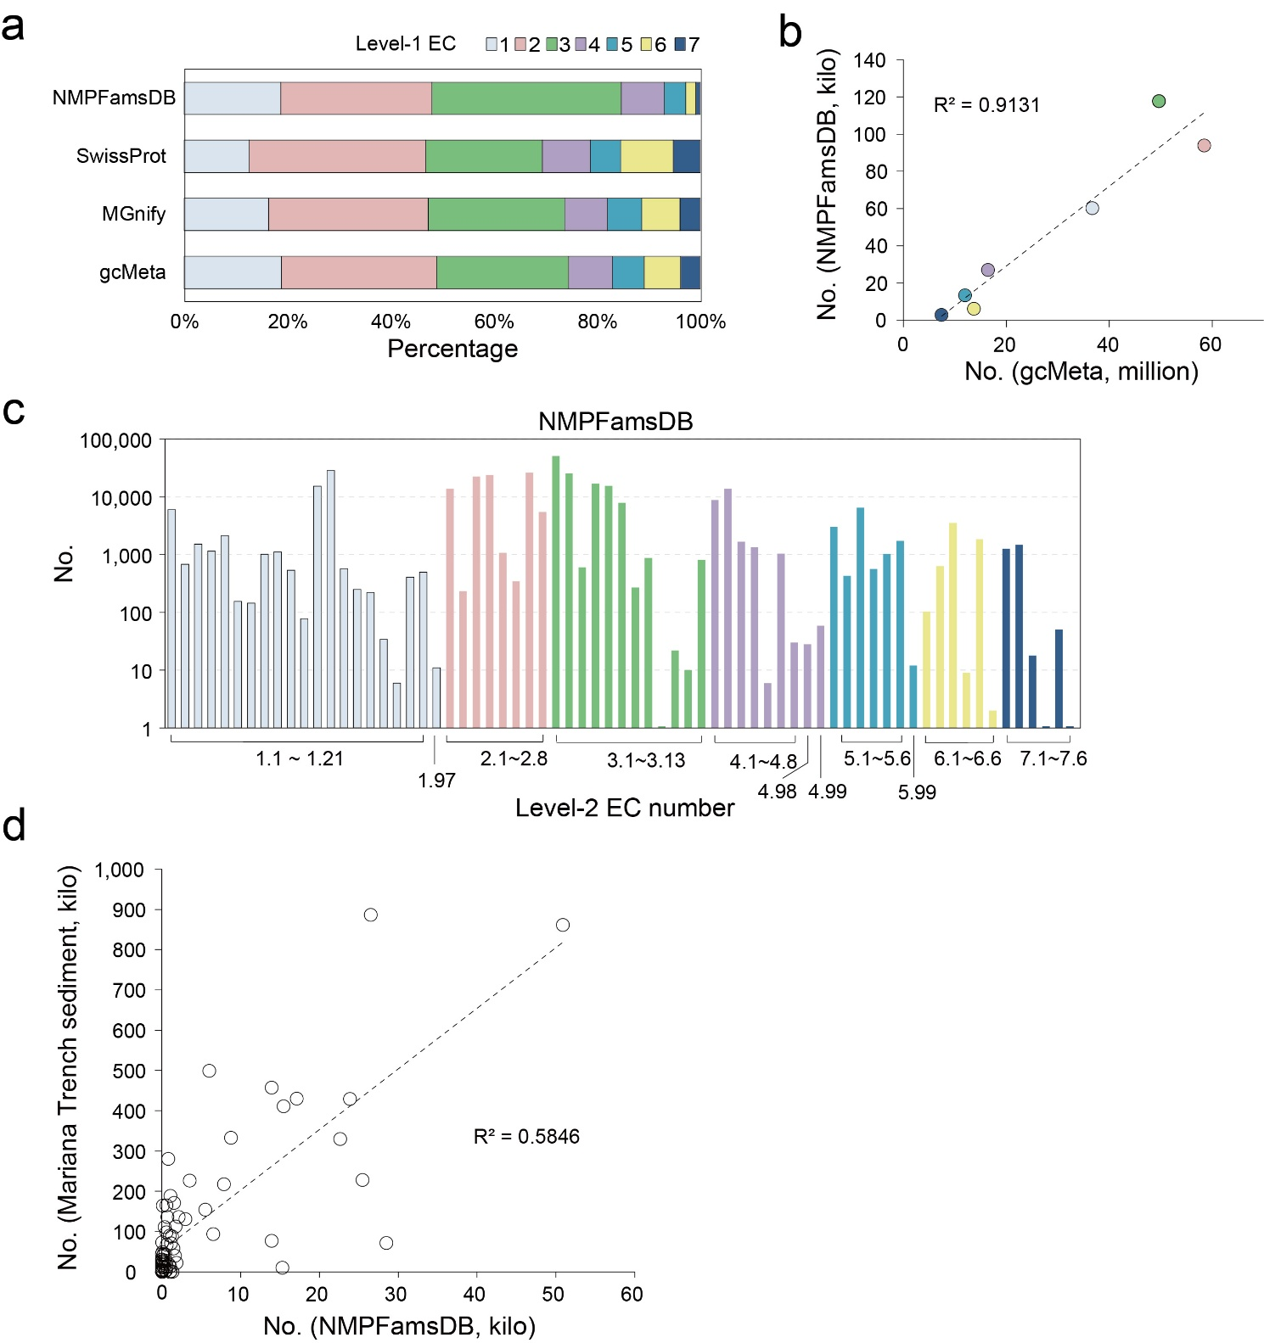
SFig. 9. EC class distribution of bacterial unclassified ‘dark matter’ proteins from NMPFamsDB. NMPFamsDB is a large-scale curated database of novel, undercharacterised, and metagenome-derived protein families, enabling global exploration of uncharted microbial enzyme functional space⁵. Enzymes were extracted from NMPFamsDB using the enzyme classifier (SFig. 7). (a) Stacked bar chart of relative proportion of major Enzyme Commission (EC) classes across NMPFamsDB, Swiss-Prot, MGnify, and gcMeta datasets. (b) The level-1 EC profiles between NMPFamsDB and gcMeta are correlated, with linear regression R² indicated. (c) enzyme abundance profile across all Level-2 EC functional categories within NMPFamsDB. (d) Correlation analysis of level-2 EC enzyme profiles between NMPFamsDB and predicted enzymes from Mariana Trench sediment metagenomes.

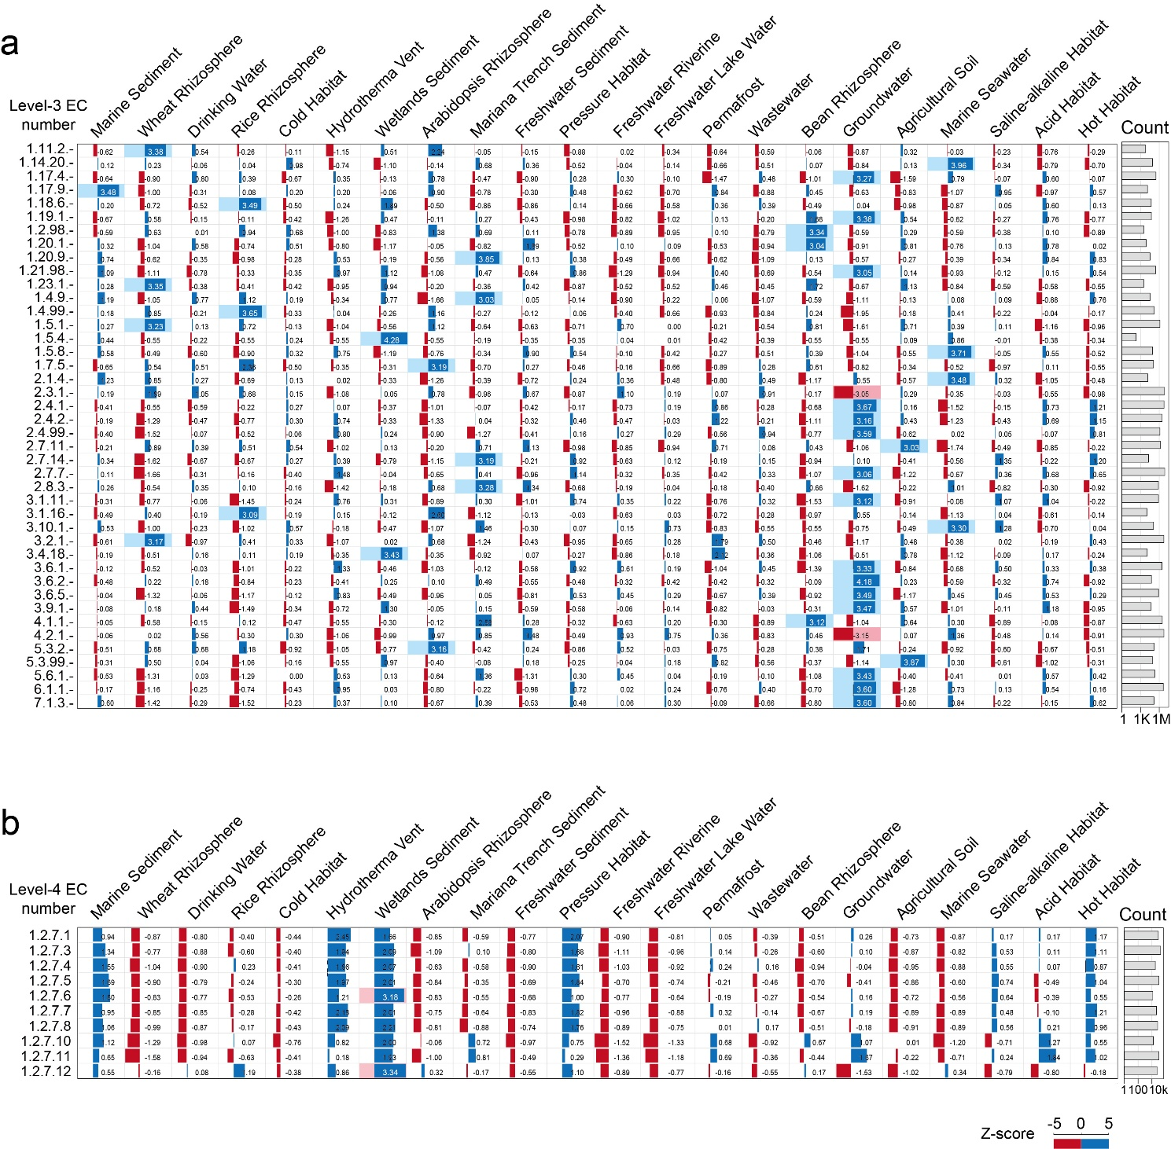
SFig. 10. Over- and under-represented EC enzyme classes associated with distinct environmental microbiomes. The Z-score scale denotes relative deviation in enzyme abundance. Blue, over-representation; red, under-representation. Representative level-3 (a) and level-4 (b) EC classes with over- and/or under-represented enzymes in certain environments are shown. Enzyme counts for each listed EC class are provided in the rightmost column.

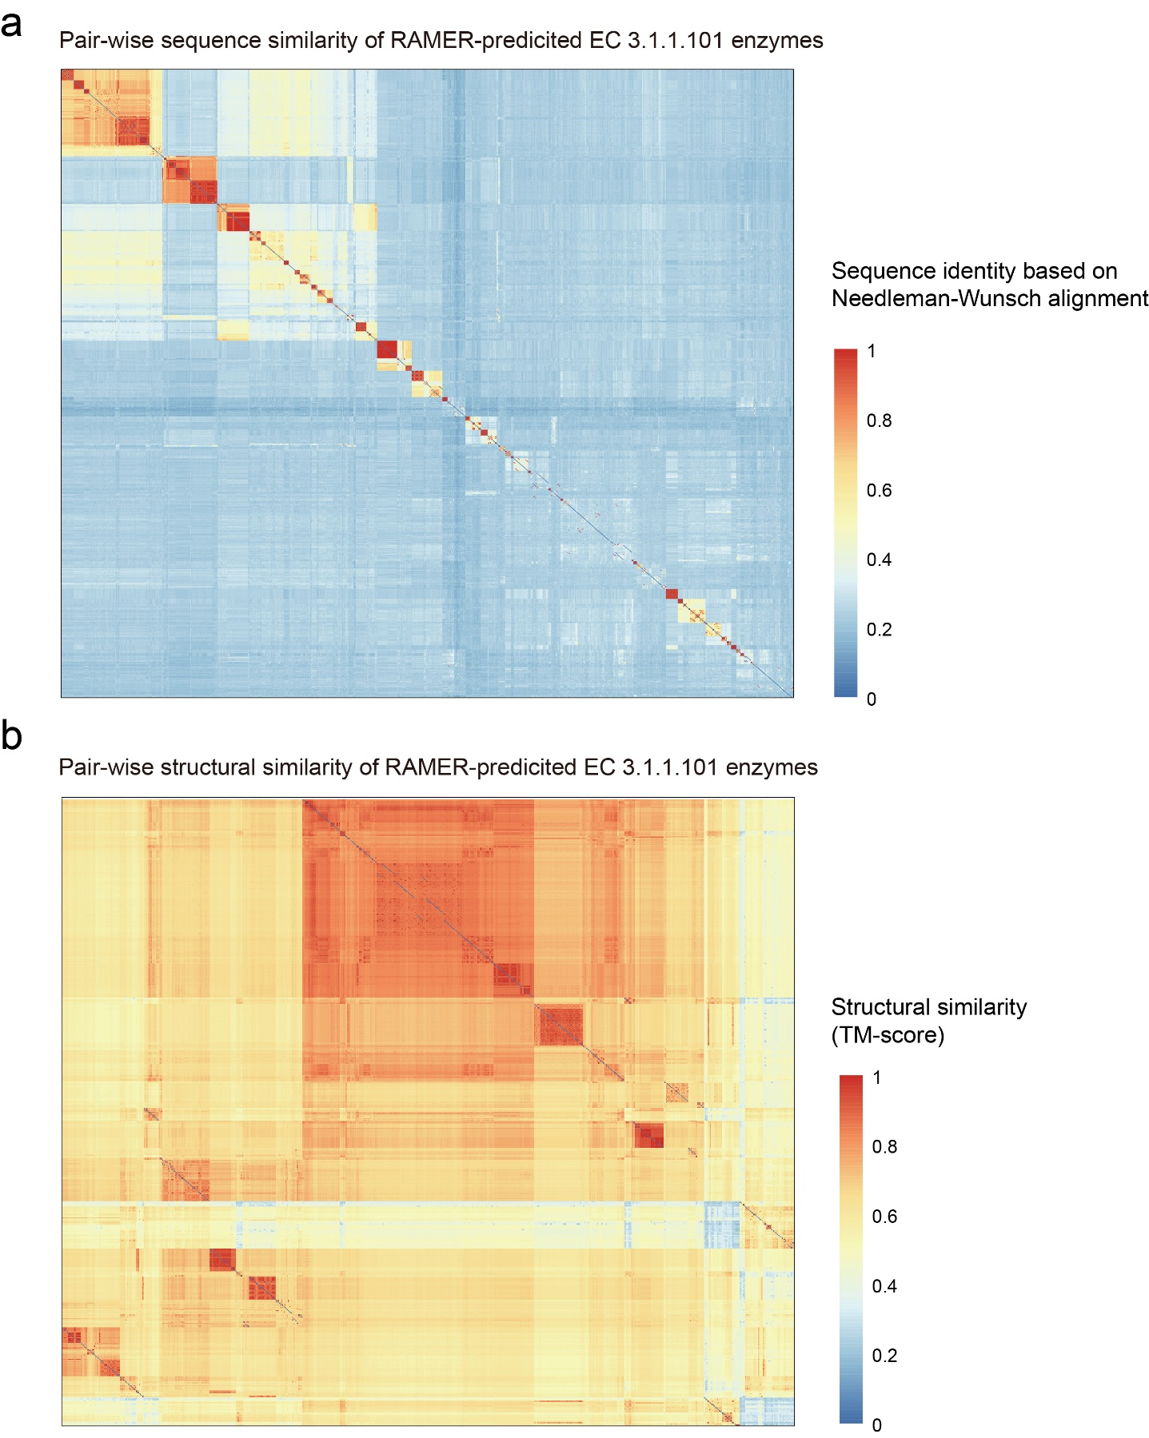
SFig. 11. Sequence and structural similarities of the known and predicted PETases, corresponding to Fig. 3a right panel. (a) All-to-all pairwise heatmap of global sequence identity, calculated via Needleman–Wunsch (NW) alignment. (b) Matching pairwise heatmap of structural similarity for the same enzyme set, quantified by Template Modelling score (TM-score). While overall sequence identity across the enzyme atlas remains relatively low, these proteins exhibit structural similarity. This suggests that RAMER can identify conserved structural architectures among large sequence datasets, despite extensive underlying sequence divergence.
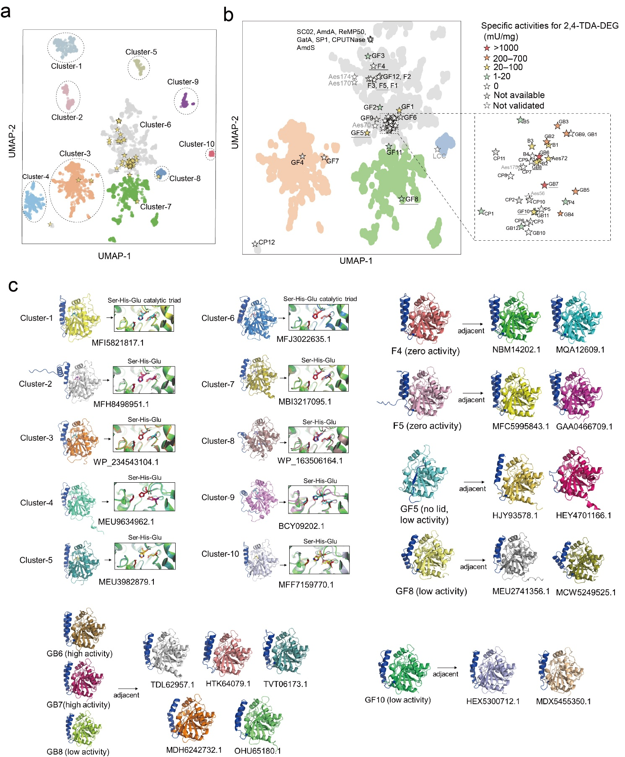
SFig. 12. Mining of candidate PUases, corresponding to Fig. 3h. (a) UMAP of mined candiated PUases with RAMER embeddings. Ten visual clusters (Cluster 1–10) are manually annotated and outlined. (b) Magnified view of the central region from a, highlighting the positions of experimentally characterized variants, marked by star symbols colored according to their measured specific activity towards 2,4-TDA-DEG substrate. (c) Representative predicted protein structures extracted from each Cluster 1–10, with the conserved Ser-His-Glu catalytic triad highlighted for each group. Additional structures of experimentally validated homologs are shown adjacent; lid domains in all structures are highlighted in dark blue. Structures are grouped by relative activity level (high, low, or zero measured activity) and local structural adjacency.

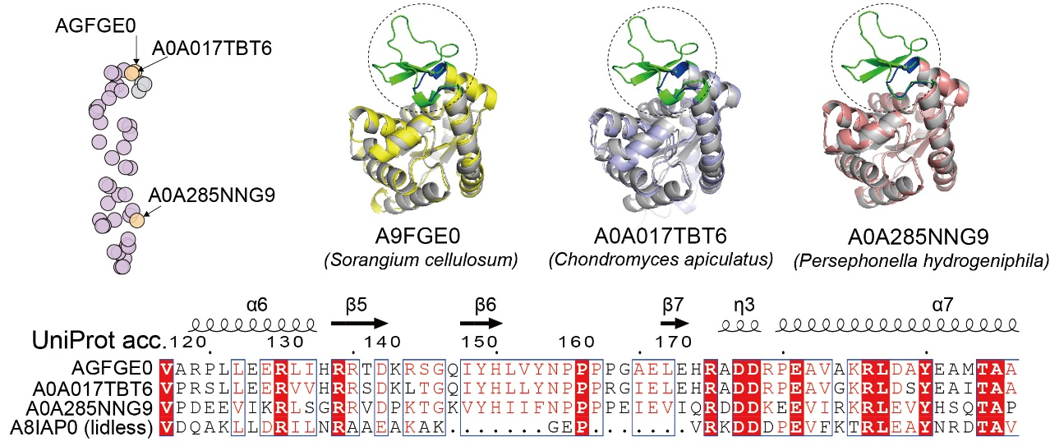
SFig. 13. Structural and sequence analysis of previously misannotated adenylate kinase (ADK) homologs. Three ADK homologs, previously incorrectly annotated as lidless variants in ref.⁸ (highlighted in the RAMER-generated cluster), are characterized here, corresponding to Fig. 3i. Protein structure prediction using AlphaFold3 and multiple sequence alignment confirm that the three ADKs possess a H-bond lid domain.

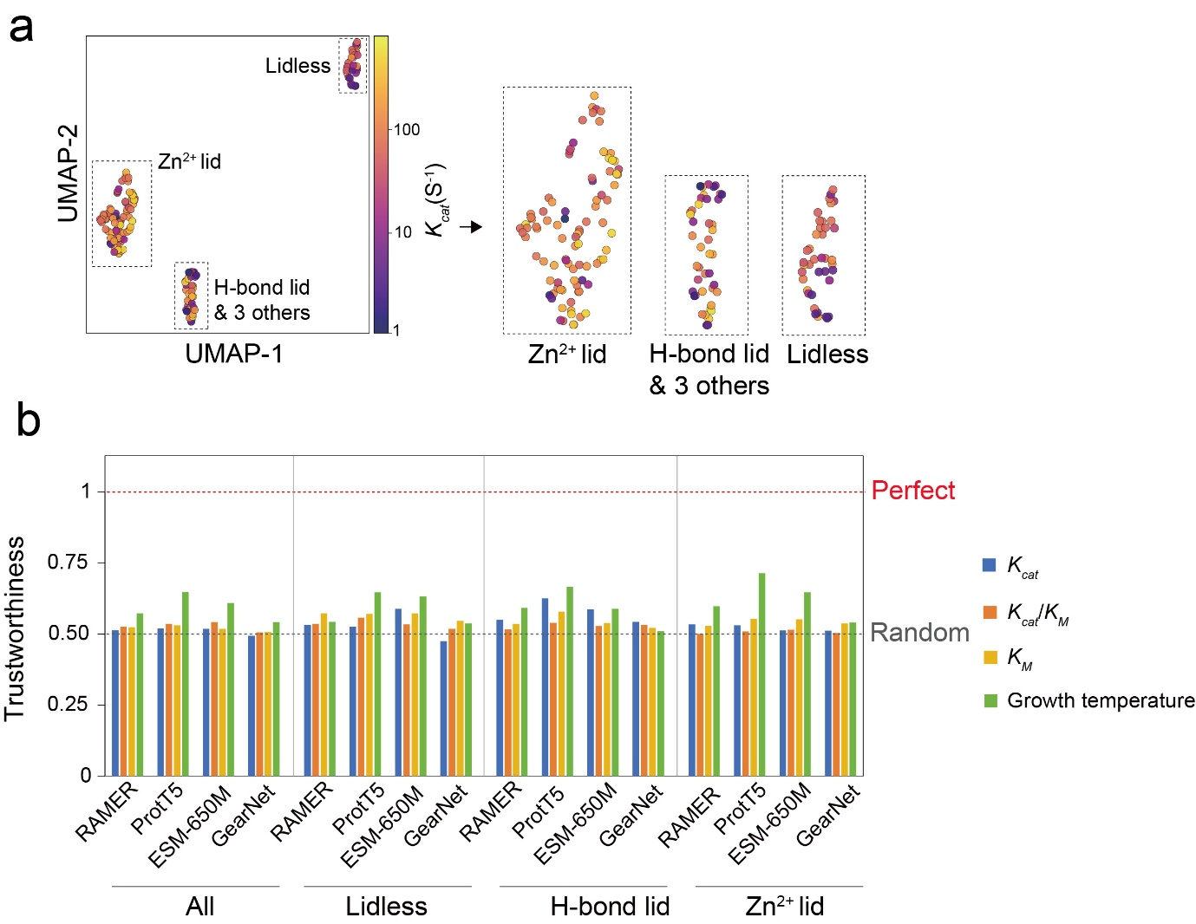
SFig. 14. RAMER-derived prediction of catalytic activity and growth temperature of adenylate kinase (ADK) enzymes. (a) UMAP visualization of RAMER embeddings for ADKs, colored by experimentally validated catalytic turnover constant (K_{cat}) from ref.⁸. The right panels show magnified views of the three distinct ADK lid subtype clusters. (b) Benchmark comparison of functional activity prediction performance for ADKs. All models were trained and evaluated using the dataset and methodology reported in ref.⁸. RAMER exhibits no performance advantage over other baseline benchmark models in predicting enzyme catalytic activity and optimal growth temperature.

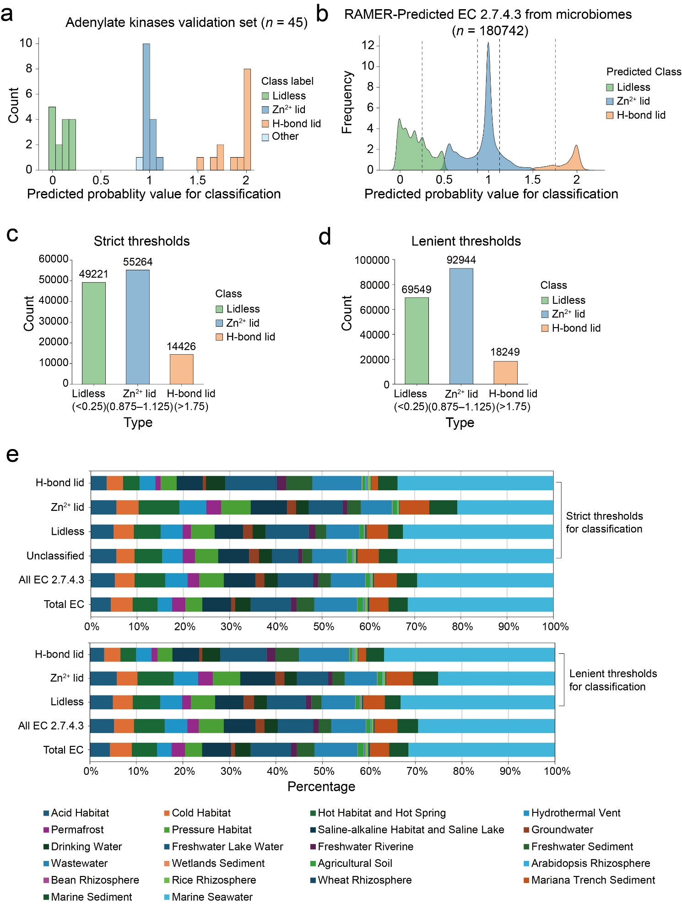
SFig. 15. Adenylate kinase (ADK) subtype classifier and distribution across environmental microbiomes. An XGBoost ADK subtype three-class classifier was built on the set of 175 ADK sequences validated in ref.⁸ (listed in SFile 6). Of these, 130 sequences were used for model training, and the remaining 45 sequences were reserved as the held-out test set. (a) Classification probability distribution for the 45-sample ADK test set. (b) Predicted subtype probability distribution for all RAMER-annotated EC 2.7.4.3 ADK enzymes mined from 25 distinct gcMeta and Mariana Trench environmental metagenomes in the enzyme atlas. (c–d) Subtype abundance counts classified under strict thresholds (c) and lenient thresholds (d). Under the strict threshold regime, ambiguous intermediate predictions are assigned to unclassified and excluded from subtype assignment. (e) Distribution of the three ADK lid subtypes across environments, corresponding to results in Figure 3k. Top: composition under strict classification thresholds, including comparisons of unclassified sequences assigned EC 2.7.4.3, overall EC 2.7.4.3 ADKs, and that of all ECs. Bottom: distributions obtained using lenient classification thresholds. The distribution patterns are qualitatively consistent between the two thresholds.
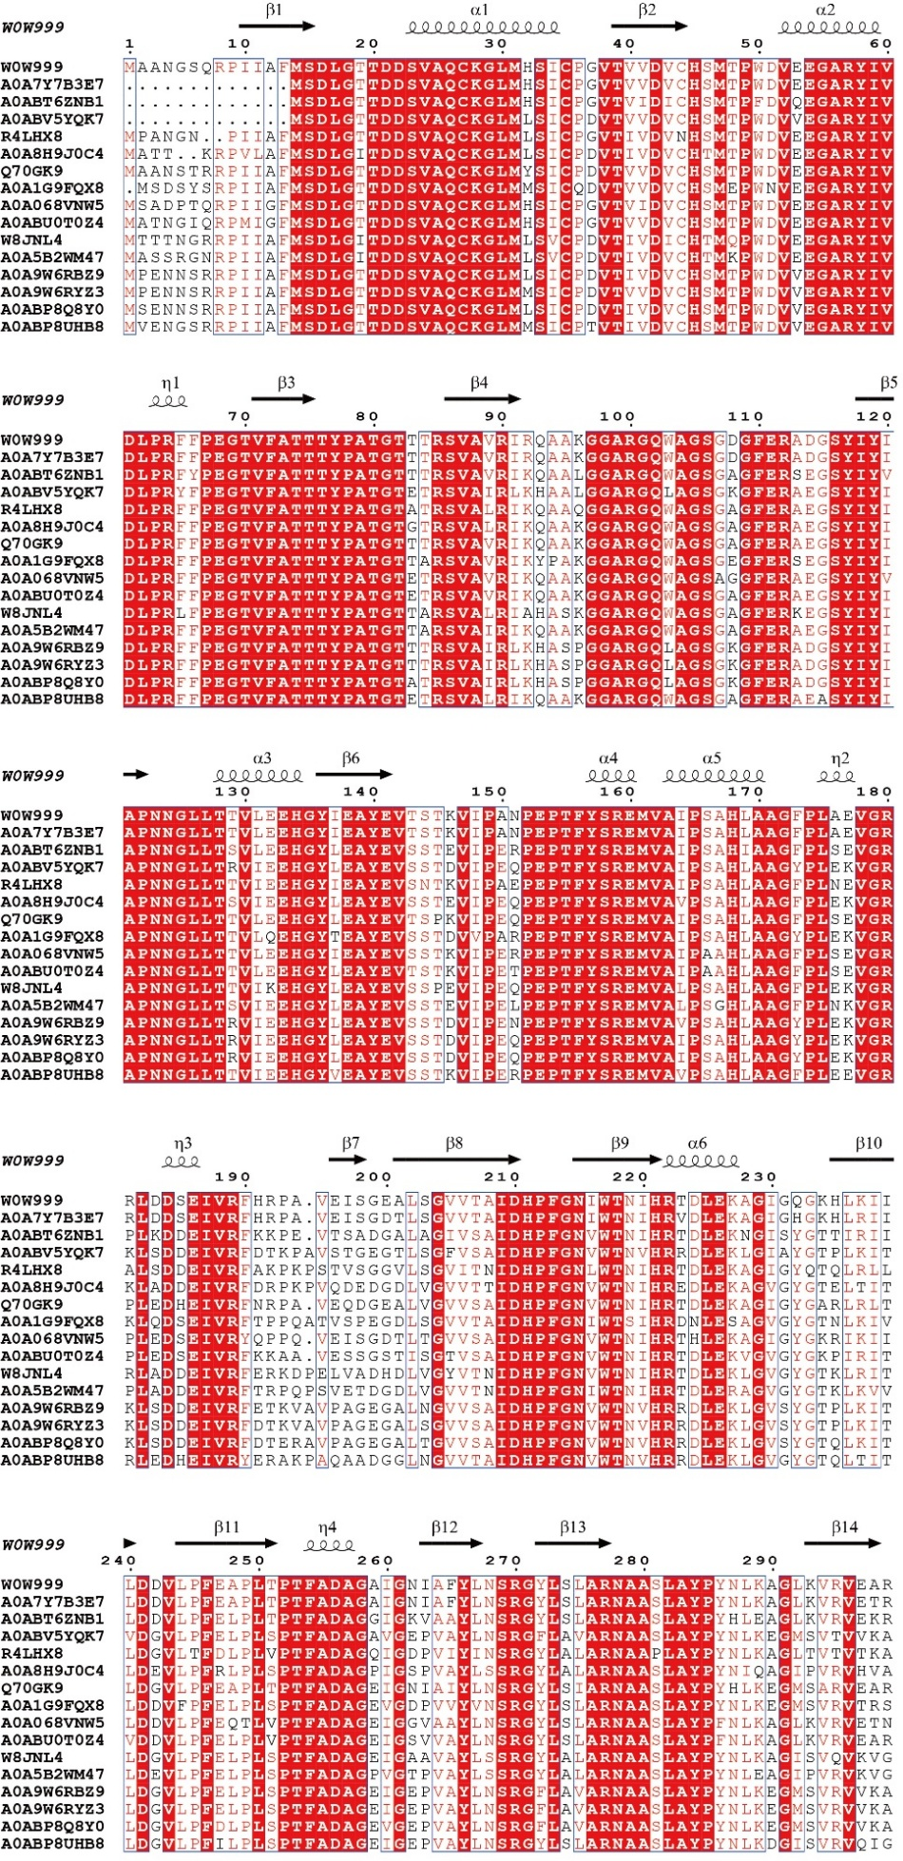
SFig. 16. Alignment of mined fluorinases and known fluorinases. Secondary structure elements of the canonical fluorinase fold are annotated above the reference sequence (UniProt accession, W0W999).
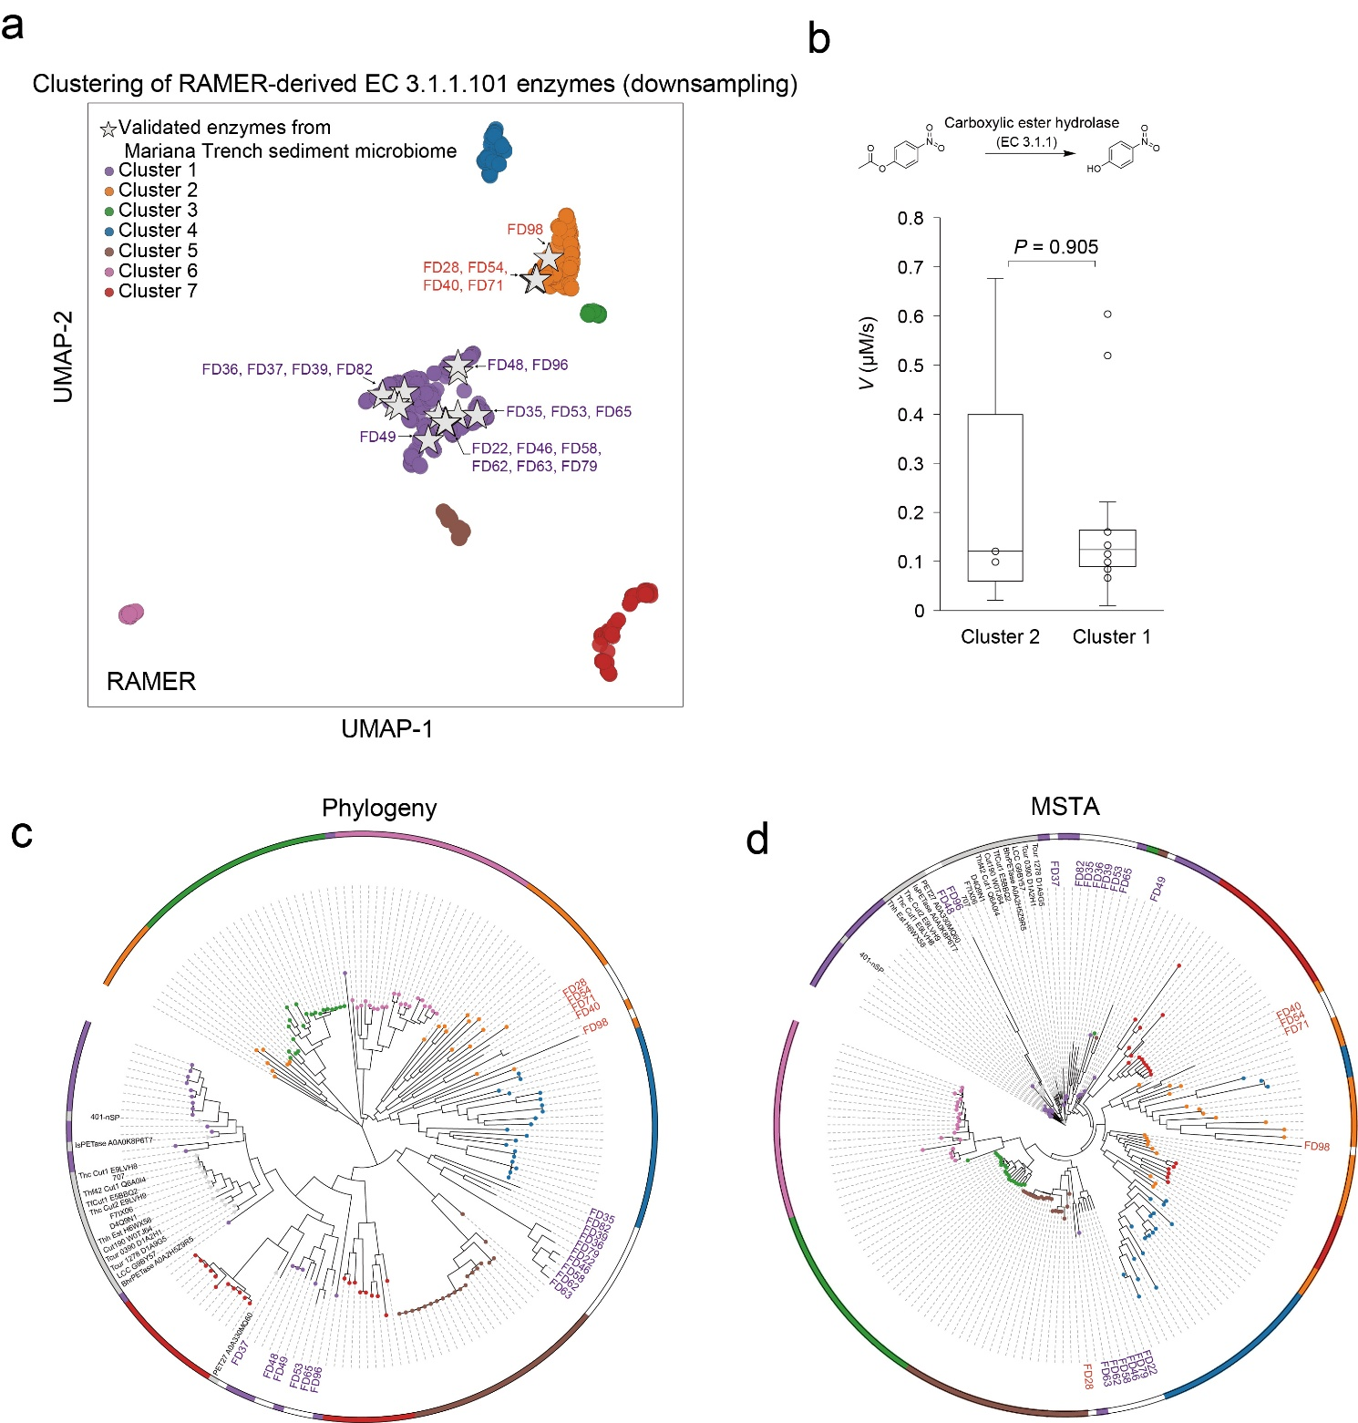
SFig. 17. RAMER-based clustering, phylogeny and structural analysis of experimentally validated PETase candidates, corresponding to Fig. 4e-f. (a) PETase candidates for validation (STab. 5) recovered from Mariana Trench sediment metagenomes are organized with enzymes assigned to EC 3.1.1.101 (SFile 5) in Fig. 3a right panel. The cluster definition is as Fig. 3a right panel. (b) Box-plot of measured carboxylic ester hydrolase activity for enzymes from Cluster 1 and Cluster 2. No statistically significant difference in catalytic activity was observed between the two clusters (two-side Wilcoxon rank sum test, P = 0.905). (c) Phylogenetic tree constructed from representative candidate sequences selected from the UMAP clusters. (d) Multiple structural analysis (MSTA) based on AlphaFold3-predicted protein structures of the same set of representative PETase homologs.

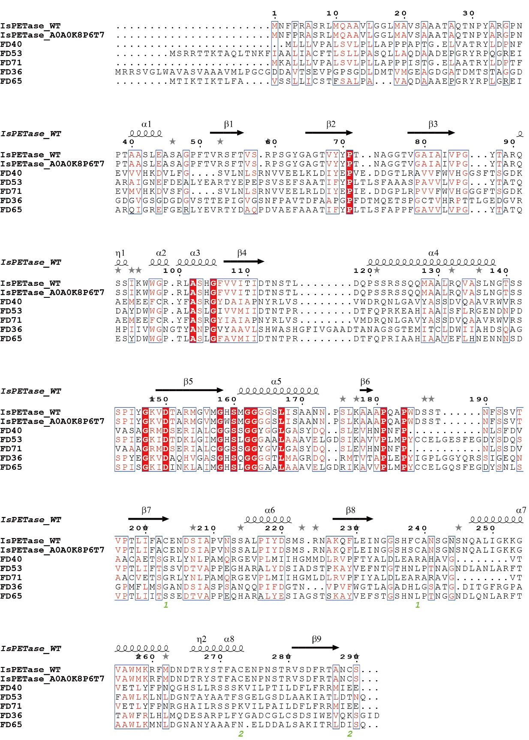
SFig. 18. Alignment of mined PETases in Marina Trench sediment microbiome and IsPETase. Secondary structure elements of the canonical fluorinase fold are annotated above the wild-type IsPETase.

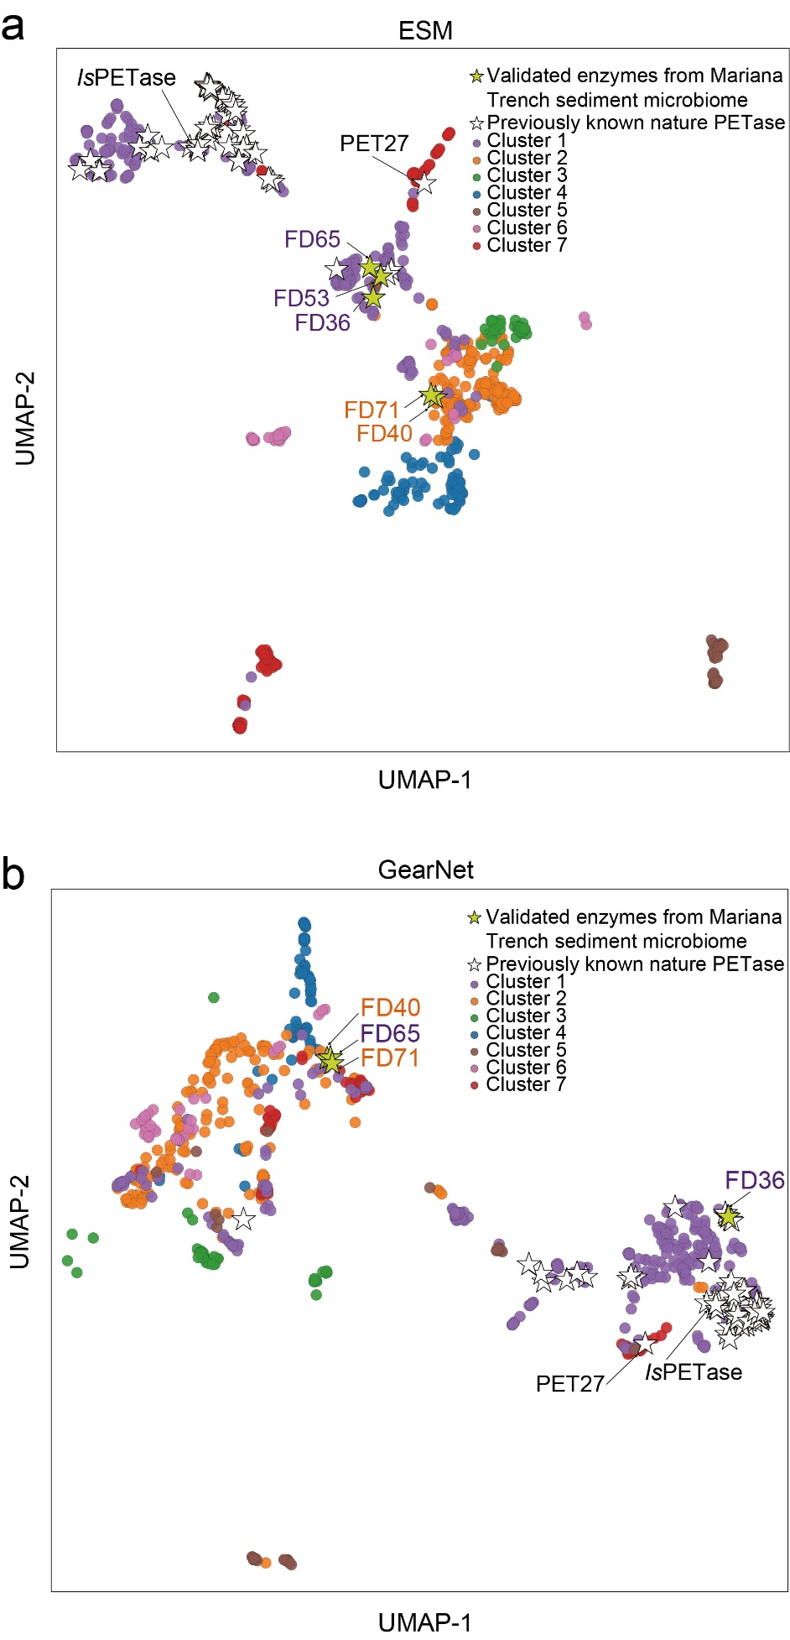
SFig. 19. ESM- and GearNet-based clustering of PETases mined in Marina Trench sediment microbiome. Newly discovered Mariana Trench-derived PETases are clustered alongside the RAMER predicted PETases and previously reported canonical PETase reference sequences (listed in SFile. 6).
References
1. Yu, T. et al. Enzyme function prediction using contrastive learning. Science 379, 1358–1363 (2023).
2. Xiao, X. et al. Microbial ecosystems and ecological driving forces in the deepest ocean sediments. Cell 188, 1363-1377.e9 (2025).
3. Sun, Y. et al. gcMeta 2025: a global repository of metagenome-assembled genomes enabling cross-ecosystem microbial discovery and function research. Nucleic Acids Res. 54, D724–D733 (2025).
4. Richardson, L. et al. MGnify: the microbiome sequence data analysis resource in 2023. Nucleic Acids Res. 51, D753–D759 (2023).
5. Baltoumas, F. A. et al. NMPFamsDB: a database of novel protein families from microbial metagenomes and metatranscriptomes. Nucleic Acids Res. 52, D502–D512 (2024).
6. Chen, J. et al. Global marine microbial diversity and its potential in bioprospecting. Nature 633, 371–379 (2024).
7. Wang, Z. et al. Robust enzyme discovery and engineering with deep learning using CataPro. Nat. Commun. 16, 2736 (2025).
8. Muir, D. F. et al. Evolutionary-scale enzymology enables exploration of a rugged catalytic landscape. Science 388, eadu1058 (2025).

