Supplementary file 1

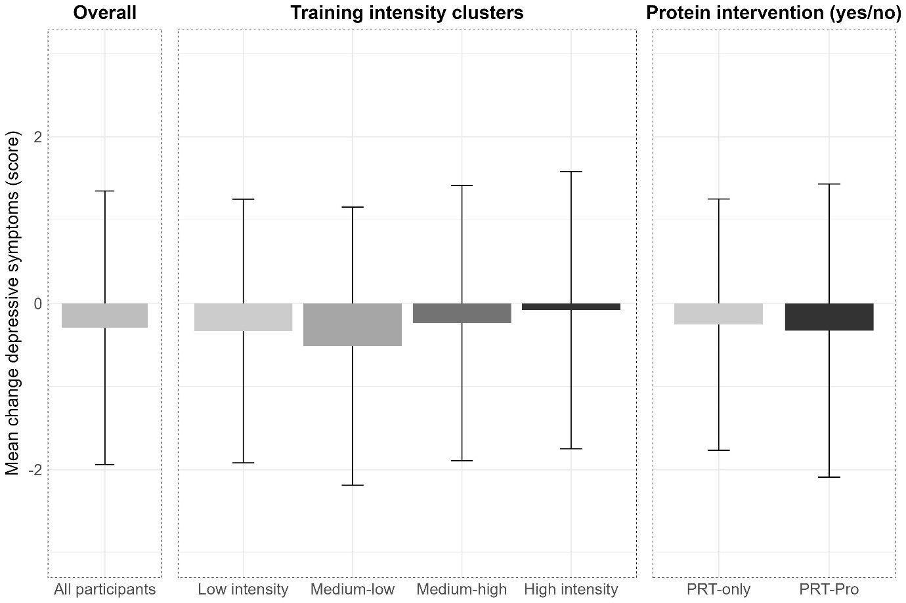
Figure S1. Mean change of observed values between baseline and follow-up with standard deviation of depressive symptoms measured with the Geriatric Depression Scale 15-items for all participants, stratified by training intensity, and stratified by protein intervention (yes/no). * indicates a significant within-group effect.
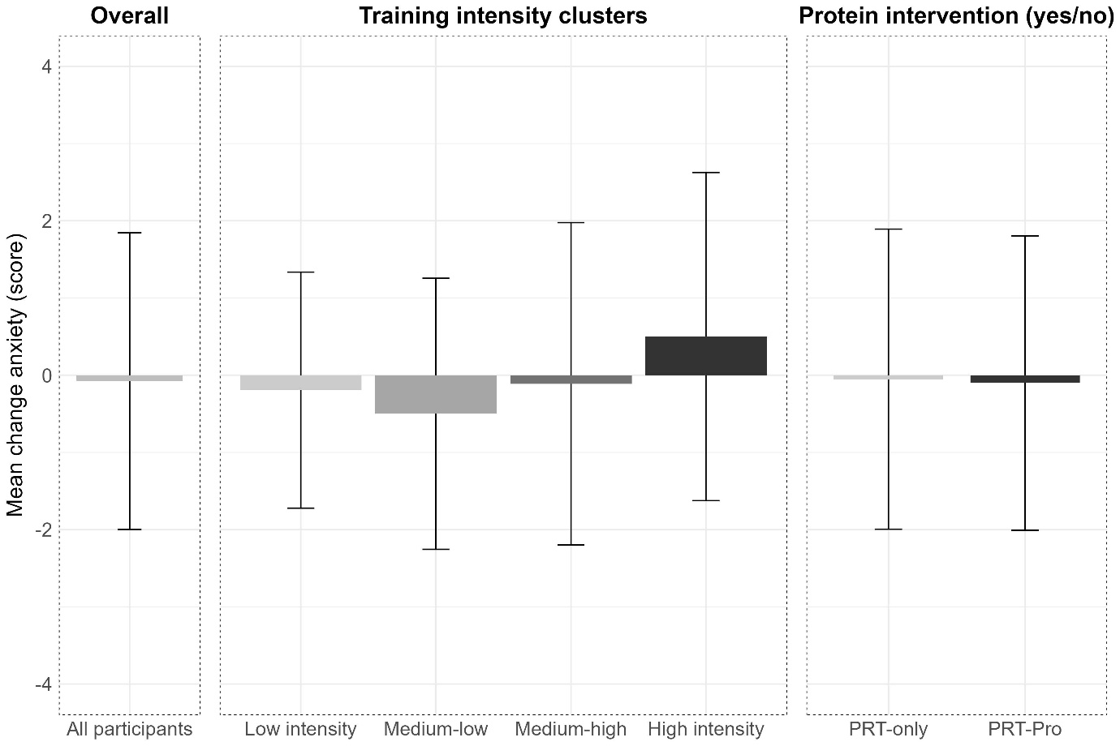
Figure S2. Mean change of observed values between baseline and follow-up with standard deviation of anxiety measured with the State-Trait Anxiety Inventory 6-items for all participants, stratified by training intensity, and stratified by protein intervention (yes/no). Only a * indicates a significant within-group effect and a * with bar means a significant between-group effect.
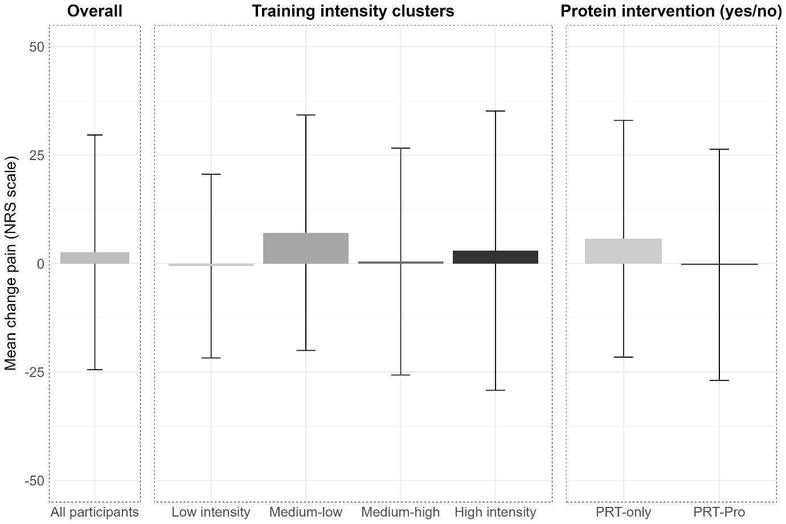
Figure S3. Mean change of observed values between baseline and follow-up with standard deviation of pain measured with the Numeric Rating Scale for all participants, stratified by training intensity, and stratified by protein intervention (yes/no).

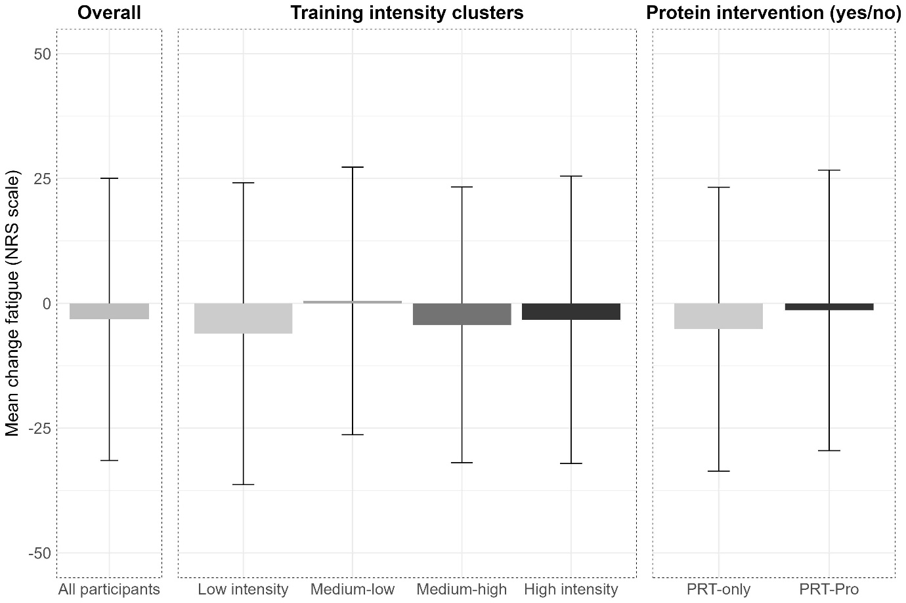
Figure S4. Mean change of observed values between baseline and follow-up with standard deviation of fatigue measured with the Numeric Rating Scale for all participants, stratified by training intensity, and stratified by protein intervention (yes/no).

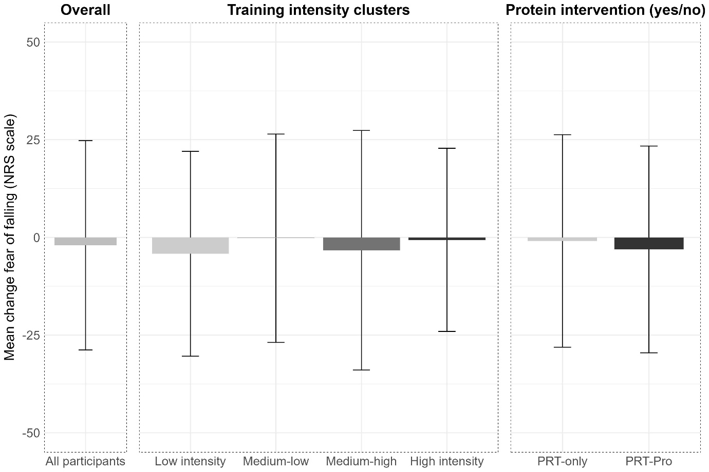
Figure S5. Mean change of observed values between baseline and follow-up with standard deviation of fear of falling measured with the Numeric Rating Scale for all participants, stratified by training intensity, and stratified by protein intervention (yes/no). Only a * indicates a significant within-group effect and a * with bar means a significant between-group effect.

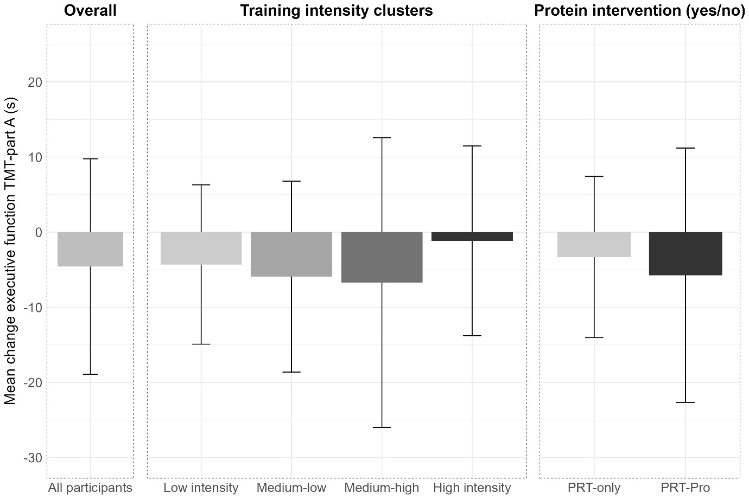
Figure S6. Mean change of observed values between baseline and follow-up with standard deviation of executive function measured with the Trail Making Test-part A for all participants, stratified by training intensity, and stratified by protein intervention (yes/no). * indicates a significant within-group effect.

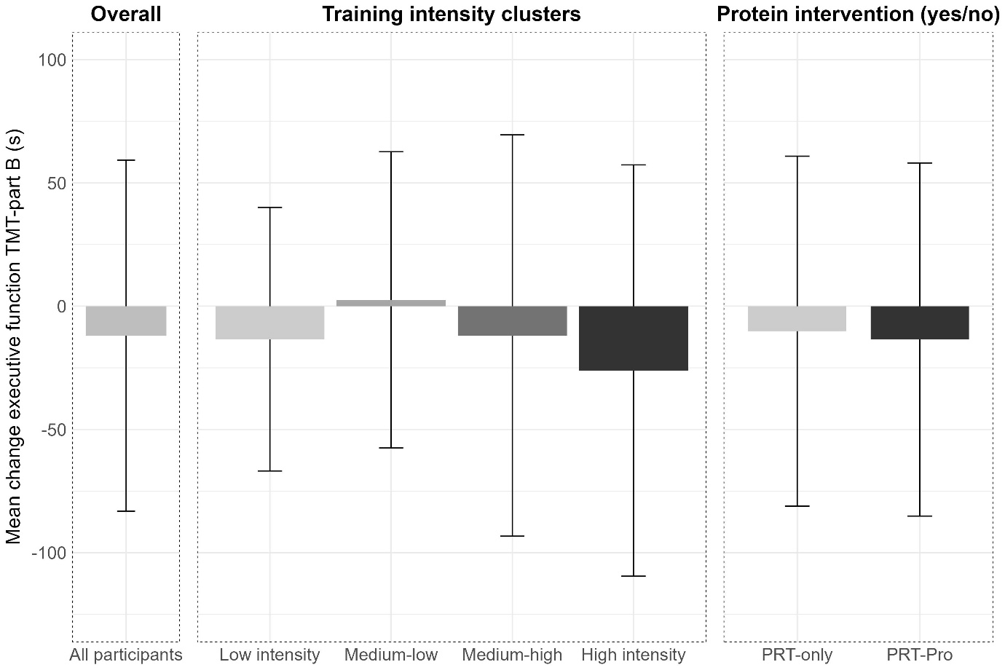
Figure S7. Mean change of observed values between baseline and follow-up with standard deviation of executive function measured with the Trail Making Test-part B for all participants, stratified by training intensity, and stratified by protein intervention (yes/no). * indicates a significant within-group effect.

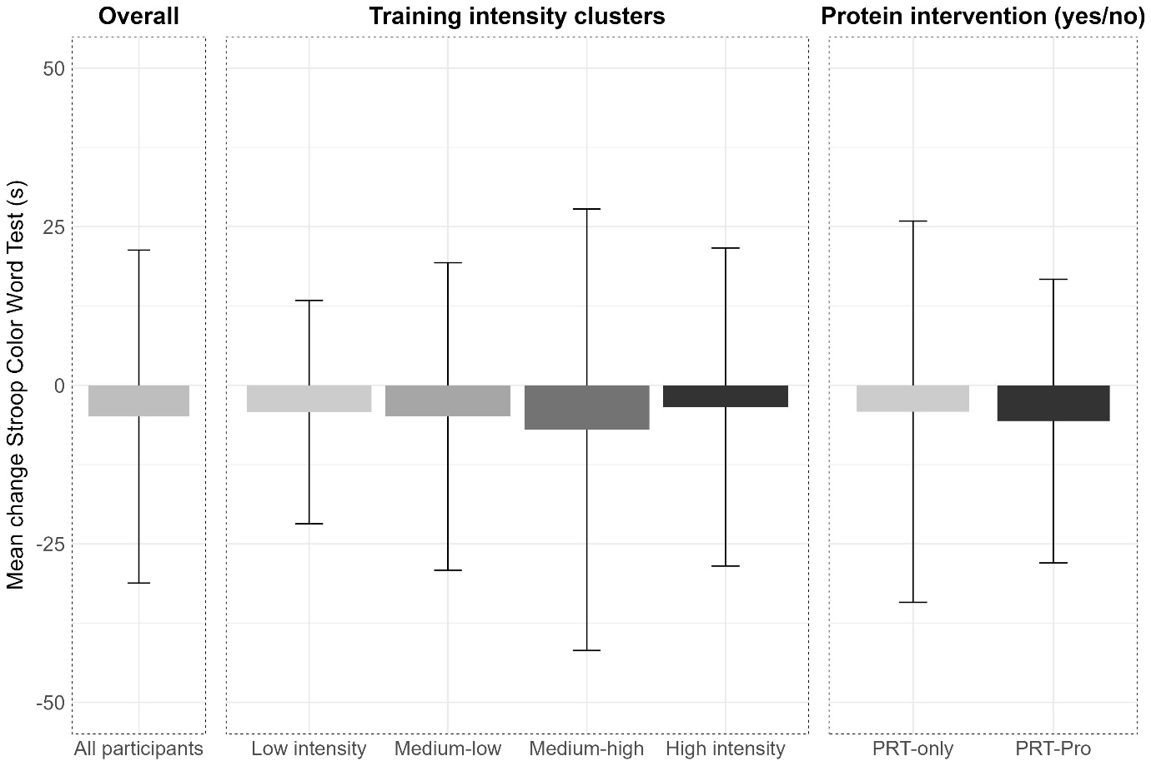
Figure S8. Mean change of observed values between baseline and follow-up with standard deviation of executive function measured with the Stroop Color Word Test for all participants, stratified by training intensity, and stratified by protein intervention (yes/no). * indicates a significant within-group effect.

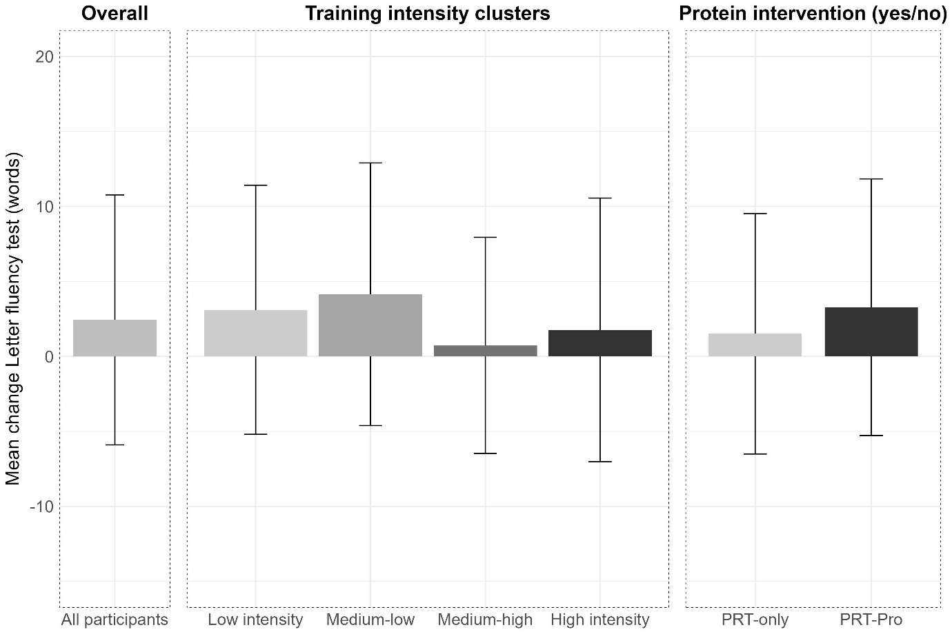
Figure S9. Mean change of observed values between baseline and follow-up with standard deviation of executive function measured with the Letter fluency test for all participants, stratified by training intensity, and stratified by protein intervention (yes/no). Only a * indicates a significant within-group effect and a * with bar means a significant between-group effect.
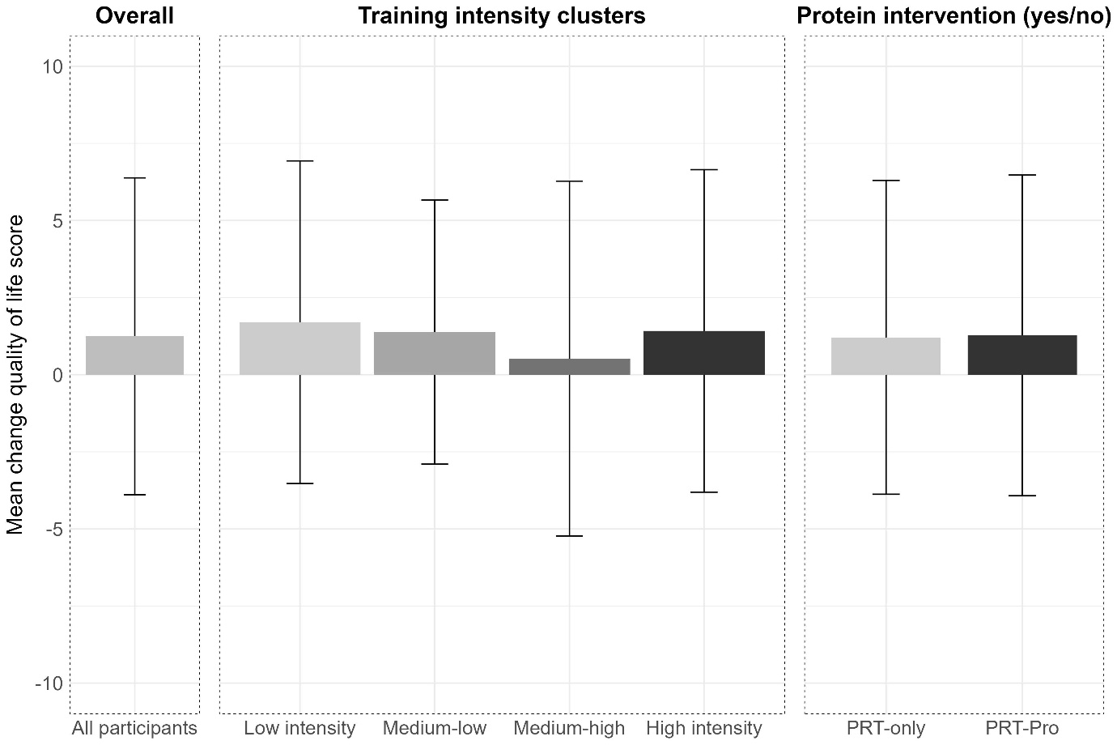
Figure S10. Mean change of observed values between baseline and follow-up with standard deviation in quality of life score for all participants, stratified by training intensity, and stratified by protein intervention (yes/no). * indicates a significant within-group effect.

