Long-read genome sequencing resolves a complex structural variant involving TBCD and exposes a gap in existing variant classification frameworks
Supplementary information
Supplementary methods
Exome sequencing
A buccal sample was taken at 3 weeks of age and DNA was extracted using standard techniques, and exome sequencing was performed at a CLIA-accredited diagnostic laboratory in North America. Hybridisation-based capture and sequencing with Illumina technology was performed. Targeted regions were sequenced at ~50x coverage or above. Sequence analysis and deletion/duplication testing was performed on 865 genes, based on in-house leukodystrophy, leukoencephalopathy and neurodevelopmental disorders panels (available on request). Analysis focused on coding regions ±20bp and custom regions for specific genes where clinically relevant variants are known to reside outside such regions.
HiFi genome sequencing
The individual was recruited to our translational genomics research programme (IRB #986876) at 5 months of age. DNA was extracted from whole blood using a high molecular weight protocol (PacBio Nanobind PanDNA Kit). HiFi genome sequencing was performed using the Revio instrument (PacBio). Seeking to resolve more precisely the structure of this chromosomal gain, our analysis used the HiFi-human-WGS-WDL pipeline (https://github.com/PacificBiosciences/HiFi-human-WGS-WDL), where read-alignments are assigned into phase groups with HiPhase. We obtained mean coverage of >30x with a mean HiFi read length of 8189bp (N50 = 7798bp).

Genetic testing results
The diagnostic report issued to the patient noted two pathogenic (P) variants; the known familial NM_016042.4:c.238G>T p.(Val80Phe) variant in EXOSC3 associated with pontocerebellar hypoplasia type 1B, which is previously reported¹ and listed in ClinVar (VCV000129024.91), and a deletion of the entire coding sequence of NPHP1. As both were heterozygous and these genes are associated with disease via an autosomal recessive inheritance pattern (MIM 606489 and 607100), neither were considered to be relevant to the patient’s phenotype. Additionally, due to positive family history for Galloway-Mowat syndrome 1 (MIM 251300), a founder variant in the Amish community², [NM_032856.5(WDR73):c.888del, p.(Phe296LeufsTer26), VCV000225244.15], was also screened and found to be absent.

Table S1: Fourteen cis-morphic SNVs used for phasing across TBCD duplication.
Genomic coordinates | dbSNP ID | Allele frequency in gnomAD | Ancestry group with max AF | Allelic fraction | SV specific allele | Distance from breakpoint/last informative SNV
17:82,792,115 | Proximal breakpoint |  |  |  |  |  | NA
17:82,796,931G>C | rs118094311 | 0.01977 | Ashkenazi Jewish | 43% | G (REF) | 4,816 bp
17:82,806,719C>T | rs1377532723 | 0.00001314 | Amish | 53% | C (REF) | 9,788 bp
17:82,813,955A>G | rs949203286 | 0.00001314 | Amish | 63% | A (REF) | 7,236 bp
17:82,821,809C>G | rs187486171 | 0.001663 | Middle Eastern | 52% | G (ALT) | 7,854 bp†
17:82,824,351C>T | rs7224189 | 0.1618 | Amish | 45% | T (ALT) | 2,542 bp
17:82,825,845C>T | rs9914570 | 0.2364 | East Asian | 49% | C (REF) | 1,494 bp
17:82,827,999A>G | rs8067667 | 0.2442 | East Asian | 55% | A (REF) | 2,154 bp
17:82,828,284C>A | rs539821738 | 0.0004014 | South Asian | 43% | A (ALT) | 285 bp‡
17:82,831,752T>C | rs8074277 | 0.1709 | Admixed American | 39% | C (ALT) | 3,468 bp§
17:82,832,512G>A | rs12450046 | 0.1692 | Admixed American | 34% | A (ALT) | 760 bp
17:82,833,593G>A | rs9906115 | 0.2354 | East Asian | 64% | G (REF) | 1,081 bp
17:82,833,930A>G | rs113051447 | 0.1921 | European (Finnish) | 36% | G (ALT) | 337 bp
17:82,833,954C>T | rs9908751 | 0.7681 | South Asian | 62% | C (REF) | 24 bp
17:82,833,980T>C | rs138570107 | 0.1598 | Amish | 35% | C (ALT) | 26 bp
17:82,834,184 | Distal breakpoint |  |  |  |  |  | 204 bp
As well as these fourteen SNVs there were three heterozygous indels: †, a 86 bp deletion (rs1567834337); ‡, a 4bp deletion (rs78229497) and §, another 4bp deletion (rs142352768). Global allele frequencies reported are taken from gnomAD version 4.1.0 and genomic coordinates are reported on GRCh38.

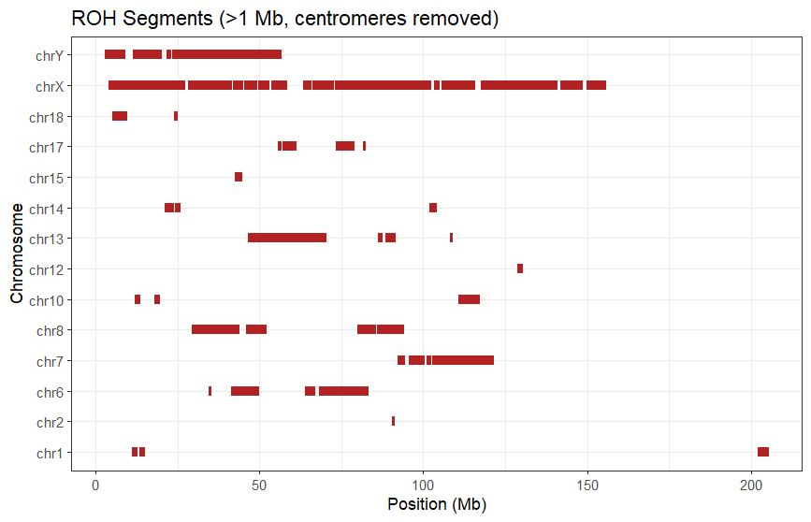
Figure S1: Runs of homozygosity (ROH) were identified from VCF data using the roh module in bcftools (v1.20) with default settings (allele frequency = 0.4). ROH segments were filtered to retain only those >1 Mb and overlapping centromeric regions were excluded based on GRCh38 centromere coordinates. Plots of ROH were generated in R (version 2024.04.0) using the dplyr package for data manipulation, gtools for chromosome sorting, and ggplot2 for visualization of total ROH per chromosome and individual ROH segments. These findings are consistent with the parents being 2nd cousins.

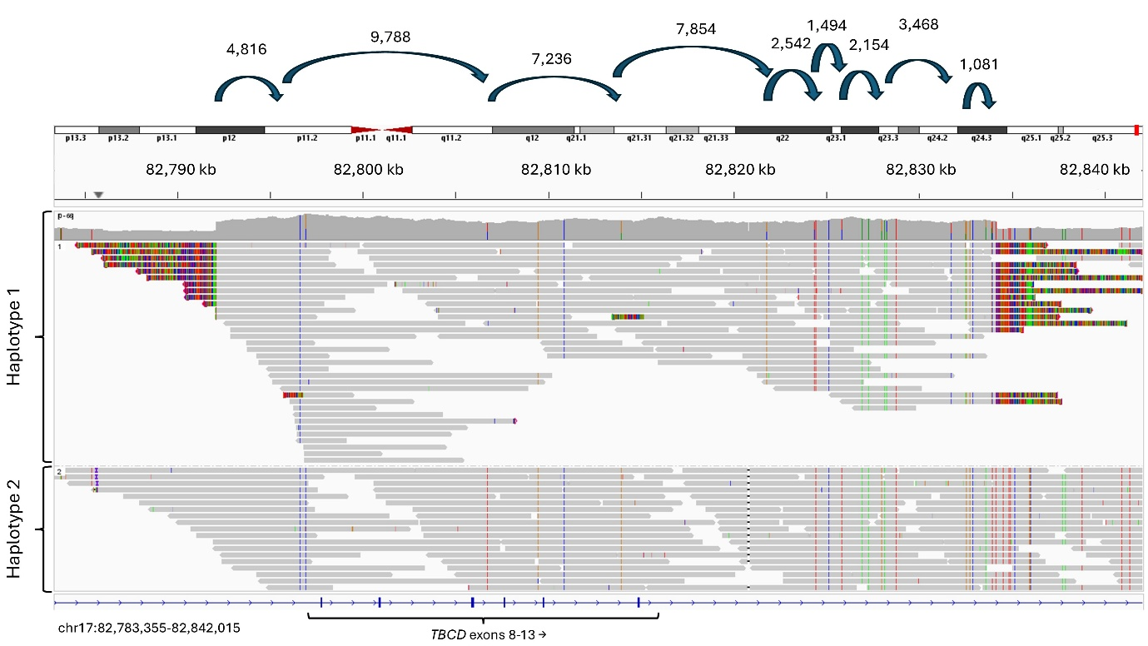
Figure S2: PacBio read alignments showing that the breakpoints are either side the same copy of TBCD duplication. The two haplotypes were separated using HiPhase, where phase assignment was facilitated by the presence of 14 cis-morphic SNVs. Labels showing the distance between informative SNVs are shown only where the spanning distance is >1 kb. A majority of genomic duplication events involve homologous alleles and a recent study indicates that 85% of de novo duplications likely occurred in maternal meiosis II³. After the initial duplication event, the two copies of TBCD exons 8-13 are likely to have started out being identical. However, as the duplicated 42 kb segments are not oriented in tandem, this elevates the likelihood that a recombination event could have occurred. This likely explains the presence of the 14 cis-morphisms (that appear as heterozygous genotypes), which helped facilitate phasing across the 42 kb segment (Table S1). Although recombination rates are typically increased in telomeric regions, there is only 370,738 bp (i.e. 221,713 bp + 149,025 bp) separating the two copies of the TBCD segment and so there would be a very low chance of recombination between the two these loci, per generation (i.e. 0.4% chance, based on the approximation of 1 cM = 1 Mb). Together with the small size of the ROH region (Figure 2A), the presence of these cis-morphisms, as well as the frequency within the community, suggests that this Amish founder variant occurred many generations ago.

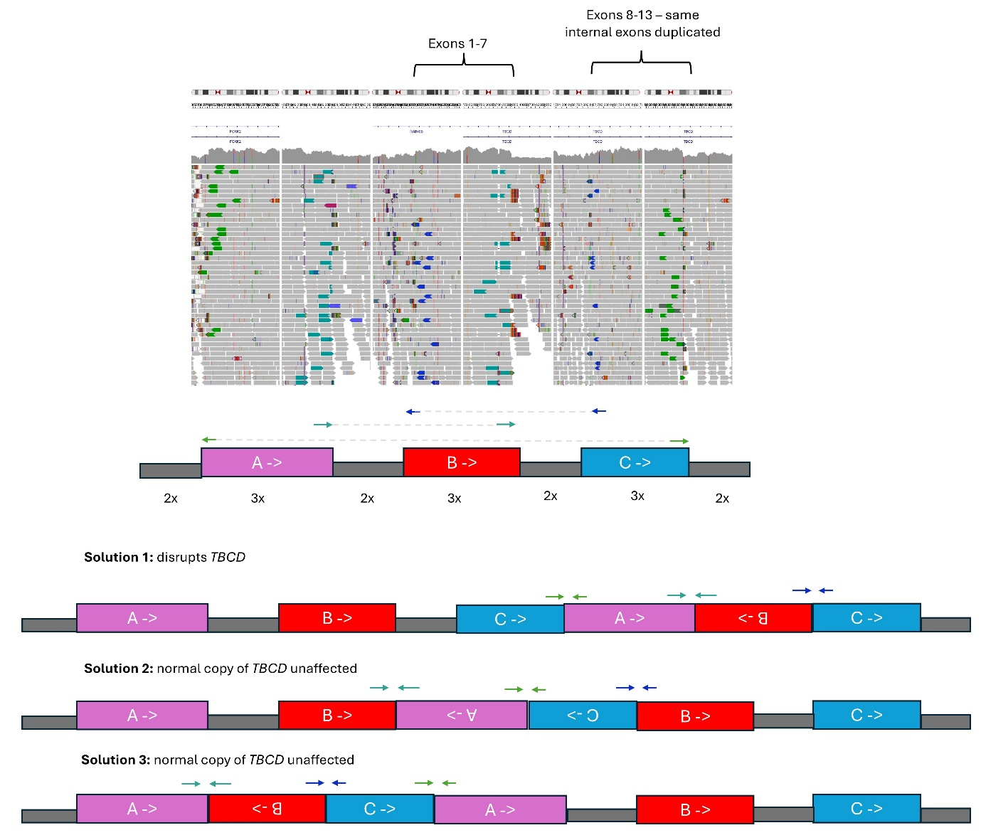
Figure S3: Illumina short-read data from UK Biobank participant showing a similar complex SV overlapping the same exons 8-13. For this SV there are three interlinked duplications and the configuration is ambiguous with short-read genome sequencing data. Only the structure shown here as “Solution 1” would be likely to disrupt gene function.

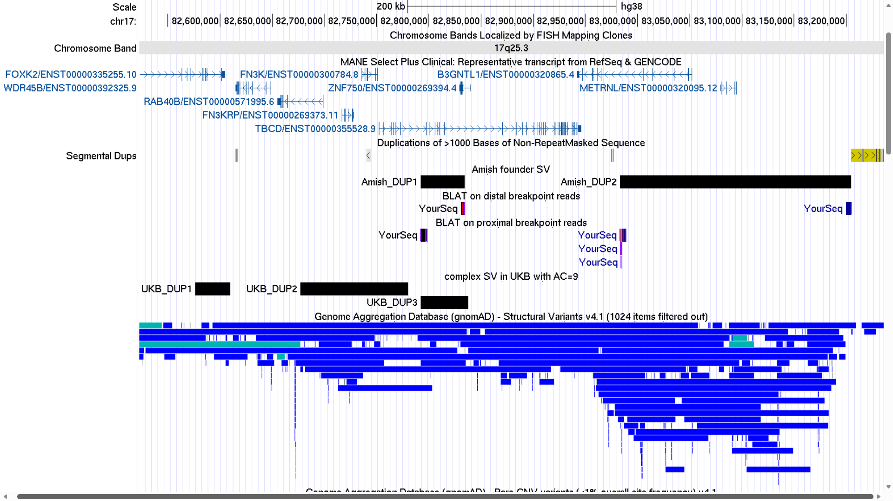
Figure S4: An overlapping complex SV in UK Biobank. Comparison of duplication coordinates shows that for the complex SV detected in the UK Biobank, although “DUP3” involves exons 8-13, the precise breakpoints are slightly different. An interactive UCSC session is available at https://genome.ucsc.edu/s/ExeterGenetics/TBCD_coordinates. The BLAT search results tracks are for representative sequences for HiFi reads that span the distal and proximal breakpoints of the TBCD exon 8-13 duplicated segments for the Amish founder SV. GRCh38 coordinates of the three duplicated segments are: chr17 82,576,382-82,609,705, chr17:82,677,005-82,780,312 and chr17 82,792,374-82,837,797. SVs from gnomAD v4.1 database are shown in blue (duplications) and cyan (complex SVs).

Note S1: Identification of additional complex SVs spanning TBCD in UK Biobank
To determine how frequent this SV may be in the wider population, genome sequencing of 490,640 UK Biobank participants was assessed, as described elsewhere^{3–6}. Although we were unable to find any carriers, a different complex duplication involving the same exons (8-13) of TBCD was identified. This duplication was identified in 9 heterozygous participants but was linked to different duplicated segments on the proximal side (Figure S3, S4). The sizes of these three duplicated segments were 33 kb, 103 kb and 45 kb. Long-read data is not yet available for UK Biobank participants and TBCD gene product is not tested on the Olink proteomics platform and hence we were unable to ascertain whether this related SV disrupts gene-function.
The absence of the DUP-INV-DUP variant from UK Biobank and relatively high frequency in our internal database of Amish exome/genome data is consistent with the complex SV being a founder variant. However, the distal portion of the three interlinked duplications (DUP-NML-DUP-NML-DUP variant) that was detected in UK Biobank is strikingly similar to the proximal segment of the Amish founder SV, involving exons 8-13 of TBCD (Figure S4). Our findings thus provide generalizable lessons for SV interpretation and care must be taken to avoid intragenic duplications being falsely reported as pathogenic, without careful characterisation of breakpoint sequences. Further studies should also assess whether the genomic architecture of the exon 8-13 TBCD locus can predispose to the formation of complex SVs.

Supplemental bibliography
1 Zanni G, Scotton C, Passarelli C, Fang M, Barresi S, Dallapiccola B et al. Exome sequencing in a family with intellectual disability, early onset spasticity, and cerebellar atrophy detects a novel mutation in EXOSC3. Neurogenetics 2013; 14: 247–250.
2 Jinks RN, Puffenberger EG, Baple E, Harding B, Crino P, Fogo AB et al. Recessive nephrocerebellar syndrome on the Galloway-Mowat syndrome spectrum is caused by homozygous protein-truncating mutations of WDR73. Brain 2015; 138: 2173–2190.
3 Jung H, Yang TP, Walker S, Danecek P, Garcia-Salinas OI, Neville MDC et al. Complex de novo structural variants are an underestimated cause of rare disorders. Nat Commun 2025; 16. doi:10.1038/S41467-025-64722-2.
4 Fasham J, Rankin J, Schot R, White SM, Bell KM, Wakeling MN et al. Palindrome-mediated 16p13.3 triplications cause a recognizable neurodegenerative disorder with ataxia. The American Journal of Human Genetics 2026; 113: 221–233.
5 Moore AR, Yu J, Pei Y, Cheng EWY, Taylor Tavares AL, Walker WT et al. Use of genome sequencing to hunt for cryptic second-hit variants: analysis of 31 cases recruited to the 100 000 Genomes Project. J Med Genet 2023; 60: 1235–1244.
6 Carss K, Halldorsson B V., Hou L, Liu J, Wheeler E, Lo Y et al. Whole-genome sequencing of 490,640 UK Biobank participants. Nature 2025; 645: 692–701.

