Supporting Information

Synthesis and Photophysical Properties of Naphthalimide-Based Dual Fluorescence Probe

Susantha K. Ganegamage ^{ab}*, Talysa Ogas ^{b}, Praveen L. Patidar ^{b},

Virginia Chang ^{c}, and Michael D. Heagy ^{c}*
ª Department of Chemistry and Biochemistry, Lamar University, Beaumont, Texas, 77710.
^{b} Department of Chemistry, New Mexico Institute of Mining and Technology, Socorro, New Mexico, 87801.
^{c} Rochester Institute of Technology, Rochester, New York, 14623.

Index Pages

Purity Analysis by HPLC………………………………………………………………….…….S1
UV–vis and fluorescence spectroscopic studies...……….…………………….......….…………S2
Quantum Yield Calculations…………………………………………………….…………...S2-S5
Fluorescence lifetime measurements…………….….………………………...…......……...…...S6
Electronic structure calculations………………………………...………………..…...……..S7-S8
¹H & ¹³C NMR Characterization of Compounds…………………...……….…….………..S9-S12
IR Characterization of Compounds……………….…………...…………….……….……S13-S14

Purity Analysis of 18NIO Probe by HPLC
HPLC Conditions:
Instrument : Agilent HPLC 1200 Series
Column : Eclipse Plus C18
Column particle size : 5 µm
Column length : 120 mm
Flow rate : 1.00 mL/min
Time : 20 min
Method : Isocratic
Solvent system : Acetonitrile: Phosphate buffer (pH = 3.4), 70:30
Injection volume : 1 µL
Sample injection solvent : Acetonitrile
Concentration of sample : 100 µM
Detector : UV
Wavelength : 254 nm

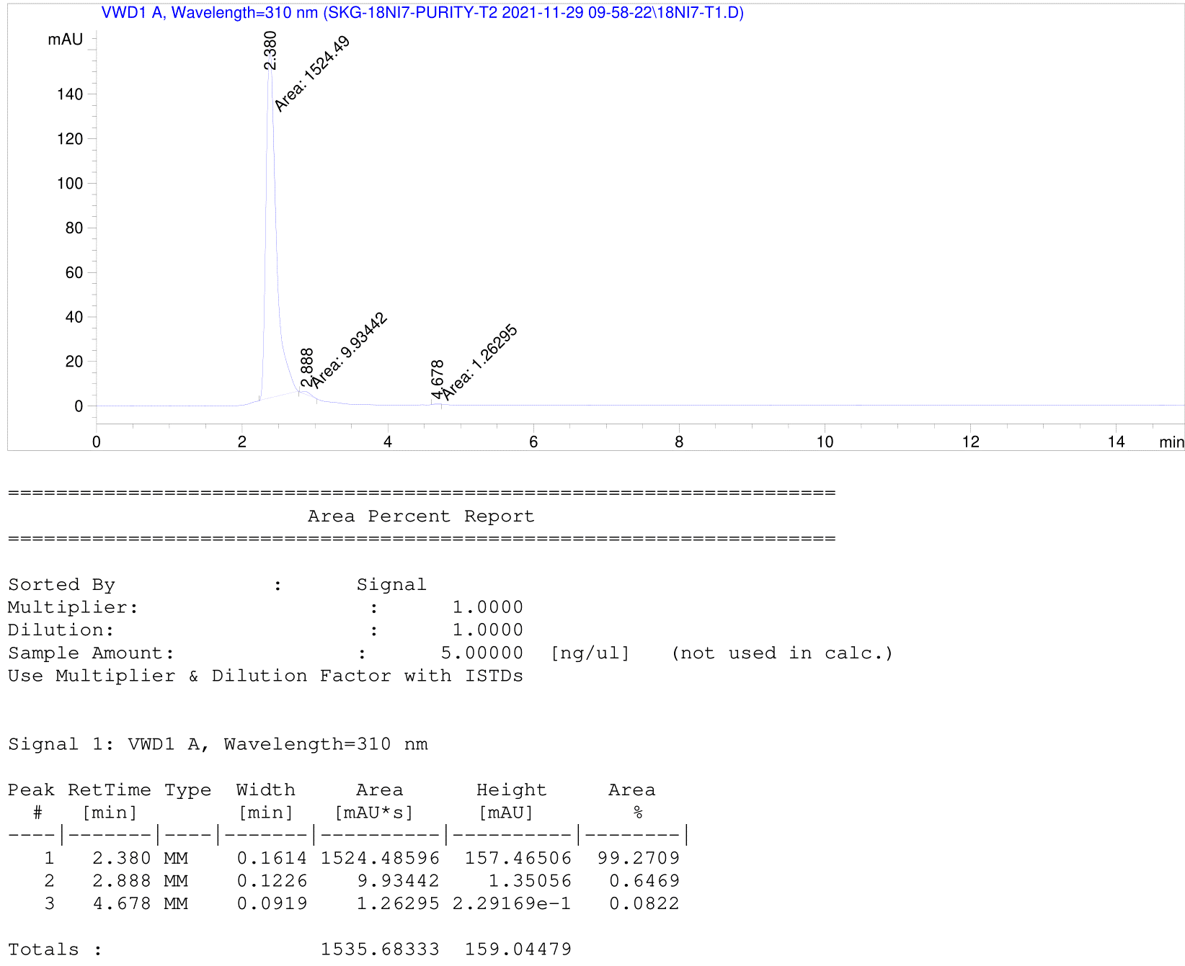
Figure S1. HPLC spectrum and purity analysis report of 18NIO
UV–vis and fluorescence spectroscopic studies
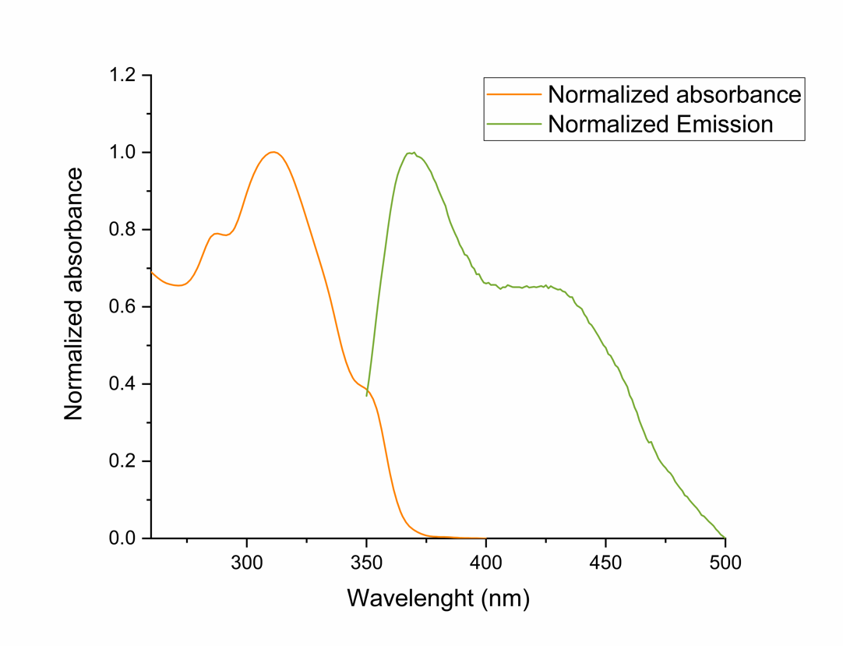
Figure S2. Normalized absorbance (λ_{max.} = 310 nm) and emission (λ_{em.} = 371 and 425 nm) of 18NIO

Quantum Yield Calculations
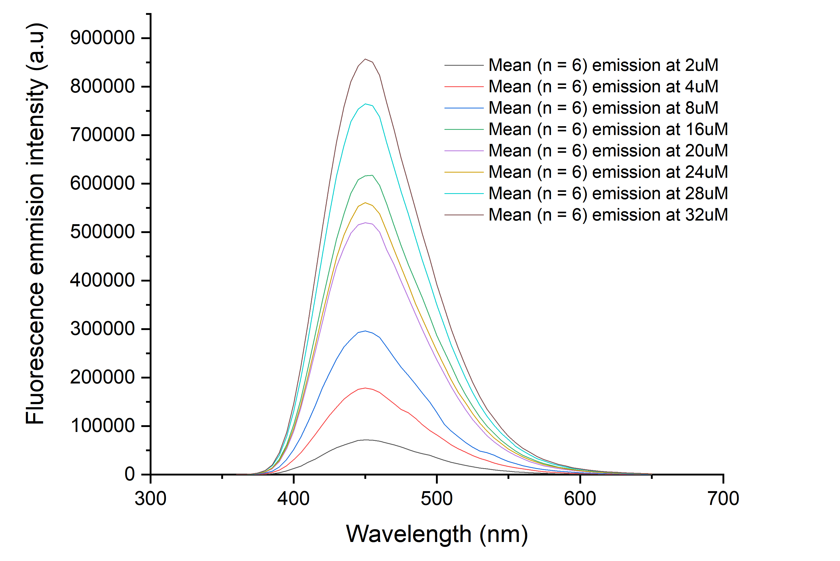
Figure S3. Mean (n = 6) fluorescence emission of quinine sulfate standard (in 0.1 M aqueous sulfuric acid) at 350 nm at room temperature.
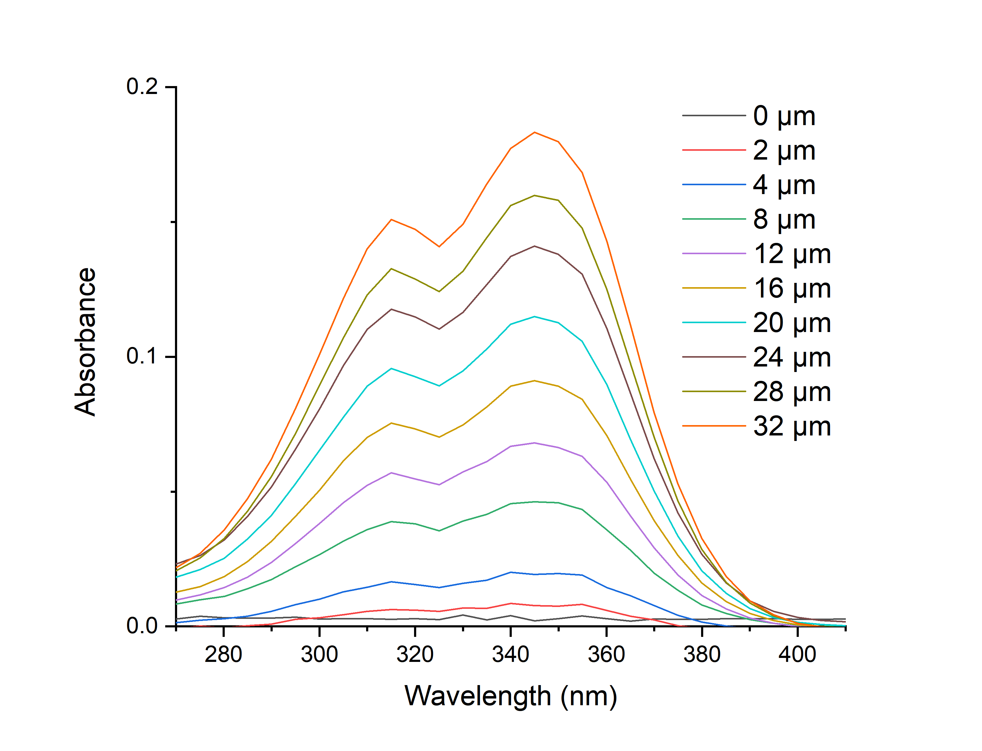
Figure S4. Mean (n = 6) absorbance of quinine sulfate standard (in 0.1 M aqueous sulfuric acid) (λ_{ex.} = 350 nm) at room temperature.

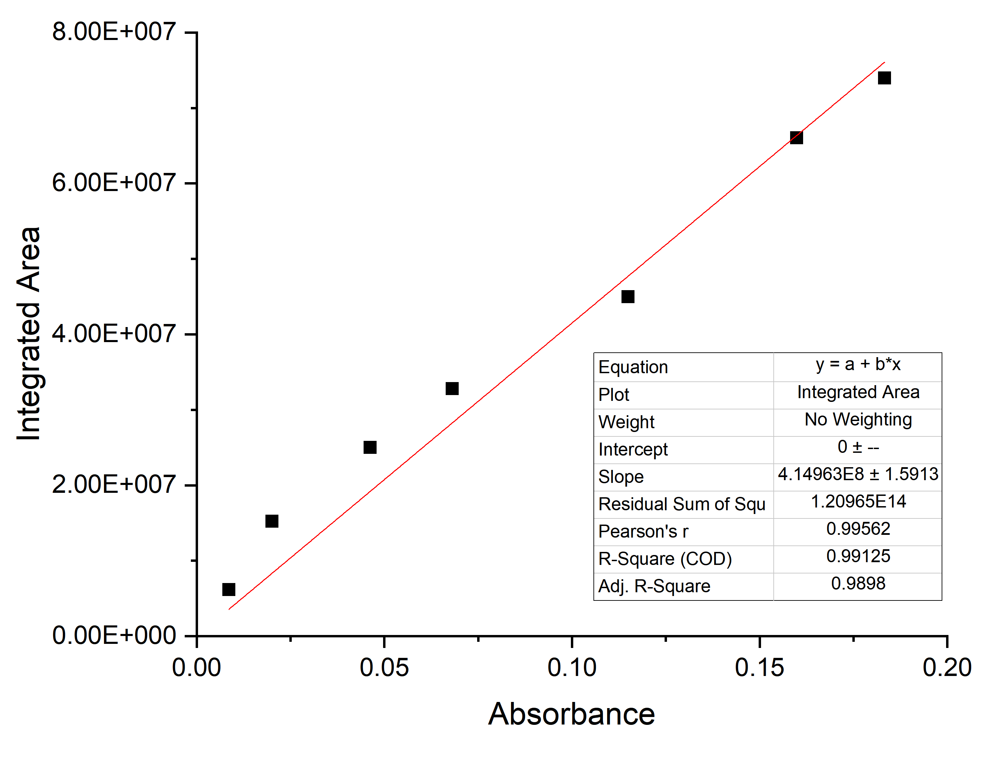
Figure S5. Absorbance vs integrated area of emission of compounds quinine sulfate standard (in 0.1 M aqueous sulfuric acid) at room temperature.
18NIO Probe Extinction Coefficient
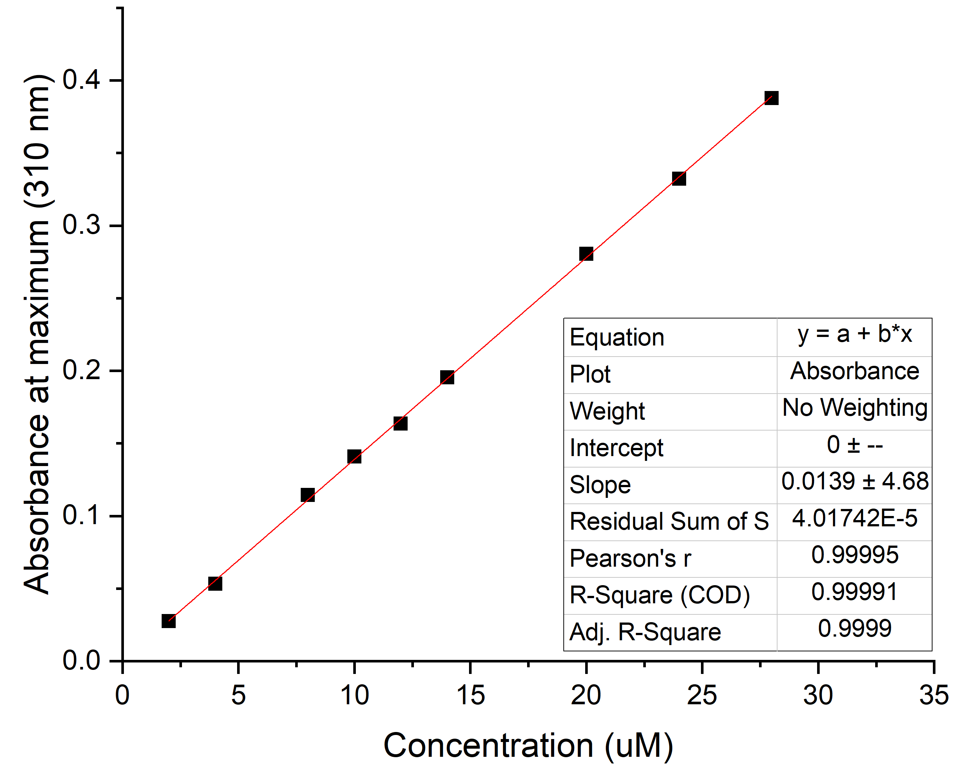
Figure S6. Extinction coefficient (ε) of 18NIO in DMSO at its maximum (310 nm) absorbance = 13900 M⁻¹cm⁻¹

Azide Parameters
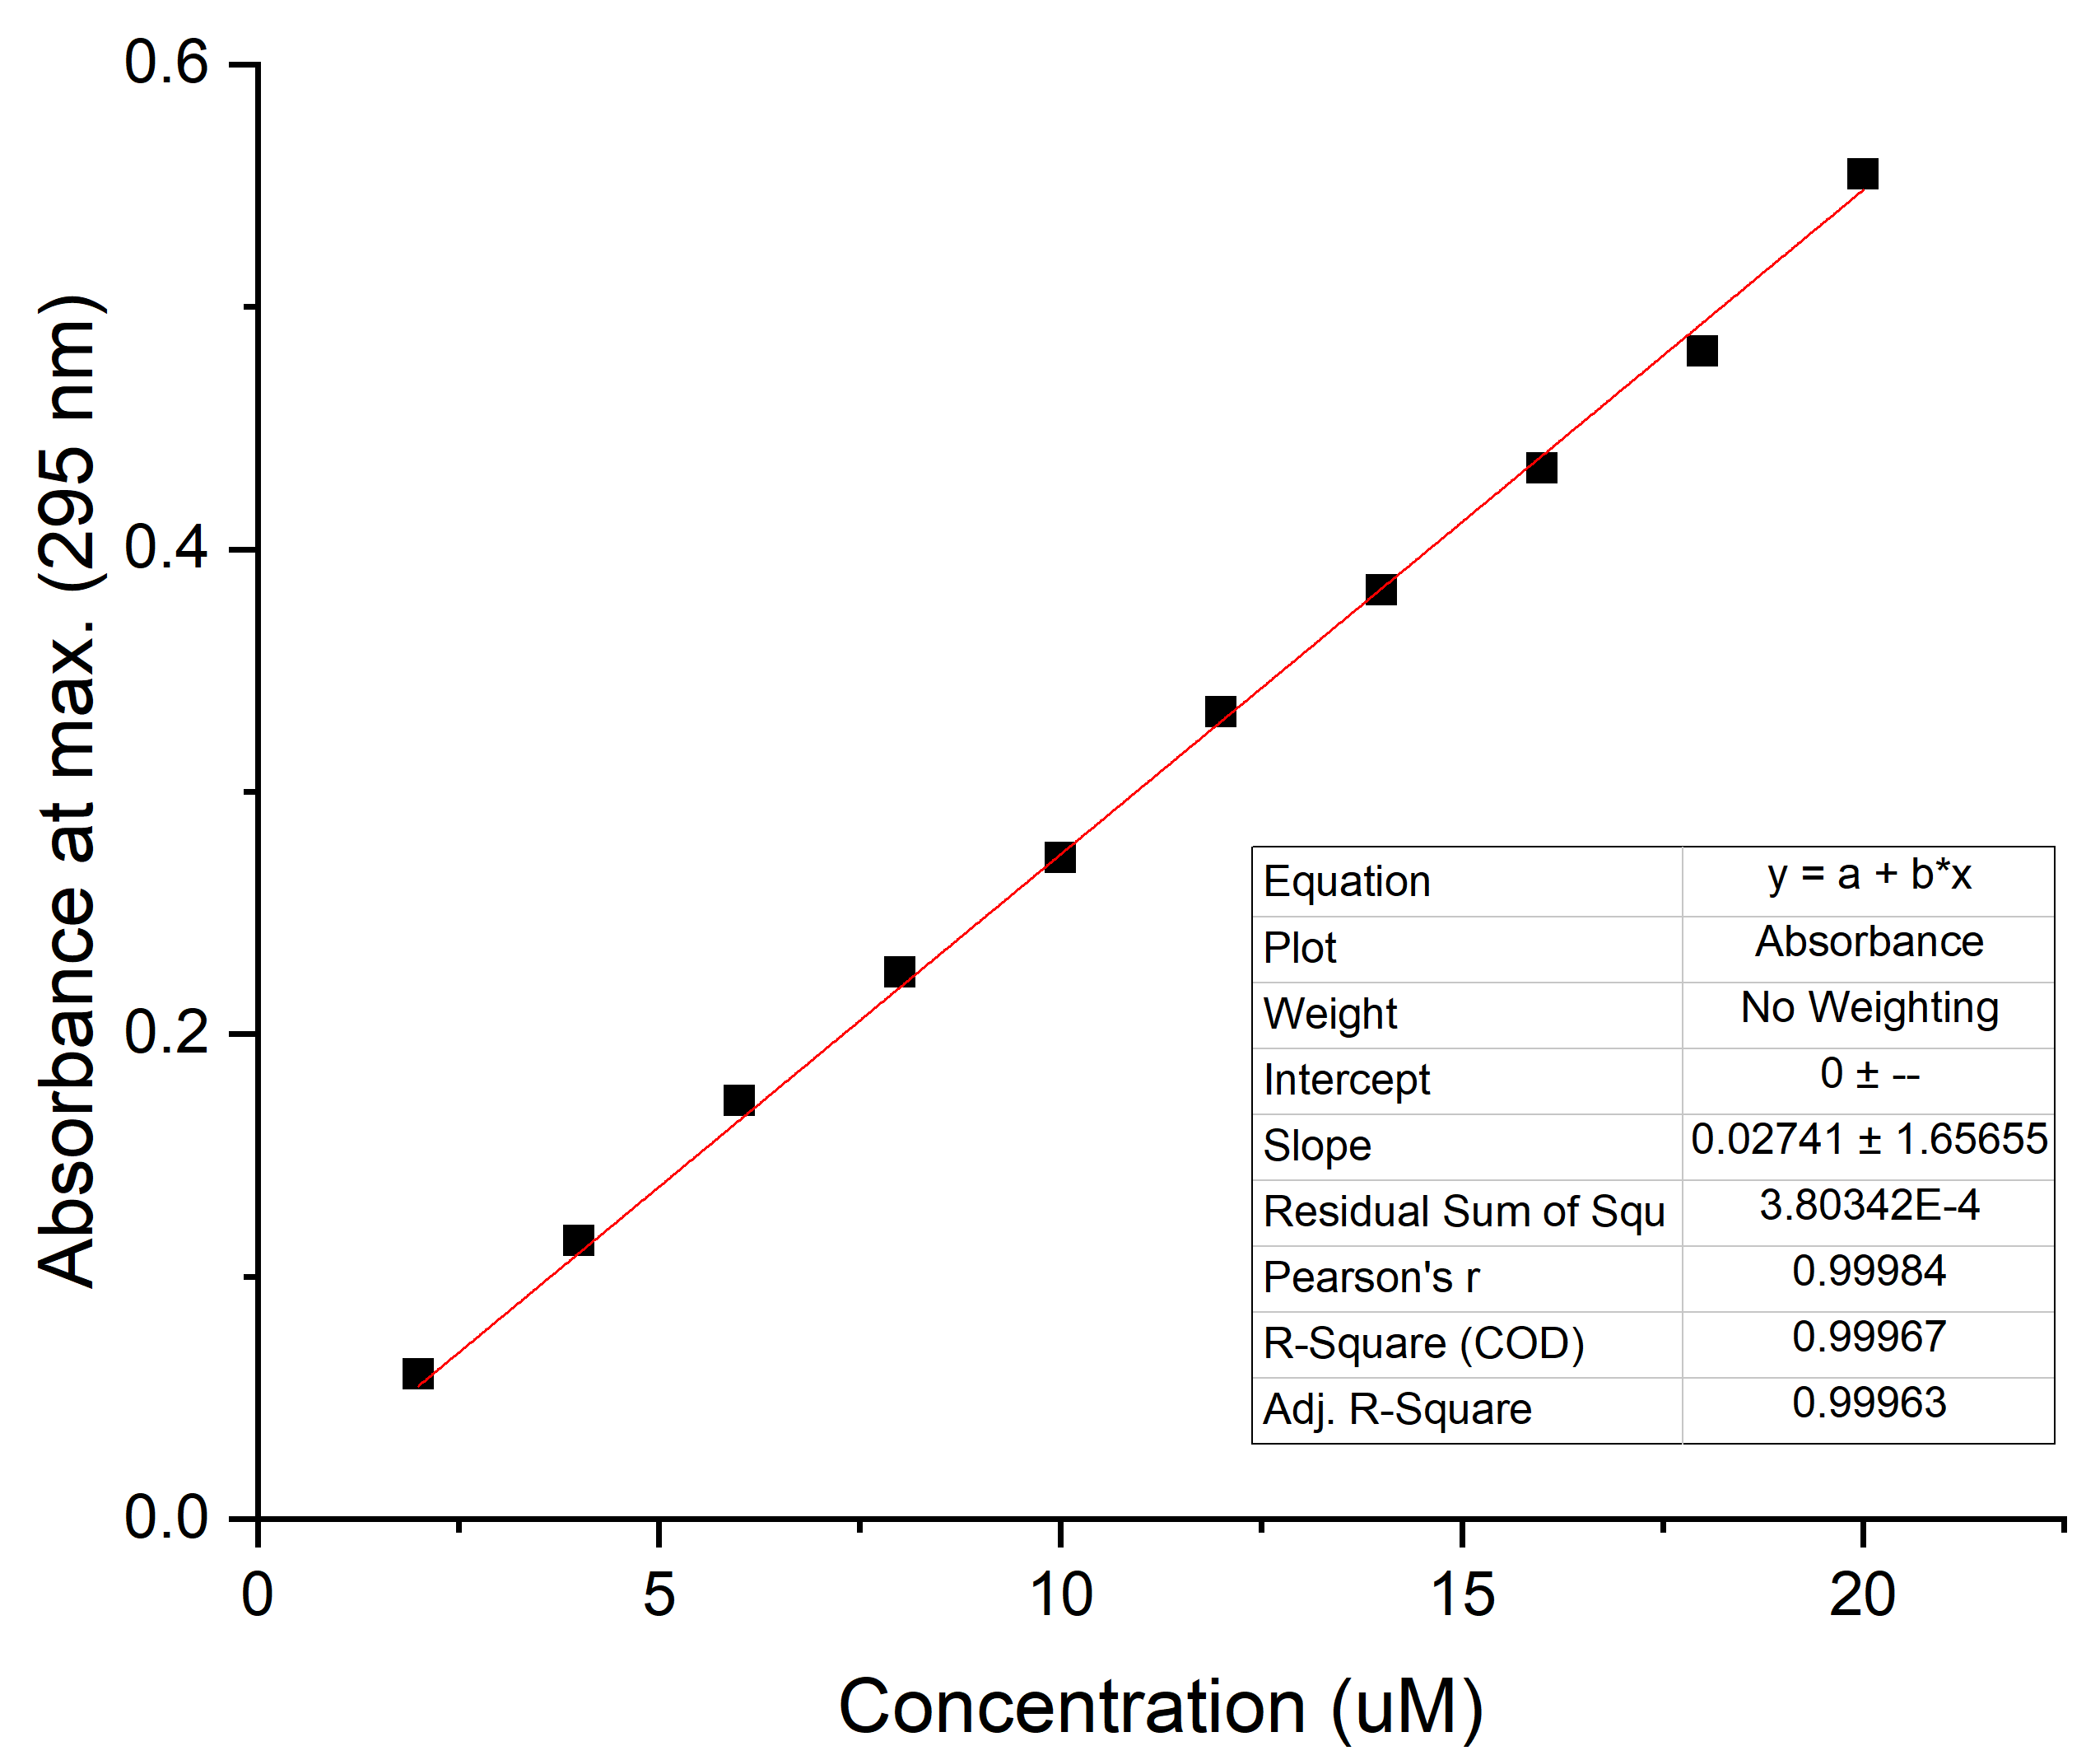
Figure S7. Extinction coefficient (ε) of azide in DMSO at its maximum (295 nm) absorbance = 27410 M⁻¹cm⁻¹

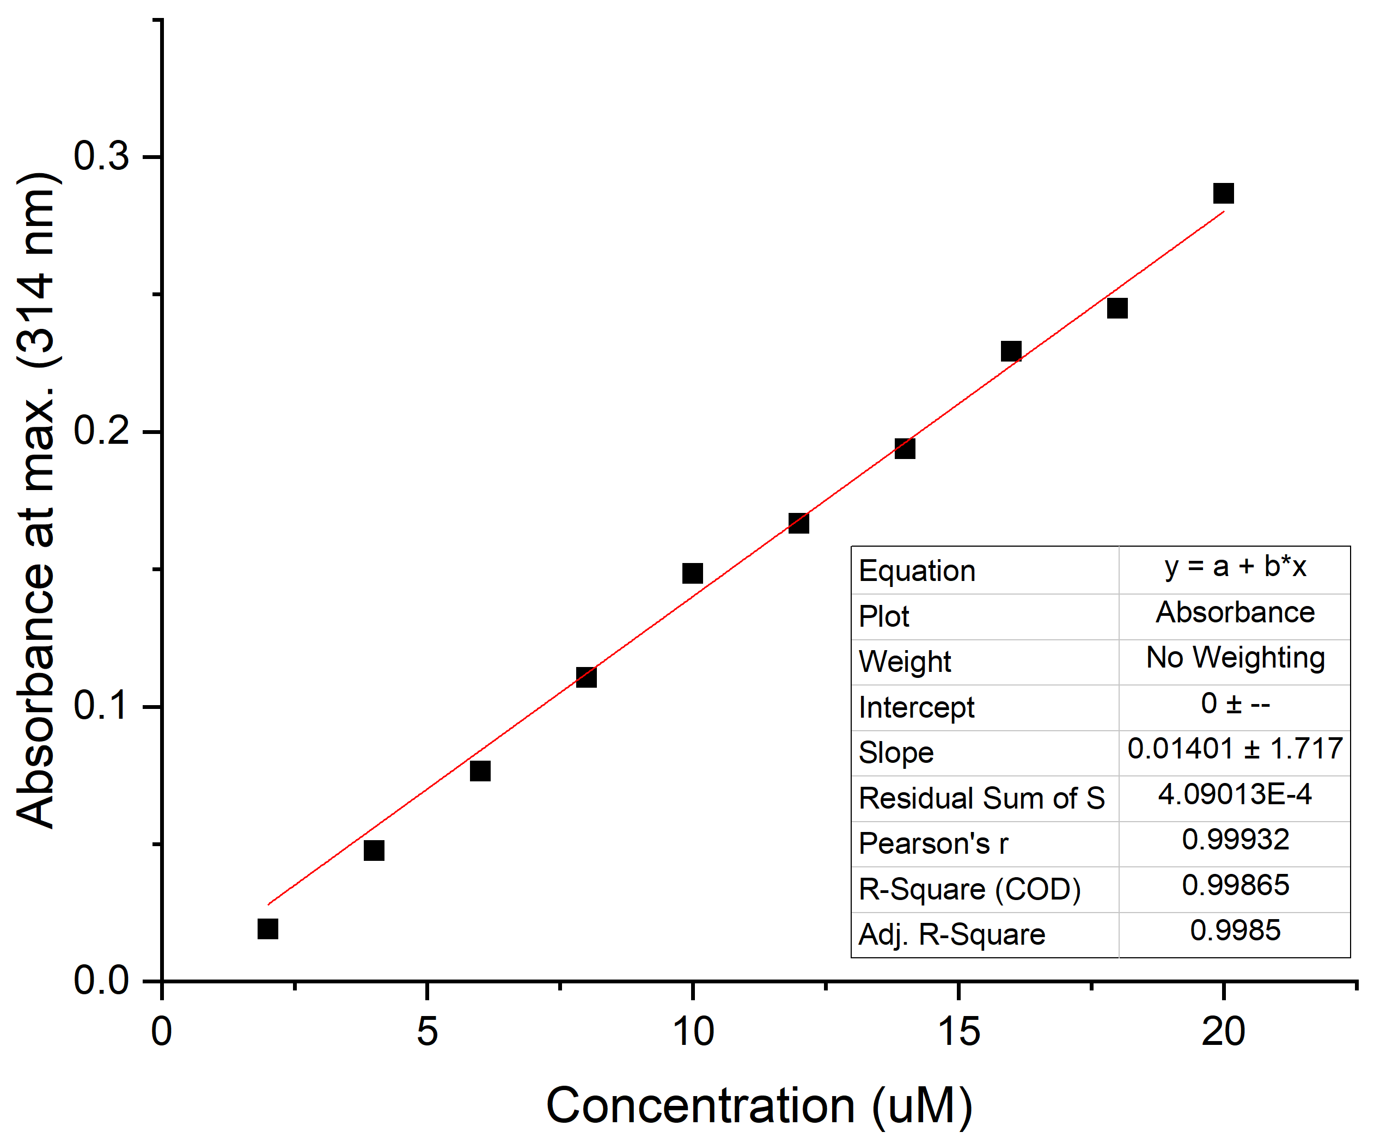
Figure S8. Extinction coefficient (ε) of alkyne in DMSO at its maximum (314 nm) absorbance = 14010 M⁻¹cm⁻¹

Fluorescence lifetime measurements

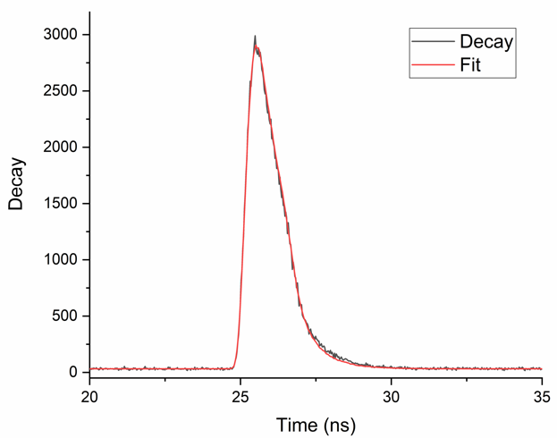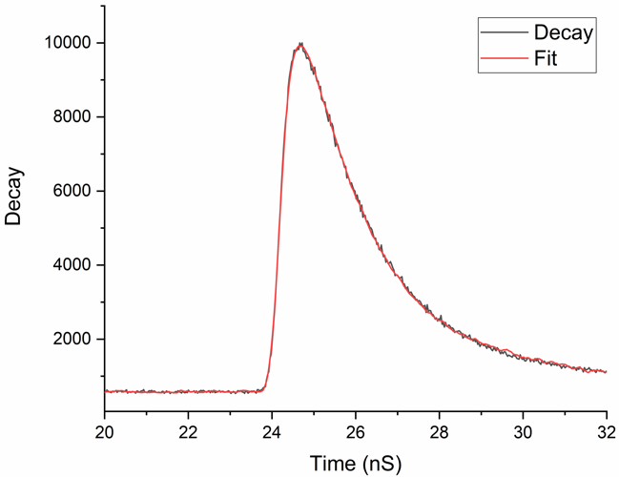
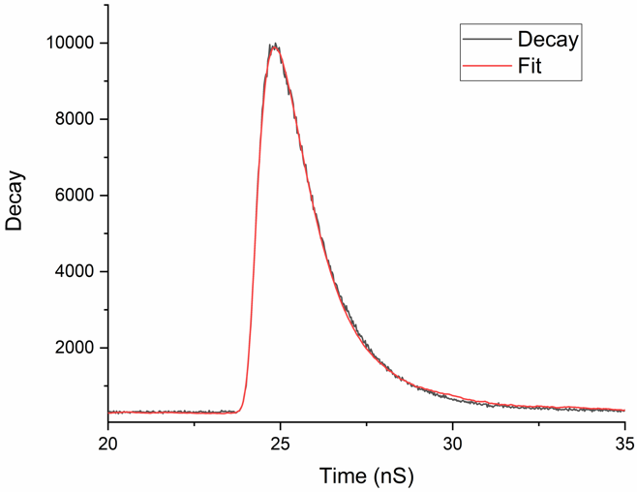

Figure S9. Fluorescence lifetime decay and exponential fitting of 18NIO (top left), alkyne (top right) and azide (bottom) in DMSO.
Electronic structure calculations

Table S10. Atomic coordinates (Å) of the optimized structures for the S₀ ground states found at the TD-B3LYP level of theory in DMSO.
Atom | x | y | z
C | 11.967 | -2.331 | 2.171
C | 12.715 | -2.198 | 1.021
C | 12.160 | -1.606 | -0.142
C | 10.809 | -1.150 | -0.101
C | 10.059 | -1.296 | 1.092
C | 10.635 | -1.879 | 2.207
C | 12.897 | -1.451 | -1.344
C | 12.322 | -0.871 | -2.454
C | 10.988 | -0.423 | -2.410
C | 10.238 | -0.557 | -1.255
C | 8.840 | -0.080 | -1.231
N | 8.138 | -0.245 | -0.021
C | 8.659 | -0.826 | 1.152
O | 7.964 | -0.920 | 2.151
O | 8.292 | 0.435 | -2.193
C | 6.769 | 0.224 | 0.022
C | 5.729 | -0.644 | -0.300
C | 4.415 | -0.191 | -0.262
C | 4.124 | 1.133 | 0.100
C | 5.185 | 1.992 | 0.421
C | 6.500 | 1.541 | 0.382
C | 2.739 | 1.617 | 0.145
C | 1.550 | 0.916 | 0.121
N | 0.583 | 1.865 | 0.198
N | 1.141 | 3.099 | 0.267
N | 2.430 | 2.948 | 0.237
C | -0.832 | 1.703 | 0.209
C | -1.416 | 0.641 | -0.485
C | -2.794 | 0.487 | -0.466
C | -3.602 | 1.397 | 0.231
C | -3.001 | 2.463 | 0.916
C | -1.621 | 2.614 | 0.912
C | -5.050 | 1.220 | 0.229
N | -5.752 | 0.280 | -0.328
C | -7.073 | 0.593 | -0.044
C | -7.102 | 1.731 | 0.701
O | -5.817 | 2.142 | 0.884
C | -8.196 | -0.289 | -0.482
O | -8.030 | -1.497 | -0.643
N | -9.380 | 0.339 | -0.674
 | -10.614 | -0.360 | -1.021
C | -11.452 | -0.694 | 0.223
N | -12.698 | -1.381 | -0.113
C | -13.216 | -2.150 | 1.028
C | -14.450 | -2.966 | 0.639
C | -15.545 | -2.067 | 0.054
C | -14.976 | -1.207 | -1.080
C | -13.722 | -0.458 | -0.626
H | 12.401 | -2.785 | 3.053
H | 13.742 | -2.546 | 0.993
H | 10.046 | -1.982 | 3.110
H | 13.924 | -1.797 | -1.377
H | 12.893 | -0.757 | -3.367
H | 10.534 | 0.033 | -3.282
H | 5.948 | -1.667 | -0.583
H | 3.616 | -0.873 | -0.528
H | 4.975 | 3.015 | 0.706
H | 7.316 | 2.209 | 0.632
H | 1.328 | -0.136 | 0.094
H | -0.804 | -0.050 | -1.051
H | -3.252 | -0.332 | -1.005
H | -3.612 | 3.170 | 1.462
H | -1.156 | 3.426 | 1.453
 | -7.872 | 2.320 | 1.168
H | -9.410 | 1.345 | -0.601
H | -10.349 | -1.279 | -1.543
H | -11.168 | 0.276 | -1.713
H | -11.637 | 0.230 | 0.799
H | -10.858 | -1.353 | 0.861
H | -13.474 | -1.477 | 1.869
H | -12.423 | -2.815 | 1.380
H | -14.819 | -3.502 | 1.519
 | -14.159 | -3.721 | -0.100
H | -15.936 | -1.412 | 0.843
H | -16.387 | -2.667 | -0.304
H | -15.720 | -0.482 | -1.428
H | -14.721 | -1.843 | -1.936
H | -13.996 | 0.279 | 0.154
H | -13.306 | 0.106 | -1.464

¹H and ¹³C{¹H} NMR Characterization of Compounds

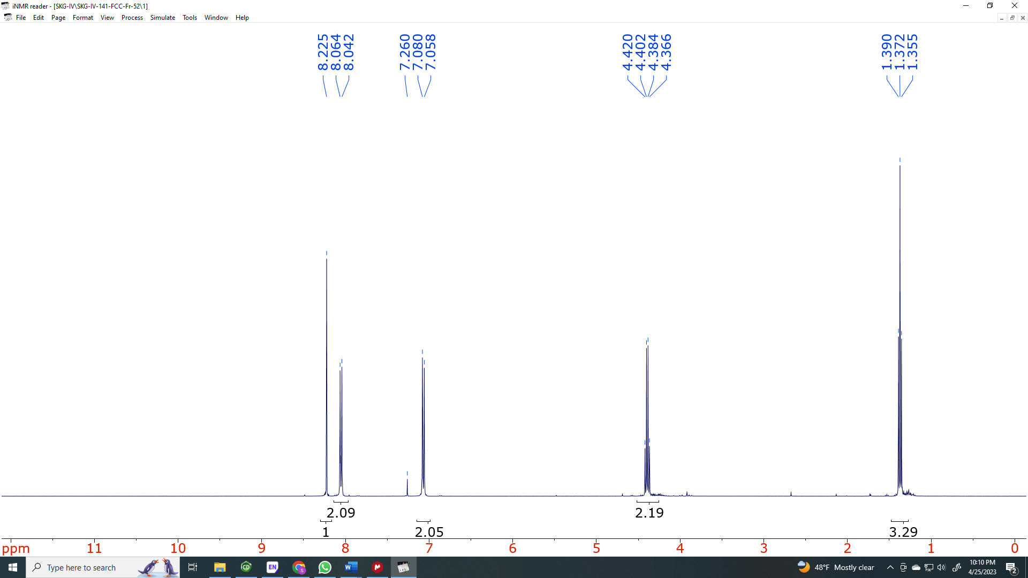

Figure S11. ¹H NMR spectrum of ethyl 2-(4-azidophenyl)-1,3-oxazole-4-carboxylate (2)

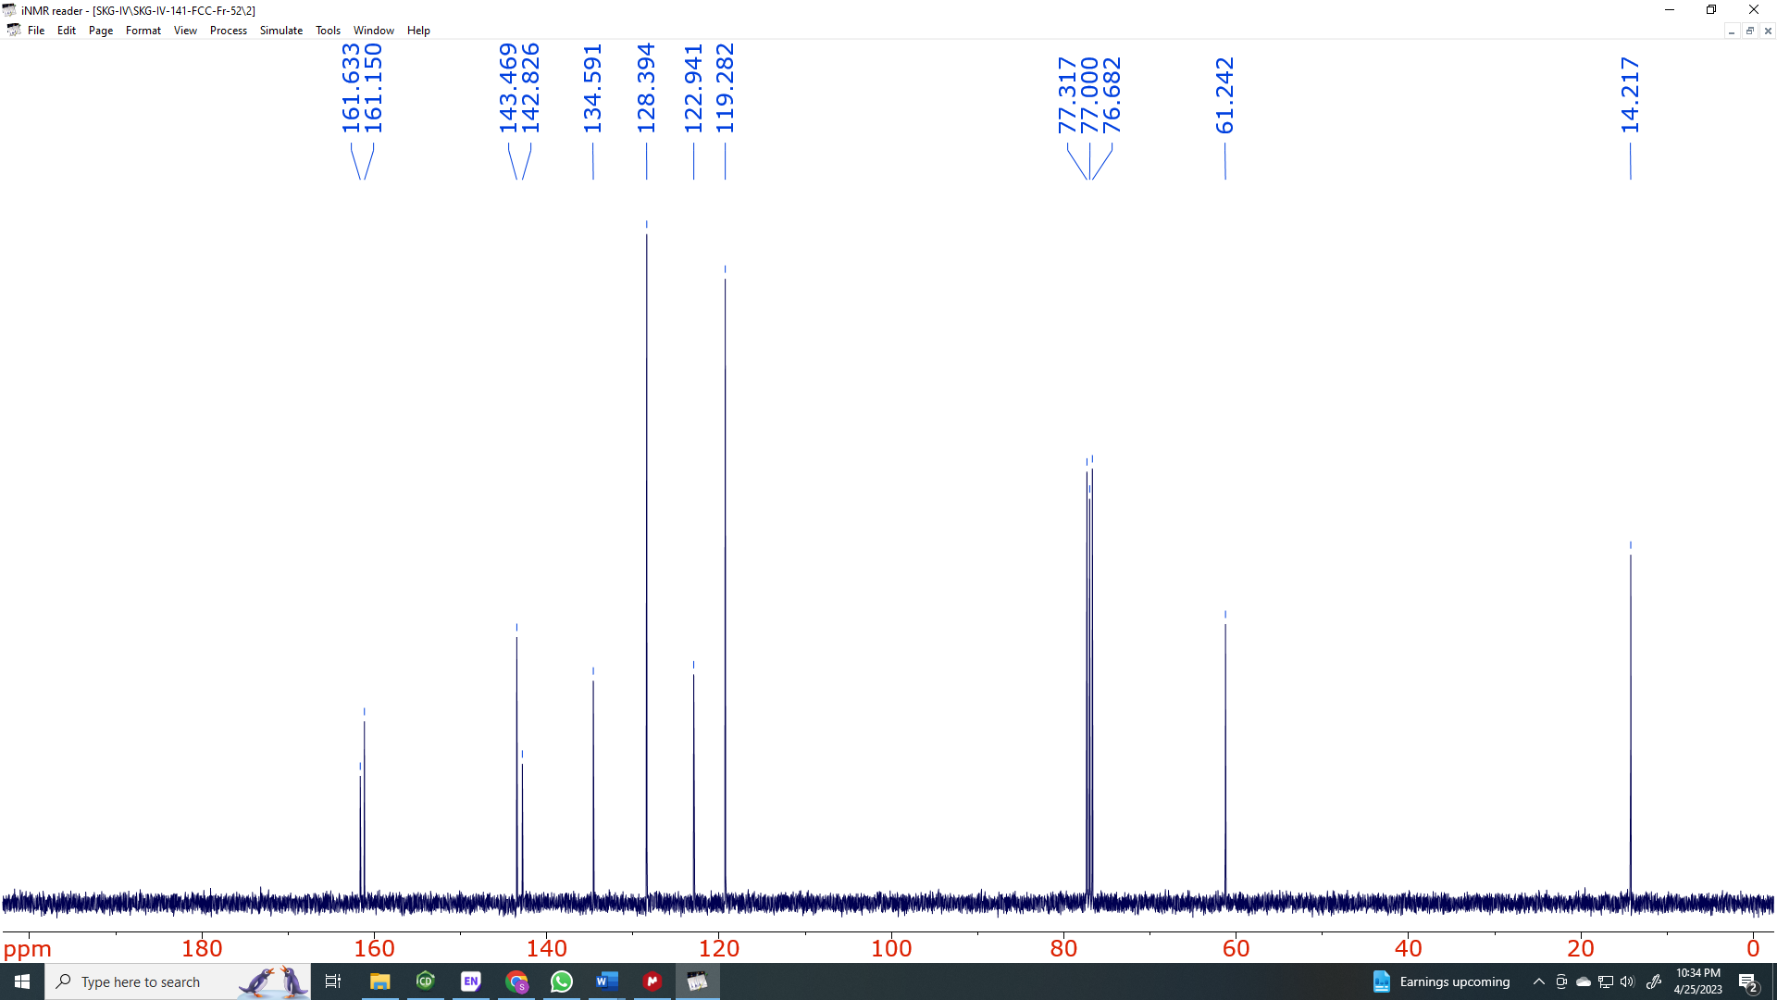

Figure S12. ¹³C{¹H} NMR spectrum of ethyl 2-(4-azidophenyl)-1,3-oxazole-4-carboxylate (2)
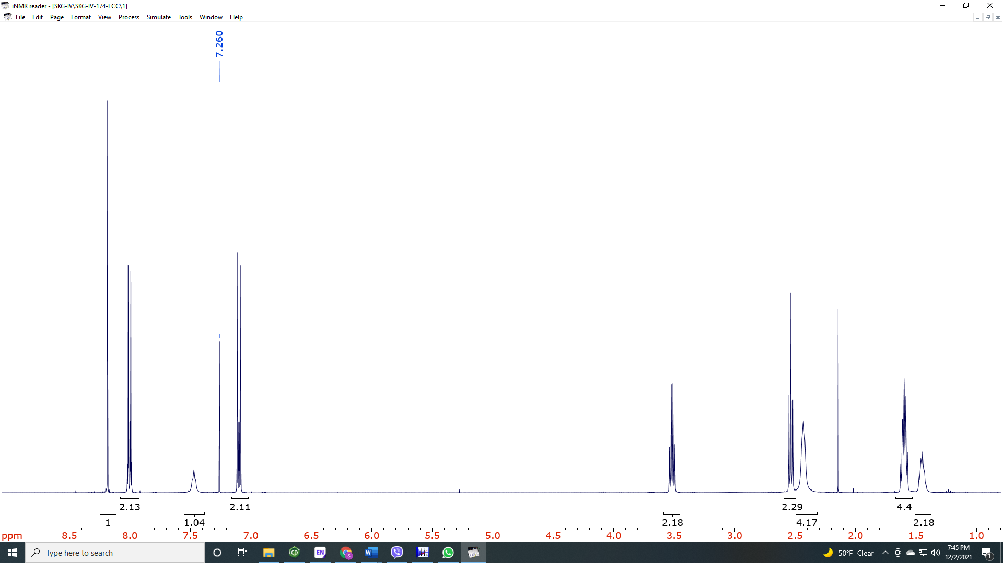

Figure S13. ¹H NMR spectrum of 2-(4-azidophenyl)-N-[2-(piperidin-1-yl)ethyl]-1,3-oxazole-4-carboxamide (3)

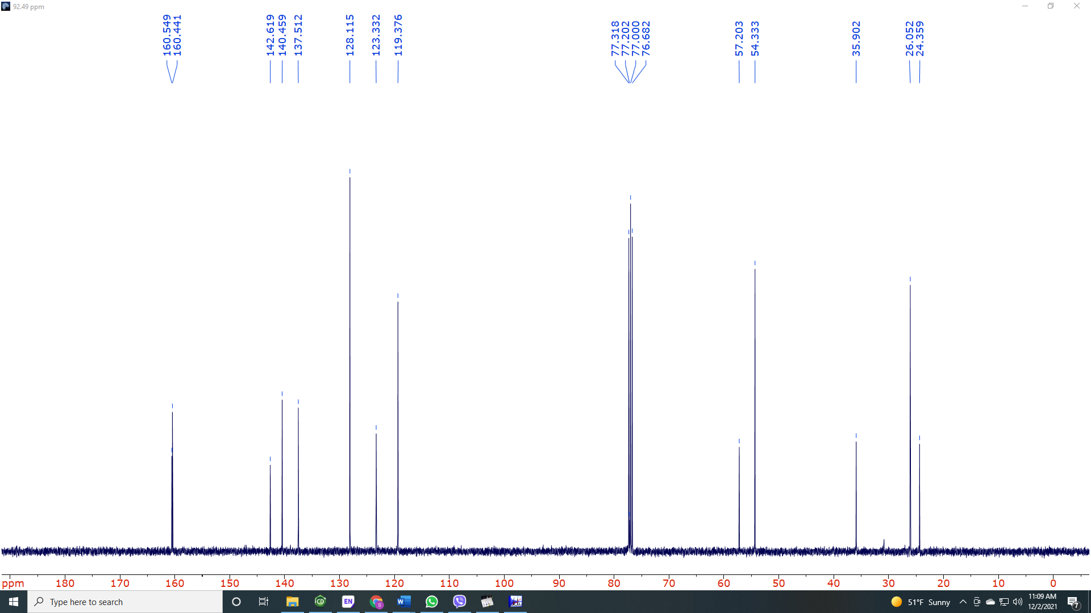

Figure S14. ¹³C{¹H} NMR spectrum of 2-(4-azidophenyl)-N-[2-(piperidin-1-yl)ethyl]-1,3-oxazole-4-carboxamide (3)

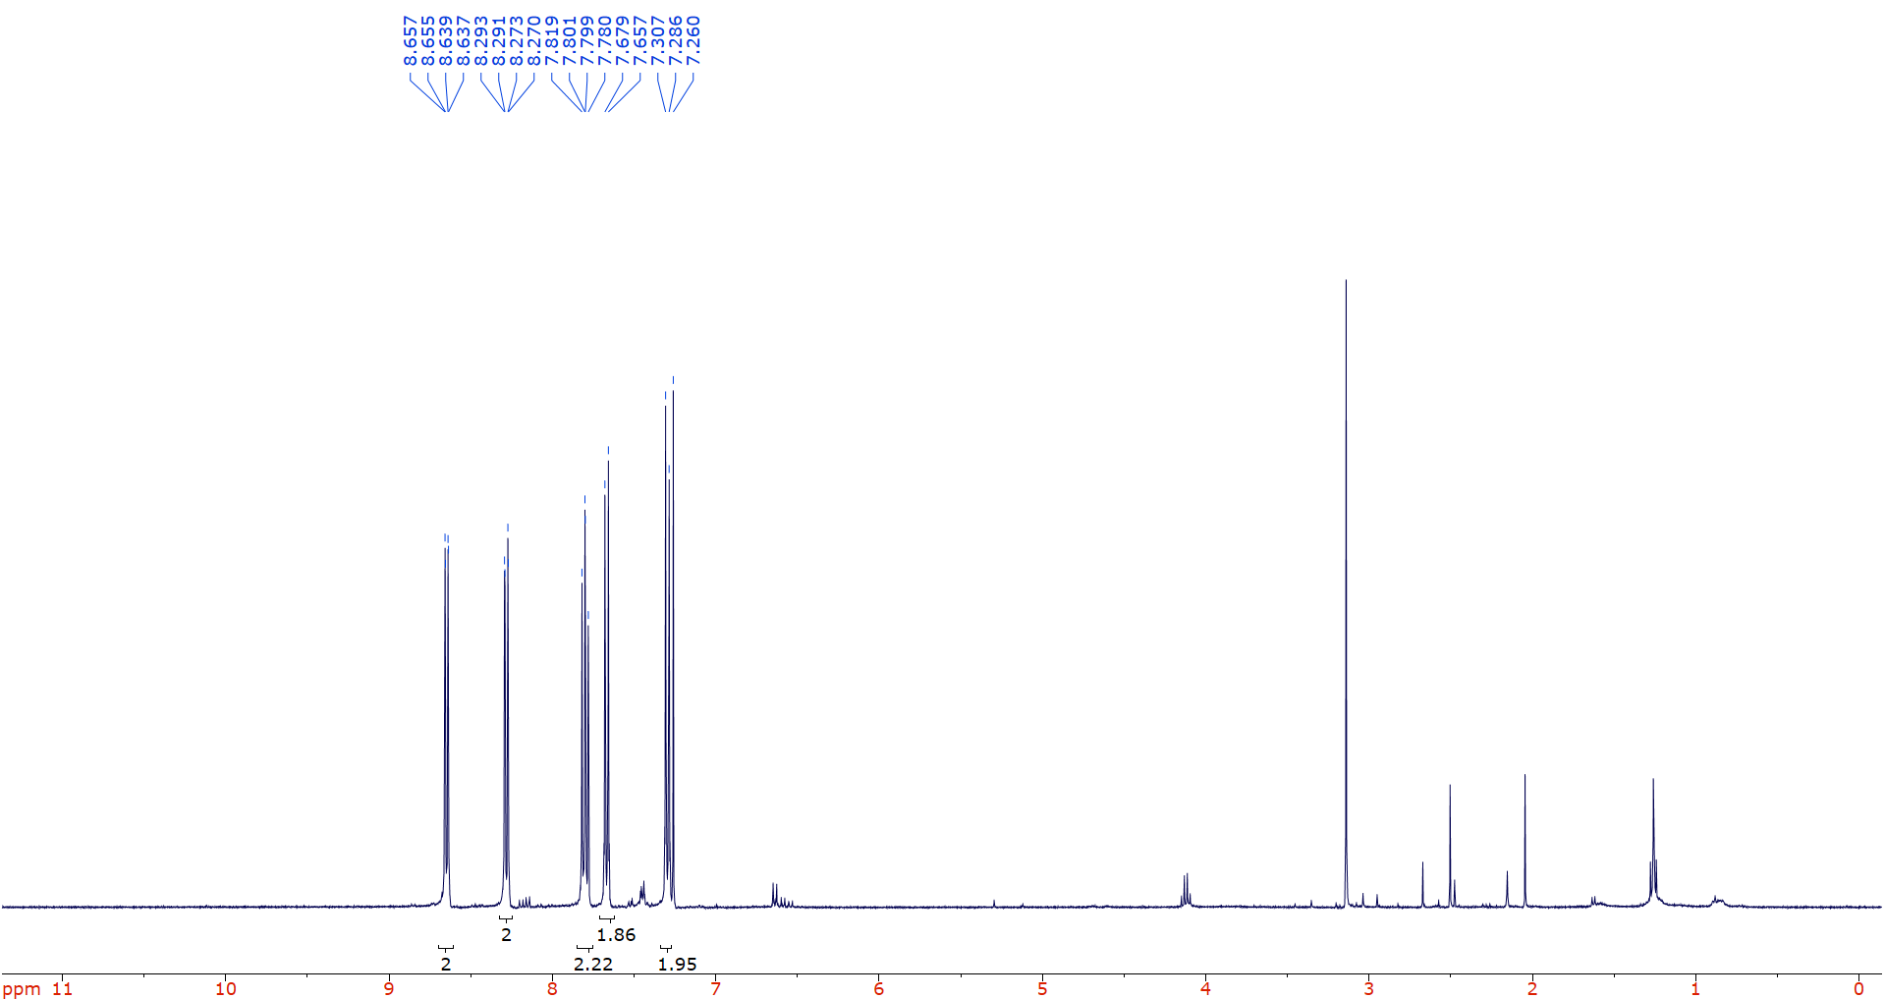

Figure S15. ¹H NMR spectrum of 2-(4-ethynylphenyl)-1H-benzo[de]isoquinoline-1,3(2H)-dione (5)

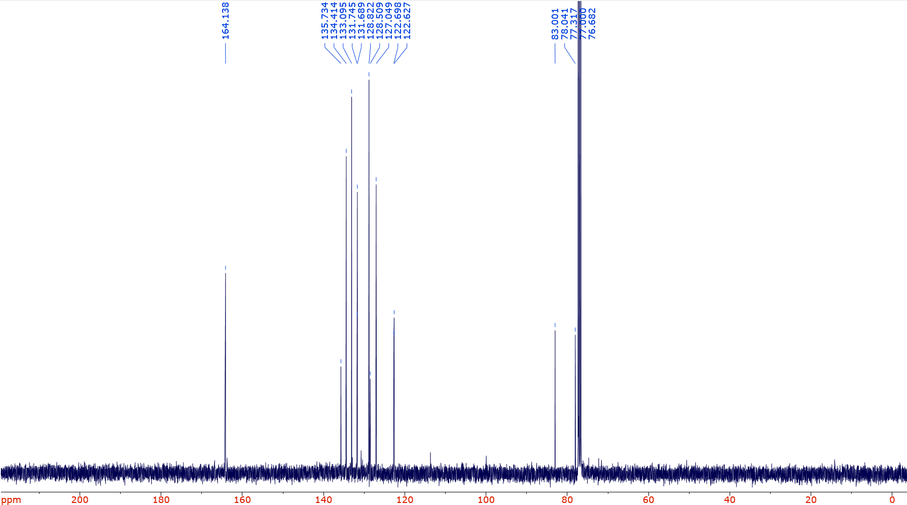

Figure S16. ¹³C{¹H} NMR spectrum of 2-(4-ethynylphenyl)-1H-benzo[de]isoquinoline-1,3(2H)-dione (5)

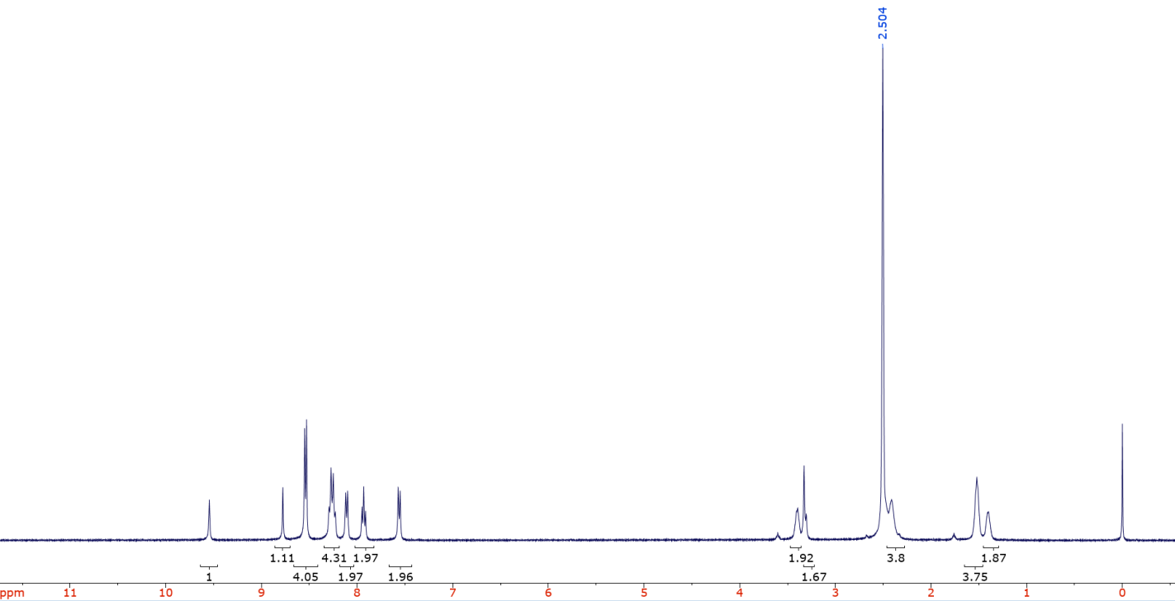
Figure S17. ¹H NMR spectrum of 2-{4-[4-(4-{2,4-dioxo-3-azatricyclo[7.3.1.0⁵,¹³]trideca-1(13),5,7,9,11-pentaen-3-yl}phenyl)-1H-1,2,3-triazol-1-yl]phenyl}-N-[2-(piperidin-1-yl)ethyl]-1,3-oxazole-4-carboxamide (18NIO)
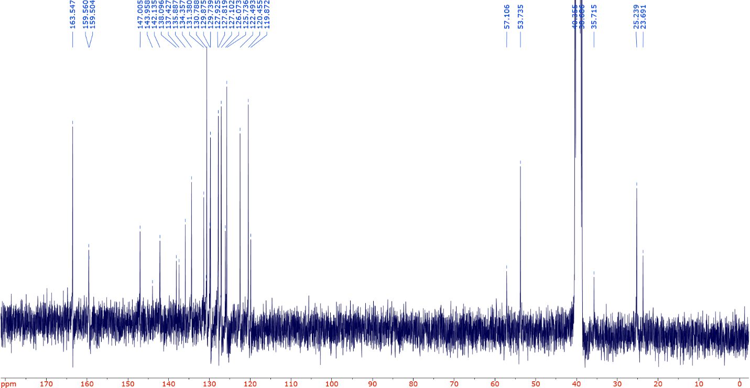
Figure S18. ¹³C{¹H} NMR spectrum of 2-{4-[4-(4-{2,4-dioxo-3-azatricyclo[7.3.1.0⁵,¹³]trideca-1(13),5,7,9,11-pentaen-3-yl}phenyl)-1H-1,2,3-triazol-1-yl]phenyl}-N-[2-(piperidin-1-yl)ethyl]-1,3-oxazole-4-carboxamide (18NIO)
IR Characterization of Compounds
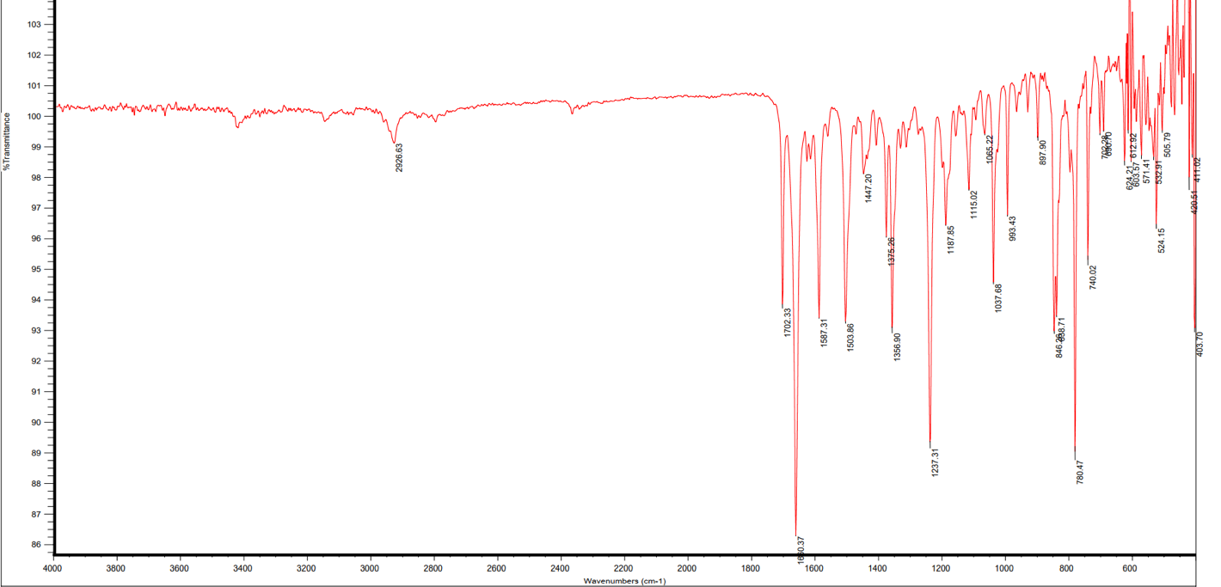
Figure S19. IR spectrum of 2-{4-[4-(4-{2,4-dioxo-3-azatricyclo[7.3.1.0⁵,¹³]trideca-1(13),5,7,9,11-pentaen-3-yl}phenyl)-1H-1,2,3-triazol-1-yl]phenyl}-N-[2-(piperidin-1-yl)ethyl]-1,3-oxazole-4-carboxamide (18NIO)
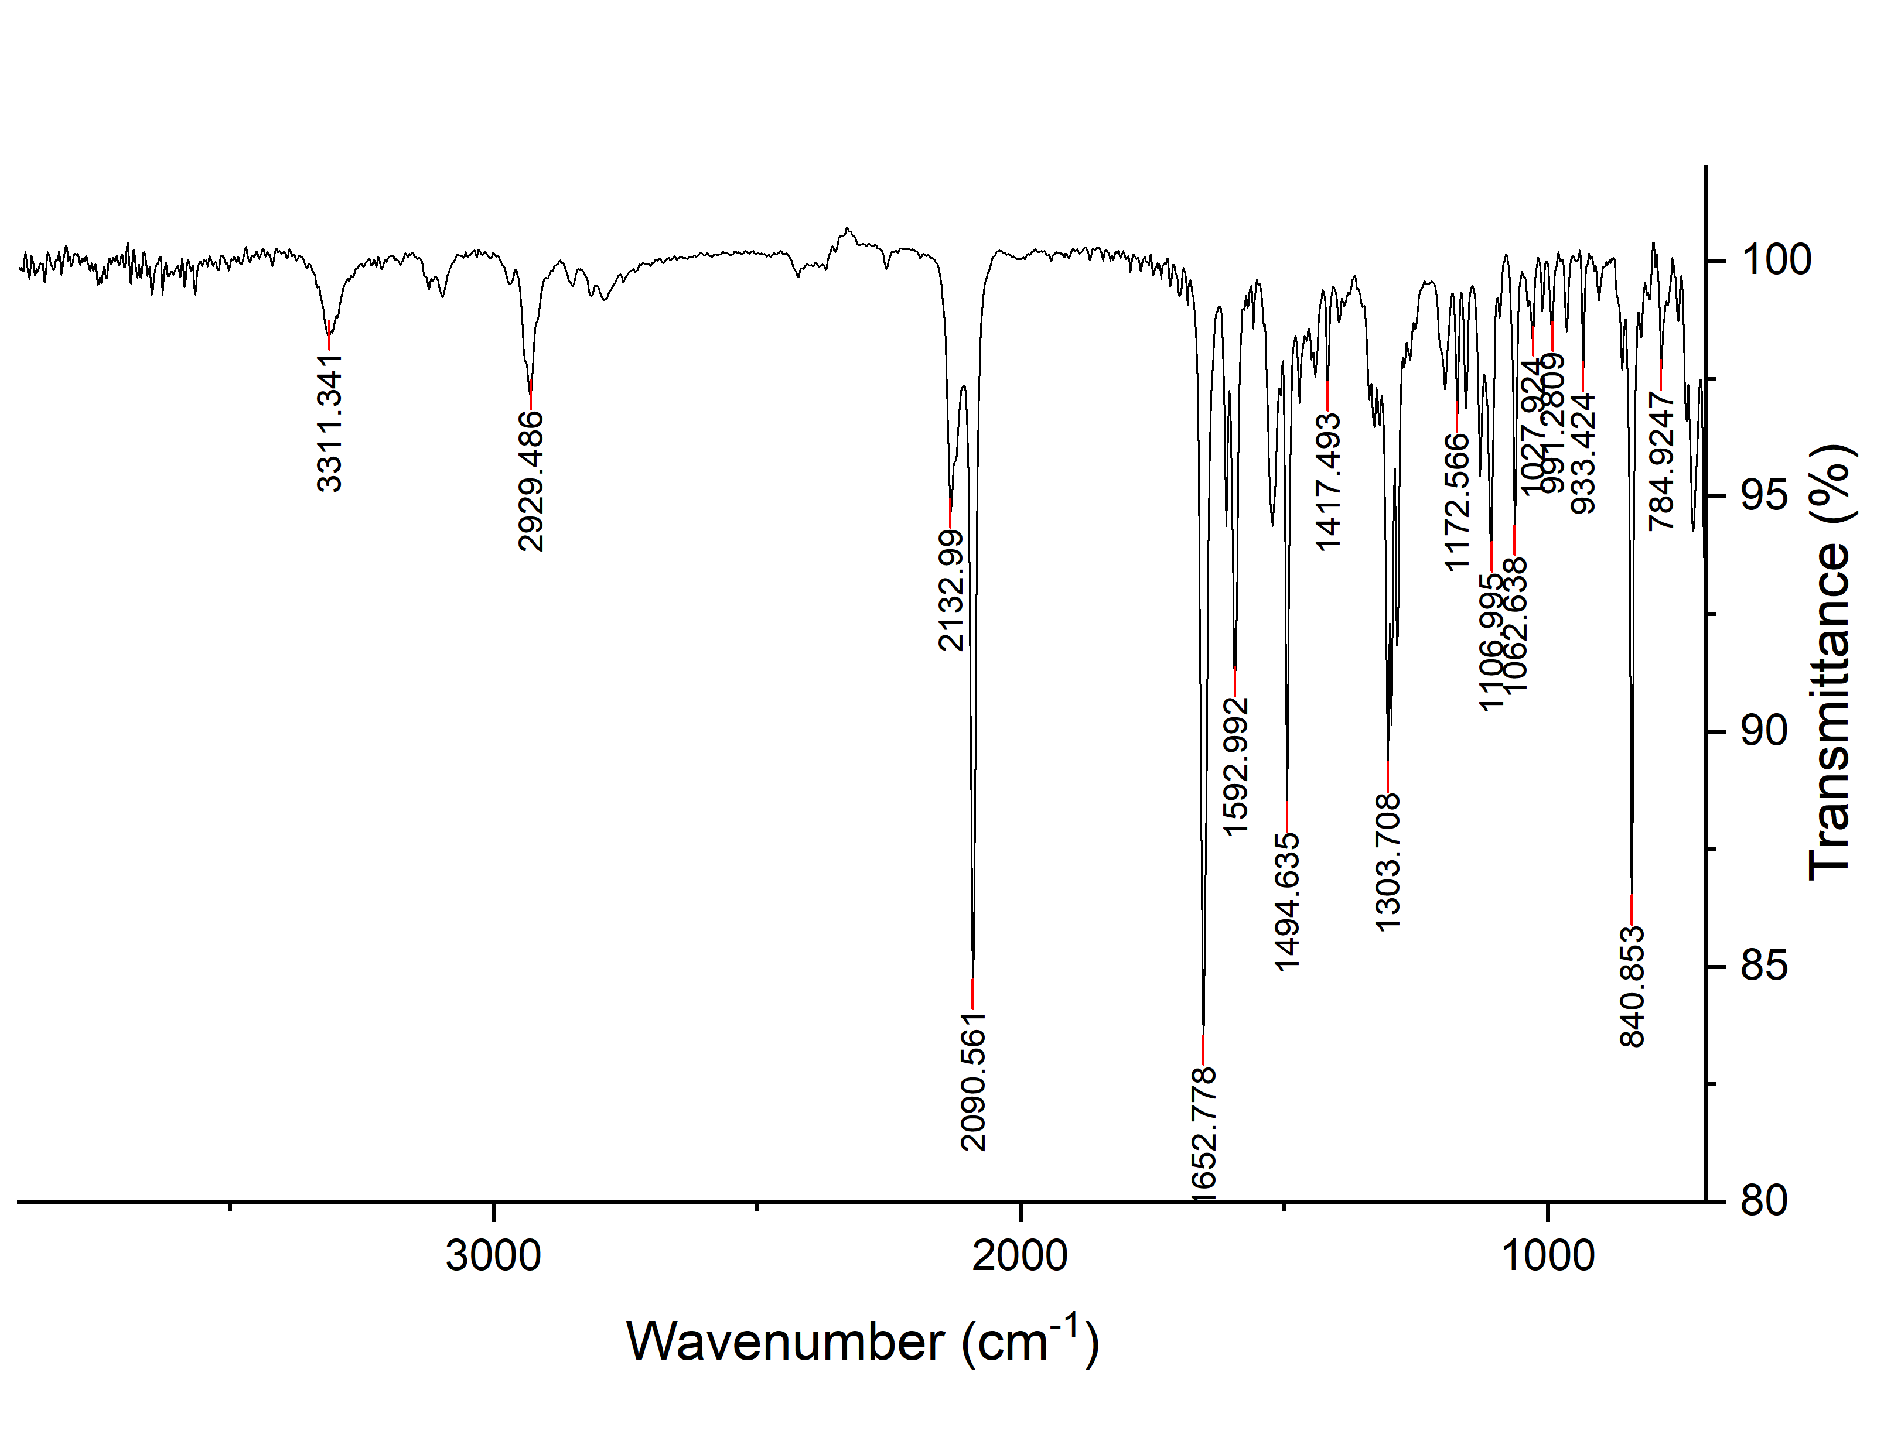

Figure S20. IR spectrum of 2-(4-azidophenyl)-N-[2-(piperidin-1-yl)ethyl]-1,3-oxazole-4-carboxamide (3)

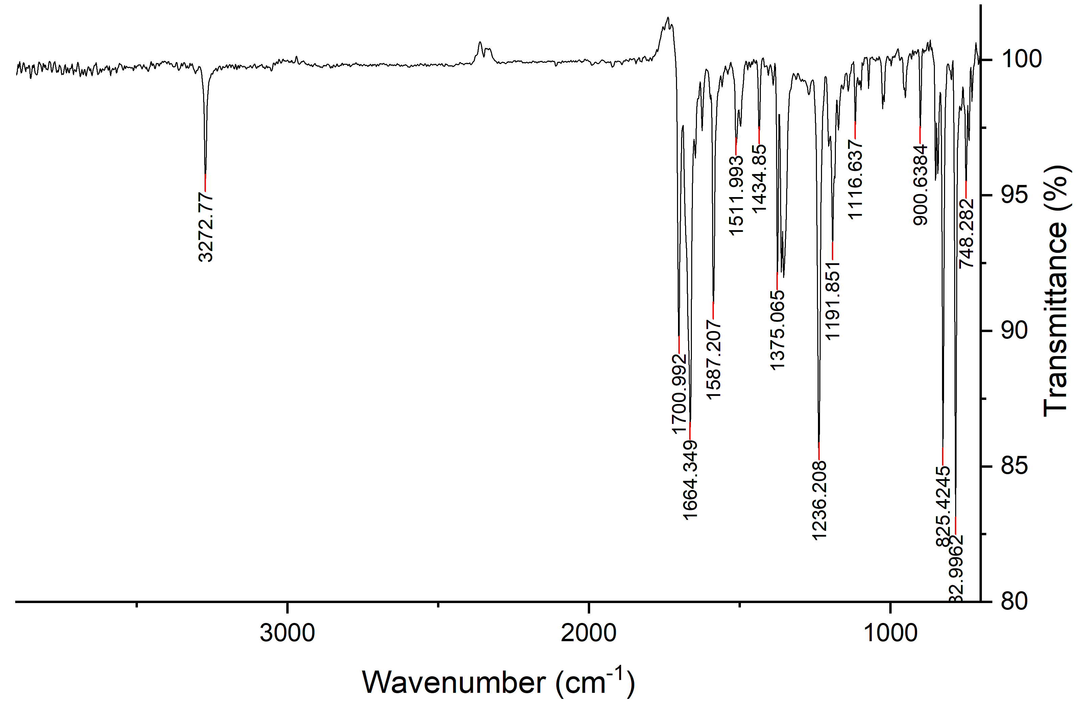

Figure S21. IR spectrum of 2-(4-ethynylphenyl)-1H-benzo[de]isoquinoline-1,3(2H)-dione (5)

