Additional file 1
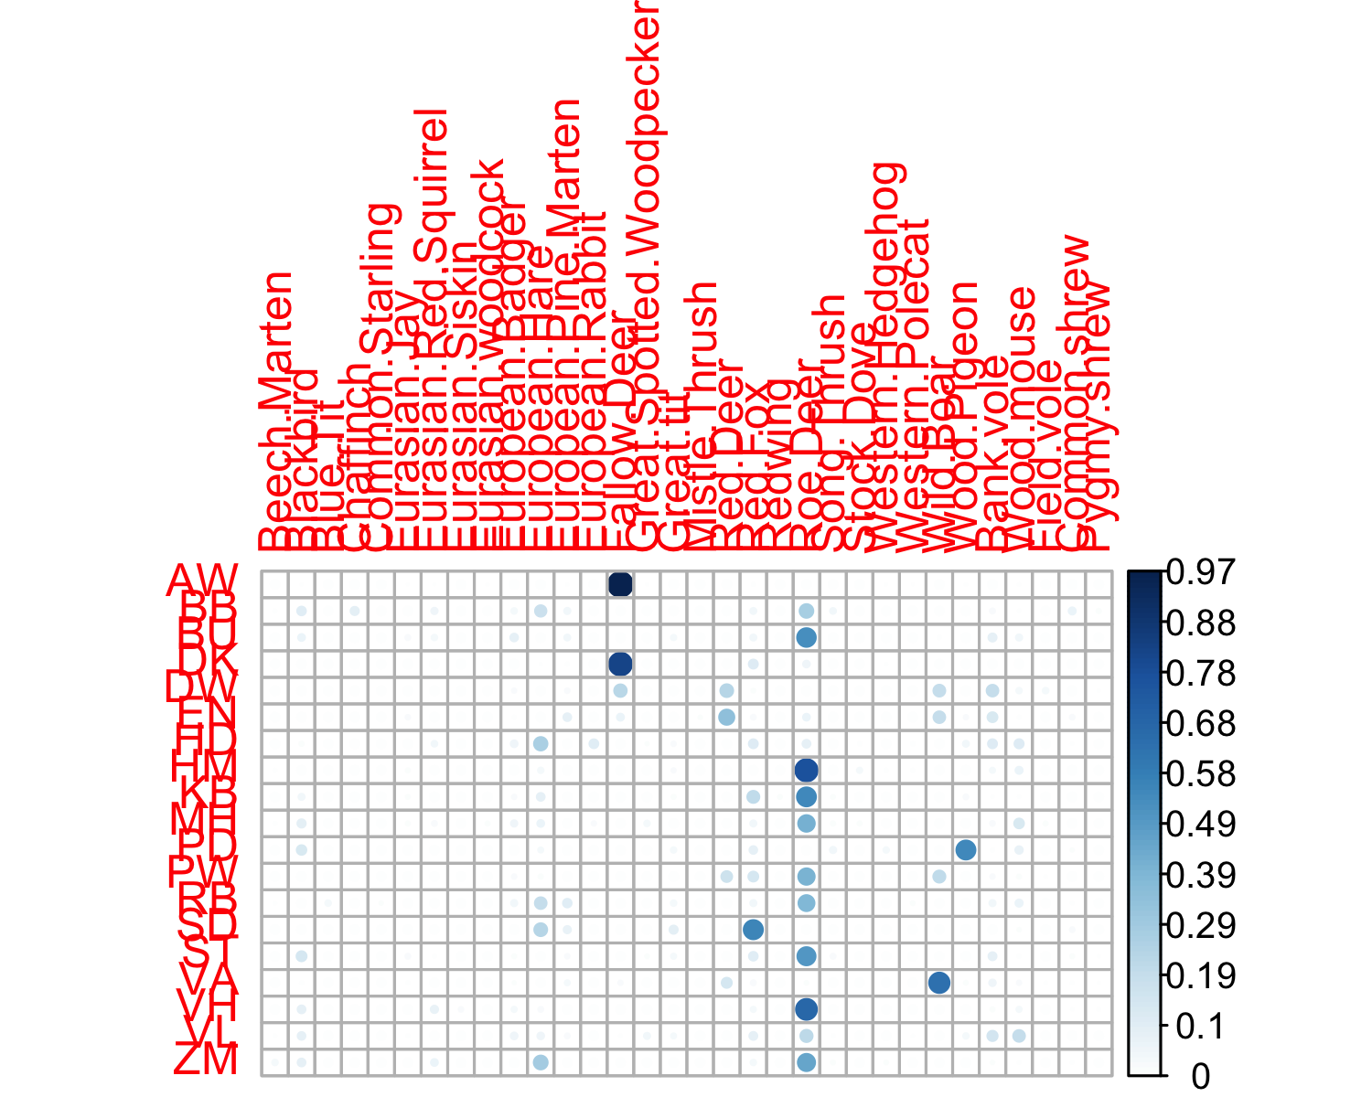
Figure 4: Encounter probability [14] for each forest site (row) and an individual vertebrate species (column) increases from 0 (light circle) to 1 (dark circle). A row sum equals to 1.

Table 5: Number of larval ticks on four ungulate species.
Species | Samples | DOL | Reference
Fallow.deer | 115 | 5719 | [28]
Red.deer | 32 | 0 | [32]
Red.deer | 147 | 4140 | [28]
Red.deer | 38 | 305 | [27]
Red.deer | 49 | 70 | [33]
Red.deer | 33 | 256 | [34]
Red.deer | 197 | 416 | [35]
Wild.boar | 9 | 73 | [27]
Roe.deer | 35 | 3 | [32]
Roe.deer | 224 | 621 | [35]
Roe.deer | 80 | 862 | [36]
Roe.deer | 67 | 577 | [28]
Roe.deer | 154 | 459 | [37]
Roe.deer | 37 | 9805 | [38]
Roe.deer | 367 | 1052 | [39]
Roe.deer | 142 | 268 | [40]
Roe.deer | 2 | 130 | [41]
Roe.deer | 50 | 0 | [41]
Roe.deer | 54 | 8 | [41]
Roe.deer | 28 | 30 | [41]

Table 6: Summary of tests for the presence of Anaplasma phagocytophilum in questing Ixodes ricinus nymphs.
 | DON | Test | Positive | NIP | DIN
BU | 2200 | 688 | 0 | 0.000 | 0.000
DW | 1647 | 1650 | 68 | 0.041 | 67.876
HM | 1531 | 624 | 36 | 0.058 | 88.327
EN | 1379 | 1397 | 62 | 0.044 | 61.201
ST | 1134 | 1129 | 9 | 0.008 | 9.040
VH | 1039 | 1039 | 4 | 0.004 | 4.000
DK | 870 | 858 | 31 | 0.036 | 31.434
BB | 869 | 742 | 6 | 0.008 | 7.027
RB | 859 | 863 | 7 | 0.008 | 6.968
KB | 794 | 791 | 2 | 0.003 | 2.008
VA | 765 | 763 | 42 | 0.055 | 42.110
PW | 760 | 767 | 114 | 0.149 | 112.960
AW | 726 | 678 | 39 | 0.058 | 41.761
ZM | 680 | 665 | 21 | 0.032 | 21.474
MH | 640 | 639 | 11 | 0.017 | 11.017
VL | 403 | 398 | 2 | 0.005 | 2.025
PD | 130 | 130 | 1 | 0.008 | 1.000
HD | 120 | 120 | 1 | 0.008 | 1.000
SD | 22 | 26 | 0 | 0.000 | 0.000

Table 7: Correlation in encounter rates between ungulates and other forest species [14].
 | Roe.Deer | Fallow.Deer | Red.Deer | Wild.Boar
Beech.Marten | 0.345 | -0.130 | -0.215 | -0.150
Blackbird | 0.325 | -0.180 | -0.358 | -0.200
Blue.Tit | 0.266 | -0.068 | -0.111 | -0.078
Chaffinch | -0.071 | -0.068 | -0.111 | -0.078
Common.Starling | 0.266 | -0.068 | -0.111 | -0.078
Eurasian.Jay | 0.185 | 0.100 | 0.357 | 0.265
Eurasian.Red.Squirrel | 0.108 | -0.069 | -0.316 | -0.220
Eurasian.Siskin | 0.244 | -0.068 | -0.111 | -0.078
Eurasian.woodcock | -0.231 | 0.872 | -0.153 | -0.106
European.Badger | 0.247 | -0.228 | -0.133 | -0.051
European.Hare | 0.189 | -0.196 | -0.320 | -0.224
European.Pine.Marten | -0.037 | -0.033 | 0.475 | 0.344
European.Rabbit | -0.145 | -0.075 | -0.123 | -0.086
Fallow.Deer | -0.327 | 1.000 | -0.110 | -0.083
Great.Spotted.Woodpecker | 0.233 | 0.034 | -0.187 | -0.130
Great.tit | 0.358 | -0.220 | -0.363 | -0.253
Mistle.Thrush | -0.207 | -0.059 | 0.661 | 0.085
Red.Deer | -0.435 | -0.110 | 1.000 | 0.685
Red.Fox | 0.024 | -0.004 | -0.247 | -0.090
Redwing | 0.293 | -0.068 | -0.111 | -0.078
Roe.Deer | 1.000 | -0.327 | -0.435 | -0.325
Song.Thrush | 0.085 | -0.189 | -0.312 | -0.217
Stock.Dove | 0.326 | -0.116 | -0.191 | -0.133
Western.Hedgehog | -0.259 | 0.317 | -0.222 | -0.155
Western.Polecat | 0.256 | 0.073 | -0.240 | -0.167
Wild.Boar | -0.325 | -0.083 | 0.685 | 1.000
Wood.Pigeon | -0.299 | -0.047 | -0.087 | -0.039
Bank.vole | -0.065 | -0.198 | 0.459 | 0.253
Wood.mouse | 0.193 | -0.094 | -0.144 | -0.057
Field.vole | -0.306 | -0.070 | 0.458 | 0.248
Common.shrew | -0.191 | -0.169 | 0.331 | 0.164
Pygmy.shrew | -0.069 | -0.121 | 0.067 | 0.209

