SUPPLEMENTARY INFORMATION ON
REACTION MECHANISM AND RATE CONSTANTS OF BENZOTHIOPHENE DESULFURIZATION: A DFT AND KINETIC MODELING STUDY
Basheer Aazaad¹, and Angappan Mano Priya²*
¹ Department of Physics, Saveetha Engineering College (Autonomous), Thandalam, Chennai -602105, Tamilnadu, India.
² Institut de Physique de Rennes - UMR 6251 du CNRS, Université de Rennes, Rennes, France.

Corresponding Author: manoophys@gmail.com, mano-priya.angappan@univ-rennes.fr

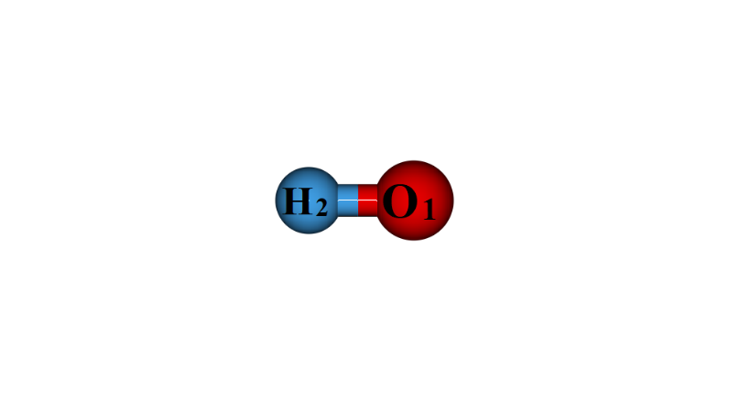
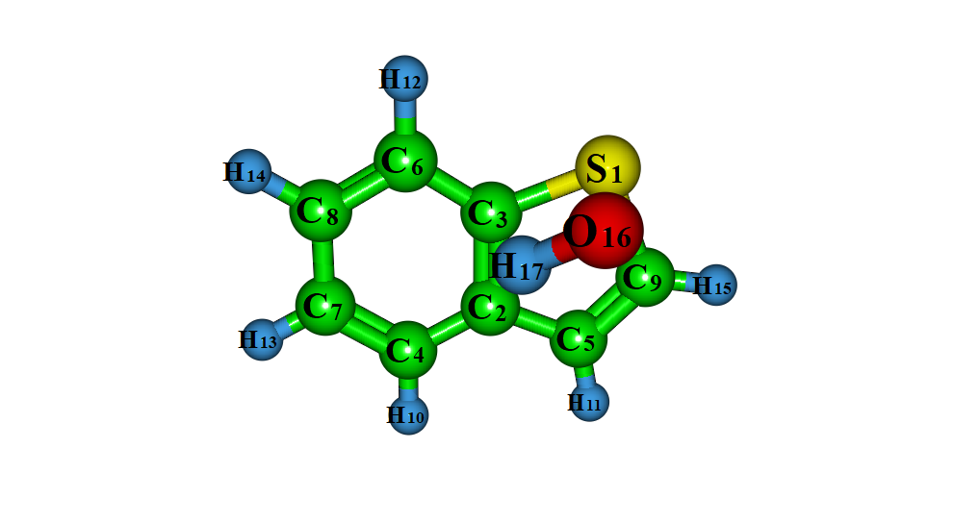
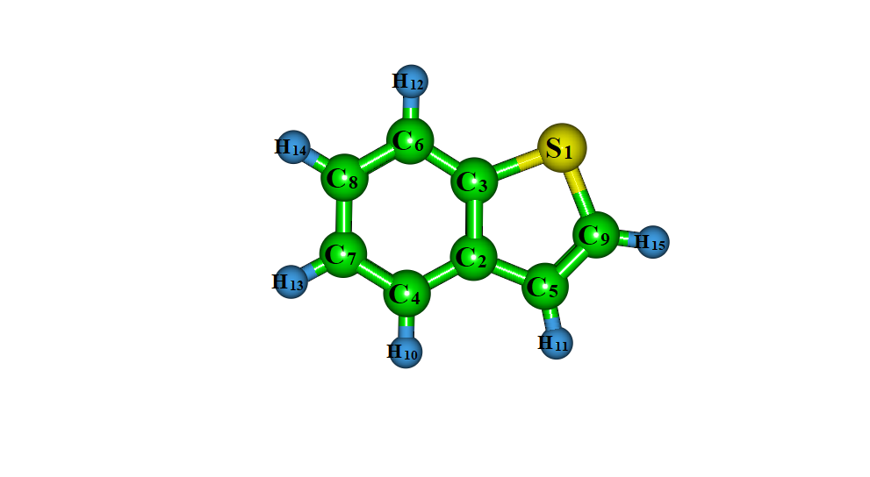
R OH RC
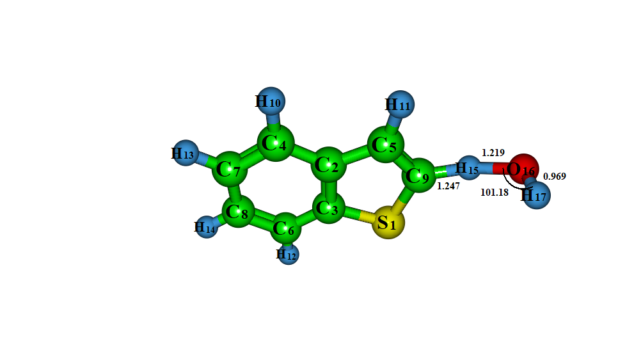
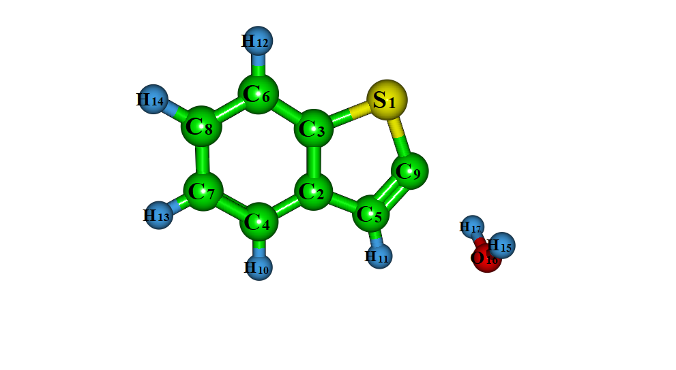

TS1-abs IC1-abs

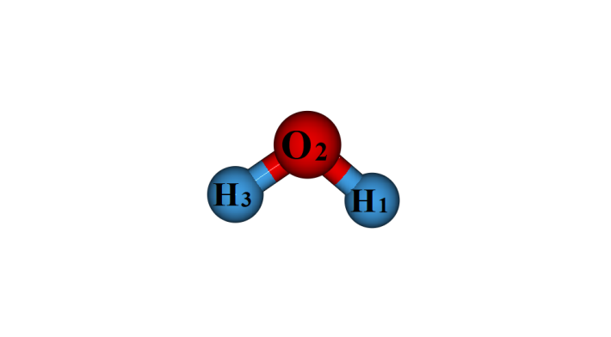
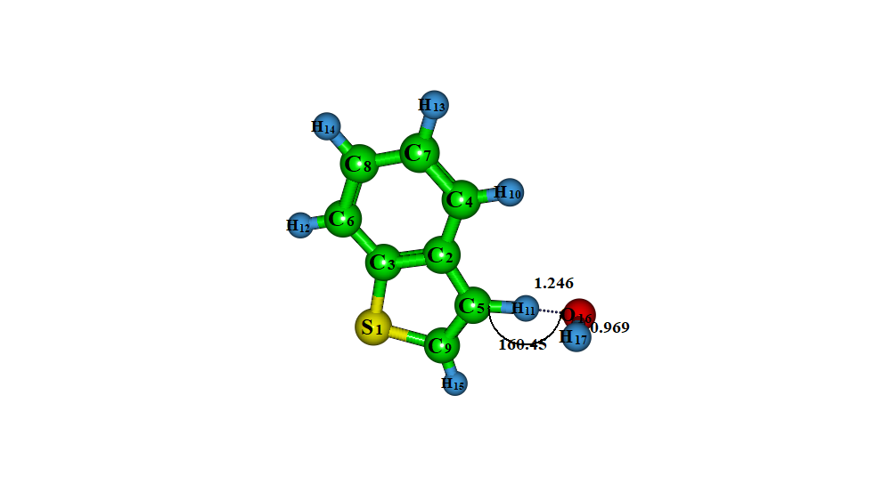
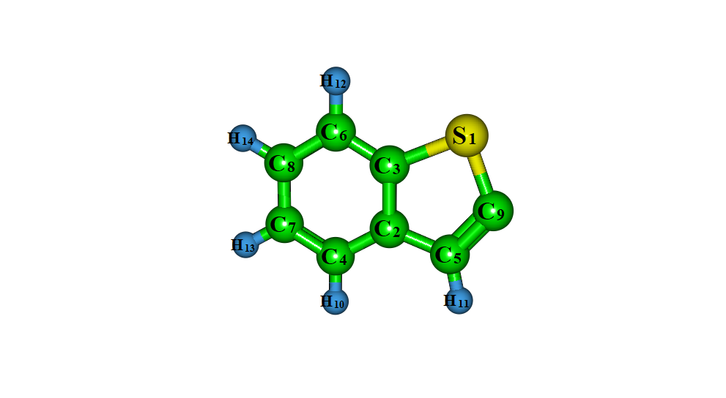
I1-abs H₂O TS2-abs

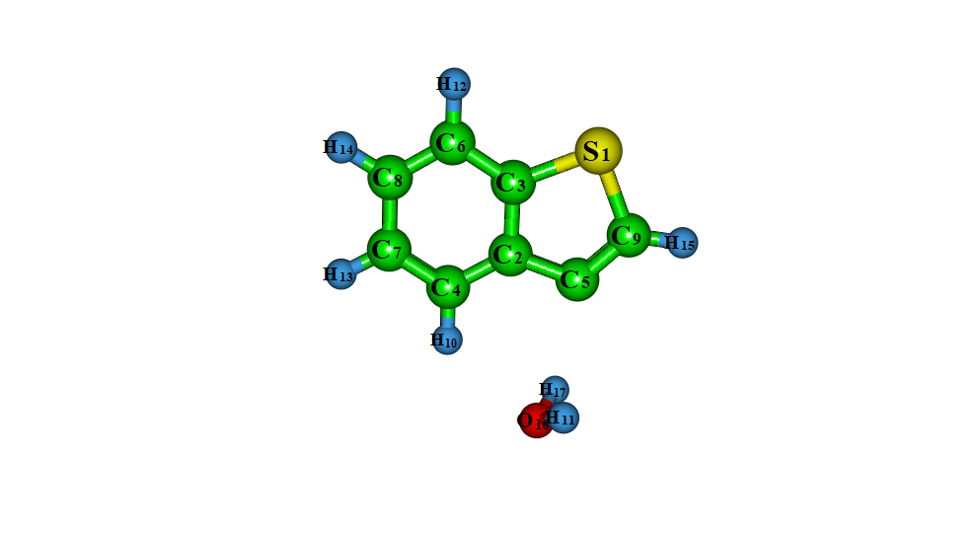
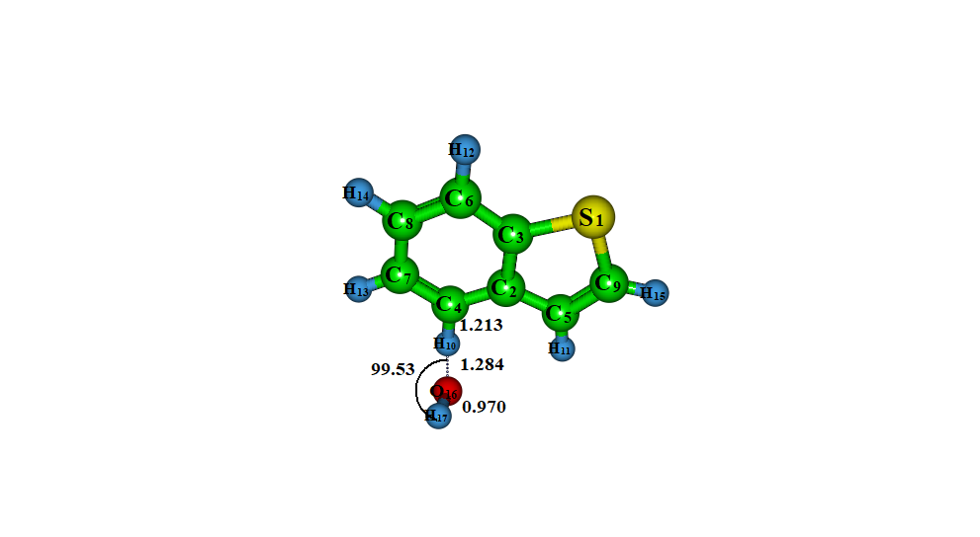
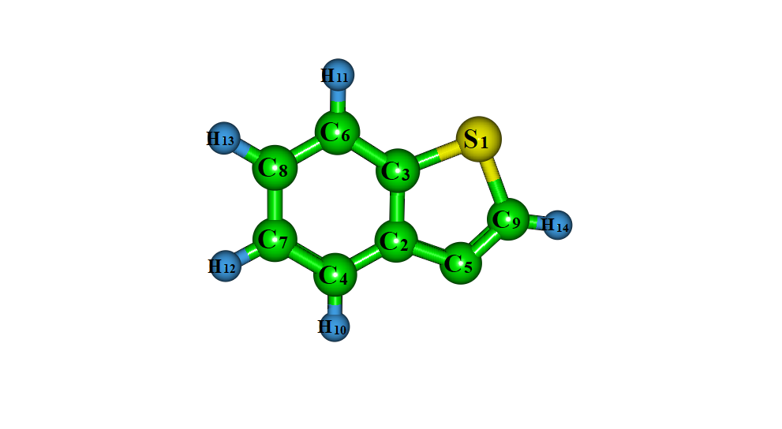
IC2-abs I2-abs TS3-abs

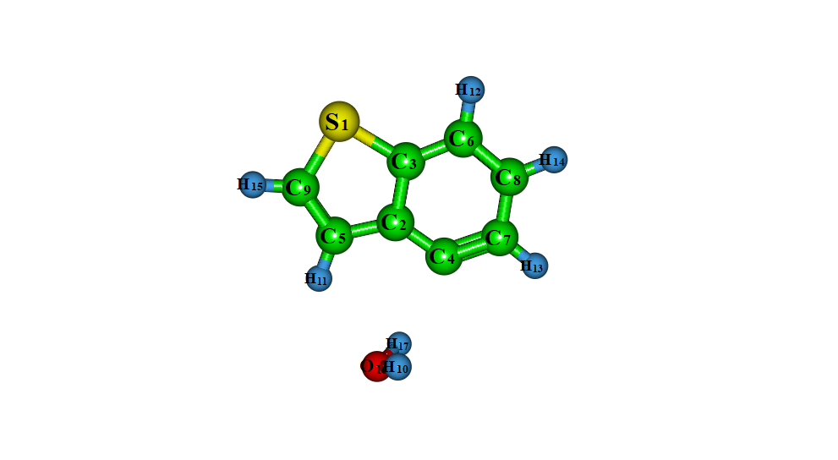
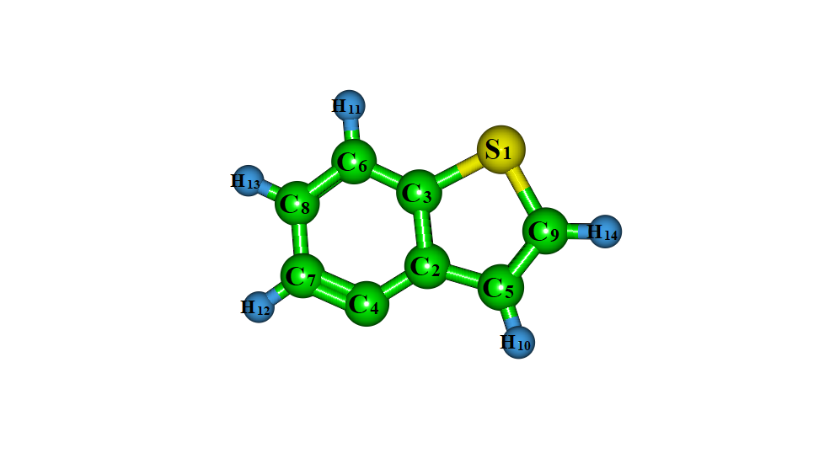
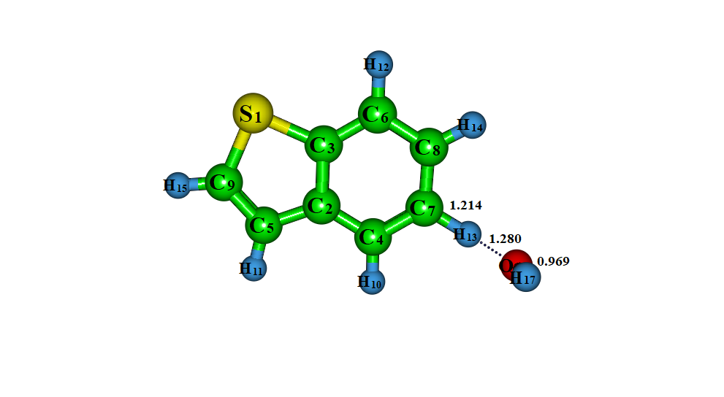
IC3-abs I3-abs TS4-abs

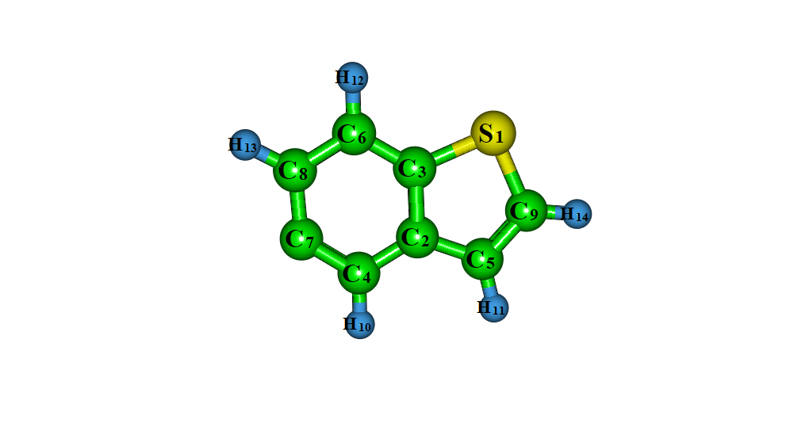
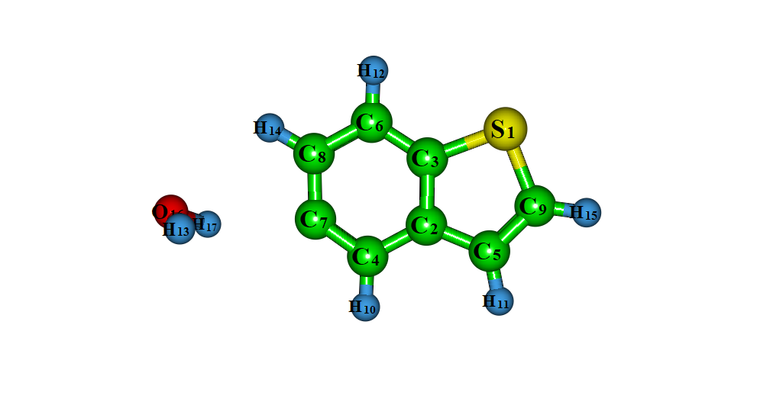

IC4-abs I4-abs

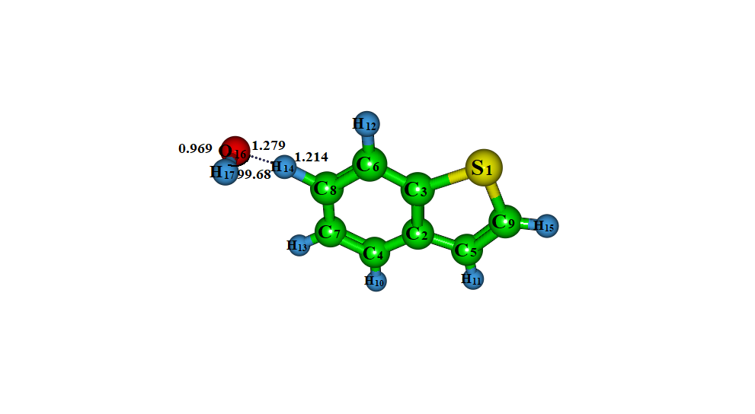
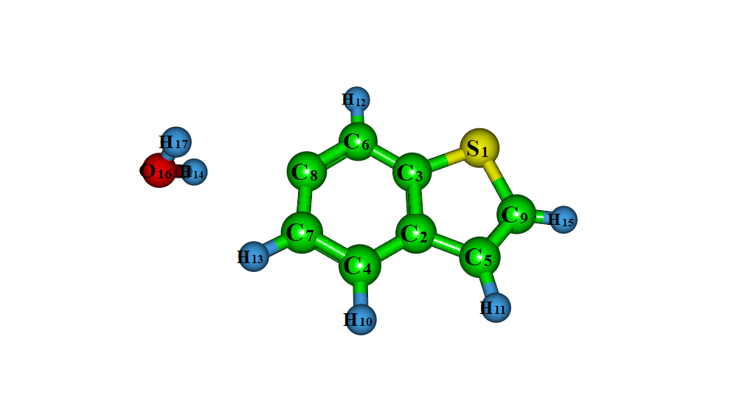
TS5-abs IC5-abs
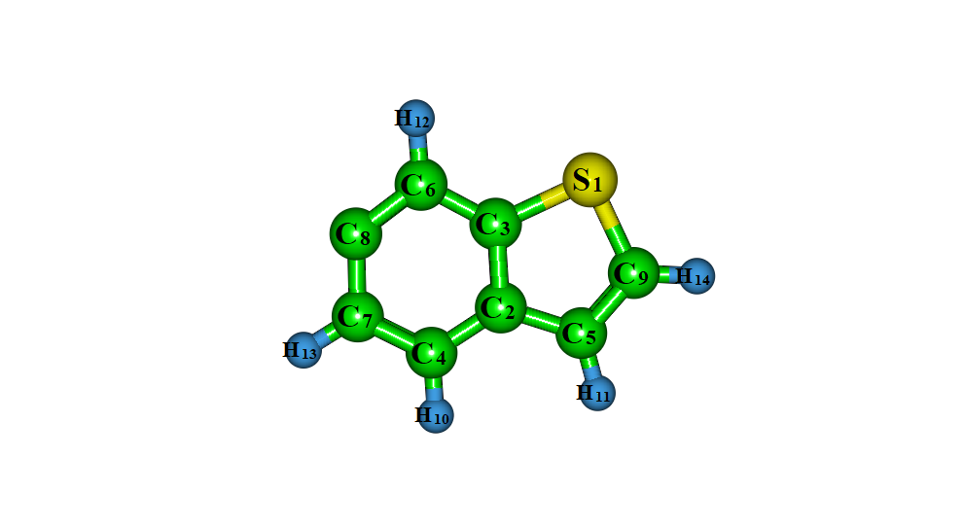
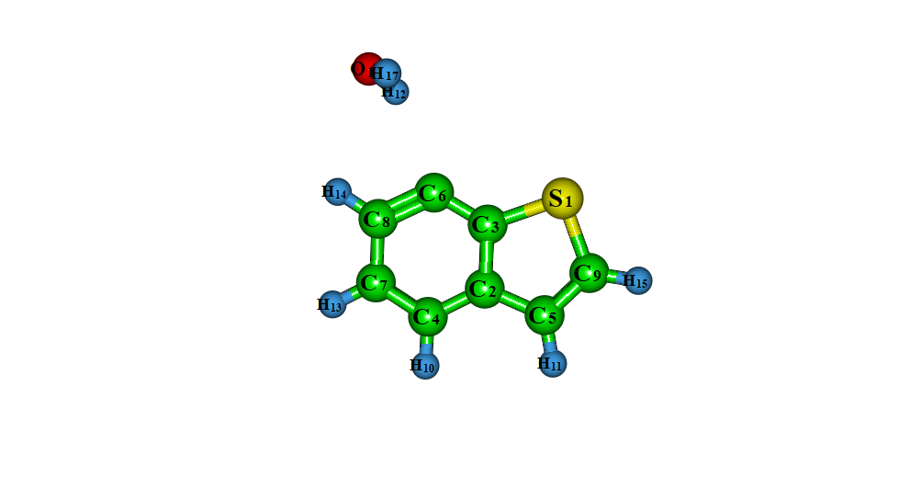
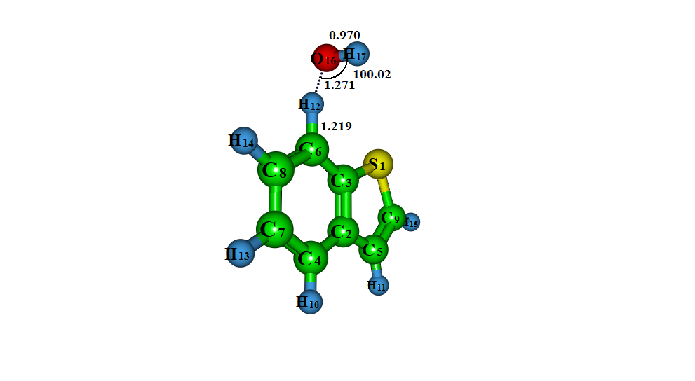

I5-abs TS6-abs IC6-abs

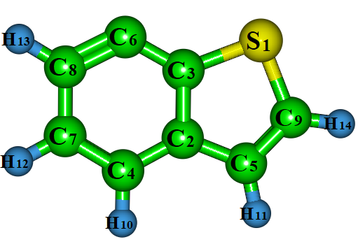

I6-abs

Fig. S1 Optimized structures of BT with OH radical via H-abstraction at M06-2X/6-311++G(d, p) level of theory

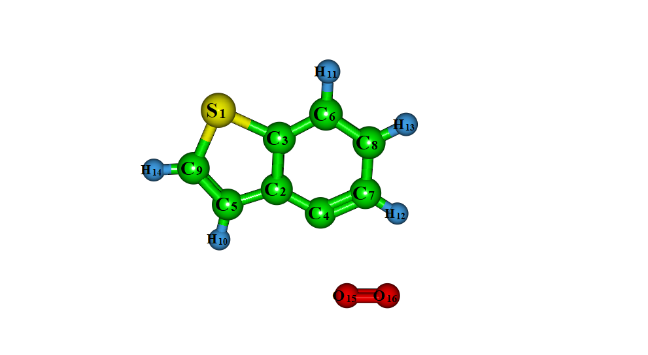
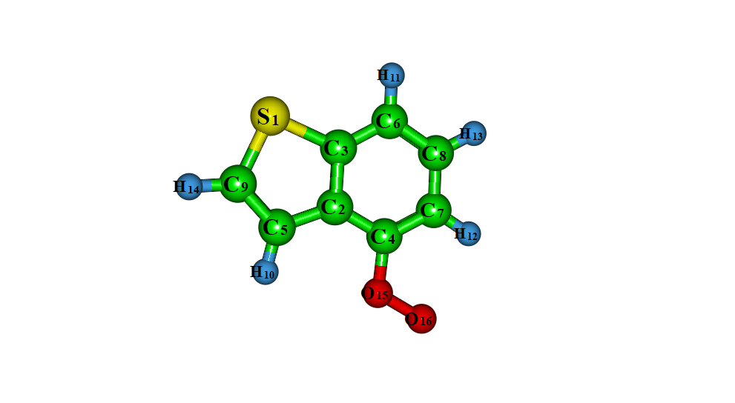

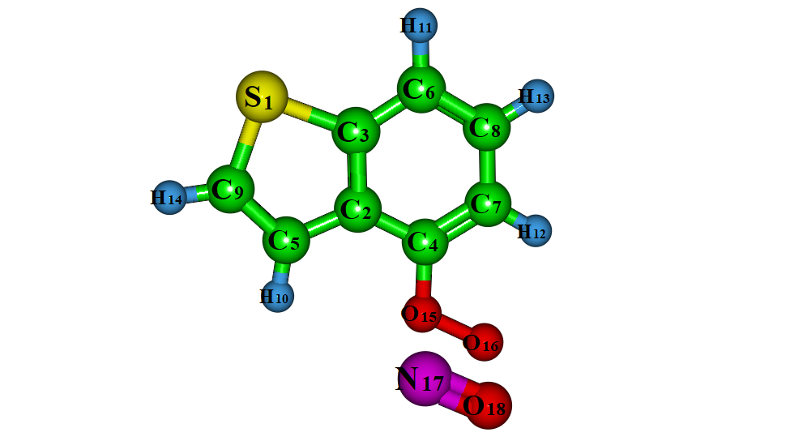
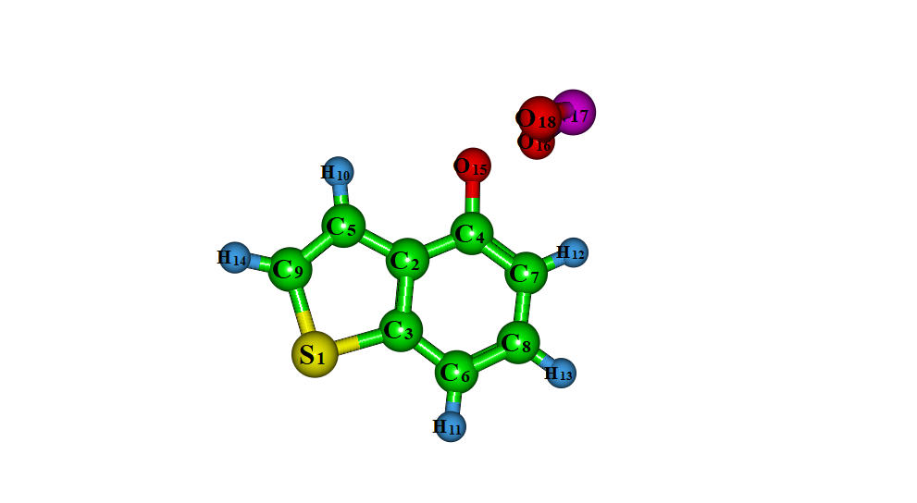
I3-abs + O₂ I7

I7+NO I8
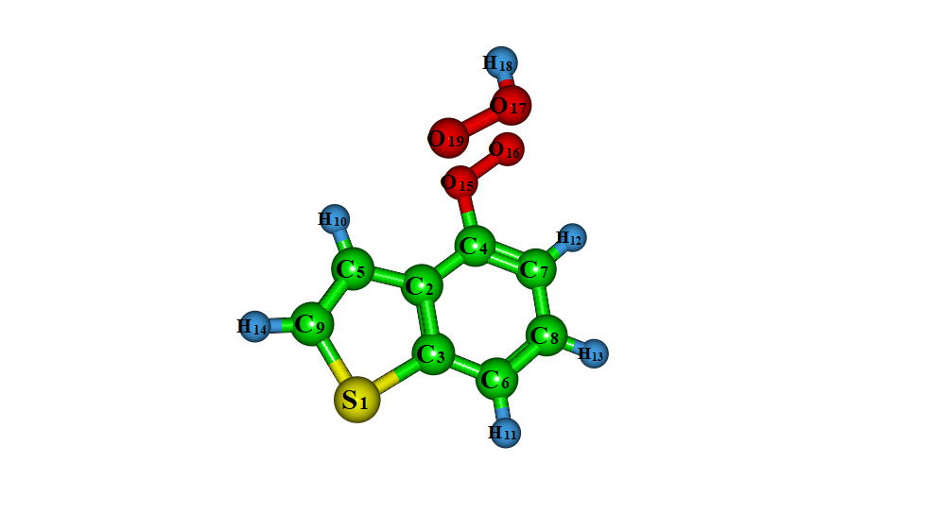
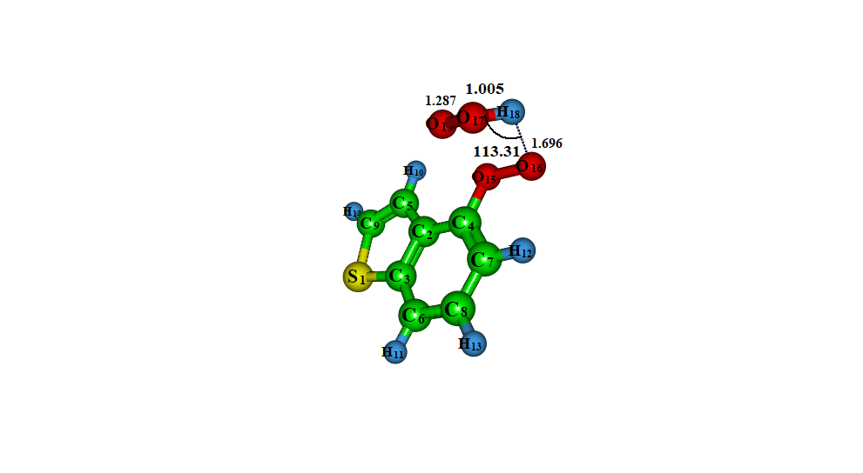
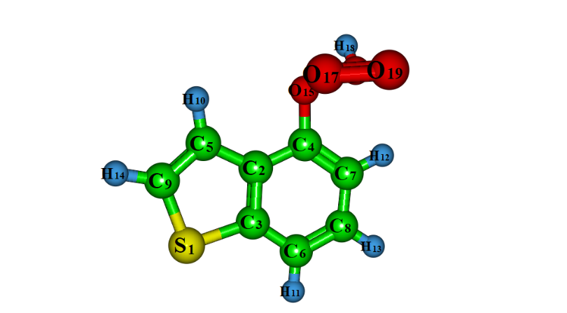

I7 + HO₂ TS7 P1
Fig. S2 Optimized structures of I3-abs with O₂, NO and HO₂ at M06-2X/6-311++G(d, p) level of theory.

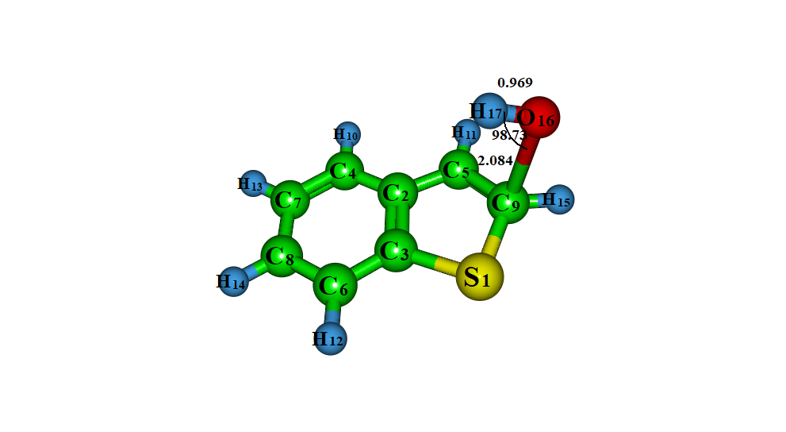
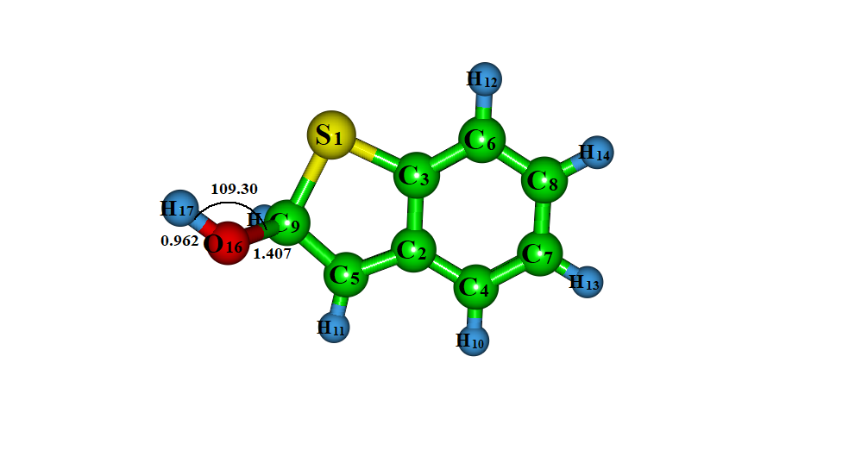

TS1-add I1-add

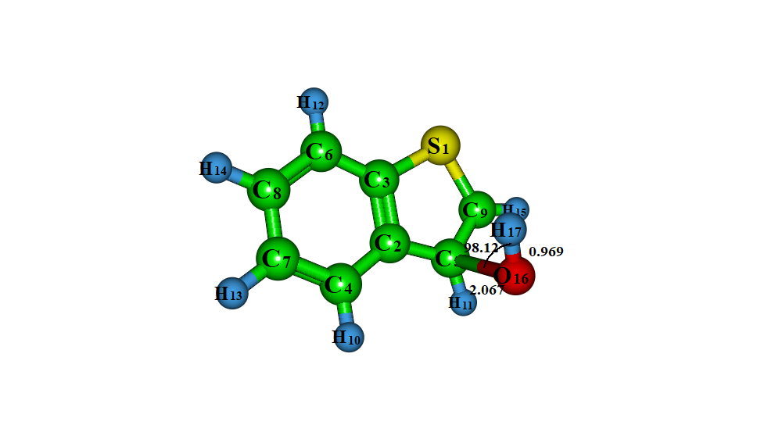
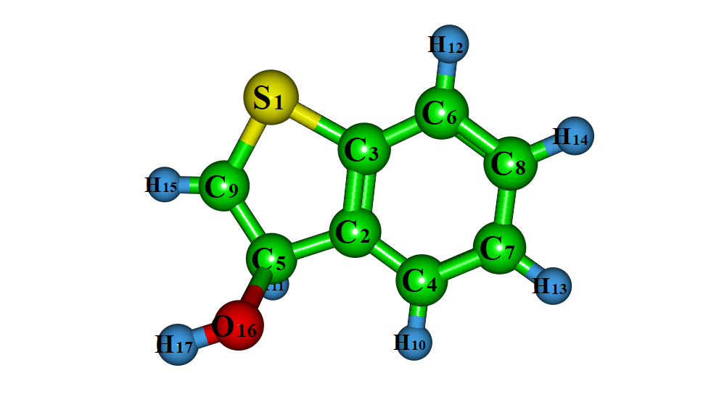
TS2-add I2-add
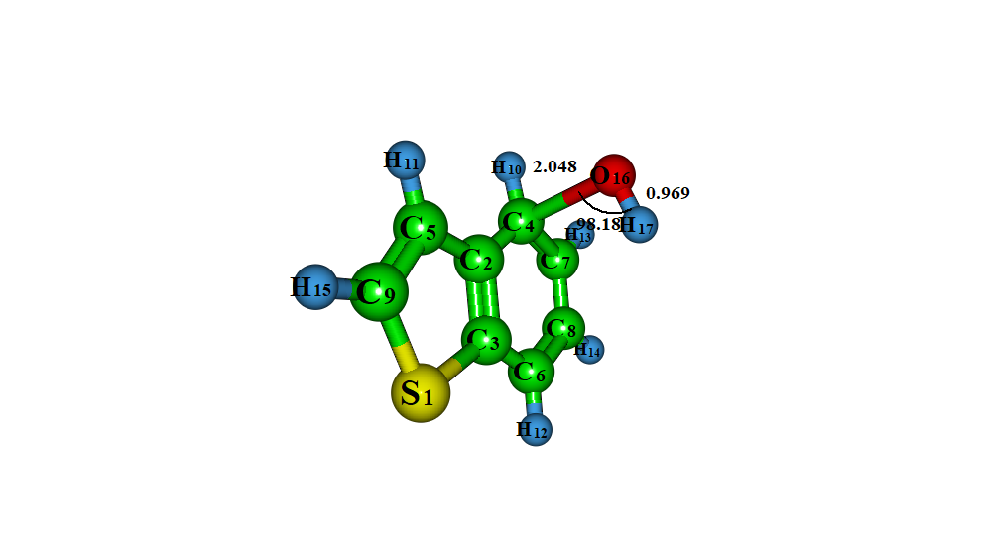
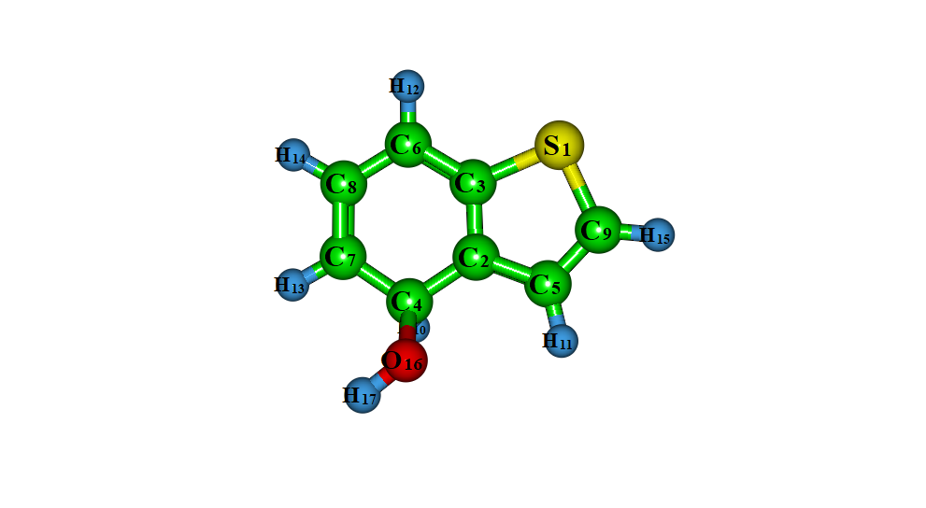
TS3-add I3-add

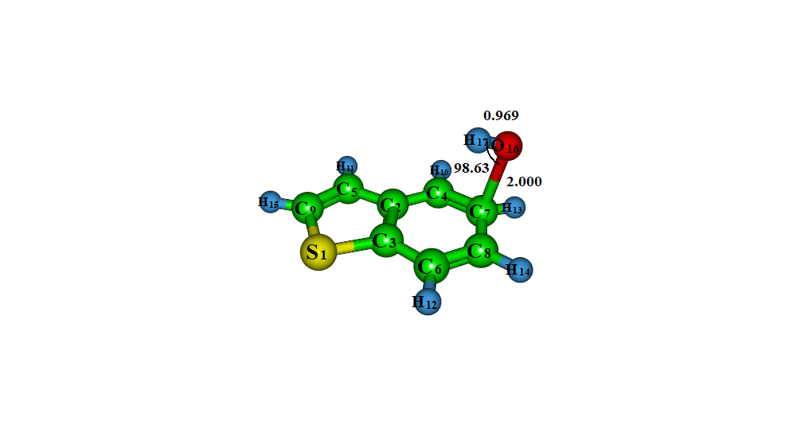
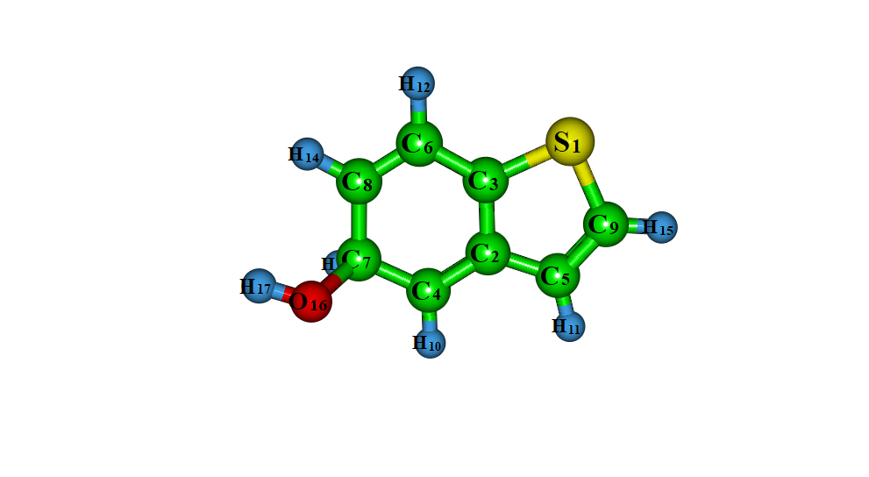
TS4-add I4add
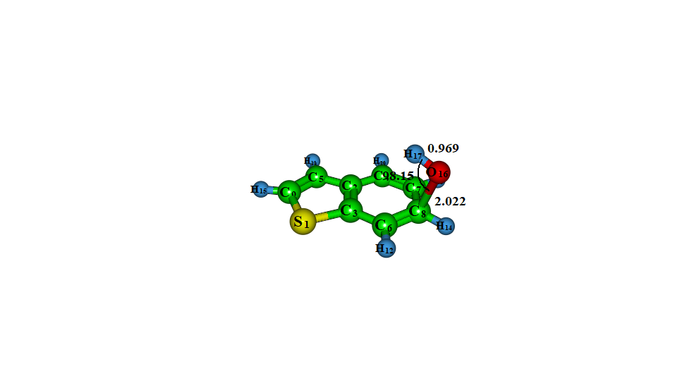
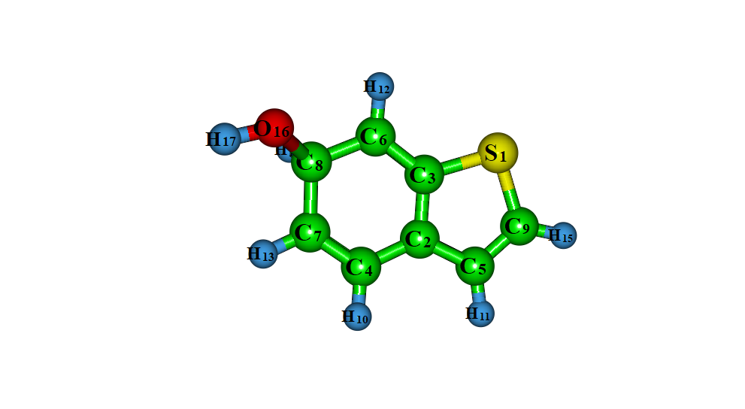

TS5-add I5-add
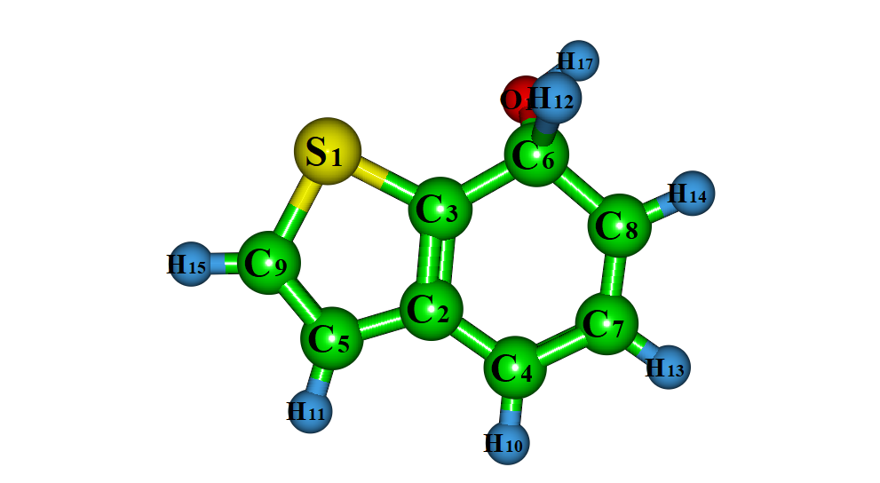
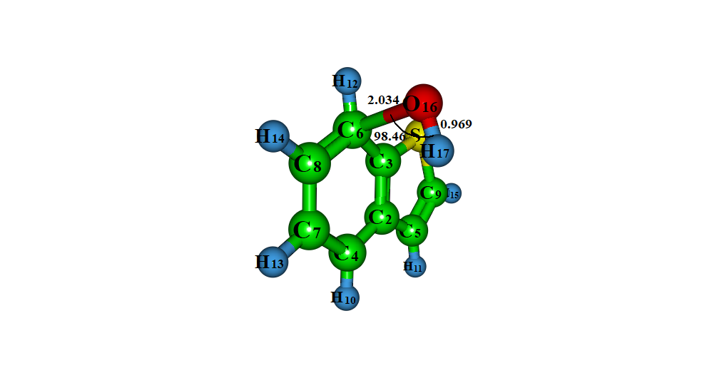

TS6-add I6-add
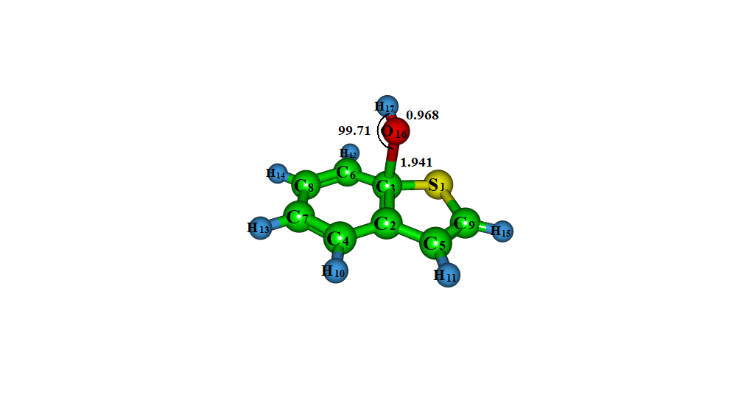
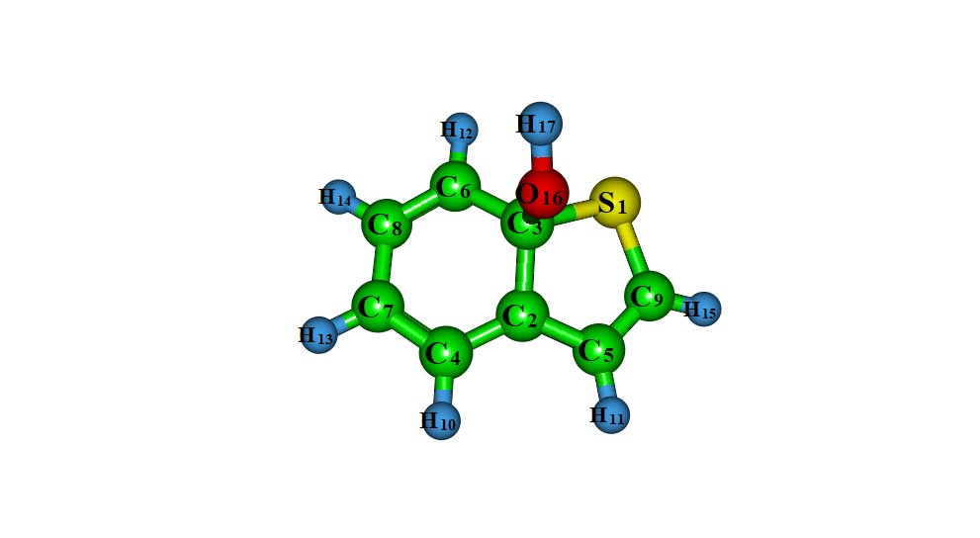
TS7-add I7-add
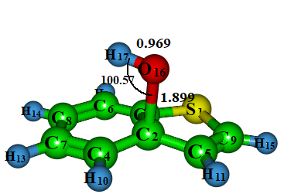
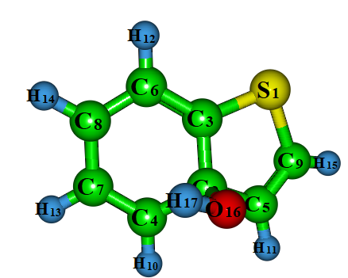

TS8-add I8-add

Fig. S3 Optimized structures of BT with OH radical via OH-addition at M06-2X/6-311++G(d, p) level of theory

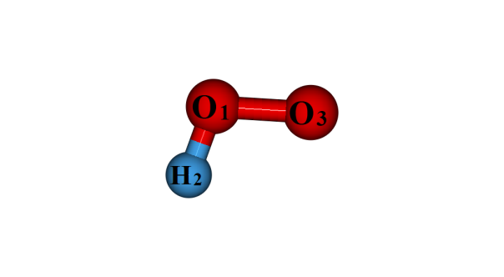
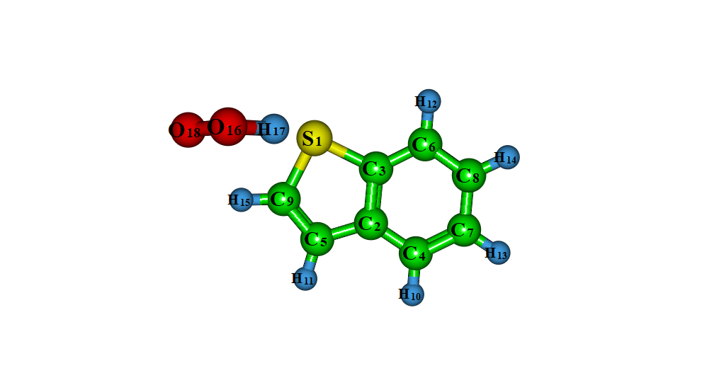
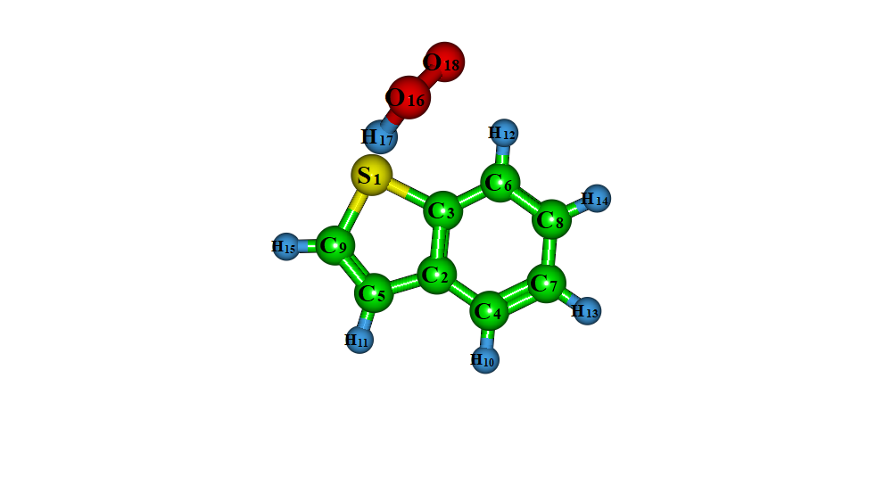

HO₂ RC1- HO₂ RC2 - HO₂

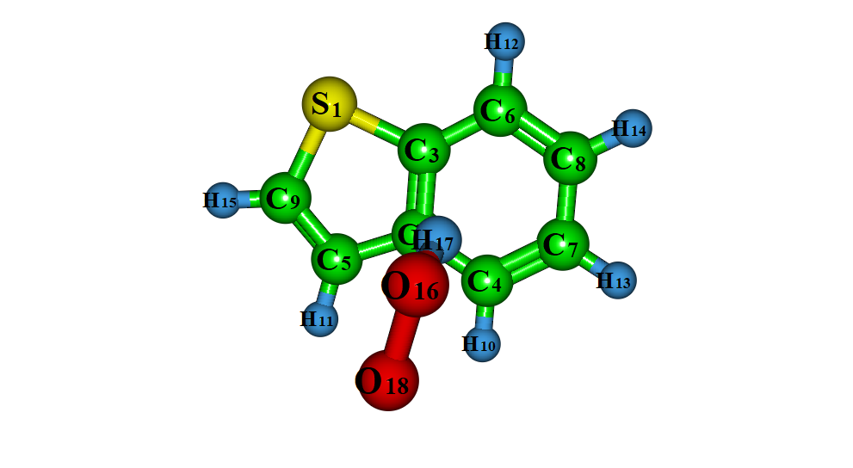
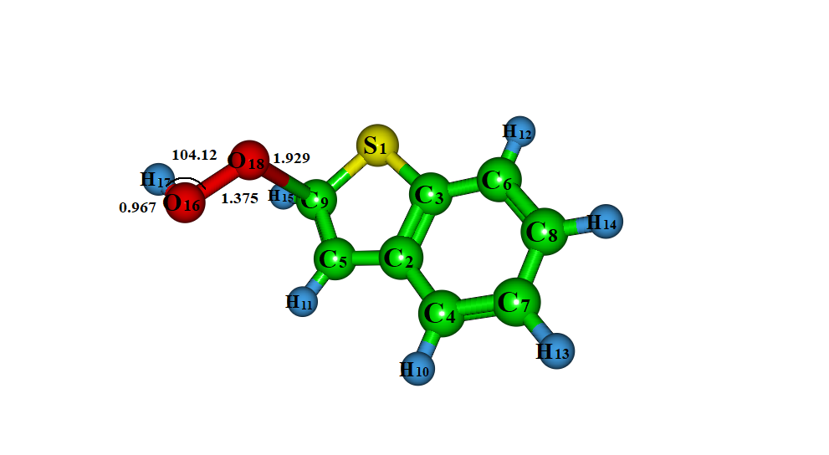

RC3- HO₂ TS1- HO₂
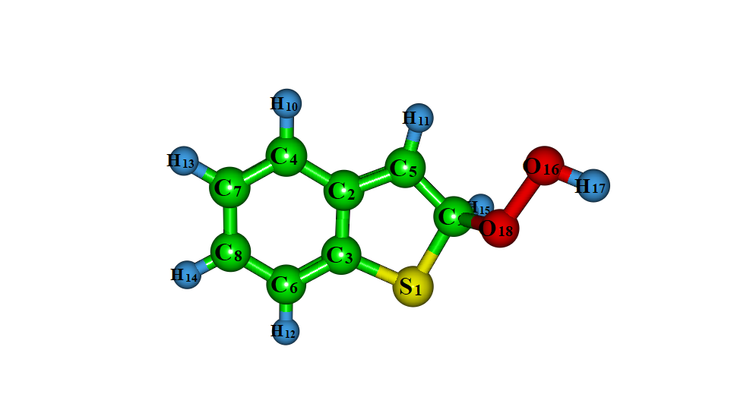
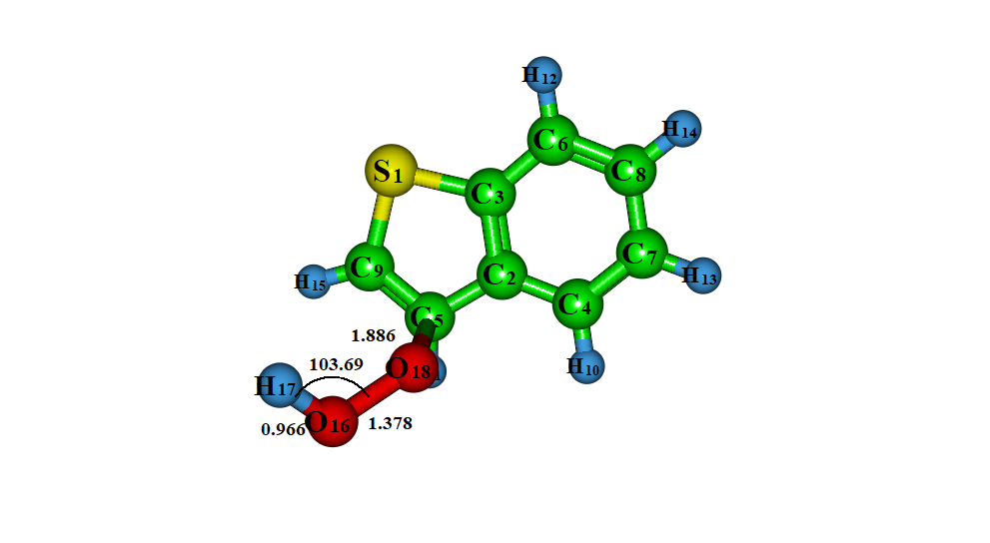

I1- HO₂ TS2-HO₂

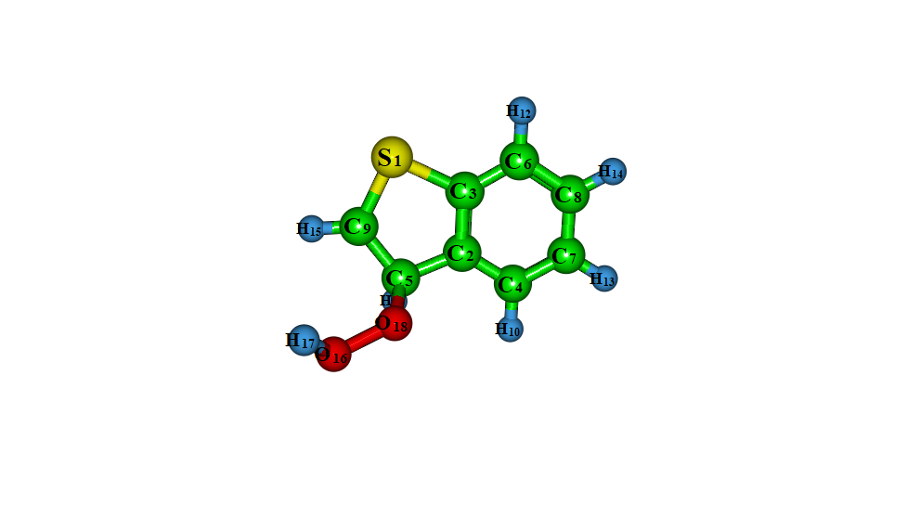
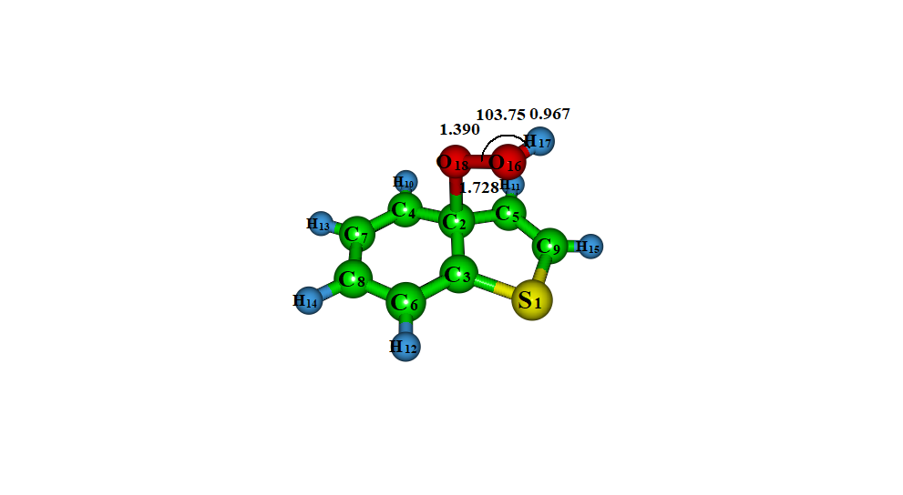

I2-HO₂ TS3-HO₂
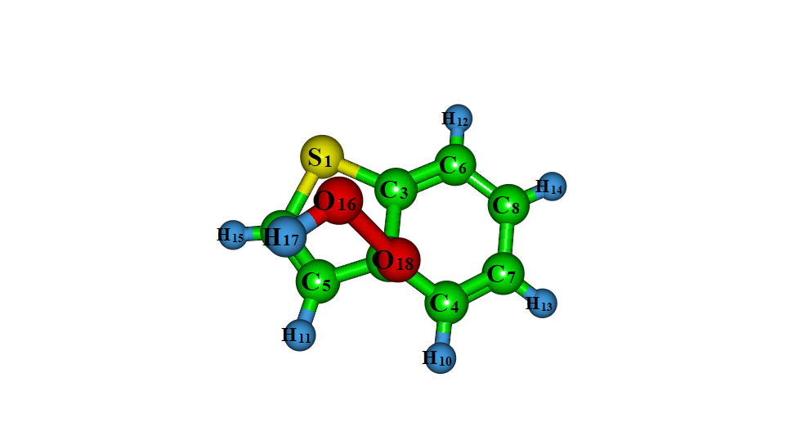
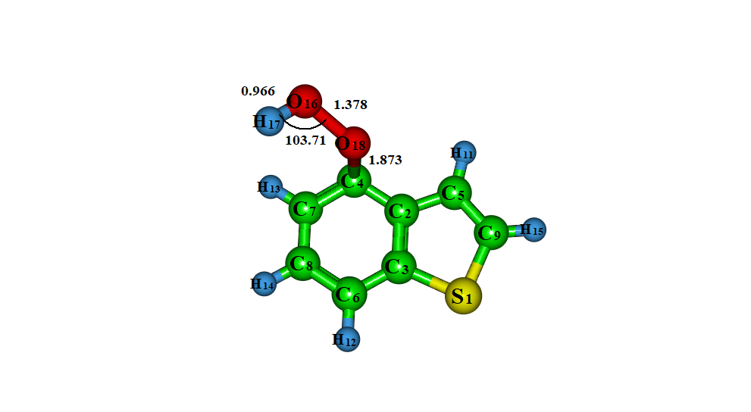

I3-HO₂ TS4-HO₂
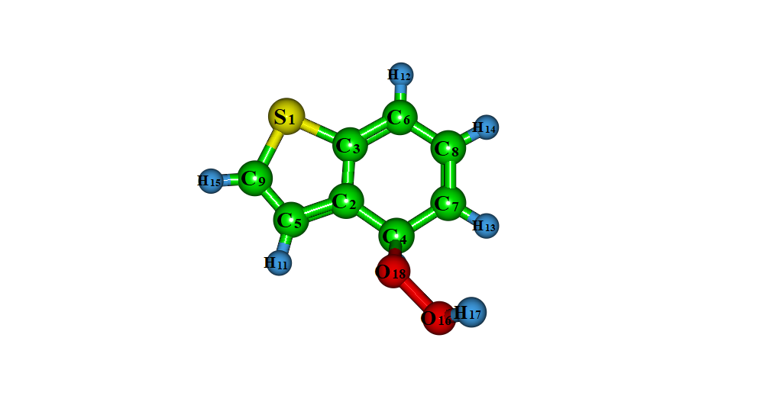
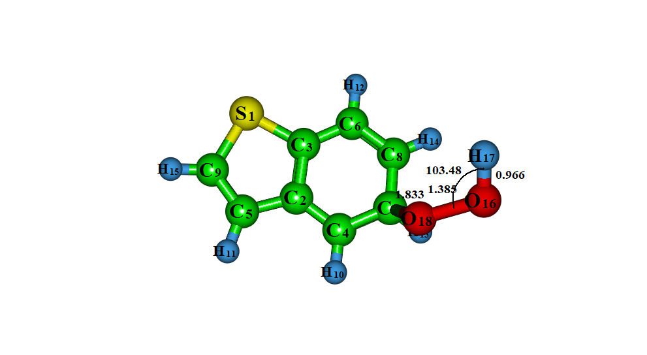

I4-HO₂ TS5-HO₂

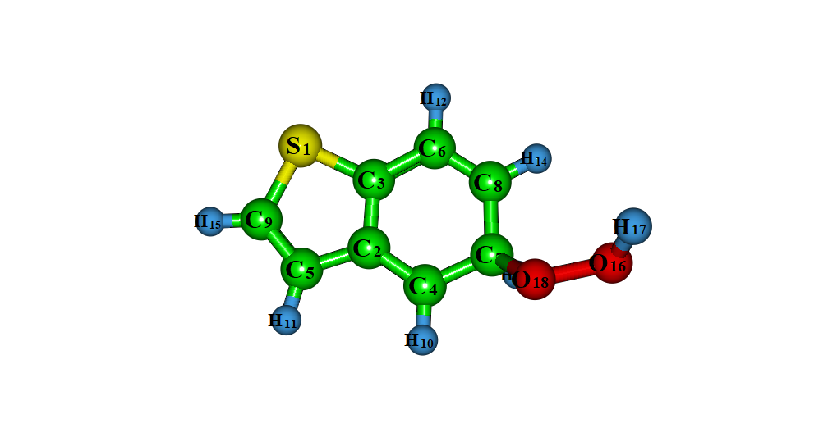
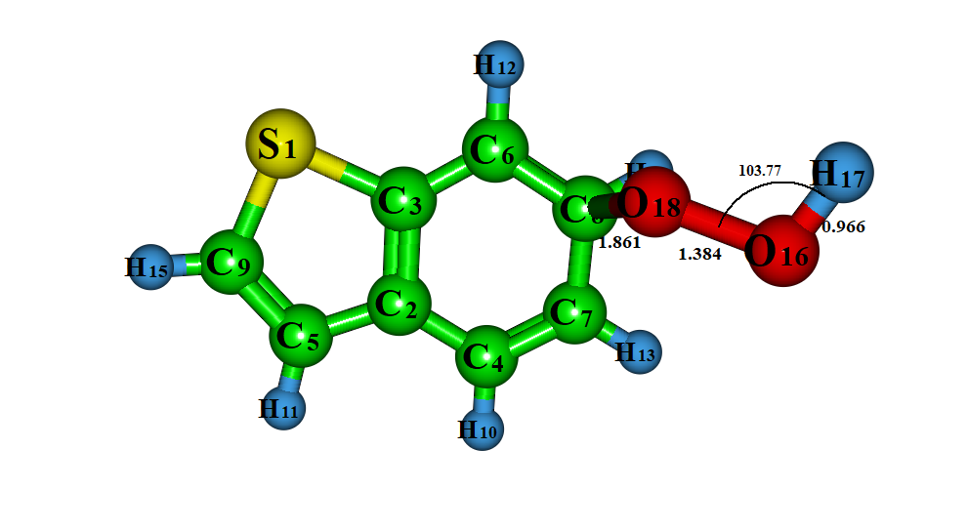

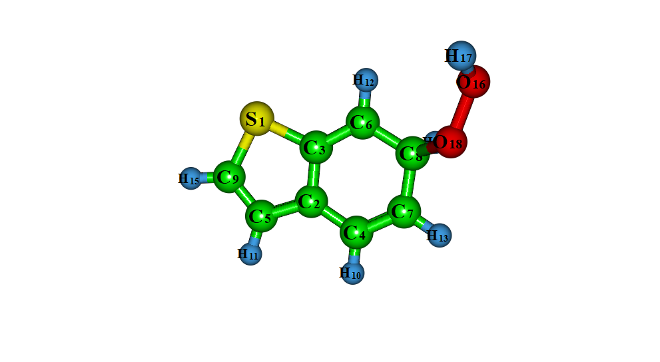
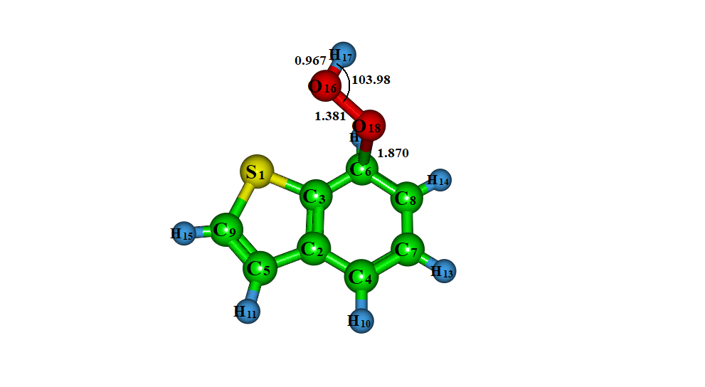
I5-HO₂ TS6-HO₂

I6-HO₂ TS7-HO₂
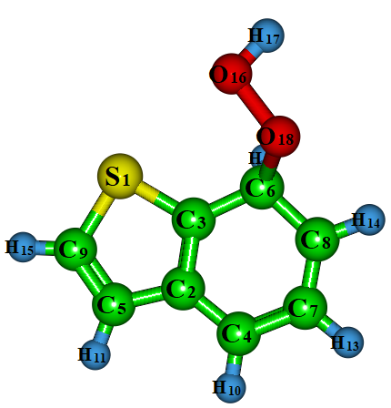
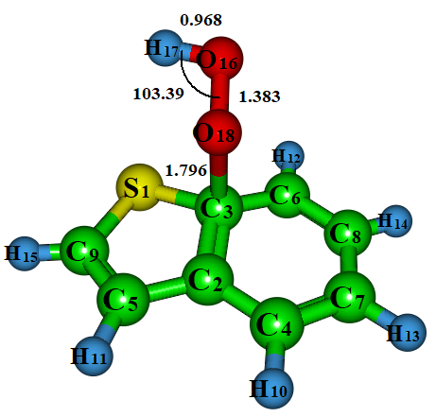

I7-HO₂ TS8-HO₂

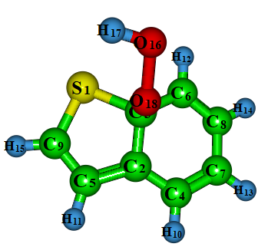

I8-HO₂

Fig. S4 Optimized structures of BT with HO₂ radical via addition mechanism at M06-2X/6-311++G(d, p) level of theory

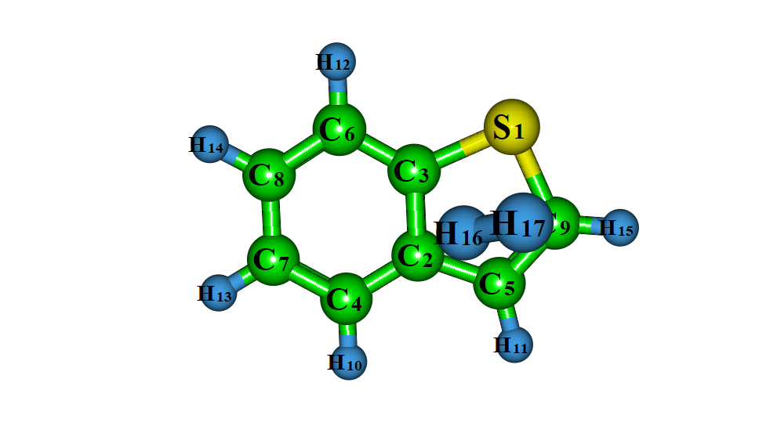
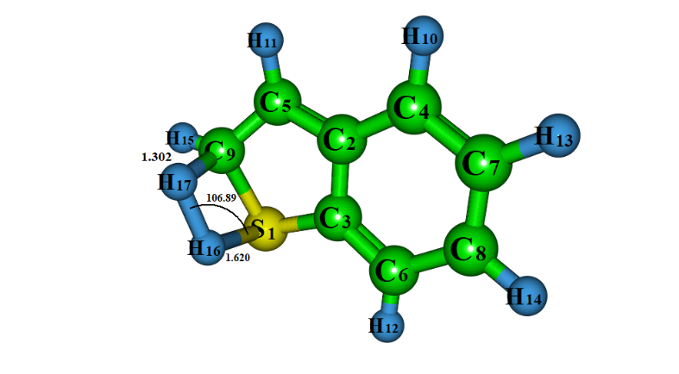
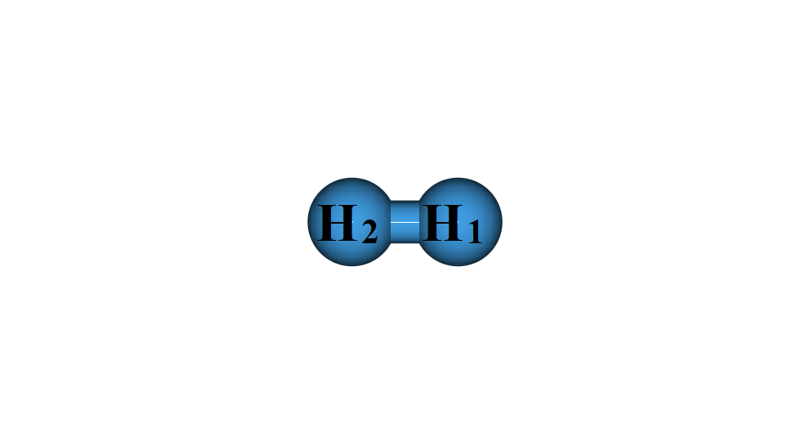

H₂ RC1-H₂ TS1-H₂
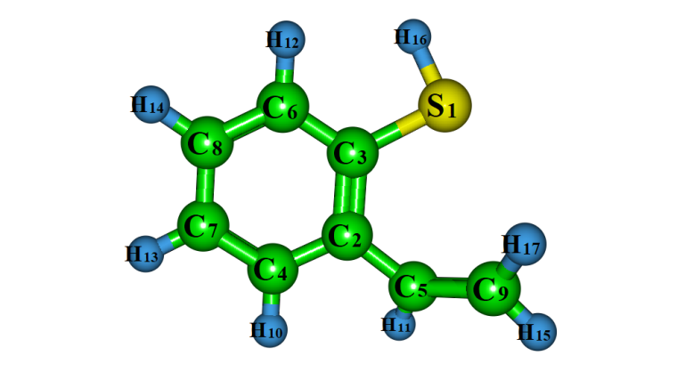
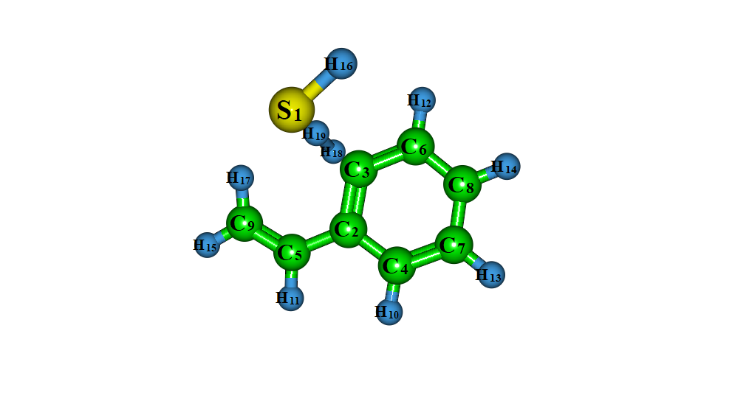
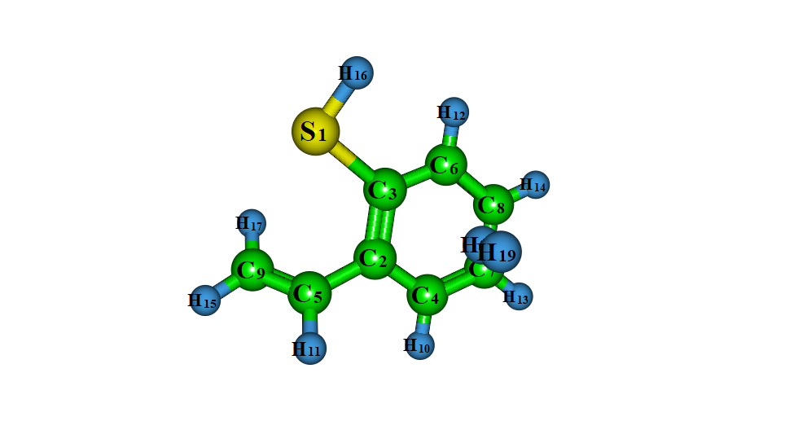

I1-H₂ RC2-H₂ TS2-H₂
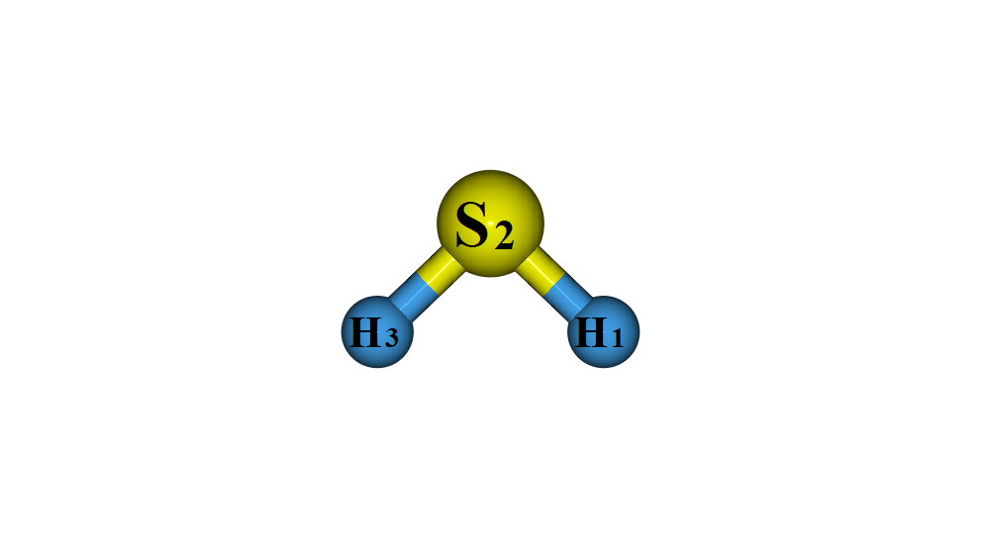
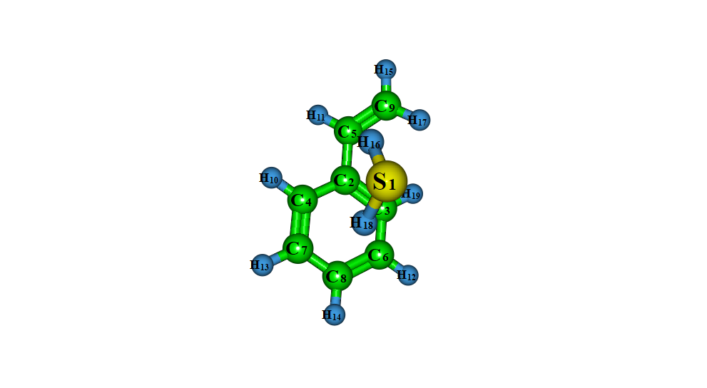
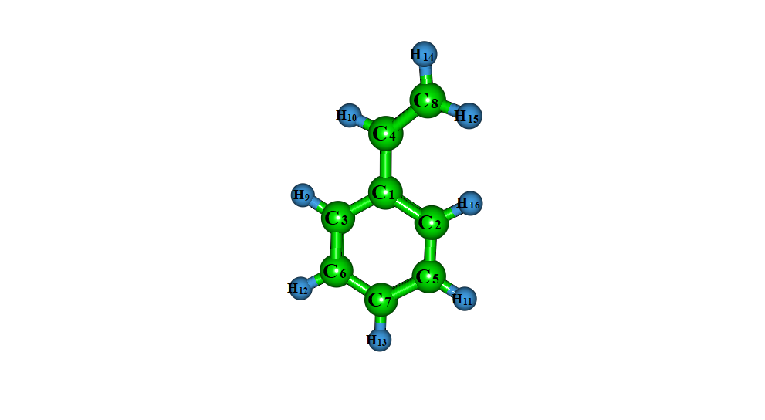

IC2-H₂ I2-H₂ H₂S

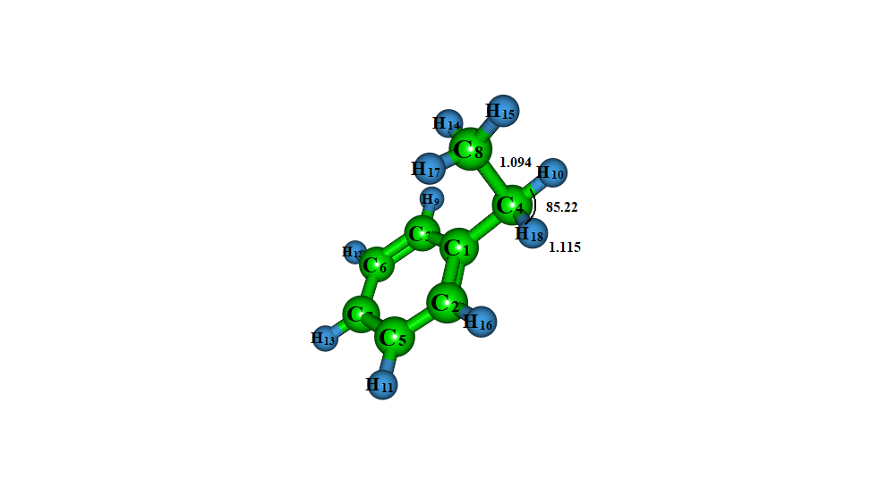
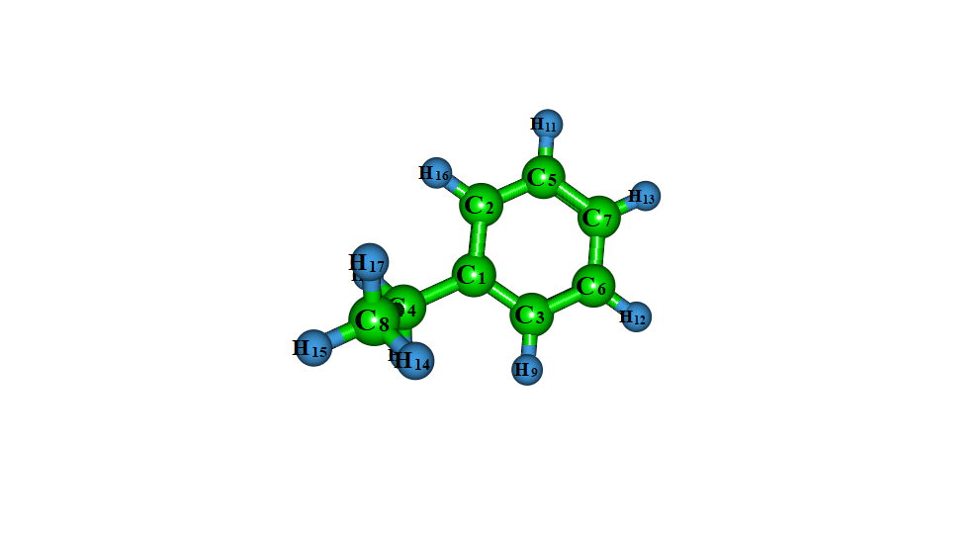
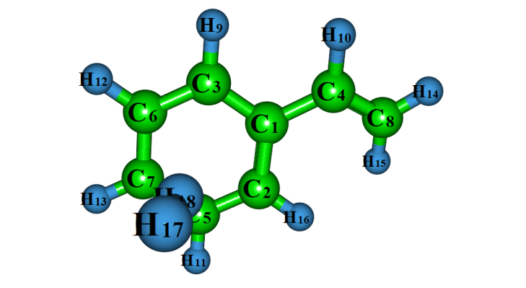
RC3-H₂ TS3-H₂ I3-H₂
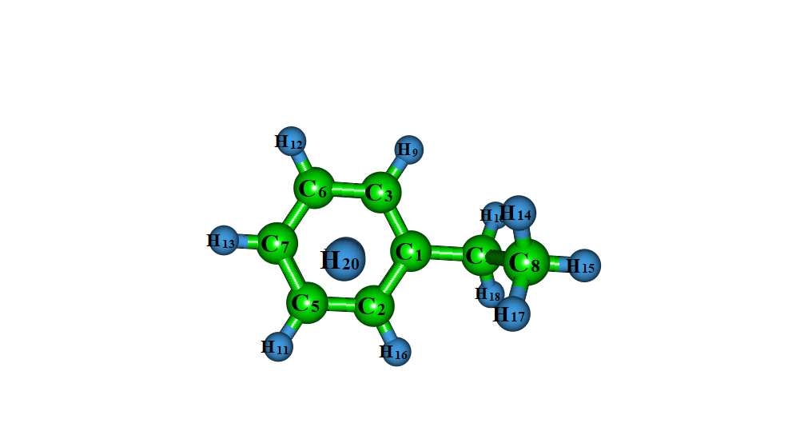
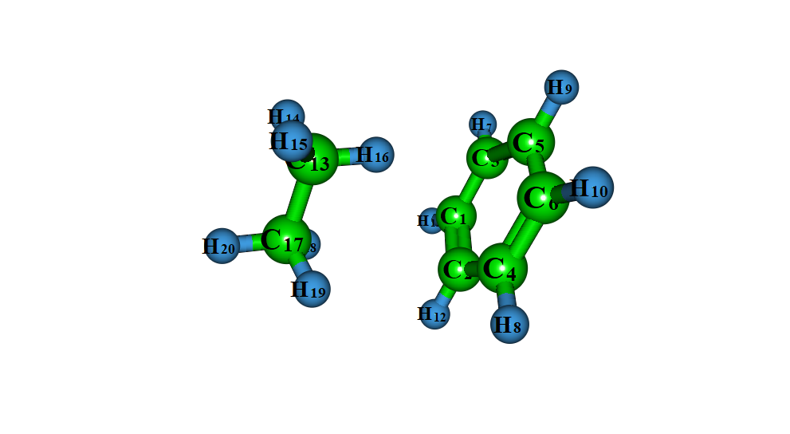
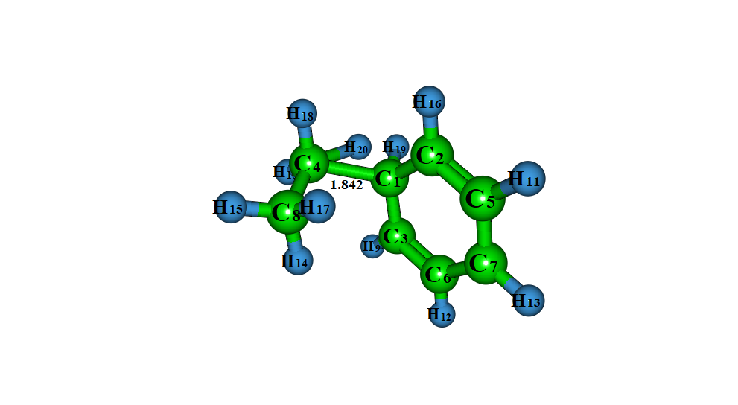

RC4-H₂ TS4-H₂ IC3-H₂
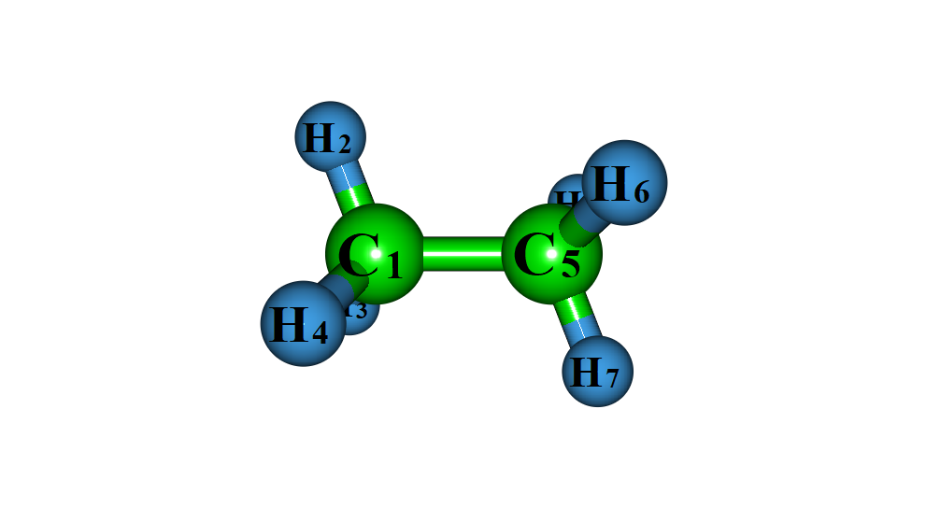
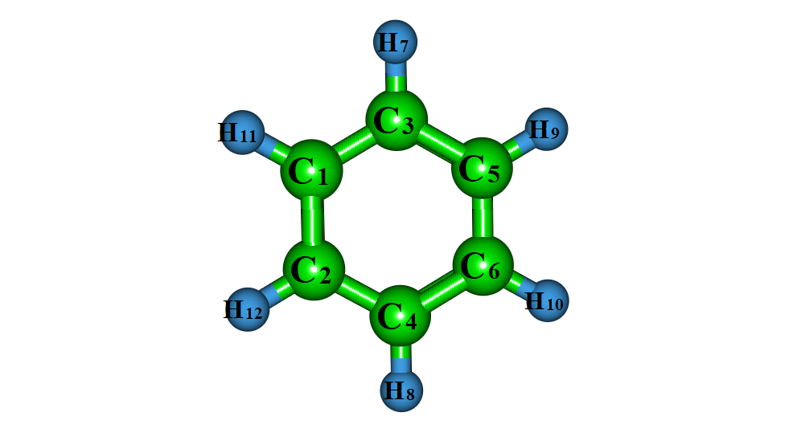

P1-H₂ C₂H₆
Fig. S5 Optimized structures of BT with H₂ radical via auto-oxidation mechanism at M06-2X/6-311++G(d, p) level of theory

Table S1: The cartesian co-ordinates of all the optimized geometries of H-abstraction reaction channel of BT (in Å).
Name | Cartesian co-ordinates
R | S -1.629241000000 1.172815000000 0.000000000000  C 0.010163000000 -0.855279000000 0.000000000000  C 0.000000000000 0.552933000000 0.000000000000  C 1.243650000000 -1.525182000000 0.000000000000  C -1.323519000000 -1.400268000000 0.000000000000  C 1.184046000000 1.294307000000 0.000000000000  C 2.415544000000 -0.794524000000 0.000000000000  C 2.385794000000 0.609978000000 0.000000000000  C -2.275539000000 -0.441175000000 0.000000000000  H 1.267171000000 -2.609201000000 0.000000000000  H -1.539979000000 -2.460167000000 0.000000000000  H 1.160385000000 2.377495000000 0.000000000000  H 3.370105000000 -1.306817000000 0.000000000000  H 3.316147000000 1.165205000000 0.000000000000  H -3.346801000000 -0.576304000000 0.000000000000
OH | O 0.000000000000 0.000000000000 0.108002000000  H 0.000000000000 0.000000000000 -0.864014000000
RC1 | S -1.647389000000 -0.509745000000 -0.800478000000  C 0.320145000000 0.965494000000 0.072676000000  C 0.055094000000 -0.302521000000 -0.482780000000  C 1.642445000000 1.293704000000 0.414039000000  C -0.880544000000 1.749623000000 0.212413000000  C 1.072099000000 -1.238583000000 -0.693580000000  C 2.648693000000 0.370840000000 0.205147000000  C 2.364965000000 -0.890036000000 -0.346691000000  C -1.981667000000 1.089610000000 -0.208914000000  H 1.862440000000 2.265496000000 0.841022000000  H -0.899790000000 2.751952000000 0.618079000000  H 0.850394000000 -2.212008000000 -1.113903000000  H 3.669619000000 0.618635000000 0.468811000000  H 3.168182000000 -1.600269000000 -0.500474000000  H -3.002753000000 1.439857000000 -0.202380000000  O -1.289399000000 -1.526986000000 1.981802000000  H -0.422049000000 -1.120632000000 1.808207000000
RC2 | S -1.154894000 1.568609000 -0.073830000  C 0.233721000 -0.607866000 -0.463007000  C 0.366400000 0.715024000 0.001802000  C 1.361054000 -1.444279000 -0.466530000  C -1.117010000 -0.899545000 -0.872606000  C 1.590993000 1.213830000 0.452142000  C 2.572719000 -0.953238000 -0.020983000  C 2.687239000 0.370249000 0.435417000  C -1.946871000 0.160300000 -0.715393000  H 1.271592000 -2.465754000 -0.817835000  H -1.439727000 -1.859394000 -1.251381000  H 1.679187000 2.234344000 0.804560000  H 3.446393000 -1.593445000 -0.021735000  H 3.646732000 0.736181000 0.780278000  H -3.003970000 0.203133000 -0.929464000  O -2.483347000 -1.576950000 1.349231000  H -1.744590000 -1.064062000 1.717969000
RC3 | S -1.156062000 -1.569519000 -0.071455000  C 0.232287000 0.606505000 -0.464015000  C 0.365256000 -0.715832000 0.002274000  C 1.359545000 1.443008000 -0.468989000  C -1.118720000 0.897701000 -0.873142000  C 1.590111000 -1.214035000 0.452581000  C 2.571457000 0.952560000 -0.023452000  C 2.686289000 -0.370403000 0.434377000  C -1.948445000 -0.161963000 -0.714085000  H 1.269847000 2.464072000 -0.821444000  H -1.441609000 1.857059000 -1.252995000  H 1.678531000 -2.234132000 0.806134000  H 3.445082000 1.592832000 -0.025320000  H 3.645964000 -0.735867000 0.779219000  H -3.005672000 -0.205078000 -0.927482000  O -2.473427000 1.584612000 1.349360000  H -1.734416000 1.071281000 1.716986000
RC4 | S 2.040815000 0.823355000 0.342454000  C 0.072817000 -0.652165000 -0.523688000  C 0.358376000 0.652870000 -0.076668000  C -1.245114000 -0.971705000 -0.891490000  C 1.242358000 -1.491606000 -0.507701000  C -0.636131000 1.634866000 0.002266000  C -2.228192000 -0.002495000 -0.816146000  C -1.924152000 1.296624000 -0.373039000  C 2.342601000 -0.837584000 -0.074628000  H -1.484232000 -1.976738000 -1.218584000  H 1.239085000 -2.531169000 -0.805487000  H -0.401786000 2.634364000 0.348224000  H -3.247305000 -0.247963000 -1.087199000  H -2.709802000 2.039860000 -0.315749000  H 3.342471000 -1.230073000 0.034067000  O -1.984954000 -1.155504000 1.922698000  H -1.407223000 -0.390761000 1.750446000
H₂O | H 0.000000000000 0.761593000000 -0.466439000000  O 0.000000000000 0.000000000000 0.116610000000  H 0.000000000000 -0.761593000000 -0.466439000000
TS1-abs | S 1.027347000000 -1.339545000000 -0.064116000000  C -0.493470000000 0.792830000000 -0.041249000000  C -0.564459000000 -0.613955000000 -0.007074000000  C -1.684270000000 1.534559000000 -0.010288000000  C 0.870457000000 1.266512000000 -0.104842000000  C -1.787524000000 -1.284929000000 0.051955000000  C -2.895127000000 0.872714000000 0.053039000000  C -2.946445000000 -0.530256000000 0.084009000000  C 1.738333000000 0.237998000000 -0.142600000000  H -1.645439000000 2.617430000000 -0.037454000000  H 1.155222000000 2.309552000000 -0.126962000000  H -1.826991000000 -2.367156000000 0.074053000000  H -3.817549000000 1.439937000000 0.077823000000  H -3.906360000000 -1.029793000000 0.133321000000  H 2.978907000000 0.335561000000 -0.230291000000  O 4.142223000000 0.492407000000 0.096962000000  H 4.061905000000 0.535091000000 1.061957000000
IC1-abs | S 0.598614000000 1.785563000000 -0.000512000000  C -0.309472000000 -0.680217000000 -0.001289000000  C -0.752378000000 0.657869000000 0.000000000000  C -1.263387000000 -1.707757000000 -0.001065000000  C 1.137985000000 -0.785765000000 -0.002648000000  C -2.108115000000 0.984710000000 0.001527000000  C -2.608314000000 -1.387452000000 0.000449000000  C -3.028975000000 -0.049186000000 0.001742000000  C 1.674917000000 0.441186000000 -0.002245000000  H -0.939985000000 -2.742158000000 -0.002060000000  H 1.697609000000 -1.711153000000 -0.003851000000  H -2.431413000000 2.018510000000 0.002502000000  H -3.348420000000 -2.178351000000 0.000664000000  H -4.087555000000 0.180356000000 0.002930000000  H 4.102093000000 -0.473823000000 0.762468000000  O 4.357966000000 -1.004039000000 0.003024000000  H 4.112558000000 -0.470402000000 -0.757479000000
I1-abs | S -1.846440000000 -0.906595000000 0.000089000000  C 0.092380000000 0.863865000000 0.000059000000  C -0.128792000000 -0.528445000000 -0.000236000000  C 1.411891000000 1.338430000000 0.000146000000  C -1.146937000000 1.620091000000 -0.000155000000  C 0.926527000000 -1.440647000000 -0.000081000000  C 2.459817000000 0.436706000000 0.000049000000  C 2.219382000000 -0.945606000000 -0.000043000000  C -2.188658000000 0.779521000000 0.000088000000  H 1.600339000000 2.405808000000 0.000356000000  H -1.204944000000 2.699544000000 -0.000739000000  H 0.738888000000 -2.507485000000 -0.000023000000  H 3.480491000000 0.799498000000 0.000088000000  H 3.054600000000 -1.635335000000 -0.000064000000
TS2-abs | S -0.258044000000 2.140739000000 0.023184000000  C -0.071145000000 -0.467065000000 -0.069687000000  C 0.721159000000 0.694647000000 0.012786000000  C 0.545126000000 -1.726281000000 -0.091694000000  C -1.462435000000 -0.120251000000 -0.130434000000  C 2.114626000000 0.618294000000 0.073993000000  C 1.922660000000 -1.799629000000 -0.028134000000  C 2.702401000000 -0.633595000000 0.054177000000  C -1.723679000000 1.196924000000 -0.074662000000  H -0.065703000000 -2.618935000000 -0.160764000000  H -2.339551000000 -0.978686000000 -0.242133000000  H 2.717774000000 1.516187000000 0.133908000000  H 2.411334000000 -2.766065000000 -0.044262000000  H 3.781546000000 -0.715192000000 0.101387000000  H -2.680361000000 1.696242000000 -0.093542000000  O -3.131335000000 -1.893928000000 0.054496000000  H -3.137930000000 -1.812220000000 1.020423000000
IC2-abs | S -1.322399000000 1.878954000000 0.000890000000  C 0.330206000000 -0.164005000000 -0.001634000000  C -1.045382000000 0.152993000000 0.000344000000  C 0.736506000000 -1.506773000000 -0.002338000000  C 1.085620000000 1.049451000000 -0.002659000000  C -2.016777000000 -0.850547000000 0.001612000000  C -0.229737000000 -2.493702000000 -0.001101000000  C -1.596409000000 -2.168169000000 0.000857000000  C 0.406945000000 2.197823000000 -0.001599000000  H 1.794120000000 -1.742721000000 -0.003779000000  H 3.563629000000 0.236566000000 0.762833000000  H -3.071122000000 -0.601351000000 0.003115000000  H 0.068330000000 -3.534952000000 -0.001626000000  H -2.334265000000 -2.961365000000 0.001802000000  H 0.761409000000 3.216854000000 -0.002169000000  O 3.848502000000 -0.277599000000 0.002335000000  H 3.562434000000 0.242063000000 -0.753995000000
I2-abs | S -1.801331000000 -0.887307000000 0.000188000000  C 0.130763000000 0.889924000000 0.000107000000  C -0.097256000000 -0.503482000000 -0.000068000000  C 1.446336000000 1.374896000000 0.000145000000  C -1.124847000000 1.572180000000 -0.000163000000  C 0.966068000000 -1.409230000000 -0.000213000000  C 2.494511000000 0.475791000000 0.000062000000  C 2.255352000000 -0.908473000000 -0.000094000000  C -2.225986000000 0.820946000000 -0.000106000000  H 1.625695000000 2.443072000000 0.000150000000  H 0.783296000000 -2.477127000000 -0.000267000000  H 3.514645000000 0.839575000000 0.000115000000  H 3.093082000000 -1.595248000000 -0.000106000000  H -3.265067000000 1.111330000000 -0.000922000000
TS3-abs | S 2.392351000000 -0.048155000000 0.057437000000  C -0.185696000000 -0.382118000000 -0.072707000000  C 0.789635000000 0.633695000000 0.011164000000  C -1.522190000000 0.016020000000 -0.120157000000  C 0.395029000000 -1.698191000000 -0.098309000000  C 0.438071000000 1.985869000000 0.050734000000  C -1.899027000000 1.335740000000 -0.074612000000  C -0.901796000000 2.326767000000 0.005730000000  C 1.744367000000 -1.659917000000 -0.034918000000  H -2.359817000000 -0.855470000000 -0.227091000000  H -0.191004000000 -2.604557000000 -0.164970000000  H 1.200556000000 2.752380000000 0.116909000000  H -2.944964000000 1.614665000000 -0.107967000000  H -1.190791000000 3.370471000000 0.033673000000  H 2.426965000000 -2.496423000000 -0.039091000000  O -3.145948000000 -1.830057000000 0.056276000000  H -3.201335000000 -1.717326000000 1.017791000000
IC3-abs | S 2.176528000000 -0.883499000000 -0.000032000000  C -0.322753000000 -0.153045000000 0.000042000000  C 0.985411000000 0.387127000000 -0.000036000000  C -1.349570000000 0.778649000000 0.000087000000  C -0.322921000000 -1.593569000000 0.000084000000  C 1.216571000000 1.766910000000 -0.000064000000  C -1.187119000000 2.132126000000 0.000070000000  C 0.134704000000 2.628653000000 -0.000012000000  C 0.930679000000 -2.097822000000 0.000059000000  H -3.444434000000 -0.776657000000 -0.757268000000  H -1.227588000000 -2.186106000000 0.000133000000  H 2.228038000000 2.154008000000 -0.000126000000  H -2.029794000000 2.813114000000 0.000117000000  H 0.299910000000 3.699517000000 -0.000033000000  H 1.218220000000 -3.138503000000 0.000092000000  O -3.616766000000 -1.343401000000 -0.000087000000  H -3.444684000000 -0.776355000000 0.756928000000
I3-abs | S -1.695740000000 -1.000471000000 0.000142000000  C 0.086991000000 0.899595000000 0.000126000000  C -0.023070000000 -0.510545000000 -0.000111000000  C 1.379073000000 1.401289000000 0.000153000000  C -1.199648000000 1.546629000000 0.000138000000  C 1.103750000000 -1.339766000000 -0.000133000000  C 2.511899000000 0.643509000000 -0.000229000000  C 2.359718000000 -0.760374000000 0.000031000000  C -2.217925000000 0.658694000000 -0.000339000000  H -1.331145000000 2.619241000000 0.000195000000  H 0.993830000000 -2.417102000000 -0.000090000000  H 3.499293000000 1.089437000000 0.000129000000  H 3.241311000000 -1.390610000000 0.000264000000  H -3.276179000000 0.872380000000 -0.000585000000
TS4-abs | S -2.453994000000 0.708287000000 0.064464000000  C -0.301522000000 -0.757321000000 -0.047931000000  C -0.717328000000 0.588765000000 -0.007311000000  C 1.074631000000 -1.043860000000 -0.104041000000  C -1.418326000000 -1.666003000000 -0.020661000000  C 0.195470000000 1.647314000000 -0.023630000000  C 1.948616000000 0.014884000000 -0.128998000000  C 1.547508000000 1.351948000000 -0.081439000000  C -2.605426000000 -1.022807000000 0.038474000000  H 1.427104000000 -2.068331000000 -0.135506000000  H -1.318137000000 -2.742514000000 -0.045624000000  H -0.144809000000 2.675446000000 0.007315000000  H 3.135736000000 -0.222392000000 -0.216908000000  H 2.284027000000 2.145634000000 -0.098700000000  H -3.591253000000 -1.462051000000 0.068437000000  O 4.354860000000 -0.480630000000 0.075060000000  H 4.290624000000 -0.490868000000 1.042301000000
IC4-abs | S -2.385377000000 0.972617000000 -0.000065000000  C -0.529653000000 -0.858757000000 0.000053000000  C -0.696258000000 0.541917000000 0.000028000000  C 0.777148000000 -1.391577000000 0.000162000000  C -1.792244000000 -1.550484000000 -0.000057000000  C 0.389234000000 1.423505000000 0.000087000000  C 1.795134000000 -0.485088000000 0.000248000000  C 1.673905000000 0.896479000000 0.000169000000  C -2.844947000000 -0.702426000000 -0.000127000000  H 0.941660000000 -2.463149000000 0.000216000000  H -1.887933000000 -2.627679000000 -0.000074000000  H 0.233873000000 2.495975000000 0.000057000000  H 4.383077000000 -0.367088000000 -0.757236000000  H 2.545981000000 1.539514000000 0.000148000000  H -3.894245000000 -0.956972000000 -0.000212000000  O 4.853334000000 -0.007119000000 -0.000252000000  H 4.383032000000 -0.366916000000 0.756775000000
I4-abs | S -1.660403000000 -1.023117000000 0.000035000000  C 0.128687000000 0.874445000000 0.000165000000  C 0.012512000000 -0.530821000000 -0.000009000000  C 1.415477000000 1.454458000000 0.000426000000  C -1.158789000000 1.519468000000 -0.000335000000  C 1.130235000000 -1.371142000000 0.000074000000  C 2.468824000000 0.589671000000 -0.000173000000  C 2.393511000000 -0.794451000000 -0.000104000000  C -2.180544000000 0.634435000000 0.000026000000  H 1.540594000000 2.531439000000 0.000020000000  H -1.293247000000 2.592571000000 -0.000509000000  H 1.014915000000 -2.448761000000 -0.000057000000  H 3.283050000000 -1.412548000000 -0.000502000000  H -3.238348000000 0.850782000000 0.000071000000
TS5-abs | S 1.905177000000 -1.365984000000 0.007552000000  C 0.694212000000 0.945488000000 -0.008009000000  C 0.430818000000 -0.438460000000 0.040176000000  C -0.378230000000 1.851839000000 0.009083000000  C 2.107519000000 1.216749000000 -0.071965000000  C -0.876478000000 -0.935062000000 0.102702000000  C -1.675739000000 1.376140000000 0.072758000000  C -1.887561000000 -0.003252000000 0.126938000000  C 2.852738000000 0.089706000000 -0.071131000000  H -0.184732000000 2.918021000000 -0.026779000000  H 2.526218000000 2.213021000000 -0.115199000000  H -1.082886000000 -1.997748000000 0.139907000000  H -2.516961000000 2.057763000000 0.089922000000  H -3.028801000000 -0.406004000000 0.222410000000  H 3.928750000000 0.011073000000 -0.111984000000  O -4.198184000000 -0.840278000000 -0.061617000000  H -4.142611000000 -0.837060000000 -1.029484000000
IC5-abs | S -2.223166000000 -1.185682000000 -0.000006000000  C -0.645382000000 0.893884000000 0.000042000000  C -0.614901000000 -0.516547000000 0.000038000000  C 0.559895000000 1.615572000000 0.000004000000  C -1.996226000000 1.395814000000 0.000016000000  C 0.596493000000 -1.226559000000 0.000006000000  C 1.769565000000 0.937421000000 -0.000031000000  C 1.717768000000 -0.448189000000 -0.000012000000  C -2.918465000000 0.409082000000 -0.000035000000  H 0.539655000000 2.699828000000 0.000013000000  H -2.244367000000 2.448534000000 0.000038000000  H 0.626467000000 -2.309612000000 0.000018000000  H 2.716491000000 1.463850000000 -0.000077000000  H 4.305770000000 -0.664820000000 -0.757236000000  H -3.993295000000 0.510329000000 -0.000066000000  O 4.812684000000 -0.359400000000 -0.000012000000  H 4.305992000000 -0.664858000000 0.757326000000
I5-abs | S 1.761409000000 -0.907042000000 0.000009000000  C -0.205497000000 0.808458000000 0.000030000000  C 0.050157000000 -0.578629000000 0.000084000000  C -1.532525000000 1.269383000000 0.000059000000  C 1.015465000000 1.574348000000 0.000058000000  C -0.992137000000 -1.519657000000 0.000086000000  C -2.577262000000 0.357250000000 0.000006000000  C -2.249631000000 -0.989338000000 -0.000139000000  C 2.119040000000 0.795756000000 -0.000124000000  H -1.733570000000 2.335122000000 -0.000026000000  H 1.044611000000 2.655604000000 0.000069000000  H -0.801861000000 -2.586320000000 -0.000055000000  H -3.608191000000 0.689411000000 -0.000244000000  H 3.150806000000 1.113431000000 -0.000250000000
TS6-abs | S -1.137033000000 -1.519779000000 -0.075448000000  C -0.719648000000 1.059669000000 0.028085000000  C -0.036344000000 -0.172457000000 -0.056178000000  C 0.024841000000 2.249744000000 0.055535000000  C -2.146364000000 0.867613000000 0.077012000000  C 1.350488000000 -0.192450000000 -0.115709000000  C 1.404509000000 2.202686000000 0.001951000000  C 2.082312000000 0.970926000000 -0.076619000000  C -2.494268000000 -0.437586000000 0.032924000000  H -0.489561000000 3.201619000000 0.121462000000  H -2.859635000000 1.678209000000 0.140816000000  H 1.916989000000 -1.266431000000 -0.218161000000  H 1.978613000000 3.121094000000 0.023292000000  H 3.164318000000 0.940648000000 -0.113176000000  H -3.490784000000 -0.852763000000 0.054181000000  O 2.365824000000 -2.422039000000 0.061503000000  H 2.252845000000 -2.418474000000 1.024729000000
IC6-abs | S -1.183728000000 -1.716491000000 0.000076000000  C -1.005445000000 0.896447000000 -0.000036000000  C -0.210082000000 -0.273458000000 0.000071000000  C -0.374582000000 2.152157000000 -0.000058000000  C -2.409154000000 0.572623000000 -0.000122000000  C 1.159647000000 -0.128925000000 0.000155000000  C 1.004513000000 2.237874000000 0.000036000000  C 1.804614000000 1.074169000000 0.000143000000  C -2.636218000000 -0.759409000000 -0.000068000000  H -0.978485000000 3.052060000000 -0.000146000000  H -3.195699000000 1.315142000000 -0.000216000000  H 3.361852000000 -1.500372000000 -0.757928000000  H 1.486625000000 3.208154000000 0.000022000000  H 2.886719000000 1.135084000000 0.000200000000  H -3.590726000000 -1.264045000000 -0.000118000000  O 3.950936000000 -1.451301000000 -0.000187000000  H 3.362106000000 -1.500625000000 0.757736000000
I6-abs | S -1.772670000000 -0.983342000000 0.000012000000  C 0.137603000000 0.808349000000 -0.000043000000  C -0.075958000000 -0.590139000000 0.000078000000  C 1.454624000000 1.298252000000 0.000010000000  C -1.110650000000 1.527476000000 -0.000036000000  C 1.021592000000 -1.421853000000 0.000046000000  C 2.521359000000 0.420004000000 0.000071000000  C 2.311460000000 -0.976658000000 -0.000176000000  C -2.183962000000 0.706332000000 -0.000015000000  H 1.626466000000 2.368275000000 0.000069000000  H -1.180834000000 2.606899000000 -0.000065000000  H 3.535763000000 0.801034000000 0.000218000000  H 3.151270000000 -1.661214000000 -0.000015000000  H -3.226358000000 0.987895000000 -0.000017000000

Table S2: The cartesian co-ordinates of all the optimized geometries of OH-addition reaction channel of BT (in Å).

Name | Cartesian co-ordinates
RC1-add | S -1.647389000000 -0.509745000000 -0.800478000000  C 0.320145000000 0.965494000000 0.072676000000  C 0.055094000000 -0.302521000000 -0.482780000000  C 1.642445000000 1.293704000000 0.414039000000  C -0.880544000000 1.749623000000 0.212413000000  C 1.072099000000 -1.238583000000 -0.693580000000  C 2.648693000000 0.370840000000 0.205147000000  C 2.364965000000 -0.890036000000 -0.346691000000  C -1.981667000000 1.089610000000 -0.208914000000  H 1.862440000000 2.265496000000 0.841022000000  H -0.899790000000 2.751952000000 0.618079000000  H 0.850394000000 -2.212008000000 -1.113903000000  H 3.669619000000 0.618635000000 0.468811000000  H 3.168182000000 -1.600269000000 -0.500474000000  H -3.002753000000 1.439857000000 -0.202380000000  O -1.289399000000 -1.526986000000 1.981802000000  H -0.422049000000 -1.120632000000 1.808207000000
RC2-add | S -1.154894000 1.568609000 -0.073830000  C 0.233721000 -0.607866000 -0.463007000  C 0.366400000 0.715024000 0.001802000  C 1.361054000 -1.444279000 -0.466530000  C -1.117010000 -0.899545000 -0.872606000  C 1.590993000 1.213830000 0.452142000  C 2.572719000 -0.953238000 -0.020983000  C 2.687239000 0.370249000 0.435417000  C -1.946871000 0.160300000 -0.715393000  H 1.271592000 -2.465754000 -0.817835000  H -1.439727000 -1.859394000 -1.251381000  H 1.679187000 2.234344000 0.804560000  H 3.446393000 -1.593445000 -0.021735000  H 3.646732000 0.736181000 0.780278000  H -3.003970000 0.203133000 -0.929464000  O -2.483347000 -1.576950000 1.349231000  H -1.744590000 -1.064062000 1.717969000
RC3-add | S -1.156062000 -1.569519000 -0.071455000  C 0.232287000 0.606505000 -0.464015000  C 0.365256000 -0.715832000 0.002274000  C 1.359545000 1.443008000 -0.468989000  C -1.118720000 0.897701000 -0.873142000  C 1.590111000 -1.214035000 0.452581000  C 2.571457000 0.952560000 -0.023452000  C 2.686289000 -0.370403000 0.434377000  C -1.948445000 -0.161963000 -0.714085000  H 1.269847000 2.464072000 -0.821444000  H -1.441609000 1.857059000 -1.252995000  H 1.678531000 -2.234132000 0.806134000  H 3.445082000 1.592832000 -0.025320000  H 3.645964000 -0.735867000 0.779219000  H -3.005672000 -0.205078000 -0.927482000  O -2.473427000 1.584612000 1.349360000  H -1.734416000 1.071281000 1.716986000
RC4-add | S 2.040815000 0.823355000 0.342454000  C 0.072817000 -0.652165000 -0.523688000  C 0.358376000 0.652870000 -0.076668000  C -1.245114000 -0.971705000 -0.891490000  C 1.242358000 -1.491606000 -0.507701000  C -0.636131000 1.634866000 0.002266000  C -2.228192000 -0.002495000 -0.816146000  C -1.924152000 1.296624000 -0.373039000  C 2.342601000 -0.837584000 -0.074628000  H -1.484232000 -1.976738000 -1.218584000  H 1.239085000 -2.531169000 -0.805487000  H -0.401786000 2.634364000 0.348224000  H -3.247305000 -0.247963000 -1.087199000  H -2.709802000 2.039860000 -0.315749000  H 3.342471000 -1.230073000 0.034067000  O -1.984954000 -1.155504000 1.922698000  H -1.407223000 -0.390761000 1.750446000
RC5-add | S 1.844393000 1.006843000 0.070916000  C -0.041603000 -0.691873000 -0.523508000  C 0.156334000 0.657047000 -0.161174000  C -1.351365000 -1.154356000 -0.734545000  C 1.202490000 -1.411798000 -0.605449000  C -0.917971000 1.535895000 0.002431000  C -2.414896000 -0.287344000 -0.572632000  C -2.199172000 1.052812000 -0.202711000  C 2.268247000 -0.633364000 -0.317134000  H -1.518152000 -2.189963000 -1.006981000  H 1.274005000 -2.460201000 -0.860165000  H -0.751855000 2.567426000 0.288124000  H -3.426858000 -0.640516000 -0.728288000  H -3.046007000 1.717093000 -0.079666000  H 3.308383000 -0.922015000 -0.298936000  O -0.540866000 -1.016067000 2.292153000  H -1.235262000 -0.454892000 1.902367000
TS2-add | S -1.243397000000 -1.591501000000 0.011188000000  C 0.153804000000 0.583595000000 -0.386219000000  C 0.299047000000 -0.755563000000 0.008173000000  C 1.284069000000 1.405127000000 -0.441069000000  C -1.231710000000 0.930107000000 -0.645961000000  C 1.541234000000 -1.292266000000 0.343243000000  C 2.521614000000 0.877538000000 -0.116738000000  C 2.649193000000 -0.463305000000 0.272432000000  C -2.055017000000 -0.167740000000 -0.531797000000  H 1.178365000000 2.445555000000 -0.724612000000  H -1.532537000000 1.840242000000 -1.142241000000  H 1.638312000000 -2.327610000000 0.646286000000  H 3.402470000000 1.506350000000 -0.158373000000  H 3.626198000000 -0.857768000000 0.524000000000  H -3.120979000000 -0.192493000000 -0.699341000000  O -1.833308000000 1.893583000000 1.081132000000  H -1.604400000000 1.196117000000 1.713827000000
I2-add | S -1.228109000000 -1.660653000000 -0.042897000000  C 0.124496000000 0.593037000000 0.223655000000  C 0.301055000000 -0.769116000000 -0.008924000000  C 1.230453000000 1.430484000000 0.266205000000  C -1.312291000000 1.028566000000 0.356694000000  C 1.564329000000 -1.318194000000 -0.193160000000  C 2.502799000000 0.896270000000 0.086956000000  C 2.665154000000 -0.469721000000 -0.140251000000  C -2.117253000000 -0.234187000000 0.333822000000  H 1.091975000000 2.493789000000 0.425905000000  H -1.471257000000 1.570953000000 1.299462000000  H 1.689333000000 -2.378927000000 -0.373505000000  H 3.370372000000 1.543650000000 0.120284000000  H 3.658817000000 -0.878436000000 -0.279880000000  H -3.189207000000 -0.286947000000 0.449727000000  O -1.592847000000 1.920335000000 -0.730311000000  H -2.509962000000 2.200853000000 -0.663135000000
TS3-add | S 2.157434000000 0.686425000000 0.271669000000  C -0.023984000000 -0.565516000000 -0.394290000000  C 0.435517000000 0.697449000000 0.009878000000  C -1.414835000000 -0.759273000000 -0.613980000000  C 1.035214000000 -1.524780000000 -0.477229000000  C -0.430682000000 1.787709000000 0.149274000000  C -2.264702000000 0.357665000000 -0.528782000000  C -1.780457000000 1.601864000000 -0.124231000000  C 2.239331000000 -0.992900000000 -0.153934000000  H -1.756963000000 -1.666708000000 -1.091884000000  H 0.887107000000 -2.559880000000 -0.752128000000  H -0.056513000000 2.756364000000 0.457911000000  H -3.318771000000 0.228552000000 -0.738277000000  H -2.462462000000 2.437960000000 -0.031371000000  H 3.195903000000 -1.493042000000 -0.132086000000  O -2.000354000000 -1.668513000000 1.125369000000  H -1.776817000000 -0.951255000000 1.737943000000
I3-add | S -2.218726000000 0.622246000000 -0.125565000000  C 0.057386000000 -0.554789000000 0.197491000000  C -0.486846000000 0.707411000000 0.006116000000  C 1.534533000000 -0.754534000000 0.345350000000  C -0.922926000000 -1.576936000000 0.226116000000  C 0.293082000000 1.879058000000 -0.086696000000  C 2.295145000000 0.535097000000 0.205823000000  C 1.699295000000 1.742770000000 0.008910000000  C -2.189644000000 -1.092438000000 0.066016000000  H 1.733570000000 -1.174554000000 1.345484000000  H -0.692180000000 -2.626969000000 0.343393000000  H -0.163633000000 2.846461000000 -0.245210000000  H 3.376374000000 0.468528000000 0.274369000000  H 2.313680000000 2.631155000000 -0.082538000000  H -3.114891000000 -1.647236000000 0.044268000000  O 1.937752000000 -1.728571000000 -0.625857000000  H 2.864520000000 -1.938594000000 -0.478631000000
TS4-add | S -2.170422000000 -0.830413000000 0.257493000000  C -0.183860000000 0.762209000000 -0.282728000000  C -0.485146000000 -0.601189000000 -0.082393000000  C 1.131252000000 1.130671000000 -0.576129000000  C -1.355655000000 1.593470000000 -0.155519000000  C 0.501862000000 -1.600163000000 -0.176368000000  C 2.143791000000 0.154794000000 -0.591538000000  C 1.791482000000 -1.221872000000 -0.451122000000  C -2.466939000000 0.880867000000 0.127473000000  H 1.386606000000 2.170496000000 -0.739926000000  H -1.343851000000 2.668650000000 -0.271873000000  H 0.243994000000 -2.643403000000 -0.041047000000  H 3.111911000000 0.406086000000 -1.000641000000  H 2.573548000000 -1.967009000000 -0.521426000000  H -3.470265000000 1.250497000000 0.275804000000  O 2.948335000000 0.555962000000 1.195044000000  H 2.177392000000 0.360867000000 1.748819000000
I4-add | S -2.246087000000 -0.832580000000 0.137902000000  C -0.218105000000 0.782363000000 -0.139183000000  C -0.545618000000 -0.588811000000 -0.044571000000  C 1.097795000000 1.177704000000 -0.284917000000  C -1.403676000000 1.608379000000 -0.054814000000  C 0.463863000000 -1.600078000000 -0.083626000000  C 2.214022000000 0.186050000000 -0.345615000000  C 1.755283000000 -1.242982000000 -0.229054000000  C -2.534013000000 0.886311000000 0.090210000000  H 1.367561000000 2.225803000000 -0.330685000000  H -1.383311000000 2.688736000000 -0.103627000000  H 0.185342000000 -2.643858000000 0.006498000000  H 2.741392000000 0.308196000000 -1.307417000000  H 2.528061000000 -2.004650000000 -0.261400000000  H -3.546688000000 1.250278000000 0.175052000000  O 3.140806000000 0.529163000000 0.698357000000  H 3.941290000000 0.009869000000 0.577713000000
TS5-add | S -1.906092000000 -1.160179000000 -0.080392000000  C -0.378650000000 0.956929000000 -0.009027000000  C -0.328493000000 -0.433299000000 -0.249957000000  C 0.810010000000 1.715361000000 -0.114722000000  C -1.704585000000 1.394919000000 0.310672000000  C 0.855464000000 -1.075086000000 -0.590332000000  C 1.987176000000 1.091139000000 -0.433972000000  C 2.044014000000 -0.322692000000 -0.618707000000  C -2.603360000000 0.379212000000 0.305633000000  H 0.777447000000 2.785957000000 0.051210000000  H -1.963028000000 2.421828000000 0.530813000000  H 0.886794000000 -2.140367000000 -0.780298000000  H 2.905861000000 1.658598000000 -0.510021000000  H 2.930794000000 -0.760776000000 -1.053904000000  H -3.662050000000 0.439095000000 0.509324000000  O 2.803536000000 -0.935987000000 1.151730000000  H 2.103906000000 -0.592473000000 1.727776000000
I5-add | S -1.942960000000 -1.198099000000 -0.018971000000  C -0.457515000000 0.957784000000 -0.008532000000  C -0.352385000000 -0.458844000000 -0.121134000000  C 0.748798000000 1.738723000000 -0.046087000000  C -1.792822000000 1.388264000000 0.150530000000  C 0.836378000000 -1.109262000000 -0.276119000000  C 1.944732000000 1.144606000000 -0.204137000000  C 2.120456000000 -0.343147000000 -0.352510000000  C -2.690525000000 0.356261000000 0.162390000000  H 0.677747000000 2.815707000000 0.061987000000  H -2.083046000000 2.425384000000 0.255679000000  H 0.903433000000 -2.188663000000 -0.331733000000  H 2.852063000000 1.740368000000 -0.229560000000  H 2.585488000000 -0.544544000000 -1.332780000000  H -3.762508000000 0.418578000000 0.270447000000  O 2.987671000000 -0.877905000000 0.657525000000  H 3.870108000000 -0.520311000000 0.522892000000
TS6-add | S -1.715835000000 -1.050238000000 -0.325569000000  C -0.248088000000 1.050914000000 0.091665000000  C -0.162015000000 -0.291190000000 -0.308397000000  C 0.927913000000 1.821519000000 0.158451000000  C -1.606110000000 1.441135000000 0.367022000000  C 1.080336000000 -0.911219000000 -0.584422000000  C 2.146533000000 1.248080000000 -0.173404000000  C 2.222767000000 -0.087906000000 -0.569992000000  C -2.479731000000 0.425535000000 0.181398000000  H 0.872657000000 2.860703000000 0.462085000000  H -1.895511000000 2.434147000000 0.683140000000  H 1.113761000000 -1.880954000000 -1.060184000000  H 3.049620000000 1.844397000000 -0.134230000000  H 3.178522000000 -0.526524000000 -0.826416000000  H -3.551414000000 0.444628000000 0.310063000000  O 1.486625000000 -1.923054000000 1.132379000000  H 1.503095000000 -1.169364000000 1.741701000000
I6-add | S -1.652161000000 -1.079445000000 -0.153813000000  C -0.275648000000 1.091822000000 0.035504000000  C -0.135251000000 -0.271273000000 -0.147772000000  C 0.876382000000 1.928758000000 0.095364000000  C -1.655707000000 1.474812000000 0.161297000000  C 1.169852000000 -0.971499000000 -0.334262000000  C 2.151231000000 1.340102000000 -0.022323000000  C 2.312815000000 -0.001107000000 -0.217516000000  C -2.496231000000 0.414906000000 0.074928000000  H 0.768130000000 2.994712000000 0.246786000000  H -1.985223000000 2.493655000000 0.314980000000  H 1.193138000000 -1.429931000000 -1.336915000000  H 3.029070000000 1.972276000000 0.047604000000  H 3.308979000000 -0.422826000000 -0.305177000000  H -3.572953000000 0.411743000000 0.147093000000  O 1.248081000000 -2.028294000000 0.630108000000  H 2.024121000000 -2.561275000000 0.434460000000
TS7-add | S -1.758134000000 -0.847790000000 -0.443487000000  C 0.117974000000 0.949721000000 -0.015680000000  C -0.066188000000 -0.475124000000 -0.095720000000  C 1.418695000000 1.458834000000 0.014442000000  C -1.132594000000 1.636673000000 0.026698000000  C 1.033999000000 -1.310390000000 -0.456167000000  C 2.488352000000 0.606725000000 -0.183090000000  C 2.292672000000 -0.768943000000 -0.446822000000  C -2.189617000000 0.812397000000 -0.182134000000  H 1.577976000000 2.521666000000 0.153426000000  H -1.228066000000 2.701793000000 0.187250000000  H 0.869701000000 -2.358518000000 -0.677733000000  H 3.496719000000 1.002413000000 -0.174277000000  H 3.149154000000 -1.396239000000 -0.661360000000  H -3.233797000000 1.088256000000 -0.202187000000  O -0.046289000000 -0.721789000000 1.829011000000  H 0.089013000000 -1.679784000000 1.869425000000
I7-add | S -1.762562000000 -0.816213000000 -0.469328000000  C 0.149059000000 0.964121000000 0.127148000000  C -0.064616000000 -0.525213000000 0.243229000000  C 1.452852000000 1.451140000000 0.071034000000  C -1.076750000000 1.670778000000 0.040926000000  C 1.019211000000 -1.332293000000 -0.400099000000  C 2.498522000000 0.588996000000 -0.203229000000  C 2.250400000000 -0.792364000000 -0.518125000000  C -2.137705000000 0.875386000000 -0.265870000000  H 1.629400000000 2.517638000000 0.155465000000  H -1.150760000000 2.747203000000 0.124639000000  H 0.817373000000 -2.365145000000 -0.662695000000  H 3.508935000000 0.970554000000 -0.276367000000  H 3.071017000000 -1.395793000000 -0.888687000000  H -3.151570000000 1.208551000000 -0.437118000000  O -0.114463000000 -0.785821000000 1.643990000000  H -0.153539000000 -1.740344000000 1.772004000000
TS8-add | S -1.783722000000 -1.093400000000 0.035848000000  C 0.098067000000 0.719534000000 -0.198555000000  C -0.097816000000 -0.690335000000 0.013462000000  C 1.419929000000 1.152427000000 -0.548418000000  C -1.161926000000 1.359685000000 -0.571417000000  C 0.977938000000 -1.561541000000 0.142772000000  C 2.470868000000 0.278472000000 -0.442873000000  C 2.256829000000 -1.068362000000 -0.070426000000  C -2.211352000000 0.536283000000 -0.453521000000  H 1.571151000000 2.187732000000 -0.828801000000  H -1.231425000000 2.407119000000 -0.828912000000  H 0.818423000000 -2.609898000000 0.362788000000  H 3.477441000000 0.615147000000 -0.657821000000  H 3.104546000000 -1.737609000000 0.012707000000  H -3.254039000000 0.771724000000 -0.606240000000  O 0.080226000000 1.323013000000 1.601729000000  H 0.896419000000 0.919107000000 1.932733000000
I8-add | S 1.802698000000 1.090895000000 0.021635000000  C -0.112006000000 -0.802124000000 0.097874000000  C 0.109052000000 0.695186000000 0.122558000000  C -1.437708000000 -1.147165000000 -0.512608000000  C 1.130433000000 -1.386436000000 -0.521347000000  C -0.941116000000 1.579362000000 0.160100000000  C -2.448643000000 -0.243701000000 -0.505844000000  C -2.235191000000 1.108248000000 -0.096526000000  C 2.163498000000 -0.550675000000 -0.541746000000  H -1.589854000000 -2.171989000000 -0.831778000000  H 1.182907000000 -2.429868000000 -0.802737000000  H -0.767259000000 2.639995000000 0.299598000000  H -3.437014000000 -0.535535000000 -0.841417000000  H -3.068959000000 1.798117000000 -0.079335000000  H 3.174816000000 -0.767443000000 -0.855039000000  O -0.100275000000 -1.312944000000 1.457892000000  H -0.905520000000 -1.000206000000 1.886643000000

Table S3: The cartesian co-ordinates of all the optimized geometries of HO₂-addition reaction channel of BT (in Å).
Name | Cartesian co-ordinates
HO₂ | O 0.054932000000 -0.598933000000 0.000000000000  H -0.878907000000 -0.872844000000 0.000000000000  O 0.054932000000 0.708039000000 0.000000000000
RC1-HO₂ | S -0.919600000000 -0.564855000000 0.954552000000  C 1.024659000000 0.890404000000 -0.003232000000  C 0.718001000000 -0.435941000000 0.351302000000  C 2.302024000000 1.180837000000 -0.504132000000  C -0.090778000000 1.779240000000 0.220230000000  C 1.649980000000 -1.466222000000 0.220525000000  C 3.227060000000 0.162832000000 -0.638674000000  C 2.902997000000 -1.154190000000 -0.277787000000  C -1.173852000000 1.147402000000 0.716766000000  H 2.553854000000 2.198067000000 -0.781212000000  H -0.063865000000 2.839574000000 0.007701000000  H 1.400138000000 -2.481911000000 0.502307000000  H 4.215024000000 0.380903000000 -1.025390000000  H 3.642781000000 -1.937536000000 -0.389253000000  H -2.140693000000 1.560799000000 0.960278000000  O -3.162386000000 -0.597629000000 -1.370884000000  H -2.269276000000 -0.784069000000 -1.007790000000  O -3.835728000000 -0.072911000000 -0.385297000000
RC2-HO₂ | S 1.129368000000 -1.080540000000 0.756284000000  C -1.254198000000 -0.710380000000 -0.243891000000  C -0.231357000000 -0.025141000000 0.436771000000  C -2.426552000000 -0.018361000000 -0.582253000000  C -0.906914000000 -2.088259000000 -0.495802000000  C -0.350931000000 1.321138000000 0.786047000000  C -2.549129000000 1.314926000000 -0.241361000000  C -1.516811000000 1.980507000000 0.438187000000  C 0.316340000000 -2.412124000000 -0.028182000000  H -3.223680000000 -0.532305000000 -1.107046000000  H -1.557666000000 -2.786252000000 -1.005366000000  H 0.451353000000 1.832458000000 1.302059000000  H -3.450836000000 1.855938000000 -0.501210000000  H -1.631928000000 3.026587000000 0.694537000000  H 0.812943000000 -3.369329000000 -0.081509000000  O 2.598480000000 0.988265000000 -1.240574000000  H 2.187557000000 0.121539000000 -1.033538000000  O 2.633978000000 1.632506000000 -0.107622000000
RC3-HO₂ | S -2.226303000000 0.397075000000 0.476612000000  C 0.018033000000 -0.019427000000 -0.785800000000  C -0.586767000000 0.871332000000 0.126088000000  C 1.354240000000 0.197962000000 -1.167007000000  C -0.874783000000 -1.083008000000 -1.170459000000  C 0.110289000000 1.963675000000 0.653381000000  C 2.042378000000 1.275957000000 -0.644528000000  C 1.422515000000 2.155475000000 0.260759000000  C -2.085147000000 -0.978008000000 -0.579844000000  H 1.834347000000 -0.492045000000 -1.850487000000  H -0.597255000000 -1.881781000000 -1.844011000000  H -0.365534000000 2.638719000000 1.354181000000  H 3.073353000000 1.444980000000 -0.929744000000  H 1.981551000000 2.992620000000 0.660567000000  H -2.930767000000 -1.640194000000 -0.689568000000  O 1.339699000000 -1.784753000000 1.416212000000  H 1.017520000000 -0.937456000000 1.045317000000  O 1.560685000000 -2.562972000000 0.392840000000
TS1-add | S -0.595520000000 1.676975000000 -0.268750000000  C 0.587316000000 -0.661115000000 -0.411656000000  C 0.825345000000 0.682458000000 -0.041207000000  C 1.632971000000 -1.595768000000 -0.298761000000  C -0.743637000000 -0.862914000000 -0.868115000000  C 2.064224000000 1.094762000000 0.439566000000  C 2.864641000000 -1.184198000000 0.169275000000  C 3.078815000000 0.153788000000 0.537482000000  C -1.538965000000 0.275199000000 -0.739497000000  H 1.460818000000 -2.628979000000 -0.577100000000  H -1.141898000000 -1.814361000000 -1.192662000000  H 2.232988000000 2.124483000000 0.729872000000  H 3.674015000000 -1.898030000000 0.259780000000  H 4.051238000000 0.457439000000 0.905955000000  H -2.453085000000 0.448268000000 -1.288679000000  O -3.350209000000 -1.160707000000 0.648855000000  H -4.183171000000 -0.731832000000 0.410758000000  O -2.491897000000 -0.114525000000 0.892340000000
I1-add | S -0.649930000000 1.605972000000 -0.240432000000  C 0.611176000000 -0.729533000000 -0.251261000000  C 0.823598000000 0.661145000000 -0.041362000000  C 1.715690000000 -1.603890000000 -0.148631000000  C -0.720501000000 -1.046205000000 -0.547521000000  C 2.075726000000 1.163412000000 0.258180000000  C 2.966989000000 -1.097200000000 0.147946000000  C 3.149762000000 0.276090000000 0.351612000000  C -1.663020000000 0.109458000000 -0.474377000000  H 1.568809000000 -2.666469000000 -0.302949000000  H -1.097796000000 -2.043997000000 -0.722972000000  H 2.223146000000 2.224281000000 0.419969000000  H 3.814668000000 -1.766717000000 0.226577000000  H 4.135777000000 0.658325000000 0.585641000000  H -2.295358000000 0.217756000000 -1.359468000000  O -3.410270000000 -1.052010000000 0.421874000000  H -4.265438000000 -0.608220000000 0.474079000000  O -2.519911000000 0.038239000000 0.672941000000
TS2-add | S 0.355078000000 2.037277000000 -0.054399000000  C -0.308426000000 -0.437885000000 0.482173000000  C -0.835815000000 0.744634000000 -0.052257000000  C -1.111732000000 -1.575869000000 0.551789000000  C 1.105586000000 -0.310150000000 0.824368000000  C -2.149005000000 0.821726000000 -0.506891000000  C -2.424474000000 -1.506817000000 0.110493000000  C -2.938348000000 -0.315771000000 -0.414143000000  C 1.523502000000 1.013670000000 0.688107000000  H -0.701805000000 -2.500884000000 0.939764000000  H 1.596531000000 -0.983733000000 1.514214000000  H -2.544776000000 1.741901000000 -0.918894000000  H -3.058054000000 -2.383454000000 0.165726000000  H -3.965554000000 -0.279555000000 -0.756334000000  H 2.494569000000 1.409649000000 0.944251000000  O 3.179318000000 -1.234982000000 -0.572316000000  H 3.457808000000 -0.537372000000 -1.179810000000  O 1.804721000000 -1.223044000000 -0.670230000000
I2-add | S 0.262496000000 2.087776000000 -0.041519000000  C -0.262868000000 -0.479809000000 0.299916000000  C -0.872872000000 0.729233000000 -0.031107000000  C -1.018935000000 -1.642827000000 0.348917000000  C 1.222615000000 -0.382535000000 0.520736000000  C -2.232389000000 0.803844000000 -0.306895000000  C -2.382524000000 -1.583368000000 0.077349000000  C -2.981358000000 -0.367040000000 -0.247189000000  C 1.559743000000 1.069630000000 0.455603000000  H -0.539950000000 -2.585237000000 0.588553000000  H 1.550641000000 -0.838844000000 1.461594000000  H -2.698281000000 1.748258000000 -0.560241000000  H -2.980803000000 -2.485136000000 0.116257000000  H -4.043671000000 -0.329076000000 -0.456800000000  H 2.523331000000 1.494931000000 0.686444000000  O 3.217894000000 -1.176548000000 -0.313557000000  H 3.538076000000 -0.613203000000 -1.029092000000  O 1.814887000000 -1.158313000000 -0.542241000000
TS3-add | S 1.559967000000 -1.379344000000 0.020508000000  C -0.176117000000 0.552465000000 -0.475845000000  C -0.069986000000 -0.791929000000 0.080062000000  C -1.502452000000 0.946428000000 -0.924275000000  C 1.068981000000 0.878282000000 -1.192335000000  C -1.186542000000 -1.462588000000 0.555049000000  C -2.586743000000 0.254603000000 -0.479819000000  C -2.438620000000 -0.919618000000 0.308329000000  C 2.050795000000 -0.001557000000 -0.956847000000  H -1.603893000000 1.837703000000 -1.531398000000  H 1.182846000000 1.780677000000 -1.778538000000  H -1.087712000000 -2.416921000000 1.057661000000  H -3.583806000000 0.583310000000 -0.747169000000  H -3.322374000000 -1.433888000000 0.664722000000  H 3.069768000000 0.039006000000 -1.314377000000  O 1.051985000000 1.306120000000 1.658970000000  H 1.727200000000 1.871528000000 1.260424000000  O -0.089158000000 1.577826000000 0.912859000000
I3-add | S -1.587523000000 1.382179000000 0.011710000000  C 0.153693000000 -0.647824000000 -0.320261000000  C 0.038160000000 0.775889000000 0.158528000000  C 1.493311000000 -0.934310000000 -0.919597000000  C -1.075982000000 -0.918697000000 -1.139130000000  C 1.146386000000 1.479257000000 0.565525000000  C 2.561545000000 -0.192917000000 -0.544879000000  C 2.413866000000 0.965868000000 0.277936000000  C -2.033285000000 -0.003512000000 -0.989928000000  H 1.590376000000 -1.803851000000 -1.558070000000  H -1.181461000000 -1.822642000000 -1.725875000000  H 1.046111000000 2.457602000000 1.020442000000  H 3.551409000000 -0.455296000000 -0.899476000000  H 3.294848000000 1.512419000000 0.588710000000  H -3.021612000000 -0.014896000000 -1.428234000000  O -0.972044000000 -1.332992000000 1.655909000000  H -1.616117000000 -1.960440000000 1.302944000000  O 0.165875000000 -1.563294000000 0.841970000000
TS4-add | S 2.564828000000 0.186184000000 -0.416948000000  C 0.202907000000 -0.394602000000 0.489010000000  C 0.930734000000 0.666791000000 -0.061071000000  C -1.188681000000 -0.213805000000 0.783339000000  C 0.977919000000 -1.587218000000 0.596351000000  C 0.367965000000 1.935411000000 -0.252130000000  C -1.706526000000 1.107606000000 0.686765000000  C -0.955309000000 2.137237000000 0.139457000000  C 2.251799000000 -1.417446000000 0.154684000000  H -1.671074000000 -0.914105000000 1.454942000000  H 0.592101000000 -2.523357000000 0.975905000000  H 0.950274000000 2.743449000000 -0.677202000000  H -2.726377000000 1.289563000000 1.003691000000  H -1.394591000000 3.121402000000 0.029306000000  H 3.043283000000 -2.150919000000 0.124970000000  O -3.281387000000 -1.114382000000 -0.579233000000  H -3.582390000000 -0.381015000000 -1.131903000000  O -1.910279000000 -1.081594000000 -0.711638000000
I4-add | S -2.634291000000 0.107674000000 0.215714000000  C -0.153380000000 -0.414543000000 -0.269157000000  C -0.994074000000 0.649784000000 0.027700000000  C 1.314230000000 -0.206607000000 -0.467214000000  C -0.835424000000 -1.654533000000 -0.330661000000  C -0.542661000000 1.980867000000 0.143120000000  C 1.717553000000 1.233984000000 -0.352228000000  C 0.836462000000 2.229870000000 -0.058217000000  C -2.173818000000 -1.526524000000 -0.090973000000  H 1.638209000000 -0.616792000000 -1.433527000000  H -0.349053000000 -2.599407000000 -0.531643000000  H -1.225507000000 2.785476000000 0.380034000000  H 2.764729000000 1.457284000000 -0.516381000000  H 1.194602000000 3.249928000000 0.022037000000  H -2.922172000000 -2.303672000000 -0.074110000000  O 3.338081000000 -1.077059000000 0.222396000000  H 3.726535000000 -0.639798000000 0.989647000000  O 1.950416000000 -1.024140000000 0.539891000000
TS5-add | S 2.482082000000 -0.920749000000 0.344536000000  C 0.632198000000 0.804322000000 -0.280371000000  C 0.851848000000 -0.584696000000 -0.133302000000  C -0.620793000000 1.259313000000 -0.671378000000  C 1.829853000000 1.562607000000 -0.004096000000  C -0.161148000000 -1.527057000000 -0.406078000000  C -1.699250000000 0.338129000000 -0.799295000000  C -1.397190000000 -1.071917000000 -0.771141000000  C 2.872456000000 0.778134000000 0.339095000000  H -0.805652000000 2.318435000000 -0.803766000000  H 1.880528000000 2.641593000000 -0.056920000000  H 0.046752000000 -2.588635000000 -0.345158000000  H -2.565450000000 0.649385000000 -1.371457000000  H -2.190182000000 -1.773390000000 -1.000975000000  H 3.873340000000 1.085026000000 0.602469000000  O -3.728732000000 -0.122648000000 0.776551000000  H -3.490925000000 -0.928889000000 1.253152000000  O -2.559964000000 0.619577000000 0.794633000000
I5-add | S 2.604792000000 -0.874642000000 0.211215000000  C 0.640117000000 0.793673000000 -0.171519000000  C 0.925113000000 -0.586185000000 -0.064542000000  C -0.653849000000 1.223634000000 -0.397646000000  C 1.840625000000 1.588089000000 -0.024599000000  C -0.101306000000 -1.573265000000 -0.191398000000  C -1.784124000000 0.255175000000 -0.500679000000  C -1.374424000000 -1.186452000000 -0.408818000000  C 2.941129000000 0.835759000000 0.182633000000  H -0.890654000000 2.277521000000 -0.474890000000  H 1.851411000000 2.668541000000 -0.072799000000  H 0.152265000000 -2.624850000000 -0.118899000000  H -2.355143000000 0.425720000000 -1.424775000000  H -2.161445000000 -1.922373000000 -0.522383000000  H 3.956693000000 1.172298000000 0.325979000000  O -3.920544000000 -0.051918000000 0.330722000000  H -3.993209000000 -0.610423000000 1.113804000000  O -2.683991000000 0.615078000000 0.576019000000
TS6-add | S -2.270941000000 -1.219560000000 -0.011598000000  C -0.820453000000 0.955457000000 0.018027000000  C -0.734764000000 -0.435466000000 0.271385000000  C 0.323666000000 1.765012000000 0.230492000000  C -2.127954000000 1.340292000000 -0.406811000000  C 0.430570000000 -1.029398000000 0.713925000000  C 1.492176000000 1.193730000000 0.638978000000  C 1.606724000000 -0.233699000000 0.794391000000  C -2.989850000000 0.291631000000 -0.464097000000  H 0.256331000000 2.834662000000 0.068909000000  H -2.405631000000 2.355640000000 -0.655508000000  H 0.479726000000 -2.089061000000 0.930275000000  H 2.380888000000 1.794432000000 0.784886000000  H 2.421397000000 -0.607833000000 1.404025000000  H -4.030108000000 0.312930000000 -0.752593000000  O 3.759508000000 -0.198305000000 -0.710392000000  H 4.287111000000 -0.952796000000 -0.417694000000  O 2.473573000000 -0.704242000000 -0.783917000000
I6-add | S 2.011275000000 -1.429130000000 -0.072018000000  C 0.975367000000 0.972610000000 0.033798000000  C 0.602330000000 -0.385411000000 -0.181137000000  C -0.046186000000 1.982430000000 -0.022394000000  C 2.358589000000 1.119904000000 0.276395000000  C -0.680063000000 -0.773662000000 -0.442255000000  C -1.328291000000 1.655394000000 -0.262093000000  C -1.781422000000 0.242051000000 -0.475291000000  C 3.035676000000 -0.068375000000 0.251145000000  H 0.235527000000 3.018891000000 0.128238000000  H 2.839743000000 2.070886000000 0.463201000000  H -0.941929000000 -1.808046000000 -0.626890000000  H -2.102280000000 2.412532000000 -0.295048000000  H -2.337917000000 0.161833000000 -1.419926000000  H 4.092221000000 -0.225995000000 0.405135000000  O -3.441104000000 -1.194205000000 0.235612000000  H -3.233986000000 -1.747751000000 0.998054000000  O -2.752369000000 0.008466000000 0.568203000000
TS7-add | S -1.502174000000 -1.122553000000 0.528174000000  C -0.603457000000 1.196717000000 -0.199722000000  C -0.194227000000 -0.008524000000 0.384819000000  C 0.338092000000 2.225929000000 -0.380626000000  C -2.008308000000 1.190568000000 -0.508713000000  C 1.171107000000 -0.263073000000 0.712655000000  C 1.652320000000 2.042441000000 0.050893000000  C 2.054180000000 0.853127000000 0.633220000000  C -2.604667000000 0.025406000000 -0.165320000000  H 0.033750000000 3.162151000000 -0.833647000000  H -2.529510000000 2.024050000000 -0.959770000000  H 1.399867000000 -1.056952000000 1.414426000000  H 2.365027000000 2.851217000000 -0.055248000000  H 3.074264000000 0.729102000000 0.974113000000  H -3.643443000000 -0.245112000000 -0.278973000000  O 1.086656000000 -2.476425000000 -0.707510000000  H 1.696928000000 -3.074564000000 -0.255480000000  O 1.764302000000 -1.274149000000 -0.744920000000
I7-add | S 1.227007000000 -1.437760000000 -0.270823000000  C 0.877100000000 1.088118000000 0.100292000000  C 0.182384000000 -0.073921000000 -0.191794000000  C 0.190043000000 2.332290000000 0.188575000000  C 2.284314000000 0.848088000000 0.260550000000  C -1.293938000000 -0.123077000000 -0.423650000000  C -1.200103000000 2.363498000000 -0.036050000000  C -1.912865000000 1.237533000000 -0.329390000000  C 2.607241000000 -0.456427000000 0.082470000000  H 0.734423000000 3.238046000000 0.421822000000  H 3.002691000000 1.621465000000 0.497202000000  H -1.518449000000 -0.581856000000 -1.397529000000  H -1.720137000000 3.312673000000 0.022159000000  H -2.982506000000 1.283950000000 -0.492799000000  H 3.581544000000 -0.915389000000 0.153067000000  O -1.608398000000 -2.277885000000 0.335571000000  H -2.441336000000 -2.659156000000 0.031368000000  O -1.978277000000 -0.921138000000 0.563411000000
TS8-add | S 1.716489000000 -0.108594000000 -0.873655000000  C -0.338247000000 1.095596000000 0.269492000000  C 0.031729000000 -0.188436000000 -0.292443000000  C -1.686556000000 1.364340000000 0.501397000000  C 0.808374000000 1.917022000000 0.503531000000  C -0.980344000000 -0.973981000000 -0.950989000000  C -2.648409000000 0.493734000000 0.018676000000  C -2.288954000000 -0.650530000000 -0.739865000000  C 1.940991000000 1.408015000000 -0.037114000000  H -1.974697000000 2.277094000000 1.009819000000  H 0.769941000000 2.863633000000 1.025672000000  H -0.692546000000 -1.854821000000 -1.510162000000  H -3.697023000000 0.709769000000 0.182124000000  H -3.069870000000 -1.271369000000 -1.161588000000  H 2.926854000000 1.849028000000 -0.014748000000  O 0.717353000000 -2.345226000000 0.977761000000  H 1.676434000000 -2.215480000000 0.960425000000  O 0.228343000000 -1.081639000000 1.253593000000
I8-add | S 1.726509000000 -0.124660000000 -0.860377000000  C -0.351324000000 1.075764000000 0.336035000000  C 0.061297000000 -0.314856000000 -0.065248000000  C -1.703890000000 1.367375000000 0.467605000000  C 0.770802000000 1.941880000000 0.460875000000  C -0.960523000000 -1.054013000000 -0.863565000000  C -2.650224000000 0.492113000000 -0.038326000000  C -2.253208000000 -0.678797000000 -0.769897000000  C 1.897102000000 1.452259000000 -0.116023000000  H -2.006828000000 2.319636000000 0.888234000000  H 0.710903000000 2.931293000000 0.895312000000  H -0.654461000000 -1.938390000000 -1.406244000000  H -3.702940000000 0.731497000000 0.040567000000  H -3.017774000000 -1.261158000000 -1.270601000000  H 2.847012000000 1.961939000000 -0.193251000000  O 0.691924000000 -2.305080000000 0.963623000000  H 1.654706000000 -2.211202000000 0.991821000000  O 0.268708000000 -0.973594000000 1.205308000000

Table S4: The cartesian co-ordinates of all the optimized geometries of auto-oxidation reaction channel of BT (in Å).
Name | Cartesian co-ordinate
H₂ | H 0.000000000000 0.000000000000 0.370233000000  H 0.000000000000 0.000000000000 -0.370233000000
RC1-H₂ | S -1.731889000000 -0.986992000000 -0.099439000000  C 0.127050000000 0.841373000000 -0.101151000000  C -0.043755000000 -0.556475000000 -0.083332000000  C 1.428683000000 1.367102000000 -0.077191000000  C -1.135344000000 1.534486000000 -0.128566000000  C 1.047953000000 -1.427419000000 -0.040834000000  C 2.509166000000 0.507908000000 -0.035883000000  C 2.319444000000 -0.884061000000 -0.018218000000  C -2.190182000000 0.689782000000 -0.128503000000  H 1.575670000000 2.441115000000 -0.088670000000  H -1.229239000000 2.611942000000 -0.142896000000  H 0.900965000000 -2.500535000000 -0.024474000000  H 3.515446000000 0.908353000000 -0.016000000000  H 3.179979000000 -1.541198000000 0.015522000000  H -3.238962000000 0.945586000000 -0.143998000000  H -0.402063000000 0.275442000000 2.599652000000  H -0.969666000000 0.214976000000 3.073949000000
TS1-H₂ | S -1.723731000000 -0.969536000000 -0.246547000000  C 0.165525000000 0.859929000000 -0.109455000000  C 0.022431000000 -0.539882000000 -0.015985000000  C 1.470806000000 1.363937000000 -0.080680000000  C -1.092028000000 1.559397000000 -0.155548000000  C 1.074985000000 -1.418343000000 0.077196000000  C 2.552091000000 0.489989000000 0.018507000000  C 2.371214000000 -0.886106000000 0.102565000000  C -2.143634000000 0.732074000000 0.290434000000  H 1.634729000000 2.433575000000 -0.137694000000  H -1.151730000000 2.636084000000 -0.068367000000  H 0.912525000000 -2.488538000000 0.123434000000  H 3.557288000000 0.895127000000 0.036008000000  H 3.223480000000 -1.548447000000 0.181751000000  H -3.192431000000 0.963790000000 0.135835000000  H -1.851583000000 -0.773127000000 1.356657000000  H -2.080914000000 0.428149000000 1.554931000000
I1-H₂ | S 1.534593000000 -1.504022000000 0.119662000000  C -0.020663000000 0.794516000000 0.107854000000  C -0.001932000000 -0.608481000000 0.014856000000  C -1.263259000000 1.440917000000 0.105042000000  C 1.183362000000 1.641717000000 0.228247000000  C -1.205431000000 -1.306591000000 -0.122955000000  C -2.454681000000 0.746108000000 -0.025123000000  C -2.420794000000 -0.639570000000 -0.143952000000  C 2.343037000000 1.469424000000 -0.402034000000  H -1.276862000000 2.521633000000 0.198985000000  H 1.063185000000 2.512579000000 0.868129000000  H -1.190964000000 -2.387129000000 -0.206426000000  H -3.398534000000 1.276807000000 -0.031160000000  H -3.338998000000 -1.205454000000 -0.246281000000  H 3.156896000000 2.169074000000 -0.255852000000  H 0.959096000000 -2.704931000000 0.280561000000  H 2.514853000000 0.653534000000 -1.094163000000
RC2-H₂ | S 1.553071000000 -1.510275000000 0.080574000000  C 0.017844000000 0.800797000000 0.033977000000  C 0.029648000000 -0.601192000000 -0.076464000000  C -1.219462000000 1.456690000000 -0.002268000000  C 1.223043000000 1.635915000000 0.211356000000  C -1.173555000000 -1.288308000000 -0.264834000000  C -2.411044000000 0.772355000000 -0.179751000000  C -2.383081000000 -0.612015000000 -0.316347000000  C 2.403362000000 1.461438000000 -0.378578000000  H -1.228847000000 2.535873000000 0.107866000000  H 1.086536000000 2.497821000000 0.859930000000  H -1.164169000000 -2.367962000000 -0.359235000000  H -3.350578000000 1.309909000000 -0.207291000000  H -3.301535000000 -1.169867000000 -0.453783000000  H 3.218071000000 2.150469000000 -0.192251000000  H 0.961381000000 -2.705947000000 0.220229000000  H 2.592583000000 0.653745000000 -1.075854000000  H -1.277957000000 -0.209873000000 2.455242000000  H -1.305154000000 -0.283850000000 3.193407000000
TS2-H₂ | S -1.728932000000 -1.490006000000 -0.505547000000  C 0.168947000000 0.925804000000 0.007063000000  C 0.018145000000 -0.409817000000 0.443353000000  C 1.451586000000 1.302949000000 -0.410581000000  C -0.930177000000 1.874770000000 -0.007882000000  C 1.125146000000 -1.269581000000 0.597801000000  C 2.541562000000 0.452290000000 -0.350291000000  C 2.363174000000 -0.833207000000 0.170717000000  C -2.189337000000 1.652832000000 0.387322000000  H 1.571306000000 2.314058000000 -0.786176000000  H -0.665709000000 2.867754000000 -0.360526000000  H 0.988800000000 -2.264420000000 1.001096000000  H 3.516614000000 0.781828000000 -0.681774000000  H 3.205081000000 -1.510785000000 0.252178000000  H -2.918488000000 2.452212000000 0.349351000000  H -1.031503000000 -2.623303000000 -0.334313000000  H -2.556175000000 0.695560000000 0.737961000000  H -0.603117000000 -0.294558000000 1.692283000000  H -1.138173000000 -0.754493000000 1.193654000000
IC2-H2 | S -1.303355000000 -2.320549000000 -0.078007000000  C -0.007370000000 1.054688000000 -0.173588000000  C 0.423838000000 0.764031000000 1.125478000000  C 0.809817000000 0.690189000000 -1.248144000000  C -1.308035000000 1.696451000000 -0.439670000000  C 1.620823000000 0.093971000000 1.339464000000  C 2.006264000000 0.014670000000 -1.036046000000  C 2.412510000000 -0.291212000000 0.259427000000  C -2.373289000000 1.629614000000 0.358092000000  H 0.490198000000 0.920039000000 -2.259122000000  H -1.387827000000 2.226991000000 -1.385298000000  H 1.940157000000 -0.126393000000 2.351116000000  H 2.620278000000 -0.273360000000 -1.880983000000  H 3.345567000000 -0.815339000000 0.428104000000  H -3.301437000000 2.119891000000 0.092312000000  H -1.788310000000 -1.112134000000 -0.405390000000  H -2.356366000000 1.075667000000 1.291067000000  H -0.036417000000 -1.872502000000 -0.065379000000  H -0.179508000000 1.071496000000 1.971606000000
I2-H₂ | C -0.510887000000 -0.222596000000 -0.057865000000  C -0.012620000000 1.085312000000 -0.081778000000  C 0.401690000000 -1.279685000000 0.001932000000  C -1.953869000000 -0.523329000000 -0.096826000000  C 1.353017000000 1.324301000000 -0.026225000000  C 1.770539000000 -1.042710000000 0.059087000000  C 2.251058000000 0.261487000000 0.047718000000  C -2.946063000000 0.335378000000 0.129948000000  H 0.029396000000 -2.298769000000 0.010682000000  H -2.201641000000 -1.558854000000 -0.317267000000  H 1.721383000000 2.343236000000 -0.049237000000  H 2.460678000000 -1.876555000000 0.109939000000  H 3.316977000000 0.451011000000 0.088258000000  H -3.979167000000 0.015588000000 0.078746000000  H -2.767165000000 1.374115000000 0.383706000000  H -0.697652000000 1.921280000000 -0.160774000000
H₂S | H 0.000000000000 0.967924000000 -0.824717000000  S 0.000000000000 0.000000000000 0.103090000000  H 0.000000000000 -0.967924000000 -0.824717000000
RC3-H₂ | C -0.545710000000 -0.220299000000 -0.028211000000  C -0.048219000000 1.088058000000 -0.005692000000  C 0.365258000000 -1.275571000000 -0.133350000000  C -1.986110000000 -0.522702000000 0.060442000000  C 1.314720000000 1.329643000000 -0.106077000000  C 1.731196000000 -1.035838000000 -0.235010000000  C 2.210706000000 0.269001000000 -0.223997000000  C -2.984755000000 0.335461000000 -0.137705000000  H -0.005836000000 -2.295062000000 -0.139193000000  H -2.225679000000 -1.557349000000 0.293355000000  H 1.682839000000 2.348535000000 -0.080328000000  H 2.420187000000 -1.868017000000 -0.317603000000  H 3.274554000000 0.460327000000 -0.296322000000  H -4.015859000000 0.016896000000 -0.050844000000  H -2.813204000000 1.372670000000 -0.402624000000  H -0.730745000000 1.921598000000 0.111398000000  H 1.073581000000 -0.112041000000 3.239004000000  H 0.997652000000 -0.094069000000 2.500760000000
TS3-H₂ | C 0.471868000000 -0.087719000000 -0.441590000000  C -0.266928000000 -1.241122000000 -0.176428000000  C -0.180976000000 1.148652000000 -0.383197000000  C 1.969962000000 -0.181484000000 -0.675433000000  C -1.606230000000 -1.154410000000 0.189473000000  C -1.517842000000 1.234017000000 -0.015255000000  C -2.238243000000 0.080302000000 0.278041000000  C 2.408422000000 0.250018000000 0.839105000000  H 0.373159000000 2.049636000000 -0.620956000000  H 3.048622000000 -0.248976000000 -0.843792000000  H -2.156707000000 -2.063371000000 0.402566000000  H -2.000068000000 2.203513000000 0.033287000000  H -3.280859000000 0.142147000000 0.564858000000  H 2.358428000000 1.339614000000 0.901238000000  H 3.439266000000 -0.046086000000 1.059589000000  H 0.211047000000 -2.212230000000 -0.239388000000  H 1.752532000000 -0.165646000000 1.604964000000  H 2.014386000000 -1.288126000000 -0.550659000000
I3-H₂ | C -0.436186000000 0.000182000000 -0.338491000000  C 0.262573000000 1.199189000000 -0.190816000000  C 0.262268000000 -1.199011000000 -0.191055000000  C -1.922915000000 0.000327000000 -0.595014000000  C 1.623612000000 1.202089000000 0.095881000000  C 1.623330000000 -1.202272000000 0.095674000000  C 2.308706000000 -0.000204000000 0.240122000000  C -2.721444000000 -0.000222000000 0.713863000000  H -0.267582000000 -2.139681000000 -0.306021000000  H -2.190423000000 -0.878072000000 -1.188454000000  H 2.150627000000 2.143160000000 0.202514000000  H 2.150066000000 -2.143525000000 0.202109000000  H 3.369547000000 -0.000346000000 0.460303000000  H -2.478826000000 -0.882345000000 1.310566000000  H -3.796121000000 -0.000536000000 0.520477000000  H -0.267138000000 2.139952000000 -0.305700000000  H -2.479357000000 0.881760000000 1.311023000000  H -2.190453000000 0.879163000000 -1.187801000000
RC4-H₂ | C 0.447692000000 -0.000903000000 -0.437594000000  C -0.252307000000 -1.199755000000 -0.293047000000  C -0.251141000000 1.198812000000 -0.294617000000  C 1.937240000000 -0.001691000000 -0.675084000000  C -1.614387000000 -1.201987000000 -0.010496000000  C -1.613226000000 1.202733000000 -0.012074000000  C -2.299292000000 0.000806000000 0.132240000000  C 2.714862000000 0.001238000000 0.646428000000  H 0.280170000000 2.139153000000 -0.404931000000  H 2.213259000000 0.875680000000 -1.266123000000  H -2.141514000000 -2.142746000000 0.097701000000  H -2.139401000000 2.144164000000 0.094896000000  H -3.360079000000 0.001455000000 0.352394000000  H 2.462195000000 0.884137000000 1.237932000000  H 3.792452000000 0.000807000000 0.469974000000  H 0.278139000000 -2.140729000000 -0.402070000000  H 2.462118000000 -0.879002000000 1.241849000000  H 2.212967000000 -0.881876000000 -1.262043000000  H -0.310527000000 0.001396000000 2.388658000000  H -0.166426000000 0.002047000000 3.117230000000
TS4-H₂ | C 0.408376000000 -0.063232000000 -0.860739000000  C -0.274458000000 -1.277503000000 -0.442510000000  C -0.245077000000 1.205904000000 -0.583540000000  C 2.138785000000 -0.072666000000 -0.228408000000  C -1.479357000000 -1.177162000000 0.217112000000  C -1.449692000000 1.209784000000 0.083660000000  C -2.098343000000 0.043905000000 0.505414000000  C 1.931208000000 0.126968000000 1.255837000000  H 0.224573000000 2.126815000000 -0.905932000000  H 2.726536000000 0.736993000000 -0.679063000000  H -1.958294000000 -2.102917000000 0.520790000000  H -1.905366000000 2.175075000000 0.281726000000  H -3.046274000000 0.084634000000 1.021190000000  H 1.458551000000 1.090960000000 1.447773000000  H 2.892226000000 0.091518000000 1.772283000000  H 0.171999000000 -2.239695000000 -0.659227000000  H 1.283511000000 -0.656687000000 1.652524000000  H 2.577958000000 -1.046776000000 -0.465923000000  H 0.584581000000 -0.135873000000 -2.126568000000  H 1.401340000000 -0.100034000000 -1.540527000000
IC4-H₂ | C 0.752622000000 0.786362000000 1.205728000000  C 0.424032000000 1.400061000000 0.000635000000  C 1.414033000000 -0.438491000000 1.205276000000  C 0.752748000000 0.787512000000 -1.204999000000  C 1.746003000000 -1.049806000000 -0.000448000000  C 1.414165000000 -0.437350000000 -1.205614000000  H 1.669025000000 -0.917031000000 2.143512000000  H 0.492252000000 1.263339000000 -2.143280000000  H 2.259505000000 -2.004050000000 -0.000864000000  H 1.669271000000 -0.915025000000 -2.144263000000  H 0.492026000000 1.261362000000 2.144404000000  H -0.094900000000 2.351599000000 0.001062000000  C -2.236348000000 -1.112682000000 -0.000547000000  H -2.556453000000 -1.672313000000 0.881116000000  H -2.556885000000 -1.671683000000 -0.882450000000  H -1.145006000000 -1.084877000000 -0.000797000000  C -2.821137000000 0.297547000000 0.000099000000  H -2.495839000000 0.856081000000 0.880774000000  H -2.496382000000 0.856650000000 -0.880416000000  H -3.913324000000 0.277032000000 0.000424000000
P1-H₂ | C 1.196814000000 0.710349000000 0.000001000000  C 1.213662000000 -0.681093000000 -0.000001000000  C -0.016985000000 1.391574000000 -0.000005000000  C 0.016782000000 -1.391630000000 0.000002000000  C -1.213558000000 0.681214000000 0.000001000000  C -1.196688000000 -0.710438000000 0.000004000000  H -0.030028000000 2.475167000000 0.000018000000  H 0.030117000000 -2.475205000000 -0.000003000000  H -2.158753000000 1.211357000000 0.000009000000  H -2.128755000000 -1.263259000000 -0.000033000000  H 2.128640000000 1.263691000000 -0.000020000000  H 2.158605000000 -1.211610000000 0.000015000000
P2-H₂ | C 1.614192000000 0.753381000000 4.608259000000  H 1.614192000000 1.770964000000 4.212752000000  H 2.495451000000 0.244596000000 4.212773000000  H 0.732932000000 0.244596000000 4.212773000000  C 1.614191000000 0.753407000000 6.135199000000  H 0.732932000000 1.262192000000 6.530687000000  H 1.614191000000 -0.264175000000 6.530708000000  H 2.495450000000 1.262192000000 6.530687000000

