Supplemental Materials
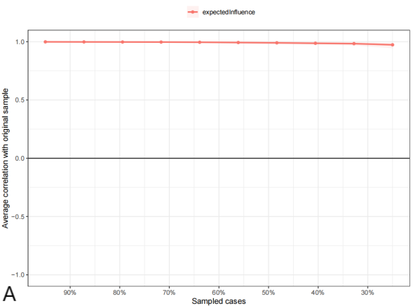
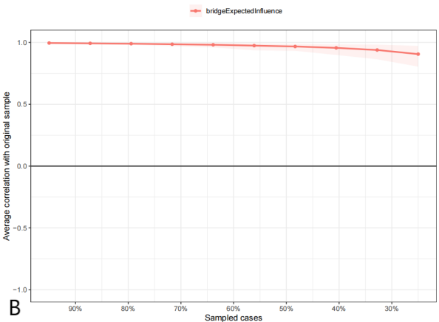
Figure S1. Bootstrapped Stability Test for Node EI (A) and Bridge EI (B) Centrality in The Network

Figure S2: Bootstrapped Difference Test for Node EI (A) and Bridge EI (B) Centrality in The Network.
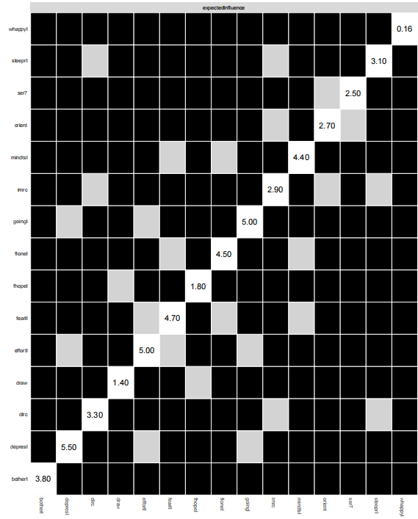
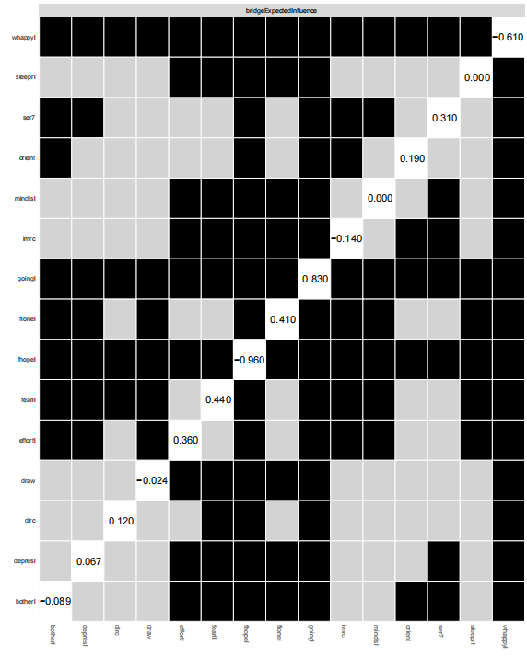
The color of the boxes represents whether the node centrality differ significantly from each other (i.e., black) or do not differ significantly (i.e., grey). The number in the white boxes (i.e., the diagonal line) denotes the value of the node strength of a specific node

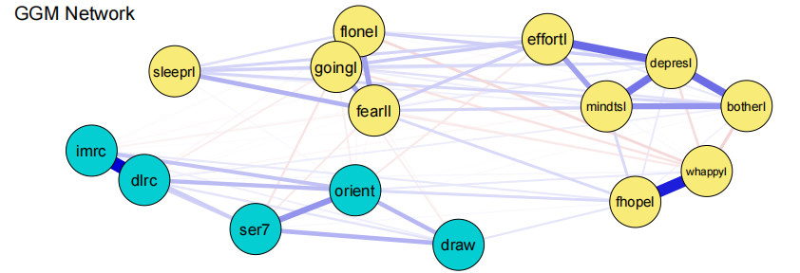
Figure S3. Gaussian Graphical Model (GGM) network of depressive and cognitive symptoms estimated from original continuous variables using EBICglasso. Blue edges indicate positive partial correlations; edge thickness reflects association strength. Nodes are grouped into depressive (light blue) and cognitive (light green) communities.

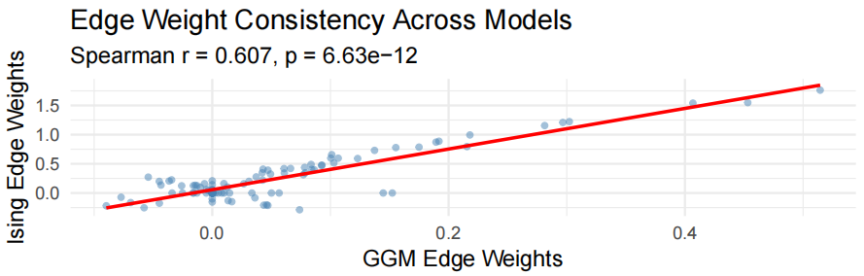
Figure S4. Scatterplot comparing edge weights between the binary Ising model and the continuous Gaussian Graphical Model (GGM). Each point represents one edge. The red line denotes the linear fit. Spearman's rank correlation indicated strong consistency between the two models (r= 0.607, p< 0.001).

Table S1. Bridge Expected Influence for Each Node in the Ising Model and Gaussian Graphical Model.
Symptom Node | Abbreviation | BEI (Ising) | BEI (GGM)
Depressed mood | depresl | 0.060 | 0.010
Effort | effortl | 0.358 | −0.064
Sleep restless | sleeprl | 0.041 | 0.011
Unhappy | whappyl | −0.613 | 0.060
Lonely | flonel | 0.407 | −0.040
Bothered | botherl | −0.084 | 0.052
Cannot continue | goingl | 0.701 | −0.159
Mind distraction | mindtsl | 0.000 | −0.016
Hopeless | fhopel | −0.834 | 0.230
Fear | fearll | 0.445 | −0.103
Immediate recall | imrc | −0.147 | 0.013
Delayed recall | dlrc | 0.116 | 0.018
Orientation | orient | 0.184 | 0.028
Visuospatial ability | draw | 0.000 | 0.000
Calculation | ser7 | 0.329 | −0.079
Note. BEI = Bridge Expected Influence (1-step). Bolded rows indicate the three bridge symptoms consistently identified across both models ("Cannot continue," "Orientation," "Calculation"). Communities: Depressive = 10 CESD-10 items; Cognitive = 5 cognitive function indicators. Ising BEI values were derived from the binary Ising model estimated via IsingFit; GGM BEI values were derived from the Gaussian Graphical Model estimated via EBICglasso using original continuous variables. The two BEI scales are not directly comparable in absolute magnitude due to differences in model specification (logistic vs. partial correlation). Cross-model comparison should focus on the relative ranking and directional consistency of bridge symptoms rather than on absolute values.

