Supporting Information

Hydrogen sulfide (H₂S) Donor–Osimertinib Conjugates: Design, Synthesis, and Biological Evaluation as EGFR Inhibitors
Peng-Fei Gu^{a#}, Zheng Li^{a#}, Xue-Long Yang^{a#}, Yun-sheng Xueª, Lin Anª*, Hao Liu^{b}*, You-Guang Zheng^{a, c, d} *
ªCollege of Pharmacy, Xuzhou Medical University, Xuzhou 221004, PR China;
^{b}Department of Emergency Medicine, Xuzhou Central Hospital, Xuzhou Clinical School of Xuzhou Medical Univesity, Xuzhou 221002, PR China;
^{c}Jiangsu Institute of Nuclear Medicine, NHC Key Laboratory of Nuclear Medicine and Jiangsu Key Laboratory of Molecular Nuclear Medicine, 20 Qianrong Rd, Wuxi 214063, PR China;
^{d}Jiangsu Yuanlong Hospital Management Co., Ltd., 84 Huaihai Rd, Xuzhou 221002, PR China.
#Peng-Fei Gu, Zheng Li, Xue-Long Yang contributed equally to this work.
* Corresponding author. zhengyouguang@xzhmu.edu.cn

Contents
1.1 ¹H NMR and ¹³C NMR of all compounds………………………………….…………S1-S24
1.2 HRMS of all compounds…………………………………………………..………….S25-S28
1.3 Raw data of CCK8…………………………………………………..…………….S29-S33
1.4 Raw data of EGFR…………………………………………………..…………….S34-S36
1.5 Short Tandem Repeat (STR) Genotyping Report………………..…………. . .S38-S50

1.1 ¹H NMR and ¹³C NMR of all compounds
(9a): Yield: 14.5%; mp 123.2−124.4 °C; ¹H NMR (400 MHz, d₆-DMSO) δ 9.14(s, 1H), 8.97 (s, 1H), 8.58 (s, 1H), 8.31-8.2 (m, 3H), 7.88 (s, 1H), 7.77 (d, J = 8.0 Hz, 2H), 7.67 (s, 1H), 7.48 (t, J = 8.0 Hz, 1H), 7.19 (q, J = 16.0 Hz, 2H), 7.11 (t, J = 12.0 Hz, 1H), 7.0 (d, J = 8.0 Hz, 2H), 6.93 (s, 1H), 6.69 (q, 1H), 6.20 (q, J = 16.0 Hz ,1H) , 5.63(d, J = 12.0 Hz, 1H), 4.55 (s, 2H), 3.86 (s, 3H), 3.83 (s, 3H), 3.3 (s, 2H), 2.98 (t, J = 16.0 Hz, 2H), 2.64(s, 3H). ¹³C NMR (100 MHz, CDCl₃) δ 215.03, 172.30, 167.56, 162.83, 162.17, 159.85, 159.31, 157.73, 144.43, 138.30, 134.88, 134.12, 132.28, 128.59, 127.73, 127.64, 126.77, 125.98, 125.42, 122.14, 121.25, 120.58, 115.60, 113.60, 110.20, 110.09, 108.10, 103.90, 67.16, 56.21, 55.87, 44.40, 38.11, 33.22.
¹H NMR spectrum of compound 9a
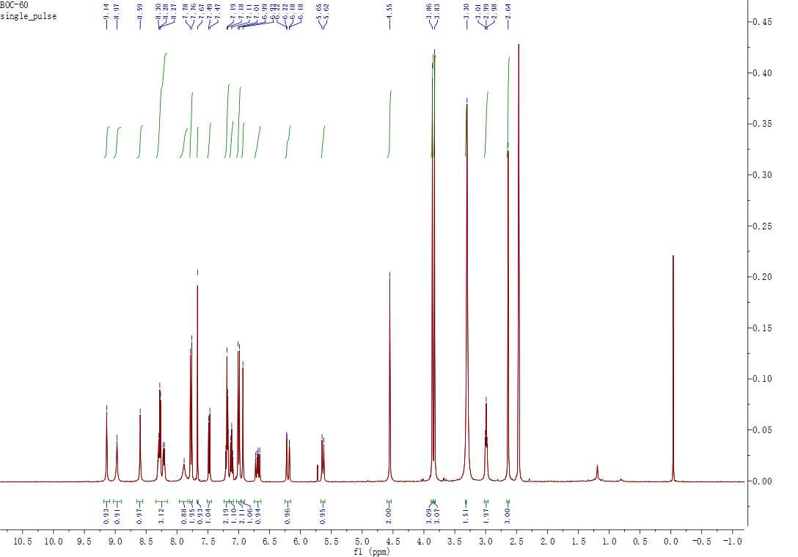

¹³C NMR spectrum of compound 9a
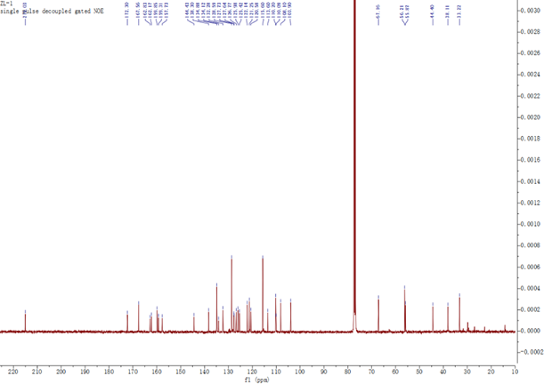

(9b): Yield: 16.6%; mp 72.5−75.3 °C; ¹H NMR (400 MHz, CDCl₃) δ 9.71 (s, 1H), 8.95 (s, 1H), 8.72 (s, 1H), 8.31 (d, J = 4.0 Hz, 1H), 8.05 (d, J = 8.0 Hz, 1H), 7.83 (s, 1H), 7.38-7.36 (m, 1H), 7.31-7.26 (m, 1H), 7.17 (d, J = 4.0 Hz, 1H), 6.71 (s, 1H), 6.45 (t, J = 8.0 Hz, 2H), 5.87 (t, J = 8.0 Hz, 2H), 5.84-5.75 (m, 2H), 5.19-5.1 (m, 2H), 3.95 (s, 3H), 3.87 (s, 3H), 3.36-3.32 (m, 2H), 3.29-3.27 (m, 2H), 3.06 (t, J = 12.0 Hz, 2H), 2.92 (t, J = 12.0 Hz, 2H), 2.65(s, 3H), 2.5 (t, J = 12.0 Hz, 2H). ¹³C NMR (100 MHz, CDCl₃) δ 171.44, 162.81, 162.26, 159.54, 157.85, 144.67, 138.30, 134.89, 134.40, 133.29, 132.42, 127.61, 126.73, 126.01, 122.02, 121.12, 120.47, 118.87, 113.68, 110.32, 110.19, 108.13, 103.88, 56.20, 44.17, 42.02, 38.08, 36.06, 33.83, 33.20.
¹H NMR spectrum of compound 9b
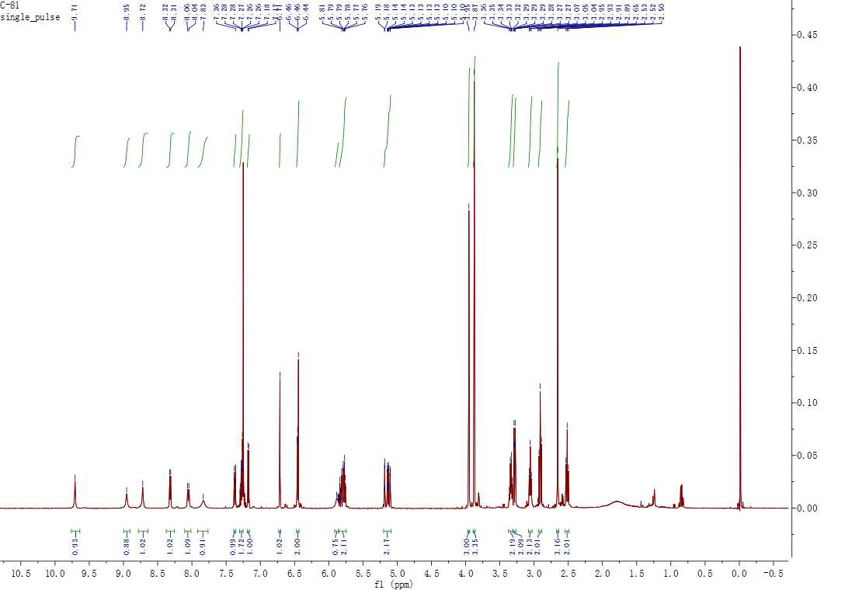

¹³C NMR spectrum of compound 9b
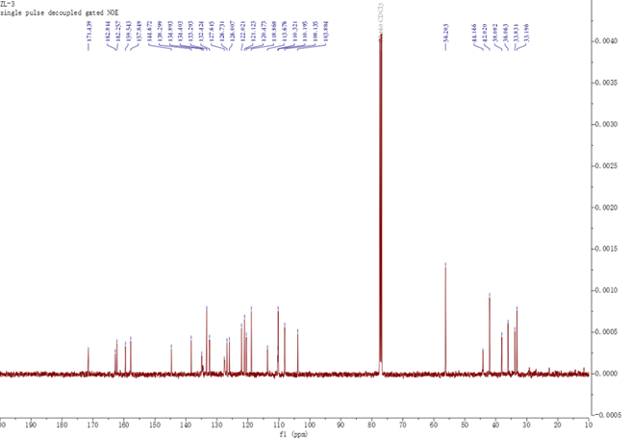

(9c): Yield: 12.9%; mp 125.2−127.3 °C; ¹H NMR (400 MHz, DMSO-D6) δ 9.31 (s, 1H), 8.94 (s, 1H), 8.57 (s, 1H), 8.28 – 8.15 (m, 3H), 787 – 7.70 (m, 4H), 7.47 (d, J = 8.1 Hz, 1H), 7.21 – 7.11 (m, 3H), 7.03 (d, J = 8.9 Hz, 2H), 6.88 (s, 1H), 6.72 (dd, J = 16.9, 10.2 Hz, 1H), 6.21 (d, J = 17.0 Hz, 1H), 5.72 – 5.66 (m, 1H), 4.58 (s, 2H), 3.83 (d, J = 18.8 Hz, 6H), 3.32 (s, 5H), 3.16 (q, J = 6.5 Hz, 2H), 1.59 (p, J = 6.8 Hz, 2H). ¹³C NMR (100MHz, d₆-DMSO) δ 215.36, 174.17, 167.67, 163.40, 162.21, 161.61, 160.42, 158.13, 146.87, 138.49, 138.20, 134.85, 134.28, 133.05, 129.44, 126.69, 126.63, 125.87, 125.24, 124.74, 122.54, 121.99, 121.48, 116.28, 115.66, 112.97, 111.02, 107.61, 104.80, 67.50, 56.51, 52.69, 43.27, 36.27, 33.51, 27.36.
¹H NMR spectrum of compound 9c
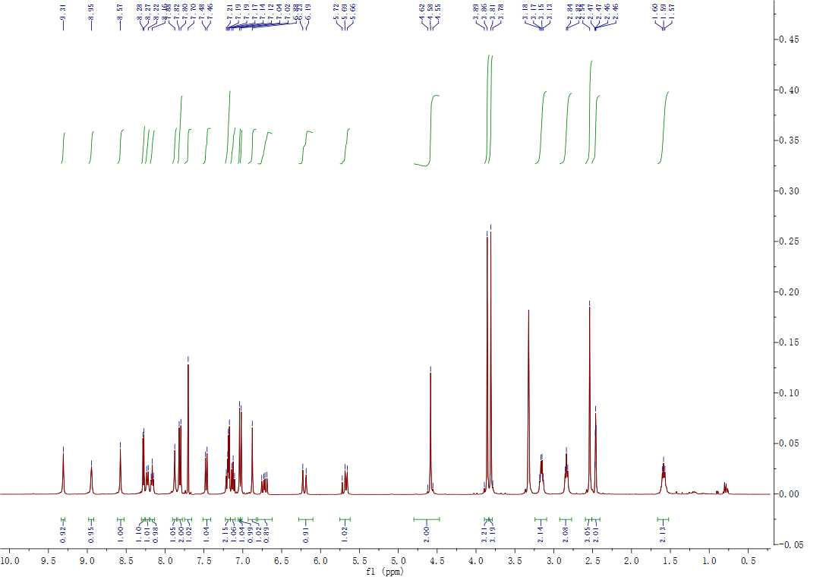

¹³C NMR spectrum of compound 9c
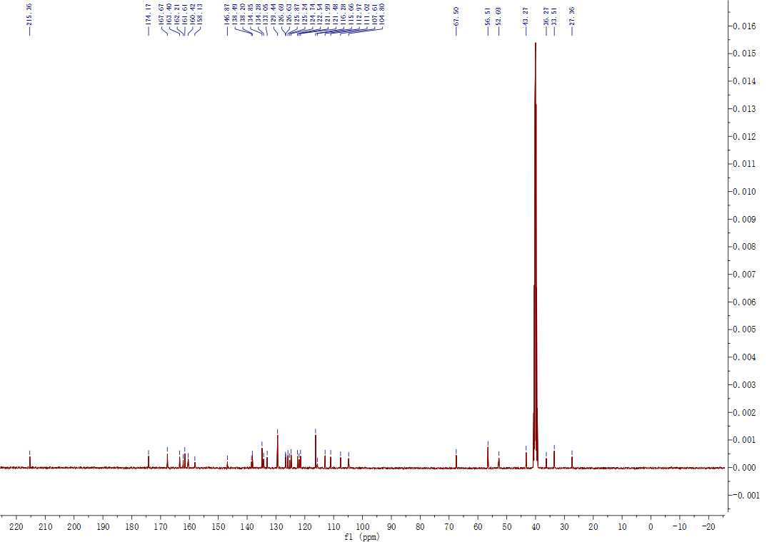

(9d): Yield: 21.0%; mp 73.2−76.3 °C; ¹H NMR (400 MHz, CDCl₃) δ 9.81(s, 1H), 9.01 (s, 2H), 8.29 (s, 1H), 8.38-8.36 (d, J = 4.0 Hz, 1H), 7.88 (s, 1H), 7.38 (q, J = 8.0 Hz, 1H), 7.3-7.25 (m, 2H), 7.19 (d, J =8.0 Hz, 1H), 6.73 (s, 1H), 6.56 (q, J = 16.0 Hz 1H), 6.44(q, J = 16.0 Hz, 1H), 5.79-5.69 (m, 3H), 5.11-5.05 (m, 2H), 3.97 (s, 3H), 3.87 (s, 3H), 3.28 (q, J = 16.0 Hz, 2H), 3.12-3.1 (m, 2H), 2.92 (t, J = 16.0 Hz, 2H), 2.73 (t, J = 12.0 Hz, 2H), 2.59 (s, 3H), 2.40 (t, J = 16.0 Hz, 2H), 1.62-1.57 (m, 2H). ¹³C NMR (100 MHz, CDCl₃ ) δ 170.95, 163.00, 162.17, 159.49, 157.78, 144.43, 138.20, 134.94, 134.25, 133.26, 132.60, 128.12, 127.14, 126.26, 125.90, 121.90, 121.02, 120.34, 118.71, 113.52, 110.27, 110.12, 107.96, 103.70, 56.13, 52.99, 44.24, 41.91, 36.80, 35.80, 33.92, 33.10, 27.62.
¹H NMR spectrum of compound 9d
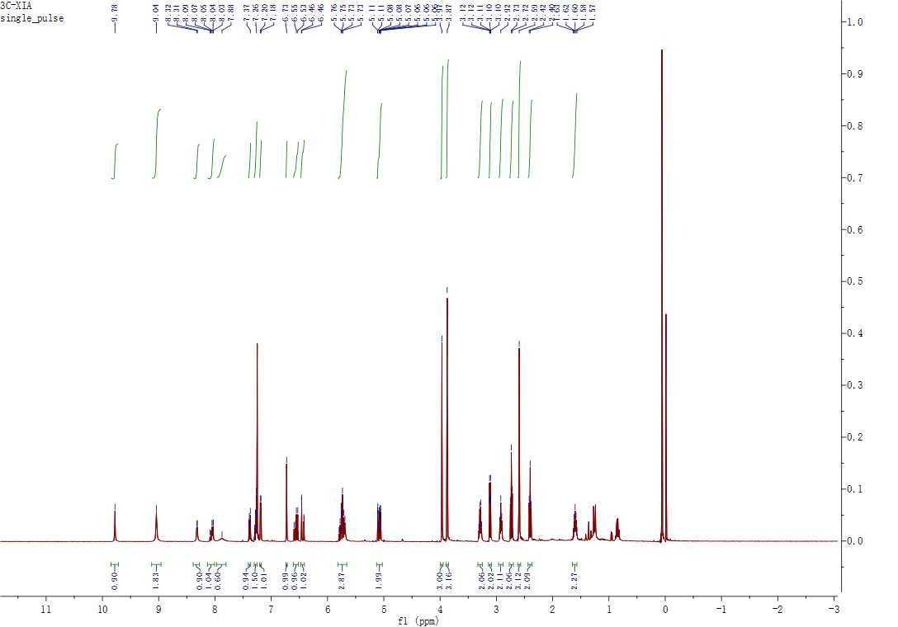

¹³C NMR spectrum of compound 9d
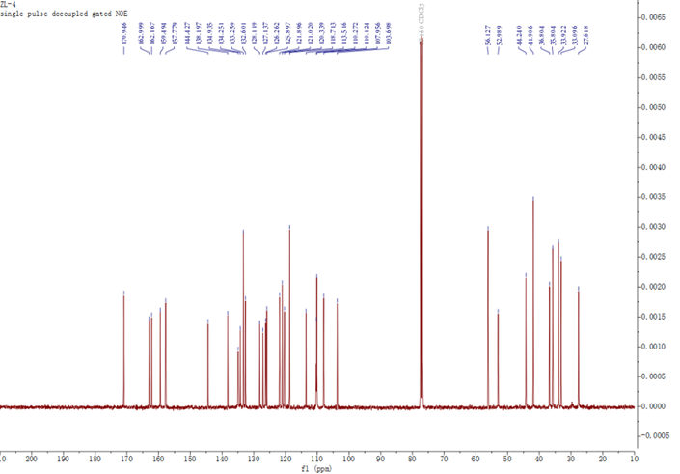

(12a): Yield: 16.9%; mp 76.2−77.3 °C; ¹H NMR (400 MHz, DMSO-D6) δ 9.20 (s, 1H), 8.70 (s, 1H), 8.49 (s, 1H), 8.19 (d, J = 9.8 Hz, 3H), 7.95 (s, 1H), 7.52 (d, J = 8.4 Hz, 1H), 7.31 – 7.14 (m, 3H), 6.98 (s, 1H), 6.70 (dd, J = 17.0, 10.3 Hz, 1H), 6.19 (d, J = 17.0 Hz, 1H), 5.75 (dt, J = 24.2, 9.7 Hz, 2H), 5.11 (dd, J = 23.7, 13.4 Hz, 2H), 3.83 (d, J = 30.1 Hz, 7H), 3.65 (d, J = 5.9 Hz, 3H), 3.33 (d, J = 7.4 Hz, 2H), 3.23 (d, J = 6.2 Hz, 2H), 2.98 (s, 3H), 2.83 (t, J = 7.3 Hz, 2H), 2.45 (s, 2H). ¹³C NMR (100 MHz CDCl₃,) δ 171.96, 169.41, 163.28, 162.23, 159.60, 157.85, 144.95, 138.24, 135.56, 134.58, 133.21, 132.31, 126.94, 126.82, 125.94, 122.10, 121.17, 120.52, 118.85, 113.62, 111.48, 110.19, 108.17, 103.73, 56.16, 55.31, 43.79, 43.66, 41.91, 37.76, 35.34, 33.69, 33.22.
¹H NMR spectrum of compound 12a
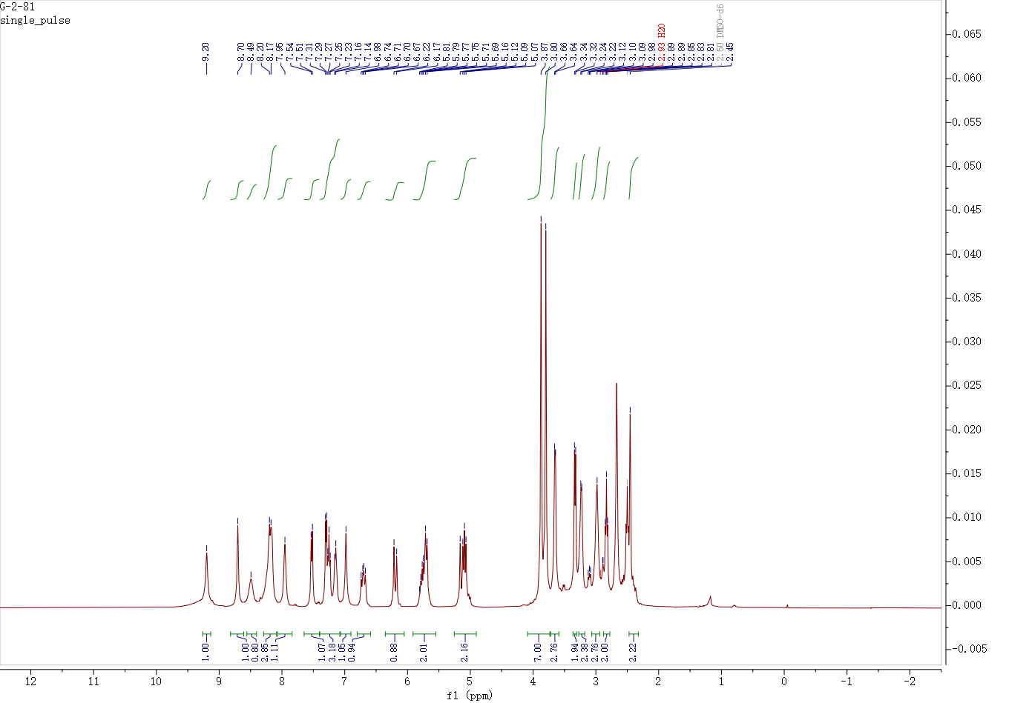

¹³C NMR spectrum of compound 12a
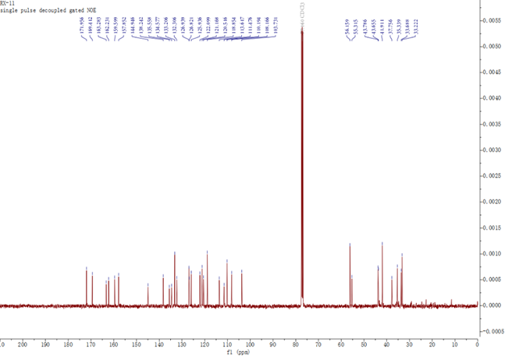

(12b): Yield: 15.6%; mp 78.4−80.3 °C; ¹H NMR (400 MHz, DMSO-D6) δ 9.25 (s, 1H), 8.76 (s, 1H), 8.53 (s, 1H), 8.19 (dd, J = 15.0, 6.8 Hz, 3H), 8.04 (t, J = 5.6 Hz, 1H), 7.57 (d, J = 8.2 Hz, 1H), 7.32 (dd, J = 26.8, 7.1 Hz, 2H), 7.18 (t, J = 7.6 Hz, 1H), 7.03 (s, 1H), 6.76 (dd, J = 16.9, 10.2 Hz, 1H), 6.24 (d, J = 16.9 Hz, 1H), 5.85 – 5.73 (m, 2H), 5.20 – 5.11 (m, 2H), 4.30 – 4.27 (m, 1H), 3.88 (d, J = 32.3 Hz, 8H), 3.37 (d, J = 7.3 Hz, 2H), 3.26 (d, J = 6.1 Hz, 2H), 2.86 (t, J = 6.8 Hz, 2H), 2.71 (s, 3H), 2.53 (d, J = 7.2 Hz, 2H), 0.95 – 0.81 (m, 3H). ¹³C NMR (100 MHz, CDCl₃) δ 172.44, 171.38, 163.23, 162.24, 159.56, 157.78, 144.88, 138.25, 135.47, 134.74, 133.22, 132.44, 127.05, 126.68, 125.97, 122.02, 121.12, 120.50, 118.83, 113.64, 111.50, 110.16, 108.09, 103.63, 56.17, 55.35, 49.03, 43.89, 41.94, 37.74, 35.58, 33.71, 33.20, 17.53.
¹H NMR spectrum of compound 12b
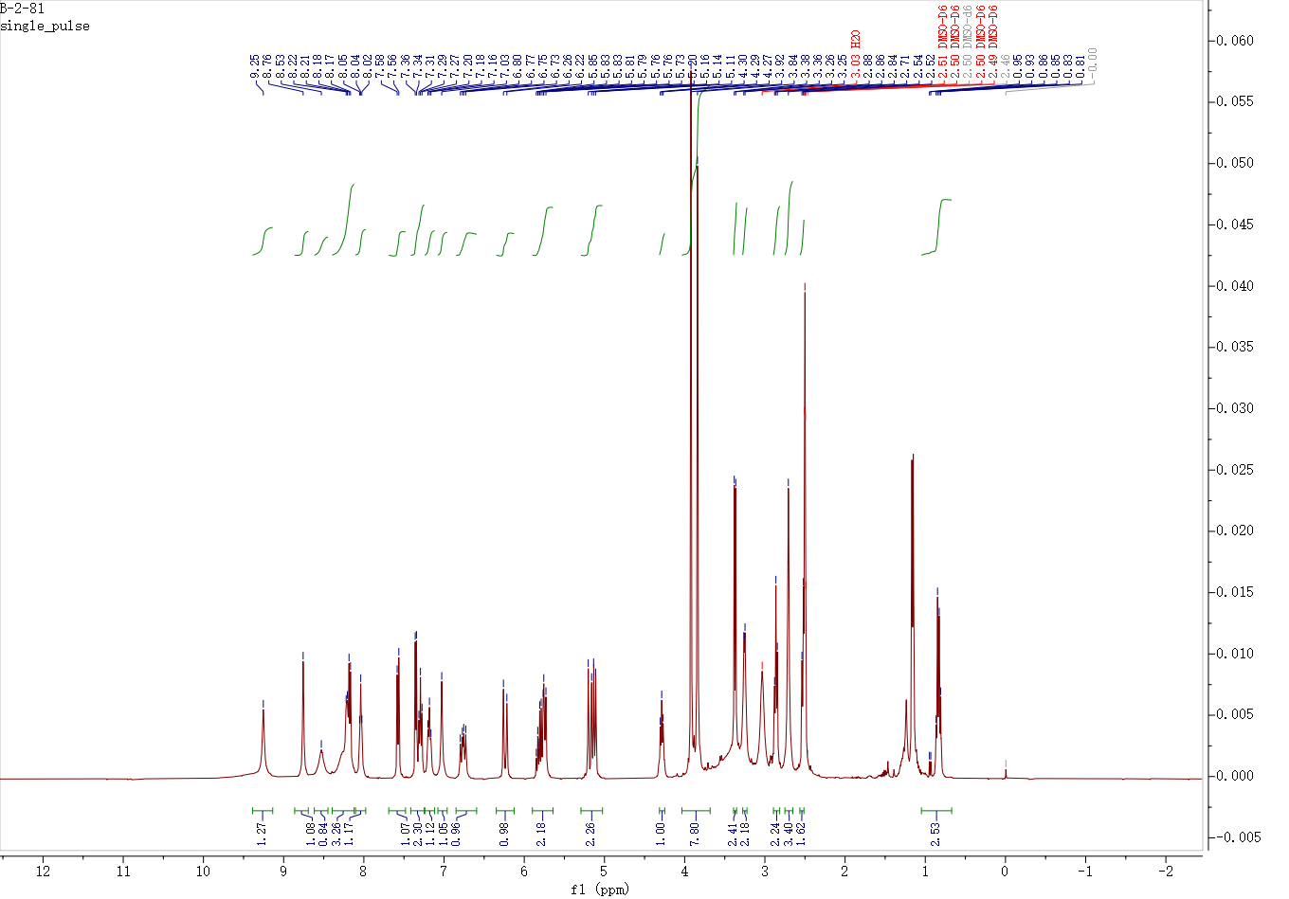

¹³C NMR spectrum of compound 12b
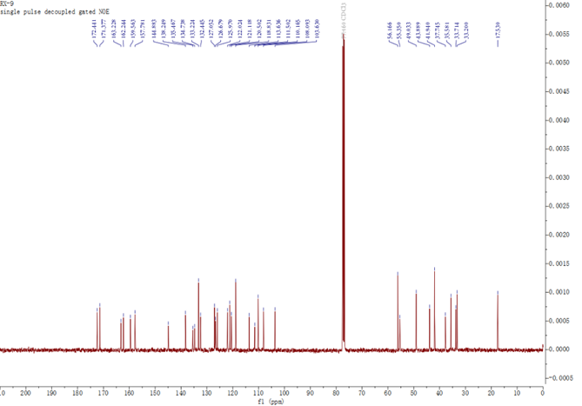

(12c): Yield: 14.2%; mp 132.44−135.6 °C; ¹H NMR (400 MHz, DMSO-D6) δ 9.19 (s, 1H), 8.99 (s, 1H), 8.63 (s, 1H), 8.29 (dd, J = 24.9, 6.7 Hz, 2H), 8.10 – 7.93 (m, 3H), 7.53 (d, J = 8.2 Hz, 1H), 7.26 – 7.15 (m, 3H), 6.96 (s, 1H), 6.79 (dd, J = 16.9, 10.2 Hz, 1H), 6.28 (dd, J = 17.0, 2.0 Hz, 1H), 5.78 – 5.68 (m, 2H), 5.14 – 5.04 (m, 2H), 4.32 (td, J = 9.1, 5.5 Hz, 1H), 3.89 (d, J = 16.3 Hz, 7H), 3.17 (dd, J = 31.6, 6.8 Hz, 5H), 2.64 – 2.57 (m, 6H), 1.42 – 1.32 (m, 2H), 0.82 (dd, J = 10.7, 6.6 Hz, 8H). ¹³C NMR (100 MHz, CDCl₃) δ 172.41, 171.60, 163.21, 162.19, 159.44, 157.67, 144.79, 138.18, 135.35, 134.73, 133.18, 132.47, 127.01, 126.95, 126.61, 125.90, 121.95, 121.06, 120.43, 118.74, 113.54, 111.49, 110.11, 108.00, 103.53, 56.10, 55.24, 51.96, 43.90, 41.87, 40.13, 37.67, 35.50, 33.72, 33.12, 24.77, 22.98, 21.93.
¹H NMR spectrum of compound 12c
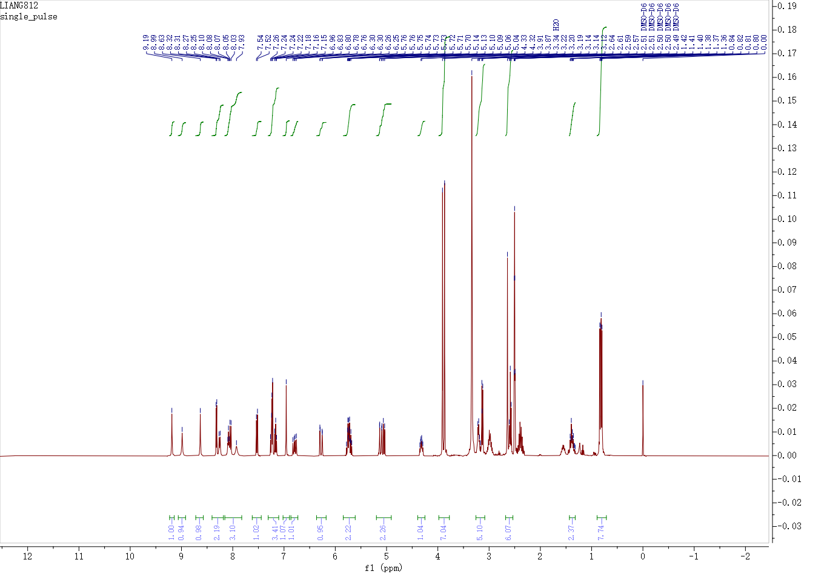

¹³C NMR spectrum of compound 12c
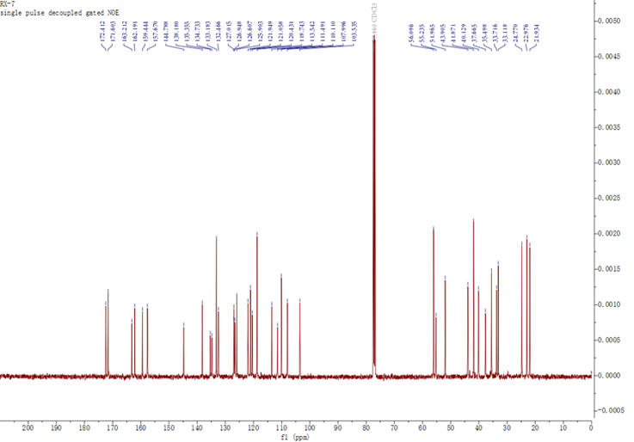

(12d): Yield: 14.0%; mp 79.2−80.3 °C; ¹H NMR (400 MHz, CDCl₃) δ 9.7(s, 1H), 8.9-8,82 (s, 2H), 8.36-8.34 (d, J = 8Hz, 2H), 8.07-8.06 (m, 1H), 7.69 (s, 1H), 7.39-7.36 (m, 1H), 7.27-7.25 (m, 2H), 7.18-7.17 (d, J = 4.0 Hz, 1H), 6.73-6.67 (m, 2H), 6.55-6.45 (m, 2H), 6.36-6.33 (m, 1H), 5.78-5.72 (m, 2H), 5.15-5.07 (m, 2H), 3.95 (s, 3H), 3.86 (s, 3H), 3.82 (m, 2H), 3.25-3.15 (m, 4H), 2.88 (m, 4H), 2.59 (s, 3H), 2.55-2.52 (m, 2H). ¹³C NMR (100MHz, CDCl₃) δ 171.54, 168.86, 163.05, 162.05, 159.43, 157.79, 144.53, 138.13, 134.67, 134.39, 133.08, 132.35, 127.34, 126.95, 126.46, 125.83, 121.88, 120.98, 120.28, 118.78, 113.54, 110.53, 110.07, 107.96, 103.56, 56.05, 52.85, 43.49, 43.38, 41.76, 36.69, 35.10, 33.51, 33.08, 26.90.
¹H NMR spectrum of compound 12d
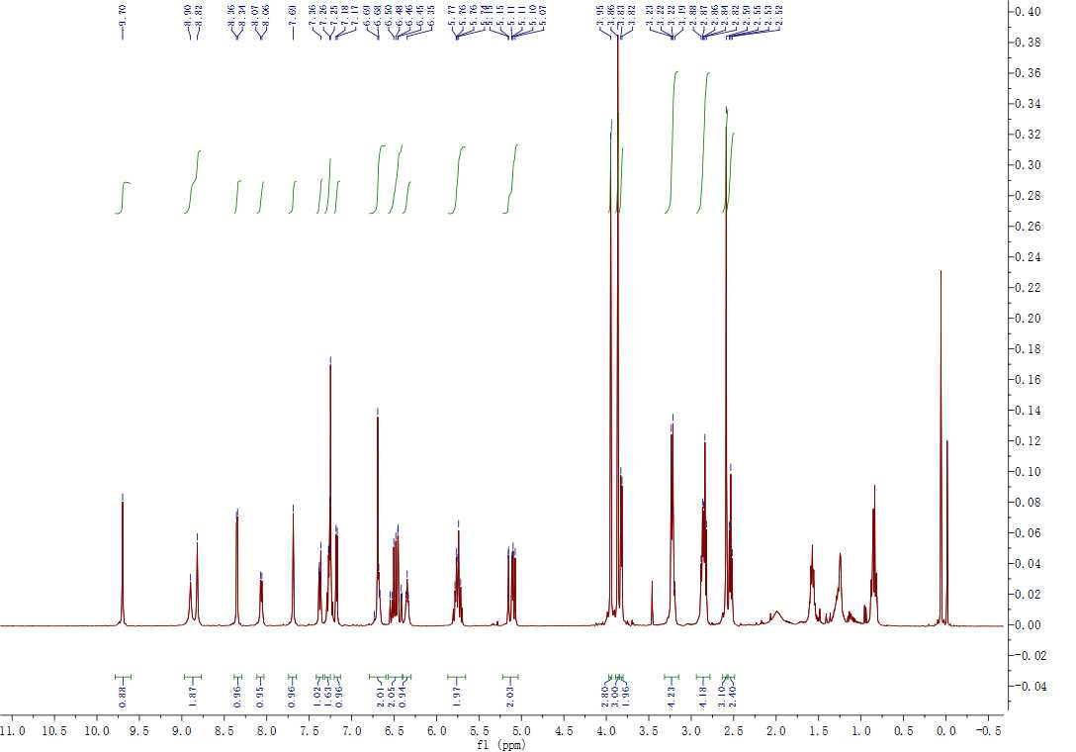

¹³C NMR spectrum of compound 12d
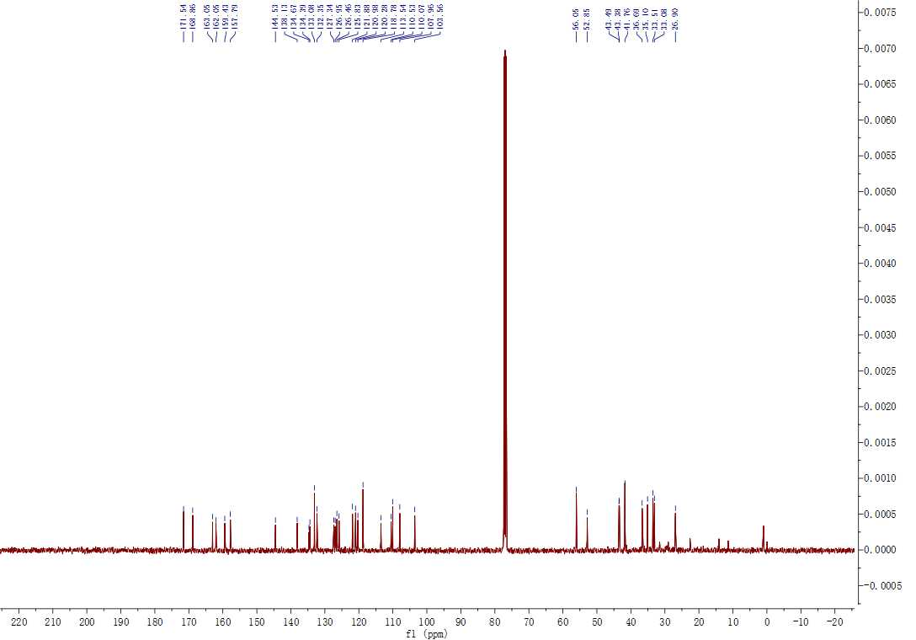

(12e): Yield: 14.6%; mp 74.2−76.3 °C; ¹HNMR (400 MHz, CDCl₃) δ 9.73 (s, 1H), 8.95 (s, 1H), 8.35-8.34 (m, 2H), 8.05 (s, 1H), 7.74 (s, 1H), 7.36 (s, 1H), 7.28-7.25 (m, 2H), 7.18-7.12 (s, 1H), 6.70 (s, 1H), 6.59-6.52 (m, 1H), 6.46-6.35 (m, 3H), 5.8-5.73 (m, 2H), 5.16-5.08 (m, 2H), 4.4 (m, 1H), 3.96 (s, 3H), 3.88 (s, 3H), 3.30-3.19 (m, 4H), 2.93-2.81 (m, 4H), 2.64-2.49 (m, 5H), 1.62-1.56 (m, 2H), 1.33-1.3 (m, 3H). ¹³C NMR (100MHz, CDCl₃) δ 172.08, 170.91, 162.98, 162.13, 159.33, 157.58, 144.49, 138.15, 134.90, 134.37, 133.13, 132.49, 127.64, 127.05, 126.30, 125.86, 121.83, 120.96, 120.27, 118.74, 113.53, 110.51, 110.05, 107.87, 103.55, 56.07, 52.77, 48.95, 43.75, 41.83, 36.65, 35.41, 33.57, 33.06, 27.13, 17.96.
¹H NMR spectrum of compound 12e
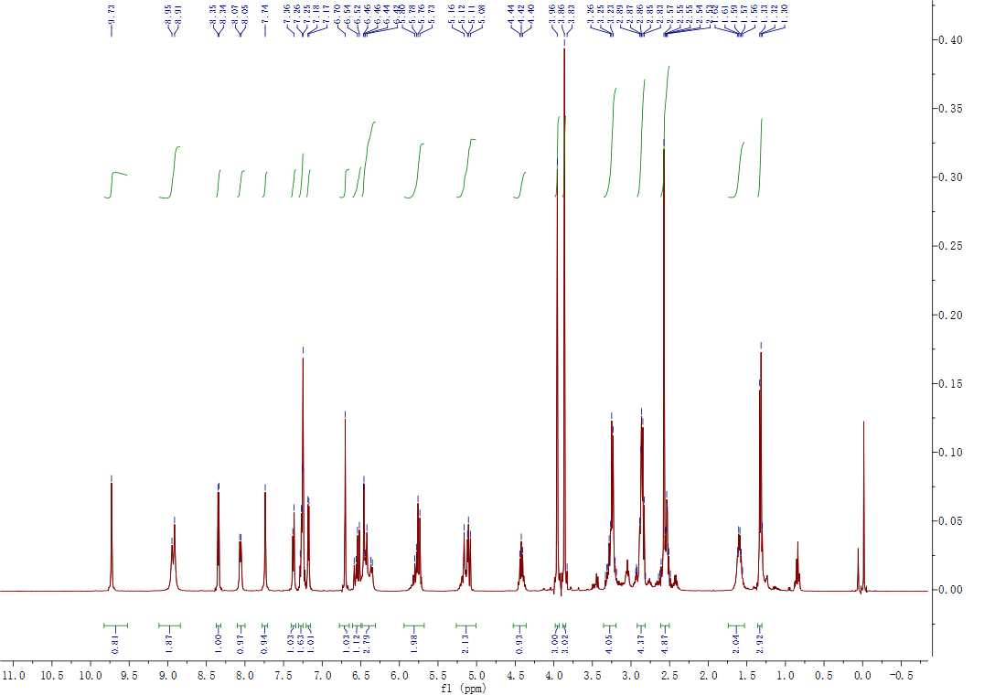

¹³C NMR spectrum of compound 12e
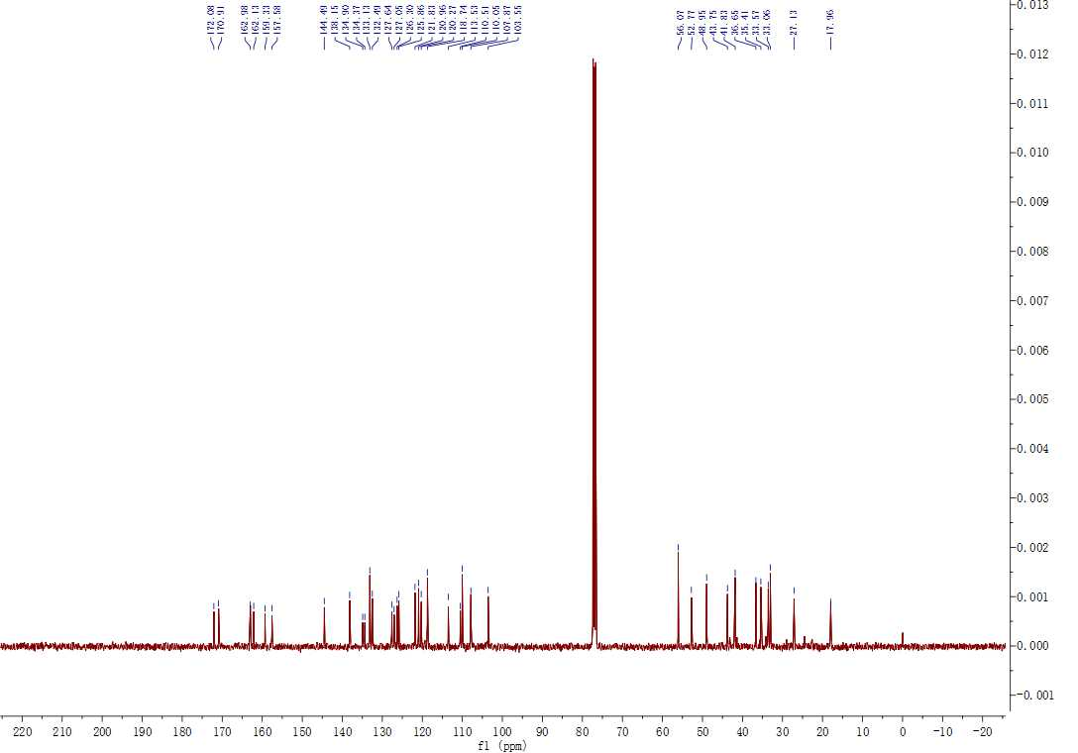

(12f): Yield: 14.6%; mp 144.3−145.1 °C; ¹HNMR (400 MHz, CHLOROFORM-D) δ 9.75 (s, 1H), 8.94 (d, J = 31.2 Hz, 2H), 8.37 (d, J = 5.4 Hz, 1H), 8.08 (d, J = 6.6 Hz, 1H), 7.74 (s, 1H), 7.41 – 7.38 (m, 1H), 7.31 – 7.27 (m, 2H), 7.20 (d, J = 5.3 Hz, 1H), 6.72 (s, 1H), 6.57 (dd, J = 16.8, 9.8 Hz, 1H), 6.19 (d, J = 56.1 Hz, 2H), 5.83 – 5.73 (m, 2H), 5.17 – 5.09 (m, 2H), 4.38 (q, J = 8.4 Hz, 1H), 3.98 (s, 3H), 3.89 (s, 3H), 3.25 (d, J = 7.3 Hz, 2H), 2.92 – 2.84 (m, 4H), 2.60 (s, 5H), 1.72 – 1.25 (m, 7H), 0.90 (dd, J = 9.3, 6.4 Hz, 6H). ¹³C NMR (100MHz, d6-DMSO) δ 171.87, 171.18, 163.01, 162.12, 159.34, 144.48, 138.18, 134.97, 134.42, 133.14, 132.55, 127.56, 127.06, 126.26, 125.89, 121.83, 120.97, 120.28, 118.74, 113.58, 110.56, 110.06, 107.87, 103.53, 77.32, 77.00, 76.68, 56.08, 52.68, 51.83, 43.65, 41.81, 40.51, 36.60, 35.41, 33.53, 33.07, 27.06, 24.76, 22.91, 21.90.
¹H NMR spectrum of compound 12f
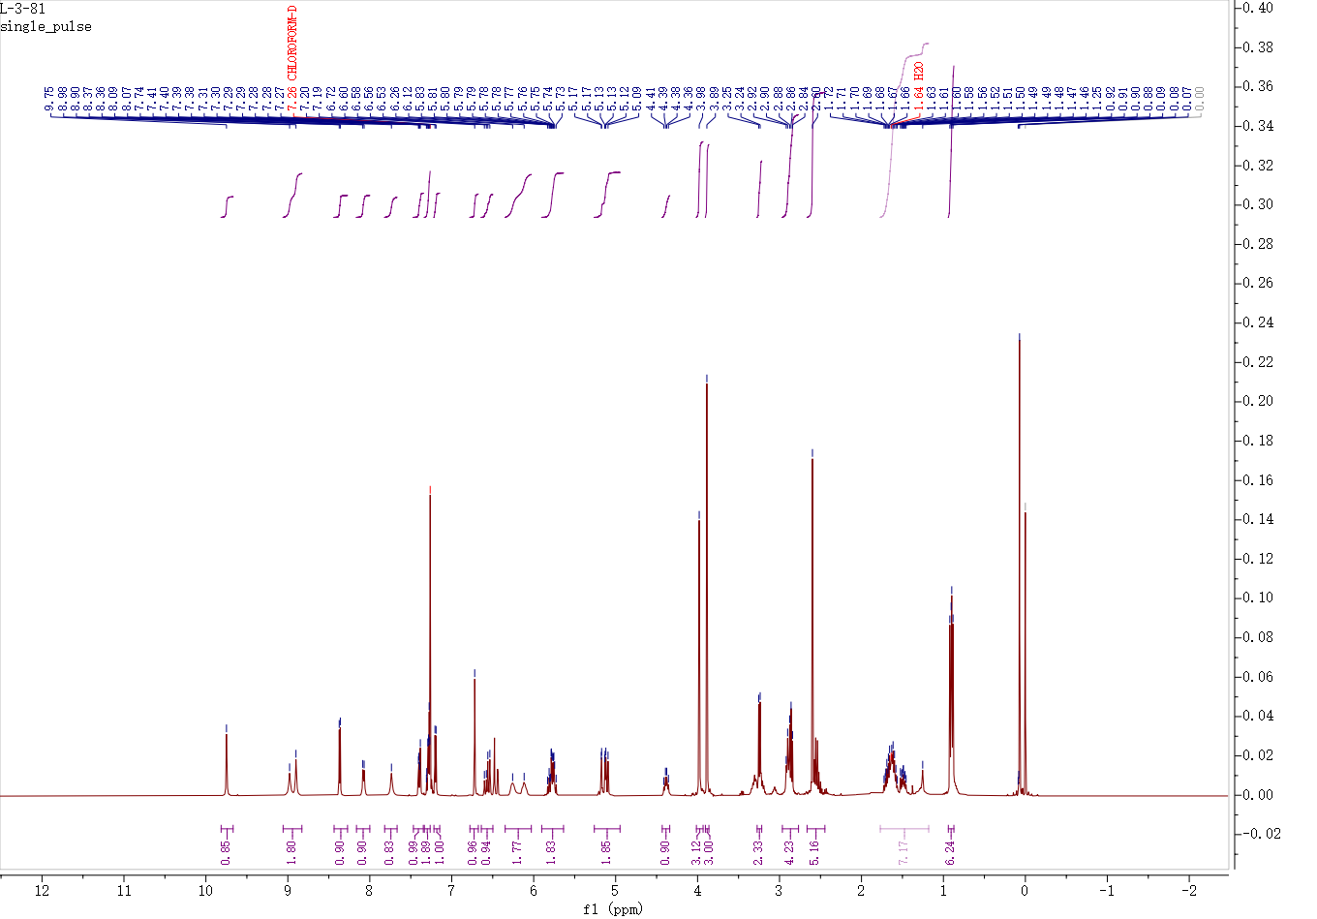

¹³C NMR spectrum of compound 12f
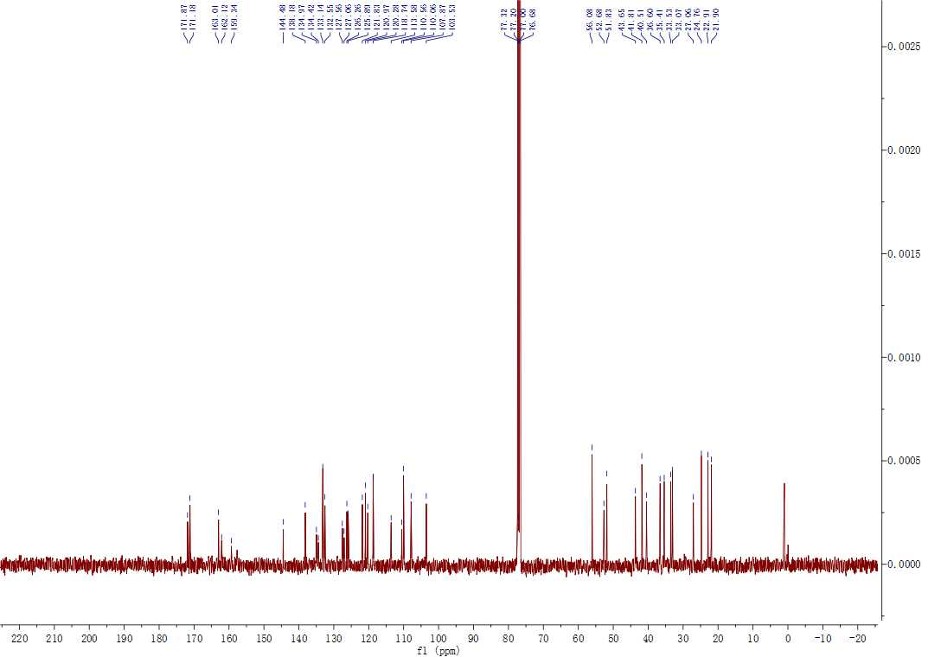

(16a): Yield: 14.7%; mp 96.1−98 °C; ¹H NMR (400 MHz, CDCl₃) δ 9.83 (s, 1H), 9.05 (s, 1H), 8.8 (s, 1H), 8.35 (d, J = 8.0 Hz, 1H), 8.04 (t, J = 8.0 Hz, 1H), 7.92 (d, J = 12.0 Hz, 1H), 7.57-7.54 (m, 2H), 7.4-7.38 (m, 1H), 7.35(t, J = 4.0 Hz, 1H), 7.3-7.26 (m, 2H), 7.20 (d, J = 4.0 Hz, 1H), 6.91-6.88 (m, 2H), 6.78 (s, 1H), 6.39 (q, 1H) ,6.22 (q, 1H) ,5.67 (q, 1H), 4.01(t, J = 12.0 Hz, 2H), 3.96 (s, 3H), 3.88 (s, 3H), 3.08 (t, J = 8.0 Hz, 2H), 2.67(s, 3H) ,1.94 (t, J = 8.0 Hz, 2H). ¹³C NMR (100 MHz, CDCl₃) δ 215.22, 173.11, 162.51, 162.31, 162.24, 159.55, 157.94, 144.49, 138.35, 135.09, 134.72, 133.66, 132.41, 128.73, 128.33, 127.86, 126.43, 126.04, 124.34, 122.02, 121.14, 120.41, 115.50, 113.72, 110.23, 109.52, 108.20, 103.90, 66.16, 56.25, 53.79, 44.35, 33.22, 27.43.
¹H NMR spectrum of compound 16a
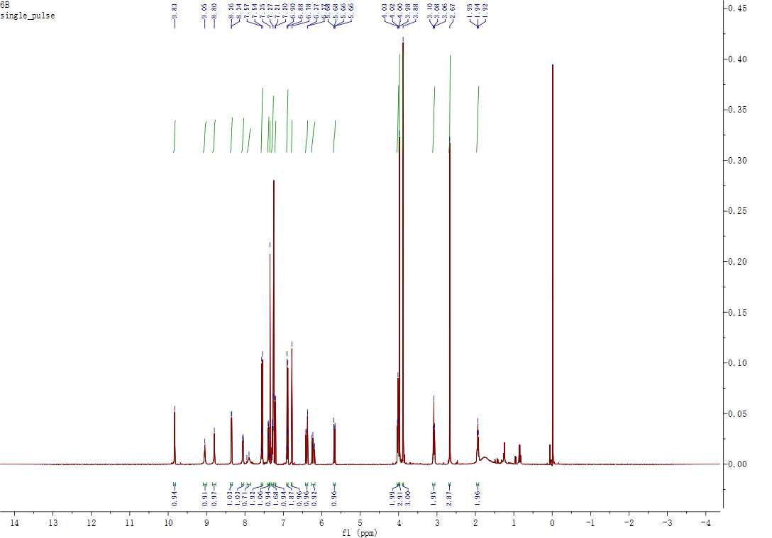

¹³C NMR spectrum of compound 16a

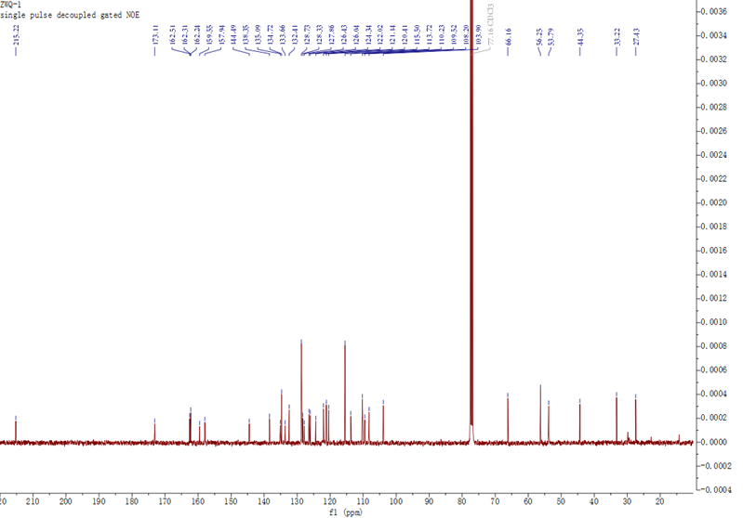

(16b): Yield: 14.7%; ¹H NMR (400 MHz, CDCl₃) δ 9.83 (s, 1H), 9.07 (s, 1H), 8.86 (s, 1H), 8.34 (d, J = 4.0 Hz, 1H), 8.05 (q, J = 8.0 Hz, 1H), 7.85(s, 1H), 7.4-7.38 (m, 1H), 7.3-7.26 (m, 2H), 7.20 (d, J = 4.0 Hz, 1H), 6.75 (s, 1H), 6.44 (q, 2H), 5.77-7.72 (m, 2H), 5.2-5.06 (m, 2H), 4.16 (t, J = 12.0 Hz, 2H), 3.98 (s, 3H), 3.88 (s, 3H), 3.30 (q, J = 8.0 Hz, 1H), 3.13-3.11 (m, 1H), 2.95-2.88 (m, 3H), 2.74-2.69 (m, 2H), 2.62 (d, J = 4.0 Hz, 3H), 2.57 (t, J = 16.0 Hz, 1H), 1.81-1.74 (m, 2H). ¹³C NMR (100 MHz, CDCl₃) δ 172.07, 162.71, 162.39, 159.39, 157.64, 144.51, 138.38, 135.37, 134.19, 133.90, 132.64, 128.40, 127.68, 126.39, 126.07, 121.96, 121.12, 120.37, 117.44, 113.72, 110.23, 109.76, 108.07, 103.86, 62.29, 56.28, 53.25, 44.20, 34.88, 34.61, 33.21, 27.08, 25.68.
¹H NMR spectrum of compound 16b
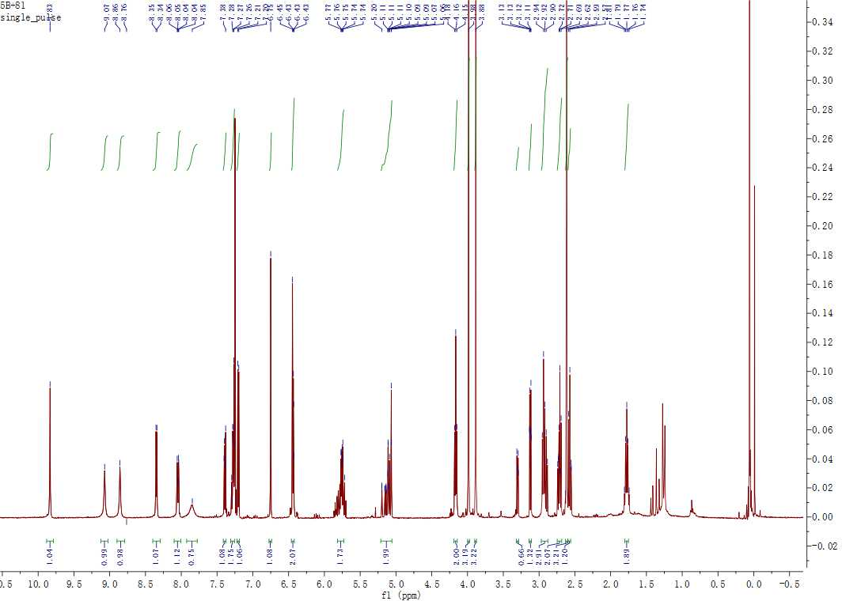

¹³C NMR spectrum of compound 16b
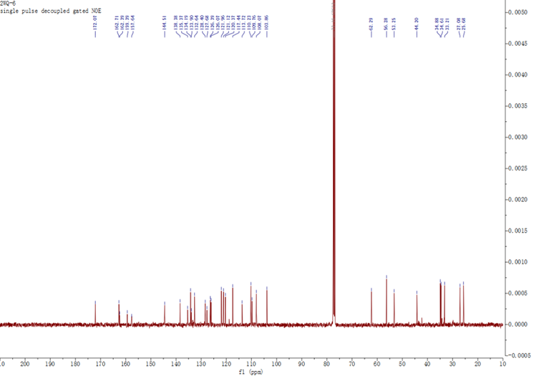

1.2 HRMS of all compounds
9a MS (m/z): HRMS (ESI) Calcd for C₃₇H₃₅N₇O₄S₃ ([M+H]⁺): 738.1991, found: 738.1989.
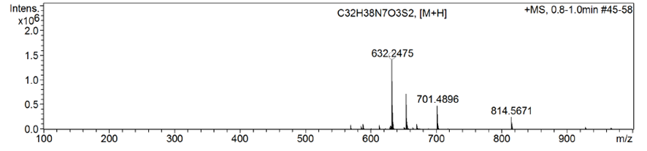

9b MS (m/z): HRMS (ESI) Calcd for C₃₂H₃₇N₇O₃S₂ ([M+H]⁺): 632.2478 found: 632.2475.
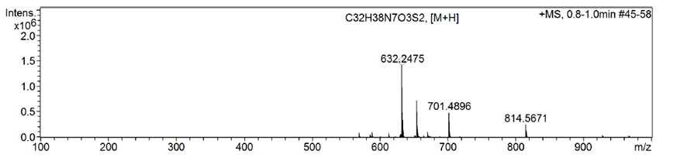

9c MS (m/z): HRMS (ESI) Calcd for C₃₈H₃₇N₇O₄S₃ ([M+H]⁺): 752.2147, found: 752.2146.
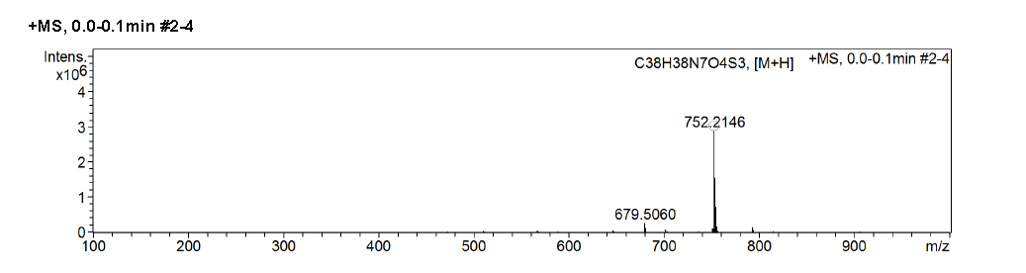

9d MS (m/z): HRMS (ESI) Calcd for C₃₃H₃₉N₇O₃S₂ ([M+H]⁺): 646.2634, found: 646.2635.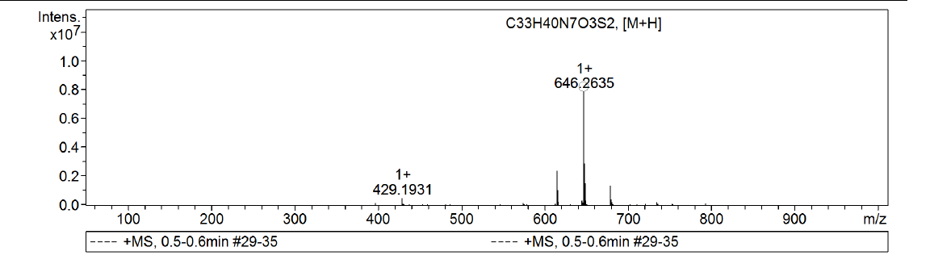

12a MS (m/z): HRMS (ESI) Calcd for C₃₄H₄₀N₈O₄S₂ ([M+H]⁺): 689.2692, found: 689.2686.
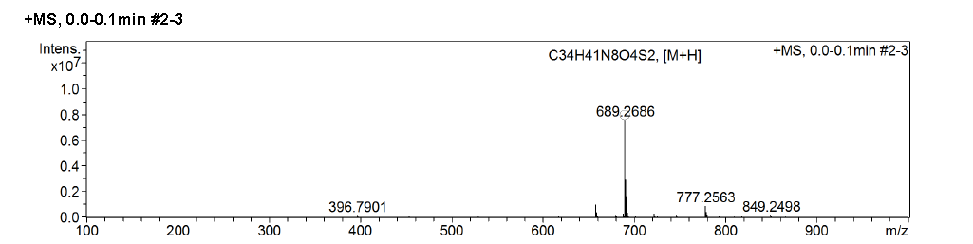

12b MS (m/z): HRMS (ESI) Calcd for C₃₅H₄₂N₈O₄S₂ ([M+H]⁺): 703.2849, found: 703.2845.
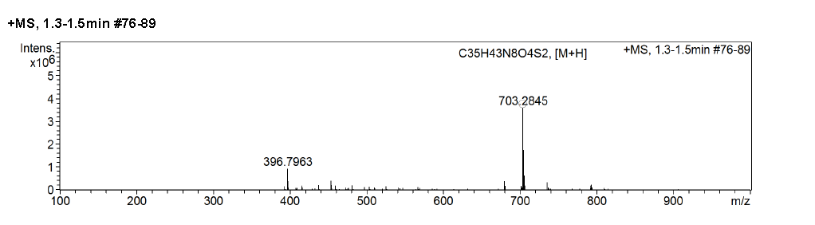

12c MS (m/z): HRMS (ESI) Calcd for C₃₈H₄₈N8O₄S₂ ([M+H]⁺): 745.3318, found: 745.3315.
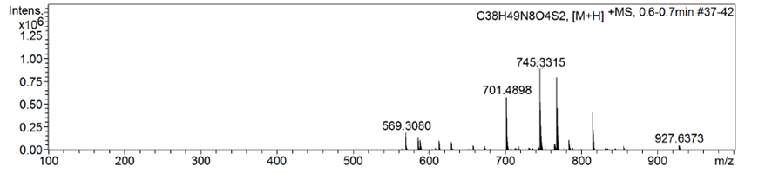

12d MS (m/z): HRMS (ESI) Calcd for C₃₅H₄₂N₈O₄S₂ ([M+H]⁺): 703.2849, found: 703.2845.
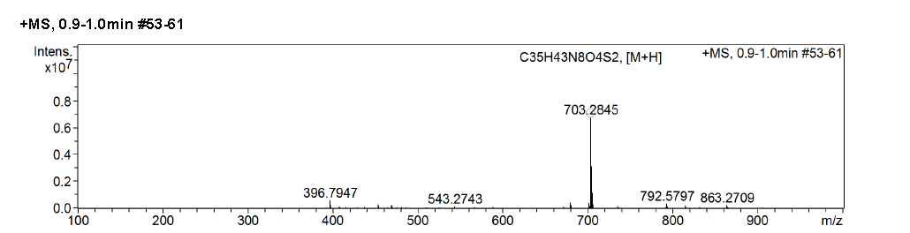

12e MS (m/z): HRMS (ESI) Calcd for C₃₆H₄₄N₈O₄S₂ ([M+H]⁺): 717.3005, found: 717.3002.
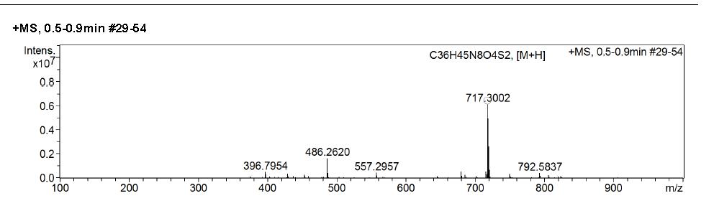

12f MS (m/z): HRMS (ESI) Calcd for C39H50N8O4S2 ([M+H]+): 759.3475, found: 759.3475.
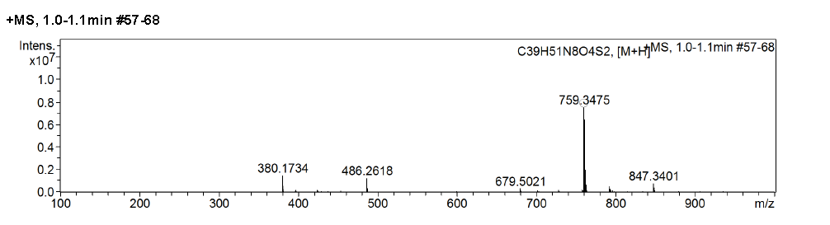

16a MS (m/z): HRMS (ESI) Calcd for C₃₆H₃₄N₆O₃S₃ ([M+H]⁺): 695.1933, found: 695.1929.
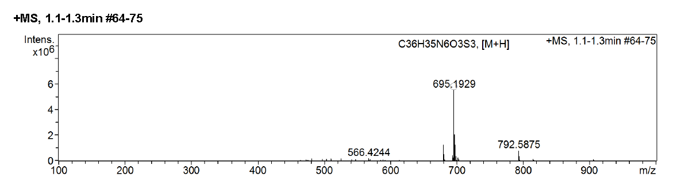

16b MS (m/z): HRMS (ESI) Calcd for C₃₃H₃₈N₆O₄S₂ ([M+H]⁺): 647.2474, found: 647.2472.
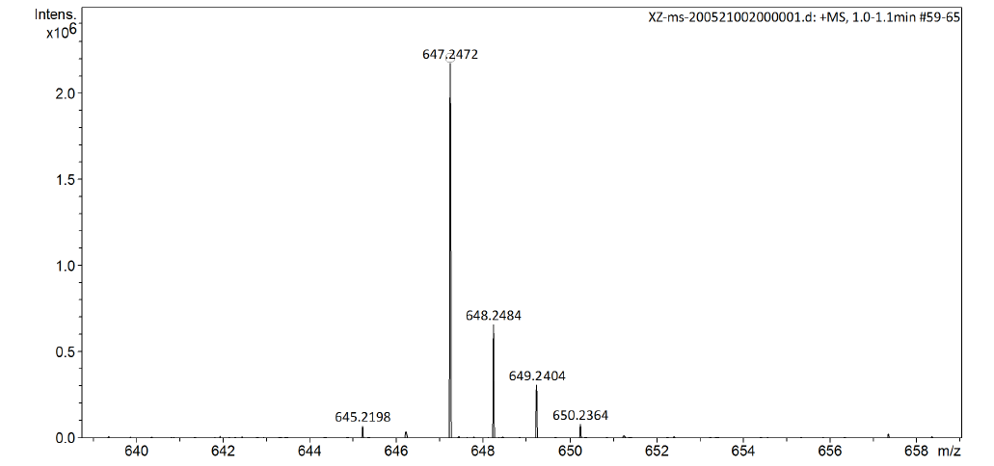

1.3 Raw data of CCK8
PC-9 72h
Group |  | Mean±SD | Inhibition rate
Negative control |  | 1.112±0.024
12a IC50=12.197μM | 100μM | 0.012±0.008 | 98.92%
12a IC50=12.197μM | 50μM | 0.092±0.03 | 91.73%
12a IC50=12.197μM | 25μM | 0.335±0.015 | 69.87%
12a IC50=12.197μM | 12.5μM | 0.434±0.02 | 60.97%
12a IC50=12.197μM | 6.25μM | 0.874±0.014 | 21.40%
12a IC50=12.197μM | 3.13μM | 0.986±0.019 | 11.33%
12a IC50=12.197μM | 1.56μM | 1.013±0.01 | 8.90%
12a IC50=12.197μM | 0.78μM | 1.102±0.023 | 0.90%
12a IC50=12.197μM | 0.39μM | 1.065±0.021 | 4.23%

NCI-H1975 72h
Group |  | Mean±SD | Inhibition rate
Negative control |  | 1.23±0.029
12a IC50=11.05μM | 100μM | 0.037±0.033 | 96.99%
12a IC50=11.05μM | 50μM | 0.116±0.032 | 90.57%
12a IC50=11.05μM | 25μM | 0.393±0.016 | 68.05%
12a IC50=11.05μM | 12.5μM | 0.548±0.026 | 55.45%
12a IC50=11.05μM | 6.25μM | 0.909±0.017 | 26.10%
12a IC50=11.05μM | 3.13μM | 1.127±0.025 | 8.37%
12a IC50=11.05μM | 1.56μM | 1.19±0.013 | 3.25%
12a IC50=11.05μM | 0.78μM | 1.206±0.02 | 1.95%
12a IC50=11.05μM | 0.39μM | 1.204±0.016 | 2.11%

PC-9 72h
Group |  | Mean±SD | Inhibition rate
Negative control |  | 1.112±0.024
12b IC50=11.622μM | 100μM | 0.034±0.019 | 96.94%
12b IC50=11.622μM | 50μM | 0.127±0.043 | 88.58%
12b IC50=11.622μM | 25μM | 0.341±0.017 | 69.33%
12b IC50=11.622μM | 12.5μM | 0.426±0.009 | 61.69%
12b IC50=11.622μM | 6.25μM | 0.831±0.021 | 25.27%
12b IC50=11.622μM | 3.13μM | 0.95±0.024 | 14.57%
12b IC50=11.622μM | 1.56μM | 1.076±0.018 | 3.24%
12b IC50=11.622μM | 0.78μM | 1.095±0.013 | 1.53%
12b IC50=11.622μM | 0.39μM | 1.098±0.027 | 1.26%

NCI-H1975 72h
Group |  | Mean±SD | Inhibition rate
Negative control |  | 1.23±0.029
12b IC50=11.259μM | 100μM | 0.036±0.005 | 97.07%
12b IC50=11.259μM | 50μM | 0.174±0.016 | 85.85%
12b IC50=11.259μM | 25μM | 0.368±0.015 | 70.08%
12b IC50=11.259μM | 12.5μM | 0.51±0.005 | 58.54%
12b IC50=11.259μM | 6.25μM | 1.011±0.027 | 17.80%
12b IC50=11.259μM | 3.13μM | 1.078±0.018 | 12.36%
12b IC50=11.259μM | 1.56μM | 1.156±0.098 | 6.02%
12b IC50=11.259μM | 0.78μM | 1.209±0.049 | 1.71%
12b IC50=11.259μM | 0.39μM | 1.199±0.037 | 2.52%

PC-9 72h
Group |  | Mean±SD | Inhibition rate
Negative control |  | 1.141±0.024
12d IC50=10.059μM | 100μM | 0.021±0.005 | 98.16%
12d IC50=10.059μM | 50μM | 0.155±0.035 | 86.42%
12d IC50=10.059μM | 25μM | 0.234±0.021 | 79.49%
12d IC50=10.059μM | 12.5μM | 0.442±0.029 | 61.26%
12d IC50=10.059μM | 6.25μM | 0.796±0.029 | 30.24%
12d IC50=10.059μM | 3.13μM | 0.981±0.019 | 14.02%
12d IC50=10.059μM | 1.56μM | 1.028±0.034 | 9.90%
12d IC50=10.059μM | 0.78μM | 1.033±0.019 | 9.47%
12d IC50=10.059μM | 0.39μM | 1.069±0.007 | 6.31%

NCI-H1975 72h
Group |  | Mean±SD | Inhibition rate
Negative control |  | 1.208±0.023
12d IC50=11.899μM | 100μM | 0.068±0.024 | 94.37%
12d IC50=11.899μM | 50μM | 0.172±0.02 | 85.76%
12d IC50=11.899μM | 25μM | 0.275±0.003 | 77.24%
12d IC50=11.899μM | 12.5μM | 0.545±0.012 | 54.88%
12d IC50=11.899μM | 6.25μM | 0.894±0.019 | 25.99%
12d IC50=11.899μM | 3.13μM | 1.148±0.024 | 4.97%
12d IC50=11.899μM | 1.56μM | 1.18±0.037 | 2.32%
12d IC50=11.899μM | 0.78μM | 1.214±0.028 | -0.50%
12d IC50=11.899μM | 0.39μM | 1.185±0.017 | 1.90%

PC-9 72h
Group |  | Mean±SD | Inhibition rate
Negative control |  | 1.117±0.036
12e IC50=5.362μM | 100μM | 0.037±0.005 | 96.69%
12e IC50=5.362μM | 50μM | 0.045±0.012 | 95.97%
12e IC50=5.362μM | 25μM | 0.354±0.012 | 68.31%
12e IC50=5.362μM | 12.5μM | 0.393±0.038 | 64.82%
12e IC50=5.362μM | 6.25μM | 0.485±0.037 | 56.58%
12e IC50=5.362μM | 3.13μM | 0.65±0.037 | 41.81%
12e IC50=5.362μM | 1.56μM | 0.879±0.017 | 21.31%
12e IC50=5.362μM | 0.78μM | 0.994±0.035 | 11.01%
12e IC50=5.362μM | 0.39μM | 1.106±0.025 | 0.98%

NCI-H1975 72h
Group |  | Mean±SD | Inhibition rate
Negative control |  | 1.228±0.026
12e IC50=9.587μM | 100μM | 0.076±0.004 | 93.81%
12e IC50=9.587μM | 50μM | 0.136±0.012 | 88.93%
12e IC50=9.587μM | 25μM | 0.442±0.031 | 64.01%
12e IC50=9.587μM | 12.5μM | 0.534±0.009 | 56.51%
12e IC50=9.587μM | 6.25μM | 0.703±0.025 | 42.75%
12e IC50=9.587μM | 3.13μM | 0.839±0.004 | 31.68%
12e IC50=9.587μM | 1.56μM | 0.988±0.017 | 19.54%
12e IC50=9.587μM | 0.78μM | 1.108±0.024 | 9.77%
12e IC50=9.587μM | 0.39μM | 1.178±0.03 | 4.07%

PC-9 72h
Group |  | Mean±SD | Inhibition rate
Negative control |  | 1.117±0.036
12f IC50=11.806μM | 100μM | 0.024±0.008 | 97.85%
12f IC50=11.806μM | 50μM | 0.046±0.005 | 95.88%
12f IC50=11.806μM | 25μM | 0.403±0.027 | 63.92%
12f IC50=11.806μM | 12.5μM | 0.504±0.013 | 54.88%
12f IC50=11.806μM | 6.25μM | 0.915±0.01 | 18.08%
12f IC50=11.806μM | 3.13μM | 1.018±0.026 | 8.86%
12f IC50=11.806μM | 1.56μM | 1.039±0.02 | 6.98%
12f IC50=11.806μM | 0.78μM | 1.093±0.015 | 2.15%
12f IC50=11.806μM | 0.39μM | 1.078±0.019 | 3.49%

NCI-H1975 72h
Group |  | Mean±SD | Inhibition rate
Negative control |  | 1.228±0.026
12f IC50=12.779μM | 100μM | 0.086±0.018 | 93.00%
12f IC50=12.779μM | 50μM | 0.046±0.007 | 96.25%
12f IC50=12.779μM | 25μM | 0.174±0.02 | 85.83%
12f IC50=12.779μM | 12.5μM | 0.661±0.015 | 46.17%
12f IC50=12.779μM | 6.25μM | 1.036±0.024 | 15.64%
12f IC50=12.779μM | 3.13μM | 1.134±0.006 | 7.65%
12f IC50=12.779μM | 1.56μM | 1.178±0.017 | 4.07%
12f IC50=12.779μM | 0.78μM | 1.207±0.034 | 1.71%
12f IC50=12.779μM | 0.39μM | 1.2±0.011 | 2.28%

NCI-H1975 72h
Group |  | Mean±SD | Inhibition rate
Negative control |  | 1.37±0.003
12e +ZnCL₂ IC50=16.827μM | 100μM | 0.153±0.023 | 88.81%
12e +ZnCL₂ IC50=16.827μM | 50μM | 0.291±0.012 | 78.73%
12e +ZnCL₂ IC50=16.827μM | 25μM | 0.483±0.007 | 64.71%
12e +ZnCL₂ IC50=16.827μM | 12.5μM | 0.703±0.016 | 48.66%
12e +ZnCL₂ IC50=16.827μM | 6.25μM | 1.164±0.037 | 15.02%
12e +ZnCL₂ IC50=16.827μM | 3.13μM | 1.286±0.024 | 6.11%
12e +ZnCL₂ IC50=16.827μM | 1.56μM | 1.326±0.032 | 3.18%
12e +ZnCL₂ IC50=16.827μM | 0.78μM | 1.33±0.033 | 2.90%
12e +ZnCL₂ IC50=16.827μM | 0.39μM | 1.364±0.041 | 0.43%

NCI-H1975 72h
Group |  | Mean±SD | Inhibition rate
Negative control |  | 1.23±0.027
ZnCl2 IC50＞10μM | 10μM | 1.056±0.007 | 14.15%
ZnCl2 IC50＞10μM | 5μM | 1.157±0.029 | 5.93%
ZnCl2 IC50＞10μM | 2.5μM | 1.192±0.018 | 3.09%
ZnCl2 IC50＞10μM | 1.25μM | 1.187±0.026 | 3.50%
ZnCl2 IC50＞10μM | 0.625μM | 1.193±0.005 | 3.01%
ZnCl2 IC50＞10μM | 0.313μM | 1.198±0.009 | 2.60%
ZnCl2 IC50＞10μM | 0.156μM | 1.203±0.032 | 2.20%
ZnCl2 IC50＞10μM | 0.078μM | 1.233±0.025 | -0.24%
ZnCl2 IC50＞10μM | 0.039μM | 1.214±0.022 | 1.30%

1.4 Raw data of EGFR

Compound 12e result of EGFR (WT) enzyme activity influence

12e | EGFR (WT)  Luminescence |  | % Activity
12e | Repeat1 | Repeat2 | Repeat1 | Repeat2
No compound | 13421 | 13438
1 nM | 13837 | 13431 | 98 | 100
3.3 nM | 13973 | 15534 | 98 | 92
10 nM | 17581 | 19880 | 84 | 76
33 nM | 21107 | 22833 | 71 | 65
100 nM | 24993 | 26783 | 56 | 50
333 nM | 29351 | 29811 | 40 | 38
1 µM | 33273 | 32791 | 25 | 27
3.3 µM | 36771 | 37237 | 12 | 10
10 µM | 38766 | 39741 | 4 | 1
Background | 39829 | 40011

Compound Osimertinib result of EGFR (WT) enzyme activity influence

Osimertinib | EGFR (WT)  Luminescence |  | % Activity
Osimertinib | Repeat1 | Repeat2 | Repeat1 | Repeat2
No compound | 13421 | 13438
0.1 nM | 17491 | 16245 | 85 | 89
0.33 nM | 19216 | 20353 | 78 | 74
1 nM | 22770 | 23214 | 65 | 63
3.3 nM | 32345 | 33191 | 29 | 25
10 nM | 35466 | 37261 | 17 | 10
33 nM | 36581 | 38304 | 13 | 6
100 nM | 38583 | 38855 | 5 | 4
333 nM | 39387 | 39923 | 2 | 0
1 µM | 39921 | 39652 | 0 | 1
Background | 39829 | 40011

Compound 12e result of EGFR (T790M) enzyme activity influence

12e | EGFR (T790M)  Luminescence |  | % Activity
12e | Repeat1 | Repeat2 | Repeat1 | Repeat2
No compound | 12891 | 13398
1 nM | 12976 | 13023 | 101 | 100
3.3 nM | 12914 | 14543 | 101 | 95
10 nM | 15800 | 16239 | 91 | 89
33 nM | 19140 | 19506 | 79 | 77
100 nM | 25625 | 26827 | 56 | 51
333 nM | 28815 | 29599 | 44 | 42
1 µM | 32929 | 33748 | 30 | 27
3.3 µM | 38958 | 39754 | 8 | 6
10 µM | 40410 | 40853 | 3 | 2
Background | 40911 | 41745

Compound Osimertinib result of EGFR (T790M) enzyme activity influence

Osimertinib | EGFR (T790M)  Luminescence |  | % Activity
Osimertinib | Repeat1 | Repeat2 | Repeat1 | Repeat2
No compound | 12891 | 13398
0.1 nM | 14622 | 16741 | 95 | 87
0.33 nM | 18626 | 18937 | 81 | 79
1 nM | 18717 | 20537 | 80 | 74
3.3 nM | 27487 | 30086 | 49 | 40
10 nM | 35763 | 36694 | 20 | 16
33 nM | 38696 | 40016 | 9 | 5
100 nM | 39997 | 40523 | 5 | 3
333 nM | 40468 | 40214 | 3 | 4
1 µM | 41085 | 41319 | 1 | 0
Background | 40911 | 41745

Compound 12e result of EGFR (L858R/T790M) enzyme activity influence

12e | EGFR (L858R/T790M)  Luminescence |  | % Activity
12e | Repeat1 | Repeat2 | Repeat1 | Repeat2
No compound | 11708 | 11919
1 nM | 11752 | 12181 | 100 | 99
3.3 nM | 11923 | 11742 | 100 | 100
10 nM | 13093 | 11663 | 96 | 100
33 nM | 12400 | 14270 | 98 | 92
100 nM | 20768 | 18830 | 71 | 77
333 nM | 23775 | 25672 | 61 | 55
1 µM | 31871 | 31516 | 35 | 36
3.3 µM | 34691 | 35042 | 26 | 24
10 µM | 38090 | 38012 | 15 | 15
Background | 42789 | 42316

Compound Osimertinib result of EGFR (L858R/T790M) enzyme activity influence

Osimertinib | EGFR (L858R/T790M)  Luminescence |  | % Activity
Osimertinib | Repeat1 | Repeat2 | Repeat1 | Repeat2
No compound | 11708 | 11919
0.1 nM | 12293 | 13172 | 98 | 96
0.33 nM | 14594 | 15807 | 91 | 87
1 nM | 20904 | 19604 | 70 | 75
3.3 nM | 24718 | 25941 | 58 | 54
10 nM | 31949 | 33251 | 34 | 30
33 nM | 34256 | 35487 | 27 | 23
100 nM | 37613 | 37435 | 16 | 17
333 nM | 41546 | 41717 | 3 | 3
1 µM | 42086 | 42187 | 2 | 1
Background | 42789 | 42316

1.5 Short Tandem Repeat (STR) Genotyping Report
PC-9 cells

H1975 cells

