Supporting Information
Green and Selective Recovery of Lithium from Spent Lithium Iron Phosphate Cathodes via Fenton Reaction
Yan Zeng^{a,b}*, Chaojun Du^{c}, Heng Chen^{a,b}, Di Cheª, Jiao Guoª, Jiangju Siª, Hui Wang^{a,b}
a School of Chemistry & Materials Engineering, Xinxiang University, Xinxiang 453003, China
b Henan Photoelectrocatalytic Material and Micro-Nano Application Technology Academician Workstation, Xinxiang 450003, China
c School of Biological and Chemical Engineering, Nanyang Institute of Technology, Nanyang 473000, China.

Text S1 Reagents
Text S2 Characterization
Text S3 Experimental setup
Table S1. Kinetics parameters from the Shrinking Core Model.
Figure S1. Temperature dependent fitting curves based on (a) Gas film diffusion control model, (b)Surface chemical reaction control model and (c)Product layer diffusion control model.
Figure S2. XRD pattern of the (a)LFP black mass leached under optimum conditions at different time intervals (b)leached residues.
Figure S3. Circulating leaching of waste LiFePO4 with reused of FeSO4 via irradiation of ultraviolet light。
Figure S4. The efficience of circulating leaching of waste LiFePO_{4。}
Figure S5. XRD pattern of the recycled Li₂CO_{3。}
Figure S6. SEM and XRD patterns of regenerated LiFePO_{4。}
Figure S7. Electrochemical characterization of regenerated LiFePO_{4。}

Text S1 Reagents
LFP cathode powder (containing 33.9 wt% Fe and 4.4 wt% Li) was purchased from Huanqiuxinnengyuan Cailiao Co., Ltd. (China). FeSO₄·7H₂O (AR) was obtained from Tianjin ZhongLian Chemical Plants Co., Ltd. (China). NaOH (≥99%), H₂O₂ (30 vol.%), and Na₂CO₃ (99.8%, AR) were purchased from Beijing Chemical Plants Co. and Sinopharm Chemical Reagent Co., Ltd., respectively. All reagents were used as received without further purification.

Text S2 Characterization
The crystal phases of the samples were identified using X-ray diffraction (XRD; D8 ADVANCE, Bruker, Germany). Sample morphology and elemental distribution were characterized by scanning electron microscopy coupled with energy-dispersive X-ray spectroscopy (SEM-EDS; SU8100, Hitachi, Japan). The surface chemical states of the materials were investigated by X-ray photoelectron spectroscopy (XPS; K-Alpha, Thermo Fisher Scientific, USA).

Text S3 Experimental setup
Photocatalytic experiments were carried out within a dark chamber, the experimental system consisted of both a light source component and a reaction setup. The light source is a 350 W high-pressure mercury lamp (CEL-M350). The reaction system was composed of a magnetic stirrer and a 250 mL Round-bottom flask. During the reactions, UV light was supplied by the 350 W high-pressure mercury lamp equipped with a 254 nm filter. Additionally, the reaction temperature was kept constant at the reaction temperature using a constant temperature bath.

Table S1. Kinetics parameters from the Shrinking Core Model
Gas film diffusion control model
($\text{X=}{\text{k}}_{\text{1}}\text{t}$)
No. | Temperature (ﹾC) | k₁ (min⁻¹) | R²
1 | 30 | 0.0338 | 0.8988
2 | 50 | 0.0218 | 0.9866
3 | 70 | 0.0162 | 0.9769
4 | 90 | 0.0118 | 0.9962
Surface chemical reaction control model
($\text{1-}{\left(\text{1-X}\right)}^{\frac{\text{1}}{\text{3}}}\text{=}{\text{k}}_{\text{2}}\text{t}$)
No. | Temperature (ﹾC) | k₂ (min⁻¹) | R²
1 | 30 | 0.0195 | 0.9877
2 | 50 | 0.0108 | 0.9868
3 | 70 | 0.0069 | 0.9892
4 | 90 | 0.0046 | 0.9988
Product layer diffusion control model
($\text{1-3}{（\text{1-X}）}^{\frac{\text{2}}{\text{3}}}\text{+2}\left(\text{1-X}\right)\text{=}{\text{k}}_{\text{3}}\text{t}$)
No. | Temperature (ﹾC) | k₃ (min⁻¹) | R²
1 | 30 | 0.0522 | 0.9102
2 | 50 | 0.0675 | 0.9792
3 | 70 | 0.0776 | 0.9904
4 | 90 | 0.0863 | 0.9852

(c)
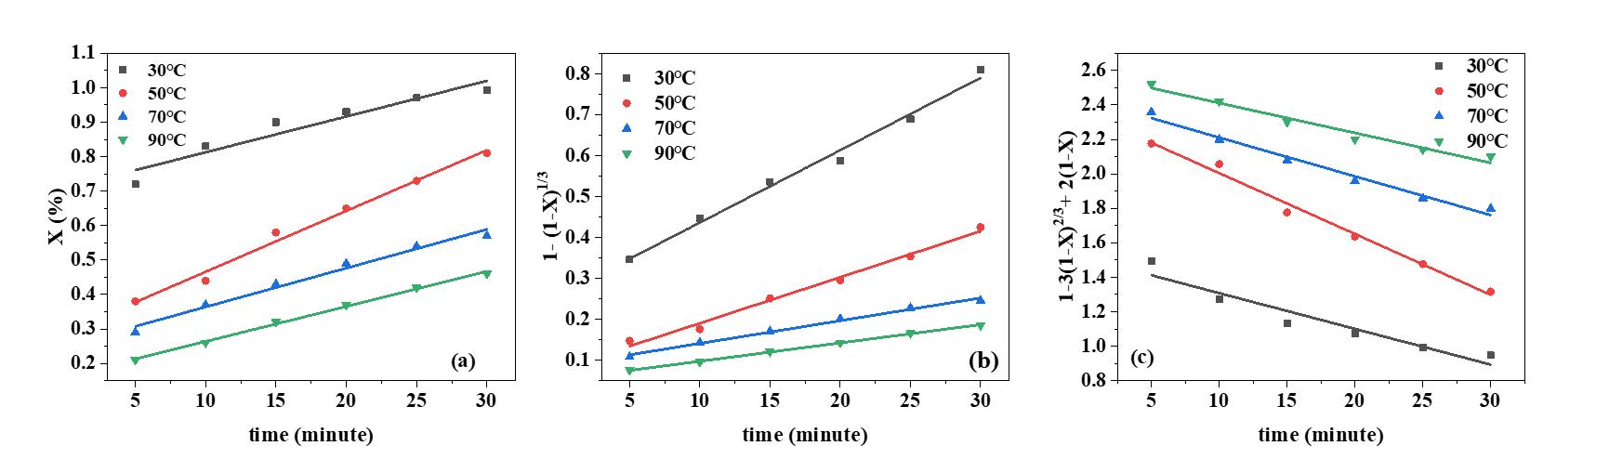
Figure S1. Temperature dependent fftting curves based on (a) Gas film diffusion control model, (b)Surface chemical reaction control model and (c)Product layer diffusion control model. Experimental conditions: 800 mmol/L H₂O₂ concentration, 100 mmol/LFeSO₄ concentration, 30 ℃ and 30 min reaction time.

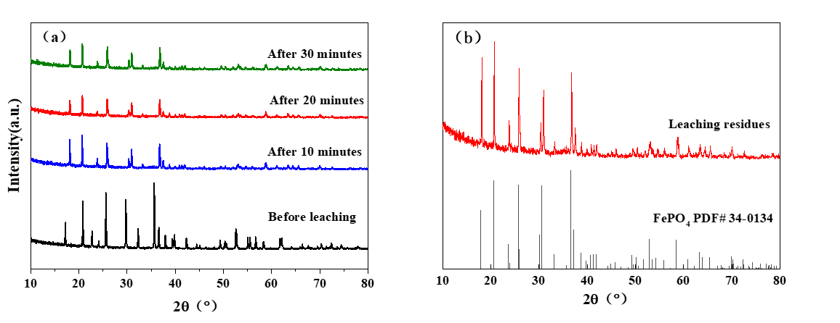
Figure S2. XRD pattern of the (a)LFP black mass leached under optimum conditions at different time intervals (b)leached residues.

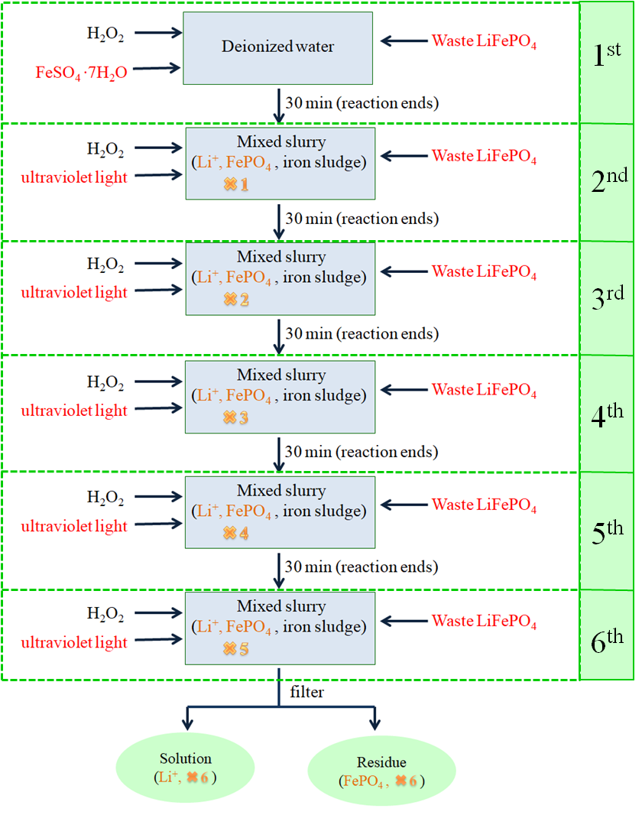
Figure S3. Circulating leaching of waste LiFePO₄ with reused of FeSO4 via irradiation of ultraviolet light.

Figure S4. The efficience of circulating leaching of waste LiFePO_{4.}
Figure S5. XRD pattern of the recycled Li₂CO_{3.}

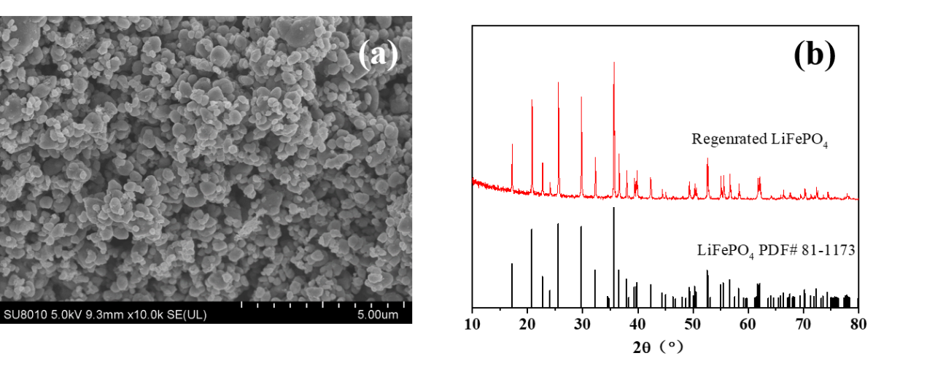
Figure S6. SEM(a) and XRD(b) patterns of regenerated LiFePO_{4.}

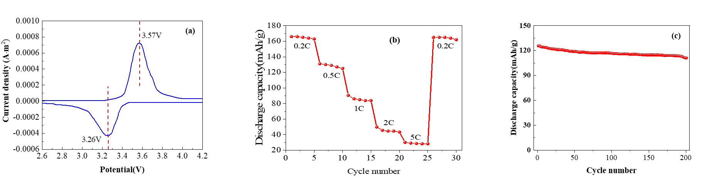
Figure S7. Electrochemical characterization of regenerated LiFePO₄: (a) cyclic voltammograms, (b) magnification performance diagram at current density of 0.2 C, 0.5 C, 1 C, and 2 C and 2 C, (c) cycling stability at 0.5C rate over 200 cycles.

Yan Zeng, zengyaner@126.com, ORCiD ID: 0000-0001-7694-7434, School of Chemistry & Materials Engineering, Xinxiang University Xinxiang 453003, China.

