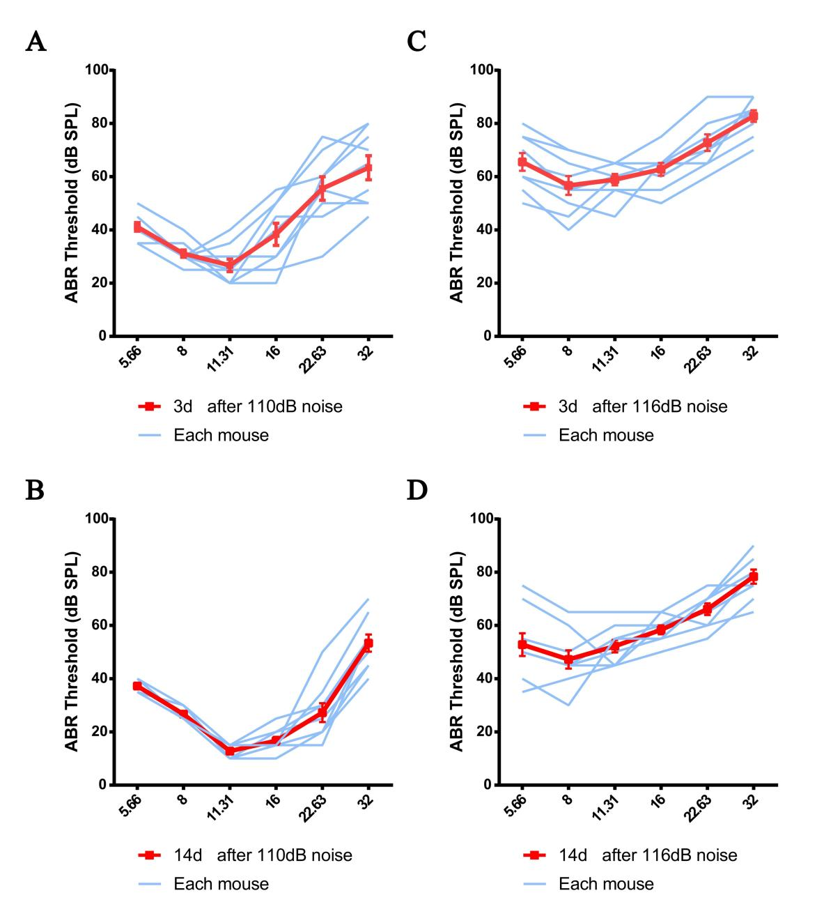Figure S1. Auditory brainstem response (ABR) thresholds in wild-type mice following noise exposure.
- D) ABR thresholds measured at multiple frequencies (5.66, 8, 11.31, 16, 22.63, and 32 kHz) in 4–6 week-old wild-type mice at 3 days (A) and 14 days (B) following exposure to 110 dB SPL broadband noise, and at 3 days (C) and 14 days (D) following exposure to 116 dB SPL broadband noise. Red lines represent mean thresholds (n = 9 per group), and blue lines represent individual mice. Data are presented as mean ± SEM.
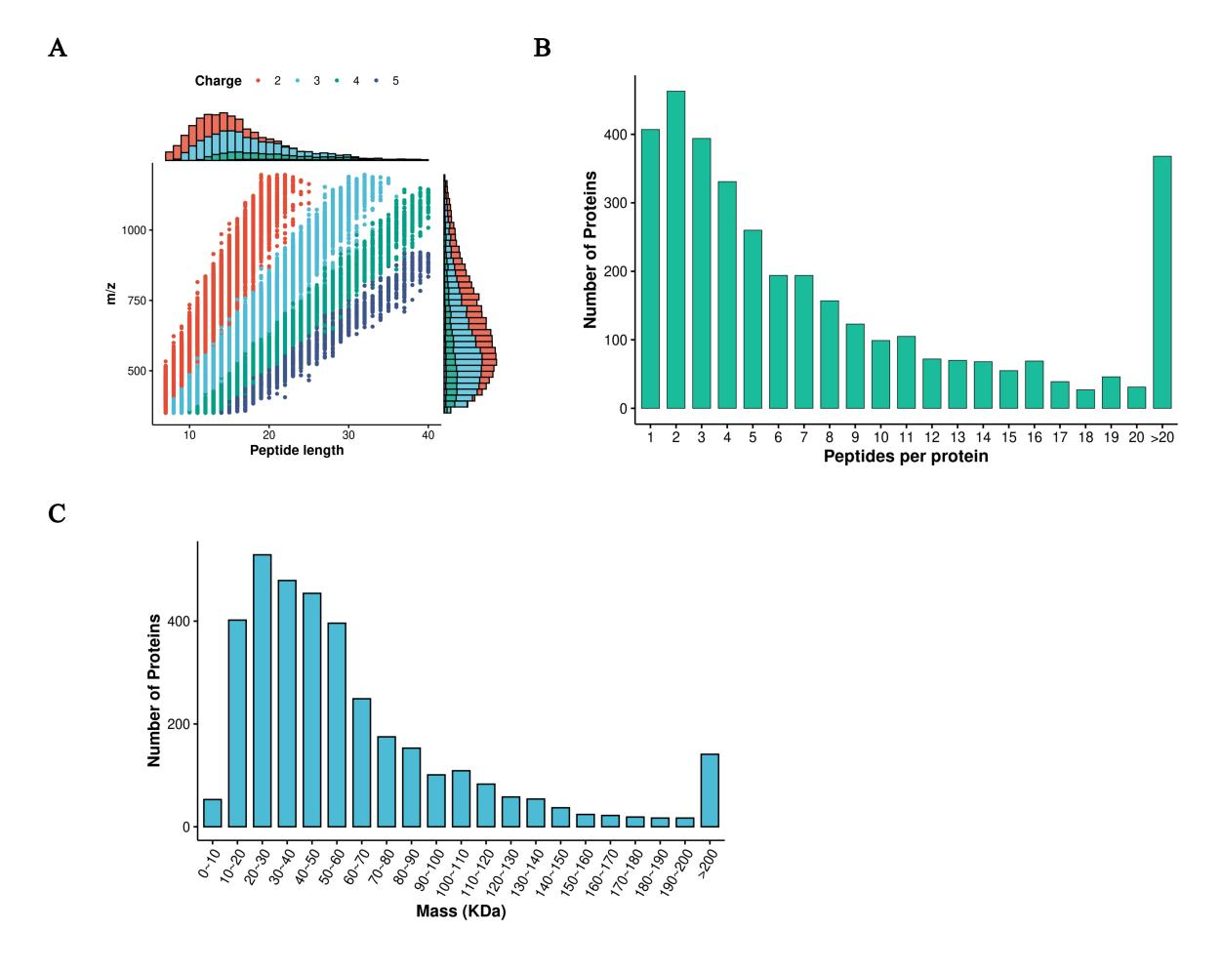
Figure S2. Quality control metrics for quantitative proteomic analysis of cochlear extracts from noise-exposed mice.
(A) Peptide length distribution of identified peptides, demonstrating that the majority range from 7 to 20 amino acids, consistent with typical tryptic digestion. (B) Number of unique peptides per protein, showing that most proteins were quantified with two or more unique peptides, ensuring reliable identification and accurate quantification. (C) Molecular weight distribution of identified proteins, spanning a broad and uniform range, indicating no systematic bias in protein extraction or detection.

