Tea-Derived Carbon Quantum Dot-Modified PCN-415-NH₂ Nanocomposite as a Bifunctional Adsorbent–Photocatalyst for Efficient Wastewater Treatment under Visible Light
Tina Reyhani, Azita Shahnazi, Ali Haseli, Roya Sedghi
Department of Polymer and Materials Chemistry, Faculty of Chemistry and Petroleum Sciences, Shahid Beheshti University, Tehran, 1983969411, Iran.

Supplementary material:

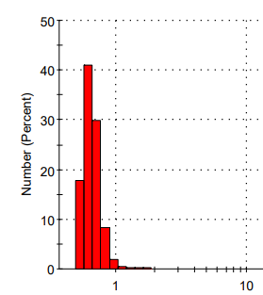
Fig. S1: The particle size distribution of CQDs.

Fig.S2: The BJH adsorption curves (a) and the BET surface area plots (b) of the samples.

Fig. S3: Adsorption capacity of PCN-415-NH₂/CQDs as a function of initial concentration of RhB.

Fig. S4: Pseudo-second-order kinetic model for RhB adsorption on PCN-415-NH₂/CQDs.

(a)
(b)

Fig. S5: Linearized (a) Langmuir and (b) Freundlich isotherm plots for RhB adsorption.

Fig. S6: Optimization of RhB photodegradation parameters: (a) PCN-415-NH₂/CQDs dosage, (b) initial solution pH, and (c) RhB concentration.

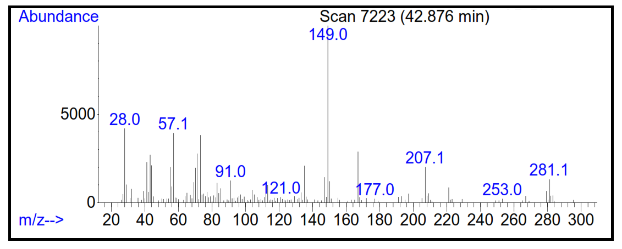
Fig. S7: Mass spectrum of Diisobutyl phthalate.

