Development of LC-qToF-MS based method for detection and quantification of ricinine in castor oil
Divya Verma^{a1}, Deepali Tripathi^{a1}, Suryansh Vermaª, Sandeep K. Sharmaª*
ªFood Toxicology Group, FEST Division, CSIR - Indian Institute of Toxicology Research, Vishvigyan Bhawan, 31, Mahatma Gandhi Marg, Lucknow-226001, Uttar Pradesh, India.
¹Equal contribution

*Corresponding Author
Sandeep Kumar Sharma
Food Toxicology Group, FEST Division
CSIR-Indian Institute of Toxicology Research
Vishvigyan Bhawan, 31, Mahatma Gandhi Marg.
Lucknow-226001, India.
Phone 91-522-2217497
E-mail: sandeep.sharma@csir.res.in
Supplementary material
S1. Extraction of castor oil from seeds using different extraction methods
Castor seeds were washed, dried at 35ºC and crushed to coarse powder for extraction. Accurately weighed samples were extracted using three different extraction methods, viz. Cold-pressed method (CP), Traditional hot extraction method (TH) and Chemical extraction method (CE) (Avramovic et al. 2025). For Cold-pressed method (CP), 30 grams castor seeds were crushed in mixer grinder and then the powder was pressed through manual syringe to extract the oil from the powder. Traditional hot extraction method (TH) involved mixing of 30 grams castor seed powder with 100 ml distilled water and boiled at 100ºC on hotplate till oil got separated on the surface. The separated oil was scooped and stored in an airtight container. For Chemical extraction method (CE), 30g of castor seed powder was extracted in 250 ml of hexane and allowed to rotate overnight on an orbital shaker at 35 ºC. The mixture was filtered through Whatman filter paper No. 5 and was evaporated using rotary evaporator until only oil was left. The extracted oil was stored in airtight container until further analysis.
Reference
Avramovic JM, Marjanović Jeromela AM, Krstić MS, Kiprovski BM, Veličković AV, Rajković DD, & Veljković VB (2025) Castor Oil Extraction: Methods and Impacts. Separation & Purification Reviews, 54(1), 60-82. doi:https://doi.org/10.1080/15422119.2024.2361674

Table S1. LC-qToF-MS quantification of ricinine in castor oil samples procured from the market.
Castor oil sample | Ricinine (ppm)*
S-1 | 36.5±1.33
S-2 | 13.44±0.31
S-3 | 25.3±0.24
S-4 | 19.49±0.91
S-5 | 21.56±1.15
S-6 | 55.46±1.17
S-7 | 36.88±0.79
S-8 | 37.8±0.84
S-9 | 46.91±0.97
S-10 | 52.66±1.24
S-11 | 27.07±1.42
S-12 | 16.95±0.38
S-13 | 46.62±1.17
S-14 | 3.61±0.21
S-15 | 86.62±1.12
S-16 | 2.91±0.28
S-17 | 128.18±0.36
*Values ± SD, n=3

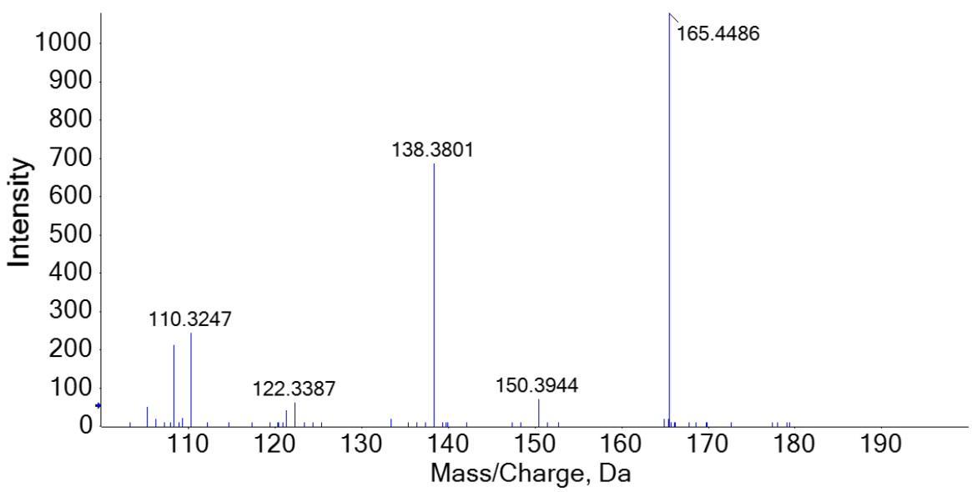

Fig. S1 Mass spectra showing precursor and daughter ions of ricinine observed at 165.4486→138.3801 Da

Fig. S2 Residual plot of the regression analysis for the calibration of ricinine.

