Supplementary information
Table S1. Summary of Meteorological factors and Socio–economic factors in China, 2005–2020.
Figure S1. The monthly and annual incidence of amoebic dysentery (A) and bacillary dysentery (B) in China, 2005-2020.
Figure S2. Spatiotemporal variation in the incidence of amoebic dysentery in China, 2005-2020.
Figure S3. Spatiotemporal variation in the incidence of bacillary dysentery in China, 2005-2020.
Figure S4. Month of annual peak of amoebic dysentery and bacillary dysentery at the provincial level in China, 2005-2020.
Figure S5. The average monthly incidence rate of amoebic dysentery in each province of China, 2005-2020.
Figure S6. The average monthly incidence rate of bacillary dysentery in each province of China, 2005-2020.
Table S1. Summary of Meteorological factors and Socio–economic factors in China, 2005–2020.
Driving factors | Variable | Average | Frequency distribution
Driving factors | Variable | Average | 5% Percentile | 50% Percentile | 95% Percentile
Meteorological factors | Temperature (℃) | 13.67 | 4.13 | 14.83 | 22.32
 | Rainfall (mm) | 8939.52 | 1639.76 | 7721.9 | 17721.65
 | Relative humidity (%) | 66.66 | 50.42 | 67.82 | 80.25
 | Wind speed (m/s) | 2.15 | 1.57 | 2.18 | 2.82
Socioeconomic factors | Per capita GDP (RMB) | 41841.52 | 10798.75 | 35991 | 96502
 | COD (10,000 tons) | 50.07 | 4.56 | 35.35 | 135.04
 | Medical personnel (per 1,000 population) | 5.13 | 2.84 | 5.05 | 7.78
 | Waste disposal volume (10,000 tons) | 590.18 | 80.33 | 492.47 | 1538.26
 | Toilets (unit) | 4104.20 | 463.50 | 3699.00 | 9691.75
 | Population density (persons/sq.km) | 439.43 | 7.96 | 270.60 | 1241.01

Figure S1. The monthly and annual incidence of amoebic dysentery (A) and bacillary dysentery (B) in China, 2005-2020.

Figure S2. Spatiotemporal variation in the incidence of amoebic dysentery in China, 2005-2020.

Figure S3. Spatiotemporal variation in the incidence of bacillary dysentery in China, 2005-2020.

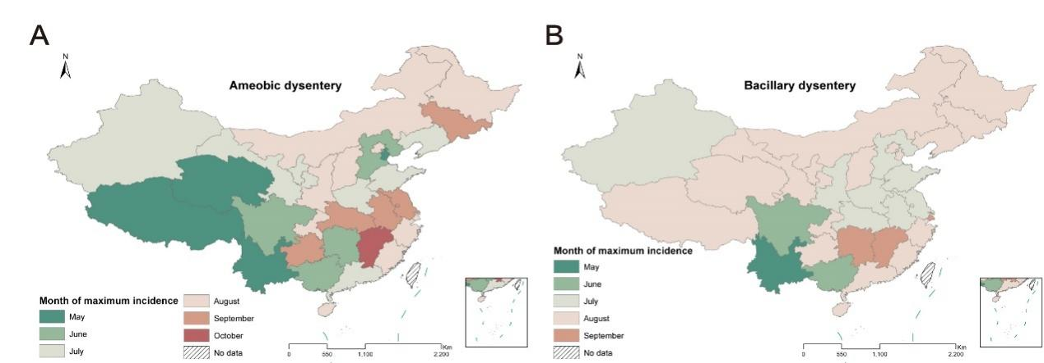
Figure S4. Month of annual peak of amoebic dysentery (A) and bacillary dysentery (B) at the provincial level in China, 2005-2020.

Figure S5. The average monthly incidence rate of amoebic dysentery in each province of China, 2005-2020 (The order of each map is for each of the seven major regions of China, i.e., Northeast, North, East, South, Central, Northwest, and Southwest).

Figure S6. The average monthly incidence rate of bacillary dysentery in each province of China, 2005-2020 (The order of each map is for each of the seven major regions of China, i.e., Northeast, North, East, South, Central, Northwest, and Southwest).

