Supplementary Data
From Water to Fish: Microplastic Exposure and Ecological Risk in a Tropical Freshwater Fishery Lake in the Philippines
Ariel B. Lanceta Jr ª, Jocelyn D. Bantigue ª, Mark Ariel D. Malto ^{b}

ª Graduate School, State University of Northern Negros, Sagay City, Negros Occidental, Philippines
^{b} Fisheries Department, Sorsogon State University, Magallanes Campus, Aguada Norte, Magallanes, Sorsogon 4705, Philippines

Correspondence: Mark Ariel D. Malto
Email: madmalto@sorsu.edu.ph

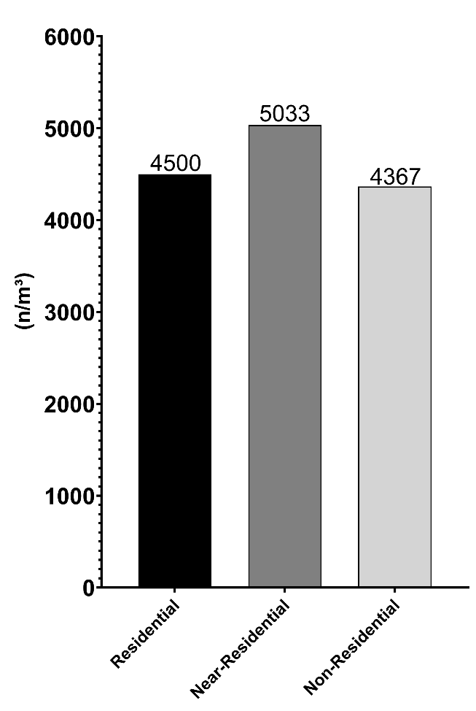
Figure S1. Mean microplastics concentration (particles/m³) among the sampling sites of Lake Sampaloc. Differences among zones were evaluated using one-way ANOVA and Kruskal–Wallis tests, which indicated no significant differences in total MP abundance (p > 0.05).
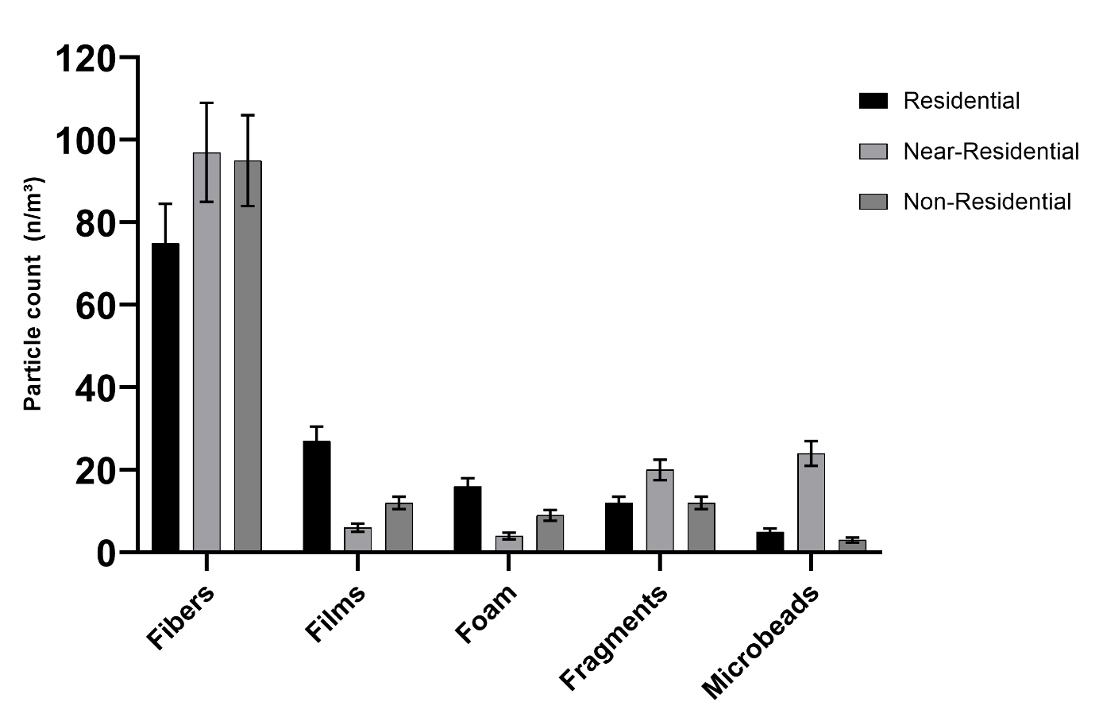
Figure S2. Microplastics shape characteristics among residential, near residential and non-residential zone of Lake Sampaloc. Differences in morphotype composition among zones were assessed using a chi-square test of independence, revealing significant compositional differences (p < 0.05).

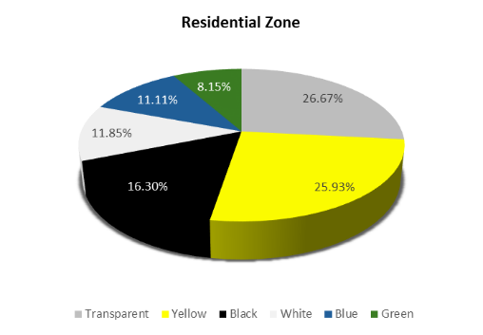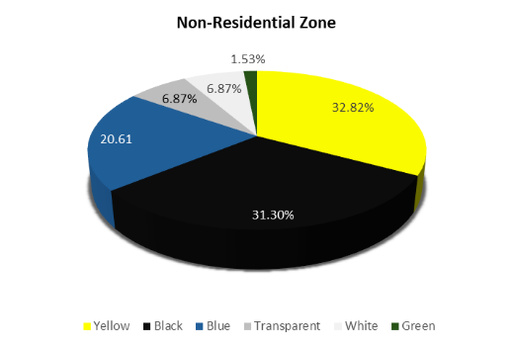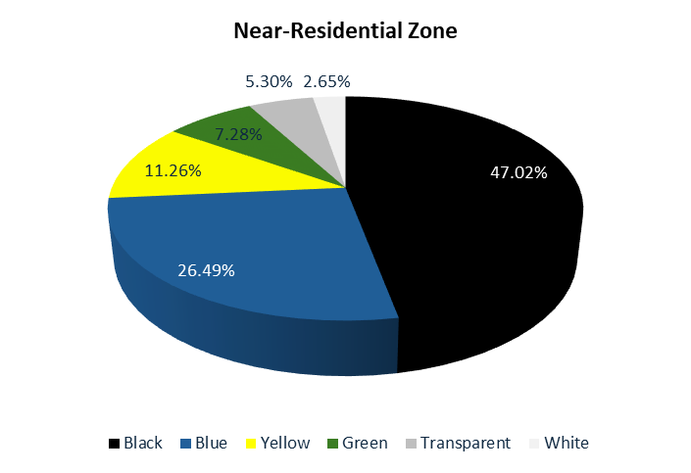
Figure S3. Microplastics color characteristics among residential, near residential and non-residential zones of Lake Sampaloc. Spatial differences in color composition were evaluated using a chi-square test, indicating significant variation among zones (p < 0.05).

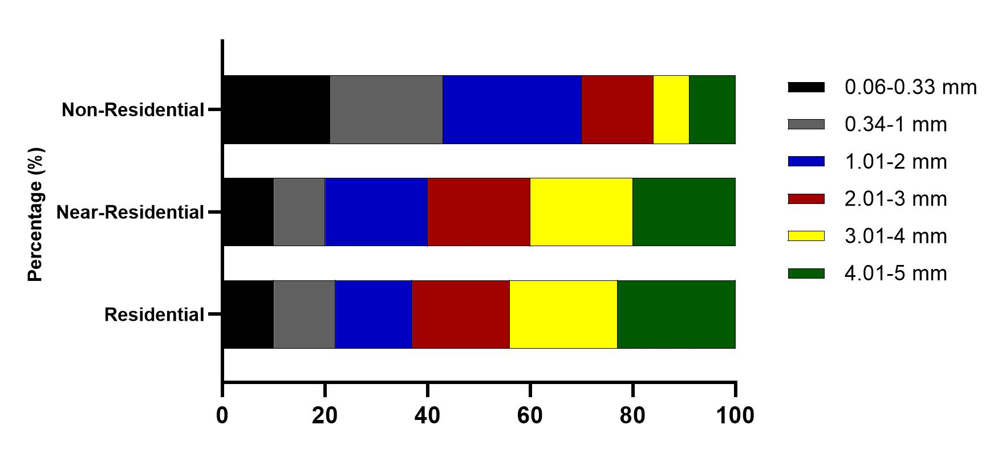
Figure S4. Microplastics size characteristics among residential, near residential and non-residential zones of Lake Sampaloc. Differences among zones were tested using a chi-square test of independence, showing no significant variation in size distribution (p > 0.05).

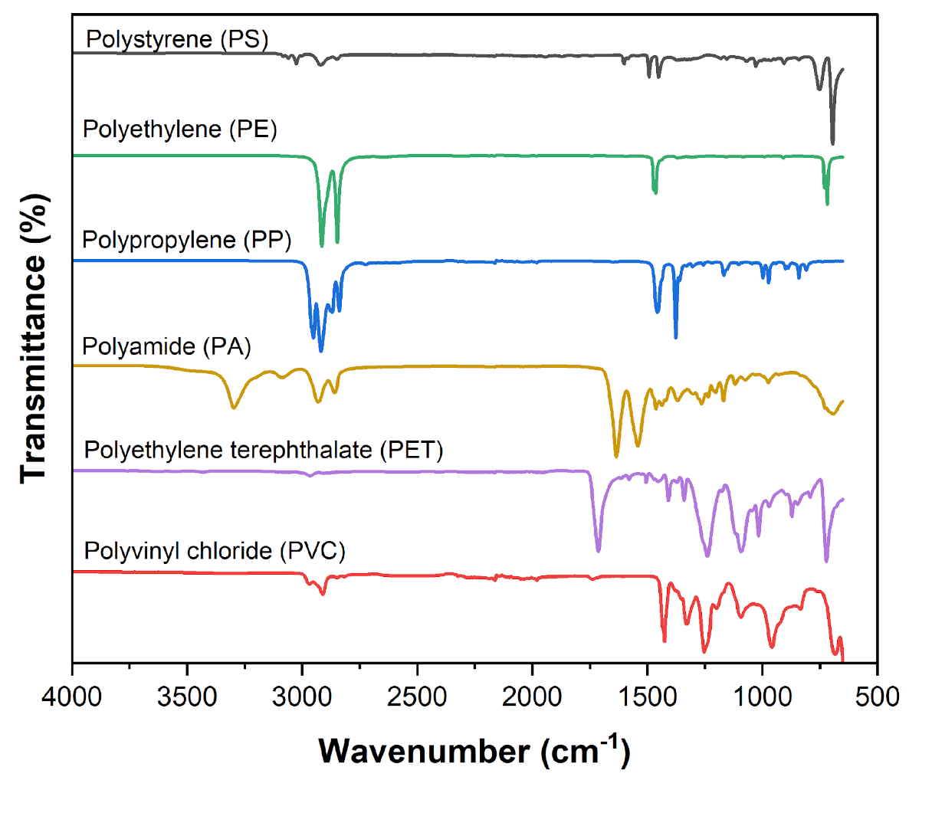
Figure S5. FTIR (Fourier Transform Infrared Spectroscopy) spectra of different polymer types detected in Lake Sampaloc.

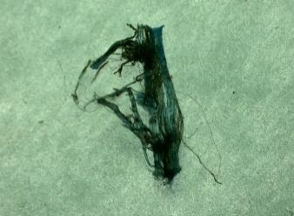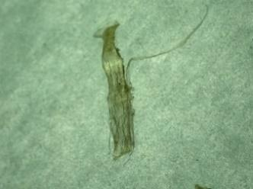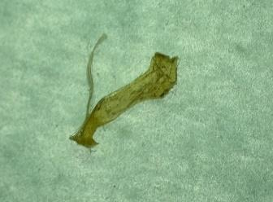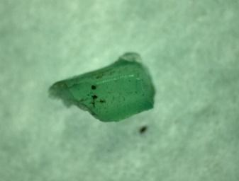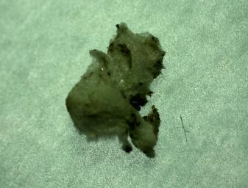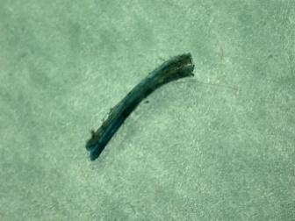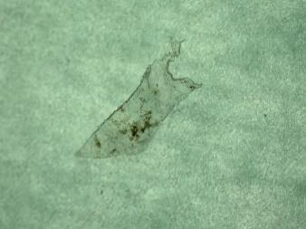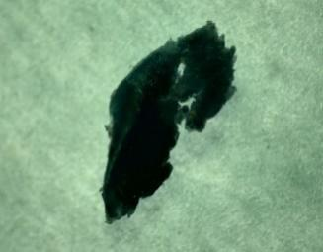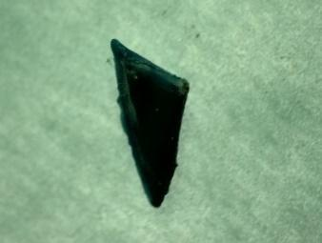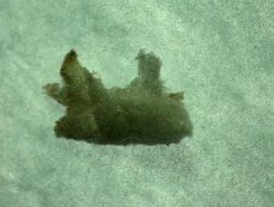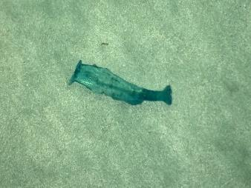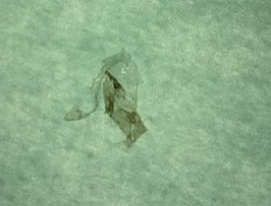

Figure S6. Sample photographs of microplastics under the stereomicroscope.

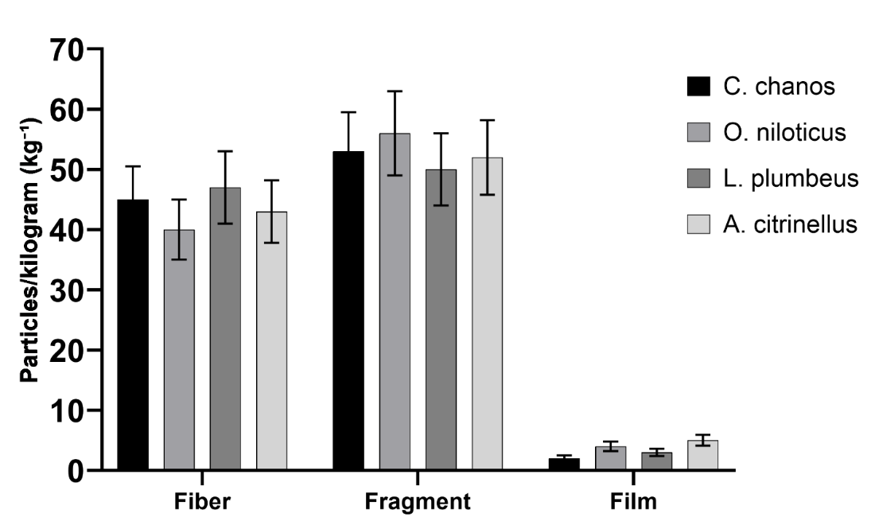

Figure S7. Microplastic morphologies in fish samples. Differences in morphotype composition among species were assessed using a chi-square test, which indicated no significant interspecific differences (p > 0.05).

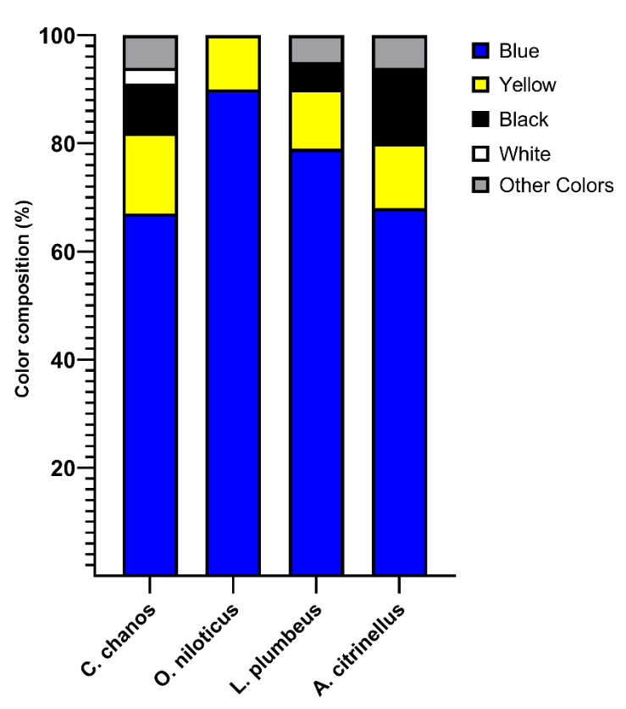

Figure S8. Color characteristics of microplastics recovered from fish samples. Species-level differences were evaluated using a chi-square test of independence, revealing no significant variation in color composition among species (p > 0.05).

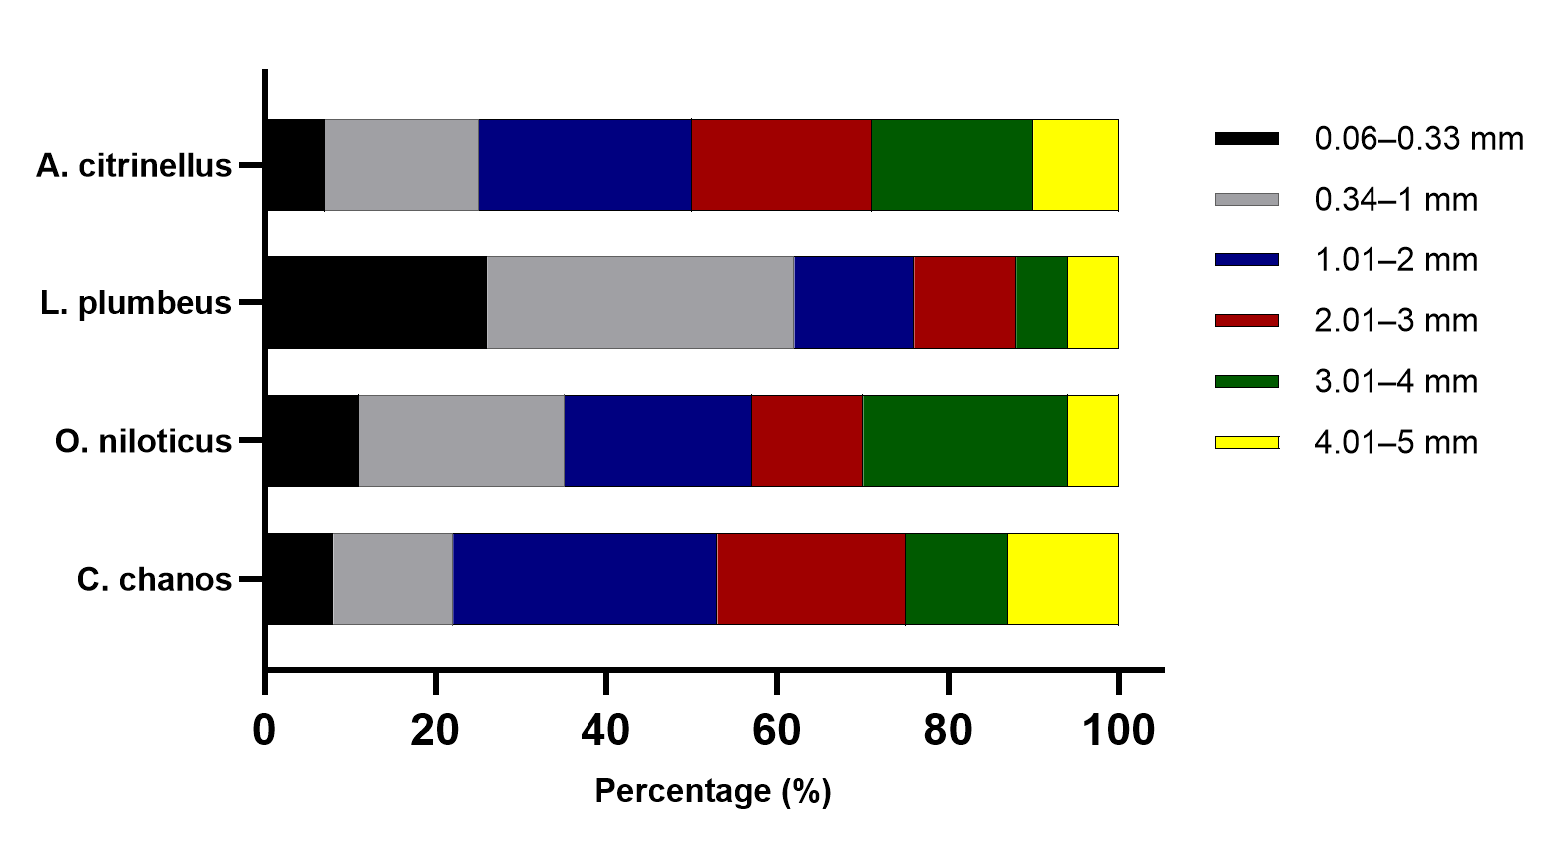
Figure S9. Size characteristics of microplastics recovered from fish samples. Differences in size distribution among species were assessed using a chi-square test, which indicated significant interspecific variation (p < 0.05).

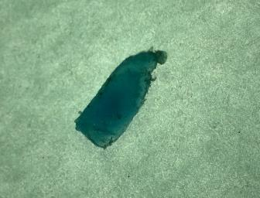
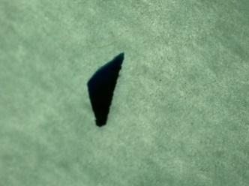
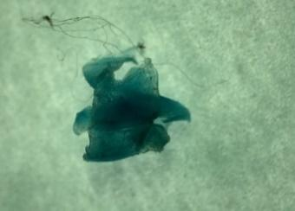
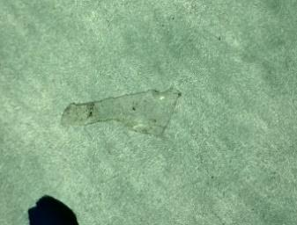
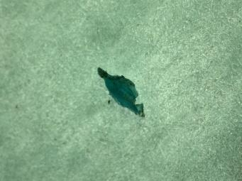
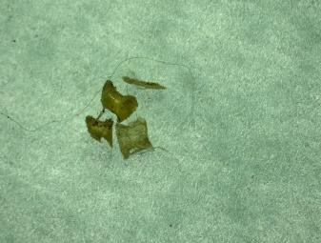
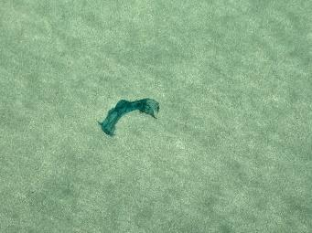
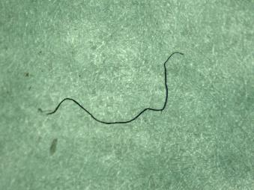

Figure S10. Sample photomicrographs of microplastics recovered from fish samples, captured under a stereomicroscope.

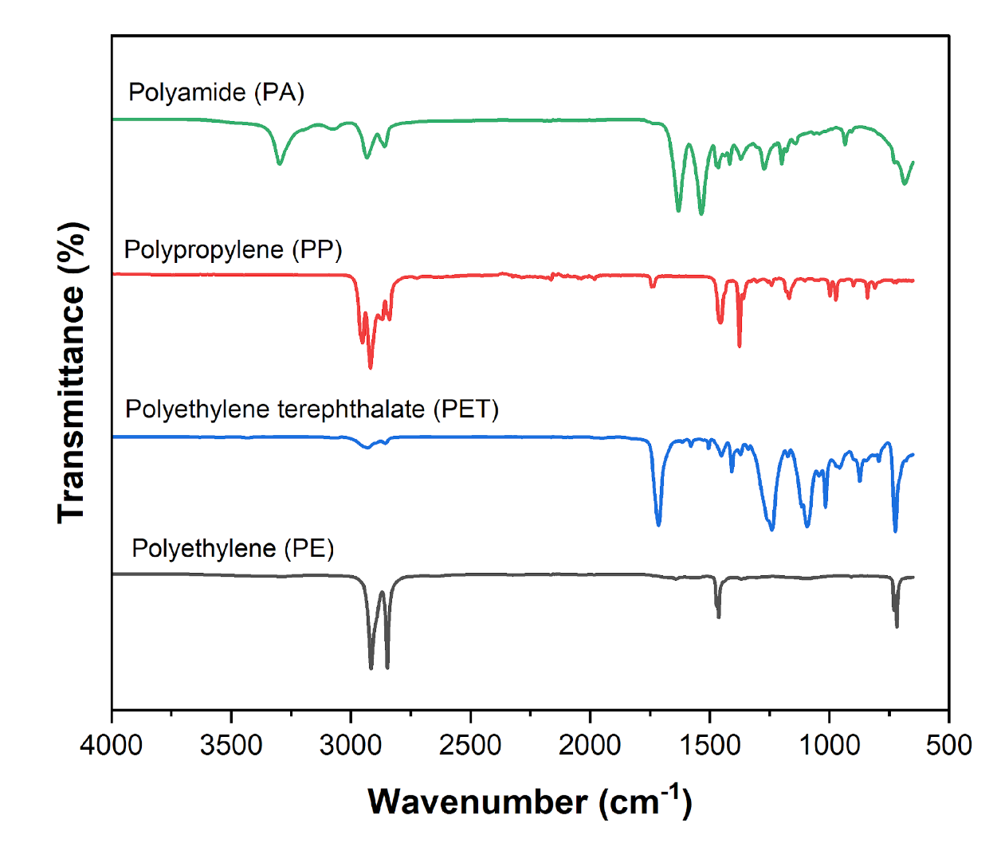
Figure S11. (FTIR (Fourier Transform Infrared Spectroscopy) spectra illustrating the different polymer types detected in fish samples.

Table S1. Information on sample fish.
No. | Fish species common name | Scientific name | Sampling area | n = fish | Feeding zone |  | Mean ± SD (cm) | Mean ± SD (g)
1 | Bangus | C. chanos | Aquaculture | 25 |  | Pelagic | 29.7 ± 1.43 | 335.86 ± 55.36
2 | Tilapia | O. niloticus | Aquaculture | 25 |  | Pelagic | 21.34 ± 1.78 | 267.73 ± 64.39
3 | Ayungin | L. plumbeus | Wild Habitat | 25 |  | Pelagic | 12.96 ± 0.17 | 31.64 ± 2.63
4 | Flower Horn | A. citrinellus | Wild Habitat | 25 |  | Pelagic | 14.73 ± 0.25 | 69.28 ± 1.58

Table S2. Definition and potential sources of microplastic types.
Microplastics Types | Definition | Potential Sources
Fragment | Hard, jagged plastic particle | Bottles, hard, sturdy plastic
Fiber | Fiber – thin or fibrous; straight plastic  filament – a thicker type of line | Fishing line/nets, clothing, or textiles
Film | Thin plain of flimsy plastic | Plastic bags, wrappers, or sheeting
Foam | Lightweight, sponge-like plastic | Foam floats, Styrofoam cushioning
Microbead | White, little squishy, rounded plastic particle | Facial cleanser, toothpaste, cosmetics, exfoliants
Note: This table was adapted from Natuel et a 2023.

 | Length | Fish Weight | Gut Weight | Fiber | Film | Fragment
Length | — | 0.875432 | 0.861294 | 0.602813 | –0.348217 | –0.198765
Fish Weight | 0.875432 | — | 0.928317 | 0.691204 | –0.438290 | –0.251903
Gut Weight | 0.861294 | 0.928317 | — | 0.643918 | –0.393205 | –0.223871
Fiber | 0.602813 | 0.691204 | 0.643918 | — | 0.503612 | 0.307284
Film | –0.348217 | –0.438290 | –0.393205 | 0.503612 | — | 0.403581
Fragment | –0.198765 | –0.251903 | –0.223871 | 0.307284 | 0.403581 | —
Table S3. Pearson’s correlation coefficients for microplastic presence in fish, showing relationships between fish length, fish weight, gut weight, and types of microplastics (fiber, film, fragment).
Note: Overall mean Pearson correlation (including fish biometric parameters and microplastic types): r ≈ 0.58, indicating a moderate positive relationship. Mean correlation among fish biometric parameters alone: r ≈ 0.89, indicating strong positive relationships.
Table S4. Mean (± SD) counts and relative abundance (%) of microplastic morphotypes in surface water across different zones of Lake Sampaloc

Zone | Fibers (mean ± SD) | Microbeads (mean ± SD) | Fragments (mean ± SD) | Films (mean ± SD) | Foam (mean ± SD)
Residential | 75 ± 9.5 | 5 ± 0.8 | 10 ± 1.2 | 3 ± 0.5 | 2 ± 0.3
Near-Residential | 97 ± 12 | 24 ± 3.0 | 20 ± 2.5 | 1 ± 0.2 | 1 ± 0.2
Non-Residential | 95 ± 11 | 3 ± 0.6 | 11 ± 1.0 | 3 ± 0.4 | 2 ± 0.3
Note: Mean ± SD of microplastic counts per 10 L sample; percentages show relative contribution of each morphotype. All values are blank-corrected.

Table S5. Distribution of microplastic morphotypes in fish from Sampaloc Lake
Species | Morphotype | Mean ± SD (particles/fish) | % of total MPs
Chanos chanos | Fiber | 12 ± 2 | 19%
Chanos chanos | Fragment | 48 ± 5 | 75%
Chanos chanos | Film | 3 ± 1 | 5%
Oreochromis niloticus | Fiber | 10 ± 1.5 | 19%
Oreochromis niloticus | Fragment | 40 ± 4 | 75%
Oreochromis niloticus | Film | 3 ± 0.5 | 6%
Leiopotherapon plumbeus | Fiber | 8 ± 1.2 | 19%
Leiopotherapon plumbeus | Fragment | 30 ± 3 | 75%
Leiopotherapon plumbeus | Film | 2 ± 0.8 | 6%
Amphilophus citrinellus | Fiber | 9 ± 1.5 | 19%
Amphilophus citrinellus | Fragment | 35 ± 4 | 75%
Amphilophus citrinellus | Film | 3 ± 1 | 6%
Note: Mean ± SD per fish; % = proportion of total microplastics per species. All counts are blank-corrected.

