Supplementary Materials for

Persuasive Messaging to Encourage COVID-19 Risk Reduction

This PDF file includes:

Questionnaire and Coding
Figs. S1 to S13
Tables S1 to S3

S-1 Questionnaire and Coding
Experiment 1
Treatment Messages
1. Baseline:

To end the COVID-19 pandemic, public health officials believe we should practice social distancing. Social distancing means that you should:
- Avoid gatherings of any size outside your household, such as a friend’s house, parks, restaurants, shops, or any other place.
- Work from home when possible.
- Stay at least 6 feet away from others If you need to go out in public, for example to shop for food or medicine. Also consider covering your mouth and nose with a cloth face covering when around others, including when you have to go out in public.
- Avoid using any kind of public transportation, ridesharing, or taxis, if possible.

The following text was added to the baseline message shown above for each treatment.

2. Not Bravery:

Soldiers, fire fighters, EMTs, and doctors are putting their lives on the line to serve others during the COVID-19 pandemic. That's bravery.
But people who don't practice social distancing because they don't think they will get sick or aren't worried it aren't brave, they are reckless. By not social distancing, you are risking the health of your family, friends, and community.
There is nothing attractive and independent-minded about ignoring public health guidance to practice social distancing. Not social distancing means you risk the health of others. To show strength practice social distancing so you don't get sick and take resources from other people who need them more, or risk spreading the disease to those who are at risk. Social distancing may be inconvenient, but it works.

3. Not Bravery + Pollution

Soldiers, fire fighters, EMTs, and doctors are putting their lives on the line to serve others during the COVID-19 pandemic. That's bravery.
But people who don't practice social distancing because they don't think they will get sick or aren't worried it aren't brave, they are reckless. By not social distancing, you are risking the health of your family, friends, and community by polluting the community with the risk of infection.
There is nothing attractive and independent-minded about ignoring public health guidance to practice social distancing. Not social distancing means you risk the health of others by creating a toxic environment around you. To show strength practice social distancing so you don't get sick and take resources from other people who need them more, or risk spreading the disease to those who are at risk. Social distancing may be inconvenient, but it works.

4. Protect Self, Individual Action

Stopping COVID-19 is important because it reduces the risk that you could get sick and die. COVID-19 kills people of all ages. Even for those who are young and healthy, there is a risk of death or long-term disability. Many other people are already social distancing. Remember, when you practice social distancing you reduce the risk that you get sick. Your choices affect you.

5. Protect Self, Linear Cooperation

Stopping COVID-19 is important because it reduces the risk that you could get sick and die. COVID-19 kills people of all ages. Even for those who are young and healthy, there is a risk of death or long-term disability. Many other people are already social distancing. Remember, every person who practices social distancing reduces the risk that you get sick. While you can't do it alone, we can all protect ourselves by working together.

6. Protect Self, Threshold Cooperation

Stopping COVID-19 is important because it reduces the risk that you could get sick and die. COVID-19 kills people of all ages. Even for those who are young and healthy, there is a risk of death or long-term disability. Many other people are already social distancing. Remember, if enough people practice social distancing then we can reduce the risk that you get sick. While you can't do it alone, we can protect ourselves if enough of us work together.

7. Other-regarding, Individual Action

Stopping COVID-19 is important because it reduces the risk that members of your family and community could get sick and die. COVID-19 kills people of all ages. Even for those who are young and healthy, there is a risk of death or long-term disability. Many other people are already social distancing. Remember, when you practice social distancing you reduce the risk that people you care about get sick. Your choices affect those around you.

8. Other-regarding, Linear Cooperation

Stopping COVID-19 is important because it reduces the risk that members of your family and community could get sick and die. COVID-19 kills people of all ages. Even for those who are young and healthy, there is a risk of death or long-term disability. Many other people are already social distancing. Remember, every person who practices social distancing reduces the risk that people you care about get sick. While you can't do it alone, we can all protect everyone by working together.

9. Other-regarding Threshold Cooperation

Stopping COVID-19 is important because it reduces the risk that members of your family and community could get sick and die. COVID-19 kills people of all ages. Even for those who are young and healthy, there is a risk of death or long-term disability. Many other people are already social distancing. Remember, if enough people practice social distancing then we can reduce the risk that people you care about get sick. While you can't do it alone, we can protect our loved ones if enough of us work together.

10. Return to Normal

Stopping COVID-19 is important because it reduces the risk that members of your family and community could get sick and die. COVID-19 kills people of all ages. Even for those who are young and healthy, there is a risk of death or long-term disability. Many other people are already social distancing. Remember, every person who practices social distancing reduces the risk that people you care about get sick. While you can't do it alone, we can all protect everyone by working together.
Social distancing now means we can more quickly return to our normal way of life.

11. New Normal

Stopping COVID-19 is important because it reduces the risk that members of your family and community could get sick and die. COVID-19 kills people of all ages. Even for those who are young and healthy, there is a risk of death or long-term disability. Many other people are already social distancing. Remember, every person who practices social distancing reduces the risk that people you care about get sick. While you can't do it alone, we can all protect everyone by working together.
Social distancing now means we are adapting to the "new normal" necessary because of COVID-19.

Primary Outcomes

BELIEFS about the efficacy and importance of social distancing scale, composed of the average of the following 3 items.
To what extent do you agree with the following statements?

Scored 0 (Strongly disagree), .25 (Somewhat disagree), .5 (Neither agree nor disagree), .75 (Somewhat agree), and 1 (Strongly agree).

1. Practicing social distancing is important so that I do not get sick
2. Practicing social distancing is important so that I do not risk infecting others or pose a burden on the health system
3. I would feel guilty if I did not practice social distancing

OWN-SD scale is composed of the average of the following 6 items.
1. If you go out in public this week to a store or somewhere else where you have to be inside with other people, how likely are you to wear a mask?

To what extent do you agree with the following statements?

Scored 0 (Strongly disagree), .25 (Somewhat disagree), .5 (Neither agree nor disagree), .75 (Somewhat agree), and 1 (Strongly agree).

2. I am likely to practice social distancing in the future.

How likely are you to do each of the following things in the next two weeks?

Scored 0 (Extremely unlikely), .25 (Somewhat unlikely), .5 (Neither likely nor unlikely), .75 (Somewhat likely), and 1 (Extremely likely). For Reverse Coded items, scale is flipped.

3. Go to a doctor or dentist for an elective procedure (Reverse Coded)
4. Go to a friend's house (Reverse Coded)
5. Go to another family member's house (Reverse Coded)
6. Go to a small party or similar social event (Reverse Coded)

FOOD behaviors scale, composed of the average of the following 3 items.
How likely are you to do each of the following things in the next two weeks?

Scored 0 (Extremely unlikely), .25 (Somewhat unlikely), .5 (Neither likely nor unlikely), .75 (Somewhat likely), and 1 (Extremely likely). For Reverse Coded items, scale is flipped.

- Go to a coffee shop (Reverse Coded)
- Go out to eat (Reverse Coded)

Would you like to see a list of restaurants in your area that are open for Dine In or Take Out service?

Yes, Dine In
Yes, Take out
No

- The last item was coded 1 if a respondent said Yes, Take Out or No and 0 if they said Yes dine in.

Evaluations and actions toward OTHERS based on their social distancing behavior scale, composed of the average of the following 6 items.

How likely are you to do each of the following things:

Scored 0 (Extremely unlikely), .25 (Somewhat unlikely), .5 (Neither likely nor unlikely), .75 (Somewhat likely), and 1 (Extremely likely). For Reverse Coded items, scale is flipped.

1. Report a local business that is violating rules for protecting public health, like limiting crowd sizes and maintaining appropriate social distancing
2. Persuade a friend or relative to practice social distancing if they were not already doing so

Now, we would like you to think about a friend or relative who hasn’t been practicing social distancing. What would you think about this person? Are they…

Scored 0 (Not at all), .25 (Slightly), .5 (Somewhat), .75 (Mostly), and 1 (Very). For Reverse Coded items, scale is flipped.

3. Trustworthy (Reverse coded)
4. Selfish
5. Likeable (Reverse coded)
6. Competent (Reverse coded)

Secondary Outcomes

Voting in the fall election
Suppose you couldn't vote by mail, how likely would you be to show up at a polling place on election day to vote in person?

Scored 0 (Extremely unlikely), .25 (Somewhat unlikely), .5 (Neither likely nor unlikely), .75 (Somewhat likely), and 1 (Extremely likely). For Reverse Coded items, scale is flipped.

How likely are you to request a mail/absentee ballot to vote in the 2020 Presidential Election in this November?

Scored 0 (Extremely unlikely), .25 (Somewhat unlikely), .5 (Neither likely nor unlikely), .75 (Somewhat likely), and 1 (Extremely likely). For Reverse Coded items, scale is flipped.

COVID-19 vaccine

Suppose that a COVID-19 vaccine was available this fall, how likely would you be to go and receive the vaccine?

Scored 0 (Extremely unlikely), .25 (Somewhat unlikely), .5 (Neither likely nor unlikely), .75 (Somewhat likely), and 1 (Extremely likely). For Reverse Coded items, scale is flipped.

Liberty Scale

Liberty Scale, composed of the average of the following 5 items.

How much do you agree with each of the following statements?

Scored 0 (Strongly disagree), .25 (Somewhat disagree), .5 (Neither agree nor disagree), .75 (Somewhat agree), and 1 (Strongly agree). For Reverse Coded items, scale is flipped.

1. People who are successful in business have a right to enjoy their wealth as they see fit
2. Society works best when it lets individuals take responsibility for their own lives without telling them what to do
3. The government interferes far too much in our everyday lives
4. The government should do more to advance the common good, even if that means limiting the freedom and choices of individuals (Reverse Coded)
5. People should be free to decide what group norms or traditions they themselves want to follow

The liberty scale is coded by adding scores for these items together and dividing by 5. It therefore runs from 0 to 1. The liberty scale is used in both Experiment 1 and Experiment 2.

Experiment 2
Primary Outcomes
For all outcome measures composed of multiple items, we used mean imputation for missing items if the missing items constitute 25% or fewer of the measures used to construct the scale.
In the below lists where multiple items are combined to form a scale, we list the prompt used for each item first.
BELIEFS about the efficacy and importance of social distancing scale, composed of the average of the following 3 items.

To what extent do you agree with the following statements?

Scored 0 (Strongly disagree), .25 (Somewhat disagree), .5 (Neither agree nor disagree), .75 (Somewhat agree), and 1 (Strongly agree).

1. Practicing social distancing is important so that I do not get sick
2. Practicing social distancing is important so that I do not risk infecting others or pose a burden on the health system
3. I would feel guilty if I did not practice social distancing

OWN-SD scale is composed of the average of the following 16 items.
To what extent do you agree with the following statements?

Scored 0 (Strongly disagree), .25 (Somewhat disagree), .5 (Neither agree nor disagree), .75 (Somewhat agree), and 1 (Strongly agree).

1. I am likely to practice social distancing in the future

How likely are you to do each of the following things in the next two weeks?

Scored 0 (Extremely unlikely), .25 (Somewhat unlikely), .5 (Neither likely nor unlikely), .75 (Somewhat likely), and 1 (Extremely likely). For Reverse Coded items, scale is flipped.

2. Attend indoor group religious services, for example at a church, synagogue, or a mosque (Reverse Coded)
3. Go to a library (Reverse Coded)
4. Go to a doctor for an elective procedure (Reverse Coded)
5. Go inside at another family member member’s house (Reverse Coded)
6. Go inside at a friend’s house (Reverse Coded)
7. Attend a campaign rally or political protest (Reverse Coded)
8. Use public transportation, taxi, or ride share service (Reverse Coded)
9. Travel on an airplane (Reverse Coded)
10. Stay at home if you have had close unprotected contact in the last 14 days with someone who has COVID-19
11. Work outside the home (Reverse Coded)

Suppose you were diagnosed with COVID-19. How likely would you be to...

Scored 0 (Extremely unlikely), .25 (Somewhat unlikely), .5 (Neither likely nor unlikely), .75 (Somewhat likely), and 1 (Extremely likely). For Reverse Coded items, scale is flipped.

12. Alert public health authorities

In the next month, how likely would you be to attend...

Scored 0 (Extremely unlikely), .25 (Somewhat unlikely), .5 (Neither likely nor unlikely), .75 (Somewhat likely), and 1 (Extremely likely). For Reverse Coded items, scale is flipped.

13. A 5-10 person gathering outside at a friend's house (Reverse Coded)
14. A 5-10 person gathering inside at a friend's house (Reverse Coded)
15. A gathering of over 25 people outside at a friend's house (Reverse Coded)
16. A gathering of over 25 people inside at a friend house (Reverse Coded)

FOOD behaviors scale, composed of the average of the following 4 items.
How likely are you to do each of the following things in the next two weeks?

Scored 0 (Extremely unlikely), .25 (Somewhat unlikely), .5 (Neither likely nor unlikely), .75 (Somewhat likely), and 1 (Extremely likely). For Reverse Coded items, scale is flipped.

1. Go to a coffee shop (Reverse Coded)
2. Eat outside at a restaurant (Reverse Coded)
3. Eat inside at a restaurant (Reverse Coded)
4. Go to a bar (Reverse Coded)

Evaluations and actions toward OTHERS based on their social distancing behavior scale, composed of the average of the following 8 items.

How likely are you to do each of the following things:

Scored 0 (Extremely unlikely), .25 (Somewhat unlikely), .5 (Neither likely nor unlikely), .75 (Somewhat likely), and 1 (Extremely likely)

1. Report a local business that is violating rules for protecting public health, like limiting crowd sizes and maintaining appropriate social distancing
2. Persuade a friend or relative to practice social distancing if they were not already doing so

Now, we would like you to think about a friend or relative who hasn’t been practicing social distancing. What would you think about this person? Are they…

Scored 0 (Not at all), .25 (Slightly), .5 (Somewhat), .75 (Mostly), and 1 (Very). For Reverse Coded items, scale is flipped.

3. Trustworthy (Reverse coded)
4. Selfish
5. Likeable (Reverse coded)
6. Competent (Reverse coded)
7. Intelligent (Reverse coded)

Suppose you were diagnosed with COVID-19. How likely would you be to...

Scored 0 (Extremely unlikely), .25 (Somewhat unlikely), .5 (Neither likely nor unlikely), .75 (Somewhat likely), and 1 (Extremely likely).

8. If asked, share with public health authorities the names of people you might have exposed to COVID-19

MASK wearing scale, composed of the average of the following 7 items.
Suppose you had to do each of the following things in the next two weeks. How likely would you be to wear a mask for each activity?

Scored 0 (Extremely unlikely), .25 (Somewhat unlikely), .5 (Neither likely nor unlikely), .75 (Somewhat likely), and 1 (Extremely likely).

1. Work outside the home
2. Use public transportation, a taxi, or a ride share service
3. Go on a walk in your neighborhood
4. Shop inside a store
5. Visit inside a friend's house
6. Visit a park

The last scale component is calculated from two items asked using this prompt:
How likely are you to do each of the following things in the next two weeks?

Scored 0 (Extremely unlikely), .25 (Somewhat unlikely), .5 (Neither likely nor unlikely), .75 (Somewhat likely), and 1 (Extremely likely). For Reverse Coded items, scale is flipped.

7. The difference between these two items: Go to a store that requires mask wearing minus Go to a store that prohibits mask wearing, adding 1 to the difference and dividing by 2 so the difference runs from 0 to 1.

Secondary Outcomes
Voting behaviors in fall election (items examined separately)
How likely are you to do each of the following things:

Scored 0 (Extremely unlikely), .25 (Somewhat unlikely), .5 (Neither likely nor unlikely), .75 (Somewhat likely), and 1 (Extremely likely)

1. Request a mail/absentee ballot to vote in the 2020 Presidential Election this November
2. If you couldn’t vote by mail, show up at a polling place on Election Day to vote in person

Interest in receiving a future COVID-19 vaccine

How likely are you to do each of the following things:
Scored 0 (Extremely unlikely), .25 (Somewhat unlikely), .5 (Neither likely nor unlikely), .75 (Somewhat likely), and 1 (Extremely likely)

1. Receive a COVID-19 vaccine when it becomes available

Fig. S1.

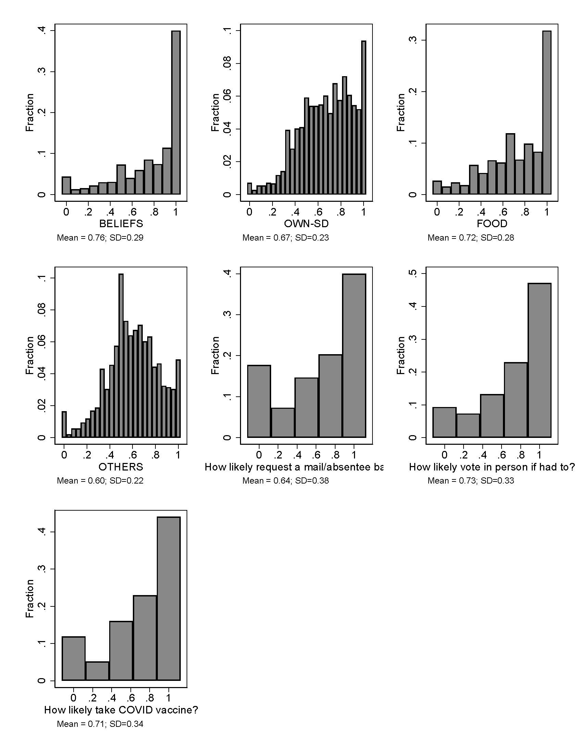
Experiment 1. Distributions of responses for primary and secondary outcomes.

Fig. S2.
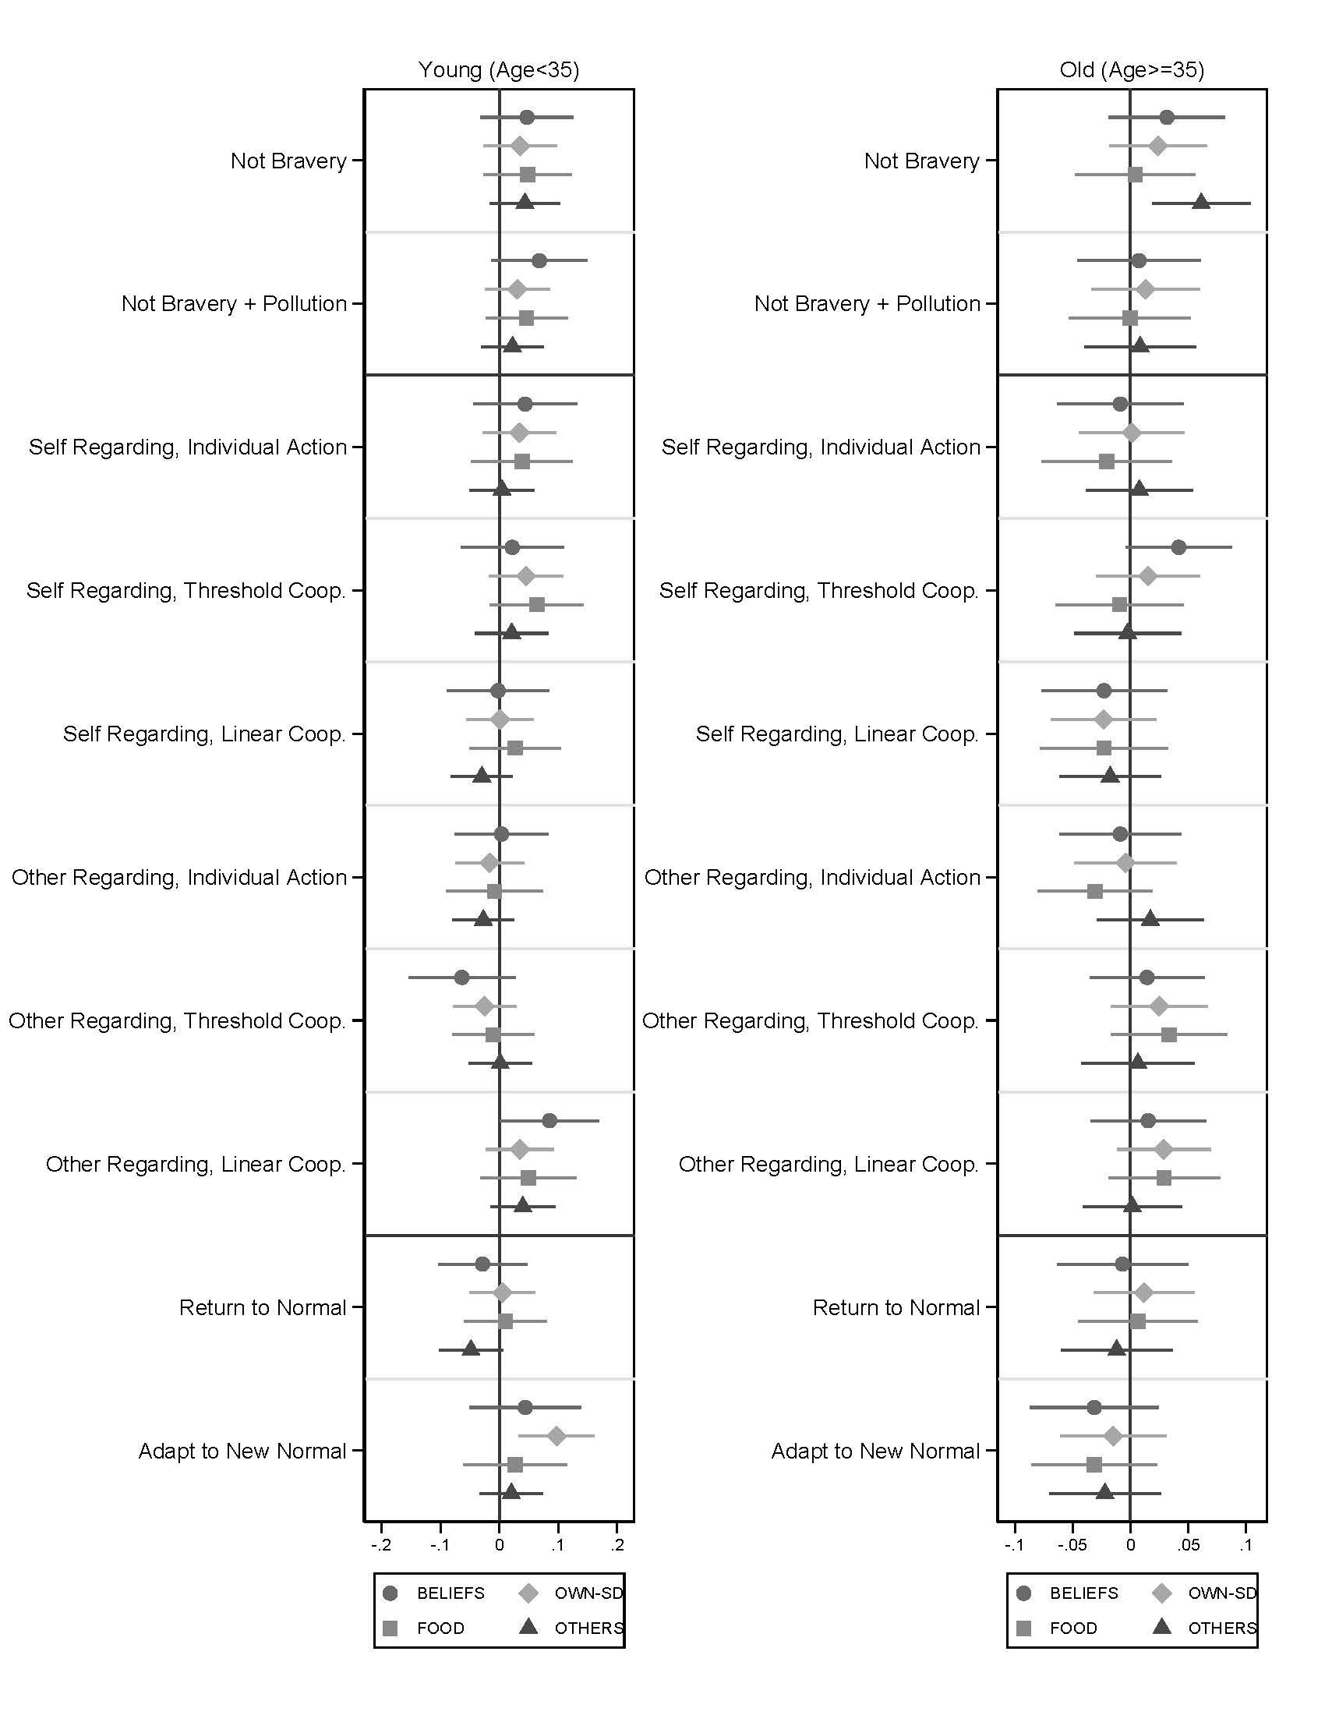
Experiment 1. Covariate-adjusted treatment effect estimates for primary outcomes by age. Comparison to baseline control with 95% confidence intervals are shown.

Fig. S3.
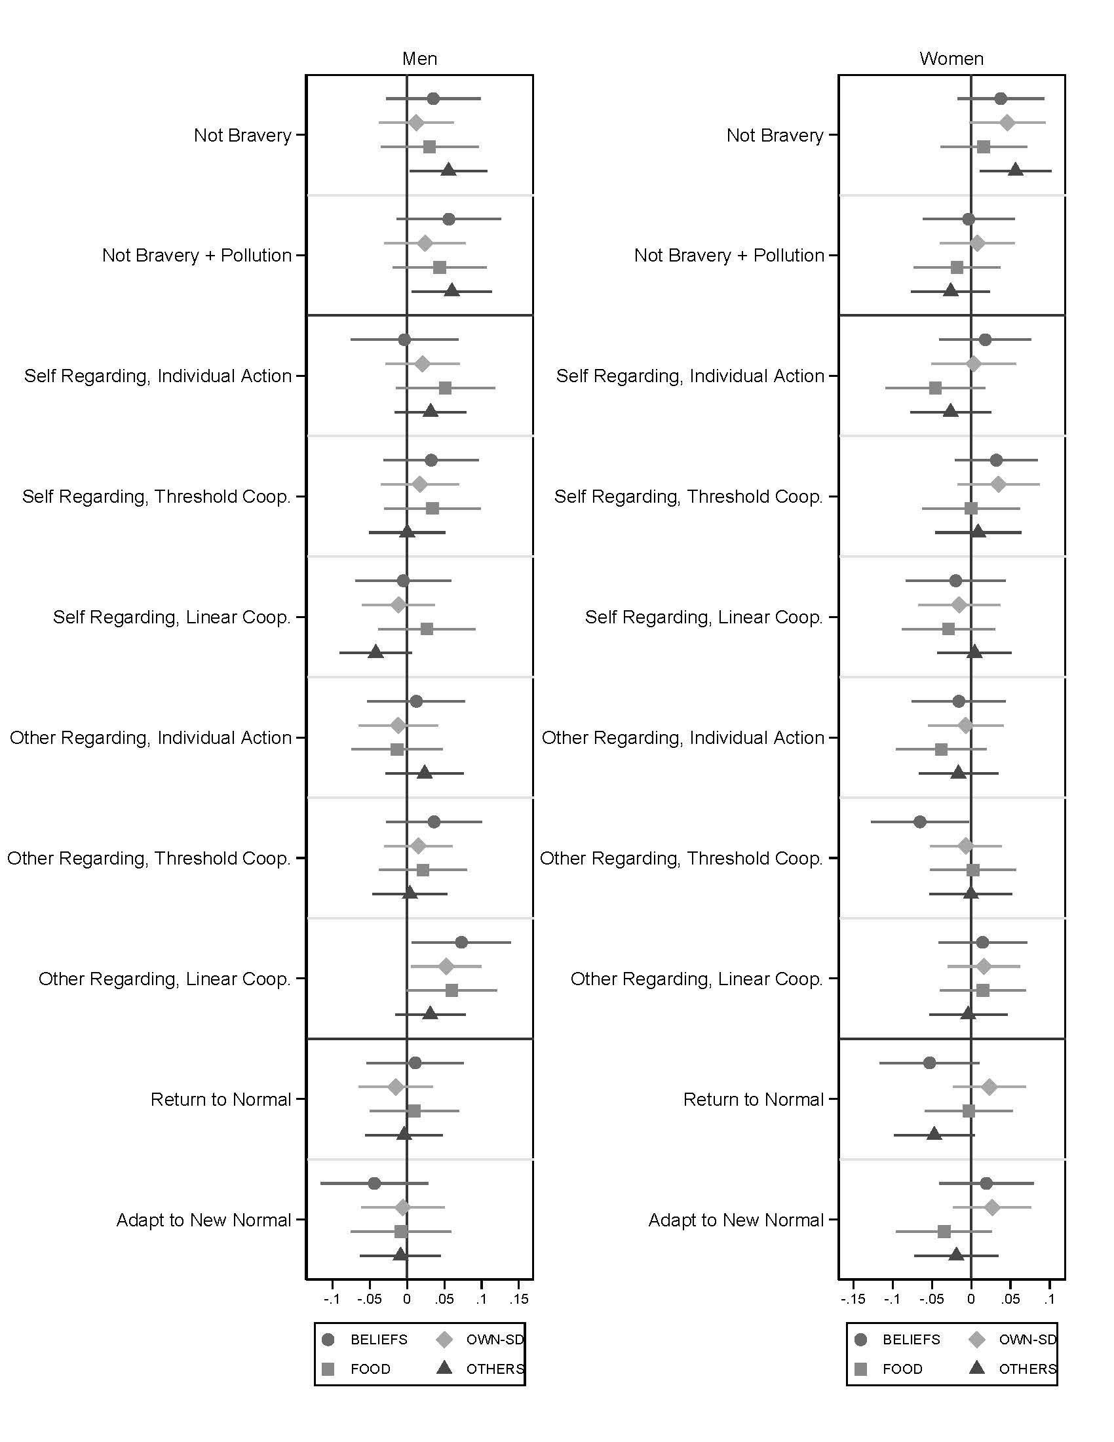
Experiment 1. Covariate-adjusted treatment effect estimates for primary outcomes by gender. Comparison to baseline control with 95% confidence intervals are shown.

Fig. S4.
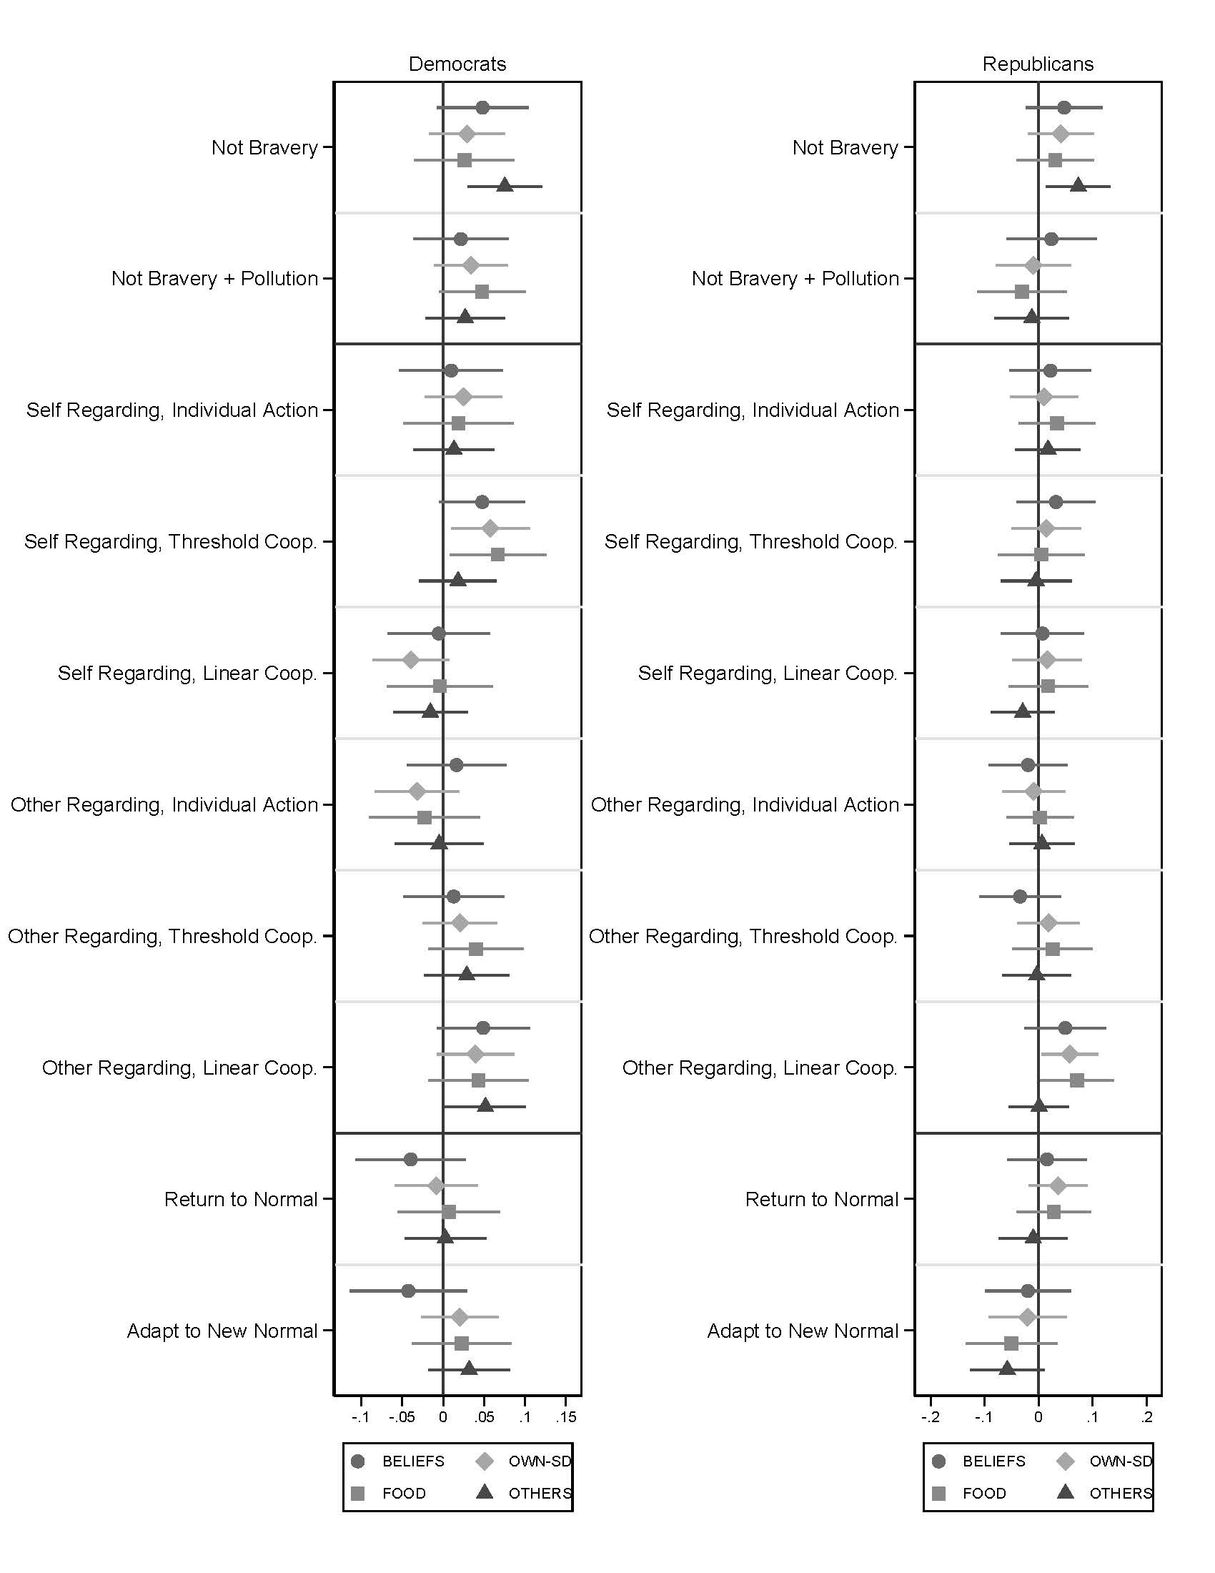
Experiment 1. Covariate-adjusted treatment effect estimates for primary outcomes by partisanship. Comparison to baseline control with 95% confidence intervals are shown.

Fig. S5.
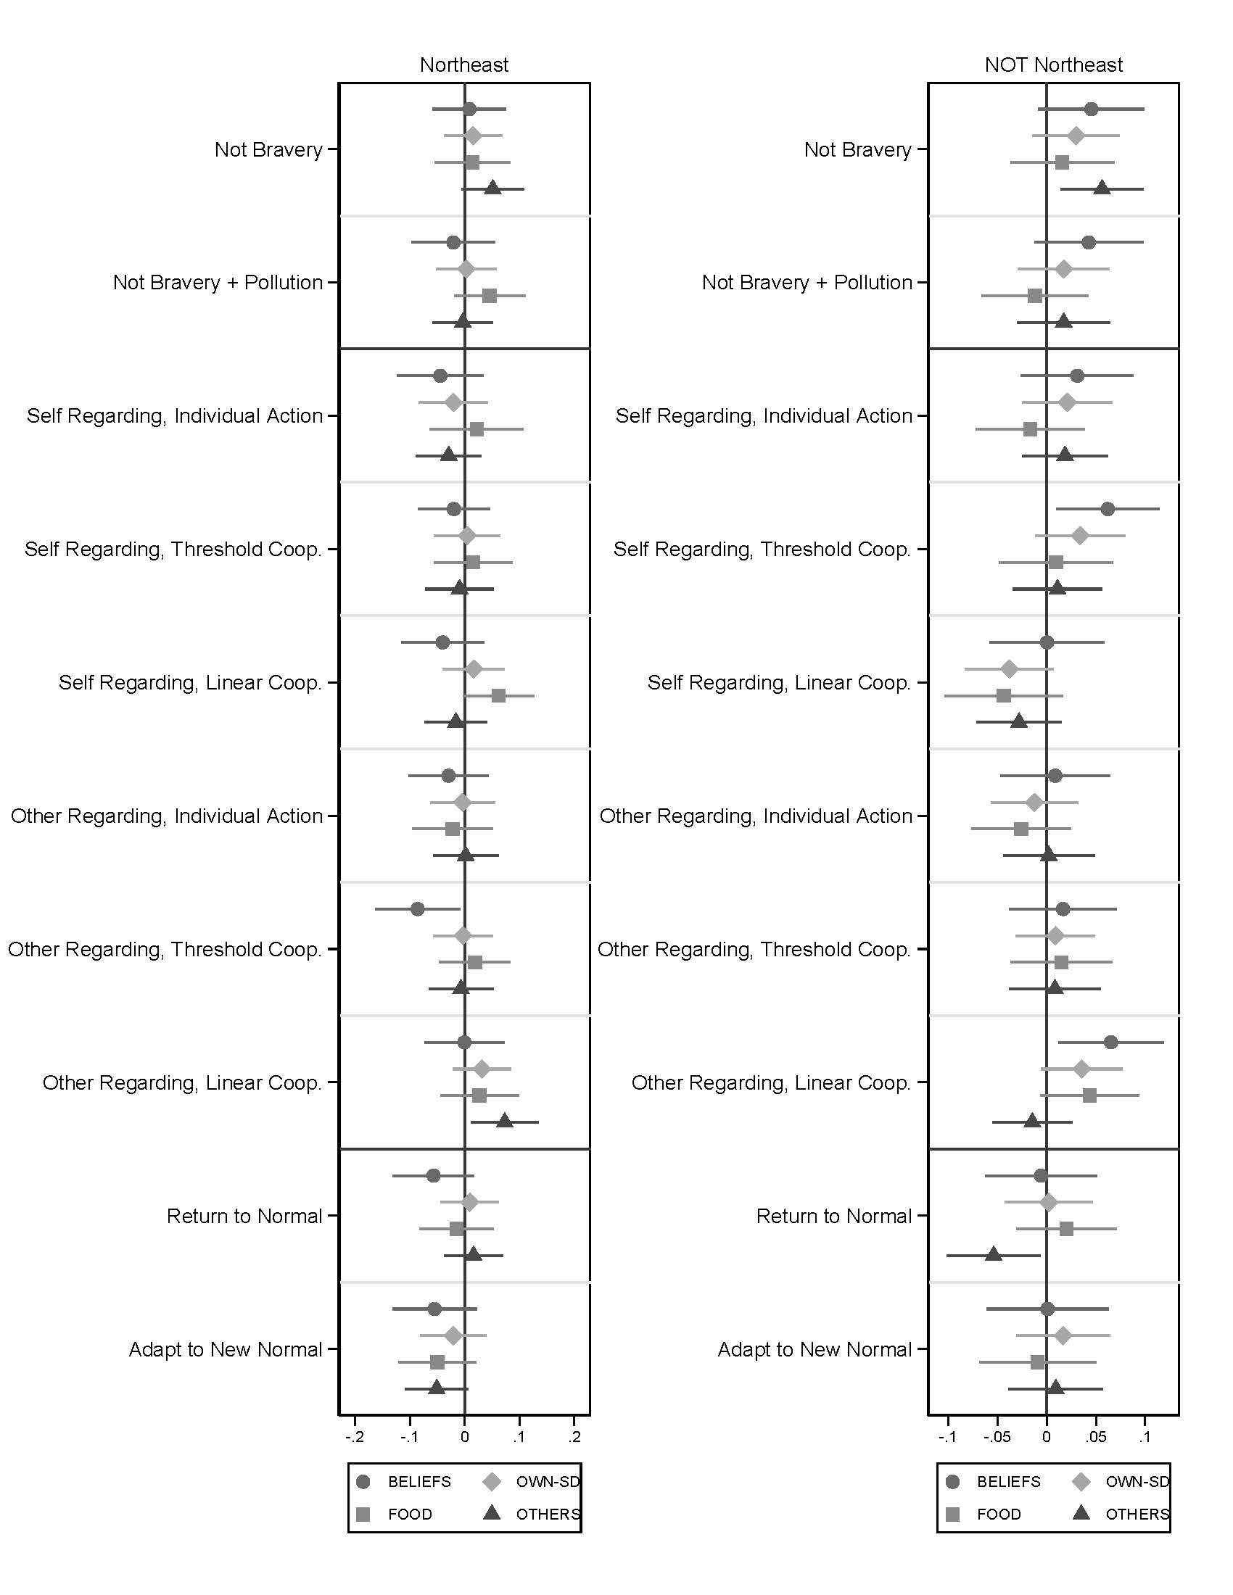
Experiment 1. Covariate-adjusted treatment effect estimates for primary outcomes split by northeast U.S. that was heavily affected by COVID-19 or not northeast. Comparison to baseline control with 95% confidence intervals are shown.

Fig. S6.
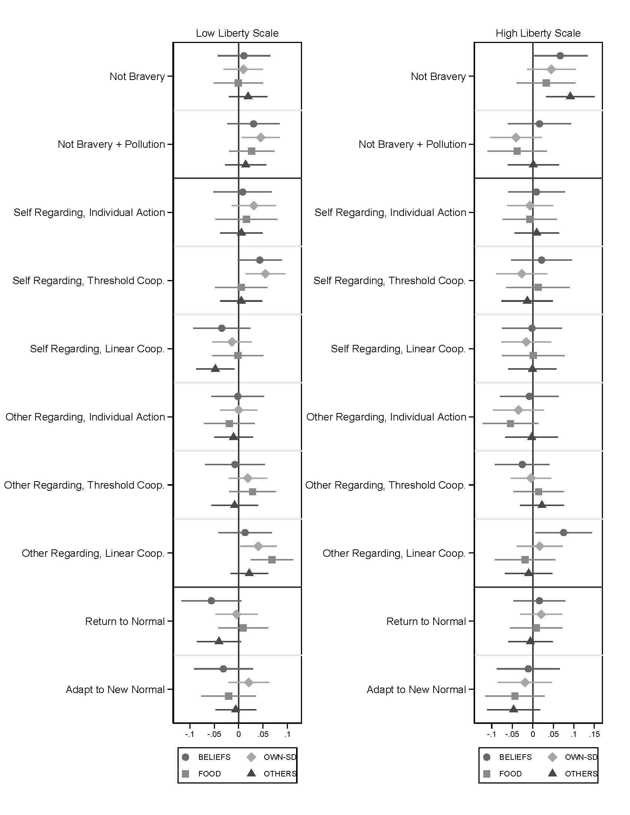
Experiment 1. Covariate-adjusted treatment effect estimates for primary outcomes by level of endorsement of liberty values. Comparison to baseline control with 95% confidence intervals are shown.

Fig. S7.
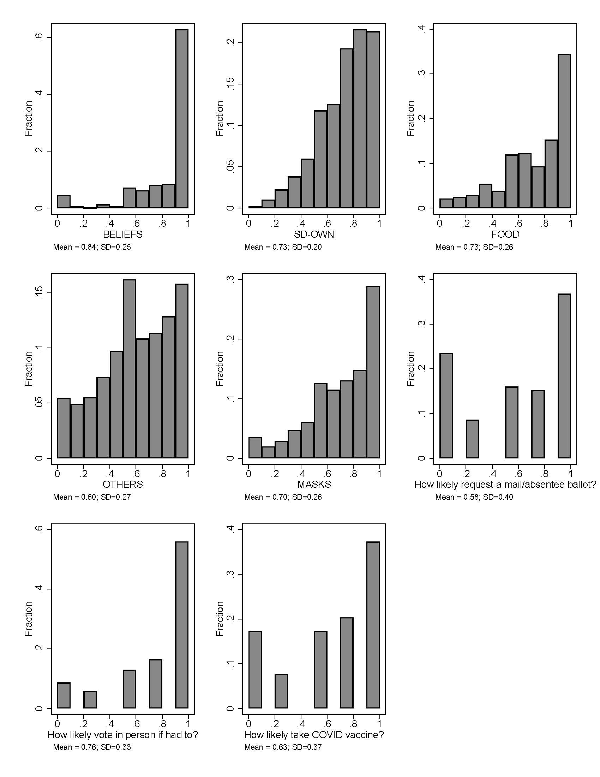
Experiment 2. Distributions of responses for primary and secondary outcomes.

Fig. S8.

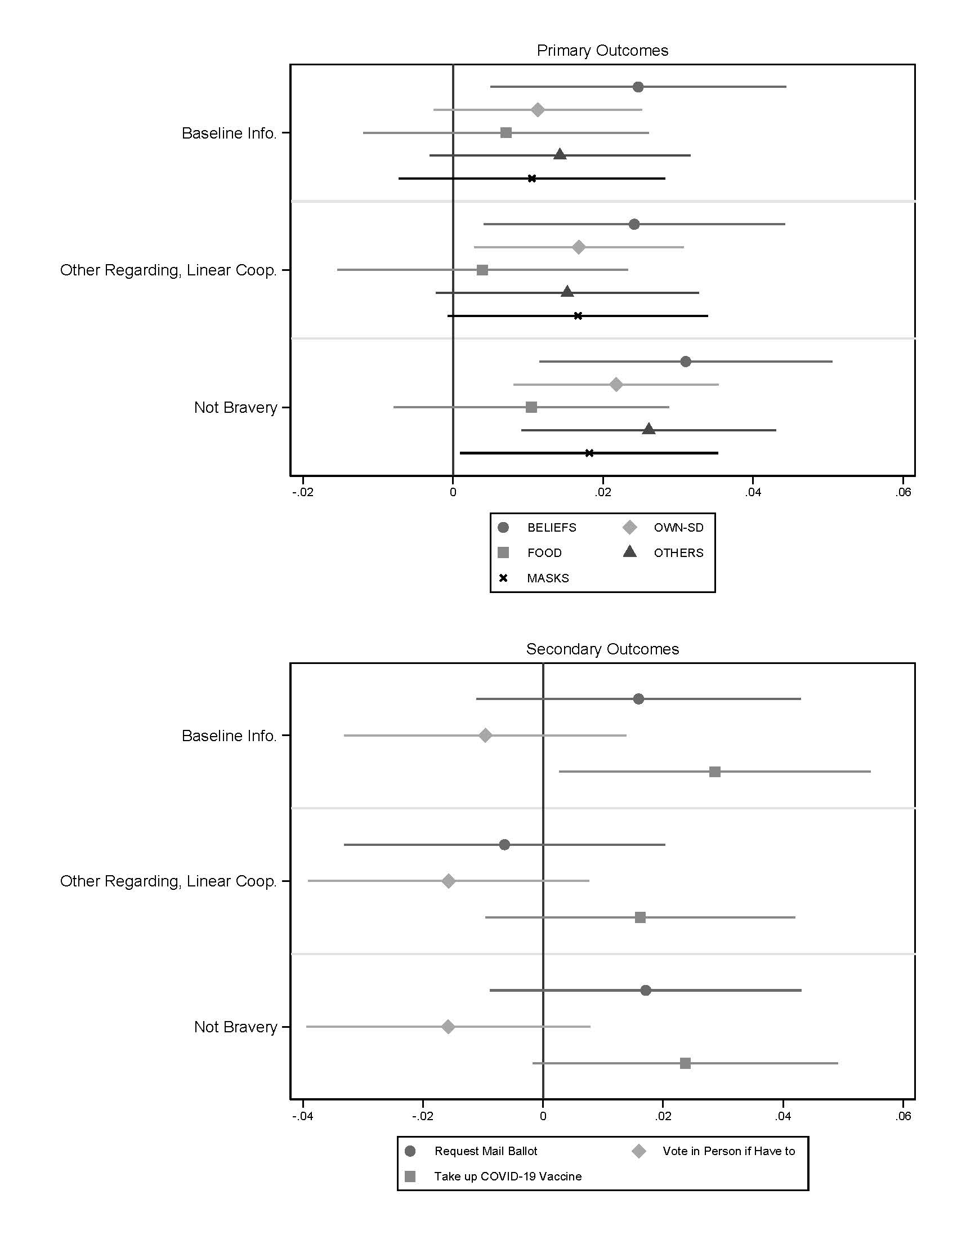
Experiment 2. Covariate-adjusted treatment effect estimates for primary outcomes with population weights. Comparison to placebo-treated control with 95% confidence intervals are shown.

Fig. S9.

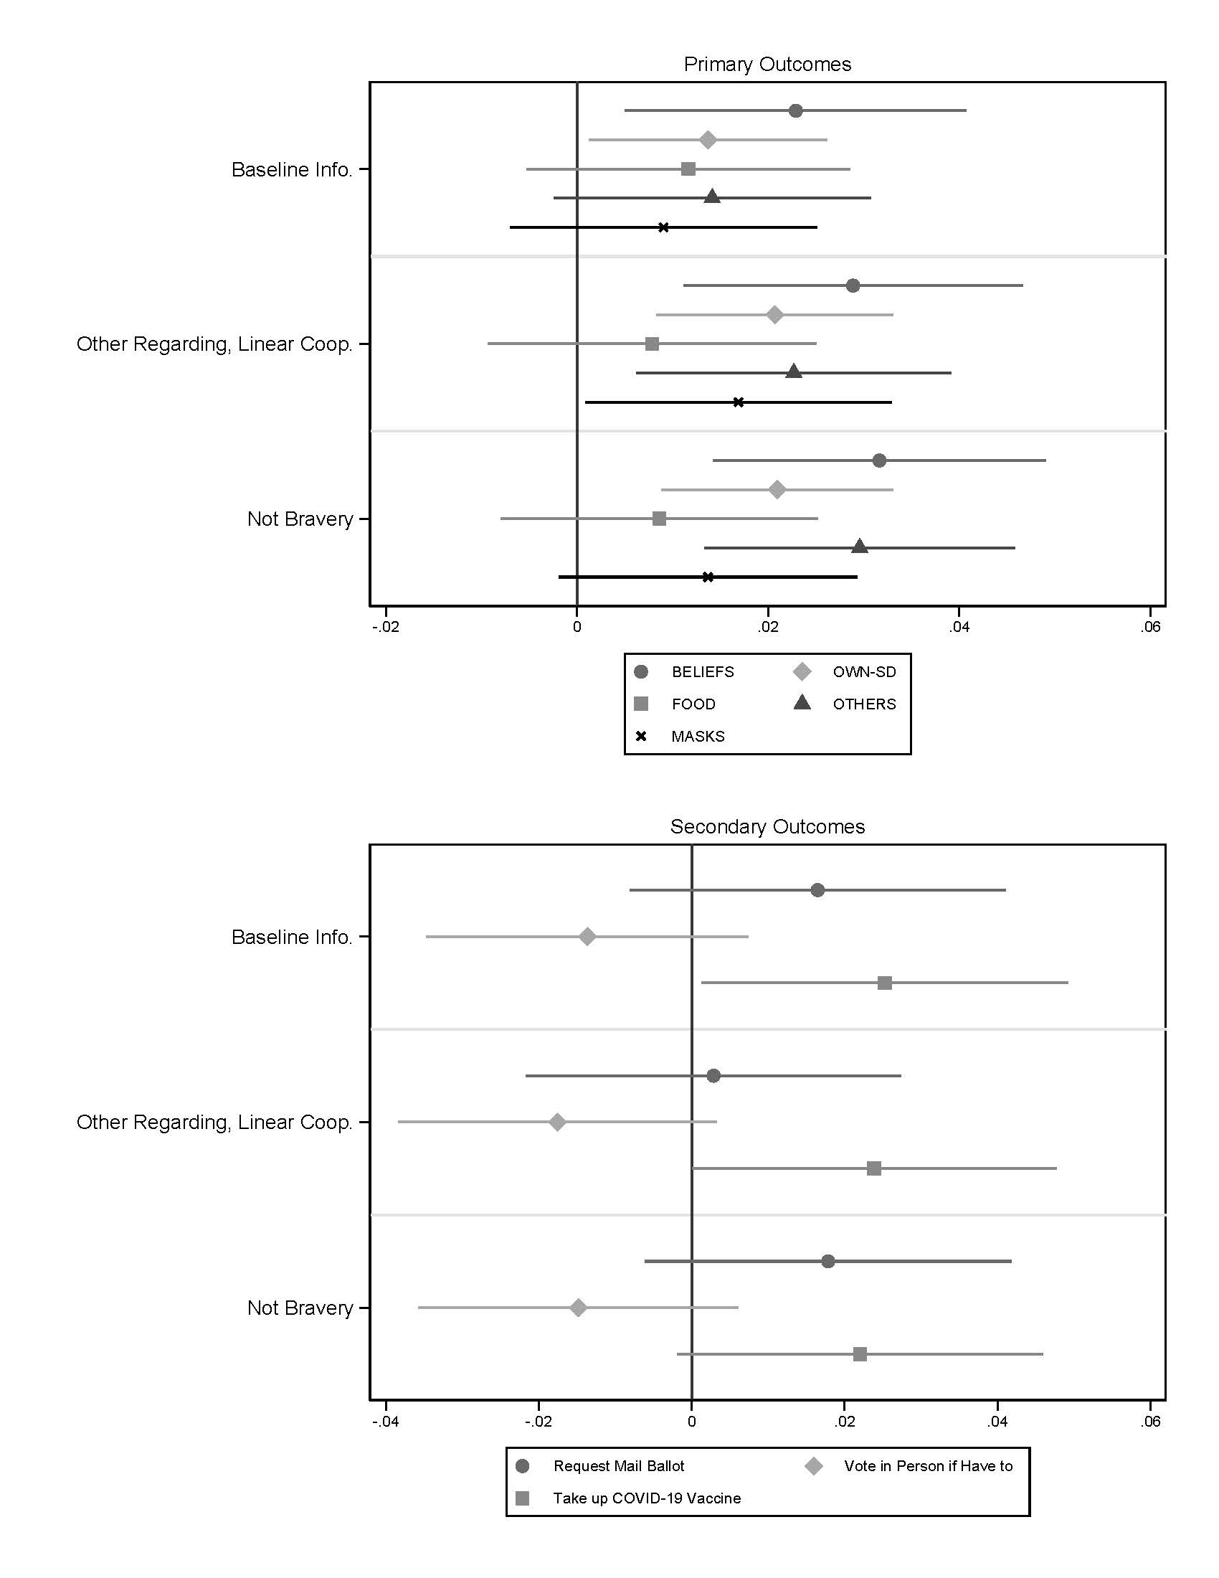
Experiment 2. Unadjusted treatment effect estimates for primary outcomes. Comparison to placebo-treated control with 95% confidence intervals are shown.

Fig. S10.

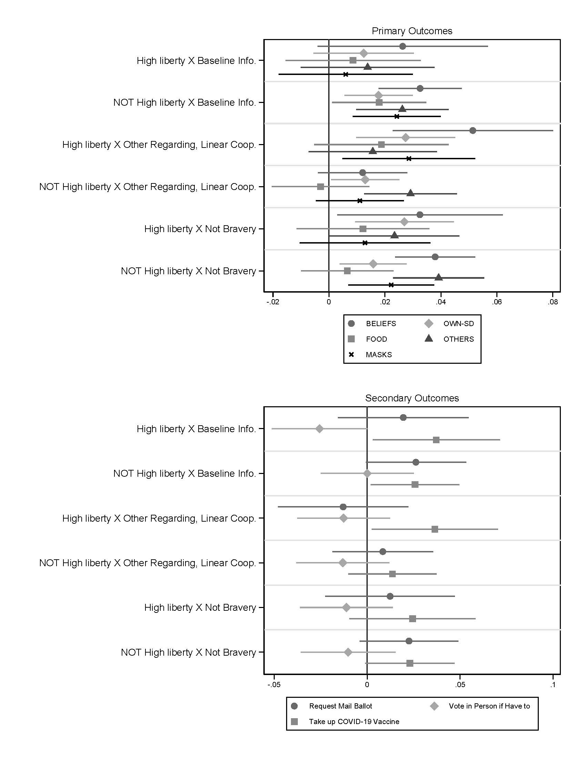
Experiment 2. Covariate-adjusted treatment effect estimates for primary outcomes by level of endorsement of liberty values. Comparison to placebo-treated control with 90% confidence intervals are shown.

Fig. S11.

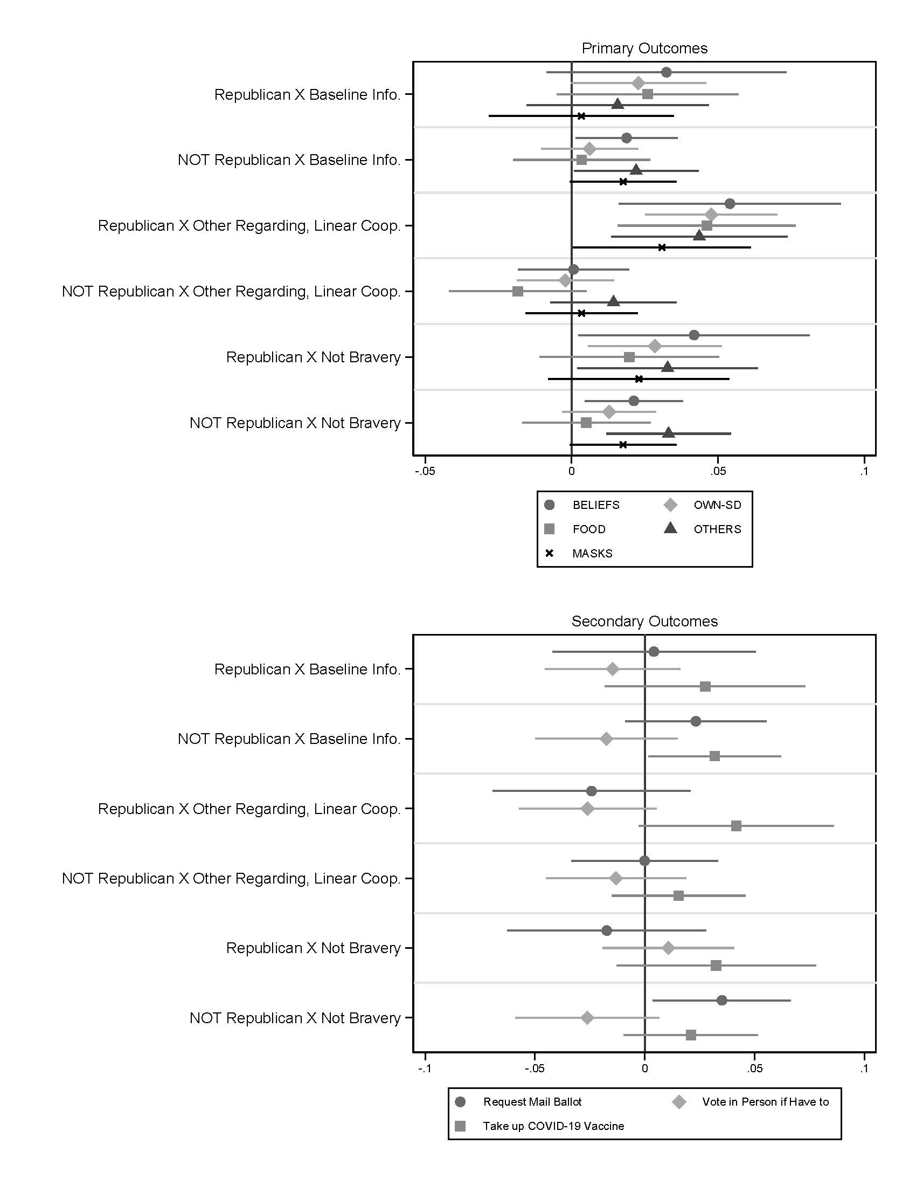
Experiment 2. Covariate-adjusted treatment effect estimates for primary outcomes by partisanship. Comparison to placebo-treated control with 95% confidence intervals are shown.

Fig. S12.

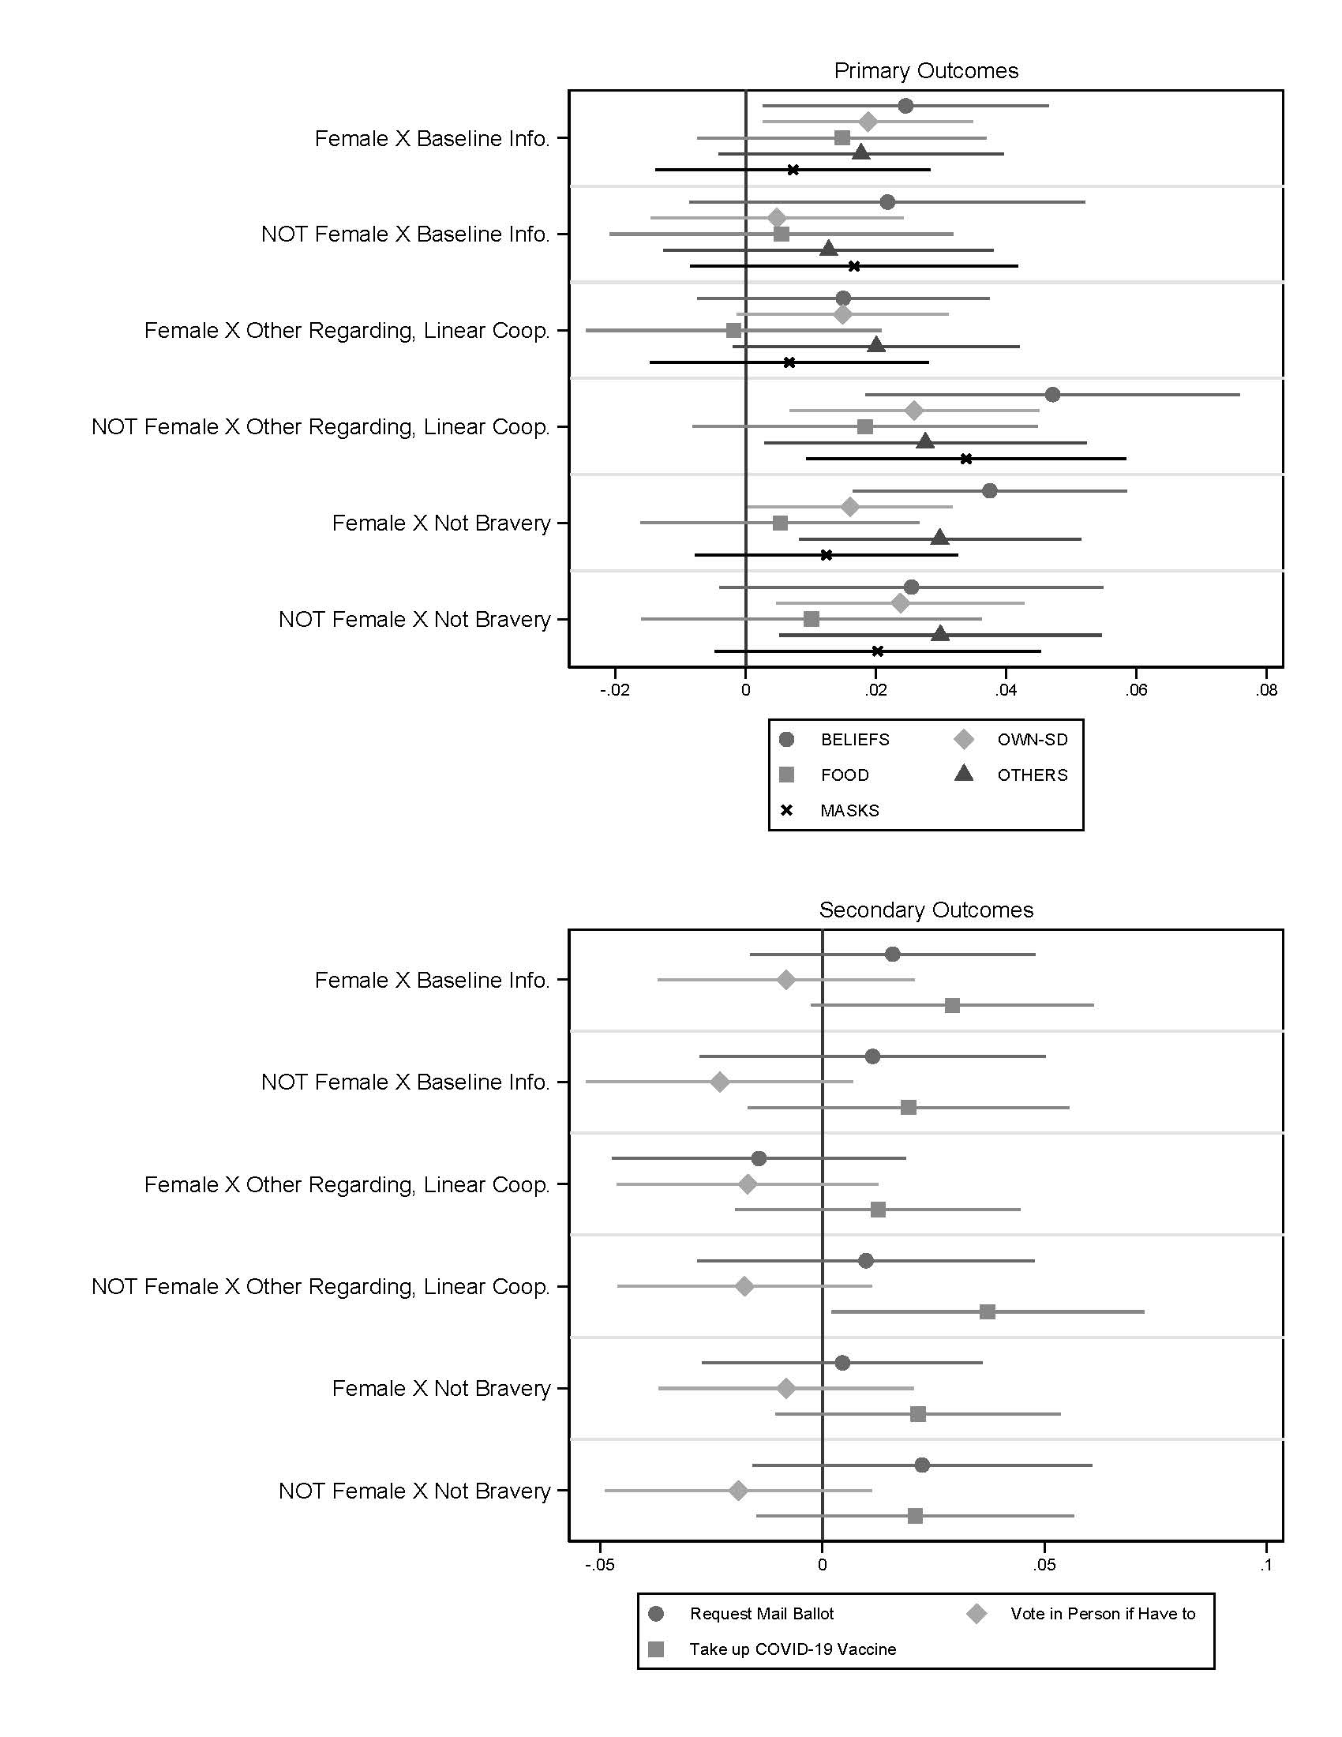
Experiment 2. Covariate-adjusted treatment effect estimates for primary outcomes by gender. Comparison to placebo-treated control with 95% confidence intervals are shown.

Fig. S13.

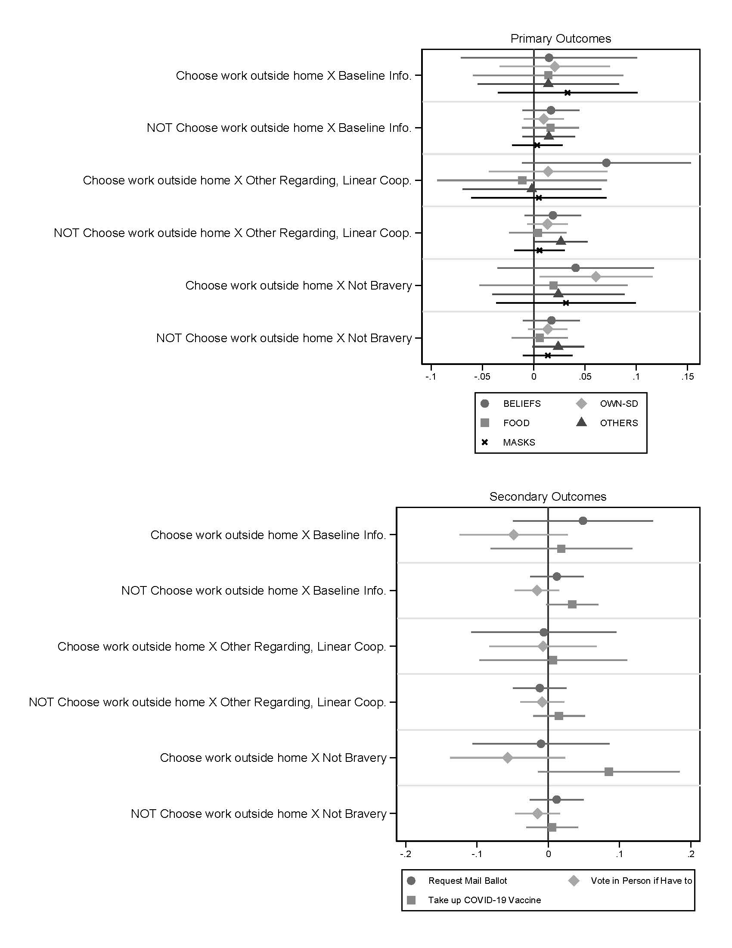
Experiment 2. Covariate-adjusted treatment effect estimates for primary outcomes by where people work outside the home. Comparison to placebo-treated control with 95% confidence intervals are shown.

Table S1.
 | (1) | (2) | (3) | (4) | (5) | (6) | (7)
 | BELIEFS | OWN-SD | FOOD | OTHERS | How likely request a mail/absentee ballot? | How likely vote in person if had to? | How likely take COVID vaccine?
Not Bravery | 0.037 | 0.030 | 0.019 | 0.058 | 0.017 | 0.007 | -0.012
 | [0.021]* | [0.018]* | [0.021] | [0.017]*** | [0.029] | [0.025] | [0.026]
Not Bravery + Pollution | 0.021 | 0.017 | 0.012 | 0.013 | 0.023 | 0.008 | -0.036
 | [0.023] | [0.018] | [0.021] | [0.019] | [0.029] | [0.026] | [0.029]
Self Regarding, Individual Action | 0.008 | 0.012 | 0.000 | 0.005 | 0.011 | 0.033 | -0.052
 | [0.023] | [0.019] | [0.024] | [0.018] | [0.029] | [0.025] | [0.028]*
Self Regarding, Threshold Coop. | 0.033 | 0.024 | 0.013 | 0.004 | -0.017 | 0.018 | -0.020
 | [0.021] | [0.019] | [0.023] | [0.019] | [0.030] | [0.027] | [0.028]
Self Regarding, Linear Coop. | -0.013 | -0.012 | 0.000 | -0.021 | 0.006 | 0.012 | -0.038
 | [0.023] | [0.018] | [0.023] | [0.017] | [0.029] | [0.025] | [0.027]
Other Regarding, Individual Action | -0.003 | -0.009 | -0.026 | 0.001 | -0.002 | 0.033 | -0.002
 | [0.022] | [0.018] | [0.021] | [0.018] | [0.030] | [0.023] | [0.028]
Other Regarding, Threshold Coop. | -0.021 | 0.004 | 0.015 | 0.002 | 0.017 | 0.022 | 0.005
 | [0.023] | [0.016] | [0.020] | [0.019] | [0.030] | [0.025] | [0.028]
Other Regarding, Linear Coop. | 0.040 | 0.034 | 0.038 | 0.013 | 0.032 | -0.005 | 0.002
 | [0.022]* | [0.017]** | [0.021]* | [0.017] | [0.030] | [0.027] | [0.027]
Return to Normal | -0.023 | 0.007 | 0.007 | -0.026 | -0.018 | 0.040 | -0.003
 | [0.023] | [0.017] | [0.021] | [0.018] | [0.030] | [0.025] | [0.026]
Adapt to New Normal | -0.017 | 0.010 | -0.023 | -0.014 | 0.044 | 0.054 | 0.019
 | [0.024] | [0.019] | [0.023] | [0.019] | [0.029] | [0.024]** | [0.026]
Age in years | 0.004 | 0.003 | 0.003 | 0.001 | -0.002 | 0.002 | 0.000
 | [0.000]*** | [0.000]*** | [0.000]*** | [0.000]*** | [0.000]*** | [0.000]*** | [0.000]
Female (1=yes) | 0.063 | 0.057 | 0.055 | 0.028 | 0.005 | -0.028 | -0.065
 | [0.011]*** | [0.009]*** | [0.011]*** | [0.009]*** | [0.014] | [0.012]** | [0.013]***
Household Income | 0.003 | 0.000 | -0.001 | 0.000 | 0.001 | 0.004 | 0.003
 | [0.001]*** | [0.001] | [0.001] | [0.001] | [0.001] | [0.001]*** | [0.001]***
Household Income missing | -0.098 | -0.008 | 0.027 | -0.030 | -0.064 | -0.053 | -0.067
 | [0.031]*** | [0.023] | [0.028] | [0.022] | [0.042] | [0.036] | [0.037]*
Some high school (base category) | 0.000 | 0.000 | 0.000 | 0.000 | 0.000 | 0.000 | 0.000
 | [0.000] | [0.000] | [0.000] | [0.000] | [0.000] | [0.000] | [0.000]
High school graduate | 0.027 | 0.030 | 0.011 | 0.010 | 0.032 | 0.036 | 0.027
 | [0.034] | [0.025] | [0.028] | [0.026] | [0.043] | [0.041] | [0.041]
Post high school vocational training | 0.002 | 0.018 | -0.056 | 0.014 | 0.063 | 0.077 | 0.031
 | [0.043] | [0.033] | [0.040] | [0.036] | [0.058] | [0.054] | [0.054]
Some college | 0.045 | 0.036 | 0.013 | 0.020 | 0.087 | 0.105 | 0.089
 | [0.034] | [0.026] | [0.030] | [0.027] | [0.044]** | [0.042]** | [0.042]**
Associate’s degree | 0.020 | 0.030 | 0.011 | 0.024 | 0.096 | 0.089 | 0.056
 | [0.037] | [0.028] | [0.032] | [0.029] | [0.048]** | [0.045]** | [0.046]
Bachelor’s degree | 0.044 | 0.028 | 0.005 | 0.021 | 0.089 | 0.131 | 0.097
 | [0.034] | [0.025] | [0.029] | [0.027] | [0.044]** | [0.041]*** | [0.042]**
Masters degree | 0.065 | 0.042 | -0.036 | 0.025 | 0.202 | 0.100 | 0.151
 | [0.036]* | [0.027] | [0.032] | [0.028] | [0.047]*** | [0.043]** | [0.044]***
Professional Degree | 0.009 | 0.011 | -0.041 | 0.047 | 0.190 | 0.090 | 0.108
 | [0.053] | [0.041] | [0.050] | [0.039] | [0.057]*** | [0.053]* | [0.054]**
Strong Democrat | 0.058 | 0.027 | 0.008 | 0.057 | 0.290 | 0.230 | 0.148
 | [0.018]*** | [0.014]** | [0.018] | [0.014]*** | [0.023]*** | [0.023]*** | [0.022]***
Democrat | 0.070 | 0.035 | 0.040 | 0.049 | 0.160 | 0.080 | 0.106
 | [0.020]*** | [0.015]** | [0.019]** | [0.016]*** | [0.027]*** | [0.027]*** | [0.025]***
Democrat Lean | 0.043 | 0.002 | 0.021 | 0.031 | 0.173 | 0.123 | 0.125
 | [0.023]* | [0.018] | [0.022] | [0.017]* | [0.030]*** | [0.030]*** | [0.028]***
Republican Lean | -0.095 | -0.061 | -0.050 | -0.026 | 0.031 | 0.217 | -0.015
 | [0.026]*** | [0.020]*** | [0.024]** | [0.021] | [0.035] | [0.029]*** | [0.033]
Republican | -0.039 | -0.063 | -0.034 | -0.067 | 0.047 | 0.159 | 0.010
 | [0.021]* | [0.017]*** | [0.020]* | [0.018]*** | [0.030] | [0.027]*** | [0.027]
Strong Republican | -0.071 | -0.136 | -0.163 | -0.078 | 0.074 | 0.285 | 0.025
 | [0.020]*** | [0.015]*** | [0.019]*** | [0.016]*** | [0.026]*** | [0.023]*** | [0.024]
Northeast (base category) | 0.000 | 0.000 | 0.000 | 0.000 | 0.000 | 0.000 | 0.000
 | [0.000] | [0.000] | [0.000] | [0.000] | [0.000] | [0.000] | [0.000]
Midwest | -0.040 | -0.043 | -0.019 | -0.034 | 0.002 | -0.009 | -0.034
 | [0.017]** | [0.014]*** | [0.016] | [0.014]** | [0.023] | [0.019] | [0.021]
South | -0.017 | -0.040 | -0.025 | -0.021 | -0.017 | -0.013 | -0.031
 | [0.015] | [0.012]*** | [0.014]* | [0.012]* | [0.019] | [0.016] | [0.018]*
West | -0.037 | -0.043 | -0.042 | -0.034 | 0.071 | -0.046 | -0.026
 | [0.016]** | [0.013]*** | [0.016]*** | [0.013]** | [0.020]*** | [0.019]** | [0.020]
Constant | 0.522 | 0.540 | 0.602 | 0.547 | 0.500 | 0.365 | 0.596
 | [0.039]*** | [0.029]*** | [0.034]*** | [0.030]*** | [0.050]*** | [0.046]*** | [0.047]***
Observations | 2529 | 2527 | 2528 | 2419 | 2531 | 2531 | 2531
R-squared | 0.123 | 0.149 | 0.131 | 0.086 | 0.128 | 0.154 | 0.076
Mean of DV | 0.762 | 0.673 | 0.723 | 0.604 | 0.644 | 0.729 | 0.705
Std. Dev. of DV | 0.289 | 0.231 | 0.280 | 0.223 | 0.376 | 0.328 | 0.339
Robust standard errors in brackets
* significant at 10%; ** significant at 5%; *** significant at 1%

OLS regression analysis with Huber-White standard errors for estimates displayed in Figure 1.

Table S2.
 | (1) | (2) | (3) | (4) | (5) | (6) | (7) | (8)
 | BELIEFS | SD-OWN | FOOD | OTHERS | MASKS | How likely request a mail/absentee ballot? | How likely vote in person if had to? | How likely take COVID vaccine?
Baseline Info. | 0.023 | 0.013 | 0.011 | 0.016 | 0.011 | 0.014 | -0.015 | 0.025
 | [0.009]** | [0.006]** | [0.009] | [0.008]* | [0.008] | [0.013] | [0.011] | [0.012]**
Other Regarding, Linear Coop. | 0.029 | 0.020 | 0.007 | 0.023 | 0.018 | -0.004 | -0.017 | 0.023
 | [0.009]*** | [0.006]*** | [0.009] | [0.008]*** | [0.008]** | [0.013] | [0.011] | [0.012]*
Not Bravery | 0.032 | 0.019 | 0.007 | 0.030 | 0.016 | 0.012 | -0.013 | 0.021
 | [0.009]*** | [0.006]*** | [0.008] | [0.008]*** | [0.008]* | [0.012] | [0.011] | [0.012]*
Constant | 0.752 | 0.531 | 0.525 | 0.533 | 0.659 | 0.497 | 0.546 | 0.436
 | [0.026]*** | [0.018]*** | [0.025]*** | [0.023]*** | [0.022]*** | [0.034]*** | [0.029]*** | [0.033]***
Observations | 5295 | 6066 | 6067 | 6058 | 6052 | 6063 | 6066 | 6064
R-squared | 0.170 | 0.225 | 0.160 | 0.262 | 0.228 | 0.250 | 0.174 | 0.184
Control Group Mean of DV | 0.813 | 0.711 | 0.718 | 0.574 | 0.687 | 0.571 | 0.774 | 0.608
ORLC v Baseline est | 0.005 | 0.007 | -0.004 | 0.008 | 0.007 | -0.017 | -0.002 | -0.001
ORLC v Baseline p | 0.274 | 0.136 | 0.342 | 0.182 | 0.192 | 0.085 | 0.414 | 0.451
Not Bravery v Baseline est | 0.009 | 0.007 | -0.003 | 0.014 | 0.004 | -0.001 | 0.002 | -0.004
Not Bravery v Baseline p | 0.159 | 0.141 | 0.350 | 0.047 | 0.293 | 0.454 | 0.435 | 0.381
Average ORLC/Not Bravery v Baseline est | 0.007 | 0.007 | -0.003 | 0.011 | 0.006 | -0.009 | 0.000 | -0.003
Average ORLC/Not Bravery v Baseline p | 0.181 | 0.106 | 0.324 | 0.069 | 0.208 | 0.194 | 0.488 | 0.403
Covariates omitted. OLS Coefficients with robust standard errors in brackets.
* significant at 10%; ** significant at 5%; *** significant at 1%

OLS regression analysis with Huber-White standard errors for estimates displayed in Figure 2.

Table S3.
 | (1) | (2) | (3) | (4) | (5) | (6) | (7)
 | Agree: I am likely to practice Soc. Dist. (Scale 0-1) | How likely: Stay at home if exposed to COVID-19 (Scale 0-1) | How likely: Alert authorities if get COVID-19 (Scale 0-1) | How likely: If asked, cooperate with public health authorities to trace exposure | RC How likely: Attend indoor group religious services (Scale 0-1) | RC How likely: Go INSIDE at another family member's house (Scale 0-1) | RC How likely: Go INSIDE at a friend's house (Scale 0-1)
Baseline Info. | 0.020 | 0.004 | 0.010 | 0.009 | 0.018 | 0.006 | 0.019
 | [0.010]** | [0.010] | [0.012] | [0.011] | [0.012] | [0.013] | [0.013]
Other Regarding, Linear Coop. | 0.029 | 0.006 | 0.028 | 0.027 | 0.015 | 0.031 | 0.040
 | [0.010]*** | [0.010] | [0.012]** | [0.011]** | [0.012] | [0.013]** | [0.013]***
Not Bravery | 0.028 | 0.020 | 0.029 | 0.017 | 0.037 | 0.015 | 0.035
 | [0.009]*** | [0.010]** | [0.011]** | [0.011] | [0.012]*** | [0.013] | [0.013]***
Constant | 0.728 | 0.653 | 0.537 | 0.609 | 0.540 | 0.358 | 0.356
 | [0.027]*** | [0.029]*** | [0.032]*** | [0.030]*** | [0.033]*** | [0.035]*** | [0.034]***
Observations | 5766 | 6056 | 6062 | 6063 | 6060 | 6064 | 6060
R-squared | 0.144 | 0.111 | 0.117 | 0.142 | 0.170 | 0.101 | 0.117
Control Group Mean of DV | 0.794 | 0.814 | 0.696 | 0.750 | 0.733 | 0.454 | 0.527
ORLC v Baseline est | 0.009 | 0.002 | 0.018 | 0.018 | -0.003 | 0.025 | 0.021
ORLC v Baseline p | 0.187 | 0.441 | 0.061 | 0.046 | 0.412 | 0.029 | 0.049
Not Bravery v Baseline est | 0.008 | 0.015 | 0.019 | 0.008 | 0.019 | 0.010 | 0.016
Not Bravery v Baseline p | 0.200 | 0.063 | 0.050 | 0.224 | 0.054 | 0.229 | 0.100
Average ORLC/Not Bravery v Baseline est | 0.008 | 0.008 | 0.018 | 0.013 | 0.008 | 0.017 | 0.019
Average ORLC/Not Bravery v Baseline p | 0.160 | 0.170 | 0.033 | 0.080 | 0.213 | 0.064 | 0.045
Covariates omitted. OLS Coefficients with robust standard errors in brackets.
* significant at 10%; ** significant at 5%; *** significant at 1%

OLS regression analysis with Huber-White standard errors for estimates displayed in Figure 3.

