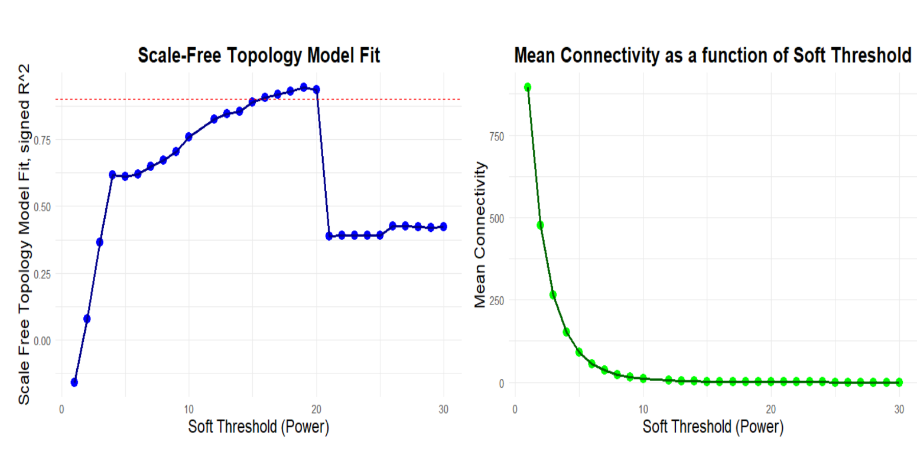
Supplementary Information, Figure S1. Analysis of network topology for a set of soft thresholding powers. The left plot displays the scale of free fit index (y-axis) as a function of the soft thresholding power (x-axis). The right plot shows the mean connectivity (degree, y-axis) as a function of the soft thresholding power (x-axis).

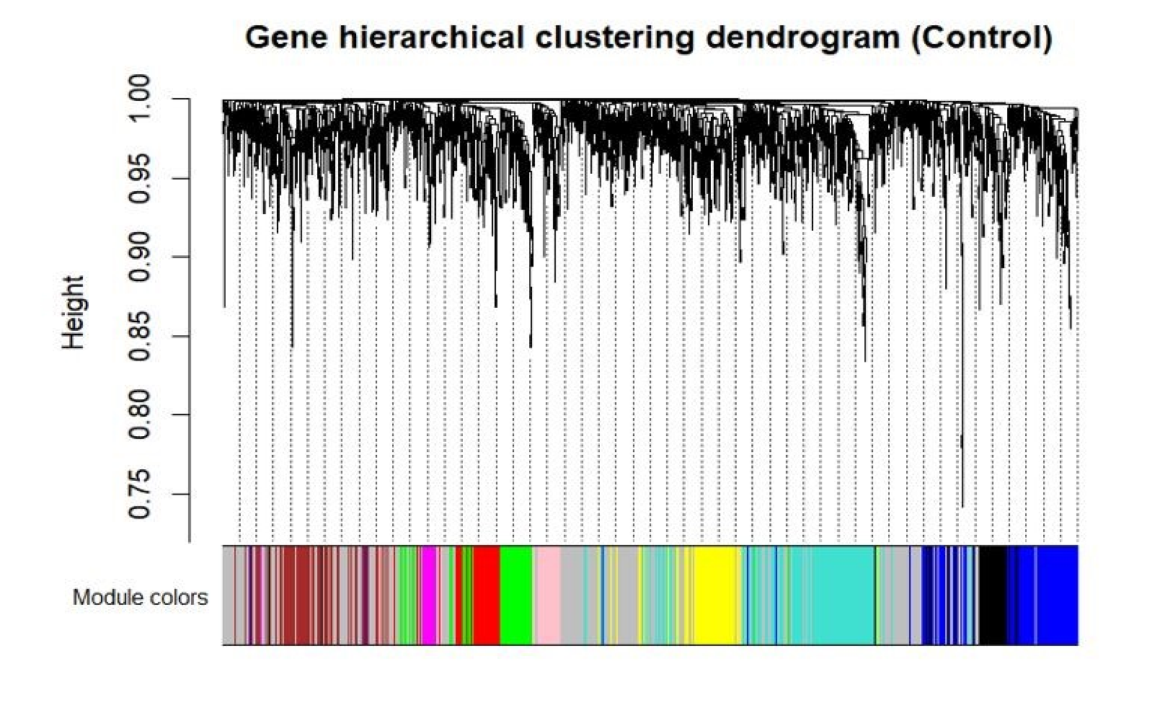
Supplementary Information, Figure S2. Clustering dendrogram of genes based on a dissimilarity measure (1-TOM), which was then used to assign genes into nine modules. Genes are clustered into modules based on their similarity in their RNA stability. The branches correspond to modules of highly interconnected groups of genes. The y-axis indicates the co-expression distance and the x-axis corresponds to genes. Each color is assigned to a module (grey represented unassigned genes).

