Supplementary Information
OPA1 drives ROS-dependent neutrophil extracellular trap formation to promote tumor immunotherapy resistance
Zao Wang^{1,4#}, Linzhou Zhang^{2,3#}, Jialiang Chen^{2,3}, Xi Huang^{2,3}，Jiajie Liang^{2,3}, Kuiming Wang^{2,3}, Gang Chen ^{2,3}, Bing Liu^{2,3*}, Guangliang Niu^{1,4 *}, Jie Zhang^{1*}

¹Jiangxi Provincial Key Laboratory of Oral Diseases, Department of Stomatology, The First Affiliated Hospital, Jiangxi Medical College, Nanchang University, Nanchang, Jiangxi 330006, China.
²State Key Laboratory of Oral & Maxillofacial Reconstruction and Regeneration, Key Laboratory of Oral Biomedicine Ministry of Education, Hubei Key Laboratory of Stomatology, School & Hospital of Stomatology, Wuhan University, Wuhan 430079, China.
³Department of Oral and Maxillofacial Surgery, School & Hospital of Stomatology, Wuhan University, Wuhan 430079, China.
⁴Department of Stomatology, Beijing Hospital of Integrated Traditional Chinese and Western Medicine, Beijing 100039, China.
#Co-first author
*Corresponding Author: Jie Zhang, Jiangxi Provincial Key Laboratory of Oral Diseases, Department of Stomatology, The First Affiliated Hospital, Jiangxi Medical College, Nanchang University, Nanchang, Jiangxi 330006, China. E-mail: ndyfy02134@ncu.edu.cn; Guangliang Niu, Jiangxi Provincial Key Laboratory of Oral Diseases, Department of Stomatology, The First Affiliated Hospital, Jiangxi Medical College, Nanchang University, Nanchang, Jiangxi, China. Email: newgl@sina.com; Bing Liu, Department of Oral and Maxillofacial Surgery, School and Hospital of Stomatology, Wuhan University, Wuhan, Hubei 430079, China. E-mail: liubing9909@whu.edu.cn.

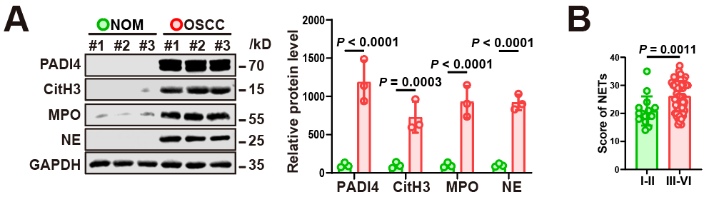
Supplementary Fig. 1. Upregulation of NETs in TME promotes tumor progression
(A) Western blot analysis of NET‑associated proteins (PADI4, MPO, CitH3, NE) in paired samples of normal oral mucosa (NOM) and oral squamous cell carcinoma (OSCC) from three patients. Representative blots (left) and densitometric quantification normalized to GAPDH (right) are shown. (B) NETs scores in OSCC specimens stratified by clinical grade: early‑stage (GI-GII, n = 15) versus advanced‑stage (GIII-GIV, n = 60). Data are presented as mean ± SD. Statistical analysis was performed using two-sided unpaired t‑test (A-B).

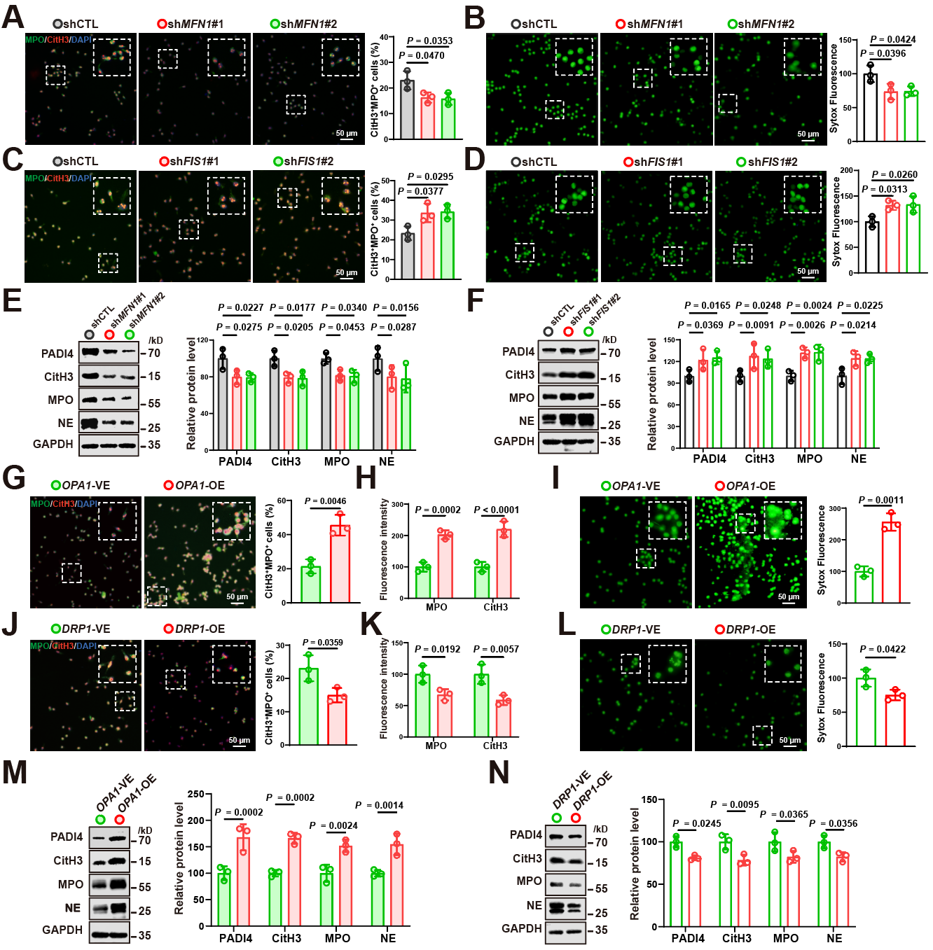
Supplementary Fig. 2. In vitro analysis links OPA1, DRP1, MFN1, and FIS1 to NET formation
(A-D) Knockdown of MFN1 and FIS1. (A) Immunofluorescence staining for MPO (green) and CitH3 (red) in shCTL, shMFN1#1, and shMFN1#2 neutrophils. Nuclei were counterstained with DAPI (blue). Scale bar, 50 µm. Quantification of CitH3⁺MPO⁺ cells from three independent experiments is shown on the right. (B) NET formation assessed by Sytox Green staining in the corresponding groups, with representative images (left) and quantitative analysis of fluorescence intensity (right). Scale bar, 50 µm. (C, D) Corresponding analyses for FIS1 knockdown neutrophils (shFIS1#1 and shFIS1#2), with immunofluorescence (C) and Sytox Green staining (D). (E, F) Western blot analysis of NET‑associated proteins (PADI4, MPO, CitH3, NE) in MFN1 (E) and FIS1 (F) knockdown neutrophils, with representative blots (left) and quantification (right). (G-N) Overexpression of OPA1 and DRP1. (G) Immunofluorescence staining for MPO and CitH3 in vector-control (OPA1-VE) and OPA1-overexpressing (OPA1-OE) neutrophils. Representative images (left) and quantification of CitH3⁺MPO⁺ cells from three independent experiments (right) are shown. Scale bars, 50 µm. (H) Quantification of mean fluorescence intensity (MFI) for CitH3 and MPO from the experiments in (G). (I) Sytox Green staining of NETs in OPA1-VE and OPA1-OE neutrophils, with representative images (left) and fluorescence intensity quantification (right). Scale bar, 50 µm. (J-L) Corresponding analyses for DRP1-overexpressing neutrophils. (J) Immunofluorescence staining for MPO and CitH3 in DRP1-VE and DRP1-OE neutrophils, with quantification of CitH3⁺MPO⁺ cells (right). Scale bars, 50 µm. (K) Quantification of MFI for CitH3 and MPO from the experiments in (J). (L) Sytox Green staining of NETs in DRP1-VE and DRP1-OE neutrophils, with fluorescence intensity quantification (right). Scale bar, 50 µm. (M, N) Western blot analysis of NET-associated proteins in OPA1 (M) and DRP1 (N) overexpression neutrophils, with representative blots (left) and quantification (right). Data represent mean ± SD. Statistical significance was determined by two-way ANOVA (E, F, H, K, M and N), two-sided unpaired t‑test (A-D, G, I, J and L).

Supplementary Fig. 3. OPA1 regulates NET formation in primary neutrophils
(A) Flow cytometry gating strategy for human primary neutrophils using CD11b and CD66b as surface markers. (B) Representative transmission electron microscopy images (left) and quantification of mean mitochondrial length (right) in control versus NET‑forming neutrophils (n = 10). Scale bars, 1 µm. (C) Live‑cell fluorescence imaging of mitochondrial morphology (left) in control and NET‑forming neutrophils stained with MitoTracker Red (mitochondria) and DAPI (nuclei). Mitochondria were categorized as fragmented (< 1 µm), intermediate (1-2 µm), or tubular (> 2 µm); proportions of each subtype are quantified (n = 10). Scale bars, 1 µm. (D) Western blot (left) and quantification (right) of OPA1 and DRP1 expression in NET‑forming neutrophils. Data are presented as mean ± SD. Statistical significance was determined using two-sided unpaired t-test (B), two-way ANOVA (C-D).

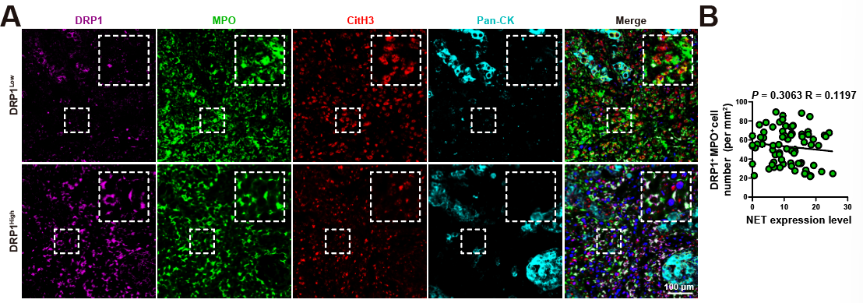
Supplementary Fig. 4. Neutrophil DRP1 expression is dispensable for NET formation in OSCC
(A) Representative multiplex immunohistochemistry (mIHC) images of human OSCC tissues exhibiting low versus high DRP1 expression. Sections were stained for MPO (green), CitH3 (red), DRP1 (purple), and Pan‑CK (cyan). Scale bars, 100 µm. (B) Spearman correlation analysis between DRP1⁺MPO⁺ cell number and NET expression levels in OSCC specimens (n = 75).

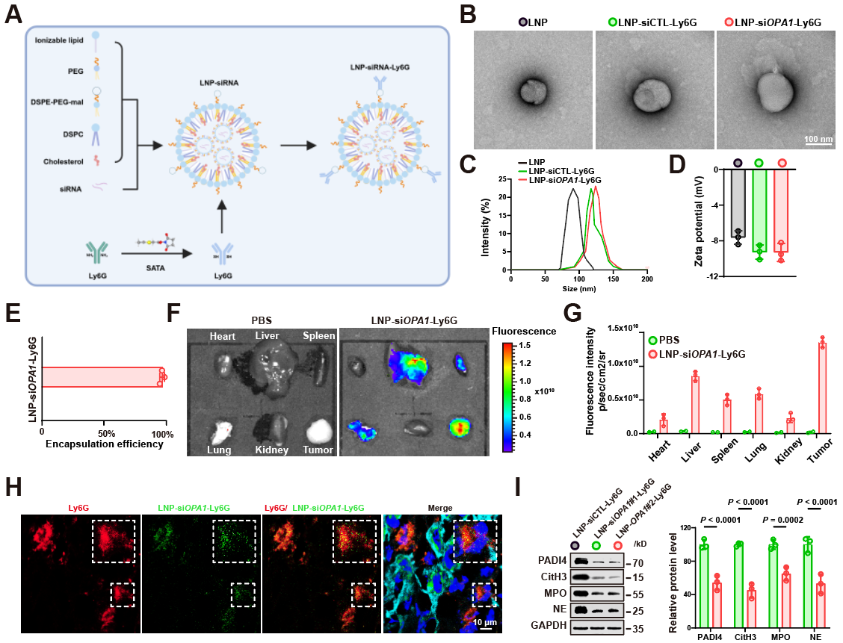
Supplementary Fig. 5. LNP-siOPA1-Ly6G enables targeted delivery of siOPA1 to neutrophils
(A) Schematic illustration of LNP‑siOPA1‑Ly6G assembly. (B-D) Representative TEM images (B), particle size distribution (C), and zeta potential (D), of LNP, LNP‑siCTL‑Ly6G, and LNP‑siOPA1‑Ly6G. (E) siRNA concentration and encapsulation efficiency of LNP‑siOPA1‑Ly6G measured using Quant‑iT RiboGreen assay. (F) In vivo fluorescence imaging showing the tumor-targeting capability of LNP‑siOPA1‑Ly6G in tumor-bearing mice. (G) Quantification of LNP-siOPA1-Ly6G^{Cy5.5} biodistribution in major organs and tumors at 4 h post‑injection in tumor‑bearing mice (n = 3 mice per group). (H) Representative immunofluorescence image of MOC1 tumor tissue harvested 4 hours after systemic administration LNP‑siOPA1‑Ly6G^{Cy5.5} (pseudo‑colored green). Sections were co‑stained for neutrophils (Ly6G, red), tumor cells (Pan‑CK, cyan), and nuclei (DAPI, blue). Colocalization of Cy5.5 and Ly6G signals confirms neutrophil‑specific uptake. Scale bar, 10 µm. (I) Western blot analysis confirming the knockdown efficiency of two independent siRNAs targeting OPA1 (siOPA1#1 and siOPA1#2) on NET-associated protein expression in tumor-infiltrating neutrophils. Data are presented as mean ± SD. Statistical significance was determined using two-sided unpaired t-test (D), two-way ANOVA (G, I).
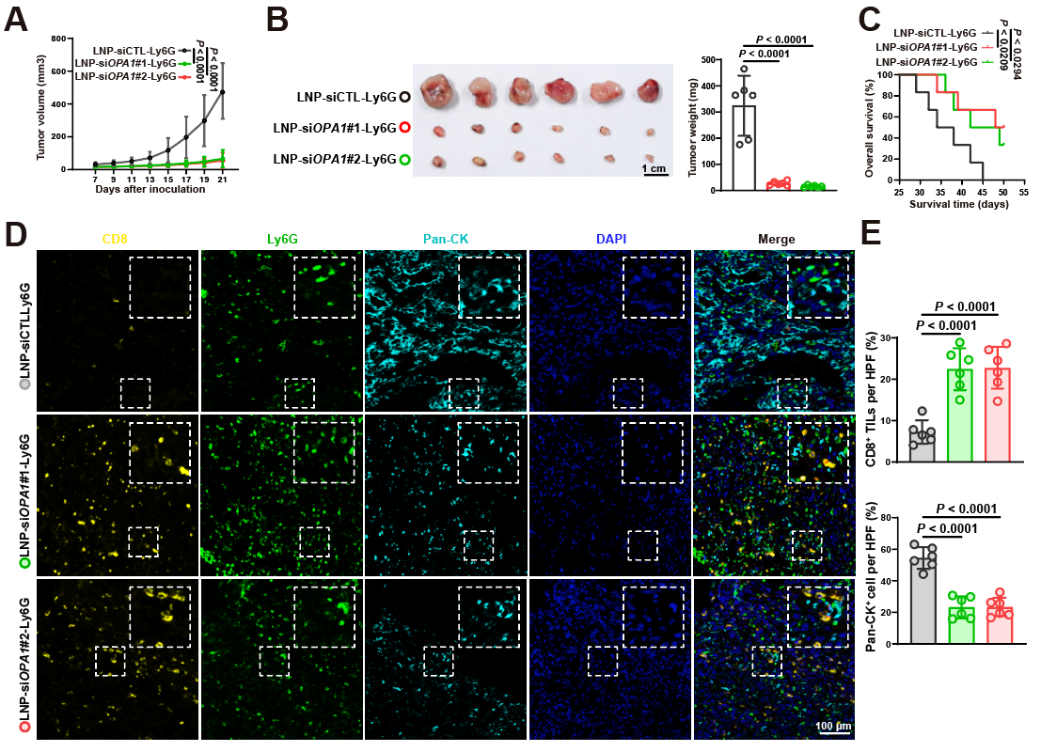
Supplementary Fig. 6. Targeting neutrophil OPA1 promotes anti-tumor immunity in TME
(A) Tumor growth curves of MOC1‑bearing C57BL/6 mice receiving the indicated treatments (n = 6 mice per group). (B) Representative images of excised MOC1 tumors (left) and quantification of final tumor weights (right). (C) Overall survival for C57BL/6 mice bearing MOC1 tumors with indicated treatments (n = 6 mice per group). (D) Representative mIHC images of MOC1 tumors stained for CD8 (yellow), Ly6G (green), and Pan‑CK (cyan). Scale bars, 100 µm. (E) Quantification of immune and tumor cell populations per field, including CD8⁺ T cells, and tumor cells (Pan-CK⁺) (n = 6 mice per group). Data are presented as mean ± SD. Statistical significance was determined using two-way ANOVA (A), two-sided unpaired t-test (B, E), log-rank test (C).

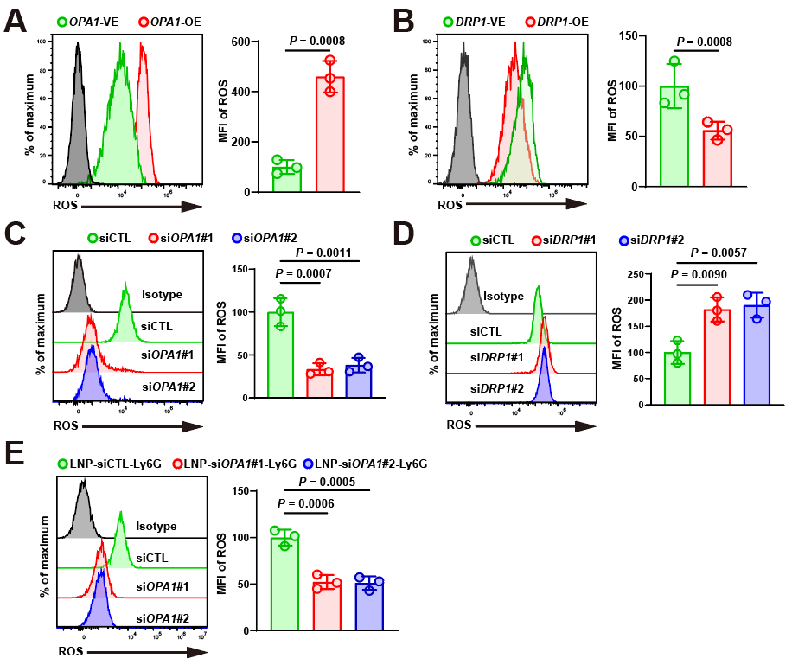
Supplementary Fig. 7. Neutrophil OPA1 promotes ROS production
(A) Representative flow cytometry plots (left) and quantification of mean fluorescence intensity (MFI; right) showing intracellular ROS levels in control versus OPA1‑overexpressing (OPA1‑OE) neutrophils. (B) Intracellular ROS levels in control versus DRP1‑overexpressing (DRP1‑OE) neutrophils, shown as representative flow plots (left) and MFI quantification (right). (C) Intracellular ROS levels in control versus OPA1‑knockdown (OPA1‑KD) neutrophils, displayed as flow plots (left) and MFI quantification (right). (D) Intracellular ROS levels in control versus DRP1‑knockdown (DRP1‑KD) neutrophils, presented as flow plots (left) and MFI quantification (right). (E) Representative flow cytometry plots (left) and MFI quantification (right) of intracellular ROS levels in tumor-infiltrating neutrophils isolated from MOC2‑bearing mice after treatment with control or LNP‑siRNA‑Ly6G. Data are presented as mean ± SD. Statistical significance was determined by two-sided unpaired t-test (A-E).

Supplementary Fig. 8. Neutrophil p-AKT is inversely correlated with NET formation
(A) Representative multiplex immunohistochemistry (mIHC) images of human OSCC tissues exhibiting low versus high p-AKT expression. Sections were stained for MPO (green), CitH3 (red), p-AKT (purple). Scale bars, 100 µm. (B) Spearman correlation analysis between p-AKT⁺MPO⁺ cell number and NET expression level in OSCC specimens (n = 75).

Supplementary Fig. 9. Targeting neutrophil OPA1 enhances anti‑PD‑1 efficacy in multiple tumor models
(A) Representative images of excised MOC2 tumors. (B) Representative images of resected B16F10 tumors.

Supplementary tables
Supplementary Table 1

Summary of clinical features of OSCC patients

Sample ID | Gender | Location | TNM stage | Follow up  (months) | Survival | Anti PD 1  therapy | Response*
1 | Male | Tongue | T2N0M0 | 37 | 1 | No | NA
2 | Male | Tongue | T3N0M0 | 6 | 0 | No | NA
3 | Male | Cheek | T2N0M0 | 12 | 0 | No | NA
4 | Male | Cheek | T2N2M0 | 16 | 0 | No | NA
5 | Male | Cheek | T3N0M0 | 24 | 0 | No | NA
6 | Male | Tongue | T3N1M0 | 30 | 0 | No | NA
7 | Male | Cheek | T3N0M0 | 26 | 0 | No | NA
8 | Male | Tongue | T3N0M0 | 32 | 0 | No | NA
9 | Male | Mouth floor | T2N0M0 | 18 | 0 | No | NA
10 | Female | Gingiva | T4N2bM0 | 5 | 1 | No | NA
11 | Male | Tongue | T2N0M0 | 28 | 0 | No | NA
12 | Male | Cheek | T2N2M0 | 18 | 1 | No | NA
13 | Male | Palate | T2N2bM0 | 17 | 1 | No | NA
14 | Female | Mouth floor | T4N1M0 | 8 | 1 | No | NA
15 | Male | Tongue | T4N0M0 | 24 | 1 | No | NA
16 | Male | Gingiva | T1N0M0 | 32 | 0 | No | NA
17 | Male | Tongue | T2N1M0 | 32 | 0 | No | NA
18 | Male | Cheek | T3N1M0 | 24 | 1 | No | NA
19 | Female | Lip | T2N0M0 | 32 | 0 | No | NA
20 | Male | Tongue | T3N0M0 | 32 | 0 | No | NA
21 | Male | Tongue | T3N1M0 | 16 | 1 | No | NA
22 | Female | Tongue | T2N2M0 | 33 | 0 | No | NA
23 | Female | Gingiva | T3N2M0 | 32 | 0 | No | NA
24 | Male | Tongue | T4N1M0 | 16 | 1 | No | NA
25 | Male | Mouth floor | T3N0M0 | 34 | 0 | No | NA
26 | Female | Tongue | T2N0M0 | 34 | 0 | No | NA
27 | Male | Gingiva | T4N0M0 | 21 | 1 | No | NA
28 | Male | Mouth floor | T2N1M0 | 35 | 0 | No | NA
29 | Male | Cheek | T2N0M0 | 35 | 0 | No | NA
30 | Male | Tongue | T3N1M0 | 37 | 0 | No | NA
31 | Male | Tongue | T4N2M0 | 6 | 1 | No | NA
32 | Male | Tongue | T2N0M0 | 38 | 0 | No | NA
33 | Male | Gingiva | T4N2M0 | 8 | 1 | No | NA
34 | Male | Mouth floor | T3N1M0 | 10 | 1 | No | NA
35 | Male | Tongue | T1N1M0 | 38 | 0 | No | NA
36 | Male | Tongue | T2N0M0 | 38 | 0 | No | NA

37 | Male | Tongue | T3N3bM0 | 8 | 1 | No | NA
38 | Male | Cheek | T4aN0M0 | 12 | 1 | No | NA
39 | Male | Tongue | T3N2bM0 | 24 | 1 | No | NA
40 | Male | Gingiva | T4aN2bM0 | 32 | 1 | No | NA
41 | Female | Tongue | T1N0M0 | 43 | 0 | No | NA
42 | Female | Tongue | T2N1M0 | 14 | 1 | No | NA
43 | Male | Tongue | T2N2bM0 | 15 | 1 | No | NA
44 | Male | Cheek | T2N1M0 | 38 | 1 | No | NA
45 | Male | Tongue | T2N1M0 | 46 | 1 | No | NA
46 | Male | Tongue | T2N0M0 | 48 | 0 | No | NA
47 | Male | Gingiva | T1N0M0 | 36 | 0 | No | NA
48 | Male | Tongue | T2N0M0 | 38 | 1 | No | NA
49 | Male | Gingiva | T4aN1M0 | 14 | 1 | No | NA
50 | Male | Tongue | T3N2bM0 | 15 | 1 | No | NA
51 | Male | Tongue | T3N3bM0 | 24 | 1 | No | NA
52 | Male | Tongue | T3N2bM0 | 15 | 1 | No | NA
53 | Male | Gingiva | T1N2M0 | 18 | 1 | Yes | SD
54 | Male | Cheek | T4N3M0 | 5 | 1 | Yes | PD
55 | Male | Mouth floor | T2N0M0 | 6 | 1 | Yes | PD
56 | Male | Tongue | T2N1M0 | 4 | 0 | Yes | PR
57 | Male | Tongue | T2N2M0 | 7 | 0 | Yes | PR
58 | Male | Cheek | T4N2M0 | 13 | 1 | Yes | PD
59 | Male | Palate | T3N2M0 | 7 | 1 | Yes | SD
60 | Female | Cheek | T1N2M0 | 8 | 1 | Yes | PD
61 | Female | Palate | T2N2M0 | 8 | 0 | Yes | PR
62 | Male | Tongue | T2N2M0 | 18 | 0 | Yes | CR
63 | Female | Tongue | T4N2M1 | 6 | 0 | Yes | CR
64 | Male | Gingiva | T4N0M0 | 5 | 1 | Yes | CR
65 | Male | Gingiva | T2N2M0 | 8 | 1 | Yes | CR
66 | Male | Gingiva | T1N2M0 | 17 | 0 | Yes | PD
67 | Male | Cheek | T4N2M0 | 6 | 0 | Yes | PR
68 | Male | Tongue | T0N3bM0 | 15 | 0 | Yes | PR
69 | Female | Cheek | T3N2bM0 | 7 | 0 | Yes | SD
70 | Male | Tongue | T0N3M0 | 2 | 1 | Yes | SD
71 | Male | Tongue | T2N2M0 | 3 | 1 | Yes | SD
72 | Female | Gingiva | T4N2MO | 2 | 1 | Yes | PD
73 | Male | Tongue | T3N3M0 | 4 | 0 | Yes | PR
74 | Male | Tongue | T0N3M0 | 5 | 0 | Yes | CR
75 | Female | Cheek | T0N3bM0 | 3 | 0 | Yes | CR
*, response was analyzed by irRECIST. CR, complete response. PR, partial response. SD, stable disease. PD, progressive disease; all patients were over 18 years old.

Supplementary Table 2
A list of reagents used in this study
REAGENT or RESOURCE | SOURCE | IDENTIFIER
Antibodies
Immunoblotting:Anti-human MPO | Cell Signaling Technology | Cat. 14569
Immunoblotting:Anti-mouse MPO | Proteintech | Cat. 22225-1-AP
Immunoblotting:Anti-human/mouse CitH3 | Cell Signaling Technology | Cat. 97272
Immunoblotting:Anti-human/mouse NE | Proteintech | Cat. 27642-1-AP
Immunoblotting:Anti-human/mouse PADI4 | Proteintech | Cat. 17373-1-AP
Immunoblotting:Anti-human/mouse MDM2 | Proteintech | Cat. 66511-1-Ig
Immunoblotting:Anti-human/mouse AKT | Proteintech | Cat. 60203-2-Ig
Immunoblotting:Anti-human/mouse Phospho-AKT | Proteintech | Cat. 66444-1-Ig
Immunoblotting:Anti-human/mouse Pan-CK | Proteintech | Cat. 26411-1-AP
Immunoblotting:Anti-human/mouse OPA1 | Proteintech | Cat. 27733-1-AP
Immunoblotting:Anti-human/mouse MFN1 | Proteintech | Cat. 13798-1-AP
Immunoblotting:Anti-human/mouse FIS1 | Proteintech | Cat. 10956-1-AP
Immunoblotting:Anti-human/mouse DRP1 | Proteintech | Cat. 12957-1-AP
Immunoblotting: Anti-human/mouse GAPDH | ABclonal | Cat. AC002
Immunohistochemical: Anti-human CD8 (D8A8Y) | Cell Signaling Technology | Cat. 85336
immunohistochemistry: Anti-mouse CD8 (D4W2Z) | Cell Signaling Technology | Cat. 98941
immunohistochemistry: Anti-Mouse Ly6G (E6Z1T) | Cell Signaling Technology | Cat. 87048
Flow cytometry: PE anti-mouse/human CD11b | Biolegend | Cat. 101207
Flow cytometry: APC anti-human CD66b | Biolegend | Cat. 305117
Flow cytometry: Anti-mouse Ly6G FITC | Biolegend | Cat. 127605
Flow cytometry: Anti-mouse CD11b BV605 | Biolegend | Cat. 101237
Flow cytometry: Anti-Mouse Ly6G (1A8) | Biolegend | Cat. 127632
Blocking: Mouse IgG isotype (MOPC-21) | BioXCell | Cat. BE0083
Blocking: Anti- mouse PD-1 (RMP1-14) | BioXCell | Cat. BE0146
Chemicals, Peptides, and Recombinant Proteins
PMA | MedChemExpress | Cat. HY-18739
Hoechst | Beyotime | Cat. C1029
PhosSTOP | Sigma-Aldrich | Cat. 4906837001
Complete mini proteasome inhibitors | Sigma-Aldrich | Cat. 05892791001
MitoTracker Red | Invitrogen | Cat. A66444
SYTOX Green | Invitrogen | Cat. S7020
Lip3000 | Invitrogen | Cat. L3000001
C12-200 | MedChemExpress | Cat. HY-145405
PEG2000 | MedChemExpress | Cat. HY-Y0873B
DSPE-PEG2000-mal | MedChemExpress | Cat. HY-140739
DSPC | MedChemExpress | Cat. HY-W040193
SATA | MedChemExpress | Cat. HY-135233
Cholesterol | sigma | Cat. C8503
N-acetyl-L-cysteine (NAC) | Beyotime | Cat. S0077
Hydroxylamine hydrochloride | Beyotime | Cat. ST1303
Critical Commercial Assays
Reactive Oxygen Species Assay Kit | Beyotime | Cat. S0033S
Opal 6-Plex Manual Detection Kit | Akoya | Cat. NEL811001KT
PIERCE ECL Western Blotting Substrate | Thermo Fisher Scientific | Cat. 32209
Quant-iT RiboGreen assay | Invitrogen | Cat. R11491
Oligonucleotides
shRNA Targeting sequences for human OPA1 #1:  5'--3': CCGGACCTTAGTGAATATAAA | This paper | N/A
shRNA Targeting sequences for human OPA1 #2:  5'--3': GCCCTCTTTGTATTCCCATTT | This paper | N/A
shRNA Targeting sequences for human MFN1 #1:  5'--3': GCTCCCATTATGATTCCAATA | This paper | N/A
shRNA Targeting sequences for human MFN1 #2:  5'--3': GCGGCTTTCCAAGCCTAATAT | This paper | N/A
shRNA Targeting sequences for human FIS1 #1:  5'--3': CAAGAGCACGCAGTTTGAGTA | This paper | N/A
shRNA Targeting sequences for human FIS1 #2:  5'--3': GAACTACCGGCTCAAGGAATA | This paper | N/A
shRNA Targeting sequences for human DRP1 #1:  5'--3': GCTACTTTACTCCAACTTATT | This paper | N/A
shRNA Targeting sequences for human DRP1 #2:  5'--3': CGGTTCATCAGTAATCCTAAT | This paper | N/A
Recombinant DNA
pLV2-CMV-HA-OPA1(human)-Puro | MIAOLING PLASMID | Cat. P52073
pLV3-CMV-DRP1(human)-EGFP-Puro | MIAOLING PLASMID | Cat. P94883
pLV3-CMV-OPA1(mouse)-EF1a-mCherry-Puro | MIAOLING PLASMID | Cat. P69507
pLV2-CMV-HA-mCherry-MCS-Neo | MIAOLING PLASMID | Cat. P80432
pLV3-CMV-MCS-EGFP-Puro | MIAOLING PLASMID | Cat. P84726
pLV3-CMV-MCS-EF1a-mCherry-Puro | MIAOLING PLASMID | Cat. P37564
pLKO.1-U6-Puro | MIAOLING PLASMID | Cat. P29436

