Supporting Information
Quasi-degenerate cation occupation enables nearly defect-free functional crystals
Jinfeng Han, Fei Liang, Kui Wu, Dazhi Lu*, Deliang Cui, Haohai Yu**, Huaijin Zhang
¹ State Key Laboratory of Crystal Materials and Institute of Crystal Materials, Shandong University, Jinan 250100, China
Corresponding authors:
* Email address: dazhi.lu@sdu.edu.cn, ** haohaiyu@sdu.edu.cn
Keywords: Quasi-degenerate cation occupation; Oxygen vacancy; NLO crystal; Langasite family.

Table of Contents
Section-I: Measurement methods and calculation methods
Section-II: Additional figures and tables

Measurement methods
Polycrystalline Synthesis
La₂O₃, TiO₂, and Ga₂O₃ powders with high quality (> 99.99%) were purchased from Alfa Aesar and were weighed in the stoichiometric proportion. The mixture is fully mixed in the mixer for 25 hours and then pressed into blocks in the press. Finally, blocks are put into the muffle furnace for sintering. The sintering temperature of the muffle furnace is set at 1300 ℃, and the holding time is 20 hours so that it is a fully solid-phase reaction, and the polycrystalline material is obtained. The solid-phase reaction of this process proceeds according to the following chemical reaction:
3La₂O₃ + 2TiO₂ + 5Ga₂O₃ ------ 2La₃TiGa₅O₁₄
Powder X-ray Diffraction Measurement
The XRD pattern of La₃TiGa₅O₁₄ (LGTi) was obtained by a high-resolution X-ray diffractometer (Smartlab 3 kW) and a Cu-Kα target (λ = 1.5406 Å) with an accuracy of 1° min⁻¹. The test range was 10–70°. The crystal structure of LGTi was verified and refined through Rietveld method using General Structure Analysis System (GSAS). The background of the XRD pattern was simulated using the linear interpolation between a set background points with refinable heights. The peak profile was modeled by pseudo-voigt function. No restraints or constraints were adopted when performing structure refinement. In addition, the anisotropic atomic displacement parameters were used in the refinement process, and finally the reliability factors (R_{p} = 5.41, R_{wp} = 7.19) were obtained.
Differential Scanning Calorimetry Measurement
Differential Scanning Calorimetry (DSC) was employed to investigate the thermal properties of the LGTi crystal. The measurement was performed using a STA 449F3+ASC. A continuous nitrogen (N₂) purge was maintained throughout the experiment to ensure an inert atmosphere. The temperature program was: 308 K → 1273 K at 20 K min⁻¹, then 1273 K → 1873 K at 5 K min⁻¹, followed by cooling from 1873 K to 1573 K at 5 K min⁻¹, and finally free cooling to room temperature.
Single Crystal Growth
LGTi crystals were grown using the Czochralski method, which allowed larger crystals to be grown for later device design. The JPG Auto Diameter Control Program of the single-crystal furnace automatically controlled the entire growth process, of which accuracy is ± 0.01 g. The crystals were grown using LGS seeds along the [001] direction in an iridium crucible with a diameter of 70 mm (600 g of the melt). The crystal growth atmosphere was N₂ with 1% O₂. Before seeding, the melt must be kept at a suitable temperature (20-30 ℃ higher than the melting point) for 8-12 hours to establish uniform density, viscosity, surface tension and other physical and chemical properties of the melt. During the crystal growth process, each stage requires careful selection of different pulling velocities (0.4-0.8 mm·h⁻¹) and rotation velocities (5-8 rpm) to ensure a slightly convex and stable solid-liquid interface shape.
Nevertheless, its extremely narrow single-phase stability field poses a significant challenge for obtaining large, crack-free crystals. To overcome this limitation, a rapid-cooling seeding strategy was employed during the initial stage of Czochralski growth. This approach, which is commonly used to promote stable single-nucleus capture and suppress parasitic nucleation near the melt surface, enabled controlled crystallization even under a narrow compositional window.
Single Crystal X-ray Determination
A Bruker SMART APEX II 4K CCD single crystal diffractometer was applied to collect the single-crystal X-ray diffraction measurements for LGTi under Mo Kα radiation (λ = 0.71073 Å) at 298 K. Data collection, reduction, and cell refinement were applied using the software APEX3. The crystal structures were solved by the direct method by intrinsic phasing with the ShelXT structure solution program and refined using least-squares minimization with the ShelXTL refinement package in Olex2. Potential missing symmetry of crystal data was checked with the program PLATON30, and no higher symmetry was found. The detailed crystallographic data for LGTi is listed in Table S1-S5.
Optical Homogeneity Measurement
The optical homogeneity of a double-side polished LGTi crystal plate with dimensions of 15 × 15 × 1 mm³ was analyzed using a Zygo laser interferometer (VerifireTM MST).
High-resolution X-ray diffraction
High-resolution X-ray diffraction (HRXRD) was implemented on a Bruker-AXS D5005HR diffractometer equipped with a two-crystal Ge (220) monochromator set for Cu-Kα₁ radiation (λ = 1.54056 Å). The accelerating voltage and tube current were 30 kV and 30 mA, and the step time and step size were 0.1 s and 0.001°, respectively. The rocking curves of the (110) and (001) wafers of LGTi crystal polished to optical quality with the thickness of 1 mm were obtained.
High-angle annular dark-field (HAADF-STEM)
HAADF-STEM images were obtained for the LGTi crystals using aberration-corrected STEM (Spectra 300). Microstructural characterization was performed using a probe-corrected scanning transmission electron microscope (STEM) equipped with a cold-field emission gun. The instrument provides a guaranteed spatial resolution of ≤0.08 nm at an accelerating voltage of 200 kV and ≤0.11 nm at 80 kV.
The microscope is equipped with a condenser lens aberration corrector, allowing for optimized imaging at various accelerating voltages, primarily 30 kV, 80 kV, and 200 kV. A cold-field emission electron source was utilized, providing a high beam current of ≥1 nA at a probe size of 0.2 nm. The beam stability was excellent, with a measured drift rate of ≤1 nm per minute, ensuring high-resolution image acquisition over prolonged periods. The objective lens system, with a spherical aberration (Cs) coefficient of 0.5 mm, was used for imaging. The current stability of the objective lens was maintained at ≤0.2 ppm per minute, which is critical for achieving atomic-scale resolution and minimizing image distortion. The resulting STEM images were acquired using a bottom-mounted 4K × 4K CMOS camera.
Transmission Spectrum Measurement
The transmission spectra were recorded using 1 mm-thick LGTi (KTP (1mm), SrTiO₃ (1mm), TiO₂ (1mm), BaTiO₃ (0.5mm)) slabs. The slabs were uncoated and polished to optical quality. The transmission spectra in the visible and near IR range (0.2-2.5 μm) were then measured using a Cary 5000 DUV spectrophotometer, and the spectra in the mid-IR range (2.5-25 μm) were recorded on a Thermo-Nicolet NEXUS 670 FTIR spectrophotometer.
Raman Spectroscopy Measurement
LGTi, LGS, LGT, and LGN slabs were placed on an objective slide, and an in-situ confocal Raman Spectrometer (LabRAM HR Evolution) was used to record the Raman spectra under a laser excitation at 532 nm.
Infrared Vibrational Spectroscopy Measurement
Infrared vibrational spectroscopies were conducted on double-side polished LGTi, LGS, LGT, and LGN wafers with a thickness of 1 mm using a Shimadzu IRSpirit-X Fourier-transform infrared spectrophotometer.
X-ray Photoelectron Spectroscopy Measurements
X-ray photoelectron spectroscopy (XPS) measurements were performed using a Thermo Scientific ESCALAB 250XI spectrometer to characterize the presence of V_{O}.
Electron paramagnetic resonance Measurement
Electron paramagnetic resonance (EPR) spectroscopy was performed on U- and A-sample using a Bruker EMXplus-6/1 spectrometer to detect signals from Ti³⁺ and V_{O}.
Laser damage threshold measurement
The LDTs were measured using a Q-switched (Nd: YAG) laser at 1064 nm (LPS-1064-A) with a 10 ns pulse width and 1 Hz repetition rate. The (001) plane of the crystal was polished precisely without coating. The laser beam was focused onto a polished 1-mm-thick U- and A-sample (LGTi) slab with aperture dimensions of 15 × 15 mm² using a 150-mm-focal lens (1 mm spot diameter). The error in the laser energy was determined by combining the 3% uncertainties of the energy measurements. Laser conditioning was investigated as a function of frequency using the 1-on-1 approach.
Z-scanning measurement
The detailed parameters of the Z-scanning device are as follows: the light source is a commercial picosecond laser (PL2251, EKSPLA) with a wavelength of 1064 nm, a pulse width of 20 ps, a pulse repetition rate of 10 Hz. The beam is a Gaussian beam in TEM₀₀ mode, and the fluence at the focus is 6.62 J/cm². The U- and A-sample all processed at (001) plan with a thickness of 1.2 mm.
Maker-Fringe Experiment
Using the Maker Fringe setup, we selected type I second harmonic generation (SHG) to determine d₁₁ of LGTi relative to d₃₆ of the KDP under identical wavelengths. For this purpose, the (001) plane of U- and A-sample (LGTi) with dimensions of 10 × 10 × 1.0 mm³ was cut and polished to optical quality, while the (110) plane of KDP with dimensions of 10 × 10 × 1.0 mm³ was also prepared. An Nd:YAG Q-switched laser with a pulse width of 10 ns and a repetition frequency of 10 Hz was employed as the fundamental light source. These samples were adhered to a turntable with a precision of 0.00125° (RAK 100, Zolix Inc). The second harmonic signal generated from the sample was detected using a side window photomultiplier tube (PMT), averaged using a fast-gated integrator and boxcar averager (Stanford Research Systems), and automatically recorded by a computer.
Refractive Index Measurement
The high optical quality LGTi crystals were cut into prisms with a vertex angle of 18.64°. The (210) and (100) planes of the prisms were polished precisely without coating. The LGTi prism was placed in a high-precision automatic spectrometer goniometer (HR Spectro Master UV-VIS-IR from Trioptics). By adjusting the proper orientation of the linear polarization of the input beam, it has been possible to determine the values of the ordinary and extraordinary principal refractive indices of LGTi. We recorded refractive indices (i.e., n_{o} and n_{e}) of 12 sets of discrete wavelengths ranging from 0.365 to 2.325 μm with a precision of 10⁻⁵. The LGTi crystal, being a positive uniaxial crystal, is characterized by two principal refractive indices: the ordinary index (n_{o}) and the extraordinary index (n_{e}), where n_{o} < n_{e}. The wavelength-dependent refractive indices, obtained experimentally, were fitted via a least-squares method to the Sellmeier equation of the form n² = A + B / (λ² – C) – Dλ², where λ is the wavelength in micrometers.

Calculation Method
The first principles calculations
(1) Formation Energy Calculation
The first-principles were employed to carry out the spin-polarization density functional theory (DFT) calculations¹ and all spin polarized DFT calculations were performed with the Perdew-Burke-Ernzerhof (PBE) exchange-correlation functional in a plane wave pseudopotential implementation using the Vienna ab initio simulation packages (VASP).² The projector augmented wave (PAW) method was employed to describe the core–valence interaction.³ with a plane-wave cutoff energy of 450 eV. Electron smearing was employed through the Gaussian smearing method with a smearing width of 0.05 eV. The 5 × 5 × 3 k-point mesh was used in all calculations to sample the Brillouin zone integration. The convergence criterion for the electronic self-consistent iteration was set to 10⁻⁵ eV, and the maximum force on each atom was constrained to be less than 0.03 eV/Å.
(2) Defect calculations of Ti³⁺ and V_{O}
First-principles calculations were performed using the CASTEP package based on the DFT.⁴ Optimized ultrasoft pseudopotentials were used to simulate the ion-electron interactions for all constituent elements. A kinetic energy cutoff of 500 eV was chosen with Monkhorst-Pack k-point meshes (4 × 4 × 2) in the Brillouin zone. The generalized gradient approximation using the PBE was adopted.⁵ Only the atomic positions in the unit cells of all crystals were fully optimized using the BFGS method.⁶ The convergence thresholds between optimization cycles for energy change, maximum force, maximum stress, and maximum displacement were set to 5.0 × 10⁻⁶ eV/atom, 0.01 eV/Å, 0.02 GPa, and 5.0 × 10⁻⁴ Å, respectively. The optimization was terminated when all these criteria were satisfied.
(3) Calculation of the second-harmonic generation origin in LGTi crystals
Considering the co-occupied atom, model structure La₃TiGa₅O₁₄ was established without disorder to further analyze the electronic properties. The first-principles calculations were carried out by the plane-wave pseudopotential method implemented in the CASTEP package.⁴ The PBE functional within GGA with the scheme was adopted to describe the optical performance.⁵ The ion-electron interactions were modeled by the norm-conserving pseudopotentials for all elements. La-5d¹6s², Ga-3d¹⁰4s²4p¹, Ti-3s²3p⁶3d²4s², and O-2s²2p⁴, were treated as the valence electrons, respectively. The cutoffenergy was set to be 800 eV, with the Monkhorst-Pack k-point meshes spanning less than 0.04 Å⁻¹ in the Brillouin zone to ensure the sufficient accuracy of the calculated results. The scissors operator is set as the difference between the experimental and GGA band gaps. The number of empty bands needed to achieve converging results for the optical properties is set to three times of the number of VBs.The SHG coefficients are calculated using the so-called length-gauge formalism derived by Aversa and Sipe,⁷ and later modified by Rashkeev et al.⁸ and Sharma et al. At zero frequency, the static second-order nonlinear susceptibilities can be ascribed to the virtual hole (VH) and virtual electron (VE) processes:
$$χ_{αβγ}^{(2)}=χ_{αβγ}^{\left(2\right)}\left(VE\right)+χ_{αβγ}^{\left(2\right)}\left(VH\right)$$
$$χ_{αβγ}^{\left(2\right)}\left(VE\right)=\frac{e^{3}}{2ℏ^{2}m^{3}}\sum_{νcc^{'}}{\int{\frac{d^{3}k}{4π^{3}}}}P\left(αβγ\right)Im[p_{cv}^{α}p_{cc^{'}}^{β}p_{c^{'}v}^{γ}]×(\frac{1}{ω_{cν}^{3}ω_{νc^{'}}^{2}}+\frac{2}{ω_{νc}^{4}ω_{c^{'}v}})$$
$$χ_{αβγ}^{\left(2\right)}\left(VE\right)=\frac{e^{3}}{2ℏ^{2}m^{3}}\sum_{νv^{'}c}{\int{\frac{d^{3}k}{4π^{3}}}}P\left(αβγ\right)Im[p_{vv^{'}}^{α}p_{v^{'}c}^{β}p_{cv}^{γ}]×(\frac{1}{ω_{cν}^{3}ω_{v^{'}c}^{2}}+\frac{2}{ω_{νc}^{4}ω_{cv^{'}}})$$
Here, α, β, and γ are the Cartesian components; v∕v′ and c∕c′ denote the VBs and CBs; $P(αβγ)$, ${hω}_{ij}$and $p_{ij}^{α}$ refer to the full permutation, band energy difference, and momentum matrix elements, respectively.

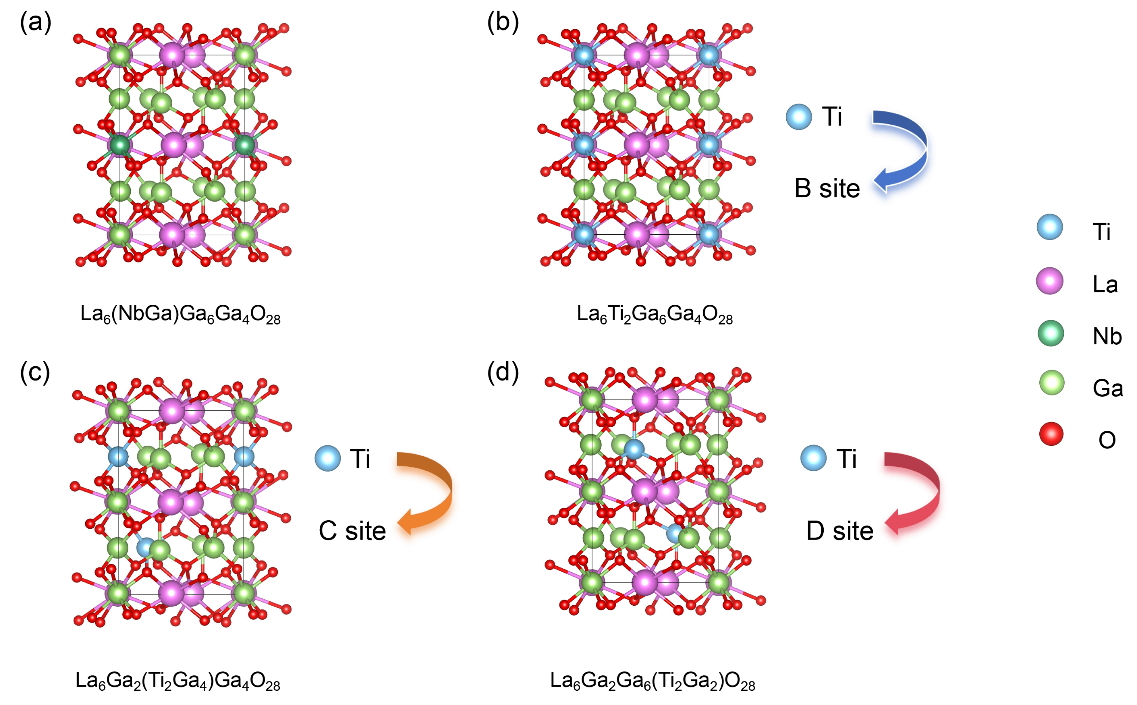
Figure S1. Structural models of La₃Nb_{0.5}Ga_{5.5}O₁₄ (LGN) after Ti incorporation: (a) structural model of LGN after supercell expansion; (b) structural model with Ti occupying the B site; (c) structural model with Ti occupying the C site; (d) structural model with Ti occupying the D site.

The figure shows structural models of Ti incorporation at different sites in the original LGN structure. The formation energies of Ti at the B, C and D sites were calculated using first-principles methods (see Calculation Method in the Supplementary Information for details). The formation energy for Ti at the B site is -5.407 eV, that at the C site is -5.366 eV, and that at the D site is -1.115 eV.

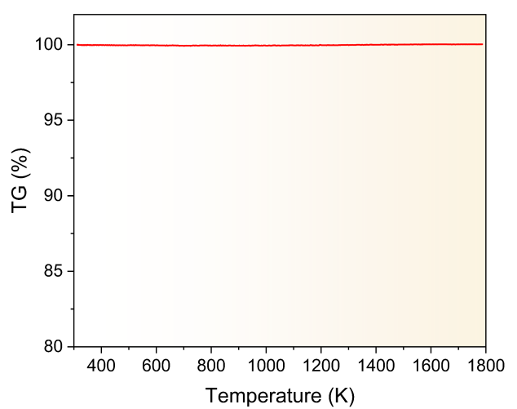
Figure S2. TG curve of the LGTi powder over the temperature range of 310–1790 K.

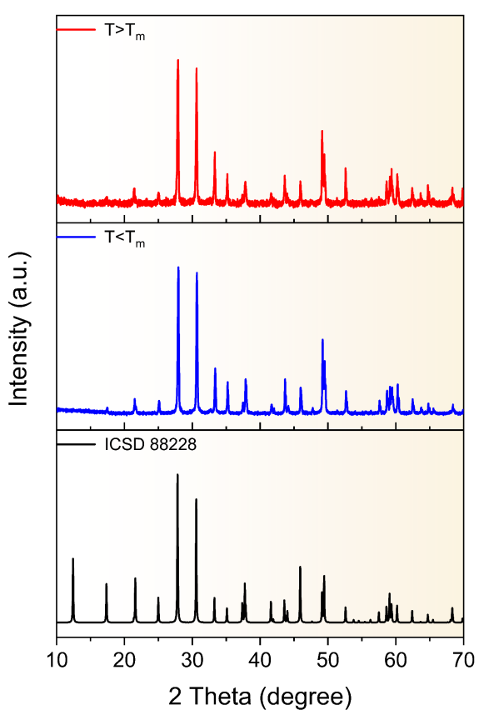
Figure S3. Post-annealing PXRD patterns of LGTi after heat treatments at T > T_{m} and T < T_{m}. A standard reference pattern (ICSD 88228) is included for comparison.

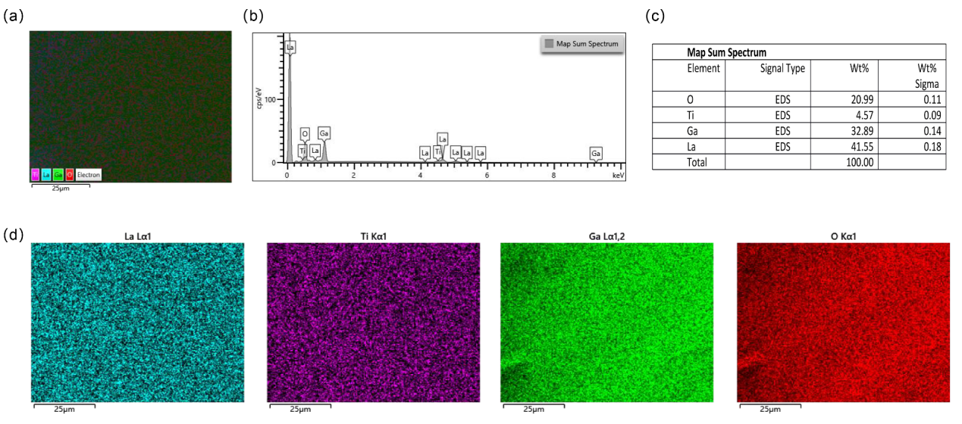
Figure S4. Energy dispersive spectroscopy (EDS) characterization of LGTi sample. (a) Combined elemental distribution map showing the overall spatial distribution of La, Ti, Ga, and O in the LGTi sample. (b) EDS sum spectrum, in which the characteristic X-ray peaks confirm the presence of O, Ti, Ga, and La. (c) Quantitative EDS results listing the elemental compositions (wt%) and their associated uncertainties (Sigma). (d) Individual elemental mapping images for La, Ti, Ga, and O, respectively, demonstrating homogeneous spatial distributions of all constituent elements across the analyzed region.

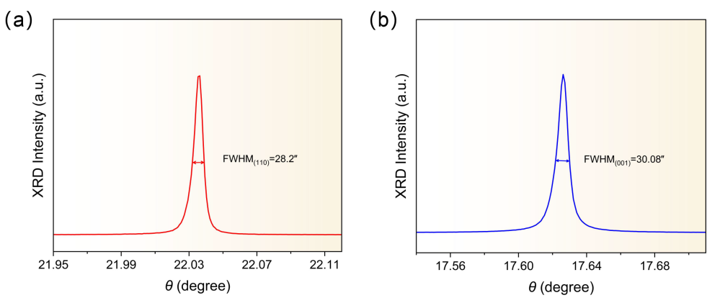
Figure S5. (a) High-resolution X-ray diffraction pattern of (a) the (110) and (b) the (001) wafer of LGTi crystal.

The figure presented the rocking curves of the [110] and [001] wafers cut from the body parts of the LGTi crystal. Their full-width at half-maximum (FWHM) values were measured to be 28.2″ and 30.08″, confirming the high crystal crystallinity.

Figure S6. Optical uniformity analysis of the as-polished LGTi crystal obtained from laser interferometry, showing a homogeneity of 4.50 × 10⁻⁴ with PV = 0.711λ and RMS = 0.104λ.

As presented in figure, for the as-grown crystal with a dimension of 15 × 15 mm² (c-cut), the optical uniformity reached 4.50 × 10⁻⁴ with a peak-to-valley (PV) wavefront distortion of 0.711λ, demonstrating the excellent optical uniformity of the as-grown crystal.

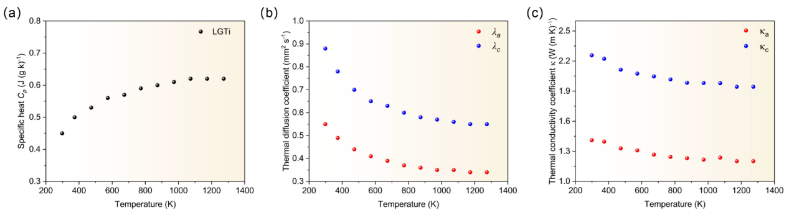
Figure S7. (a) Specific heat curve of the LGTi sample along different crystallographic directions at various temperatures. (b) Thermal diffusion coefficients and (c) thermal conductivity of LGTi crystals.

The LGTi crystal belongs to point group 32 and therefore exhibits two intrinsic thermal diffusion coefficients λ, and thermal conductivity coefficients κ along the crystallographic a- and c- axes. Specific heat measurement of LGTi was conducted on a differential scanning calorimeter (NETZSCH DSC 214 and NETZSCH STA 449F3) over a temperature range of 300-1290 K, with a sample mass of 80.637 mg. Thermal diffusion for LGTi was recorded on a NanoFlash instrument (NETZSCH LFA 467) by the laser pulse method at 300-1290 K, employing two wafers (a-cut and c-cut) sized 10 × 10 × 1mm³, whose surfaces were perpendicular and parallel to crystallographic principal axes, respectively. Besides, the crystal density ρ, was obtained according to the buoyancy method. Combing measurements and analyses of density of the LGTi crystal ρ, thermal diffusion coefficients λ, and specific heat C_{p}, the thermal conductivity coefficients for LGTi were given by:
κ(T) = ρ·λ (T)·C_{p}(T)
As shown in figure, the specific heat capacity increases with temperature from 0.45 J·g⁻¹·K⁻¹ at 300 K and gradually approaches a stable value of 0.61 J·g⁻¹·K⁻¹ at 1290 K. The thermal diffusivity of LGTi crystals was measured from 300 to 1290 K. As shown in the results, the thermal diffusivity decreases with increasing temperature, eventually plateaus, and exhibits clear anisotropy. Consequently, the thermal conductivity of the crystal was calculated. The results show that it decreases with increasing temperature and eventually approaches a constant value. The average thermal conductivity (κ_{⊥c} = 1.25 W(m·K)⁻¹，κ_{c} = 2.0 W(m·K)⁻¹ ), is comparable to that KDP (κ_{⊥c} = 1.76 W(m·K)⁻¹，κ_{c} = 1.30 W(m·K)⁻¹), and β-BBO (κ_{⊥c} = 1.20 W(m·K)⁻¹，κ_{c} = 1.60 W(m·K)⁻¹ ), indicating its potential for application in ultrafast and high-intensity laser systems due to superior heat dissipation.

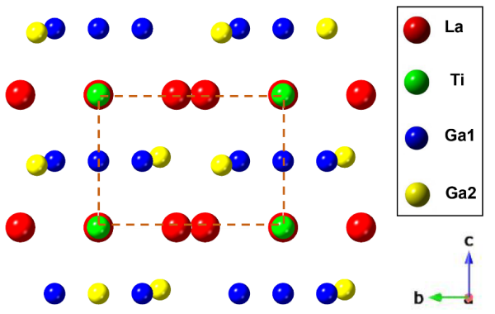
Figure S8. Observed atomic arrangements of the LGTi crystal along the a-directions.

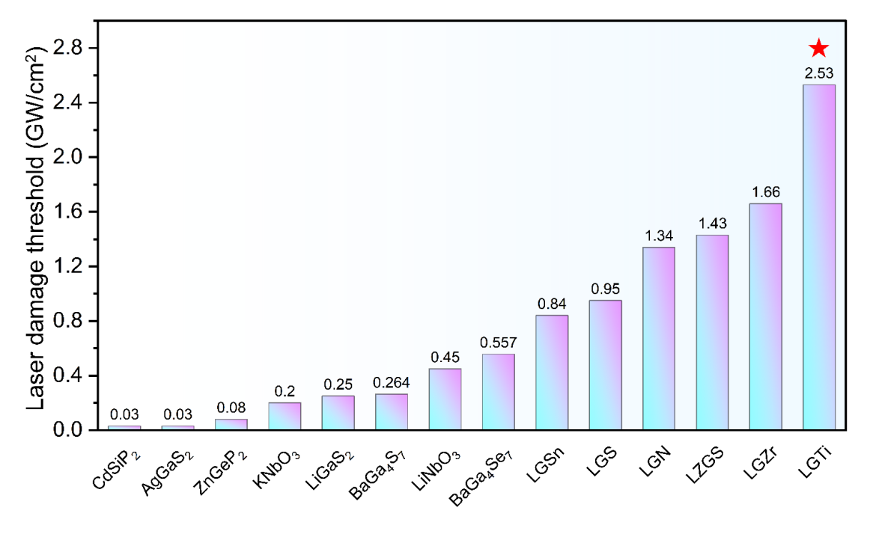
Figure S9. Laser damage threshold (LDT) comparison of state-of-art NLO crystals. Bar chart showing the LDT values of various crystals, where LGTi (marked with a red star) exhibits a relatively high LDT of 2.53 GW/cm² compared to other crystals.

Note:
La₃Ga₅SnO₁₄ (LGSn), La₃Ga₅SiO₁₄ (LGS), La₃Ga_{5.5}Nb_{0.5}O₁₄ (LGN), La₃Ga_{5.5}Ta_{0.5}O₁₄ (LGT), La₃Zr_{0.5}Ga₅Si_{0.5}O₁₄ (LZGS), La3ZrGa₅O₁₄ (LGZr), La₃TiGa₅O₁₄ (LGTi)

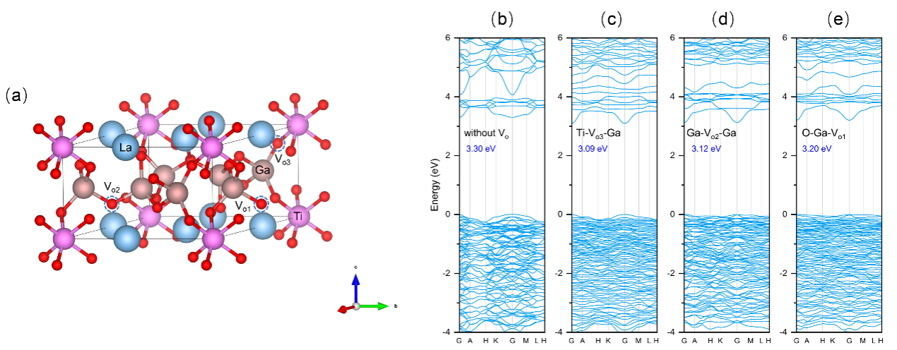
Figure S10. (a) Crystal structures of LGTi crystals with different vacancy defects. (b-e) Energy band structure and bandgap characteristics of LGTi crystal under different V_{O} configurations.

The figure shows the crystal structures and energy band structures of LGTi crystals without oxygen vacancies (without V_{O}) and with three different V_{O} configurations, namely Ti-V_{O3}-Ga, Ga-V_{O2}-Ga, and O-Ga-V_{O1}. As can be seen from the figure, the band gap is 3.30 eV without V_{o}; when the Ti-V_{O3}-Ga configuration exists, the band gap becomes 3.09 eV; for the Ga-V_{O2}-Ga configuration, the band gap is 3.12 eV; and under the O-Ga-V_{O1} configuration, the band gap is 3.20 eV. This indicates that the existence form of oxygen vacancies has a significant effect on the band gap size of LGTi crystals, and different combinations of V_{O} with surrounding atoms will lead to changes in the energy band structure, thereby causing differences in the band gap values.

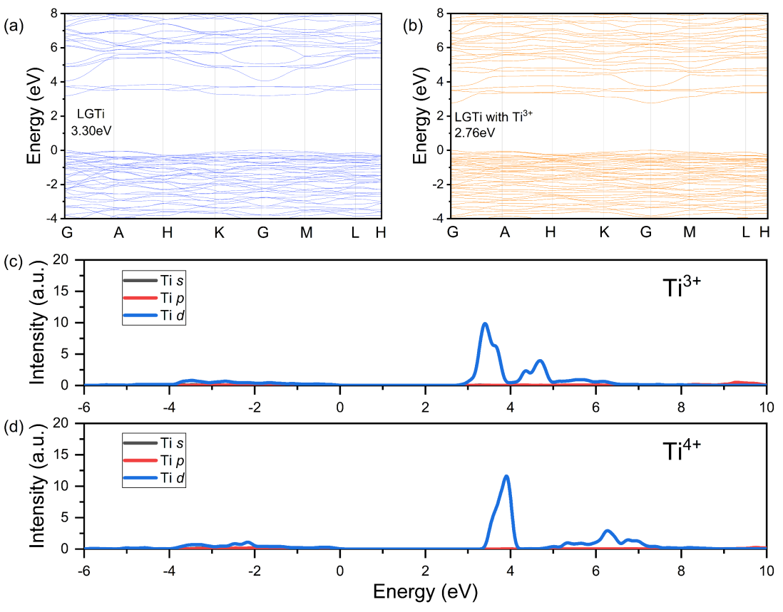
Figure S11. Energy band structure and density of states characteristics of LGTi crystal under different Ti valence states.

The figure presents the energy band structure and density of states (DOS) of LGTi crystals under different Ti valence states. (a) shows the band structure of pure LGTi, with a band gap of 3.30 eV; (b) is the band structure of LGTi containing Ti³⁺, and the band gap decreases to 2.76 eV. (c) and (d) are the partial density of states (PDOS) of Ti³⁺ and Ti⁴⁺, respectively, demonstrating the distribution of electronic states in the s, p, and d orbitals of Ti at different energy levels. It can be seen that the change in Ti valence state can alter the electronic structure, thereby influencing the band gap of LGTi, indicating that the Ti valence state has a significant effect on the electronic properties of LGTi crystal.

Figure S12. The optical band gap value of the LGTi crystal (001) plane sample after thermal oxidation treatment (A-sample).

Figure S13. Nonlinear optical absorption curves (Z-scan curves) of U- and A-sample.

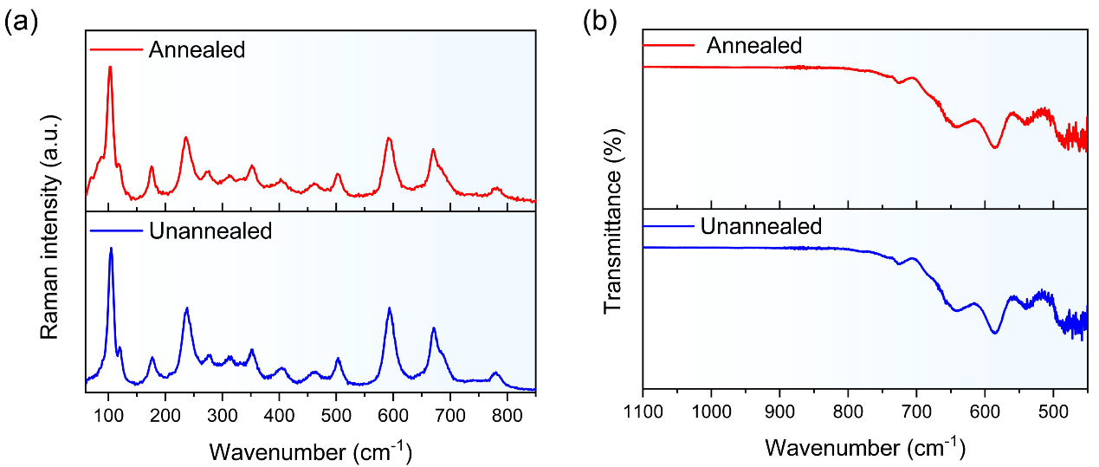
Figure S14. Comparison of (a) Raman spectra and (b) IR vibration spectra of LGTi crystal before and after thermal oxidation treatment.

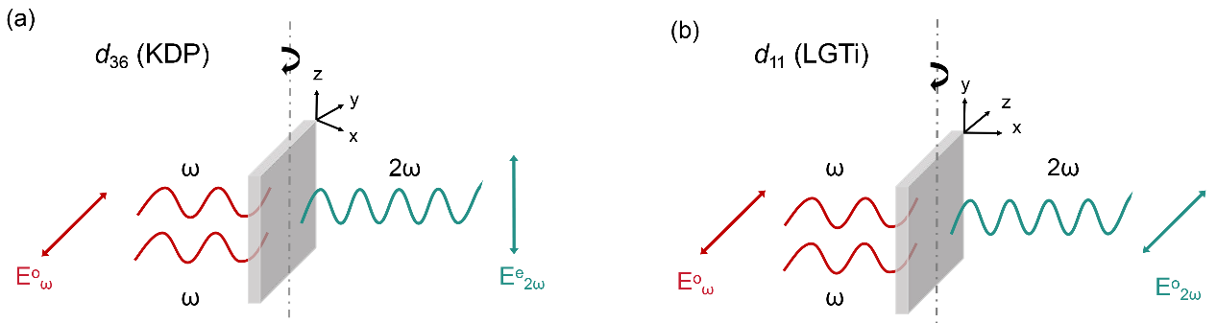
Figure S15. Sketches for (a) KDP and (b) LGTi samples used in NLO susceptibility component measurements.

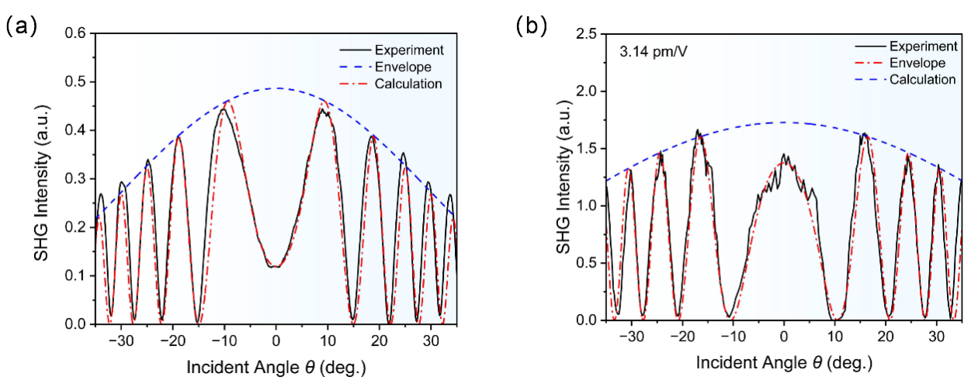
Figure S16. Measured and fitted Maker fringes of (a) d₃₆ of KDP, (b) d₁₁ of U-sample.

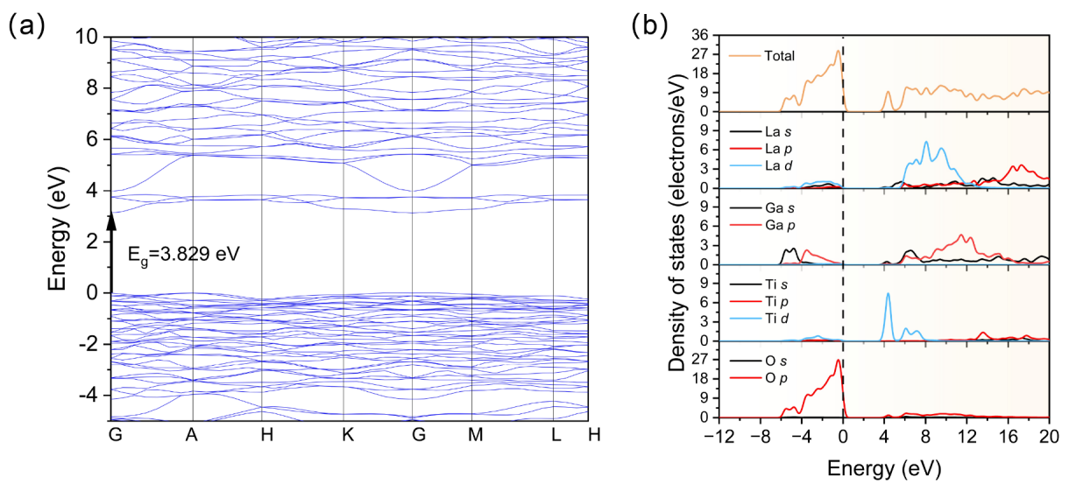
Figure S17. (a) Calculated electronic band structure of LGTi. (b) Total and partial density of states of LGTi.

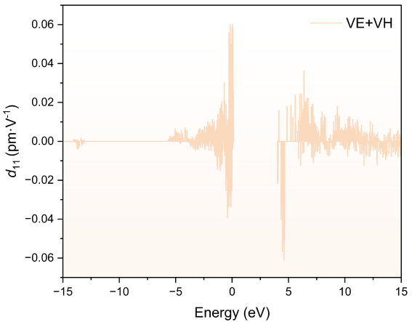
Figure S18. Band-resolved analysis of SHG in LGTi.

The SHG process involves two virtual transition mechanisms: the virtual-electron (VE) process and the virtual-hole (VH) process.

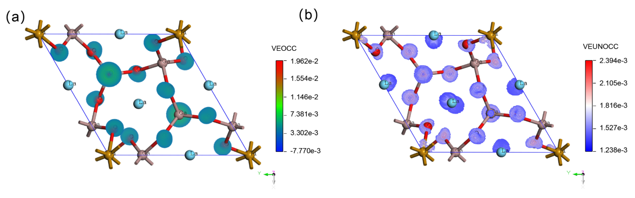
Figure S19. SHG density maps of (c) occupied (veocc) and (d) unoccupied (veunocc) orbitals in the virtual electron (VE) process of the tensor d₁₁.

To elucidate the origin of the SHG response, model structure LGTi without disorder was established for first-principle electronic structure calculations. The calculated energy band gap of LGTi was 3.83 eV using GGA functional (Figure S17). As the optical properties are related to the optical transitions between electronic states near the band gap, partial density of states (PDOS) analysis was adopted, showing that the top of the valence band (VBM) is mainly occupied by La-d, Ga-p, Ti-d and O-p orbitals, the bottom of the conduction band (CBM) is composed of La-s/d, Ga-s/p and Ti-d orbitals. To explore the potential NLO-active groups, the SHG-density method and band-resolved SHG calculations were employed. Band-resolved SHG calculations show that the sharp region of the VB consists of O-p, Ga-p, and Ti-d, whereas the CB consists of Ti-d and Ga-s (Figure S18). The shape of the SHG density around Ga, O, and Ti atoms also reveals a clear contribution to the SHG coefficient in both occupied and unoccupied states, as shown in Figure S19, indicating that the [GaO₄] and [TiO₆] units could be referred to as promising NLO-active units with large nonlinear susceptibilities, together with their parallel alignment being thought to produce high nonlinear bulk susceptibilities.

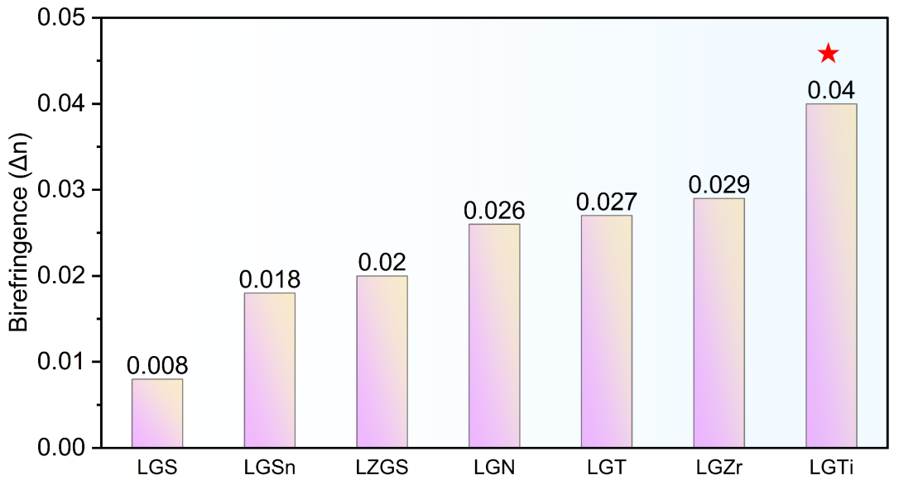
Figure S20. Comparison of the birefringence among langasite family NLO crystals.

This bar chart illustrates the birefringence (Δn) values (@ 1064 nm) of langasite family, where LGTi (marked with a red star) exhibits a largest Δn compared to other crystals.

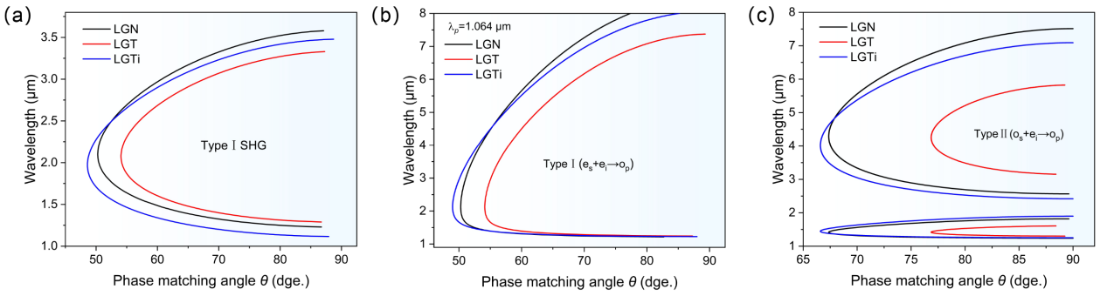
Figure S21. Comparison of type I SHG phase - matching tuning curves and type I and type II OPO tuning curves for LGN, LGT, and LGTi crystals.

Table S1. Crystal data and structure refinements of La₃TiGa₅O₁₄.
La₃TiGa₅O₁₄
Formula weight (Da) | 1037.23
Temperature (K) | 302.00
Crystal system | Trigonal
Space group | P321
a (Å) | 8.2181(3)
b (Å) | 8.2181(3)
c (Å) | 5.1104(3)
α (deg) | 90
β (deg) | 90
γ (deg) | 120
V/Å³ | 298.90(3)
Z | 1
Density (calc.) (g·cm⁻³) | 5.762
Absorption coefficient (mm⁻¹) | 22.253
F (000) | 460
Crystal size/mm³ | 0.065 × 0.044 × 0.012
Radiation type | Mo-K_{α} (λ = 0.71073)
Theta range for data collection | 2.862 - 27.495°.
Index ranges | 10<=h<=10, -10<=k<=10, -6<=l<=6
Reflections collected | 3138
Independent reflections | 466 [R_{int} = 0.0605, R_{sigma} = 0.0349]
Data / restraints / parameters | 466 / 0 / 39
Goodness-of-fit on F2 | 1.070
Flack parameter | 0.03(4)
Final R indexes [I≥2σ(I)] ^{[a]} | R₁ = 0.0195, wR₂ = 0.0446
Final R indexes [all data] ^{[a]} | R₁ = 0.0201, wR₂ = 0.0452
Largest diff. peak / hole (e·Å-3) | 0.87 /-0.74
[a]

Table S2. Fractional atomic coordinates (×10⁴) and equivalent isotropic displacement parameters (Å² × 10³) for La₃TiGa₅O₁₄.
Atom | x | y | z | U (eq) ^{[a]}
La | 10000 | 5773.0(8) | 10000 | 14.7(2)
Ga1 | 10000 | 10000 | 10000 | 16.0(6)
Ga2 | 10000 | 2372.3(17) | 5000 | 14.2(5)
Ga3 | 6666.67 | 3333.33 | 5306(3) | 14.0(4)
Ti1 | 10000 | 10000 | 10000 | 16.0(6)
Ti2 | 10000 | 2372.3(17) | 5000 | 14.2(5)
O1 | 6666.67 | 3333.33 | 1781(18) | 17(2)
O2 | 8594(9) | 768(9) | 2359(11) | 21.6(14)
O3 | 8527(9) | 3081(9) | 6932(12) | 20.8(13)
[a] U_{eq} is defined as 1/3 of the trace of the orthogonalised U_{ij} tensor.

Table S3. Anisotropic displacement parameters (Å² × 10³) for La₃TiGa₅O₁₄.
Atom | U₁₁ | U₂₂ | U₃₃ | U₂₃ | U₁₃ | U₁₂
La | 15.5(4) | 16.0(3) | 12.5(3) | 0.24(13) | 0.5(3) | 7.76(18)
Ga1 | 17.7(9) | 17.7(9) | 12.5(13) | 0 | 0 | 8.9(5)
Ga2 | 15.7(7) | 16.1(6) | 10.6(7) | -0.9(2) | -1.9(5) | 7.9(4)
Ga3 | 15.2(5) | 15.2(5) | 11.7(7) | 0 | 0 | 7.6(3)
Ti1 | 17.7(9) | 17.7(9) | 12.5(13) | 0 | 0 | 8.9(5)
Ti2 | 15.7(7) | 16.1(6) | 10.6(7) | -0.9(2) | -1.9(5) | 7.9(4)
O1 | 20(3) | 20(3) | 10(4) | 0 | 0 | 10.2(16)
O2 | 20(3) | 27(3) | 20(3) | -6(3) | -3(2) | 12(3)
O3 | 23(3) | 27(3) | 16(3) | -4(2) | -5(3) | 15(3)

Table S4. Selected bond lengths for La₃TiGa₅O₁₄.
Bond | Bond-length (Å) | Bond | Bond-length (Å)
La-O | 2.478(6) | Ga2/Ti2-O | 1.867(7)
La-O | 2.874(6) | Ga2/Ti2-O | 1.867(7)
La-O | 2.478(6) | Ga2/Ti2-O | 1.836(6)
La-O | 2.874(6) | Ga2/Ti2-O | 1.836(6)
La-O | 2.619(3) | Ga3 -O | 1.841(6)
La-O | 2.619(3) | Ga3 -O | 1.841(6)
La-O | 2.401(6) | Ga3 -O | 1.841(6)
La-O | 2.401(6) | Ga3 -O | 1.841(6)
Ti/Ga1-O | 1.979(6) | Ti/Ga1-O | 1.979(6)
Ti/Ga1-O | 1.979(6) | Ti/Ga1-O | 1.979(6)
Ti/Ga1-O | 1.979(6) | Ti/Ga1-O | 1.979(6)

Table S5. Atomic Occupancy for La₃TiGa₅O₁₄.
Site | A | B | C | D
element | La | Ti1/Ga1 | Ga2/Ti2 | Ga3
ratio | 1 | 0.7/0.3 | 0.9/0.1 | 1

Table S6. Thermophysical properties of LGS, LGN, LGT, and LGTi Crystals: thermal expansion coefficient, specific heat capacity, and thermal conductivity at room temperature.
 | Thermal Expansion Coefficient  K⁻¹ |  | Specific Heat  J·(g·K)⁻¹ | Thermal Conductivity Coefficient W·(m·K)⁻¹
 | α₁₁ | α₃₃ | C_{p} | κ_{a} | κ_{c}
LGS⁹ | 5.8×10⁻⁶ | 3.9×10⁻⁶ | 0.45 | 1.3 | 1.9
LGN⁹ | 6.1×10⁻⁶ | 4.8×10⁻⁶ | 0.50 | 1.4 | 1.7
LGT⁹ | 6.3×10⁻⁶ | 4.6×10⁻⁶ | 0.36 | 1.2 | 1.7
LGTi | 5.2×10⁻⁶ | 4.8×10⁻⁶ | 0.45 | 1.4 | 2.3

Table S7. Four coefficients of the sellmeier equation for the LGS, LGT, LGN, and LGTi crystals.
LGS¹⁰ |  |  | LGT¹⁰
 | n_{o} | n_{e} |  | n_{o} | n_{e}
A | 3.5129 | 3.5558 | A | 3.6487 | 3.7467
B | 0.0383 | 0.0387 | B | 0.0443 | 0.0475
C | 0.0236 | 0.0225 | C | 0.0267 | 0.0272
D | 0.0096 | 0.0098 | D | 0.0094 | 0.0101
LGN¹¹ |  |  | LGTi
 | n_{o} | n_{e} |  | n_{o} | n_{e}
A | 3.68270 | 3.79511 | A | 3.76154 | 3.91602
B | 0.0464 | 0.0500 | B | 0.05048 | 0.05825
C | 0.02980 | 0.03405 | C | 0.0345 | 0.0404
D | 0.00870 | 0.00964 | D | 0.01337 | 0.01564

 | Space group | a (Å) | b (Å) | c (Å) | a/c
LGS¹² | P321 | 8.162 | 8.162 | 5.087 | 1.60448
LGN¹² | P321 | 8.225 | 2.225 | 5.126 | 1.60456
LGT¹² | P321 | 8.228 | 8.228 | 5.126 | 1.60515
LGTi | P321 | 8.218 | 8.218 | 5.110 | 1.60822
Table S8. The calculated aspect ratio of the crystal principal (a/c) of LGS, LGN, LGT and LGTi crystals.

Reference
1. Kresse, G. et al. Efficient iterative schemes for ab initio total-energy calculations using a plane-wave basis set. Phys. Rev. B 54, 11169-11186 (1996).
2. Kresse, G. et al. Ab initio molecular dynamics for open-shell transition metals. Phys. Rev. B 48, 13115-13118 (1993).
3. Blöchl, P. E. Projector augmented-wave method. Phys. Rev. B 50, 17953-17979 (1994).
4. Wang, C. S. et al. First-principles electronic structure of Si, Ge, GaP, GaAs, ZnS, and ZnSe. II. Optical properties. Phys. Rev. B 24, 3417-3429 (1981).
5. Lin, Z. et al. First-principles materials applications and design of nonlinear optical crystals. J. Phys. D-Appl. Phys. 47, 253001 (2014).
6. Pfrommer, B. G. et al. Relaxation of Crystals with the Quasi-Newton Method. J. Comput. Phys. 131, 233-240 (1997).
7. Arushanov, E. et al. Photoconductivity in n-type β-FiSi₂ single crystals. Phys. Rev. B 52, 20-23 (1995).
8. Sharma, S. et al. Second-Harmonic Optical Response from First Principles. Phys. Scr. 2004, 128 (2004).
9. Wang, J. et al. Langasite family nonlinear optical crystals. Acta Phys-Chim. Sin. 36, 1907009 (2020).
10. Stade, J. et al. Electro-optic, Piezoelectric and Dielectric Properties of Langasite (La₃Ga₅SiO₁₄), Langanite (La₃Ga_{5.5}Nb_{0.5}O₁₄) and Langataite (La₃Ga_{5.5}Ta_{0.5}O₁₄). Cryst. Res. Technol. 37, 1113-1120, (2002).
11. Lu, D. et al. Acentric langanite La₃Ga_{5.5}Nb_{0.5}O₁₄ crystal: a new nonlinear crystal for the generation of mid-infrared parametric light. Opt. Express 24, 17603-17615 (2016).
12. Lan, H. et al. Pushing Nonlinear Optical Oxides into the Mid-Infrared Spectral Region Beyond 10 μm: Design, Synthesis, and Characterization of La₃SnGa₅O₁₄. J. Am. Chem. Soc. 140, 4684-4690 (2018).

