Supplementary Material
Supplementary Table S1 Training model and comparison results of 10 TPOT models

Model | Sensitivity | Specificity | Accuracy | Kappa | Hamming Loss | ROC_AUC | PRC_AUC
Model 1 | 0.996 | 0.996 | 0.996 | 0.992 | 0.004 | 1.000 | 1.000
Model 2 | 0.981 | 0.987 | 0.984 | 0.967 | 0.016 | 0.999 | 0.999
Model 3 | 0.986 | 0.994 | 0.990 | 0.980 | 0.010 | 1.000 | 1.000
Model 4 | 0.998 | 0.997 | 0.997 | 0.995 | 0.003 | 1.000 | 1.000
Model 5 | 0.990 | 0.994 | 0.992 | 0.984 | 0.008 | 1.000 | 1.000
Model 6 | 0.995 | 0.996 | 0.995 | 0.991 | 0.005 | 1.000 | 1.000
Model 7 | 0.897 | 0.924 | 0.910 | 0.820 | 0.090 | 0.973 | 0.974
Model 8 | 0.926 | 0.953 | 0.939 | 0.879 | 0.061 | 0.989 | 0.989
Model 9 | 0.912 | 0.936 | 0.924 | 0.849 | 0.076 | 0.982 | 0.983
Model 10 | 0.914 | 0.943 | 0.928 | 0.857 | 0.072 | 0.982 | 0.983

Supplementary Table S2 Parameters of TOPT models for predicting depression
Model | Parameters
1 | Rank 1: RandomForestClassifier(input_matrix, RandomForestClassifier__bootstrap=True, RandomForestClassifier__criterion=gini, RandomForestClassifier__max_features=0.6000000000000001, RandomForestClassifier__min_samples_leaf=2, RandomForestClassifier__min_samples_split=3, RandomForestClassifier__n_estimators=100)  Internal CV Score: 0.7512
2 | Rank 2: RandomForestClassifier(input_matrix, RandomForestClassifier__bootstrap=True, RandomForestClassifier__criterion=gini, RandomForestClassifier__max_features=0.25, RandomForestClassifier__min_samples_leaf=1, RandomForestClassifier__min_samples_split=5, RandomForestClassifier__n_estimators=100)  Internal CV Score: 0.7499
3 | Rank 3: RandomForestClassifier(input_matrix, RandomForestClassifier__bootstrap=True, RandomForestClassifier__criterion=gini, RandomForestClassifier__max_features=0.8500000000000001, RandomForestClassifier__min_samples_leaf=1, RandomForestClassifier__min_samples_split=5, RandomForestClassifier__n_estimators=100)  Internal CV Score: 0.7487
4 | Rank 4: RandomForestClassifier(input_matrix, RandomForestClassifier__bootstrap=True, RandomForestClassifier__criterion=gini, RandomForestClassifier__max_features=0.25, RandomForestClassifier__min_samples_leaf=2, RandomForestClassifier__min_samples_split=5, RandomForestClassifier__n_estimators=100)  Internal CV Score: 0.7482
5 | Rank 5: RandomForestClassifier(input_matrix, RandomForestClassifier__bootstrap=True, RandomForestClassifier__criterion=gini, RandomForestClassifier__max_features=0.7000000000000001, RandomForestClassifier__min_samples_leaf=1, RandomForestClassifier__min_samples_split=5, RandomForestClassifier__n_estimators=100)  Internal CV Score: 0.7466
6 | Rank 6: RandomForestClassifier(input_matrix, RandomForestClassifier__bootstrap=True, RandomForestClassifier__criterion=gini, RandomForestClassifier__max_features=0.7000000000000001, RandomForestClassifier__min_samples_leaf=1, RandomForestClassifier__min_samples_split=8, RandomForestClassifier__n_estimators=100)  Internal CV Score: 0.7465
7 | Rank 7: RandomForestClassifier(input_matrix, RandomForestClassifier__bootstrap=True, RandomForestClassifier__criterion=gini, RandomForestClassifier__max_features=0.6000000000000001, RandomForestClassifier__min_samples_leaf=2, RandomForestClassifier__min_samples_split=5, RandomForestClassifier__n_estimators=100)  Internal CV Score: 0.7457
8 | Rank 8: RandomForestClassifier(input_matrix, RandomForestClassifier__bootstrap=True, RandomForestClassifier__criterion=gini, RandomForestClassifier__max_features=0.6000000000000001, RandomForestClassifier__min_samples_leaf=1, RandomForestClassifier__min_samples_split=5, RandomForestClassifier__n_estimators=100)  Internal CV Score: 0.7445
9 | Rank 9: RandomForestClassifier(input_matrix, RandomForestClassifier__bootstrap=True, RandomForestClassifier__criterion=gini, RandomForestClassifier__max_features=0.25, RandomForestClassifier__min_samples_leaf=2, RandomForestClassifier__min_samples_split=4, RandomForestClassifier__n_estimators=100)  Internal CV Score: 0.7436
10 | Rank 10: RandomForestClassifier(input_matrix, RandomForestClassifier__bootstrap=False, RandomForestClassifier__criterion=entropy, RandomForestClassifier__max_features=0.45, RandomForestClassifier__min_samples_leaf=2, RandomForestClassifier__min_samples_split=2, RandomForestClassifier__n_estimators=100)  Internal CV Score: 0.7432

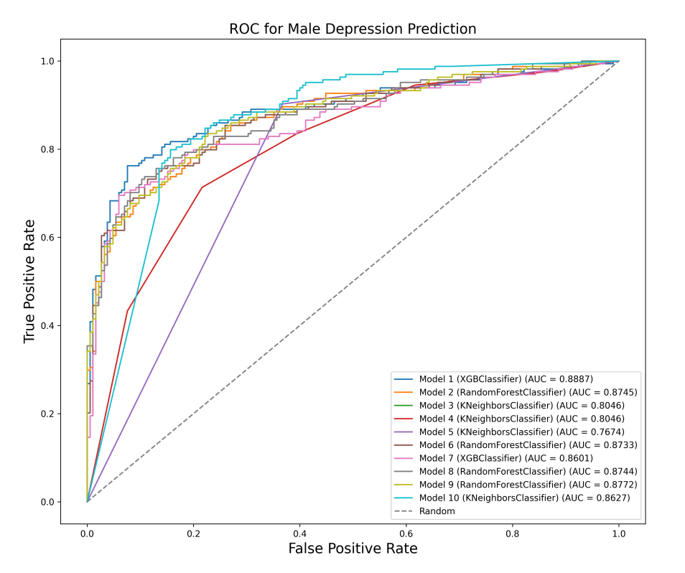 | 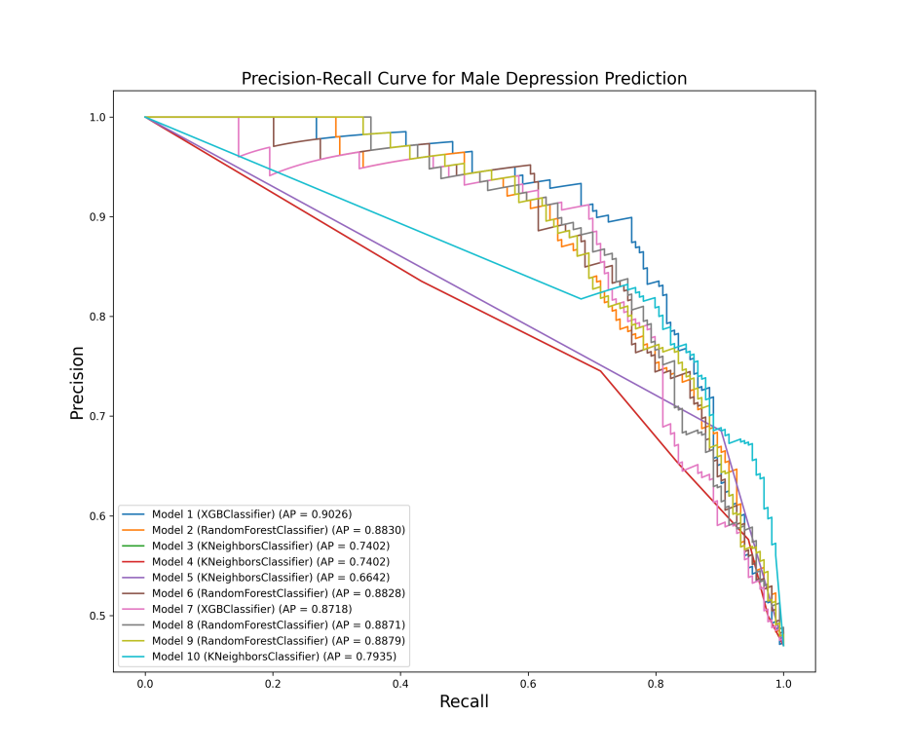
Fig.S1 ROC and PR Curves of 10 Predictive Models for Male Depression Prediction in Male Cardiac Patients (Testing Sset)
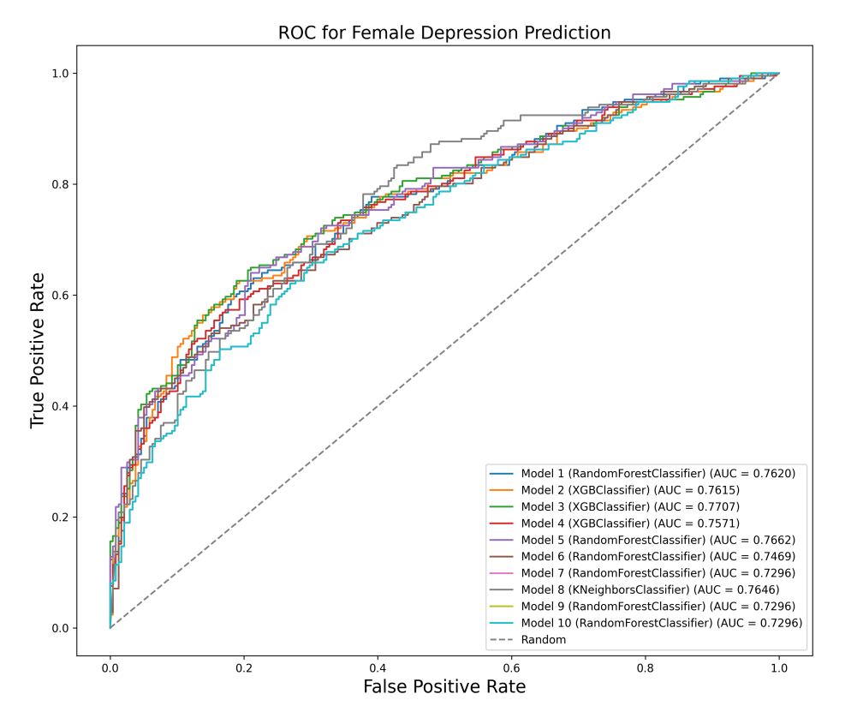 | 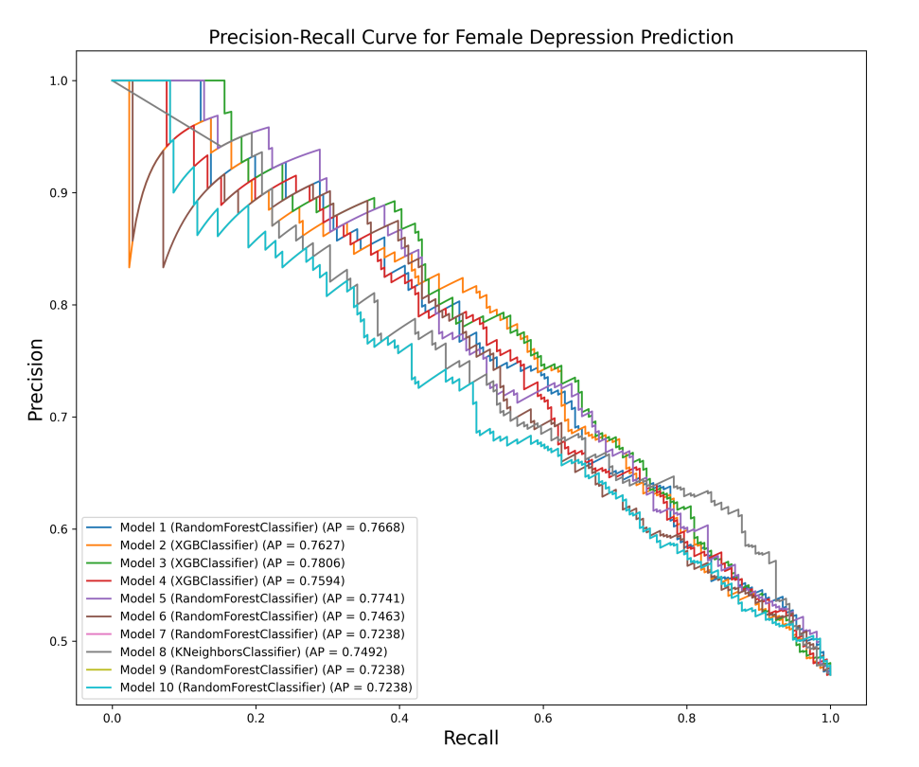
Fig.S2 ROC and PR Curves of 10 Predictive Models for Male Depression Prediction in Female Cardiac Patients (Testing Set)

