Supplementary Information

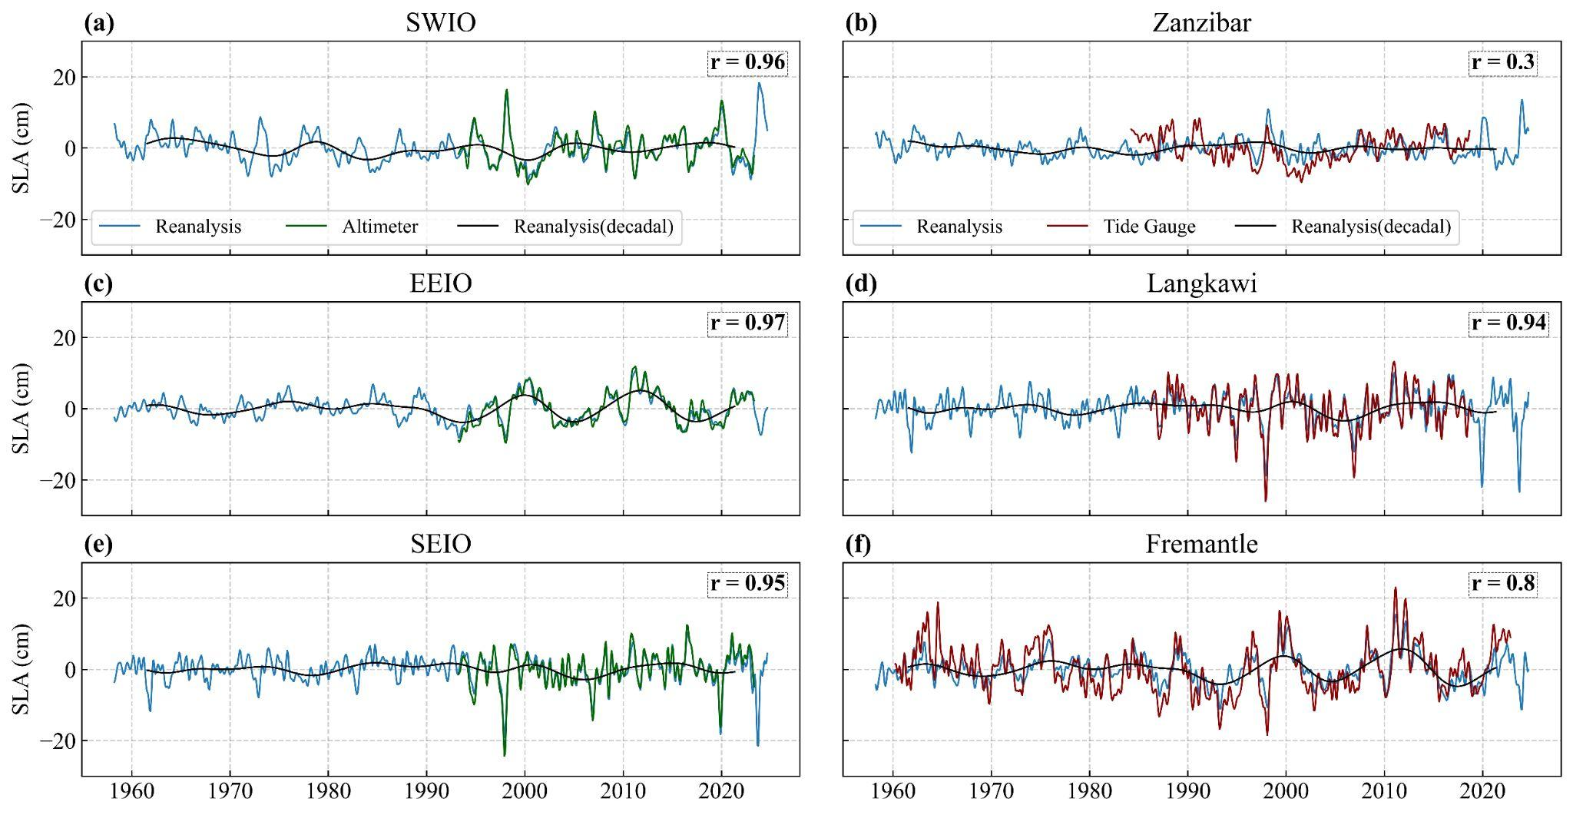

Figure S1: Comparison of monthly SLA from ensemble reanalysis (blue) with altimeter (left column) and tide-gauge (right column) SLA at selected regions in the Indian Ocean (Fig. 1a). The left panel shows SLA time series averaged in the southwest Indian Ocean (SWIO), eastern equatorial Indian Ocean (EEIO), and the west coast of Australia (WAC; black solid and dashed boxes in Figure 1a) from ensemble reanalysis and altimetry. The right column shows SLA from selected tide-gauge records (locations marked by green stars in Fig. 1a) and SLA from reanalysis averaged over a 1° radius circle around each tide-gauge location (we chose 2° for Zanzibar as this station is further away from the SWIO region; Fig. 1a). A monthly climatology is removed, a 5-month smoothing is applied, and a linear trend is removed for all time series. The linear correlation coefficient between the reanalysis and the observed (altimetry or tide-gauge) time series is shown in the top-right corner of each panel. The black curve represents the decadal signal from the ensemble reanalysis analysed in this study.

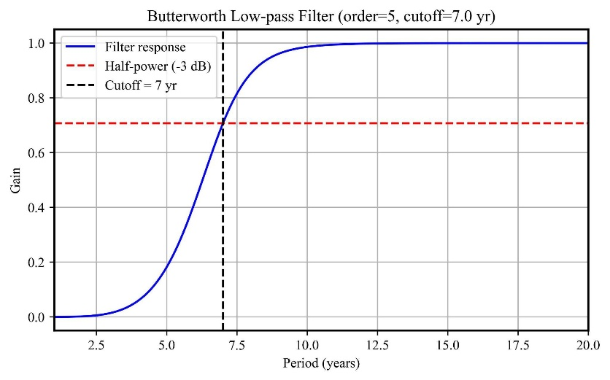
Figure S2: Frequency response diagram of a 5th-order Butterworth low-pass filter with a 7-year cutoff period, used in this study.

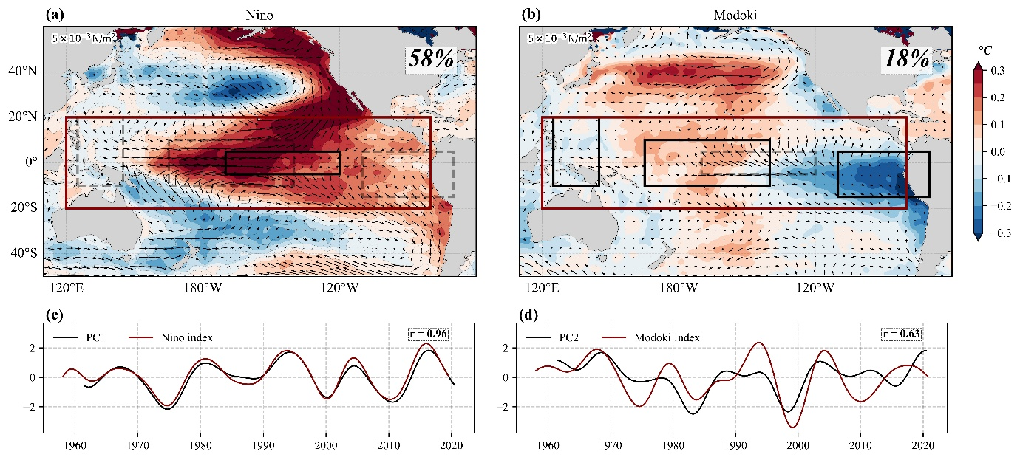
Figure S3: First two EOFs of decadal SST anomalies in the tropical Pacific. (a) Regression of decadal sea surface temperature (SST; shading) and wind stress (vectors) onto the normalised PC1. The red box indicates the region where the EOFs are computed. The black box in panel a is the Niño 3.4 region, and the dashed grey boxes represent the regions used to calculate the ENSO Modoki index (Ashok et al., 2007). Explained variance is shown in the top-left corner. The PC1 and Niño3.4 indices are shown in panel c, with their linear correlation coefficient shown in the top-right corner. (b) Same as (a), but for the PC2. The normalised PC2 and the ENSO Modoki index are shown in panel d, with their linear correlation coefficient shown in the top-right corner. All fields are detrended over 1958–2022 and subjected to an 7-year low-pass filter. We consider PC1 and PC2 as the EOF-based ENSO index (EEI) and the EOF-based Modoki Index (EMI), in this study.

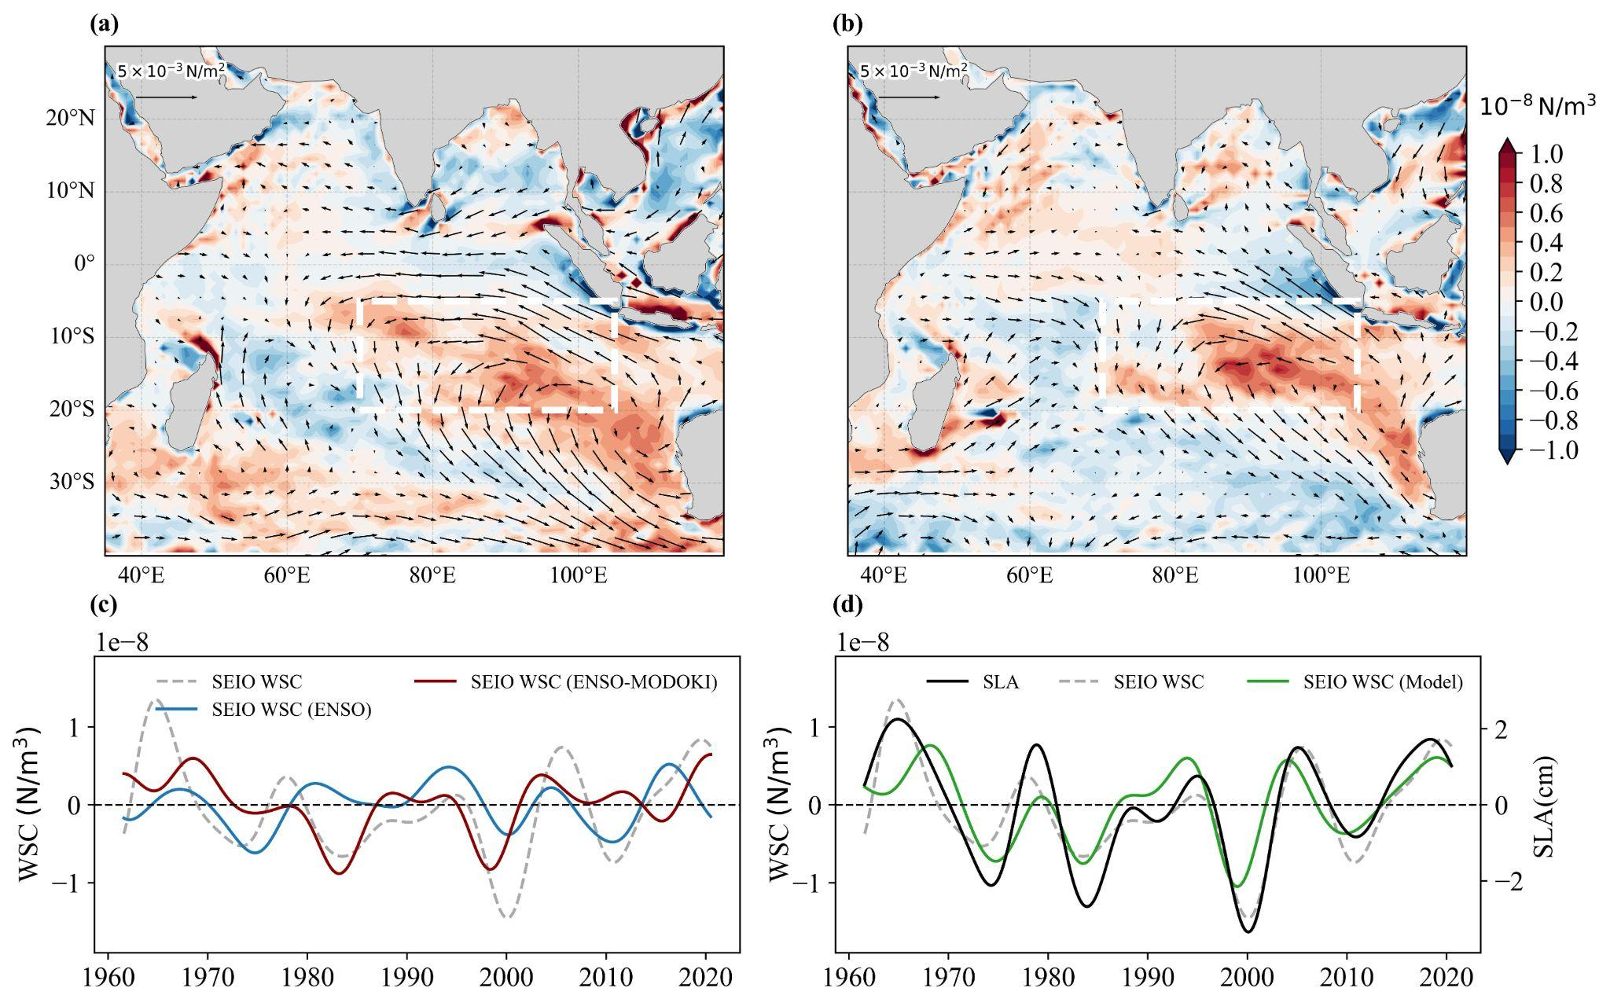

Figure S4: (a) Regression of WSC (shading) and wind stress (vector) onto (normalized) EEI. (b) same as (a) but for the (normalized) EMI. The white dashed rectangle in the SEIO represents the region of maximum WSC associated with SWIO SLA, as shown in Fig. 1b. (c) Time series of decadal WSC averaged over the SEIO (dashed white box; grey), EEI-driven (blue) and EMI-driven (red) WSC in the SEIO. The EEI- and EMI-driven WSC are computed using regression models of SEIO WSC on EEI and EMI, respectively. (d) Time series of decadal SLA in the SWIO (black), WSC averaged in the SEIO (white box in panel a), and SEIO WSC estimated by a linear regression model based on EEI and EMI.

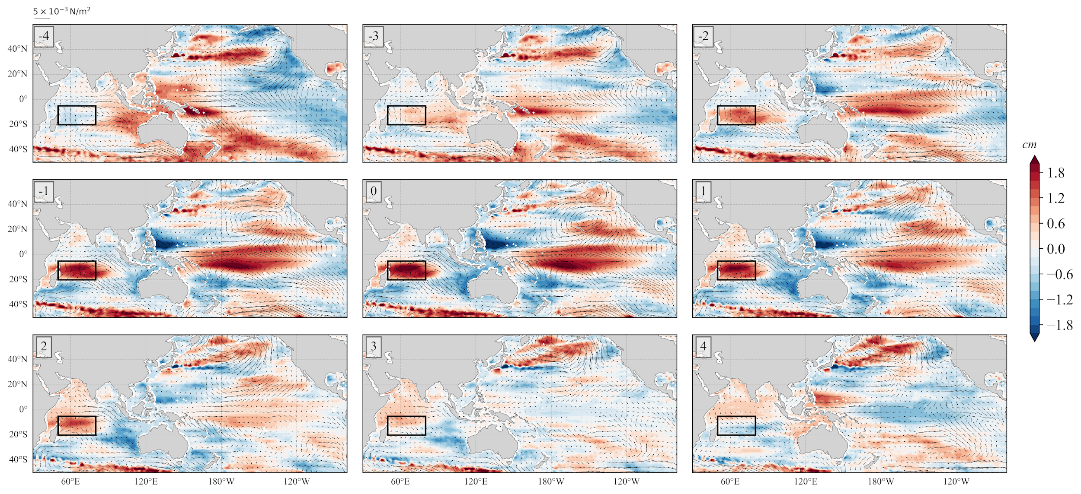
Figure S5: Regression of ensemble-mean decadal SLA (shading) and wind stress (vectors) onto normalized decadal SLA averaged in the SWIO at a lag of -4 to +4 years with a one-year interval. The lag is indicated at the left-top of each panel. The black box represents the SWIO where SLA is averaged.

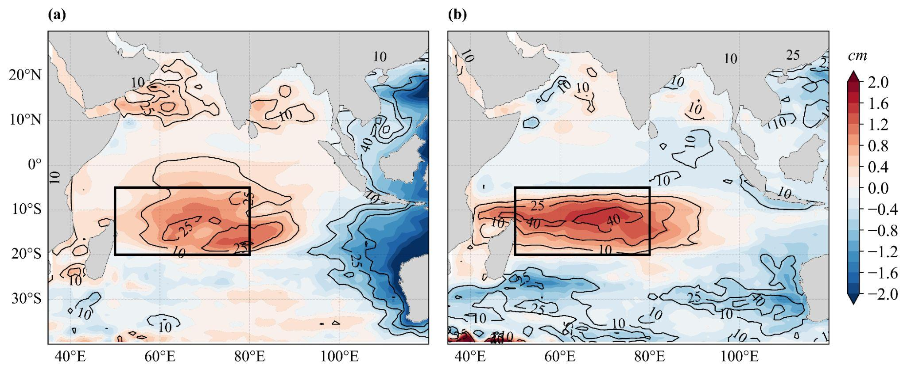
Figure S6: Regression of decadal SLA onto a) EEI and b) EMI (shading). The explained variance from the regression is overlaid with contours in each panel.

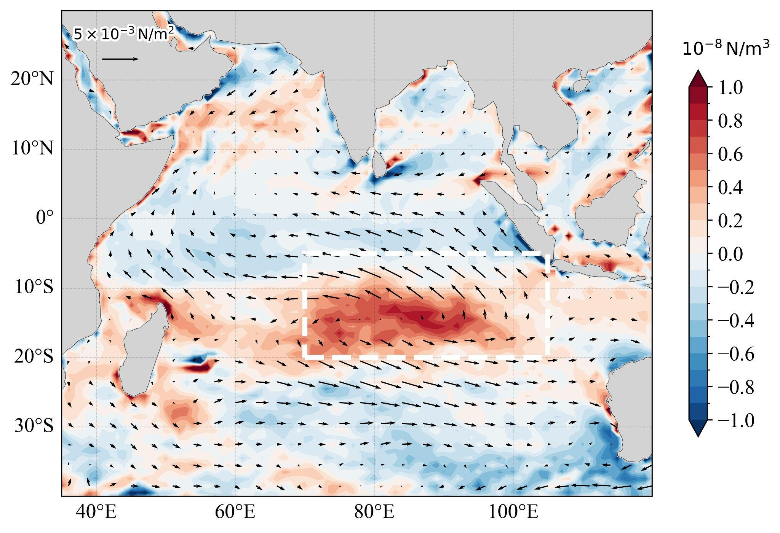
Figure S7: Regression of residual wind stress curl (shading) and residual wind stress (vectors) onto the (normalised) IDI.

 | SWIO DSL | EEI | Nino3.4 index | EMI | Modoki index | EDMI | IOD index
SWIO DSL | 1
EEI | 0.52 | 1
Nino3.4 index | 0.56 | 0.97 | 1
EMI | 0.62 | 0.01 | 0.02 | 1
Modoki index | 0.78 | 0.75 | 0.77 | 0.62 | 1
EDMI | 0.28 | -0.15 | -0.13 | 0.16 | -0.1 | 1
IOD index | 0.24 | -0.09 | -0.09 | 0.19 | 0.03 | 0.4 | 1

Table S1: Correlation between SWIO SLA and climate indices. We define climate indices based on EOFs of decadal SST in the Indian and Pacific basins (Fig. S2). Hence, the correlation coefficients are presented for those EOF-based indices (EEI, EMI, and EDMI) and for climate indices following classical definitions (Niño3.4, Modoki index, and IOD index). The significant correlation coefficients at the 90% confidence level are highlighted in bold. EDMI stands for EOF-based DMI index. DMI and EDMI are estimated after removing Pacific variability (EEI and EMI) using a linear regression.

 | PC1-Curl | IOD | SIOD | MH | SAM
PC1-Curl | 1
IOD | 0.160985 | 1
SIOD | -0.117876 | 0.005095 | 1
MH | 0.427914 | 0.014016 | 0.205049 | 1
SAM | -0.188967 | -0.029479 | -0.089782 | -0.047526 | 1

Table S2: Correlation between SEIO residual WSC PC1 (Fig. 5b) and various climate indices. The Mascarene High Index is defined based on the leading EOFs of decadal SLP over the South Indian Ocean (30–120°E, 50–30°S). The SAM Index is defined as the zonal mean sea-level pressure difference between 40°S and 65°S. The IOD and SIOD indices follow their conventional definitions. All indices are computed from the residual fields.

