Supporting Information

Regulatory Role of CAPS in Osteoarthritis and Experimental Validation of Polydatin as a Potential Therapeutic Intervention

Zhichang Zhang^{1†}, Zongye Zhang^{1†}, Xiunan Wu^{1†}, Zhendong Liu³, Zhi Sha¹, Jinpeng Gao¹, Zhenxing Hou³, Dongdong Wang¹ and Yanzheng Gao^{3*}

1. Zhengzhou University People's Hospital, Henan Provincial People's Hospital.
- Henan University People's Hospital, Henan Provincial People's Hospital
- Department of Surgery of Spine and Spinal Cord, Henan Provincial People's Hospital, Zhengzhou, 471003, China.

Contents

WGCNA-based transcriptional module identification…...……………...Figure S1
GO enrichment analysis of OA candidate genes…...…………………...... Figure S2
Single-cell data QC and clustering annotation…...……………………..... Figure S3
CellChat-based intercellular signaling analysis…...…………………...... Figure S4
Toxicity evaluation of polydatin………........…………………...……..... Figure S5

Figure S1: WGCNA-based transcriptional module identification: WGCNA identified five transcriptional modules using optimal soft-thresholding power (β=20) with scale-free topology (R²=0.9) and preserved biological connectivity (Figs. S1A-D).

Figure S2: GO enrichment analysis of OA candidate genes: GO analysis (FDR<0.05) showed 35 candidate genes enriched in ECM macromolecular assembly processes (GO:0030198, GO:0005581, GO:0005201) (Figs. S2A-C).

Figure S3: Single-cell data QC and clustering annotation: (A): Single-cell quality control (QC) results; (B): Highly variable gene assessment; (C): Principal component analysis (PCA) verifying sample homogeneity; (D): Sample integrity confirmation; (E): UMAP-based clustering of 24 cell clusters; (F): Marker gene profiling for cell annotation; (G): 10 principal cell type annotations (Figs. S3A-G).

Figure S4: CellChat-based intercellular signaling analysis: (A): Heterogeneous intercellular interaction networks identified by CellChat; (B): COLLAGEN/FN1 ligand-receptor-mediated ECM communication pathways (Figs. S4A-B).

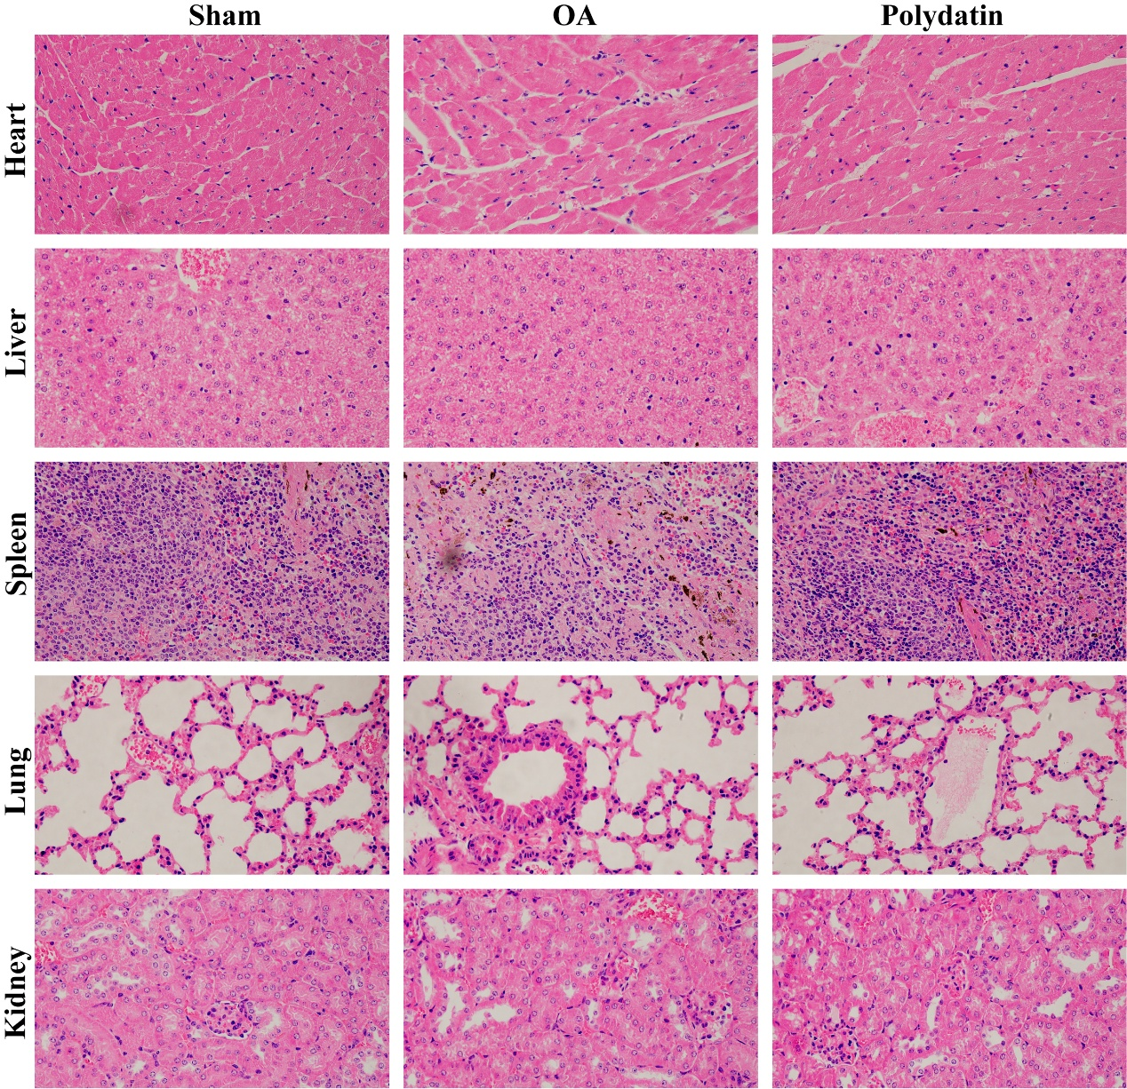Figure S5: Toxicity evaluation of polydatin: Histochemical sections of mouse heart, liver, spleen, lungs, and kidneys confirming polydatin has no toxic effects (Fig. S5).

