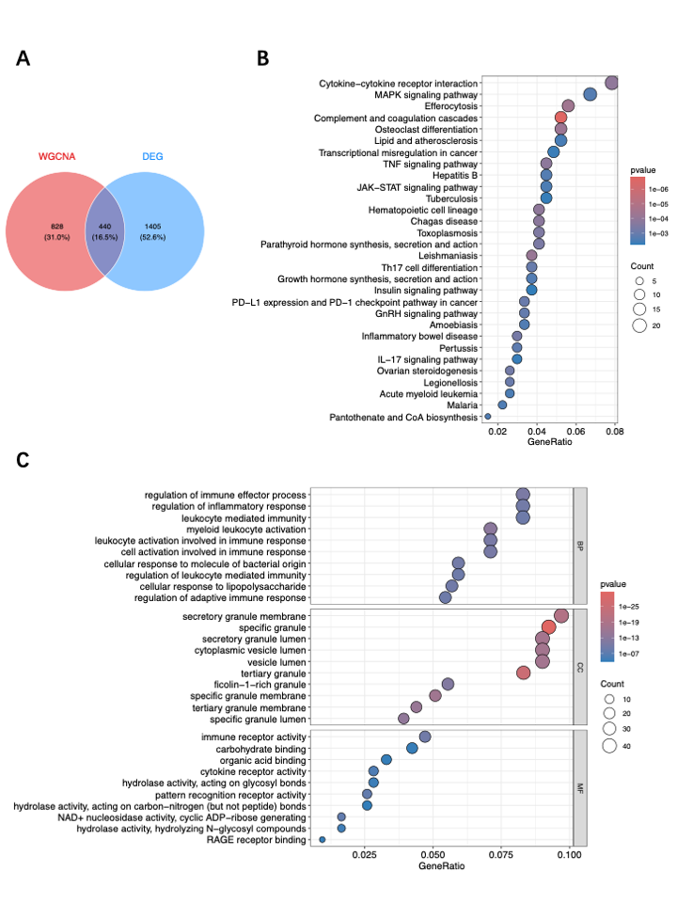
Figure S1. Functional characterization of intersecting genes between the brown module and differentially expressed genes. (A) Venn diagram showing the overlap between genes in the brown module identified by WGCNA and differentially expressed genes (DEGs). (B) KEGG pathway enrichment analysis of the overlapping genes. (C) Gene Ontology (GO) enrichment analysis of the overlapping genes. Biological process (BP), cellular component (CC), and molecular function (MF) categories are shown.

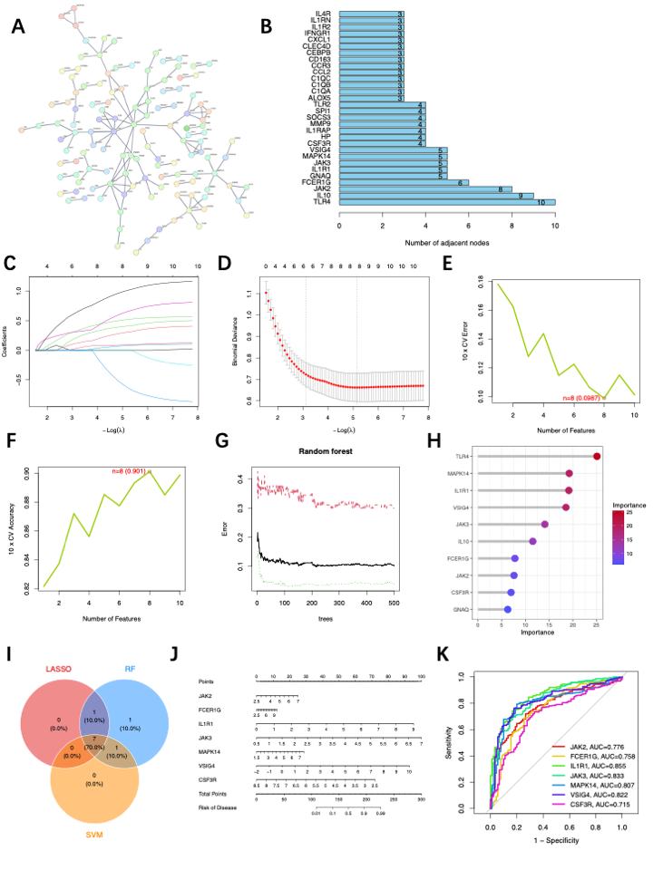Figure S2. Identification of key hub genes and construction of a diagnostic model using integrative machine learning approaches based on magenta module. (A) Protein–protein interaction (PPI) network of the 440 overlapping genes derived from the brown module and DEGs. (B) Top 10 hub genes ranked by node degree (number of adjacent connections) in the PPI network. (C–D) Feature selection using LASSO regression. (C) LASSO coefficient profiles of candidate genes. (D) Cross-validation plot showing the optimal penalty parameter (λ). (E–H) Feature selection using random forest analysis. (E–F) Cross-validation curves for determining the optimal number of variables. (G) Error rate of the random forest model across different numbers of trees. (H) Variable importance ranking of candidate genes. (I) Venn diagram showing the overlap of selected genes from LASSO, random forest, and SVM-RFE analyses. (J) Nomogram constructed based on the five selected hub genes for predicting sepsis risk. (K) Receiver operating characteristic (ROC) curves of the five hub genes, showing their diagnostic performance.
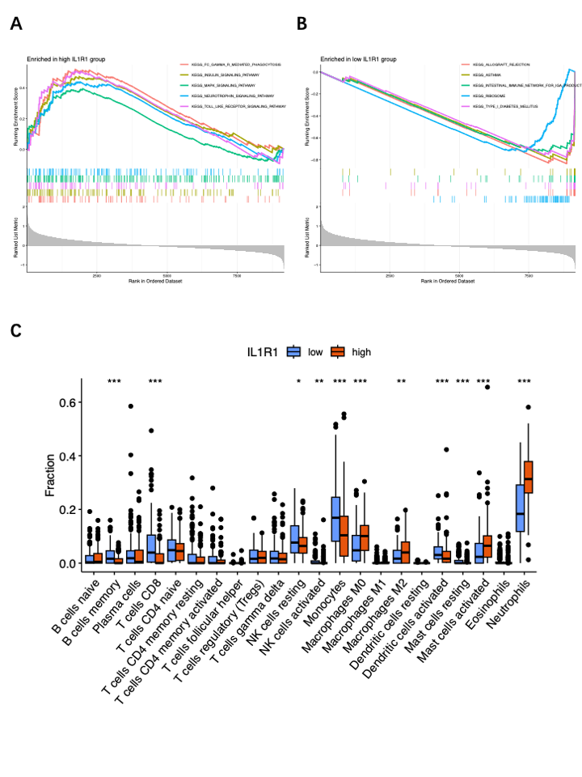
Figure S3. Functional and immune landscape associated with IL1R1 expression in sepsis. (A) Gene set enrichment analysis (GSEA) of samples with high IL1R1 expression. (B) GSEA of samples with low IL1R1 expression. (C) Immune cell infiltration analysis using CIBERSORT. Comparison of immune cell fractions between high and low IL1R1 expression groups.
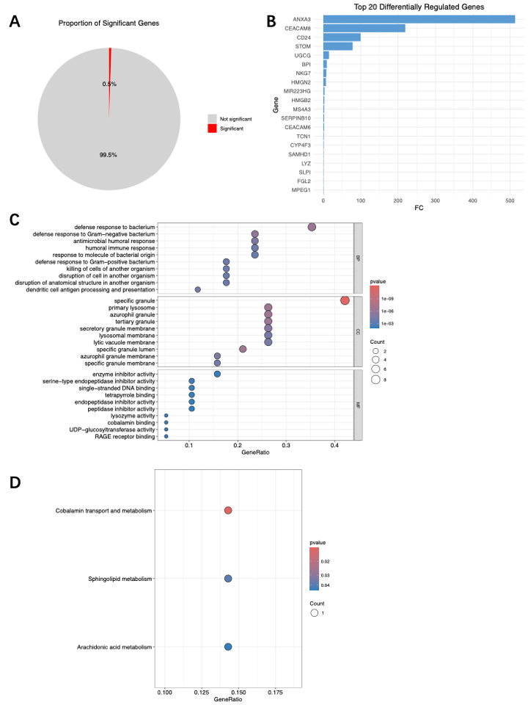
Figure S4. Single-cell transcriptomic characterization and functional impact of IL1R1 in sepsis. (A) Proportion of differentially expressed genes following in silico IL1R1 knockout. (B) Top 20 differentially expressed genes (DEGs) following IL1R1 knockout. (C) Gene Ontology (GO) enrichment analysis of the top DEGs. (D) KEGG pathway enrichment analysis of the top DEGs.
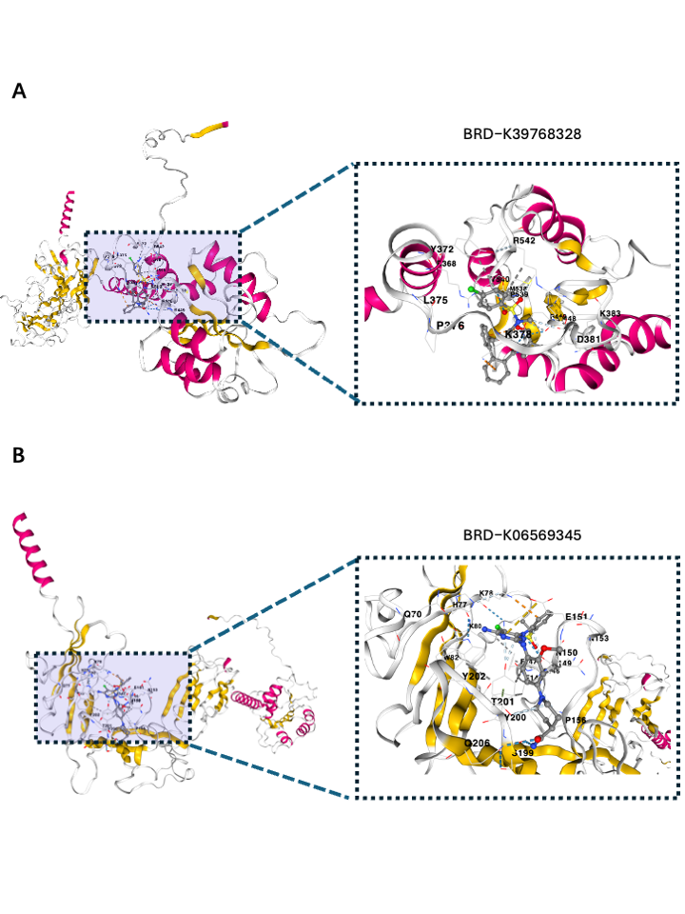
Figure S5. Identification of potential therapeutic agents for sepsis treatment targeting IL1R1. (A-B) Molecular docking between (D) BRD-K39768328 and (E) BRD-K06569345 and IL1R1..

