Appendix
Appendix 1 Comparison of model fitting indicators with different numbers of clusters
Groups | WSS | WSS decline ratio(%) | Contour coefficient | BIC
2 | 59,275.39 | 37.8 | 0.307 | -111,900.12
3 | 49,904.47 | 15.8 | 0.214 | -111,787.66
4 | 45,564.91 | 8.7 | 0.186 | -111,903.00
5 | 42,384.66 | 7.0 | 0.164 | -111,940.19
6 | 39,940.85 | 5.8 | 0.155 | -111,903.06
Bold indicates the optimal value. The larger the BIC value, the better the model fits. A contour coefficient greater than 0.25 is acceptable.
Appendix A 1 The elbow rule determines the optimal number of clusters
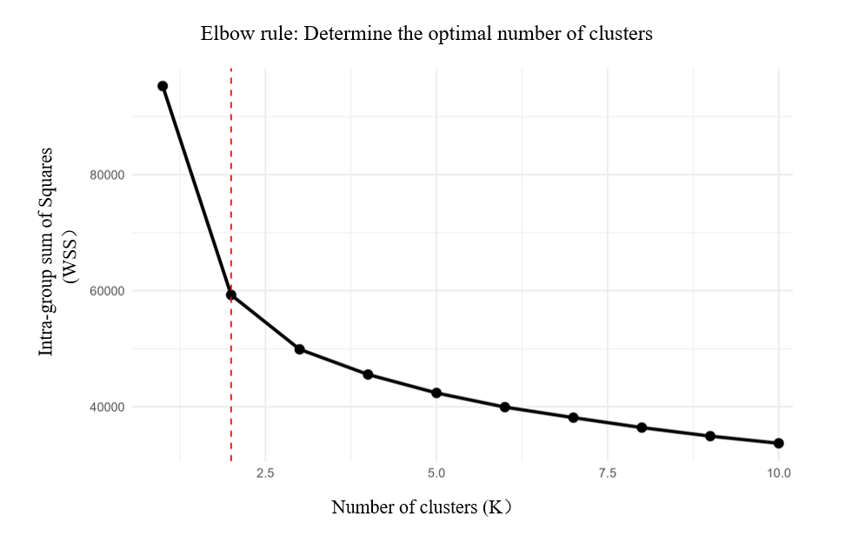
Appendix A 2 The Contour coefficient method determines the optimal number of clusters
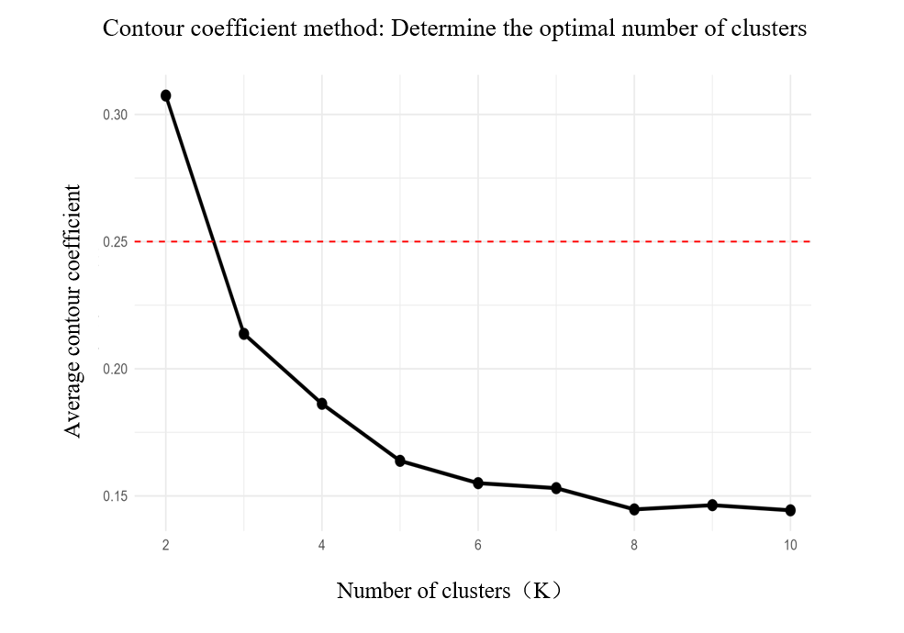
Appendix A 3 The BIC of the Gaussian Mixture model (GMM) varies with the number of groups
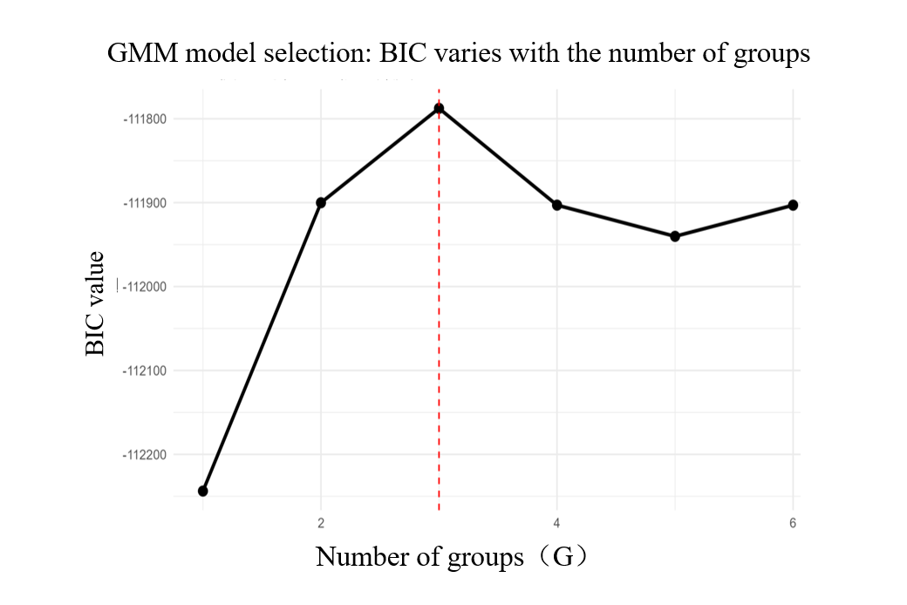
Appendix B 1 Sensitivity analysis: Comparison of the distribution of K-means and GMM trajectory groups
Method | Low-level deterioration group | Moderate improvement group | High-level stable group
K-means (Principal Analysis) | 28.6% | 43.2% | 28.2%
GMM (Sensitivity Analysis) | 17.6% | 24.2% | 58.2%
This table only describes the differences in the distribution of groups between the two clustering methods and does not involve comparisons between groups, so no statistical tests were conducted. The BIC of GMM is -111,788

