Online Supplement of the Behavior Genetics Article: Uncovering the Role of Biological Sex in the Divergent Genetic Profiles of Early and Late-Diagnosed Autism

Authors: Sophie Breunig^{1,2}, Lukas Schaffer^{1,2}, Jeremy Lawrence^{1,2}, Alexander Sheppard^{1,2}, Andrew Grotzinger^{1,2}

¹Department of Psychology and Neuroscience, University of Colorado at Boulder, Boulder, CO
²Institute for Behavioral Genetics, University of Colorado at Boulder, Boulder, CO

Corresponding Author: Sophie Breunig (sophie.breunig@colorado.edu)
Institute for Behavioral Genetics
University of Colorado at Boulder
1480 30th Street
Boulder, CO 80303

Multiple Regressions Partition Early-Diagnosis and Sex-Stratified Liability
To evaluate the independence of early-diagnosis associations, we conducted multiple regression models regressing each external trait on ASD_{early} alongside ASD_{male} and ASD_{female} respectively. Given the high genetic correlation between the sex-stratified groups and the similar patterns in ASD_{male} and ASD_{female}, these models partition ASD_{early} associations into unique versus shared ASD liability rather than to isolate distinct sex-specific pathways. Regression results for the top 20 most different external traits can be found in Supplemental Figure 1A and B for males and females, and a comprehensive set of all 31 significant results can be found in Supplemental Table S6 and S7 for males and females respectively. Patterns of these findings and further exploratory avenues for the mechanisms underlying those patterns are described below.

Robustness of the Early-Specific Signal. Across both male and female models, specific cognitive hallmarks of the early-diagnosis phenotype remained significant and independent. For the Symbol Digit Task and Non-cognitive component of educational attainment, ASD_{early} remained a significant predictor. In several instances, a suppression effect was observed where the ASD_{early} coefficient increased in magnitude after accounting for the sex-stratified background (e.g., Non-cognitive 𝛽_{univariate} = 0.17 → 𝛽_{multivariate} = 0.37 in male models). This highlights these findings as specific clinical hallmarks of the early-diagnosis phenotype and suggests that a unique genetic signature for early identification exists but is partially masked by general ASD covariance in univariate analyses.

Attenuation by General ASD Liability. Conversely, a broad cluster of psychiatric and behavioral traits, including MDD, ADHD, bipolar disorder, and anxiety, showed consistent attenuation of the ASD_{early} signal in both sex-stratified models. In these cases, the sex-stratified predictors remained robust while the ASD_{early} coefficient was reduced to non-significance. For example, for MDD, the ASD_{early} coefficient was reduced to non-significance (𝛽_{univariate} = 0.12 → 𝛽_{multivariate} = -0.42, p_{FDR} = 0.052), while ASD_{male} remained a robust predictor (𝛽_{multivariate} = 0.72, p_{FDR} = 0.003). The same was true for females, where the ASD_{early} coefficient was reduced to non-significance (𝛽_{univariate} = 0.12 → 𝛽_{multivariate} = -0.11, p_{FDR} = 0.052) while ASD_{female} remained a robust predictor (𝛽_{multivariate} = 0.54, p_{FDR} = 9.70E-06). The high degree of similarity in these attenuation patterns across both sexes indicates that the univariate associations between early diagnosis and these comorbidities are primarily driven by shared genetic liability common to the broader ASD spectrum, rather than signal that is specific to males or females with ASD.

Emergent and Non-Significant Associations. Partitioning out the sex-stratified covariance unmasked previously non-significant ASD_{early} associations with sports group attendance and insomnia across both models. This suggests that these may be reliable features of the early-diagnosis genetic profile where general ASD background initially obscured these diagnostic-specific links. Traits such as loneliness, sensitivity to environmental stress, and suicidality showed no significant association with ASD_{early} regardless of the inclusion of sex-stratified variables, suggesting that these traits may be more relevant to other diagnostic subgroups, such as late-diagnosed individuals.

Divergent Sex-Stratified Signals. While the patterns of attenuation and suppression were largely similar across sexes, several key divergences were identified that suggest sex differences represent an independent dimension of ASD heterogeneity. The early-diagnosis signal for PTSD was emergent in the male-stratified model, revealing a significant additive risk (𝛽_{multivariate_early} = -0.55; 𝛽_{multivariate_male} = 0.87), but was fully attenuated in the female-stratified model. Adulthood-Diagnosed ADHD showed no significant univariate association with ASD_{early} but reached significance only when accounting for the male-stratified signal. No such emergence was observed in the female-stratified model.

Overall male ASD signal explains more of the early relationship with external traits than female signal as can be seen in Supplemental Figure 2. This highlights that early diagnosed ASD has more male specific pathways in terms of ASD symptoms and correlates, given that effect sizes are bigger. While ASD_{late} was too highly correlated with the sex-stratified groups to permit a stable comprehensive model in this dataset, our results demonstrate that sex differences in ASD represent an independent dimension of heterogeneity that cannot be explained solely by the timing of diagnosis. This underscores the necessity for future research to consider both sex and age of diagnosis as distinct, interacting factors in the etiology of autism.

Supplemental Figures

Supplemental Figure 1. Comparison of univariate ASD_{early} effects with partial effects in the multiple regressions. A. Univariate ASD_{early} as well as the partial ASD_{early} and ASD_{male} genetic correlations, for the 20 most significantly different external traits. B. Univariate ASD_{early} as well as the partial ASD_{early} and ASD_{female} genetic correlations, for the 20 most significantly different external traits. Error bars display the standard error of the estimates. The plot is divided into three sections, displaying from left to right (I) external traits whose genetic relationship with ASD_{early} was attenuated to non-significance by the inclusion of sex stratified ASD, (II) external traits whose genetic relationship with ASD_{early} was non-significant in the univariate regression, but became significant with the inclusion of sex stratified ASD, and (III) external traits whose genetic relationship with ASD_{early} was non-significant in the univariate regression, and does not became significant with the inclusion of sex stratified ASD.

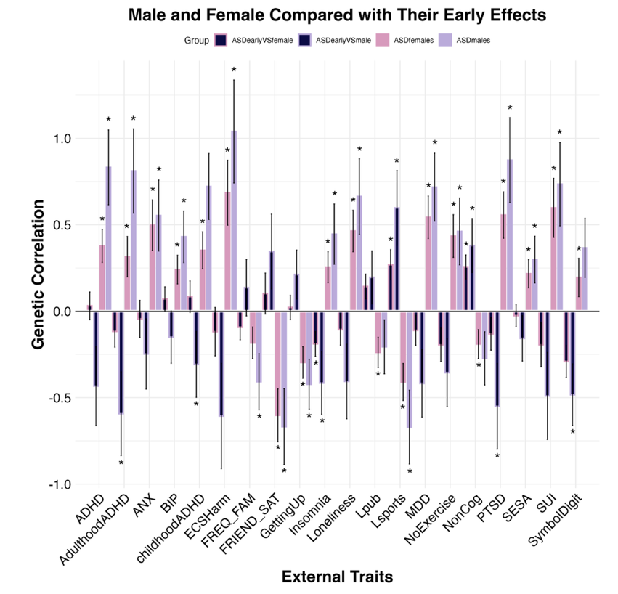

Supplemental Fig 2. Comparison of early and sex specific effects in the multiple regressions. The figure displays the partial ASD_{early} and sex specific genetic correlations from the ASD_{early} and ASD_{male}, as well as the ASD_{early} and ASD_{female} multiple regressions for the 20 most significantly different external traits. An asterisk signifies a significant p-value at an FDR corrected threshold of p <0.05.

