Supplementary Information
Supplementary Data 1-10 are provided in the spread sheet.
Supplementary Data 1. Bulk TWAS-O risk genes of PD. Listed are chromosome, start position, omnibus TWAS-O p-value, and TWAS p-values by TIGAR/DPR, PrediXcan/EN, and FUSION. Note: The bulk TWAS-O analysis in this study uses a stringent genome-wide significance threshold (p-value<2.5E-06).

Supplementary Data 2. Cell-type-aware TWAS-O risk genes of PD in Astrocytes. Cell-type-aware TWAS-O results showing the chromosome, start position, TWAS-O p-value, TWAS p-values by TIGAR/DPR, PrediXcan/EN, and FUSION.

Supplementary Data 3. Cell-type-aware TWAS-O risk genes of PD in Microglia. Cell-type-aware TWAS-O results showing the chromosome, start position, TWAS-O p-value, TWAS p-values by TIGAR/DPR, PrediXcan/EN, and FUSION.

Supplementary Data 4. Cell-type-aware TWAS-O risk genes of PD in Excitatory Neurons. Cell-type-aware TWAS-O results showing the chromosome, start position, TWAS-O p-value, TWAS p-values by TIGAR/DPR, PrediXcan/EN, and FUSION.

Supplementary Data 5. Cell-type-aware TWAS-O risk genes of PD in Inhibitory Neurons. Cell-type-aware TWAS-O results showing the chromosome, start position, TWAS-O p-value, TWAS p-values by TIGAR/DPR, PrediXcan/EN, and FUSION.

Supplementary Data 6. Cell-type-aware TWAS-O risk genes of PD in Oligodendrocytes. Cell-type-aware TWAS-O results showing the chromosome, start position, TWAS-O p-value, TWAS p-values by TIGAR/DPR, PrediXcan/EN, and FUSION.

Supplementary Data 7. Cell-type-aware TWAS-O risk genes of PD in Opcs. Cell-type-aware TWAS-O results showing the chromosome, start position, TWAS-O p-value, TWAS p-values by TIGAR/DPR, PrediXcan/EN, and FUSION.

Supplementary Data 8. Bulk PWAS-O risk genes of PD. Bulk PWAS-O results showing chromosome, start position, FDR q-values derived from omnibus PWAS-O p-values corrected for genomic control factor, omnibus PWAS-O p-values, and PWAS p-values by TIGAR/DPR, PrediXcan/EN and FUSION.
Supplementary Data 9. TWAS/PWAS risk genes replicated for global parkinsonian score and PD pathology using individual-level ROS/MAP GWAS data. Columns include phenotype, omics data used to derive xQTL weights, chromosome, start position, gene name, replication TWAS/PWAS p-values.
Supplementary Data 10. Gene set enrichment analysis results by PathDIP. Pathway enrichment results for xWAS-O risk genes of PD detected from integrating snRNA-seq, bulk RNA-seq, and proteomics data with GWAS summary data. Columns include pathway source, pathway name, corresponding reference, nominal p-value, Benjamini–Hochberg FDR q-value, Bonferroni-corrected q-value, enrichment type, and functional category.
Supplementary Figures

Fig. S1. Quantile-Quantile (Q-Q) plots of transcriptome-wide -log10(p-values) obtained by bulk TWAS-O and three individual tools for studying PD.
Inflated false positive rates are observed in all TWAS results.

- TWAS-O | - TIGAR/DPR
- PrediXcan/EN | - FUSION/BestModel

Fig. S2. Quantile-Quantile (Q-Q) plots of transcriptome-wide -log10(p-values) obtained by TWAS-O and three individual tools for studying PD in astrocytes.
Inflated false positive rates are observed in all TWAS results.

- TWAS-O | - TIGAR/DPR
- PrediXcan/EN | - FUSION/BestModel

Fig. S3. Quantile-Quantile (Q-Q) plots of transcriptome-wide -log10(p-values) obtained by TWAS-O and three individual tools for studying PD in microglia.
Inflated false positive rates are observed in all TWAS results.

- TWAS-O | - TIGAR/DPR
- PrediXcan/EN | - FUSION/BestModel

Fig. S4. Quantile-Quantile (Q-Q) plots of transcriptome-wide -log10(p-values) obtained by TWAS-O and three individual tools for studying PD in excitatory neurons.
Inflated false positive rates are observed in all TWAS results.

- TWAS-O | - TIGAR/DPR
- PrediXcan/EN | - FUSION/BestModel

Fig. S5. Quantile-Quantile (Q-Q) plots of transcriptome-wide -log10(p-values) obtained by TWAS-O and three individual tools for studying PD in inhibitory neurons.
Inflated false positive rates are observed in all TWAS results.

- TWAS-O | - TIGAR/DPR
- PrediXcan/EN | - FUSION/BestModel

Fig. S6. Quantile-Quantile (Q-Q) plots of transcriptome-wide -log10(p-values) obtained by TWAS-O and three individual tools for studying PD in oligodendrocytes.
Inflated false positive rates are observed in all TWAS results.

- TWAS-O | - TIGAR/DPR
- PrediXcan/EN | - FUSION/BestModel

Fig. S7. Quantile-Quantile (Q-Q) plots of transcriptome-wide -log10(p-values) obtained by TWAS-O and three individual tools for studying PD in oligodendrocyte precursor cells.
Inflated false positive rates are observed in all TWAS results.

- TWAS-O | - TIGAR/DPR
- PrediXcan/EN | - FUSION/BestModel

Fig. S8. Quantile-Quantile (Q-Q) plots of proteome-wide -log10(p-values) obtained by PWAS-O and three individual tools for studying PD.
Inflated false positive rates are observed in all PWAS results.

- PWAS-O | - TIGAR/DPR
- PrediXcan/EN | - FUSION/BestModel

Fig. S9. Locus plots of the fine-mapped results by GIFT of TWAS-O results in bulk (Bulk).
Each panel represents the fine-mapped results by GIFT within one genomic region (±1Mb around the top significant TWAS-O risk genes) that contains multiple significant TWAS-O risk genes. X-axis: chromosomal position (Mb); Y-axis: -log10(p-values) by GWAS (gray dots), TWAS-O (blue squares), and GIFT (red diamonds); Dashed horizontal line: the significance threshold of 0.05 for GIFT p-value. Genes with significant GIFT p-values < 0.05 are labeled with their gene names.

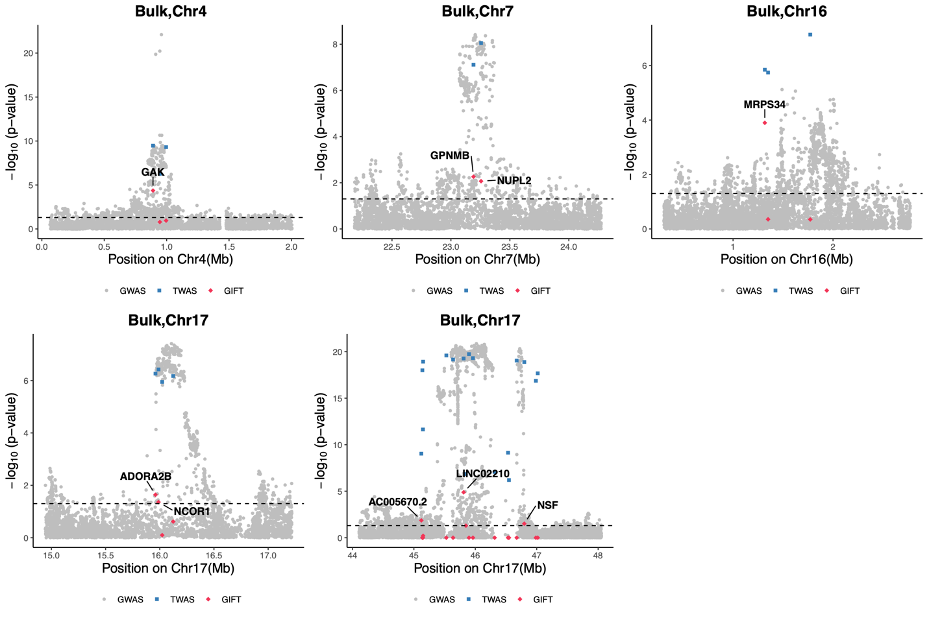

Fig. S10. Locus plots of the fine-mapped results by GIFT of TWAS-O results in oligodendrocytes (Oli) and oligodendrocyte precursor cells (Opc).
Each panel represents the fine-mapped results by GIFT within one genomic region (±1Mb around the top significant TWAS-O risk genes) that contains multiple significant TWAS-O risk genes. X-axis: chromosomal position (Mb); Y-axis: -log10(p-values) by GWAS (gray dots), TWAS-O (blue squares), and GIFT (red diamonds); Dashed horizontal line: the significance threshold of 0.05 for GIFT p-value. Genes with significant GIFT p-values < 0.05 are labeled with their gene names.

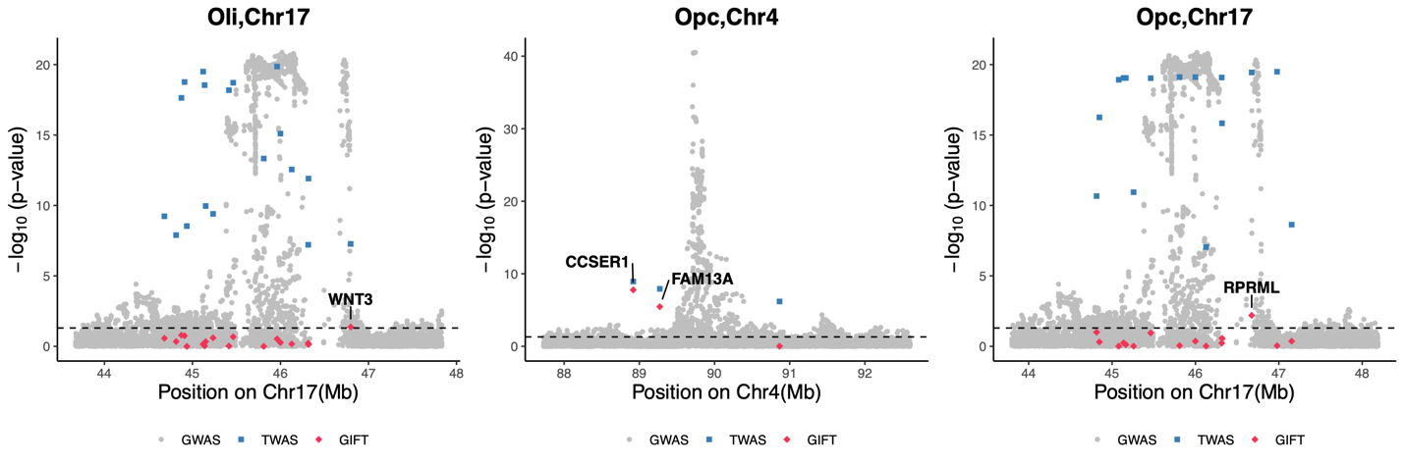

Fig. S11. Locus plots of the fine-mapped results by GIFT of TWAS-O results in proteomics (Proteome).
Each panel represents the fine-mapped results by GIFT within one genomic region (±1Mb around the top significant PWAS-O risk genes) that contains multiple significant PWAS-O risk genes. X-axis: chromosomal position (Mb); Y-axis: -log10(p-values) by GWAS (gray dots), PWAS-O (blue squares), and GIFT (red diamonds); Dashed horizontal line: the significance threshold of 0.05 for GIFT p-value. Genes with significant GIFT p-values < 0.05 are labeled with their gene names.

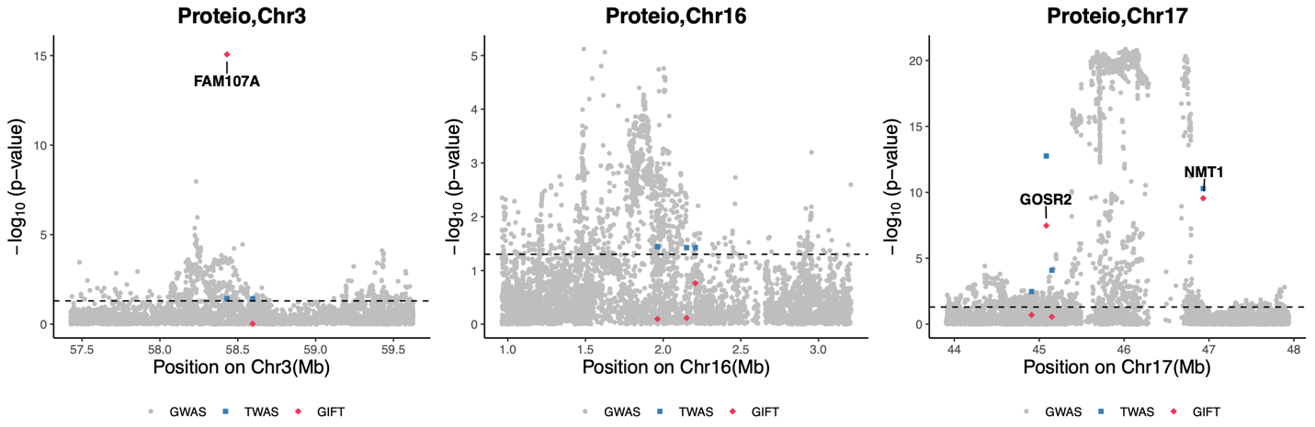

Fig S12. Venn diagram of detected significant risk genes by xWAS-O analyses integrating multi-omics data of dorsolateral prefrontal cortex and GWAS summary data of Parkinson’s disease.
The Venn diagram shows the overlapped numbers of significant risk genes of PD identified using three omics reference panels.

Fig. S13. Jaccard similarity indexes of overlapped transcriptome-wide and proteome-wide significant TWAS-O/PWAS-O risk genes by pair-wise comparisons.
Jaccard similarity index is the proportion of overlapped significant risk genes among the union of unique significant risk genes detected by both compared analyses. Only genes with exactly the same names are considered overlapped in the calculation of Jaccard similarity indexes. Higher Jaccard Index value represents higher proportions of overlapped findings.

Fig S14. Numbers of significant risk genes detected by xWAS-O analyses integrating multi-omics data of dorsolateral prefrontal cortex and GWAS summary data of Parkinson’s disease.

