Supporting Information
In vitro antioxidant and anti-inflammatory activity of Secondary Metabolites, Fractions and Extracts from Allium subhirsutum L.
Dilara Nur Abacı^{[a]}, Sibel Avunduk^{[a]}*
^{[a]} Vocational School of Health Care, Mugla Sıtkı Kocman University, Marmaris, Mugla, 48187, Turkey
*E-mail: sibelavunduk@mu.edu.tr
sibel.avunduk@gmail.com

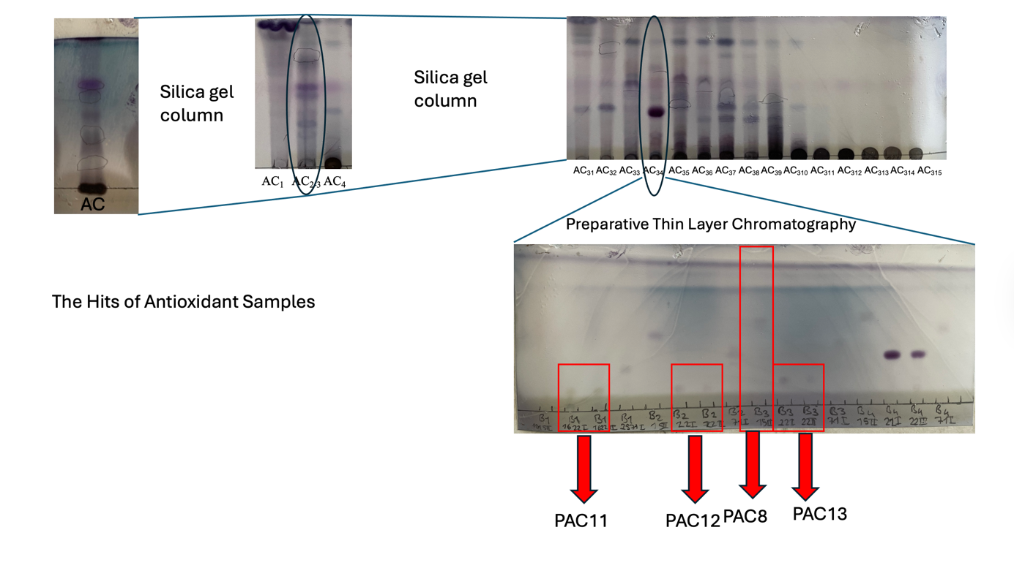
Figure 1. The Most Antioxidant Samples

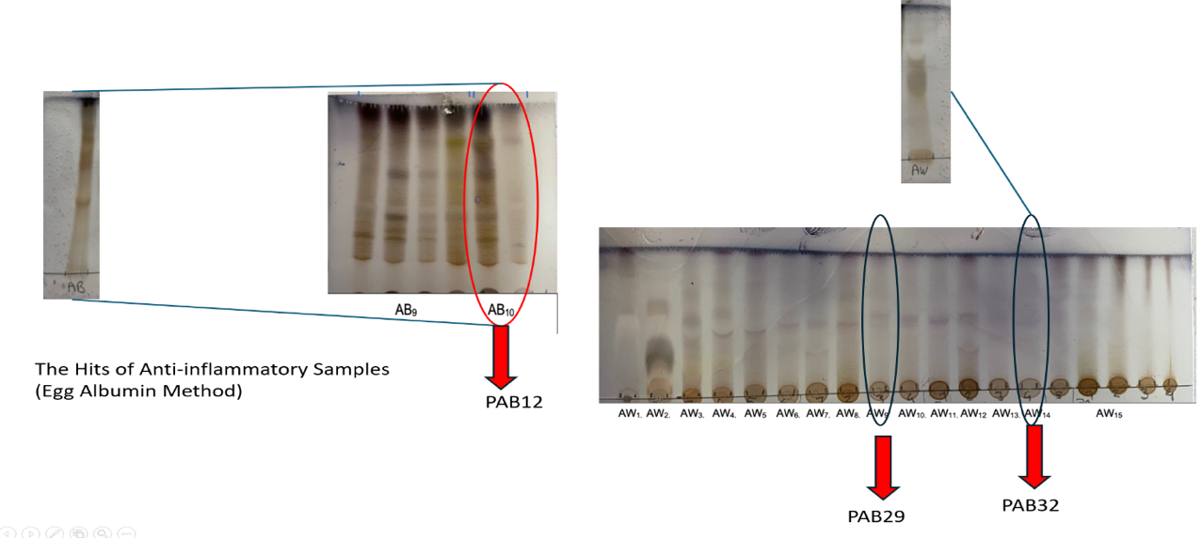
Figure 2. The Most Anti-inflammatory polar extract column fractions in the egg albumin denaturation method

Figure 3. The Most Anti-inflammatory nonpolar extract column fractions in the egg albumin denaturation method

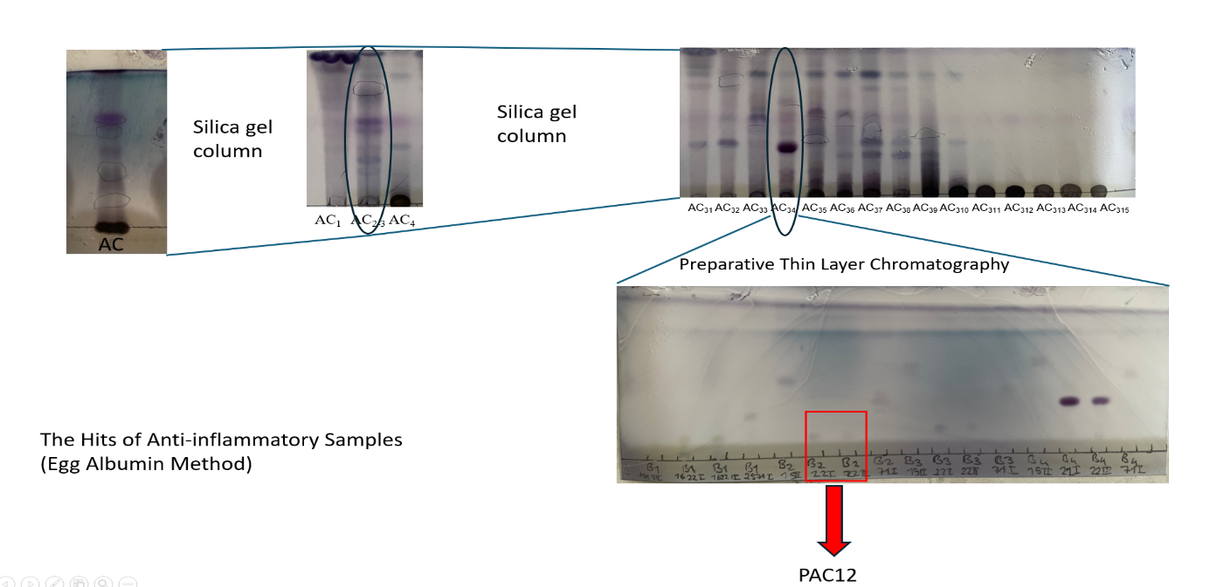

Figure 4. The Most Anti-inflammatory nonpolar extract column fractions in the egg albumin denaturation method and lipoxygenase inhibition method.

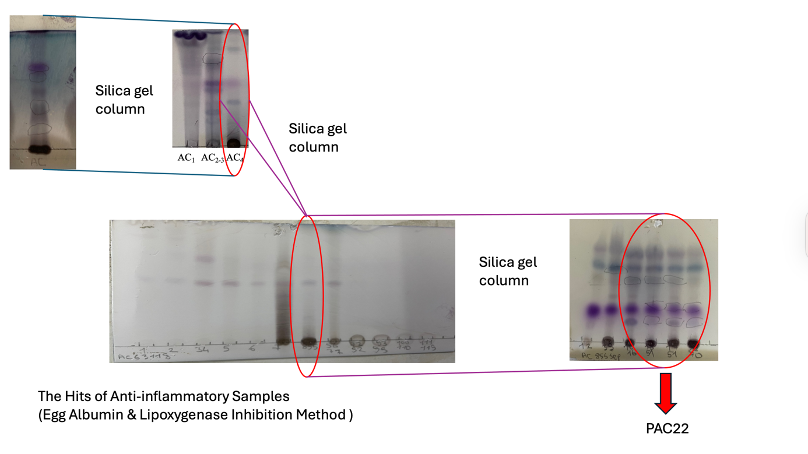

Figure 5. The Most Anti-inflammatory n-BuOH extract column fractions in the lipoxygenase inhibition method.
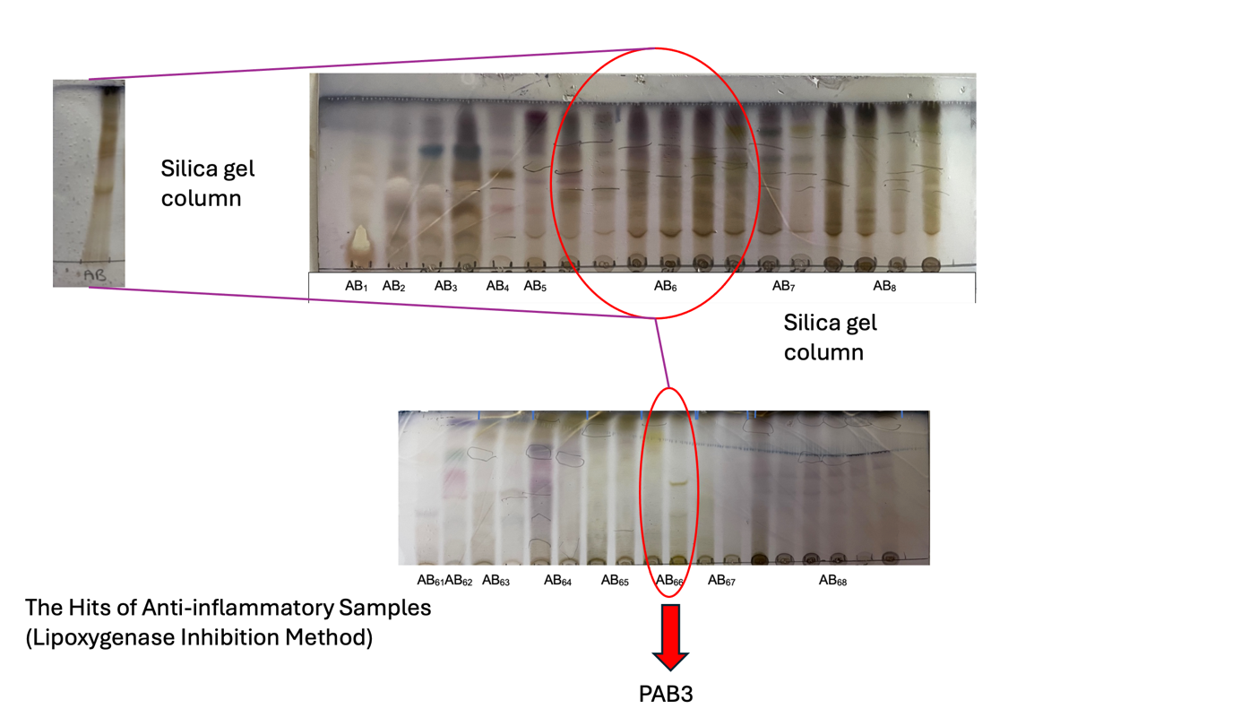

Figure 6. The Most Anti-inflammatory H₂O extract column fractions in the lipoxygenase inhibition method.

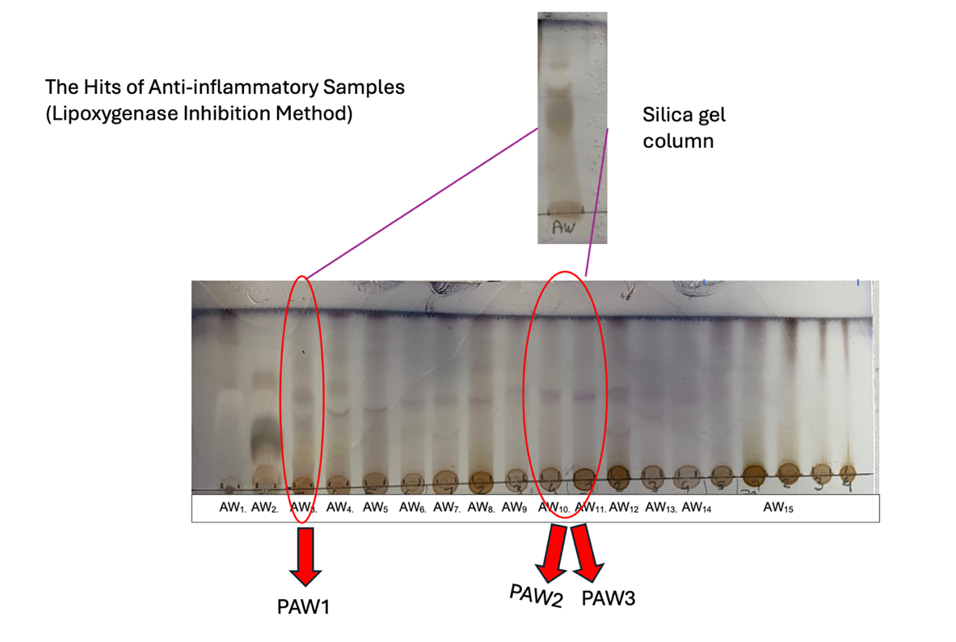

Figure 7. Selected antioxidant assay Photos
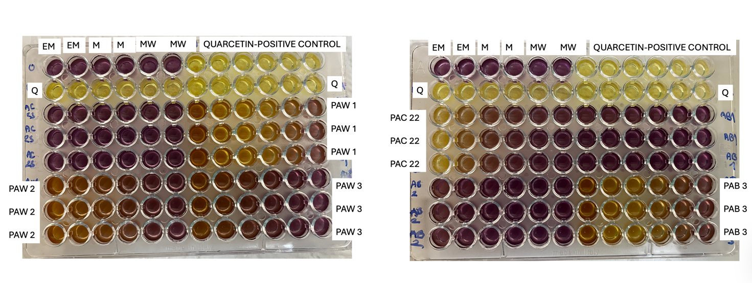

EM: Ethylacetat-Methanol mixture- Solvent Blank
M:Methanol- Solvent Blank
MW: Methanol-Water mixture- Solvent Blank
Q:Quarcetin-Positive Control

Figure 8. Lipoxygenase Inhibition Assay Photo
