Supplementary Figures 1-10: Cross-stratification heatmaps demonstrating the combined influence of Body Mass Index (BMI) and De Ritis (AST/ALT) ratio on serum lipid profiles and NMR-derived lipoprotein subfraction concentrations. Each cell displays the mean concentration of the respective biomarker within a specific intersection of standard WHO BMI categories (y-axis) and predefined De Ritis ratio intervals (x-axis). The color gradient visually maps the magnitude of these mean concentrations, with warmer colors (red/orange) indicating higher values and cooler colors (green/yellow) representing lower values. Blank cells denote subgroup combinations with no or insufficient data points.

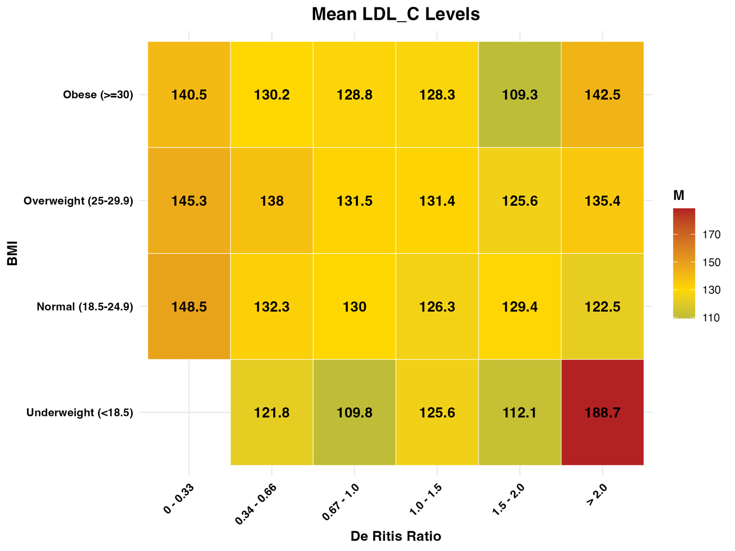
Supplementary Figure 1. Mean Low-Density Lipoprotein Cholesterol (LDL-C) levels.

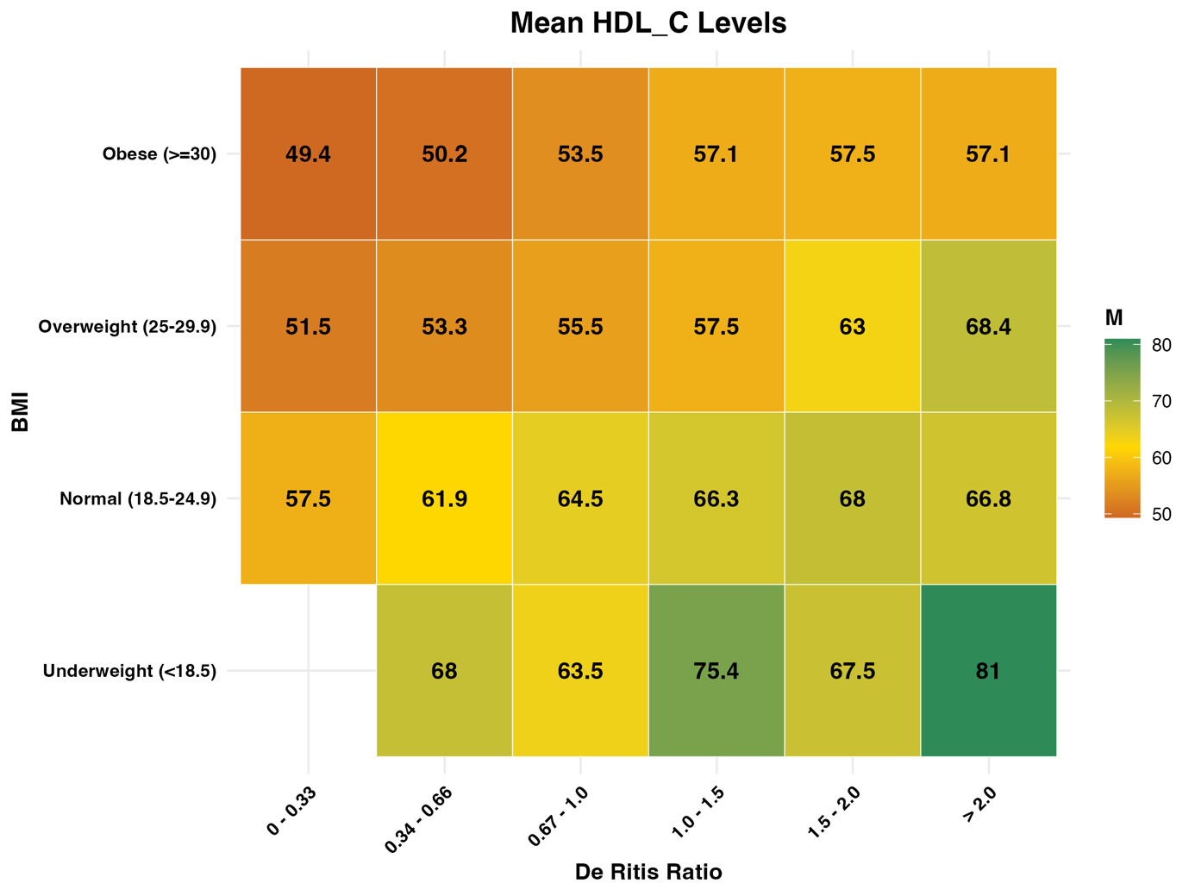
Supplementary Figure 2. Mean High-Density Lipoprotein Cholesterol (HDL-C) levels.
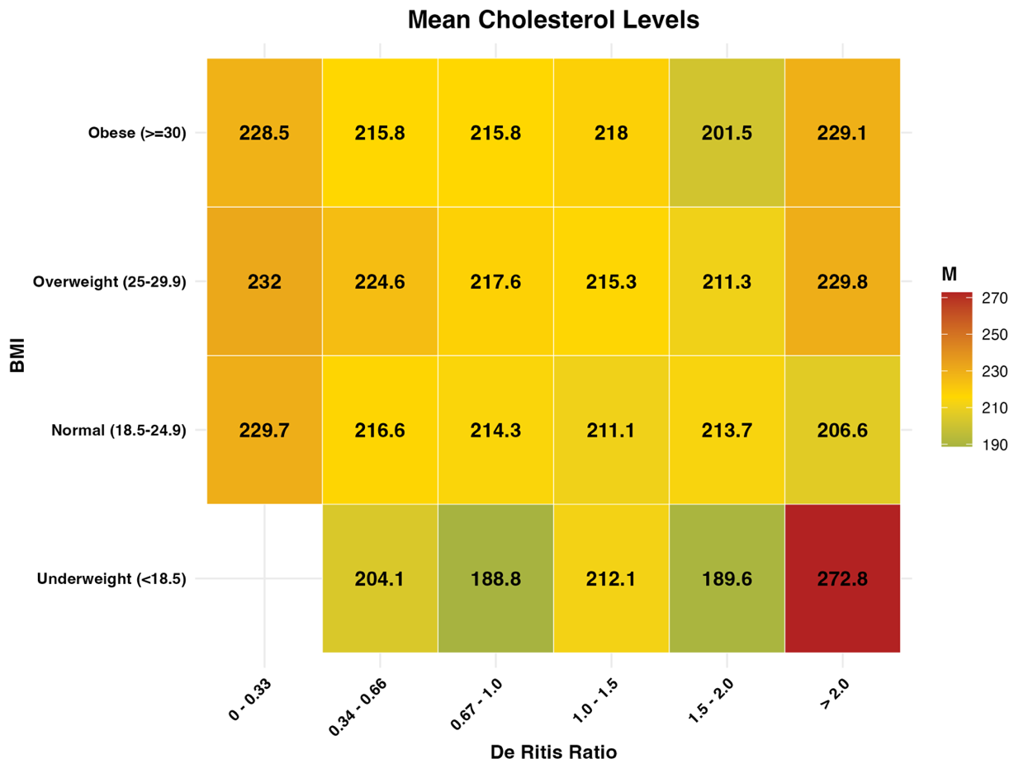Supplementary Figure 3. Mean Total Cholesterol levels.
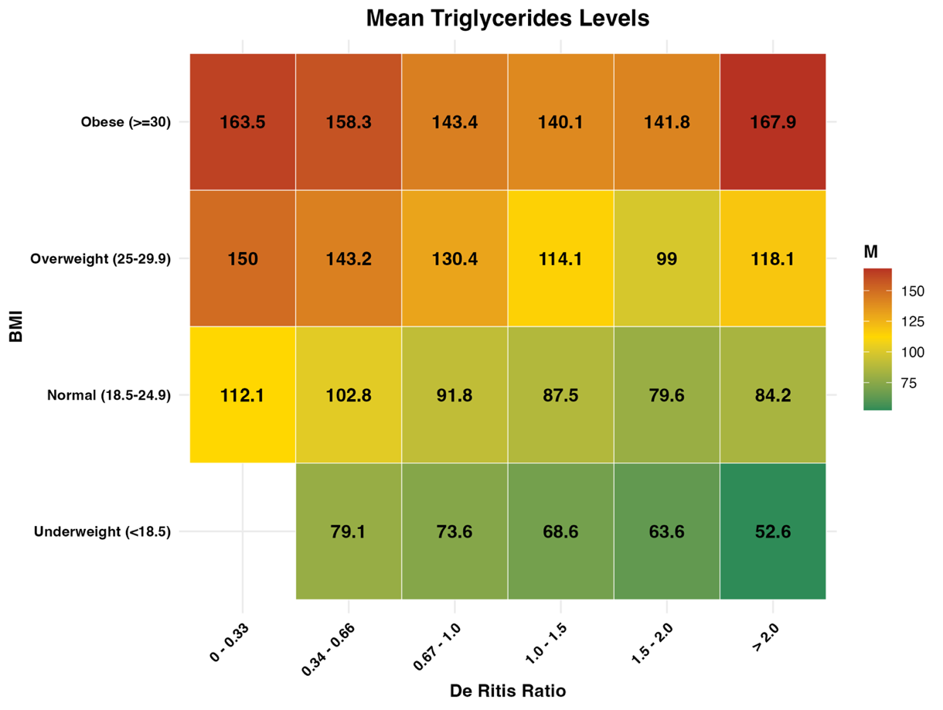Supplementary Figure 4. Mean Triglyceride levels.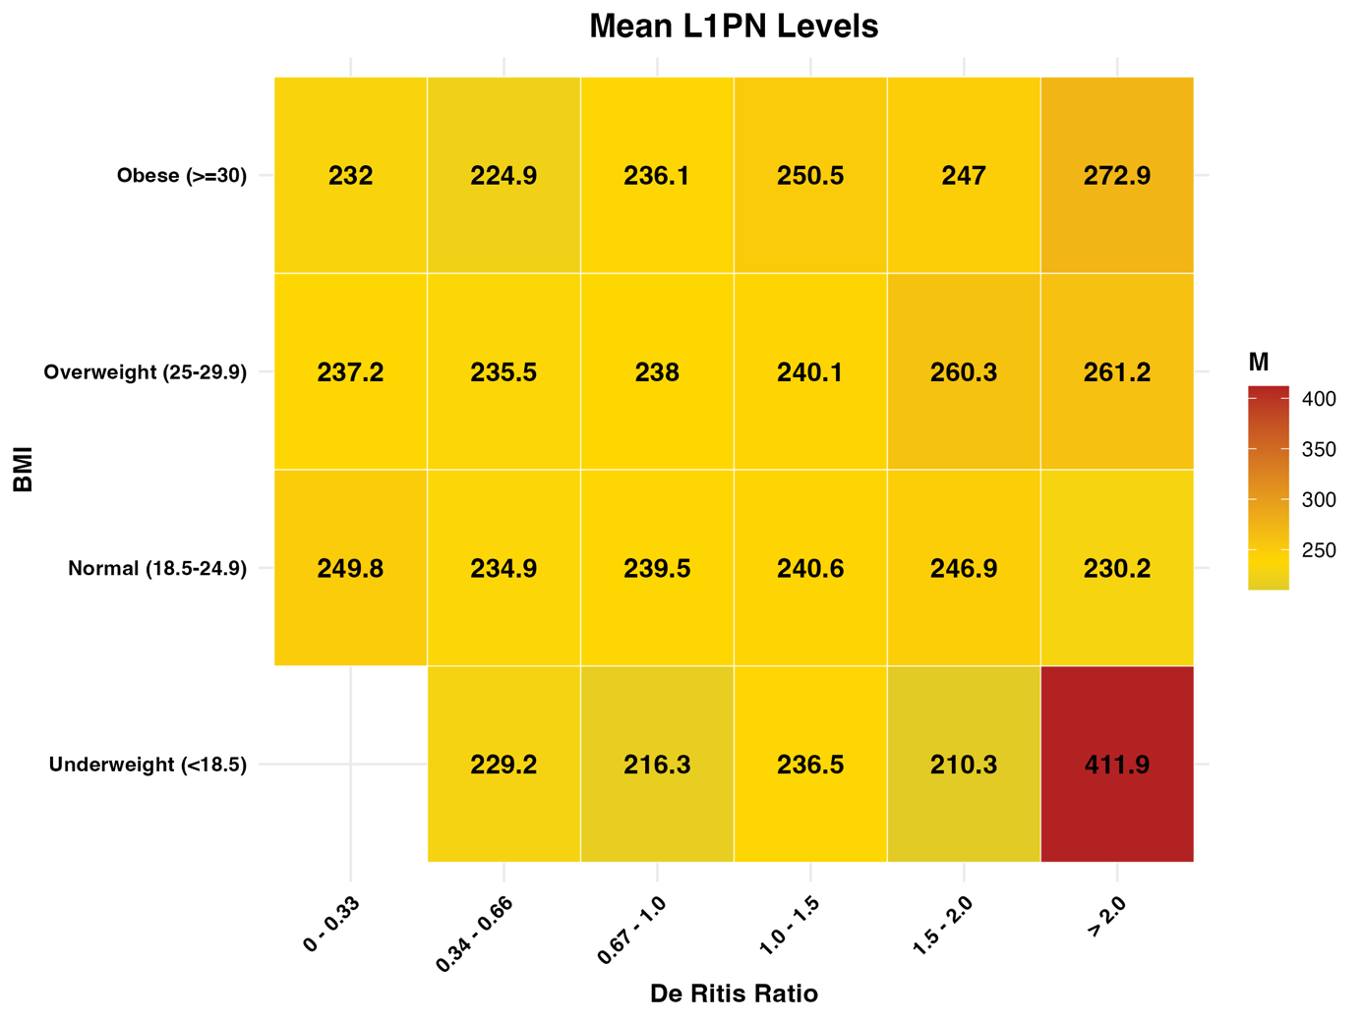
Supplementary Figure 5. Mean L1PN concentrations.

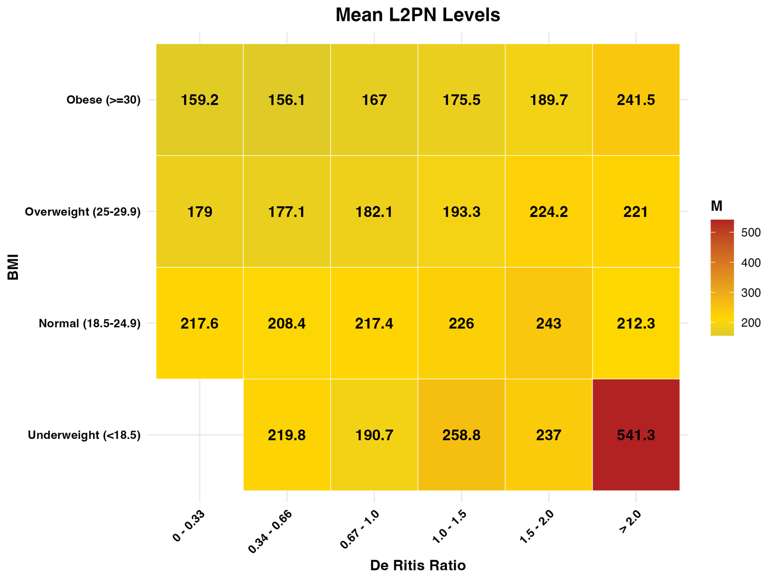
Supplementary Figure 6. Mean L2PN concentrations.
• 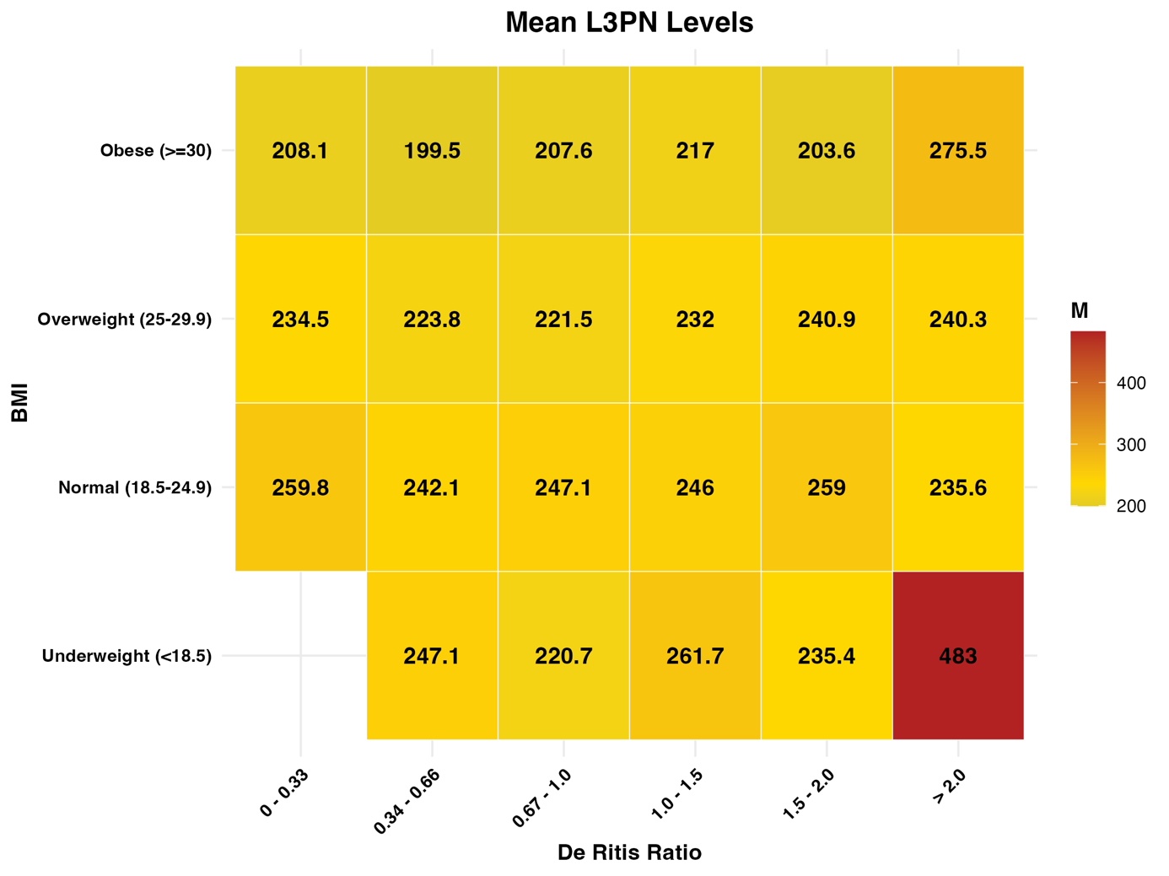 Supplementary Figure 7. Mean L3PN concentrations.

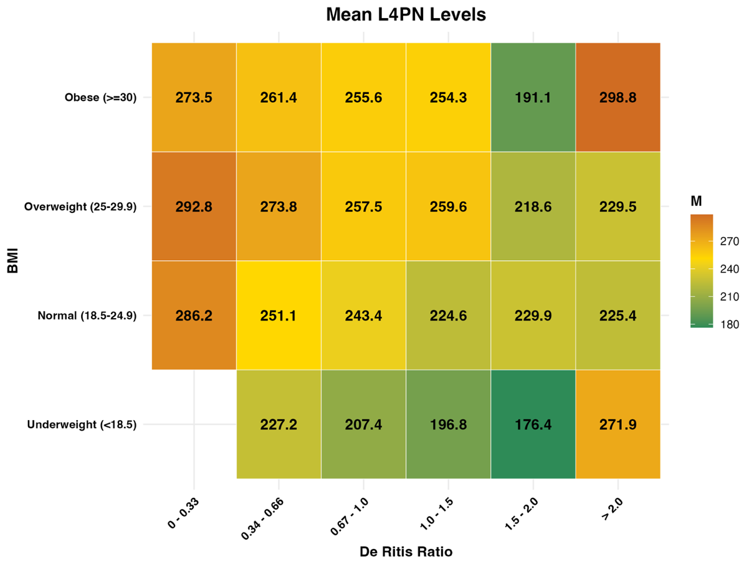 Supplementary Figure 8. Mean L4PN concentrations.
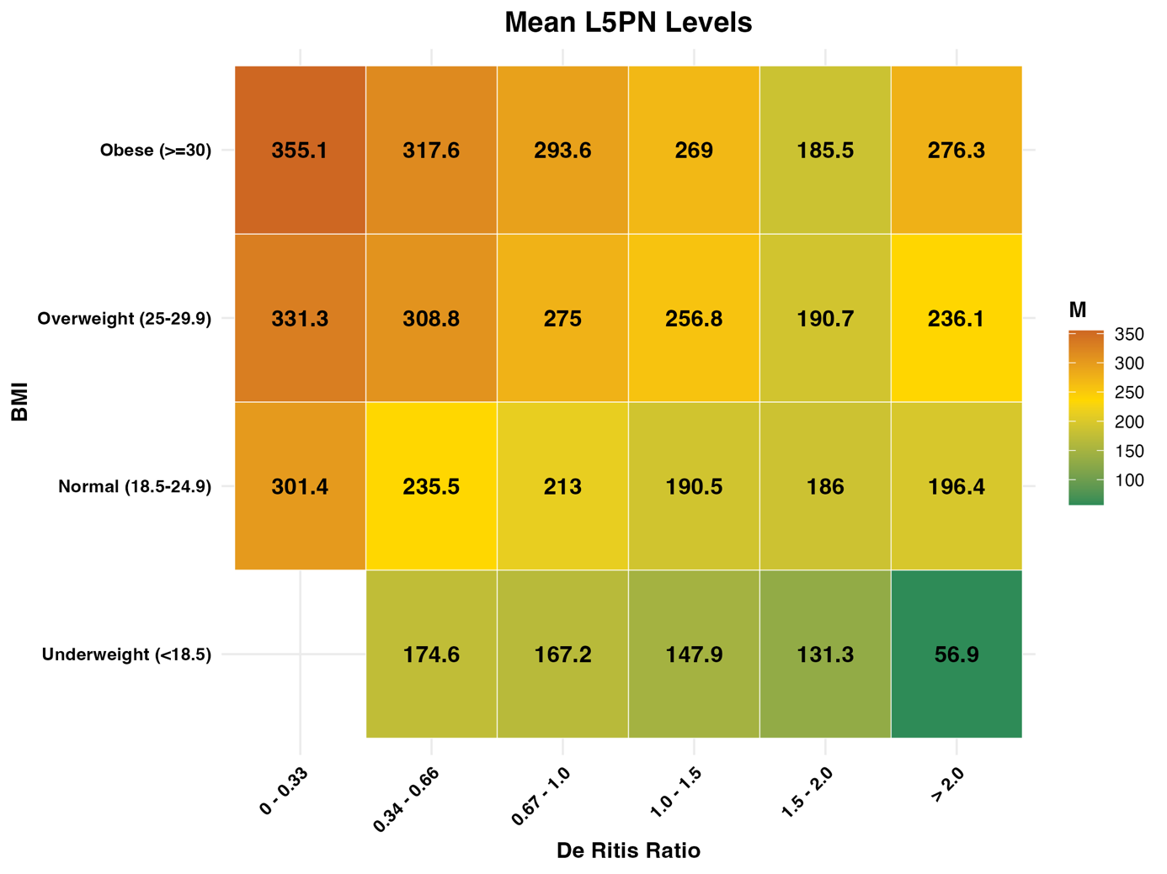 Supplementary Figure 9. Mean L5PN concentrations.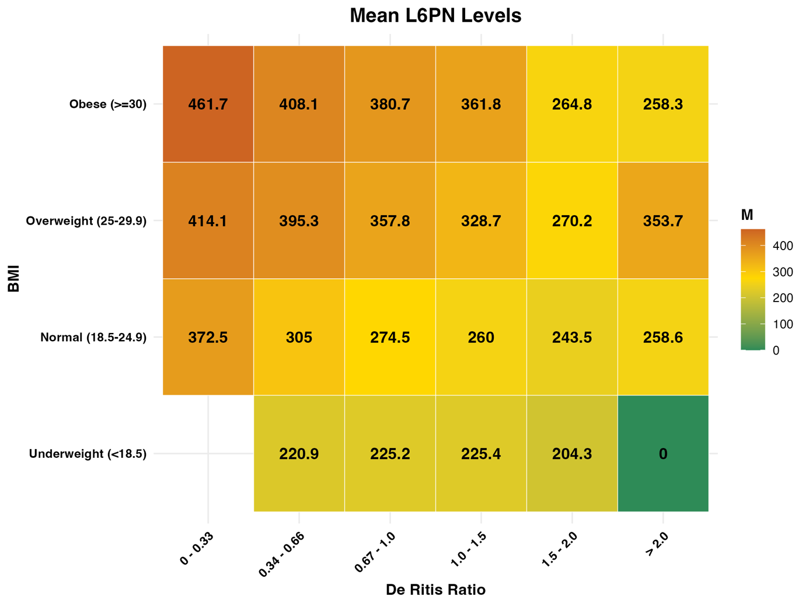 Supplementary Figure 10. Mean L6PN concentrations.

