Strongly Coupled Quadrupolar Resonances from Edge-Oriented Plasmonic Nanocube Lattices

Alexander D. Fuqua, ¹ Yufei Wang, ² Bin Wang, ¹ and Andrea R. Tao^{1,2}*
- Aiiso Yufeng Li Family Department of Chemical and Nano Engineering, University of California San Diego, La Jolla, CA 92023-0448
- Materials Science and Engineering Program, University of California San Diego, La Jolla, CA 92023
* Email: atao@ucsd.edu

Supplementary Methods:
Fitting Exponential Equation:
To fit the wavelength shift versus relative gap distance data points in figure 4d, an exponential decay function was used in OriginPro 2024. The equation is shown below. 400 nm is used for λ₀ and 105 nm is used for the nanocube (NC) face diagonal length.
$$\begin{aligned}\frac{∆λ}{λ_{0}}=0.33\exp\left(\frac{-{Gap}/{NC}Diagonal }{0.12}\right)-0.008 \#\left(1\right)\end{aligned}$$
To fit the wavelength shift versus relative gap distance data points in figure 6c, an exponential decay function was used in OriginPro 2024. The equation is shown below. 398 nm is used for λ₀ and 105 nm is used for the NC periodic length.
$$\begin{aligned}\frac{∆λ}{λ_{0}}=0.45\exp\left(\frac{-{Gap}/{NC}Periodic Length }{0.08}\right)-0.010 \#\left(2\right)\end{aligned}$$
Supplementary Figures:
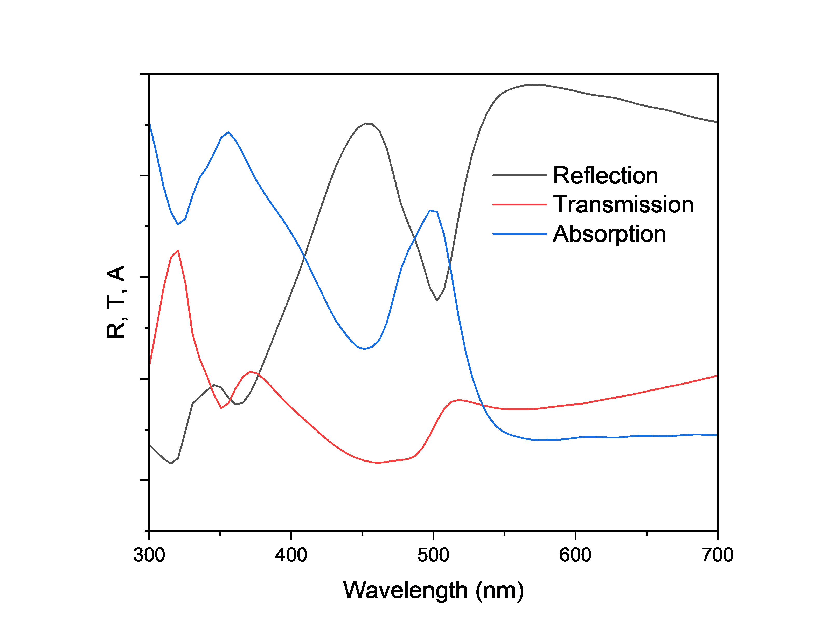
Fig. S1 Reflection, Transmission, and Absorption of Ag NC CB with 5.5 nm gaps

Fig. S2 (a) Model of Ag NC simulation. Gap distance is the spacing between NC edges. (b) Reflection spectra of Ag NCs where the water level is 70 nm and the gap distance is varied.

Fig. S3 (a) Model of two NCs with adjacent edges with electric field monitor outlined in yellow. (b) Absorption, scattering and extinction cross sections for the edge-to-edge dimer with different incident light directions. (c) Electric field heatmap of the dimer with a wavelength of 400 nm with light incident from the y-direction. (d) Electric field heatmap of the dimer with a wavelength of 582 nm with light incident from the y-direction.

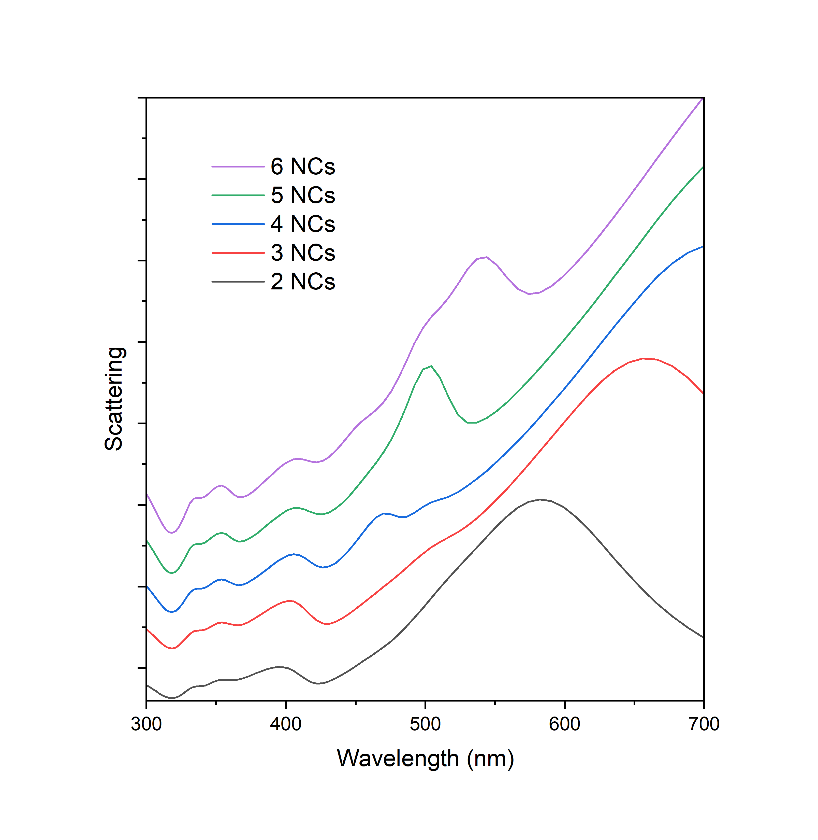Fig. S4 Scattering spectra of increasing number of NCs connected edge-to-edge illuminated from the z direction.

Fig. S5 (a) Model of multiple NCs with y and z illumination directions shown. (b) Absorption spectra of 4 to 6 NCs connected edge-to-edge illuminated from the y direction. (c) Electric field heat map of cross section of four NCs illuminated from the z direction with a wavelength of 470 nm (d-e) Electric field heat map of cross section of six NCs illuminated from the y-direction with a wavelength of (d) 543 nm and of (e) 460 nm.

