Supplementary Materials

Supplementary Material 1: Extended demographics information

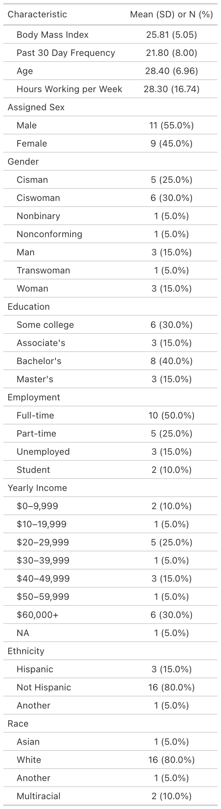

Supplementary Table 2: Complete AMEs table, including main effects of edibles on entire model

Main Effects and Pairwise Contrast Comparisons Between AMEs
 | DRUID |  |  | SHAS 3
 | Main Effects |  |  | Main Effects
Predictor | AME | 95%CI | p | AME | 95%CI | p
Edible
Fast | 0.001306 | (-0.003, 0.006) | 0.561 | 0.00031 | (0.000, 0.001) | 0.0442 *
Standard | -0.000767 | (-0.005, 0.004) | 0.731 | 0.000324 | (0.000, 0.001) | 0.0126 *
Placebo | -0.001233 | (-0.006, 0.0031) | 0.572 | 0.0000365 | (0.000, 0.0001) | 0.3434
Time | -0.000238 | (-0.003, 0.002) | 0.8533 | 0.000222 | (0.000, 0.000) | 0.0103 *
Age | 0.2187 | (0.021, 0.416) | 0.0298 * | -0.002 | (-0.019, 0.008) | 0.684
BMI | -0.186 | (-0.451, 0.080) | 0.17 | -0.00796 | (-0.022, 0.006) | 0.274
Past 30 Day Cannabis Use | 0.057 | (-0.110, 0.223) | 0.5 | -0.0052 | (-0.015, 0.004) | 0.286
Assigned Sex ( Female - Male) | 2.17 | (-0.476, 4.830) | 0.108 | 0.042 | (-0.090, 0.174) | 0.5329
 | Pairwise Differences |  |  | Pairwise Differences
Fast - Placebo | 0.922 | (-0.172, 2.017) | 0.0987 | 0.1009 | (0.014, 0.188) | 0.0224 *
Standard - Placebo | 1.401 | (0.307, 2.495) | 0.0121 * | 0.1273 | (0.025, 0.230) | 0.0149 *
Fast - Standard | -0.479 | (-1.574, 0.616) | 0.3916 | -0.0265 | (-0.106, 0.053) | 0.5121
 | SHAS 4 |  |  | SHAS 5
 | Main Effects |  |  | Main Effects
Predictor | AME | 95%CI | p | AME | 95%CI | p
Edible
Fast | 0.000334 | (0.000, 0.001) | 0.0548 | -0.000267 | (-0.001, 0.000) | 0.249
Standard | 0.000276 | (0.000, 0.001) | 0.1033 | -0.000107 | (-0.001, 0.000) | 0.664
Placebo | 0.0000479 | (0.000, 0.0001) | 0.2511 | -0.000044 | (0.000, 0.0001) | 0.588
Time | 0.000217 | (0.000, 0.000) | 0.0535 | -0.000137 | (0.000, 0.000) | 0.2468
Age | -0.0018 | (-0.002, 0.012) | 0.7974 | -0.0073 | (-0.016, 0.001) | 0.0866
BMI | -0.0235 | (-0.058, 0.011) | 0.1785 | -0.0035 | (-0.009, 0.002) | 0.2194
Past 30 Day Cannabis Use | -0.015 | (-0.037, 0.008) | 0.1947 | -0.00729 | (-0.014, 0.000) | 0.0528
Assigned Sex ( Female - Male) | 0.183 | (-0.072, 0.438) | 0.16 | 0.04557 | (-0.022, 0.113) | 0.1873
 | Pairwise Differences |  |  | Pairwise Differences
Fast - Placebo | 0.143 | (-0.023, 0.308) | 0.0908 | 0.0504 | (-0.006, 0.106) | 0.0774
Standard - Placebo | 0.13 | (-0.018, 0.277) | 0.0856 | 0.0691 | (0.004, 0.135) | 0.0388 *
Fast - Standard | 0.013 | (-0.064, 0.090) | 0.7388 | -0.0187 | (-0.084, 0.046) | 0.5739
 | SHAS 6 |  |  | SHAS 10
 | Main Effects |  |  | Main Effects
Predictor | AME | 95%CI | p | AME | 95%CI | p
Edible
Fast | 0.000227 | (0.000, 0.000) | 0.0463 * | 0.000742 | (0.000, 0.001) | 0.0153 *
Standard | 0.000141 | (0.000, 0.000) | 0.041 * | 0.000752 | (0.000, 0.001) | 0.0117 *
Placebo | 0 | (0.000, 0.0000) | 0.9995 | 0.0000808 | (0.000, 0.0002) | 0.0876
Time | 0.000121 | (0.000, 0.000) | 0.0232 * | 0.000521 | (0.000, 0.001) | 0.00517 **
Age | -0.0204 | (-0.049, 0.008) | 0.1553 | -0.0338 | (-0.078, 0.010) | 0.13276
BMI | 0.000922 | (-0.009, 0.011) | 0.8518 | -0.03113 | (-0.075, 0.013) | 0.16556
Past 30 Day Cannabis Use | -0.0122 | (-0.028, 0.003) | 0.1231 | -0.007125 | (-0.029, 0.015) | 0.52856
Assigned Sex ( Female - Male) | 0.242 | (-0.090, 0.573) | 0.1533 | -0.012967 | (-0.314, 0.288) | 0.93267
 | Pairwise Differences |  |  | Pairwise Differences
Fast - Placebo | 0.1403 | (-0.010, 0.291) | 0.0677 | 0.3048 | (0.045, 0.564) | 0.0213 *
Standard - Placebo | 0.1085 | (-0.001, 0.218) | 0.053 | 0.319 | (0.059, 0.579) | 0.0162 *
Fast - Standard | 0.0318 | (-0.061, 0.125) | 0.5022 | -0.0142 | (-0.259, 0.230) | 0.9092
 | SHAS 12 |  |  | SHAS 13
 | Main Effects |  |  | Main Effects
Predictor | AME | 95%CI | p | AME | 95%CI | p
Edible
Fast | 0.000657 | (0.000, 0.001) | 0.0649 | 0.000314 | (0.000, 0.001) | 0.0954
Standard | 0.000616 | (0.000, 0.001) | 0.0638 | 0.000249 | (-0.001, 0.001) | 0.1063
Placebo | 0.000205 | (0.000, 0.0005) | 0.1628 | 0.0000806 | (0.000, 0.0002) | 0.2675
Time | 0.00049 | (0.000, 0.001) | 0.051 | 0.000213 | (0.000, 0.000) | 0.0497 *
Age | -0.01666 | (-0.057, 0.024) | 0.4233 | -0.0105 | (-0.029, 0.008) | 0.2692
BMI | -0.03829 | (-0.105, 0.029) | 0.2629 | 0.000643 | (-0.015, 0.016) | 0.9352
Past 30 Day Cannabis Use | -0.01403 | (-0.048, 0.020) | 0.4123 | 0.000297 | (-0.010, 0.010) | 0.9546
Assigned Sex ( Female - Male) | 0.13131 | (-0.314, 0.576) | 0.5631 | 0.0938 | (-0.097, 0.285) | 0.3356
 | Pairwise Differences |  |  | Pairwise Differences
Fast - Placebo | 0.2175 | (-0.047, 0.482) | 0.1067 | 0.11613 | (-0.022, 0.254) | 0.099
Standard - Placebo | 0.2299 | (-0.042, 0.502) | 0.0978 | 0.11823 | (-0.017, -0.254) | 0.0874
Fast - Standard | -0.0124 | (-0.211, 0.186) | 0.9027 | -0.00211 | (-0.140, 0.136) | 0.9761

Supplementary Material 3: Individual Pairwise comparison tables
DRUID
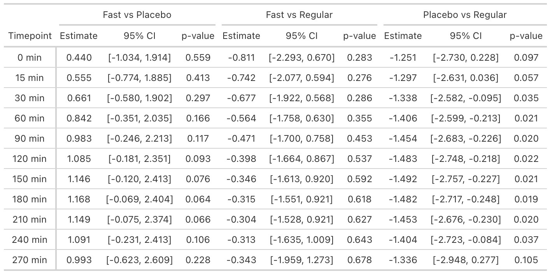

SHAS 3 “Clumsiness”
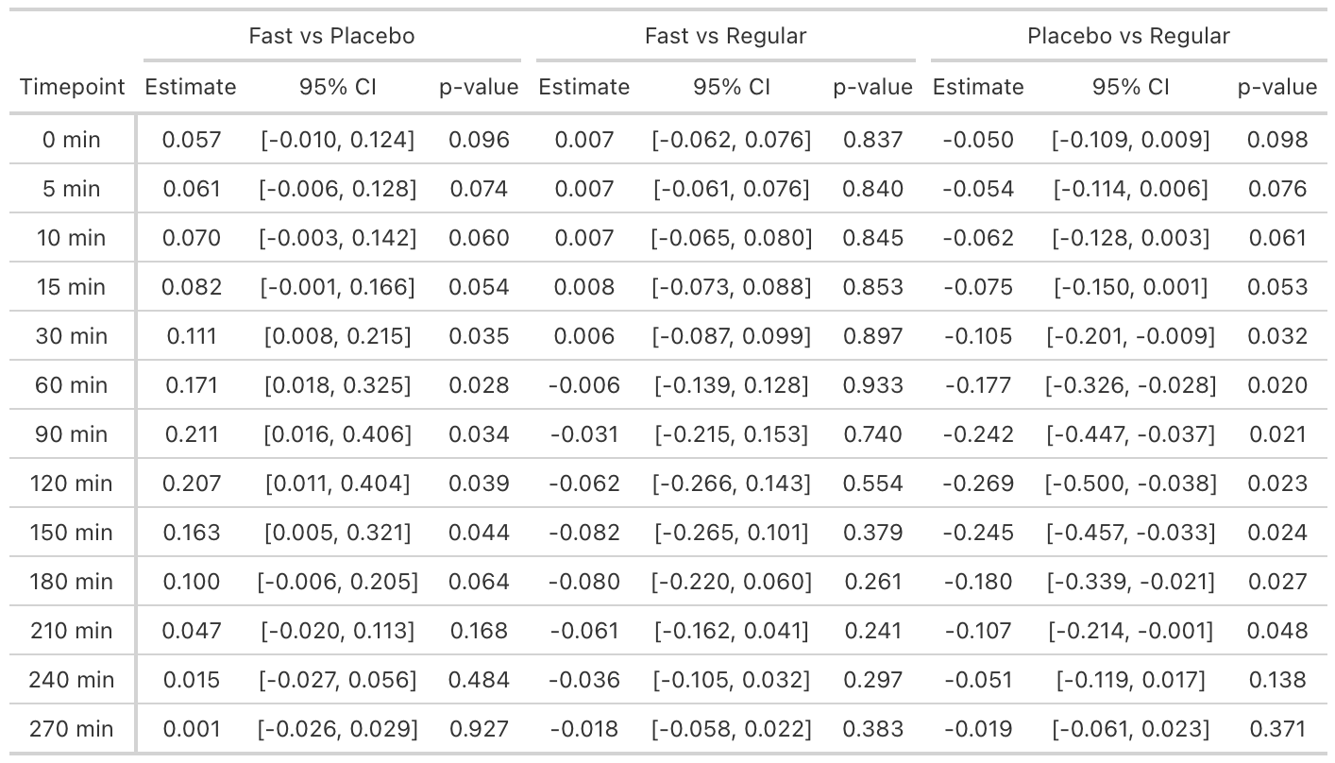

SHAS 4 “Confusion”
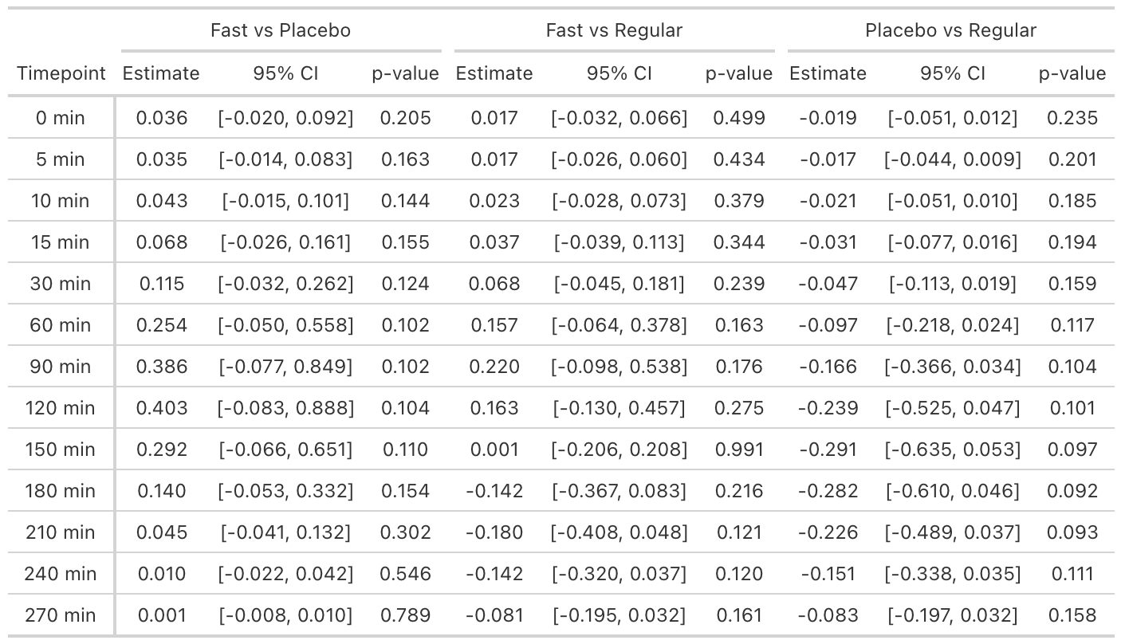

SHAS 5 “Slurring of Speech”
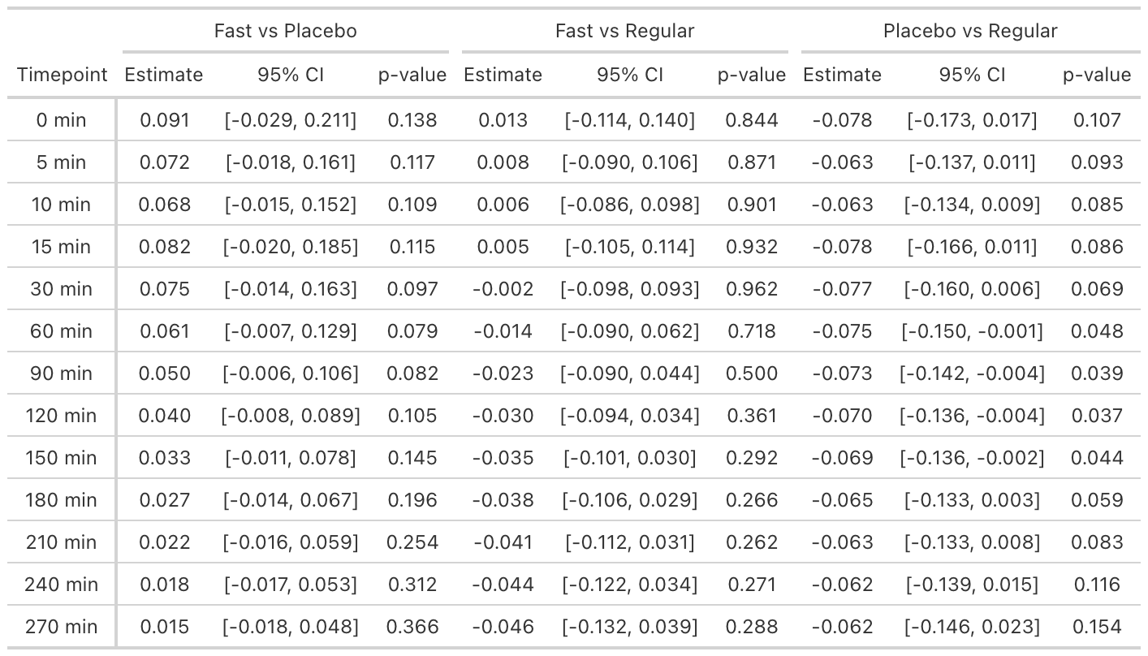

SHAS 6 “Dizziness”
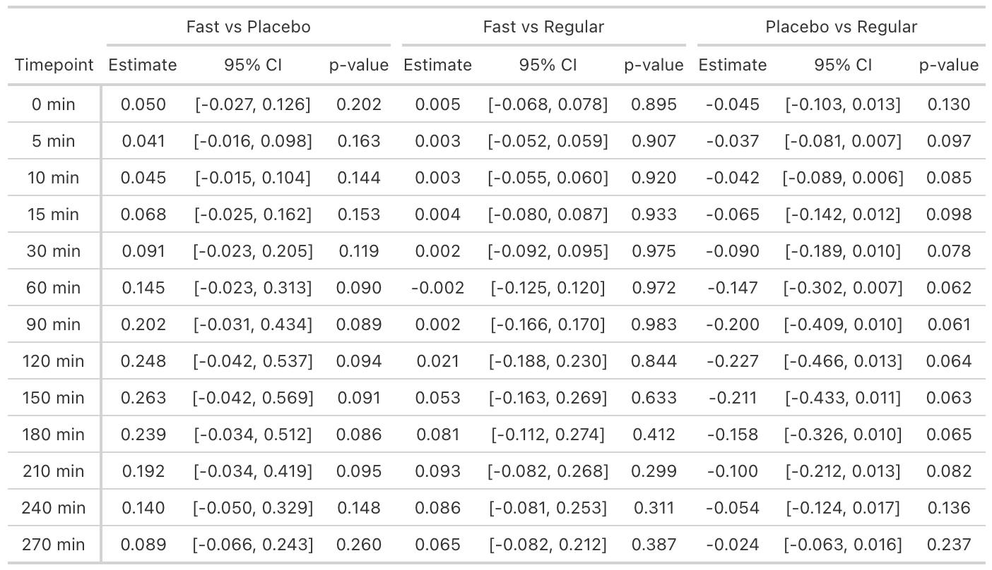

SHAS 10 “Distortion of Time”
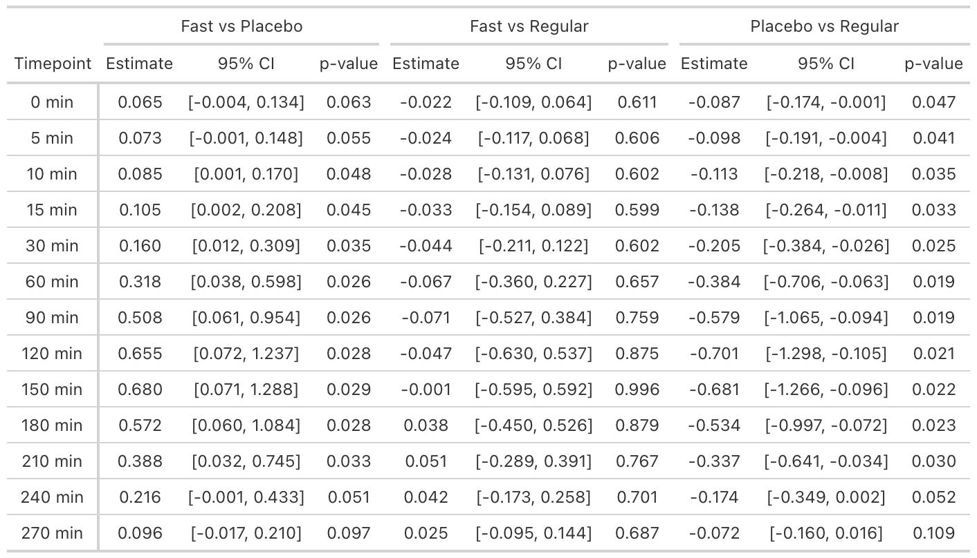

SHAS 12 “Difficulty Concentrating”
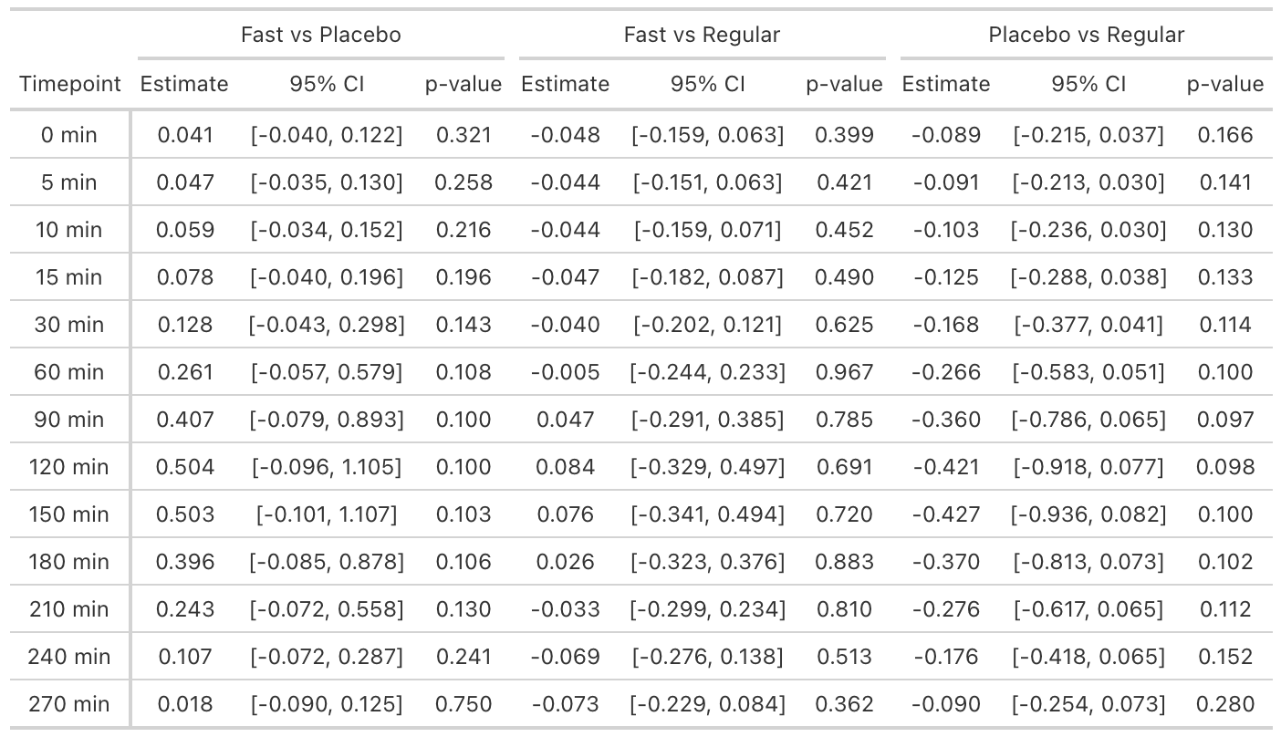

SHAS 13 “Feelings of Floating”
