Supplementary Information
Enhancement of Podoplanin-mediated melanoma internalization and reduction of IZKF-regulated phagocytic clearance improve efficiency of nanomedicine
Lin Li*^{, a}, Xiaoling Zhang^{c}, Ziye Liª, Zhiyun Yi^{c}, Yuling Chen^{c}, Zeyan Liª, Na Jiª, Qi Huang^{f}, Jingwen Sunª, Xiaoxuan Wang^{f}, Yucheng Xiang^{f}, Yingying Hou^{e}, Xiangyi Ren^{d}, Jinjue Zhang^{d}, Zhirong Zhang^{c}, Ling Zhang*^{, a, b}
ª West China School of Public Health and West China Fourth Hospital, Sichuan University, Chengdu 610041, China.
^{b}Med-X center for Materials, College of Polymer Science and Engineering, Sichuan University, Chengdu 610065, China.
^{c}Key Laboratory of Drug Targeting and Drug Delivery Systems of Ministry of Education, West China School of Pharmacy, Sichuan University, Chengdu 610065, China.
^{d}West China Hospital, Sichuan University, Chengdu 610065, China.
^{e} Department of Pharmacy, Personalized Drug Research and Therapy Key Laboratory of Sichuan Province, Sichuan Provincial People’s Hospital, University of Electronic Science and Technology of China, Chengdu, 610072, China
^{f} School of Pharmacy, Chengdu Medical College, Chengdu, 610500, China
*Corresponding author. Tel.: 028-85501566; fax: 028-85501615
E-mail: lilin93@scu.edu.cn
zhangling83@scu.edu.cn
Figure S1. Basic characterization of nanomaterials. (a) TEM image of PLGA nanoparticles. n = 3. (b) SEM image of PLGA nanoparticles. n = 3. (c) Hydrodynamic size distribution of PLGA nanoparticles. n = 3. (d) Hydrodynamic size distribution of albumin nanoparticles. n = 3. (e) TEM image of liposomes. n = 3. (f) Hydrodynamic size distribution of polyurethane nanoparticles. n = 3. (g) TEM image of polystyrene nanoparticles. n = 3. (h) Hydrodynamic size distribution of polystyrene nanoparticles. n = 3. (i) SEM image of silica nanoparticles. n = 3. (j) TEM image of tumor cell membrane vesicles. n = 3. (k) TEM image of PCC. n = 3. (l) Hydrodynamic size distribution of PCC. n = 3.

Figure S2. Effect of sleep deprivation on the in vivo distribution of PLGA nanoparticles in mice. (a, b) Fluorescence intensity of PLGA nanoparticles in the heart, liver, spleen, lung, and kidney of mice evaluated by IVIS (a) and corresponding semi-quantitative analysis (b) at 8 h post-injection. n = 3. (c, d) Fluorescence intensity of PLGA nanoparticles in mouse plasma evaluated by IVIS (c) and semi-quantitative analysis (d) at 8 h post-injection. n = 3.

Figure S3. Effect of sleep deprivation on the in vivo distribution of albumin nanoparticles and liposomes in mice. (a, b) Effect of sleep deprivation on melanoma targeting of albumin nanoparticles evaluated by IVIS (a) and corresponding semi-quantitative fluorescence analysis (b) at 8 h post-injection. n = 3. (c, d) Effect of sleep deprivation on the distribution of albumin nanoparticles in heart, liver, spleen, lung and kidney of mice (c) and semi-quantitative fluorescence analysis (d) at 8 h post-injection. n = 3. (e, f) Effect of sleep deprivation on the distribution of liposomes evaluated by IVIS (e) and corresponding semi-quantitative fluorescence analysis (f) at 8 h post-injection. n = 4. (g, h) Effect of sleep deprivation on the distribution of liposomes in heart, liver, spleen, lung and kidney of mice (g) and semi-quantitative fluorescence analysis (h) at 8 h post-injection. n = 4.

Figure S4. Effect of post-SD recovery on the tumor targeting of PLGA nanoparticles in mice. (a, b) Fluorescence intensity of melanoma in mice detected by IVIS (a) and corresponding semi-quantitative analysis (b) at 8 h post-injection. n = 3.

Figure S5. Effect of sleep deprivation on the inflammatory factor in mice. (a–f) Serum levels of IL-6 (a), IL-1β (b), IL-4 (c), IFN-α1 (d), TNFα (e), and corticosterone (f) in mice after 12 h of sleep deprivation measured by ELISA kits. n = 4. (g, h) Immunofluorescence staining of intratumoral IL-6 in mice evaluated by CLSM (g) and corresponding semi-quantitative analysis (h). n = 7. Scale bar, 200 μm.

Figure S6. Effect of intravenous CXCL3 administration on tumor targeting of PLGA nanoparticles. (a, b) Fluorescence intensity of PLGA nanoparticles in mouse tumors evaluated by IVIS (a) and corresponding semi-quantitative analysis (b) at 8 h post-injection. n = 4.

Figure S7. Flow cytometric analysis of cellular PDPN expression. (a) PDPN expression in macrophages and B16F10 cells. n = 3. (b, c) Flow cytometric analysis of PDPN expression in wild-type B16F10 cells and B16F10^{PDPN-KO} cells. n = 3.

Figure S8. Effect of dexamethasone (5 μM) on PDPN expression in B16F10 cells evaluated by flow cytometry (a) and corresponding semi-quantitative fluorescence analysis (b). t = 12 h. n = 4.

Figure S9. Effect of IL-17A on PDPN expression in B16F10 cells analyzed by flow cytometry. t = 12 h. n = 3.

Figure S10. Effect of PDPN in B16F10 cells on the uptake of PLGA nanoparticles. (a) CLSM observation of PLGA nanoparticle uptake by B16F10^{PDPN-KO} cells. t = 6 h, n = 4. (b, c) Flow cytometric analysis of PLGA nanoparticle uptake by B16F10^{PDPN-KO} cells (b) and corresponding semi-quantitative analysis (c). n = 4. (d) PLGA nanoparticle uptake by B16F10^{PDPN-OE} cells in the absence of mouse plasma. n = 4. (e, f) Flow cytometric analysis of PLGA nanoparticle uptake by B16F10^{PDPN-OE} cells (e) and the corresponding semi-quantitative analysis (f). n = 4.

Figure S11. The morphology of tumors in mice. n = 3.

Figure S12. IL-6-mediated p-STAT3 activation and JAK1 inhibition-regulated PDPN expression and the uptake of nanoparticles in B16F10 cells. (a) Western blot analysis of p-STAT3 protein expression in B16F10 cells treated with IL-6. (b, c) Flow cytometric analysis of the effect of JAK1-IN-13 on PDPN expression in B16F10 cells (b) and corresponding semi-quantitative analysis (c). t = 12 h, n = 3. (d, e) Flow cytometric analysis of the effect of JAK1-IN-13 on PLGA nanoparticle uptake by B16F10 cells (d) and corresponding semi-quantitative fluorescence analysis (e). t = 4 h, n = 3.

Figure S13. Molecular dynamics simulations of the binding between PLGA nanoparticles and CLEC2. (a) The number of contacts between PLGA nanoparticles and CLEC2. (b) The number of contacts between lactic acid (LA) and glycolic acid (GA) and CLEC2. (c) CLEC2-PLGA center of mass distance. (d) CLEC2 residue contribution during the binding of PLGA nanoparticles and CLEC2. TC5 - Aromatic (CLEC2); C1 - Hydrophobic (CLEC2); P1 - Polar (CLEC2); P2 - Polar + Hbond (CLEC2); P3 - Intermediate polar (CLEC2); P4 - Highly polar (CLEC2); Qa - Negative (CLEC2); Qd - Positive (CLEC2).

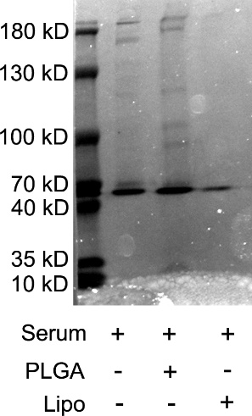
Figure S14. Plasma protein corona adsorbed on PLGA nanoparticles and liposomes were analyzed by SDS‑PAGE and visualized by coomassie brilliant blue staining.

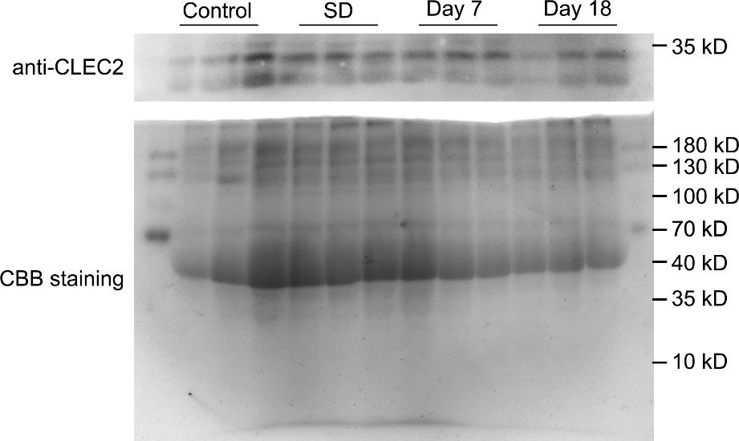
Figure S15. The plasma protein level in mice. The upper panel shows the western blot analysis of CLEC2, and the lower panel shows the coomassie brilliant blue staining image. n = 3.

Figure S16. Temperature changes of QFN under 808 nm laser irradiation (1 W/cm²) (a) and corresponding quantitative analysis (b). n = 3.

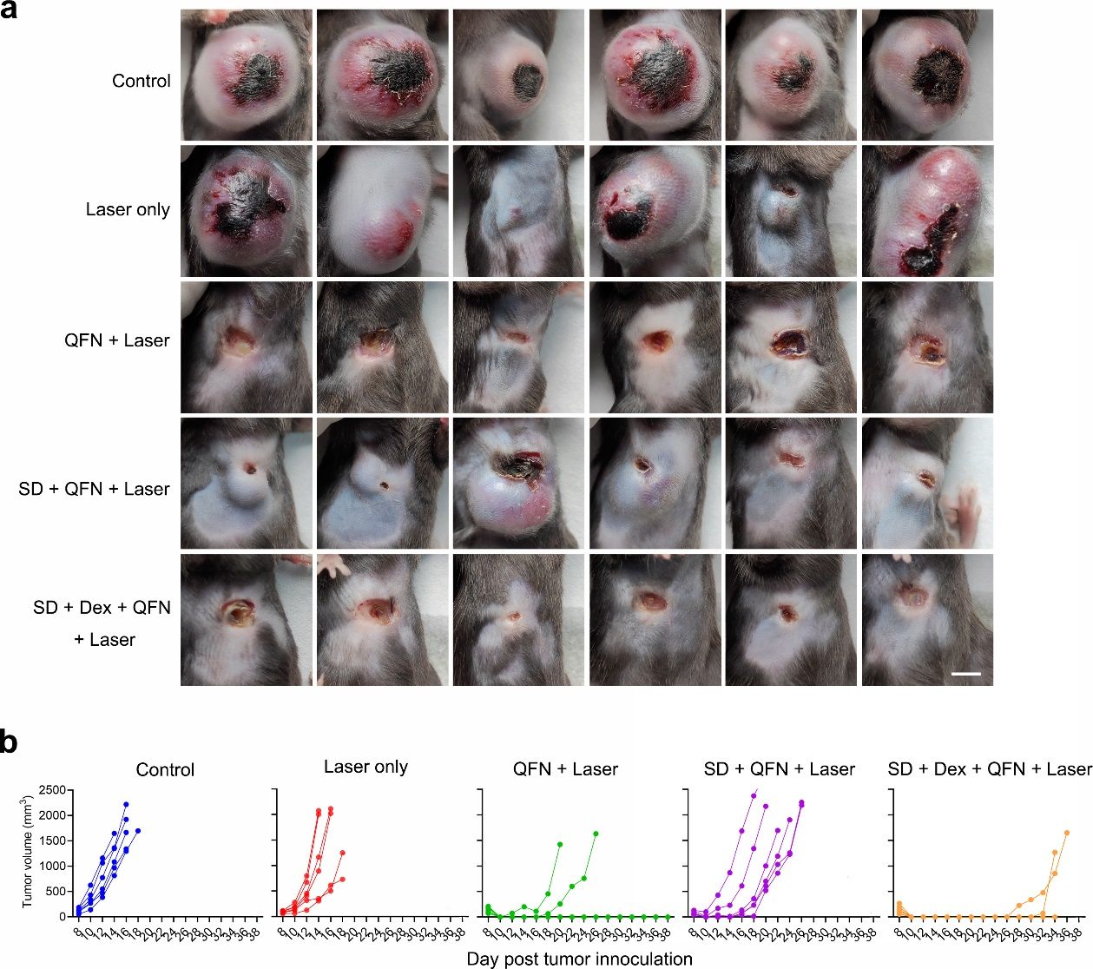
Figure S17. Tumor growth rate in mice after treatment. (a) Representative images of mouse tumors at 15 days post-inoculation. Scale bar, 0.3 cm. n = 6. (b) Tumor growth curves of mice. n = 6.

Figure S18. Body weight of mice after treatment. n = 6.

Figure S19. The organ and blood distribution of PLGA nanoparticles in CRS mice. (a, b) Effect of restraint stress on the distribution of PLGA nanoparticles in heart, liver, spleen, lung and kidney of mice evaluated by IVIS (a) and corresponding semi-quantitative fluorescence analysis (b) at 8 h post-injection. n = 3. (c, d) Effect of restraint stress on the retention of PLGA nanoparticles in mouse serum evaluated by IVIS (c) and corresponding semi-quantitative fluorescence analysis (d) at 8 h post-injection. n = 3.

Figure S20. Targeting ability of PLGA nanoparticles in advanced melanoma. (a) Images of melanoma at 7 and 18 days post-inoculation in mice. Scale bar, 0.5 cm. n = 4. (b–f) Serum levels of IL-6 (b), IL-1β (c), IFN-α1 (d), IL-4 (e), and TNFα (f) in mice. n = 4. (g) Immunofluorescence images of IL-6 in mouse tumors observed by CLSM. Scale bar, 40 μm. n = 4. (h) Distribution of PLGA nanoparticle and expression of PDPN in mouse tumors observed by CLSM at 8 h post-injection of nanoparticle. Scale bar, 40 μm. n = 4. (i, j) Flow cytometric analysis of PLGA nanoparticle uptake by tumor cells (CD44⁺) in mice (i) and corresponding semi-quantitative fluorescence analysis (j). n = 5. (k, l) Flow cytometric analysis of PDPN expression in tumor cells (CD44⁺) in mice (k) and the semi-quantitative fluorescence analysis (l). n = 5.

Figure S21. Distribution of PLGA nanoparticles in mice bearing advanced melanoma and routine blood parameters of mice. (a, b) Fluorescence intensity of PLGA nanoparticles in heart, liver, spleen, lung and kidney of mice evaluated by IVIS (a) and the semi-quantitative analysis (b). n = 3. (c, d) Retention of PLGA nanoparticles in mouse serum evaluated by IVIS (c) and corresponding semi-quantitative fluorescence analysis (d). n = 4. (e–j) Counts of red blood cells (RBC) (e), white blood cells (WBC) (f), monocytes (g), lymphocytes (h), granulocytes (i), and platelets (j) in mouse blood. n = 5.

Figure S22. Results of the whole-genome CRISPR library screen. (a) Top 10 candidate genes in the macrophage population with low uptake of polystyrene nanoparticles (PS-NPS). (b) Top 10 candidate genes in the macrophage population with low uptake of polyurethane nanoparticles (Pu-NPS).

Figure S23. The expression of IKZF1 in RAW264.7 cells analyzed by Western Blot.

Figure S24. Flow cytometric analysis of the uptake of polystyrene nanoparticles (a), polyurethane nanoparticles (b), LNP (c), silica nanoparticles (d), liposomes (e), PEI (f), and cell membrane vesicles (g) by RAW264.7^{IKZF1-KO} cells. n = 4.

Figure S25. Flow cytometry was used to evaluate the effect of lenalidomide on the uptake of polyurethane nanoparticles (a), polystyrene nanoparticles (b), and silica nanoparticles (c) by RAW264.7 cells. n = 3.

Figure S26. Effect of lenalidomide on the in vivo distribution of PLGA nanoparticles in BALB/c mice. (a, b) Effect of lenalidomide on the distribution of PLGA nanoparticles in heart, liver, spleen, lung and kidney of mice evaluated by IVIS (a) and the semi-quantitative fluorescence analysis (b). n = 3. (c, d) Fluorescence intensity of PLGA in mouse serum evaluated by IVIS (c) and the semi-quantitative analysis (d). n = 3. (e, f) Targeting ability of PLGA nanoparticles to mouse breast cancer evaluated by IVIS (e) and the semi-quantitative fluorescence analysis (f). n = 3.

Figure S27. GO and KEGG analyses of the genome-wide CRISPR library screening results. (a, b) GO (a) and KEGG (b) analyses of macrophage populations with low PLGA nanoparticle uptake. (c, d) GO (c) and KEGG (d) analyses of macrophage populations with low polystyrene nanoparticle uptake. (e, f) GO (e) and KEGG (f) analyses of macrophage populations with low polyurethane nanoparticles uptake.

Figure S28. Flow cytometry was used to detect the effect of inhibitors on cellular uptake of PLGA nanoparticles. (a) Effects of β-cyclodextrin (5 mM), cytochalasin D (1 μM), and chlorpromazine (3 μM) on PLGA nanoparticle uptake by RAW264.7 cells. n = 4. (b) Effects of β-cyclodextrin (5 mM), cytochalasin D (1 μM), and chlorpromazine (3 μM) on PLGA nanoparticle uptake by RAW264.7 IKZF1-KO cells. t = 8 h. n = 4.

Figure S29. Effects of PLGA nanoparticles on ROS levels and lysosomal acidity in RAW264.7 cells. (a) ROS levels in RAW264.7 cells and RAW264.7^{IKZF1-KO} cells treated with PLGA nanoparticles. t = 8 h. n = 4. (b) Mean fluorescence intensity (MFI) of LysoSensor Green in RAW264.7 cells and RAW264.7^{IKZF1-KO} cells treated with PLGA nanoparticles. t = 8 h. n = 4.

Figure S30. The GO analysis of RAW264.7 cells treated with lenalidomide. n = 3.

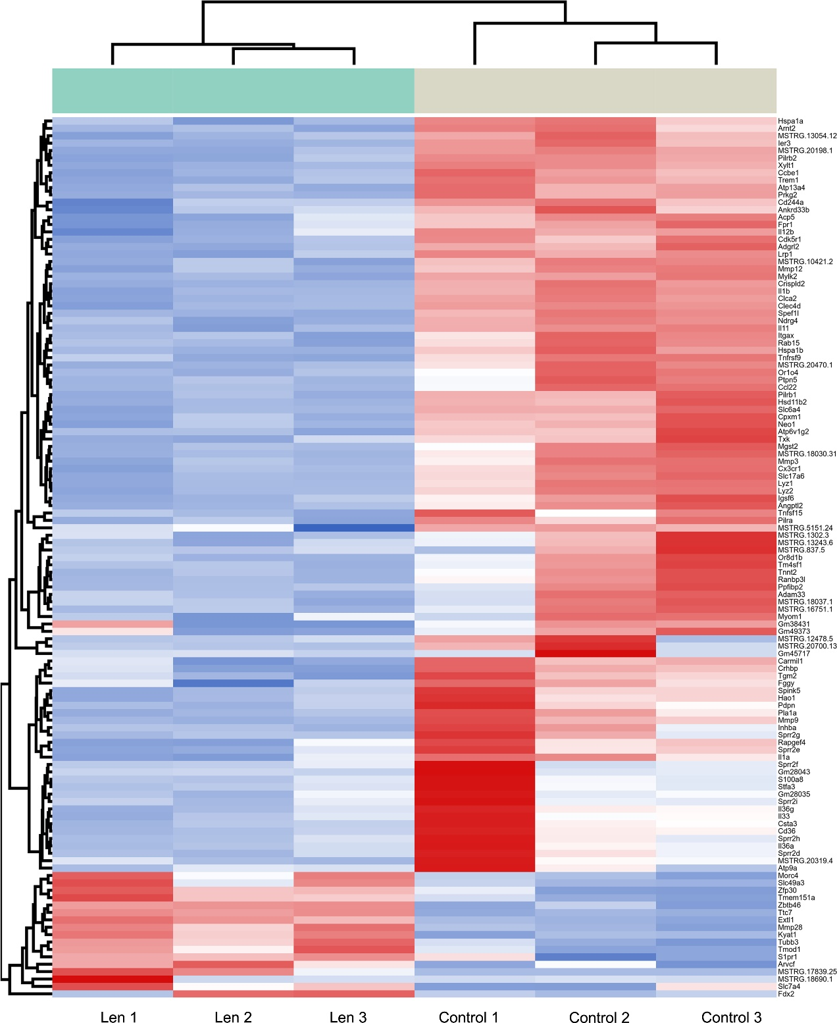
Figure S31. Significantly differentially expressed mRNAs in RAW264.7 cells treated with lenalidomide. n = 3.

Figure S32. CLSM analysis of CD11b expression in RAW264.7 cells and RAW264.7^{IKZF1-KO} cells. Scale bar, 5 μm. n = 4.

Figure S33. Flow cytometric analysis of CD11b expression in RAW264.7 cells treat with anti-CD11b antibody (2 μg/mL) (a) and the corresponding semi-quantitative fluorescence (b). n = 4.

Figure S34. Flow cytometric analysis of the effects of PP2 (5 μM) and Src inhibitor 1 (5 μM) on the uptake of PLGA nanoparticles (a) and liposomes (b) by RAW264.7 cells. t = 4 h. n = 4.

Figure S35. Adsorption of plasma protein corona on PLGA nanoparticles, polyurethane nanoparticles (PU), and polystyrene nanoparticles (PS). The upper panel shows the western blot analysis of iC3b, and the lower panel shows the coomassie brilliant blue-stained SDS-PAGE bands.

Figure S36. CLSM analysis of the colocalization between CD11b and PLGA nanoparticles, liposomes, polystyrene nanoparticles, and silica nanoparticles in RAW264.7 cells. t = 4 h. Scale bar, 5 μm. n = 4.

Figure S37. Changes of immune cells in the blood and liver at 8 h after intravenous injection of PLGA nanoparticles via the tail vein. (a–c) Flow cytometric analysis of the percentages of F4/80⁺ cells (a), Ly6G/C⁺ cells (b), and CD3⁺ cells (c) in mouse liver. n = 4. (d–g) Flow cytometric analysis of the percentages of CD11b⁺ (d), F4/80⁺ (e), Ly6G/C⁺ (f), and CD3⁺ cells (g) in the blood. n = 4. (h–m) Routine blood analysis of the counts of white blood cells (h), granulocytes (i), monocytes (j), lymphocytes (k), platelets (l), and red blood cells (m) in mouse blood at 8h post injection of nanoparticles. n = 4.

Figure S38. CLSM observation of the distribution of PLGA nanoparticles in liver and the colocalization with CD11b⁺ cells. t = 8 h, Scale bar, 100 μm, n = 4.

Figure S39. IVIS analysis of the effects of lenalidomide and anti-CD11b antibody on the retention of PLGA nanoparticles in mouse plasma (a) and the corresponding semi-quantitative fluorescence results (b). n = 3.

Figure S40. Flow cytometric analysis of the effect of lenalidomide (10 μM) on PDPN expression in B16F10 cells. t = 12 h. n = 3.

Figure S41. Effect of lenalidomide on the uptake of nanocarriers by B16F10 and 4T1 cells. (a–f) Flow cytometric analysis of the uptake of PLGA nanoparticles (a), polyurethane nanoparticles (b), polystyrene nanoparticles (c), LNP (d), liposomes (e), and silica nanoparticles (f) by B16F10 cells. t = 4 h. n = 4. (g–l) Flow cytometric analysis of the uptake of PLGA nanoparticles (g), polyurethane nanoparticles (h), polystyrene nanoparticles (i), LNP (j), liposomes (k), and silica nanoparticles (l) by 4T1 cells. t = 4 h. n = 4.

Figure S42. Effect of protein used during the preparation of CLEC2-modified PLGA nanoparticles on the cellular uptake by B16F10 cells. t = 4 h. n = 3.

Figure S43. Flow cytometric analysis of the uptake of PC and PCC by RAW264.7 cells. t = 4 h. n = 3.

Figure S44. Effects of CBL0137 and PCC on PDPN expression in B16F10 cells. (a, b) Flow cytometric analysis of the effect of CBL0137 (2 μM) on PDPN expression in B16F10 cells (a) and the corresponding semi-quantitative fluorescence results (b). t = 12 h. n = 4. (c) Flow cytometric analysis of the effect of CLEC2-modified PLGA nanoparticles on PDPN expression in tumor cells. t = 12 h. n = 4. (d) Flow cytometric analysis of the effects of PC and PCC on PDPN expression in tumor cells. CBL0137 (2 μM). t = 12 h. n = 4.

Figure S45. CLSM analysis of the effect of PC and PCC on ZBP1 expression in B16F10 cells. The concentration of CBL0137 and lenalidomide were both 5 μM. t = 12 h. Scale bar, 20 μm.

Figure S46. Effect of PCC on the morphology of B16F10 cells. Concentration of CBL0137 and lenalidomide were both 5 μM. t = 24 h. Scale bar, 100 μm.

Figure S47. CLSM observation of the colocalization of CLEC2, PDPN and PCC in tumors. t = 12 h. Scale bar, 5 μm. n = 4.

Figure S48. CLSM observation of Z-DNA levels in tumors. Scale bar, 50 μm. n = 5.

Figure S49. CLSM observation of ZBP1 expression in tumors. Scale bar, 50 μm. n = 5.

Figure S50. Flow cytometric analysis of the immune microenvironment in tumors in mice. n = 5.

Figure S51. Levels of inflammatory cytokines in tumors. n = 5.

Figure S52. Growth rate of mouse tumors. (a) Images of mouse tumors at 15 days post innoculation. Scale bar, 0.5 cm. n = 5. (b) Tumor growth rate in each group of mice. n = 5.

Figure S53. Routine blood parameters of mice in each group after treatment. (a) White blood cell (WBC) in blood. n = 5. (b) Lymphocyte in blood. n = 5. (c) Monocyte in blood. n = 5. (d) Granulocyte in blood. n = 5. (e) Red blood cell (RBC) in blood. n = 5. (f) Platelet in blood. n = 5.

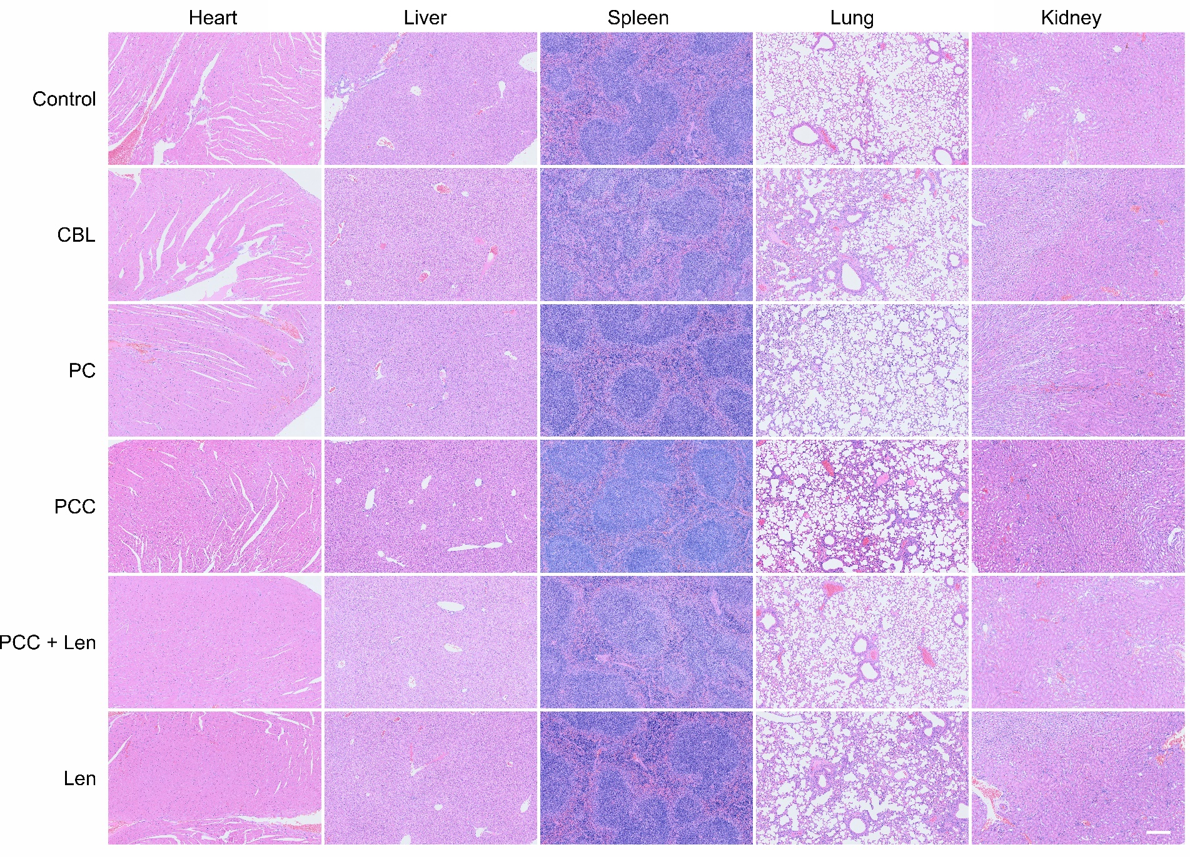
Figure S54. Hematoxylin and eosin staining images of heart, liver, spleen, lung and kidney in mice from each group after treatment. Scale bar, 200 μm. n = 5.

Figure S55. Body weight of mice after treatment. n = 5.

