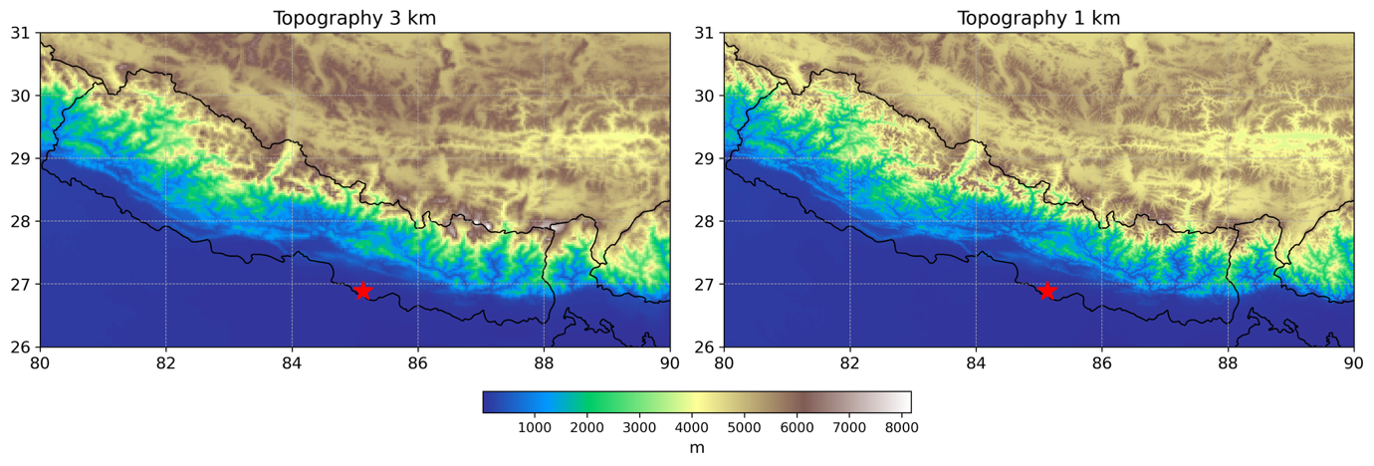
Supporting Figure S1: Orography at 3 km horizontal resolution and 1 km horizontal resolution. The red start indicates the observed Bara–Parsa tornado event region.
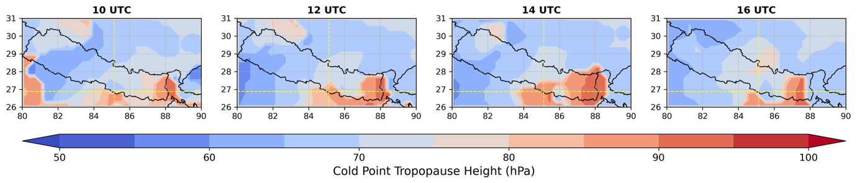
Supporting Figure S2: Cold point tropopause height (hPa) derived from ERA5 over the study domain.
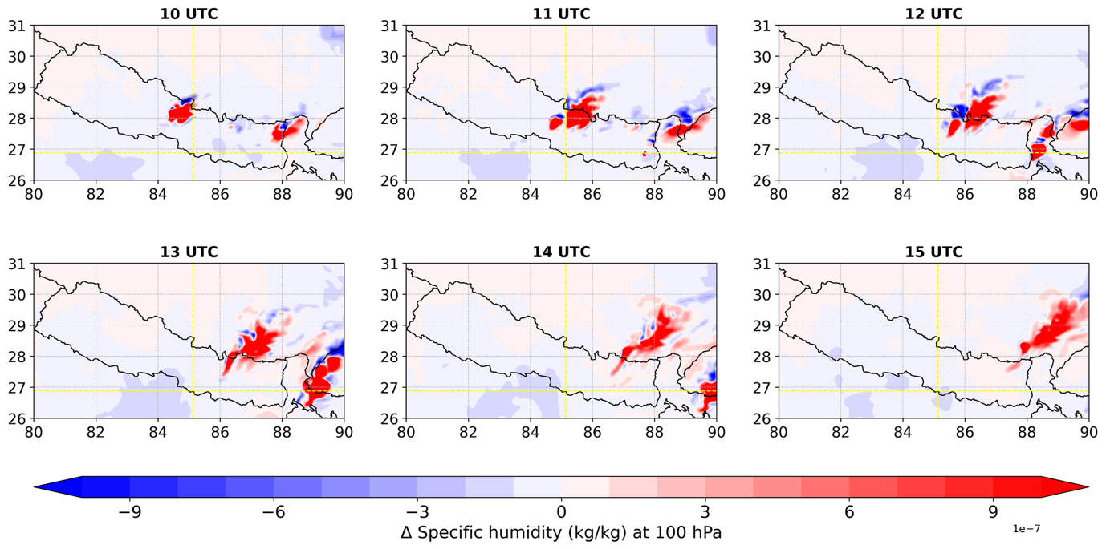
Supporting Figure S3: Anomaly in 100 hPa water vapour associated with DCS, referenced to the corresponding timestamp two days prior to event simulated using 3 km resolution simulation without deep convection parametrisation.
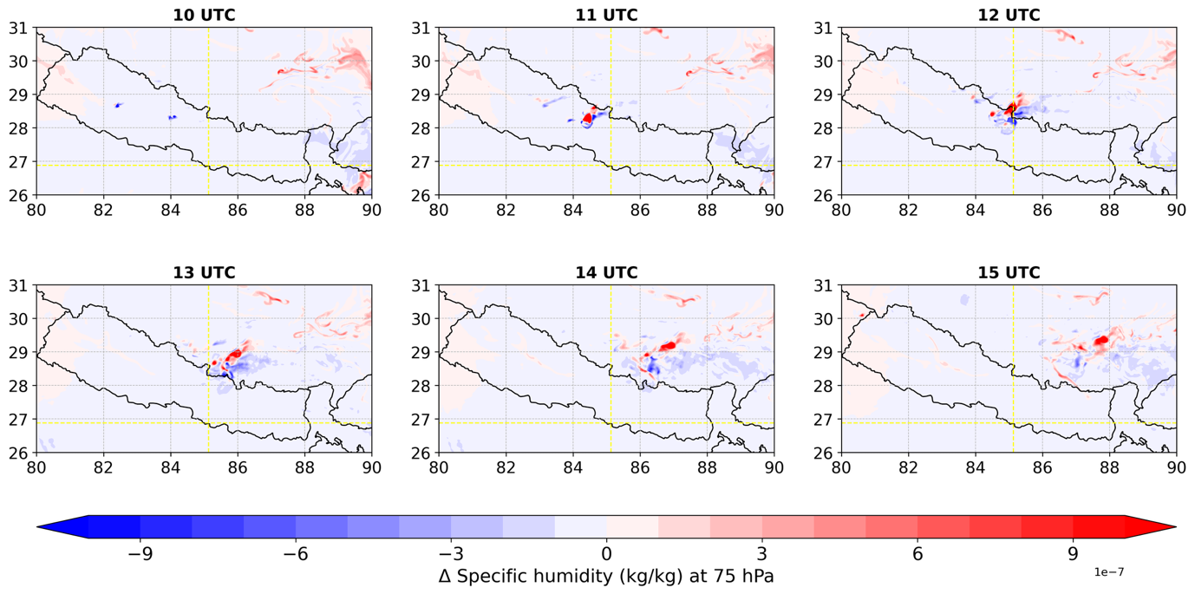
Supporting Figure S4: Anomaly in 75 hPa water vapour associated with DCS, referenced to the corresponding timestamp two days prior to event simulated using IC-1K.
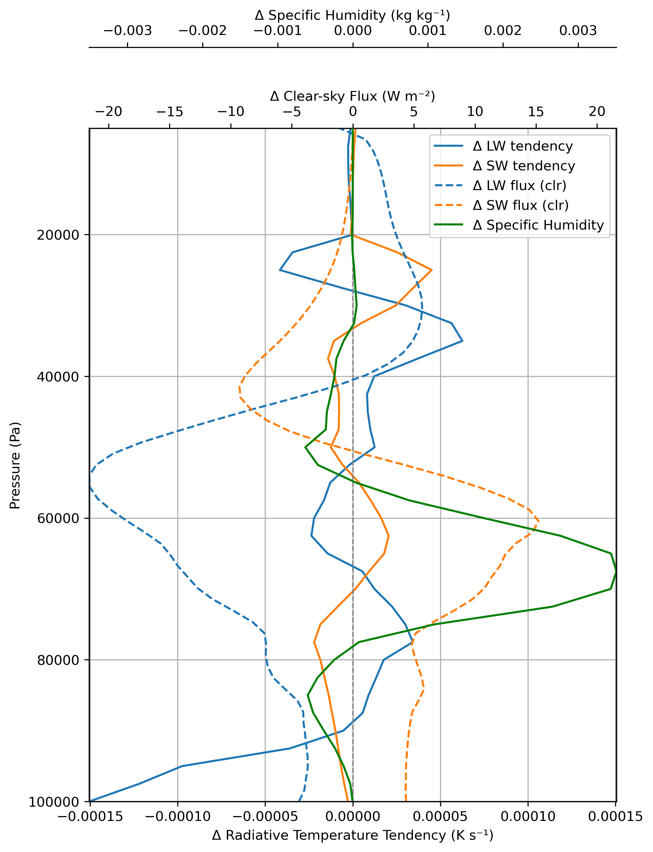
Supporting Figure S5: IC-1K simulated vertical profile anomalies of clear-sky longwave and shortwave radiative fluxes, water vapour, longwave and shortwave radiative temperature tendency over the DCS (1° grid box) at 10 UTC during the event, calculated as the difference between 31 March and 29 March.

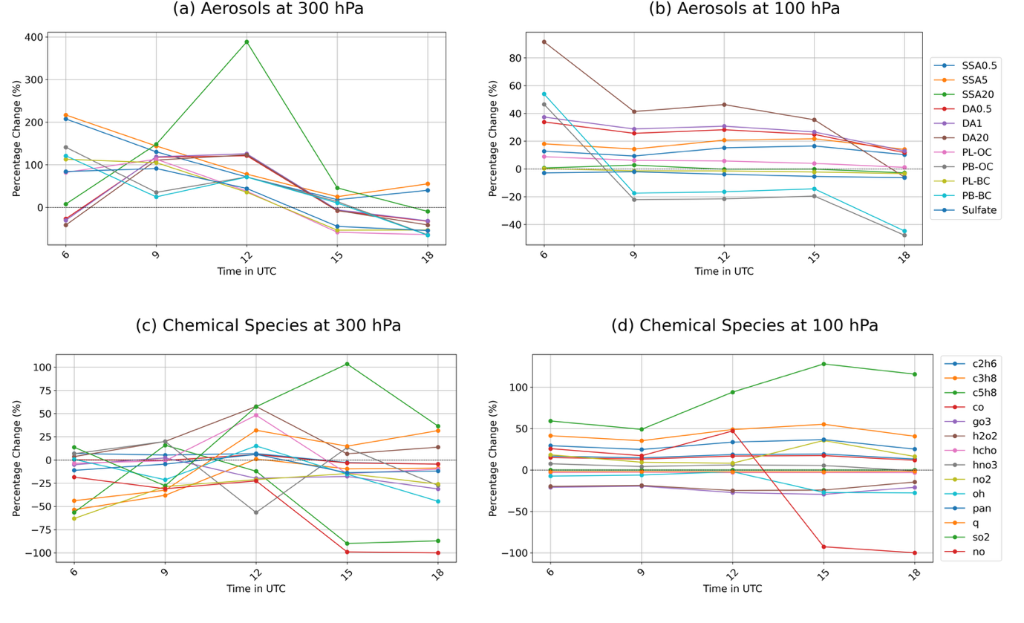
Supporting Figure S6: Changes in aerosols concentration at 300 hPa (a) and 100 hPa (b), atmospheric chemical concentration at 300 hPa (c) and 100 hPa (d) from CAMS.
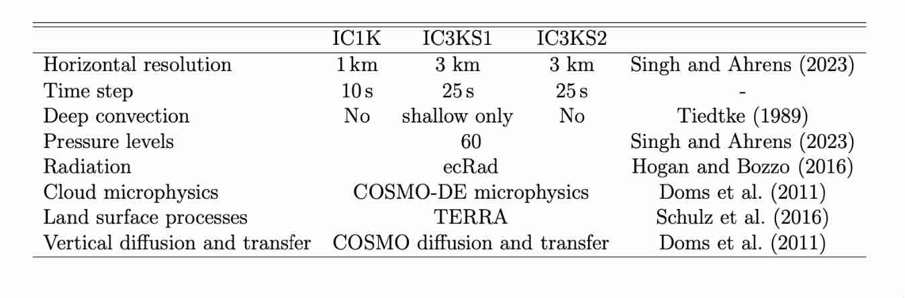
Supporting Table S1: Overview of the km-scale ICON-CLM model simulation setup.

