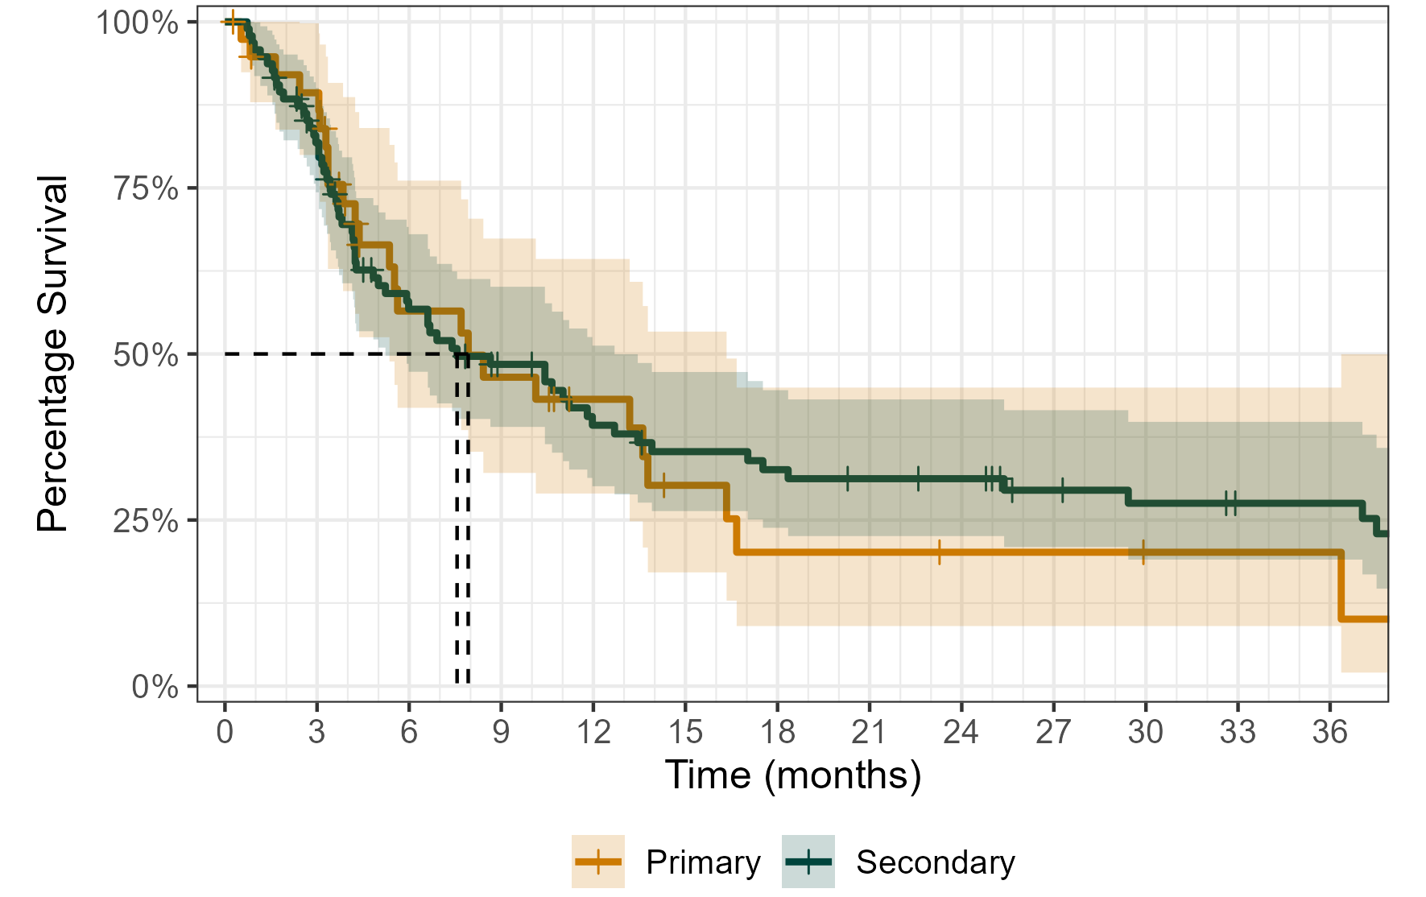
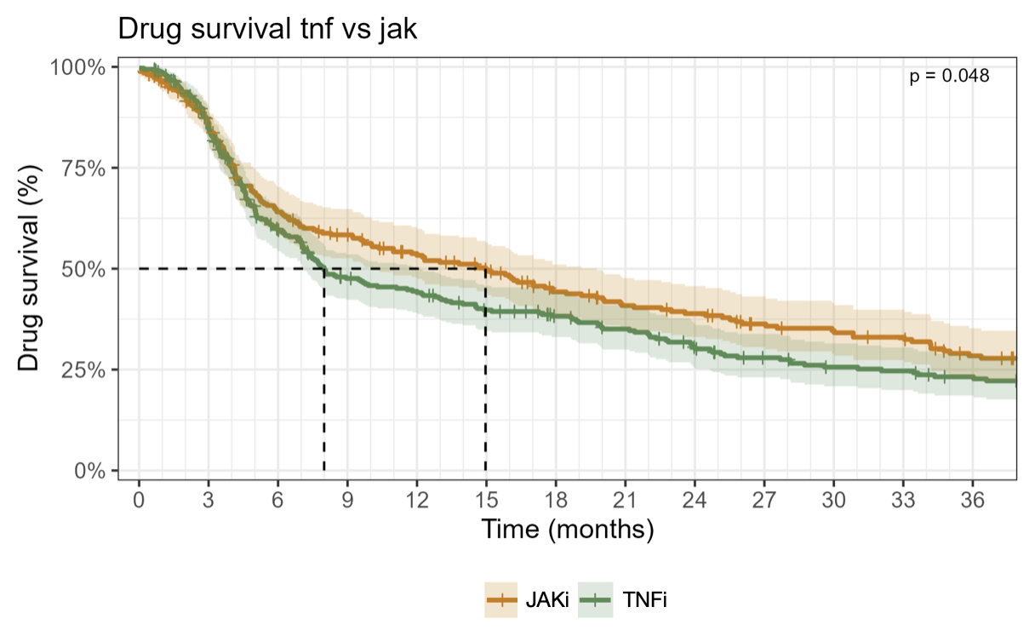
Supplementary Figure S1: Kaplan Meier survival plot including 95% confidence intervals of drug survival in the cycle subcohort for a 36-month period. Drug survival is stratified for primary and secondary non-response, with secondary non-response operationalized as non-response after 9 months.

Supplementary Figure S2: Kaplan Meier survival plot including 95% confidence intervals of drug survival in the switch subcohort for a 36-month period. Drug survival is stratified for use of TNFi and JAKi. p-value was computed using Cox-regression without additional covariates.

