Supplementary Material
Subcutaneous Perianal Nerve Division versus Intradermal Methylene Blue Injection for Refractory Idiopathic Pruritus Ani: A Retrospective Two-Arm Comparative Study.
eMethods 1. Propensity-score model and weight construction
The propensity score (PS) was estimated by a logistic regression of treatment assignment (SPND vs MBI) on the prespecified covariate set: age, sex, body mass index, symptom duration, baseline itch VAS/NRS, sleep disturbance, lichenification, and the number of failed conservative therapies. Estimated PSs were truncated at [0.02, 0.98] before weight construction to limit the influence of extreme weights. Stabilized inverse probability of treatment weights (IPTW) were then computed as Pr(Z = z) / Pr(Z = z | X), where Z is treatment assignment and X is the covariate vector. The weight construction is consistent with the method described by Austin and Stuart (2015).
eMethods 2. Component-wise sensitivity analysis of the composite primary endpoint
The primary endpoint is a composite (12-month VAS/NRS ≤ 1 OR ≥ 75% reduction from baseline). Because the SPND arm started from a higher baseline VAS/NRS, the percentage-reduction component is more readily attainable in this arm. To examine whether either component drives the primary comparison, the two components were analyzed separately, each as a binary endpoint, in crude and IPTW logistic regressions. Results are in eTable 2.
eMethods 3. Multiple imputation (MI) sensitivity
Two MI sensitivity analyses were performed. (a) MI for missing 12-month outcomes (n = 7 records lost to follow-up before 12 months): imputations were drawn from a logistic model fit on completers using treatment plus the prespecified covariate set; M = 20 imputations were combined by Rubin's rules. Three deterministic tipping-point analyses were also performed (all SPND-LTFU non-responders; all MBI-LTFU non-responders; all LTFU non-responders). (b) MI for missing recurrence dates among recurrent records (n = 6): missing recurrence times were imputed from a Weibull distribution fit on the observed (uncensored) recurrence times, drawn within the individual's recorded follow-up window; an exploratory Cox model was refit on each imputed dataset and pooled by Rubin's rules. Results are in eTables 5 and 6.
eMethods 4. E-value
E-values were computed for the IPTW-adjusted point estimate and for the limit of the 95% CI closer to the null, following the formulation of VanderWeele and Ding (2017). Because the primary outcome is non-rare, the OR was first converted to an approximate risk ratio using the approximation RR ≈ OR / [1 − p₀ + p₀·OR], where p₀ is the response proportion in the comparator (MBI) arm. The E-value is then computed from the resulting RR by E = RR + sqrt(RR · (RR − 1)).
eTable 1. Standardized mean differences before and after IPTW
Covariate | Pre-weighting |SMD| | Post-weighting |SMD| | Comment
Age | 0.270 | 0.039 | Balanced
Male sex | 0.030 | 0.031 | Balanced
Body mass index | 0.387 | 0.190 | Substantially improved
Symptom duration (mo) | 0.768 | 0.289 | Substantially improved
Baseline itch VAS/NRS | 0.839 | 0.174 | Substantially improved
Sleep disturbance | 0.550 | 0.016 | Balanced
Lichenification | 0.471 | 0.144 | Substantially improved
Failed conservative therapies (No.) | 0.573 | 0.356 | Improved but residual imbalance
Notes: |SMD| < 0.10 is the conventional threshold for adequate balance. After IPTW, 5 of 8 covariates fell below 0.10. Two covariates (failed conservative therapies, |SMD| ≈ 0.36; symptom duration, |SMD| ≈ 0.29) retained residual imbalance after weighting; this residual imbalance is acknowledged as a limitation in the main text and contributes to the interpretation that residual confounding cannot be excluded.
eFigure 1. Love plot of covariate balance before and after IPTW
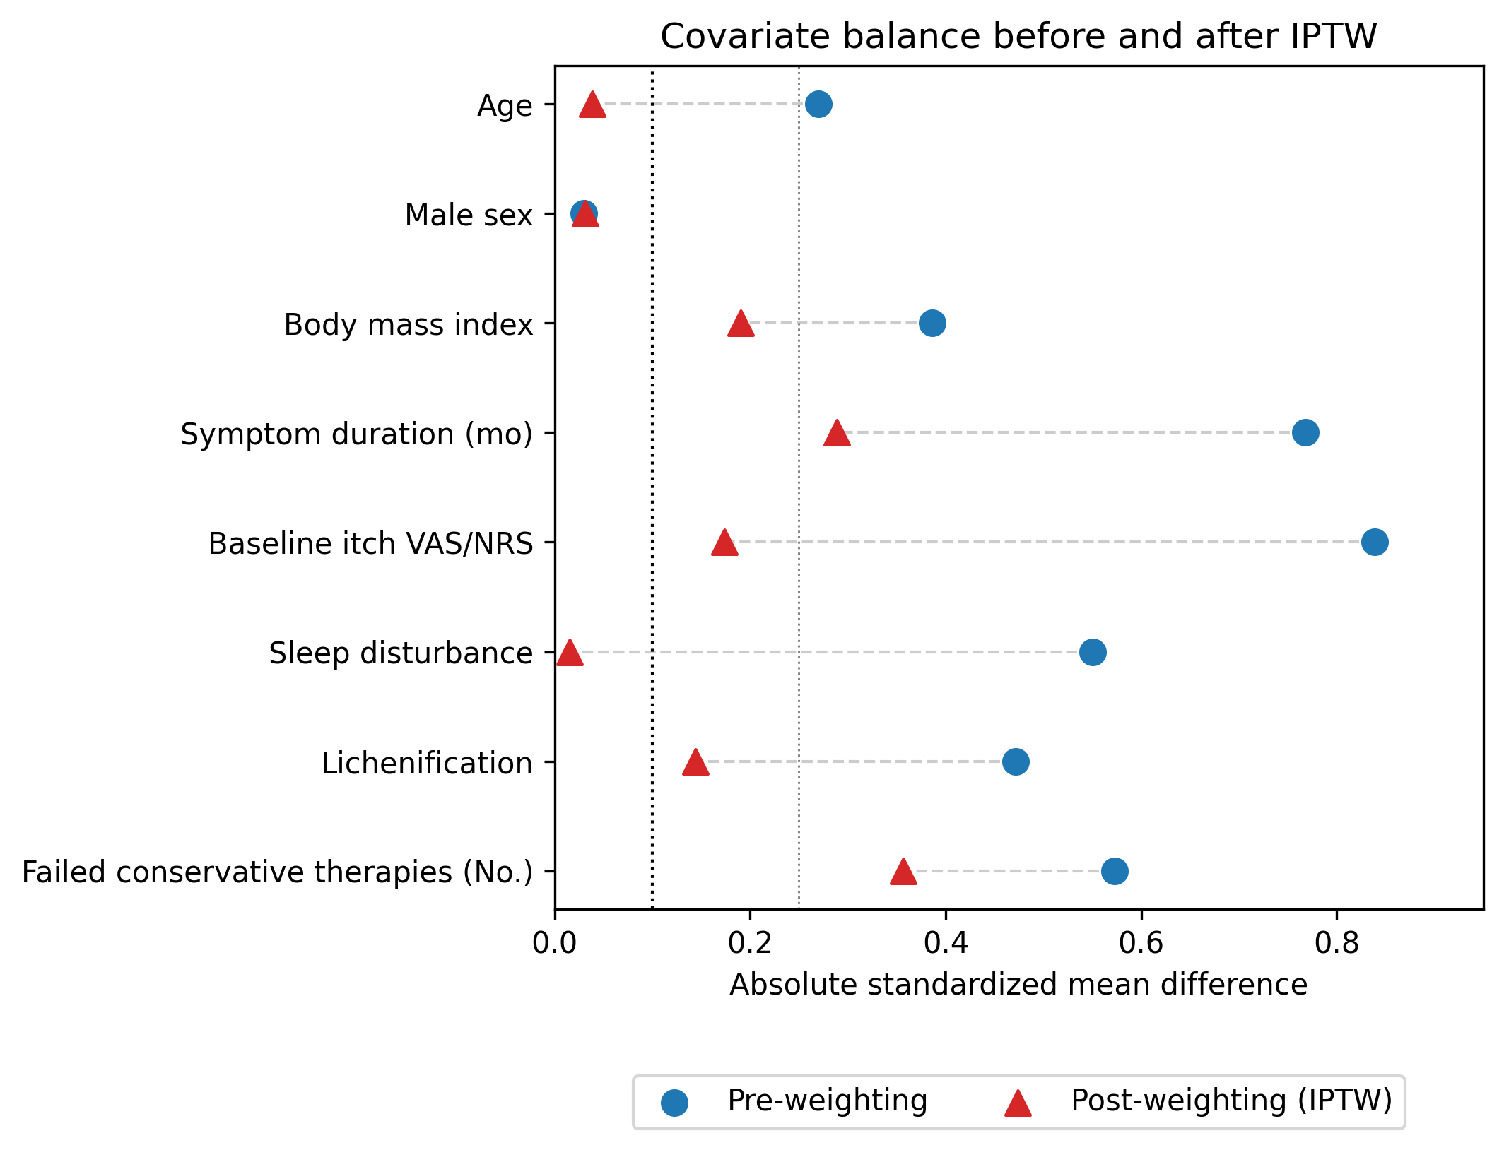
Absolute standardized mean differences (SMDs) for each prespecified covariate, before (blue circles) and after (red triangles) IPTW. Vertical reference lines at |SMD| = 0.10 (dotted black) and |SMD| = 0.25 (dotted grey).
eFigure 2. Distribution of stabilized weights and effective sample size
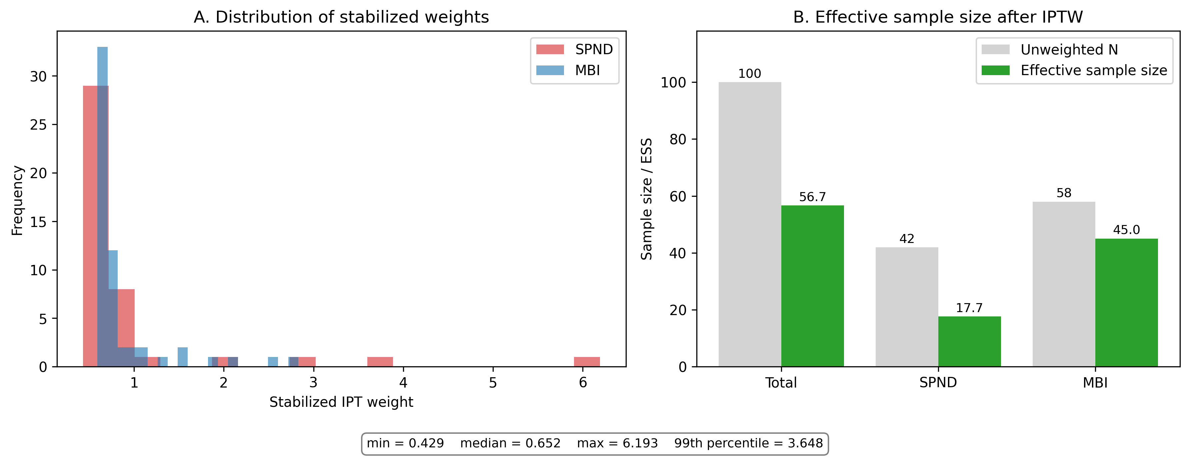
(A) Distribution of stabilized inverse probability of treatment weights, by arm. Min = 0.429, median = 0.652, max = 6.193, 99th percentile = 3.648. (B) Effective sample size (ESS) compared with unweighted N. Total N = 100; ESS = 56.66. ESS_SPND = 17.69 (unweighted n = 42); ESS_MBI = 45.04 (unweighted n = 58). The reduced ESS in the SPND arm reflects the cost of reweighting under treatment-selection imbalance and is acknowledged as a constraint on the precision of the IPTW-adjusted estimate.
eTable 2. Component-wise sensitivity analysis of the composite primary endpoint
Endpoint | SPND | MBI | Fisher P | Crude OR (95% CI) | IPTW OR (95% CI) | Note
VAS/NRS ≤ 1 alone | 22/39 (56.4%) | 28/54 (51.9%) | 0.68 | 1.2 (0.53–2.75) | 1.34 (0.55–3.25) | Stricter component
≥ 75% reduction from baseline alone | 28/39 (71.8%) | 35/54 (64.8%) | 0.509 | 1.38 (0.57–3.38) | 1.3 (0.52–3.28) | Subsumes the ≤ 1 component in this cohort
Composite primary endpoint | 28/39 (71.8%) | 35/54 (64.8%) | 0.509 | 1.38 (0.57–3.38) | 1.3 (0.52–3.28) | Composite = either component met
Notes: The OR for the VAS/NRS ≤ 1 component (1.20) is closer to the null than the OR for the ≥ 75% reduction component (1.38), consistent with the hypothesis that the percentage-reduction component partly reflects baseline-severity asymmetry. Both components, the composite, and the IPTW-adjusted version of each yield 95% CIs that include the null.
eTable 3. E-value for the IPTW-adjusted primary endpoint
IPTW OR (point estimate) | 1.3 (95% CI 0.52–3.28)
p₀ (response proportion in MBI arm) | 0.648
Approximate RR (point) | 1.089
Approximate RR (95% CI) | 0.754–1.324
E-value (point estimate) | 1.4
E-value (CI bound closer to null) | 1.0
CI includes the null? | Yes
Interpretation | An unmeasured confounder associated with both treatment assignment and the outcome by a risk ratio of at least 1.4-fold each, above and beyond the measured covariates, could explain away the observed point estimate. Because the 95% CI crossed the null, the data are already compatible with the absence of an effect, and the E-value for the CI is 1.
eTable 5. Multiple-imputation sensitivity for the IPTW-adjusted primary endpoint
Imputation scenario | Pooled OR | 95% CI | M
MAR (logistic-model imputation, M = 20) | 1.25 | 0.505–3.093 | 20
Tipping-point: all SPND-LTFU = non-responders | 1.046 | 0.428–2.555 | 20
Tipping-point: all MBI-LTFU = non-responders | 1.663 | 0.681–4.061 | 20
Tipping-point: all LTFU = non-responders | 1.422 | 0.594–3.404 | 20
Notes: For comparison, the complete-case IPTW OR (n = 93) was 1.30 (95% CI, 0.52–3.28). All MI scenarios produced 95% CIs that include the null, indicating that the negative primary-endpoint finding is robust to plausible missing-data assumptions.
eTable 6. Multiple-imputation sensitivity for the exploratory Cox HR
Analysis | HR (SPND vs MBI) | 95% CI | n events
Complete-case Cox (n = 87, events = 13) | 0.375 | 0.103–1.365 | 13
MI for missing recurrence dates (M = 20) | 0.58 | 0.22–1.53 | 13 observed + 6 imputed = 19
Notes: P value for the complete-case Cox HR was 0.137 (log-rank P = 0.121 in the unadjusted Kaplan–Meier comparison shown in Figure 3 of the main manuscript). After imputation of the 6 missing recurrence dates, the pooled HR moved toward the null (0.58 vs 0.375 complete-case) and the 95% CI continued to include the null. The exploratory time-to-event findings should therefore not be interpreted as evidence of a between-group difference.
eMethods 5. Software and reproducibility
Analyses were conducted in Python 3 with pandas 2.3, numpy 1.26, statsmodels 0.14, scipy 1.13, lifelines 0.30, and matplotlib 3.9. The full analysis code (run_supplement_analyses.py and run_mi_sensitivity.py) and the de-identified individual-level dataset are deposited in the project repository (see Data Transparency Statement of the main manuscript).

