Appendix A: Discriminant validity
Table 8 Reliability of the indicator - of external loads
 | Competitive aggressiveness | Autonomy | Innovativeness | Expansion and growth | Creation of business | Environmental dynamism | Technological entrepreneurship | Product innovation | Financial performance | Risk-taking | Proactiveness
AC1 | 0.9390
AC2 | 0.8282
AG1 |  | 0.8427
AG2 |  | 0.8078
AG4 |  | 0.7572
AG6 |  | 0.8161
AI1a |  |  | 0.8565
AI1b |  |  | 0.8768
AI2a |  |  | 0.8707
AI2b |  |  | 0.7493
APNE1 |  |  |  | 0.8531
APNE2 |  |  |  | 0.8301
APNE3 |  |  |  | 0.8299
APNE5 |  |  |  | 0.7855
CNN2 |  |  |  |  | 0.8113
CNN3 |  |  |  |  | 0.8183
CNN4 |  |  |  |  | 0.7022
CNN5 |  |  |  |  | 0.8287
CNN6 |  |  |  |  | 0.8122
DEN2 |  |  |  |  |  | 0.8336
DEN3 |  |  |  |  |  | 0.7607
DEN4 |  |  |  |  |  | 0.7616
ET3 |  |  |  |  |  |  | 0.7730
ET5 |  |  |  |  |  |  | 0.8984
IP1 |  |  |  |  |  |  |  | 0.7222
IP2 |  |  |  |  |  |  |  | 0.8501
IP3 |  |  |  |  |  |  |  | 0.8788
IP5 |  |  |  |  |  |  |  | 0.8492
RGN ª |  |  |  |  |  |  |  |  | 0.7461
ROEN ^{b} |  |  |  |  |  |  |  |  | 0.7823
OR1 |  |  |  |  |  |  |  |  |  | 0.8998
OR2 |  |  |  |  |  |  |  |  |  | 0.9132
OR3 |  |  |  |  |  |  |  |  |  | 0.8887
P1a |  |  |  |  |  |  |  |  |  |  | 0.8905
P1b |  |  |  |  |  |  |  |  |  |  | 0.9234
P1c |  |  |  |  |  |  |  |  |  |  | 0.8475
P2a |  |  |  |  |  |  |  |  |  |  | 0.8909
Note. The names of the items correspond to the way they are labeled on their measurement scales.
Note ª. RGN: Revenue growth normalized.
Note ^{b}. ROEN: Return of equity normalized.
Source: computed by the author using Smart PLS 3

Table 9 Discriminant validity - cross loadings criterion
 | Competitive aggressiveness | Autonomy | Innovativeness | Expansion and growth | Creation of business | Environment dynamism | Technological entrepreneurship | Product innovation | Financial performance | Risk-taking | Proactiveness
AC1 | 0.9390 | 0.4924 | 0.4642 | 0.4111 | 0.6623 | 0.0820 | 0.3122 | 0.4678 | -0.0591 | 0.4971 | 0.4564
AC2 | 0.8282 | 0.2084 | 0.2192 | 0.0931 | 0.4022 | -0.0658 | 0.2028 | 0.2390 | -0.1731 | 0.3285 | 0.2863
AG1 | 0.1807 | 0.8427 | 0.3662 | 0.3139 | 0.3479 | 0.0289 | 0.3795 | 0.3119 | 0.2205 | 0.5229 | 0.3569
AG2 | 0.2199 | 0.8078 | 0.3349 | 0.3277 | 0.2970 | 0.0641 | 0.4294 | 0.2726 | 0.2643 | 0.5129 | 0.3700
AG4 | 0.5823 | 0.7572 | 0.3436 | 0.2737 | 0.4992 | -0.1167 | 0.2338 | 0.3489 | 0.0725 | 0.4403 | 0.4863
AG6 | 0.3727 | 0.8161 | 0.3316 | 0.3778 | 0.3629 | 0.0807 | 0.5114 | 0.3684 | 0.0201 | 0.5462 | 0.5605
AI1a | 0.4098 | 0.3853 | 0.8565 | 0.6475 | 0.5671 | 0.1936 | 0.3885 | 0.5195 | -0.0512 | 0.4920 | 0.5060
AI1b | 0.3155 | 0.4584 | 0.8768 | 0.5154 | 0.5196 | 0.0613 | 0.4237 | 0.5264 | -0.1007 | 0.5069 | 0.4741
AI2a | 0.3519 | 0.3511 | 0.8707 | 0.5717 | 0.5365 | 0.2249 | 0.5398 | 0.6309 | -0.1292 | 0.4414 | 0.5689
AI2b | 0.3106 | 0.2207 | 0.7493 | 0.3400 | 0.5056 | 0.1674 | 0.4623 | 0.5417 | -0.0107 | 0.4422 | 0.4922
APNE1 | 0.2183 | 0.2330 | 0.4857 | 0.8531 | 0.2841 | 0.2627 | 0.5371 | 0.4534 | -0.0149 | 0.4052 | 0.4244
APNE2 | 0.2829 | 0.3052 | 0.5352 | 0.8301 | 0.3705 | 0.2479 | 0.4298 | 0.4834 | -0.0939 | 0.3946 | 0.3823
APNE3 | 0.3138 | 0.4438 | 0.5363 | 0.8299 | 0.4555 | 0.2629 | 0.5428 | 0.5216 | -0.0476 | 0.6300 | 0.4203
APNE5 | 0.2462 | 0.3321 | 0.4988 | 0.7855 | 0.3230 | 0.1376 | 0.5358 | 0.4941 | -0.1047 | 0.4176 | 0.4929
CNN2 | 0.5719 | 0.2505 | 0.4371 | 0.2397 | 0.8113 | 0.0631 | 0.2528 | 0.5660 | -0.1000 | 0.4340 | 0.4402
CNN3 | 0.5447 | 0.3793 | 0.4867 | 0.2463 | 0.8183 | 0.0653 | 0.2401 | 0.4728 | -0.1661 | 0.4839 | 0.4396
CNN4 | 0.4320 | 0.4300 | 0.4930 | 0.5147 | 0.7022 | -0.0007 | 0.2057 | 0.5603 | 0.0584 | 0.3975 | 0.3427
CNN5 | 0.5042 | 0.4638 | 0.5186 | 0.4156 | 0.8287 | -0.0600 | 0.2444 | 0.6100 | -0.0550 | 0.4510 | 0.5430
CNN6 | 0.4550 | 0.3372 | 0.5688 | 0.3067 | 0.8122 | 0.1561 | 0.3984 | 0.7002 | -0.1019 | 0.5071 | 0.5151
DEN2 | 0.0427 | -0.0732 | 0.1027 | 0.0806 | 0.0584 | 0.8336 | 0.1954 | 0.1501 | -0.2520 | 0.0805 | 0.0324
DEN3 | 0.0009 | 0.0954 | 0.2123 | 0.3283 | 0.0590 | 0.7607 | 0.2388 | 0.2315 | -0.1820 | 0.2750 | 0.0771
DEN4 | 0.0166 | 0.0537 | 0.1589 | 0.3072 | 0.0095 | 0.7616 | 0.1717 | 0.0097 | -0.1729 | 0.0654 | 0.1405
ET3 | 0.0686 | 0.2320 | 0.3397 | 0.4546 | 0.1377 | 0.1642 | 0.7730 | 0.3755 | -0.0624 | 0.4128 | 0.3137
ET5 | 0.3851 | 0.5327 | 0.5363 | 0.5750 | 0.3937 | 0.2517 | 0.8984 | 0.5195 | -0.0742 | 0.5560 | 0.6042
IP1 | 0.3267 | 0.1951 | 0.5465 | 0.4472 | 0.6268 | -0.0066 | 0.3054 | 0.7222 | -0.1270 | 0.2739 | 0.4331
IP2 | 0.4729 | 0.3612 | 0.5750 | 0.3345 | 0.7141 | 0.0826 | 0.3526 | 0.8501 | -0.1594 | 0.5485 | 0.3827
IP3 | 0.3007 | 0.3290 | 0.5796 | 0.6750 | 0.5870 | 0.2887 | 0.5876 | 0.8788 | -0.3353 | 0.5472 | 0.5301
IP5 | 0.3139 | 0.4537 | 0.4801 | 0.4788 | 0.5260 | 0.1660 | 0.5256 | 0.8492 | -0.2274 | 0.5577 | 0.4838
RGN ª | -0.0934 | 0.1452 | -0.0923 | 0.0274 | -0.0914 | -0.2150 | 0.0329 | -0.2548 | 0.7461 | 0.0197 | -0.0283
ROEN ^{b} | -0.0818 | 0.1184 | -0.0461 | -0.1424 | -0.0467 | -0.1888 | -0.1520 | -0.1515 | 0.7823 | -0.1086 | 0.0494
OR1 | 0.3648 | 0.4912 | 0.4891 | 0.4595 | 0.5159 | 0.0983 | 0.4749 | 0.5379 | 0.0214 | 0.8998 | 0.5055
OR2 | 0.4521 | 0.5392 | 0.5535 | 0.4737 | 0.5505 | 0.1284 | 0.5628 | 0.4992 | -0.0259 | 0.9132 | 0.5448
OR3 | 0.4810 | 0.6580 | 0.4713 | 0.5891 | 0.4821 | 0.2268 | 0.5440 | 0.5532 | -0.1521 | 0.8887 | 0.5820
P1a | 0.3551 | 0.4396 | 0.4925 | 0.3639 | 0.4847 | 0.1347 | 0.4673 | 0.4810 | -0.0408 | 0.4536 | 0.8905
P1b | 0.3956 | 0.4922 | 0.5917 | 0.4425 | 0.5716 | -0.0455 | 0.4985 | 0.5272 | 0.0121 | 0.5345 | 0.9234
P1c | 0.3925 | 0.4994 | 0.5405 | 0.5114 | 0.5106 | 0.0959 | 0.5464 | 0.4921 | 0.1129 | 0.5985 | 0.8475
P2a | 0.4057 | 0.5425 | 0.5267 | 0.5249 | 0.4813 | 0.1647 | 0.5205 | 0.4727 | -0.0324 | 0.5588 | 0.8909
Note. The names of the items correspond to the way they are labeled on their measurement scales.
Note ª. RGN: Revenue growth normalized.
Note ^{b}. ROEN: Return of equity normalized.
Source: computed by the author using Smart PLS 3

Table 10 Confidence intervals bias corrected - HTMT - exogenous variables
 | Original sample (O) | Sample mean (M) | 2.5 % | 97.5 %
Competitive aggressiveness -> Autonomy | 0.4952 | 0.5231 | 0.3176 | 0.6541
Creation of business -> Autonomy | 0.5550 | 0.5639 | 0.3867 | 0.7036
Creation of business -> Competitive aggressiveness | 0.7567 | 0.7584 | 0.5706 | 0.9145
Environment dynamism -> Autonomy | 0.1605 | 0.2516 | 0.0629 | 0.1879
Environment dynamism -> Competitive aggressiveness | 0.1234 | 0.2276 | 0.0380 | 0.1636
Environment dynamism -> Creation of business | 0.1451 | 0.2461 | 0.0548 | 0.1565
Expansion and growth -> Autonomy | 0.4768 | 0.4811 | 0.2467 | 0.6782
Expansion and growth -> Competitive aggressiveness | 0.3565 | 0.3927 | 0.1395 | 0.5443
Expansion and growth -> Creation of business | 0.5064 | 0.5188 | 0.2787 | 0.7086
Expansion and growth -> Environment dynamism | 0.3929 | 0.4304 | 0.1796 | 0.5970
Innovativeness -> Autonomy | 0.5023 | 0.5036 | 0.2872 | 0.6886
Innovativeness -> Competitive aggressiveness | 0.4824 | 0.4883 | 0.2684 | 0.6829
Innovativeness -> Creation of business | 0.7369 | 0.7396 | 0.5831 | 0.8538
Innovativeness -> Environment dynamism | 0.2671 | 0.3178 | 0.1029 | 0.4491
Innovativeness -> Expansion and growth | 0.7252 | 0.7275 | 0.5584 | 0.8539
Proactiveness -> Autonomy | 0.6346 | 0.6322 | 0.4204 | 0.7946
Proactiveness -> Competitive aggressiveness | 0.5081 | 0.5109 | 0.2531 | 0.7249
Proactiveness -> Creation of business | 0.6498 | 0.6498 | 0.4559 | 0.7931
Proactiveness -> Environment dynamism | 0.1687 | 0.2386 | 0.0556 | 0.2483
Proactiveness -> Expansion and growth | 0.5925 | 0.5958 | 0.3740 | 0.7634
Proactiveness -> Innovativeness | 0.6864 | 0.6873 | 0.5197 | 0.8081
Product innovation -> Autonomy | 0.4834 | 0.4910 | 0.2741 | 0.6706
Product innovation -> Competitive aggressiveness | 0.5079 | 0.5207 | 0.2566 | 0.7526
Product innovation -> Creation of business | 0.8675 | 0.8673 | 0.7581 | 0.9495
Product innovation -> Environment dynamism | 0.2594 | 0.3293 | 0.1179 | 0.3790
Product innovation -> Expansion and growth | 0.6933 | 0.6996 | 0.4718 | 0.8439
Product innovation -> Innovativeness | 0.7780 | 0.7795 | 0.6338 | 0.8796
Product innovation -> Proactiveness | 0.6315 | 0.6293 | 0.4366 | 0.7704
Risk-taking -> Autonomy | 0.7329 | 0.7322 | 0.5535 | 0.8612
Risk-taking -> Competitive aggressiveness | 0.5712 | 0.5766 | 0.3406 | 0.7644
Risk-taking -> Creation of business | 0.6587 | 0.6623 | 0.4532 | 0.8093
Risk-taking -> Environment dynamism | 0.2323 | 0.2943 | 0.0828 | 0.3885
Risk-taking -> Expansion and growth | 0.6461 | 0.6461 | 0.4426 | 0.8069
Risk-taking -> Innovativeness | 0.6437 | 0.6425 | 0.4780 | 0.7705
Risk-taking -> Proactiveness | 0.6715 | 0.6712 | 0.4339 | 0.8434
Risk-taking -> Product innovation | 0.6758 | 0.6776 | 0.4848 | 0.8304
Technological entrepreneurship -> Autonomy | 0.6733 | 0.7074 | 0.3769 | 0.9562
Technological entrepreneurship -> Competitive aggressiveness | 0.3922 | 0.4581 | 0.1468 | 0.6095
Technological entrepreneurship -> Creation of business | 0.4394 | 0.5046 | 0.1929 | 0.6473
Technological entrepreneurship -> Environment dynamism | 0.3876 | 0.4348 | 0.1309 | 0.6564
Technological entrepreneurship -> Expansion and growth | 0.8683ª | 0.8866 | 0.6649 | 1.1124
Technological entrepreneurship -> Innovativeness | 0.7370 | 0.7554 | 0.5002 | 0.9865
Technological entrepreneurship -> Proactiveness | 0.7445 | 0.7575 | 0.5294 | 0.9407
Technological entrepreneurship -> Product innovation | 0.7448 | 0.7689 | 0.4903 | 1.0065
Technological entrepreneurship -> Risk-taking | 0.7971 | 0.8120 | 0.5658 | 1.0506
Note ª. Confidence intervals that contain the value 1 are in boldface.
Source: computed by the author using Smart PLS 3

Appendix B: Descriptive statistics and correlations
Table 11 Descriptive statistics and correlations
 | Mean | S.D.ª | 1 | 2 | 3 | 4 |  | 5 | 6 | 7 | 8 | 9 | 10 |  | 11 |  | 12
1. Environmental dynamism | 3.65 | 1.26 | 1
2. Innovativeness | 4.21 | 1.39 | .194 | 1
3. Proactiveness | 4.67 | 1.46 | .104 | .605** | 1
4. Risk taking | 3.98 | 1.47 | .168 | .561** | .604** | 1
5. Autonomy | 4.84 | 1.16 | .020 | .429** | .556** | .625** |  | 1
6. Competitive aggressiveness | 4.45 | 1.20 | .007 | .384** | .417** | .461** |  | .394** | 1
7. Business creation | 4.51 | 1.32 | .052 | .631** | .570** | .571** |  | .474** | .600** | 1
8. Product innovation | 4.65 | 1.27 | .153 | .655** | .549** | .590** |  | .412** | .404** | .734** | 1
9. Technological entrepreneurship | 3.97 | 1.50 | .244* | .514** | .541** | .572** |  | .445** | .253* | .303** | .519** | 1
10. Expansion and growth | 4.00 | 1.49 | .288** | .624** | .521** | .556** |  | .395** | .279** | .433** | .574** | .609** | 1
11. Return of equity | -0.09 | 1.16 | -.191 | -.047 | .048 | -.107 |  | .119 | -.075 | -.046 | -.141 | -.140 | -.143 |  | 1
12. Revenue growth | 0.00 | 1.05 | -.208 | -.089 | -.028 | .021 |  | .144 | -.127 | -.092 | -.253* | .021 | .029 |  | .169 |  | 1
*. La correlación es significativa en el nivel 0.05 (bilateral)
**. La correlación es significativa en el nivel 0.01 (bilateral)
n = 87
Note ª: Standard deviation
Source: computed by the author using Smart PLS 3

Appendix C: Bootstrapping total effects
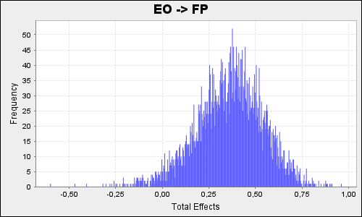 | 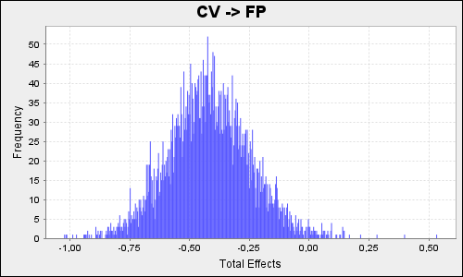
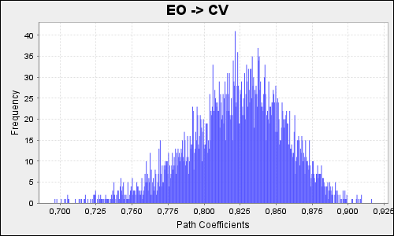 | 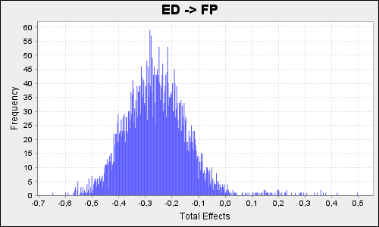
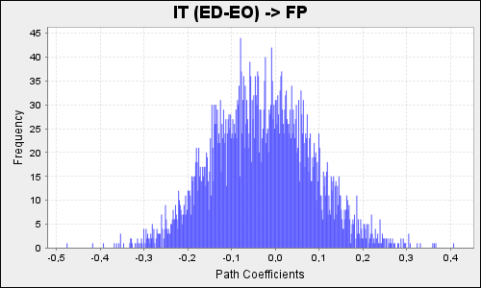 | 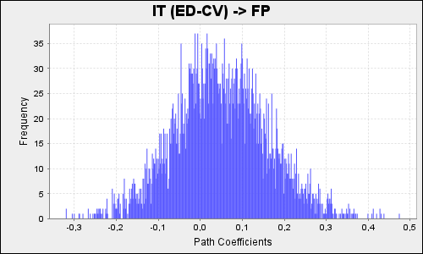
Fig. 6 Bootstrapping total effects
Source: computed by the author using Smart PLS 3

