Supplementary Figures (captions condensed for brevity; expand as needed)

Supplementary Figure 1 Validation of the APOD⁺CAF signature across 11 independent ICB datasets

(A–K) Violin plots and box plots showing the APOD⁺ CAF signature scores in responders (R) and non-responders (NR) across 11 independent immune checkpoint blockade (ICB) datasets (including BCC, RCC, SCC, SKCM, and TNBC). In all cohorts, APOD⁺ CAF signature scores are significantly and consistently higher in the non-responder group. The meta-P value was calculated using Fisher’s method (meta-P = 1.1 × 10⁻⁷), indicating the robust predictive value of this signature.

Supplementary Figure 2 Lineage specificity and marker expression of identified cell subtypes Dot plot illustrating the expression of canonical and subtype-specific markers across major cell lineages. The results confirm the high lineage specificity of APOD for APOD⁺ CAFs, CST7 for CST7⁺ endothelial cells (ECs), and VCAN for VCAN⁺ monocytes. The color gradient represents the average expression level, and the dot size represents the percentage of cells expressing the marker.

Supplementary Figure 3. Reproducibility of CAF subclustering and DEG analysis across clinical cohorts. (A–F) Metrics demonstrating the consistency of our analysis workflow. (A–B) Bar plots showing the total CAF counts and proportion of each subtype across different ICB cohorts. (C–D) Venn diagrams showing the overlap of differentially expressed genes (DEGs) identified in each individual cohort. (E–F) Scatter plots showing the correlation of gene expression effect sizes (log2 Fold Change) between different cohorts, demonstrating high reproducibility of the molecular features of APOD⁺ CAFs.

Supplementary Figure 4. Performance and stability of the machine-learning derived M.Sig model. (A–B) Feature selection process using Recursive Feature Elimination (RFE) to identify the optimal 69-gene set for M.Sig. (C) Ten-fold cross-validation ROC curves, showing a mean Area Under the Curve (AUC) of 0.87. (D–E) Calibration plots and decision curve analysis (DCA) evaluating the clinical utility of the M.Sig model. (F–G) Multivariate Cox regression analysis (Forest plot) demonstrating that M.Sig is an independent prognostic factor (Hazard Ratio [HR] = 1.83, 95% CI: 1.41–2.38) after adjusting for other clinical variables.

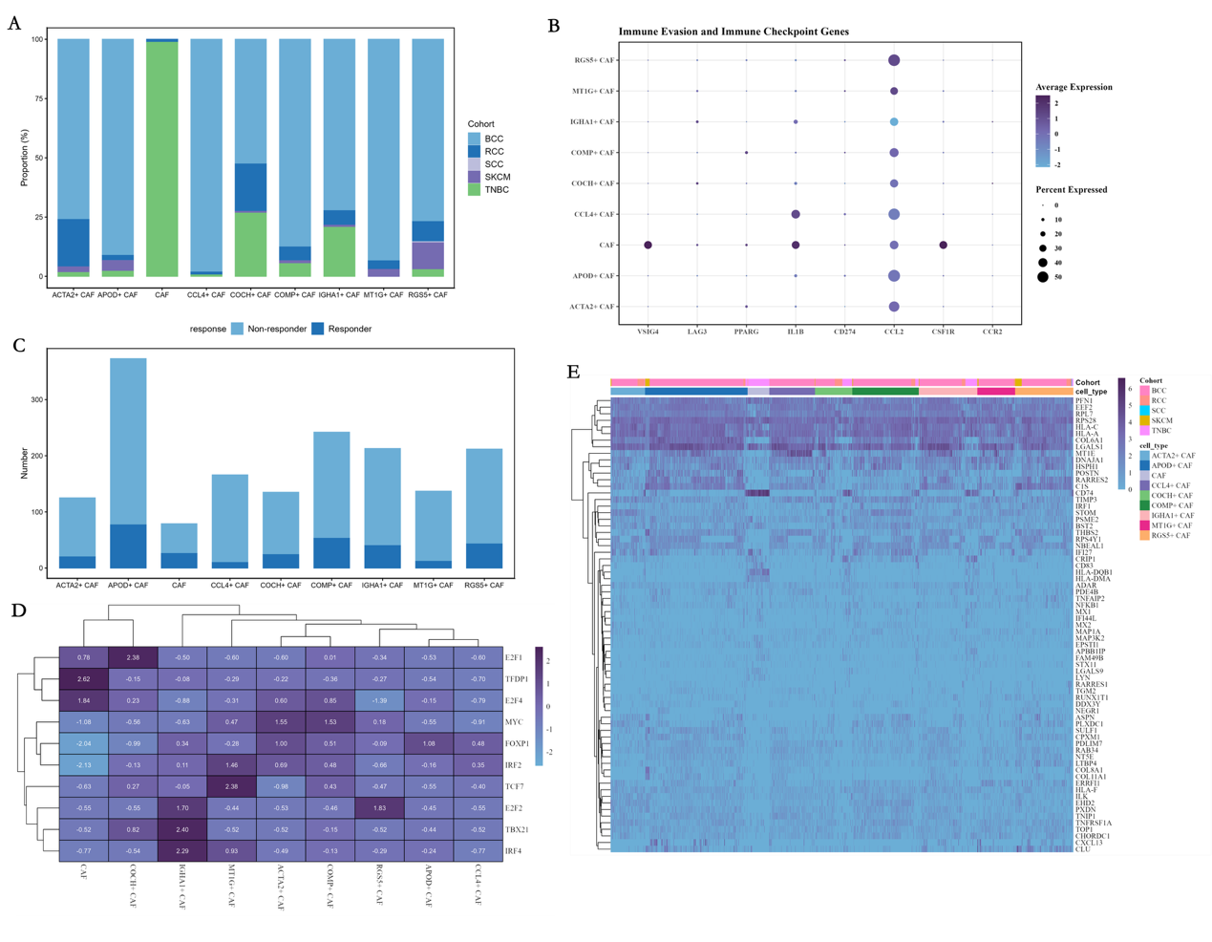

Supplementary Figure 5 Expression profiles of immune checkpoint ligands in CAF subpopulations. (A–E) Heatmaps and violin plots showing the mRNA expression levels of various immune checkpoint ligands (ICLs) across different CAF subtypes. (D) Specifically highlights that APOD⁺ CAFs uniquely and highly co-express CD276 (B7-H3), PDCD1LG2 (PD-L2), and LGALS9 (Galectin-9), suggesting their role in orchestrating a suppressive niche.

、

Supplementary Figure 6. Characterization of CD8⁺T-cell states associated with therapy response. (A–C) UMAP visualization and bar plots showing the distribution and frequencies of CD8⁺ T-cell subtypes between responders (R) and non-responders (NR). (D–F) Box plots comparing the scores of cytotoxicity, exhaustion, and progenitor-like modules in T cells across groups. Higher exhaustion scores are observed in the TME of NR patients, potentially driven by interactions with APOD⁺ CAFs.

Supplementary Figure 7. Compositional shifts in endothelial and myeloid compartments.

(A) Bar plots representing the proportions of different endothelial cell subtypes stratified by response status, validating the expansion of CST7⁺ ECs in non-responders. (B) Box plots showing the relative abundance of VCAN⁺ monocytes/macrophages in R vs NR patients, highlighting their association with immunotherapy resistance.

Supplementary Figure 8. Cell-cell communication network between CAFs and immune cells.

(A–B) Interaction-strength heatmaps (CellChat) showing the global signaling outgoing/incoming patterns. Higher communication intensity is observed from APOD⁺ CAFs to T cells and NK cells in the non-responder group. (C–D) Information flow plots comparing the significant signaling pathways (e.g., CXCL, MHC-I, and TGF-β) between R and NR, identifying specific ligand-receptor pairs mediated by APOD⁺ CAFs.

