Supplementary Materials for:

Microglia regulate adult neurogenesis via interleukin-6 trans-signaling triggered by apoptotic progenitors

The PDF file includes:

Figs. S1 to S5
Tables 1 to 4

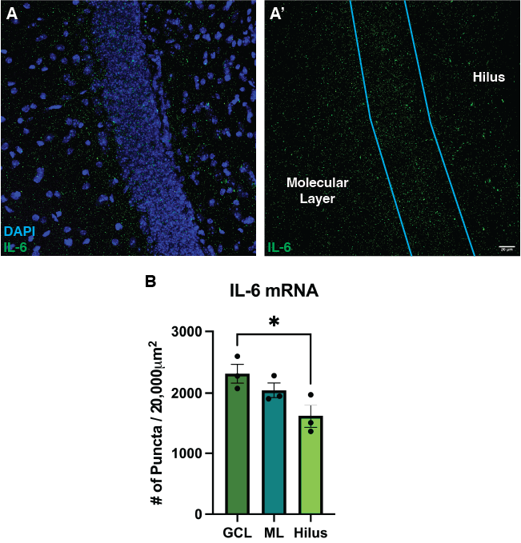

Fig. S1. IL-6 is expressed at significantly higher levels in the GCL than in the hilus (A-B). Representative images of IL-6 mRNA labeled via RNAscope from a young adult mouse (A-A’). Quantification of IL-6 puncta (B).

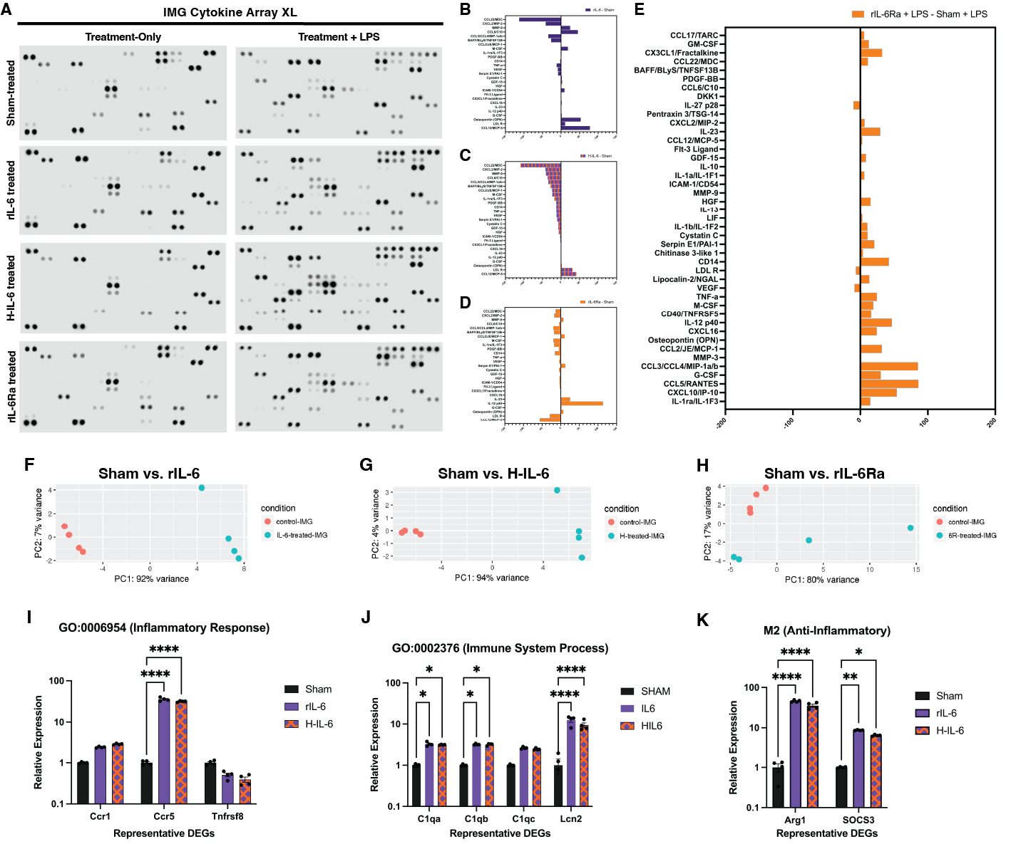
Fig. S2. Images showing the membranes from the experiments using the cytokine array XL (A). Graphs showing changes in the secretory profile of IMG treated with rIL-6R vs sham (B) H-IL-6 vs sham (C) and rIL-6Ra vs sham (D) and rIL-6Ra + LPS vs sham and LPS (E). Principle components analysis demonstrates changes in transcription vs control (F-H). Assessments of representative genes from activated GO pathways show that rIL-6 and H-IL-6 lead to identical changes in gene expression in both direction and magnitude (I-K).

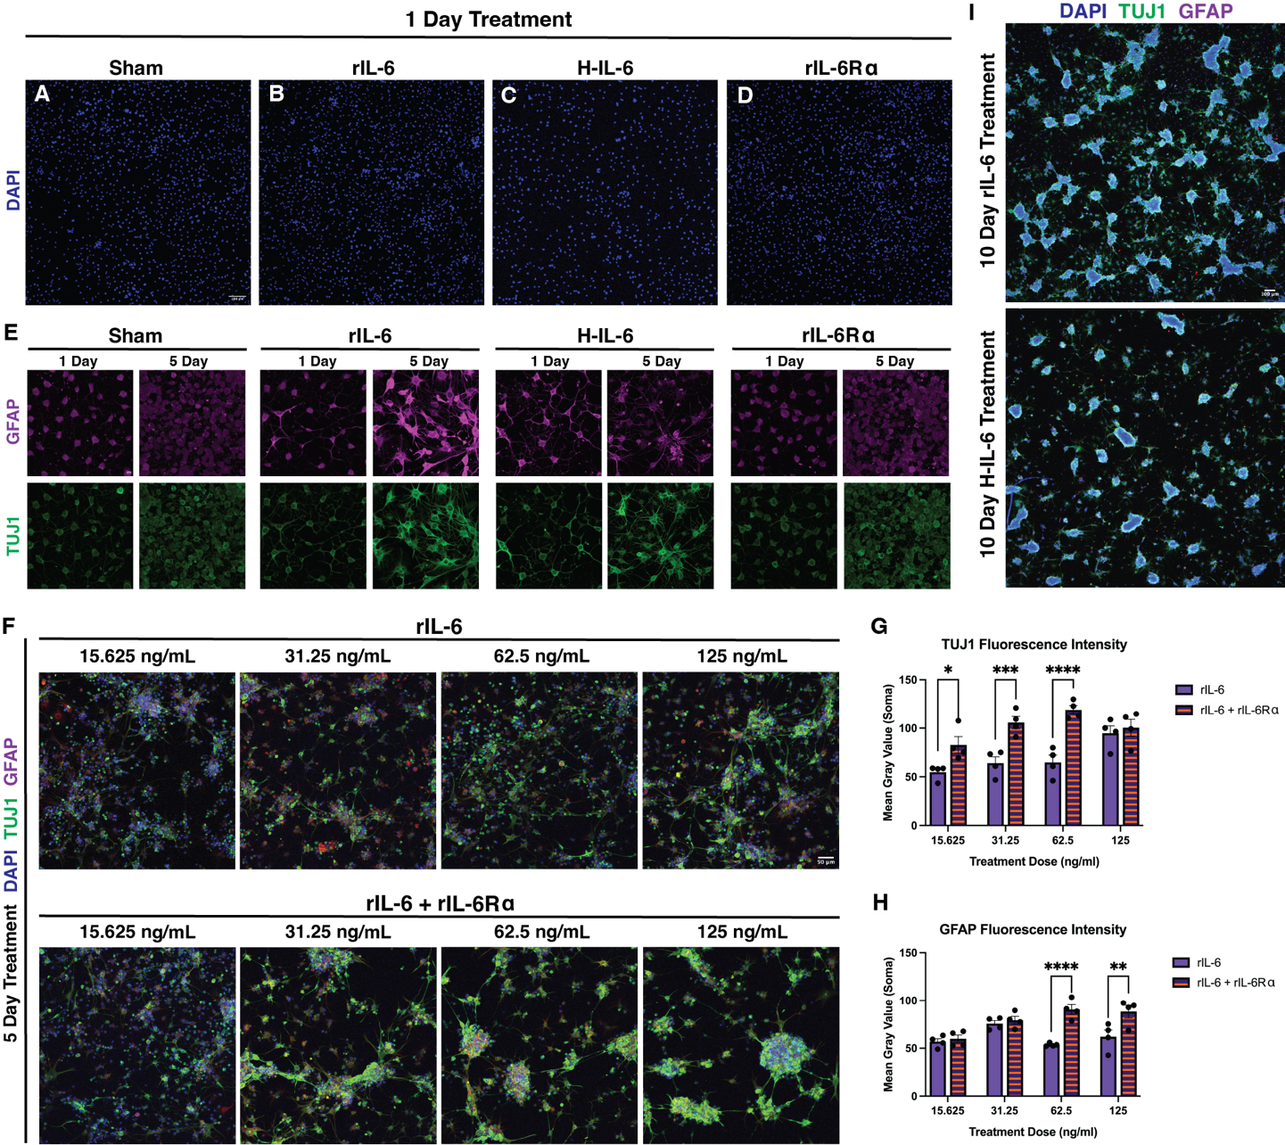
Fig. S3. Representative images from RAH-NSC proliferation assays (A-D) and individual channels for fluorescence intensity analysis (E). Assays of titrations of treatments reveal that rIL-6Ra boosts the potency of rIL-6 (F-H). Representative images of RAH-NSC clusters after 10-day treatments (I).

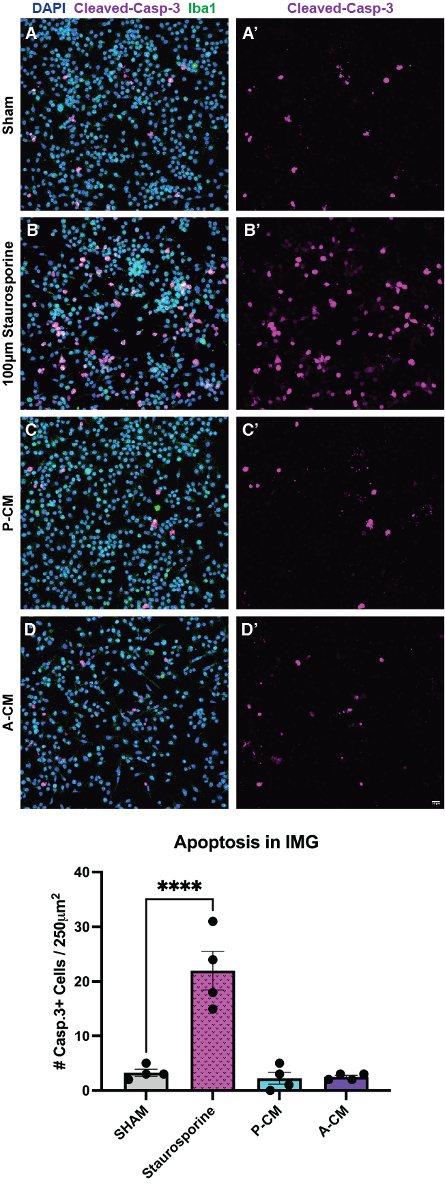
Fig. S4. P-CM and A-CM do not cause apoptosis in IMG microglia (A-D’).

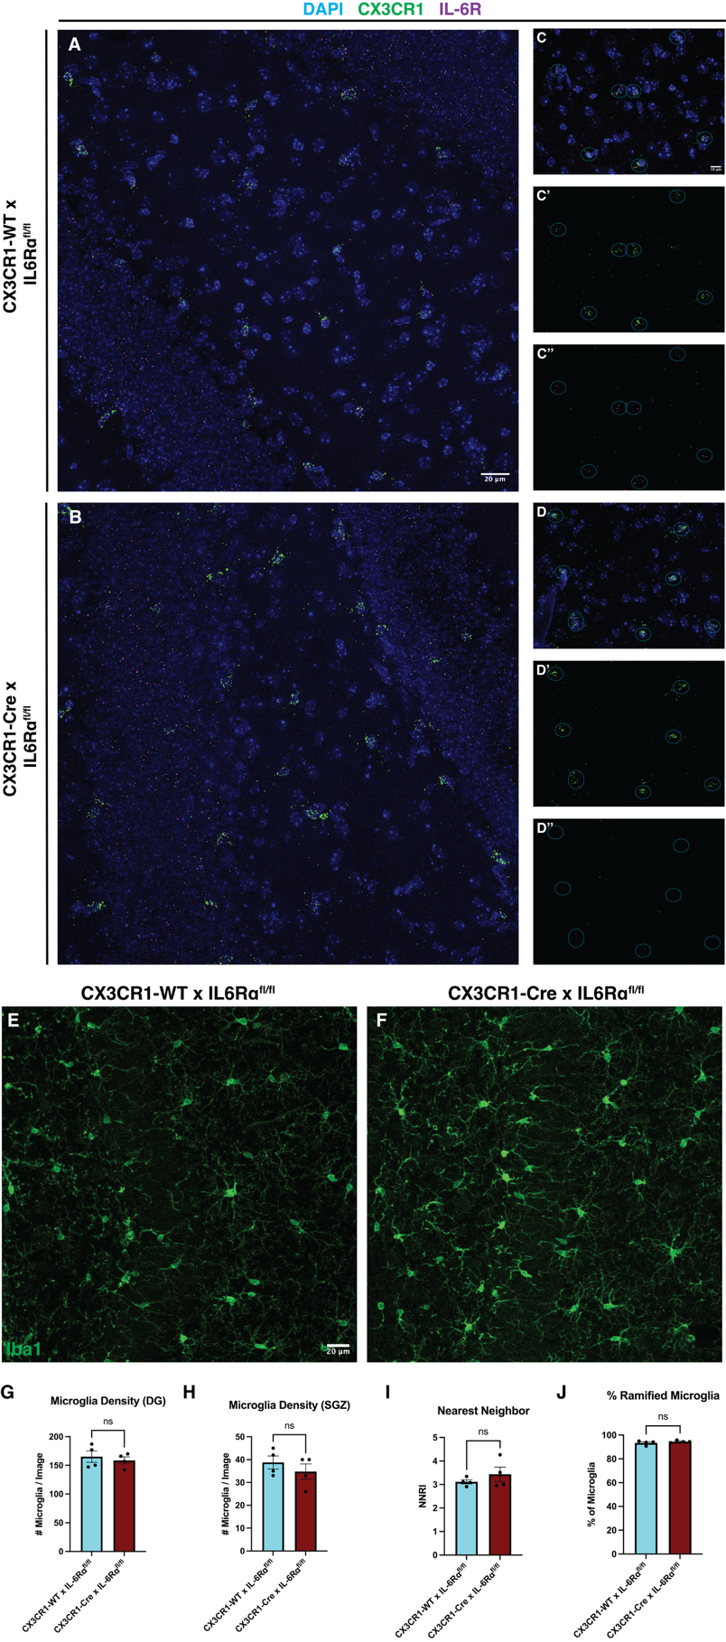
Fig. S5. Representative images of RNAscope-labeled microglia and IL-6R in the hippocampus of control or double-transgenic mice (A-D’’). Immunolabeling for iba1 (E-F) and analyses of microglia density (G-H), tiling regularity (I), and activation state (J) reveal that microglia from both groups are unchanged in many ways.
Supplementary Table 1.

Supplementary Figure 2I-K Data
 | Sham | rIL-6 | H-IL-6 | Sham vs. rIL-6 | Sham vs. H-IL-6
CCR1 | 1.00 +/-0.04 | 2.377 +/-0.10 | 2.826 +/-0.11 | P=.21 | P=.08
CCR5 | 1.00 +/-0.12 | 35.76 +/-3.52 | 31.54 +/-1.13 | P<.0001 | P<.0001
Tnfrsf8 | 1.00 +/-0.12 | 0.50 +/-0.10 | 0.39 +/-0.11 | P=.79 | P=.71
C1qa | 1.00 +/-0.07 | 3.27 +/-0.37 | 3.13 +/-0.06 | P=.01 | P=.02
C1qb | 1.00 +/-0.05 | 3.20 +/-0.13 | 3.19 +/-0.17 | P=.02 | P=.02
C1qc | 1.00 +/-0.05 | 2.64 +/-0.15 | 2.46 +/-0.13 | P=.10 | P=.15
Lcn2 | 1.00 +/-0.83 | 12.57 +/-3.08 | 9.39 +/-2.55 | P<.0001 | P<.0001
Arg1 | 1.00 +/-0.46 | 45.88 +/-2.99 | 35.39 +/-6.47 | P<.0001 | P<.0001
Socs3 | 1.00 +/-0.04 | 8.70 +/-0.20 | 6.45 +/-0.27 | P=.002 | P=.03

Supplementary Table 2.

Figure 3P-Q Data
 | TUJ1 | GFAP
Sham 1 Day | 65.57 +/-0.74 | 28.29 +/-2.01
Sham 5 Day | 69.72 +/-6.24 | 29.00 +/-0.87
rIL-6 1 Day | 80.57 +/-4.25 | 30.71 +/-0.97
rIL-6 5 Day | 132.02 +/-11.68 | 49.44 +/-6.82
H-IL-6 1 Day | 93.65 +/-6.91 | 43.67 +/-1.83
H-IL-6 5 Day | 132.20 +/-11.65 | 43.33 +/-6.95
rIL-6R⍺ 1 Day | 75.49 +/-6.37 | 29.07 +/-1.73
rIL-6R⍺ 5 Day | 67.27 +/-7.61 | 28.09 +/-2.71

Supplementary Table 3.

Supplementary Figure 3G Data
TUJ1 | rIL-6 | rIL-6 + rIL-6Ra | rIL-6 vs. rIL-6 + rIL-6Ra
15.625 ng/ml | 54.77 +/- 7.52 | 82.86 +/- 17.00 | P=.03
31.25 ng/ml | 64.00 +/- 13.10 | 105.79 +/- 12.70 | P=.001
62.5 ng/ml | 64.77 +/- 14.72 | 119.04 +/- 9.02 | P<.0001
125 ng/ml | 94.78 +/- 15.12 | 100.52 +/- 17.33 | P=.96

Supplementary Table 4.

Supplementary Figure 3H Data
GFAP | rIL-6 | rIL-6 + rIL-6Ra | rIL-6 vs. rIL-6 + rIL-6Ra
15.625 ng/ml | 56.83 +/- 6.10 | 59.89 +/- 7.97 | P=.98
31.25 ng/ml | 75.74 +/- 6.29 | 79.27 +/- 8.19 | P=.97
62.5 ng/ml | 53.60 +/- 1.76 | 90.54 +/- 10.28 | P<.0001
125 ng/ml | 62.03 +/- 14.12 | 88.43 +/- 13.38 | P=.002

