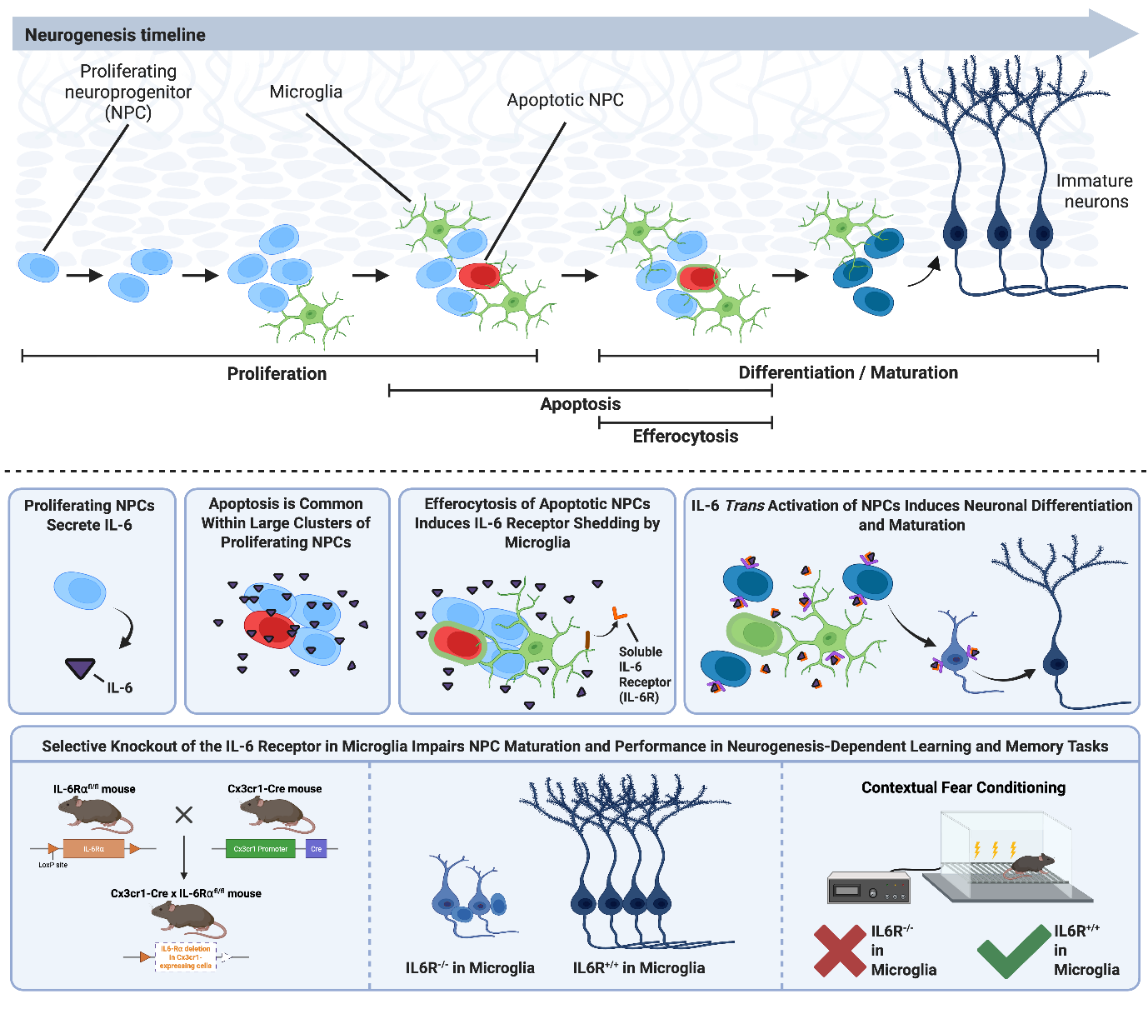
Graphical abstract: Recent advances have identified microglia and IL-6 as regulators of AHN. However, the mechanisms underlying this regulation remain unclear. Here, we demonstrate that proliferating NPCs secrete IL-6 and that apoptosis is common within clusters of proliferating NPCs. Next, we show that the efferocytosis of apoptotic NPCs induces IL-6R shedding by microglia and that IL-6 trans activation of NSCs induces neuronal differentiation and maturation. Finally, we generated conditional knockout mice that lack IL-6R expression exclusively in microglia and detected disturbed neurogenesis and cognitive deficits in a hippocampal neurogenesis-dependent learning and memory task. Thus, we posit that microglial efferocytosis in the SGZ induces IL-6R shedding, which initiates the transition from proliferation to differentiation and maturation in proximal healthy adult NPCs.

