Supplementary Figure1
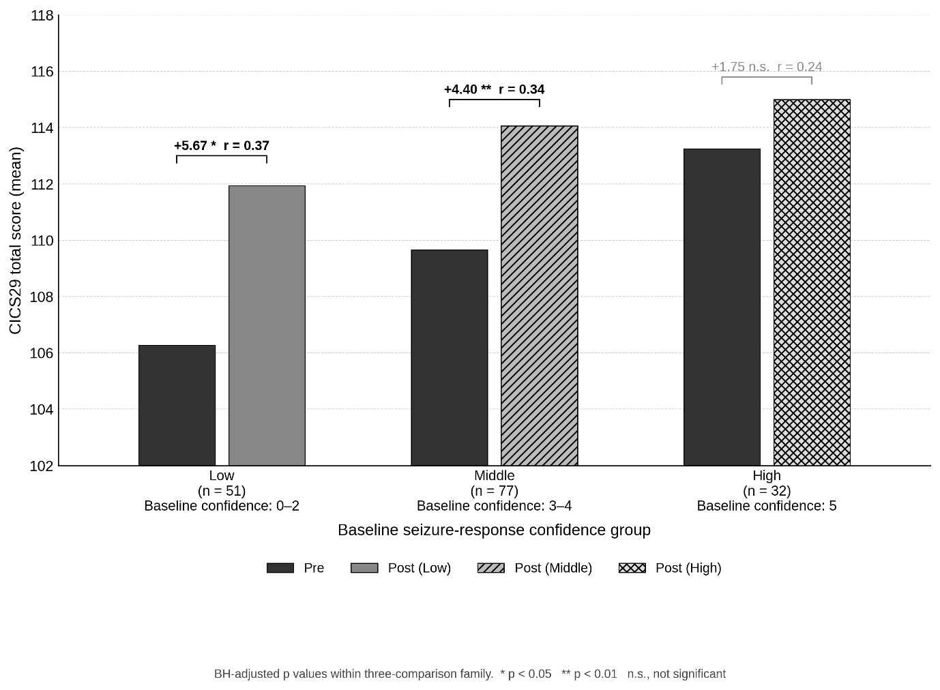
Fig. S1 Mean pre-to-post change in CICS29 total score by baseline seizure-response confidence group (exploratory analysis).
Participants were grouped by their self-rated seizure-response confidence recorded immediately before training: Low (score 0–2, n = 51); Middle (score 3–4, n = 77); High (score 5, n = 32). Bar heights represent group means. Labels above brackets show the mean change (Δ) and effect size (r, rank-biserial correlation). BH-adjusted p values (3-comparison family): * p < 0.05; ** p < 0.01; n.s., not significant. This analysis was pre-specified as exploratory; findings should be interpreted as hypothesis-generating.

Table S1. Comparison of baseline characteristics between matched and unmatched pre-training respondents.
Characteristic | Matched (n = 209) | Unmatched (n = 194) | p ᵃ
Work experience, median years (IQR)
Overall work experience | 4.0 (1.0–8.0) | 4.0 (1.0–8.0) | 0.315
Pediatric experience | 2.0 (1.0–4.0) | 2.0 (0.0–4.0) | 0.448
CAPS Clinic experience | 1.5 (0.0–3.0) | 1.5 (0.0–3.0) | 0.640
Categorical variables, n (%)
Prior simulation training | 45 (21.5) | 42 (21.6) | 0.522
Low seizure-response confidence (score 0–2) | 64 (30.6) | 70 (36.1) | 0.063
Values are median (interquartile range) for continuous variables and n (%) for categorical variables.
ᵃ Continuous variables compared using Mann–Whitney U tests; categorical variables compared using χ² tests.
No variable reached statistical significance at p < 0.05, indicating that attrition was not systematic. The p value for low baseline confidence (0.063) represents a non-significant trend, with comparable proportions across groups (matched 30.6% vs unmatched 36.1%).
CAPS, Child Allergy Primary care Service; IQR, interquartile range.

Table S2. Sensitivity analysis: independent-samples comparison of all pre-training and post-training respondents.
Measure | Pre-training (n = 378) Mean (SD) | Post-training (n = 216) Mean (SD) | U | p
CICS29 total (range 29–145) | 108.9 (14.8) | 113.2 (16.3) | 34,892 | <0.001
T-TPQ total (range 35–175) | 137.1 (18.0) | 139.0 (19.7) | 38,524 | 0.236
Independent-samples Mann–Whitney U tests (two-tailed) were conducted to assess the robustness of the primary paired analysis (matching rate 51.9%) against all respondents with valid scores.
The direction and significance pattern are consistent with the primary paired analysis (Table 3): CICS29 scores were significantly higher in post-training respondents, whereas T-TPQ scores did not differ significantly.
CICS29, Chiba Interprofessional Competency Scale; T-TPQ, TeamSTEPPS Teamwork Perceptions Questionnaire; SD, standard deviation.

